*Original Research Article*

FACTORS AFFECTING SEROCONVERSION RATE FOLLOWING HEPATITIS B VACCINATION IN PATIENTS WITH STAGE 4 CHRONIC KIDNEY DISEASE

**ABSTRACT**

**Aim:** To assess the seroconversion rate following hepatitis B vaccination in patients with stage 4 chronic kidney disease (CKD) and to determine the factors associated with non-response to vaccination.

**Study Design**: A prospective quantitative cohort study.

**Setting and Duration of Study**: Armadale Renal Service, Armadale Hospital, Western Australia, July 2022 to January 2025.

**Background:** Preventing the blood borne hepatitis B virus through vaccination is crucial for the high-risk haemodialysis patients.However**,** these individuals often exhibit low vaccine response rates due to declining immunity as kidney function deteriorates. While early vaccination before dialysis is suggested, a global consensus on the most effective CKD stage for initiation remains elusive.

**Method:** Patients with stage 4 CKD (eGFR 15-29 ml/min/1.73m21.73M2) were enrolled in the study. Eligible patients with Hepatitis B surface Antibodies (HBsAb) <10 mIU/mL were recruited with informed consent. They received 40mcg of H_B_VAX II® intramuscularly in the deltoid muscle at 0 -1- 6 - month interval. Vaccine response, defined as HBsAb >10 mIU/mL, was measured six-eight weeks post vaccination. Response rate, patient and clinical factors were entered into the Statistical Package for Social Sciences version 29.0 for Windows for data analysis. Data were expressed as mean ± Standard Deviation, results analysed using *t*-tests and chi-square *χ2* tests. *P* value <0.05 as statistically significant.

**Results:** Of the 106 enrolled patients (Males-71, Females-35), 99 (Males-67, Females-32) completed the course; seven deceased patients with incomplete vaccination were excluded for data analysis. Vaccination response rate was 47.47% (n= 47) while 52.52% (n=52) were non-responders (*P*=0.001). Factors negatively associated with vaccine response included older age group (*P*=0.001), presence of cardiovascular disease (*P*=0.011), Vitamin D3 deficiency (*P*=0.028), lower transferrin saturation (*P* =0.045), and presence of multiple comorbidities (*P*=0.017).

**Conclusion:** This study showed a low hepatitis B vaccine response rate even in stage 4 CKD, underscoring the importance of early vaccination before progression to dialysis requirement. Identifying the factors that influence the response rate can aid in individualizing vaccination management strategy.

***Key words:*** *chronic kidney disease; hepatitis B vaccination; seroconversion; stage 4 chronic kidney disease; hepatitis B virus.*

1. INTRODUCTION

**1.1 Background and Significance**

Haemodialysis (HD) is a blood purification process for patients with end-stage kidney failure (ESKD). The procedure involves frequent blood exposure procedures, cannulation with skin integrity invasion three times a week and planned or unplanned surgical procedures for haemodialysis vascular access. These factors collectively expose HD patients to a high risk of infection, particularly the hepatitis B virus (HBV) infection. Data consistently shows infection as the second leading cause of mortality in this population (1-3).

The hepatitis B vaccine, developed in1982 (4) following two fatal infection outbreaks in 1970s (5), is a critical preventative measure. Haemodialysis patients face an elevated risk of the bloodborne HBV infection due to frequent blood exposure and invasive procedures (1, 6).

HBV infection can lead to acute hepatitis, liver fibrosis and hepatocellular carcinoma (primary liver cancer) (7-9). While vaccination against this blood borne virus remains a vital defense (10), vaccine response rate in the HD patients are notably low (11) , and diminishing response is attributed to a decline in immune function as the kidney disease progresses (12) (13) ,prompting ongoing research to identify the most effective CKD stage for vaccine initiation. Despite four decades of research, there is little consensus regarding recommendations for vaccine commencement stage (9, 14, 15) .

A previous publication by the authors explored vaccine response in stage 5 CKD (both dialysis and non-dialysis dependent) (16) (light 2024) and highlighted variations in clinical practice through a clinical practice patterns survey. This survey also revealed limited knowledge regarding the necessity and benefits of early CKD hepatitis B vaccination and identified barriers to the vaccination management (17) . This prospective cohort study aims to investigate the efficacy of initiating vaccination at an earlier stage of CKD (Stage 4) and to examine the influence of patient and clinic factors on the vaccine response.

**1.2 Aim**

The aim of the study was to assess the seroconversion rate following hepatitis B vaccine in patients with stage 4 chronic kidney disease and to determine the factors associated with non-response to the vaccination.

**1.3 Objectives**

The objectives of the study were to:

* Evaluate the efficacy of commencing hepatitis B vaccination at an early-stage CKD, before reaching dialysis requirement stage.
* Explore the impact of patient factors such as age and gender on the vaccine response.
* Investigate the effect of clinical factors that might have effects on the response rate such as co-morbidities of Diabetes Mellitus (DM), Cardiovascular disease (CVD), hypertension (HT), chronic obstructive pulmonary disease (COPD), Obstructive Sleep Apnea (OSA), and laboratory investigations such as serum albumin, parathyroid hormones (PTH), vitamin D3, hemoglobin (Hb), iron status including transferrin, serum ferritin, transferrin saturation (TSAT), and erythropoietin stimulating agents (ESA) dependence (the dependency of the ESA medication for treatment of anaemia caused by CKD).

2. material and methods

**2.1 Study Design**

Participants for this prospective quantitative cohort study were recruited from July 2022 to July 2024. Eligible participants completed a three-dose (0-1- 6-month) hepatitis B vaccination course over six months. The final patient completed the vaccination regime in January 2025. Post-vaccination response was assessed by obtaining the hepatitis B serology six-eight weeks after the final (third) vaccine dose.

**2.2 Recruitment**

Patients attending renal clinics under the care of the Renal Service of the Armadale Hospital in Western Australia were screened for eligibility. Patients identified with stage 4 CKD (eGFR 15-29 mL/min/1.73m2) from routine renal clinic biochemistry results were invited to participate. Study information was provided, and a screening test for hepatitis B serology was conducted. Patients with serology result of HBsAb < 10mIU/mL and no prior hepatitis B vaccination were deemed eligible and recruited into the study.

**2.3 Participation**

Participation was voluntary. All participants were fully informed about the hepatitis B virus, the rationale for vaccination, the potential side effects, risks and injection site discomfort. All participants completed the Patient Specific Information Consent Form (PICF), as approved by the East Metropolitan Health Service (EMHS) Human Research Ethics Committee (HREC), before study entry. Eligible participants with HBsAb < 10 mIU/mL were commenced on H_B_VAX II® 40 mcg administered intramuscularly in the deltoid muscle given as per unit clinical practice protocol at 0 -1- 6 - month intervals.

**2.4 Data Collection**

Patients’ demographic information and medical information were retrieved from the Digital Medical Records; laboratory results were obtained from the digital Information Clinical Management iSOFT database. All patient data were recorded in a password- protected Excel spread sheet with patient names de-identified and allocated study- specific coded numbers.

**2.5 Data Analysis and Statistics**

Analyses were performed using the Statistical Package for Social Sciences (SPSS), version 29.0.0 for Windows (IBM, Corporation, Armonk, NY, USA).

Descriptive statistics (Mean, Standard Deviation [SD]). were used to analyse demographic data. The categoric variables were analysed using the Chi-square $χ2$ test for gender, DM, CVD, HT, COPD, OSA, Serum Albumin < 35g/L and ESA dependence, and were presented as frequencies and percentages.

The Independent Samples *t-* test was used to test the significance of difference of values in the continuous variables such as age, eGFR, serum albumin, PTH, Vitamin D3, HB, Transferrin, TSATs, Ferritin and the presence of number of co-morbidities. A *P* value of < 0.05 is considered as statistically significant.

**3. RESULTS**

**3.1 Demographics**

A total of 106 patients (M=71, F=35) were eligible and participated in the study, seven patients deceased before completion of the vaccination regimen. The final complete dataset for analysis comprised of 99 patients (M=67, F=32). The mean age of the participants was 72.01 years +/- 10.268.

The demographics and presence of co-morbidities of the final participants (N=99) are detailed in Table 1:

|  |  |
| --- | --- |
| **Table 1. Demographics and presence of co-morbidities** | |
| **Parameters** | **Stage 4 CKD patients (N=99)** |
| Mean Age, years (SD) | 72.01 (± 10.268) |
| Gender male, n (%) | 67 (67.7) |
| Gender female, n (%) | 32 (32.3) |
| DM, n (%) | 55 (52.5) |
| HT, n (%) | 69 (69.7) |
| CVD, n (%) | 53 (53.5) |
| COPD, n (%) | 10 (10.1) |
| OSA, n (%) | 25 (25.3) |
| S ALB <35 g/L, n (%) | 18 (18.2) |
| ESA dependence, n (%) | 13 (13.1) |
| *Notes: DM: Diabetes Mellitus; HT, hypertension; CVD, cardiovascular disease; COPD, chronic obstructive pulmonary disease; OSA, obstructive sleep apnoea; S Alb, Serum Albumin; ESA, erythropoietin stimulating agents* | |

**3.2 Etiology of CKD**

Figure 1 showing the etiologies of CKD in the study cohort included 1. Diabetic Nephropathy (28.3%), 2. Glomerulonephritis (10.4%), 3. Tubulointerstitial nephritis 11.3%),4. Hereditary or cystic disease (3.8%), 5. Nephrosclerosis/Renovascular disease (32.1%), 6. Dyscrasias or neoplasm (2.8%) and 7. Obstructive Nephropathy (11.3%).

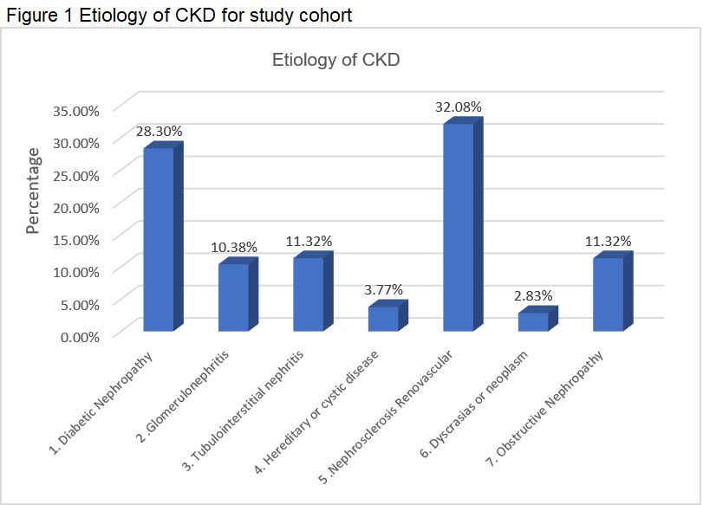

**3.3 Vaccine response**

The hepatitis B vaccine response is defined by the measurement of Hepatitis B surface antibodies (HBsAb), with HBsAb < 10 mIU/mL classified as non-responders and HBsAb >10 mIU/mL classified as responders (18). The results presented in Table 2 show that 52.52% (n=52) of the participants were “Non-responders”, while 47.47 % (n=47) were “Responders” to the vaccine (*P*=0.001).

The range, median, and interquartile Range (IQR) of the “Responders” are further detailed in Table 2.

|  |  |
| --- | --- |
| **Table 2: Hepatitis B vaccine response in stage 4 CKD patients (N=99)** | |
| **Parameters** | **Stage 4 CKD patients** |
| **Non-responders** (HBsAb <10 mIU/mL) n, % | 52, 52.52% |
| **Responders** (HBsAb > 10 mIU/mL) n, % | 47, 47.47%  (*P*=0.001) |
| **Results of the Responders** | |
| Min | 13 |
| Max | 1000 |
| Quartile 1 | 47 |
| Quartile 2 (Median) | 85 |
| Quartile 3 | 371.05 |
| Interquartile Range (IQR) | 324.05 |
| Range | 987 |

**3.4 Patient characteristics and vaccine response**

The relationship of the patient factors and clinical factors by vaccine responders and non-responders is detailed in Table 3. Age was significantly associated with non-response (*P*=0.001). Clinical factors were the presence of CVD, TSAT levels, Vitamin D3 level and the presence of multiple comorbidities have a significant negative response to the hepatitis B vaccine.

Other factors investigated in the study such as DM, HT, COPD, OSA, ESA dependence, S Alb < 35g/L, PTH, HB, transferrin and ferritin levels, did not have a significant effect on the vaccine response (*P* >0.05).

|  |  |  |  |  |  |  |
| --- | --- | --- | --- | --- | --- | --- |
| **Table 3: Patient characteristics and vaccine response** | | | | | | |
| **Stage 4 CKD patients N=99** | | | | | | |
|  | **Responders**  (n=47, 47.47%) | | **Non-Responders**  (n=52, 52.52%) | |  |  |
| **Categoric Data *( χ2 )*** | **n** | **%** | **n** | **%** | ***χ2 (df)*** | ***P* value** |
| Gender  Male  Female | 31  16 | 65.96  34.04 | 36  16 | 69.23  30.77 | 0.121(1) | 0.728 |
| DM  Yes  No | 21  26 | 44.68  55.32 | 31  91 | 59.61  40.39 | 2.450(2) | 0.294 |
| CVD |  |  |  |  |  |  |
| Yes  No | 19  28 | 40.42  59.58 | 34  18 | 65.38  34.62 | 8.974(2) | **0.011\*** |
| HT |  |  |  |  |  |  |
| Yes  No | 32  15 | 68.08  31.92 | 37  15 | 71.15  28.85 | 2.268(2) | 0.322 |
| COPD |  |  |  |  |  |  |
| Yes  No | 4  43 | 8.52  91.48 | 6  46 | 11.54  88.46 | 0.366(2) | 0.833 |
| OSA |  |  |  |  |  |  |
| Yes  No | 11  36 | 23.40  76.60 | 14  38 | 26.92  73.08 | 0.199(2) | 0.905 |
| ESA Dependent |  |  |  |  |  |  |
| Yes  No | 6  41 | 12.76  87.24 | 7  45 | 13.46  86.54 | 0.018(2) | 0.991 |
| S Alb <35g/L |  |  |  |  |  |  |
| Yes  No | 6  41 | 12.76  87.24 | 12  40 | 23.08  76.92 | 1.764(1) | 0.184 |
| **Numerical data (*T* test)** | **Mean**  **Responders** | **±SD** | **Mean**  **Non-responders** | **±SD** | ***t (df)*** | ***P* value** |
| Age | 70.79 | 12.685 | 73.12 | 7.406 | -1.128(97) | **0.001\*** |
|  |  |  |  |  |  |  |
| eGFR | 23.68 | 4.274 | 23.12 | 4.255 | 0.659(97) | 0.943 |
|  |  |  |  |  |  |  |
| S Alb | 40.32 | 5.205 | 38.77 | 4.837 | 1.536(97) | 0.937 |
|  |  |  |  |  |  |  |
| PTH | 22.14 | 17.64 | 22.39 | 18.712 | -0.068(94) | 0.753 |
|  |  |  |  |  |  |  |
| VitD3 | 65 | 24.136 | 67 | 30.392 | -0.357(95) | **0.028\*** |
|  |  |  |  |  |  |  |
| HB | 117.36 | 18.85 | 119.4 | 14.882 | -0.601(97) | 0.148 |
|  |  |  |  |  |  |  |
| Transferrin | 29.19 | 5.072 | 28.31 | 5.929 | 0.793(97) | 0.151 |
|  |  |  |  |  |  |  |
| TSATs | 24.77 | 12.23 | 21.54 | 7.421 | 1.604(97) | **0.045\*** |
|  |  |  |  |  |  |  |
| Ferritin | 222.28 | 228.07 | 218.44 | 218.86 | 0.085(97) | 0.531 |
|  |  |  |  |  |  |  |
| HBsAb | 260.91 | 307.39 | 10 | 0 | 5.889(97) | 0.943 |
|  |  |  |  |  |  |  |
| Number of co-morbidities | 2.11 | 1.202 | 2.71 | 1.273 | -2.425(97) | **0.017\*** |
|  |  |  |  |  |  |  |
| *Abbreviations: DM: Diabetes Mellitus; CVD, cardiovascular disease; HT, hypertension; COPD, chronic obstructive pulmonary disease; OSA, obstructive sleep apnoea; ESA, erythropoietin stimulating agents; S Alb, Serum Albumin; PTH, Parathyroid Hormone; VitD3, Vitamin D3; HB, Haemoglobin; TSAT, Transferrin Saturation; HBsAb, Hepatitis B surface antibodies; SD, standard deviation*  *Note for P values: Chi-square $χ2$ tests used for categoric variables: Gender, DM, CVD, HT, COPD, OSA, ESA Dependent, S Alb <35 g/L*  *t-test, Independent Samples t test used for numerical data for Age, S Alb, PTH, VitD3, HB, Transferrin, TSATs, Ferritin*  ***\**** *P <0.05, statistically significant* | | | | | | |

**3.5 Sub-groups analysis**

Further sub-group analyses were conducted on age and eGFR detailing the vaccine response trends in relationship to these two subgroups, as well as vaccine response in the presence of co-morbidities (DM, HT, CVD, COPD, OSA, ESA dependence and Serum Albumin <35g/L).

Figure 2 showed a notably higher response in the 31-50 years group compared to the 51-70 years and 71-90 years groups.

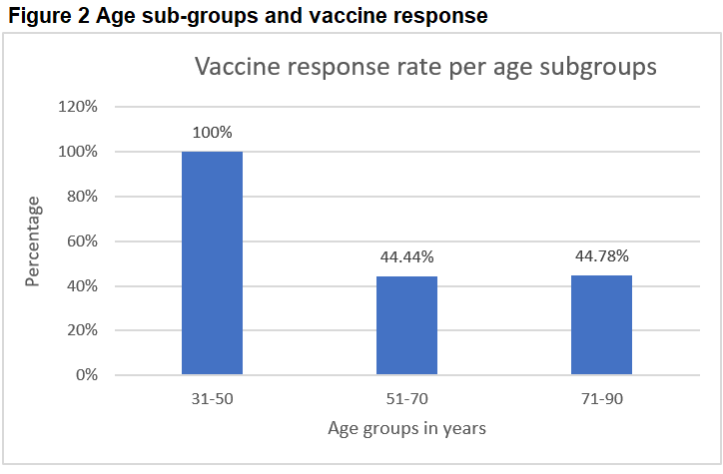

Figure 3 showed the response rate was greater in the eGFR 26-29 sub-group compared to the sub-groups with lower eGFRs (15-20; 21-25).

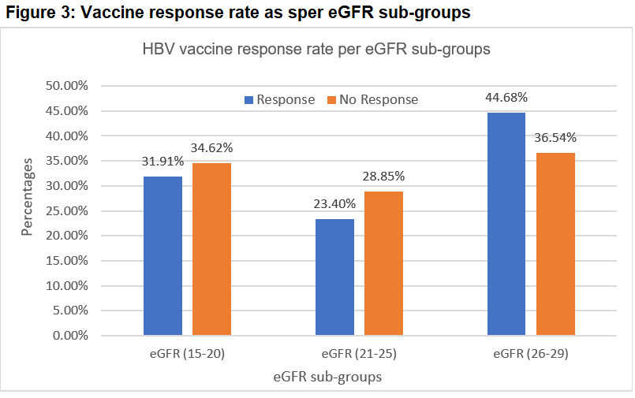

The vaccine non-responders also presented with a greater number of co-morbidities.

Table 4 and Figure 4 indicated that 43 (91.49%) of the vaccine responders (n=47) had at least one comorbidity with maximum of four comorbidities. In contrast, 50 (96.15%) of the vaccine non-responders (n=52) showed at least one comorbidity with maximum of six comorbidities.

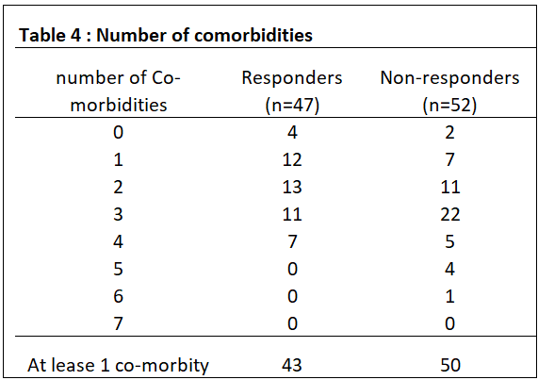

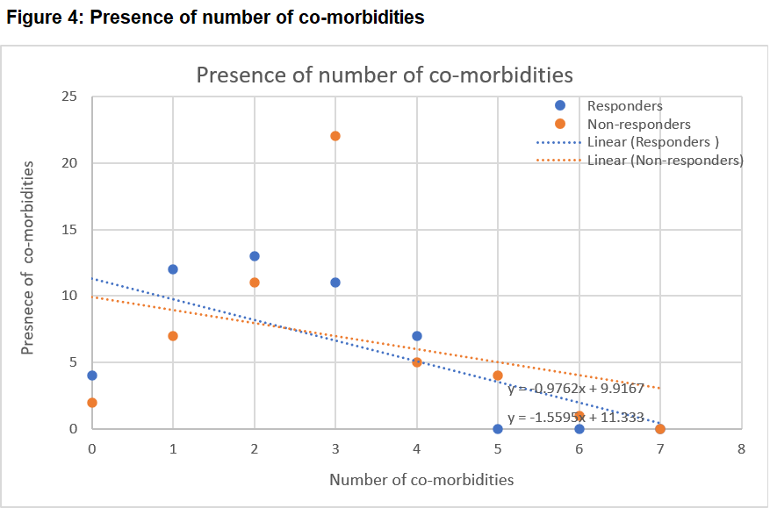

**4. DISCUSSION**

**4.1 Discussion of results**

Hepatitis B vaccination has been a standard of practice since its development in the 1980s, prompted by the fatal infection outbreaks in two Edinburg hospital HD units in 1970 (5). Low vaccine response rate in the HD population, and knowledge that the immune response correlating with the degree of kidney function decline, have prompted ongoing research to achieve better vaccine response rates. Four decades on, global practices remain diverse, with varied protocols and no consensus regarding the most beneficial CKD stage to commence the vaccination.

In Australia, a recent clinical practice pattern survey demonstrated variation in vaccination practice across the states and territories (17) The current study focused on the stage 4 CKD population to explore the efficiency and applicability of establishing a standardised beneficial CKD stage for the vaccine initiation. The study results from our 99 participants showed a low response rate even in stage 4 CKD (47.47%). The study further explored the patient and clinical factors that might influence the vaccine response, and identified that age, presence of CVD, TSATS levels, Vitamin D deficiency and co-existence of multiple co-morbidities were negatively associated with vaccine response.

* *Age*

The significant negative effect of age on vaccine response reported in this study aligns with the findings by Sit (19) and Zitt (20) .Yang explained that the bone marrow depression during aging leads to impaired humoral and cellular response in older people (21) ,this is reflected in our study cohort’s mean age of 72.01 years. The weakening of the adaptive immune system (known immunosenescence) is characterized by thymic size reduction and compromised T-cell production and differentiation, also contributes to reduced response rate (22, 23).

Further sub-group analysis of the age factor revealed that the 31-50 years group exhibited the highest response rate compared to the 51-70 year and 71-90 year groups This analysis highlights the importance of initiating vaccination at an earlier age, particularly as younger patients are more likely to be considered for kidney transplantation. Studies have shown that organs from HBV positive donor are safe for seroprotective recipients (24), thereby expanding the kidney transplant pool and emphasizing the benefit of early vaccination to enhance seroconversion in potential kidney recipients.

* *Cardiovascular Disease (CVD)*

The presence of CVD had a significant negative effect on vaccine response in the current study, similar to the negative association found in our previous study investigating vaccine response in stage 5 non-dialysis dependent CKD patients (16). While there was limited literature directly support the negative effect of CVD on the hepatitis B vaccine in the CKD population, it may be explained by the inflammatory progression in CVDs often lead to suppressed innate and adaptive immune responses (25). In addition, it is known that a subset of T cells called Regulatory T cells ( also known as Tregs) has a crucial role in modulating immune response and maintaining immune homeostasis. Studies have shown that the inflammatory state and oxidative stress associated with CVD can lead to dysfunction or decreased numbers of Tregs (25-27). Thus, the negative hepatitis B vaccine response in CVD patients in our study could be attributed to dysfunctional or reduced Tregs.

* *Transferrin Saturation (TSAT)*

Transferrin saturation (TSAT) and ferritin serve as iron status indicators in anemia management and markers of iron supplementation in CKD patients. The serum ferritin level correlates with iron stores; a low serum ferritin level indicates absolute iron deficiency in the absence of inflammation (28).Thus, TSAT is a crucial biochemical marker of overall body iron status as the ratio of serum iron to total iron-binding capacity. The TSAT levels are affected by serum iron, which can fluctuate diurnally with dietary iron intake, or rapidly decrease due to the iron sequestration in macrophages during inflammation. Therefore, low TSAT levels indicate both iron deficiency and inflammatory or nutritional conditions (29).

In this study, we found that the TSAT levels negatively impacted hepatitis B vaccine response. There are few studies that explore the specific effect of TSATS on the vaccine in CKD patients reported in the contemporary literature. We hypothesize that this negative influence could be due to the underlying inflammation and nutritional deficiencies associated with low TSAT, as other studies have demonstrated that malnutrition can also negatively affect vaccine response(16, 30).Furthermore, recent evidence by Stoffel and Drakesmith suggests that iron deficiency leads to impaired adaptive immunity by reducing B-cells production, T-cell activation and proliferation (31).

* *Vitamin D*

Vitamin D receptors are present in nearly all immune cells and play a role in both innate and adaptive immunity (32).Vitamin D can inhibit B and T cell proliferation, reduce inflammatory cytokine production and enhance the anti-inflammatory cytokines levels (33) , highlighting its importance in immune regulation. Kashi *et al*

(2021) reported that low vitamin D levels at the initiation of hepatitis B vaccination were associated with poorer vaccine response in the general population (34) . While some studies have explored the effect of vitamin D levels on hepatitis B vaccine response in the haemodialysis population (35, 36) , only one article by Zitt *et al* (2012) reported the negative vaccine effect of low vitamin D levels in both pre dialysis and dialysis patients (35). Our prospective study cohort with stage 4 CKD confirmed that low vitamin D significantly negatively impact HBV vaccine response, aligning with Zitt’s finding.

Given the high prevalence of vitamin D deficiency is in the CKD patients due to impaired availability by the proximal renal tubular cells (in decreased renal function), poor dietary intake, reduced absorption relating to gastrointestinal disturbance in CKD and reduced sunlight exposure (35, 37), improving or correcting the vitamin D deficiency could significantly improve hepatitis B seroconversion.

* *Number of co-morbidities*

CKD patients frequently present with multiple co-morbidities (38-40). Conditions such as DM, CVD and HT are often the primary causes of CKD (41).Our study expanded to include other comorbidities such as COPD, OSA, ESA dependence (indicating anaemia) and Serum Albumin <35 (indicating malnutrition,(42, 43)) and examined their effect on vaccine response. Our results showed 93.94% of the cohort had at least one comorbidity, with a maximum of six comorbidities. This is consistent with the cross-sectional study by MacRae *et al*, where 98.2% of adult CKD patients had at least one comorbidities (39) ,and Bowling *et al* showed 85.0% of the CKD patients had two or more comorbidities in their study(38). Evidently, our data further demonstrated better vaccine response with responders having fewer co-morbidities (1 - 4) than non-responders (1 - 6). These results highlighted the significant negative impact of the number of comorbidities on the vaccine response. These findings should be considered in the HBV vaccination management.

**4.2 Summary of vaccine affecting factors**

This prospective cohort study revealed five factors that significantly affect vaccine response. Reasons for their negative impact can be deduced as follows:

* Age (older): Bone marrow depression and immunosenescence leading to impaired humoral and cellular response.
* Presence of CVD: Inflammation and oxidative stress can lead to dysfunction or reduced numbers of regulatory T cells (Tregs).
* TSAT (low): Indicative of inflammation, malnutrition and impaired adaptive immunity due to reduced B-cell production, T-cell activation and proliferation.
* Vitamin D (deficiency): Impaired regulation of immune response, including inhibition of B & T cells proliferation and altered cytokines production.
* Multiple co-morbidities: A higher number of morbidities exerts a stronger negative effect on immune function and vaccine response

**4.3 Significance of the study**

Although the response rate of the stage 4 CKD patients was low, the identified affecting factors could play a vital role in enhancing the response rate and may inform future research. Our results highlight that ensuring the younger patients are vaccinate no later than stage 4 CKD is crucial, particularly to promote seroconversion for increasing opportunities in the kidney transplant recipient pool. The knowledge of the Vitamin D3 deficiency and improving TSATs /iron deficiency could also enhance the vaccine response rate. These findings could help establish a standard practice to commence the vaccine no later than stage 4 CKD, in addition to targeting these individualized factors. Finally, while new recommendations advocate for HBV vaccination at birth in the younger generations (44), the fact that the HBsAb levels and protective immunity is not long lived and wane over time, as evidenced by many studies (45, 46), underscores the continued importance of tailored, individualized vaccine programs for CKD patients .

**4.4 Limitation of the study**

It is possible that the observed low vaccine response rate is partly attributed to the higher number of older age participants. Further studies should include younger participants. It is acknowledged that younger patients can be challenging to recruit due to the rigorous nature of the vaccination program commitment, the pre-selection serology screening for eligibility, the time and travel commitment to the clinic, which may disincentivize potential younger participants engaged in the workforce. This is a single center cohort study with voluntary recruitment. A larger sample to include all clinic attendants with stage 4 CKD as well as a control group should be considered in future studies.

**5. CONCLUSION**

This study demonstrated that the hepatitis B vaccine response rate even commencing in stage 4 CKD is low, emphasizing the critical importance of early vaccination before progression to dialysis. Recognizing the identified influencing patient and clinical factors could also contribute to individualizing and prioritizing vaccination management strategies.

**DISCLAIMER** **(ARTIFICIAL INTELLIGENCE)**

Authors hereby declare that NO generative AI technologies such as Large Language Models (ChatGPT, COPILOT, etc.) and text-to-image generators have been used during writing or editing of manuscripts.

**CONSENT**

Signed consent was essential from all participants in this study. Information for the study was detailed in the PICF form as voluntary participation and free to withdrawal.

Participants were encouraged to consult their GPs or discuss with family if they wished prior to committing to the study.

**ETHICAL APPROVAL**

Ethics approval for the study has been granted by the East Metropolitan Health Service (EMHS) Human Research Ethics Committee (HREC), protocol number GS0000005290 and reciprocal ethic approval through the Curtin University Human Research Ethics Committee, protocol number HRE2022-0378.

**ANIMAL ETHICS**

This study did not involve animal subjects or tissue.

**REFERENCE**

1. Fabrizi F, Dixit V, Messa P, Martin P. Transmission of hepatitis B virus in dialysis units: a systematic review of reports on outbreaks. Int J Artif Organs. 2015;38(1):1-7.

2. Reddy S, Chitturi C, Yee J. Vaccination in Chronic Kidney Disease. Adv Chronic Kidney Dis. 2019;26(1):72-8.

3. Syed-Ahmed M, Narayanan M. Immune Dysfunction and Risk of Infection in Chronic Kidney Disease. Adv Chronic Kidney Dis. 2019;26(1):8-15.

4. CDC. Recommendation of the Immunization Practices Advisory Committee (ACIP) inactivated Hepatitis B virus vaccine. MMWR Weekly. 1982;31:317-22.

5. Bone J, Tonkin, R., Davidson, A., Marmion, B., & Robson, J. Outbreak of dialysis associated hepatitis B in Edinburgh. . 1970;8(23).

6. Bernieh B. Viral hepatitis in hemodialysis: An update. J Transl Int Med. 2015;3(3):93-105.

7. Nguyen MH, Wong G, Gane E, Kao JH, Dusheiko G. Hepatitis B Virus: Advances in Prevention, Diagnosis, and Therapy. Clin Microbiol Rev. 2020;33(2).

8. Hettenbaugh J, Mullane R, Gillispie G, Shostrom V, Flores L, Fillaus JA, et al. Hepatitis B Vaccination in Advanced Chronic Kidney Disease: A Quality Improvement Project at a Veteran Affairs Chronic Kidney Disease Clinic. Infect Dis Rep. 2021;13(4):1036-42.

9. Mysore P, Khinkar, R. M., McLaughlin, D., Desai, S., McMahon, G. M., Ulbricht, C., & Mendu, M. L. Improving hepatitis B vaccination rates for advanced chronic kidney disease patients: a quality improvement initiative Clinical and experimental nephrology,. 2021;25(5):501–8.

10. Krueger KM, Ison MG, Ghossein C. Practical Guide to Vaccination in All Stages of CKD, Including Patients Treated by Dialysis or Kidney Transplantation. Am J Kidney Dis. 2020;75(3):417-25.

11. Elhanan E, Boaz M, Schwartz I, Schwartz D, Chernin G, Soetendorp H, et al. A randomized, controlled clinical trial to evaluate the immunogenicity of a PreS/S hepatitis B vaccine Sci-B-Vac™, as compared to Engerix B(®), among vaccine naïve and vaccine non-responder dialysis patients. Clin Exp Nephrol. 2018;22(1):151-8.

12. da Silva EN, Baker, A., Alshekaili, J., Karpe, K., & Cook, M. C. A randomized trial of serological and cellular responses to hepatitis B vaccination in chronic kidney disease. PloS One. 2018;13(10).

13. Du Y, Zhang S, Hu M, Wang Q, Liu N, Shen H, et al. Association between hepatitis B virus infection and chronic kidney disease: A cross-sectional study from 3 million population aged 20 to 49 years in rural China. Medicine (Baltimore). 2019;98(5):e14262.

14. Haddiya I. Current Knowledge of Vaccinations in Chronic Kidney Disease Patients. International Journal of Nephrology and Renovascular Disease. 2020;13:179 - 85.

15. Nadeem M, Shah SZA, Arshad N, Riaz F, Kiani RS, Quddus MA. Vaccination against hepatitis B virus in hemodialysis patients: trends in dialysis centers of Northern Pakistan. F1000Research. 2021;10:55.

16. Light C, Heslop K, H. K. Comparison of Factors Affecting the Immune Response to Hepatitis B Vaccination in Patients with Stage 5 Chronic Kidney Disease-haemodialysis and Predialysis. Open Urol Nephrol J. 2024;17(e1874303X304324. ).

17. Light C, Heslop K, Kulkarni H. Clinical Practice Patterns in Hepatitis B Vaccination for Patients With Chronic Kidney Disease Asian Journal of Research in Nephrology. 2024;7(1):73:83.

18. WHO. Hepatitis B vaccine : WHO position paper-2017. Availabel online at: <https://iris.who.int/bitstream/handle/10665/255841/WER9227.pdf?sequence=1>. 2017;27(92):367-92.

19. Sit D, Esen B, Atay AE, Kayabaşı H. Is hemodialysis a reason for unresponsiveness to hepatitis B vaccine? Hepatitis B virus and dialysis therapy. World journal of hepatology. 2015;7(5):761-8.

20. Zitt E, Hafner-Giessauf H, Wimmer B, Herr A, Horn S, Friedl C, et al. Response to active hepatitis B vaccination and mortality in incident dialysis patients. Vaccine. 2017;35(5):814-20.

21. Yang S, Tian G, Cui Y, Ding C, Deng M, Yu C, et al. Factors influencing immunologic response to hepatitis B vaccine in adults. Sci Rep. 2016;6:27251.

22. Goronzy JJ, Weyand CM. Mechanisms underlying T cell ageing. Nat Rev Immunol. 2019;19(9):573-83.

23. Huang Y, Zheng H, Zhu Y, Hong Y, Zha J, Lin Z, et al. Loss of CD28 expression associates with severe T-cell exhaustion in acute myeloid leukemia. Front Immunol. 2023;14:1139517.

24. Huprikar S, Danziger-Isakov L, Ahn J, Naugler S, Blumberg E, Avery R, et al. Solid Organ Transplantation From Hepatitis B Virus–Positive Donors: Consensus Guidelines for Recipient Management. American Journal of Transplantation. 2015;15(5):1162 - 72.

25. Zhang YS, Chen YQ. Dysfunctional regulatory T cell: May be an obstacle to immunotherapy in cardiovascular diseases. Biomed Pharmacother. 2024;173:116359.

26. Kumar V, Narisawa M, Cheng XW. Overview of multifunctional Tregs in cardiovascular disease: From insights into cellular functions to clinical implications. Faseb j. 2024;38(13):e23786.

27. Xia Y, Gao D, Wang X, Liu B, Shan X, Sun Y, et al. Role of Treg cell subsets in cardiovascular disease pathogenesis and potential therapeutic targets. Front Immunol. 2024;15:1331609.

28. Kuragano T, Joki N, Hase H, Kitamura K, Murata T, Fujimoto S. Low transferrin saturation (TSAT) and high ferritin levels are significant predictors for cerebrovascular and cardiovascular disease and death in maintenance hemodialysis patients. PLoS ONE. 2020;15(9 e0236277).

29. Elsayed ME, Sharif MU, Stack AG. Transferrin Saturation: A Body Iron Biomarker. Adv Clin Chem. 2016;75:71-97.

30. Fabrizi F, Cerutti R, Dixit V, Ridruejo E. Hepatitis B virus vaccine and chronic kidney disease. The advances. Nefrologia (Engl Ed). 2021;41(2):115-22.

31. Stoffel NU, Drakesmith H. Effects of Iron Status on Adaptive Immunity and Vaccine Efficacy: A Review. Adv Nutr. 2024;15(6):100238.

32. Chang SH, Chung Y, Dong C. Vitamin D suppresses Th17 cytokine production by inducing C/EBP homologous protein (CHOP) expression. J Biol Chem. 2010;285(50):38751-5.

33. Ghaseminejad-Raeini A, Ghaderi A, Sharafi A, Nematollahi-Sani B, Moossavi M, Derakhshani A, et al. Immunomodulatory actions of vitamin D in various immune-related disorders: A comprehensive review. Frontiers in Immunology. 2023;14:950465.

34. Kashi DS, Oliver SJ, Wentz LM, Roberts R, Carswell AT, Tang JCY, et al. Vitamin D and the hepatitis B vaccine response: a prospective cohort study and a randomized, placebo-controlled oral vitamin D(3) and simulated sunlight supplementation trial in healthy adults. Eur J Nutr. 2021;60(1):475-91.

35. Zitt E, Sprenger-Mähr H, Knoll F, Neyer U, Lhotta K. Vitamin D deficiency is associated with poor response to active hepatitis B immunisation in patients with chronic kidney disease. Vaccine. 2012;30(5):931-5.

36. Eleftheriadis T, Pissas G, Antoniadi G, Liakopoulos V, Stefanidis I. Factors affecting effectiveness of vaccination against hepatitis B virus in hemodialysis patients. World journal of gastroenterology : WJG. 2014;20(34):12018-25.

37. Jean G, Souberbielle JC, Chazot C. Vitamin D in Chronic Kidney Disease and Dialysis Patients. Nutrients. 2017;9(4).

38. Bowling CB, Plantinga L, Phillips LS, McClellan W, Echt K, Chumbler N, et al. Association of Multimorbidity with Mortality and Healthcare Utilization in Chronic Kidney Disease. J Am Geriatr Soc. 2017;65(4):704-11.

39. MacRae C, Mercer SW, Guthrie B, Henderson D. Comorbidity in chronic kidney disease: a large cross-sectional study of prevalence in Scottish primary care. Br J Gen Pract. 2021;71(704):e243-e9.

40. Zemplényi A, Sághy E, Kónyi A, Szabó L, Wittmann I, Laczy B. Prevalence, Cardiometabolic Comorbidities and Reporting of Chronic Kidney Disease; A Hungarian Cohort Analysis. Int J Public Health. 2023;68:1605635.

41. Sullivan MK, Rankin AJ, Jani BD, Mair FS, Mark PB. Associations between multimorbidity and adverse clinical outcomes in patients with chronic kidney disease: a systematic review and meta-analysis. BMJ Open. 2020;10(6):e038401.

42. Fabrizi F, Dixit V, Martin P, Jadoul M, Messa P. Meta-Analysis: The Impact of Nutritional Status on the Immune Response to Hepatitis B Virus Vaccine in Chronic Kidney Disease. Digestive diseases and sciences. 2012;57(5):1366-72.

43. Gama-Axelsson T, Heimbürger O, Stenvinkel P, Bárány P, Lindholm B, Qureshi AR. Serum albumin as predictor of nutritional status in patients with ESRD. Clin J Am Soc Nephrol. 2012;7(9):1446-53.

44. Madihi S, Boukaira S, Benani A. Advancing hepatitis B elimination: A systematic review of global immunization progress and future directions. . Diagnostic Microbiology and Infectious Disease. 2025;111(3).

45. Lin SY, Liu JH, Lin CC, Wang SM, Tsai CA, Chou CY, et al. Comparison of hepatitis B surface antibody decay rates after vaccination between hemodialysis and peritoneal dialysis patients. Vaccine. 2011;29(21):3738-41.

46. Holt SG, Locarnini S, Sasadeusz J. Hepatitis B related dilemmas in the renal unit. Nephrology (Carlton). 2021;26(4):287-93.