Original Research Article

First documented occurrence of the non-native invasive armored catfish Pterygoplichthys pardalis (Castelnau, 1855) in Nirmal Lake, Vasai, Palghar District, Maharashtra, India

ABSTRACT
Invasive species have been known for a long time in science. Such species are called invasive because they tend to harm native ecosystems and organisms. Invasive species being less demanding, less predators, hardy nature and high reproduction rates have a negative impact on native organisms and hence increase the competition for such native organisms. One such organism which we have reported in this paper is the Pterygoplichthys pardalis also known as “Amazon sailfin catfish”. This fish along with other genus’ are known as “janitor fish”. These fishes belong to the family Loricariidae known as “armored catfishes”. These fishes are very popular for their hardy nature and in the aquarium trade it is also known by the aquarists as an impossible fish to kill because it can survive in any conditions , although in the aquarium trade due to lack of knowledge among aquarium hobbyist these catfishes tend to grow larger than the tanks they were kept , this results in many of the people releasing these large catfishes in local water bodies as a mean to get rid of it and hence such catfishes become invasive. One such case is the invasion of these catfishes in Nirmal Lake, Maharashtra which is the first recorded occurrence in this region. After obtaining the specimen and its detailed analysis we in this study emphasize the harmful effects of such invasive species to local fishermen and also to local fauna and further raise awareness among the common people.

KEYWORDS: Invasion, Amazon sailfin catfish, Vasai, Janitor fish

INTRODUCTION

Pterygoplichthys pardalis (Castelnau, 1855) Also known by the common name as Armored sailfin catfish, this group of catfish which are native to South America are medium to large sized reaching lengths of 30-35cm but in suitable conditions can reach 100cm (Nico et al. 2009). They have a distinctive appearance like a sail like dorsal fin having 10-12 rays, flat body structure and bony armour of scutes all over the body (Wu et al. 2011). These Armoured catfishes are valuable and prized in the aquarium trade due to their unique appearance and also their ability to control algae in aquariums (Pound et al. 2011) And was hence introduced to many countries including India for their algae controlling ability (Jumawan et al., 2016). Although now Pterygoplichthys have become invasive in most parts of the world (Joshi 2006; Hubilla et al. 2007), this is mostly because of improper release of such exotic species in the wild (Wanjari et al. 2023). Species of Pterygoplichthys have the incredible ability to adapt to changing environments and water quality (Nico and Martin, 2001) Once established in an ecosystem, these invasive species are difficult to remove (Hill and Sowards 2015; Reaser et al. 2007). Pterygoplichthys species are successful in being invasive because of their High fecundity rate (Hoover et al. 2004; Gibbs et al. 2008), varied physiological environment tolerance (Capps et al. 2011; Brion et al. 2013), broad tolerance to various PH levels (Harter et al. 2014), tolerance to polluted waters (Liang et al. 2005), Their rapid growth rate (Liang et al. 2005; Gibbs et al. 2013) and also their ability to stay outside water for more than 30 hours because of their hypervascularized stomachs which allows air-breathing (Armbruster 1998; Gibbs and Groff 2014).
Hence these fishes grow rapidly and reach large populations and alter aquatic systems by consumption of organic matter, algae and invertebrates (Chaichana et al. 2011). Their intense grazing behaviour can decrease food resources in an ecosystem (Scott et al. 2012). Initially these fishes were thought to be herbivores feeding only on algae and plants but studies have also found that Pterygoplichthys species can also feed on eggs of fishes and also dead carcases (Bijukumar et al., 2015), hence these fishes also have potential to reduce breeding success of native fish population by consuming their eggs (Chaichana and Jongphadungkiet 2012). Another study also confirmed that colder waters does not affect populations of Pterygoplichthys species in their survival (Carlson 2025).

MATERIALS AND METHODS

Study area
Nirmal lake is a large lake located in the village of Nirmal, Vasai. It is approximately 50km away from the city of Mumbai. The lake is divided into 2 lakes which are virmal and malai lake and these are divided by the public roads created between them. The waters are utilized for various purposes like agriculture, ritual ceremonies and many more. There is moderate fishing activity done on a daily basis although the fishing is not up to commercial extent but serves as the need of local people. Frequently caught fishes include various species of fish like Mozambique tilapia (Oreochromis mossambicus), Rohu (Labeo rohita), Blue panchax (Aplocheilus panchax) and many more species.

The invasion was reported only in one lake which is malai lake. It is located to the right of virmal lake (19.398850, 72.783389) and its area is approx. 92,387.78 m² (area calculated by delineating the lake perimeter with polygon drawing tool in satellite imagery). Malai lake also has artificial bunds in the middle region which is used to draw water and to throw cast nets to catch fishes
.

Collection of specimens
Cast nets were thrown in the lake by the local fishermen from the artificial bunds created in the lake. Nets were then drawn out of water and bought on land and then the fishermen started to segregate the fishes. Almost 50 individuals of P. pardalis were caught in a single cast. Further the fishermen then started to fill gunny bags with the P. pardalis and then they were left out to die. We collected one of the specimens from those, further these fishes were then brought to the Research Lab of Department of Zoology, Annasaheb Vartak College and were placed in a tank for further notes and observations. During the entire study the fishes were kept in very suitable conditions and their feeding was also done on a daily basis following their natural diet by feeding them vegetables, algae wafers and small fishes.

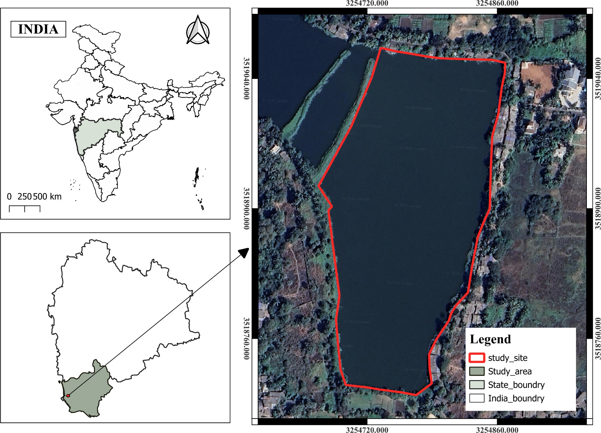

Figure No. 1: Map showing Study area - Nirmal Lake (Malai lake)

RESULT AND DISCUSSION
Following the collection of the specimen it was very carefully transferred and housed in a controlled and monitored habitat which would resemble its natural habitat and minimize the stress and to maintain its natural morphological characteristics. High resolution images were captured of the specimen using a Canon sx430is camera. Images were taken of the dorsal, ventral, lateral and few closeups of the ventral suckermouth and eyes. These images were further sent to The Zoological survey of India for expert identification. For identification analysis was done of external morphology, meristic counts, pigmentation patterns. After detailed analysis the specimen was identified to be Pterygoplichthys pardalis. Photographic presentation and proper meristic counts made the identification more accurate and reliable.

Morphological characters
The fish has a very large 1st dorsal fin which has faint black and white dots or patterns. The 1st dorsal fin has 13 rays including the largest ray. The 1st Dorsal fin originates ahead of the pelvic fins and extends beyond the origin of the anal fin. The 2nd dorsal fin is very small, having a single ray. The pectoral fin is medium sized having 5 rays including the large and sharp pectoral spine and the pectoral fin origins at the end of the gill arch. The pelvic fin is small having 5 rays including the largest ray. Caudal fin has 1st and last rays longer than the rest. The entire body has 24 lateral line plates. The fish is black and yellow patches all over its body. The head region has dark geometric patterns on the dorsal side. The body near the gills has dark vermiculated patterns which slowly end to a more striped look near the caudal fin. In the ventral view the fish has dark spots (with few vermiculations) on a light background which is a key in identifying P. paradalis. The first rays of all the fins have yellow and black stripes. All fins are greyish in color and the tips of extended caudal fin rays are orangish in color.
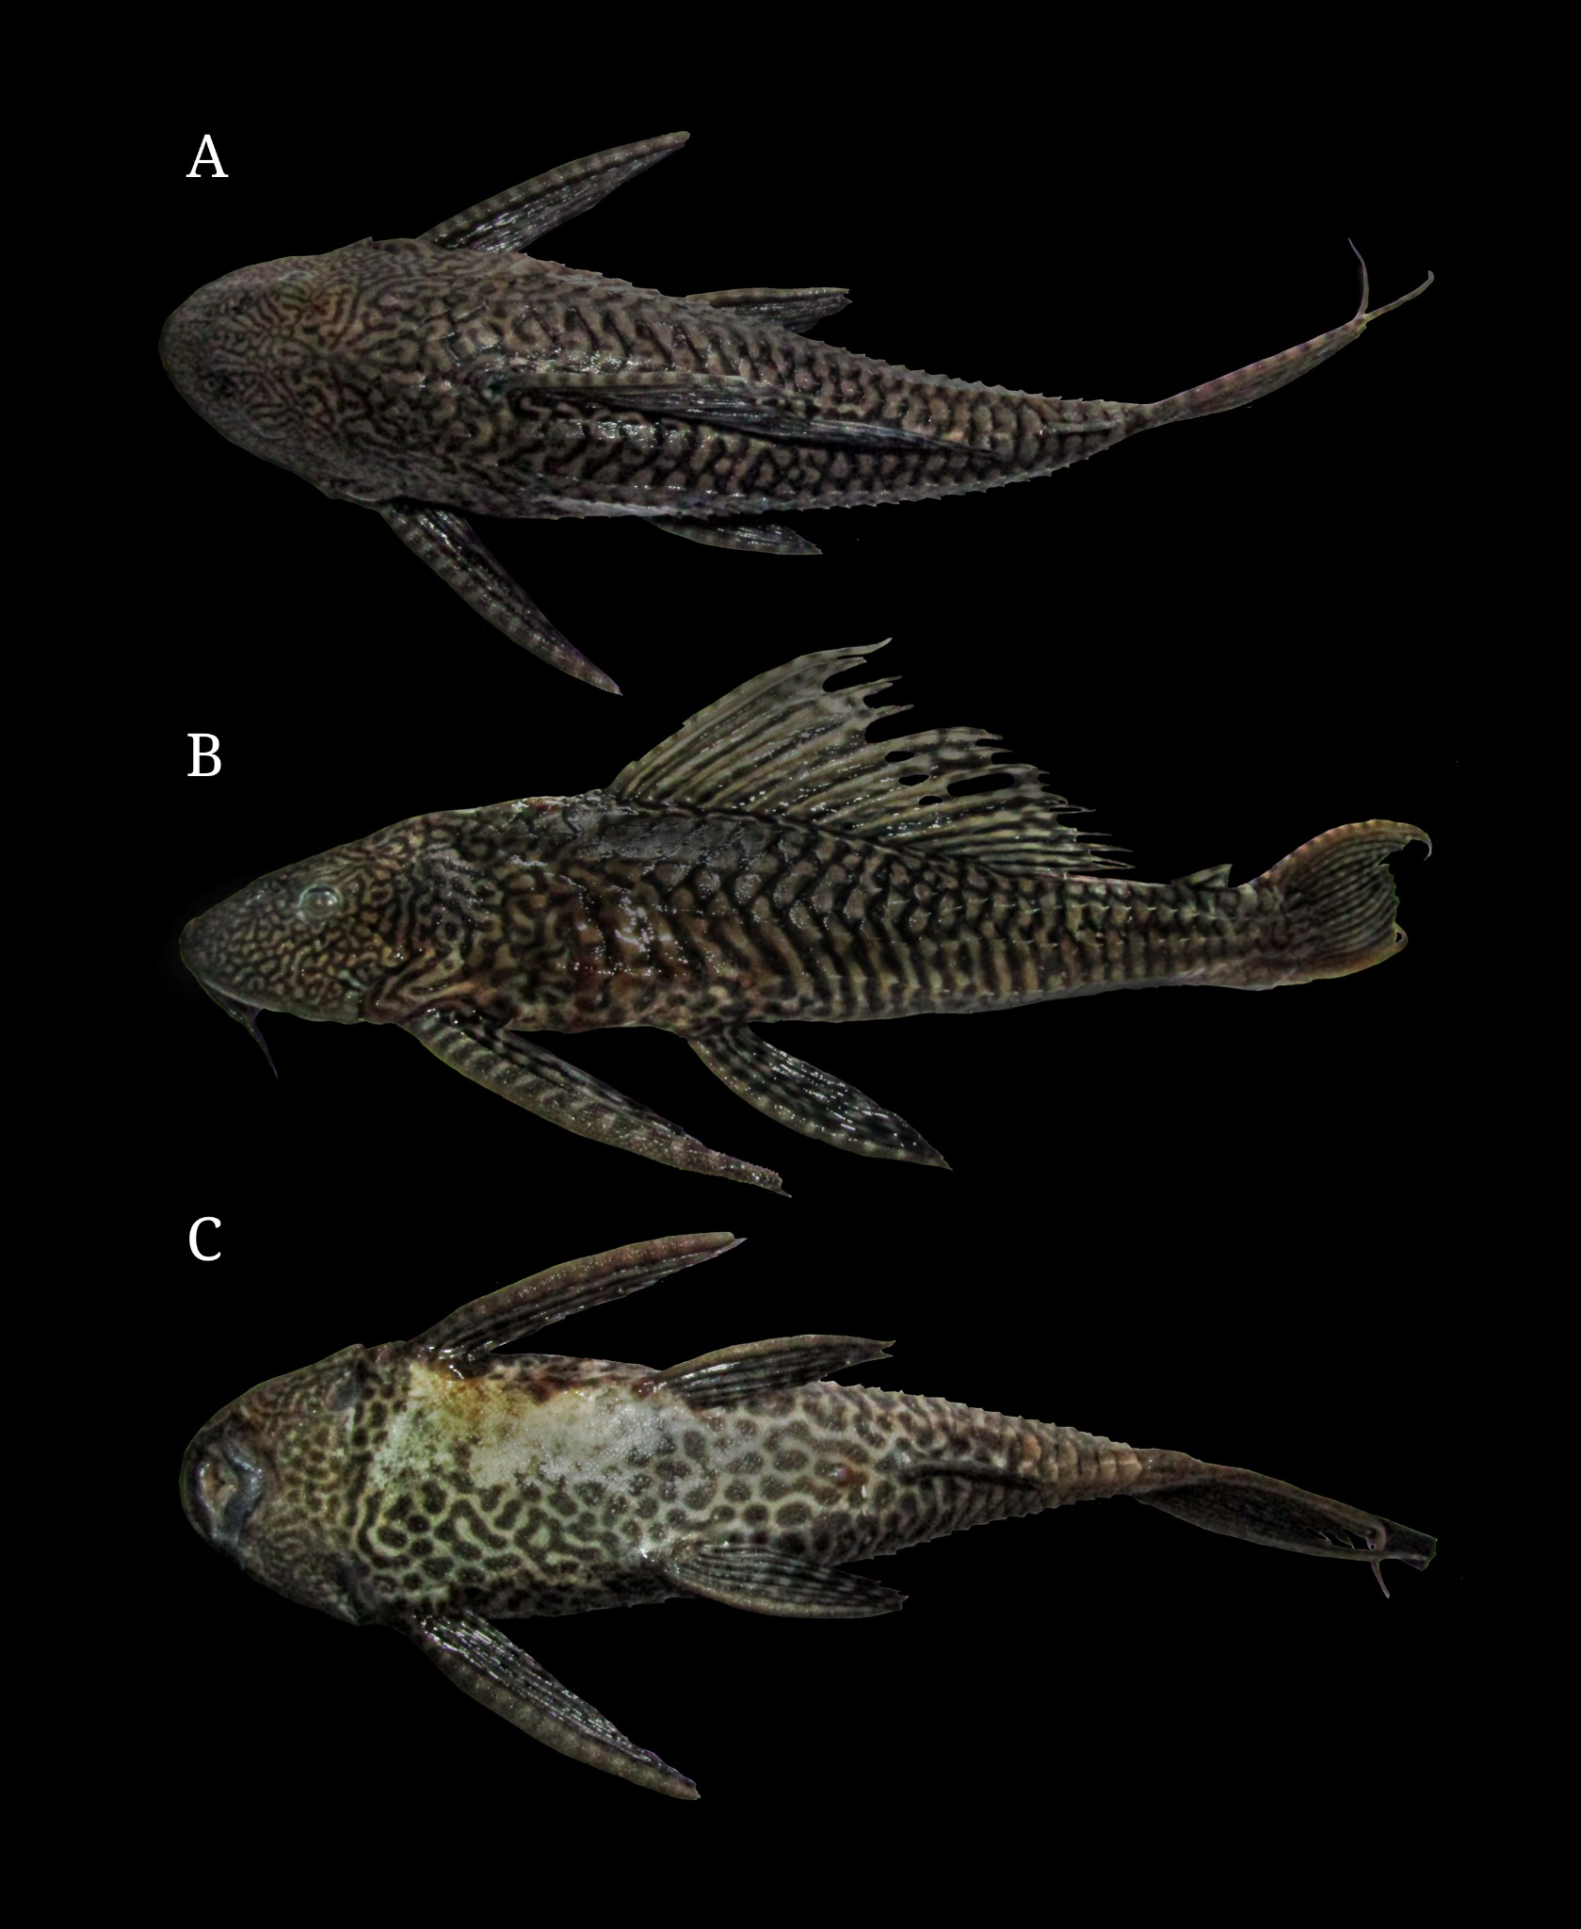

Figure No. 2: Photographs of specimen of P. pardalis collected from Nirmal Lake showing Dorsal view (A), Lateral view (B), Ventral view (C)

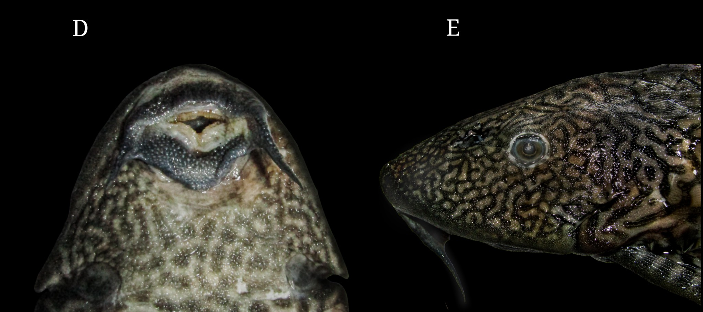
Figure No. 3: Ventral view of suckermouth (D), Head region (E)

Distribution
P. pardalis naturally occurs in the amazon river basin of Brazil and Peru (Weber 2003) Although invasion of the species has been in many parts of the world. In India a total of 18 Research papers have been published considering the invasion of P.pardalis, This includes papers from Bijukumar et al. 2015; Choudhary et al. 2024; Ganguly and Umapathy 2024; Hussan et al. 2016; Hussan et al. 2020; Hussan et al. 2022; Hussan et al 2023; Hussan et al 2025a; Hussan et al 2025b; Mogalekar et al. 2017; More et al. 2020; Muralidharan et al 2014; Raj et al. 2020; Raj et al. 2021; Rao et al. 2017; Sahoo et al. 2022; Sudarshan et al. 2022; Veena et al. 2023 . Apart from P. pardalis many other species are also reports from India Like P. disjunctivus (Chakraborty et al. 2020; Daniel et al. 2022; Das et al. 2020; Ganguly and Umapathy 2024; Hussan et al. 2016; Hussan et al. 2020; Karthick et al. 2017; Meena et al. 2016; Mohanty et al. 2017; Panikkar et al. 2015; Kumar et al. 2021; Sarkar et al. 2012; Suresh et al. 2019; Wanjari et al. 2024), P. anisitsi (Sinha et al. 2010) and
P. multiradiatus (Krishnakumar et al. 2009), According to the Inaturalist database there are currently 64 observations made of Pterygoplichthys sp. by the users from all over India, however none of these observations have been resolved to the species level . This lack of species level identification is due to various factors like the quality of images, images not showing proper morphological characters and the overall difficulty to distinguish morphological characters and overall appearance of the specimens of Pterygoplichthys sp.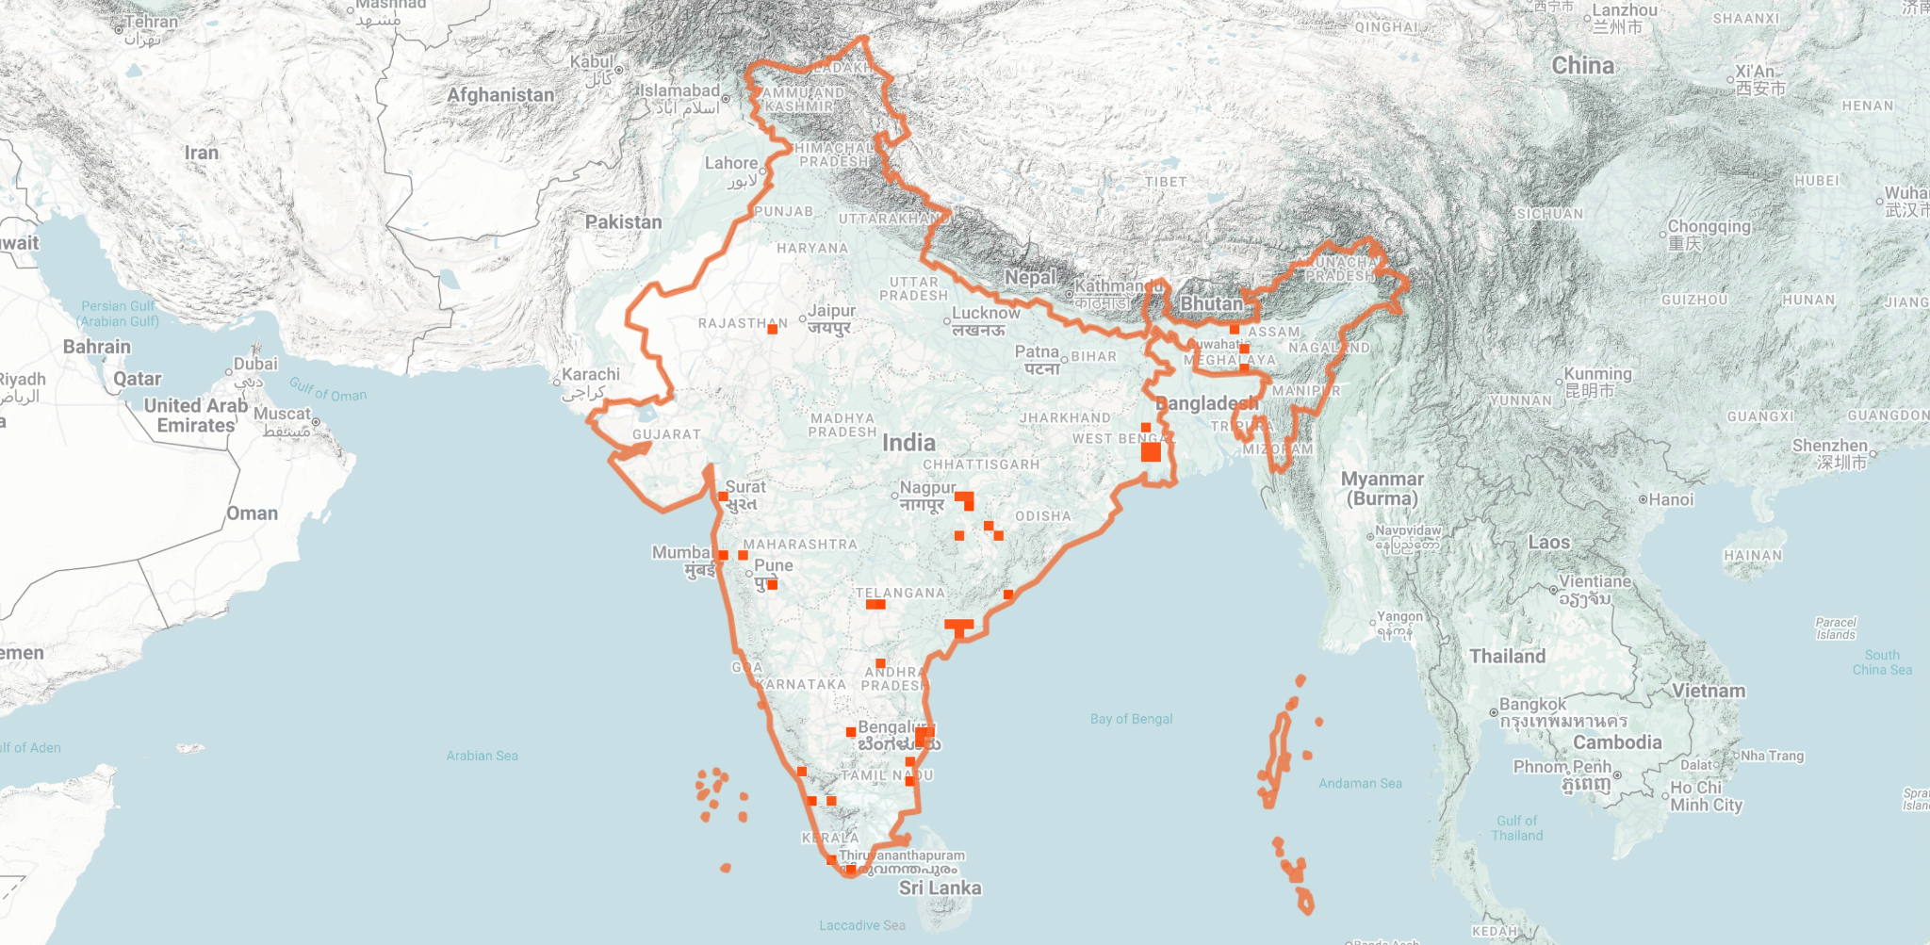
Figure No. 4 - Map showing Pterygoplichthys observations throughout India
(Courtesy Inaturalist)

CONCLUSION
Currently many parts of the world are facing invasion of Pterygoplichthys species. According to the local fishermen from our collection site around 1000 individuals were discarded by them last year and this year the problem seems to be increasing more. Further these fishes having less predators provides a lesser competition for the basic needs of this fish; hence these fishes rapidly establish themselves. There is also a need for more studies regarding the management and control of such fishes because apart from mass eradication there seems to be no other option to eliminate the invasion of such fishes. As Pterygoplichthys species are also known to prey on fish eggs hence they also become a major threat to the native fish population and also a major issue for the livelihood of fishermen. We also know from current studies that Pterygoplichthys species also dwell in caves for their shelter and this can cause infrastructure damage too (Raj et al 2021) depending on the place. In our study we only found the invasion in one of the lakes, although there could be possibilities of these fishes spreading to other nearby parts also due to various factors like flooding hence there should be taken measures to control or eradicate population of such fishes. Also, there should be awareness among the common people, aquarium hobbyists and breeders regarding such fishes. Although we may not be fully confirmed, the presence of such fish in a non-native habitat is only possible if it is introduced. Fish stores often sell these fishes when they are small and the sellers do not warn about the fact that these fishes can grow upto 1 feet long, hence in most scenarios fish keeping hobbyists fail to know this and thus the fish tends to outgrow the tanks they are inhabited in. Hence the hobbyist is left with either donating the fish, or throwing them in nearby water bodies and hence such invasions happen. Hence our study is just an addition to the various reports of invasion of Pterygoplichthys species and we also hope to invite others to work on the eradication or elimination of such species.

DISCLAMER (ARTIFICIAL INTELLIGENCE)

Author(s) hereby declare that NO generative AI technologies such as Large Language Models (ChatGPT, COPILOT, etc.) and text-to-image generators have been used during writing or editing of this manuscript.

REFERENCES
Nico LG, Jelks HL, Tuten T. (2009). Non-native suckermouth armored catfishes in Florida: description of nest burrows and burrow colonies with assessment of shoreline conditions. Aquat NuisanceSp Res Progr Bull 9:1–30.

Wu, L. W., Liu, C. C., & Lin, S. M. (2011). Identification of exotic sailfin catfish species (Pterygoplichthys, Loricariidae) in Taiwan based on morphology and mtDNA sequences. Zoological Studies, 50(2), 235–246.

Pound, K.L., Nowlin, W.H., Huffman, D.G. et al. (2011). Trophic ecology of a nonnative population of suckermouth catfish (Hypostomus plecostomus) in a central Texas spring-fed stream. EnvironBiol Fish 90, 277–285
https://doi.org/10.1007/s10641-010-9741-7

Jumawan, Joycelyn & Vallejo, Benjamin & Jumawan, Jess & Herrera, Annabelle. (2016). Size structure and reproductive phenology of the suckermouth sailfin catfish Pterygoplichthys disjunctivus (Weber 1991) from Marikina River, Philippines. ARPN Journal of Agricultural and Biological Science. 11.18-26

Joshi, Ravindra. (2006). Invasive alien species (IAS): Concerns and status in the Philippines. https://www.researchgate.net/publication/228680226_Invasive_alien_species_ IAS_Concerns_and_status_in_the_Philippines/citation/download

Hubilla, M., Kis, F., & Primavera, J. (2008). Janitor fish Pterygoplichthys disjunctivus in the Agusan Marsh: a threat to freshwater biodiversity. Journal of Environmental Science
and Management, 10(1).

Wanjari, R. N., Shah, T. H., Telvekar, P., Bhat, F., Abubakr, A., Bhat, B. A., ... & Eamteke, k. K. (2023). exotic red-bellied pacu, piaractus brachypomus (Cuvier, 1818) recorded for the first time from a tropical river wainganga, maharashtra, India. J. Inland Fish. Soc. India, 55(3),338-346. http://dx.doi.org/10.47780/jifsi.55.3.2023.148765

Nico, L. G., & Martin, R. T. (2001). The South American Suckermouth Armored Catfish, Pterygoplichthys anisitsi (Pisces: Loricaridae), in Texas, with Comments on Foreign Fish Introductions in the American Southwest. The Southwestern Naturalist, 46(1),
98–104.https://doi.org/10.2307/3672381
Hill, Jeffrey & Sowards, Jeff. (2015). Successful eradication of the non-native loricarii catfish Pterygoplichthys disjunctivus from the Rainbow River, Florida. Management of Biological Invasions. 6. 311-317. 10.3391/mbi.2015.6.3.11
Reaser, J. K., Meyerson, L. A., Cronk, Q., De Poorter, M. A. J., Eldrege, L. G., Green, E., … & Vaiutu, L. (2007). Ecological and socioeconomic impacts of invasive alien species in island ecosystems. Environmental Conservation, 34(2),98-111 https://doi.org/10.1017/S0376892907003815
Hoover, Jan & Killgore, K. & Cofrancesco, Alfred. (2004). Suckermouth Catfishes: Threats to Aquatic Ecosystems of the United States?. Aquatic Nuisance Species Research
Program Bulletin.https://www.researchgate.net/publication/255635508 Suckermouth Catfishes_Threats_to_Aquatic_Ecosystems_of_the_United_States
Gibbs MA, Shields JH, Lock DW, Talmadge KM, Farrell TM (2008) Reproduction in an invasive exotic catfish Pterygoplichthys disjunctivus in Volusia Blue Spring, Florida,
U.S.A. Journal of Fish Biology 73: 1562–1572, https://doi.org/10.1111/j.1095-8649.2008.02031.x
Capps, Krista & Nico, Leo & Mendoza-Carranza, Manuel & Arévalo-Frías, Wendi & Ropicki, Andrew & Heilpern, Sebastian & Rodiles-Hernandez, Rocio. (2011). Salinity tolerance of non-native suckermouth armoured catfish (Loricariidae: Pterygoplichthys) in south-eastern Mexico: Implications for invasion and dispersal.
Aquatic Conservation Marine and Freshwater Ecosystems. 21. 528. 10.1002/aqc.1210
Brion, M. A., Guillermo Jr, J. G., Uy, C., Chavez, J., & Carandang IV, J. S. (2013). Salinity tolerance of introduced South American sailfin catfishes (Loricariidae:
Pterygoplichthys GILL 1858). Philippine Journal of Science 142(1),13-19
Harter, T. S., Shartau, R. B., Baker, D. W., Jackson, D. C., Val, A. L., & Brauner, C. J. (2014). Preferential intracellular pH regulation represents a general pattern of pH homeostasis during acid–base disturbances in the armoured catfish, Pterygoplichthys pardalis.
Journal of Comparative Physiology B, 184, 709-718. https://doi.org/10.1007/s00360-014-0838-8
Liang, S. H., Wu, H. P., & Shieh, B. S. (2005). Size structure, reproductive phenology, and sex ratio of an exotic armored catfish (Liposarcus multiradiatus) in the Kaoping River of southern Taiwan. ZOOLOGICAL STUDIES-TAIPEI-, 44(2),252.
https://zoolstud.sinica.edu.tw/Journals/44.2/252.pdf
Gibbs, M. A., Kurth, B. N., & Bridges, C. D. (2013). Age and growth of the loricariid catfish Pterygoplichthys disjunctivus in Volusia Blue Spring, Florida. Aquatic Invasions, 8(2). doi:http://dx.doi.org/10.3391/ai.2013.8.2.08
Armbruster, J. W. (1998). Phylogenetic Relationships of the Suckermouth Armored Catfishes of the Rhinelepis Group (Loricariidae: Hypostominae). Copeia, 1998(3), 620–636. https://doi.org/10.2307/1447792
Gibbs MA, Groff BW (2014) Patterns of aerial respiration by Pterygoplichthys disjunctivus (Loricariidae) in Volusia Blue Spring, Florida. Florida Scientist 77: 53–68, https://doi.org/10.3391/ai.2013.8.2.08
Chaichana, R., Pouangcharean, S., & Yoonphand, R. (2011). Habitat, abundance and diet of invasive suckermouth armored catfish (Loricariidae Pterygoplichthys) in the Nong Yai Canal, East Thailand. Tropical Zoology, 24(1)
Scott, S.E., Pray, C.L., Nowlin, W.H. et al. Effects of native and invasive species on stream ecosystem functioning. Aquat Sci 74, 793–808 (2012).
https://doi.org/10.1007/s00027-012-0263-6
Kumar, Biju & Raj, Smrithy & Sureshkumar, U. & George, Shaijumon. (2015). Invasion of South American suckermouth armoured catfishes Pterygoplichthys spp. (Loricariidae) in Kerala, India- a case study. Journal of Threatened Taxa.7.10.11609/jott.1897.6987-6995 https://doi.org/10.11609/JoTT.o4133.6987-95
Chaichana, R., & Jongphadungkiet, S. (2012). Assessment of the invasive catfish Pterygoplichthys pardalis (Castelnau, 1855) in Thailand: ecological impacts and biological control alternatives. Tropical Zoology, 25(4), 173–182. https://doi.org/10.1080/03946975.2012.738494
Carlson, A. K. (2025). Protected from Pterygoplichthys? Predicting thermal habitat suitability for nonnative armored catfish in the Suwannee River. Transactions of the American Fisheries Society, Volume 154, Issue 4, Pages 398–413
Weber, C. (2003) Subfamily Hypostominae (armored catfishes). In Check list of the freshwater fishes of South and Central America, R. E. Reis, S. O. Kullander y C. Ferraris, Jr.(eds.). EDIPUCRS., Porto Alegre, Rio Grande do Sul.Xi+729
Choudhary, P., Sharma, D., & Gandotra, R. (2024). The first record of Pterygoplichthys pardalis (Castelnau, 1855), Amazon sucker mouth catfish from the Northwestern Himalayan region of India. Ecology, Environment & Conservation (0971765X),30.
DOI:10.53550/EEC. 2024.v30i05s.004
Ganguly, N., & Umapathy, G. (2024). Is it there? —Estimating the invasion of armored sailfin catfish (Pterygoplichthys sp.) in the water bodies of Eastern Ghats, India using the eDNA approach. Environmental DNA, 6, e538. https://doi.org/10.1002/edn3.538
Hussan, A., Choudhury, T. G., Das, A., & Gita, S. (2016). Suckermouth sailfin catfishes: A future threat to aquatic ecosystems of India. Aquaculture times, 2(6), 20-22.
Hussan, A., Sundaray, J. K., Ghosal, R., & Mallick, S. (2020). Lovesome chum of aquarium are wreaking havoc in East Kolkata Wetlands, India. Aquaculture Asia, 24(3),9-15
Hussan, A., Sundaray, J. K., Ghosal, R., Hoque, F., & Mallick, S. (2022). Skeletal deformities in invaded population of amazon sailfin catfish Pterygoplichthys pardalis (castelnau,
1855) in the east Kolkata wetland, India. International Journal of Bio-resource and Stress Management, 13(4), 326-331.10.23910/1.2022.2664
Hussan, A., Naik, A. R., Adhikari, S., Das, A., Hoque, F., & Sundaray, J. K. (2023). Seasonal Variation in the Biological Traits of Invasive Amazon Sailfin Catfish (Pterygoplichthys pardalis) in East Kolkata Wetlands, India. Journal of the Indian Society of Coastal Agricultural Research, 41(2). https://doi.org/10.54894/JISCAR.41.2.2023.145553

Hussan, A., Naik, A. R., Adhikari, S., Das, A., Hoque, F., Sahoo, P. K., & Sundaray, J. K. (2025) A. invasive Amazon sailfin catfish (Pterygoplichthys pardalis) impact the survivability and growth of native food fishes in India. Aquatic Living Resources, 38, 5.https://doi.org/10.1051/alr/2025002
Hussan, A., Naik, A. R., Adhikari, S., Das, A., Hoque, F., Sahoo, P. K., & Sundaray, J. K. (2025) B. Reproductive Traits of Invasive Amazon Sailfin Catfish (Pterygoplichthys pardalis) in Association with the Nutrient Concentration of the Invaded Habitat. Https://dx.doi.org/10.17582/journal.pjz/20240203174724
Mogalekar, H. S., Jawahar, P., Srinivasan, A., Marx, K. K., Sujathkumar, N. V., Canciyal, J., & Sudhan, C. (2017). Discovery of the Amazon sailfin catfish Pterygoplichthys
pardalis (Castelnau, 1855) (Teleostei: Loricariidae) from Manimuthar dam, Tamiraparani River system, India. Journal of Entomology and Zoology Studies, 5, 1229-1231.https://www.entomoljournal.com/archives/2017/vol5issue4/PartP
/5-4-227-734.pdf
More, R. M., Sarwade, J. P., & Karna, S. K. (2020). Pterygoplichthys pardalis (Castelnau, 1855) (Siluriformes: Loricariidae) from Ujani reservoir, Maharashtra, India.
BIOINFOLET-A Quarterly Journal of Life Sciences, 17(4a),
Muralidharan, M., Manikandan, K., & Gobi, M. (2014). Extended distribution of the invasive Sucker catfish Pterygoplichthys pardalis (Pisces: Loricariidae) to Cauvery River
system of Peninsular India. International Journal of Aquatic Biology, 3(1), 14–18. https://doi.org/10.22034/ijab.v3i1.41
Raj S, Kumar AB, Raghavan R, Dahanukar N (2020). Amazonian invaders in an Asian biodiversity hotspot: Understanding demographics for the management of the armoured sailfin catfish, Pterygoplichthys pardalis in Kerala, India. J Fish Biol.; 96: 549–553.https://doi.org/10.1111/jfb.14243
Raj, S., Devi, S., Joy, A., & Kumar, A. B. (2021). On the reproductive biology of the invasive Armoured Sailfin Catfish Pterygoplicthys pardalis (Castelnau, 1855) (Siluriformes: Loricariidae) from the natural drainages in Thiruvananthapuram, India. Journal of Threatened Taxa, 13(9), 19263-19273.
Rao, K. R., & Sunchu, V. (2017). A report on Pterygoplichthys pardalis Amazon sailfin suckermouth Catfishes in Freshwater tanks at Telangana state, India. International Journal of Fisheries and Aquatic Studies, 5(2), 249-254. https://www.fisheriesjournal.com/archives/2017/vol5issue2/PartD/5-1-98-572.pdf
Sahoo, L., Swain, P. P., Hussan, A., Mohapatra, A., & Sundaray, J. K. (2022). DNA barcoding delineates the identity of invasive South American sucker mouth armoured catfishes of genus Pterygoplichthys of East Kolkata Wetland, West Bengal, India as single species. Indian Journal of Fisheries, 69(4),115-118. https://doi.org/10.21077/ijf.2022.69.4.124310-15
Sudarshan, S., Vijayarahavan, V., Santhoshkumar, S., Subburaj, A., Alamelu, V., & Krishnaveni, N. (2022). Length-weight relationship and condition factor of invasive Amazon sailfin catfish, Pterygoplichthys pardalis (Castelnau, 1855) in river-fed ponds, Nagapattinam, Tamil Nadu. Journal of Experimental Zoology India, 25(1). https://connectjournals.com/pages/articledetails/toc035070
Veena, V., Sasikala, G., & Selvaraju, R. (2023). Occurrence of south American sucker armoured catfish (Pterygoplichthys pardalis) in the Gayathripuzha River, Palakkad, Kerala. DOI: https://doi.org/10.22271/fish.2023.v11.i2a.2783

Chakraborty, P., Chakrabarti, S., Mukherjee, P., Yardi, K., & Das, S. (2020). Notes on the discovery and ecology of the invasive armoured catfish Pterygoplichthys disjunctivus (Weber, 1991) and the exotic cichlid Amphilophus trimaculatus (Gunther, 1867) from Southern West Bengal, India. Ecological Questions, 31(1), 7-13. https://doi.org/10.12775/EQ.2020.001
Daniel, N., Praveenraj, J., & Kumar, J. S. S. (2022). Report on the invasion of South American armored suckermouth catfish (Pterygoplichthys disjunctivus) from Southern India. IJBS, 4(2),199-202. 10.33545/26649926.2022.v4.i2c.122
Das, B. K., Ray, A., Manna, R. K., Roshith, C. M., Baitha, R., Karna, S. K., ... & Bhor, M. (2020) Occurrence of exotic vermiculated sailfin catfish Pterygoplichthys
disjunctivus from the lower stretch of River Ganga, West Bengal, India. Current Science, 119(12),2006-2009.10.18520/cs/v119/i12/2006-2009
Karthick, S., Aanand, S., & Jawahar, P. (2017). Record of non-native loricariid catfish, Pterygoplichthys disjunctivus (Weber, 1991) (Siluriformes, Loricariidae) in Kadamba Tank–Tamiraparani River Basin, Tamil Nadu. Journal of Experimental Zoology India, 20(2), 677-681.
Meena, M., Sundaramanickam, A., & Kumar, T. T. A. (2016). Occurrence of a Pterygoplichthys disjunctivus (Weber, 1991) population in Cauvery River System, Tamil Nadu, South India. International Journal of Fisheries and Aquaculture, 8(6), 62-66.10.5897/IJFA2015.0526
Mohanty, B. P., Ganguly, S. A. T. A. B. D. I., Mahanty, A. R. A. B. I. N. D. A., Mitra, T. A.N. D.
R. I.M. A., Mahaver, L. A. D. U. R. A. M., Bhowmick, S. A. N. J. A. Y., ... &Das, B. K.
(2017). Nutritional composition of the invasive Pterygoplichthys disjunctivus from East Kolkata Wetland, India. Journal of Inland Fisheries Society of India, 49(2), 48-54.
Panikkar, Preetha & Jagadeesh, T D & Rao, D.s.K. & Sarkar, Uttam & Naskar, M. (2015). First record of non-native loricariid catfish, Pterygoplichthys disjunctivus (weber, 1991) (siluriformes, loricariidae) in cauvery river of peninsular India. The Bioscan.
Vol.10. 1659-1663.
Kumar, Lohith & Gogoi, Pranab & Manna, Ranjan & Roshith, C. & S., Sibina & Ergowda, Vijaykumar & Suresh, Vettath & Samanta, Srikanta & Das, Basanta. (2021). Composition and distribution of non-native fishes in relation to water quality parameters in River Cauvery, India. 53.
Sarkar, U. K., Dubey, V. K., Singh, A. K., Gupta, B. K., Pandey, A., Sani, R. K., & Lakra, W. S. (2012). The recent occurrence of exotic freshwater fishes in the tributaries of river Ganga basin: abundance, distribution, risk, and conservation issues. The Environmentalist, 32, 476-484,
Suresh, V. R., Ekka, A., Biswas, D. K., Sahu, S. K., Yousuf, A., & Das, S. (2019). Vermiculated sailfin catfish, Pterygoplichthys disjunctivus (Actinopterygii: Siluriformes: Loricariidae): invasion, biology, and initial impacts in east Kolkata Wetlands, India. Acta Ichthyol. Piscat,49(3),221-233. https://doi.org/10.3750/AIEP/02551
Wanjari, R. N., Shah, T. H., Telvekar, P., Bhat, F. A., Ramteke, K. K., Magloo, A. H., & Mathialagan, D. (2024). A new record of the invasive vermiculated sailfin catfish

Pterygoplichthys disjunctivus in the Wainganga River, Eastern Maharashtra, India. Journal of Asia-Pacific Biodiversity, 17(3), 484-489.10.1016/j.japb.2024.01.015
Sinha, R. K., Sinha, R. K., Sarkar, U. K., & Lakra, W. S. (2010). First record of the southern sailfin catfish, Pterygoplichthys anisitsi Eigenmann & Kennedy, 1903 (Teleostei: Loricariidae), in India. Journal of Applied Ichthyology, 26(4), 606-608. https://doi.org/10.1111/j.1439-0426.2010.01474.x
Krishnakumar, K., Raghavan, R., Prasad, G., Bijukumar, A., Sekharan, M., Pereira, B., & Ali, A (2009). When pets become pests–exotic aquarium fishes and biological invasions in Kerala, India. Current science, 97(4),474-476

