**GENOTOXICITY ASSESSMENT IN FRESHWATER AFRICAN CATFISH *Clarias gariepinus* EXPOSED TO LOCAL GIN ‘*OGOGORO’***

**ABSTRACT**

Ogogoro is deeply intertwined with Nigerian culture and traditions, often consumed during social gatherings, celebrations, and rituals. This traditional drink is produced by fermenting palm wine and subsequently distilling the fermented liquid. While Ogogoro plays a vital role in social cohesion and cultural identity, the potential health risks posed by its consumption warrant scientific scrutiny, hence the need to examine the potential genotoxic effects.

This study seeks to examine the acute toxicity 96 h LC50 of Ogogoro using African catfish *Clarias gariepinus*; determine the cytogenotoxic effect of the sub-lethal concentration in the peripheral erythrocytes of *C. gariepinus* using micronucleus assay. High mortality and damage to the body morphology of the experimental animals were recorded during the acute toxicity testing. Exposure of *C. gariepinus* to sub-lethal concentrations of local gin resulted in a dose-dependent and significant (P<0.05) increase in the formation of micronuclei and nuclear anomalies in peripheral erythrocytes. The results obtained from this study indicate the local gin induction into *C. gariepinus* have genotoxic potential and is capable of causing significant ecological disruption of the DNA population and also, indicate that exposure to Ogogoro induces genotoxic effects in *Clarias gariepinus*, as evidenced by a dose-dependent increase in nuclear abnormalities in erythrocytes.

**Keywords**: Local gin, Micronucleus assay, Acute toxicity, Genotoxicity, *Clarias gariepinus*, Cytotoxocity.

**INTRODUCTION**

Several global morbidities and mortalities have been associated with alcohol. Certain Alcoholic beverages that are locally brewed have become the socio-economic realities of the Nigerian and West African realities.

These alcoholic beverages pose an adverse effect on our health, economy, and social life within the concept of our deprived social amenities and constantly increasing poverty ravaging our society (Moritiwon *et al.,* 2021). Ogogoro is one of the renowned alcoholic beverages known as local gin or ‘Sapele water’, ‘kaikai”, ‘kparaga’ or ‘Sun gbalaja’. The local African alcoholic drink is locally brewed from Palm wine with the active ingredient ethanol with a high concentration. According to Moritiwon *et al.* (2021), the alcohol percentage of the local beverage ranges between 30% - 60%. The genotoxic potential of ethanol raises concerns about the safety of alcoholic beverages, prompting further investigations into their impact on human health (Okaru and Lachenmeier, 2021).

Chronic alcohol consumption has been associated with an increased risk of genotoxic damage due to its ability to generate reactive oxygen species, induce oxidative stress, and interfere with DNA repair mechanisms (Na and Lee, 2017). According to the American Cancer Society, alcohol use accounts for about 6% of all cancers and 4% of all cancer deaths in the United States; it has been linked with several cancers, including those of the mouth, liver, stomach, and breast (Ma *et al.,* 2019). The underlying mechanisms for alcohol carcinogenesis are still unclear. Multiple factors can be at play: alcohol is metabolized into acetaldehyde, a genotoxic chemical that can cause cancer in laboratory animals; and/or alcohol increases reactive oxygen species (ROS), leading to DNA damage and lipid peroxidation, increasing the risk of cancer.

Ogogoro, an alcoholic beverage which is widely consumed and deeply embedded in various cultures and societies of Nigeria is derived from palm wine through fermentation and distillation, holds significant cultural and social importance (Adiri *et al.,* 2022). Several health and social challenges have been attributed to ogogoro, including liver damage, blindness, addiction, and an increase in alcohol-related social issues (Osakwe, 2021). However, there is dearth of information regarding its genotoxicity- the ability of substances to damage DNA and potentially lead to mutations and other genetic alterations. Evaluation of the genotoxic effects of Ogogoro is crucial for assessing its safety for human consumption and for informing public health policies. Genotoxicity is a pivotal concept in toxicology, especially in assessing the potential health risks associated with exposure to various substances. Substances with genotoxic properties have the potential to disrupt the genetic material, leading to mutagenesis, chromosomal abnormalities, and ultimately, the development of diseases such as cancer (Ren *et al.,* 2017).

Genotoxicity assessment plays a critical role in evaluating the safety of chemicals, drugs, and environmental agents, including food and beverages. The in vivo micronucleus assay is strongly recommended by regulatory agencies for evaluating cytogenetic damage to DNA and identifying the mutagenic and carcinogenic potential of chemical substances (OECD, 2016). Fish have been widely utilized in genotoxicity studies, owing to their physiological similarities to humans and their high sensitivity to environmental changes. Despite the widespread use of fish in toxicological studies, there is paucity of information on the genotoxic effects of local gin exposure in aquatic organisms. This study aimed to assess the genotoxic effect of local gin, ‘Ogogoro’ using African Catfish, *C. gariepinus* as study model.

**METHODOLOGY**

Juvenile *Clarias gariepinus* were obtained from a local fish farm in Okitipupa. They were acclimatized to laboratory conditions of 26∘C and 12/12 h dark/light modes for three weeks prior to the experimental set-up. They were stocked at a population density of 30 (n = 30) fish per 25 L transparent plastic aquarium containing dechlorinated water and fed 5% of their body weight with standard fish feed which contains 35% crude protein twice daily (Anita *et al.,* 2016). Tap water free from chlorine were renewed every two days with these physiochemical characteristics (Temp 32 ± 0.02∘C, pH 7.3 ± 0.33, and DO 5.5 ± 0.33 mg L−1).

The local gin is diluted into water meant for the fish brooding at different concentrations into three main groups. The acute toxicity dose concentration (96 h LC50) was made in 5%, 7%, 10%, 12% and 15% using a specific water level of 10L per plastic aquarium. The sub-lethal dose concentration was made in, 0.1%, 0.2%, 0.3%, 0.5% and 1.0% of local gin diluted into a water volume of 10L per plastic aquarium. The negative and positive control are dechlorinated tap water and 0.02ml/L of benzene in dechlorinated tap water respectively.

The experimental animals were introduced into the varied prepared concentration of local gin at 10 fish per plastic aquarium and were placed under critical and close examination. After the first three (3) days of exposure, the water was changed to the same concentration to continue exposure for 7days. Blood samples were collected after two phases of exposure protocol, including three (3) days exposure and seven (7) days exposure. The test concentration and control substances were replaced every 72h to reduce accumulation of metabolic wastes, remains of food particles, and volatilization of less stable substances in the concentration and benzene (Alimba, *et al.,* 2015).

The weight and length of each fish was determined before exposure and after seven (7) days exposure to make certain scientific inferences that may result from the effect of the local gin on their body.

**Micronucleus Assay**

At the end of each exposure time, blood was collected from the caudal vein of each fish in a test group and control groups for micronucleus analysis. Thin smear of the peripheral blood was made on three precleaned slides per fish. The slides were air dried, fixed in absolute methanol for 20 minutes, and counterstained with 10% May-Grunwald and 5% Giemsa for 30minutes and rinsed with distilled water (Alimba *et al.,* 2011). 1000 erythrocytes cells per fish were scored for micronucleus induction under the microscope at ×1000. For proper identification, each micronucleus (MN) must have the same colour, clearly separated and the size, one-third of the main nucleus. Nuclear abnormalities (NAs) were also scored as cytotoxic parameters (Bakare *et al.,* 2013) at the same magnification. Cells with two nuclei were considered as binucleated (BN). Blebbed nucleus (BL) presents a relatively small evagination of the nuclear membrane, which contains euchromatin. When the evagination is larger than the blebbed nuclei and containing several lobes, it was considered as lobe nucleus (LB), while notched nucleus (NT) contains vacuoles and appreciable depth into the nucleus that does not contain nuclear materials. Other scored NAs are budding nucleus. Only cells with intact cell and nuclear membranes were scored.

Data were entered into SPSS software and analyzed using one way analysis of variance (ANOVA) of compare means. Data of nuclear aberration observed were recorded as frequency and the mean of frequency, standard deviation and standard error. Bar charts were also used to present relative frequencies of weight and length.

**RESULTS**

There was total mortality recorded across the acute toxicity dose concentration with the time of death relative each concentration. Table 1 gives clarity on the observed effects of acute toxic dose across our experimental concentration. For behavioural attitude, erratic swimming induced by the local gin was observed across the experimental concentration but observed in different proportion. At 5% concentration the erratic swimming was observed to be rare, severe in both 7% and 10%, very severe at 12% concentration while it was observed to be extremely severe at 15% concentration. Response to activity was observed to be relatively low across 5% concentration, 7% concentration and 10% concentration, extremely low at 12% concentration while no response was observed at 15% concentration. Difficulty in breathing was observed across all concentration in different proportion which also gives rise to erratic swimming. Difficulty in breathing was observed to be mild in 5% and 7% concentration, severe at 10% concentration, very severe at 12% concentration while was observed to be extremely severe in 15% concentration. The time of death varied in respect to concentration but all suffered mortality in less than 2 hours.

**Table 1: Observed effects of acute toxicity dose on *Clarias gariepinus***

|  |  |  |  |  |  |
| --- | --- | --- | --- | --- | --- |
| Samples ID | Erratic swimming | Response to activity | Difficulty in breathing | Mucus secretion | Tiny holes/ skin scalding |
| Negative Control | Not observed | Not observed | Not observed | Not observed | Not observed |
| 5% Conc | Mild | Mild | Mild | Mild | Mild |
| 7% Conc | Severe | Mild | Mild | Mild | Mild |
| 10% Conc | Severe | Mild | Severe | Severe | Severe |
| 12% Conc | Very Severe | Extremely slow | Very Severe | Very severe | Very severe |
| 15% Conc | Extremely severe | No response | Extremely severe | Extremely severe | Extremely severe |

**Frequency of Nuclear aberration induced by local gin in *C. gariepinus* for 3 day’s exposure.**

The frequencies of micro-nucleated erythrocytes and other nuclear abnormalities (bi-nucleated cells, budded cells and vacuolated cells) were concentration dependent and significant (p<0.05) but were time dependent at tested concentrations of local gin. The frequency of MN has a uniform increased from 0.1% concentration to 1% concentration through the 3rd day. There was significant, concentration-dependent increase in the frequency of nuclear abnormalities (Table 2 and Table 3). Throughout the experimental period the induction of the MN with other nuclear abnormalities and their frequency was found significantly higher in 0.5% concentration and 1% concentration in comparison to other experimental controls and concentration.

For the 3rd day exposure Table 2 indicate that values were compared within as concentrations within duration. It was found that negative control showed no significant variations within the induction period, whereas other treatment samples showed significant differences within the same row. When all the treatments were compared between concentrations within the duration, they showed a significant difference (p<0.05). The highest MN mean frequency observed has a value of 0.113 ± 0.022% and was observed at 3rd day of 1% concentration in sub-lethal treatment, 0.2% concentration has the lowest mean frequency of MN (0.063 ± 0.008). The highest BN mean frequency has a value of 0.108 ± 0.0.014% was observed at 3rd day of 1% concentration in sub-lethal treatment, 0.3% concentration has the lowest frequency value of BN (0.058 ± 0.016) with 0.1% concentration having no observable frequency of BN. The highest BD frequency value of 0.113 ± 0.016% was observed at 3rd day of 1% concentration in sub-lethal treatment, 0.3% concentration has the lowest frequency value of BD (0.071±0.013) with 0.1% and 0.2% concentration having no observable frequency of BD. The highest VC frequency of 0.108 ± 0.018% was observed at 3rd day of 1% concentration in sub-lethal treatment, while 0.3% concentration has the lowest frequency of BD (0.075± 0.016).

**Table 2: Frequency (Mean ± SE) of Nuclear aberration induced by local gin in *C. gariepinus* for 3 days’ exposure.**

|  |  |  |  |  |
| --- | --- | --- | --- | --- |
| Sample treatment | MN Freq(%)± SE | BN Freq (%) ± SE | BD Freq (%) ± SE | VC Freq (%) ± SE |
| Negative Control | 0 | 0 | 0 | 0 |
| Positive Control | 0.079± 0.017 | 0.016±0.008 | 0.0000±0.0000 | 0.035±0.068 |
| 0.1% Conc | 0.07±0.018 | 0.00± 0.00 | 0.00± 0.00 | 0.08±0.03 |
| 0.2% Conc | 0.063± 0.008 | 0.1±0.015 | .00000±.00000 | 0.104± 0.026 |
| 0.3% Conc | 0.104±0.014 | 0.058± 0.016 | 0.071±0.013 | 0.075± 0.016 |
| 0.5% Conc | 0.096±0.014 | 0.100±0.015 | 0.104± 0.013 | 0.071±0.018 |
| 1% Conc | 0.113± 0.022 | 0.108±0.0.014 | 0.113±0.016 | 0.108±0.018 |

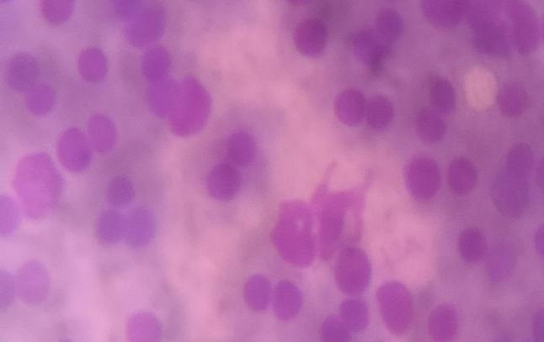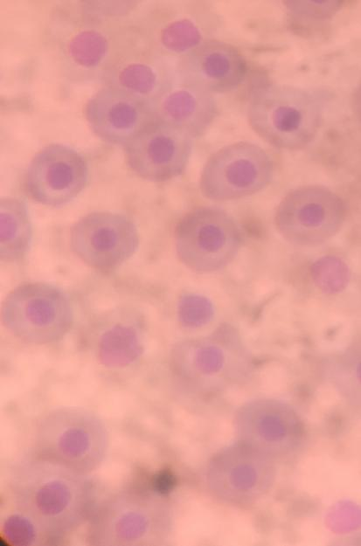



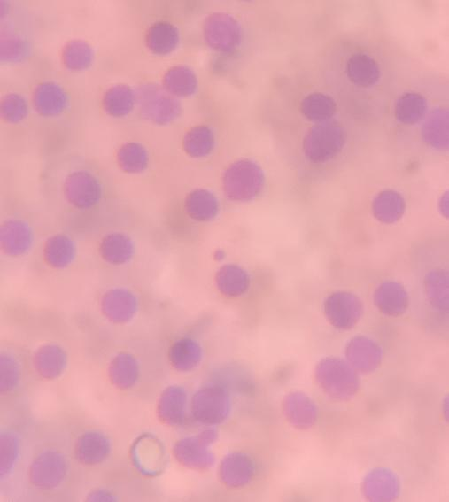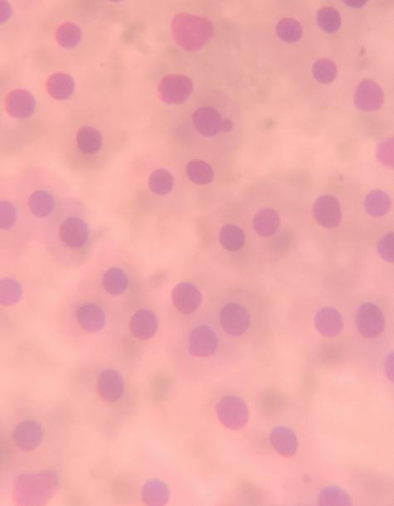**(a) (b)**

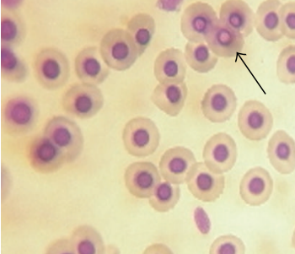**(c) (d)**

**(e)**

**Plate 1**: Micronucleated (MN) and nuclear abnormalities observed in local gin treated *C. gariepinus* are shown by the arrows: (3a) normal peripheral erythrocyte. (3b) Bi-MN peripheral erythrocyte (3c) Budded nucleus (3d) MN peripheral erythrocyte (3e) Vacuolated nucleus in peripheral erythrocytes (Magnification: x1000).

**Table 3: Frequency (Mean ± S.E)** **of Nuclear aberration induced by local gin in *C. gariepinus* for 7days exposure.**

|  |  |  |  |  |
| --- | --- | --- | --- | --- |
| Sample treatment | MN Freq(%)±SE | BN Freq (%) ± SE | BD Freq (%) ± SE | VC Freq(%)±SE |
| Negative Control | 0 | 0 | 0 | 0 |
| Positive Control | 0.81±0.023 | 0.04±0.018 | 0.50±0.021 | 0.0479±0.019 |
| 0.1% Conc | 0.0750±0.013 | 0.067±0.024 | 0.0583±0.016 | 0.44±0.017 |
| 0.2% Conc | 0.12±0.028 | 0.14±0.034 | 0.086±0.056 | 0.058±0.017 |
| 0.3% Conc | 0.13±0.043 | 0.12±0.041 | 0.053±0.022 | 0.064±0.026 |
| 0.5% Conc | 0.15±0.052 | 0.16±0.062 | 0.061±0.02 | 0.083±0.062 |
| 1% conc | 0.18±0.080 | 0.131±0.072 | 0.05±0.030 | 0.072±0.030 |

**Effects of Local gin consumption on length of Clarias gariepinus for 7days exposure.**

Table 4 represents the effects of Local gin consumption on weight of Clarias gariepinus for 7days exposure. The mean of the initial and final weight was calculated per concentrations. There was a sustainable increase in the weight of the fish at positive and negative concentration after seven (7) days, while a noticeable decrease in mean weight of fish observed across 1% concentration, 0.5% concentration, 0.3% concentration, 0.2% concentration and 0.1% concentration.

The reduction in certain concentrations weight mean and length mean were basically because of the recorded mortality during the cause of the exposure. The mortality recorded is a factor in the determination of the final weight mean and length mean.

|  |  |  |  |
| --- | --- | --- | --- |
| **Table 4 Effects of Local gin consumption on length on Clarias gariepinus for 7days exposure** | | | |
| **Sample Treatment** | **Initial length**  **mean (cm)** | **Final length mean (cm)** | **Increase in length mean(cm)** |
| Positive Control | 10.82 | 11.03 | 0.22 |
| Negative Control | 13.17 | 13.73 | -0.57 |
| 1% Conc | 7.35 | 3.82 | -3.54 |
| 0.5% Conc | 9.32 | 6.17 | -3.15 |
| 0.3% Conc | 10.13 | 7.64 | -2.50 |
| 0.2% Conc | 10.93 | 8.45 | -2.48 |
| 0.1% Conc | 12.70 | 12.72 | 0.02 |
| **Grand Total** | **74.42** | **63.56** | **10.86** |

**Fig 1: Effects of Local gin consumption on length of C. gariepinus for 7days exposure**

**Effects of Local gin consumption on weight of C. gariepinus for 7days exposure.**

Table 5 represents the effects of Local gin consumption on weight of C. gariepinus for 7days exposure. The mean of the initial and final weight was calculated per concentrations. There was a sustainable increase in the weight of the fish at positive and negative concentration after seven (7) days, while a noticeable decrease in mean weight of fish observed across 1% concentration, 0.5% concentration, 0.3% concentration, 0.2% concentration and 0.1% concentration.

**Table 5 Effects of Local gin consumption on weight of *C. gariepinus* for 7days exposure**

|  |  |  |  |  |
| --- | --- | --- | --- | --- |
| **Sample Treatment** | **Initial weight mean (g)** | | **Final weight mean (g)** | **Weight Gain(g)** |
| Positive Control | 10.59 | 11.28 | | 0.69 |
| Negative Control | 18.86 | 20.69 | | 1.83 |
| 1% Conc | 5.24 | 3.22 | | -2.02 |
| 0.5% Conc | 14.36 | 7.84 | | 6.52 |
| 0.3% Conc | 8.55 | 6.45 | | 2.10 |
| 0.2% Conc | 14.24 | 9.74 | | -4.50 |
| 0.1% Conc | 16.26 | 15.72 | | 0.54 |
| **Grand Total** | **88.09** | **74.93** | | **13.16** |

**Fig 2: Effect of local gin on the length of *Clarias gariepinus***

**DISCUSSION**

The effects were observed in different strata of behavioural attitudes (erratic swimming, response to activity and difficulty in breathing), time of death and post-mortem observation (Maurya *et al.,* 2019).

In this study, we assessed the levels of cytogenetic damage, apparent as MN frequencies and other nuclear aberrations. Genotoxic assays have been considered useful tools to evaluate the effects of certain substance in fish (Lara *et al.*, 2021) and other aquatic organisms. Micronucleus is formed by the elimination of amplified genetic materials from the cell (Esenowo *et al.*, 2021) and chromosomal breaks or losses that are not incorporated to the main nucleus during cell division cycle (Renu and Saxena, 2015). The present study indicated that exposure to sublethal concentrations of local gin was sufficient to induce severe nuclear abnormality in the peripheral erythrocytes of *C. gariepinus*; hence, local gin is genotoxic.

Studies have shown concentration and duration dependent increase of MN and other nuclear aberration in the peripheral blood cells of *C. gariepinus* exposed to local gin, Alimba and Bakare (2016) affirmed the concentration and duration dependent increase of MN and other nuclear aberration. High production of reactive oxygen species (ROS) has been observed to be the major culprit that produces oxidative stress resulting in the formation of MN (Thi Thuy *et al.,* 2020). In our study, the insignificant formation of MN indicated a negligible formation of ROS. ROS such as superoxide (O2), hydrogen peroxide (H2O2), and hydroxyl (OH-) radicals are free radicals that contain oxygen atoms that are highly reactive due to the presence of unpaired electrons (Eva and Filip, 2020). The inability of the body to temporally eliminate ROS by the antioxidant system would lead to oxidative stress. Our study shows that local gin was sufficient to breach the antioxidant system that could have resulted in the formation of MN.

The genotoxicity induced by the local gin in *C. gariepinus*, vis-a-vis increased micronucleus and nuclear abnormalities in peripheral erythrocytes, suggests that in the tested local gins are clastogens and/or aneugens. The observed micronucleus and nuclear abnormalities indicate increased genetic alterations which may enhance somatic mutation and cancer formation (Alimba *et al.,* 2016). This may lead to decreased embryonic viability, genetic disorders, reduced fitness, and biodiversity loss in aquatic biota. Significant increase in total nuclear abnormalities observed in the treated *C. gariepinus* compared to the control suggests the presence of cytotoxins in the local gins. The formation of binucleated cells suggests that constituents of the local gin are capable of blocking cytokinesis of a normal dividing cell at M phase of the cell cycle (Leo, 2018) and may increase mutational frequency and carcinogenesis. According to Alimba *et al.,* (2015), vacuolated cell and nuclear bud formation are associated with cell injury, and cell death.

**CONCLUSION**

The results of this present investigation on the genotoxic potential of local gin *‘ogogoro”* raised a severe concern about the potential danger to its consumption by aquatic organisms especially to fish and humans. However, studies are needed to explore the biological consequences of nuclear anomalies in aquatic organism after local gin exposure and to formulate the proper dose intake for safeguarding the consumers of local gin.

Although the MN and other nuclear abnormalities revealed different pattern of variation across concentrations, the lowest values for all measured parameters were observed in the 0.1% concentration. In general, significantly higher values for erythrocyte deformations, including MN were observed at 0.5% and 1% concentration. The results of this study suggest that all toxic materials that finally end into the body through the intake of local gin to display genotoxic effect on the consumers. Frequencies of MN and nuclear abnormalities may vary, depending on concentrations, their combination and time of exposure. These findings indicate that exposure to Ogogoro induces genotoxic effects in *Clarias gariepinus*, as evidenced by a dose-dependent increase in nuclear abnormalities in erythrocytes.

**RECOMMENDATION**

1. A non-lethal dose intake must be formulated for consumption of local gin intake to reduce the frequency of genotoxicity in human population.

2. Indiscriminate production of local gin, ‘Ogogoro’ at large quantity must be checkmate by National Drug Law Enforcement Agency (NDLEA).

3. Sensitization of the general public about the genotoxic effects of regular, and chronic consumption of local gin.

4. Production of local gin should be taken far away from residential area, farmland, and aquatic habitat to prevent the constant exposure of the ecosystem population to genotoxic materials that may damage their DNA information.

Ethical approval: Ethical approval was obtained from Olusegun Agagu University of Science and technology (Animal Care and Use Committee).

Disclaimer (Artificial intelligence)

Option 1:

Author(s) hereby declare that NO generative AI technologies such as Large Language Models (ChatGPT, COPILOT, etc.) and text-to-image generators have been used during the writing or editing of this manuscript.

Option 2:

Author(s) hereby declare that generative AI technologies such as Large Language Models, etc. have been used during the writing or editing of manuscripts. This explanation will include the name, version, model, and source of the generative AI technology and as well as all input prompts provided to the generative AI technology

Details of the AI usage are given below:

1.

2.

3.

**REFERENCES**

Adiri, C. O., Asimadu, E. E., Nwafor, M. I., Nweze, S. O., and Ukaegbe, C. I. (2022). Perception of safety and consumption of alcoholic beverages during pregnancy. *Journal of Obstetrics and Gynaecology*, 42(7): 3021-3025.

Alimba C. G., Saliu J. K., Adesanya A., and Bakare A. A (2011). Evaluation of genotoxicity of a municipal landfill leachate by micronucleus test using *Clarias gariepinus*. *Research in Environment and Life Sciences,* 4: 1(1–6).

Alimba, C. G. and Bakare, A. A. (2016). In vivo micronucleus test in the assessment of cytogenotoxicity of landfill leachates in three animal models from various ecological habitats. *Ecotoxicology*, 25: 310-319.

Alimba, C. G., Ajayi, E. O., Hassan, T., Sowunmi, A. A., and Bakare, A. A. (2015). Cytogenotoxicity of Abattoir Effluent in *Clarias gariepinus* (Burchell, 1822) Using Micronucleus Test. *Chinese Journal of Biology,* 6.

Anita Bhatnagar, Abhay Singh Yadav, and Navneet Cheema (2016). Genotoxic Effects of Chlorpyrifos in Freshwater Fish *Cirrhinus mrigala* Using Micronucleus Assay. *Advances in Biology,* 26: 6.

Esenowo, I. K., Nelson, A. U., Alimba, C. G., Ekpo, N. D. and Emmanuel, O. C. (2020). Genotoxicity evaluation of Chlorfenapyr in exposed freshwater African catfish *Clarias gariepinus* using micronucleus test. *Aceh Journal of Animal Science*, 6 (1): 7-12.

Eva Tvrdá, and Filip Benko. (2020). *Free radicals: what they are and what they do*. In *Pathology* (pp. 3-13).

Osakwe K. A. (2021). Toxicological effects of kaikai- An experimental study in Wistar rats. *International Journal of Science and Research*, 10 (6): 64-70.

Lara M. Schuijt, Feng-Jiao Peng, Sanne J. P. van den Berg, Milou M.L. Dingemans, and Paul J. Van den Brink (2021). Ecotoxicological tests for assessing impacts of chemical stress to aquatic ecosystems: facts, challenges, and future. *Science of the Total Environment*, 795: 148776.

Leo, I. Q. (2018). *New insights into colorectal carcinogenesis: from early precursor lesions to the role of aneuploidy* (Doctoral dissertation, Universitat de Barcelona).

Ma. J., Jemal. A., Fedewa S. A., Islami, F., Lichtenfeld, J. L., Wender, R. C. and Brawley, O. W. (2019). The American Cancer Society 2035 challenge goal on cancer mortality reduction. *CA: A Cancer Journal for Clinicians*, 69(5): 351-362.

Maurya, P. K., Malik, D. S., Yadav, K. K., Gupta, N., and Kumar, S. (2019). Haematological and histological changes in fish *Heteropneustes fossilis* exposed to pesticides from industrial wastewater. *Human and Ecological Risk Assessment: An International Journal*, 25 (63): 1-28.

Moritiwon, O., Ogundeko, T. O., Oyebode, D., Bitrus, J., and Bassi, A. P. (2021). Evaluation of selected locally brewed alcoholic beverages on the serum hormonal profile of albino rats. *World Journal of Advanced Research and Reviews*, *9*(1): 037-045.

Na, H. K. and Lee, J. Y. (2017). Molecular basis of alcohol-related gastric and colon cancer. *International journal of molecular sciences*, 18(6): 1116.

OECD. (2016). *Mammalian Erythrocyte Micronucleus Test*. OECD Publishing. Test No. 474.

Okaru, A. O. and Lachenmeier, D. W. (2021). Margin of exposure analyses and overall toxic effects of alcohol with special consideration of carcinogenicity. *Nutrients*, 13(11): 3785.

Ren, N., Atyah, M., Chen, W. Y. and Zhou, C. H. (2017). The various aspects of genetic and epigenetic toxicology: testing methods and clinical applications. *Journal of Translational Medicine*, 15:1-13.

Renu, C. and Saxena K. (2015). Genotoxic evaluation of fenvalerate in *Channa punctatus* by micronucleus test. *Indian Journal of Scientific Research and Technology*, 3: 30–33.

Thi Thuy, Tien Vo, Ching-Zong Wu, and I-Ta Lee. (2020). Potential effects of noxious chemical-containing fine particulate matter on oral health through reactive oxygen species-mediated oxidative stress: Promising clues. *Biochemical Pharmacology*, 182: 114286.