**Characterization of cervical lesions among hiv-infected women at hiv clinic, university of abuja teaching hospital Gwagwalada, Abuja, Nigeria**

**ABSTRACT**

**Background:** Human Immunodeficiency Virus (HIV) infection increases the risk of cervical lesions due to immune suppression. In Nigeria, where HIV remains prevalent, characterizing these lesions can guide targeted screening strategies.

**Objective:** To characterize cervical lesions among HIV-positive women attending the University of Abuja Teaching Hospital, Nigeria, and to assess associations with immunological and clinical factors.

**Methods:** A cross-sectional study was conducted among 61 HIV-positive women between January and May 2025. Participants underwent visual inspection with acetic acid/Lugol iodine (VIA/VILI) and liquid-based cytology. Statistical analysis included descriptive methods, t-test, Pearson correlation, and ordinal logistic regression.

**Results:** Cervical lesion prevalence was 50.8%. Low-grade squamous intraepithelial lesion (LGSIL) was most common (61.3%), followed by inflammation (19.4%), ASCUS (12.9%), and high-grade SIL (6.5%). CD4+ count was significantly associated with lesion severity (t = 37.186, p < 0.001; B = 2.715). HIV viral load showed a moderate inverse correlation (r = –0.340), and ART duration was negatively correlated with lesion occurrence (r = –0.256).

**Conclusion:** CD4+ count is a key predictor of cervical lesion severity. Integrating cervical screening into HIV care, especially for immunocompromised women, is vital for early detection and intervention.

**Keywords:** Cervical lesions, HIV, CD4 count, ART, Pap smear

**1. INTRODUCTION**

Cervical cancer remains a leading cause of morbidity and mortality among women in sub-Saharan Africa, particularly among HIV-positive populations due to their immunocompromised status (WHO, 2021). In Nigeria, cervical cancer is the second most common cancer among women, with an estimated age-standardized incidence rate of 25 per 100,000 women and a mortality rate of 18.9 per 100,000 women (Jedy-Agba et al., 2016). The burden is disproportionately higher in northern Nigeria, where cultural barriers and limited access to screening services contribute to advanced disease presentation (Okoye et al, 2022). Current estimates suggest that approximately 14,089 new cases of cervical cancer are diagnosed annually in Nigeria, with over 10,403 deaths recorded yearly (Ferlay et al., 2015). HIV infection significantly increases the risk of persistent human papillomavirus (HPV) infection, which is a known etiological factor for cervical lesions. HIV-positive women have a 2 – 12 fold increased risk of developing cervical intraepithelial neoplasia and invasive cervical cancer compared to HIV-negative women (Abraham et al., 2013). The immunosuppressive effects of HIV lead to impaired clearance of HPV infections, increased viral persistence, and accelerated progression from low-grade to high-grade lesions (Denslow et al., 2014). HIV-positive women demonstrate higher rates of HPV co-infection with multiple high-risk types, increased viral load, and reduced response to standard treatments (Massad et al., 2021). The synergistic relationship between HIV and HPV creates a complex pathophysiological environment where immune dysfunction facilitates HPV persistence, leading to a more aggressive cervical disease progression. Despite the widespread use of antiretroviral therapy (ART), cervical cancer screening for HIV positive individuals remains inconsistent, and the relationship between immunological parameters and lesion progression is still unclear in some populations (Ovuakporaye et al., 2020). Given the high burden of both HIV and cervical cancer in Nigeria, and the limited data on cervical lesion characterization among HIV-positive women in this region. This study justified evidence-based insights into improved clinical management and prevention strategies as well as identifying prevalence and types of cervical lesions and sociodemographic, reproductive, and clinical correlates.

**2. METHODS**

**Study Design and Period**

This research employed a prospective cross-sectional study design, conducted from January to May 2025. The design was selected to enable simultaneous assessment of HIV status, immunological parameters, and cervical cytological findings, allowing for correlation analyses between these variables.

**Description of Study Area**

The research was done at University of Abuja Teaching Hospital (UATH), Gwagwalada, Federal Capital Territory, Abuja, Nigeria. Gwagwalada is a major local government area of the Federal Capital Territory and was established on October 15, 1984. The region is found at about 45km of the Abuja city centre and is bordered latitude 8°55' and 9°00' N and longitude 7°00' and 7°05' E.

It has a tropical climate with a proper wet/dry season with temperatures varying between 30oC and 37oC and averagely raining 1650mm a year. As the capital city center, Gwagwalada is the second most cosmopolitan area within the FCT, and it harbors more than 26 federal outfits such as University of Abuja, General Azazi military Barracks, and UATH. Such centrality and multiplicity of institutions combine with population mobility and other social forces that establish patterns in the transmission of HIV in the area.

UATH is also a huge referral center in the HIV care and these patients are referred by not only their own FCT but also neighboring states such as Nasarawa, Kogi, Kaduna, and Niger. The HIV clinic in the hospital offers a full package of services that covers counseling, testing, the use of antiretroviral therapy, treatment of opportunistic infections.

**Source Population:**

The source population comprised all female patients attending the HIV clinic at UATH during the study period.

**Study Population**

The study population consisted of HIV-positive women aged 20-65 years who were receiving care at the HIV clinic in UATH and met the inclusion criteria.

**Sample Size Determination**

The number of sample required in this research was guided by upper limit required to give 95% level of confidence at an expected prevalence of about 4.2% using the precise formula:

$N=\frac{z^{2}pq}{D^{2}}$

N = required sample size

Z = score (for 95% confidence, Z=1.96)

P = estimated prevalence = 4.2% (Abah, 2014)

d = margin of error (precision), typically 0.05 (5%)

$$N=\frac{ {(1.96)}^{2} X 0.042 (1 – 0.042)}{{(0.05)}^{2}}$$

$$N=\frac{ 3.8416 × 0.042 (0.958)}{0.0025} \\ N=\frac{ 0.1546}{0.0025}$$

$$N=61$$

The calculation sample size is **61**.

**Inclusion and Exclusion Criteria:**

**Inclusion Criteria**

Women aged 20 years and above with confirmed HIV-positive status in the laboratory were included. All participants had to be undergoing HIV care at the University of Abuja Teaching Hospital Gwagwalada, Abuja Nigeria and give an informed consent to participate in the study.

**Exclusion Criteria**

Women with previous total hysterectomy and those pregnant were not included. Individuals who have a documented history of cervical cancer or lesions before they were diagnosed with HIV as well as individuals who menstruated during the time they were giving their samples were also excluded.

**Clinical Examination and Visual Inspection**

Participants underwent standardized clinical examinations following WHO infection prevention guidelines (WHO, 2021). Visual Inspection with Acetic Acid (VIA) was performed by applying 3% acetic acid to the cervix and observing for acetowhite changes after 1–2 minutes. Visual Inspection with Lugol’s Iodine (VILI) followed, identifying non-staining areas as potential lesions (WHO, 2020).

**Cervical Cytology Collection and Processing**  
Cervical samples were collected using the liquid-based cytology (LBC) technique with a cyto-brush rotated 3–5 times at the squamo-columnar junction. Samples were preserved in ThinPrep® PreservCyt® Solution and processed at the UATH Histopathology Department. Processing included centrifugation, vortexing, and preparation of monolayer smears, which were stained using the Papanicolaou method. Slides were reported by cytopathologists using the 2014 Bethesda System (Nayar and Wilbur, 2015).

**Medical Record Review**  
Clinical data, including CD4+ T-lymphocyte counts, viral load, ART history, and HIV-related clinical history, were extracted from participants’ most recent hospital records.

Quality Assurance:  
Data collection tools were pre-tested and validated (Bolarinwa, 2015). The research team received training on study protocols (Franzen et al., 2017). SOPs guided laboratory and clinical procedures (WHO, 2020). Laboratory quality control included slide reviews by two independent cytopathologists and adherence to ISO 15189 standards (ISO, 2022). Data integrity was ensured through double data entry, routine cleaning, and random audits (Olubodun et al., 2019).

**Data Analysis**  
Data were analyzed using SPSS version 23. Descriptive statistics were used to summarize categorical variables (frequencies, percentages) and continuous variables (means, standard deviations) (Field, 2013). Chi-square tests were applied to examine associations between categorical variables, while ordinal logistic regression was performed to assess the relationship between lesion severity and immunological parameters such as CD4+ count and viral load. Statistical significance was set at p<0.05.

**3. RESULTS**

**Table 1**: Percentage distribution of cases and the various types of cervical lesions among HIV-positive women attending University of Abuja Teaching Hospital, Gwagwalada Abuja, Nigeria.

|  |  |  |  |
| --- | --- | --- | --- |
| Cases | Type of Cervical Lesion | Frequency | % |
| Negative | Nil | 30 | 100 |
| Total |  | 30 | 100 |
| Positive | Inflammation | 6 | 19.4 |
|  | ASCUS | 4 | 12.9 |
|  | LSIL | 19 | 61.3 |
|  | HSIL | 2 | 6.5 |
| Total |  | 31 | 100.0 |

Out of 61 HIV-positive women, 30 (49.2%) had normal cervical cytology while 31 (50.8%) had various abnormalities. LSIL accounted for the majority (61.3%) of lesions, followed by inflammatory changes (19.4%), atypical squamous cells of undetermined significance (ASCUS, 12.9%), and high-grade squamous intraepithelial lesion (HGSIL, 6.5%).

**Table 2:** Socio-demographic, reproductive, and clinical factors associated with the development of cervical lesions in HIV-positive women at University of Abuja Teaching Hospital, Gwagwalada Abuja, Nigeria.

|  |  |  |  |
| --- | --- | --- | --- |
| Factors Associated with the Development of Cervical Legions | Socio-Demographic, Reproductive and Clinical Factors | Frequency | Percentage |
| Socio-Demographic | Age | 39 | 63.9 |
|  | Marital Status | 5 | 8.2 |
|  | Educational Level | 15 | 24.6 |
|  | Occupation | 2 | 3.3 |
|  | Total | 61 | 100.0 |
| Reproductive | Age at first sexual intercourse | 29 | 47.5 |
|  | Number of sexual partners in lifetime | 19 | 31.1 |
|  | Number of pregnancies | 6 | 9.8 |
|  | Number of live births | 2 | 3.3 |
|  | Number of those who took contraceptives | 5 | 8.2 |
|  | Total | 61 | 100.0 |
| Clinical Factors | CD4+ Count | 32 | 52.5 |
|  | Viral Load | 19 | 31.1 |
|  | ART | 10 | 16.4 |
|  | Total |  |  |

Sociodemographic and reproductive factors such as age, marital status, number of pregnancies, age at first sexual intercourse, number of sexual partners, and HPV infection status were found to be associated with lesion presence.

**Table 3**: Ordinal Logistic Regression Analysis of the Correlation between Immunological Parameters (CD4+ Count and Viral Load) and the Severity of Cervical Lesions in HIV-Positive Women

|  |  |  |  |  |  |
| --- | --- | --- | --- | --- | --- |
| Predictor | | Estimate (B) | Std. Error | Ward | Decision |
| Threshold | [Severity = 1] | -31.237 | 2285.096 | .000 |  |
|  | [Severity =2] | -29.010 | 2285.096 | .000 |  |
|  | [Severity =3/] | 3.395 | 2284.261 | .000 |  |
| Location | CD4+ Count | 2.715 | 2.479 | 1.199 | Very Strong Positive Association |
|  | Viral Load | .001 | .005 | .035 | Weak Positive Association |

Ordinal logistic regression revealed a strong positive association between CD4+ count and lesion severity (B = 2.715), indicating higher CD4+ count was associated with less severe lesions. Viral load showed a weak positive association (B = 0.001), but the overall correlation was not statistically significant (p > .05).

**Table 4**: Analysis on how Antiretroviral Therapy (Duration and Regimen) Influence the Occurrence and Progression of Cervical Lesions in HIV-Positive Women

|  |  |  |  |
| --- | --- | --- | --- |
| Influence of Antiretroviral Therapy | Levels of Occurrence and Progression | Frequency | Percentage |
| Occurrence | Immune Restoration | 36 | 59.0 |
|  | Reduced Risk of New Lesions | 20 | 33.3 |
|  | Early Initiation of ART | 5 | 8.3 |
|  | Total | 61 | 100.0 |
| Progression | Slow | 32 | 52.4 |
|  | Still Progressing | 2 | 3.3 |
|  | Regression of Lesions | 27 | 44.3 |
|  | Total | 61 | 100.0 |

Among participants, 59.0% showed immune restoration, while 33.3% had reduced risk of new lesions and 8.3% initiated ART early. Regarding progression, 52.4% experienced slow lesion progression, 44.3% showed regression, and only 3.3% still showed lesion progression. Pearson correlation revealed no significant association between ART duration and lesion occurrence (r = -0.256, p = .164).

**FINDINGS:**

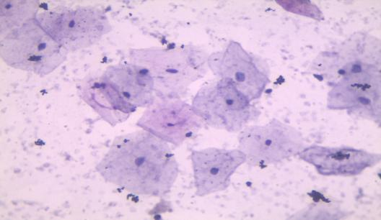

Plate 1, X400, Pap stain:Smear from healthy adult females showing normal cells PAP X400

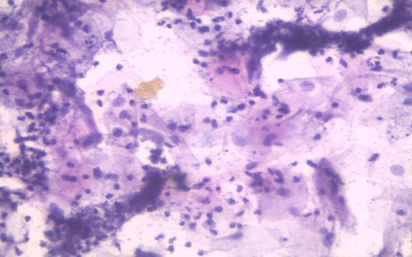

Plate 2, X400, Pap stain:The smear shows sheets of ectocervical cells and clusters of endocervical cells with normal cytological details and within a background of dense lymphocytic infiltrate. Chronic cervicitis. Negative for intraepithelial lesion or malignancy

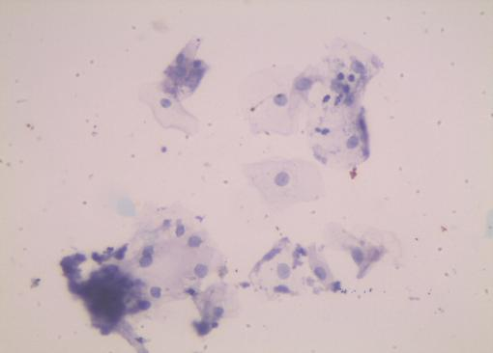

Plate 3, X400, Pap stain:Cervical smear shows very few parabasal and intermediate squamous cells that appear lightly abnormal on a clean background.Atypical squamous cells of undetermined significance.

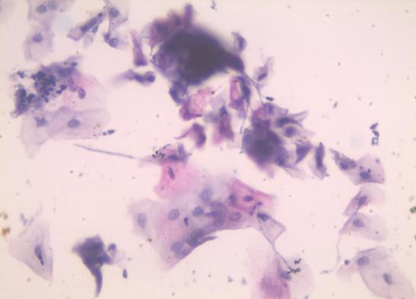

Plate 4, X400, Pap stain: Cervical smear is adequate and shows single and clusters of superficial, intermediate and parabasal squamous epithelial cells on a clean background. Low grade squamous intraepithelial lesion.

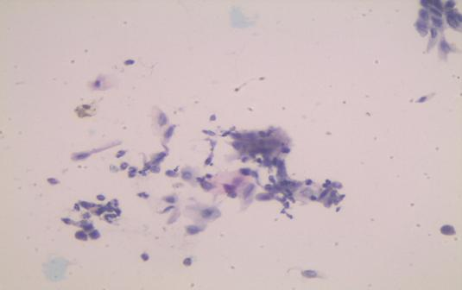

Plate 5, X100, Pap stain: Cervical smear is cellular showing clusters of superficial, intermediate and parabasal squamous cells on a moderate background of neutrophilic inflammation. High grade squamous intraepithelial lesion

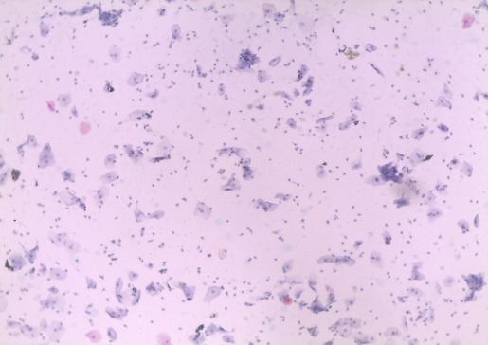

Plate 6, X100, Pap stain: Smear is cellular and adequate showing superficial, intermediate, squamous epithelial cells. There is heavy presence of inflammatory cells in the background. Few clumps of endocervical cells are seen (black arrow). Features are in keeping with inflammatory smear.

**4. DISCUSSION**

The study on characterization of cervical lesions among HIV-infected women attending the University of Abuja Teaching Hospital, Gwagwalada, Abuja showed is no significant difference between the prevalence of various types of cervical lesions in HIV-positive women and the CD4+ count levels, but an earlier finding by Olubodun et al., (2019) that investigated 710 HIV-positive women reported a 24.3% prevalence of cervical lesions, with 9.2% categorized as HSIL. They observed a strong association between HPV infection with types 16, 18, and 45 and the development of high-grade lesions, with immunosuppression acting as a significant cofactor. Our second finding revealed that the duration of antiretroviral therapy has no significant association with the occurrence of cervical lesions among HIV-positive women. This study agrees with that of Kelly et al., (2018) who examined 253 HIV-positive women in Makurdi, Nigeria and found a 30.8% prevalence of cervical lesions. They noted further that women with CD4+ counts below 200 cells/mm³ had nearly three times higher risk of developing high-grade lesions compared to those with counts above 500 cells/mm³. Additionally, they identified longer duration of HIV infection above 5 years as an independent risk factor that is not associated with the rate of cervical lesions. The socio-demographic factors have no significant association with the progression of cervical lesions among HIV-positive women. This finding is similar to a cross-sectional study by Jolly et al., (2017) on a bivariate analysis where they showed no significant association between socio-demographic variables and the presence of cervical lesions detectable through VIA among HIV-positive women. However, the number of lifetime sexual partners and HIV status were significantly associated with cervical lesions. HIV viral load has no significant association with the severity of cervical lesions among HIV-positive women. This finding is in line with that of **Medeiros et al., (2022) whose** study examined 108 HIV-infected women and found that while higher HIV viral loads were observed in women with squamous intraepithelial lesions compared to those without, the difference was not statistically significant.

**5. CONCLUSION**

The findings of this study establish that HIV-positive women at UATH experience a substantially elevated prevalence of cervical abnormalities compared to the general population, emphasizing their vulnerability to HPV-related cervical disease. Immunological status, particularly CD4+ count, significantly influences the type and potentially the severity of cervical lesions that develop. While antiretroviral therapy demonstrates promise in reducing lesion occurrence and promoting regression through immune restoration, its protective effect may depend on duration, timing of initiation, and immune reconstitution dynamics. The relationships between viral suppression, immune recovery, and cervical pathology appear complex and potentially non-linear. These findings underscore the critical importance of integrating regular cervical cancer screening into routine HIV care, with consideration of immunological parameters for risk stratification and screening prioritization.

**Ethical Approval and Informed Consent**

Ethical approval was obtained from the University of Abuja Teaching Hospital Research Ethics Committee with approval number: UATH/HREC/PR/2025/03/318). All participants provided written informed consent after receiving detailed information about the study objectives, procedures, potential risks, and benefits. Participants were assured of confidentiality and their right to withdraw from the study at any time without affecting their clinical care.

Disclaimer (Artificial intelligence)

Option 1:

Author(s) hereby declare that NO generative AI technologies such as Large Language Models (ChatGPT, COPILOT, etc.) and text-to-image generators have been used during the writing or editing of this manuscript.

Option 2:

Author(s) hereby declare that generative AI technologies such as Large Language Models, etc. have been used during the writing or editing of manuscripts. This explanation will include the name, version, model, and source of the generative AI technology and as well as all input prompts provided to the generative AI technology

Details of the AI usage are given below:

1.

2.

3.

**References**

Abah, R. C. (2014). The Demographic implications of the HIV Prevalence Trend in Nigeria. Journal of Public Health in Africa, 5(1), Article 277

Abraham, A. G., Strickler, H. D., Jing, Y., Gange, S. J., Sterling, T. R., Silverberg, M., ... and D'Souza, G. (2013). Invasive cervical cancer risk among HIV-infected women: A North American multicenter collaboration prospective study. Journal of Acquired Immune Deficiency Syndromes, 62(4), 405-413.

Abiodun, O. A., Fatungase, O. K., and Olu-Abiodun, O. O. (2013). An assessment of women's awareness and knowledge about cervical cancer and screening and the barriers to cervical screening in Ogun State, Nigeria. IOSR Journal of Dental and Medical Sciences, 10(3), 52–58. DOI: 10.9790/0853‑1035258.

Adler, D. H., Wallace, M., Bennie, T., Mrubata, M., Abar, B., Meiring, T. L., Williamson, A. L., and Bekker, L. G. (2020). High risk human papillomavirus persistence among HIV-infected young women in South Africa. International Journal of Infectious Diseases, 87, 40-46.

Chigbu, C. O., and Aniebue, U. U. (2017). Why southeastern Nigerian women who are aware of cervical cancer screening do not go for cervical cancer screening. International Journal of Gynecological Cancer, 27(4), 918–924.

Denny, L., Adewole, I., Anorlu, R., Dreyer, G., Moodley, M., Smith, T., Snyman, L., Wiredu, E., Molijn, A., Quint, W., Ramakrishnan, G., and Schmidt, J. (2017). Human papillomavirus prevalence and type distribution in invasive cervical cancer in sub-Saharan Africa. International Journal of Cancer, 134(6), 1389-1398.

Denslow, S. A., Rositch, A. F., Firnhaber, C., Ting, J., and Smith, J. S. (2014). Incidence and progression of cervical lesions in women with HIV: A systematic global review. International Journal of STD and AIDS, 25(3), 163-177.

Ezechi, O. C., Petterson, K. O., Gabajabiamila, T. A., Idigbe, I. E., Kuyoro, O., Ujah, I. A. O., and Ostergren, P. O. (2021). Predictors of abnormal cervical cytology among HIV-positive women in Lagos, Nigeria. International Journal of Gynecology and Obstetrics, 126(3), 231-234

Ferlay, J., Soerjomataram, I., Dikshit, R., Eser, S., Mathers, C., Rebelo, M. and Bray, F. (2015). Cancer incidence and mortality worldwide: Sources, methods and major patterns in GLOBOCAN 2012. International Journal of Cancer, 136(5), E359-E386.

Field, A. (2013). Discovering Statistics Using IBM SPSS Statistics (4th ed.). Sage Publication ISBN: ISBN 978-1446249185.  
Publisher link: <https://us.sagepub.com/en-us/nam/discovering-statistics-using-ibm-spss-statistics/book236067>

Jaquet, A., Horo, A., Ekouevi, D. K., Toure, B., Coffie, P. A., Effi, B., Messou, E., Minga, A., Moh, R., Kone, M., Dabis, F., and Sasco, A. J. (2019). Cervical human papillomavirus and HIV infection in women of child-bearing age in Abidjan, Côte d'Ivoire. British Journal of Cancer, 107(3), 556- 563.

Jedy-Agba, E., Curado, M. P., Ogunbiyi, O., Oga, E., Fabowale, T., Igbinoba, F., ... and Adebamowo, C. A. (2016). Cancer incidence in Nigeria: A report from population-based cancer registries. Cancer Epidemiology, 36(5), e271-e278.

Kelly, H., Mayaud, P., Segondy, M., Pant Pai, N., and Peeling, R. W. (2018). A systematic review and meta-analysis of studies evaluating the performance of point-of-care tests for human papillomavirus screening. Sexually Transmitted Infections, 93(S4), S36-S45.

Konopnicki, D., Gilles, C., Barlow, P., De Marchin, J., Feoli, F., Delforge, M., Clumeck, N., and De Wit, S. (2016). High-risk human papillomavirus infection in HIV-positive African women living in Europe. Journal of the International AIDS Society, 16(1), 18023.

Medeiros, L. R., et al. (2022). Parity and the risk of cervical intraepithelial neoplasia: Systematic review and meta-analysis. International Journal of Gynecology and Obstetrics, 156(1), 10–17.

Menon, S., Mabeya, H., Luchters, S., Forland, F., Callens, S., and Vanden Broeck, D. (2018). Epidemiology of HPV genotypes among HIV positive women in Kenya: a systematic review and meta-analysis. PLoS One, 11(10), e0163965.

Okoye, J. O., Aniebue, P. N., & Aguwa, E. N. (2022). Knowledge and risk perception of cervical cancer among women in Enugu, Southeast Nigeria. BMC Public Health, 22(1), 1105.

Okunade, K. S., Nwogu, C. M., Oluwole, A. A., andAnorlu, R. I. (2017). Prevalence and risk factors for genital high-risk human papillomavirus infection among women attending the outpatient clinics of a university teaching hospital in Lagos, Nigeria. The Pan African Medical Journal, 28, 227

Olubodun. T., Odukoya, O. O., & Balogun, M. R. (2019). Knowledge, attitude and practice of cervical cancer prevention among women residing in the urban slum in Lagos, South-West Nigeria. Pan Africa Medical Journal, 32, Article 130.

Omole-Ohonsi, A., & Attah, R. A. (2010). Risk factors for cervical cancer among women in Kano, Northern Nigeria. Nigerian Medical Journal, 51(2), 78-82. <https://doi.org/10.61386/imj.v6i1.101>

Ovuakporaye, S. I, Enaohwo, M.T., Mordi, J.C., Naiho A.O. (2020). Serum electrolytes and renal histology of Wistar rats treated with seed extract of Citrullus lanatus. Journal of Pharmacy and Bioresources. 17 (1) 66-74. <https://doi.org/10.4314/jpb.v17i1.11>

Palefsky, J. M., Minkoff, H., Kalish, L. A., Levine, A., Sacks, H. S., Garcia, P., ... and Miotti, P. (1999). Cervicovaginal human papillomavirus infection in human immunodeficiency virus-1 (HIV)-positive and high-risk HIV-negative women. *JNCI: Journal of the National Cancer Institute,* 91(3), 226-236.

World Health Organization (WHO). (2020). WHO manual for organizing a national external quality assessment programme for health laboratories and other testing sites. WHO.

World Health Organization (WHO). (2021). WHO guideline for screening and treatment of cervical precancer lesions for cervical cancer prevention (2nd ed.). WHO.