**When Hemorrhage Meets Ischemia: Cerebral Vasculitis in a Patient with Dengue and Malaria Co-Infection**

**ABSTRACT**

**Background**

Stroke is one of the several neurologic complications of Dengue described in the literature. In this article we report a case of subarachnoid haemorrhage and ischaemic stroke due to cerebral vasculitis occurring simultaneously in an African patient with Dengue Haemorrhagic fever and malaria.

**Presentation of case**

We report the case of a 29-year-old female with a known history of patent ductus arteriosus who presented with fever, headaches, gingival bleeding, jaundice, and hepatomegaly. Laboratory investigations revealed a positive Dengue IgM serology, a positive malaria blood smear. Despite initiation of antimalarial treatment with intravenous artesunate, her headache persisted. A brain CT scan performed on day 3 of admission revealed a subarachnoid haemorrhage. On day 7, the patient developed sudden aphasia and left-sided hemiparesis. Repeat neuroimaging, including CT and MRI, revealed features of cerebral vasculitis and an ischemic stroke involving the left internal capsule. The patient was discharged after 4 days of rehabilitation planning for outpatient physiotherapy. This case highlights the rare but severe neurological complications of dengue and malaria co-infection, posing both a diagnostic and therapeutic challenge.

**Conclusion**

This case highlights a challenging diagnostic dilemma, where overlapping hemorrhagic and ischemic manifestations in dengue and malaria co-infection delayed recognition of underlying cerebral vasculitis.

***Keywords:*** *Dengue, Subarachnoid, Haemorrhage, Vasculitis, Ischaemic, Stroke*

**Introduction**

Dengue is a mosquito-borne viral infection caused by the dengue virus and transmitted by Aedes mosquitoes, predominantly Aedes aegypti. Over the past two decades, dengue has experienced a dramatic global resurgence, with the World Health Organization (WHO) reporting more than a tenfold increase in cases between 2000 and 2019 [1]. In 2010 alone, approximately 96 million cases were confirmed worldwide, 16% of which were reported from the African continent [1,2]. In Senegal, dengue re-emerged after nearly two decades of epidemiological silence, with a major outbreak occurring in 2009 [4]. The country is now recognized among the 34 dengue-endemic nations in Africa [5].

The WHO classifies dengue into three clinical categories based on severity: dengue fever, dengue hemorrhagic fever (DHF), and dengue shock syndrome. Neurological complications of dengue although relatively rare have been increasingly recognized in the literature, particularly in endemic regions across Asia. Among these, **hemorrhagic stroke** is one of the most documented central nervous system (CNS) manifestations, primarily reported through case series and population based studies [6-10]. In contrast, **ischemic stroke**is less frequently described, and often attributed to dengue-associated vasculopathy or coagulation abnormalities [11,12].

To date, the occurrence of **ischemic stroke caused by cerebral vasculitis following subarachnoid hemorrhage in the context of dengue hemorrhagic fever** has not been reported in sub-Saharan Africa. Furthermore, the coexistence of **severe**Plasmodium falciparum**malaria**, another major tropical infection known for its own neurological complications, adds an additional layer of diagnostic and therapeutic complexity.

Here, we report a rare and illustrative case of a young woman with co-infection by **dengue virus and**Plasmodium falciparum, who developed **subarachnoid hemorrhage followed by ischemic stroke due to cerebral vasculitis.**

**Presentation of case**

A 29-year-old female patient presented with a two-day history of frontal headache without photophobia, associated with fever, postprandial vomiting, and arthralgia. She had no significant past medical, medication, or obstetric history. On examination, she was conscious and alert with scleral jaundice and a fever of 39.9°C. She had gingival hyperemia suggestive of gingival bleeding and tenderness in the right hypochondrium with hepatomegaly (14 cm). The rest of her physical examination was unremarkable. A thick blood smear revealed 9846 Plasmodium falciparum trophozoites/ml. Liver enzymes were elevated (AST/ALT >13×N), GGT was 469 U/L, and PT was 34% (INR 2.08). A complete blood count showed anemia (Hb 8.6 g/dl), thrombocytopenia (97,000/mm³), and CRP was elevated at 37 mg/L. Renal function was normal. An abdominal ultrasound showed homogenous hepatomegaly. HIV serology was negative. After four days on artesunate, the malaria smear was negative.

However, persistent headache prompted a CT scan showing peri-encephalic subarachnoid hemorrhage. Dengue IgM was positive. She was transferred to the infectious diseases unit.  
She later developed epistaxis and right ear bleeding; IV vitamin K was started. On day 3, she developed respiratory distress with hypoxia. Chest CT showed acute pulmonary edema and pulmonary hypertension. She improved with furosemide and oxygen.

On day 7, she was stable and transferred to the general ward. The next day, she developed right hemiparesis with left facial deviation and dysarthria. Brain MRI showed ischemic stroke in the left internal capsule, and MRI angiography revealed cerebral vasculitis. Autoimmune screening (anti-ENA, ANA, ANCA) was negative. She was treated with oral prednisolone (1 mg/kg) and Clopidogrel. Her condition improved with physiotherapy. She was discharged on day 13.

**DISCUSSION**

The occurrence of an ischemic stroke following a subarachnoid hemorrhage in a patient with dengue hemorrhagic fever and severe malaria raises a critical diagnostic challenge regarding the underlying etiology of the cerebral vasculitis. Multiple hypotheses were considered at the onset of the neurological complications.

Among the initial differential diagnoses considered in our patient was a **cardioembolic stroke**, especially in light of her **congenital heart defect** (patent ductus arteriosus). Although no echocardiographic evidence of thrombus was available in this case, the literature supports the notion that **cardiac complications** can occur in the context of tropical infections such as **dengue** and **malaria**.

Indeed, **myocardial involvement in dengue**, including arrhythmias, myocarditis, and pericarditis, has been described and can potentially contribute to ischemic events through embolic mechanisms [13]. Interestingly, **Plasmodium vivax malaria**, which was previously considered relatively benign, has also been associated with **acute myocardial injury [14].**

The possibility of **malaria-induced cerebral complications** was also considered, as severe Plasmodium falciparum malaria can cause neurological manifestations through microvascular obstruction, endothelial dysfunction, and coagulopathy [1]. Nonetheless, the timing of events argued against malaria as a direct cause: the neurological complications occurred after the patient had completed anti-malarial therapy with artesunate and had a negative follow-up thick blood smear.

Given the temporal relationship, we strongly considered the hypothesis of **dengue-related vascular complications**. One known sequela of **subarachnoid hemorrhage**, a complication already present in our patient, is **cerebral vasospasm**, which can lead to secondary cerebral ischemia [15].However, vasospasm alone may not fully explain the findings seen on MRI.

The MRI revealed **vascular wall thickening and stenosis,** findings highly suggestive of **cerebral vasculitis**. Although definitive diagnosis requires **histological confirmation via vessel wall biopsy**, magnetic resonance imaging is now widely used as a non-invasive surrogate, allowing detailed visualization of arterial walls, assessment of inflammatory changes through contrast enhancement, and detection of vessel stenosis.

The detection of **Dengue-specific IgM** antibodies confirmed the acute nature of the infection. In Senegal, serologic testing is the mainstay for diagnosis beyond the first four days of illness, as RT-PCR is limited to early-phase detection. Our patient’s positive IgM supported the hypothesis of dengue as the most plausible trigger of the cerebral vasculitis.

**Cerebral vasculitis** is defined as inflammation and necrosis of the CNS vessel walls, and has been described in several **viral infections**, including hepatitis B, HIV, varicella-zoster virus (VZV), Herpes Simplex Virus, and Cytomegalovirus [16].Proposed mechanisms involve aneurysmal dilation, intimal thickening, and vascular stenosis that may lead to cerebral ischemia, as observed in HIV and VZV infections [17]. While dengue-associated vasculitis remains rare, two case reports have described such complications: one pediatric case with confirmed MRI findings [11], and one adult case with a presumptive diagnosis based on clinical evolution [18].

The neurological manifestations of **dengue hemorrhagic fever (DHF)** are increasingly reported, with **intracranial hemorrhages** being among the most severe but uncommon complications. In addition to subarachnoid hemorrhage, other forms of CNS bleeding such as **subdural hematoma** have been documented [19].

Our patient presented **several distinguishing features** compared to previously reported cases. First, the **stroke occurred during the post-acute phase** of the illness after ICU discharge mirroring the case reported by Herath et al. (Sri Lanka) [18]. This suggests that dengue-related ischemic strokes due to vasculitis may arise not only in the acute phase [7,12], but also as delayed immune-mediated complications.

Second, the **anatomical location of infarction** varied significantly from prior reports. Wanda et al. described involvement of the anterior cerebral, posterior cerebral, and vertebral arteries [11]; Herath et al. reported infarcts in the pons and medulla [18]. In our patient, vasculitis was localized to arteries supplying the **left internal capsule**, reinforcing the notion that dengue-associated vasculitis is not site-specific and may involve any cerebral territory.

Another notable point is the **lack of correlation with thrombocytopenia**. In some reports, neurological recovery paralleled the normalization of platelet counts [20]. However, in our case, the ischemic stroke occurred after platelet counts had already returned to normal, and the clinical deterioration was rapid progressing from hemiparesis to complete hemiplegia and aphasia within 48 hours. This implies a mechanism beyond simple thrombocytopenia or bleeding risk.

From a therapeutic perspective, the case raised several management dilemmas. **Antiplatelet therapy and thrombolytics** such as aspirin and tissue plasminogen activator (tPA) are standard in acute ischemic stroke [21]. In one report, a patient with dengue and ischemic stroke was successfully treated with aspirin after platelet counts normalized [20]. However, due to our patient's prior **subarachnoid hemorrhage**, we opted against aspirin or anticoagulation due to bleeding risks. **Clopidogrel** was selected instead, given its **lower bleeding risk** profile in post-stroke patients [22], although data on its use in infectious vasculitis are lacking [17].

The second therapeutic challenge involved the **use of corticosteroids**. Steroids have shown benefit in vasculitis associated with VZV and HSV infections, and have been used in dengue-associated vasculitis in the two previously reported cases [11,18]. We administered oral prednisolone (1 mg/kg/day), which resulted in a favorable outcome. However, **no consensus exists** on the optimal dosage or duration of corticosteroid therapy in dengue-associated cerebral vasculitis.

**CONCLUSION**

This case illustrates the complexity of diagnosing and managing neurovascular complications in the context of co-endemic tropical infections. The dual presence of hemorrhagic and ischemic stroke in a patient with dengue and malaria underscores the importance of considering infectious vasculitis in such clinical scenarios. Accurate diagnosis requires imaging, serology, and exclusion of autoimmune etiologies. This report calls for increased awareness of such overlapping syndromes and the need for strengthened diagnostic capacity in tropical healthcare settings.

**Summary**

Haemorrhagic stroke has been well described as one of the neurologic complications of Dengue, in case reports and population-based studies, mostly from Asian countries. Cases of isolated ischaemic stroke occurring in patients with dengue fever have also been reported. However, ischaemic stroke caused by cerebral vasculitis, occurring after a subarachnoid haemorrhage in a patient with dengue haemorrhagic fever, has not yet been described in an African setting. Therefore, we present a case that had a unique and unexpected clinical progression and required a multidisciplinary approach to her management.

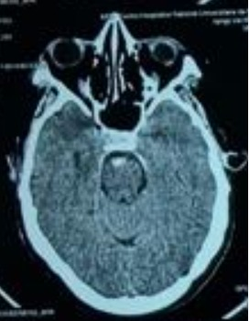

**Figure 1.** Subarachnoid peri-mesencephalic haemorrhage

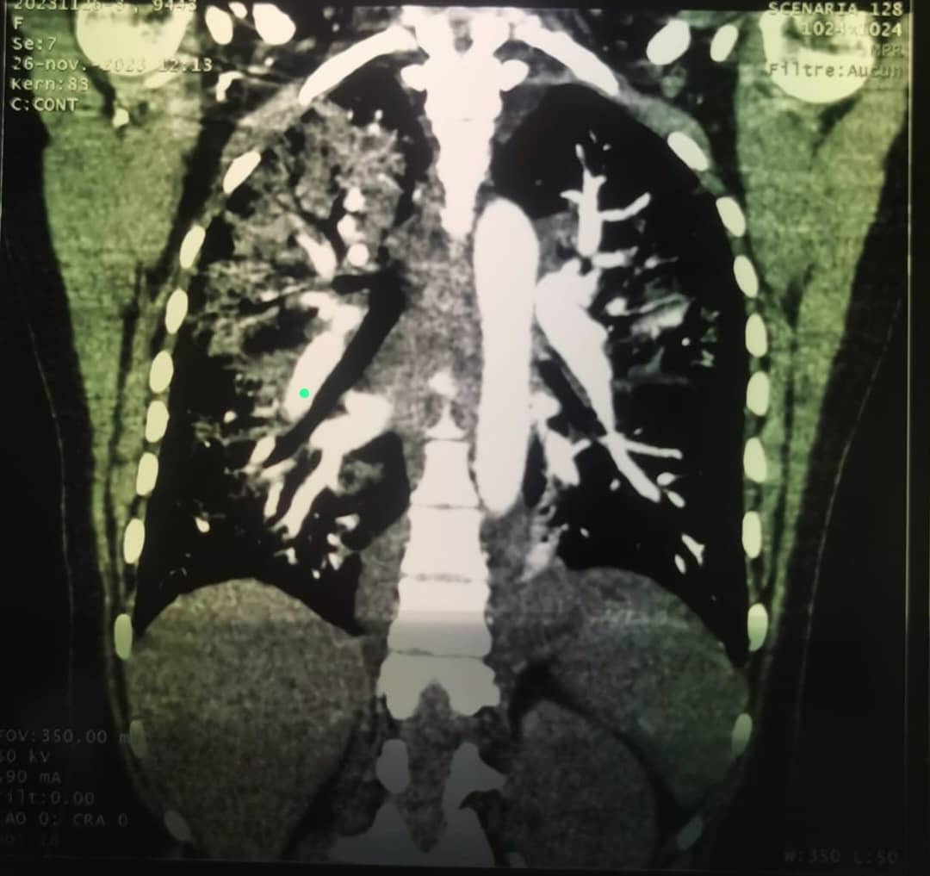

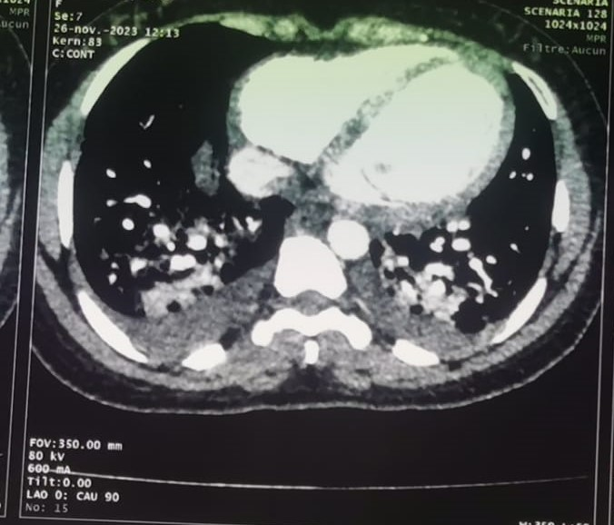

**Figures 2 & 3.** Acute Pulmonary Oedema with pulmonary arterial hypertension

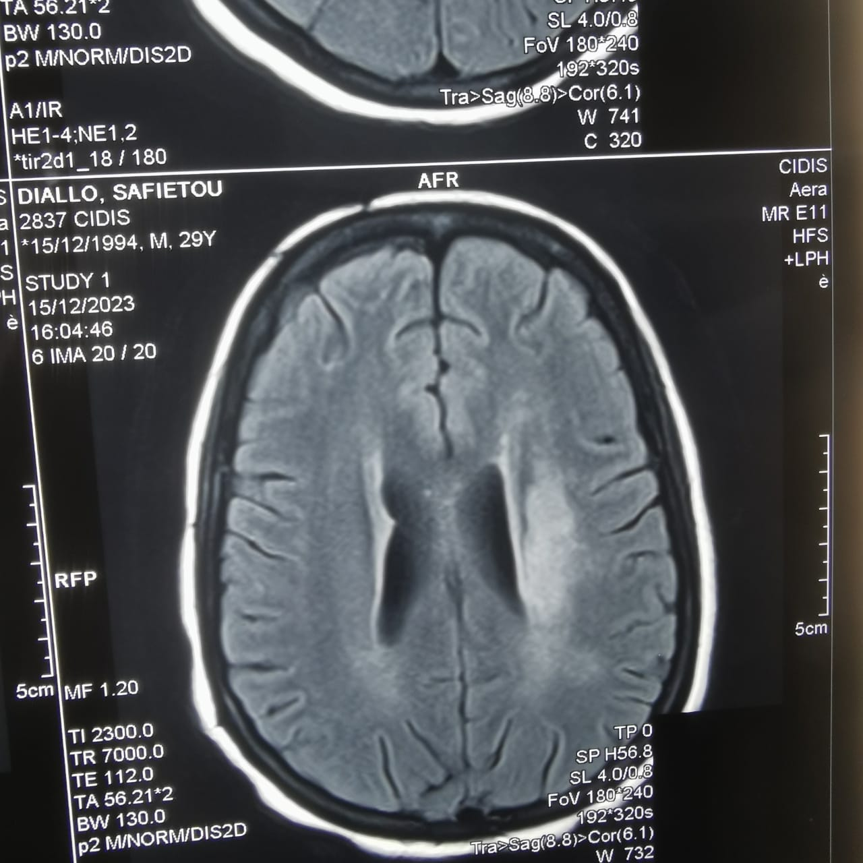

**Figure 4.** a cerebral MRI in diffusion sequence showing a left deep sylvian infarct

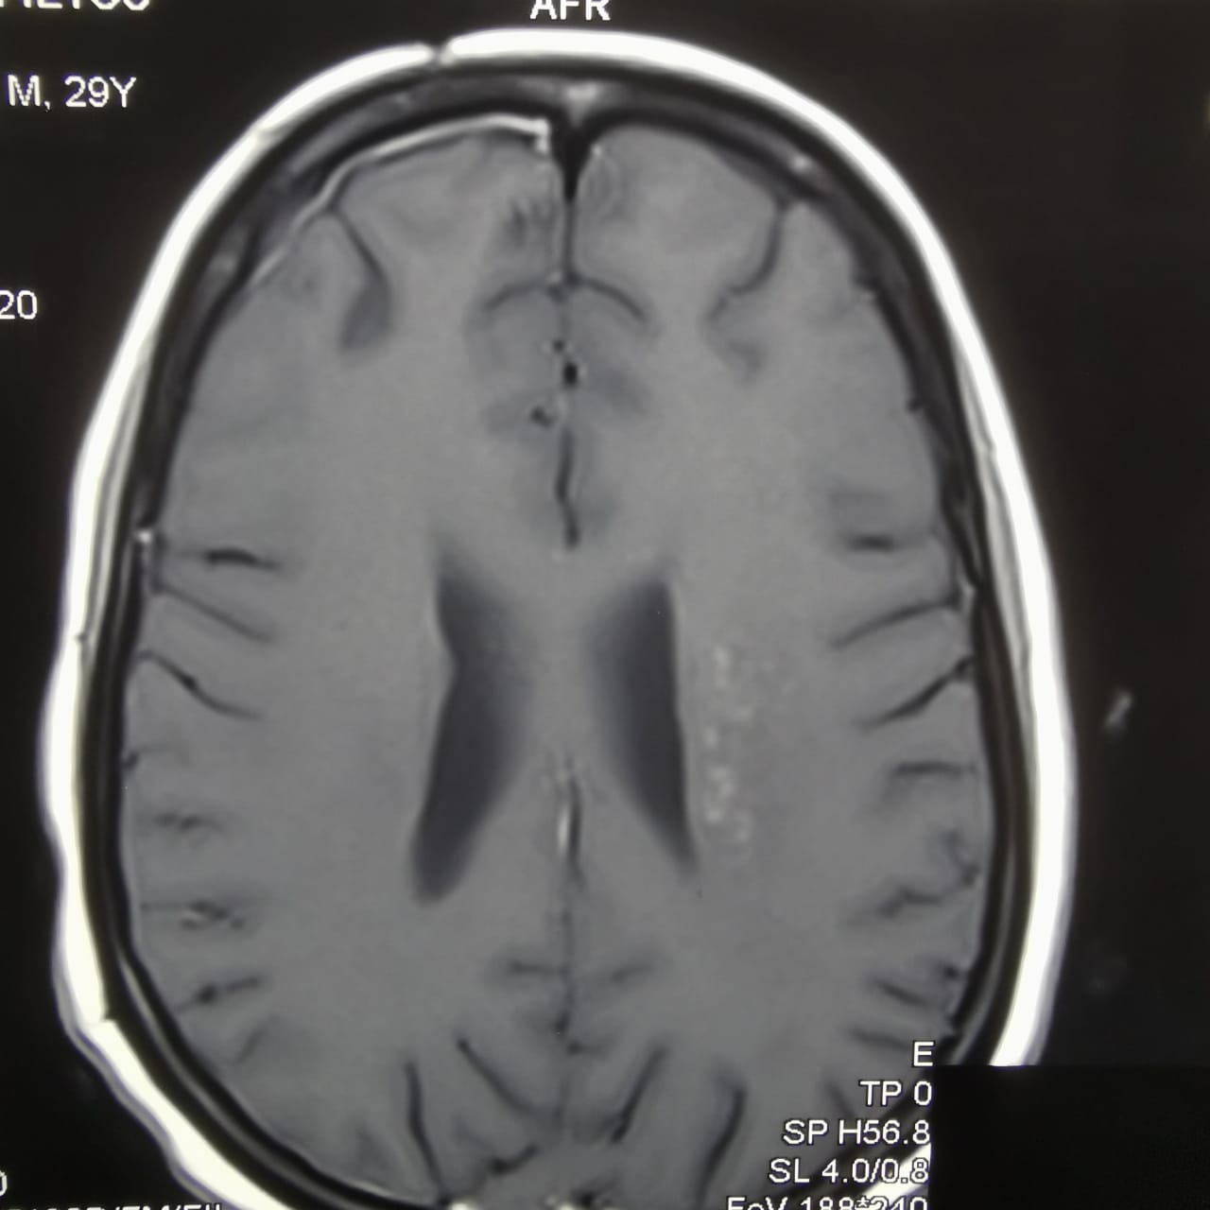

**Figure 5.** a cerebral MRI in flair sequence showing a left internal capsule vasculitis.

**Consent**

As per international standards or university standards, patient(s) written consent has been collected and preserved by the author(s).

Disclaimer (Artificial intelligence)

Author(s) hereby declare that NO generative AI technologies such as Large Language Models (ChatGPT, COPILOT, etc.) and text-to-image generators have been used during the writing or editing of this manuscript.

**REFERENCES**

1. WHO. Dengue and severe dengue. Who. 2023; Accessed 14December 2023.

Available: https://www.who.int/news-room/fact-sheets/detail/dengue-and-severe-dengue

1. Bhatt S, Gething PW, Brady OJ, Messina JP, Farlow AW, Moyes CL, et al. The global distribution and burden of dengue. Nature. 2013;496(7446) 504-7. doi: 10.1038/nature12060. PMID: 23563266.
2. Eltom K, Enan K, El Hussein ARM, Elkhidir IM. Dengue Virus Infection in Sub-Saharan Africa Between 2010 and 2020: A Systematic Review and Meta-Analysis. Frontiers in Cellular and Infection Microbiology. 2021;11 (678945). doi: 10.3389/fcimb.2021.678945. PMID: 34113579.
3. Amarasinghe A, Kuritsky JN, William Letson G, Margolis HS. Dengue virus infection in Africa. Emerg Infect Dis. 2011;17(8) :1349-54. doi: 10.3201/eid1708.101515. PMID: 21801609.
4. Were F. The dengue situation in Africa. Paediatr Int Child Health. 2012;32 (s1):18-21. doi: 10.1179/2046904712Z.00000000048. PMID: 22668445.
5. Li HM, Huang YK, Su YC, Kao CH. Risk of stroke in patients with dengue fever: A population-based cohort study. CMAJ. 2018;190(10):E285-E290. doi: 10.1503/cmaj.170994.PMID: 29530869.
6. Wei KC, Sy CL, Wang WH, Wu CL, Chang S, Huang YT. Major acute cardiovascular events after dengue infection–A population-based observational study. PLoS Negl Trop Dis. 2022;16(2):e0010134. doi: 10.1371/journal.pntd.0010134. PMID: 35130277.
7. Ee SJ, Sheng GT, Wahab NA. Deadly intracranial bleed in patients with dengue fever: A series of nine patients and review of literature. J Neurosci Rural Pract. 2016;7(3):423-34. doi: 10.4103/0976-3147.182777. PMID: 27365962;
8. Kumar R, Prakash O, Sharma BS. Intracranial hemorrhage in dengue fever: management and outcome. A series of 5 cases and review of literature. Surg Neurol. 2009;72(4):429-33. doi: 10.1016/j.surneu.2009.01.021. PMID: 19328535.
9. Yoganathan S, Sudhakar S, Priyambada L, Thomas M. Stroke in a child with dengue encephalopathy. Annals of Indian Academy of Neurology. 2017;20(3):329-331. doi: 10.4103/aian.AIAN_504_16. PMID: 28904475.
10. Nanda SK, Jayalakshmi S, Mohandas S. Pediatric ischemic stroke due to dengue vasculitis. Pediatr Neurol. 2014;51(4):570-2. doi: 10.1016/j.pediatrneurol.2014.06.019. PMID: 25266622.
11. Putta R, Basha KV, Perumalla KNIP. Dengue Fever Presenting as Ischaemic Stroke: A Case Report.Journal of clinical and diagnostic research. 2023;17(4):07-09. Doi:10.7860/jcdr%2F2023%2F62146.17750.
12. Araiza-Garaygordobil D, García-Martínez CE, Burgos LM, Saldarriaga C, Liblik K, Mendoza I, et al. Dengue and the heart. Cardiovascular journal of Africa. 2021;32(5):276-283. doi: 10.5830/CVJA-2021-033. PMID: 34292294;
13. **[**Dinkar A, Singh J, Singh S. Acute myocardial infarction associated with severe *Plasmodium vivax*malaria. J Vector Borne Dis. 2020 Apr-Jun;57(2):193-196. doi: 10.4103/0972-9062.310872. PMID: 34290167.**]**
14. Viderman D, Tapinova K, Abdildin YG. Mechanisms of cerebral vasospasm and cerebral ischaemia in subarachnoid haemorrhage. Clinical Physiology and Functional Imaging. 2023;43(1):1-9. doi: 10.1111/cpf.12787. PMID: 36082805.
15. Younger DS, Coyle PK. Central Nervous System Vasculitis due to Infection. Neurologic Clinics. 2019; 37(2):441-463. doi: 10.1016/j.ncl.2019.01.002. PMID: 30952418.
16. Carod Artal FJ. Clinical management of infectious cerebral vasculitides. Expert Review of Neurotherapeutics. 2016;16(2):205-21. doi:10.1586/14737175.2015.1134321.PMID: 26689107.
17. Herath HMM, Hewavithana JS, De Silva CM, Kularathna OAR, Weerasinghe NP. Cerebral vasculitis and lateral rectus palsy-two rare central nervous system complications of dengue fever: Two case reports and review of the literature. Journal of Medical Case Reports. 2018; 12(1):100. doi: 10.1186/s13256-018-1627-x. PMID: 29669602.
18. [Singh J, Bhavya J, Dinkar A, Kumar N, Kumar K, Singh SK. Spontaneous Intracranial Hemorrhage and Acute Respiratory Distress Syndrome Associated with Dengue: A Case Report. Infect Disord Drug Targets. 2024;24(3):e021123223085. doi: 10.2174/0118715265186320231025172947.].
19. Paciaroni M, Ince B, Hu B, Jeng JS, Kutluk K, Liu L, et al. Benefits and Risks of Clopidogrel vs. Aspirin Monotherapy after Recent Ischemic Stroke: A Systematic Review and Meta-Analysis. Cardiovascular Therapeutics. 2019; 20 (2019):1607181. doi: 10.1155/2019/1607181. PMID: 31867054
20. Warner JJ, Harrington RA, Sacco RL, Elkind MSV. Guidelines for the early management of patients with acute ischemic stroke 2019 update to the 2018 guidelines for the early management of acute ischemic stroke. Stroke. 2019;50(12):3331-3332. doi: 10.1161/STROKEAHA.119.027708. PMID: 31662117.
21. Liou LM, Lan SH, Lai CL. Dengue fever with ischemic stroke: a case report. Neurologist. 2008 Jan;14(1):40-2. doi: 10.1097/NRL.0b013e3180d0a391. PMID: 18195656