*Case report*

Kikuchi-Fujimoto Disease Secondary to Systemic Lupus Erythematosus: A case report

.

ABSTRACT

|  |
| --- |
| **Aims:** To describe a rare case of Kikuchi-Fujimoto disease (KFD) secondary to systemic lupus erythematosus (SLE), emphasizing diagnostic challenges, therapeutic approach, and a review of relevant literature. . **Study Design:** Case report. . **Place and Duration of Study:** Department of Medicine, ABVIMS & Dr. RML hospital, over a period of two months in 2024. . **Methodology:** We present an 18-year-old female with a 4-month history of photosensitive malar rash, intermittent fevers, generalized lymphadenopathy, weight loss, and hair thinning. Extensive investigations revealed anemia, transaminitis, hypocomplementemia, and strongly positive ANA (SSA+). PET-CT revealed hypermetabolic lymphadenopathy. Lymph node biopsy showed histiocytic necrotizing lymphadenitis consistent with KFD. The patient fulfilled ACR/EULAR criteria for SLE. She was treated with hydroxychloroquine, corticosteroids and mycophenolate mofetil. .  **Results:** Diagnosis of KFD secondary to SLE was established. The patient responded well to immunosuppressive therapy and remains asymptomatic on follow-up. . **Conclusion:** This case highlights the importance of considering KFD-SLE overlap in young females presenting with prolonged fever and lymphadenopathy. Early biopsy and serological work-up are crucial for differentiating from infectious and malignant etiologies. Keywords: Kikuchi-Fujimoto disease, systemic lupus erythematosus, lymphadenopathy, histiocytic necrotizing lymphadenitis, case report. |

*Keywords: Kikuchi-Fujimoto disease, systemic lupus erythematosus, lymphadenopathy, histiocytic necrotizing lymphadenitis.*

1. INTRODUCTION

Kikuchi-Fujimoto disease (KFD), or histiocytic necrotizing lymphadenitis, is a rare, self-limiting lymphadenopathy first reported in Japan by Kikuchi and Fujimoto independently in 1972.1 It is predominantly seen in young women and has a higher prevalence in Asian populations, though cases are now recognized worldwide. KFD typically manifests as tender cervical lymphadenopathy, fever, night sweats, fatigue, and weight loss.1 The pathogenesis remains uncertain, but hypotheses include autoimmune dysregulation and hyperimmune responses to viral infections such as Epstein-Barr virus, human herpesvirus, and parvovirus B19.1  
  
Histogically, KFD is characterized by paracortical necrosis, karyorrhectic debris, crescentic histiocytes, and plasmacytoid dendritic cells, with an absence of neutrophils and plasma cells—features that help differentiate it from other lymphadenitides.1  
  
Systemic lupus erythematosus (SLE) is a multisystem autoimmune disease with diverse manifestations including skin rashes, arthritis, renal involvement, and hematologic abnormalities.2 Lymphadenopathy is observed in about 25–60% of SLE patients, and lupus lymphadenitis can closely resemble KFD histologically3. The overlap of KFD and SLE, though rare, is increasingly recognized, raising diagnostic challenges. Bahmad et al. (2024)4 and Wibowo et al. (2024)5 described cases where KFD preceded or coincided with SLE, suggesting a potential immunopathological link.  
  
Here, we present a case of KFD secondary to SLE in a young female, highlighting the diagnostic approach, therapeutic implications, and a review of similar cases in literature.

2. Case Presentation

An 18-year-old female presented with a 4-month history of photosensitive malar rash and a 3-month history of intermittent fevers, fatigue, diffuse hair loss, and 5 kg unintentional weight loss. She developed small swellings in her hands which were not painful and soft to touch. There was no history of oral ulcers, joint pain, Raynaud’s phenomenon, or sicca symptoms. Past medical history was unremarkable.  
  
On examination, she was febrile (101°F) and tachycardic (120 bpm). A violaceous malar rash involving both cheeks and the nasal bridge sparing the nasolabial folds was noted. Subcutaneous nodules were present in the extensor aspect of both her fingers. These nodules were non tender, mobile with no attachment to the underlying tissue.

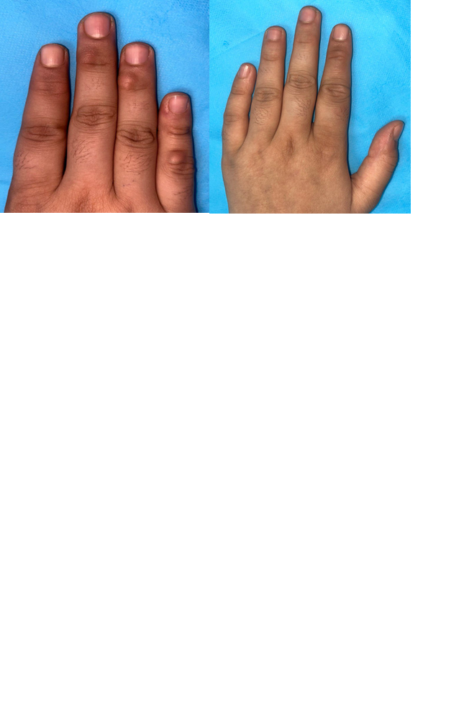

**Figure 1: Subcutaneous nodules**

Generalized lymphadenopathy was noted (largest node 1.5 cm, firm, mobile). No hepatosplenomegaly or synovitis was detected.

**Table 1: Laboratory Investigations of the Patient**

|  |  |  |
| --- | --- | --- |
| **Parameter** | **Result** | **Reference Range** |
| **Hemoglobin** | **7.4 g/dL** | 12–16 g/dL |
| **Total leukocyte count** | 6300/µL | 4000–11000/µL |
| **Platelet count** | 210,000/µL | 150,000–450,000/µL |
| **ESR** | **46 mm/hr** | <20 mm/hr |
| **CRP** | **12 mg/L** | <5 mg/L |
| **AST** | 168 U/L | 10–40 U/L |
| **ALT** | 127 U/L | 7–56 U/L |
| **LDH** | 503 U/L | 140–280 U/L |
| **C3** | **64 mg/dL** | 90–180 mg/dL |
| **C4** | **6.9 mg/dL** | 10–40 mg/dL |
| **ANA** | **3+ speckled** | Negative |
| **Anti-SSA** | **Positive** | Negative |
| **Serum Ferritin** | **6948 ng/mL** | 20–200 ng/mL |

PET-CT revealed hypermetabolic lymphadenopathy in cervical, axillary, and inguinal regions

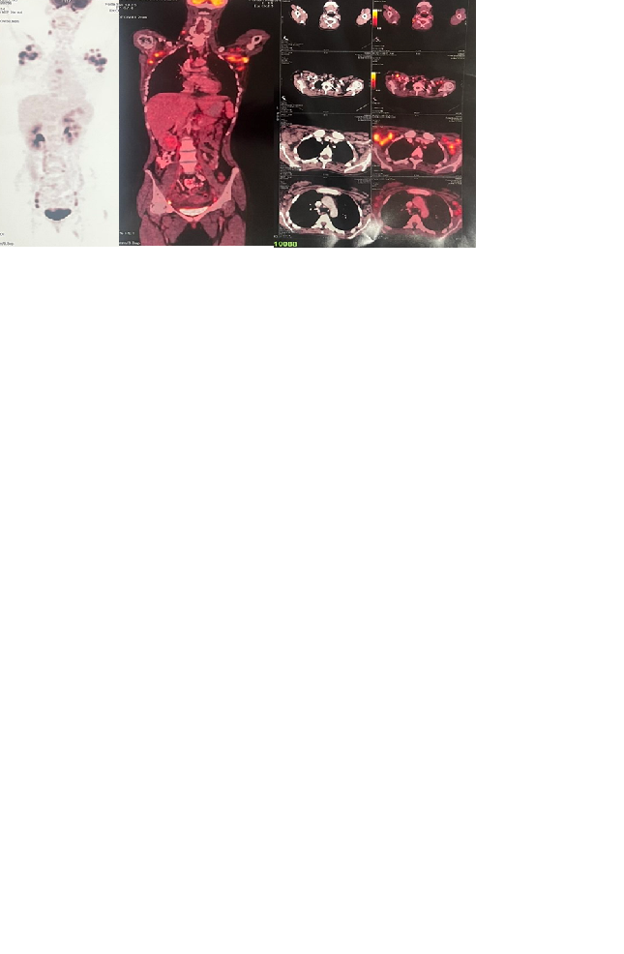  
**Figure 2: PET-CT showing lymphadenopathy**

Cervical lymph node biopsy showed partial effacement with necrosis, karyorrhectic debris, crescentic histiocytes, and plasmacytoid dendritic cells. Immunohistochemistry was CD68+ and CD123+, supporting KFD.

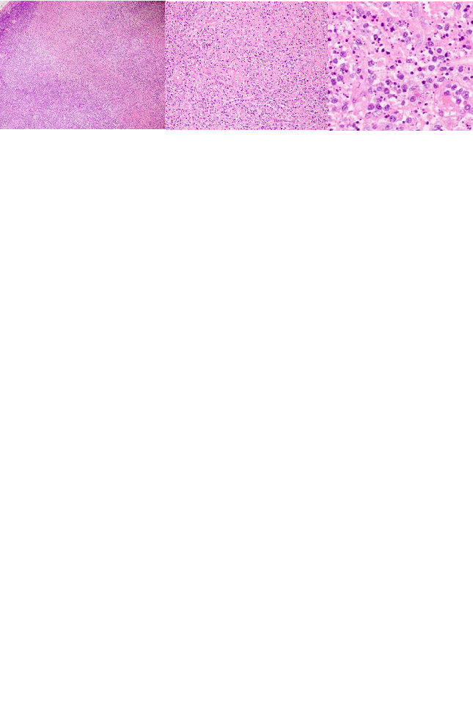

**Figure 3: LN biopsy H&E**

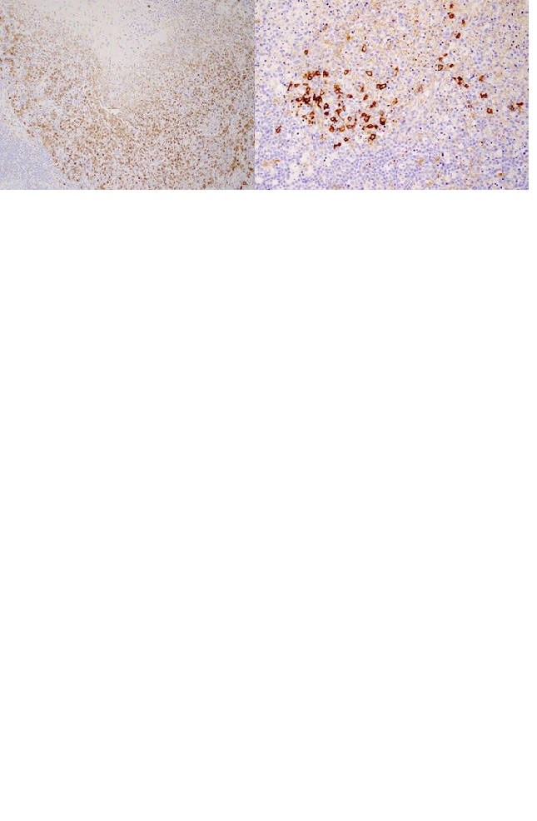  
**Figure 4: IHC staining CD68/CD123**

The patient fulfilled ACR/EULAR 2019 criteria for SLE (score: 12). She was treated with hydroxychloroquine 200 mg daily and oral prednisolone 40 mg daily, tapered over eight weeks. She was later started on oral Mycophenolate mofetil 500mg twice a day. Marked improvement was observed within two weeks. At three-month follow-up, she remained asymptomatic and the nodules (Probably lupus panniculitis- biopsy not done) had disappeared.

3. discussion

Kikuchi-Fujimoto disease (KFD) is a rare, self-limiting lymphadenitis first described in 1972.1 It predominantly affects young women under 40 years and is more prevalent in Asian populations.1 The etiology remains speculative but is hypothesized to involve an aberrant T-cell mediated immune response, possibly triggered by infectious agents such as Epstein-Barr virus, parvovirus B19, or other herpesviruses. However, no single causative agent has been consistently implicated.1 The association of KFD with autoimmune diseases, particularly systemic lupus erythematosus (SLE), suggests a potential shared immunopathological mechanism.3

Histopathologically, KFD is characterized by patchy areas of necrosis with abundant karyorrhectic debris, crescent-shaped histiocytes, and plasmacytoid dendritic cells. Notably, there is an absence of neutrophilic infiltration and plasma cells, which helps to differentiate KFD from suppurative bacterial lymphadenitis and lupus lymphadenitis. In contrast, SLE lymphadenitis often shows hematoxylin bodies, fibrinoid necrosis, and abundant plasma cells. In our patient, the biopsy findings of necrotizing lymphadenitis with CD68+ histiocytes and CD123+ plasmacytoid dendritic cells, combined with the absence of neutrophils and plasma cells, favored a diagnosis of KFD.1-18

The overlap between KFD and SLE has been increasingly recognized in the literature. In some cases, KFD precedes SLE by several months to years, while in others, it coincides or follows SLE diagnosis. Bahmad et al. (2024)4 reported a cohort of KFD patients in which one developed SLE within a year, suggesting KFD may be a harbinger of autoimmune pathology. Wibowo et al. (2024)5 described a case of KFD preceding an overlap syndrome of SLE and Sjögren’s syndrome. These findings highlight the need for vigilant follow-up of patients diagnosed with KFD, particularly if serological markers for autoimmunity are present.

**Differential diagnoses for prolonged febrile lymphadenopathy include:**

• **Tuberculous lymphadenitis:** Characterized by caseating granulomas and AFB positivity on staining, both absent in this case.

• **Lymphoma:** Excluded by the absence of atypical lymphoid cells and a preserved nodal architecture.

• **Hemophagocytic lymphohistiocytosis (HLH):** Considered due to elevated serum ferritin but ruled out due to the lack of cytopenias, splenomegaly, and other HLH criteria.

• **Rosai-Dorfman disease:** Typically shows S100-positive histiocytes with emperipolesis, which were absent here.21

Management of KFD is generally supportive, with antipyretics and non-steroidal anti-inflammatory drugs sufficing for most cases. However, in patients with significant symptoms or when KFD overlaps with SLE, immunosuppressive therapy becomes necessary. Corticosteroids remain the mainstay of treatment, with hydroxychloroquine added in cases with cutaneous or systemic SLE manifestations. Our patient responded well to prednisolone and hydroxychloroquine, achieving complete resolution of symptoms within two weeks and no recurrence at three-month follow-up.1-18

Table 2 summarizes similar cases of KFD associated with SLE from the literature. The majority of these patients were young women, presenting with fever and lymphadenopathy, and responded favorably to corticosteroids and hydroxychloroquine.

**Table 2: Summary of Reported Cases of KFD Associated with SLE**

|  |  |  |  |  |
| --- | --- | --- | --- | --- |
| **Author (Year)** | **Patient Details** | **Presentation** | **Histopathology** | **Outcome** |
| Bahmad et al. (2024)4 | 25F | Fever, lymphadenopathy, rash | Necrotizing lymphadenitis | Improved with steroids |
| Wibowo et al. (2024)5 | 30F | Cervical lymphadenopathy, arthritis | Histiocytic infiltration | Overlap syndrome; treated with immunosuppression |
| Santana et al. (2005)10 | 28F | Fever, photosensitive rash | Necrotizing lymphadenitis | Resolved with HCQ and steroids |
| Kwon et al. (1999)11 | 35F | Lymphadenopathy, malar rash | Histiocytic necrosis | Good response to steroids |
| Shrestha et al. (2018)14 | 22F | Fever, arthralgia, lymphadenopathy | Karyorrhectic debris | Recovered with HCQ, no relapse |

The clinical significance of this overlap lies in the need for differentiation and appropriate management. While KFD is self-limiting, SLE requires long-term immunosuppressive therapy to prevent disease progression and organ damage. Furthermore, patients diagnosed with KFD should be monitored periodically for the emergence of autoimmune features, given the documented progression to SLE in a subset of cases.14-20

This case underscores the importance of excisional lymph node biopsy in prolonged febrile lymphadenopathy and highlights the diagnostic challenge posed by overlapping histopathological features in KFD and SLE.

4. Conclusion

This case highlights the diagnostic complexity of Kikuchi-Fujimoto disease (KFD) when it overlaps with systemic lupus erythematosus (SLE), particularly in young females presenting with prolonged febrile lymphadenopathy. Histopathology remains the cornerstone for diagnosis, allowing differentiation from other causes such as lymphoma, tuberculosis, and lupus lymphadenitis. Recognition of this overlap is critical, as KFD alone is self-limiting, while SLE necessitates prompt immunosuppressive therapy to prevent morbidity. Vigilant follow-up is essential since KFD may precede or signal the onset of systemic autoimmune disease. Early diagnosis and targeted treatment can result in excellent clinical outcomes.

**Ethical Approval:**

As per international standards or university standards written ethical approval has been collected and preserved by the author(s).

**Consent**

As per international standards or university standards, patient(s) written consent has been collected and preserved by the author(s).

Definitions, Acronyms, Abbreviations

KFD: Kikuchi Fujimoto Disease

SLE: Systemic Lupus Erythematosus

ACR/EULAR: American College of Rheumatology and the European League Against Rheumatism

PET-CT: Positron Emission Tomography- Computed Tomography

**Disclaimer (Artificial intelligence)**

Author(s) hereby declare that generative AI technologies such as Large Language Models, etc. have been used during the writing or editing of manuscripts. This explanation will include the name, version, model, and source of the generative AI technology and as well as all input prompts provided to the generative AI technology

Details of the AI usage are given below:

Authors hearby declare that generative AI has been used to edit this manuscript. It has been used in research of various relevant studies and rephrasing to a grammatically correct sentence.

The AI used is Scholar GPT (ChatGPT- Open AI), Version 4o. The input prompts given were “Rephrase the following.” and “Find relevant articles regarding KFD, SLE and its overlap”. Other than the use mentioned, regenerative AI wasn’t used for any other purpose.

References

1. Bosch X, Guilabert A. Kikuchi-Fujimoto disease. Orphanet J Rare Dis. 2006;1:18. doi:10.1186/1750-1172-1-18.
2. Siegel CH, Sammaritano LR. Systemic lupus erythematosus: a review. *JAMA*. 2024;331(17):1480–1491. doi:10.1001/jama.2024.2315.
3. Kitsanou M, Andreopoulou E, Bai MK, Elisaf M, Drosos AA. Extensive lymphadenopathy as the first clinical manifestation in systemic lupus erythematosus. *Lupus*. 2000;9(2):140–3. doi:10.1191/096120300678828037.
4. Bahmad HF, Abouzeid H, Nassar J, et al. Kikuchi–Fujimoto Disease: A Case Series and Review of the Literature. Diseases. 2024;12(11):271. DOI:10.3390/diseases12110271.
5. Wibowo SAK, Ariane A, Hidayat R. Kikuchi-Fujimoto Disease Preceding Overlap Syndrome of Sjögren’s Syndrome and Systemic Lupus Erythematosus: Literature Review Based on a Case Report. Indones J Rheumatol. 2024;12(2):210-217.
6. Kucukardali Y, Solmazgul E, Kunter E, et al. Kikuchi-Fujimoto Disease: analysis of 244 cases. Clin Rheumatol. 2007;26(1):50-54.
7. Bosch X, Guilabert A, Miquel R, et al. Enigmatic Kikuchi-Fujimoto disease: a comprehensive review. Am J Clin Pathol. 2004;122(1):141-152.
8. Dorfman RF, Berry GJ. Kikuchi’s histiocytic necrotizing lymphadenitis: an analysis of 108 cases with emphasis on differential diagnosis. Semin Diagn Pathol. 1988;5(4):329-345.
9. Kuo TT. Kikuchi’s disease (histiocytic necrotizing lymphadenitis): a clinicopathologic study of 79 cases with analysis of histologic subtypes and immunohistology. Am J Surg Pathol. 1995;19(7):798-809.
10. Santana A, Lessa B, Galrão L, Lima I, Santiago M. Kikuchi-Fujimoto’s disease associated with systemic lupus erythematosus: a case report and review of the literature. Clin Rheumatol. 2005;24(1):60-63.
11. Kwon SY, Kang MS, Park PW, et al. Two cases of Kikuchi-Fujimoto disease associated with systemic lupus erythematosus. J Korean Med Sci. 1999;14(2):217-220.
12. Choe JY, Kim SK, Lee H, et al. Kikuchi disease in systemic lupus erythematosus patients: a case-control study and literature review. Lupus. 2016;25(6):653-659.
13. Rosai J, Dorfman RF. Sinus histiocytosis with massive lymphadenopathy: a newly recognized benign clinicopathological entity. Arch Pathol. 1969;87(1):63-70.
14. Shrestha S, Anwar S, Singh H, et al. Kikuchi-Fujimoto disease in a patient with systemic lupus erythematosus: a case report. BMC Res Notes. 2018;11:776.
15. Kim YJ, Koo DW, Lee SH, et al. Kikuchi disease and systemic lupus erythematosus: a case report and review of the literature. Korean J Intern Med. 2001;16(3):205-208.
16. Baenas DF, Navarro JT, Campo E. Kikuchi-Fujimoto disease: a review. J Hematopathol. 2012;5(1):11-18.
17. Hirakawa M, Okuyama K, Mizutani Y, et al. Kikuchi-Fujimoto disease developing into systemic lupus erythematosus: A case report and literature review. Mod Rheumatol Case Rep. 2021;5(3):401-405.
18. Tamiya S, Kuroda N, Miyazaki E, et al. Kikuchi-Fujimoto disease: an immunohistochemical study on apoptotic cell death of T lymphocytes. Virchows Arch. 2001;439(6):660-666.
19. Lin HC, Su CY, Huang CC, et al. Kikuchi’s disease: a review and analysis of 61 cases. Otolaryngol Head Neck Surg. 2003;128(5):650-653.
20. Rezai K, Kuchipudi S, Chundi V, et al. Kikuchi-Fujimoto disease: hydroxychloroquine as a treatment. Clin Infect Dis. 2004;39(12):e124-e126.
21. Dorfman RF. Kikuchi’s disease: a new form of lymphadenitis. Am J Clin Pathol. 1973;59(6):715-722.