**Clinical Epidemiological Analysis of Lassa Fever Predictors and Outcomes in Primary Healthcare Centres in Rivers State, Nigeria**

**Original Research Article**

**ABSTRACT**

**Introduction:** Lassa fever is a serious viral haemorrhagic disease prevalent in West Africa, causing considerable illness and death. Early detection at Primary Health Centres (PHCs) is essential for minimizing diagnostic delays and enhancing patient outcomes. This study aimed to identify the clinical signs that predict Lassa fever and assess the outcomes of patients who visit PHCs in Rivers State, Nigeria.

**Methods:** A retrospective cohort study was conducted in 15 PHCs in Rivers State from January 2023 to March 2025. The medical records of patients suspected of having Lassa fever were examined. Data analysis involved descriptive statistics, bivariate analysis, and multivariate logistic regression to pinpoint independent clinical predictors.

**Results:** Out of 312 suspected cases analysed, 78 (25.0%) were confirmed as positive for Lassa fever. Key clinical predictors identified were persistent fever lasting more than seven days (AOR = 3.12, 95% CI: 1.62-5.98), bleeding tendencies (AOR = 4.85, 95% CI: 2.11-11.12), sore throat (AOR = 2.77, 95% CI: 1.32-5.79), and hearing loss (AOR = 6.41, 95% CI: 1.90-21.59). The mortality rate among confirmed cases was 20.5%.

**Conclusion:** Significant clinical indicators of Lassa fever at the PHC level include persistent fever, bleeding, sore throat, and hearing loss. It is important to improve the diagnostic capabilities and early referral processes at PHCs to improve patient outcomes.

**Keywords:** Lassa fever, clinical predictors, outcomes, Primary Health Centres, Rivers State, Nigeria.

**1.INTRODUCTION**

Lassa fever is a zoonotic, acute viral haemorrhagic disease caused by the Lassa virus, an Arenavirus endemic to West Africa (Yun & Walker, 2015). Transmission occurs primarily through contact with food or household items contaminated by Mastomys rodents (Olayemi et al., 2020), with secondary human-to-human spread via bodily fluids, especially in healthcare settings lacking adequate infection prevention and control (IPC) measures (Ijarotimi et al., 2018).

Clinical presentation is often non-specific, including fever, sore throat, vomiting, and myalgia, with an incubation period of 6–21 days (Shaffer et al., 2014). Severe cases may progress to haemorrhage, shock, hearing loss, and multi-organ failure (Duvignaud et al., 2021; Ficenec et al., 2020; Ibekwe et al., 2011).

In Nigeria, seasonal outbreaks remain a major public health concern. In 2023, over 8,000 suspected cases and nearly 200 deaths were reported, with Rivers State among the most affected (Nigeria Centre for Disease Control (NCDC), 2024). Contributing factors include delayed presentation, limited diagnostic capacity, and poor recognition of early symptoms at the primary health care (PHC) level (Adewumi et al., 2025; Ilori et al., 2019).

While most studies focus on tertiary hospitals (Buba et al., 2018; Raabe et al., 2017;), early identification at PHCs is critical for timely ribavirin therapy and improved outcomes (Dalhat et al., 2022). Syndromic surveillance based on clinical symptoms is essential in PHCs lacking laboratory infrastructure (Dan-Nwafor et al., 2019; Usman et al., 2022).

This study aimed to identify the clinical signs that predict Lassa fever and assess the outcomes of patients who visit PHCs in Rivers State. This would provide evidence for frontline health workers training and early case identification strategies (Asogun et al., 2019; Wadi et al., 2022).

**2. METHODS AND MATERIALS**

**2.1. Study Design**

A retrospective cross-sectional study was conducted across fifteen PHCs in Rivers State between January 2023 and March 2024. These facilities were selected based on high Lassa fever caseloads and geographic representation (Ilori et al., 2019).

**2.2. Study Setting**

The study was carried out at 15 Primary Health Centres across five Local Government Areas (LGAs) in Rivers State: Abua/Odual, Ahoada East, Bonny, Port Harcourt, and Oyigbo. Rivers State is one of Nigeria's 36 states, located in the country's South-South geopolitical area. Latitude 4°45′N, Longitude 6°50′E. It shares borders with Imo, Abia, and Anambra States to the north, Akwa Ibom State to the east, Bayelsa and Delta States to the west, and the Atlantic Ocean to the South. Port Harcourt, the state capital, is an important industrial and economic hub that includes major seaports and oil companies as of 2025, Rivers State is estimated to have a population of about 9 million inhabitants with annual growth rate of 3.2%, making it one of Nigeria’s most densely populated States. Port Harcourt, the State capital, accounts for over 3 million residents, driven by urbanization and economic opportunities in the oil and gas sector. It has twenty-three Local Government Areas (LGAs). The climate is divided into two main seasons: wet season (April to October) and dry season (November to March). Temperatures are continuously warm, ranging from 25°C to 32°C.

The state's economy is primarily driven by the oil and gas industry, which includes multinational companies. The traditional occupations include subsistence farming, fishing, and aquaculture, particularly in riverine communities. A substantial portion of the workforce serves in administrative roles for State and Federal governments. The location of key ports, including the Onne Port and Port Harcourt Port, enables extensive trade and logistical operations.

Rivers State poses significant public health problems because of environmental, infrastructure, and socioeconomic factors. These include poor sanitation, overpopulation, insufficient healthcare facilities, and climate change-related dangers. Urban slums and informal settlements are severely overcrowded, which facilitates the spread of tuberculosis, malaria, Lassa fever, respiratory infections, and so on.

**2.3. Study Population**

All patients who presented to the selected PHCs between January 2023 and March 2025 with suspected Lassa fever were eligible. Suspected cases were defined according to the NCDC (2022) case definition.

**2.3.1. Inclusion Criteria**

• Patients with persistent fever who do not respond to anti-malarial or antibiotic treatments.

• Patients with symptoms indicating viral hemorrhagic fever.

• Access to comprehensive patient medical records.

**2.3.2 Exclusion Criteria**

• Patients who were referred promptly without a clinical evaluation.

• Incomplete or missing records.

**2.4. Sample Size**

The sample size was calculated using the formula for single population proportion:

n = Z² × p(1–p) / d²

Where:

n = minimum sample size.

*Z*=Standard normal deviate (1.96 for a 95% confidence level).

*p*= Estimated proportion of the population with the attribute (25% prevalence from a previous study, NCDC, 2018).

*d*= margin of error (0.05).

n = (1.96² × 0.25 × 0.75) / 0.0025 = 288.

However, 312 cases were reviewed to account for incomplete data.

**2.5. Sampling Technique**

A simple random sampling was used to select the 5 LGAs from the 23 LGAs of Rivers State by balloting. A purposive sampling technique was used to select 3 PHCs from each LGA. In each LGA, the list of all the functioning PHCs was obtained from the health authority and arranged serially to form the sampling frame from which the 3 PHCs were randomly selected using computer generated random numbers.

**2.6. Data Collection**

Data abstraction was performed by using a structured proforma. The following information was extracted: demographic data (age, gender, occupation), clinical symptoms (fever, bleeding, vomiting, diarrhoea, sore throat, hearing loss, etc.), laboratory findings (where available), and patient outcomes (discharged, referred, or deceased). Lassa fever was confirmed using RT-PCR data from certified NCDC facilities.

**2.7. Data Analysis**

The data was imported into Microsoft Excel and analysed with Statistical Product and Service Solution (SPSS) Version 27 (Armonk, NY: IBM Corporation). Descriptive data were presented as frequencies, proportions, means, and standard deviations.

The Chi-square test was used in bivariate analysis to examine the associations among clinical characteristics and confirmed Lassa fever. Multivariate logistic regression was used to determine independent predictors of confirmed Lassa fever. Variables with p<0.2 in the bivariate analysis were included to the model. The outcome analysis involved calculating mortality, referral, and recovery rates. Statistical significance was determined at p < 0.05.

**3. RESULTS**

The socio-demographic features of the 312 suspected cases showed that 176 (56.4%) were males and 136 (43.6%) were females. The mean age was 29.8 ± 12.5 years. Table 1 shows that many patients (32.7%) were traders, followed by farmers (21.5%) and students (18.6%).  
The demographic data show that males constituted many suspected cases. This may reflect higher exposure risks among men due to occupational activities such as trading, farming, and artisanal work. The 15–29 years age group accounted for the highest proportion, suggesting a young and economically active population is most at risk.

**Table 1: Socio-demographic Characteristics of Suspected Lassa Fever Cases at PHCs in Rivers State (n=312)**

| **Variable** | **Frequency (n)** | **Percentage (%)** |
| --- | --- | --- |
| **Sex** |  |  |
| Male | 176 | 56.4% |
| Female | 136 | 43.6% |
| **Age group (years)** |  |  |
| <15 | 38 | 12.2% |
| 15–29 | 121 | 38.8% |
| 30–44 | 95 | 30.4% |
| ≥45 | 58 | 18.6% |
| Mean age 29.8 ± 12.5 years.  **Occupation** |  |  |
| Trader | 102 | 32.7% |
| Farmer | 67 | 21.5% |
| Student | 58 | 18.6% |
| Artisan | 45 | 14.4% |
| Others (Civil servants, unemployed, etc.) | 40 | 12.8% |

The three most prevalent clinical symptoms of Lassa fever, as seen in Table 2; Figures 1&2, were persistent fever, weakness, and vomiting. Persistent fever was the most frequently reported symptom, followed by weakness and vomiting. These findings align with the typical non-specific early presentation of Lassa fever, which often mimics other febrile illnesses. The relatively lower frequencies of bleeding and hearing loss may indicate that most patients presented in earlier stages.

**Table 2: Clinical Symptoms among Suspected Lassa Fever Cases at PHCs (n=312)**

| **Symptom** | **Frequency (n)** | **Percentage (%)** |
| --- | --- | --- |
| Persistent fever (>7 days) | 88 | 28.2% |
| Vomiting | 66 | 21.2% |
| Bleeding (gums, nose, etc.) | 32 | 10.3% |
| Sore throat | 45 | 14.4% |
| Hearing loss | 10 | 3.2% |
| Diarrhea | 40 | 12.8% |
| Weakness | 72 | 23.1% |
| Abdominal pain | 34 | 10.9% |

Table 3 shows the statistically significant clinical symptoms associated with confirmed Lassa fever. Bivariate analysis revealed significant associations between Lassa fever and persistent fever, bleeding, sore throat, and hearing loss. These symptoms should raise a high index of suspicion for Lassa fever, especially in resource-limited PHC settings.

**Table 3: Bivariate Analysis of Clinical Symptoms** **Associated with Confirmed Lassa Fever Cases**

| **Symptom** | **Confirmed Cases (n=78)** | **Suspected but Negative (n=234)** | **p-value** |
| --- | --- | --- | --- |
| Persistent fever (>7 days) | 41 (52.6%) | 47 (20.1%) | <0.001**\*** |
| Bleeding tendencies | 24 (30.8%) | 8 (3.4%) | <0.001**\*** |
| Sore throat | 18 (23.1%) | 27 (11.5%) | 0.008**\*** |
| Hearing loss | 7 (9.0%) | 3 (1.3%) | 0.002**α**\* |
| Vomiting | 19 (24.4%) | 47 (20.1%) | 0.442 |
| Diarrhea | 10 (12.8%) | 30 (12.8%) | 1.000 |

*.* **\*Statistically significant (p<0.05); α=Fishers Exact p.**

Table 4; Figure 3 shows the predictors of confirmed Lassa fever. The logistic regression model identified persistent fever, bleeding, sore throat, and hearing loss as strong independent predictors of Lassa fever. Hearing loss, though less frequent, had the highest adjusted odds ratio, underscoring its diagnostic relevance when present.

**Table 4: Multivariate Logistic Regression for** **Predictors of Confirmed Lassa Fever**

| **Predictor** | **Adjusted Odds Ratio (AOR)** | **95% Confidence Interval** | **p-value** |
| --- | --- | --- | --- |
| Persistent fever (>7 days) | 3.12 | 1.62–5.98 | 0.001**\*** |
| Bleeding tendencies | 4.85 | 2.11–11.12 | <0.001**\*** |
| Sore throat | 2.77 | 1.32–5.79 | 0.007**\*** |
| Hearing loss | 6.41 | 1.90–21.59 | 0.003**\*** |

**\*Statistically significant (p<0.05).**

The outcomes of confirmed Lassa fever patients are reported in Table 5; Figure 4. Many infected people recovered emphasising the importance of early detection and management.

**Table 5: Outcomes of Confirmed Lassa Fever Cases (n=78)**

|  |  |  |
| --- | --- | --- |
| Recovered | 49 | 62.8% |
| Referred | 13 | 16.7% |
| Died | 16 | 20.5% |
|  |  |  |

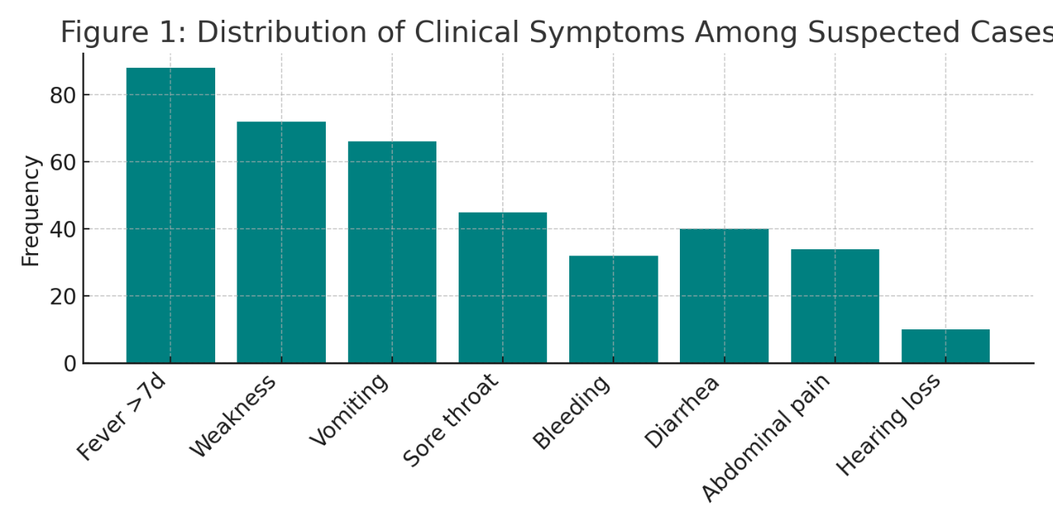

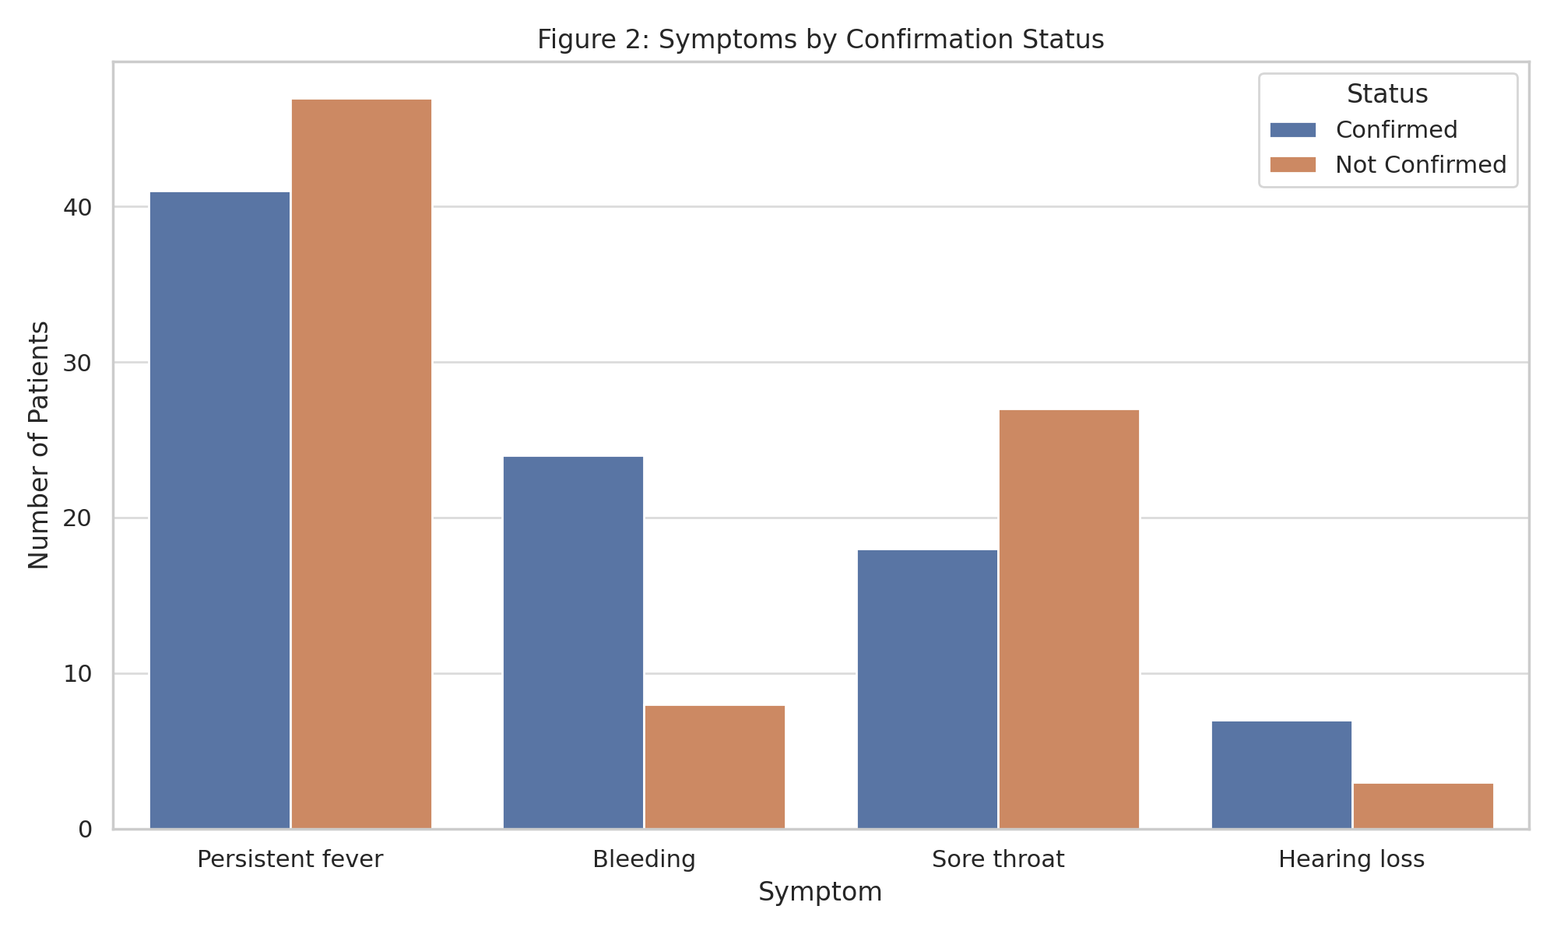

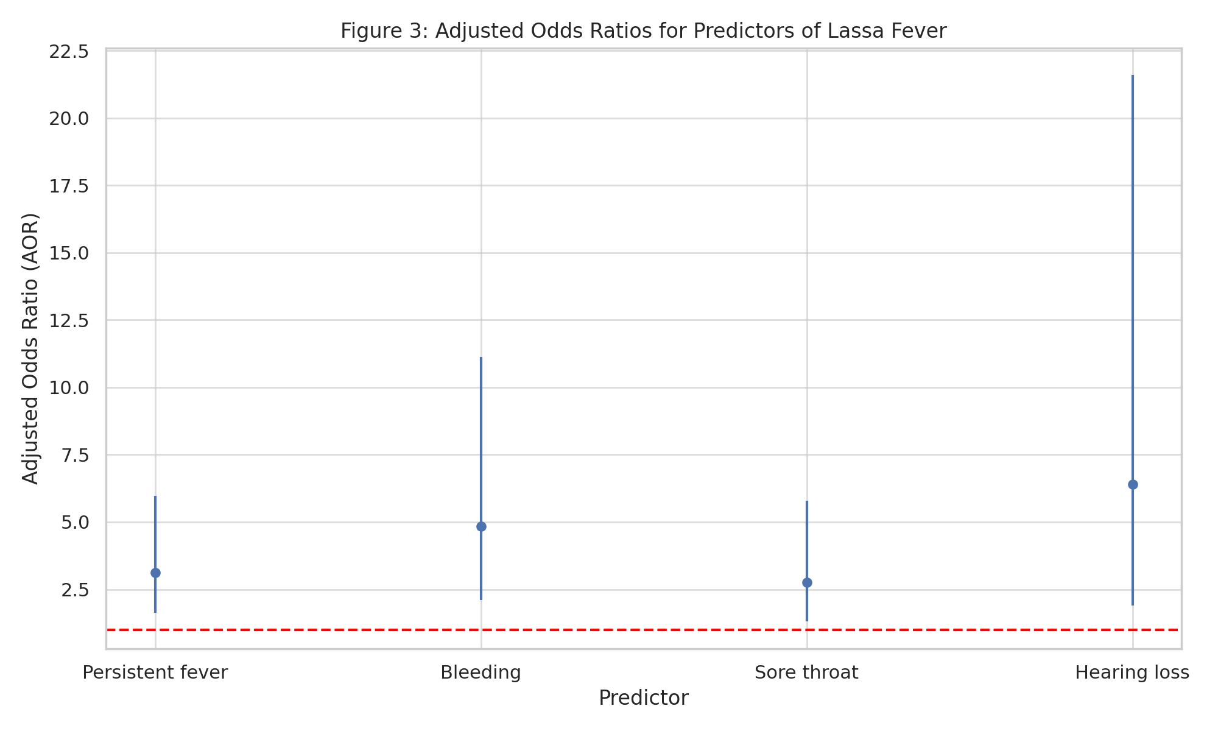

Figure 4: Clinical Outcomes of confirmed Lassa Fever

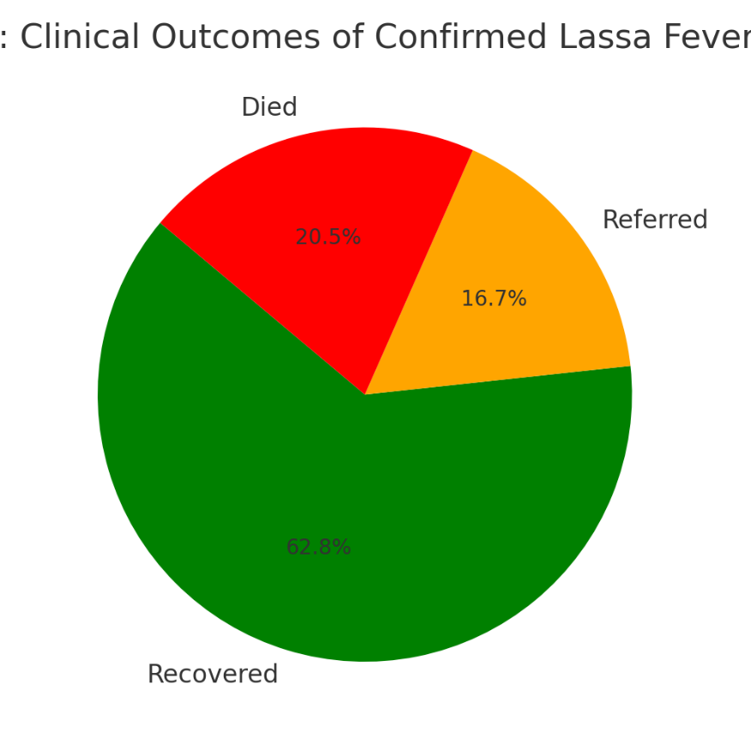

**4. DISCUSSION**

This study identified persistent fever, bleeding tendencies, sore throat, and hearing loss as independent clinical predictors of Lassa fever among patients presenting to PHCs (Olayemi et al., 2016; Shaffer et al., 2014). These findings are consistent with tertiary-level investigations that highlight protracted fever and bleeding diathesis as hallmark features of the disease (Ilori et al., 2019; Okokhere et al., 2018).

Hearing loss emerged as a strong predictor, aligning with evidence that sensorineural hearing impairment occurs in a significant proportion of Lassa fever survivors (Ficenec et al., 2020; Ibekwe et al., 2011; Shaffer et al., 2014). Its presence, though less frequent, should not be overlooked during clinical evaluation at PHCs (Duvignaud et al., 2021).

The mortality rate of 20.5% among confirmed cases reflects national trends and underscores the lethality of Lassa fever when diagnosis and treatment are delayed (Adewumi et al., 2025; Buba et al., 2018). Contributing factors include limited access to ribavirin, delayed referrals, and inadequate supportive care (Dalhat et al., 2022; Raabe et al., 2017).

The syndromic technique, which relies on known clinical indicators, provides a practical and cost-effective strategy for early case diagnosis, especially in resource-constrained settings. However, relying only on clinical judgement has some drawbacks. Studies have indicated that overlapping symptoms with other febrile diseases, such as malaria, typhoid, and COVID-19 (Efunshile et al., 2015), can contribute to misdiagnosis and delays in diagnosis (Dan-Nwafor et al., 2019). As a result, efforts must be made to increase rapid diagnostic tests (RDTs) and establish laboratory confirmation networks in high-burden LGAs (Asogun et al., 2019).

This study also adds to the expanding body of evidence supporting the decentralisation of Lassa fever surveillance and response protocols. PHCs can play an important role in early outbreak identification if properly trained and equipped (NCDC, 2022; Usman et al., 2022). The integration of clinical algorithms, electronic surveillance tools, and telemedicine consultations can improve diagnostic accuracy and reaction time**.**

**5. LIMITATIONS OF THE STUDY**

The study's limitations include the retrospective method of data collecting, potential inconsistencies in medical records, and missing data on laboratory variables. Nonetheless, the study's strength is its real-world application, with a focus on primary healthcare providers, who are frequently under-represented in Lassa fever research.

**6. CONCLUSION**

Early clinical indicators such as persistent fever, bleeding, sore throat, and hearing loss should alert health care providers to the possibility of Lassa fever. Improving diagnostic and referral capacities at the PHC level is critical for improved outcomes.  
  
The evidence presented in this study supports the urgent need for equipping primary health care providers with the knowledge and tools to recognize early signs of Lassa fever. Doing so can significantly reduce delays in initiating care, improve clinical outcomes, and ultimately lower the case-fatality rate. Clinical features such as persistent fever, bleeding, sore throat, and hearing loss should serve as red flags during routine evaluation of febrile patients in endemic areas.  
  
Strengthening PHC systems through integrated training, improved diagnostics, and rapid referral frameworks will be critical in achieving better management outcomes for Lassa fever. The decentralization of surveillance systems and implementation of point-of-care testing can also bridge the gap in early case identification. These actions must be supported by sustained public health education and rodent control measures to reduce community transmission.

**7. RECOMMENDATIONS**

1. Regular training for PHC personnel in recognizing early symptoms.

2. Implement diagnostic tools, such as rapid diagnostic tests (RDTs), in primary healthcare centers.

3. Strengthen emergency referral systems for urgent situations.

4. Public awareness to educate the community on rodent control and early care-seeking.

**DISCLAIMER (ARTIFICIAL INTELLIGENCE)**

Author(s) hereby declares that NO generative AI technologies such as Large Language Models (ChatGPT, COPILOT, etc.) and text-to-image generators have been used during writing or editing of this manuscript.

**ETHICAL APPROVAL**

Ethical approval was obtained from the Rivers State Primary Health Care Management Board. Permission was obtained from the Medical Officer of Health in charge of the 15 LGAs. Confidentiality was ensured.

**REFERENCES**

1. Adewumi, I. P., Adedokun, A. O., & Adeoluwa, O. O. (2025). Critical analysis of infectious disease surveillance and response system in Nigeria. Discover Public Health, 22, Article 272. <https://doi.org/10.1186/s12982-025-00668-6>
2. Asogun, D. A., Günther, S., Akpede, G. O., Ihekweazu, C., & Zumla, A. (2019). Lassa fever: Epidemiology, clinical features, diagnosis, management and prevention. Infectious Disease Clinics of North America, 33(4), 933–951. https://doi.org/10.1016/j.idc.2019.08.002
3. Buba, M. I., Dalhat, M. M., Nguku, P., et al. (2018). Mortality among Confirmed Lassa Fever Cases during the 2015-2016 Outbreak in Nigeria. American Journal of Public Health, 108, 262-264. https://doi.org/10.2105/AJPH.2017.304186
4. Dalhat, M. M., Olayinka, A. B., Meremikwu, M. M., Dan‑Nwafor, C., Iniobong, A., Ntoimo, L. F., & et al. (2022). Epidemiological trends of Lassa fever in Nigeria, 2018–2021. PLOS ONE, 17(12), Article e0279467. https://doi.org/10.1371/journal.pone.0279467
5. Dan-Nwafor, C., Ipadeola, O., Smout, E., et al. (2019). A cluster of nosocomial Lassa fever cases in a tertiary health facility in Nigeria: Description and lessons learned, 2018. International Journal of Infectious Diseases, 83, 88–94. https://doi.org/10.1016/j.ijid.2019.03.030
6. Duvignaud, A., Alabi, J. F., De Laval, F., Delamou, A., et al. (2021). Lassa fever outcomes and prognostic factors in Nigeria (LASCOPE): A prospective cohort study. The Lancet Global Health, 9(4), e469–e478. https://doi.org/10.1016/S2214-109X(20)30518-0
7. Efunshile, A. M., Olawale, T., Stensvold, C. R., Kurtzhals, J. A. L., & König, B. (2015). Epidemiological study of the association between malaria and helminth infections in Nigeria. American Journal of Tropical Medicine and Hygiene. American Society of Tropical Medicine and Hygiene. https://doi.org/10.4269/ajtmh.14-0548
8. Eneh, S. C., Obi, C. G., Ikpongifono, E. U., et al. (2025). The resurgence of Lassa fever in Nigeria: Economic impact, challenges, and strategic public health interventions. Frontiers in Public Health, 13, Article 1574459. https://doi.org/10.3389/fpubh.2025.1574459
9. Ficenec, S. C., Percak, J., Arguello, S., et al. (2020). Lassa fever induced hearing loss: The neglected disability of hemorrhagic fever. International Journal of Infectious Diseases, 100, 82–87. https://doi.org/10.1016/j.ijid.2020.08.021
10. Ibekwe, T. S., Okokhere, P. O., Asogun, D. A., et al. (2011). Early-onset sensorineural hearing loss in Lassa fever. European Archives of Oto-Rhino-Laryngology, 268(12), 1975–1980. <https://doi.org/10.1007/s00405-011-1714-8>
11. Ijarotimi, I. T., Ilesanmi, O. S., Aderinwale, A., Abiodun‑Adewusi, O., & Okon, I. M. (2018). Knowledge of Lassa fever and use of infection prevention and control facilities among health care workers during Lassa fever outbreak in Ondo State. Pan African Medical Journal, 30, Article 56. https://doi.org/10.11604/pamj.2018.30.56.13125
12. Ilori, E. A., Furuse, Y., Ipadeola, O. B., et al. (2019). Epidemiologic and clinical features of Lassa fever outbreak in Nigeria, January 1–May 6, 2018. Emerging Infectious Diseases, 25(6), 1066–1074. <https://doi.org/10.3201/eid2506.181035>
13. Nigeria Centre for Disease Control. (2018). 2018 Lassa Fever Outbreak Situation Reports. Abuja: NCDC. <https://ncdc.gov.ng/diseases/sitreps>
14. Nigeria Centre for Disease Control. (2022). National Guidelines for Lassa Fever Case Management. Abuja: NCDC. <https://ncdc.gov.ng/themes/common/docs/protocols/46_1646579109.pdf>
15. Nigeria Centre for Disease Control. (2024). Lassa Fever Situation Report. <https://ncdc.gov.ng>
16. Okokhere, P. O., Colubri, A., Azubike, C., Iruolagbe, C., Osazuwa, O., Tabrizi, S., et al. (2018). Clinical and laboratory predictors of Lassa fever outcome in a dedicated treatment facility in Nigeria: A retrospective, observational cohort study. The Lancet Infectious Diseases, 18(6), 684–695. https://doi.org/10.1016/S1473-3099(18)30123-3
17. Okwuraiwe, A. P., & Onyeaghala, C. A. (2025). Clinical outcomes of Lassa fever in West Africa: A systematic review and meta-analysis. medRxiv. <https://doi.org/10.1101/2025.01.10.24319564>
18. Olayemi, A., Cadar, D., Magassouba, N., et al. (2016). New hosts of the Lassa virus. Scientific Reports, 6, 25280. https://doi.org/10.1038/srep25280
19. Raabe, V. N., Kann, G., Ribner, B. S., et al. (2017). Favipiravir and ribavirin treatment of epidemiologically linked cases of Lassa fever. Clinical Infectious Diseases, 65(5), 855–859. https://doi.org/10.1093/cid/cix406
20. Shaffer, J.G., Grant, D.S., Schieffelin, J.S., Boisen, M.L., Goba, A., Hartnett, J.N., et al. (2014) Lassa Fever in Post-Conflict Sierra Leone. PLoS Negl Trop Dis 8(3): e2748. https://doi.org/10.1371/journal.pntd.0002748
21. Usman, R., Bakare, L., Akpan, U. O., et al. (2022). Establishing event‑based surveillance system in Nigeria: a complementary information generating platform for improved public health performance. Pan African Medical Journal, 42, Article 63. <https://doi.org/10.11604/pamj.2022.42.63.29621>
22. Wada YH, Ogunyinka IA, Yusuff KB, Ochu CL, Yahaya M, et al. (2022). Knowledge of Lassa fever, its prevention and control practices and their predictors among healthcare workers during an outbreak in Northern Nigeria: A multi-centre cross-sectional assessment. PLOS Neglected Tropical Diseases 16(3): e0010259. https://doi.org/10.1371/journal.pntd.0010259
23. Yun, N. E., & Walker, D. H. (2012). Pathogenesis of Lassa fever. Viruses, 4(10), 2031–2048. <https://doi.org/10.3390/v4102031>