****Effects of the**** RNA ****Interference Cassette Targeting the**** Puroindoline ****A on Grain Hardness and**** Puroindoline ****Protein in Soft Wheat****

Abstract

**Aims:** This study is to generated wheat varieties with a range of grain hardness index, provided some parental materials for breeding wheat varieties, and determined the optimal gene combinations for high grain hardness.

**Study design:** This study was performed using the particle bombardment method.

**Place and Duration of Study:** Department of Science Education, School of Education, Zhejiang International Studies University, Hangzhou, China

**Methodology:** In this study, **we introduced a RNA interference vector targeting the *Pina* and its linear expression cassette into soft wheat Emai 12 via particle bombardment.** **Screening the transgenic positive plants from the progeny by PCR, then performing trait testing on their T2 seeds, including grain hardness measurement and PIN protein content detection, to observe whether the interference has effectively reduced the PIN protein expression level.**

**Results:**

**Conclusion:** The experimental results demonstrated that in transgenic progeny with successful RNA interference, **the grain hardness index of their seeds increased,** and **the expression level of PINA protein decreased**. The finding confirms that the function of the Pina gene is indeed associated with grain hardness.

*Key words: Puroindoline; kernel hardness; linear expression cassette; transgenic lines; RNA interference.*

**Introduction**

Wheat is one of the world's three major food crops and **its demand continues to grow substantially**. **The hardness of wheat kernels** is one of the key traits determining wheat milling quality, primarily **determined by the *Puroindoline* (*Pin*) genes,** which include ***Pina*** and ***Pinb*, mapped to the *Ha* locus on chromosome 5D** (Glenn and Saunders 1990; Gaines et al. 1996; Giroux and Morris 1998, Wanjugi et al. 2007, Jolly et al. 1993)**. The** Pina **and** Pinb **genes** encode **PINA and PINB proteins,** which are present on the surface of starch granules in the **developing endosperm, thus responsible for the soft grain texture in wheat.** PINA and PINB are two forms of proteins with an amino acid sequence similarity as high as 68% (Shewry et al. 2004; Gautier et al. 1994). **Composed of 145 amino acids, PINs possessed a relatively low molecular weight and were rich in cysteine and tryptophan. If a mutation is present in either or both wild-type alleles these two genes, the grain hardness increases, resulting in a hard kernel wheat (**Giroux and Morris 1998; Beecher et al. 2002; Morris 2002**). For instance, a non-functional mutation in** Pinb leads to **reduced or absent accumulation of PINB protein** onstarch granules, **thereby resulting in the development of medium-hard or hard-textured wheat. The** Pina-D1b **allelic mutation,** characterized by **the absence of PINA protein, results in significantly harder wheat kernel texture** (Gazza et al. 2005). **Research on allelic variation of** Pin **is abundant, revealing both the diversity of wheat** Pin **genes and the genetic diversity within populations (**Ayala et al 2013, Shaaf et al. 2016, Li et al. 2019, Wang, et al. 2022, Khan, et al. 2024**).** Differences in Pin genotypes among wheat varieties can lead to significant variations in grain hardness values (Giroux and Morris 1998; Morris et al. 2001a, b). **The presence of these proteins at the starch granule surface weakens the strong interfacial interactions between starch and polar lipids, resulting in varying degrees of grain hardness (**Ali et al. 2015; Geneix et al. 2015**). In a study，overexpression of the** Pina **gene, initially intended to increase PINA protein expression, ultimately triggered the co-suppression phenomenon of the endogenous** Pina **gene, counterproductively reducing its expression** (Xia et al. 2008)**.** Krishnamurthy discovered that introducing PIN proteins into rice plants enhances their antimicrobial capacities, and further proposed that this might be related to the protein's ability to disrupt cell membranes (Krishnamurthy et al. 2001). Faize found that introducing the Pin gene into apple significantly improved its resistance to Scab; further experiments demonstrated a clear negative correlation between the susceptibility of transgenic apple plants and the content of PINB protein (Faize et al. 2004). Some researchers introduced the Pina gene into durum wheat varieties Luna and Venusia2 (Luo et al. 2008). They observed significantly enhanced resistance to leaf rust in transgenic wheat plants under both greenhouse and field conditions, along with a substantial increase in yield. These findings demonstrate that the PINA protein possesses a clear fungal-inhibitory function.

Previous studies have shown that **overexpression of the *Pina* gene** not only softens wheat kernels but also **worsens the dough mixing properties of flour (L**i et al. 2014; Heinze et al. 2016; Martin et al. 2007).

This study is to developed wheat varieties with a range of grain hardness index, provided elite parental materials for breeding wheat varieties, and determined the optimal gene combinations for high grain hardness. **A RNA interference vector targeting the *Pina* and its linear expression cassette were simultaneously introduced into soft wheat.** For transgenic progeny confirmed as PCR-positive, assessment of their **grain hardness and PIN protein expression profiles** provides strategic insights for developing novel crop cultivar.

**Methods and material**

**Plant materials**

**Linearized expression** **construct and genetic transformation**

The interfering element in the pAHC25-*Pina*-RNAi vector used in the experiment consists of sense and antisense sequences of Pina joined by an intron (sequence detailed in Figure S1) combined with a **ubiquitin (ubi)** promoter and **a nopaline synthase (Nos)** terminator**. The linear expression cassette was released from the parental vector by restriction digestion, containing exclusively the promoter, sense sequences, an intron, antisense sequences, and terminator.** The structure of pAHC25-*Pina*-RNAi vector and its linear expression cassette is illustrated in Figure 1. To verify the vector construct, we digested it using **Hind*III*** restriction sites flanking the interfering element and the digestion results were depicted in the Figure 2.

**Regeneration of transgenic plants and PCR detection**

The pAHC25-*Pina*-RNAi vector and its linear expression cassette were introduced into the scutellum of soft-grained wheat (*Triticum aestivum* L. cv. *Emai 12*) using particle bombardment technology. Through wheat tissue culture, transgenic regenerated seedlings were obtained, and PCR detection of foreign gene fragments was performed on the genomic DNA of the T0 generation. **Seeds of T0 transgenic positive plants were germinated in a phytotron to generate T0 regenerated plants, followed by PCR analysis of the T1 generation plants. Genomic DNA was extracted with the** Cetyltrimethylammonium Bromide (**CTAB) method to detect whether the Pina vector and its linear expression cassette were successfully transferred into transgenic regenerated plants** (Giroux and Morris 1998)**.**The nested PCR and semi-nested PCR were employed to confirm the intact integration of the Pina vector and its linear expression cassette in the genome of regenerated plants raise from poor sequence specificity. The PCR amplification was conducted in a 25 µl reaction volume containing 90 ng of genomic DNA, 0.15 μM primers, and 12.5 µl 2×Es Taq Master Mix (Tiangen, Beijing, China).The program is, denaturing at 94 ℃ for 5 min, following by 36 cycles of 94 ℃ for 30 s, 59 ℃ for 15 s and 72 ℃ for 25 s , with a final extension of 4 min. Then **the PCR products were sent to AuGCT Biotechnology** company **(Beijing, China) for sequencing to determine whether the sequencing results matched the target sequence.**

**Grain hardness measurement**

**Grain hardness was performed on T₂ seeds harvested from PCR-positive T₁ seedlings of wheat. The** grain hardness of 10 mature seeds harvested from each **transgenic regenerated line** were measured using the Perten Single Kernel Characterization System 4100 (Perten Instruments, Inc., Springfield, IL, USA) according to the approved method of AACC N°55-31. The wheat Emai 12 is soft-textured wheat with kernel hardness index (HI) ≤40. If the **RNA interference** is successful, the kernel hardness of transgenic regenerated wheat plants will be harder, exceeding 40 on the hardness scale.

**SDS-PAGE and Western blotting**

**For seeds exhibiting a certain increase in grain hardness value, total seed proteins were extracted using the half-seed technique.** The total seed proteins were extracted according to He’s method (He et al. 1999). Their separation was manipulated using a 12% sodium dodecyl sulfate-polyacrylamide gel electrophoresis (SDS-PAGE) to detect whether the total proteins correspond to that of the *Triticum aestivum* L. cv. Emai 12 positive control seeds (Figure S2). Then the proteins were transferred onto a nitrocellulose membrane and blocked with Buffer A (0.1% Tween-20, 5% non-fat milk, 1*TBS) for two hours. The membrane was incubated with PINA and PINB antibodies diluted 2,000-fold at room temperature for two hours, respectively. The membrane was washed twice with TBST and incubated with a goat anti-rabbit secondary antibody diluted 2,000-fold at room temperature for two hours, followed by twice washes. The PINA antibody was developed by Miao, while the PINB antibody was prepared by Li (Li et al. 2019). The positive control for this Western blotting was the wheat variety Emai12 with the wild-type *Pina-D1a*/*Pinb-D1a* genotype. Quantitative analysis of PINA and PINB proteins was performed using the Bio-Rad ChemiDoc XRS+ system.

**Results**

**The PCR identification of transgenic regenerated plants**

The first set comprised semi-nested primers, including the outer primer pair D-F/Nos-R and the inner primer pair Nos-F/Nos-R (Table 1), ultimately produced a target band of 253 bp (Figure 3). The second set consisted of **nested primers,** including the **outer primer pair** Inno-F/Inno-R and the **inner primer pair** D5-F/D5-R, yielding a final PCR product of **510 bp** amplified by the D5 primers.

**Following PCR screening across T0 and T1 generations,** the **pAHC25-*Pina*-RNAi vector** yielded **four putative transgenic-positive plants,** while its **linear expression cassette** produced **three putative transgenic-positive plants.**

**Kernel hardness**

The selected controls included wild-type Emai 12 seeds, tetraploid durum wheat Luna, and transgenic-negative plants, all cultivated simultaneously in the same climate chamber to ensure consistent environmental conditions. The kernel HI of these T2 seeds was presented in Table 2. The data indicated that certain transgenic-positive lines exhibited higher kernel HI compared to both wild-type and transgenic-negative controls. **The** kernel HI **for E2 transgenic line of pAHC25-*Pina*-RNAi exhibited a significant increase in grain hardness, while the E3 transgenic line showed a slight increase. In contrast, the E1 and E4 lines of pAHC25-*Pina*-RNAi displayed almost no change in grain hardness. Among these transgenic lines transformed with the linear expression cassette, the L1 line demonstrated a marked rise in kernel HI, the L3 line a marginal increase, and the L2 line no significant alteration.**

**Western blotting of Puroindoline**s

SDS-PAGE analysis was performed to determine whether the protein profiles of transgenic-positive wheat seeds were consistent with those of wild-type Emai 12 seeds. As shown in Figure S2, the protein bands of transgenic wheat seeds were identical to those of wild-type seeds.

Analysis of total seed proteins using Pina- and Pinb-specific antibodies revealed distinct expression patterns across transgenic lines, as shown in Figure 4. In the E3 transgenic line, PINA protein expression was reduced in some seeds, with several wells showing no detectable expression. Conversely, PINB protein expression increased correspondingly in these seeds. Similarly, in the L2 transgenic line, a decrease in PINA expression coincided with a compensatory rise in PINB levels.

**Discussion**

Genetically, wheat kernel hardness is primarily controlled by the *Pin* gene, while environmental factors also exert considerable influence (Qury et al.2015). Therefore, when comparing transgenic-positive seeds with transgenic-negative and wild-type wheat seeds, it is essential that they are cultivated under identical controlled greenhouse conditions. This approach helps minimize environmental impacts on their comparative analysis to some extent. The kernel hardness index for T2-generation transgenic-positive seeds are presented in Table 2. Compared to the control lines, the kernel HI of E2 and L1 lines showed an increase of 20. These lines may not yet be homozygous, which likely contributes to their relatively large standard deviations. The E3 and L3 lines both exhibited small variation in kernel hardness values, likely reflecting an average measurement resulting from the mixed testing of both transgenic-positive and non-transgenic seeds. This aligns with previous findings by Gasparis, demonstrating that silencing of the ***Pina*** gene can increase the kernel HI of soft wheat (Gasparis et al. 2011).

The quantity of PIN protein in T2-generation transgenic-positive seeds is shown in Figure 2. A common phenomenon observed in both lines 1 analyzed is that when the expression level of PINA protein decreases or is even absent, the expression level of PINB protein exhibits a compensatory increase. **This may indicate a compensatory effect between PINA and PINB proteins, but there is still insufficient experimental evidence to confirm it. This phenomenon differs from what was reported in Sebastian's study on *Pin*RNAi, which did not mention such compensatory effects. Therefore, it might represent a phenomenon observed only in a limited number of lines**(Gasparis et al. 2011). **The grain hardness of transgenic line E3 increased significantly, which may be attributed to the complete suppression of PINA protein expression in some seeds. According to previous studies, when one of the PIN proteins is not expressed, wheat grains exhibit a hard phenotype (Morris 2002). Therefore, even though PINB protein expression was upregulated, the complete interference of PINA protein ultimately led to the hard-grain phenotype in wheat. The grain hardness of transgenic line L2 showed minimal change, likely because although PINA protein expression was reduced in some seeds, the compensatory** increase **of PINB expression resulted in almost no phenotypic alteration.** Whether it is an RNA interference vector or its linear expression cassette, when introduced into wheat, either may lead to a decrease in the PINA protein content. Moreover, a reduction in PINA content might lead to a compensatory increase or decrease in PINB protein.

**Conclusion**

The **pAHC25-*Pina*-RNAi vector** and its **linear expression cassette** were introduced into the common soft-kernel wheat cultivar *Triticum aestivum* L. cv. Emai 12 using the **gene gun bombardment. The identification of four pAHC25-*Pina*-RNAi positive lines and three linear expression cassette lines was achieved by amplifying regenerated plants via nested PCR and semi-nested PCR.** **The kernel HI of some transgenic seeds from RNAi vector or linear expression cassette** exhibited a certain degree of elevation**, with some variation observed across different transgenic lines.** The interference of *Pina* demonstrated that the *Pina* gene is functionally associated with grain hardness once again. Western blotting analysis revealed the presence of completely silenced PINA protein lines in the progeny of transgenic plants harboring the ***Pina* interference vector.** Furthermore, in transgenic lines where PINA protein content was reduced, PINB protein content may increase or decrease.

Disclaimer (Artificial intelligence)

I declare that NO generative AI technologies such as Large Language Models (ChatGPT, COPILOT, etc.) and text-to-image generators have been used during the writing or editing of this manuscript.

**References**

Ayala, M., Guzmán, C., Alvarez, J. B., & Pena, R. J. (2013). Characterization of genetic diversity of puroindoline genes in mexican wheat landraces. *Euphytica*, 190(1), 53-63.

Beecher, B., Bettge, A. , Smidansky, E., & Giroux, M. (2002). Expression of wild-type pinb sequence in transgenic wheat complements a hard phenotype. *Theoretical and Applied Genetics,*105(6-7), 870-877.

Faize, M., Sourice, S., Dupuis, F., Parisi, L., & Gautier, MF., (2004). Expression of wheat puroindoline-b reduces scab susceptibility intransgenic apple (Malus × domestica Borkh. *Plant Science*, 167, 347-354.

Gaines, C. S., Finney, P.F., Fleege, L. M., & Andrews, L.C. (1996). Predicting a hardness measurement using the single-kernel characterization system. *Cereal Chemistry*, 73(2), 278-283.

Gasparis, S., Orczyk, W., Zalewski, W.,& Nadolska-Orczyk, A., (2011) The RNA-mediated silencing of one of the *Pin* genes in allohexaploid wheat simultaneously decreases the expression of the other, and increases grain hardness. *J Exp Bot*, 62(11), 4025-4036.

Gautier, MF., Aleman, ME., Guirao, A., Marion D, & Joudrier, P. (1994) *Triticum aestivum* puroindolines, two basic cysteine-rich seed proteins: cDNA sequence analysis and developmental gene expression. *Plant Mol Biol,* 25, 43–57.

Gazza. L., Nocente, F., &Ng, PK.(2005) Genetic and biochemical analysis of common wheat cultivars lacking puroindoline a. *Theor Appl Genet*, 110(3), 470-8.

Geneix, N., Dalgalarrondo, M., Bakan, B., Rolland-Sabate, A., Elmorjani, K., & Marion, D. (2015) A single amino acid substitution in puroindoline b impacts its self-assembly and the formation of heteromeric assemblies with puroindoline a. *Journal of Cereal Science*, 64, 116-125.

Glenn, G. M., & Saunders, R. M. (1990) Physical and structural properties of wheat endosperm associated with grain texture. *Cereal Chem*, 67, 176–182.

Giroux, MJ., & Morris, CF. (1998) Wheat grain hardness results from highly conserved mutations in the friabilin components puroindoline a and b. *Proc Natl Acad Sci USA*, 95, 6262–6266.

He, G.Y., Rooke, L., Steele, S., Békés, F., Gras, P., & Tatham, A.S. (1999) Transformation of pasta wheat (*Triticum turgidum* L.var. durum) with high-molecular-weight glutenin subunit genes and modification of dough functionality. *Molecular Breeding,* 5(4)**,** 377-386.

Heinze, K., Kiszonas, A. M., Murray, J. C., Morris, C. F., & Lullien-Pellerin, V. (2016) *Puroindoline* genes introduced into durum wheat reduce milling energy and change milling behavior similar to soft common wheats. *Journal of Cereal Science,* 71, 183-189.

Jolly, C. J., Rahman, S., Kortt, A. A., & Higgins, T. J. (1993) Characterisation of the wheat Mr 15000 "grain-softness protein" and analysis of the relationship between its accumulation in the whole seed and grain softness. *Theoretical and Applied Genetics*, 86, 589-597.

Li, Y., Mao, X., & Wang, Q.(2014) Overexpression of *Puroindoline a* gene in transgenic durum wheat (*Triticum turgidum* ssp *durum*) leads to a medium-hard kernel texture. *Mol Breed*, 33(3), 545-554.

Li, X., Li, Y., & Zhang, M. (2019) Diversity of Puroindoline genes and their association with kernel hardness in Chinese wheat cultivars and landraces. *Molecular Breeding*, 39(4).

Luo, L. T., Zhang, J. R., & Yang, G. X.(2008) Expression of puroindoline a enhances leaf rustresistance in transgenic tetraploid wheat. *Molecular Biology Reports*, 35, 195-200.

Khan, M. A., Tian, Y., Qayyum, H., Rasheed, A., & He, Z. (2024). Allelic variation in puroindoline genes in synthetic hexaploid wheats and development of allele-specific pcr markers for new soft-texture alleles. *Cereal Research Communications,* *52*(4).

Krishnamurthy, K., & Giroux, M. J.(2001) Expression of wheat *puroindoline* genes in transgenic rice confers grain softness. *Nature Biotechnology*, 19, 162-166.

Martin, J. M., Meyer, F. D. , Morris, C. F., & Giroux, M. J. (2007). Pilot scale milling characteristics of transgenic isolines of a hard wheat over-expressing puroindolines. *Crop Sci,* 47(2), 497-506.

Morris, C. F., Lillemo, M., Simeon, G. M., Giroux, M. J., Babb, S., & Kidwell, K. K. (2001a) Prevalence of puroindoline grain hardness genotypes among historically significant North American spring and winter wheat. *Crop Sci*, 41, 218–228.

Morris, C. F., King, G. E., Allen, R. E., & Simeone, M. C. (2001b) Identification and characterization of near-isogenic hard and soft hexaploid wheat. *Crop Sci*, 41, 211–217.

Morris, C. F. (2002) Puroindolines: the molecular basis of wheat grain hardness. *Plant Mol Biol*, 48, 633–647.

Oury, F. X., Lasme, P., Michelet, C., Rousset, M., Abecassis, J., & Lullien-Pellerin, V. (2015) Relationships between wheat grain physical characteristics studied through near-isogenic lines with distinct puroindoline-b allele. *Theor Appl Genet* 128, 913–929.

Shaaf, S., Sharma, R., Baloch, F. S., Badaeva, E. D., Knüpffer, Helmut, & Kilian, B. (2016). The grain hardness locus characterized in a diverse wheat panel (triticum aestivum l.) adapted to the central part of the fertile crescent: genetic diversity, haplotype structure, and phylogeny. *Molecular Genetics and Genomics*, 291(3), 1-17.

Shewry, P. R., Jenkins, J., Beaudoin, F., & Mills, E. N. C. (2004) The classification, functions and evolutionary relationships of plant proteins in relation to food allergens. In: Mills ENC, Shewry PR (eds) Plant food allergens. *Blackwell Science*, Oxford, pp 24–41.

Wang, J., Yang, C., Zhao, W., Wang, Y., Qiao, L., & Wu, B., (2022). Genome-wide association study of grain hardness and novel puroindoline alleles in common wheat. *Molecular Breeding*, (7), 42.

Wanjugi, H.W., Hogg, A. C., Martin, J. M., & Giroux, M. J. (2007) The role of puroindoline A and B individually and in combination on grain hardness and starch association. *Crop Sci*, 47, 67–76.

Xia, L. , Geng, H., Chen, X., He, Z., Lillemo, M., & Morris, C. F. ( 2008) Silencing of puroindoline a alters the kernel texture in transgenic bread wheat[J]. *Journal of Cereal Science*, 47(2), 331-338.

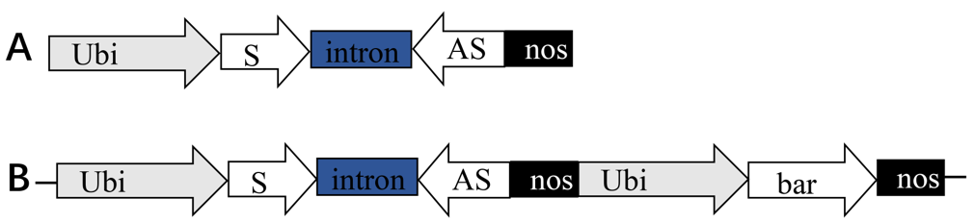

Figure 1 Composition of **pAHC25-*Pina*-RNAi (B) and its linear expression cassette (A); Ubi indicates** the ubiquitin promoter; S is the sense strand, intron is the sequence of intron, AS is the antisense strand, the S, intron and AS constitue the **linear expression cassette**of *Pina*RNAi **sequence for RNA interference;** nos indicates the nos terminator; bar indicates the bialaphos resistance gene sequence.

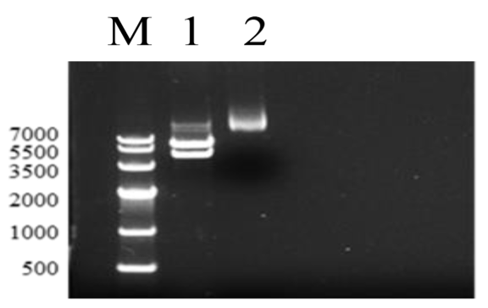

Figure 2 Amplification of linear expression constructs;

Lane M: DNA Marker; Lane 2: original RNAi vector; lane 1: linear expression cassette.

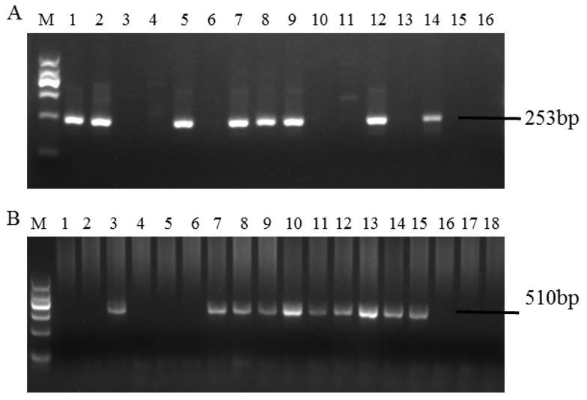

Figure 3 The PCR identification of T0 regenerant plants**;**

A: Detection of semi-nested PCR (D, Nos), lane M: DNA Marker Ⅱ, lane 1-15: transgenic regenerated plants, lane 16: distilled water for negative control;

B: Detection of nested PCR (Inno,D5), lane M: DNA Marker Ⅱ, lanes 1-13: transgenic regenerated plants, lane 18: distilled water for negative control.

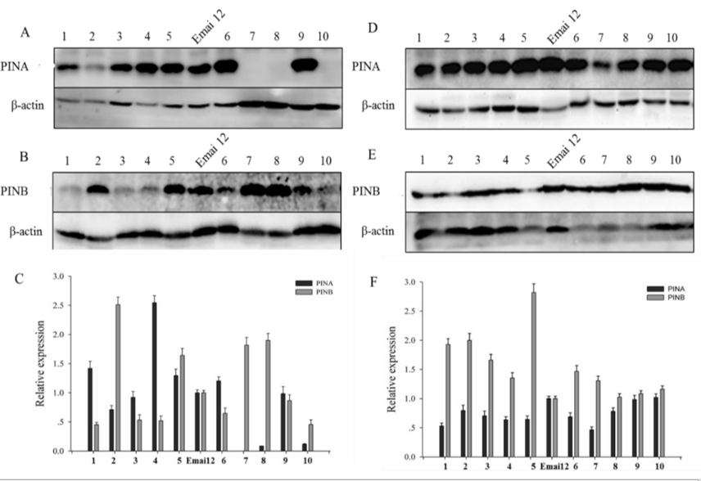

Figure 4 Western blotting analysis of T2 generation transgenic wheat PIN protein expression

A, B and C: Western blotting analysis of PINA (A) and PINB (B) protein and relative quantitative analysis (C) of the two proteins by densitometry in seeds of transgenic line E3 and wild-type, lanes 1-10: Transgenic regenerated plants E3, lane Emai 12: **non-transgenic Emai12;**

D, E and F: Western blotting analysis of PINA (D) and PINB (E) protein and relative quantitative analysis (F) of the two proteins by densitometry in seeds of transgenic line L2 and wild-type, lanes 1-10: transgenic regenerated plants L2, lane Emai 12: **non-transgenic Emai12;**

Table 1 Primer sequences

|  |  |  |  |  |
| --- | --- | --- | --- | --- |
| Primer Name | Primer sequence（5'-3'） | amplicon | annealing temperature | amplification area |
| Inno-F | GGTTCTGAGATAGGGTAAACTCCACT | 704 bp | 61°C | Intron +antisense+ Nos |
| Inno-R | TCATCGCAAGACCGGCAA |
| D5-F | ATGTGCCCGACAAGGCTAGG | 510 bp | 61°C | Intron + antisense + Nos |
| D5-R | TTTATTGCCAAGTGTTTGAACGA |
| D-F | GATCTAGTAACATAGATGAC | 428 bp | 55°C | Intron + antisense +Nos |
| D-R | TTAAATGTATAATTGCGGGACT |
| Nos-F | GATCGTTCAAACATTTGGCA | 253 bp | 57°C | Nos |
| Nos-R | GATCTAGTAACATAGATGAC |

Table 2 The kernel hardness index of T2 transgenic wheat

|  |  |  |  |  |  |  |  |  |
| --- | --- | --- | --- | --- | --- | --- | --- | --- |
| T2 | Hardness | | Weight | | Moisture | | Diameter | |
| Average | Std.Dev. | Average | Std.Dev. | Average | Std.Dev. | Average | Std.Dev. |
| Emai12 | 38.2 | 12.2 | 32.4 | 8.8 | 10.5 | 0.2 | 2.9 | 0.4 |
| VC | 39.7 | 11.5 | 38.1 | 8.7 | 11.1 | 0.3 | 2.8 | 0.3 |
| Luna | 89.2 | 15.2 | 42.1 | 8.7 | 11.2 | 0.3 | 2.5 | 0.3 |
| E1 | 40.5 | 11.8 | 35.9 | 7.2 | 11.1 | 0.2 | 2.8 | 0.3 |
| E2 | 59.4 | 22.1 | 34.9 | 5.9 | 11.3 | 0.2 | 2.7 | 0.2 |
| E3 | 48.6 | 20.5 | 38.5 | 5.9 | 11.2 | 0.2 | 3.0 | 0.2 |
| E4 | 37.5 | 10.7 | 34.7 | 6.8 | 11.5 | 0.3 | 2.8 | 0.3 |
| L1 | 55.1 | 19.5 | 35.2 | 5.5 | 11.3 | 0.2 | 2.8 | 0.2 |
| L2 | 39.2 | 13.3 | 37.2 | 6.2 | 11.1 | 0.3 | 2.9 | 0.2 |
| L3 | 45.9 | 20.7 | 36.4 | 7.1 | 11.6 | 0.3 | 2.7 | 0.3 |