Assessment of the Phytoremediation Potential of Aquatic Macrophytes in the Steel City Area of Jajpur District, Odisha, India

ABSTRACT
This study evaluates the role of pollution-preventing aquatic macrophytes in the industrial zones of Jajpur district, Odisha, India. Surveys were conducted in 2024 across various aquatic habitats within these zones to document aquatic phytodiversity and assess its potential in pollution mitigation. Both extensive and intensive floristic surveys were performed, and voucher specimens were collected and preserved using standard herbarium techniques. A total of 23 aquatic plant species were identified, representing 23 genera and 18 families. These included 7 free-floating, 4 marshy, 7 amphibious, 2 submerged, and 3 fixed-floating species. Quantitative diversity indices were applied to evaluate species richness and distribution. Species richness (S) was 23, indicating a relatively high level of biodiversity. The Shannon-Wiener Diversity Index (H') was calculated at 1.5, suggesting moderate diversity, with certain species showing dominance. Simpson’s Diversity Index (D) was found to be 0.762, indicating a moderately diverse community with a few dominant species. These aquatic plants play a vital ecological role by reducing water pollution, supporting biodiversity, and contributing to the ecological stability of industrial aquatic ecosystems. Additionally, they offer economic and cultural benefits to local communities, reinforcing their importance in sustainable livelihoods. Given the increasing pressure on aquatic habitats from industrial expansion and pollution, conservation of these macrophytes is crucial. Protecting these species ensures the preservation of their ecological functions, particularly in natural water purification and habitat stabilization. Conservation efforts should include habitat protection, pollution control, community awareness, and the integration of aquatic plant biodiversity into local environmental planning. The study underscores the need for further research into the ecological functions, distribution, and conservation of these aquatic plants to enhance pollution management strategies and promote the sustainable use of these valuable bio-resources for future generations.

KEYWORDS: Aquatic macrophytes, Bio-resources, Conservation, Livelihood, Phytoremediation

Introduction
Environmental pollution, driven by anthropogenic activities such as industrial expansion, urbanization, agriculture, and improper waste disposal, has emerged as a critical global concern. Among the various pollutants released into the environment, heavy metals pose a particularly severe threat due to their persistence, bioaccumulation potential, and toxicity. These metals—often discharged from industrial processes, mining operations, and agricultural runoff—can accumulate in terrestrial and aquatic ecosystems, leading to detrimental effects on both biodiversity and human health (Waisberg et al., 2003). The problem is especially pronounced in developing regions, where regulatory oversight and remediation infrastructure are often limited.
In response to the growing challenge of heavy metal contamination, phytoremediation has gained prominence as a sustainable and cost-effective remediation strategy. This approach utilizes plants to remove, stabilize, or degrade environmental pollutants through mechanisms such as phytoextraction, phytodegradation, phytostabilization, phytovolatilization, and rhizofiltration. Aquatic macrophytes, in particular, have demonstrated significant potential in mitigating waterborne pollutants due to their rapid growth, high biomass production, and adaptive tolerance to contaminated environments.
Aquatic ecosystems—comprising freshwater, marine, brackish, and artificial habitats—are ecologically significant zones that support diverse biological communities. In regions such as the Jajpur district of Odisha, freshwater ecosystems are shaped by variations in topography, hydrological cycles, and the physico-chemical properties of soil and water. Aquatic plants, which are morphologically and anatomically adapted to waterlogged conditions, serve as primary producers and play a vital role in nutrient cycling, habitat structure, and water purification (Sahoo & Nayak, 2022). However, the proliferation of invasive aquatic weeds can disrupt ecosystem balance and reduce native biodiversity, necessitating effective management strategies (Jena et al., 2023).
Despite increasing industrial activity and associated water pollution in Jajpur, several aquatic macrophytes in the region exhibit notable tolerance to heavy metals and other contaminants. Prior studies have explored the phytoremediation potential of various aquatic species for removing heavy metals (Odjegba & Fasidi, 2007; Abdulwahid, 2023), synthetic dyes (Tan et al., 2016; Ewadh, 2020; Baldawi et al., 2020), and pharmaceutical residues (Singh et al., 2019; Cerbaro & Rocha, 2022). Sahoo et al. (2024) documented 84 aquatic plant species in the area, yet there remains a lack of targeted research on pollution-preventing aquatic macrophytes specific to this region.
Therefore, the present study aims to conduct a comprehensive floristic survey and diversity analysis of pollution-tolerant aquatic macrophytes in the freshwater ecosystems of Jajpur district, Odisha. The objective is to identify species with phytoremediation potential and promote their conservation for sustainable ecosystem management.

Study area
Jajpur district spread over an area of 2899 sq km in Odisha. Jajpur is located at 85⁰40’E to 86⁰44’E longitude and 20⁰30’N to 21⁰ 10’N latitude. It has various blocks including Bari, Barchana, Binjharpur, Danagadi, Dasarathapur, Dharmasala, Jajpur, Korei, Rasulpur and Sukinda. Among them, Danagadi and Sukinda are famous for its mineral-based industries and mines pockets. The district is rich in minerals like chromite, iron ore, nickel ore, quartzite and pyroxenite. Tata steel,Visa steel, Jindal steel, Nilachal Ispat Nigam Ltd., Mesco steel etc. are the well known mineral based industries located in and arouud this area. Hence this area is popularly known as steel city of the district. The district is facilitated by river Brahmani, Baitarani and their tributaries (Sahoo et al. 2024).

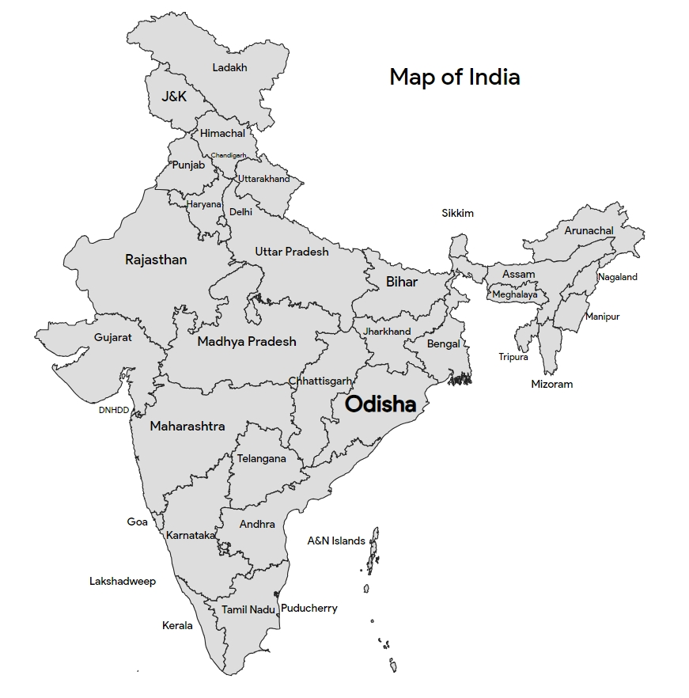

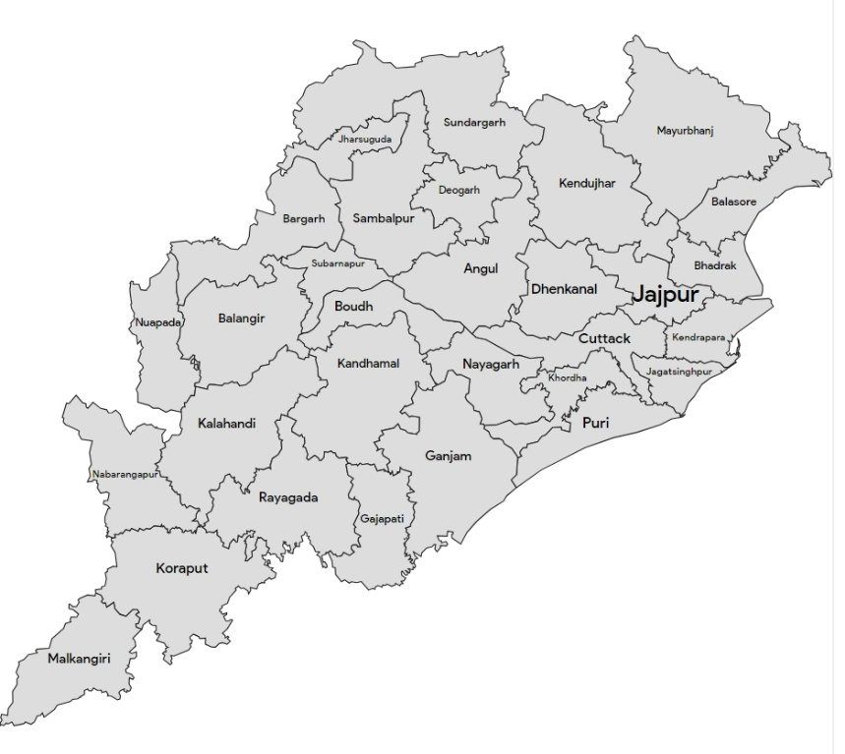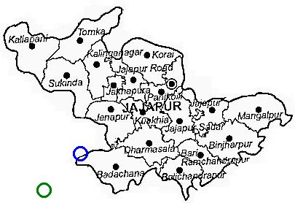

Fig-1 Location of study area

Methodology
Several field trips have been conducted in different seasons of the year 2023 to different aquatic habitats of Jajpur district to collect plant specimens. The steps like identification, processing, drying and herbaria preparation of the specimens were carried out by following standard methods. Plant identification was done by using the Flora of Bihar and Orissa (Haines, 1925) and the Flora of Orissa (Saxena and Brahmam, 1994). The phytoremediation potential of the plant species is reviewed from different published literature. All the voucher specimens of the plant species found have been deposited in the herbarium of N.C. Autonomous College, Jajpur. The plants were classified based on their habitat. Diversity study has also been conducted based on different ecological parameters like species richness, Simpson's Diversity Index (D) and
Shannon-Wiener Diversity Index (H').

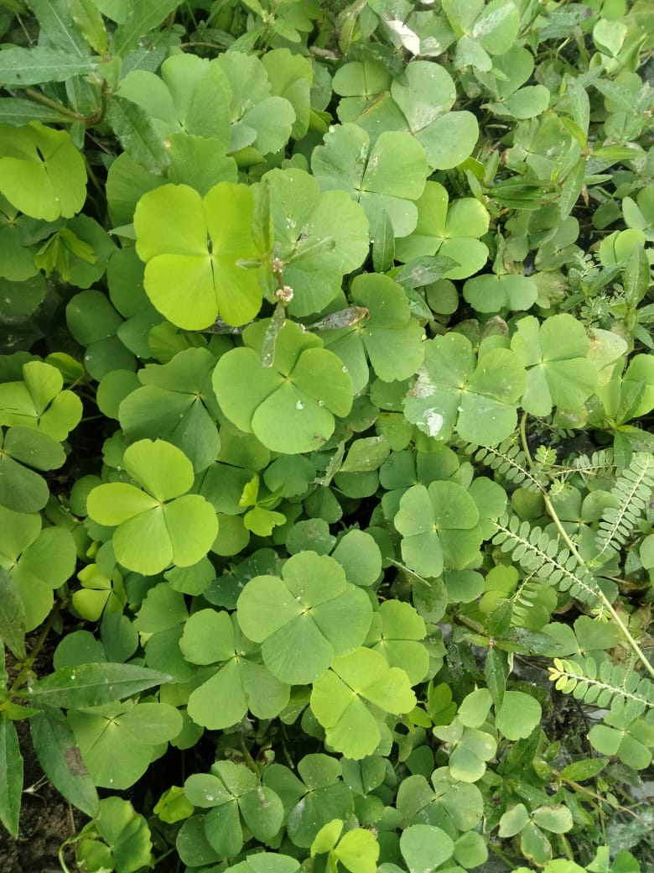  Marsilea quadrifolia L. | 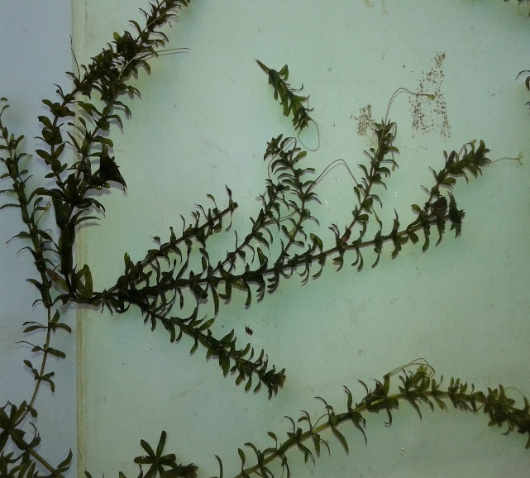  Hydrilla verticillata (L.F.) Royle
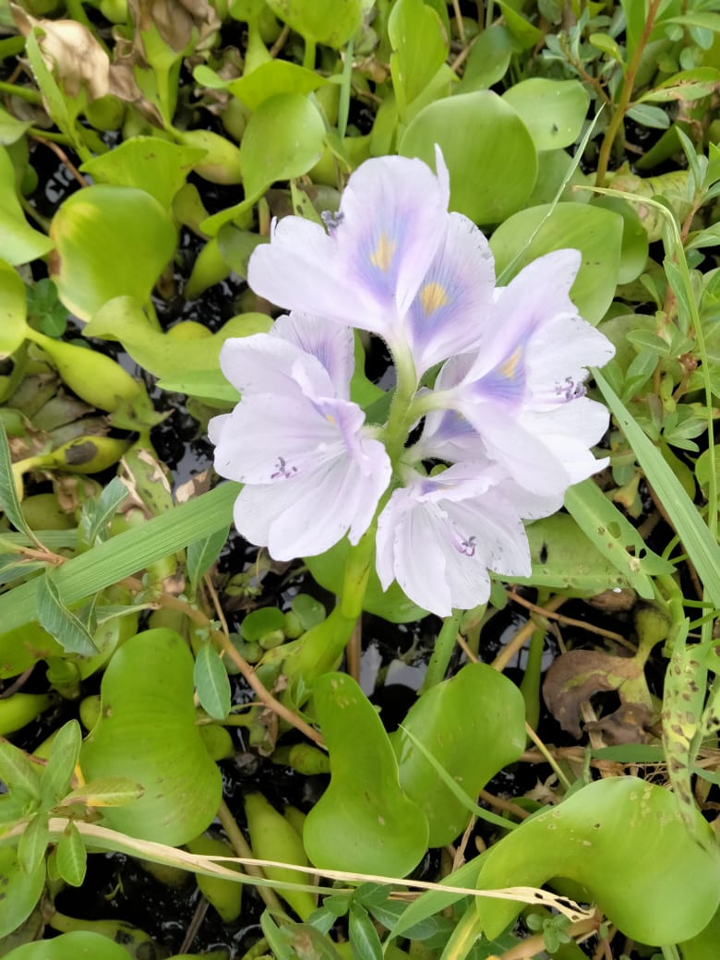  Eichhornia crassipes (Mart.) Solms | 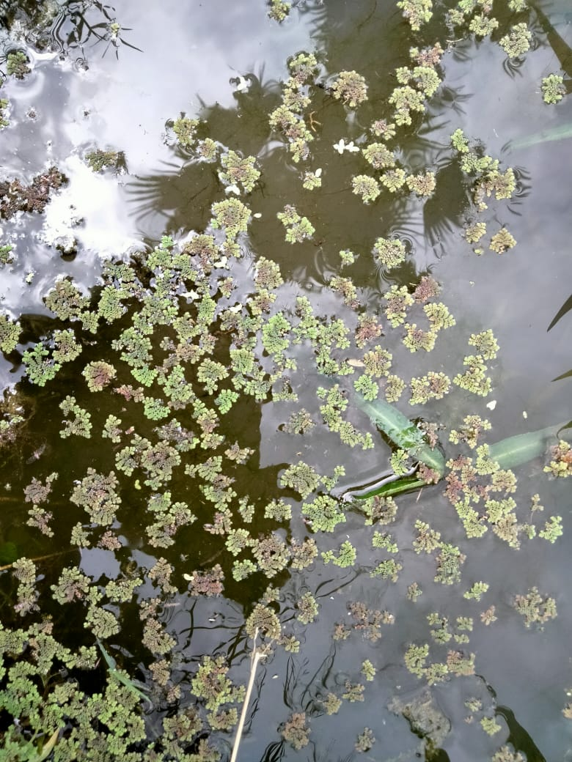  Azolla filiculoides Lam.
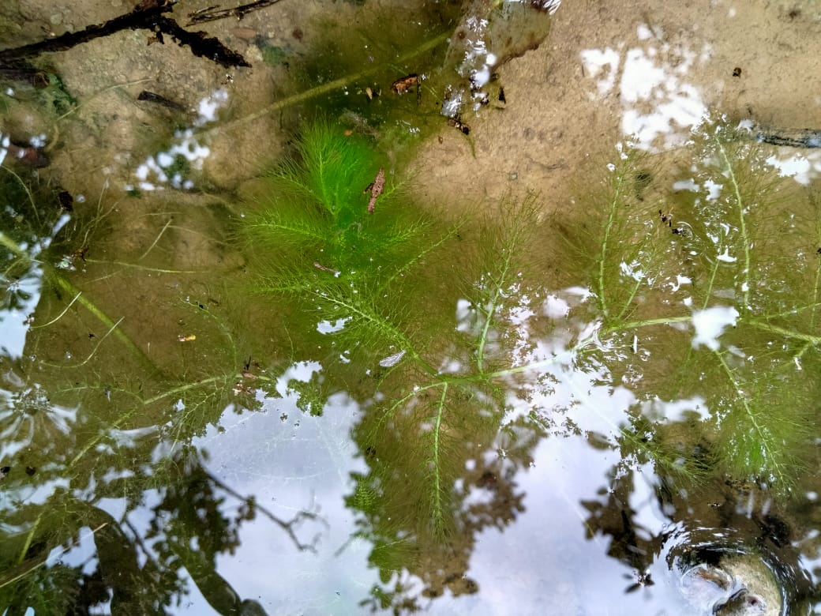  Ceratophyllum demersum L. | 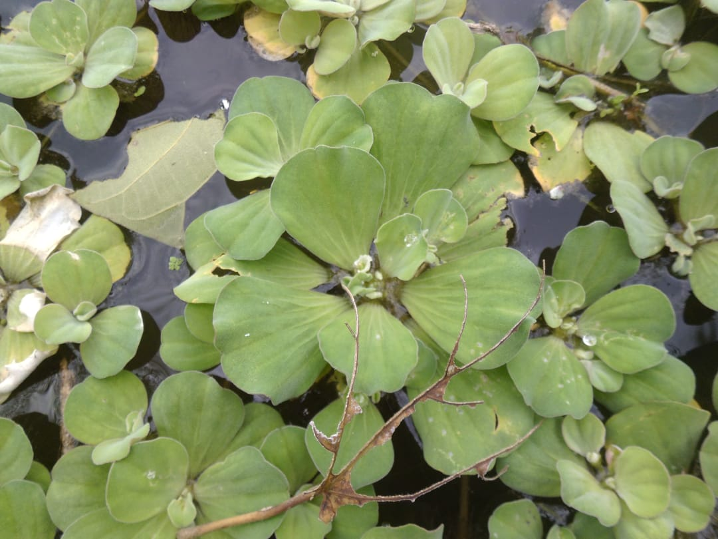  Pistia stratiotes L.

Fig-2 Some pollution-preventing aquatic plants from the study site

Results
Table-1. List of the pollution-preventing aquatic plants from the study site
Sl. No | Plant Group | Plant Name and Family  And Voucher No. | Bioremediation activities
01 | Free floating plants  Free floating plants | Azolla microhylla Kaulf (AZOLLACEAE)  NCACBOT0128 | - Phytoremediation of lead from the aqueous environment (Mishra et. al 2014) and Ni-contaminated water (Biswasi et.al 2014)  - Bioremediation of bio-ethanol wastewater (Annisa et.al 2021)
02 | Free floating plants  Free floating plants | Eichhornia crassipes (Mart.)Solms-Laub (PONTEDERIACEAE)  NCACBOT0135 | - Removal of Cr, Cd, Ag, Ni, Zn, Cu, Pb & Hg (Odjegba and Fasidi 2007) and Sodium Cyanide (Ebel et. al 2007)  - Phytoremediation of Methylene Orange and Methyl Blue(Tan et. al 2016)
03 | Free floating plants  Free floating plants | Pistia stratiotes L. (ARACEAE)  NCACBOT0450 | - It has the ability of phytoremediation of Cd (Das et.al 2014), antibiotics ciprofloxacin (Masiyambir et. al 2023) and herbicide clomazone in water (Escoto et. al 2019)
04 | Free floating plants  Free floating plants | Salvinia molesta D.Mitch  (SALVINIACEAE)  NCACBOT673 | - Can remove Phosphate and Nitrate (Ng, and Chan, 2017).  - Decontamination of Ni, Cu, Pb, Zn, Cd & Fe (George and Gabriel 2017)  - Biodecolorization of methyl orange (Baldawi et. al 2020)
05 | Free floating plants  Free floating plants | Spirodola polyrrhiza (L.) Schleid(LEMNACEAE)  NCACBOT0822 | - Accumulate arsenic (Rahman et.al 2007) and decolorize methylene blue (Manghabati and Pazuki 2014)  - Degradation of antibiotic Ofloxacin (Singh et.al 2019)
06 | Free floating plants  Free floating plants | Wolffia globosa (Roxb.)  Hartog &Plas  (ARACEAE)  NCACBOT1003 | - Potential Cd accumulator (Xie et.al 2013)  - Plant Nutrient remediation (Landesman et.al 2010)  - Removal of benzotriazoles from water (Polińska et.al 2022)
07 | Free floating plants  Free floating plants | Lemna minor L.  (LEMNACEAE)  NCACBOT0357 | - Phytoremediation potential of Ni, Cd, Pb, and Cu (Bokhari et. al 2016)  - Removal of methylene blue (MB) dye (Imron et. al 2019)  - Capacity to remove the antibiotics Amoxicillin (Cerbaro and Rocha 2022)

08 | Submerged plants | Ceratophyllum demersum L.  (CERATOPHYLLACEAE)  NCACBOT0232 | - Phytoremediation can be used to remove methylene blue by the help of Ceratophyllum demersum (Ewadh 2020)  - Phytoremediation of cadmium (Abdulwahid 2023) and antibiotics tetracycline from contaminated water (Ali et.al 2023)
09 | Submerged plants | Hydrilla verticellata (L.f.) Royle  (HYDROCHARITACEAE)  NCACBOT0463 | - Phytoremediation of lead (Hassan et.al 2016); Cr and Cu(Abdul-Alghaffar et.al 2016)  - Removal of metronidazole (Ewadh and Satee 2022)
10 | Marshy plants | Cyperus rotundus L.  (CYPERACEAE)  NCACBOT0301 | - Phytoremediation of cadmium and chromium (Subhashini & Swamy 2014)  - Phytoremediation of fluoride from water (Khandare et. al 2021)  - Soil contaminated by crude oil can be bioremediated (Basumatary et al., 2012).
11 | Marshy plants | Eclipta prostrate (L.) L.  (ASTERACEAE)  NCACBOT0155 | - Nickel accumulation (Chandrasekhar & Ray 2019)
12 | Marshy plants | Vetiveria zizanioides (L.)Nash.  (POACEAE)  NCACBOT0887 | - Phytoremediation of phenol (Sing et. al 2008)  - Heavy metals and inorganic waste removal (Danh et. al 2009)
13 | Marshy plants | Ludwigia peploides (Kunth) P.H. Raven  (ONAGRACEAE)  NCACBOT0364 | - Bioaccumulation of heavy metals (Salawu et. al 2018)  - Hydroponic Phytoremediation of atrazine and lambda-cyhalothrin by hydroponic method (Bouldin et. al 2006)
14 | Amphibious plants | Typha angustata Bory & Chaub.  (TYPHACEAE)  NCACBOT0906 | - Ability of heavy metals removal (Chandra and Yadav 2010)  - Removal of dyes and effluents released from textile industries (Khandar and Govindwar 2015).  - Phytoremediation of pharmaceutical-contaminated wastewater (Li et.al 2020)
15 | Amphibious plants | Polygonum hydropiper L.  (POLYGONACEAE)  NCACBOT0701 | - Treatment of livestock wastewater containing N and P (Zheng et.al 2013)  - Phytoremediation of paddy soil contaminated with manganese (Yang et.al 2018)
16 | Amphibious plants | Aeschynomene indica L.  (FABACEAE)  NCACBOT0111 | - Removal of 2, 4, 6-trinitrotoluene (Kwon et. al 2004)  - Heavy metals (Cd, Pb) (Lee et. al 2007)
17 | Amphibious plants | Alternanthera Philoxeroides  (Mart) Griseb  (AMARANTHACEAE)  NCACBOT0176 | - Phytoremediation of Cd (Yan et. al 2023)  - Treatment of red dye containing sulfonated Remazol (Rane et. al 2015)  - Removal of ibuprofen (Du et. al 2021)
18 | Amphibious plants | Monochoria hastate Solms-Laub.  (PONTEDERIACEAE)  NCACBOT0288 | - Phytoremediation of Cd (Baruah et. al 2017)  - Removal of Arsenic from soil (Islam et. al 2013)
19 | Amphibious plants | Marsilea minuta L.  (MARSILEACEAE)  NCACBOT0662 | - Removal of arsenic from soil and water (Singh et. al 2022)  - Cadmium accumulation (Das et. al 2013)
20 | Amphibious plants | Enydra fluctuans Lour.  (ASTERACEAE)  NCACBOT0196 | - Cu and Pb accumulation and removal (Parven et. al 2022)  - Arsenic accumulation (Shaheen et. al 2006)
21 | Fixed floating plants | Ipomoea aquatica Forssk.  (CONVOLVULACEAE)  NCACBOT0374 | - Removal of Zn, Pb and Cd from polluted soil (Saad 2020)  - Phytoremediation of chromium and manganese (Haokip & Gupta 2021)
22 | Fixed floating plants | Nelumbo nucifera Gaertn.  (NYMPHACEAE)  NCACBOT0889 | - Heavy metals phytoremediation (Hamidian et. al 2016)  - Phytoremediation of phosphorous from domestic wastewater (Thongtha et. al 2014)
23 | Fixed floating plants | Nymphaea nouchali Burm.f  (NYMPHACEAE)  NCACBOT0908 | - Phytoremediation of Vegetable Leachate by Nymphaea nouchali (Mokhtar et. al 2020)

Table-2. Floral statistics of pollution preventing aquatic macrophytes from the study site
Taxa | Plant groups based on their habit
Taxa | Free floating | Submerged | Marshy | Amphibious | Fixed floating
Species | 07 | 02 | 04 | 07 | 03
Genera | 07 | 02 | 04 | 07 | 03
Families | 05 | 02 | 04 | 07 | 02

Statistical analysis
Species richness (S)
It is the total of different species in a given area. It's simply the count of species, without accounting for their abundance(Magurran 2004).
Species count
- Free Floating: 7
- Submerged: 2
- Marshy: 4
- Amphibious: 7
- Fixed Floating: 3
Total Species Richness (S)
Stotal​=7+2+4+7+3=23
Thus, the total species richness (S) is 23.
Table-3 Calculation of Shannon-Wiener Diversity Index (H')
and Simpson's Diversity Index

Plant Group | Species count | Proportion (pᵢ) | ln(pᵢ) | pᵢ×ln(pᵢ) | pᵢ²
Free Floating | 7 | 7/23 | -1.18 | -0.359 | 0.092
Submerged | 2 | 2/23 | -2.44 | -0.212 | 0.007
Marshy | 4 | 4/23 | -1.75 | -0.304 | 0.030
Amphibious | 7 | 7/23 | -1.18 | -0.359 | 0.092
Fixed Floating | 3 | 3/23 | -2.03 | -0.264 | 0.017

Shannon-Wiener Diversity Index (H')
The Shannon-Wiener Diversity Index accounts for both species richness and evenness (the distribution of individuals among species).
The formula for H' is:
H′=−∑(pi​⋅ln(pi​)) (Shannon 1948)
Where:
- pi​ is the proportion of individuals belonging to the i^{th} species in the sample.
- ln (pi) is the natural logarithm of pi​.

Shannon-Wiener Index (H') Calculation
H′=−∑(pi​⋅ln(pi​))= -(-1.498)= 1.5
Thus, H' ≈1.50
Simpson's Diversity Index (D):
The Simpson's Diversity Index is another measure of diversity, but it places more emphasis on the dominance of certain species. The formula for Simpson’s Index is:
D=1−∑(pi²​) (Simpson 1949)
Where:
- pi is the proportion of individuals of the i^{th} species, as with H'.
∑(pi²​) = 0.092+0.007+0.030+0.092+0.017 = 0.238
D= 1 −∑(pi²​) = 1−0.238=0.762

The investigation identified a total of 23 aquatic plant species, which belong to 23 genera and 18 families, in the industrial areas of Jajpur district, Odisha. The monocot flora comprises 10 species, spread across 10 genera and 7 families, while the dicot flora consists of 10 species from 10 genera and 8 families. The Pteridophytes are represented by 3 species from 3 genera and 3 families. Among the plant families, Asteraceae, Araceae, and Pontederiaceae each contribute 2 species, whereas the following families contribute only one species each: Poaceae, Cyperaceae, Ceratophyllaceae, Typhaceae, Nymphaceae, Fabaceae, Onagraceae, Polygonaceae, Lemnaceae, Hydrocharitaceae, Amaranthaceae, Convolvulaceae, Salviniaceae, Marsileaceae and Azolaceae.

Table-1 lists the pollution-preventing aquatic macrophytes identified in the study area, along with their bioremediation activities. This comprehensive overview underscores the significant role of specific species such as Eichhornia crassipes, Pistia stratiotes, and Ceratophyllum demersumetc. in mitigating pollutants like heavy metals, dyes, and pharmaceuticals, highlighting their phytoremediation potential
The habitat-wise distribution of these plant species shows that free-floating and amphibious plants are the most abundant, with each contributing 7 species to the overall community. Marshy plants are the second most numerous, with 4 species, followed by fixed-floating plants (3 species) and submerged plants (2 species), as shown in Table-2. This suggests that free-floating and amphibious plants dominate the aquatic habitats of the region, while other plant forms are less represented.
Species diversity analysis using the Shannon-Wiener Diversity Index (H') yielded a value of 1.5, indicating moderate diversity within the plant community. The Simpson’s Diversity Index (D) was calculated at 0.762, supporting the moderate diversity found in the community, with some species showing dominance over others. Species richness (S) was calculated to be 23, indicating a relatively diverse plant community contributing to the ecological balance of the area.

Discussion
The aquatic plant community documented in the industrial zones of Jajpur district exhibits moderate diversity, as indicated by the Shannon-Wiener Index (H' = 1.5) and Simpson’s Index (D = 0.762). Ecologically, these values suggest a community that is neither highly homogeneous nor highly diverse, with a few species exerting dominance. In polluted environments, such patterns may reflect selective pressure, where only species with higher tolerance to contaminants persist, leading to reduced evenness. Similar trends have been reported in other industrially impacted freshwater systems, such as those studied by Mishra et al. (2018) in eastern India, where pollution-tolerant macrophytes dominated low-diversity assemblages. The presence of free-floating and amphibious species—including Eichhornia crassipes, Pistia stratiotes, and Alternanthera philoxeroides—may indicate their adaptive resilience to fluctuating water quality and pollutant loads. While these species are known for their phytoremediation potential (Odjegba & Fasidi, 2007; Tan et al., 2016), the current study did not directly measure pollutant concentrations or uptake rates. Therefore, claims regarding their tolerance should be interpreted cautiously and warrant further experimental validation.
The observed species richness (S = 23) is relatively high for a polluted aquatic system, suggesting that despite industrial pressures, the ecosystem retains a degree of functional redundancy and ecological resilience. However, without baseline data from less disturbed sites or seasonal comparisons, it is difficult to determine whether this richness reflects long-term stability or short-term variability. Seasonal fluctuations, hydrological changes, and unmeasured pollutant gradients may all influence species composition and abundance.
One limitation of this study is the absence of direct water quality data, which restricts the ability to correlate plant diversity with specific pollutant levels. Additionally, the survey was conducted during a single season, potentially overlooking temporal dynamics in species distribution and community structure. Future studies should incorporate multi-seasonal sampling, physico-chemical water analysis, and controlled experiments to assess pollutant uptake capacities and tolerance thresholds of dominant species.
To build on these findings, future research should focus on:
- Quantifying heavy metal concentrations in water and sediments
- Testing pollutant uptake efficiency of key macrophytes under controlled conditions
- Assessing physiological and biochemical responses of plants to contaminant exposure
- Mapping species distribution across pollution gradients to identify indicator taxa
These insights can inform local conservation strategies, particularly in identifying and protecting pollution-buffering species. Moreover, integrating phytoremediation into aquatic plant management and pollution mitigation programs could offer sustainable solutions for restoring degraded water bodies in industrial regions like Jajpur.

This study documents the diversity and ecological characteristics of aquatic macrophytes in the industrial zones of Jajpur district, Odisha, with a focus on species potentially tolerant to pollution. The plant community exhibited moderate diversity, as indicated by the Shannon-Wiener Index (H' = 1.5) and Simpson’s Index (D = 0.762), suggesting a community shaped by environmental stressors, likely due to industrial contamination. A total of 23 species were recorded, with a dominance of free-floating and amphibious hydrophytes, which are known to thrive in disturbed aquatic habitats.
While the study did not directly measure pollutant uptake, the presence and prevalence of certain species—such as Eichhornia crassipes, Pistia stratiotes, and Alternanthera philoxeroides—suggest their potential resilience to industrial pollutants and their suitability for future phytoremediation research. These findings contribute to a growing body of evidence that aquatic macrophytes can play a role in ecosystem stabilization and pollution buffering, particularly in regions facing rapid industrial expansion.
Importantly, this baseline floristic assessment lays the groundwork for targeted experimental studies on pollutant tolerance and uptake efficiency. It also underscores the need for conservation and management strategies that incorporate pollution-tolerant species into local waterbody restoration efforts. By identifying and protecting these ecologically valuable plants, stakeholders can promote sustainable remediation practices and enhance biodiversity in industrially impacted freshwater ecosystems.

Conclusion

This study documents the diversity and ecological characteristics of aquatic macrophytes in the industrial zones of Jajpur district, Odisha, with a focus on species potentially tolerant to pollution. The plant community exhibited moderate diversity, as indicated by the Shannon-Wiener Index (H' = 1.5) and Simpson’s Index (D = 0.762), suggesting a community shaped by environmental stressors, likely due to industrial contamination. A total of 23 species were recorded, with a dominance of free-floating and amphibious hydrophytes, which are known to thrive in disturbed aquatic habitats.
While the study did not directly measure pollutant uptake, the presence and prevalence of certain species—such as Eichhornia crassipes, Pistia stratiotes and Alternanthera philoxeroides—suggest their potential resilience to industrial pollutants and their suitability for future phytoremediation research. These findings contribute to a growing body of evidence that aquatic macrophytes can play a role in ecosystem stabilization and pollution buffering, particularly in regions facing rapid industrial expansion.
Importantly, this baseline floristic assessment lays the groundwork for targeted experimental studies on pollutant tolerance and uptake efficiency. It also underscores the need for conservation and management strategies that incorporate pollution-tolerant species into local waterbody restoration efforts. By identifying and protecting these ecologically valuable plants, stakeholders can promote sustainable remediation practices and enhance biodiversity in industrially impacted freshwater ecosystems.

Acknowledgment
The authors of the present study are highly grateful to the local people for their kind to provide necessary information during the course of the investigation. The authors are also grateful to the Principal, N.C. Autonomous College, Jajpur, Odisha for the provision of required laboratory facilities to carry out and accomplish this work.

Disclaimer (Artificial intelligence)
Option 1:
Author(s) hereby declare that NO generative AI technologies such as Large Language Models (ChatGPT, COPILOT, etc.) and text-to-image generators have been used during the writing or editing of this manuscript.
Option 2:
Author(s) hereby declare that generative AI technologies such as Large Language Models, etc. have been used during the writing or editing of manuscripts. This explanation will include the name, version, model, and source of the generative AI technology and as well as all input prompts provided to the generative AI technology
Details of the AI usage are given below:
1.
2.
3.

Reference

Abdul-Alghaffar, H. N., & Al-Dhamin, A. S. (2016). Phytoremediation of chromium and Copper from aqueous solutions using Hydrilla verticillata. Iraqi Journal of Science, 57(1A), 78–86.
Abdulwahid, K. D. (2023). Phytoremediation of cadmium pollutants in wastewater by using Ceratophyllum demersum L. as an Aquatic Macrophytes. Water Conservation & Management, 7, 83–88.
Ali, M. F., Ali, Q. A., M-Ridha, M. J., Mohammed, S. J., & Bohan, H. R. (2023). Phytoremediation of tetracycline via the coontail Ceratophyllum demersum in antibiotics-contaminated water. Biocatalysis and Agricultural Biotechnology, 53.
Annisa, K., Sutarno, S., & Santosa, S. (2021). Azolla microphylla and Pseudomonas aeruginosa for bioremediation of bioethanol wastewater. Biodiversitas Journal of Biological Diversity, 22(4).
Baldawi, I. A., Abdullah, S. R. S., Almansoory, A. F., Ismail, N. I., Hasan, H. A., & Anuar, N. (2020). Role of Salvinia molesta in biodecolorization of methyl orange dye from water. Scientific Reports, 10(1).
Baruah, S., Bora, M. S., Sharma, P., Deb, P., & Sarma, K. P. (2017). Understanding of the distribution, translocation, bioaccumulation, and ultrastructural changes of Monochoria hastata plant exposed to cadmium. Water, Air, & Soil Pollution, 228, 1–21.
Basumatary, B., Saikia, R., & Bordoloi, S. (2012). Phytoremediation of crude oil contaminated soil using nut grass, Cyperus rotundus. Journal of Environmental Biology, 33(5).
Biswasi, S. P., Mohanty, M., & Satapathy, K. B. (2014). Phytoremediation of aqueous solutions contaminated with nickel (Ni) by exploitation of Azolla microphylla Kaulf & Salvinia molesta Mitchell: a novel bioseparation process for waste water treatment. Industrial and Environmental Biotechnology, 289–298.
Bokhari, S. H., Ahmad, I., Mahmood-Ul-Hassan, M., & Mohammad, A. (2016). Phytoremediation potential of Lemna minor L. for heavy metals. International Journal of Phytoremediation, 18(1), 25–32.
Bouldin, J. L., Farris, J. L., Moore, M. T., Smith, S., & Cooper, C. M. (2006). Hydroponic uptake of atrazine and lambda-cyhalothrin in Juncus effusus and Ludwigia peploides. Chemosphere, 65(6), 1049–1057.
Cerbaro, K. A., & Da Rocha, R. D. C. (2022). Tolerance and phytoremediation capacity of the Lemna minor in an aqueous medium contaminated by the Amoxicillin. Research, Society and Development, 11(7), e45711730251–e45711730251.
Chandra, R., & Yadav, S. (2010). Potential of Typha angustifolia for phytoremediation of heavy metals from aqueous solution of phenol and melanoidin. Ecological Engineering, 36(10), 1277–1284.
Chandrasekhar, C., & Ray, J. G. (2019). Nickel accumulation, localisation and the biochemical responses in Eclipta prostrata (L.) L. Soil and Sediment Contamination. An International Journal, 28(1), 81–100.
Danh, L. T., Truong, P., Mammucari, R., Tran, T., & Foster, N. (2009). Vetiver grass, Vetiveria zizanioides: a choice plant for phytoremediation of heavy metals and organic wastes. International Journal of Phytoremediation, 11(8), 664–691.
Das, K., Mandal, C., Ghosh, N., Dey, N., & Adak, M. K. (2013). Cadmium accumulation in Marsilea minuta Linn. and its antioxidative responses.
Das, S., Goswami, S., & Talukdar, A. D. (2014). A study on cadmium phytoremediation potential of water lettuce, Pistia stratiotes L. Bulletin of Environmental Contamination and Toxicology, 92, 169–174.
Du, Y. D., Zhang, X. Q., Shu, L., Feng, Y., Lv, C., Liu, H. Q., & Kong. (2021). Safety evaluation and ibuprofen removal via an Alternanthera philoxeroides-based biochar. Environmental Science and Pollution Research, 28, 40568–40586.
Ebel, M., Evangelou, M. W., & Schaeffer, A. (2007). Cyanide phytoremediation by water hyacinths (Eichhornia crassipes). Chemosphere, 66(5), 816–823.
Escoto, D. F., Gayer, M. C., Bianchini, M. C., Da Cruz Pereira, G., Roehrs, R., & Denardin, E. L. (2019). Use of Pistia stratiotes for phytoremediation of water resources contaminated by clomazone. Chemosphere, 227, 299–304.
Ewadh, H. M. (2020). Removal of methylene blue by coontail (Ceratophyllum demersum) using phytoremediation concept. Plant Archives, 20(2).
Ewadh, H., & Satee, S. (2022). The removing of metronidazole using Hydrilla verticillate from water using phytoremediation. In AIP Conference Proceedings (Vol. 2386). AIP Publishing.
George, G. T., & Gabriel, J. J. (2017). Phytoremediation of heavy metals from municipal waste water by Salvinia molesta Mitchell. Haya: The Saudi Journal of Life Sciences, 2, 108–115.
Haines, H. H. (1921). The Botany of Bihar and Odisha (Vol. 1). London: Adlard and Sons and West Newman, Ltd.
Hamidian, A. H., Norouznia, H., & Mirzaei, R. (2016). Phytoremediation efficiency of Nelumbo nucifera in removing heavy metals (Cu, Cr, Pb, As and Cd) from water of Anzali wetland. Journal of Natural Environment, 69(3), 633–643.
Haokip, N., & Gupta, A. (2021). Phytoremediation of chromium and manganese by Ipomoea aquatica Forssk. from aqueous medium containing chromium-manganese mixtures in microcosms and mesocosms. Water and Environment Journal, 35(3), 884–891.
Hassan, N. A., Abdul-Hameed, M., Al-Kubaisi, A. A., & Al-Obiadi, A. M. (2016). Phytoremediation of lead by Hydrilla verticellata Lab. Work. Int J Curr Microbiol App Sci, 5(6), 271–278.
Imron, M. F., Kurniawan, S. B., Soegianto, A., & Wahyudianto, F. E. (2019). Phytoremediation of methylene blue using duckweed (Lemna minor). Heliyon, 5(8).
Islam, M. S., Wahid-Uz-Zaman, M., & Rahman, M. M. (2013). Phytoaccumulation of arsenic from arsenic contaminated soils by Eichhornia crassipes L., Echinochloa crusgalli L. and Monochoria hastata L. International Journal of Environmental Protection, 3(4).
Khandare, R. V., & Govindwar, S. P. (2015). Phytoremediation of textile dyes and effluents: current scenario and future prospects. Biotechnology Advances, 33(8), 1697–1714.
Khandare, R. V., Watharkar, A. D., Pawar, P. K., Jagtap, A. A., & Desai, N. S. (2021). Hydrophytic plants Canna indica, Epipremnum aureum, Cyperus alternifolius and Cyperus rotundus for phytoremediation of fluoride from water. Environmental Technology & Innovation, 21.
Kwon, Y. S., Kim, D. I., Choung, Y. K., Bae, B. H., Lee, I. S., & Chang, Y. Y. (2004). Removal of 2, 4, 6-trinitrotoluene (TNT) by Indigenous Grasses, Abutilon avicennae and Aeschynomene indica, in Hydroponic Culture. Hydroponic Culture, 20, 32–36.
Landesman, L., Fedler, C., Duan, R. (2010). Plant Nutrient Phytoremediation Using Duckweed. In: Ansari, A., Singh Gill, S., Lanza, G., Rast, W. (eds) Eutrophication: causes, consequences and control. Springer, Dordrecht. https://doi.org/10.1007/978-90-481-9625-8_17
Lee, I., Baek, K., Kim, H., Kim, S., Kim, J., Kwon, Y., & Bae. (2007). Phytoremediation of soil co-contaminated with heavy metals and TNT using four plant species. Journal of Environmental Science and Health Part A, 42(13), 2039–2045.
Li, Y., Lian, J., Wu, B., Zou, H., & Tan, S. K. (2020). Phytoremediation of pharmaceutical-contaminated wastewater: Insights into rhizobacterial dynamics related to pollutant degradation mechanisms during plant life cycle. Chemosphere.
Li, Y., Lin, J., Huang, Y., Yao, Y., Wang, X., Liu, C., & Yu. (2020). Bioaugmentation-assisted phytoremediation of manganese and cadmium co-contaminated soil by Polygonaceae plants (Polygonum hydropiper L. and Polygonum lapathifolium L.) and Enterobacter sp. FM-1. Plant and Soil, 448, 439–453.

Magurran, A. E. (2004). Measuring Biological Diversity (Vol. 256). Oxford: Blackwell Publishing.
Manghabati H, Pazuki G.2014. A study on the decolorization of methylene blue by Spirodela polyrrhiza: experimentation and modeling
Masiyambiri, V., Balarabe, B. Y., Adjama, I., Moussa, H., Oumarou, M. N. I., & Sodo, A. M. I. (2023). A study of the phytoremediation process using water lettuce (Pistia stratiotes) in the removal of ciprofloxacin. American Journal of Life Science and Innovation, 2(1), 1–8.
Mishra, M., Pradhan, C., & Satapathy, K. B. (2014). Decontamination of Lead from aquatic environment by exploitation of floating macrophyte Azolla microphylla Kauf. IOSR Journal of Environmental Science, 8(12), 17–23.
Mokhtar, H., Muhamad, N. S., Rahman, N. A., & Ayob, A. (2020). Phytoremediation of Vegetable Leachate by Nymphaea Nouchali. In IOP Conference Series: Earth and Environmental Science (Vol. 616). IOP Publishing.
Naghipour, D., Ashrafi, S. D., Gholamzadeh, M., Taghavi, K., & Naimi-Joubani, M. (2018). Phytoremediation of heavy metals (Ni, Cd, Pb) by Azolla filiculoides from aqueous solution: A dataset. Data in Brief, 21, 1409–1414.
Ng, Y. S., & Chan, D. J. C. (2017). Wastewater phytoremediation by Salvinia molesta. Journal of Water Process Engineering, 15, 107–115.
Odjegba, V. J., & Fasidi, I. O. (2007). Phytoremediation of heavy metals by Eichhornia crassipes. The Environmentalist, 27, 349–355.
Parven, S., De, A., & Gupta, A. (2022). Cu and Pb accumulation and removal from aqueous medium by Enydra fluctuans Lour.(Asteraceae)-a medicinal plant with potential for phytoremediation. Environmental Science and Pollution Research, 29(44), 66902–66912.
Polińska, W., Piotrowska-Niczyporuk, A., Karpińska, J., Struk-Sokołowska, J., & Kotowska, U. (2022). Mechanisms, toxicity and optimal conditions-research on the removal of benzotriazoles from water using Wolffia arrhiza. Science of The Total Environment, 847.
Rahman, M. A., Hasegawa, H., Ueda, K., Maki, T., Okumura, C., & Rahman, M. M. (2007). Arsenic accumulation in duckweed (Spirodela polyrhiza L.): a good option for phytoremediation. Chemosphere, 69(3), 493–499.
Rane, N. R., Chandanshive, V. V., Watharkar, A. D., Khandare, R. V., Patil, T. S., Pawar, P. K., & Govindwar, S. P. (2015). Phytoremediation of sulfonated Remazol Red dye and textile effluents by Alternanthera philoxeroides: an anatomical, enzymatic and pilot scale study. Water Research, 83, 271–281.
Saad, F. N. M., Lim, F. J., Izhar, T. N. T., & Odli, Z. S. M. (2020). Evaluation of phytoremediation in removing Pb, Cd and Zn from contaminated soil using Ipomoea aquatica and Spinacia Oleracea. In IOP Conference Series: Earth and Environmental Science (Vol. 476). IOP Publishing.
Saheen R, Mitra N, Mahmud R.2006. Assessment of Arsenic Accumulation Efficiency by Selected Naturally Grown Weeds. Int. J. Sustain. Crop Prod. 1(1): 24-31.
Sahoo S, Jena M.K, Bagartee D, Pradhan M.K. 2024. Asian Jr. of Microbiol. Biotech. Env. Sc. Vol. 26, No. (2): 284-289
Sahoo, S., & Nayak, R. K. (2022). Studies on Invasive Alien Aquatic species in Jajpur District of Odisha, India. India. Eco. Env. & Cons, 28, S309–S312.
Salawu, M. O., Sunday, E. T., & Oloyede, H. O. B. (2018). Bioaccumulative activity of Ludwigia peploides on heavy metals-contaminated water. Environmental Technology & Innovation, 10, 324–334.
Saxena, H. O. M. (1996). The Flora of Orissa. In I-IV. Orissa Forest Development Corporation (Ed.), The Flora of Orissa.
Shannon, C.E. (1948) A Mathematical Theory of Communication. The Bell System Technical Journal, 27, 379-423. https://doi.org/10.1002/j.1538-7305.1948.tb01338.x
Simpson, E. H. (1949). Measurement of diversity. Nature, 163(4148), 688–688. doi:10.1038/163688a0
Singh, R., Sharma, A., Goswami, P., Pradhananga, D., Aryal, D., Pradhanang, S. M., & Kumar, R. (2023). Phytoremediation of Organic Contaminants: An Eco-friendly Approach-Based Application of Aquatic Macrophytes. In Aquatic Macrophytes: Ecology, Functions and Services (pp. 175–205). Singapore; Singapore: Springer Nature.
Singh, S., Karwadiya, J., Srivastava, S., Patra, P. K., & Venugopalan, V. P. (2022). Potential of indigenous plant species for phytoremediation of arsenic contaminated water and soil. Ecological Engineering, 175.
Singh, S., Melo, J. S., Eapen, S., & Dsouza, S. F. (2008). Potential of vetiver (Vetiveria zizanoides L. Nash) for phytoremediation of phenol. Ecotoxicology and Environmental Safety, 71(3), 671–676.
Singh, V., Pandey, B., & Suthar, S. (2019). Phytotoxicity and degradation of antibiotic ofloxacin in duckweed (Spirodela polyrhiza) system. Ecotoxicology and Environmental Safety, 179, 88–95.
Subhashini, V., & Swamy, A. V. V. S. (2014). Phytoremediation of cadmium and chromium contaminated soils by Cyperus rotundus L. Am Int J Res Sci Technol Eng Math, 6, 97–101.
Sundararaman, S., Kumar, P., Deivasigamani, P., Jagadeesan, A. K., Devaerakkam, M., Al-Hashimi, A., & Choi, D. (2021). Assessing the plant phytoremediation efficacy for Azolla filiculoides in the treatment of textile effluent and redemption of congo red dye onto Azolla biomass. Sustainability, 13(17).
Tan, K. A., Morad, N., & Ooi, J. Q. (2016). Phytoremediation of methylene blue and methyl orange using Eichhornia crassipes. International Journal of Environmental Science and Development, 7(10).
Thongtha, S., Teamkao, P., Boonapatcharoen, N., Tripetchkul, S., Techkarnjararuk, S., & Thiravetyan, P. (2014). Phosphorus removal from domestic wastewater by Nelumbo nucifera Gaertn. and Cyperus alternifolius L. Journal of Environmental Management, 137, 54–60.
Tizro, N., Saeb, K., & Wani, A. K. (2022). Phytoremediation of organophosphorus pesticides from aqueous media using Azolla filiculoides (Case study: Anzali Wetland). Biomedical Journal of Scientific & Technical Research, 45(5), 36848–36852.
Waisberg M, Joseph P, Hale B, Beyersmann D.(2003). Molecular and cellular mechanismsof cadmium carcinogenesis, Toxicology, Volume 192, Issues 2–3, Pages 95-117, https://doi.org/10.1016/S0300-483X(03)00305-6.
Xie, W. Y., Huang, Q., Li, G., Rensing, C., & Zhu, Y. G. (2013). Cadmium accumulation in the rootless macrophyte Wolffia globosa and its potential for phytoremediation. International Journal of Phytoremediation, 15(4), 385–397.
Yan, D., Xue, S., Zhang, Z., Xu, G., Zhang, Y., Shi, Y., & Zhang. (2023). Physiological changes and antioxidative mechanisms of Alternanthera philoxeroides in phytoremediation of cadmium. Environment & Health, 1(2), 90–101.
Yang, Qw., Ke, Hm., Liu, Sj. et al. (2018). Phytoremediation of Mn-contaminated paddy soil by two hyperaccumulators (Phytolacca americana and Polygonum hydropiper) aided with citric acid. Environ Sci Pollut Res 25, 25933–25941 https://doi.org/10.1007/s11356-018-2647-1
Zheng, Z. C., Li, T. X., Zeng, F. F., Zhang, X. Z., Yu, H. Y., Wang, Y. D., & Liu, T. (2013). Accumulation characteristics of and removal of nitrogen and phosphorus from livestock wastewater by Polygonum hydropiper. Agricultural Water Management, 117, 19–25.

