Original Research Article

Morpho- physiological and biochemical screening of advanced grass pea lines for drought stress tolerance

ABSTRACT

Drought stress significantly affects the growth, physiology, and yield of leguminous crops like grass pea (Lathyrus sativus L.). This study evaluated the drought tolerance of five grass pea genotypes (GM-04, GM-02, GM-03, BARI Khesari-2, and BINA Khesari-2) under three water regimes: control, 60%, and 40% field capacity. Key physiological traits—chlorophyll content (SPAD), proline and soluble sugar levels, oxidative stress (MDA), and yield components were analyzed. GM-04 statistically outperformed other genotypes, maintaining higher SPAD values, increased proline and sugar accumulation, and lower MDA levels under stress, indicating effective osmotic adjustment and oxidative stress tolerance. It also achieved the highest yield under both moderate and severe drought, reflecting superior water-use efficiency. In contrast, BINA Khesari-2 showed poor drought response, with significant physiological damage and yield decline. These results suggest GM-04 as a promising drought-tolerant genotype suitable for cultivation in water-limited areas and valuable for breeding programs aimed at enhancing grass pea resilience to climate stress.

Key words: Genotype, drought, physiological, biochemical analysis, yield

1. INTRODUCTION

A significant food crop, pulses are an excellent source of readily digested protein for diet. A human should consume 80 g head-1 day-1 of pulses at minimum, but in Bangladesh, the amount consumed is only 14.19 g (BBS, 2024). Different varieties of pulse crops are cultivated in Bangladesh. Among these, cowpea, lentil, blackgram, mungbean, chickpea, and grass pea are highly significant. The grass pea (Lathyrus sativus L.), often known as khesari, is an important pulse crop in Bangladesh. It belongs to the Leguminosae family's Papilionaceae subfamily. In Bangladesh, it is widely consumed as a common pulse and is the most significant pulse crop in terms of area (6,02,000 acres) and production (1,77,000 m. ton) (BBS, 2024). Grass pea (Lathyrus sativus L.) confers several advantageous traits, such as an exceptionally high nutritional value (Solovyeva et al., 2020), the capacity to fix nitrogen (Lambein et al., 2019), resistance to temperature extremes (Dixit et al., 2016), moderate water logging tolerance (Solaiman et al., 2007), and low soil fertility. The high seed protein content of grass peas (20–32%) makes them suitable for human consumption (Savage et al., 1989). Grass peas offer a viable alternative to high-protein legumes like beans and peas that require better growing conditions. They also serve as excellent green manure, adding significant nitrogen and biomass to the soil when plowed in (Jeromela et al., 2017). Grass pea production also serves as the elements include nodulation, stress tolerance, nitrogen fixation, and plant growth promotion through mechanisms like nutrient mobilization and phytohormone production (Mohammed et al., 2020). Compared to other grass pea-growing countries, Bangladesh’s average yield is very low at 0.73 t/ha (BBS, 2024). This low yield results from various factors, with drought being a major constraint affecting crop development, growth, and productivity. Water shortage negatively impacts plant development, average yield, and crude protein content in legumes, with the flowering stage being the most vulnerable to water stress (Golakiya and Patel, 1992, Jan et al., 2025). A number of morphological and physiological characteristics of grass peas, including as their deep and extensive root system, winged-edged stems, small leaves, and excellent water usage efficiency, set them apart from other legumes (Lambein et al., 2019). Grass pea’s xerophytic traits help it tolerate drought and access water from diverse soils, but water scarcity—especially post-flowering—can drastically reduce growth and seed yield (Gusmao et al., 2012). Despite this, the physiological mechanisms underlying its drought tolerance are not well understood. Under water stress, many plants show morphological and physiological changes, such as reduced leaf area (Bangar et al., 2019), higher water retention (Anyia and Herzog, 2004), and accumulation of osmolytes like soluble sugars and proline, which aid osmotic adjustment (Nadeem et al., 2019; Tokarz et al., 2020). Because the mechanisms of plant species' resistance to water stress vary greatly genetically within and between species (Obata et al., 2015), little research has been done on the significance of these responses and how they relate to production and growth metrics. For instance, agronomic parameters in wheat were found to be weekly correlated with increased proline concentration (Mwadzingeni et al., 2016). Additionally, transgenic chickpea (Cicer arietinum) lines that overexpressed the proline gene did not show increased biomass in their shoots (Mathur et al., 2009). In addition to being a crop with significant agricultural potential for human and animal nutrition, grass peas can be helpful in research on plant drought resilience (Choudhary et al., 2016). According to Korte et al., (1983), the timing of the occurrence matters more than the severity of the water stress. Any moment during the reproductive growth process, water stress can have a significant impact on seed output. Throughout stem elongation and flowering, many seed crops are most vulnerable to water deficits (Zebarjadi et al., 2012). To comprehend how the grass pea plant resists water deficiency stress, basic study on the mechanisms of drought resistance is crucial., The creation of crops resistant to drought will become more crucial as water resources become more limited (Choudhary and Suri, 2014a). In view of the above circumstances, the current research aimed to conduct with the following objectives: To screen the advanced grass pea lines on physiological characteristics under drought stress condition and to generate information of best grass pea lines tolerant to drought for breeders.

2. material and methods

2.1. Plant Material and Treatment
On the basis of yield and yield contributing characters, five salt-tolerant genotypes (G 13, G 20-1, G 9, G 22, G 20-2), one susceptible (G 24) genotype and one check variety of wheat BARI ghom 25 (high yielding, salt-tolerant) were used as planting materials for this experiment. The experiments of this study were conducted at the Laboratory of Department of Agronomy, Bangabandhu Sheikh Mujibur Rahman Agricultural University (BSMRAU), Gazipur 1706, and Bangladesh. Sodium hypochlorite @ 2.5% was used for seed sterilization. After being germinated on filter paper in Petri plates, four seedlings were transplanted to plastic pots (20 L). The seedlings were nourished with full strength Hoagland nutrient solution, as stated by Hoagland and Arnon (1950). Thirty days after sowing (DAS), different salt treatments (4, 8 and 12 dS m−1) were applied by a modified Hoagland solution during the whole period of study. Only Hoagland’s nutrient solution was provided to control plants. Therefore, the treatment combinations were control (0 dS m−1); 4 dS m−1 NaCl; 8 dS m−1 NaCl and 12 dSm−1 NaCl. The experimental pots were positioned in a completely randomized design with five replications.
2.2. Assessment of Yield Contributing Parameters and Yield
The wheat was harvested at maturity. Yield data were recorded from each pot. Plant height was measured by scale after harvest. Total tillers and effective tiller number plant−1 were counted from five plants per replication of each genotype of all the treatments. Then the number was computed to per plant. Spikes from five harvested plants of each replication were taken and the total number of spikelet was counted and averaged per spike. Wheat grains yield was recorded on a 14% moisture basis.
2.3. SPAD Value Determination
SPAD value was measured by using SPAD 502 Plus Chlorophyll Meter.
2.4. Proline content Determination
Proline content was measured as described previously by Bates et al., (1973).
2.5. Soluble Sugar Determination
Soluble sugar content was measured according to Yoshida et al.,(1976). Soluble protein content was determined as described previously by Lowry et al., (1951).
2.6. Determination of Melondealdehyde (MDA)
Hydrogen peroxide (H2O2) was estimated as described previously by Velikova et al., (2000). Malondialdehyde (MDA) was estimated as described previously by Rao et al., (2000) [89].
2.7. Statistical Analysis
RStudio software was used for statistical evaluation of the collected data. The data were analyzed using the analysis of variance (ANOVA) technique and comparison of the mean difference was carried out by the least significant difference (LSD) test with a 5% level of significance.

3. results and discussion

3.1 SPAD Value of Five Genotypes under Different Water Stress Condition:
Measuring SPAD values, reflecting chlorophyll content, is crucial for assessing grasspea’s drought response as chlorophyll supports photosynthesis and plant health. Our study revealed significant genotypic differences in SPAD under drought, with GM-04 showing the highest chlorophyll retention both under control (59.07) and moderate stress (62.67 at 60% field capacity), while BINA Khesari-2 had the lowest (46.09). These findings, consistent with Rahbarian et al. (2011) and Aloui et al. (2023), highlight GM-04’s superior ability to maintain photosynthetic efficiency and drought tolerance Monteoliva et al., (2021) and Khatun et al., (2021), who found that drought stress typically leads to a reduction in chlorophyll content, with more tolerant genotypes retaining higher chlorophyll concentrations At severe drought (40% field capacity), all genotypes showed a significant decline in SPAD values, confirming the negative effect of water stress on chlorophyll content. However, GM-04 maintained better chlorophyll retention, indicating superior drought tolerance, consistent with Rahbarian et al. (2011) who identified chlorophyll maintenance as key for drought resilience.
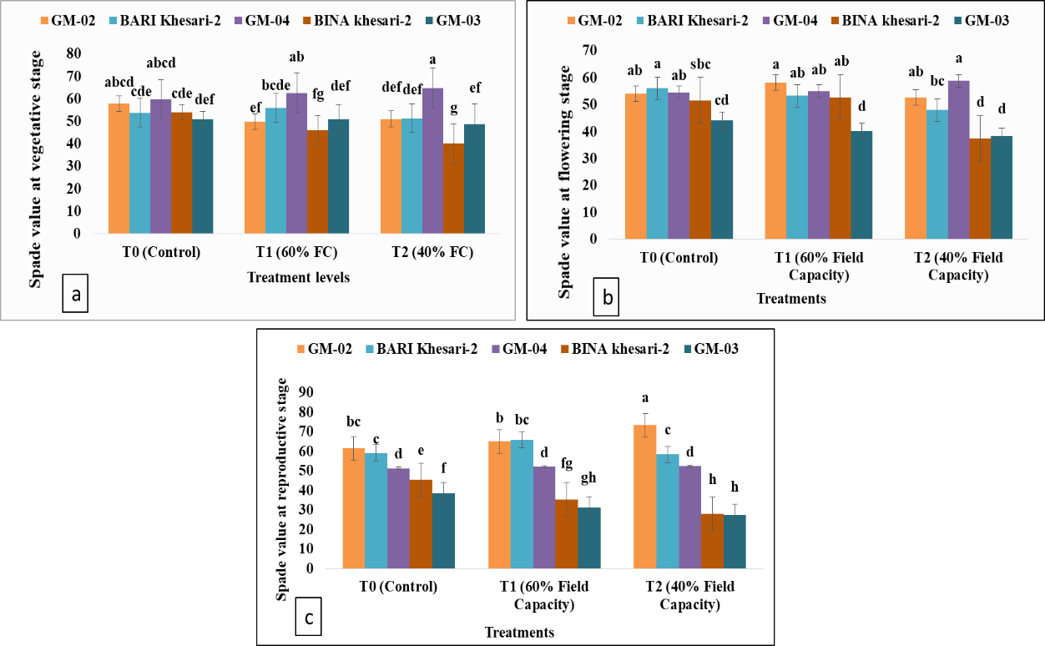
Fig 1. SPAD value of five genotypes at (a) vegetative, (b) flowering and (c) Reproductive stage as affected by variable drought levels.
GM-04’s stable SPAD during flowering and reproduction supports sustained photosynthesis, unlike more variable readings in sensitive genotypes like GM-03. Higher SPAD values correlate with drought tolerance, plant health, and yield potential, aligning with Hassan et al. (2019) on chlorophyll’s role in biomass and seed production under drought.
3.2 Accumulation of Melondealdehyde (MDA) Content
This study shows that MDA content, an indicator of lipid peroxidation and oxidative stress, varies significantly among genotypes under drought. Under control conditions, all genotypes had similar baseline MDA levels. However, under moderate water stress, GM-04 exhibited the lowest MDA content (0.13 nmol g⁻¹ FW), indicating greater oxidative damage tolerance compared to GM-03 and GM-02. Under severe drought (40% field capacity), GM-04 again maintained the lowest MDA (0.12 nmol g⁻¹ FW), highlighting its drought resilience. These findings align with recent research linking lower MDA levels to enhanced drought tolerance through better oxidative stress management (Jiang et al., 2013; Mirzai et al., 2013). In contrast, genotypes such as GM-03 and GM-02, which accumulated higher MDA levels under stress, likely suffered greater oxidative damage, indicative of reduced stress tolerance. These findings align with previous research suggesting that plants with efficient antioxidant systems, which minimize ROS-induced lipid peroxidation, tend to show improved drought resistance (Hussain et al., 2019). The ability of GM-04 to sustain lower MDA concentrations even under severe water stress underscores its potential as a promising drought-tolerant genotype, highlighting the importance of oxidative damage management in enhancing stress resilience. Further research on antioxidant enzyme activities and genetic factors could provide deeper insights into the mechanisms behind these observations.
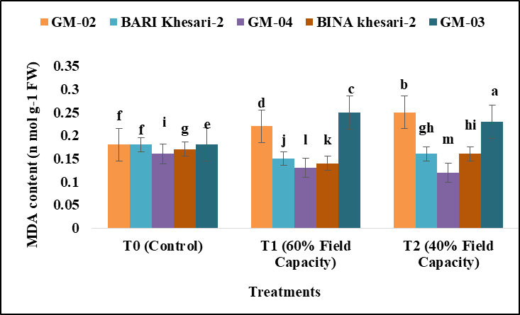
Fig 2. Malondealdehyde (MDA) content at flowering stage as affected by variable drought levels.
3.3 Soluble Sugar Accumulation as a Mechanism for Drought Stress Tolerance in Grass pea
Soluble sugar accumulation plays a critical role in enabling plants to adapt to drought stress. During water deficit conditions, plants undergo various biochemical and physiological adjustments to mitigate stress, and the accumulation of soluble sugars such as sucrose, glucose, and fructose is a key response. These sugars serve multiple functions, including osmotic adjustment, stabilization of cellular structures, and protection against oxidative stress, all of which are vital for maintaining plant integrity under drought stress (Salehi-Lisar et al., 2016; Kumar et al., 2018).
In the current study, at control conditions (100% field capacity, FC), the highest soluble sugar content was observed in the genotypes GM-04 (36.83 mg g⁻¹ FW), GM-02 (34.13 mg g⁻¹ FW), and BARI Khesari-2 (31.43 mg g⁻¹ FW). These values reflect the natural genetic variability in soluble sugar accumulation under optimal growth conditions, consistent with previous findings indicating genotype-specific differences in sugar metabolism (Ye et al., 2018). In contrast, the lowest soluble sugar content was recorded in Binakheshari-2 (26.5 mg g⁻¹ FW), which suggests a relatively lower baseline sugar accumulation capacity in this genotype.
Fig 3. Soluble sugar content at flowering stage as affected by variable drought levels.

At moderate water stress conditions (60% FC), the highest soluble sugar accumulation was observed in GM-04 (39.93 mg g⁻¹ FW), followed by GM-02 (37.23 mg g⁻¹ FW), reflecting their better drought adaptability. This is in agreement with recent studies where high soluble sugar accumulation was linked to enhanced drought tolerance in legumes (Bashir et al., 2021). BINA Khesari-2 showed the lowest soluble sugar content (25.27 mg g⁻¹ FW), reflecting limited sugar accumulation and reduced drought tolerance. GM-03 had moderate levels (32.13 mg g⁻¹ FW), suggesting intermediate drought resilience. Under severe drought (40% FC), similar patterns emerged, with GM-04 maintaining the highest sugar content. This consistency highlights GM-04’s strong drought tolerance, likely linked to efficient osmotic adjustment mechanisms (Abobatta 2019). In contrast, Binakheshari-2 continued to exhibit the lowest soluble sugar content, reinforcing its vulnerability to severe water stress.
These findings align with recent research showing that soluble sugar accumulation is a key drought survival strategy. Higher sugar levels under stress enhance drought resilience by aiding osmotic regulation, protecting membranes, and scavenging reactive oxygen species (ROS) (Abobatta 2019; Kumar et al., 2018). The genotypic differences observed in this study underscore the potential for breeding drought-tolerant grasspea varieties with improved soluble sugar accumulation.
3.4 Proline Accumulation as a Mechanism for Drought Stress Tolerance in Grass pea at Flowering Stage
Under control conditions (100% field capacity), all Grass pea genotypes exhibited similar levels of proline accumulation, suggesting no significant variation in their baseline physiological responses. However, under moderate drought stress (60% field capacity), the genotype GM-04 displayed the highest proline accumulation, followed closely by GM-02. In contrast, the lowest proline accumulation was observed in GM-03, followed by BINA Khesari-2 and BARI Khesari-2. These genotype-dependent differences highlight the role of proline metabolism in coping with moderate water deficit, consistent with findings from other drought-tolerant legumes, where proline serves as an essential osmoprotectant, stabilizing proteins and cellular membranes during stress (Nahar et al., 2016).
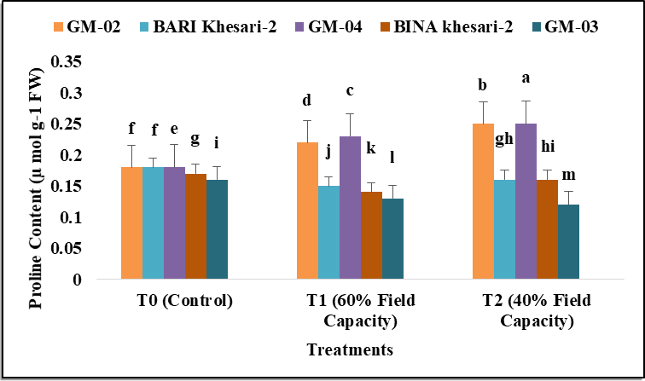
Fig 4. Proline content at flowering stage as affected by variable drought levels.
Under severe drought (40% field capacity), GM-04 showed the highest proline accumulation, significantly surpassing GM-02. GM-03 had the lowest levels, followed by BINA Khesari-2 and BARI Khesari-2, highlighting GM-04's superior resilience. Proline accumulation under drought is a well-known adaptive response, aiding in oxidative stress protection, cellular integrity maintenance, and osmoregulation (Trovato et al., 2019). This observation aligns with recent studies highlighting the importance of proline in enhancing drought tolerance in various legume species (Sabbioni et al., 2022; Hosseinifard et al., 2022).
This study highlights proline accumulation as a key drought tolerance mechanism in grasspea, especially during the critical flowering stage. Genotypes like GM-04, with consistently higher proline levels under moderate and severe drought, show strong adaptive responses to water stress. This agrees with recent work by Tokarz et al. (2022), who found that increased proline accumulation in drought tolerant Lathyrus genotypes correlates with improved water-use efficiency and reproductive outcomes under water-limited environments. Moreover, other studies have shown that proline, along with other compatible solutes, contributes to mitigating the detrimental effects of oxidative stress and improving plant survival under drought (Goncalves et al., 2022).
3.5 Effect of Drought on Yield and Yield Contributing Characters of Grass Pea
The results from this study demonstrate how varying levels of water stress affect the growth and yield attributes of five genotypes (GM-03, GM-04, BARI Khesari-2, GM-02, and BINA Khesari-2) (Table-1). Differences in traits like days to maturity, plant height, branches, pods, 1000-seed weight, and yield highlight the strong influence of water availability on crop performance. GM-04 emerged as the most resilient genotype, maintaining the highest yield, plant height, branches, and seed weight across all treatments. Although yield declined under stress, GM-04 showed the smallest reduction, indicating superior water-use efficiency and better drought tolerance, making it well-suited for cultivation in water-scarce regions. This is in line with findings from Blum et al., (2010), who emphasized that genotypes capable of maintaining high yield under moderate water stress have inherent drought tolerance mechanisms, such as improved root systems and osmotic regulation, which help conserve water and nutrients. Grass pea is a hardy legume suited to marginal areas, but its yield is highly sensitive to environmental conditions during key growth stages. Optimizing sowing time and understanding weather effects, particularly from flowering to pod development, are crucial for maximizing pod set and seed yield. (Ghosh, 2020).
GM-03, on the other hand, demonstrated the lowest performance under severe water stress, with reductions in plant height, pod number, and seed weight. Such results reflect the well-documented response of many crops to drought stress, where reduced water availability impairs cell elongation and reproductive processes, leading to stunted growth and reduced yield (Blum, 2011). The reduced number of pods and lower 1000-seed weight observed in GM-03 under extreme stress is a direct consequence of decreased photosynthesis and nutrient allocation to the reproductive organs (Bhattacharya et al., 2021). This is consistent with the work of Araus et al., (2008), who found that water stress often results in smaller seeds and fewer pods, particularly in genotypes with less efficient water use and drought resistance traits.
In contrast, BARI Khesari-2 and BINA Khesari-2 exhibited lower yields and a reduced number of branches and pods under both moderate and severe water stress. The lower branching capacity observed in BARI Khesari-2 suggests it has a poor ability to adapt to water stress, as branching is closely related to photosynthetic capacity and resource allocation (Song et al., 2019). The limited ability to produce pods under water stress conditions, as seen in BINA Khesari-2, could be attributed to a combination of reduced pollination success and impaired seed set, both of which are common under drought stress (Boyer, 1982). These findings highlight those genotypes such as GM-04, which can better maintain reproductive processes, are more likely to sustain higher yields in water-limited environments.
Variety | Treatments | DM | PH (cm) | No of branch | No of pods/ plant | 1000 Seed wt. (g) | yield /Plant (g)
GM-02 | T0 | 110 b | 40.00 a | 11.00 bc | 31.67 ab | 81.95 b | 3.59 c
GM-02 | T1 | 105 e | 38.67 ab | 10.00 bcdef | 23.67 bcd | 70.21 e | 3.38 e
GM-02 | T2 | 98 j | 31.00 d | 8.67 defgh | 16.33 de | 75.82 c | 3.25 d
BARI Khesari-2 | T0 | 108 d | 40.33 a | 8.33 efgh | 35.00 ab | 72.58 d | 3.47 f
BARI Khesari-2 | T1 | 105 e | 33.33 bcd | 7.00 gh | 25.33 bcd | 70.33 e | 3.16 h
BARI Khesari-2 | T2 | 97 k | 30.33 d | 6.67 h | 17.00 cde | 70.82 e | 3.14 g
GM-04 | T0 | 101 h | 40.00 a | 13.33 a | 43.00 a | 86.23 a | 3.97 a
GM-04 | T1 | 101 h | 39.33 ab | 11.33 ab | 40.67 ab | 85.34 a | 3.67 b
GM-04 | T2 | 99 i | 30.00 d | 11.00 bc | 35.00 ab | 86.15 a | 3.81 c
BINA khesari-2 | T0 | 104 f | 42.67 a | 12.00 ab | 29.67 ab | 60.72 g | 2.77 j
BINA khesari-2 | T1 | 104 f | 38.67 ab | 10.33 bcde | 20.67 bcd | 58.16 h | 2.49 l
BINA khesari-2 | T2 | 102 g | 31.33 cd | 8.00 fgh | 15.67 de | 59.75 g | 2.05 n
GM-03 | T0 | 112 a | 38.00 ab | 10.67 bcd | 29.67 ab | 65.50 f | 2.95 i
GM-03 | T1 | 110 b | 37.33 abc | 9.00 cdefg | 28.33 bc | 60.20 g | 2.57 k
GM-03 | T2 | 109 c | 27.67 d | 7.33 gh | 11.00 e | 60.15 g | 2.22 m
CV (%) |  | 2.02 | 10 | 14.08 | 29.29 | 0.86 | 1.27
LSD (0.05) |  | 3.53 | 6 | 2.27 | 11.94 | 1.03 | 0.06
Table 1 Effect of different drought stress on yield performance of Grasspea genotypes

[T0= Control, T1= 60% field capacity, T2= 40% field capacity, DM= Days to Maturity, PH= plant height, wt. = weight, HI (%) = Harvest index]
Overall, the results align with the growing body of research on drought-tolerant crops that emphasizes the importance of selecting genotypes with high yield stability under water stress (Blum, 2011). GM-04’s ability to maintain yield across varying water conditions highlights its potential for cultivation in regions with unpredictable water availability, a growing concern amid climate change. Breeding efforts that enhance water-use efficiency, drought tolerance, and reproductive stability under stress will be vital for improving food security in drought-prone areas. (Bhattacharya et al., 2021; Pereira et al., 2012).

3.6 Flower Count, Harvest Index (Hi), and Reproductive Efficiency under Control and Drought Stress Conditions
Under control conditions (100% field capacity), GM-02 and BARI Khesari-2 had the highest flower counts (44 each), followed by BINA Khesari-2 (42), GM-03 (40.67), and GM-04 (39). This indicates similar performance across genotypes under optimal water availability, with slight genetic variation in flowering potential. Under moderate water stress (T1, 60% field capacity), flower numbers declined in most cultivars: GM-02 (37.67), BARI Khesari-2 (32.67), GM-04 and BINA Khesari-2 (34 each), while GM-03 showed the highest count (43), suggesting better floral resilience under stress (Table-2). The reduction in flower count under moderate water stress reflects the impact of water limitations on reproductive processes, which has been observed in other leguminous crops such as chickpeas and lentils (Sadras et al., 2019). GM-03 produced the highest number of flowers under moderate stress, indicating good adaptation to water-limited conditions. Under severe stress (T2, 40% field capacity), flower numbers increased in some genotypes, with GM-04 showing the highest (51), followed by BINA Khesari-2 (48.67), GM-03 (45.67), BARI Khesari-2 (44), and GM-02 (41.33). This suggests a compensatory flowering response under drought, particularly in GM-04 and GM-03. Under control conditions, GM-04 had the highest harvest index (44.29%), indicating efficient biomass allocation to reproductive parts, followed by GM-02, BARI Khesari-2, GM-03, and BINA Khesari-2. These results suggest that GM-04 efficiently partitioned biomass toward reproductive organs under favorable conditions, which is crucial for achieving higher seed yield (Yuan et al., 2021). Under moderate water stress (T1), GM-04 showed the highest harvest index (HI) at 43.21%, indicating better biomass partitioning to reproductive structures. In contrast, BINA Khesari-2 had the lowest HI (32.80%), reflecting poor stress tolerance. Under severe stress (T2), all genotypes showed reduced HI, with GM-04 again leading at 42.09%, while BINA Khesari-2 remained lowest at 28.37%. These results highlight GM-04’s superior efficiency in resource allocation under drought conditions. The reduction in HI under severe stress reflects the negative impact of drought on biomass accumulation and its subsequent allocation to reproductive parts. This decline is consistent with findings in other legumes under drought stress (Islam et al., 2021).
Reproductive efficiency, indicating a genotype’s ability to convert reproductive structures into yield, varied across cultivars and water treatments. Under control conditions, GM-04 showed the highest efficiency (76.83%) due to superior biomass allocation. However, under moderate drought (T1), efficiency declined in all genotypes, with GM-04 dropping sharply to 31.70%, indicating reproductive sensitivity to stress. Conversely, GM-02 and BINA Khesari-2 maintained more stable efficiencies. These findings highlight the importance of evaluating both yield potential and reproductive resilience when selecting drought-tolerant grasspea genotypes.

Table 2: Effect of drought on Grass pea flower production shoot and root dry weight, harvest index and reproductive efficiency
Variety | Treatments | Flower no | root Dry wt. (g) | Shoot dry wt. (g) | HI (%) | Reproductive efficiency (%)
GM-02 | T0 | 44.00 cd | 0.22 ab | 4.84 cde | 41.23 d | 62.10 abcd
GM-02 | T1 | 37.67 h | 0.20 ab | 4.63 de | 41.15 d | 61.10 abcd
GM-02 | T2 | 41.33 ef | 0.17 bc | 4.53 cde | 40.48 e | 39.56 def
BARI Khesari-2 | T0 | 49.00 b | 0.17 ab | 5.24 e | 39.89 f | 51.00 cde
BARI Khesari-2 | T1 | 32.67 i | 0.16 bc | 4.85 e | 39.14 g | 52.30 bcde
BARI Khesari-2 | T2 | 44.00 cd | 0.15 c | 4.77 bcde | 38.79 g | 52.97 bcde
GM-04 | T0 | 39.00 gh | 0.20 a | 4.88 ab | 44.29 a | 76.83 a
GM-04 | T1 | 34.00 i | 0.17 ab | 4.64 bc | 43.21 b | 31.70 ef
GM-04 | T2 | 51.00 a | 0.18 a | 4.58 bcde | 42.09 c | 64.80 abc
BINA khesari-2 | T0 | 42.00 ef | 0.17 ab | 5.32 bcd | 33.51 j | 67.63 abc
BINA khesari-2 | T1 | 34.00 i | 0.10 c | 4.87 cde | 32.80 k | 51.67 bcde
BINA khesari-2 | T2 | 48.67 b | 0.10 c | 5.05 a | 28.37 m | 75.33 ab
GM-03 | T0 | 40.67 fg | 0.13 bc | 5.27 bcd | 35.24 h | 69.57 abc
GM-03 | T1 | 43.00 de | 0.12 c | 5.01 de | 34.41 i | 25.43 f
GM-03 | T2 | 45.67 c | 0.10 c | 5.11 de | 29.75 l | 65.00 abc
CV (%) |  | 2.79 | 28.62 | 17.71 | 0.81 | 25.11
LSD (0.05) |  | 1.95 | 0.07 | 1.39 | 0.51 | 23.72

[T0= Control, T1= 60% field capacity, T2= 40% field capacity, wt. = weight, HI (%) = Harvest index]
Under severe water stress (T2), reproductive efficiency was 39.56% in GM-02, 52.97% in BARI Khesari-2, 64.80% in GM-04, 75.33% in BINA Khesari-2, and 65% in GM-03. Notably, BINA Khesari-2 showed the highest reproductive efficiency, indicating potential adaptive mechanisms for sustaining reproduction under extreme drought. Similar trends have been observed in other drought-tolerant legumes, where higher reproductive efficiency is associated with improved water-use efficiency and osmotic adjustment (Goncalves et al., 2022).
3.7 Interaction between Genotypes and Treatments over Yield
The results of this study clearly demonstrate the interaction between genotypes and varying water stress conditions, with genotype performance declining progressively from the control treatment (T0) to moderate (T1) and extreme water stress (T2) conditions. This finding is consistent with previous research that highlights the negative impact of water stress on yield across different crops (Chaves et al., 2003). In our study, GM-04 exhibited the best yield performance across all treatments, with a yield of 3.97 g under control conditions, 3.67 g under moderate water stress, and 3.81 g under extreme stress conditions. This genotype’s ability to maintain relatively high yield levels under both moderate and extreme stress suggests that it possesses traits such as enhanced water-use efficiency and better drought tolerance, as reported by researchers studying drought-resistant cultivars (Samarah et al., 2016).
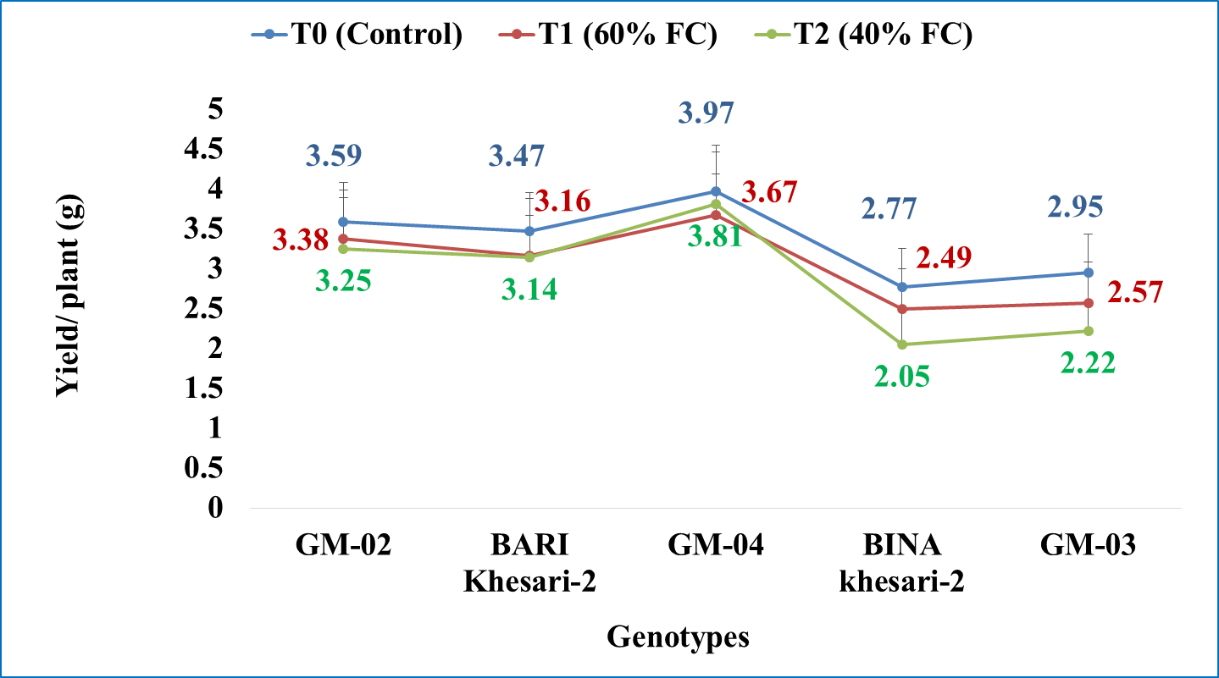
Fig 5: Interaction between genotypes and treatments over yield

In contrast, BINA khesari-2 exhibited the poorest yield performance, with a drop from 2.77 g at control to 2.05 g under extreme water stress. The reduced yield in this genotype is likely attributed to its lower 1000 seed weight, a trait that has been shown to influence yield potential under stress conditions (Subbaramamma et al., 2017). Similarly, GM-03 showed moderate yield reduction, with a yield of 2.95 g at control and 2.22 g under extreme stress, in line with findings by Semahegn et al., (2021), who reported that genotypes with low stress tolerance are less productive under reduced water availability. The genotypic differences in drought tolerance observed in this study agree with the concept that yield stability under water-limited conditions can be largely attributed to genetic factors, such as improved root systems, osmotic regulation, and early drought avoidance mechanisms (Comas et al., 2013). Therefore, genotypes like GM-04 may be promising for regions with variable water availability, while BINA khesari-2 and GM-03 may require improvements in drought resistance to perform better in such environments.

4. Conclusion

This study highlights significant genetic variability in drought tolerance among grasspea genotypes. GM-04 showed superior resilience, maintaining higher chlorophyll, lower oxidative damage (MDA), and greater osmoprotectant levels (soluble sugars, proline), sustaining yield under drought. In contrast, BINA Khesari-2 and GM-03 performed poorly due to lower stress tolerance and reproductive efficiency. Key drought-tolerance traits include osmotic adjustment, oxidative stress management, and efficient resource allocation. These findings emphasize the need to breed for such traits to improve drought resilience in grasspea. Further research into underlying molecular mechanisms will aid the development of drought-tolerant varieties for water-scarce regions.

COMPETING INTERESTS DISCLAIMER:
Authors have declared that they have no known competing financial interests OR non-financial interests OR personal relationships that could have appeared to influence the work reported in this paper.

Disclaimer (Artificial intelligence)
Option 1:
Author(s) hereby declare that NO generative AI technologies such as Large Language Models (ChatGPT, COPILOT, etc.) and text-to-image generators have been used during the writing or editing of this manuscript.
Option 2:
Author(s) hereby declare that generative AI technologies such as Large Language Models, etc. have been used during the writing or editing of manuscripts. This explanation will include the name, version, model, and source of the generative AI technology and as well as all input prompts provided to the generative AI technology
Details of the AI usage are given below:
1.
2.
3.

References

Solovyeva, A. E., Shelenga, T. V., Shavarda, A. L., & Burlyaeva, M. O. (2020). Comparative analysis of wild and cultivated Lathyrus L. species to assess their content of sugars, polyols, free fatty acids, and phytosterols. Vavilov Journal of Genetics and Breeding, 24(7), 730.
Lambein, F., Travella, S., Kuo, Y. H., Van Montagu, M., & Heijde, M. (2019). Grass pea (Lathyrus sativus L.): orphan crop, nutraceutical or just plain food? Planta, 250, 821-838.
Dixit, G. P., Parihar, A. K., Bohra, A., & Singh, N. P. (2016). Achievements and prospects of grass pea (Lathyrus sativus L.) improvement for sustainable food production. The Crop Journal, 4(5), 407-416.
Solaiman, Z., Colmer, T. D., Loss, S. P., Thomson, B. D., & Siddique, K. H. M. (2007). Growth responses of cool-season grain legumes to transient waterlogging. Australian Journal of Agricultural Research, 58(5), 406-412.
Savage, G. A., & Deo, S. (1989). The nutritional value of peas (Pisum sativum). A literature review.
Jeromela, A. M., Mikić, A. M., Vujić, S., Ćupina, B., Krstić, Đ., Dimitrijević, A., … & Miladinović, D. (2017). Potential of legume–brassica intercrops for forage production and green manure: encouragements from a temperate southeast European environment. Frontiers in Plant Science, 8, 312.
Mohammed, M. A., Chernet, M. T., & Tuji, F. A. (2020). Phenotypic, stress tolerance, and plant growth promoting characteristics of rhizobial isolates of grass pea. International Microbiology, 23(4), 607-618.
Golakiya, B. A., Jadav, N. J., & Patel, M. S. (1992). 7. SOIL THE SHRINKING RESOURCE. Environment, Yesterday, Today & Tomorrow, 63.
Jan, M. F., Altaf, M. T., Liaqat, W., Liu, C., Mohamed, H. I., & Li, M. (2025). Approaches for the amelioration of adverse effects of drought stress on soybean plants: from physiological responses to agronomical, molecular, and cutting-edge technologies. Plant and Soil, 1-53.
Gusmao, M., Siddique, K. H. M., Flower, K., Nesbitt, H., & Veneklaas, E. J. (2012). Water deficit during the reproductive period of grass pea (Lathyrus sativus L.) reduced grain yield but maintained seed size. Journal of Agronomy and Crop Science, 198(6), 430-441.
Bangar, P., Chaudhury, A., Tiwari, B., Kumar, S., Kumari, R., & Bhat, K. V. (2019). Morphophysiological and biochemical response of mungbean [Vigna radiata (L.) Wilczek] varieties at different developmental stages under drought stress. Turkish journal of biology, 43(1), 58-69.
Anyia, A. O., & Herzog, H. (2004). Water-use efficiency, leaf area and leaf gas exchange of cowpeas under mid-season drought. European Journal of Agronomy, 20(4), 327-339.
Nadeem, M., Li, J., Yahya, M., Sher, A., Ma, C., Wang, X., & Qiu, L. (2019). Research progress and perspective on drought stress in legumes: A review. International journal of molecular sciences, 20(10), 2541.
Tokarz, B., Wójtowicz, T., Makowski, W., Jędrzejczyk, R. J., & Tokarz, K. M. (2020). What is the difference between the response of grass pea (Lathyrus sativus L.) to salinity and drought stress? —A physiological study. Agronomy, 10(6), 833.
Obata, T., Witt, S., Lisec, J., Palacios-Rojas, N., Florez-Sarasa, I., Yousfi, S., ... & Fernie, A. R. (2015). Metabolite profiles of maize leaves in drought, heat, and combined stress field trials reveal the relationship between metabolism and grain yield. Plant physiology, 169(4), 2665-2683.
Mwadzingeni, L., Shgupimelis, H., Tesfay, S., & Tsilo, T. J. (2016). Screening of bread wheat genotypes for drought tolerance using phenotypic and proline analyses. Frontiers in plant science, 7, 1276.
Bhatnagar-Mathur, P., Vadez, V., Jyostna Devi, M., Lavanya, M., Vani, G., & Sharma, K. K. (2009). Genetic engineering of chickpea (Cicer arietinum L.) with the P5CSF129A gene for osmoregulation with implications on drought tolerance. Molecular Breeding, 23(4), 591-606.
Choudhary, D. K., Kasotia, A., Jain, S., Vaishnav, A., Kumari, S., Sharma, K. P., & Varma, A. (2016). Bacterial-mediated tolerance and resistance to plants under abiotic and biotic stresses. Journal of plant growth regulation, 35(1), 276-300.
Korte, LL, Specht, JE, Williams, JH, & Sorensen, RC (1983). Irrigation of soybean genotypes during reproductive ontogeny II. Yield component responses 1. Crop Science, 23 (3), 528-533.
Zebarjadi, a., mirany, t., kahrizi, d., ghobadi, m., & nikoseresht, r. (2012). Assessment of drought tolerance in some bread wheat genotypes using drought resistance indices. Biharean biologist, 6(2).
Choudhary, A. K., & Suri, V. K. (2014). Integrated nutrient-management technology for direct-seeded upland rice (Oryza sativa) in Northwestern Himalayas. Communications in Soil Science and Plant Analysis, 45(6), 777-784.
Hoagland, D.R.; Arnon, D.I., (1950). The water-culture method for growing plants without soil. Circular. Calif. Agric. Exp. Stn. 347, 32.
Bates, L.S.;Waldren, R.P.; Teare, I.D. (1973). Rapid determination of free proline for water-stress studies. Plant Soil.39, 205–207. [CrossRef]
Yoshida, S.; Coronel, V. (1976). Nitrogen nutrition, leaf resistance, and leaf photosynthetic rate of the rice plant. Soil Sci. Plant Nutr. 22, 207–211. [CrossRef]
Lowry, O. H., Rosebrough, N. J., Farr, A. L., & Randall, R. J. (1951). Protein measurement with the Folin phenol reagent. J biol Chem, 193(1), 265-275.
Velikova, V., Yordanov, I., & Edreva, A. J. P. S. (2000). Oxidative stress and some antioxidant systems in acid rain-treated bean plants: protective role of exogenous polyamines. Plant science, 151(1), 59-66.
Rahbarian, R., Khavari-Nejad, R., Ganjeali, A., Bagheri, A., & Najafi, F. (2011). Drought stress effects on photosynthesis, chlorophyll fluorescence and water relations in tolerant and susceptible chickpea (Cicer arietinum L.) genotypes. Acta biologica Cracoviensia. Series botânica, 53(1).
Rao, K. M., & Sresty, T. V. S. (2000). Antioxidative parameters in the seedlings of pigeonpea (Cajanus cajan (L.) Millspaugh) in response to Zn and Ni stresses. Plant science, 157(1), 113-128.
Monteoliva, M. I., Guzzo, M. C., & Posada, G. A. (2021). Breeding for drought tolerance by monitoring chlorophyll content. Gene Technol, 10(165), 10-35248.
Aloui, K., Choukri, H., El Haddad, N., Gupta, P., El Bouhmadi, K., Emmrich, P. M., ... & Kumar, S. (2023). Impact of heat and drought stress on grasspea and its wild relatives. Plants, 12(19), 3501.
Khatun, M., Sarkar, S., Era, F. M., Islam, A. M., Anwar, M. P., Fahad, S., ... & Islam, A. A. (2021). Drought stress in grain legumes: Effects, tolerance mechanisms and management. Agronomy, 11(12), 2374.
Mirzai, M., Moeini, A., & Ghanati, F. (2013). Effects of drought stress on the lipid peroxidation and antioxidant enzyme activities in two canola (Brassica napus L.) cultivars.
Jiang, J., Su, M., Chen, Y., Gao, N., Jiao, C., Sun, Z., ... & Wang, C. (2013). Correlation of drought resistance in grass pea (Lathyrus sativus) with reactive oxygen species scavenging and osmotic adjustment. Biologia, 68(2), 231-240.
Hussain, S., Rao, M. J., Anjum, M. A., Ejaz, S., Zakir, I., Ali, M. A., ... & Ahmad, S. (2019). Oxidative stress and antioxidant defense in plants under drought conditions. In Plant abiotic stress tolerance: agronomic, molecular and biotechnological approaches (pp. 207-219). Cham: Springer International Publishing.
Salehi-Lisar, S.Y., Bakhshayeshan-Agdam, H. (2016). Drought Stress in Plants: Causes, Consequences, and Tolerance. In: Hossain, M., Wani, S., Bhattacharjee, S., Burritt, D., Tran, LS. (eds) Drought Stress Tolerance in Plants, Vol 1. Springer, Cham. https://doi.org/10.1007/978-3-319-28899-4_1
Kumar, S., Sachdeva, S., Bhat, K. V., & Vats, S. (2018). Plant responses to drought stress: physiological, biochemical and molecular basis. In Biotic and abiotic stress tolerance in plants (pp. 1-25). Singapore: Springer Singapore.
Ye, H., Roorkiwal, M., Valliyodan, B., Zhou, L., Chen, P., Varshney, R. K., & Nguyen, H. T. (2018). Genetic diversity of root system architecture in response to drought stress in grain legumes. Journal of Experimental Botany, 69(13), 3267-3277.
Bashir, S. S., Hussain, A., Hussain, S. J., Wani, O. A., Zahid Nabi, S., Dar, N. A., ... & Mansoor, S. (2021). Plant drought stress tolerance: Understanding its physiological, biochemical and molecular mechanisms. Biotechnology & Biotechnological Equipment, 35(1), 1912-1925.
Abobatta, W. F. (2019). Drought adaptive mechanisms of plants—A review. Advances in Agriculture and Environmental Science, 2(1), 62-65.
Nahar, K., Hasanuzzaman, M., & Fujita, M. (2016). Roles of osmolytes in plant adaptation to drought and salinity. In Osmolytes and plants acclimation to changing environment: Emerging omics technologies (pp. 37-68). New Delhi: Springer India.
Trovato, M., Forlani, G., Signorelli, S., & Funck, D. (2019). Proline metabolism and its functions in development and stress tolerance. In Osmoprotectant-mediated abiotic stress tolerance in plants: recent advances and future perspectives (pp. 41-72). Cham: Springer International Publishing.
Hosseinifard, M., Stefaniak, S., Ghorbani Javid, M., Soltani, E., Wojtyla, Ł., & Garnczarska, M. (2022). Contribution of exogenous proline to abiotic stresses tolerance in plants: a review. International Journal of Molecular Sciences, 23(9), 5186.
Sabbioni, G., & Forlani, G. (2022). The emerging role of proline in the establishment and functioning of legume-rhizobium symbiosis. Frontiers in Plant Science, 13, 888769.
Tokarz, B., Wójtowicz, T., Makowski, W., Jędrzejczyk, R. J., & Tokarz, K. M. (2020). What is the difference between the response of grass pea (Lathyrus sativus L.) to salinity and drought stress? A physiological study. Agronomy, 10(6), 833.
Goncalves, L., Rubiales, D., Bronze, M. R., & Vaz Patto, M. C. (2022). Grass pea (Lathyrus sativus L.) A sustainable and resilient answer to climate challenges. Agronomy, 12(6), 1324.
Blum, A. (2010). Plant breeding for water-limited environments. Springer Science & Business Media.
Blum, A. (2011). Plant breeding for water-limited environments. Springer Science & Business Media.
Bhattacharya, A. (2021). Role of plant growth hormones during soil water deficit: a review. Soil water deficit and physiological issues in plants, 489-583.
Araus Ludlow, M. M., & Muchow, R. C. (1990). A critical review of the effects of water stress on maize. Field Crops Research, 25(2), 243-270.
Boyer, J. S. (1982). Plant productivity and environment. Science, 218(4571), 443-448.
Pereira, L. S., Cordery, I., & Iacovides, I. (2012). Improved indicators of water use performance and productivity for sustainable water conservation and saving. Agricultural water management, 108, 39-51.
Islam, M. S., Fahad, S., Hossain, A., Chowdhury, M. K., Iqbal, M. A., Dubey, A., ... & Sabagh, A. E. (2021). Legumes under drought stress: plant responses, adaptive mechanisms, and management strategies in relation to nitrogen fixation. In Engineering tolerance in crop plants against abiotic stress (pp. 179-207). CRC Press.
Sadras, V. O., Kirkegaard, J., & Hunt, J. (2019). Water use in rainfed systems: Physiology of grain yield and its agronomic implications agriculture. In Australian agriculture in 2020: from conservation to automation (pp. 205-219). Australian Society of Agronomy.
Samarah, N. H. (2016). Understanding how plants respond to drought stress at the molecular and whole plant levels. In Drought Stress Tolerance in Plants, Vol 2: Molecular and Genetic Perspectives (pp. 1-37). Cham: Springer International Publishing.
Chaves, M. M., Maroco, J. P., & Pereira, J. S. (2003). Understanding plant responses to drought—from genes to the whole plant. Functional plant biology, 30(3), 239-264.
Semahegn, Y., Shimelis, H., Laing, M., & Mathew, I. (2021). Genetic variability and association of yield and yield components among bread wheat genotypes under drought-stressed conditions. Australian Journal of Crop Science, 15(6), 863-870.
Subbaramamma, P., Sangamitra, M., & Manjusha, D. (2017). Mitigation of drought stress in production of pulses. Int. J. Multidiscip. Adv. Res. Trends, 4, 41-62.
Comas, L. H., Becker, S. R., Cruz, V. M. V., Byrne, P. F., & Dierig, D. A. (2013). Root traits contributing to plant productivity under drought. Frontiers in plant science, 4, 442.
Yuan, M., Cai, C., Wang, X., Li, G., Wu, G., Wang, J., ... & Sun, Y. (2021). Warm air temperatures increase photosynthetic acclimation to elevated CO2 concentrations in rice under field conditions. Field Crops Research, 262, 108036.
Ghosh, A. (2020). Assessing the impact of agro-climatic factors on pod filling of grass pea. Legume Research-An International Journal, 43(4), 563-567.
Jeromela, A. M., Mikić, A. M., Vujić, S., Ćupina, B., Krstić, Đ., Dimitrijević, A., ... & Miladinović, D. (2017). Potential of legume–brassica intercrops for forage production and green manure: encouragements from a temperate southeast European environment. Frontiers in Plant Science, 8, 312.

