Original Research Article
Effect of Organic Amendments in Hybrid Maize under Soil Salinity Condition

ABSTRACT
Salinity is a major concern for crop production in coastal areas of Bangladesh. Organic amendments could contribute to the improvement of crop production in coastal areas. The study was to investigate the mitigation of the adverse effects of soil salinity in maize by using organic amendments. There were nine (9) treatment combinations consisting of control, 30 mM NaCl, 60 mM NaCl, 30 mM NaCl+Cowdung (5t/ha), 60 mM NaCl+Cowdung (5t/ha), 30mM NaCl + Poultry manure (3t/ha), 60 mM NaCl + PM(3 t/ha), 30 mM NaCl + Compost (6t/ha), 60 mM NaCl+ Compost (6t/ha). Results revealed that plants were exposed to different concentrations of NaCl at vegetative stage. Salt stress caused a significant reduction in growth and yield of the maize variety. High salt stress (60 mM NaCl) caused a drastic decrease in growth and height of the maize variety. Salt stress also decreased K+/Na+ ratio and nutrient contents in maize variety. BARI Hybrid Maize-9 conferred tolerance to high salinity, when soils were amended with cowdung or PM than compost. However, the application of organic amendments, especially cowdung at 5 t/ha under 30 mM NaCl (T4), enhanced shoot height, root length, plant dry weight, and nutrient contents (N, P, K, S), while improving the K+/Na+ ratio, thus conferring greater salt tolerance. The present study suggests that BARI Hybrid Maize-9 can be recommended to cultivate for grain production and fodder crop with organic amendments in saline affected areas of Bangladesh since soil amendments with organic manures improved electrical conductivity and organic matter status under salinity condition.
Key words: Hybrid maize, Organic amendments, Salinity

INTRODUCTION
Soil salinity is a major concern to agriculture all over the world because it affects almost all plant functions. More than 6% of the world’s land and one third of the world's irrigated land are significantly affected by soil salinity (FAO, 2008). Out of 2.86 million ha of coastal and offshore lands in Bangladesh, about 1.056 million ha are affected by varying degrees of salinity (SRDI, 2010). Plants that undergo exposure to salinity experience both osmotic stress and ionic toxicity (Zhu, 2003). Salt stress disturbs cytoplasmic K+ /Na+ homeostasis, causing an increase in Na+ to K+ ratio in the cytosol (Zhu, 2003). Accumulation of excess Na+ and Cl- causes ionic imbalances that may impair the selectivity of root membranes and induce K+ deficiency (Gadallah, 1999) that are often associated with a decrease in photosynthetic electron transport activities in photosynthesis. Soil fertility in coastal regions of Bangladesh are quite low (Haque 2006). There is a great possibility of bringing saline areas under maize cultivation with proper reclamation and management.
Maize (Zea mays L.) in Bangladesh is becoming an important crop in the rice-based cropping system. Among the cereals grown in Bangladesh, maize is the third-most important crop after rice and wheat. (Khatun et al. 2019). It is an important C4 plant from the Poaceae family and is moderately sensitive to salt stress (Mansour et al., 2005). Maize play a gainful role in the agro-economy by contributing significantly towards solving food problem (Das et al. 2013).In Bangladesh, maize may be produced all year round in a variety of agroclimatic zones. With the increase in demand from poultry and other feed industries, more area is expected to divert from rice to hybrid maize in coming years. Appropriate management strategies and techniques with suitable genotypes having higher yield potential could contribute to the improvement of hybrid maize production in the coastal areas of Bangladesh. Addition of organic manures is the best means of maintaining soil fertility, productivity and salt tolerance (Das et al. 2013). Various organic amendments such as poultry manure (PM), compost and mulch can be used for the amelioration of saline soils (Leithy et al., 2010). Organic amendments improve physical, chemical and biological properties of soils under saline conditions (Raafat and Thawrat, 2011). Composts function as sources of nutrients and organic matter. It has also a positive impact on the chemical and physical characteristics of soil. (Debosz et al., 2002; Lynch et al., 2005; Tejada et al., 2006; Wanas and Omran, 2006). Soil amendments with compost and poultry manure improve salt tolerance in rice by increasing K+ /Na+ ratio and nutrient uptake (Chowdhury et al. 2019). Cow dung significantly reduce the soil EC compared to other amendments (Khatun et al. 2019). Application of poultry manure was found to mitigate the negative effects of salinity stress in winter pulses (Mannan and Khan, 2020). There are evidence that soil amendments with organic manures reduce the toxic effects of salinity in various plant species (Idrees et al. 2004, Abou El-Magd et al. 2008, Leithy et al. 2010, Raafat and Thawrat 2011).
Organic amendments with FYM and PM conferred tolerance to salinity in rice by increasing chlorophyll content,K+/Na+ratio and Nuptake, resulted in an increasein growth and yield component (Alam et al. 2016). Increased nutrient uptake and K+ /Na+ ratio were observed in rice due to proline as well as organic manure application under saline conditions (Dhar et al. 2015). In BatiaghataUpazila, Khulna, applying organic amendments reduced soil EC (from 10.6 dS/m to 3.4 dS/m) and pH (from 7.63 to 7.38) compared to control and also improved plant performance (Khatun et al., 2019). There is less information in Bangladesh about the role of organic amendments in mitigation of soil salinity in crop plants. Considering abovementioned facts, the present study was undertaken for the improvement of salinity tolerance and economic maize crop production through organic amendments in the coastal areas of southern Bangladesh. The objectives of this study were to investigate the effect of organic amendments on the growth and yield of maize and to suggest the best perform organic amendment for further application in coastal area.

MATERIALS AND METHODS
Location and site description
The pot experiment was carried out at the net house of the Department of Soil Science, Bangladesh Agricultural University (BAU), Mymensingh (24.750 N and 90.500 E at an average altitude of 18 m above the mean sea level) to investigate the mitigation of the adverse effects of soil salinity on the growth and yield of maize through organic amendments.

Soil collection and pot preparation
Soils were collected from the Soil Science Field Laboratory, BAU. A total of 27 equal size plastic pots were filled with 8 kg soils each. Characteristically, the soil was silt loam having pH 6.15, EC 0.20 dS/m, exchangeable Na 0.383 meq/100 g soil, total nitrogen 0.11% and organic matter 1.90%. BARI Hybrid Maize 9 was used as test crop.

Plant materials and treatments
Nine treatment combinations viz. control (no salt added), 30 mM NaCl, 60 mM NaCl, 30 mM NaCl + 5 t/ha cowdung, 60 mM NaCl + 5 t/ha cowdung, 30 mM NaCl + 3 t/ha PM, 60 mM NaCl + 3 t/ha PM, 30 mM NaCl + 6 t/ha compost, 60 mM NaCl + 6 t/ha compost were used for the maize variety, each of the treatments were replicated thrice under completely randomized design. Three maize seeds were sown into each pot. One healthy plant was kept in each pot and others were uprooted after emergence. Cowdung, compost and PM were mixed with soils as per treatment before seed sowing. Plants were exposed to different concentrations of NaCl (0-60 mM) at vegetative stage.

Management practices, crop harvesting and data recording
Fertilization and other management practices were performed as and when required (BARC, 2012). The crops were harvested at full maturity. Root growth, yield attributes (Cob number, cob diameters, total number of grains per cob, 100 grain weight, total grain weight per plant (g), and grain and straw yields were recorded.

Chemical analysis of plant and soil samples
Soil pH, EC, exchangeable Na and organic carbon content were measured using standard methods. Grain and straw samples were analyzed for N, P, K, S and Na content using the methods described by Khanam et al. (2001).

Statistical analysis
Data were statistically analyzed by ANOVA. The significant differences between mean values were compared by Duncan’s Multiple Range Test (DMRT) and ranking was indicated by letters. Differences at p < 0.05 were considered significant.

RESULTS AND DISCUSSIONS
The present experiment was carried out in order to observe the effect of salt stress on the root and shoot growth of maize as well as to mitigate the adverse effect of salt stress by application of organic amendments. The data obtained on different parameters of the maize variety are presented in this chapter.
Shoot Height
Shoot height of BARI Hybrid maize-9 was significantly influenced due to the application of different organic amendments under salinity condition (Fig. 1). Shoot height ranged from 75.33 to 216 cm. The tallest plant of 216 cm was found in T₁ which was significantly higher than all the treatments. The treatments T₄, T₆ and T₈ were statistically similar and after T₁ they had higher shoot height. The shortest plant of 75.33 cm was found in T₃ being similar with T₂. T₅, T₇ and T₉ were statistically similar. The treatments were ranked in order of T₁> T₄>T₆>T₈>T₇>T₉>T₅>T₂>T₃ with respect to shoot height.
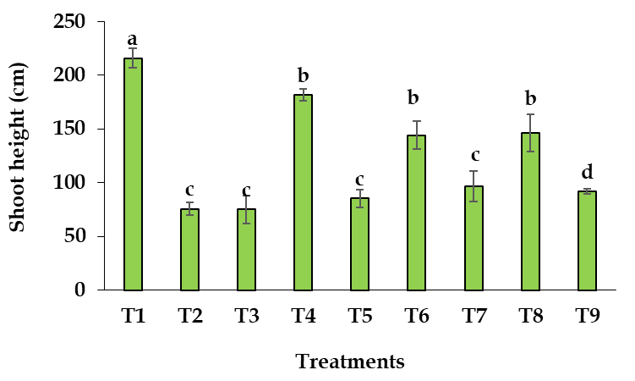
Fig.1: Effects of cowdung, compost and PM in presence and absence of NaCl on shoot height of BARI Hybrid Maize-9. Same letter represents insignificant difference at p < 0.05 for the variety. Here, T₁= Control, T₂ =30 mM NaCl, T₃ = 60 mM NaCl, T₄ = 30 mM NaCl + cowdung (5 t/ha), T₅ = 60 mM NaCl + cowdung (5 t/ha), T₆ = 30 mM NaCl + poultry manure (3 t/ha), T₇= 60 mM NaCl + poultry manure (3 t/ha), T₈ = 30 mM NaCl + compost (6 t/ha), T₉ = 60 mM NaCl + compost (6 t/ha).

Root Height
Root height of BARI Hybrid maize-9 was significantly influenced due to the application of different organic amendments under salinity stress (Fig. 2). Root height ranged from 9 to 58 cm. The highest root height was 58 cm and found in T₁ and the second highest root height of 34.33 cm observed in T₈ which was identical to the T₄, T₆. The lowest root height of 9 cm was found in T₃treatment being statistically similar to T₅ and T₇. The treatments were ranked in order of T₁> T₈> T₆> T₄> T₉> T₇> T₅> T₂>T₃ with respect to root length.
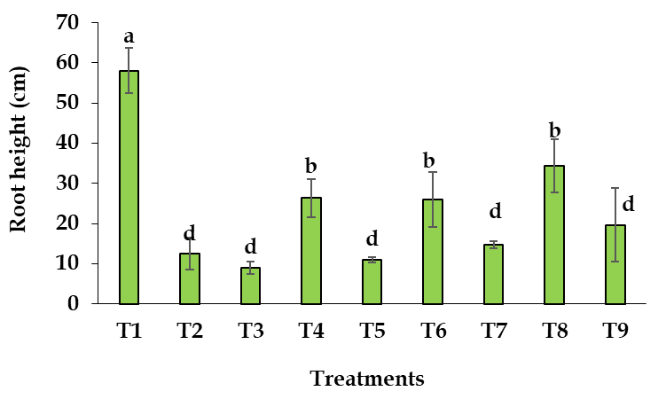
Fig.2: Effects of Cowdung, Compost and PM in presence and absence of NaCl on root length of BARI Hybrid Maize-9. Same letter represents insignificant difference at p < 0.05 for the respective variety. Here, T₁= Control, T₂ =30 mM NaCl, T₃ = 60 mM NaCl, T₄ = 30 mM NaCl + cowdung (5 t/ha), T₅ = 60 mM NaCl + cowdung (5 t/ha), T₆ = 30 mM NaCl + poultry manure (3 t/ha), T₇= 60 mM NaCl + poultry manure (3 t/ha), T₈ = 30 mM NaCl + compost (6 t/ha), T₉ = 60 mM NaCl + compost (6 t/ha).

Shoot Dry Weight
Shoot dry weight of BARI Hybrid maize-9 was significantly influenced due to the application of different organic amendments under saline soil (Fig. 3). Shoot dry weight ranged from 4.43 to 95.24 g. The highest shoot dry weight of 95.24 g was found in T₁and the second highest weight of 52.73 g observed in T₄which was identical to the observed treatments no T₆, and T₈. The lowest shoot dry weight of 4.43 g was found in T₃treatment being similar with T₂. The treatments were ranked in order of T₁> T₄> T₆> T₈> T₉> T₇> T₅> T₂>T₃with respect to plant dry weight.
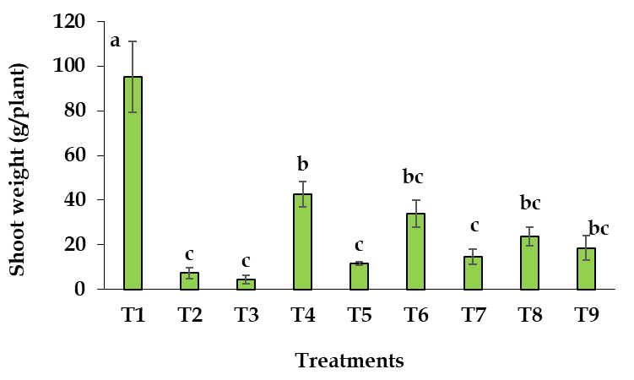
Fig. 3: Shoot dry weight of BARI Hybrid Maize-9 influenced by Cowdung, Compost and PM under salt stress; same letter represents insignificant difference at p < 0.05 for the respective variety. Here, T₁= Control, T₂ =30 mM NaCl, T₃ = 60 mM NaCl, T₄ = 30 mM NaCl + cowdung (5 t/ha), T₅ = 60 mM NaCl + cowdung (5 t/ha), T₆ = 30 mM NaCl + poultry manure (3 t/ha), T₇= 60 mM NaCl + poultry manure (3 t/ha), T₈ = 30 mM NaCl + compost (6 t/ha), T₉ = 60 mM NaCl + compost (6 t/ha).

Root Dry Weight
Salinity stress caused a significant reduction in root weight of BARI Hybrid Maize-9 (Fig. 4). Root weight ranged from 0.51—21.63 g/plant. The highest root weight 21.63 g/plant was found in T₁. The second highest 5.39 g/plant weight was observed in T₄ which was identical to the T₈.The lowest root weight of 0.51 cm was found in T₅ and T₃ treatment. The treatments were ranked in order of T₁>T₄>T₈>T₆>T₉>T₇>T₂>T₅>T₃ with respect to root weight.

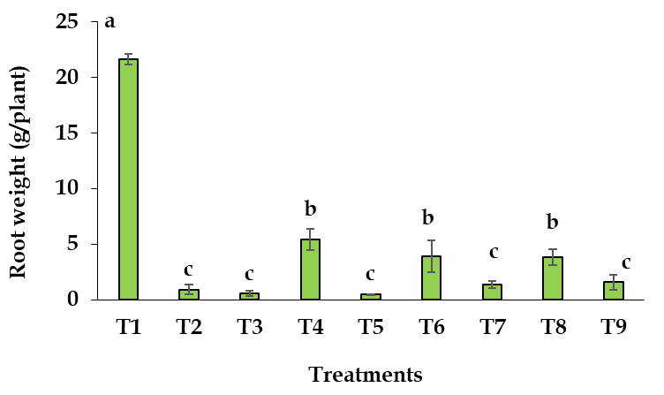
Fig. 4: Effects of cowdung, compost and PM in presence and absence of NaCl on root weight of BARI Hybrid Maize-9. Same letter represents insignificant difference at p < 0.05 for the variety.Here, T₁= Control, T₂ =30 mM NaCl, T₃ = 60 mM NaCl, T₄ = 30 mM NaCl + cowdung (5 t/ha), T₅ = 60 mM NaCl + cowdung (5 t/ha), T₆ = 30 mM NaCl + poultry manure (3 t/ha), T₇= 60 mM NaCl + poultry manure (3 t/ha), T₈ = 30 mM NaCl + compost (6 t/ha), T₉ = 60 mM NaCl + compost (6 t/ha).

Effects of Organic Amendments on Plant
Plant height of BARI Hybrid maize-9 was significantly influenced due to application of different organic amendments under saline conditions. The tallest plant was noted in T₁, and the shortest plant was evaluated from T₃ followed by T₂. Under no stress condition plants perform better than any other treatments. Cowdung, PM, compost performed better at mild salinity stress (30 mM) than strong (60 mM) stress. After application of organic amendments especially cowdung at 30 mM salt stress plant height increased in T₄ treatment (Fig.1). Plant height increased in soils with organic amendments in saline soil and Zaki et al. (2015) also agrees with the statement by reporting that vegetative growth parameters of rice, NPK uptake and vegetative yield under saline conditions increased with the addition of organic amendments in soil. Root height of BARI Hybrid maize-9 was significantly influenced due to application of different organic amendments under salinity. The T₄, T₆, T₈ treatments had higher root length of the hybrid maize at 30 mM salt stress than T₅, T₇, T₉ treatments at 60 mM salt stress. Lehman et al. (2023) found that manure helps plant root growth by providing sufficient porous systems in soil and also protect the roots from osmotic pressure under high saline condition but the protective capacity of organic amendments depend on their mineralization rates and salinity level. Leithy et al. (2010) on Peanut, Abou El-Magd et al. (2008) on sweet funnel and Raafat et al.(2011) on rice also found that organic amendments increased plant shoot and root height at different levels of soil salinity.

Table 1: Effects of organic manures on nitrogen content (mean ± se) by BARI Hybrid Maize-9 under salt stress
Treatments | K⁺/Na⁺uptake
 | Shoot | Root
T₁: Control | 5.19 a ± 0.04 | 4.33 a ± 0.03
T₂: 30 mM NaCl | 4.52 b ± 0.03 | 3.47 b ± 0.04
T₃: 60 mM NaCl | 2.62 e ± 0.01 | 2.64 c ± 0.01
T₄: 30 mM NaCl + Cowdung (5 t/ha) | 4.39 b ± 0.08 | 3.17 b ± 0.03
T₅: 60 mM NaCl + Cowdung (5 t/ha) | 3.48 d ± 0.02 | 3.04 b ± 0.04
T₆: 30mM NaCl + poultry manure (3 t/ha) | 3.87 c ± 0.01 | 2.82 c ± 0.03
T₇: 60mM NaCl + poultry manure (3 t/ha) | 3.94 d ± 0.04 | 3.18 b ± 0.04
T₈: 30 mM NaCl + Compost (6 t/ha) | 4.62 b ± 0.02 | 3.16 b ± 0.04
T₉: 60 mM NaCl + Compost (6 t/ha) | 3.65 d ± 0.02 | 3.05 b ± 0.04
Same letter in a column represents insignificant difference at p < 0.05. SE= Standard errors of means.

Shoot dry weight of BARI Hybrid maize-9 was significantly influenced due to application of different organic amendments under saline soil. Organic amendments such as cowdung, compost and PM resulted in a significant increase in shoot dry weight of BARI Hybrid Maize-9 under 30mM salinity conditions (T₄, T₆, T₈) than 60 mM salinity (T₅, T₇, T₉). The highest root weight of 21.63 cm was obtained from T₁. The lowest root weight of 0.51 cm was noted in T₃ treatment. The treatments with mild salinity had better performance than soils with higher salinity. Under same salinity stress, treatments without organic amendments showed poor performance than treatments with organic amendments. Similarly, Das et al. (2013) stated that organic amendments with PM significantly increased the root length, root weight, plant height and plant weight of both maize varieties (BARI Hybrid Maize-5 and Hybrid Maize Pacific-987) at 25 mM NaCl stress than 50 mM NaCl. The study found cow dung more efficient than other amendments; this may be due to the easy mineralization of less stable cowdung than more stable compost.
Effects of Organic Amendments on Plant Nutrient Contents
Salt stress significantly decreased N content in BARI Hybrid Maize-9 (Table 1). N content in shoot was found high in T₆ after T₁ (control). Whereas, the nitrogen content of root varied from 0.34 to 0.5% (Table-1) Amanullah MM 2008: Response of lowland rice varieties to reclamation practices in coastal saline soils hhh1). N content in root was found high in T₆, T₈ after T₁. Phosphorus content by shoot due to different treatments ranged from 0.13% to 0.15% (Table 2). The highest P content in shoot (0.15%) was found in T₁ and then applying with cowdung, compost and PM amendments; highest was T₄, T₆, T₈ at mild salinity stress. Phosphorus content by root due to different treatments ranged from 0.14% to 0.16% (Table 2). The highest S content in root (0.21) was found in T₁, T₄ and T₆. So, nutrient content was high with cowdung and PM at 30 mM (Table 3). Application of organic amendments, the highest K content was noted in T₄ (30 mM salt stress) both at shoot and root (Table 4). On the other hand, Na contents was high at T₃followed by T₂ and lowest was noted in T₁ (Table 5). Application of organic amendments in different salinity levels increased NPKS nutrient content (Leithyet al., 2010) although organic amendments did not show any changes of nutrient content except Na (Leithy et al., 2010). On the other hand, Shah et al. (2023) reported that organic fertilizer sources application, 10 t/ha poultry manure and farmyard manure improved the growth and yield of hybrids maize significantly, under normal irrigation and severe drought.

Table 2: Effects of organic manures on phosphorus content (mean ± se) by BARI Hybrid Maize-9 under salt stress
Treatments | P Content (%)
 | Shoot | Root
T₁: Control | 0.15 a ± 0.02 | 0.16 a ± 0.01
T₂: 30 mM NaCl | 0.12c± 0.01 | 0.13 c ± 0.01
T₃: 60 mM NaCl | 0.12c± 0.02 | 0.13c ± 0.01
T₄: 30 mM NaCl + Cowdung (5 t/ha) | 0.14 b ± 0.01 | 0.14b ± 0.01
T₅: 60 mM NaCl + Cowdung (5 t/ha) | 0.13 b ± 0.02 | 0.14bc ± 0.02
T₆: 30mM NaCl + poultry manure (3 t/ha) | 0.14 b ± 0.01 | 0.14b ± 0.01
T₇: 60mM NaCl + poultry manure (3 t/ha) | 0.13 b ± 0.01 | 0.14b ± 0.01
T₈: 30 mM NaCl + Compost (6 t/ha) | 0.14b ± 0.02 | 0.14b ± 0.01
T₉: 60 mM NaCl + Compost (6 t/ha) | 0.13 b ± 0.02 | 0.14 b ± 0.01
Same letter in a column represents insignificant difference at p < 0.05. SE= Standard errors of means.

Table 3: Effects of organic manures on sulphur content (mean ± se) by BARI Hybrid Maize-9 under salt stress
Treatments | S Content (%)
 | Shoot | Root
T₁: Control | 0.16 a ± 0.01 | 0.21 a ± 0.02
T₂: 30 mM NaCl | 0.12 c ± 0.02 | 0.17 b ± 0.03
T₃: 60 mM NaCl | 0.14 c ± 0.01 | 0.16 c ± 0.01
T₄: 30 mM NaCl + Cowdung (5 t/ha) | 0.15 b± 0.01 | 0.20a ± 0.01
T₅: 60 mM NaCl + Cowdung (5 t/ha) | 0.15 b ± 0.01 | 0.18b ± 0.01
T₆: 30mM NaCl + poultry manure (3 t/ha) | 0.15b ± 0.01 | 0.20a ± 0.03
T₇: 60mM NaCl + poultry manure (3 t/ha) | 0.13c ± 0.02 | 0.18 b ± 0.01
T₈: 30 mM NaCl + Compost (6 t/ha) | 0.15 b ± 0.01 | 0.18 b ± 0.02
T₉: 60 mM NaCl + Compost (6 t/ha) | 0.15 b ± 0.01 | 0.18 b ± 0.01
Same letter in a column represents insignificant difference at p < 0.05. SE= Standard errors of means.

Table 4: Effects of organic manures on K content (mean ± se) by BARI Hybrid Maize-9 under salt stress
Treatments | K Content (%)
 | Shoot | Root
T₁: Control | 1.44a ± 0.01 | 1.56a ± 0.02
T₂: 30 mM NaCl | 1.24 d ± 0.02 | 1.37 d± 0.01
T₃: 60 mM NaCl | 1.15 e ± 0.02 | 1.37 d± 0.01
T₄: 30 mM NaCl + Cowdung (5 t/ha) | 1.37 b ± 0.02 | 1.46 b ± 0.02
T₅: 60 mM NaCl + Cowdung (5 t/ha) | 1.35cd ± 0.01 | 1.40cd± 0.01
T₆: 30mM NaCl + poultry manure (3 t/ha) | 1.36 b ± 0.03 | 1.46 b± 0.21
T₇: 60mM NaCl + poultry manure (3 t/ha) | 1.34 d ± 0.01 | 1.40 cd ± 0.01
T₈: 30 mM NaCl + Compost (6 t/ha) | 1.36bc ± 0.01 | 1.42 c ± 0.01
T₉: 60 mM NaCl + Compost (6 t/ha) | 1.35d ± 0.01 | 1.40 cd± 0.01
Same letter in a column represents insignificant difference at p < 0.05. SE= Standard errors of means.

Table 5: Effects of organic manures on Na content (mean ± se) by BARI Hybrid Maize-9 under salt stress
Treatments | Na Content (%)
 | Shoot | Root
T₁: Control | 0.27 d ± 0.01 | 0.36 d± 0.01
T₂: 30 mM NaCl | 0.37 a ± 0.02 | 0.48 ab± 0.01
T₃: 60 mM NaCl | 0.39 a ± 0.02 | 0.51 a± 0.02
T₄: 30 mM NaCl + Cowdung (5 t/ha) | 0.35 b ± 0.02 | 0.46 b± 0.01
T₅: 60 mM NaCl + Cowdung (5 t/ha) | 0.32 b ± 0.02 | 0.44 bc± 0.02
T₆: 30mM NaCl + poultry manure (3 t/ha) | 0.31 b ± 0.01 | 0.42c ± 0.01
T₇: 60mM NaCl + poultry manure (3 t/ha) | 0.30c ± 0.01 | 0.45 b± 0.01
T₈: 30 mM NaCl + Compost (6 t/ha) | 0.30 c ± 0.01 | 0.45 b± 0.01
T₉: 60 mM NaCl + Compost (6 t/ha) | 0.37 a ± 0.02 | 0.44 bc± 0.02
Same letter in a column represents insignificant difference at p < 0.05. SE= Standard errors of means.

K⁺/Na⁺ ratio

Shoot
Salt stress caused a significant reduction in K⁺/Na⁺ ratio in shoot of BARI Hybrid Maize-9 (Table 6). High salt stress drastically decreased K⁺/Na⁺ ratio in shoot. Organic amendments with cowdung, compost and PM significantly increased K⁺/Na⁺ ratio in shoot of BARI Hybrid Maize-9 at 30 mM NaCl stress. The K⁺/Na⁺ content by shoot due to different treatments ranged from 2.66% to 5.09%. The highest K⁺/Na⁺ content in shoot (5.09%) was found in T₁ (Control) followed by the second highest N content in shoot (4.58%) observed in T₈ which was statistically similar with T₆ (4.55%). T₆ and T₈ increased K⁺/Na⁺ content at 30mM salt stress with PM and compost amendments. The lowest K⁺/Na⁺ content in shoot (2.66%) was obtained from T₃ (60mMNaCl) followed by T₂(Table 6).

Root
Salt stress also caused a significant reduction in K⁺/Na⁺ ratio in root of BARI Hybrid Maize-9 (Table 6). The K⁺/Na⁺ content by root due to different treatments ranged from 2.62% to 4.3%. The highest K⁺/Na⁺ content in root (4.3%) was found in T₁ (Control) followed by the second highest N content in root (3.47%)was observed from T₆. T₄,T₇ and T₈ treatments were statistically similar with values 3.2%,3.21%,3.18%, respectively. The lowest K⁺/Na⁺ content in root (2.62%) was obtained from T₃ (60m MNaCl) followed by T₂.

Table 6: K⁺/Na⁺ content ratio in Hybrid maize influenced by organic manures under salt stress (mean ± se)
Treatments | K⁺/Na⁺  (in shoot) | K⁺/Na⁺  (in root)
T₁: Control | 5.09 ± 0.01a | 4.3 ± 0.02a
T₂: 30 mM NaCl | 3.83 ± 0.01e | 2.79 ± 0.01f
T₃: 60 mM NaCl | 2.66 ± 0.01h | 2.62 ± 0.01g
T₄: 30 mM NaCl + Cowdung (5 t/ha) | 4.38 ± 0.02c | 3.2 ± 0.01c
T₅: 60 mM NaCl + Cowdung (5 t/ha) | 3.51 ± 0.02g | 3.01 ± 0.01e
T₆: 30mM NaCl + poultry manure (3 t/ha) | 4.55 ± 0.01b | 3.47 ± 0.02b
T₇: 60mM NaCl + poultry manure (3 t/ha) | 3.89 ± 0.02d | 3.21 ± 0.01c
T₈: 30 mM NaCl + Compost (6 t/ha) | 4.58 ± 0.02b | 3.18 ± 0.01c
T₉: 60 mM NaCl + Compost (6 t/ha) | 3.62 ± 0.01f | 3.06 ± 0.01d
Same letter in a column represents insignificant difference at p < 0.05. SE= Standard errors of mean.
Changes in soil properties by organic manures
This study investigated the changes in soil properties such as pH, EC and SOC status (Table 7). A slightly increase in soil pH, EC was observed when NaCl was added to the soils. Addition of compost, PM, cowdung considerably increased SOC status in soils. With the increase of salinity, the EC value also increased. Soil pH was noted low at T₁(6.25) and highest at T₃ (6.55). EC was low at T₁ (0.341 dS/m) and highest at T₃ (5.55ds/m).In T₄,T₆,T₈ soil EC was 2.17dS/m,2.20dS/m,2.13dS/m, respectively, on the other hand, soil EC was double at T₅,T₇,T₉. Lowest SOC was noted in T₂ (1.50%), highest was noted in T₉ (2.24%). There was also increasing evidences that soil amendments such as compost increased the SOC probably due to the slow mineralization of stable compound, but cow dung and PM had similar SOC in post-harvest soil. Similar results were also reported in previous studies (Rahman et al., 2010; Ahmed et al., 2003; Jaleelet al., 2008; Mohamed, 2017).
In this study, the treatment T₄: 30 mM NaCl + Cowdung @ 5 t/ha can be considered as the best treatment in terms of shoot height, plant dry weight , N-P-K-S content by shoot and root of maize (BARI Hybrid maize-9). Among all the organic amendments cowdung (5t/ha) would be effective for the cultivation of BARI Hybrid maize-9 in saline areas. However, Hybrid maize cultivation in saline areas might be profitable with organic amendment of soils to identify the most suitable amendment and application rate extensive field research work is needed to test the result under actual field condition since organic manures like compost, cowdung and PM are easily available and less expensive and hence could be a nice option for growing maize in saline area
Table 7: Changes in soil properties by organic manures under salt stress
Treatments | Soil pH | EC (dS/m) | % SOC
T₁: Control | 6.25c | 0.341c | 1.62c
T₂: 30 mM NaCl | 6.53a | 2.58b | 1.50c
T₃: 60 mM NaCl | 6.55a | 5.55a | 1.51c
T₄: 30 mM NaCl + Cowdung (5 t/ha) | 6.46b | 2.17b | 1.91b
T₅: 60 mM NaCl + Cowdung (5 t/ha) | 6.46b | 4.65a | 1.95b
T₆: 30mM NaCl + poultry manure (3 t/ha) | 6.45b | 2.20b | 1.91b
T₇: 60mM NaCl + poultry manure (3 t/ha) | 6.44b | 4.62a | 1.95b
T₈: 30 mM NaCl + Compost (6 t/ha) | 6.42b | 2.13b | 2.16a
T₉: 60 mM NaCl + Compost (6 t/ha) | 6.47b | 4.40a | 2.24a

CONCLUSION
This study demonstrated that organic amendments, particularly cowdung, poultry manure (PM), and compost, significantly mitigate the adverse effects of soil salinity on BARI Hybrid Maize-9 under controlled conditions. Salt stress at 30 mM and 60 mM NaCl reduced plant growth, yield, K+/Na+ ratio, and nutrient uptake, with more pronounced effects at higher salinity levels. However, the application of organic amendments, especially cowdung at 5 t/ha under 30 mM NaCl (T4), enhanced shoot height, root length, plant dry weight, and nutrient contents (N, P, K, S), while improving the K+/Na+ ratio, thus conferring greater salt tolerance. Cowdung outperformed PM and compost, likely due to its faster mineralization rate, which improved soil organic carbon (SOC) and reduced electrical conductivity (EC). These amendments also enhanced soil properties, reducing EC and increasing SOC, which are critical for sustaining soil fertility in saline conditions. Findings suggest that BARI Hybrid Maize-9, when cultivated with organic amendments like cowdung or PM, is a viable option for grain and fodder production in the saline-affected coastal areas of Bangladesh. Among the treatments, T4 (30 mM NaCl + cowdung at 5 t/ha) was the most effective, indicating cowdung’s potential as a cost-effective and readily available amendment. However, to validate these results under field conditions and optimize application rates, extensive field trials are recommended. This approach could support sustainable maize cultivation in saline regions, contributing to food security and economic stability in Bangladesh’s coastal agroecosystems.

DISCLAIMER (ARTIFICIAL INTELLIGENCE)
Author(s) hereby declare that NO generative AI technologies such as Large Language Models (ChatGPT, COPILOT, etc) and text-to-image generators have been used during writing or editing of this manuscript.
REFERENCES
Abou El-Magd, M.M., Zaki, M.F and Hussein, S.D.A. 2008. Effect of organic manure and different levels of saline irrigation water on growth, green yield and chemical content of sweet fennel. Australian Journal of Basic and Applied Sciences, 2: 90-98.
Ahmed, B. 2003. Fertility evaluation of different soils of Bangladesh. M.S. Thesis, Department of Soil Science, Bangladesh Agricultural University, Mymensingh, p.31.
Alam, M.Z., Das, D.K., Hashem, M.A. andHoque,M.A. 2016. Soil amendments with farm yard manure and poultry manure confer tolerance to salt stress in rice (Oryza sativa L.). Res. Agric. Livest., Fish, 3 (3): 379-386
Amanullah, M.M 2008. Response of lowland rice varieties to reclamation practices in coastal saline soils. Journal of Applied Science, 4:871-874.
Chowdhury, S., Bhusan, S.D., Hashem, M.A. and Hoque, M.A. 2019. Organic amendments for mitigating soil salinity in rice. Res. Agric. Livest. Fish, 6 (1): 11-17.
Das, D.K., Dey, B.R., Mian, M.J.A. and Hoque, M.A. 2013. Mitigation of the adverse effects of salt stress on maize (Zea mays L.) through organic amendments. International Journal of Applied Sciences and Biotechnology, 1: 233-239
Debosz K., Petersen, S.B.O., Kure, L.K. and Ambus, P. 2002. Evaluating effects of sewage sludge and household compost on soil physical, chemical and microbiological properties. Appl. Soil Ec,19: 237-248.
Dhar, S., Kibria, M.G., Rahman, M.M. and Hoque,M.A . 2015. Mitigation of the adverse effects of soil salinity in rice using exogenous proline and organic manure. Asian J. Med. Biol. Res. 1 (3), 478-486; doi: 10.3329/ajmbr.v1i3.26465
FAO 2008. Land and Plant Nutrition Management Service. Rome, FAO of UN, Available from: http://www.fao.org/ag/agl/agll /spush.
Gadallah, M.A.A. 1999. Effects of proline and glycinebetaine on Viciafaba responses to salt stress. Biologia Plantarum, 42: 249-257.
Haque, S.A. 2006. Salinity problems and crop production in coastal regions of Bangladesh. Pakistan Journal of Botany, 38: 1359-1365
Idrees, S., Qureshi, M.S., Ashraf, M.Y., Hussain, M. and Naveed, N.H. 2004. Influence of sulphate of potash (SOP) and farmyard manure (FYM) on sugarcane (Saccharum officinarum L.) grown under salt stress. Pakistan Journal of Life and Social Sciences, 2: 65–69.
Jaleel, C.A., Gopi, R., Manivannan, P., Panneerselvam, R. 2008. Soil salinity alters the morphology in Catharanthus roseus and its effects on endogenous mineral constituents. Eurasia Journal of Biological Science,2: 18-25.
Khanam M, Rahman MM, Islam MR and Islam MR. 2001. Effect of manures and fertilizers on the growth and yield of BRRI dhan30. Pakistan Journal of Biological Sciences. 4: 172-174.
Khatun M, Shuvo MAR, Salam MTB, Rahman SMH. 2019. Effect of organic amendments on soil salinity and the growth of maize (Zea mays L.). Plant Science Today; 6(2):106-111. https://doi.org/10.14719/pst.2019.6.2.491
Lehmann J, Cowie A, Masiello CA, Kammann C, Woolf D, Amonette JE, Cayuela ML, Camps-Arbestain M and Whitman T 2023. Biochar in climate change mitigation. NatuGeosci 14(12)883-892.
Leithy S, Gaballah MS and Gomaa AM. 2010. Associative impact of bio- and organic fertilizers on geranium plants grown under saline conditions. Electronic Journal of Environmental, Agricultural and Food Chemistry, 9: 617-626.
Lynch DH, Voroney RP and Warman PR. 2005. Soil physical properties and organic matter fractions under forages receiving composts, manure or fertilizer. Compost Sei. Util.13: 252- 261.
Mannan MA, & Khan MAR. 2020. Salinity Stress Mediated by Organic Amendments of Winter Pulses.
Mansour MMF, Salama KHA, Ali FZM, Abou Hadid AF. 2005. Cell and plant responses to NaCl in Zea mays cultivars differing in salt tolerance. General Applied Plant Physiology, 31: 29–41
Mohammad, K.N. 2017. Comparative Study of Groundwater of Selected Aquifers of Nilphamaridistrictrict, MS Thesis, Department of Agricultural Chemistry, Bangladesh Agricultural University, Mymensingh.
Raafat, N.Z and Tharwat EER. 2011. Improving wheat grain yield and its quality under salinity conditions at a newly reclaimed soil using different organic sources as soil or foliar applications. Journal of Applied Sciences Research, 7: 42-55.
Rahman zadeh, S., Kazemitabar, K., Yazdifar, S. andJafroudi, A. T. 2010. Evaluation of rice (Oryza sativa L.) cultivars response to salinity stress through greenhouse experiment and tissue culture technique. Asian Journal of Plant Sciences, 7(2)207-21.
Shah, M. N., Wright, D. L., Hussain, S., Koutroubas, S. D., Seepaul, R., George, S. and Eswaramoorthy, R. 2023. Organic fertilizer sources improve the yield and quality attributes of maize (Zea mays L.) hybrids by improving soil properties and nutrient uptake under drought stress. Journal of King Saud University-Science, 35(4), 102570. https://www.sciencedirect.com/science/article/pii/S1018364723000320
SRDI 2010. Saline soils of Bangladesh. SRMAF Project, Ministry of Agriculture, Dhaka, Bangladesh, pp: 1–60.
Tejada, M., Garcia, C., Gonzalez, J.L. and Hernandez, M.T. 2006. Use of organic amendment as a strategy for saline soil remediation: Influence on the physical, chemical and biological properties of soil. Soil Bid. Biochem, 38:1413-1421.
Wanas, S.A. and Omran, W.M. 2006. Advantages of Applying Various Compost Types to Different Layers of Sandy Soil: 1. Hydro-Physical Properties. J. Appl. Sci. Res, 2(12): 1298-1303.
Zaki, M.F., Ahmed, A.A., Singer, S.M. and El –Magd, M.M.A. 2015. Reducing the adverse effect of irrigation water salinity on the vegetative growth, green yield and quality of sweet fennel plants by organic manure. Australian Journal of Basic and Applied Science,3(4)4449-4464.
Zhu, J.K. 2003. Regulation of ion homeostasis under salt stress. Current Opinion in Plant Biology, 6: 441-445

