Original Research Article

Stacked Boost Forest: A Hybrid Model to Predict Domestic Cinnamon Purchasing Cost in Down South Sri Lanka

.
abstract
Sri Lanka is the leading exporter of true cinnamon, providing 90% of global demand. However, domestic farmers face challenges in securing a stable market price due to varying prices set by different intermediate buyers and a lack of awareness of price fluctuation patterns. This research aims to develop a web-based forecasting system to predict the highest and average purchase prices of cinnamon from domestic farmers in southern Sri Lanka, using historical data from 2016 to 2024. The study introduces a hybrid model incorporating a Random Forest Regressor, a Gradient Boosting Regressor, and a Stacking Regressor with a Linear Regression meta-model, achieving 96% accuracy for the highest price prediction and 98% accuracy for average price prediction. Compared to previous studies that primarily focus on the export market, this research analyzes both external and internal factors influencing price fluctuations and considers both domestic and export markets. The proposed system provides stakeholders with a user-friendly platform to enhance price transparency and stability. Future work aims to expand the forecast coverage to the entire country and introduce a comparative report feature for year-over-year price analysis.

Keywords: Cinnamon, Machine Learning, Linear Regression, Random Forest, Domestic Price Prediction

1. INTRODUCTION

Cinnamon is the dried bark of the perennial tree of C.zeylanicum of the Lauraceae family. True cinnamon is native to Sri Lanka (1). According to (2,3), Cinnamon is currently also one of the world’s most commonly used spices. There are four main types of cinnamon in the world market: True Cinnamon, Cassia Cinnamon, Korintje Cinnamon and Saigon Cinnamon (1). Ceylon cinnamon is mainly categorized into 4 major grades based on the diameter of the quil: Alba, Continental, Mexican and Hamburg. Studies indicate that there is no general procedure to predict the prices of domestic cinnamon purchases according to real value. Therefore, buyers demand according to their needs. Current practices are based on manual assessments and unreliable market information, which leads to inefficiencies and economic disparities. Researchers’ familiarity with the region’s cinnamon trade, coupled with expertise in machine learning, positions to address this pressing issue. As a result, several issues can be characterized as price volatility, lack of data utilization, market disparities, and the Influence of external factors.
Existing solutions determine diverse approaches to reduce the problems caused by unpredictable pricing. Consequently, there are multiple methods to assess predictions that range from manual price expectations to sophisticated digital approaches (4). Existing solutions provide mobile and online platforms for all stakeholders to deliver market price information. However, statistical-based (5) solutions do not provide price predictions. On the other hand, machine Learning-based solutions have not been implemented based on external factors such as dollar exchange rates (6). Overall, available works support ad-hoc predictions with recent prices and do not provide future price predictions. To overcome existing solutions, this research contributes to the following objectives.
- To develop a hybrid model capable of accurately predicting domestic cinnamon purchase prices based on historical data.
- To identify the key features that influence domestic cinnamon purchase prices.
- To analyze the impact of external factors, such as exchange rates, on cinnamon purchase prices in the down south region.
- To provide a user-friendly system for stakeholders to access reliable price predictions for decision-making and market planning.
This article is structured as follows. Section two elaborates on the research conducted with machine learning in the price prediction domain. The methodology describes features of data collection, data preprocessing, training and testing steps related to the proposed hybrid architecture. In addition, it presents the development process of the web-based platform. Section four presents results in detail and discusses the proposed architecture performance with similar works. Finally, section five concludes the paper with suggestions for future works.

2. Literature Review

Among the Cinnamon types in the global market, True Cinnamon or Ceylon Cinnamon is mainly cultivated in Sri Lanka (7) (Table 1). Sri Lanka currently supplies 90% of the demand for true cinnamon in the market (1). Ceylon cinnamon is a highly desired spice in the global export economy (8). Sri Lanka occupies a leading position among the world’s main cinnamon-exporting countries (Table 2). Cinnamon produced in Sri Lanka is classified under 4 main categories. They are Alba, Continental, Mexican and Hamburg (1).

Table 1. Global Cinnamon Classification Source: Department of Cinnamon Development
Cinnamon Type | Scientific Name | Country
True Cinnamon | Cinnamomum verum J. Presl. | Sri Lanka
Cassia Cinnamon | Cinnamomum aromaticum Nees | China
Korintje Cinnamon | Cinnamomum burmanni (Nees & T.Nees) Blume | Indonesia
Saigon Cinnamon | Cinnamomum loureiroi Nees | Vietnam

Table 2. Global Cinnamon Export Values Source: trademap.org
Exporter | Value in 2020 | Value in 2021 | Value in 2022 | Value in 2023
Viet Nam | 238092 | 266206 | 259940 | 254982
Sri Lanka | 216351 | 247368 | 217295 | 209469
China | 292898 | 275620 | 247380 | 188395
Indonesia | 151295 | 160688 | 131449 | 99704

The combination of Linear Regression and Random Forest and Gradient Boosting and LSTM and ARIMA (9,10) methods perform successfully in predicting agricultural prices. The cinnamon price prediction performance of LSTM at (6) reached 97% accuracy. Science has demonstrated Light GBM, GRNN and Random Forest as highly effective models when predicting prices for garlic (11) along with cardamom (12) and vegetable crops (13). Most price forecast models rely on standard base methods alone instead of using combination or enhancement techniques to enhance their accuracy potential.
Research today focuses on hybrid models including LSTM-GARCH (14) and ARIMA-SVM (15), because these models produce enhanced accuracy in market volatility scenarios. Multiple algorithms surpass individual models because they identify linear and non-linear patterns simultaneously. By uniting Deep learning techniques with Hidden Markov Models (16) along with ensemble learning approaches data predictions have shown improvement while dataset preprocessing methods like normalization and outlier removal create better performance outcomes.
Research shows that models which combine LSTM-GARCH with ARIMA-SVM and Holt-Winters-GRU deliver higher accuracy levels. However, gaps remain in Table 3.
Table 3. Feature Selection Gap
Research | Internal Features | External Factors
(17) | Weather Data | No
(18) | Climate Data | No
(19) | Environmental Data, Soil Texture | No
Proposed Research | Grade, Location | USD Buy, Sell Rate

Digital systems leverage three models (LSTM, XGB and Random Forest) among others for their operations. These models used Flask web applications (20,21) and mobile applications for price prediction (6).

The current systems tend to exclude simple user interface options for viewers with limited technology skills. The solution focuses exclusively on requirements from export clients instead of providing access to local stakeholders in the platform.
Proposed Contribution: A web-based system should be developed to serve cinnamon stakeholders across the board. Sub-category predictions must include applicable internal and external features along with them. The application requires a basic interactive platform that delivers both accessibility and ease of use.

3. METHODOLOGY

The methodologies address the development of the StackBoostForest model, feature identification, analysis of external factors, and the development of a user-friendly application.
3.1. Cross-Validation of State-of-art Works
The past related works conducted between 2-3 years related to the domain of the proposed research were found, and the machine learning algorithms used to predict the price of each study were identified separately using the proposed research data set from (22) and (23). For each algorithm identified in this way, the model will be trained separately for each algorithm by applying the data set of the proposed research (Figure 1). According to the data of the proposed research, it is expected to build a hybrid system by selecting the algorithms that provide the most accurate evaluation metrics and combining two or more of them.
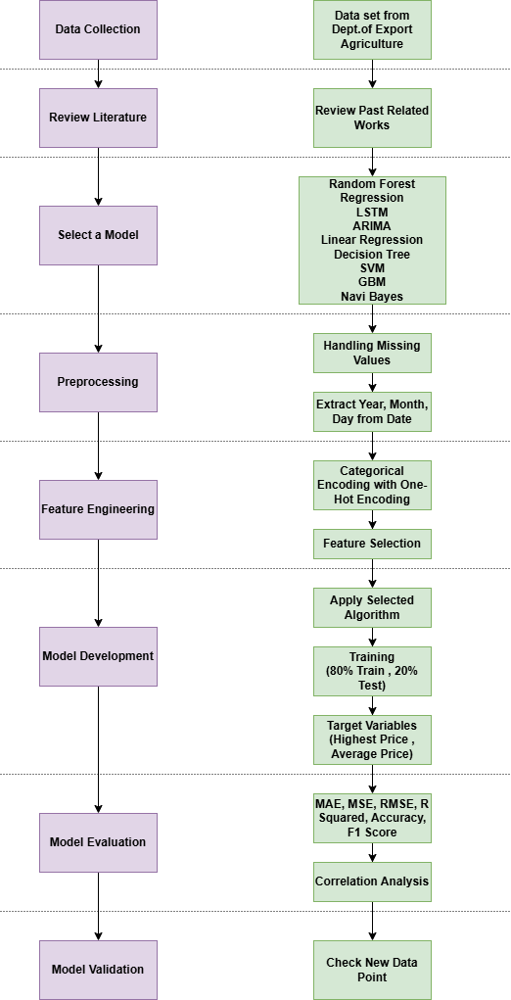
Figure 1. Process of Model Selection for Hybrid Development
3.2 Correlation Analysis of Features
Many factors have more and less influence on cinnamon price fluctuation and the selection of the most suitable factors for the hybrid model for predicting domestic cinnamon purchase prices in down south Sri Lanka has a critical effect on the accuracy of the system. Figure 2 shows the steps of correlation calculation.
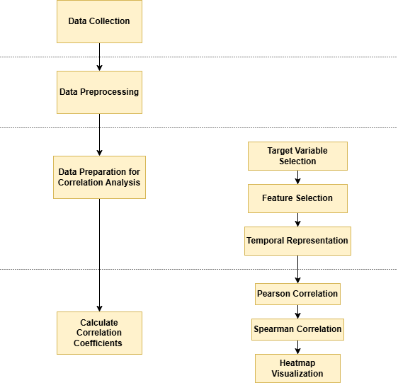
Figure 2. Correlation Analysis Steps

The step of data preparation for correlation analysis includes the following steps: Target Variable Selection, Feature Selection (Features influencing target variables), and Temporal Representation (Convert date-related columns into numerical values).
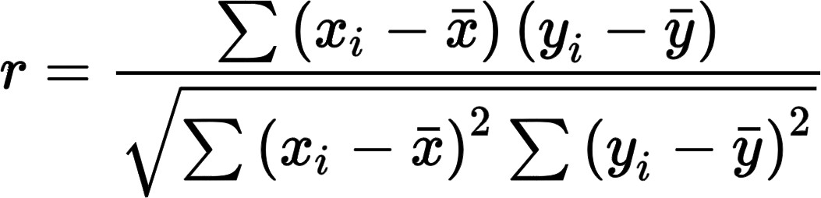
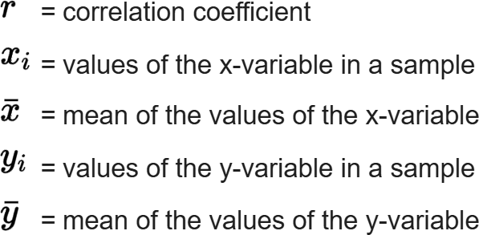
Pearson Correlation (24) measures the linear relationship between continuous variables and used to identify their strength and direction (Figure 3). Spearman Correlation (25) should be employed when the relationships cannot be described as linear or when working with ordinal data (Figure 4). Heatmaps (26) are used to display correlation matrices, which helps users understand relationships more easily.

Figure 3. Pearson Correlation Coefficient (27)
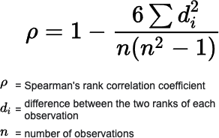

Figure 4. Spearman Correlation (28)

3.3 Hybrid Model for Domestic Cinnamon Price Prediction
The approach integrates multiple machine-learning models into a stacking regressor while developing a machine-learning-based hybrid system for forecasting the domestic cinnamon purchase price. By combining the strengths of different algorithms, the accuracy of the final model is enhanced. In creating a hybrid system for predicting domestic cinnamon purchase price, the relevant data set between 2016-2024 was obtained through the Department of Export Agriculture, Sri Lanka (22). The data set contains the following features: Date, Cinnamon Grade, Location, Thaara per Kilo, USD Buy Rate, USD Sell Rate, Highest Price, Average Price.
In preprocessing and cleaning, the following steps were performed: Date Formatting, Handling Missing Values, Outlier Removal - Z-score method used to filter extreme outliers and Feature Engineering - Extract Year, Month and Date, Use One-Hot Encoding to convert categorical features into numerical, Second-degree polynomial features were introduced for numerical variables to capture non-linear relationships.
The Hybrid System contains three major components.
- Feature Preprocessing Pipeline – Designed a Column Transfer to process categorical and numerical features separately. In numerical features filling missing values using mean, scaled with Standard Scaler and transformed with Polynomial Features. Categorical features are handled by filling in missing values using the most frequent category and one-hot encoding used to convert categorical features into numerical ones.
- Base Models – Random Forest (29) and Gradient Boosting (30) – Random Forest Regressor captures complex relationships in data by using numerous decision trees and aids in avoiding overfitting and lowering variance.
Tuned Hyperparameters
n estimators: 300, 400, 500
max depth: 15, 20, None
min samples split: 2, 3, 5
min samples leaf: 1, 2
- Gradient Boosting Regressor builds trees one after the other to fix mistakes from earlier models. Efficient in identifying pricing data’s non-linear correlations.
Tuned Hyperparameters
n estimators: 300, 500
learning rate: 0.01, 0.03 max depth: 3, 5, 7
subsample: 0.8, 1.0
- Stacking Regressor (31–33) - Enhances accuracy by combining predictions from base models using a Linear Regression meta-model.
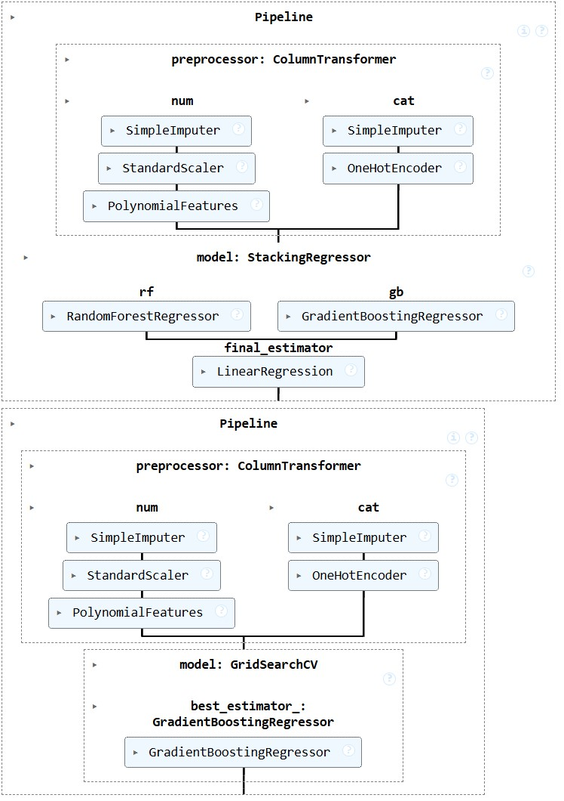
The data set was split into 80% training and 20% testing. The Random Forest and Gradient Boosting models’ optimal parameters were determined using GridSearchCV. To avoid overfitting, 5-fold validation was used for cross-validation. Different pipelines were created to forecast the Average Price and the Highest Price. A Stacking Regressor (Random Forest+ Gradient Boosting with Linear Regression meta-model) was the pipeline used to predict the highest price. Gradient Boosting Regressor was the final model used in the pipeline for average price prediction.

Figure 5. Pipeline Diagram of Hybrid Model
In stacked generalization, the output of each estimator is stacked, and the final prediction is calculated using a regressor. By using each estimator’s output as the input of a final estimator, stacking enables the utilization of each estimator’s strength. Figure 5 shows the pipeline diagram of machine learning-based StackBoostForest hybrid model.

3.4 Develop a User-Friendly Price Prediction Platform
The research creates a user-friendly web platform that allows all the stakeholders to easily predict the domestic cinnamon purchase Highest Price and Average Price in down south Sri Lanka. For this, it used Anvil as the platform on which the web application was developed. User inputs are given as per Figure 6, and through that, the proposed research tries to get the predicted Highest Price and the predicted Average Price as the output.

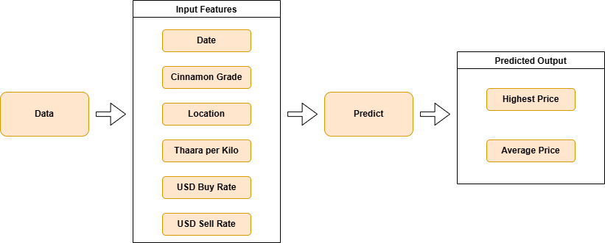

Figure 6. Prediction Steps of the System

4. results and discussion

Thus, to predict the domestic cinnamon purchase price by using the Random Forest + Gradient Boosting with Linear Regression meta-model, and create the StackBoostForest hybrid model, it was necessary to make decisions based on various results and plan the next steps. The results were obtained when the data set of the research was trained for the algorithms used in past related works. (Table 4)

Table 4. Algorithm Selection
Algorithm | MAE | Accuracy | F1 Score
LSTM | 222.86 | 0.93 | 0.92
ARIMA | 233.75 | 0.005 | 0.001
Random Forest | 64.93 | 0.977 | 0.956
Linear Regression | 311.86 | 0.518 | 0.517
Decision Tree | 61.07 | 0.83 | 0.82
SVM | 221.55 | 0.0024 | 0.0044
GBM | 157.19 | 0.0020 | 0.0032
Navi Bayes | 549.07 | 0.0082 | 0.0028

Based on the results, the Random Forest Regressor (34) (35) was selected as the most suitable algorithm, and correlation analysis was obtained before training and after training for the algorithm to identify the effect of external factors and internal features on the predicted highest price and predicted average price. For further study, the correlation between the actual prices and the predicted prices was also obtained.

When developing the hybrid model, various algorithms were combined with random forest regressor, resulting in Table 5. Based on its results, following evaluation metrics were obtained for the hybrid model selected. (Table 6)

Table 5. Hybrid Model Selection
Model | Prediction | Status
RF + GBM | Same price | Rejected
RF + GBM (HP) | High Average Price | Rejected
RF + DT | Do not align | Rejected
RF + LSTM | Too low | Rejected
RF + GBM +Stacking Regressor | Align Closely | Selected

Table 6. Hybrid Model Evaluation
RF + GBM + Stacking Regressor with LR Meta Model
 | MAE | Accuracy | F1 Score
Highest Price | 60.691 | 0.9691 | 0.9689
Average Price | 47.854 | 0.9800 | 0.9800

Correlation analysis was obtained for the selected model to understand the relationship between features and prices. Figure 7 values were obtained for the Pearson correlation and Spearman correlation, and the overall correlation analysis is shown in Figure 8.
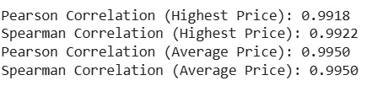

Figure 7. Pearson & Spearman Correlation Values

According to the results, the researcher identified that the factors selected as internal features, such as Grade, Location, and Date have a positive impact on the predicted highest price and average price and also identified that the Thaara per kilo factor chosen as an internal factor is constant. The researcher found that the USD Buy Rate and USD Sell Rate selected as external factors have a positive impact of more than 0.77 on the predicted highest price and predicted average price. Thus, it was concluded that the factors of Date and USD Rates have a high positive impact on the determination of domestic cinnamon purchase price. In contrast, the factors of Grade and Location have a positive impact and Thaara per kilo is a constant.
After that, a feature importance analysis was done to gain an understanding of the effect of each feature (Figure 9).

Through the correlation analysis and the feature importance analysis, it is possible to identify the internal features that affect the domestic cinnamon purchase price in down south Sri Lanka and how they affect it, as well as the external factors that affect the domestic cinnamon purchase price and their importance.

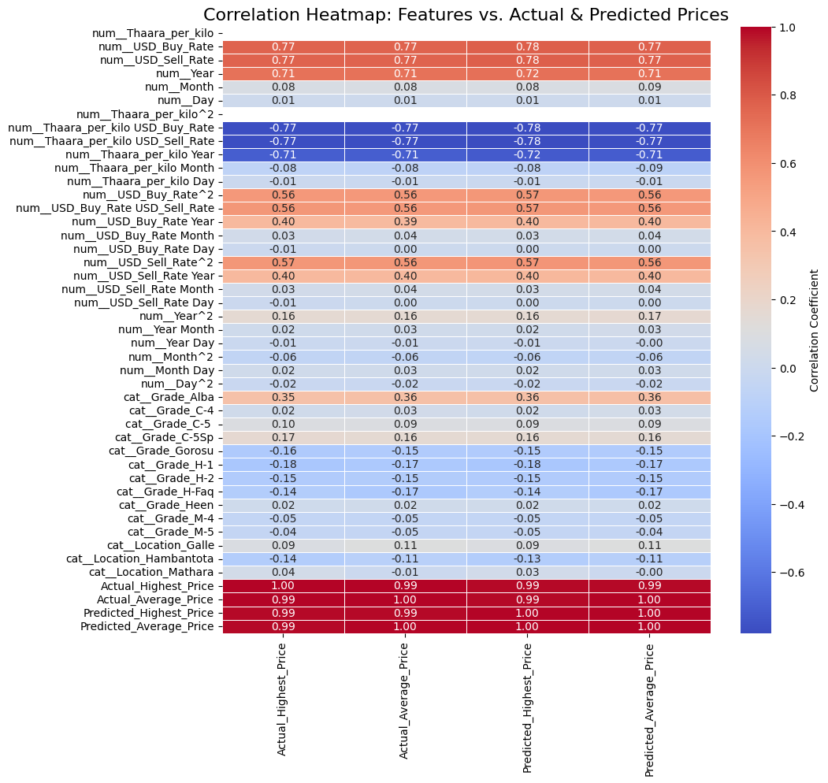

Figure 8. StackBoostForest Correlation Heat Map

A residual analysis was done separately for the highest and average price to understand the variation between actual prices and predicted prices. The well-distributed model predictions are guaranteed by residual analysis (36,37) .Through the scatter plots obtained in this way, it is possible to clearly identify how the predicted Highest Price and predicted Average Price vary compared to the actual price.(Figure 10).

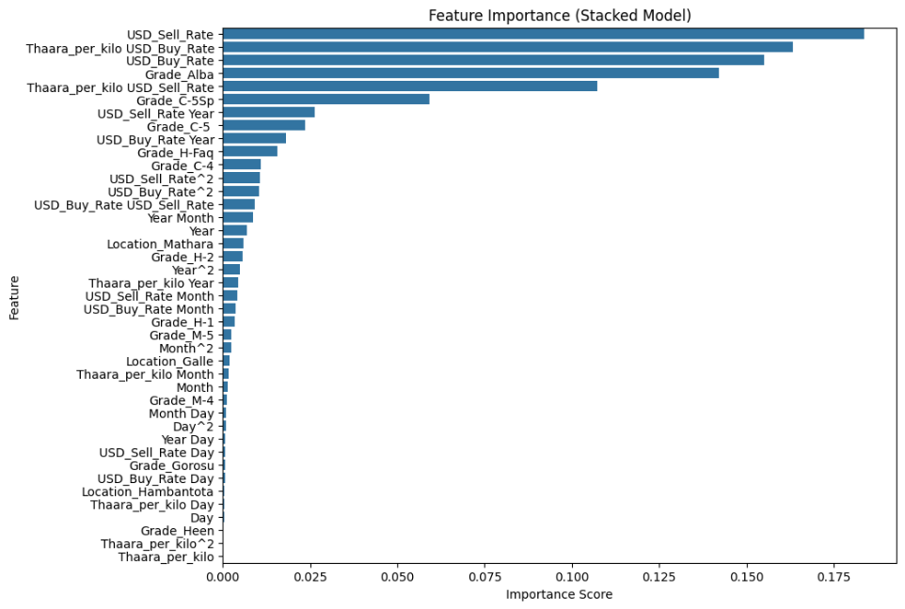

Figure 9. Feature Importance Analysis
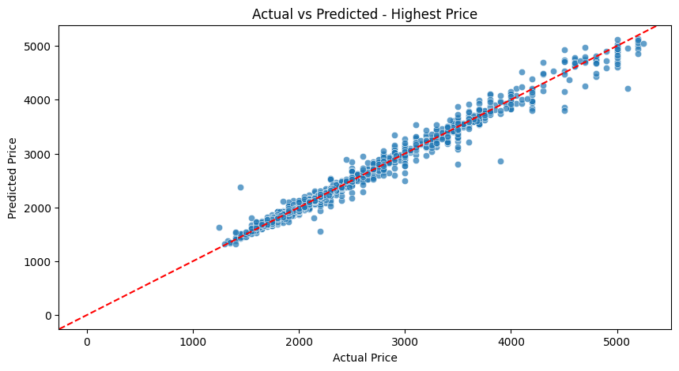
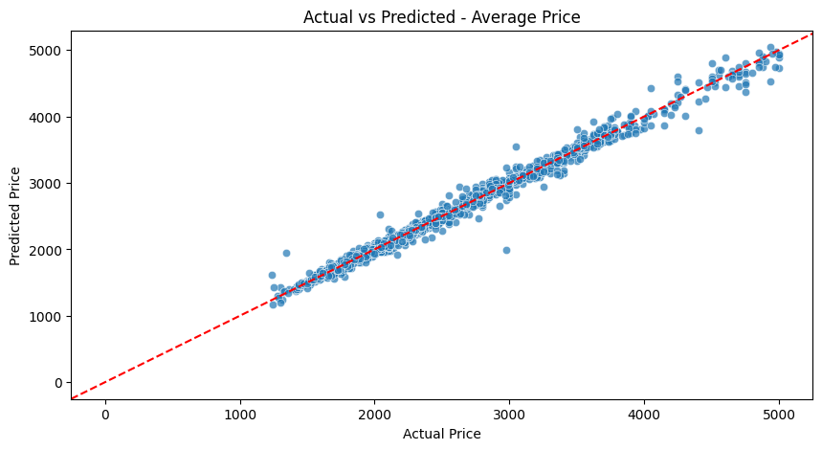

Figure 10. Residual Analysis (Predicted vs. Actual)

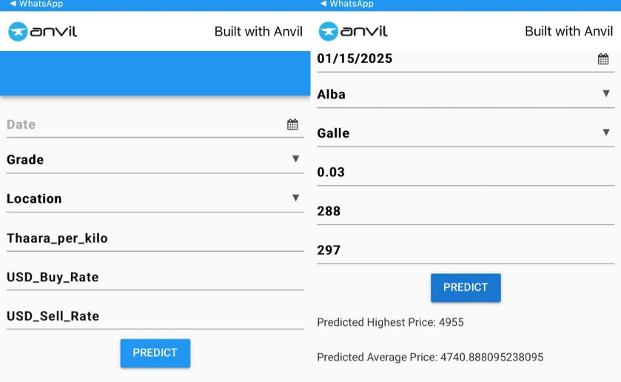

Figure 11. Web Application Interface

The final web app was created using Anvil (38) as a platform to predict the domestic cinnamon purchase price. The web interface provides the facility to users to select a date, cinnamon grade and location from a dropdown menu and enter the values for Thaara per kilo, and USD Rates. When the user taps the Predict button in the interface, the StackBoostForest system displays the Predicted Highest and Average Price and as the output (Figure 11).

In conclusion, this web app is user-friendly for all stakeholders related to the cinnamon industry. It makes it easy to predict domestic cinnamon purchase prices in down south Sri Lanka. It can be accessed through any device, including mobile phones and laptops, and it can be used with both Android and iOS operating systems.

The performance of the proposed hybrid model—StackBoostForest, which combines Random Forest, Gradient Boosting, and a Linear Regression meta-model—was thoroughly evaluatedusing multiple performance metrics. These included Mean Absolute Error (MAE), Accuracy, and F1 Score for both predicted highest and average cinnamon purchase prices.
For the highest price prediction, the model achieved an MAE of 60.691, an accuracy of 96.91%, and an F1 score of 0.9689. Similarly, the average price prediction yielded an MAE of 47.854, an accuracy of 98%, and an F1 score of 0.9800. These results clearly demonstrate the model’s high reliability and robustness when applied to domestic cinnamon pricing scenarios in Down South Sri Lanka.
Further, correlation analysis and residual analysis confirmed the model’s predictive strength. Visualizations revealed a strong alignment between predicted and actual values, and residual plots showed evenly distributed errors, indicating the model did not underfit or overfit the data. Additionally, feature importance analysis highlighted that USD Buy Rate, USD Sell Rate, and Date had the strongest influence on pricing outcomes, while Thaara per kilo was mostly constant.
Compared to individual base models and other hybrid combinations tested (Table 7), the StackBoostForest model significantly outperformed alternatives in both accuracy and consistency. This confirms its suitability for real-world deployment and reliable decision-making support for cinnamon industry stakeholders.
Table 7. Comparison with Existing Works
Algorithm | Work | Accuracy
LSTM | (6) | 0.97
RF | (13) | 0.85
LR | (39) | 0.98
ANN | (40) | 0.94
RF + GBM +Stacking Regressor | Proposed Research | 0.98 (Average Price)  0.96 (Highest Price)

The comparative analysis in the table shows various machine learning algorithms applied in similar research studies besides the suggested hybrid model by this study. Every algorithm is presented along with the relative accuracy measure found in the said work.
The model that was proposed in the given research is a hybrid: it includes both Random Forest and Gradient Boosting Machine (GBM) as well as a Stacking Regressor. It is much better than past models in that it has an accuracy of 0.98 and 0.96 for Average Price and Highest Price prediction.
This indicates that the model proposed would work in equal pace or more favorably than current practices especially since they are ensembles of techniques assisting in the decreasing of the variance and enhance the predictive precision.

5. Conclusion

The research is aimed at developing a hybrid system for forecasting domestic cinnamon prices in southern Sri Lanka, in which various machine learning models will be integrated to improve predicting effectiveness. In the discussion section, the researcher noted several important results from the study. For example, the Stacking Regressor model outperformed individual models when forecasting the highest price of cinnamon. The Gradient Boosting Regressor model had the best performance in predicting average price. The implementation of feature engineering strategies, such as one-hot encoding and polynomial transformations increased model performance. It was noted by the researcher that seasonality and exchange rates have big implications for cinnamon pricing. The ability of the model to generalize and apply well to new data was conducted using TimeSeriesSplit cross-validation to ensure that the model was generalizing effectively.
Although there were promising results integrated from the study, hybrid modelling presented several technical limitations and constraints. The modelling process was a long and technical process, with plenty of data pre-processing challenges faced. For example, the researcher had to make sure values were handled correctly, including missing values, inconsistent records, and investigating outliers in historical price datasets. Subsequently, another challenge was generated when attempting to make predictions of cinnamon prices with the Stacking Regressor. A greater number of computational resources were needed to make predictions with Stacking Regressor, compared to simpler models, especially as it required additional layers base learners and then later a meta-learner to produce its final predictions. Another constraint for the researcher was hyperparameter tuning associated with multiple ensemble modes, as they needed to exhaustively search to find the ideal specification, which used an extensive amount of time and subsequent computation. These constraints further highlight the spectrum inaccuracy relative to computation in applied forecasting.
Future work can be based on the results found here in multiple ways. First, the current study domain is spatially limited to the southern pool of data where most of the cinnamon production takes place. The model could be extended beyond that to include all cinnamon-producing areas of the country which would allow for a nationwide price prediction system. Finding additional methods to include current market data, weather, operational practices, and demand elasticity as predictive factors would also improve predictions. It would be useful for instance if the system could report on year-over-year-of-the-same-period price changes which could be valuable comparative information for farmers, traders, and policy makers in the cinnamon supply chain thinking of them in their decision-making process using evidence. Future studies may focus on operationalizing lighter but still high-performing hybrid systems, enhancing computational efficiency, and understanding the economic implications if we were to deploy the system as a policy decision-support system for the spice trade sector in Sri Lanka.

COMPETING INTERESTS DISCLAIMER:
Authors have declared that they have no known competing financial interests OR non-financial interests OR personal relationships that could have appeared to influence the work reported in this paper.

Disclaimer (Artificial intelligence)
Option 1:
Author(s) hereby declare that NO generative AI technologies such as Large Language Models (ChatGPT, manuscript.
Option 2:
Author(s) hereby declare that generative AI technologies such as Large Language Models, etc. have been used during the writing or editing of manuscripts. This explanation will include the name, version, model, and source of the generative AI technology and as well as all input prompts provided to the generative AI technology
Details of the AI usage are given below:
1.
2.
3.

References

1. Home – Department of Cinnamon Development [Internet]. [cited 2025 Jan 26]. Available from: https://cinnamon.gov.lk/eng/
2. Spence C. Cinnamon: The historic spice, medicinal uses, and flavour chemistry. International Journal of Gastronomy and Food Science. 2024 Mar 1;35:100858.
3. Rehman NU, Albaqami FF, Salkini MAA, Farahat NM, Alharbi HH, Almuqrin SM, et al. Comparative GC Analysis, Bronchodilator Effect and the Detailed Mechanism of Their Main Component—Cinnamaldehyde of Three Cinnamon Species. Separations. 2023 Mar;10(3):198.
4. Yang W, Sun S, Hao Y, Wang S. A novel machine learning-based electricity price forecasting model based on optimal model selection strategy. Energy. 2022 Jan 1;238:121989.
5. Wihartiko FD, Nurdiati S, Buono A, Santosa E. Agricultural Price Prediction Models: A Systematic Literature Review. In: Proceedings of the International Conference on Industrial Engineering and Operations Management [Internet]. Singapore, Singapore: IEOM Society International; 2021 [cited 2025 Feb 27]. Available from: https://index.ieomsociety.org/index.cfm/article/view/ID/892
6. Pulasinghe K, Kasthurirathna DD, Ravishan SAA. AgroX: Uplift Ceylon Cinnamon Industry. International Research Journal of Innovations in Engineering and Technology (IRJIET). 2023 Nov;7(11):27–34.
7. Senaratne R, Pathirana R, editors. Cinnamon: Botany, Agronomy, Chemistry and Industrial Applications [Internet]. Cham: Springer International Publishing; 2020 [cited 2024 Oct 18]. Available from: http://link.springer.com/10.1007/978-3-030-54426-3
8. Marasinghe T, Paranawithana N, Balthazaar F, Radeesha M, Wisenthige K, Jayathilaka R. Factors Affecting Sri Lankan Cinnamon Export Income. 2024;
9. Ali A malik, Mushi J. Investigation of a Suitable Hybrid Time Series Model for Predicting Clove Price. Journal of ICT Systems. 2023 Sep 15;1:1–16.
10. Paul RK, Yeasin M, Kumar P, Kumar P, Balasubramanian M, Roy HS, et al. Machine learning techniques for forecasting agricultural prices: A case of brinjal in Odisha, India. PLOS ONE. 2022 Jul 6;17(7):e0270553.
11. Dhaka SS, Urmila, Poolsingh D. Comparative Analysis of Price Forecasting Models for Garlic (Allium sativum L.) in Kota District of Rajasthan, India. Res World Agric Econ. 2023 Oct 16;4(4):10–22.
12. Mareena Thomas* And Priya P Menon. FORECASTING OF SMALL CARDAMOM PRICE USING SARIMA MODEL. J Res ANGRAU. 2022 Dec 31;50(4):116–23.
13. Ranaweera H, Rathnayake R, Ananda A. Crop Price Prediction Using Machine Learning Approaches: Reference to the Sri Lankan Vegetable Market. Journal of Management Matters. 2023 Sep 30;10:19–34.
14. Wang Y, Liu P, Zhu K, Liu L, Zhang Y, Xu G. A Garlic-Price-Prediction Approach Based on Combined LSTM and GARCH-Family Model. Applied Sciences. 2022 Jan;12(22):11366.
15. Zhao C. A Review of Agricultural Product Price Forecasting Research. Zabed HM, Singh AK, Ibrahim MA, Chen N, editors. BIO Web Conf. 2024;142:01002.
16. Avinash G, Dahiya S, Iquebal MA, Godara S, Manjunatha B. Price Forecasting of TOP (Tomato, Onion and Potato) Commodities using Hidden Markov-based Deep Learning Approach. 22(2).
17. Bayona-Oré S, Cerna R, Hinojoza ET. Machine Learning for Price Prediction for Agricultural Products. WSEAS TRANSACTIONS ON BUSINESS AND ECONOMICS. 2021 Jun 9;18:969–77.
18. Vellayudan N, AKP, MAPM, Sivasankar CA, Farhan CC. Crop yield and price prediction. Int J Emerg Res Areas. 2023;3(1):298. doi:10.5281/zenodo.8201954.
19. Yoon S, Kim TH, Kim DS. Data-driven analysis of climate impact on tomato and apple prices using machine learning. Heliyon. 2025 Jan;11(1):e41478.
20. Kumari N, Singh J, Saxena V. Forecasting Crop Prices through Machine Learning and Inventory Management. Library Progress International. 2024;
21. Kakaraparthi GS, Prabhakar Rao BVANSS. CROP PRICE PREDICTION USING MACHINE LEARNING. IRJMETS. 2021 Jun;Volume:03(Issue:06).
22. Dept. of Export Agriculture [Internet]. [cited 2025 Feb 13]. Available from: https://dea.gov.lk/
23. Central Bank of Sri Lanka [Internet]. [cited 2025 Feb 13]. Available from: https://www.cbsl.gov.lk/
24. Yang Q, Kang Q, Huang Q, Cui Z, Bai Y, Wei H. Linear correlation analysis of ammunition storage environment based on Pearson correlation analysis. J Phys: Conf Ser. 2021 Jun;1948(1):012064.
25. Ali Abd Al-Hameed K. Spearman’s correlation coefficient in statistical analysis. International Journal of Nonlinear Analysis and Applications. 2022 Mar 1;13(1):3249–55.
26. Gu Z. Complex heatmap visualization. iMeta. 2022;1(3):e43.
27. Burgund D, Nikolovski S, Galić D, Maravić N. Pearson Correlation in Determination of Quality of Current Transformers. Sensors. 2023 Jan;23(5):2704.
28. Yu H, Hutson AD. A robust Spearman correlation coefficient permutation test. Communications in Statistics - Theory and Methods. 2024 Mar 18;53(6):2141–53.
29. Adetunji AB, Akande ON, Ajala FA, Oyewo O, Akande YF, Oluwadara G. House Price Prediction using Random Forest Machine Learning Technique. Procedia Computer Science. 2022 Jan 1;199:806–13.
30. Shrivastav LK, Kumar R. An Ensemble of Random Forest Gradient Boosting Machine and Deep Learning Methods for Stock Price Prediction. JITR. 2022 Jan 1;15(1):1–19.
31. Rahmaddeni R, Wicaksono MT, Wulandari D, Agustriono A, Ibrahim SA. Enhancing Multiple Linear Regression with Stacking Ensemble for Dissolved Oxygen Estimation. MATRIK : Jurnal Manajemen, Teknik Informatika dan Rekayasa Komputer. 2024 Nov 6;24(1):85–94.
32. scikit-learn [Internet]. [cited 2025 Feb 23]. StackingRegressor. Available from: https://scikit-learn/stable/modules/generated/sklearn.ensemble.StackingRegressor.html
33. Ahrens A, Ersoy E, Iakovlev V, Li H, Schaffer ME. An Introduction to Stacking Regression for Economists. In: Sriboonchitta S, Kreinovich V, Yamaka W, editors. Credible Asset Allocation, Optimal Transport Methods, and Related Topics. Cham: Springer International Publishing; 2022. p. 7–29.
34. scikit-learn [Internet]. [cited 2025 Jul 29]. RandomForestRegressor. Available from: https://scikit-learn/stable/modules/generated/sklearn.ensemble.RandomForestRegressor.html
35. Reddy KT. DRAWBACKS OF RANDOM FOREST ALGORITHM TO EXAMINE EXTENSIVE DATASETS.
36. Li S, Mo B, Wang K, Xiao G, Zhang P. Nonlinear prediction modeling of surface quality during laser powder bed fusion of mixed powder of diamond and Ni-Cr alloy based on residual analysis. Optics & Laser Technology. 2022 Jul 1;151:107980.
37. Benko Ľ, Munkova D, Munk M, Benkova L, Hajek P. The use of residual analysis to improve the error rate accuracy of machine translation. Sci Rep. 2024 Apr 23;14(1):9293.
38. Anvil | Build Web Apps with Nothing but Python [Internet]. [cited 2025 Feb 24]. Available from: https://anvil.works/
39. Roshini N, Kumar PGS, Venkatesh P, Dhanabalan G. CROP PRICE PREDICTION. 2023;8(4).
40. Alawathugoda R, Imalka K. Predictive Analysis of Ceylon Cinnamon Market Price Fluctuations Using Artificial Neural Networks. Eighth International Conference of Sabaragamuwa University of Sri Lanka. 2021 Dec 3;218.

