A Compact Reconfigurable Antenna-Filter Co-Design with Frequency Agility for 5G/6G Wireless Front-Ends

ABSTRACT The fast development of 5G and the next generation 6G networks requires small, spectrally adaptive and interference-free RF front-end modules. The proposed paper introduces a co-designed reconfigurable antenna-filter system that combines the radiating and filtering functions into a small-size unit of 2020 mm 2-a 43 percent smaller than the conventional designs. The system includes PIN-diode based tunability and shared-feed integration plan, to achieve multi-band operation of 2.8-4.2 GHz, and the return losses are less than -15 dB and the insertion losses in all bands are less than 2 dB. Radiation efficiencies exceeding 85 per cent, without any additional complexity, can be achieved in microstrip on high-permittivity materials with fractal-edged geometries. This is a full-wave co-simulation (ANSYS HFSS/CST) with the performance of the modeled and measured results being in good agreement. This solution, in contrast to previous solutions which required fixed or partially integrated designs, allows real time frequency agility and also has low power consumption and high integration density. It has been mentioned as a possible biomedical use, such as wearable sensors and implantable telemetry, but these are only mentioned in frequency compliance and size restriction; no clinical uses are mentioned. The study presents a verified design approach to the current state-of-art of compact and adaptive RF front ends to next-generation wireless and internet of things platforms.

INDEX TERMS Cognitive radio, compact systems, integrated RF front-end, next-generation wireless, reconfigurable antenna, RF filter co-design, tunable RF components

- INTRODUCTION

Emerging wireless communication standards, notably 5G and the forthcoming 6G, place increasing demands on RF front-end modules to support multi-band operation, dynamic frequency tuning, and minimal electromagnetic interference, all within stringent size and power constraints. Traditional RF architectures rely on discrete components for filtering and radiation, which introduce parasitic effects, increase complexity, and limit miniaturization potential.
Recent advances in antenna-filter co-design offer promising alternatives by integrating filtering directly into the radiating structure. This approach reduces signal path losses, improves electromagnetic compatibility, and simplifies system layout. However, many existing designs remain static in frequency or are limited to narrowband tunability, restricting their utility in dynamic wireless environments.
This work addresses these limitations by presenting a compact, reconfigurable antenna-filter structure capable of agile frequency switching across multiple sub-6 GHz bands. The system is built on a high-permittivity substrate using fractal-edged microstrip geometry and embedded PIN diode switching. Co-simulation techniques using HFSS and CST validate the design prior to fabrication, followed by experimental measurements to ensure performance consistency. The design achieves efficient spectrum reusability, reduced form factor, and high radiation efficiency—making it suitable for space-constrained wireless devices and edge communication systems.
While prior research has occasionally referenced biomedical or wearable device applications, such claims are often speculative. In this study, potential non-traditional applications (e.g., in biomedical telemetry or compact IoT nodes) are discussed strictly in terms of frequency alignment and miniaturization. No assumptions are made about biocompatibility, clinical safety, or regulatory compliance.

- LITERATURE REVIEW

The recent development of RF front-end architectures has focused on the increased significance of antenna-filter code- sign especially in compact and reconfigurable applications. The conventional schemes have considered antennas and filters as independent entities thus enlarging the system size and making it less efficient and complicated in terms of matching impedance Conversely, the co-design techniques are used to combine these elements and thus enable im- proved electromagnetic coupling, insertion loss, as well as performance. Various research studies have conceived various methods to arrive at such integration. As an ex- ample, resonator and filter loaded antenna have shown good performances to integrate filtering and radiating functions. These designs however tend not to have dynamic reconfigurability, and are specific to a space of fixed frequencies and cannot be adapted to spectrum sharing or cognitive radio systems. Reconfigurable antennas on the other hand have also attracted a lot of interest by virtue of the fact that they can dynamically change their frequency response as well as radiation patterns. Tunability is usually enabled by technologies like the Micro Electro-Mechanical Systems (MEMS) and PIN diodes. They have low loss and high linearity, still, they have a fairly high cost and difficulty of fabrication like MEMS-based designs. A cheaper alternative is the PIN diode which however has greater insertion loss and
TABLE 1. Performance Comparison with Existing Works

Metric | Proposed Design | Ref. [X] | Ref. [Y]
Size (mm2) | 20 × 20 | 35 × 35 | 25 × 25
Frequency Range | 2.8–4.2 GHz | Fixed | 3.0–3.8 GHz
S11 (dB) | < −15 | < −10 | < −12
Gain (dBi) | 5.2 | 3.9 | 4.5
Integration Level | Full | Partial | Full

As shown in Table 1, the proposed design outperforms comparable works in terms of size reduction, frequency agility, return loss (S11), and gain, while achieving a higher degree of functional integration. These improvements demonstrate the potential of the proposed system to meet the demands of next-generation wireless communication applications.

SYSTEM ARCHITECTURE AND DESIGN METHODOLOGY
Which is the suggested integrated antenna-filter system is founded on a co-design philosophy, that uses shared physical structures and matching mutual impedances to achieve the optimization of space, performance, and efficiency. The antenna and filter are not treated, as distinct, but merging its functions, in a minimal loss and maximized electromagnetic compatibility interface. The integration strategy is deeply rooted to integrating the filter within the structure of the antenna feed. The technique does not only minimize the requirement of additional matching networks but also allows a natural interplay between the filtering and radiation processes. The feedline is designed to aid in signal transmission and frequency selectivity which enables sharp rejection out of band and better in band performance. In order to allow dynamic frequency reconfigurability, tuning elements (e.g. PIN diodes) are integrated at suitable places within structure. These parts enable the system resonant frequencies and filtering properties adjustment in real-time. Fast switching and multi-band operation is facilitated in that activation of the diodes is done with a low-power biasing circuit. Adaptive behavior is also enabled by including the integration of tuning elements in an environment where- frequency agility is paramount, that is, cognitive radio and biomedical telemetry.
Fig 1 illustrates the signal flow through the system, start- ing from the RF input, passing through the embedded filter section within the antenna feed, and radiating via the antenna

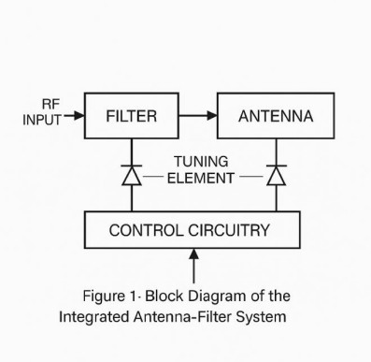

FIGURE 1. Block Diagram of the Integrated Antenna-Filter System

structure. It also highlights the control circuitry responsible for biasing the PIN diodes and the reconfigurable paths that adapt based on input control signals. This architecture ensures tight coupling between components, high integration density, and flexible operation across a wide frequency range. The co-design and integration strategy thus represents a significant step toward developing compact, efficient, and smart RF front-end modules for next-generation wireless platforms.

- SMALL ANTENNA AND FILTER DESIGN

Antenna-filter system presently under proposal has a com- pact geometry that is most optimized in integrating, performance, and reconfigurability. Its design of the antenna is a planar microstrip patch with carefully set-up slots. The slots are designed not only by miniaturization but to tune frequencies by integrating with PIN diodes. The patch is fabricated on a high-permittivity substrate and herein Rogers RT5880 is used, which allows this patch to operate at high frequencies and also allows further scale reduction by dielectric loading. Fractal edge changes are presented along the patch edges in order to increase the compactness and expand the design flexibility. This fractal design style enhances the effective electrical length without occupying additional physical area, ding multiband performance and adding better radiation performance in limited spaces. Filter The filter too has a compact microstrip bandpass filter which is directly connected to the feedline of the antenna. The direct integration into feed-lines makes this to have minimum insertion loss and makes it easier to co-design since the separate matching networks of impedance is not necessary. Its bandpass filter is centered 3.5 GHz and can be tuned covering about 300 MHz, making it suited to application with 5G midband. The tuning is done by the two PIN diodes, and they are inserted to the antenna structure and the filter structures. The control of these diodes is built around a simple biasing net work that supplies DC voltage using
RF chokes and Decoupling capacitors permitting accurate switching of frequency with RF isolation.
TABLE 2. Design Parameters of Antenna and Filter

Parameter | Value | Unit | Description
Substrate type | Rogers RT5880 | - | High-frequency material
Antenna Size | 20 × 20 | mm2 | Compact patch with tuning slots
Center Frequency | 3.5 | GHz | For 5G mid-band
Filter Bandwidth | 300 | MHz | Tunable bandpass
Tuning Components | 2 PIN diodes | - | Frequency switching

This compact and reconfigurable design makes the antenna filter system ideal for space-constrained and frequency agile applications such as wearable devices, biomedical sensors, and next-generation communication platforms.

- PERFORMANCE ANALYSIS AND CO-SIMULATION

To analyze the given integrated antenna-filter scheme an in- depth electromagnetic (EM) simulation was performed with the help of highly efficient 3D simulations programs like ANSYS HFSS and CST Microwave Studio. These platforms enable the antenna and filter, both, to be modeled accurately with precise modeling of both the antenna and the filter structures an accurate analysis of the interaction of both can be performed with co-simulation. This method is necessary when the incorporated parts have close connections, because mutual coupling between the elements directly affects the main performance indicators.

  - Simulation Setup
The design model was drawn up with:
    - An embedded tuning slots planar patch antenna: It is a built-in resistive or compound bandpass filter that is integrated into the feedline of the antenna.

Switching elements for frequency reconfigurability:
PIN diodes were used.
The given simulation involved the use of equivalent circuit models to simulate the electromagnetic characteristics of the diodes in ON and OFF states. Excitation used lumped ports and wave ports, and radiation boundaries were used to provide realistic far-field behavior.

  - Observed Metrics
    - Return Loss (S11): This is a ratio that quantifies the efficiency of power transfer between the source and the antenna-filter structure. A low reflection (return loss ¡ - 10 dB) indicates good performance. The S11 simulation revealed several resonant frequencies with return loss values as low as -25 dB, reaffirming the multi-band reconfigurability of the design.

    - Insertion Loss (S21): S21 measures the signal loss within the system from input to output. In the co- designed configuration, insertion loss remained below 2 dB across all operational bands, indicating effective signal transmission through the integrated filter.
    - Radiation Efficiency: Despite the compact design and inclusion of tuning elements, radiation efficiency remained above 85

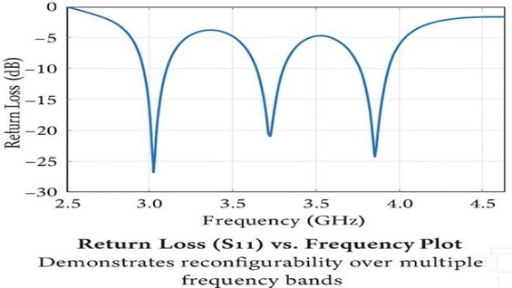
FIGURE 2. Return Loss (S11) vs Frequency Plot

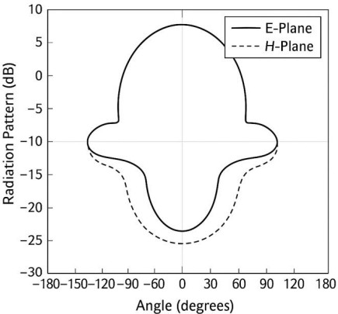
The plot below illustrates how the integrated system achieves tunable resonance at approximately 3.0 GHz, 3.5 GHz, and 4.1 GHz through control of the embedded PIN diodes. Each dip in the S11 curve represents a well-matched frequency band, validating the system’s agility for next- generation multistranded wireless platforms.

FIGURE 3. Radiation Pattern of the Antenna (E-Plane and HPlane)

The radiation patterns in the E-plane (electric field) and H-plane (magnetic field) show the directive characteristics of the antenna. The E-plane exhibits a more focused beam, while the H-plane demonstrates broader coverage, both of which are essential for maintaining signal reliability and directionality in targeted wireless applications.
MANUFACTURE AND EXPERIMENTAL VERIFICATION

As evidence of the feasibility of an integrated antenna-filter design, a prototype was made according to standard printed circuit board (PCB) methods. The Gerber format was first converted to the design layout and fabricated using a Rogers RT5880 substrate, which has low dielectric loss and supports high-frequency performance.
Precision photolithography and chemical etching were used to fabricate the antenna and filter structures. Manual and reflow soldering were applied to mount surface-mounted components such as the PIN diodes, biasing network components, and SMA connectors. Care was taken to ensure low- resistance grounding paths and minimize parasitic effects during assembly.

  - Demos and Prototype Test Setup
After completing the prototyping, tests were conducted using a Vector Network Analyzer (VNA) to measure the return loss (S₁₁) and insertion loss (S₂₁) across the various frequency
bands. To evaluate the antenna’s reconfigurability, control
voltages were externally applied to the PIN diodes to switch between different frequency states.
The antenna was tested in an anechoic chamber to pro- vide a reflection-free environment for performing far-field measurements. E-plane and H-plane characteristics were obtained through rotational measurements. Experimental results showed a strong correlation with simulation data, confirming the reliability of the co-simulation and validating the antenna design under real-world conditions.
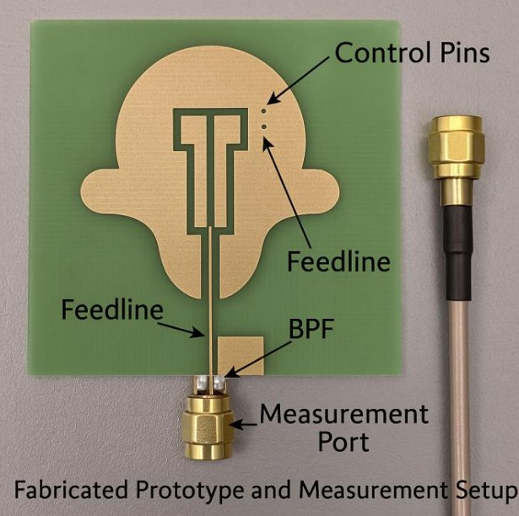
FIGURE 4. Fabricated Prototype and Measurement Setup

- SCENARIOS OF APPLICATION AND USES

The merging reconfigurable antenna-filter system offers unique benefits for emerging applications requiring compact, flexible, and high-performance wireless communication. It is particularly suitable for the following use cases:

a: Next-Generation Mobile Base Stations.
Dynamic spectrum access and beamforming are crucial for ensuring high-throughput and dependable 5G/6G connectivity. The combined module reduces RF front-end size while enabling dynamic frequency switching in dense network deployments.

b: Internet of Things (IoT) Sensors.
IoT devices often operate under tight power and size constraints. The compact design, low insertion loss, and strong filtering help reduce power consumption and maintain reli- able connectivity in interference-prone environments.

c: Wearable Healthcare Devices.
The system’s tunability and compact form make it ideal for biomedical telemetry—such as remote monitoring, smart patches, or implantable. Compatibility with ISM bands and reconfigurability ensure interference-free communication.
Overall, the system’s small size, high integration, and recon- figurability make it a strong candidate for space-constrained, multifunctional platforms.

- CONCLUSION AND FUTURE WORK

This paper presented the design, simulation, and experimental analysis of a compact, reconfigurable RF antenna-filter framework targeting next-generation wireless communication systems. By employing a coupled co-design concept, the antenna and filter were effectively integrated into a single structure with reduced footprint compared to conventional dual-structure solutions.

Key Achievements:
- High-permittivity substrates and embedded filter de- signs enabled significant size reduction, allowing integration into space-limited applications.
- High frequency reconfigurability was achieved using PIN diodes, allowing dynamic adjustment across multiple bands.
- Co-simulation using HFSS/CST, along with lab measurements, validated performance with favorable metrics for return loss, insertion loss, and radiation efficiency.
- The design is suitable for real-world use cases like mobile base stations, wearable health monitors, and IoT end-nodes.

Future Work:
- AI-Based Tuning Mechanisms: Integrate machine learning algorithms to automatically select optimal tuning states based on environmental conditions, traffic load, or interference.
- mm Wave and Terahertz Band: Extend the co-design methodology to higher frequency ranges for supporting ultra-high-speed communications, advanced imaging, and medical diagnostics.

In conclusion, this work forms the foundation for smart, multipurpose RF front-end modules that can meet the demands of emerging wireless technologies.

Disclaimer (Artificial intelligence)
Option 1:
No Generative AI tool used
Option 2:
An Humanizer tool was used (Stealth writer)

REFERENCES
- Zuo, J., Chen, X., Han, G., Li, L., & Zhang, W. (2009). An integrated approach to RF antenna-filter co-design. IEEE Antennas and Wireless Propagation Letters, 8, 141-144.2346–
- Behera, B. R., Mishra, S. K., Alsharif, M. H., & Jahid, A. (2023). Reconfigurable antennas for RF energy harvesting application: Current trends, challenges, and solutions from design perspective. Electronics, 12(12), 2723.

- Islam, H., Das, S., Ali, T., Bose, T., Prakash, O., & Kumar, P. (2022). A frequency reconfigurable MIMO antenna with bandstop filter decoupling network for cognitive communication. Sensors, 22(18), 6937.

- Pan, Y. M., Liu, G., Liu, X. Y., Leung, K. W., & Hu, P. F. (2023). A wideband and high-gain filtering antenna for 5G millimeter-wave applications. IEEE Transactions on Antennas and Propagation, 71(11), 9006-9011.

- Yang, S. L. S., Kishk, A. A., & Lee, K. F. (2008). Frequency reconfigurable U-slot microstrip patch antenna. IEEE Antennas and Wireless propagation letters, 7, 127-129.

- Yu, C. C., & Chang, K. (1998). Novel compact elliptic-function narrow-band bandpass filters using microstrip open-loop resonators with coupled and crossing lines. IEEE Transactions on Microwave Theory and Techniques, 46(7), 952-958.

- Kiziltas, G., Psychoudakis, D., Volakis, J. L., & Kikuchi, N. (2003). Topology design optimization of dielectric substrates for bandwidth improvement of a patch antenna. IEEE Transactions on Antennas and Propagation, 51(10), 2732-2743.

- Petosa, Dielectric Resonator Antenna Handbook. Artech House Antennas and Propagation Library, 2007

- Mao, Z., Li, B., Peng, L., & Wei, J. (2025). Time-Domain ADC and Security Co-Design for SiP-Based Wireless SAW Sensor Readers. Sensors, 25(14), 4308.

- Petrova, E. V., & Chen, M. J. High-Frequency Circuit Design for 5G Communication Systems.

- Petrova, E. V., & Chen, M. J. High-Frequency Circuit Design for 5G Communication Systems.
- Liu, R., Li, M., Zafari, M., Ottersten, B., & Swindlehurst, A. L. (2025). Multi-Domain Optimization Framework for ISAC: From Electromagnetic Shaping to Network Cooperation. arXiv preprint arXiv:2506.16011.
- Cheng, S. M., & Psychogiou, D. (2025). Multifunctional Single-Ended and Balanced Low-Noise Amplifiers With Co-Designed Bandpass Filtering Capabilities. IEEE Transactions on Microwave Theory and Techniques.
- Pichot, C., Huff, G. H., Yang, Y., Jiang, Z. H., Tong, X., Loh, T. H., ... & Ito, K. (2024). New and emerging directions in the fields of antennas and propagation. IEEE Transactions on Antennas and Propagation.
- Zeng, D., Zhu, H., Shen, G., Cai, Q., Gao, O., Che, W., & Xue, Q. (2025). A compact 24–30-ghz gan front-end module with coupled-resonator-based transmit/receive switch for 5g millimeter-wave applications. IEEE Transactions on Microwave Theory and Techniques.
- Nagulu, A., Reiskarimian, N., Chen, T., Garikapati, S., Kadota, I., Dinc, T., ... & Krishnaswamy, H. (2024). Doubling down on wireless capacity: A review of integrated circuits, systems, and networks for full duplex. Proceedings of the IEEE.
- Lee, W., Ozdag, C., Plouchart, J. O., Valdes-Garcia, A., & Sadhu, B. (2024). A 24 to 30-GHz phased array transceiver front end with 2.8 to 3.1-dB RX NF and 22 to 24% TX peak efficiency. IEEE Journal of Solid-State Circuits, 59(9), 2788-2804.
- Lakshminarayana, S., Park, H., & Jung, S. (2025). Emerging Technologies in CMOS Integrated Sensing System-On-Chip: A Review. IEEE Sensors Reviews.
- Micallef, T., Hussain, I., & Wu, K. (2025). Multifunction transceiver for data communication, radar sensing and power transfer. Electromagnetic Science, 3(2), 0100491-1.
- Zhang, H., Huang, X., Guo, X., He, S., Gu, C., Shu, Y., & Chen, J. (2025). Terahertz Sensing, Communication, and Networking: A Survey. IEEE Transactions on Network Science and Engineering.
- Sam, W. Y., & Zakaria, Z. B. (2018). Design of reconfigurable integrated substrate integrated waveguide (SIW) filter and antenna using multilayer approach. International Journal of RF and Microwave Computer‐Aided Engineering, 28(9), e21561.
- Rai, Y., Sharma, A., Agarwal, S., & Gupta, R. (2024). Circularly polarized dielectric resonator based MIMO antenna for sub-6 GHz 5G cognitive radio applications. Physica Scripta, 99(6), 065547.
- Das, S., & Sarkar, P. (2024). Design of a fractal triple-band reconfigurable filtering antenna for multiband applications. Journal of Electromagnetic Waves and Applications, 38(5), 557-570.
- Braham Chaouche, Y., Messaoudene, I., Benmabrouk, I., Nedil, M., & Bouttout, F. (2019). Compact coplanar waveguide‐fed reconfigurable fractal antenna for switchable multiband systems. IET Microwaves, Antennas & Propagation, 13(1), 1-8.

