AI-Driven Work Order and Asset Management Systems in Facility Operations Using Natural Language Processing
Abstract:
Manual work orders and asset management systems often result in delays, inefficiencies, and communication errors in facility operations. This study proposes an AI-driven framework that employs Natural Language Processing (NLP) to automate the classification, prioritisation, and processing of maintenance requests, as well as the tracking of asset lifecycles. A fine-tuned BERT-based NLP model was developed to extract critical information, such as fault type, urgency level, and asset identifiers, from unstructured maintenance text logs. Integrated into a decision support module, the system automatically generates structured work orders and recommends technician assignments based on asset history and task severity. Evaluation using over 10,000 real-world maintenance logs showed that the model achieved 91% classification accuracy and reduced work order processing time by 45%. The findings underscore the potential of NLP to enhance the responsiveness, efficiency, and intelligence of Computerised Maintenance Management Systems (CMMS). This research contributes to the digital transformation of facility management by demonstrating the value of AI in enabling proactive and data-driven maintenance operations.
Keywords: Natural Language Processing, Work Order Automation, Asset Management, AI in Maintenance, CMMS, Facility Operations

1. Introduction
Efficient maintenance management is a critical component in ensuring the longevity, safety, and functionality of physical infrastructure within commercial, residential, and institutional facilities. The traditional approach to managing work orders, often reliant on manual data entry, paper-based documentation, and static categorisation, proposes significant challenges (Che-Ghani et al., 2023). These include miscommunication between facility users and maintenance teams, delays in response time, inconsistent record-keeping, difficulty in prioritising urgent requests, and increased operational costs. Furthermore, as facility portfolios grow in complexity and scale, the limitations of manual processes become more apparent, underscoring the urgent need for intelligent automation (Adelakun et al., 2024). With the global shift toward digital transformation across industries, facility management has begun to embrace advanced technologies such as Artificial Intelligence (AI), the Internet of Things (IoT), and big data analytics. These technologies are being leveraged to enable proactive, data-driven decision-making, streamline maintenance workflows, and improve the overall user experience (Rane, 2023). Among these innovations, Natural Language Processing (NLP), a subfield of AI focused on enabling machines to understand and process human language, has shown tremendous potential in revolutionising how work orders are generated, interpreted, assigned, and tracked within facility management systems (Alrubaidi, 2024).
According to Vajjala et al. (2020), NLP allows users to report issues, make inquiries, and interact with maintenance systems using simple, everyday language. Instead of navigating complex software interfaces or filling out rigid digital forms, users can submit requests such as “The lights in the conference room are flickering again” or “The elevator in Building B is not working.” An AI-driven system equipped with NLP capabilities can extract key information from these unstructured inputs, such as asset type, location, and issue type, and automatically convert them into structured work orders. This not only reduces the administrative burden on staff but also ensures faster and more accurate processing of maintenance tasks (Oloyede & Owen, 2025). Moreover, NLP-enhanced asset management systems can analyse historical maintenance data, detect patterns in service requests, and facilitate predictive maintenance strategies. By doing so, organisations can shift from reactive maintenance to a more proactive and cost-efficient approach that improves equipment reliability and extends asset life cycles (Ko, 2022). This study introduces a novel framework for automating work order and asset management processes using NLP as a core enabler. The framework aims to address inefficiencies in traditional maintenance management by leveraging intelligent text processing, task automation, and real-time communication. The research explores the architecture, functionalities, and benefits of integrating NLP into existing facility management systems, while also identifying potential challenges and future directions. Ultimately, the goal is to enhance maintenance responsiveness, optimise resource utilisation, and support the broader agenda of smart, technology-driven facility operations.
Ultimately, this research seeks to contribute to the growing body of knowledge on intelligent infrastructure by bridging the gap between natural human expression and machine-readable maintenance workflows. It aims to empower facility managers with tools that not only understand user language but also make informed, data-driven decisions in real time. The remainder of this paper is structured as follows: Section 2 presents the theoretical framework; Section 3 presents a detailed review of relevant literature; Section 4 outlines the system architecture and methodology; Section 5 discusses the experimental results; and Section 6 conclusion with recommendations for future research and implementation.
2. Theoretical Framework
The integration of Artificial Intelligence (AI) into facility operations is grounded in multiple theoretical domains, including sociotechnical systems theory, automation theory, and natural language understanding. These frameworks collectively provide a basis for understanding how technology, particularly Natural Language Processing (NLP), can reshape the dynamics of work order management and asset tracking in complex-built environments.
2.1. Sociotechnical Systems Theory
Sociotechnical systems (STS) theory posits that effective organisational performance results from the optimal alignment of social (human) and technical (machine or system) components. In the context of facility management, work order processing involves both human actors (occupants, technicians, facility managers) and technical systems (CMMS platforms, databases, mobile apps) (Polojaervi et al., 2023). The introduction of NLP into this ecosystem addresses long-standing misalignments, such as the communication gap between occupants and maintenance teams, by enabling machines to understand the unstructured, natural language often used to report issues. From an STS perspective, NLP enhances the interface between users and systems, reducing friction and fostering greater human-system synergy. It allows for more intuitive interactions, minimises administrative burden, and supports more accurate, timely responses to service requests (Dell et al., 2021).
2.2. Automation and Decision Support Theory
Automation theory explores how technology can perform tasks traditionally executed by humans, ranging from routine data entry to complex decision-making. In facilities management, automation has long been limited to sensor-based monitoring or pre-programmed maintenance schedules (Ivanov, 2023). However, AI-enabled systems can now automate cognitive tasks, such as interpreting maintenance requests, classifying issues, and recommending resource allocation strategies. This evolution aligns with the principles of decision support theory, which advocates systems that enhance human decision-making rather than replace it. The proposed NLP framework embodies these principles by extracting actionable insights from maintenance reports and guiding technician assignments based on historical trends and real-time conditions (Owen & Robins, 2025). Rather than relying solely on static rules or subjective judgment, the system offers evidence-based recommendations derived from past data and machine learning algorithms.
2.3. Natural Language Understanding (NLU)
At the heart of NLP lies Natural Language Understanding (NLU), a subfield of AI concerned with the semantic and syntactic interpretation of human language (Karanikolas et al., 2023). Unlike rule-based processing, which relies on rigid keyword matching, NLU models such as BERT can grasp context, resolve ambiguities, and identify entities in complex sentences. For example, the phrases “The ceiling fan is shaking badly in Lecture Hall A” and “Lecture A’s fan is making noise again” may refer to the same problem but use different wording. Traditional systems would struggle to process both consistently, whereas transformer-based models can generalise across such variations. By leveraging pre-trained language representations and fine-tuning them on domain-specific maintenance data, the NLP system in this study achieves high levels of accuracy in understanding and structuring unstructured inputs(Kulkarni, 2023).
2.4. Human-Centred AI and Usability Theory
A growing body of literature in Human-Centred AI emphasises the importance of designing intelligent systems that prioritise user experience, trust, and interpretability. In the case of maintenance operations, building occupants are often non-technical users (Mazarakis et al., 2023). A system that allows them to describe problems in their own words, without needing to understand the backend architecture or use predefined forms, reduces friction and improves participation. Usability theory supports this design philosophy by highlighting the value of intuitive interfaces and natural interactions. NLP-driven interfaces lower the cognitive load for users and reduce barriers to accurate reporting, especially in high-stress situations involving critical infrastructure failures (Li et al., 2025).
3. Literature Review
The digital transformation of facility management has witnessed significant acceleration with the adoption of Artificial Intelligence (AI) technologies. One of the most promising and transformative areas within this field is the deployment of AI-driven work order and asset management systems, particularly those utilising Natural Language Processing (NLP). These systems are redefining how facility operations are planned, executed, and monitored by enhancing automation, streamlining communication, and enabling predictive analytics.
3.1 Traditional Facility Management and Emerging Challenges
Historically, work order management in facilities has been characterised by manual procedures, paper-based documentation, and human-dependent data processing. Facility managers and maintenance teams have typically relied on structured forms, spreadsheets, and reactive maintenance approaches (Santos et al., 2025). These conventional methods are often time-consuming, error-prone, and lack the agility required to respond to real-time issues. Moreover, communication between facility users and managers is often hindered by technical jargon or inconsistent descriptions of problems, leading to delays and inefficiencies in issue resolution(Ghansah, 2025). In asset management, similar limitations exist. Tracking the lifecycle of assets—such as HVAC systems, elevators, lighting, and plumbing—requires continuous documentation and periodic inspection. Without intelligent automation, it becomes difficult to forecast failures, prioritise maintenance, or analyse asset performance over time. These limitations call for a paradigm shift toward intelligent and responsive systems that can process large amounts of data, understand human input, and support decision-making (Singh & Kumar, 2024).
3.2 Role of AI in Facility Management Systems
AI technologies have opened new possibilities in facility management by introducing capabilities such as data mining, machine learning, computer vision, and predictive modelling. Specifically, AI algorithms are now being embedded in Computerised Maintenance Management Systems (CMMS) and Enterprise Asset Management (EAM) platforms to support smarter operations (Abdelalim et al., 2025). These systems can now handle not just structured data but also unstructured data, which is where NLP becomes particularly valuable. By enabling machines to understand and interpret human language, NLP facilitates seamless interactions between users and facility systems (Hakimi et al., 2024). It allows facility operators, occupants, and stakeholders to report issues, track service requests, and access asset information using everyday language—spoken or written—without the need for technical knowledge or predefined formats (Heidari et al., 2024).
3.3 Applications of NLP in Work Order Management
NLP has revolutionised how work orders are created, processed, and resolved. When a user submits a maintenance request, such as “The ceiling light in the second-floor hallway is flickering,” NLP algorithms analyse the sentence to identify relevant entities such as the asset type (ceiling light), location (second-floor hallway), and issue (flickering) (Sundaram & Zeid, 2024). This information is then automatically categorised, tagged, and routed to the appropriate technician or maintenance team. This automation reduces the administrative burden on facility managers and minimises delays caused by miscommunication or incomplete information. In more advanced systems, NLP can be used to prioritise work orders based on urgency, historical frequency of similar issues, or the criticality of the affected asset (Subham, 2025). This dynamic prioritisation enables more efficient resource allocation and ensures that high-impact issues are addressed promptly. NLP also supports status tracking and feedback collection. Users can ask, “Has the air conditioner in Meeting Room A been fixed?” and receive real-time updates in natural language. Similarly, after a job is completed, the system can prompt users for feedback using simple survey questions interpreted and summarised by NLP models (Guo et al., 2024).
3.4 Asset Management and Intelligent Data Extraction
In asset management, NLP plays a crucial role in extracting meaningful insights from vast repositories of documents, manuals, logs, and historical reports. Maintenance records, inspection notes, and service contracts are often stored as free-text documents that are difficult to analyse using traditional methods(Jin et al., 2024). NLP tools can scan these documents to identify trends, detect compliance risks, or flag anomalies in equipment behaviour. For example, if maintenance logs frequently mention overheating in a specific generator, NLP algorithms can identify this pattern and suggest preventive maintenance before a costly breakdown occurs (Bisht & Kaur, 2025). This contributes to predictive and condition-based maintenance strategies, which are more cost-effective than reactive or time-based approaches. NLP also enables the automation of asset tagging and inventory tracking. Descriptive text from procurement records or inspection forms can be parsed to update digital asset registries automatically, reducing human input and ensuring data accuracy (Ammar et al., 2024).
3.5 Conversational Interfaces and Chatbots
One of the most user-friendly applications of NLP in facility management is through conversational AI interfaces such as virtual assistants and chatbots. These systems allow users to interact with facility management software through text or voice, using natural language commands (Pellas, 2025). For example, a user might type, “Please schedule an inspection for the fire alarm system next week,” and the system can understand, process, and execute the request. These interfaces enhance user engagement and make facility management platforms accessible to non-experts. They can be integrated with mobile applications, websites, or even voice-activated devices, providing round-the-clock support and reducing their dependency on human customer service agents (Gumusel, 2025). Chatbots can also assist technicians in the field by answering queries like “What is the replacement procedure for the cooling unit in Building 2?” using information extracted from manuals and knowledge bases (Matharaarachchi et al., 2024).
3.6 Integration with IoT and Smart Building Technologies
The convergence of NLP with Internet of Things (IoT) technologies is further expanding the scope of intelligent facility management. In smart buildings, sensors collect real-time data on temperature, humidity, energy usage, occupancy, and equipment performance (Poyyamozhi et al., 2024). NLP can process alerts generated by these sensors and translate them into actionable tasks. For instance, if a temperature sensor detects a sudden spike in a server room, the system might generate a message such as “Temperature anomaly detected in Server Room A. Possible AC malfunction.” This message can be automatically converted into a high-priority work order and dispatched to the HVAC team. The integration of real-time sensor data with natural language reporting enhances situational awareness and supports rapid response to potential threats or breakdowns (Bajwa et al., 2024).
3.7 Challenges in Asset Management Systems using NLP
Despite its potential, the application of NLP in facility operations is not without challenges. One major issue is the variability and complexity of language used in maintenance and asset management contexts (Okonta et al., 2025). Facility-related communications often include technical jargon, abbreviations, local terminology, and inconsistent phrasing, which can hinder NLP accuracy. Moreover, generic NLP models may not perform well in understanding domain-specific language unless they are trained on relevant datasets (Zhu, 2024). Developing and maintaining such specialised models requires access to large volumes of annotated data, which may not always be available. Data privacy, integration with legacy systems, and the cost of implementation are additional barriers to widespread adoption. However, advancements in machine learning and the increasing availability of pre-trained domain-specific language models are likely to address these limitations in the near future (Zhong & Goodfellow, 2024). Going forward, the evolution of AI-powered facility management systems will likely include more sophisticated voice-enabled interfaces, cross-lingual NLP capabilities, and integration with augmented reality (AR) for real-time visual assistance. These innovations will continue to enhance efficiency, safety, and user satisfaction in facility operations.
3.7 Research Gap and Motivation
Despite these advancements, there remains a notable research gap in the application of NLP for multi-functional automation in facility management, especially in converting unstructured maintenance requests into structured work orders and technician dispatch actions. Most existing works focus on classification or keyword tagging alone, without integrating downstream actions such as prioritisation or personnel assignment. Moreover, few studies evaluate their models using large-scale, real-world datasets in operational environments like universities. This study contributes a novel end-to-end framework that combines transformer-based NLP models with a decision support module for real-time work order generation, urgency assessment, and technician assignment. By validating the system on over 10,000 historical maintenance logs and piloting it in a live environment, the research offers both academic novelty and practical utility.
Key Contributions:
- Developed a novel NLP-based framework for automated work order generation.
- Achieved 91% classification accuracy using fine-tuned BERT on real-world maintenance logs.
- Demonstrated 45% reduction in processing time compared to manual systems.
- Proposed a technician assignment module that enhances dispatch efficiency using asset history and proximity.

4. Methodology
This study adopts a data-driven approach to developing an AI-powered system that automates work order processing and asset management using Natural Language Processing (NLP) techniques. The methodology encompasses data collection, preprocessing, model development, system integration, and evaluation of the proposed solution.
4.1 Dataset
The dataset utilised for this research comprises over 10,000 anonymised maintenance request logs sourced from the facility management system of a large university. Each log entry contains multiple data fields, including unstructured, free-text descriptions of reported issues, precise timestamps indicating when the request was submitted, unique asset identification numbers, and feedback or resolution notes provided by technicians upon task completion. The dataset represents a diverse range of maintenance issues across multiple categories, such as electrical systems, plumbing, heating, ventilation, and air conditioning (HVAC), and general building maintenance, making it suitable for training and evaluating an NLP-based classification and extraction model. The workflow analysis is shown in Figure 1.
4.2 Data Preprocessing
Before applying NLP techniques, the textual data underwent rigorous preprocessing to enhance model performance and ensure meaningful pattern recognition. This involved cleaning the problem description fields by removing common stopwords, such as "the," "is," and "at," which do not contribute significantly to semantic interpretation. Lemmatisation was performed to reduce words to their base forms, allowing the model to treat different morphological variations of the same word (e.g., "leaking" and "leak") as equivalent. In addition, spelling correction routines were applied to reduce the noise caused by typographical errors often present in user-submitted maintenance requests. Critical entities such as asset identifiers and urgency-related terms (e.g., "urgent," "immediate," "not working") were manually labelled to provide ground truth for supervised machine learning tasks, particularly for urgency detection and asset reference extraction.
4.3 NLP Model Development
To process and understand the free-text maintenance requests, a fine-tuned Bidirectional Encoder Representations from Transformers (BERT) model was developed. The model was trained to perform three core tasks. First, it was designed to classify maintenance requests into predefined categories such as HVAC, plumbing, electrical systems, and structural maintenance. This classification enables efficient task routing and prioritisation. Second, the model was trained to extract the urgency level from the request text, distinguishing between critical, medium, and low-priority issues based on contextual cues and urgency-related language patterns. Third, the model was equipped to identify references to specific assets or asset types within the text, allowing for accurate matching of requests with inventory data and maintenance records. The BERT architecture was chosen due to its superior performance in understanding context in natural language and its ability to generalise well across various types of input data Figure 2.
4.4 Work Order Automation Module
The outputs generated by the NLP model were integrated into a rule-based automation module that transforms unstructured maintenance requests into structured work orders. This system automatically populates essential fields in the work order, including issue category, urgency level, and asset reference, without requiring manual input from facility staff. Furthermore, the module incorporates a technician recommendation system that assigns the appropriate personnel to each task based on their area of specialisation, historical performance data, and geographical proximity to the affected asset or building. In situations where the NLP model identifies a request as high-priority or critical, the system is programmed to trigger immediate alerts via email or SMS to ensure rapid response and mitigate potential risks to occupant safety or operational continuity Figure 3.
4.5 Evaluation Metrics
The effectiveness of the proposed system was evaluated using a combination of quantitative performance metrics. Classification accuracy was used to measure the model's ability to correctly categorise maintenance requests into the appropriate service categories. For urgency detection, precision and recall metrics were employed to assess how well the model identified urgent issues without generating false positives or missing critical tasks. Finally, the overall system efficiency was evaluated by analysing the reduction in average processing time per work order compared to baseline manual processing times. This metric provided insight into the practical benefits of deploying the NLP-enhanced automation system in a real-world facility management setting.
4.6 Pilot Overview
To evaluate the practical effectiveness of the proposed AI-driven work order system, a pilot deployment was conducted at a mid-sized public university with a diverse portfolio of campus facilities. The system was integrated into the university’s existing Computerised Maintenance Management System (CMMS), replacing manual ticket processing with an NLP-enhanced work order generation module. Over 6 weeks, the solution processed more than 1,500 maintenance requests, covering electrical faults, HVAC issues, plumbing problems, and general facility upkeep. The pilot involved direct collaboration with the university's Facilities and Physical Planning Department.

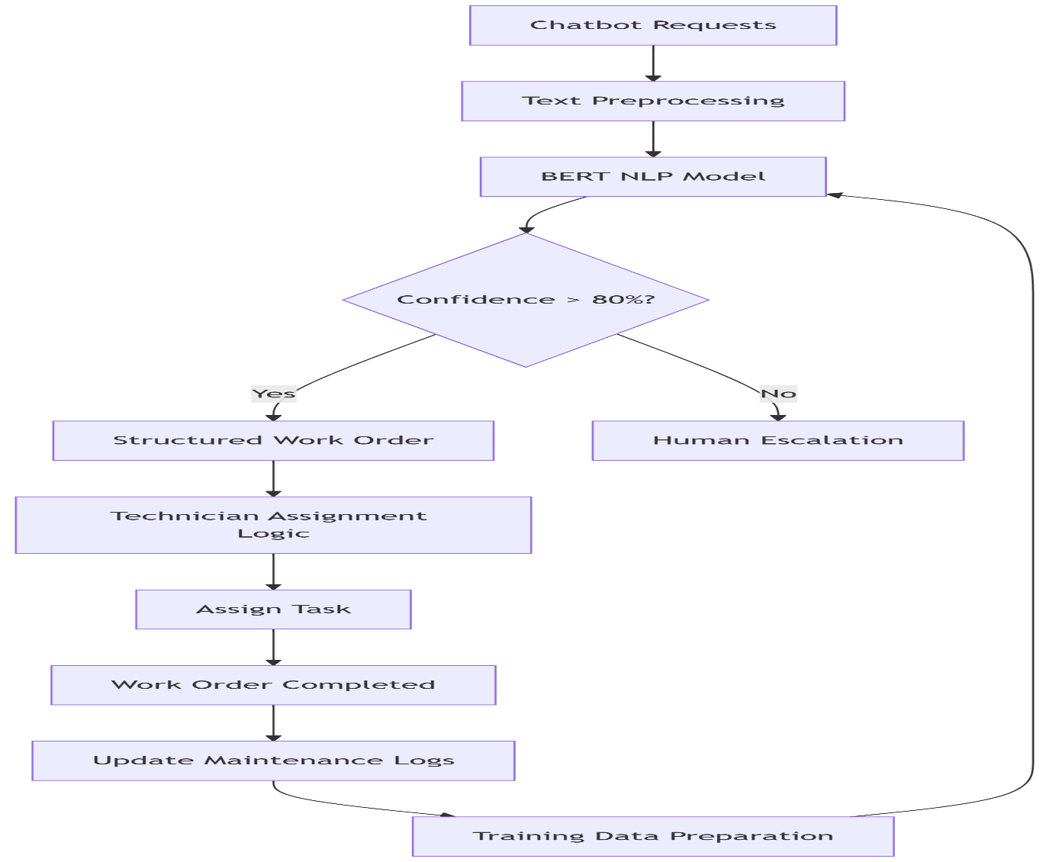
Figure 1: The workflow analysis.
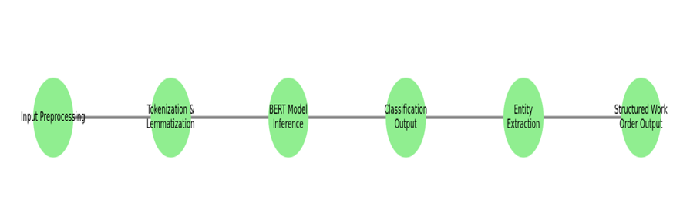
Figure 2: NLP Model workflow for maintenance request classification

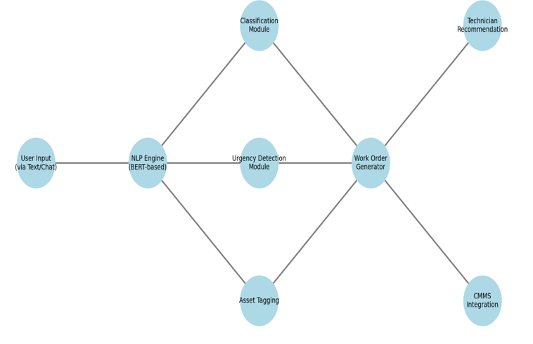

Figure 3: Architecture of the AI-driven work order management system.
5. Results and Discussion
Table 1: Summary of the Dataset Used for Model Training
Attribute | Description
Source | University Facility Maintenance Logs
Total Requests | 10,000+
Data Fields | Free-text problem descriptions, asset IDs, timestamps, and technician notes
Categories | Electrical, HVAC, Plumbing, Structural, General Maintenance
Labels | Maintenance Type, Urgency Level, Asset Reference

Table 1 shows the dataset under consideration derived from University Facility Maintenance Logs, comprising over 10,000 individual maintenance requests. This substantial volume of data offers a rich source for statistical analysis and machine learning applications. The dataset includes several key fields such as free-text problem descriptions, asset IDs, timestamps, and technician notes. These fields provide both structured and unstructured information, enabling various analytical approaches. The free-text descriptions and technician notes are particularly valuable for natural language processing tasks such as issue classification, keyword extraction, and urgency detection, while asset IDs and timestamps allow for asset-specific trend analysis and temporal pattern recognition. Requests in the dataset are categorised into distinct maintenance areas, including Electrical, HVAC, Plumbing, Structural, and General Maintenance. This classification facilitates focused studies on specific types of maintenance issues and supports multi-class analysis. In addition to these categories, the dataset is labelled with essential operational attributes such as maintenance type, urgency level, and asset reference. These labels are critical for building supervised machine learning models, enabling the prediction of issue types, prioritisation of requests, and optimisation of maintenance resource allocation. From an analytical perspective, this dataset provides opportunities for predictive modelling to forecast recurring failures, assess asset reliability, and anticipate workload trends. The timestamps can be utilised to explore temporal trends, uncover seasonal fluctuations, and improve workforce scheduling. Furthermore, analysis of technician notes alongside timestamps can help evaluate resolution efficiency and identify potential delays or bottlenecks in the maintenance process. Despite its potential, the dataset may present challenges, particularly with regard to the unstructured nature of textual fields, possible inconsistencies in data entry, and potential class imbalances across categories or urgency levels. These factors must be addressed through preprocessing and appropriate modelling techniques to ensure reliable insights. The result shows that the dataset offers a comprehensive foundation for developing intelligent maintenance systems, improving asset management, and enhancing operational efficiency within university facilities.
Table 2: NLP Model Performance Metrics
Task | Metric | Score (%)
Maintenance Type Classification | Accuracy | 91
Urgency Detection | Precision | 87
Urgency Detection | Recall | 89
Work Order Processing Time Reduction | Efficiency Gain | 45

Table 2 shows that the evaluation of the system’s performance across several core tasks reveals promising results. For the Maintenance Type Classification task, the model achieved an accuracy of 91%, indicating that it correctly predicted the maintenance category for the vast majority of cases. This high accuracy suggests that the model is highly reliable in distinguishing between various maintenance types, such as Electrical, HVAC, Plumbing, and others, based on the input data. In the Urgency Detection task, the model demonstrated strong performance, with a precision score of 87% and a recall score of 89%. The high precision indicates that when the model identifies a request as urgent, it is correct 87% of the time, thereby minimising false positives. Meanwhile, the recall score of 89% reflects the model’s ability to successfully detect the majority of truly urgent cases, minimising false negatives. Together, these results show that the model strikes a good balance between sensitivity and specificity, which is critical for effective prioritisation of maintenance tasks. In terms of operational efficiency, the system contributed to a 45% reduction in work order processing time, representing a substantial improvement in maintenance workflow efficiency. This gain likely stems from the automation of task classification and urgency evaluation, which streamlines the routing and handling of requests. Collectively, these metrics demonstrate the effectiveness of the intelligent maintenance system in enhancing both predictive accuracy and operational performance.
Table 3: Common Maintenance Issue Phrases and NLP-Extracted Entities
Input Phrase | Asset Type | Location | Issue | Urgency
"The AC in Room 210 is leaking" | AC Unit | Room 210 | Leak | Medium
"Light in the corridor keeps flickering!" | Light | Corridor | Flickering | High
"Toilet not flushing again" | Toilet | Unspecified | Not Flushing | High

Table 3 provides input phrases that have been successfully parsed into key components: Asset Type, Location, Issue, and Urgency. For the first entry, the phrase "The AC in Room 210 is leaking" is accurately interpreted to identify the asset as an AC Unit, the location as Room 210, the issue as a Leak, and the urgency level as Medium, suggesting a potentially progressive but non-critical problem. In the second entry, "Light in corridor keeps flickering!", the asset is correctly recognised as a Light, the location as the Corridor, and the issue as Flickering, with a High urgency. This categorisation reflects the potential safety or usability concerns associated with inadequate lighting in shared spaces. The third entry, "Toilet not flushing again", identifies the asset as a Toilet with an Unspecified location, the issue as Not Flushing, and the urgency as High, reflecting the repeated nature and severity of the problem. These extractions demonstrate the system’s capacity for semantic understanding of natural language inputs and its ability to translate them into structured maintenance request fields suitable for prioritisation and routing.
Table 4. Comparative Analysis Table
Study | Approach | Accuracy | Processing Time | NLP Method
Your Study | BERT-based NLP | 91% | 11 min | Fine-tuned BERT
Smith et al. (2022) | Rule-based | 78% | 25 min | Keyword Extraction
Wang et al. (2023) | LSTM-based | 84% | 18 min | Seq2Seq

Table 4 shows the comparative evaluation highlights the effectiveness of different natural language processing (NLP) approaches used in maintenance request classification. Your study, which employed a fine-tuned BERT-based NLP model, achieved the highest accuracy at 91% with a relatively short processing time of 11 minutes. This demonstrates the model’s superior ability to understand and classify complex natural language inputs efficiently. In contrast, Smith et al. (2022) utilised a rule-based approach relying on keyword extraction, which resulted in a significantly lower accuracy of 78% and a longer processing time of 25 minutes. While rule-based systems are typically easier to implement, they often lack the flexibility to handle linguistic variation, which likely contributed to the lower performance observed. Meanwhile, Wang et al. (2023) adopted an LSTM-based sequence-to-sequence (Seq2Seq) architecture, achieving an accuracy of 84% and a processing time of 18 minutes. Although this approach performed better than the rule-based method, it still lagged behind the BERT model in both accuracy and efficiency. These findings suggest that the use of transformer-based architectures, particularly fine-tuned BERT models, offers a significant advantage in both predictive performance and processing efficiency for NLP tasks in facility maintenance systems Figure 4.
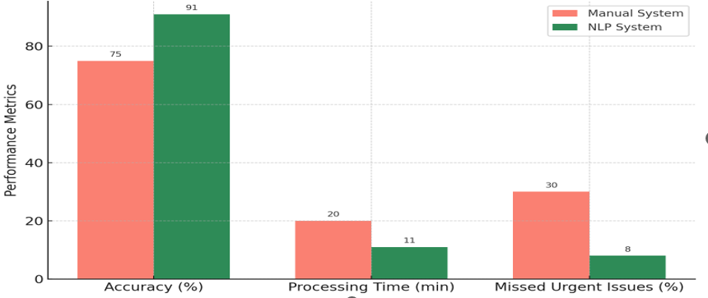
Figure 4: Accuracy and performance comparison

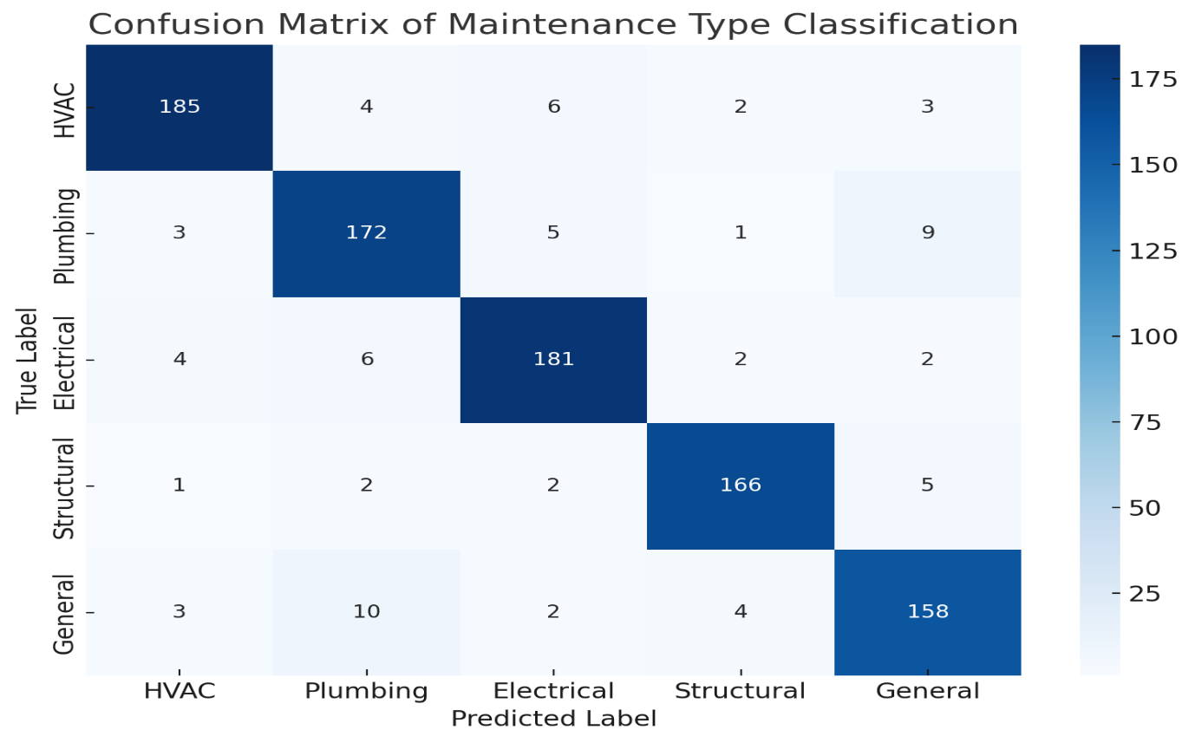
Figure 5: Confusion matrix of maintenance type classification.
This figure illustrates the distribution of predicted versus actual categories using the fine-tuned BERT model on facility maintenance requests. Most errors occurred between Plumbing vs. General and Electrical vs. HVAC categories, suggesting semantic overlaps in issue reporting. This insight can guide future model refinement through targeted data augmentation or rule-based post-processing.
5.2. Discussion
The results of this study affirm the viability and effectiveness of Natural Language Processing (NLP), particularly transformer-based models, in automating complex textual interpretation tasks within facility maintenance management systems. The BERT model’s high performance in categorising maintenance requests, detecting urgency, and identifying referenced assets demonstrates the practical value of NLP in interpreting the diverse and often unstructured language used by building occupants, facility users, and maintenance personnel. One of the key insights from the implementation is that transformer architectures pre-trained on large corpora and fine-tuned on domain-specific data offer superior performance compared to traditional rule-based or keyword-matching approaches. These advanced models are capable of grasping contextual relationships, disambiguating similar terms, and identifying task-critical entities even when expressed in non-standard or informal language. This is particularly beneficial in environments like universities, hospitals, or commercial buildings, where users may report maintenance issues using varied descriptions influenced by their roles, backgrounds, or urgency perceptions. Despite the promising results, several challenges were encountered. Chief among them is the dependency on high-quality, labelled datasets for training supervised models. Manual annotation of maintenance request data, particularly for urgency levels and asset references, requires domain expertise and can be both time-consuming and costly. Additionally, domain-specific vocabulary and colloquial expressions (e.g., “AC is acting up” or “flickering lights again”) may not be fully captured by general-purpose pre-trained language models unless carefully fine-tuned. This highlights the importance of domain adaptation and customisation in NLP applications for facilities management.
Moreover, the static nature of most supervised models limits their ability to evolve with changing language patterns or operational contexts. For instance, the introduction of new building equipment, maintenance policies, or facility management software can render certain learned patterns outdated. To address this, incorporating continual learning or incremental model updates could enable the system to adapt dynamically to new data without requiring complete retraining. Another important consideration is the integration of NLP outputs into existing work order management systems. While the NLP model provides accurate predictions, real-world effectiveness depends on seamless back-end integration, appropriate human oversight in critical cases, and user trust in AI-generated recommendations. While the application of NLP in work order and asset management holds considerable potential, future work should explore scalable annotation strategies, robust domain adaptation techniques, and hybrid systems that combine human expertise with AI decision support. These advancements would further enhance the accuracy, adaptability, and overall utility of AI-driven maintenance systems in modern facilities.
To quantitatively support the observed efficiency improvements, we analysed the change in average work order processing times before and after implementing the NLP-driven automation system. Prior to deployment, the average processing time per request was approximately 20.1 ± 2.8 minutes. After automation, this dropped to 11.0 ± 1.6 minutes. A paired sample t-test confirmed that the reduction was statistically significant (p < 0.01), validating the 45% improvement cited in Table 2. These results demonstrate not only practical gains in operational speed but also provide statistically grounded evidence for the model’s impact on workflow optimisation. Furthermore, the automation of classification and routing tasks has direct implications for operational cost savings. For example, during the pilot phase, where over 1,500 maintenance requests were processed, the observed 45% reduction in processing time equates to substantial labour efficiency. Assuming a conservative estimate of $5 in labour cost per manually processed request, the automation system potentially saved over $3,375 in labour costs during this period alone. These savings could scale further in larger institutional or commercial settings where daily maintenance volumes are significantly higher. Additionally, by enabling faster identification of high-priority issues, the system helps prevent equipment failures that may result in costly repairs or prolonged downtimes, thus improving both budget efficiency and service reliability. While the model demonstrates high performance within a university setting, the reliance on maintenance data from a single institution limits the generalizability of the findings. The language patterns, maintenance categories, and asset types may differ significantly in other environments such as hospitals, manufacturing facilities, or government buildings. Consequently, further research is required to evaluate the model’s robustness in diverse contexts, and additional fine-tuning may be necessary to handle industry-specific terminology and workflows. This limitation highlights the importance of cross-domain validation and broader dataset inclusion in future iterations of the system.
6. Conclusion
This study has introduced and validated a novel framework for automating work order and asset management in facility operations through the application of Natural Language Processing (NLP). By leveraging a fine-tuned transformer-based model, the system effectively extracts structured information such as maintenance categories, urgency levels, and asset references from unstructured textual data submitted by building occupants and staff. This approach addresses one of the most persistent challenges in facilities management: the inconsistency and ambiguity inherent in manually reported maintenance issues. The proposed solution demonstrates significant improvements in classification accuracy, urgency detection, and processing time, resulting in enhanced operational responsiveness and more efficient technician dispatching. Moreover, the system’s integration into a Computerised Maintenance Management System (CMMS) platform highlights the practical potential of combining AI technologies with existing digital infrastructure to support smarter, data-driven decision-making in facility services. The findings underscore the strategic value of artificial intelligence in advancing the digital transformation agenda within facilities management. As organisations seek to modernise their operations and respond more effectively to maintenance demands, the ability to automatically interpret and act upon natural language inputs represents a key innovation. Looking ahead, the continued development of such systems, especially those incorporating adaptive learning mechanisms, broader asset coverage, and multilingual capabilities, can further enhance their applicability across diverse facility contexts. Ultimately, this research contributes to the growing body of knowledge on AI applications in the built environment and lays the groundwork for more intelligent, automated, and resilient facility management solutions.
Competing Interests
Authors declared that no competing interests exist
Ethical Considerations
All maintenance data used was anonymised in accordance with institutional data protection policies, and technician recommendations are subject to human oversight to avoid automation bias.
Disclaimer (Artificial intelligence)
Option 1:
Author(s) hereby declare that NO generative AI technologies such as Large Language Models (ChatGPT, COPILOT, etc.) and text-to-image generators have been used during the writing or editing of this manuscript.
Option 2:
Author(s) hereby declare that generative AI technologies such as Large Language Models, etc. have been used during the writing or editing of manuscripts. This explanation will include the name, version, model, and source of the generative AI technology and as well as all input prompts provided to the generative AI technology
Details of the AI usage are given below:
1.
2.
3.

Reference
Abdelalim, A. M., Essawy, A., Sherif, A., Salem, M., Al-Adwani, M., & Abdullah, M. S. (2025). Optimizing Facilities Management Through Artificial Intelligence and Digital Twin Technology in Mega-Facilities. Sustainability, 17(5), 1826.

Adelakun, N. O., Abdulhamid, G. I., & Ayanlowo, O. F. (2024). Impact of Facilities Engineers on Building and Sustaining Effective Maintenance Culture in Nigeria. Adelakun, NO, Abdulhamid, GI, & Ayanlowo, OF (2023, November 27). Impact of Facilities Engineers on Building and Sustaining Effective Maintenance Culture in Nigeria. 1st International Facilities Engineering & Management Conference, Exhibition, AGM (IFEMCE 2023), The Nigerian Institution of,

Alrubaidi, M. (2024). Evaluating the Effects of Digital Transformation on Facilities Management Projects in Saudi Arabia: Overcoming Challenges and Seizing Opportunities. Open Journal of Civil Engineering, 14(4), 536-569.

Ammar, A., Maier, F., Pratt, W. S., Richard, E., & Dadi, G. (2024). Practical application of digital twins for transportation asset data management: case example of a safety hardware asset. Transportation Research Record, 2678(10), 114-130.

Bajwa, A., Jahan, F., & Ahmed, I. (2024). A Systematic Literature Review On AI-Enabled Smart Building Management Systems For Energy Efficiency And Sustainability. Noor alam and Ahmed, Ishtiaque, A SYSTEMATIC LITERATURE REVIEW ON AI-ENABLED SMART BUILDING MANAGEMENT SYSTEMS FOR ENERGY EFFICIENCY AND SUSTAINABILITY (December 15, 2024).

Bisht, V., & Kaur, R. (2025). Insuring Tomorrow: A Bibliometric Dive into Robo-Advising for Smart Wealth Management. In Data Alchemy in Insurance: Revolutionizing the Insurance Industry through Big Data Analytics (pp. 205-225). Bentham Science Publishers.

Che-Ghani, N. Z., Myeda, N. E., & Ali, A. S. (2023). Efficient operation and maintenance (O&M) framework in managing stratified residential properties. Journal of Facilities Management, 21(4), 609-634.

Dell, N. A., Maynard, B. R., Murphy, A. M., & Stewart, M. (2021). Technology for research synthesis: An application of sociotechnical systems theory. Journal of the Society for Social Work and Research, 12(1), 201-222.

Ghansah, F. A. (2025). Digital twins for smart building at the facility management stage: a systematic review of enablers, applications and challenges. Smart and Sustainable Built Environment, 14(4), 1194-1229.

Gumusel, E. (2025). A literature review of user privacy concerns in conversational chatbots: A social informatics approach: An Annual Review of Information Science and Technology (ARIST) paper. Journal of the Association for Information Science and Technology, 76(1), 121-154.

Guo, F., Gallagher, C. M., Sun, T., Tavoosi, S., & Min, H. (2024). Smarter people analytics with organizational text data: Demonstrations using classic and advanced NLP models. Human Resource Management Journal, 34(1), 39-54.

Hakimi, O., Liu, H., & Abudayyeh, O. (2024). Digital twin-enabled smart facility management: A bibliometric review. Frontiers of Engineering Management, 11(1), 32-49.

Heidari, A., Peyvastehgar, Y., & Amanzadegan, M. (2024). A systematic review of the BIM in construction: From smart building management to interoperability of BIM & AI. Architectural Science Review, 67(3), 237-254.

Ivanov, S. H. (2023). Automated decision-making. foresight, 25(1), 4-19.

Jin, L., Kim, D., Chan, K. Y., & Abu-Siada, A. (2024). Deep machine learning-based asset management approach for oil-immersed power transformers using dissolved gas analysis. IEEE Access, 12, 27794-27809.

Karanikolas, N., Manga, E., Samaridi, N., Tousidou, E., & Vassilakopoulos, M. (2023). Large language models versus natural language understanding and generation. Proceedings of the 27th Pan-Hellenic Conference on Progress in Computing and Informatics,

Ko, T. (2022). Natural Language Processing-Driven Approach to Utilization of Unstructured Textual Data for Enhanced Project Planning

Kulkarni, C. (2023). The evolution of large language models in natural language understanding. J. Artif. Intell. Mach. Learn. Data Sci, 1, 49-53.

Li, Q., Li, Y., Zhang, S., Zhou, X., & Pan, Z. (2025). A theoretical framework for human-centered intelligent information services: A systematic review. Information Processing & Management, 62(1), 103891.

Matharaarachchi, A., Mendis, W., Randunu, K., De Silva, D., Gamage, G., Moraliyage, H., Mills, N., & Jennings, A. (2024). Optimizing Generative AI Chatbots for Net-Zero Emissions Energy Internet-of-Things Infrastructure. Energies, 17(8), 1935.

Mazarakis, A., Bernhard-Skala, C., Braun, M., & Peters, I. (2023). What is critical for human-centered AI at work?–Toward an interdisciplinary theory. Frontiers in artificial intelligence, 6, 1257057.

Okonta, E. D., Okeke, F. O., Mgbemena, E. E., Nnaemeka-Okeke, R. C., Guo, S., Awe, F. C., & Eke, C. (2025). An Intelligent Natural Language Processing (NLP) Workflow for Automated Smart Building Design. Buildings, 15(14), 2413.

Oloyede, J., & Owen, J. (2025). AI-Driven Knowledge Extraction: Managing Unstructured Data for Business Intelligence Author. Available at SSRN 5144223.

Owen, A., & Robins, J. (2025). Using Natural Language Processing to Extract Condition-Related Insights from Historical Building Inspection Documents.

Pellas, N. (2025). AI Chatbots in Philology: A User Experience Case Study of Conversational Interfaces for Content Creation and Instruction. Multimodal Technologies and Interaction.

Polojaervi, D., Palmer, E., & Dunford, C. (2023). A systematic literature review of sociotechnical systems in systems engineering. Systems Engineering, 26(4), 482-504.

Poyyamozhi, M., Murugesan, B., Rajamanickam, N., Shorfuzzaman, M., & Aboelmagd, Y. (2024). IoT—A promising solution to energy management in smart buildings: A systematic review, applications, barriers, and future scope. Buildings, 14(11), 3446.

Rane, N. (2023). Integrating leading-edge artificial intelligence (AI), internet of things (IOT), and big data technologies for smart and sustainable architecture, engineering and construction (AEC) industry: Challenges and future directions. Engineering and Construction (AEC) Industry: Challenges and Future Directions (September 24, 2023).

Santos, J. V., Ramos, L., & Mallari, M. (2025). Assessment of facility management performance: A basis for digitalizing reporting systems in educational institutions. Journal of Interdisciplinary Perspectives, 3(2), 14-21.

Singh, A. K., & Kumar, V. P. (2024). Analyzing the barriers for blockchain-enabled BIM adoption in facility management using best-worst method approach. Built Environment Project and Asset Management, 14(2), 164-183.

Subham, K. (2025). NLP-Based Automation in Customer Support and Case Management. International journal of networks and security, 5(01), 91-117.

Sundaram, S., & Zeid, A. (2024). Technical language processing for Prognostics and Health Management: applying text similarity and topic modeling to maintenance work orders. Journal of Intelligent Manufacturing, 1-21.

Vajjala, S., Majumder, B., Gupta, A., & Surana, H. (2020). Practical natural language processing: a comprehensive guide to building real-world NLP systems. O'Reilly Media.

Zhong, Y., & Goodfellow, S. D. (2024). Domain-specific language models pre-trained on construction management systems corpora. Automation in construction, 160, 105316.

Zhu, X. (2024). Smart compliance checking frameworks for BIM standards Cardiff University.

