Enhancing Cybersecurity: Zero-Day Attack Detection in Network Traffic with Deep Learning Model

Abstract—A big risk to networks comes from zero-day attacks since no patches are available until after the attack takes place. Such attacks can escape detection by traditional, signature-based IDSs. Therefore, better analysis methods are needed to catch threats that examining data has not revealed before. A zero-day hack is the most dangerous thing that can happen to network security. Zero-day attacks are hard to spot because they act in ways that haven't been seen before. A lot of people are interested in intrusion detection systems (IDS) because they can find these kinds of threats. Machine learning (ML) and deep learning (DL) are being used a lot more in intrusion monitoring systems. It has been shown that these methods can find zero-day risks. The study aims how to detect Zero-Day Attack in network traffic with deep learning model and to enhancing cybersecurity. This study shows a way to find cyberattacks using deep learning and a Convolutional Neural Network (CNN) trained on the UNSW-NB15 dataset. Adopted the UNSW-NB15 dataset to reflect real-world and comprehensive cyber-attack patterns. The collection has a lot of different types of real-world network attacks. Support Vector Machine and Random Forest are not as good as the CNN model that was mentioned. The CNN model achieved the highest accuracy at 93.8%, demonstrating its superior capability in capturing complex patterns in network traffic data. A score of 95.1% means it is mostly correct, 93.8% means it is mostly precise, 96.5% means it remembers things, and 94.6% means it is most likely correct. Experiments show that the model is good at learning, generalising, and being sturdy without becoming too perfect. This proves that it can find complex zero-day attacks. This study contributes to enhancing cybersecurity through an efficient and reliable deep learning framework for network traffic analysis. The power grid and other similar systems play a big role in keeping cyber-physical systems safe. When someone breaks the control code in a power grid system, it could cause a lot of damage. If the issue is found early, it will do less damage in the future. Future tasks involve collecting more diverse datasets, building combinations of existing approaches and validating the model directly on-site during real cyber-attacks.
Keywords—Cybersecurity, Zero-Day Attack, Network Traffic Analysis, Threat Detection, Internet of Things

Introduction
At present, the digital world is growing at an exponential rate. People are embracing the internet as a new way of communication, business, knowledge, and entertainment. However, this shift in paradigm is raising serious concerns for the online security and privacy of users. Despite rigid security measures, a high number of internet attacks are conducted by exploiting application design vulnerabilities, scamming, or advanced technical methods (Siddiqi et al., 2022). The fast development of digital technology has made the world more connected. Global networks now support a huge number of services and gadgets. The IoT is one of the most important new technologies because it combines billions of smart devices, such as wearable tech, home appliances, and industrial sensors, so they can collect, send, and analyse data in real time. Some industries are more automated and efficient because of this connection, but it also makes it harder to keep networked systems safe and secure (Hindy et al., 2020). Cyberattacks are more likely to happen when the amount, type, and speed of data in these networks grow. People, businesses, and governments all need to pay more attention to safety because of this. Cyberattacks are increasing at an alarming rate, and the cost of these attacks is increasing every year. In addition, the global pandemic has changed the operations of organisations and, as a result, the attack and risk profiles of the organisations. As technology evolves, attacks increase in severity, with the most damage affecting corporate reputation and branding. Unfortunately, most public and private organisations are unaware and unprepared for the effects of these cyber risks (Perera et al., 2022; Alawida et al., 2024). Cyber threats are now able to target weaknesses in connected gadgets, network configurations and applications [1][2]. Examples of serious threats are zero-day attacks, which hide their use of unpatched security holes [3].
A big risk to networks comes from zero-day attacks since no patches are available until after the attack takes place [4]. Such attacks are able to escape detection by traditional, signature-based IDSs [5]. Therefore, better analysis methods are needed to catch threats that examining data has not revealed before. Here, using Network Traffic Analysis allows you to spot behaviour that could be a sign of an attack happening at the moment [6][7]. Using regular data analysis on networks, security tools can discover and notify about unusual activities. Yet, most traditional detection systems have difficulties managing the ongoing threat of zero-day vulnerabilities. Because of these problems, ML and DL are being used to improve cybersecurity [8][9]. They can review past traffic and find small, unusual changes that might mean a zero-day attack is happening [10]. While ML models reveal hidden statistical patterns in data, DL models and particularly deep neural networks, are very good at finding detailed insights in large, traffic-related data.

Motivation and Contribution
Cyberattacks, especially those called zero-day exploits, are growing in their complexity and frequency and can seriously harm digital infrastructure. Signature-based attack detection systems don't always find these previously unknown weaknesses. Intelligent, adaptable, and aggressive defences are needed right away because attackers are getting better at avoiding detection. Motivating this study is the urgent need to improve cybersecurity measures using ML methods that can find strange behaviour patterns, which will help find and stop zero-day attacks more quickly. By using advanced pre-processing, optimised feature selection, and a DL-based model, this study makes Zero-Day Attack Detection better for cybersecurity. Numerous important new findings in this study improve network security:
- Adopted the UNSW-NB15 dataset to reflect real-world and comprehensive cyber-attack patterns.
- Used data cleaning methods, such as handling missing values and normalisation, to make the quality of the data better.
- Used one-hot encoding to turn categorical data into a code that computers can read.
- Balanced the dataset using SMOTE to handle class imbalance and applied the VFS algorithm for optimal feature selection, reducing complexity and improving model performance.
- Used DL (CNN) to find zero-day threats in network traffic more effectively.
- Used a number of metrics (including accuracy, precision, recall, and F1-score) to fully check the accuracy of the model.

Justification and Novelty
This research addresses the critical need for effective zero-day attack detection in increasingly complex network environments, where traditional methods often fall short due to limited adaptability and inability to detect unknown threats. The unique part of this work comes from using the UNSW-NB 15 dataset, along with advanced techniques like SMOTE for making the classes equal in number and the VFS method for choosing the best features, together with a special CNN model. As a result of using this way of working, detection is better and computing requirements are cut down, making the approach more reliable and powerful than previous methods.
Organisation of the paper: The components of the paper are put together in this way. In Section II, we talk about related literature and look for study gaps. A lot of information is given about how the study was done in Section III, which covers planning and data collection. Section IV is where you report and talk about the results. In Section V, we give our conclusions and ideas for further study.

Literature Review
A lot of important research works on Zero-Day Attack Detection and Classification have been read and thought about in order to help shape and develop this work.
Kim, Bu and Cho (2018). The present paper describes a new technique called transferred deep-convolutional generative adversarial network (tDCGAN). Using this new technique, malware can be made that looks like real malware and then be taught to tell the difference. For the GAN to be taught gradually, the DAE learns about malware and other general topics before teaching it. It then sends this knowledge to the GAN generator. To make the detector better at finding malware traits, the taught discriminator uses transfer learning. Of the models they looked at, the tDCGAN model did a better job of classifying things (95.74% of the time), which makes learning more stable. It also has the best defence against virtually zero-day threats compared to others [11].
Lobato et al. (2018) offer a method for finding threats that can adapt to new information and teach their models as they are being used. Honeypots are used to collect zero-day attack data, which is then processed in real time with stream processing and tested on two real datasets. Both online-trained supervised classifiers and uncontrolled anomaly detectors that learn and change based on new threats and user behaviour are used for adaptive detection. The performance tests show that the proposed architecture strikes a great balance between finding threats and giving false positives. It also gets a high classification accuracy of more than 90%, even when real-life behaviour changes and zero-day threats are present [12].
Khuphiran et al. (2018) ML techniques have been talked about as a way to find DDoS attacks. Two methods are tested to see which one works best using the DARPA Scalable Network Monitoring and DARPA 2009 DDoS attacks datasets. The DFF DL method took 289.614 seconds to train and achieved a high test score of 99.63%. SVM has the highest accuracy of 93.01% and learns in 371.118 seconds. SVM can obtain a faster classification time in any event. Thus, SVM performs well when classification speed is crucial, whereas DFF performs well when accuracy is the most crucial factor [13].
Troia et al., (2018) focus on DL techniques to predict traffic models that let us make the best use of optical backbone networks' resources before they are needed. they looked into a type of RNN called Gated Recurrent Units (GRU) that can be very accurate (< 7.4 of mean absolute error). After that, they used the information to set up an optical network's resources in a way that was both adaptable and proactive. Based on estimates, dynamic allocation saves 66.3% of the network's available capacity, which makes it easier to handle sudden traffic spikes [14].
Huang, Chiang and Li, (2017) In this paper, describe a multitask learning architecture for predicting mobile traffic that uses DL networks. Some of the newest DL models being studied are 1) RNN, 2) 3D CNN, and 3) CNN-RNN, which blends CNN and RNN. CNN and RNN can find trends in traffic that happen in different places and times when they are tested. It is the most accurate model for all tasks, with 70% to 80% accuracy in forecasts, whether you compare CNN-RNN to deep or non-DL methods [15].
Last (2016) presented here is meant to help you make accurate predictions about where and how bad zero-day flaws will be that are found in the next 12 to 24 months. Multiple regression models and ML are used to create three separate forecasting model packages for this study. Zero-day vulnerabilities are found using these forecast model packages at both the global and category levels (web browser, operating system, and video player). Additionally, it is crucial to know the range of mistakes in these predictions. The confidence levels and predictions are shown by the experimental results that the consensus models produce. The results strongly support continuing this work by using it on specific software programs [16].
Table I summarises recent AI-based cybersecurity approaches, highlighting innovative models, datasets used, key outcomes, and associated challenges. It covers malware detection, DDoS mitigation, threat forecasting, and adaptive network security techniques

- Overview of Recent Studies on Zero-Day Attack Detection using machine learning
Author | Proposed Work | Dataset | Key Findings | Challenges/recommendations
Kim, Bu and Cho (2018) | tDCGAN for malware detection using a deep autoencoder to stabilise training | Real malware datasets | Achieved 95.74% classification accuracy; robust against zero-day attacks; stable GAN training | Improve stability and generalisation for different malware types; explore other GAN architectures
Lobato et al. (2018) | Adaptive real-time threat detection using honeypots and stream processing | Real datasets from a Brazilian network operator and lab-generated data | Achieved >90% accuracy; adapts to zero-day threats and legitimate behaviour changes | Need for scalable deployment and constant model updating in dynamic networks
Khuphiran et al. (2018) | A look at how SVM and DFF compare for finding DDoS | The Scalable Network Monitoring dataset from DARPA and the DDoS dataset from DARPA in 2009. | DFF: 99.63% accuracy, longer training; SVM: 93.01% accuracy, faster classification | Choose a model based on the accuracy vs. speed trade-off; improve DFF efficiency
Troia et al. (2018) | GRU-based RNN for traffic matrix prediction and dynamic network resource allocation | Traffic data from optical networks | GRU model leads to 66.3% resource saving; MAE < 7.4 | Need for real-time implementation and adaptation to sudden traffic anomalies
Huang, Chiang and Li (2017) | Multi-task DL (RNN, 3D CNN, CNN-RNN) for mobile traffic forecasting | Mobile traffic data | CNN-RNN achieved 70–80% forecasting accuracy; combined spatial-temporal feature learning | Improve model generalizability across different network environments
Last (2016) | Forecasting zero-day vulnerabilities using regression and ML with consensus models | Global and category-based zero-day vulnerability data | Consensus models provide strong forecasts with confidence intervals (68%, 95%) | Difficult to identify the best individual model; recommend broader application to specific software

Research Methodology
A zero-day attack detection method based on ML is shown in Figure 1. UNSW-NB15" is the dataset used in this work. Real network flow data with various kinds is included in this collection. First, empty values are filled in and duplicates are gotten rid of. Next, the features are normalised to make them all the same size. One-hot encoding turns categorical data into numerical data. Some types of attacks are less common than others, so the dataset isn't balanced. To fix this, the SMOTE method is used to make the dataset more balanced by creating fake samples for the minority classes. The VFS algorithm picks out the most important traits to keep things simple. After that, training and testing sets of data are made. It has 80% of the data in the training set and 20% of the data in the testing set. To find attacks, a CNN model learns from network data and looks for patterns. Finally, the model's performance is tested using F1-score, accuracy, precision, and recall to see if it can find zero-day threats in network data.

- Proposed flowchart for Zero-Day Attack Detection
Every step in the suggested flowchart for finding Zero-Day attacks is shown and talked about in more depth below:

Data Collection
Use the UNSW-NB 15 data set from Kaggle for the experiment. This dataset is used by many experts to classify attacks in IoT networks. The attack and normal types have 82,332 records, and the training set has 175,341 records. The collection has 49 features. Visualisations of data, like bar plots and heatmaps, were used to look at how attacks were spread out, link between features, and more:
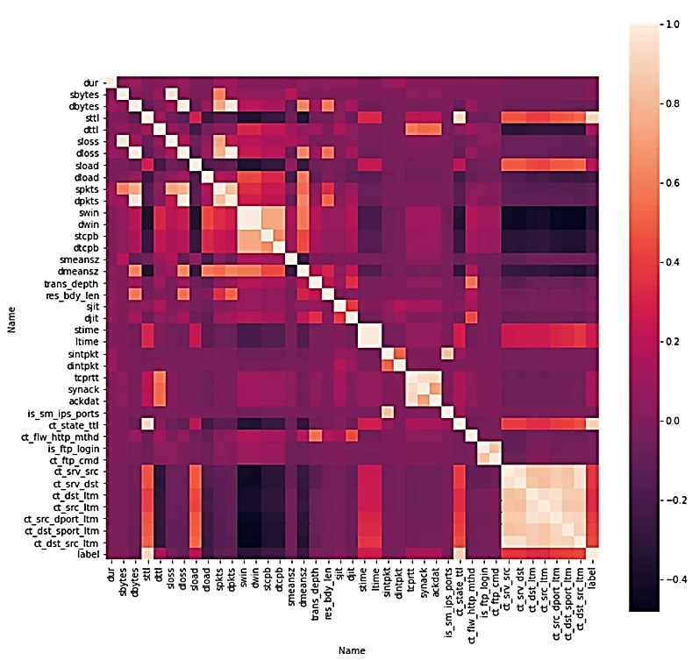
- Correlation Matrix of Features
Figure 2 is a heatmap that shows a correlation matrix of different traits. The matrix shows the Pearson correlation coefficient for each pair of features. The intensity of the colour shows how strong and in what direction the connection is. Strongly positive associations are shown by darker pink and red shades, while weaker or negative ones are shown by lighter shades. There is perfect self-correlation between diagonal parts (value = 1). Bright off-diagonal areas reveal potential multicollinearity, aiding feature selection in ML.

Data Pre-Processing
The UNSW-NB 15 dataset, a realistic and comprehensive IoT network dataset with heterogeneous attack scenarios, was utilised to train and test models. The dataset had empty spaces and missing numbers taken out before it was used. It is done before pre-processing, which changes and normalises the data. The following steps of pre-processing are as follows:
- Handle missing value: Knowing that the mean value of a column is used to fill in blanks in numerical columns, which keeps the central trend.
- Remove Space: To make working with columns easier, I took out the spaces between column names and dropped the duplicate rows by keeping the first one and removing the others from the dataset.

Max-Min Normalisation
Every feature's value is set to a range of 0 to 1 by the min-max normalisation used in this work. For this method, the equation is written as Equation (1).
$X_{normalized}=\frac{X-X_{min}}{X_{max}-X_{min}}$ (1)
where X is the data feature's current value and $X_{min}$ and $X_{max}$ are its minimum and highest values, respectively.

One-Hot Encoding for Data Labelling
One-hot encoding is a way to label data that is used in ML to turn categorical data into numerical data. It turns each category into a binary representation. Each category has its own column with a value of 1 if the data point is in that category and 0 otherwise. Each group is dealt with independently, which is important for ML algorithms that find the distances between points.

Balancing with SMOTE
One type of data in the UNSW-NB15 sample is less common than the others. The overfitting problem is avoided in this work by using SMOTE. We can make fake samples for minority groups using SMOTE, a method for oversampling. Figure 3 displays the dataset's structure before and after SMOTE.
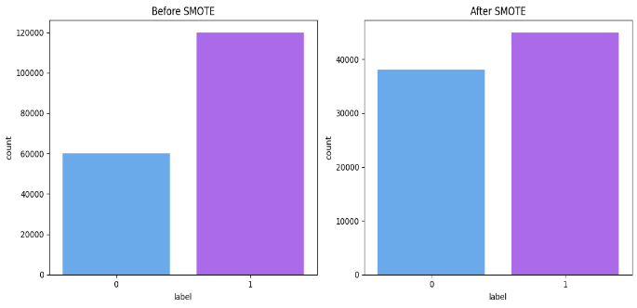
- Data Distribution with and without SMOTE
Figure 3 shows two bar plots of a binary label distribution before and after SMOTE. Before SMOTE, class '1' dominates with about 120,000 instances, while class '0' has around 60,000. After SMOTE, both classes are balanced, each with roughly 40,000–45,000 instances, indicating successful oversampling of the minority class.

VFS Algorithm for Feature Selection
The VFS algorithm for feature selection aims to identify an optimal subset of features to enhance learning performance and reduce computational complexity by representing each solution as a binary vector, where 1 indicates a selected feature and 0 an ignored one. VFS simplifies position updates by using a single formula with $C = b × d$ where b is a constant and 𝑑 controls search paths to balance exploration and exploitation. It starts with random positions, evaluates fitness, selects features with position values ≥ 0.5, keeps updates within [0,1], and iteratively finds the optimal feature subset.

Data Splitting
20% of the data is set aside for testing, and the other 80% is set aside for training.

Convolutional Neural Network (CNN) Model
A CNN is a DL system based on artificial neural networks, and it helps spot different patterns in images. Convolutional, pooling and fully connected layers are part of the structure of a CNN. Convolutional layers change images into numbers, and pooling layers lower the count of the input parameters [17]. A CNN is a DL algorithm mainly used for dealing with images. Such a network has several layers, such as convolutional, pooling and fully connected ones. CNNs get their architecture from the human brain’s way of seeing images, and they are good at capturing different levels of information and connections within pictures. For this case, the output is 5 characters long. In general, the length of the output follows (2),
$Output size=nx=2P-nhS+1,$ (2)
The size of the output is $n x + 2 P - n h S + 1,$ where nx is the length of the signal going in and nh is the length of the filter.
A popular tool for signal processing, image processing and computer vision is convolution (Conv_Op). It helps form a third signal that shows how one signal affects the second, weighted by the shape of the second signal. In computer vision, images are processed for features by applying a convolution with CNNs. The mathematical meaning of convolution is found in Equation (3):
$\left(f*g\right)\left[n\right]= \sum_{m=-∞}^{∞}{f\left[m\right]g\left[n-m\right]}$ (3)
The functions f and g can be either irregular or continuous. The number n shows where or when the output signal is. The process of convolution is shown by the symbol. If the signs coming in are discrete, the equation above can be written as Equation (4):
$\left(f*g\right)\left[n\right]=\sum_{m=-∞}^{∞}{f\left[m\right]g\left[n-m\right]∆m}$ (4)
These are two functions, f and g, which can be discontinuous or continuous. The number n shows where or when the output signal is. The process of convolution is shown by the symbol. If the data coming in is discrete, the Equation (5) above can be written as:
$\left(f*m\right)\left(t\right)=\int_{-∞}^{∞}{f\left(τ\right)g(}t-τ)dτ$ (5)
where t is the time index of the output signal.

Evaluation Metrics
Several ways are used to check how well algorithms work with the UNSW-NB 15 dataset. TP, TN, FP, and FN are the letters. TP, which stands for "True positive," is the number of attacks that were reported properly. There were TN, or "True negative," reports that were not true. The number TN tells you how many rows are not attacks, and the number (FP) “False Positive” indicates how many rows are attacks. False Negative (FN) numbers identify how many records that were not attacks were mistakenly marked as attacks. It displays F1-score, accuracy, precision, and memory. How to Read the Matrix
Accuracy: This metric is the percentage of properly predicted samples out of all the samples in a dataset. The number is written as Equation (6).
$Accuracy=\frac{TP+TN}{TP+Fp+TN+FN}$ (6)
Precision: Precision is a metric that quantifies how accurate positive predictions produced by a certain model are. The measure calculates how accurately positive events were recognised by the model. This is shown as Equation (7).
$Precision=\frac{TP}{TP+FP}$ (7)
Recall: In other words, this metric determines how many real positive cases a model can pick out compared to its total number. Equation (8) below shows what it means mathematically.
$Recall=\frac{TP}{TP+FN}$ (8)
F1 score: The F1 score gives an accurate review of model performance because it combines both recall and precision into one number. Mathematically, it is given as Equation (9)
$F1-score=2×\frac{Precision×Recall}{Precision+Recall}$ (9)
All of these measurements make it clear how well the model can show the goal variable.

Results And Discussion
This project's model makes use of Python 3.6 together with the TensorFlow 1.15 and Keras libraries. In order to construct the model, all actual work is completed in the Jupyter Notebook. Table II shows that experimental findings illustrate the great effectiveness of the proposed CNN across all significant assessment parameters. According to the results, the model accurately sorted 94.6% of all traffic as benign or malicious. The model performs very well, catching zero-day attacks with a rare chance of false identification. Being able to detect more than 94% of actual attacks greatly reduces the number of missed threats. Precision and recall are well balanced at a high level, with the CNN model being strong in the detection of new and difficult threats in networks.
- Experiment Results of Proposed Models for Zero-Day Attack Detection
Performance matrix | Convolutional neural network (CNNs)
Accuracy | 93.8
Precision | 96.5
Recall | 94.6
F1-score | 95.1
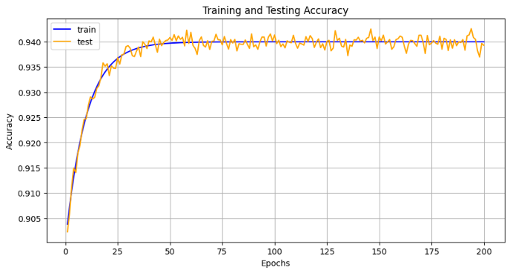
- Accuracy curves for the CNN model
Figure 4 shows how accurate a CNN model is when it is learnt and when it is tested more than 200 times. On the graph, the blue line shows how accurately the model is trained and the orange line shows how well the model performs with new data. Both models improve quickly at the beginning, finally reaching approximately 0.94. At about two-thirds of the training process, neither the training accuracy nor the testing accuracy changes much and remain around 0.94, suggesting the model is not overfitting.
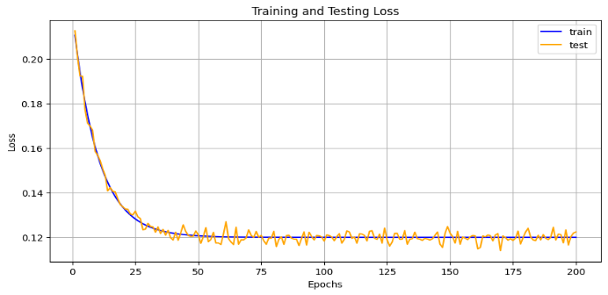
- Loss curves for the CNN Model
The training and testing loss curves for a CNN model over 200 epochs are shown in Figure 5. Blue means that you lost training, and orange means that you lost testing. Both lines show that the model learns quickly and doesn't make as many mistakes at the beginning. After about 50 iterations, the loss values for both training and testing stop changing and start to converge around 0.12. The training and testing loss curves are very close to each other throughout the epochs, especially after stabilisation. This suggests that the model is working well with new data and not overfitting too much, since the loss on new data is very similar to the loss on the training data.
- Comparison of different Zero-Day Attack Detection methods using the UNSW-NB15 dataset.
Models | Accuracy
Logistic Regression (LR) [18] | 77.21
Random Forest (RF) [19] | 87.75
Support Vector Machine [20] | 92.28
Proposed CNN | 93.8
Table III presents the comparison between proposed and existing model performance on the same data. Among the evaluated models, the CNN model achieved the highest accuracy at 93.8%, demonstrating its superior capability in capturing complex patterns in network traffic data. SVM model, achieving 92.28% showed that it was one of the top-performing traditional methods. The RF model achieved a respectable 87.75%, while LR recorded the lowest accuracy at 77.21%. The results prove that CNNs are highly effective in catching zero-day attacks in the realm of cybersecurity.
A CNN model proposed here, achieving a high accuracy rate of 93.8%, has positive results for identifying zero-day attacks. Access to learned hierarchical features straight from the network traffic makes it possible for this model to recognise patterns better than traditional ones, which often need experts to find those features manually. Due to CNNs’ ability to find associations between data at particular times and places, they are ideal for finding the small signs of zero-day attacks.

Conclusion And Future Study
The power grid and other similar systems play a big role in keeping cyber-physical systems safe. When someone breaks the control code in a power grid system, it could cause a lot of damage. If the issue is found early, it will do less damage in the future. Zero-day threats are hard to find because no one has seen their code or knows what they do. Using the UNSW-NB15 data set, tests of many ML and DL methods for finding Zero-Day Attacks have shown that CNN models work the best. The research shows that the CNN model that was made has a 93.8% success rate in finding zero-day attacks in network data and has high precision, recall, and F1-score values. Thanks to CNN’s ability to detect difficult patterns in UNSW-NB15, it shows better results when compared to SVM, RF and LR. The robustness and generalisation of the model are also proven by the clear gap between training and testing curves. The quality of training data decides the model’s effectiveness, which may leave out certain zero-day attack types. Furthermore, training CNNs takes both more power and time than it does for other methods. Future tasks involve collecting more diverse datasets, building combinations of existing approaches and validating the model directly on-site during real cyber-attacks.

Disclaimer (Artificial intelligence)
Option 1:
Author(s) hereby declare that NO generative AI technologies such as Large Language Models (ChatGPT, COPILOT, etc.) and text-to-image generators have been used during the writing or editing of this manuscript.
Option 2:
Author(s) hereby declare that generative AI technologies such as Large Language Models, etc. have been used during the writing or editing of manuscripts. This explanation will include the name, version, model, and source of the generative AI technology and as well as all input prompts provided to the generative AI technology
Details of the AI usage are given below:
1.
2.
3.

References
[1] S. Huda et al., “Defending unknown attacks on cyber-physical systems by semi-supervised approach and available unlabeled data,” Inf. Sci. (Ny)., vol. 379, pp. 211–228, Feb. 2017, doi: 10.1016/j.ins.2016.09.041.
[2] V. Kolluri, “A Pioneering Approach To Forensic Insights: Utilization Ai for Cybersecurity Incident Investigations,” Int. J. Res. Anal. Rev. (IJRAR, vol. 3, no. 3, 2016.
[3] I. Stellios, P. Kotzanikolaou, and M. Psarakis, “Advanced Persistent Threats and Zero-Day Exploits in Industrial Internet of Things,” in Advanced Sciences and Technologies for Security Applications, 2019, pp. 47–68. doi: 10.1007/978-3-030-12330-7_3.
[4] U. K. Singh, C. Joshi, and S. K. Singh, “Zero day Attacks Defense Technique for Protecting System against Unknown Vulnerabilities,” Int. J. Sci. Res. Comput. Sci. Eng., vol. 5, no. 1, pp. 13–18, 2017.
[5] K. Scarfone and P. Mell, “Guide to Intrusion Detection and Prevention Systems (IDPS),” Natl. Inst. Stand. Technol., 2007.
[6] S. Singamsetty, “Fuzzy-Optimized Lightweight Cyber-Attack Detection For Secure Edge-Based Iot Netwok.,” J. Crit. Rev., vol. 6, no. 7, 2019, doi: 10.53555/jcr.v6:i7.13156.
[7] F. Iglesias and T. Zseby, “Analysis of network traffic features for anomaly detection,” Mach. Learn., vol. 101, no. 1–3, pp. 59–84, Oct. 2015, doi: 10.1007/s10994-014-5473-9.
[8] P. Duessel, C. Gehl, U. Flegel, S. Dietrich, and M. Meier, “Detecting zero-day attacks using context-aware anomaly detection at the application-layer,” Int. J. Inf. Secur., vol. 16, no. 5, pp. 475–490, Oct. 2017, doi: 10.1007/s10207-016-0344-y.
[9] M. Ahmed and A. N. Mahmood, “Novel Approach for Network Traffic Pattern Analysis using Clustering-based Collective Anomaly Detection,” Ann. Data Sci., 2015, doi: 10.1007/s40745-015-0035-y.
[10] S. Naseer et al., “Enhanced Network Anomaly Detection Based on Deep Neural Networks,” IEEE Access, vol. 6, 2018, doi: 10.1109/ACCESS.2018.2863036.
[11] J.-Y. Kim, S.-J. Bu, and S.-B. Cho, “Zero-day malware detection using transferred generative adversarial networks based on deep autoencoders,” Inf. Sci. (Ny)., vol. 460–461, pp. 83–102, Sep. 2018, doi: 10.1016/j.ins.2018.04.092.
[12] A. G. P. Lobato, M. A. Lopez, I. J. Sanz, A. A. Cardenas, O. C. M. B. Duarte, and G. Pujolle, “An Adaptive Real-Time Architecture for Zero-Day Threat Detection,” in 2018 IEEE International Conference on Communications (ICC), IEEE, May 2018, pp. 1–6. doi: 10.1109/ICC.2018.8422622.
[13] P. Khuphiran, P. Leelaprute, P. Uthayopas, K. Ichikawa, and W. Watanakeesuntorn, “Performance comparison of machine learning models for DDoS attacks detection,” in 2018 22nd International Computer Science and Engineering Conference, ICSEC 2018, 2018. doi: 10.1109/ICSEC.2018.8712757.
[14] S. Troia, R. Alvizu, Y. Zhou, G. Maier, and A. Pattavina, “Deep Learning-Based Traffic Prediction for Network Optimization,” in International Conference on Transparent Optical Networks, 2018. doi: 10.1109/ICTON.2018.8473978.
[15] C. W. Huang, C. T. Chiang, and Q. Li, “A study of deep learning networks on mobile traffic forecasting,” in IEEE International Symposium on Personal, Indoor and Mobile Radio Communications, PIMRC, 2017. doi: 10.1109/PIMRC.2017.8292737.
[16] D. Last, “Consensus forecasting of zero-day vulnerabilities for network security,” in Proceedings - International Carnahan Conference on Security Technology, 2016. doi: 10.1109/CCST.2016.7815718.
[17] R. Tarafdar and Y. Han, “Finding Majority for Integer Elements,” J. Comput. Sci. Coll., vol. 33, no. 5, pp. 187–191, 2018.
[18] S. Meftah, T. Rachidi, and N. Assem, “Network based intrusion detection using the UNSW-NB15 dataset,” Int. J. Comput. Digit. Syst., vol. 8, no. 5, pp. 477–487, 2019, doi: 10.12785/ijcds/080505.
[19] P. Dahiya and D. K. Srivastava, “Network Intrusion Detection in Big Dataset Using Spark,” in Procedia Computer Science, 2018. doi: 10.1016/j.procs.2018.05.169.
[20] M. Belouch, S. El Hadaj, and M. Idlianmiad, “Performance evaluation of intrusion detection based on machine learning using apache spark,” in Procedia Computer Science, 2018. doi: 10.1016/j.procs.2018.01.091.

Kalla, D., Smith, N., & Samaah, F. (2023). Satellite Image Processing Using Azure Databricks and Residual Neural Network. International Journal of Advanced Trends in Computer Applications, 9(2), 48-55.

Kuraku, D. S., & Kalla, D. (2023). Phishing Website URL’s Detection Using NLP and Machine Learning Techniques. Journal on Artificial Intelligence-Tech Science.

Varadharajan, V., Smith, N., Kalla, D., Samaah, F., Polimetla, K., & Kumar, G. R. (2024). Stock Closing Price and Trend Prediction with LSTM-RNN. Journal of Artificial Intelligence and Big Data, 4, 877.

Kalla, D., Kuraku, D. S., & Samaah, F. (2021). Enhancing cyber security by predicting malwares using supervised machine learning models. International Journal of Computing and Artificial Intelligence, 2(2), 55-62.

Kuraku, D. S., Kalla, D., Smith, N., & Samaah, F. (2023). Safeguarding FinTech: elevating employee cybersecurity awareness in financial sector. International Journal of Applied Information Systems (IJAIS), 12(42).

Kalla, D., Smith, N., Samaah, F., & Polimetla, K. (2022). Enhancing Early Diagnosis: Machine Learning Applications in Diabetes Prediction. Journal of Artificial Intelligence & Cloud Computing. SRC/JAICC-205. DOI: doi. org/10.47363/JAICC/2022 (1), 191, 2-7.

Kuraku, S., Kalla, D., Samaah, F., & Smith, N. (2023). Cultivating proactive cybersecurity culture among IT professional to combat evolving threats. International Journal of Electrical, Electronics and Computers, 8(6).

Kalla, D., Smith, N., Samaah, F., & Polimetla, K. (2024). Hybrid Scalable Researcher Recommendation System Using Azure Data Lake Analytics. Journal of Data Analysis and Information Processing, 12, 76-88.

Kuraku, D. S., & Kalla, D. (2023). Impact of phishing on users with different online browsing hours and spending habits. International Journal of Advanced Research in Computer and Communication Engineering, 12(10).

Kalla, D., & Kuraku, S. (2023). Phishing website url’s detection using nlp and machine learning techniques. Journal of Artificial Intelligence, 5, 145.

Kuraku, D. S., Kalla, D., & Samaah, F. (2022). Navigating the link between internet user attitudes and cybersecurity awareness in the era of phishing challenges. International Advanced Research Journal in Science, Engineering and Technology, 9(12).

Kuraku, D. S., Kalla, D., Smith, N., & Samaah, F. (2023). Exploring How User Behavior Shapes Cybersecurity Awareness in the Face of Phishing Attacks. International Journal of Computer Trends and Technology.

Sreeramulu, M. D., Mohammed, A. S., Kalla, D., Boddapati, N., & Natarajan, Y. (2024, September). AI-driven Dynamic Workload Balancing for Real-time Applications on Cloud Infrastructure. In 2024 7th International Conference on Contemporary Computing and Informatics (IC3I) (Vol. 7, pp. 1660-1665). IEEE.

Kalla, D., Mohammed, A. S., Boddapati, V. N., Jiwani, N., & Kiruthiga, T. (2024, November). Investigating the Impact of Heuristic Algorithms on Cyberthreat Detection. In 2024 2nd International Conference on Advances in Computation, Communication and Information Technology (ICAICCIT) (Vol. 1, pp. 450-455). IEEE.

Chandrasekaran, A., & Kalla, D. (2023). Heart disease prediction using chi-square test and linear regression. Computer Science & Information Technology, 13, 135-146.

Chinta, P. C. R., Katnapally, N., Ja, K., Bodepudi, V., Babu, S., & Boppana, M. S. (2022). Exploring the role of neural networks in big data-driven ERP systems for proactive cybersecurity management. Kurdish Studies.

Routhu, K., Bodepudi, V., Jha, K. M., & Chinta, P. C. R. (2020). A Deep Learning Architectures for Enhancing Cyber Security Protocols in Big Data Integrated ERP Systems. Available at SSRN 5102662.

Moore, C. (2023). AI-powered big data and ERP systems for autonomous detection of cybersecurity vulnerabilities. Nanotechnology Perceptions, 19, 46-64.

Bodepudi, V., & Chinta, P. C. R. (2024). Enhancing Financial Predictions Based on Bitcoin Prices using Big Data and Deep Learning Approach. Available at SSRN 5112132.

Chinta, P. C. R. (2023). The Art of Business Analysis in Information Management Projects: Best Practices and Insights. DOI, 10.

Boppana, S. B., Moore, C. S., Bodepudi, V., Jha, K. M., Maka, S. R., & Sadaram, G. AI And ML Applications In Big Data Analytics: Transforming ERP Security Models For Modern Enterprises.

Katnapally, N., Chinta, P. C. R., Routhu, K. K., Velaga, V., Bodepudi, V., & Karaka, L. M. (2021). Leveraging Big Data Analytics and Machine Learning Techniques for Sentiment Analysis of Amazon Product Reviews in Business Insights. American Journal of Computing and Engineering, 4(2), 35-51.

Chinta, P. C. R., Moore, C. S., Karaka, L. M., Sakuru, M., Bodepudi, V., & Maka, S. R. (2025). Building an Intelligent Phishing Email Detection System Using Machine Learning and Feature Engineering. European Journal of Applied Science, Engineering and Technology, 3(2), 41-54.

Moore, C. (2024). Enhancing Network Security With Artificial Intelligence Based Traffic Anomaly Detection In Big Data Systems. Available at SSRN 5103209.

Chinta, P. C. R., Moore, C. S., Karaka, L. M., Sakuru, M., & Bodepudi, V. (2025). Predictive Analytics for Disease Diagnosis: A Study on Healthcare Data with Machine Learning Algorithms and Big Data. J Cancer Sci, 10(1), 1.

KishanKumar Routhu, A. D. P. Risk Management in Enterprise Merger and Acquisition (M&A): A Review of Approaches and Best Practices.

Bodepudi, V. (2023). Understanding the Fundamentals of Digital Transformation in Financial Services: Drivers and Strategic Insights. Journal of Artificial Intelligence and Big Data, 3(1), 10-31586.

Chinta, P. C. R. (2022). Enhancing Supply Chain Efficiency and Performance Through ERP Optimisation Strategies. Journal of Artificial Intelligence & Cloud Computing, 1(4), 10-47363.

Krishna Madhav, J., Varun, B., Niharika, K., Srinivasa Rao, M., & Laxmana Murthy, K. (2023). Optimising Sales Forecasts in ERP Systems Using Machine Learning and Predictive Analytics. J Contemp Edu Theo Artific Intel: JCETAI-104.

Jha, K. M., Velaga, V., Routhu, K., Sadaram, G., Boppana, S. B., & Katnapally, N. (2025). Transforming Supply Chain Performance Based on Electronic Data Interchange (EDI) Integration: A Detailed Analysis. European Journal of Applied Science, Engineering and Technology, 3(2), 25-40.

Sadaram, G., Sakuru, M., Karaka, L. M., Reddy, M. S., Bodepudi, V., Boppana, S. B., & Maka, S. R. (2022). Internet of Things (IoT) Cybersecurity Enhancement through Artificial Intelligence: A Study on Intrusion Detection Systems. Universal Library of Engineering Technology, (2022).

Maka, S. R. (2023). Understanding the Fundamentals of Digital Transformation in Financial Services: Drivers and Strategic Insights. Available at SSRN 5116707.

Siddiqi, M. A., Pak, W., & Siddiqi, M. A. (2022). A study on the psychology of social engineering-based cyberattacks and existing countermeasures. Applied Sciences, 12(12), 6042.

Perera, S., Jin, X., Maurushat, A., & Opoku, D. G. J. (2022, March). Factors affecting reputational damage to organisations due to cyberattacks. In Informatics (Vol. 9, No. 1, p. 28). MDPI.

Alawida, M., Abu Shawar, B., Abiodun, O. I., Mehmood, A., Omolara, A. E., & Al Hwaitat, A. K. (2024). Unveiling the dark side of chatgpt: Exploring cyberattacks and enhancing user awareness. Information, 15(1), 27.

Hindy, H., Atkinson, R., Tachtatzis, C., Colin, J. N., Bayne, E., & Bellekens, X. (2020). Utilising deep learning techniques for effective zero-day attack detection. Electronics, 9(10), 1684.

