Original research article
Construction of a Random Forest-Based Machine Learning Model for Depression Prediction: Application to the Analysis of Disordered Behaviors
- ABSTRACT

The topics covered in this article include the creation of a bootstrap learning model for depression predictions based on the Random Forest technique. Depression is a severe mental illness that affects millions of people worldwide. This condition causes great pain and affects quality of life, and in the most severe cases, the person takes their own life. Depression has a high incidence, but diagnosis is always complex and often delayed. It is made on the basis of clinical assessment, which is subjective, and questionnaires, which are often inaccurate and cannot identify people at risk early enough because a person's subjective perception can often be distorted.

In this context, and to illustrate our point, we aim to show how AI, and more specifically machine learning, can provide innovative applications that can be used to improve early detection cf. prevention of depression risk. Instead of stupidly defining score intervals for a child, we can train a model on a dataset to identify patterns and correlations that escape simple regression analyses. Then, we can anticipate the first signs of log-in with depression, or we can identify which combinations of self and family history are most concerning. To complement our study, we chose the decision tree ensemble algorithm.

The article highlights the need for more objective and effective prediction tools for depression, and proposes a machine learning-based solution to achieve this, potentially leading to earlier intervention and better patient care.

Keywords : Artificial intelligence, random forest, machine learning , supervised learning, depression.
- INTRODUCTION
Depression ranks among the most common and debilitating mental health disorders worldwide. It manifests as persistent sadness, marked disinterest in activities once enjoyed, as well as disturbances in sleep and appetite. In severe cases, it can also lead to suicidal thoughts. This disorder profoundly impacts the quality of life of millions of individuals and constitutes a considerable socioeconomic burden. Although advances have been made in the understanding and treatment of this complex condition, early diagnosis and prediction of its onset remain significant challenges for healthcare professionals and healthcare systems. Current assessment tools, which often rely on clinical interviews and subjective questionnaires, can lack precision and relevance, leading to delays .
Given current limitations, the rise of machine learning techniques presents exciting opportunities to revolutionize depression detection and management. By leveraging the ability of algorithms to uncover complex patterns and hidden connections within large datasets, we can create more objective and evidence-based predictive tools. Among the various algorithms available, random forests stand out for their reliability, their ability to handle diverse and nonlinear data, and their often superior performance in classification and regression tasks.

This article explores this potential by describing the development and evaluation of a random forest-based machine learning model specifically designed to predict depression. We will detail the methodology used, from the collection and preparation of relevant data to the training, validation, and interpretation of the model. The ultimate goal is to illustrate how this approach can improve the identification of at-risk individuals, leading to earlier and more personalized interventions, and ultimately, better clinical outcomes for those affected by or at risk of developing depression.

Although appearing in the title of this article "Random Forest", this algorithm given its potential to accurately predict depression, allowed us to obtain good and reliable results due to its robustness, flexibility and ability to manage large quantities of data. And it adds even more because it is able to interpret the results produced. This is what makes this model a powerful tool for predicting depression. After a careful analysis we have just noted that this model using its different criteria (characteristics) allows us to focus our attention on the characteristic: "Hopelessness about the future" which most influenced the prediction of the variable to be explained (y).

- THE ESSENTIALS ON DEPRESSION

Depression is a common and serious mental health disorder that goes far beyond temporary sadness or the blues. It is an illness that profoundly affects how a person thinks, feels, and acts, and can have devastating consequences if left untreated.

- Main symptoms (must persist most of the time for at least 2 weeks):

- Depressed mood (sadness, irritability, feeling of emptiness).
- Loss of interest or pleasure (anhedonia) in activities previously enjoyed.
- Severe fatigue or loss of energy (asthenia) even after rest.
- Sleep disorders (insomnia or hypersomnia).
- Appetite and/or weight (significant loss or gain).
- Psychomotor slowing (slowed movement and thinking) or agitation.
- Feelings of worthlessness or excessive guilt.
- Difficulty concentrating , remembering, or indecisiveness.
- Recurring thoughts of death or suicidal ideation.
- Causes and risk factors:

- Biological factors: neurotransmitter imbalances (serotonin, noradrenaline, dopamine), genetic predisposition, hormonal changes.
- Psychological factors: past trauma (childhood), chronic stress, poor coping skills, negative thought patterns.
- Environmental and social factors: stressful life events (bereavement, job loss, separation, financial problems), social isolation, chronic illness, substance abuse.

- It is often a complex interaction of these different factors.

- Impact :

- Depression can seriously impair a person's ability to function in their daily, professional, social, and family life.
- It increases the risk of other health problems (cardiovascular diseases, addictions) and, in severe cases, the risk of suicide, which is a major complication.

3.1. Epidemiology

Depression is a major global public health problem, characterized by significant epidemiology and varied impacts across populations.

3.2. Treatment of depression

Treating depression is a complex and personalized process, often involving a combination of different approaches. The goal is to reduce symptoms, improve daily functioning, and prevent recurrence. Here are the main options and solutions available:

A. Psychotherapies (talking therapies)

Psychotherapies are essential treatments for depression, whether mild, moderate, or severe. They help people understand and change their negative thinking and behavior patterns.

- Cognitive behavioral therapy (CBT): This is one of the most researched and effective forms of psychotherapy. It aims to identify and change distorted thoughts (cognitions) and maladaptive behaviors that contribute to depression. Patients learn strategies to manage stress and solve problems.
- Interpersonal therapy (IPT): This focuses on relational and social problems that may be related to the onset or maintenance of depression (e.g., interpersonal conflicts, grief, role changes, social isolation).
- Behavioral Activation: This therapy encourages patients to increase their engagement in activities that provide them with pleasure or a sense of accomplishment, in order to break the cycle of isolation and inactivity.
- Supportive psychotherapies: These provide a space for listening and support, helping the patient explore their feelings and develop coping mechanisms.
- Mindfulness-based therapies: These help cultivate non-judgmental awareness of the present moment, which can reduce rumination and the risk of relapse.

B. Drug treatments

Antidepressants are often prescribed for moderate to severe depression, sometimes in combination with psychotherapy. They work by altering the balance of neurotransmitters in the brain.

- Selective serotonin reuptake inhibitors (SSRIs): These are the most commonly prescribed antidepressants (e.g., sertraline , fluoxetine , citalopram ). They are generally well tolerated and have fewer side effects than previous generations of drugs.
- Serotonin and norepinephrine reuptake inhibitors (SNRIs): ( e.g., venlafaxine, duloxetine) Act on serotonin and norepinephrine.
- Atypical antidepressants: Other classes of drugs with varying mechanisms of action (e.g., mirtazapine , bupropion ).
- Tricyclic antidepressants (TCAs) and monoamine oxidase inhibitors (MAOIs): Older, these are very effective but have more side effects and are generally used as second-line treatment or in cases of resistant depression.
- New treatments: Options such as ketamine or esketamine are used for depression resistant to usual treatments, under strict medical supervision.

- The choice of antidepressant depends on various factors, including the patient's specific symptoms, comorbidities, and potential side effects.

C. Non-drug and non-psychotherapeutic interventions

These approaches are often complementary and can play a crucial role in managing depression.

Healthy lifestyle:

- Regular physical activity: Exercise has a proven antidepressant effect, releasing endorphins and improving mood.
- Balanced diet: Good nutrition can promote mental health.
- Adequate and regular sleep: Regulation of the sleep-wake cycle is essential.
- Avoid alcohol and drugs: These substances can worsen depression and interfere with treatment.
- Social support: Maintaining connections with family and friends or joining support groups.
- Relaxation and stress management techniques: Yoga, meditation, breathing exercises, relaxation techniques.
- Art therapy, music therapy: Can help express emotions and reduce stress.

D. Brain stimulation treatments (for severe or resistant cases)

For severe depressions, resistant to conventional treatments, more specific options may be considered:

- Electroconvulsive therapy (ECT ): Very effective treatment for severe depression, particularly at high risk of suicide or psychosis, or in cases of resistance to other treatments.
- Repetitive transcranial magnetic stimulation ( rTMS ): A non-invasive technique that uses magnetic fields to stimulate specific areas of the brain.
- Vagus nerve stimulation (VNS): Implantation of a device that stimulates the vagus nerve, sometimes used for resistant depression.

E. Integrated and personalized approach

The most effective treatment often involves a combination of these methods, tailored to each individual. Collaboration between the patient, general practitioner, psychiatrist, and other mental health professionals (psychologist, nurse, social worker) is essential for comprehensive care and for adjusting the treatment plan based on the evolution of symptoms and response to treatment. Educating the patient about their illness and the signs of relapse is also an important element.

4. MACHINE LEARNING

Machine learning is so vast that it is impossible to cover all aspects related to it; therefore, we will focus only on supervised learning algorithms, which constitute one of its methods or techniques. That being said, we will address the first point, which is:

  - Supervised learning algorithms
Supervised learning is defined as follows: Formally, the learning base is a doublet $β= \left(ϑ,ε\right) où ϑ= \left\{X_{i}\right\} i=1,…,m$and is the set of observations defined on IR ^{n} describing the shapes and: $E : {IR}^{n}→ξ$, $X→ω_{k}$is the labeling function. The $ω_{k}$, k = 1,… ,c are the class labels with c = card ( $ξ)$the total number of classes (a class is associated with only one label). Recognition then consists of assigning a class label to a new unlabeled observation by comparison with $β$[4]

$E e$This is called a classifier. A classifier is a mathematical function or algorithm that performs assignment tasks. This classifier can be built using neural networks, decision trees, SVMs, or Bayesian networks. Here are a few lines on the different supervised learning algorithms; first, we have the neural network, decision tree, SVM, and Bayesian networks.

  - Decision tree

A decision tree is a machine learning model that uses a tree structure to represent a set of decisions and their consequences.

A decision tree is a structure that allows us to deduce a result from successive decisions. To navigate a decision tree and find a solution, we must start from the root. Each node is an atomic decision. Each possible response is taken into account and allows us to move towards one of the node's children. We gradually move down the tree until we reach a leaf. This leaf represents the response provided by the tree to the case we have just tested [5].

- Start at the root of the tree
- Descend the tree through the test nodes
- The sheet reached at the end allows the tested instance to be classified.

In this article, we have chosen an algorithm that will predict the dependent variable: the “decision tree”.

c. Random forests
Random forests are algorithms known for their ability to provide effective predictions on many datasets. Fernández-Delgado et al. (2014) demonstrated, through a comparative study of 179 algorithms on 121 datasets, that random forests are consistently among the best predictive algorithms. This family of methods also has a limited number of parameters, which facilitates calibration work.

- Bagging

The term " bagging " ( Breiman (1996)) comes from the contraction of " Bootstrap AGGregatING » and denotes a set of methods for obtaining forecasting algorithms by aggregating other algorithms trained on bootstrap samples . Let us take the example of a forecasting algorithm [7].
$\int_{n}{(x)}=\frac{1}{B}\sum_{b=1}^{B}{T_{b }}\left(x\right)$
Bagging offers a compromise between these two situations by proposing to train each algorithm on bootstrap samples , i.e. samples of size n obtained from draws with replacement in the initial sample. The idea is to reduce the correlation between the predictions Tb by adding randomness from the bootstrap draws . The method is presented in algorithm [ 3].

Algorithm 1. Bagging.
Entrances:
B a positive integer;
T a forecasting algorithm. For _{b} between 1 and B :
- size replacement in { 1 ,… ,n} the sample. We note$θ_{b}$ all selected indices and$D_{n,b}^{*}$ = T ( $x_{i},y_{i}$), iϵ$θ_{b}$ associated bootstrap .
- Algorithm $D_{n,b}^{*}$T activated = T ( . , $θ_{b}, D_{n}$) .

Back :

$\int_{n}{(x)}=\frac{1}{B}\sum_{b=1}^{B}{T}\left(x, θ_{b}, D_{n}\right).$

as large as possible in order to control the randomness of the bootstrap . The user must also choose which algorithm to train on the bootstrap samples .

- Set Method
Bagging introduced in Breiman (1996):
- Key ingredients: bootstrapping and aggregation
- Aggregating independent initial forecasting methods (base learners) leads to a significant reduction in forecast error.
- It is therefore necessary to work towards obtaining initial methods that are as independent as possible.
- Naive idea: train our "base learners" (e.g., CART) on disjoint subsets of observations from the training set. Problem : the number of observations in the training set is not infinite! The "base learners" will have too little data and poor performance.
- OOB error
Using bagging implies that some data is left out for training each tree. This unused data is called out-of-bag ( oob ) data.
For an observation i in the training sample, we calculate the error obtained by aggregating all the untrained trees with this observation. The oob error is the sum of the errors thus calculated over the entire training sample.
The oob error is an approximation of the forest generalization error, it never uses predictions from the forest itself, but rather those from predictors that are aggregations of trees in that forest.
- Random forests

As their name suggests, random forests aggregate predictors by trees constructed from bootstrap samples . There are different aggregation processes [12 ], we focus on the random forests proposed by Breiman (2001) which are by far the most used.
Algorithm 1. Random forest.
Entrances:
- B a positive integer;
- mtry an integer between 1 and d;
- minimum node size an integer smaller than n.

For b between 1 and B :

- size replacement in { 1 ,… ,n} the sample. We note$θ_{b}$ all selected indices and$D_{n,b}^{*}$ = { ( $x_{i},y_{i}$), I ϵ$T_{b}\}$ associated bootstrap .

- Construct a CART tree from$D_{n,b}^{*}$ by cutting each node as follows:
  - Choose mtry random variables among the _{d} explanatory variables [3 ];
  - Select the best cut $X_{1}$≤ s considering only the mtry selected variables;
  - Do not split a node if it contains less than min.node.size observations.
- We denote by T( . , $θ_{b},D_{n})$the tree obtained.

Back :
$$\int_{n}{(x)}=\frac{1}{B}\sum_{b=1}^{B}{T}\left(x, θ_{b}, D_{n}\right).$$

In summary, random forest is a powerful and versatile algorithm that has proven successful in many machine learning applications [16] .

- MODEL CONSTRUCTION AND INTERPRETATION OF RESULTS.
Building a machine learning model requires the use of a dataset , which will be subjected to the analysis of the different variables that compose it. For this article, we will discuss supervised learning, because the input data is known and the output data is also known. Thus, we can conclude that it is possible to predict mental illnesses.
The different predictive variables that make up our Data Set are as follows:
- Difficulty concentrating: DifConc
- Feelings of excessive guilt: SentCulp
- Low self-esteem: FaiEst
- Despair about the future:
- Suicidal thoughts: Idea
- Sleep disturbance or insomnia: Hole
- Fluctuation in appetite or weight: Fluct
- Intense fatigue or loss of energy: Fat
- Mood: Hmm
Encoding variables
Difficulty concentrating which is the first variable
- Attention disorders: 37
- Dyslexia: 38
- Mental fatigue: 40

Second variable: feeling of excessive guilt
- Anxiety: 2
- The excessive desire to redeem yourself: 4
- Low self-esteem: 5

Third variable: “despair about the future”
- the unconsciousness of having a self : 6
- refusal to be oneself: 7
- will to be oneself: 8
Fourth variable: “suicidal thoughts”
– feeling in the way, useless: 9
– desire to join a deceased loved one: 10 – organization of funerals or requests concerning body donation: 11

Fifth variable “Sleep disturbance”
- Dysomnia : 14
- Parasomnias : 15
- Disorders related to psychiatric problems :16

Sixth variable: “fluctuation of appetite”

2. A chronic health problem: 23

3. Age: 24

4. Psychological factors: 25

8. Alcohol addiction: 29

Seventh variable: “Intense fatigue or loss of energy”
- Physical fatigue: 33
- Nervous or mental fatigue: 34
- Emotional fatigue: 35
Eighth variable “Mood”
- Good: 41
- Bad: 42

Ninth variable “depression”

Depression = Y
- Yes = 1
- No = 0
Table 1: DATA SET
NUMALADE | DifConc | SentCulp | Of the | Idea | Hole | Fluct | Fat | Hmm | Y
1 | 38 | 2 | 6 | 9 | 16 | 25 | 34 | 42 | 1
2 | 37 | 5 | 8 | 10 | 14 | 24 | 35 | 42 | 1
3 | 37 | 2 | 8 | 9 | 15 | 23 | 34 | 42 | 1
4 | 38 | 4 | 7 | 9 | 15 | 23 | 35 | 41 | 0
5 | 40 | 2 | 7 | 11 | 14 | 24 | 33 | 42 | 0
6 | 37 | 4 | 6 | 10 | 15 | 24 | 33 | 41 | 0
7 | 37 | 2 | 7 | 9 | 14 | 29 | 33 | 42 | 0
8 | 38 | 4 | 7 | 11 | 15 | 24 | 34 | 41 | 0
9 | 40 | 5 | 6 | 10 | 16 | 24 | 35 | 41 | 0
10 | 37 | 2 | 8 | 9 | 14 | 23 | 35 | 42 | 1
11 | 38 | 5 | 6 | 9 | 16 | 25 | 34 | 42 | 1
12 | 37 | 5 | 8 | 10 | 14 | 24 | 35 | 42 | 1
13 | 37 | 2 | 8 | 9 | 15 | 23 | 34 | 42 | 1
14 | 38 | 4 | 7 | 9 | 15 | 23 | 35 | 41 | 0
15 | 40 | 2 | 7 | 10 | 14 | 24 | 33 | 42 | 0
16 | 37 | 4 | 6 | 10 | 15 | 24 | 33 | 41 | 0
17 | 37 | 2 | 7 | 11 | 14 | 29 | 33 | 42 | 0
18 | 40 | 4 | 7 | 11 | 15 | 29 | 34 | 41 | 0
19 | 40 | 5 | 6 | 10 | 16 | 24 | 35 | 41 | 0
20 | 37 | 2 | 8 | 9 | 14 | 29 | 35 | 42 | 1

- Creating a Dataset
We want to evaluate a decision (depression or not) based on 8 characteristics: difficulty concentrating, excessive guilt, hopelessness about the future, suicidal thoughts, sleep disturbances, fluctuating appetite, intense fatigue, mood.
Fluc from ap | Fatigue | Suicidal thoughts | Sleep disturbance | Despair | Difference of con | Y
Psychological factor | Fatty nerve | Feel T | Mental disorder | Unconscious | Dyslexia | 1
Age | Big ones | Desire to re | Dysomnia | Will | AT problem | 1
Health problem | Fatty nerve | Feel T | Parasomnias | Will | AT problem | 1
Health problem | Big ones | Feel T | Parasomnias | Refusal | Dyslexia | 0
Age | pH of fats | Gift of the horn | Dysomnia | Refusal | Fatigue lies | 0
Age | pH of fats | Desire to re | Parasomnias | Unconscious | AT problem | 0
It depends on the alcohol | pH of fats | Feel T | Dysomnia | Refusal | AT problem | 0
Age | Fatty nerve | Gift of the horn | Parasomnias | Refusal | Dyslexia | 0
Age | Big ones | Desire to re | Mental disorder | Unconscious | Fatigue lies | 0
Health problem | Big ones | Feel T | Dysomnia | Will | AT problem | 1
Age | Fatty nerve | Feel T | Mental disorder | Unconscious | Dyslexia | 1
Health problem | Big ones | Desire to re | Dysomnia | Will | AT problem | 1
Health problem | Fatty nerve | Feel T | Parasomnias | Will | AT problem | 1
Age | Big ones | Feel T | Parasomnias | Refusal | Dyslexia | 0
Age | pH of fats | Desire to re | Dysomnia | Refusal | Fatigue lies | 0
Addicted to alcohol | pH of fats | Desire to re | Parasomnias | Unconscious | Attitude disorder | 0
Addicted to alcohol | pH of fats | Gift of the horn | Dysomnia | Refusal | AT problem | 0
Age | Fatty nerve | Gift of the horn | Parasomnias | Refusal | Fatigue lies | 0
It depends on the alcohol | Big ones | Desire to re | Mental disorder | Unconscious | Fatigue lies | 0
It depends on the alcohol | Big ones | Feel T | Dysomnia | will | AT problem | 1
Table 2: Creating a Dataset

7. Probability calculation

We calculate the probability of each class:
- P(yes) = 8/20
- P(no) = 12/20
We will then calculate the entropy of the entire data set:
I= - P( yes)*log2(P(yes))-P(no)*log2(P(no))
I= -8/20* log 2(8 /20)-12/20* log2( 12/20)
I=1.1
For each feature, we calculate the information gain. To do this, we take the overall entropy, that is, the entropy of each feature. The "Fluctuation" feature divides the data into four subsets. Here is the number of occurrences of each class in each subset:

Fluctuation | Yes | No
psychological factor | 1 | 0
Age | 2 | 7
Chronic health problem | 4 | 1
Alcohol addiction | 1 | 4
Table 3: Number of occurrences of each class in each subset(Fluctuation)
We calculate the probability of each set:

- P (Psychological Factor) = 1/20
- P(Age) = 9/20
Chronic health problem) = 5/20
- P (Alcohol addiction) = 5/20

We calculate the entropy of each set:

- I (psychological factor) = -1/1*log2 (1/1) – 0/1*log2 (0/1) = 0.7

- I(Age) = -2/9*log2 (2/9) – 7/9*log2 (7/9) = 0.3

- Chronic health problem) = -4/5*log2 (4/5) – 1/5*log2 (1/5) = 0.7

- I (Alcohol dependence) = -1/5*log2 (1/5) – 4/5*log2 (4/5) = 0.7

“Fluctuation” information gain

G(Fluctuation) = IG-P( Health Prob )*I( Health Prob )-P( Age )*I( Age )-P( Psychological Fact )*I( Psychological Fact )-P( Depends )*I( Depends ) G(Fluctuation) = 1.1-5/20*0.7-9/20*0.3-1/20*0-5/20*0.7= 0.43.
The "Severe Fatigue" feature divides the data into three subsets. Here is the number of occurrences of each class in each subset:
Intense fatigue | Yes | No
Nervous fatigue | 4 | 2
Emotional fatigue | 4 | 4
Physical fatigue | 0 | 6
Table 4: Number of occurrences of each class in each subset (Severe Fatigue)

We calculate the probability of each set:

I( Fatty nerve ) = -4/6*log2(4/6)-2/6*log2(2/6) = 0.6

I( Big ) em ) = -4/4*log2(4/4)-4/4*log2(4/4) = 1

I( Big ) phys ) = -0/6*log2(0/6)-6/6*log2(6/6) = 0

Information gain “Intense fatigue”
G( Fat int ) = IG-P( Fat nerve ) *I( Fat nerve ) -P( Fat em )*I( Big em )-P( Big phy )*I( Big phy )
G ( full bold) = 1.1-6/20*0.6-8/20*1-6/20*0= 0.5

The "Suicidal Ideation" feature divides the data into three subsets. Here is the number of occurrences of each class in each subset:
Suicidal thoughts | Yes | No
Feel T | 6 | 3
Desire to meet | 2 | 5
Body donation | 0 | 4
Table 5: Number of occurrences of each class in each subset (Suicidal Ideation)

We calculate the probability of each set:
I( Feel T) = -6/9*log2(6/9)-3/9*log2(3/9)= 1.2
I( Desire to meet ) = -2/7 * log2 (2/7) -5/7 * log2 (5/7) = 1
I( Body donation) = -0/4*log2(0/4)-4/4*log2(4/4) = 0
Information gain “Suicidal thoughts”
Suic Ideas ) = IG-P(Feeling T)*I(Feeling T)-P(Desire to meet)*I(Desire to meet)-P(Gift of body)*I(Desire of body) G( Suic Ideas )= 1.1-9/20*1.2-7/20*1-4/20*0= 0.3

The "Sleep Disorders" feature divides the data into three subsets. Here is the number of occurrences of each class in each subset:
Suicidal thoughts | Yes | No
Mental disorder | 2 | 2
Dysomnia | 4 | 4
Parasomnia | 2 | 6
Table 6: Number of occurrences of each class in each subset(Sleep Disorders)

We calculate the probability of each set:
I( Psychological disorder ) = -2/4*log2(2/4)-2/4*log2(2/4)=1
I ( Dysomnia )=-4/8* log2(4/8)-4/8*log2(4/8)=1
I (Parasomnia )= -2/8* log2(2/8)-6/8*log2(6/8)=1
Information gain “Sleep disorder”
somnia disorder ) = IG-P(psychological disorder)*I(psychological disorder)-P( dysomnia )*I( dysomnia )-P( parasomnia )*I( parasomnia )
G (somnia disorder ) = 1.1-4/20*1-8/20*1-8/20*1= 0.1

The "Hopelessness About the Future" feature divides the data into three subsets. Here is the number of occurrences of each class in each subset:
Despair about the future | Yes | No
Unconsciousness | 2 | 4
Will | 6 | 0
Refusal | 0 | 8
Table 7: Number of occurrences of each class in each subset (Hopelessness About the Future)

We calculate the probability of each set:

I(Unconsciousness)= -2/6* log 2 ( 2/6)-4/6*log2(4/6)= 0.6
I(Will) = -6/6* log 2 (6 /6)-0/6*log2(0/6)= 0
I(Refusal) = -0/8* log 2 (0 /8)-8/8*log2(8/8) = 0
Information gain “Despair about the future”
G( Despair fac) = IG-P(Unconscious)*I(Unconscious)-P(Will)*I(Will)-P(Refusal)*I(Refusal)
G( Despair fac) = 1,1-6/20*0,6-6/20*0-8/20*0= 1

The "Concentration Difficulty" feature divides the data into three subsets. Here is the number of occurrences of each class in each subset:
Difficulty concentrating | Yes | No
Dyslexia | 2 | 3
Attention deficit hyperactivity disorder | 6 | 4
Mental fatigue | 0 | 5
Table 8: Number of occurrences of each class in each subset (Concentration Difficulty)

We calculate the probability of each set:
I (Dyslexia ) = -2/5* log2(2/5)-3/5*log2(3/5) = 0.8
I( Att Disorder)= -6/10*log2(6/10)-4/10*log2(4/10)=1.1
I( Mental Fat) = -0/5*log2(0/5)-5/5*log2(5/5)=0
Information gain “Difficulty concentrating”
G (Diff) = IG-P (dyslexia) * I (dyslexia) -P ( Att disorder) *I (Att disorder) -P (mental fatigue) * I (mental fatigue)
G (Diff )=1.1-5/20*0.8-10/20*1.1-5/20*0=0.4

Fluctuation in appetite | Suicidal thoughts | Sleep disorders | Despair about the future | Intense fatigue | Difficulty concentrating
0.43 | 0.3 | 0.1 | 1 | 0.5 | 0.4
Table 9: Number of occurrences of each class in each subset

8. Some implementation steps
8.1 Library import

Python libraries are collections of modules and packages of reusable code. They contain functions, classes, and variables written by other developers that you can use in your own programs.
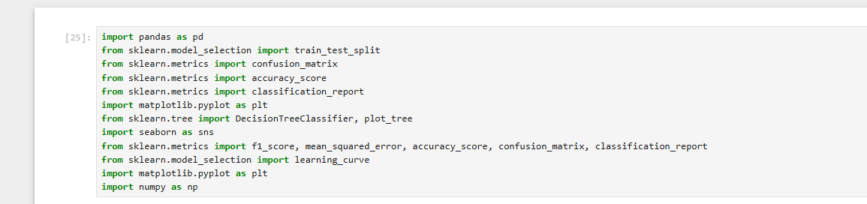
Fig.1: Library import
8.2 Importing the dataset
Fig.2: Importing the dataset
8.3 Visualizing the dataset
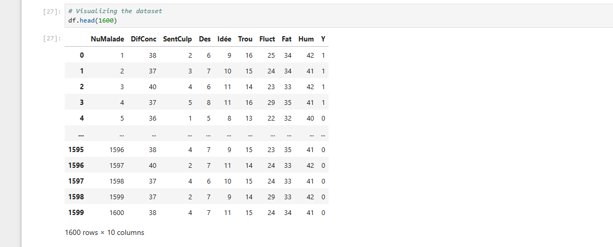
Fig.3: Visualizing the dataset
8.4 Assigning the features to the variable x
Fig.4: Assigning the features to the variable x
8.5 Assigning the target to the variable y
Fig.5: Assigning the target to the variable y

8.6 Displaying the first to 10 rows of the variable y
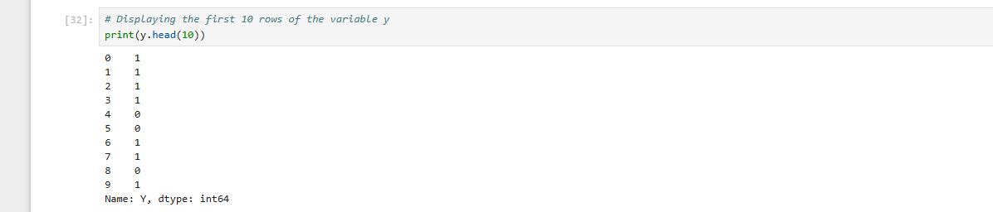
Fig.6: Displaying the first to 10 rows of the variable y
8.7 Splitting the dataset into training and testing sets
Fig.7: Splitting the dataset into training and testing sets
8.8 Collating and assigning the Decision tree algorithm
Fig.8: Colling and assigning the Decision tree algorithm
8.9 Trading the decision tree algorithm
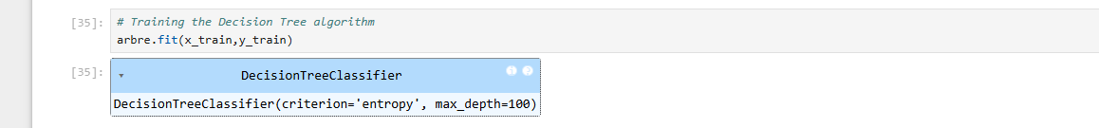
Fig.9: Trading the decision tree algorithm
8.10 Making predictions with the model

Fig.10: Making predictions with the model
8.11 Displaying the distribution of the target variable y
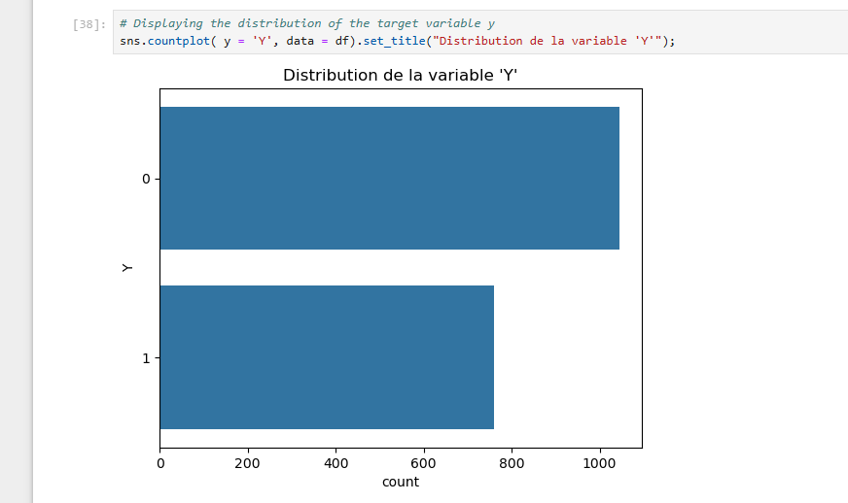
Fig.11: Displaying the distribution of the target variable y
8.12 Calculate the score on the training data

Fig.12: Calculate the score on the training data
8.13 Calculate the score on the test data
Fig.13: Calculate the score on the test data
8.14 Assigning the prediction the variable y_pred
Fig.14: Assigning the prediction the variable y_pred

8.15 Confusion matrix
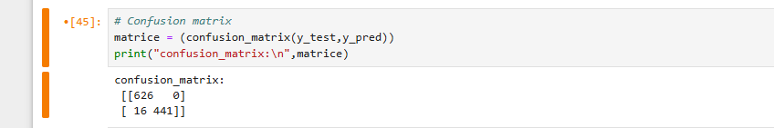
Fig. 15: Confusion matrix
8.16 Report classification : precision , recall , f1-score, support
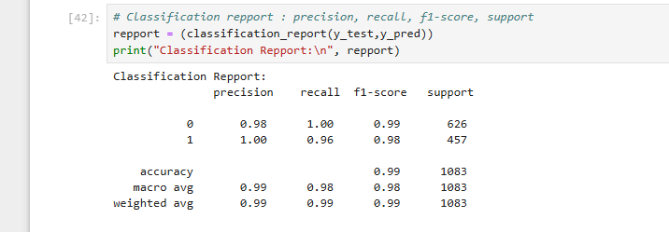
Fig.16: Report classification : precision , recall , f1-score, support
8.17 Graphical assessment
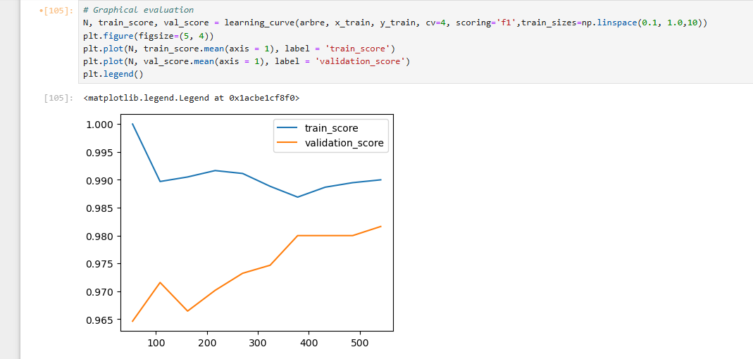
Fig.17: Graphical assessment

8.18 Visualization of decision trees

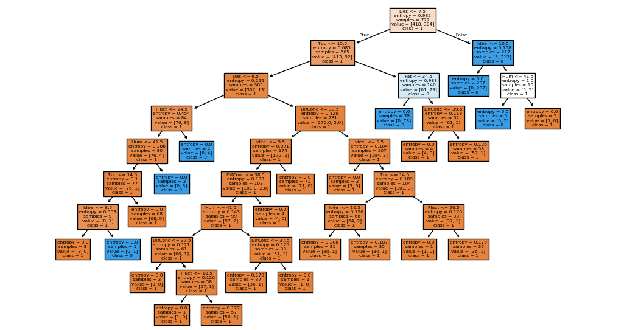
Fig.18: Visualization of decision trees
9. Conclusion
The objective of this article is to propose a machine learning model based on the random forest algorithm for the prediction of mental illnesses. The decision tree algorithm, belonging to the category of supervised learning methods, allows for early diagnosis and reliable prediction from data from a structured set.

In this context, we established a diagnostic model that has produced convincing results. One of the most influential variables identified in the prediction process is the feeling of "hopelessness about the future," which was integrated as a determining node in the decision tree.

Machine learning models applied to depression prediction represent a major advance. They have the potential to profoundly transform our understanding, diagnosis, and treatment of this condition. Future prospects are promising, with innovations that could significantly improve the quality of life of people suffering from depression.

Disclaimer ( Artificial Intelligence )
Option 1:
The authors state hereby​​ that NONE technology of AI generative such than the big ones language models​ ( ChatGPT , manuscript ).
Option 2:
The authors state hereby​​ to have used AI technologies generative , such than the big ones language models , when writing​​ or manuscript review . This explanation will include the name, version, model and source of the technology of AI generative , as well that all input prompts provided to this technology .
Details of AI use​​ are given below :​
1.
2.
3.

References

[1] L. JOLIA-FERRIER, (2014), Big Data concepts and Hadoop implementation, France,
[2] R. Bruchez , (2013), NoSQL Databases and Big Data , Paris,
[3] A. VANNIEUWENHYUZE, (2019), Artificial intelligence popularized, Machine Learning and Deep Learning through practice , Paris.
[4] Géron , A., ( 2005), Learning automatic practice with Scikit -Learn, Keras and TensorFlow , Montreal.
[5] Han, J., Kamber , M., and Pei, J. , (2008), Data Mining : Concepts and Techniques , Loslogel .
[6] Hastie, T., Tibshirani , R., & Friedman, J., ( 2016), The Elements of Learning statistics : data mining , inference and prediction , Risk.
[7] Witten, IH, Frank, E., Hall, MA, & Pal, CJ, ( 2018 ), Data Mining: Practical Tools and Techniques learning automatic , Charlotte.
[ 8 ] Xiong , J., Li, O., Pan, W., Luo, Y., Hu, Y., Wang, K., & Li, W. (2020), COVID-19 and mental health : a systematic review and meta -analysis, Montreal .
[9] Brooks, SK, Webster, RK, ( 2020 ), The impact Psychological Stress of Midlife and How to Reduce It : Review fast evidence . , Risk .
[10] Antoine CAUBRIÈRE, (2021), From signal to concept: deep neural networks applied to speech understanding , Lium ,.
[11] KOMI SÉPÉLI SODOKÉ, (2020), Knowledge extraction from multidimensional traces of eye movements for a transfer of perceptual-decisional expertise in the medical field , Quebec
[12] Caroline Etienne, (2019), Deep learning applied to the recognition of emotions in voice , Paris.
[13] Moez BACCOUCHE, (2013), Neural learning of spatio-temporal characteristics for the automatic classification of video sequences , Lyon.
[14] L. JOLIA-FERRIER, (2014), Big Data Concepts and Hadoop Implementation , Paris .
[15] R. Bruchez , (2013), NoSQL Databases and Big Data , Paris
[16] A. VANNIEUWENHYUZE, (2019), Artificial intelligence popularized, Machine Learning and Deep Learning through practice , Paris, pg . 28-200.
[17] Sharafi , A., Karimi , A., Safdari , R., and Shahmoradi , L., (2025), Text-based depression prediction on social media using machine learning: A systematic review and meta-analysis, JIMIR;
[18] Enkhbayar , D., Ko, J., Oh, S., Ferdushi , R., Kim, J., Key, J. and Urtnasan , E., ( 2025), Explainable artificial intelligence models to predict depression based on polysomnographic phenotypes , MDPI;
[19] Nomani , HF, Alsadhan , AH, Al- Mutairi , WN , Almutairi , AS, Al Mutairi , MS, & Altamimi , MM (2024), Advanced Comparative Analysis of Machine Learning and Transformer Models for Detecting Depression and Suicide in Social Media Texts, MDPI.
[20] Sun Z. et al. (2023), Deep Learning for Detection of Significant Prostate Cancer in MRI, Frontiers in Oncology , Switzerland
[21] Guiot J. et al. (2022), Radiomics for Personalized Medicine , Frontiers in Oncology , Switzerland
Avanzo M. et al. (2020), Machine & Deep Learning for Radiomics , Medical Physics Journal, Wiley , UK
[22] Demircioğlu A. (2023), Performance of Deep Models in Radiomics , European Radiology Experimental , SpringerOpen
[23] D. Woodcock et al. (2024), AI uncovers Prostate Cancer Subtypes (“ Evotypes ”), Cell Genomics , Elsevier
[24] Duran A. et al. (2022), ProstAttention Net: cancer segmentation by MRI, arXiv preprint , Cornell University
[25] Bhattacharya I. et al. (2020), CorrSigNet : Prostate Cancer Signatures, arXiv preprint , Cornell University
[26] D. Woodcock et al. (2024), AI uncovers Prostate Cancer Subtypes (“ Evotypes ”), Cell Genomics , Elsevier
[27] Hashem H. et al. (2022), Deep Learning for Prostate Cancer on MRI, arXiv preprint , Cornell University .
[28] Rui Jin et al. (2024), AI- based Segmentation of Prostate MRI: Review , arXiv preprint , Cornell University
[29] Cai JC et al. (2024), Fully Automated Deep Learning Model for MRI PCa , Radiology Journal, RSNA
[30] Hashem H. et al. (2022), Deep Learning for Prostate Cancer on MRI, arXiv preprint , Cornell University .
[31] Rui Jin et al. (2024), AI- based Segmentation of Prostate MRI: Review , arXiv preprint , Cornell University
[32] McGarry SD et al. (2021), Deep learning for prostate cancer classification in multiparametric MRI: a review, The British Journal of Radiology
[33] Komura D. & Ishikawa S. (2018), Machine learning methods for histopathological image analysis , Computational and Structural Biotechnology Journal

