Perioperative Management of Cardiac Rehabilitation in Patient Undergoing Coronary Artery Bypass Grafting: A Case Report

ABSTRACT

Aims: To highlight the importance of early diagnosis, timely intervention, and structured cardiopulmonary rehabilitation in a high-risk patient with acute coronary syndrome (ACS) requiring coronary artery bypass grafting (CABG).
Case Presentation: A 54-year-old male with poorly controlled hypertension, recent smoking cessation, and a family history of cardiovascular disease presented with exertional chest pain and dyspnea. Initially misdiagnosed as pulmonary disease, his condition progressed to acute myocardial infarction, confirmed by ECG and biomarkers. Emergency direct coronary angioplasty (DCA) was performed, followed by optimal medical therapy. Due to severe triple vessel disease, he underwent elective CABG with three grafts (LIMA–LAD, SVG–LCX, SVG–RCA). Echocardiography showed preserved LVEF (58%) and diastolic dysfunction. Postoperatively, he was enrolled in Phase I cardiac rehabilitation, including early mobilization, breathing exercises, and nursing-led mobilization, with good hemodynamic stability and functional recovery.
Discussion: This case underscores the role of cardiac rehabilitation in the perioperative pathway of CABG patients. Early mobilization reduced risks of pneumonia and deep vein thrombosis, while multidisciplinary management enhanced functional recovery. Literature supports structured rehabilitation programs as safe and effective in reducing complications and improving outcomes after CABG.
Conclusion: Early diagnosis, prompt intervention, and integrated perioperative care—particularly cardiac rehabilitation and early mobilization—are essential to optimize outcomes in high-risk ACS patients undergoing CABG.

Keywords: Coronary Artery Bypass Graft, Perioperative Care, Rehabilitation

1. INTRODUCTION
Coronary artery disease (CAD) is the leading cause of cardiovascular morbidity and mortality worldwide.¹ Atherosclerotic plaque reduces myocardial oxygen supply, predisposing to ischemia and acute coronary events. Risk factors include hypertension, diabetes, smoking, hyperlipidemia, and family history. Coronary artery bypass grafting (CABG) remains one of the most frequently performed cardiac surgeries, with approximately 400,000 procedures annually in the United States, though trends are shifting toward percutaneous coronary intervention (PCI).²
Restoring coronary blood flow through CABG alleviates angina and improves myocardial function and cardiomyocyte viability. However, perioperative complications and comorbidities increase morbidity and mortality risk. To mitigate these risks, cardiac rehabilitation has emerged as a cornerstone of comprehensive management. Defined as a structured multidisciplinary intervention, it improves functional capacity, reduces complications, and enhances quality of life.³
This case highlights the journey of a high-risk ACS patient from early diagnosis to CABG, emphasizing the integration of perioperative care such as cardiac rehabilitation to improve outcomes.

2. presentation of the case
A 54-year-old male with a history of poorly controlled hypertension and long-standing asthma presented with worsening chest pain and dyspnea. Patient has family history of cardiovascular disease. In early 2024, the patient began experiencing intermittent chest pain on exertion, such as walking or climbing stairs, which resolved with rest and initially did not interfere with the daily activities. In June 2024, he developed worsening dyspnea and wheezing accompanied by chest pain, prompting admission to a secondary hospital, where he was managed by a pulmonologist first and later a cardiologist. He was hospitalized for four days and discharged with outpatient follow-up. On July 10, he was presented with intense chest pain at rest accompanied by diaphoresis. He was diagnosed with an acute myocardial infarction and underwent emergency DCA, after he was hospitalized for seven days and later referred for CABG due to triple vessel disease.
Echocardiography revealed preserved left ventricular systolic function (EF 58%) with grade I diastolic dysfunction and regional wall motion abnormalities in the basal-mid inferoseptal and inferior walls. Coronary angiography showed severe triple vessel disease: 95% proximal stenosis in the LAD with diffuse disease, 80-90% stenosis in the LCX, and chronic total occlusion (CTO) of the RCA. Collateral circulation was observed from both LAD and LCX to the RCA. He was referred for and successfully underwent CABG with three grafts (LIMA to LAD, SVGs to LCX and RCA). He started on antiplatelet therapy statins, beta-blockers, ACE inhibitors and supportive therapy. The patient was enrolled in phase 1 cardiac rehabilitation immediately after surgery focusing on early mobilization and breathing exercises. Nursing care focused on monitoring for any signs of infection or complications and played a key role in mobilization which preventing complications such as deep vein thrombosis (DVT) and pneumonia. The patient showed good recovery with stable hemodynamics.
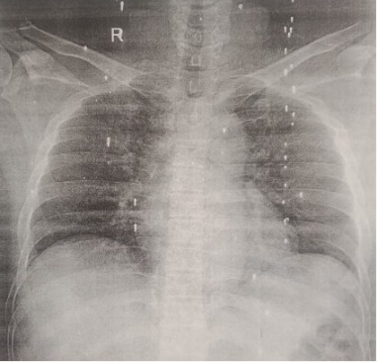
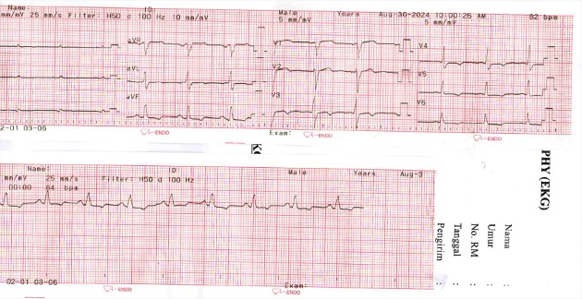
Figure 1. Chest X-ray
Figure 2. Electrocardiogram

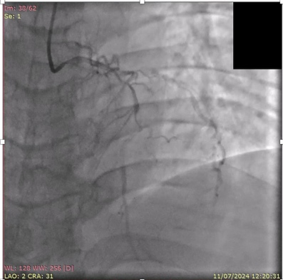
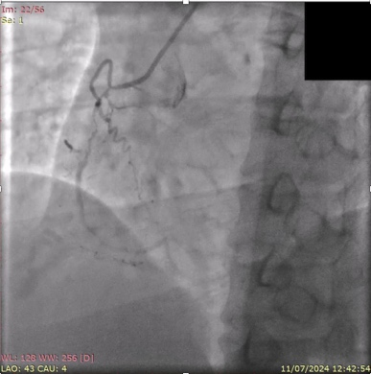

Figure 3. Coronary Angiography

3. discussion
Following coronary artery bypass grafting, or CABG, patients may experience postoperative problems that lead to extended hospital stays or even death. Phase I cardiac rehabilitation interventions are required to help hasten the recovery process following CABG and avoid problems.⁴ Even though a lot of study has been done, more studies of research papers about safe and simple strategies that can be used in cardiac rehabilitation programs for postoperative CABG patients are still required.^{5,6} Examining safe and efficient phase I cardiac rehabilitation therapies for patients receiving CABG was the aim of this literature review. During the preoperative period and postoperatively until the patient's discharge, phase I cardiac rehabilitation was implemented in patients following CABG. Education and counseling, physical activity, breathing exercises, effective coughing exercises, inspiratory muscle training, and chest physical therapy are all part of phase I cardiac rehabilitation interventions, both before and after surgery.^{7,8} Hospitals that offer CABG services might use the findings of this literature study to establish standard operating procedures for the implementation of phase I cardiac rehabilitation.⁹ Although early mobilization is seen as a crucial component of postoperative treatment, it is unclear how this intervention should be applied in clinical settings. The information pertaining to the effects of particular early mobilization procedures on postoperative outcomes following abdominal and thoracic surgery is compiled in this comprehensive review.¹⁰ Following a cardiovascular incident or intervention, this phase starts in the hospital environment. The patient's physical capacity and willingness to endure cardiac rehabilitation are assessed at the initial evaluation. In order to preserve mobility and avoid deconditioning brought on by hospitalization, therapists and nurses lead patients through mild bedside exercises. While recovering from comorbid diseases or postoperative complications, the rehabilitation staff also helps patients with everyday life activities, teaches them how to handle stress, and makes sure they get enough sleep. Patient requirements are also thoroughly assessed, including those related to discharge planning, family education, and assistive technology.¹¹
CABG patients are at risk of postoperative complications such as infection, prolonged ICU stay, and impaired recovery. Phase I cardiac rehabilitation—including early mobilization, inspiratory muscle training, and bedside exercises—is proven to reduce complications and improve outcomes.^{9,11} Early mobilization decreases risks of pneumonia, deep vein thrombosis, and deconditioning, while structured discharge planning improves long-term adherence to therapy.¹⁰
Comorbid patients are more likely to be elderly and frequently female, may require particular care in the early post-discharge period, and are more likely to experience negative outcomes. According to the most recent data, patients with comorbidities, women, and older people have a far lower likelihood of receiving cardiac rehabilitation. Furthermore, CABG patients may not always follow recommended atherosclerosis risk reduction techniques.¹² Complication rate: 8.3% of patients had complications following CABG, such as deep sternal wound infections (0.9%), stroke (0.9%), and infections (3.8%). Two important risk factors were age and duration of ICU stay. Risks of infection: diabetes, obesity, extended intubation, and a history of myocardial infarction are risk factors for postoperative infections. Complication patients exhibited greater rates of inotrope use (78%) and left ventricular dysfunction (78%) and needed lengthier stays in the intensive care unit and hospital. Infections and their consequences. Even in cases that are successfully treated, deep sternal wound infections (DSWI) can increase long-term mortality. Although they are uncommon (1-2%), DSWI is a significant consequence with death rates as high as 30%. Longer ICU stays and longer periods of mechanical breathing were observed in patients with DSWI.¹³
Recent studies confirm that early rehabilitation significantly enhances physical function, reduces ICU stay, and lowers readmission rates.^{13,14} Our patient, despite multiple risk factors, benefited from early cardiac rehabilitation, achieving stable recovery without complications. His case highlights the importance of integrating perioperative management with structured rehabilitation to optimize outcomes.

4. Conclusion
This case demonstrates several important things. Early diagnosis and timely intervention are essential in ACS. Structured perioperative care, particularly cardiac rehabilitation and early mobilization, reduces complications and accelerates recovery. Multidisciplinary collaboration among cardiologists, surgeons, nurses, and physiotherapists ensures optimal outcomes. Rehabilitation protocols should be standardized and initiated immediately post-CABG to enhance safety and recovery.

Consent (where ever applicable)

All authors declare that ‘written informed consent was obtained from the patient (or other approved parties) for publication of this case report and accompanying images. A copy of the written consent is available for review by the Editorial office/Chief Editor/Editorial Board members of this journal.

Ethical approval (where ever applicable)

Disclaimer (Artificial intelligence)

Option 1:

Author(s) hereby declare that NO generative AI technologies such as Large Language Models (ChatGPT, COPILOT, etc.) and text-to-image generators have been used during the writing or editing of this manuscript.

Option 2:

Author(s) hereby declare that generative AI technologies such as Large Language Models, etc. have been used during the writing or editing of manuscripts. This explanation will include the name, version, model, and source of the generative AI technology and as well as all input prompts provided to the generative AI technology

Details of the AI usage are given below:
1.
2.
3.

References

- Shahjehan RD, Sharma S, Bhutta BS. Coronary Artery Disease. [Updated 2024 Oct 9]. In: StatPearls [Internet]. Treasure Island (FL): StatPearls Publishing; 2025 Jan–. Available from: https://www.ncbi.nlm.nih.gov/books/NBK564304/
- Bachar BJ, Manna B. Coronary Artery Bypass Graft. [Updated 2023 Aug 8]. In: StatPearls [Internet]. Treasure Island (FL): StatPearls Publishing; 2025 Jan–. Available from: https://www.ncbi.nlm.nih.gov/books/NBK507836/
- Taylor RS, Dalal HM, McDonagh STJ. The role of cardiac rehabilitation in improving cardiovascular outcomes. Nat Rev Cardiol. 2022 Mar;19(3):180-94. doi: 10.1038/s41569-021-00611-7. Epub 2021 Sep 16. PMID: 34531576; PMCID: PMC8445013.
- Byrne RA, Rossello X, Coughlan JJ, Barbato E, Berry C, Chieffo A, et al; ESC Scientific Document Group. 2023 ESC Guidelines for the management of acute coronary syndromes. Eur Heart J. 2023 Oct 12;44(38):3720-3826. doi: 10.1093/eurheartj/ehad191. Erratum in: Eur Heart J. 2024 Apr 1;45(13):1145. doi: 10.1093/eurheartj/ehad870. PMID: 37622654.
- Dibben G, Faulkner J, Oldridge N, Rees K, Thompson DR, Zwisler AD, Taylor RS. Exercise-based cardiac rehabilitation for coronary heart disease. Cochrane Database Syst Rev. 2021 Nov 6;11(11):CD001800. doi: 10.1002/14651858.CD001800.pub4. PMID: 34741536; PMCID: PMC8571912.
- Buckley BJR, Kleinnibbelink G, Lip GYH, Taylor RS, Thijssen DHJ. Cardiac rehabilitation meta-analysis of trials in patients with coronary heart disease using individual participant data (CaReMATCH): Project protocol. Int J Cardiol Heart Vasc. 2020 Sep 2;31:100616. doi: 10.1016/j.ijcha.2020.100616. PMID: 32939394; PMCID: PMC7479493.
- Kanejima Y, Shimogai T, Kitamura M, Ishihara K, Izawa KP. Effect of early mobilization on physical function in patients after cardiac surgery: A systematic review and meta-analysis. Int J Environ Res Public Health. 2020 Sep 28;17(19):7091. doi: 10.3390/ijerph17197091. PMID: 32998202; PMCID: PMC7578990.
- Sellke FW. Secondary prevention after coronary artery bypass grafting: Anticoagulation and antiplatelet therapy is only one factor. J Card Surg. 2021 Mar;36(3):1100-2. doi: 10.1111/jocs.15286. Epub 2021 Jan 28. PMID: 33506999; PMCID: PMC7882026.
- Galih A, Tjahjono CT, Rizal A, Martini H. Phase I cardiac rehabilitation intervention in patients undergoing coronary artery bypass grafting. Health Sci J. 2022;3(4):1–7. doi: 10.21776/ub.hsj.2022.003.04.2.
- Castelino T, Fiore J Jr, Niculiseanu P, Landry T, Augustin B, Feldman L. The effect of early mobilization protocols on postoperative outcomes following abdominal and thoracic surgery: A systematic review. Surgery. 2016;159(3):991–1003. doi: 10.1016/j.surg.2015.11.029.
- Tessler J, Ahmed I, Bordoni B. Cardiac Rehabilitation. [Updated 2025 Mar 28]. In: StatPearls [Internet]. Treasure Island (FL): StatPearls Publishing; 2025 Jan–. Available from: https://www.ncbi.nlm.nih.gov/books/NBK537196/
- Scrutinio D, Giannuzzi P. Comorbidity in patients undergoing coronary artery bypass graft surgery: impact on outcome and implications for cardiac rehabilitation. Eur J Cardiovasc Prev Rehabil. 2008 Aug;15(4):379-85. doi: 10.1097/HJR.0b013e3282fd5c6f. PMID: 18677160.
- Hijazi E. Investigating outcomes of coronary artery bypass graft (CABG) surgery: a single-center retrospective study in Jordan. Future Sci OA. 2024 Dec;10(1):FSO902. doi: 10.1080/20565623.2024.2430902. Epub 2024 Nov 25. PMID: 39582329; PMCID: PMC11591588.
- Netala VR, Teertam SK, Li H, Zhang Z. A comprehensive review of cardiovascular disease management: Cardiac biomarkers, imaging modalities, pharmacotherapy, surgical interventions, and herbal remedies. Cells. 2024 Sep 1;13(17):1471. doi: 10.3390/cells13171471. PMID: 39273041; PMCID: PMC11394358.

