Original Research Article

Production and Optimization of γ-PGA from Bacillus subtilis Using Rice Husk as a Cheap Biomass

.
ABSTRACT

Aims: This study aims to optimize the production of poly γ-glutamic acid (γ-PGA) from Bacillus subtilis utilizing rice husk via solid-state fermentation (SSF). Specifically, it seeks to investigate the impact of various factors, including medium components and process conditions, on γ-PGA yield, with a focus on enhancing production efficiency.
Study Design: The study employed response surface methods to design experiments, incorporating a definitive screening design (DSD) and a full central composite design (FCCD). These designs allowed for the evaluation and optimization of significant factors affecting γ-PGA production, considering a range of variables such as temperature, citric acid concentration, glycerol concentration, and 6-diazo-5-oxo-L-norluecine (DON) concentration.
Place and Duration of Study: The study was conducted in the laboratory setting over a specified duration, utilizing resources and facilities conducive to microbial fermentation experiments. The exact location and timeframe of the study are as per the laboratory facilities and research schedule.
Methodology: Solid-state fermentation (SSF) was employed for γ-PGA production using Bacillus subtilis and rice husk as the substrate. Response surface methods, including DSD and FCCD, were utilized to design experiments and optimize production conditions. The impact of factors such as temperature, citric acid concentration, glycerol concentration, and DON concentration on γ-PGA yield was assessed. Confirmation experiments were conducted to validate the model, with analysis techniques including amino acid analysis, FT-IR spectroscopy, and SDS-PAGE for molecular weight determination.
Results: The results indicated that temperature, citric acid concentration, glycerol concentration, and DON concentration significantly influenced γ-PGA yield. Optimum conditions for γ-PGA production were determined as follows: DON concentration of 25.0 μg/100g, citric acid concentration of 5.68% (w/w), and glycerol concentration of 9.50% (v/w). Confirmation experiments confirmed the validity of the model, with a correlation coefficient of 0.9554. Analysis techniques revealed distinctive peaks of glutamic acid in amino acid analysis, characteristic bands in FT-IR spectra, and molecular weights of 35, 44, and 96 kDa respectively in SDS-PAGE.
Conclusion: This study underscores the potential of Bacillus subtilis for γ-PGA production using rice husk as a substrate via solid-state fermentation. Furthermore, it highlights the inhibitory effect of 6-diazo-5-oxo-L-norluecine (DON) on γ-glutamyl transpeptidase (γ-GTP), leading to enhanced γ-PGA yield. These findings contribute to the optimization of γ-PGA production processes and offer insights into the utilization of agricultural by-products for biopolymer synthesis, with implications for various industrial applications.

Keywords: Bacillus subtilis, Poly γ-glutamic acid, Fermentation, Rice husk

1. INTRODUCTION

Poly γ-glutamic acid is a multifarious anionic biopolymer composed mainly of D-and L-glutamic acid units connected via amide linkages between α-amino and γ-carboxylic acid groups of the monomers [1]. γ-PGA is classified into; γ-L-PGA (only L-glutamic acid residues), γ-D-PGA (only D-glutamic acid residues), and γ-LD-PGA (both L- and D-glutamic acid residues) based on the enantiomer of glutamic acid residues [2,3]. It is water-soluble, nontoxic, non-immunogenic and edible biopolymer [4]. It also has adhesive, film forming, and moisture retention properties making it an interesting material for drug delivery/release, bio-adhesive, cosmetics, food, agriculture, and sewage treatment [5]. Because of its wide applications, it has become one of the most interesting topics in biopolymer research [6]. Amongst other novel applications, it has the potential to be used for protein crystallization [7], as a soft tissue adhesive [8,9] and a non-viral vector for safe gene delivery [2,10,11].
𝛾-PGA microbial fermentation is almost exclusively of gram-positive bacteria (genus: Bacillus, class: Bacilli) [7,12,13] except for recombinant E. coli [5,12,14]. Unlike most proteinaceous materials, γ-PGA is synthesized in a ribosome-independent manner [15,16,17]; thus, substances that inhibit protein translation have no inhibitory effects on the production of γ-PGA. Furthermore, the γ-linkage of γ-PGA is resistant to proteases [1,18,19].
Optimization techniques, especially the response surface methods are statistical techniques used in the design and simulation of experiments [20]. Rice husk is a high potential substrate, which is amenable for value addition. Despite the enormous potential that could be tapped, most of the husk from rice milling is either burnt or dumped as waste in open fields and a small amount is used as fuel for boilers, electricity generation and bulking agents for composting of animal manure [21. 22].
The aim of this study was to optimize the production of γ-PGA from B. subtilis specie a soil assesses the effects of medium components and process conditions as well as the impact of γ-glutamyl transpeptidase (γ-GTP) inhibitor on γ-PGA production yield using rice husk by solid-state fermentation (SSF).

2. material and methods

2.1 Sample Collection
Bacillus subtilis used was from a newly acquired characterised isolates (accession number: MW785886-785887, MW805751 and MW805751) which were reported elsewhere. Rice husks were obtained and from a rice mill at Hayin-Dogo, adjacent to Model Learning Secondary School, Samaru; Water samples were collected from the ABU dam, Samaru, Zaria; soil samples were collected in a farm land behind in Samaru, Zaria; while Daddawa was purchased from Samaru market, in Zaria, Kaduna State, Nigeria.

2.2 Preparation of Biomass
The sample of rice husk was oven dried to remove moisture and there after milled using a laboratory size milling machine. The milled husk was sieved into different particle sizes using ISO standard no.: 0.150, 0.210 and 0.420mm and finally autoclaved [23].

2.3 Definitive screening design (DSD)
A set of 27 experimental designs was generated (Table 1) using Design Expert trial version 11.0 (State Ease, Minneapolis, USA) to screen 11 factors comprising the medium components (ammonium sulphate, DON, citric acid, glucose, glutamic acid, glycerol, and percentage moisture content) and process conditions (pH, particle size, incubation time and temperature) with three levels of each factor (low (-1), medium (0) and high (+1) respectively [24, 25, 26]. The quantity of γ-PGA produced was expressed in mg/gds of response (y).

2.4 Full Central Composite Design (FCCD) Method
Appropriate ranges were selected based on the data generated from the DSD analysis. Significant factors; DON, citric acid and glycerol from the DSD were optimized using full central composite design of response surface methodology (RSM) from a set of 20 experimental runs with 6 centre and 6 axial points each was generated as shown in (Table 3) using Design Expert wizard.

2.5 Isolation and Purification of Produced γ-PGA
Poly-γ-glutamic acid was purified using ethanol precipitation method as modified by Bajestani et al. [27]. The various peak of γ-PGA digest was determined according to the method described by Vollenbroich and Krause (1997) using reverse-phase high-performance liquid chromatography (HPLC) (Agilent 1200 series, Agilent Technologies, USA) (Figure 3). The hydrolysed purified γ-PGA was derivatized using 1-fluoro-2,4-dinitrophenyl-5-L-alanine amide following the supplier's instructions.
The spectra of the produced Purified γ-PGA were analysed using Cary 630 FT-IR Agilent technologies, USA according to the operational protocol for paste sample analysis (Figure 4). The single reflection diamond attenuated total reflectance (ATR) sample interface was cleaned with acetone and background scan was carried out. The sample was smeared on the ATR sample interface and the transmittance measured [28]. The molecular weight of the Produced γ-PGA was determined by sodium dodecyl sulphate–polyacrylamide gel electrophoresis (SDS-PAGE) using ExpressPlusTM PAGE precast gel according to the method of Laemmli [29] after deproteinizing with chloroform n-butanol (1:4 v/v) agent (Figure 5).

2.6 Data Analysis
All analysis were carried out in triplicates and expressed as mean±SD. One-way ANOVA, regression coefficient, tests of fitness (P = .05) were internally generated by design expert software to estimate the levels of significance. 3-D response surface plots were used to represent the outcome and effects of independent factors using Design Expert trial version 11.0 (Stat-Ease Inc., Minneapolis, USA).

3. results and discussion

3.1 Definitive Screening of Medium Components and Conditions
The results of γ-GPA yield in milligram per gram-dry-substrate (mg/gds) are shown in (Table 1). The normal plots (Fig. 1) showed that temperature, citric acid, glycerol and DON have the highest effects on the yield. The effect of temperature was negative, while citric acid, glycerol and DON have positive impact on the yield (P = .05). The analysis of the definitive screening design by half and normal plots (figure 2) showed that four of the independent factors have the highest effects on the yield. The effect of temperature was largely negative, while citric acid, glycerol and DON have positive impact on the yield in a descending degree respectively. The rest of the factors; Glucose, moisture contents, particle size showed positive effects but are not statistically significant. On the other hand, glutamic acid, incubation time, ammonium sulfate and initial pH gave statistically insignificant effects. There were interactions also among the factors. The interaction between particle size and moisture content, DON and glutamic acid, glycerol and temperature as well as DON and moisture contents gave statistically insignificant positive effects. In the same vein, DON and incubation time; glycerol and initial pH; ammonium sulfate, DON and citric acid; initial pH and particle size; initial pH and moisture content; DON and particle size; citric acid and incubation time as well as ammonium sulfate and DON gave a negative interaction effect on the γ-PGA yields. The lack of fit was not significant with F-value of 2.05 and percentage error probability of 37.93% and core total degree of freedom of 26 (Table 2). The regression analysis gave a low adjusted and predicted R² but the difference is within an acceptable range of 0.208 though it is slightly higher by 0.008 from the standard recommended range value of 0.2. The standard deviation of the regression analysis was 0.5610 and the coefficient of the regression analysis was 0.4358, mean of 1.00 and percentage coefficient of variability of 55.90 and adequacy precision of 6.8323.

Table 1: γ-PGA Response of DSD of Medium Components and Conditions
STD | A | B | C | D | E | F | G | H | I | J | K | Response
1 | 1.50 | 0.05 | 2.50 | 2.50 | 5.50 | 5.50 | 6.80 | 3 | 30.00 | 40.00 | 0.42 | 82.50±0.45
2 | 0.50 | 0.35 | 5.50 | 2.50 | 5.50 | 2.50 | 6.80 | 3 | 40.0 | 40.00 | 0.42 | 90.50±0.36
3 | 1.50 | 0.35 | 2.50 | 5.50 | 5.50 | 2.50 | 8.00 | 3 | 40.00 | 40.00 | 0.15 | 156.17±0.17
4 | 0.50 | 0.35 | 5.50 | 2.50 | 5.50 | 5.50 | 8.00 | 7 | 30.00 | 40.00 | 0.15 | 38.16±0.29
5 | 1.50 | 0.35 | 5.50 | 2.50 | 2.50 | 5.50 | 8.00 | 3 | 40.00 | 70.00 | 0.42 | 66.16±0.19
6 | 0.50 | 0.35 | 2.50 | 2.50 | 2.50 | 2.50 | 6.80 | 3 | 30.00 | 70.00 | 0.15 | 35.50±0.01
7 | 0.50 | 0.05 | 2.50 | 2.50 | 5.50 | 2.50 | 8.00 | 7 | 40.00 | 70.00 | 0.42 | 74.50±0.19
8 | 0.50 | 0.05 | 2.50 | 2.50 | 2.50 | 5.50 | 8.00 | 3 | 40.00 | 40.00 | 0.15 | 125.33±0.77
9 | 1.50 | 0.35 | 2.50 | 2.50 | 2.50 | 2.50 | 8.00 | 7 | 30.00 | 40.00 | 0.42 | 153.83±0.78
10 | 1.50 | 0.05 | 5.50 | 2.50 | 5.50 | 2.50 | 8.00 | 3 | 30.00 | 70.00 | 0.15 | 133.16±1.47
11 | 0.50 | 0.05 | 5.50 | 5.50 | 2.50 | 2.50 | 8.00 | 3 | 30.00 | 40.00 | 0.42 | 112.00±1.33
12 | 1.50 | 0.05 | 5.50 | 2.50 | 2.50 | 2.50 | 6.80 | 7 | 40.00 | 40.00 | 0.15 | 155.17±1.93
13 | 0.50 | 0.35 | 5.50 | 5.50 | 2.50 | 2.50 | 8.00 | 7 | 40.00 | 70.00 | 0.15 | 122.33±1.22
14 | 1.50 | 0.05 | 2.50 | 5.50 | 2.50 | 5.50 | 8.00 | 7 | 30.00 | 70.00 | 0.15 | 70.50±0.22
15 | 0.50 | 0.05 | 5.50 | 2.50 | 2.50 | 5.50 | 6.80 | 7 | 30.00 | 70.00 | 0.42 | 92.00±0.55
16 | 1.50 | 0.05 | 2.50 | 5.50 | 2.50 | 2.50 | 6.80 | 3 | 40.00 | 70.00 | 0.42 | 40.83±0.06
17 | 0.50 | 0.05 | 2.50 | 5.50 | 5.50 | 2.50 | 6.80 | 7 | 30.00 | 40.00 | 0.15 | 62.16±0.15
18 | 1.50 | 0.05 | 5.50 | 5.50 | 5.50 | 5.50 | 8.00 | 7 | 40.00 | 40.00 | 0.42 | 89.67±0.63
19 | 1.50 | 0.35 | 5.50 | 5.50 | 2.50 | 5.50 | 6.80 | 3 | 30.00 | 40.00 | 0.15 | 40.75±0.05
20 | 1.50 | 0.35 | 5.50 | 5.50 | 5.50 | 2.50 | 6.80 | 7 | 30.00 | 70.00 | 0.42 | 120.67±1.03
21 | 0.50 | 0.05 | 5.50 | 5.50 | 5.50 | 5.50 | 6.80 | 3 | 40.00 | 70.00 | 0.15 | 65.17±0.34
22 | 0.50 | 0.35 | 2.50 | 5.50 | 2.50 | 5.50 | 6.80 | 7 | 40.00 | 40.00 | 0.42 | 43.00±0.22
23 | 1.50 | 0.35 | 2.50 | 2.50 | 5.50 | 5.50 | 6.80 | 7 | 40.00 | 70.00 | 0.15 | 45.25±0.00
24 | 0.50 | 0.35 | 2.50 | 5.50 | 5.50 | 5.50 | 8.00 | 3 | 30.00 | 70.00 | 0.42 | 388.25±40.2
25 | 1.00 | 0.20 | 4.00 | 4.00 | 4.00 | 4.00 | 7.40 | 5 | 35.00 | 55.00 | 0.285 | 47.00±0.06
26 | 1.00 | 0.20 | 4.00 | 4.00 | 4.00 | 4.00 | 7.40 | 5 | 35.00 | 55.00 | 0.285 | 140.83±1.42
27 | 1.00 | 0.20 | 4.00 | 4.00 | 4.00 | 4.00 | 7.40 | 5 | 35.00 | 55.00 | 0.285 | 80.17±0.03
Factor A: (NH₄)₂SO₄ (g/100g of medium), Factor B: DON (mg/100g of medium), Factor C: Citric acid (g/100g of medium), Factor D: Glucose (g/100g of medium), Factor E: Glutamic acid (g/100g of medium), Factor F: Glycerol (ml/100g of medium), Factor G: Initial pH, Factor H: Incubation time (Days), Factor I: Temperature (°C), J: Percentage moisture content (%v/w), Factor K: Particle size (mm), Factor L: Response: γ-PGA Yield (mg/gds of medium) and Std: Standard run order from design.

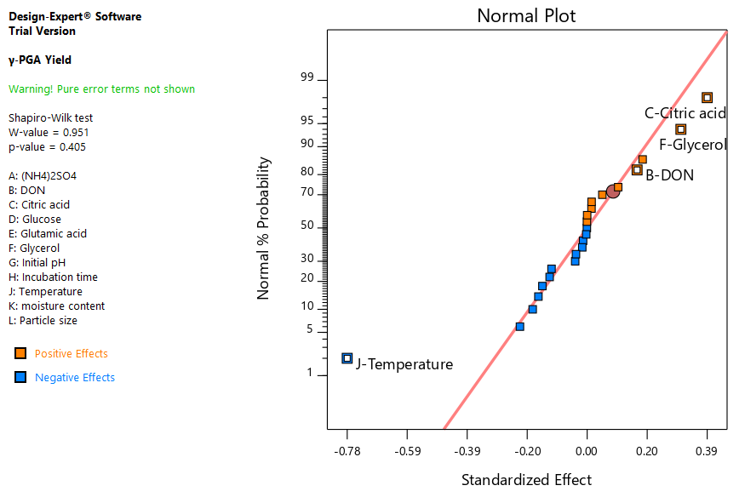
Figure 1: Normal plot of effects of independent factors and interactions on γ-PGA yield from the DSD screening

Table 2: One-way ANOVA of Selected significant Factorial Model’s Independent Factors
SN | Source | Sum of Squares | Df | Mean Square | F-value | p-value
1 | Model | 5.35 | 4 | 1.34 | 4.25 | 0.0107
2 | B-DON | 0.1619 | 1 | 0.1619
3 | C-Citric acid | 0.9294 | 1 | 0.9294
4 | F-Glycerol | 0.5676 | 1 | 0.5676
5 | J-Temperature | 3.69 | 1 | 3.69
6 | Residual | 6.92 | 22 | 0.3148
7 | Lack of Fit | 6.60 | 20 | 0.3301 | 2.05 | 0.3793
8 | Pure Error | 0.3225 | 2 | 0.1612
9 | Cor Total | 12.27 | 26

3.2 Response Surface Optimization by Full Central Composite Design
Citric acid, glycerol and DON were optimized using full central composite design (Table 3). The centre points showed reasonable agreement within the level of experimental design with an average of about 156 mg/gds. The concentration of γ-PGA tends to increase with decreasing concentration of DON while citric acid showed a positive trend in yield of γ-PGA with increase in the concentration of citric acid. Glycerol on the other hand showed a positive trend as well. There was increase in yield with increasing concentration glycerol.
The quadratic model was selected (Table 4) to analyse factors and interaction effects between the model terms and showed that all selected terms for the design were significant with p-values <0.0001 while the interactions were not significant. The fit analysis also showed coefficient of regression of 0.9554 and a standard deviation of 5.63 of the mean; 158.46±6.50mg/gds. The Model F-value of 23.78 indicative of 0.01% chance error due to noise (P<0.05). The Lack of Fit F-value of 1.76 implies the Lack of Fit is not significant relative to the pure error. The difference between adjusted and predicted R²(Table 5) was 0.155 which is reasonably within the generally accepted range of 0.2. The percentage coefficient of variability was 3.55 with adequacy precision of 18.4169.

Table 3: Response surface optimization by full central composite design
Std | A: DON (μ/100g) | B: citric acid (%:w/w) | C: glycerol (%:v/w) | γ-PGA Yield (mg/gds)
1 | (-1)20 | (-1)5 | (-1)5 | 18.76±2.20
2 | (+1)40 | (-1)5 | (-1)5 | 14.76±0.00
3 | (-1)20 | (+1)10 | (-1)5 | 17.11±0.08
4 | (+1)40 | (+1)10 | (-1)5 | 12.13±6.50
5 | (-1)20 | (-1)5 | (+1)10 | 19.55±5.75
6 | (+1)40 | (-1)5 | (+1)10 | 16.14±7.50
7 | (-1)20 | (+1)10 | (+1)10 | 17.18±4.90
8 | (+1)40 | (+1)10 | (+1)10 | 13.33±0.50
9 | (-α)13.1821 | (0)7.5 | (0)7.5 | 18.95±0.85
10 | (+α)46.8179 | (0)7.5 | (0)7.5 | 13.16±2.50
11 | (0)30  (0)30 | (-α)3.29552  (+α)11.7045 | (0)7.5  (0)7.5 | 16.37±2.68  13.64±2.20
12
13 | (0)30 | (0)7.5 | (-α)3.29552 | 14.87±4.45
14 | (0)30 | (0)7.5 | (+α)11.7045 | 16.29±2.59
15 | (0)30 | (0)7.5 | (0)7.5 | 16.33±4.75
16 | (0)30 | (0)7.5 | (0)7.5 | 15.06±3.75
17 | (0)30 | (0)7.5 | (0)7.5 | 15.85±6.50
18 | (0)30 | (0)7.5 | (0)7.5 | 16.14±8.71
19 | (0)30 | (0)7.5 | (0)7.5 | 16.18±1.25
20 | (0)30 | (0)7.5 | (0)7.5 | 16.25±1.84
DON: 6-diazo-5-oxo-L-norluecine; γ-PGA: Poly gamma glutamic acid; Std. Standard run by design; +1: High, -1: Low, 0: medium, -α and +α: are axial points of error estimates; Std: Standard run order from design

Table 4: One-way ANOVA of Selected FCCD Quadratic Model Terms
S/N | Source | Sum of Squares | Df | Mean Square | F-value | p-value
1 | Model | 68.21 | 9 | 7.58 | 24.63 | < 0.0001
2 | A-DON | 49.41 | 1 | 49.41 | 160.58 | < 0.0001
3 | B-citric acid | 14.46 | 1 | 14.46 | 46.98 | < 0.0001
4 | C-glycerol | 2.49 | 1 | 2.49 | 8.08 | 0.0175
5 | AB | 0.2521 | 1 | 0.2521 | 0.8191 | 0.3867
6 | AC | 0.3698 | 1 | 0.3698 | 1.20 | 0.2987
7 | BC | 0.1013 | 1 | 0.1013 | 0.3290 | 0.5789
8 | A² | 0.3553 | 1 | 0.3553 | 1.15 | 0.3078
9 | B² | 0.6612 | 1 | 0.6612 | 2.15 | 0.1734
10 | C² | 0.0017 | 1 | 0.0017 | 0.0056 | 0.9419
11 | Residual | 3.08 | 10 | 0.3077
12 | Lack of Fit | 1.95 | 5 | 0.3907 | 1.74 | 0.2792
13 | Pure Error | 1.12 | 5 | 0.2247
 | Core Total | 71.28 | 19
Df: Degree of freedom, AB: interaction of DON and citric acid, AC: interaction of DON and glycerol, BC: interaction of citric acid and glycerol, A²: product of interaction of DON, B²: Product of interaction of B and C²: product of interaction of C
Table 5: Summary of fit statistics of various possible models
Std. Dev. | 0.5547 | R² | 0.9558
Mean | 15.90 | Adjusted R² | 0.9180
C.V. (%) | 3.49 | Predicted R² | 0.7691
 |  | Adeq Precision | 18.736
C.V. %: Percentage coefficient of variation; R²: Coefficient of determination; Std. Dev.: Standard deviation.
3.3. Confirmation of Designed Experiment for the Production of γ-PGA
Three set of runs were carried out to validate the model. The data of the verification experiment were numerically analysed and correlated with the predicted from the model design (Table 6). The correlation coefficient was 0.9554. The resulted upper limit agrees more with the predicted values of the yield. The mean result of the confirmation experiment is slightly below the predicted by the numerical optimization. The mean experimental value was 153.50±29.00mg/gds.

Table 6: Confirmation of Designed Experiment for the Production of γ-PGA
Factors |  |  | Responses
DON | Glycerol | Citric acid | Observed | Predicted
25.00 μg/100g | 10.00% | 7.50% | 153.50 mg/gds | 172.50 mg/gds
Std. Dev.: Standard deviation, n: number of runs, SE Pred.: Standard error of Prediction, PI: Prediction interval

3.4. Three-Dimensional Response Surface Plots
The optimized factors (DON, Citric acid and Glycerol) plots are showed in figure (2a, b and c). The result showed the optimal points to be at; DON =25.0μg/100g , Citric acid =5.68% (w/w) and Glycerol= 9.50% (v/w).
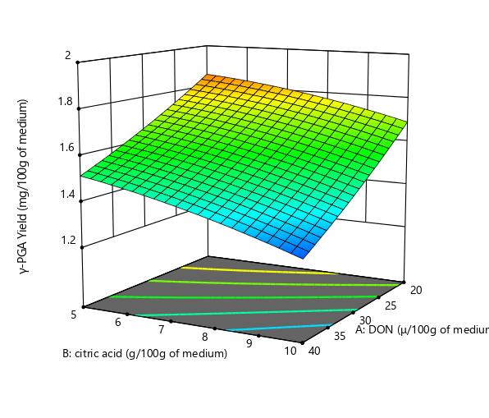
Figure 2 (a): 3D plot of Citric acid and DON
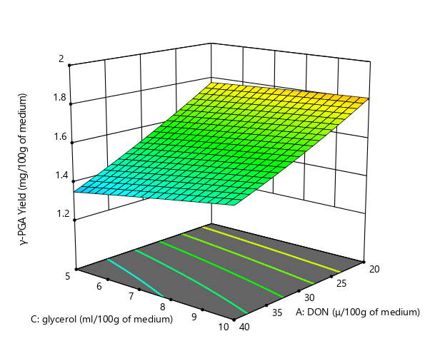
Figure 2 (b): 3D plot of Glycerol and DON
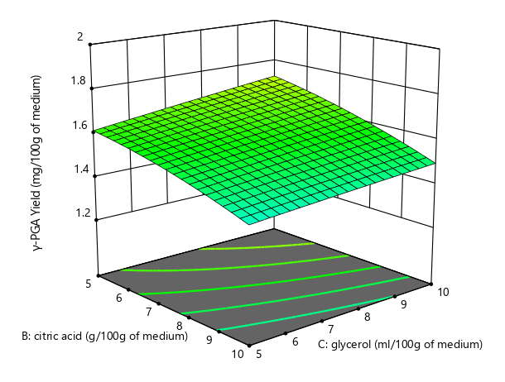
Figure 2 (c): 3D plot of Citric acid and Glycerol

3.5. Model Equation
The second order equation of the developed quadratic model is shown in equation 1 with intercept of 15.9 mg/gds and error due to noise of 1.73 mg/gds.

$$y=153.50+\left(-19.49\right)A+\left(-10.28\right)B +\left(4.27\right)C +\left(-1.76\right)AB+\left(2.15\right)AC+\left(-1.13\right)BC+\left(1.57\right)A^{2}+\left(-2.16\right)B^{2}+\left(-0.1031\right)C^{2}+0.23$$
…………………….$(Equation 1)$

Where y is the yield mg/gds and A, B and C are DON, citric acid glycerol respectively.

3.6. Polymer Characteristics

3.6.1. Amino Acid Analysis of Produced γ-PGA
The purified γ-PGA was digested using 6N HCl at 110°C. After neutralizing with concentrated NaOH solution, it was analysed using HPLC amino acids analyser (Agilent technologies, USA). Of the three different lambs, FLDA1 A gave peaks of glutamic acid at 1.75-minute retention time and a concentration of 20 Pmol/μL in the sample digest (figure 3)
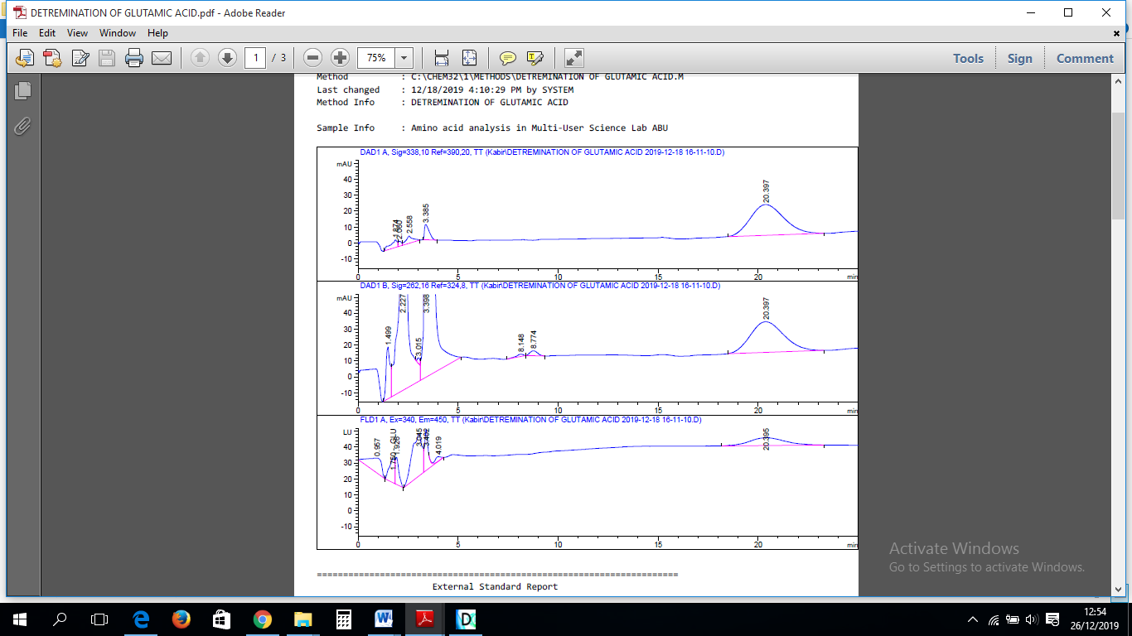
Figure 3: Absorbance Peaks of γ-PGA digest analysis by HPLC

3.6.2. FT-IR Spectra of Produced γ-PGA
The FTIR spectrum of the purified (Figure 4) showed regions characteristic of O-H, C=O groups and stretching vibrations characteristic of saturated aliphatic carboxylic acid dimers (1630–1680 cm⁻¹), C-O stretching peak assigned to carboxylic acid dimers (1320–1210cm⁻¹), N-H/C-N conjugate stretching (1420-1300cm⁻¹), and the broad O-H stretching (3000-2500cm⁻¹). There was a strong absorbance at 2974.4cm⁻¹ (80.56%) which corresponds to the absorbance O-H of carboxylic acid or conjugates of carboxylic acid. Another broad region of absorbance was at 3304.4cm⁻¹ (65.05%), this corresponds to region of absorbance of N-H of primary amines. This can be explained by the presence of free amine ends of the glutamic acid that are not involved in bonding. There was also an interesting absorbance at the N-H/C-N conjugate of 1408.9cm⁻¹ (79.9%) consequent of the presence of multiple conjugates of these functional groups in the molecule of γ-PGA. Also, C-O stretching absorbance was observed at 1080.9cm⁻¹ (47.7%), this corresponds to that of primary alcohols and COO⁻ functional group. The result of the analyses of the spectrum is presented in (Table 7).
Figure 4. FT-IR spectrum of purified γ-PGA from isolate S5 SSF

Table 7. FT-IR spectra of produced γ-PGA
SN | Region of IR (cm⁻¹) | Absorbance peak | Functional Group | Compound Class
1 | 4,000-3,000 | 3302.4: (65.05%) | N-H stretching | primary amine
2 | 3,000-2,500 | 2974.4: (80.56%) | O-H stretching | Carboxylic acid
3 | “ | 2829.7: (82.44%) | O-H stretching | Intermolecular bonds
4 | 2400-2000 | 2120.9: (97.90%) | C=O stretching | Conjugate anhydrides
5 | 1600-1300 | 1408.9: (79.90%) | N-H/C-N bending | γ-Conjugate bonds
6 | “ | 1408.9: (47.72%) | C-H bending | Alkyl group
7 | 1400-1000 | 1080.9: (47.72%) | C-O stretching | Primary alcohol
8 | “ | 1021.3: (29.24%) | C-O-O stretching | Anhydride
9 | 1000-650 | 879.7: (66.63%) | C-H bending | Substituted alkyl group

3.6.3 Molecular weight of produced γ-PGA
The SDS-PAGE electropherogram of the purified γ-PGA is shown in Figure 5. The optimized product gave three distinct bands of 35, 44 and 96kDa molecular weights with a profuse band at region of less than 10kDa.
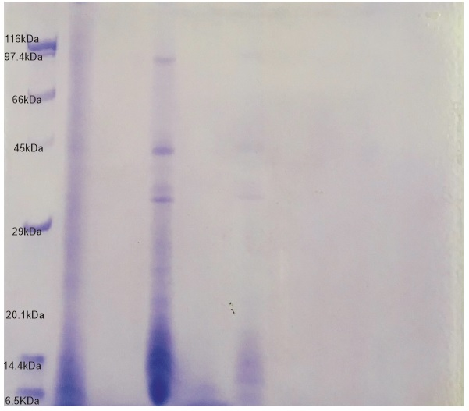
Figure 5. SDS-PAGE electropherogram of Produced γ-PGA

Discussion
The study's findings on the yield of γ-PGA (gamma-polyglutamic acid) in mg/gds highlight the significant factors influencing its production. The normal plots (Figure 1) reveal that temperature, citric acid, glycerol, and DON (6-diazo-5-oxo-L-norleucine) significantly impact yield, with temperature having a negative effect and the other three factors showing positive impacts (P = 0.05). Detailed analysis through definitive screening design (Figure 2) confirms that these four factors predominantly affect γ-PGA yield, with temperature negatively influencing it, while citric acid, glycerol, and DON positively impact it in descending order. A report by Song et al. [30] also revealed that; temperature, pH, agitation, and aeration) as well as glutamic acid, citric acid, and yeast extract has significant effects on γ-PGA production. Another report by Shih et al. [31] revealed that glycerol, glutamic acid and citric acid exhibit effects in decreasing order on the yield of γ-PGA and the interaction term of glutamic acid–glycerol exhibited a significant positive effect as well. Other factors such as glucose, moisture content, and particle size also showed positive effects, though they were not statistically significant. Factors including glutamic acid, incubation time, ammonium sulphate, and initial pH had statistically insignificant effects. Interactions between factors were observed, such as between particle size and moisture content, and between DON and glutamic acid, among others, though these interactions did not significantly impact γ-PGA yields. Other reports by Bhatt and Raut [32] as well as Halmschlag et sl. [33] revealed that glucose was a better carbon source than glycerol for cell growth rather than γ-PGA yields. Hence, glucose utilization can engender cell mass accumulation rather than product yield. But they suggest use of mixtures of glucose and glycerol in medium formulations to boast efficiency of gamma-PGA production increased.
The optimization of citric acid, glycerol, and DON using a central composite design provided significant insights. The center points demonstrated reasonable agreement with an average yield of about 156 mg/gds. The yield of γ-PGA increased with decreasing concentrations of DON, while citric acid and glycerol concentrations positively correlated with γ-PGA yield. The quadratic model analysis (Table 4) showed significant model terms (P<.00) but non-significant interactions. The model's fit, with a coefficient of regression of 0.9554, a standard deviation of 5.63, and a mean yield of 158.46 ± 6.50 mg/gds, indicates high predictability and reliability. The comprehensive analysis and optimization of medium components and conditions for γ-PGA production provide critical insights into the factors influencing yield.

4. CONCLUSION
This study successfully identifies and validates significant factors, optimizes conditions using a robust quadratic model, and characterizes the produced γ-PGA, contributing valuable knowledge to the field of biopolymer production. γ-PGA production was done using a soil isolate of Bacillus subtilis and rice husk as a substrate through a systematic approach involving definitive screening, response surface optimization, and experimental validation. This study identified key factors influencing γ-PGA yield, with temperature, citric acid, glycerol, and 6-diazo-5-oxo-L-norleucine (DON) being pivotal components. Definitive screening revealed temperature's negative impact, while citric acid, glycerol, and DON positively affected yield. The response surface optimization by Full Central Composite Design, further refined the conditions. The optimized parameters, including DON concentration, citric acid percentage, and glycerol percentage, were determined to enhance γ-PGA production. The experimental validation demonstrated a strong correlation between predicted and observed yields, affirming the reliability of the optimization model. The study also reports the inhibitory effect of DON on γ-glutamyl transpeptidase of B. subtilis hence, enhancing γ-PGA yield by curbing degradation processes. It was concluded that the newly isolated B. subtilis isolate is a promising strain for the fermentation of low molecular weight γ-PGA from cheap biomass such as rice husk producing up to 195.53±5.75/gds of γ-PGA in solid state media. The inhibition of γ-GTP with DON greatly reduces the degradation of the produced γ-GTP by the degrading enzyme hence increases the yield.

5. Disclaimer (Artificial intelligence)
Author(s) hereby declares that NO generative AI technologies such as Large Language Models (ChatGPT, COPILOT, etc.) and text-to-image generators have been used during the writing or editing of this manuscript.

References

- Titus, S. D., Bala, S. M., Aliyu, M. S., & Onyike, E. Isolation of promising strains of Bacillus subtilis for the production of low molecular weight γ-PGA. FUW Trends in Science & Technology Journal, 2023;8(3), 303–306.
- Ogunleye, A., Bhat, A., Irorere, V. U., Hill, D., Williams, C. and Radecka, I. Poly-γ glutamic acid: production, properties and applications. Microbiology. 2015;161(1):1-17.
- Jang, W. J., Oh, D. N., Lee, E. J., & Lee, J. M. Encapsulation of probiotics with poly-γ-glutamic acid alters gut microbiota and short-chain fatty acid content by maintaining cell viability in the gastrointestinal tract. Food Hydrocolloids, 2024;147, 109328.
- Wang, G., Liu, Q., Yang, Y. M., Lee, S. U., Han, J. S., Jang, K. J., ... & Tong, T. Applications and functions of γ-poly-glutamic acid and its derivatives in medicine. Current Pharmaceutical Biotechnology. 2021:22(11):1404-1411.
- Lin, B., Li, Z., Zhang, H., Wu, J. and Luo, M. Cloning and expression of the γ-polyglutamic acid synthetase gene pgsBCA in Bacillus subtilis WB600. Journal of Biomedical Research International. 2016;1:1-7.
- Ajayeoba, T. A., Dula, S., and Ijabadeniyi, O. A. Properties of poly-γ-glutamic acid producing-Bacillus species isolated from Ogi liquor and Lemon-Ogi liquor. Frontiers in Microbiology. 2019;10:1-10.
- Elbanna, K., Alsulami, F. S., Neyaz, L. A., & Abulreesh, H. H. Poly (γ) glutamic acid: a unique microbial biopolymer with diverse commercial applicability. Frontiers in microbiology. 2024;15:1348411.
- Kim, M. H., Lee, J., Lee, J. N., Lee, H., & Park, W. H. Mussel-inspired poly (γ-glutamic acid)/nano silicate composite hydrogels with enhanced mechanical properties, tissue adhesive properties, and skin tissue regeneration. Acta Biomaterialia. 2021;123:254-262.
- Ma, X. B., Yang, R., Sekhar, K. P., & Chi, B. Injectable hyaluronic acid/poly (γ-glutamic acid) hydrogel with step-by-step tunable properties for soft tissue engineering. Chinese Journal of Polymer Science. 2021;39(8):957-965.
- Sasaki, H. Development of multi-functional nanoparticles for clinical application to gene and nucleic acid medicines. Biological and Pharmaceutical Bulletin. 2020;43(8):1147-1153.
- Wang, G., Liu, Q., Yang, Y. M., Lee, S. U., Han, J. S., Jang, K. J. & Tong, T. Applications and functions of γ-poly-glutamic acid and its derivatives in medicine. Current Pharmaceutical Biotechnology. 2021;22(11):1404-1411.
- Li, D., Hou, L., Gao, Y., Tian, Z., Fan, B., Wang, F., & Li, S. Recent advances in microbial synthesis of poly-γ-glutamic acid: a review. Foods. (2022);11(5):739.
- Sun, Jia-Dong, Chen Tang, Jun Zhou, Ping Wei, Ya-Jun Wang, Wei An, Zhi-Ying Yan, and Xiao-Yu Yong. "Production of poly-γ-glutamic acid (γ-PGA) from xylose-glucose mixtures by Bacillus amyloliquefaciens C1. Biotech. 2021;11:1-10.
- Liu, C. L., Dong, H. G., Xue, K., Yang, W., Liu, P., Cai, D., ... & Bai, Z. Biosynthesis of poly‐γ‐glutamic acid in Escherichia coli by heterologous expression of pgsBCAE operon from Bacillus. Journal of applied microbiology. 2020;128(5):1390-1399.
- Castillo, T., Flores, C., Salgado-Lugo, H., Peña, C. F., & Galindo, E. Alginate and γ-polyglutamic acid hydrogels: Microbial production strategies and biomedical applications. A review of recent literature. Electronic Journal of Biotechnology. 2023;66:38-51.
- Lee, J. M., Jang, W. J., Park, S. H., & Kong, I. S. Antioxidant and gastrointestinal cytoprotective effect of edible polypeptide poly-γ-glutamic acid. International journal of biological macromolecules. 2020;153:616-624.
- Bontà, V., & Calvio, C. Poly-γ-Glutamic Acid and Its Application in Bioremediation: A Critical Review. Modern Approaches in Waste Bioremediation: Environmental Microbiology. 2023:211-225.
- Cai, M., Han, Y., Zheng, X., Xue, B., Zhang, X., Mahmut, Z., & Sun, J. Synthesis of poly-γ-glutamic acid and its application in biomedical materials. Materials, 2023;17(1), 15.
- Kimura, K.; Tran, L.S.P.; Uchida, I. and Itoh, Y. Characterization of Bacillus subtilis γ-glutamyltransferase and its involvement in the degradation of capsule poly-γ-glutamate. Microbiology. 2004b;150(1):4115–4123.
- , K., and Fujimoto, Z. Enzymatic degradation of poly-gamma-glutamic acid. In Amino-acid homopolymers occurring in nature. 2010;15:95-117.
- Goodman, B. A. Utilization of waste straw and husks from rice production: A review. Journal of Bioresources and Bioproducts. 2020;5(3):143-162.
- Divyabharathi, R., Kalidasan, B., JS, S. S. R., & Chinnasamy, S. Recent advances in sustainable agro residue utilisation, barriers and remediation for environmental management: Present insights and future challenges. Industrial Crops and Products. 2024;216:118790.
- Merkus, H. G. Particle size measurements: fundamentals, practice, quality (Vol. 17). Springer Science & Business Media;2009.
- Jones, B., & Nachtsheim, C. J. Definitive screening designs with added two-level categorical factors. Journal of Quality Technology. 2013;45(2):121-129.
- El-Shafie, A. S., Khashan, A. W., Hussein, Y. H., & El-Azazy, M. Application of a definitive screening design for the synthesis of a charge-transfer complex of sparfloxacin with tetracyanoethylene: spectroscopic, thermodynamic, kinetics, and DFT computational studies. RSC advances. 2019;9(43):24722-24732.
- Hone, C. A., Boyd, A., O'Kearney-McMullan, A., Bourne, R. A., & Muller, F. L. Definitive screening designs for multistep kinetic models in flow. Reaction Chemistry & Engineering. 2019;4(9):1565-1570.
- Bajestani, M. I., Mousavi, S. M., Mousavi, S. B., Jafari, A., & Shojaosadati, S. A. Purification of extra cellular poly-γ-glutamic acid as an antibacterial agent using anion exchange chromatography. International journal of biological macromolecules. 2018;113:142-149.
- Dang, R., Yang, Y., Kang, Y., & Tan, H. Revealing the photochemical damage behavior of acidified Xuan paper based on the spectroscopic investigation and principal component analysis. Spectrochimica Acta Part A: Molecular and Biomolecular Spectroscopy. 2023;303:123244.
- Laemmli, U. K. Nature. 1970;227:680-685.
- Song, D. Y., Reddy, L. V., Charalampopoulos, D., & Wee, Y. J. Poly-(γ-glutamic acid) production and optimization from agro-industrial bioresources as renewable substrates by Bacillus sp. FBL-2 through response surface methodology. Biomolecules. 2019;9(12):754.
- Shih, I. L., Van, Y. T., & Chang, Y. N. Application of statistical experimental methods to optimize production of poly (γ-glutamic acid) by Bacillus licheniformis CCRC 12826. Enzyme and Microbial Technology. 2002;31(3):213-220.
- Bhatt, S. N., & Raut, S. V. (2022). Microbial production of poly (γ-) glutamic acid and its use as an anti-thawing agent and as prebiotic. World Journal of Advanced Research and Reviews, 16(1), 851-863.
- Halmschlag, B., Putri, S. P., Fukusaki, E., & Blank, L. M. (2020). Poly-γ-glutamic acid production by Bacillus subtilis 168 using glucose as the sole carbon source: a metabolomic analysis. Journal of bioscience and bioengineering, 130(3), 272-282.

