Case Report

Postnatal care and surgical management of congenital giant omphalocele in a Sahiwal cross calf: A case report

ABSTRACT

|  |
| --- |
| Omphalocele is a notorious congenital anomaly for bovine calves. Calves affected with this condition are born with a defective abdominal wall. A day-old, newborn female Sahiwal cross calf weighing 21 kg was admitted to the Veterinary Teaching Hospital, Bangladesh Agricultural University, Mymensingh, Bangladesh, because of a hairless mass covered by a thin paper-like membrane (amnion) detected by the owner in the navel area immediately after birth. The owner wrapped the navel mass with a clean and moist cloth to keep the membrane intact, avoid dirt, and protect the mass from pressure damage. Clinical investigation of the calf’s navel mass revealed omphalocele containing intestinal loops and liver. Herniorrhaphy was performed to close the abdominal opening. Postsurgically, medication with normal saline, antibiotic, anti-inflammatory and antihistaminic were performed properly. The calf showed steady and progressive recovery without postsurgical complications. This report warrants a record for veterinarians that an appropriate surgical approach and proper first care and maintenance are essential for successful recovery of a case of giant omphalocele in a bovine calf. |

*Keywords: Bovine calf, congenital anomaly, first care, omphalocele*

1. INTRODUCTION

Omphalocele is one of the common congenital defect occurs due to improper closure of abdominal wall during fetal development. It is characterized by evisceration of intestines (and sometimes a portion of liver) covered by a thin amniotic tissue (Baird, 2008).

In calves, congenital ventral abdominal abnormalities are fairly prevalent. Abnormalities in the somatopleura's development result in a variety of body wall defects, particularly in the ventral median regions (Pechriggl et al., 2022). According to Cavalieri and Farin (1999), one of the most significant fatal congenital disorders is the exposure of the abdominal viscera which is very common in schistosomus reflexus (Dennis, 1972) caused by improper closure of the abdominal wall along the ventral midline and protrusion of abdominal viscera which includes spinal inversion in bovine fetal monsters (Willis, 1962).

Though the exact cause of omphalocele was not fully understood, some infectious and environmental factors may be responsible for the development of this defect. İts a defect in the ventral midline results in the failure of the abdominal organs to return to the abdominal cavity in the early gestational stages and the development of an omphalocele (Rech et al., 2022).

To avoid contamination and organ damage, the problem needs immediate attention and be addressed as an emergency. It is advisable to remove the sac at the level of the fissure if the sac is contaminated (Veena et al., 2011).

The current study describes a rare instance of giant omphalocele in a bovine calf, surgical repair of the condition and postnatal care and management of newborn calves affected with this condition.

2. Presentation of Case

**2.1 Case history and clinical examination**

A day old, female Sahiwal cross calf weighing 21kg was admitted to the Veterinary Teaching Hospital (VTH), Bangladesh Agricultural University (BAU), Mymensingh, Bangladesh with moderate body condition and protruded visceral mass covering with thin amniotic membrane. Calving history, given by the owner, was normal and unassisted. On clinical examination, there was a rise in rectal temperature (104°F), the amniotic membrane around viscera was intact, congested but clean as the owner had protected it by covering with clean, moist cloth. The liver and the intestinal loops were highly congested (Fig. 1). The umbilical opening ranged between 4-5 inches. As clinical examination revealed visceral herniation at umbilical region and herniated viscera covered with thin transparent membrane, it was a case of giant omphalocele and recommended for immediate reconstructive surgery.

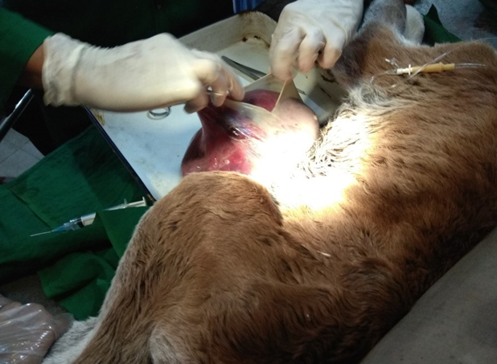

Fig. 1. Evisceration abdominal contents covered by amniotic membrane

**2.2 Surgical intervention and Outcome**

As the herniated visceral organ had not been contaminated due to intact amniotic membrane, the prognosis was regarded as good. With the consent of the owner, the calf was prepared for evaluation and correction of the herniated part through surgical intervention. The calf was sedated with intravenous injection of xylazine (0.1 mg/kg BW, Xyla, Interchemie, Holland). Fluid therapy was given with slow intravenous infusion of a combination of 0.9% sodium chloride and 5% glucose solution (Inj. DNS, Opsonin Pharma, Bangladesh). The calf was controlled in dorsal recumbency. The amniotic membrane covering was washed by using normal saline to remove dirt. The surgical site was aseptically prepared and a field block was performed by infiltrating 2% Lidocaine HCl subcutaneously around the hernial ring, which had a diameter of approximately 4-5 inches. A small cranio-caudal incision was made to remove excess skin and amniotic membrane to avoid all possible hindrance during reposition of herniated contents to its normal position. The hernia ring was incised to increase the diameter of the opening in order to avoid manipulating damage of hernia contents during pushing into the abdominal cavity. It was extended cranially approximately 2 cm and the abdominal viscera were reinserted into the abdominal cavity (Fig. 2). The peritoneum and abdominal muscles were separately closed with a simple continuous pattern using chromic catgut no. 1-0 (JOHNSON & JOHNSON PRIVATE LIMITED, India). The skin was sutured using nylon in a simple interrupted suture pattern.

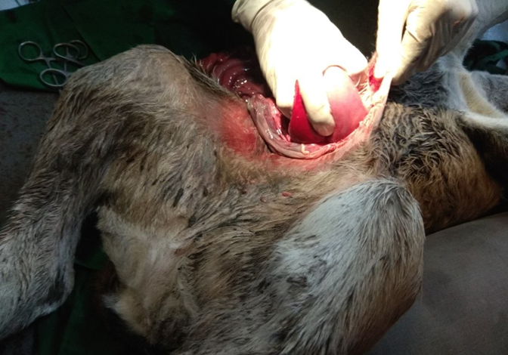

Fig. 2. Repositioning of herniated visceral contents during surgical intervention

**2.3 Postoperative care**

Postoperative care included intramuscular injection of ceftriaxone sodium dosed at the dose rate of 15 mg/kg BW (Inj. Trizon vet, The ACME Laboratories Ltd., Bangladesh) for 7 days, Tolfenamic acid at the rate of 2 mg/kg BW (Inj. Fevenil, Renata Limited, Bangladesh) for 3 days, and pheniramine maleate at the rate of 1 mg/kg BW (Inj. Asta vet, The ACME Laboratories Ltd., Bangladesh) for 5 days. The animal was discharged on the day of the surgery. The owner was advised to keep the surgical site clean with antiseptic dressing (twice daily).

3. discussion

Omphalocele is nowadays frequently found in newborn bovine calf. Though it is one of the common developmental anomalies in human baby, in case of bovine calves, this incidence is rare. In both cases, this condition is fatal. The prognosis is mainly determined by the presence of associated congenital anomalies, condition of amniotic sac (ruptured or intact), the size of the omphalocele (Poaty et al., 2019). This present case report describes the care and surgical management of a giant omphalocele in a crossbred bovine calf. Though many case of omphalocele are reported, to the best of my knowledge, this type of case had not been reported from Bangladesh before.

The survival possibility of the affected calf is increased with proper care and prompt surgical management. In this case, after delivery the owner covered the herniated visceral parts with clean moist cloth and handled it gently to avoid injury to the herniated viscera and to keep the contents clean. It also decreased the risk of infection which subsequently enhanced the successful recovery of the calf after surgery. It was also important in minimizing insensible water losses by limiting heat and evaporative losses (Wieland et al., 2014).

Often complications occur in immediate postoperative period due to a sudden change in intra-abdominal pressure. Acute increase in intra-abdominal pressure, which occurs immediately after repositioning of hernia contents, are associated with significant reductions in cardiac output, as well as reductions in regional blood flow (Sadler, 2000). It also reduce lung volume as increased intra-abdominal pressure impedes the movement of diaphragm causing more aeration necessities (Sadler, 2000; McNair et al., 2004). Tight closures of hernia opening is one of the main cause of increased intra-abdominal pressure (McNair et al., 2004) where large amount of skin is excised before closure. In present case, no abdominal muscles were excised except excess skin and severely congested part of the amniotic sac to maintain enough space of the abdominal cavity which helps to maintain least to no postoperative abdominal pressure. This technique helps to remove potential risk factors responsible for vital organs failure due to excessive abdominal pressure.

Routine use of broad-spectrum antibiotics in this case are needed immediately after birth to avoid the risk of infection. The defect can be contaminated with environmental microorganisms as it is quite impossible to avoid exposure of the defect with environmental factors (McNair et al., 2004). Antibiotic was given in proper dose and doses in this present case. Additionally, sterile gloves were used in every dressing and routine monitoring of the wound to avoid unwanted contaminats.

Pain management both in preoperative and immediate postoperative periods is vital and important for sound recovery of calves from this condition (McNair et al., 2006). In present case, Tolfenamic acid was used during pre and post-operative period to avoid pain shock which facilitates successful recovery of the case.

The common cause of death in omphalocele is excessive manipulation of viscera during repositioning of the herniated contents. Prolonged manipulation of contents to eliminate adhesions might also contribute to newborns’ death (Sagar et al., 2010). In this present study, the opening was extended enough cranio-caudally for successful repositioning with minimal presure or damage to the herniated contents. This may be one of the main factors for a successful recovery of the present case.

4. Conclusion

It was concluded that condition like the present case is surgically curable if the treatment procedure is employed immediately after parturition of calves and proper post-natal care been given. Any form of contamination or trauma to the eviscerated contents reduces the survival possibility of the patient.

Ethical approval

This reported case was managed as a part of routine clinical case of VTH, BAU; therefore, no ethical approval for animal care and welfare was needed.

**DISCLAIMER (ARTIFICIAL INTELLIGENCE)**

Author(s) hereby declare that NO generative AI technologies such as Large Language Models (ChatGPT, COPILOT, etc.) and text-to-image generators have been used during the writing or editing of this manuscript.

COMPETING INTERESTS

Authors have declared that no competing interests exist.

References

Baird, A. N. (2008). Umbilical surgery in calves. Veterinary Clinics: Food Animal Practice, 24, 468–477. DOI: https://doi.org/10.1016/j.cvfa.2008.06.005.

Pechriggl, E., Blumer, M., Tubbs, R. S., Olewnik, L., Konschake, M., Fortelny, R., et al. (2022). Embryology of the Abdominal Wall and Associated Malformations—A Review. Frontiers in Surgery, 9, 891896. DOI: https://doi.org/10.3389/fsurg.2022.891896.

Cavalieri, J., & Farin, P. W. (1999). Birth of a Holstein freemartin calf co-twinned to a schistosomus reflexus fetus. Theriogenology, 52, 815–826. DOI: https://doi.org/10.1016/s0093-691x(99)00174-0

Dennis, S. M. (1972). Schistosomus reflexus in conjoined twin lambs. Veterinary Record, 19, 509–510.

Willis, R. A. (1962). The Borderland of Embryology and Pathology (2nd ed.). London: Butterworths.

Rech, R. D., Coelho, I. C., Deponti, P. S., Agnes A. B., Corrêa, L. F. D., Pozzobon, R., et al. (2022). Omphalocele in Neonate Calf. Acta Scientiae Veterinariae, 50. DOI: https://doi.org/10.22456/1679-9216.118656

Veena, P., Sankar, P., Kokila, S., Kumar, R. V. S., & Lakshmi, N. D. (2011). Congenital Umbilical Defect with Visceral Eventration in a Buffalo Calf. Buffalo Bulletin, 30(3), 165–167.

Poaty, H., Pelluard, F., & Diallo, M. S. (2019). Omphalocele: A Review of Common Genetic Etiologies. Egyptian Journal of Medical Human Genetics, 20, 37. DOI: https://doi.org/10.1186/s43042-019-0040-3

Wieland, M. J., Reischer, N., Reichmann, F., & Sabine, M. (2014). Omphalocele in a Red Holstein Calf. Veterinary Record Case Reports, 2, e000070. DOI: https://doi.org/10.1136/vetreccr-2014-000070

Sadler, T. (2000). Digestive system. In O’Brian P & Sadler T (Eds), Langman’s Medical Embryology(8th ed., pp.270-303).Philadelphia: Lippincott Williams & Wilkins.

McNair, C., Ballantyne, M., Dionne, K., Stephens, D., & Stevens, B. (2004). Postoperative Pain Assessment in the Neonatal Intensive Care Unit. Arch Dis Child Fetal Neonatal Ed, 89(6), 537–541. DOI: https://doi.org/10.1136/adc.2003.032961

McNair, C., Hawes, J., & Urquhart, H. (2006). Caring for the Newborn with an Omphalocele. Neonatal Network, 25(5), 319–327. DOI: https://doi.org/10.1891/0730-0832.25.5.319

Sagar, P. V., Harish, D., & Babu, P. P. (2010). Ventral Hernia in an Ongole Cow. Veterinary World, 3(2), 90–91.