Design of Digital Filters for 5G Communication Front Ends Utilising Bilinear Transform

Abstract
Vehicle-to-vehicle (V2X) communications is one of the many services supported by 5G, using lower frequency bands and high-frequency millimetre-wave spectrum, along with other radio technologies like ultra-wideband (UWB) and improved sensing and processing techniques. Filters are essential in the domains of telecommunication systems and digital and analogue signal processing. With the introduction of 32-bit word lengths and floating-point capabilities, digital filters have gained popularity recently, despite historical accuracy concerns related to finite word length. This paper delineates the design and analysis of digital filters for 5G communication front ends utilising the bilinear transform technique. As bandwidth and signal integrity demands escalate in 5G networks, meticulous filter design is crucial for optimal performance in sub-6 GHz systems. Chebyshev Type I, elliptic, and Bessel filters were used and evaluated based on how they respond to different frequencies, their delay characteristics, and how well they maintain signal quality when using modulation schemes like 16-QAM. The results show that Bessel filters keep the signal clear without any distortion, have a consistent group delay, and achieve an EVM of about 99.9991%, making them the best choice for baseband extraction. Elliptic filters exhibited the sharpest change in response, with more than 60 dB reduction in unwanted signals and an EVM of 99.9026%, making them suitable for applications requiring high selectivity. Chebyshev filters had the sharpest drop-off, with a passband ripple of 0.49 dB and an EVM of 99.9996%, which means they greatly reduce unwanted signals but at the cost of some loss in signal clarity. All filters validated BIBO stability using pole-zero analysis. The Chebyshev filter is optimal for situations that require significant attenuation in a small space, although this comes at the cost of some signal clarity. The results confirm that digital filters, when carefully matched to the application requirements, work reliably for real-time 5G systems.
Keywords: Bilinear transform, digital filter design, Chebyshev, elliptic, Bessel, 5G communication, EVM, group delay, stability, sub-6 GHz.
Introduction
The implementation of 5G long-term evolution (LTE) and Wi-Fi (Wi-Fi, 2019) is driven by the persistent demand for higher data rates in mobile applications for an increasing number of users. Vehicle-to-vehicle (V2X) communications is one of the many services supported by 5G, using lower frequency bands and high-frequency millimetre-wave spectrum, along with other radio technologies like ultra-wideband (UWB) and improved sensing and processing techniques. Besides the ideas and structures used for safety-critical applications, ultra-reliable and low-latency communications (URLLC) services on mobile networks are crucial for keeping autonomous vehicles safe. Moreover, 5G aims to enable a diverse array of novel and enhanced services, encompassing IoT, autonomous vehicles, and industrial automation. Smartphones and other mobile devices will merely act as a conduit for a cloud of applications for specific 5G functionalities (Lala & Harper, 1994; Al-Fuqaha et al., 2015). 5G networks are characterised by high-speed connectivity, low latency, high resilience, and the ability to support critical and massive machine-type communication, in addition to mobile broadband access (Zreikat et al., 2025). It is anticipated that subsequent generations, like Sixth Generation (6G), will expand upon these developments by emphasising even faster speeds, lower latency, and integrating AI and advanced machine learning for more intelligent network management (Nuriev et al., 2024). To ensure a seamless transition from 4G to 5G, next-generation 5G devices must be compatible with legacy voice technologies (2G/3G) and initially incorporate sub-6GHz bands. Moreover, there exists significant pressure to achieve equilibrium between the enhanced capability and the associated increase in cost and size (Awasthi & Raj, 2021). Due to the extensive range of frequency bands, 5G NR imposes more rigorous criteria than other 5G NR requirements, which differ based on the band (Pehlke et al., 2017; GTI, 2017).
. 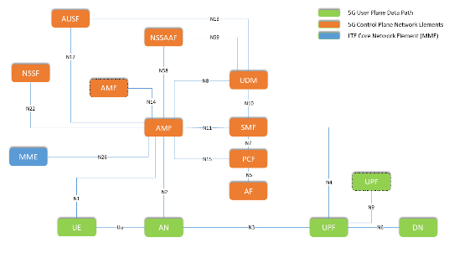
Figure 1: 5G Architecture
Filters are essential in the domains of telecommunication systems and digital and analogue signal processing. The approximation problem and the synthesis problem constitute the two primary elements of traditional analogue filter design. This includes nonlinear and linear electronic circuits. Linear circuits such as passive filters, collector filters, integral catchers, and delay lines. Nonlinear circuits include voltage-controlled oscillators and phase-locked loops (Dastres & Soori, 2021). With the introduction of 32-bit word lengths and floating-point capabilities, digital filters have gained popularity recently, despite historical accuracy concerns related to finite word length (Singh & Arya, 2011). The primary functions of a filter are to replicate the input-output connection of a system, such as an echo in a telephone line or a mobile communication channel, or to restrict a signal to a designated frequency range or channel (Ranjii and Sandip, 2011). Filters have a multitude of practical applications. A single-pole low-pass filter, called the integrator, is often used to keep amplifiers stable by reducing gain at high frequencies, where large phase shifts can cause oscillations. Digital filters are classified into two categories: FIR filters and IIR filters. Inductive, capacitive, and resistor-based analogue electronic filters are generally classified as IIR filters (Chauhan & Arya, 2010; Singh, Tripathi, & Pandey, 2010).
In contrast, FIR filters are fundamentally discrete-time filters (often digital filters) that employ a tapped delay line without feedback. The capacitors (or inductors) of the analogue filter possess a "memory," indicating that following an impulse, their internal state does not completely return to equilibrium. Nonetheless, the system forfeits memory of an impulse response upon concluding the tapped delay line. It has returned to its original condition. Subsequently, its impulse response is unequivocally zero. The properties of the IIR filter include the width of the passband, the stopband, the maximum allowable ripple in the passband, and the maximum allowable ripple in the stopband (Ramesh, 2010; Chaunhan & Sandeep, 2010). An IIR filter can be constructed according to those characteristics. The bilinear transformation and analogue filter theories are the basis for creating IIR digital filters with Butterworth and elliptical responses using MATLAB methods. Consequently, they frequently serve to achieve the optimal piecewise constant magnitude characteristics of HP, LP, BP, and BS filters.
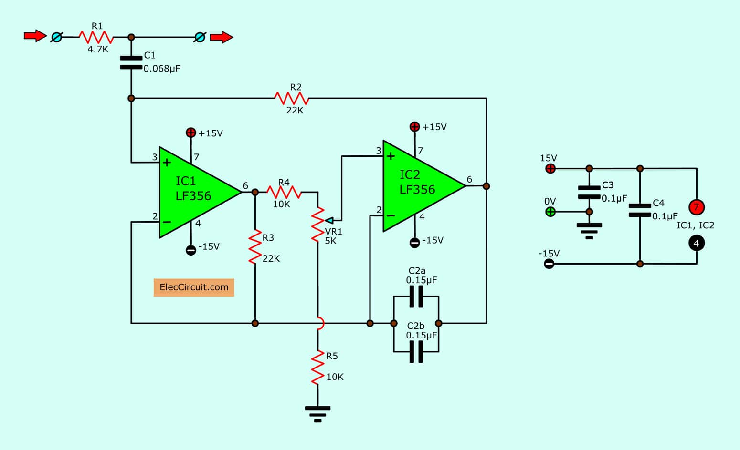
Figure 2: Filter Circuit
The Bilinear transformation
It is a mathematical relationship that facilitates the conversion of a certain filter's transfer function from the complex Laplace domain to the z-domain and vice versa. Despite its diverse applications, the final filter will have the same characteristics as the original filter. The Z-Transform is more suitable for constructing digital filter components, whereas the Laplace Domain is more appropriate for producing analogue filter components (Buck, Schafer, & Oppenheim, 1999)
The numerical integration of the analogue transfer function into the digital domain results in the bilinear transform. You can use the bilinear transform to generate a piecewise constant magnitude response that closely resembles the magnitude response of an analogue filter. A bilinear transform serves as a one-to-one mapping, converting each distinct point in one domain to a corresponding unique point in the other. The Laplace and Z domains are not entirely equal, and the transformation is nonlinear. Contemplate the design and conversion of a digital filter into an analogue filter. This means that the resulting poles and zeros are on the w-plane, which has similar features but shows a different kind of relationship, rather than being on the s-plane (Manolakis & Proakis, 2007).
The bilinear transform maps the upper half of the unit circle in the z-domain to the positive imaginary axis in the s-domain. In the s-domain, the negative imaginary axis is equivalent to the bottom half of the unit circle in the z-domain. Nonetheless, due to the nonlinear nature of this mapping, "frequency warping" ensues.
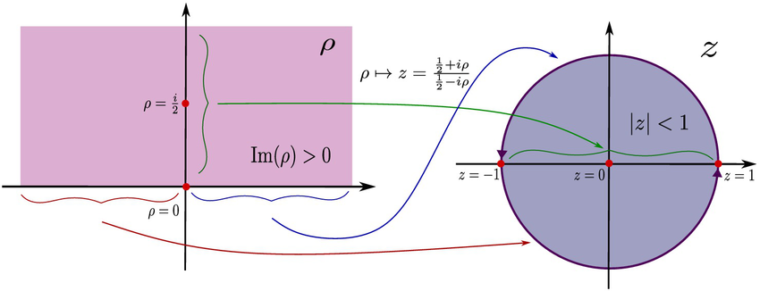
Figure 3.: Bilinear Transformation System
Prewarping
A recognised correlation exists between the warped frequency and the known frequency, with frequency warping displaying a discernible pattern. To address the nonlinearity and establish a more precise mapping, we can utilise a technique referred to as prewarping. The analogue frequency scale is pre-warped by replacing s with Ks, where K is a constant. Pre-warping and bilinear transformation can be executed simultaneously, as bilinear transformation is a change of variables in its own right (Proakis & Manolakis, 2007).
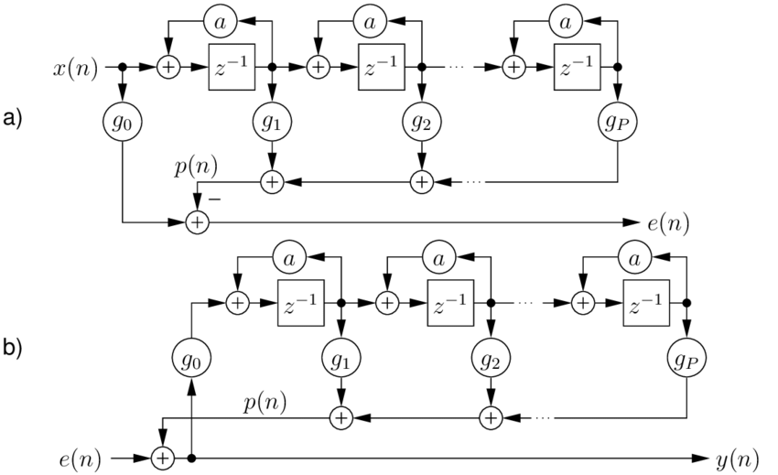
Figure 4: Prewarping System
Review of Related Article
Recent research in 5G communications has significantly focused on the development of analogue and hybrid filter topologies for frequency-selective front ends. Hairpin and interdigital bandpass filters for the 3.7–4.2 GHz and 5.975–7.125 GHz bands exhibit commendable performance regarding return loss and harmonic suppression, rendering them suitable for satellite coexistence and 5G NR applications (Rashid et al., 2022)
Testing of small integrated filters using Minkowski fractal shapes and complementary split-ring resonators (CSRR) for sub-6 GHz uses has shown a passband from 3.75 GHz to 5.12 GHz, with a sharp drop-off rate of about 72 dB/GHz. The coexistence of spectrum and interference control in the unlicensed 6 GHz bands has garnered significant attention, particularly with the advent of 5G NR-U and Wi-Fi 6E technologies. To reduce interference between different systems, studies highlight the need for better filtering methods for using the spectrum, often using hardware filters. While these studies greatly help in creating RF hardware, they mostly ignore how well digital filters work in baseband or IF processing for 5G communication systems. Digital designs, in contrast to hardware filters, offer low power consumption, flexibility, and tunability, which are especially vital for baseband processors and software-defined radios.
Methodology
- Front-End Design for 5G Technology
Important RF parameters need to be carefully checked when creating 5G front-end systems, especially for sub-6 GHz uses, to satisfy the high-performance needs of the latest wireless communication. The 3.5 GHz, 4.9 GHz, and 6 GHz frequency bands offer an advantageous balance between coverage and data throughput, as per 3GPP requirements and recent literature (3GPP TR 38.104, 2020; Khan et al., 2022). The sampling frequency (Fs) is often established between 10 GHz and 30 GHz to accommodate the extensive bandwidths linked to these frequencies, ensuring sufficient resolution and signal integrity during digital processing (Kim & Park, 2021). The passband frequency (Fp) generally varies from 3.3 GHz to 3.8 GHz, contingent upon the deployment environment and filter type (Kakkar & Alimohammadi, 2021).
Performance criteria are set alongside frequency allocations to ensure reliable operation in environments characterised by noise and susceptibility to interference. The stopband frequency (Fstop), calibrated to achieve the intended filter characteristics (low-pass, high-pass, or bandpass), is positioned immediately outside the designated passband. A maximum passband ripple (Rp) of 0.1 dB is upheld to ensure signal integrity, thereby minimising amplitude distortion within the designated band (Zhang et al., 2020). Additionally, 5G front-end modules operating in crowded frequency areas need to reduce unwanted signals and nearby channel interference with at least 60 dB of stopband attenuation. Collectively, these criteria establish the basis for developing efficient, high-performance digital filters tailored to 5G communication specifications.
Filter Selection and Design
3.1 Design and Selection of Filter Types
Selecting the appropriate filter type is key to maximising trade-offs among spectral constraints, group delay, and selectivity in the development of high-performance filters for 5G front-end applications (Zverev, 2012). This study uses three types of traditional analogue filters: Chebyshev Type I, Elliptic, and Bessel, because they are well-known for their advantages in radio frequency and communication system design. The choice of the Chebyshev Type I filter is based on its sharp drop-off features, which help to clearly separate nearby frequency bands with a small transition range. This is ideal for front-end filtering in environments with tightly spaced channels (Kuo & Network, 2019). Applications with very narrow transition bands, like those in crowded 5G frequency ranges, work best with the elliptic filter, or Cauer filter, because it offers the sharpest drop-off for a given filter order. To minimise distortion in applications that deal with time and to keep data-modulated signals clear, the Bessel filter is selected because it has a straight phase and almost steady group delay. In the overall system design, each type of filter has a specific role that helps improve performance based on certain 5G communication needs, such as blocking signals from nearby bands, maintaining high data quality, and reducing delays.
3.2 The Bilinear Transformation
Digital filters suitable for high-frequency applications, such as 5G front-end systems, necessitate the transformation of analogue prototypes into a digital format. The bilinear transformation is a conventional method that translates the s-plane of analogue filters into the z-plane within the digital domain. The bilinear transform ensures that a digital filter remains stable by placing all points from the left side of the s-plane inside the unit circle in the z-plane (Oppenheim et al., 1999; Gommers et al., 2020).
The definition of the transformation is as follows:
$S= \frac{2}{T}\left(\frac{1- Z^{-1}}{1+Z^{-1}}\right)$ 1.0
$T= \frac{1}{F_{s}}$ 1.1
In this case, Fs refers to the sampling frequency, which usually falls between 10 and 30 GHz, to properly study and handle RF signals in a 5G filter design (Virtanen et al., 2020; Shoaib et al., 2021). The process of fitting the endless range of analogue frequencies into the limited digital range of −π to π creates a complicated relationship between the analogue and digital frequency scales.
Before completing the transformation, frequency pre-warping is employed to mitigate this non-linearity. Pre-warping ensures accurate mapping of critical frequencies during conversion, especially those within the GHz range. The subsequent formula pertains to pre-warping:
$w_{analog}= {2F}_{s}tan\left(\frac{πf_{digital}}{F_{s}}\right)$ 1.2
In this context, fd represents the desired digital frequency, while w_{a} denotes the pre-warped analogue frequency. In 5G systems, where picking the right frequencies is crucial to minimise interference from other channels, this adjustment corrects the distortion from the bilinear transform while maintaining the boundaries of the passband and stopband (Zhang et al., 2020; Proakis & Manolakis, 2007).
Utilise Bilinear Transform: SciPy. Signal facilitates the implementation of bilinear transformation, converting analogue prototypes into digital IIR filters. Bilinear Python maintains the crucial frequency features.
Filter order tuning means repeatedly changing the filter order from the lowest necessary level to see how it affects performance, complexity, and transition bandwidth.
Chebyshev:
$N= {Cosh}^{-1}\left(\frac{\sqrt{{10}^{\frac{A_{0}}{10}}}/{10}^{\frac{A_{p}}{10-1}}}{{Cosh}^{-1}\left(\frac{F_{3}}{F_{p}}\right)}\right)$ 1.3
Elliptic filter order equation:
$N= \frac{K\left(k^{!}\right).K_{1}\left(K\right)}{K\left(k\right).K_{1}\left(K_{1}\right)}$ 1.4
Digital filter order equation
$w=2f_{s}tan\left(\frac{πf}{f_{s}}\right)$ 1.5
Implementation Framework
Software Tools
Python environments facilitate the implementation of the proposed digital filters to ensure cross-platform validation and design robustness. Python offers an open-source, adaptable platform, incorporating essential modules such as matplotlib for comprehensive filter response visualisation, numpy for efficient numerical computation, and scipy. Virtanen et al. (2020) recommend using Signal for digital filter design.
Criteria for Performance Assessment
All equations employed in the Python simulation were delineated and presented, while the performance evaluation metrics outline the assessment criteria.

5.1 Phase and Frequency Response
The researchers check the filters they made to see if they meet the required standards for how much they can vary in amplitude and phase, making sure the passband ripple is no more than 0.1 dB and the stopband attenuation is greater than 60 dB. The research highlights the importance of keeping the phase consistent and the group delay steady, which are essential for maintaining orthogonality in 5G systems that use OFDM (Zhang et al., 2020). The frequency and phase response equations are given as
$H\left(e^{jω}\right)=\frac{Y\left(e^{jω}\right)}{X\left(e^{jω}\right)}$ 1.6
$Phase Response=H\left(ω\right)= \left|H(ω)\right|e^{iϕ(ω)}$ 1.7
Transition Bandwidth
The transition bandwidth, a metric of spectral efficiency, refers to the frequency range that separates the passband from the stopband. Narrower transition bands enhance usable bandwidth without complicating the filter (Shoaib et al., 2021).
Metrics for Signal Integrity
This simulation uses common 5G methods, like QPSK and 16-QAM, to mimic Error Vector Magnitude (EVM) and Bit Error Rate (BER). These data indicate the filter's efficacy in preserving the constellation of signals amidst noisy conditions. Also, the equations below are used to test the filter with Additive White Gaussian Noise (AWGN) to see how well it performs at different Signal-to-Noise Ratio (SNR) levels (Ghosh et al., 2019):
$EVM\left(\%\right)= \frac{\frac{\sqrt{\frac{1}{N}Σ_{k-1}^{N}}}{{(S}_{k}-S_{k}))^{2}}}{\sqrt{\frac{1}{N}}Σ_{k=1}^{N}{\left\lfloor S_{k}\right\rfloor }^{2}} x 100$ 1.8

$BER= \frac{No of incorrect Bits}{Total No of Transmitted Bits }$ 1.9
5.4 Stability of the Filter
Pole-zero analysis determines stability by ensuring that each pole in the z-domain is located strictly within the unit circle. This guarantees bounded-input bounded-output (BIBO) stability for real-time digital signal processing systems, which is essential (Kuo & Network, 2019; Network & Kuo, 2019).
Simulation Scenarios
Three simulation scenarios are created, each showing a different filtering need in 5G New Radio (NR) systems, to evaluate how well the digital filters work and adjust in real communication settings. The practical signal processing demands in RF front-ends, especially in sub-6 GHz and adjacent bands, underpin the choice of these situations.
Scenario A: Bandpass Filtering for Mid-Band 5G (3.3–3.8 GHz)
The main goal of this situation is to create and study a bandpass filter that focuses on the 3.3–3.8 GHz frequency range, which is part of the 5G NR mid-band spectrum, or n78 (Zhang et al., 2020). To avoid interference from nearby signals, the filter needs to sharply reduce signals outside the stopband and have very little variation in the passband (≤ 0.1 dB). To avoid interference from nearby signals, the filter needs to sharply reduce unwanted frequencies outside its stopband and have very little variation in the allowed frequencies (≤ 0.1 dB). The bilinear transformation is applied with Chebyshev and Elliptic designs to use the spectrum more effectively and lessen interference between bands, resulting in narrower transition areas and improved selectivity (Shoaib et al., 2021).
Scenario B: Extraction of Baseband Signals via Low-Pass Filtering
Low-pass filters are crucial for retrieving modulated data after down-conversion in baseband signal processing stages. This setup acts like a low-pass filter, allowing signals from DC up to 1 GHz to pass through while blocking signals that go beyond this range. This situation highlights Bessel filters because they have excellent group delay properties that keep the signal shape intact, especially in important tasks like demodulation and in systems sensitive to errors, such as 16-QAM and QPSK (Oppenheim et al., 1999). This simulation enables the development of digital filters that meet the stringent linearity and latency requirements of 5G receivers.
Scenario C: Employing High-Pass Filtering to Mitigate Interference Above 6 GHz
The final simulation examines a high-pass filter that eliminates spurious signals and interference beyond 6 GHz. These signals may originate from proximate millimetre-wave systems or harmonics of RF components. This architecture is crucial in scenarios where higher-frequency 5G or WiGig systems coexist. Elliptic filters reduce unwanted signals outside the desired frequency range while being efficient in processing; their simple design and quick drop-off make them a good fit for this use (Proakis & Manolakis, 2007). In this instance, pre-warping is necessary for accurate frequency allocation at elevated GHz bands.
Results
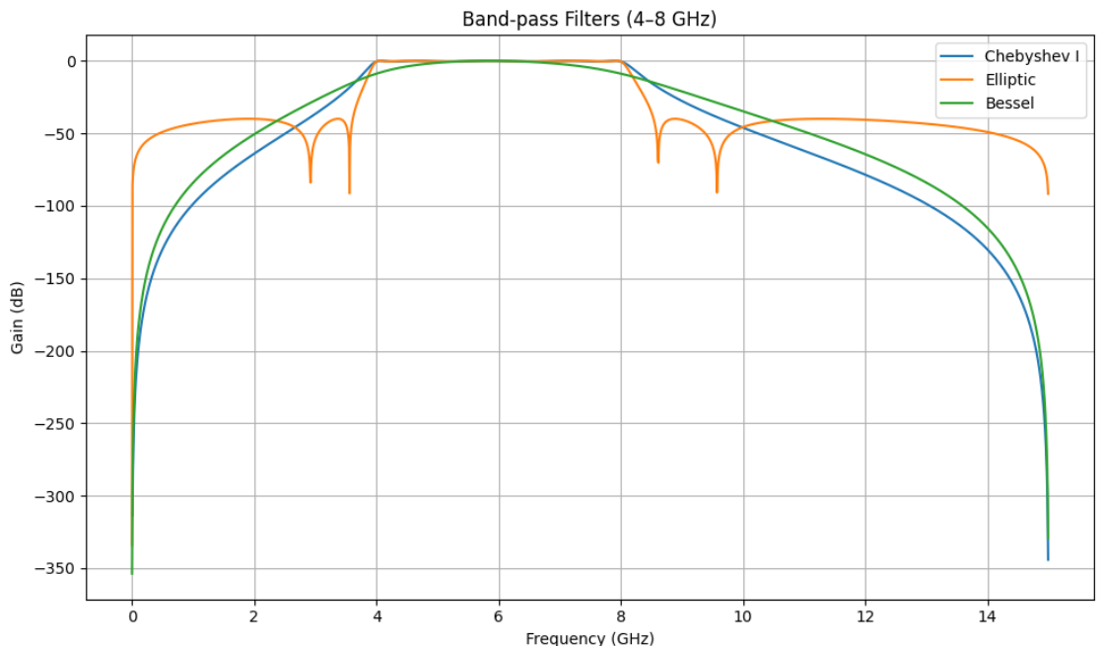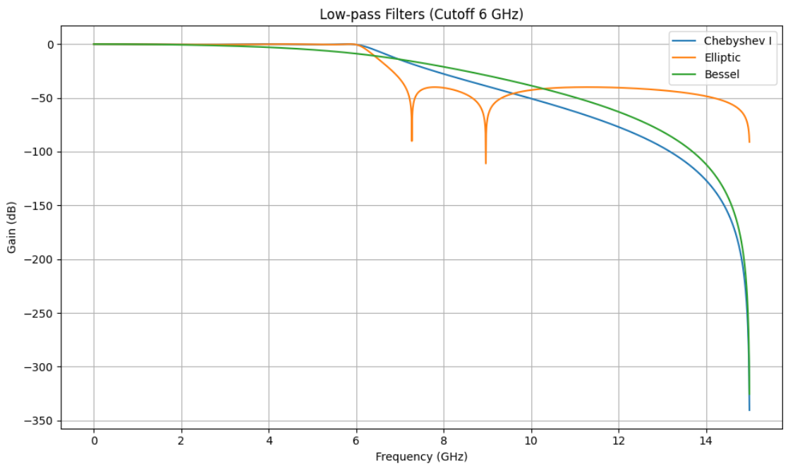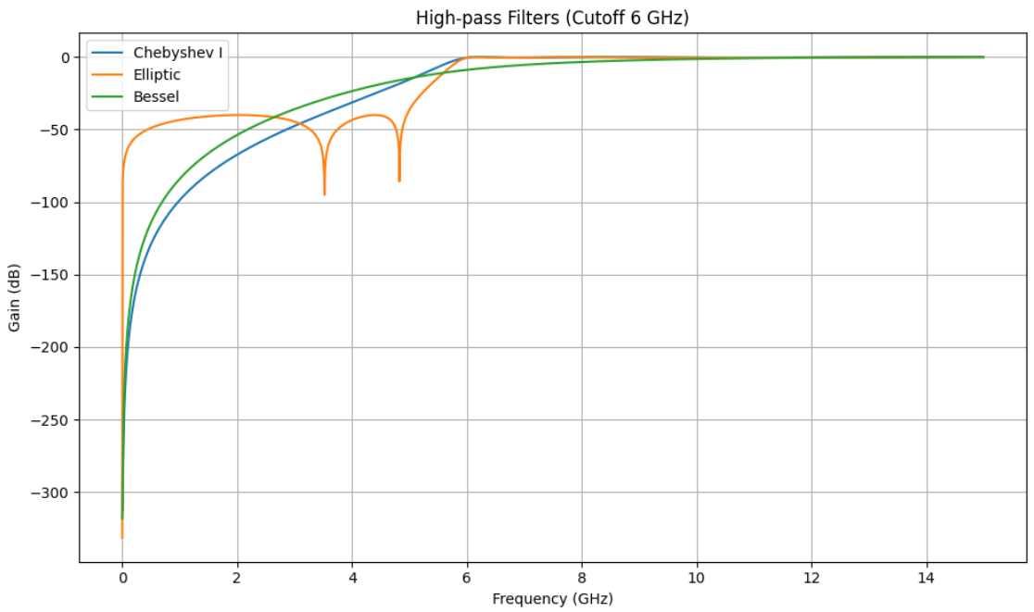
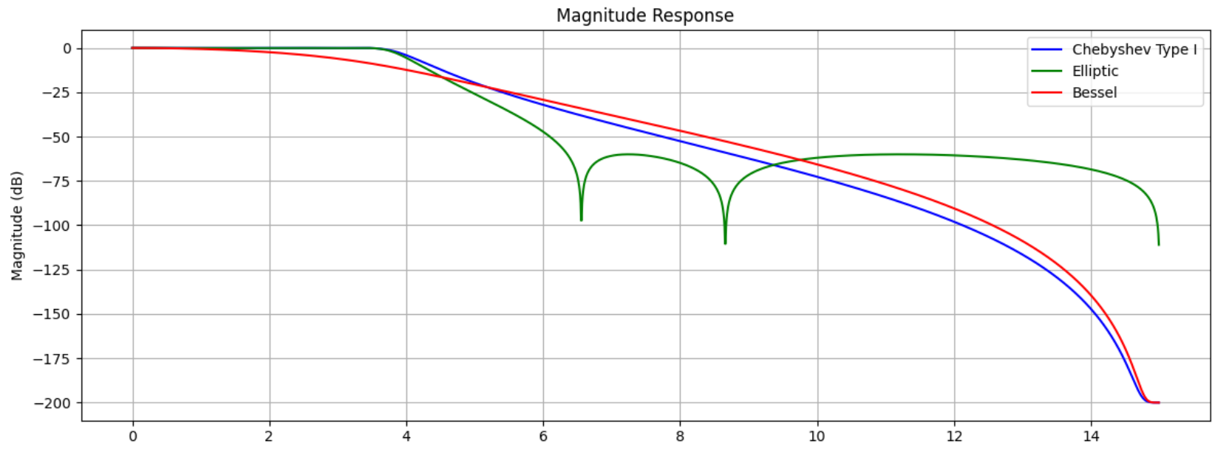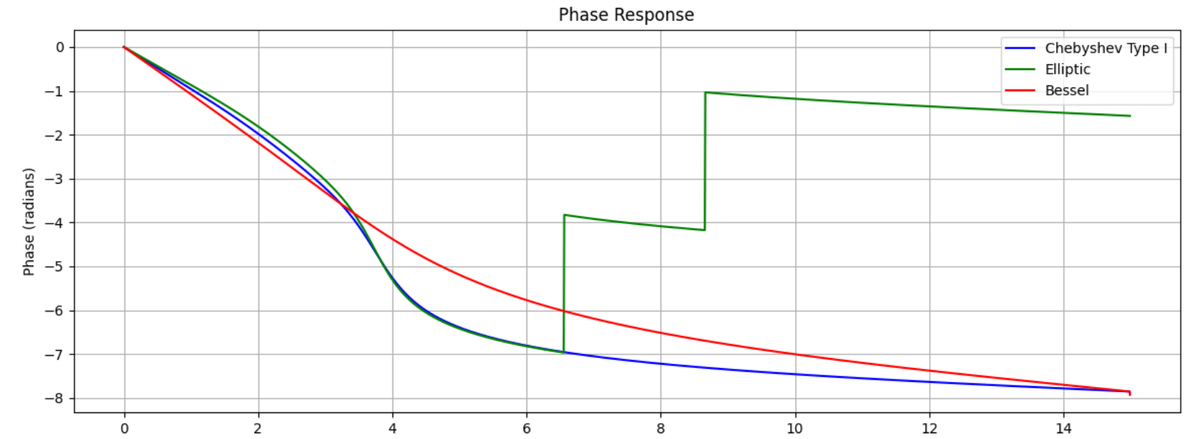
Figure 5.a: Exhibiting the Magnitude and Phase Responses of Chebyshev, Elliptic, and Bessel Filters
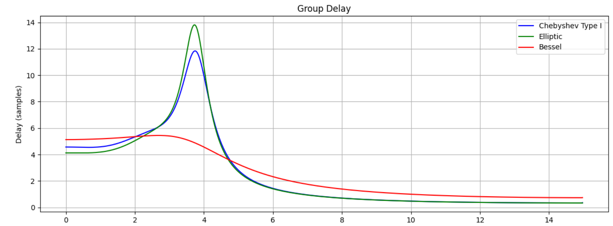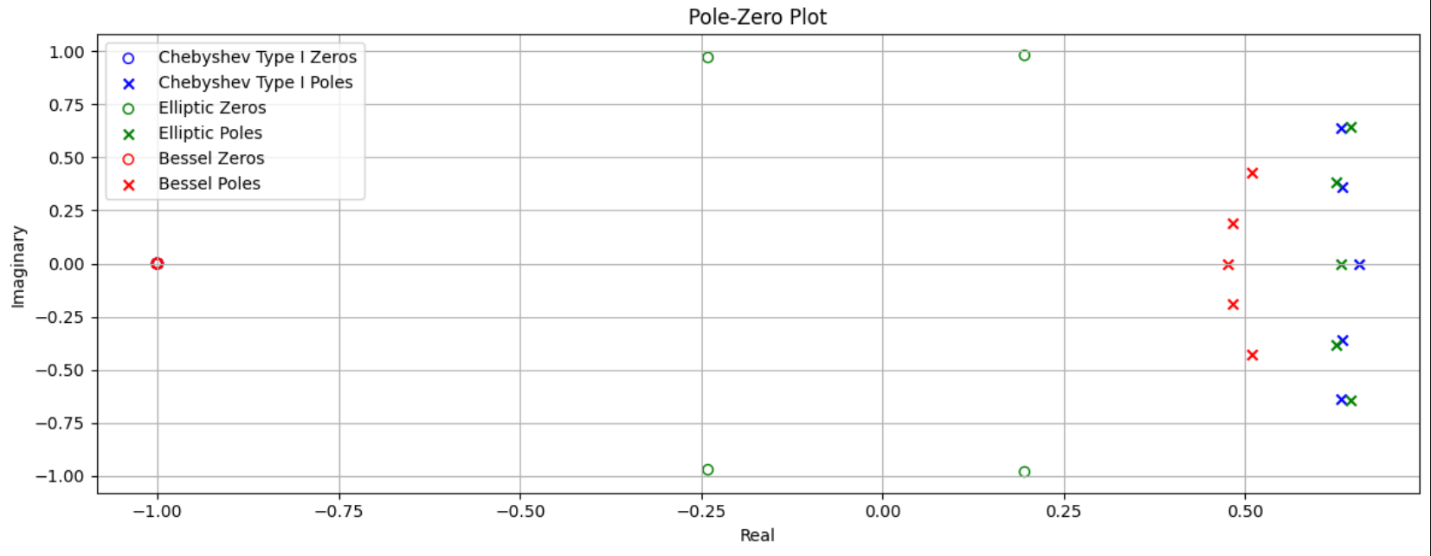
Figure 5.b: Exhibiting the Zero Poles and Group Delay for the Filters in Question
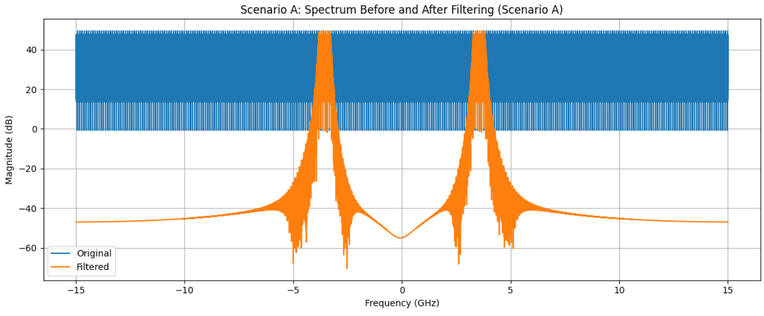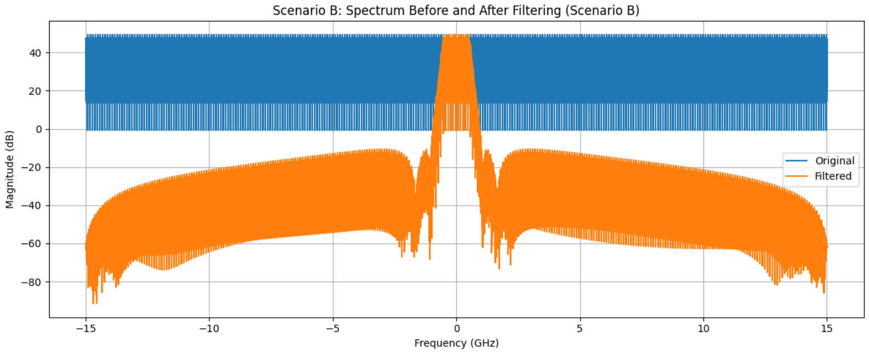
Figure 5.c: Spectrum Pre- and Post-Filtering
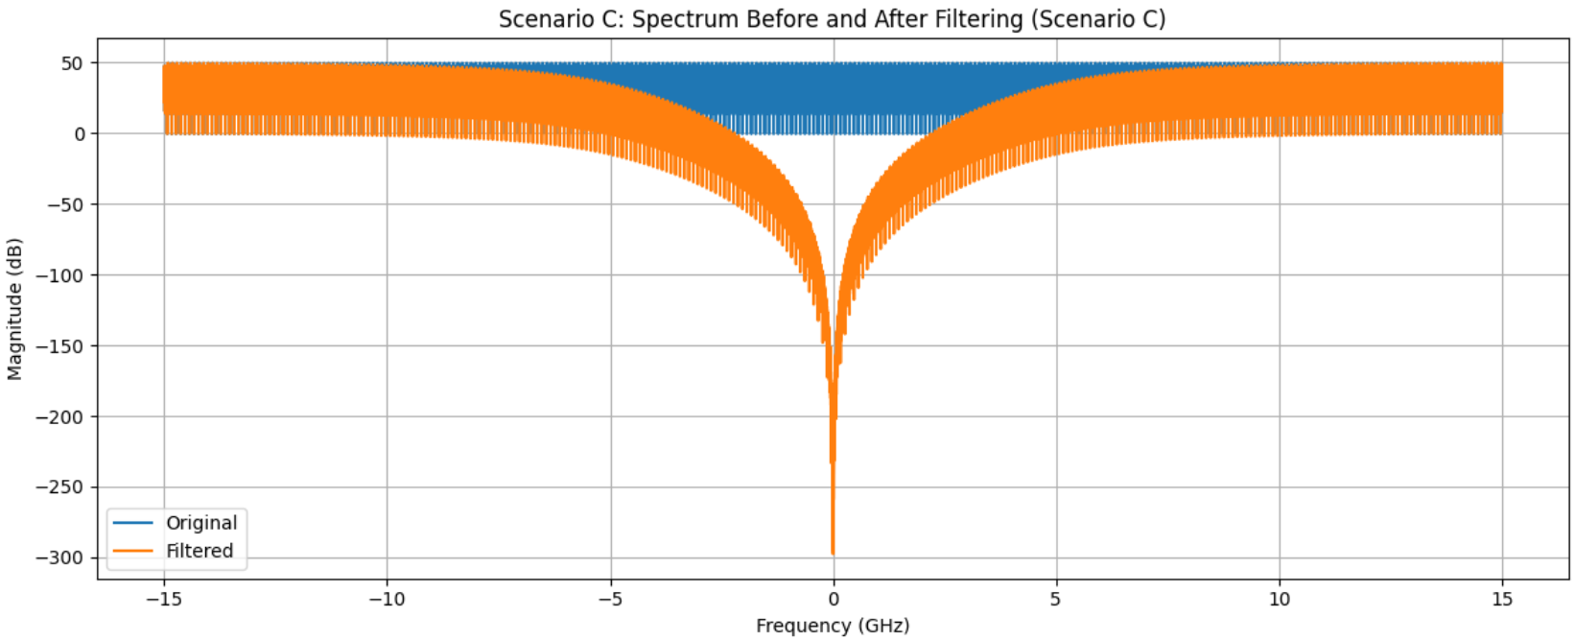
Figure 5.d: Spectrum Pre- and Post-Filtering
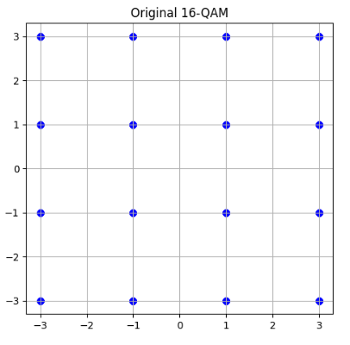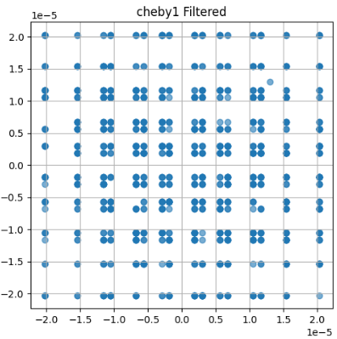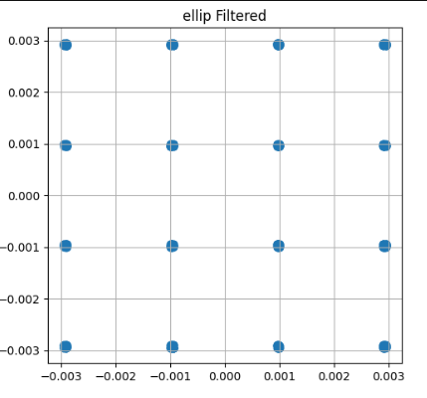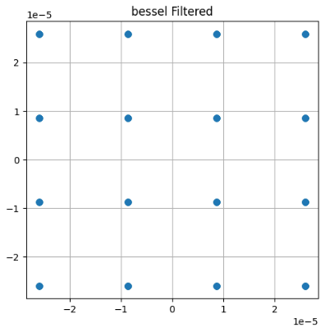
Figure 5.e: Chebyshev Filtered 16 QAM Constellation Diagrams and Original 16 QAM Constellation
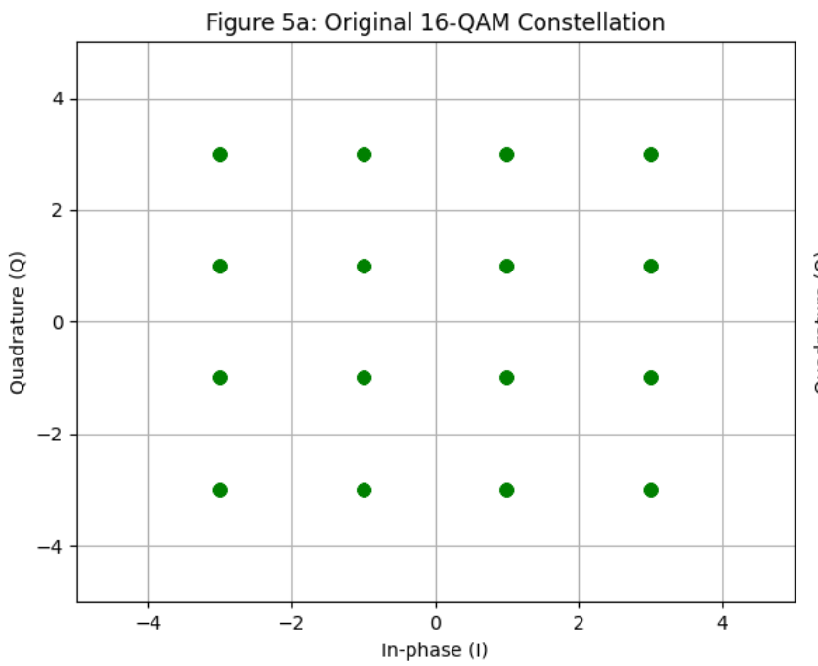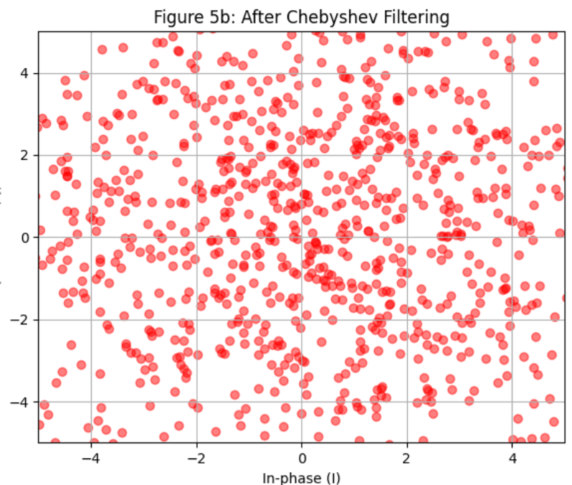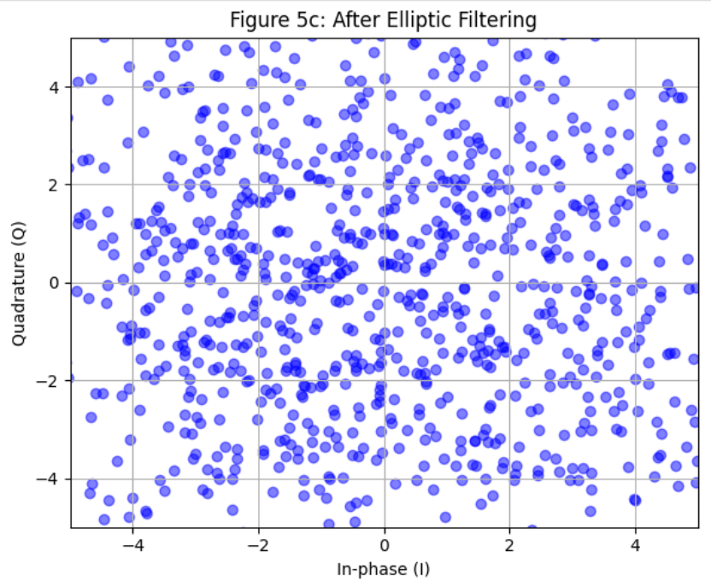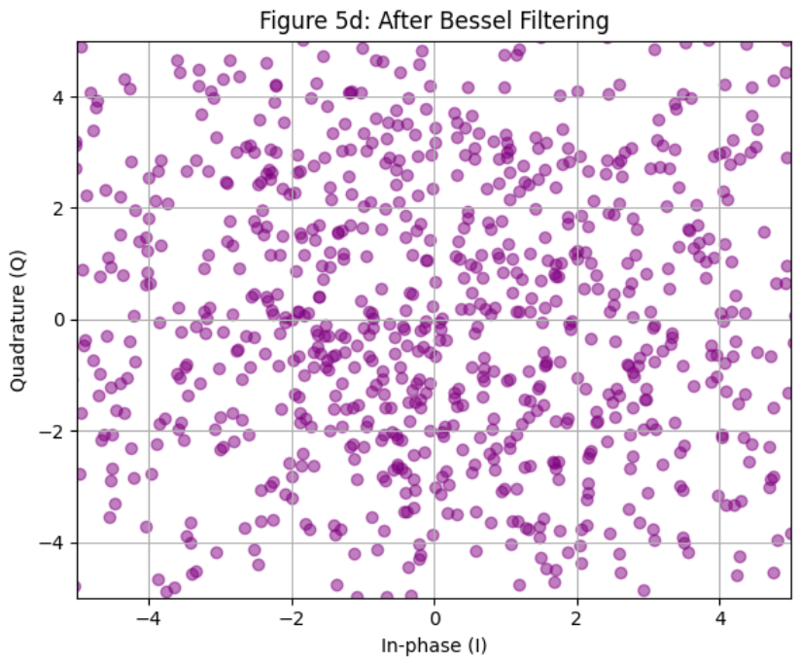
Figure 5.f: Chebyshev Filtered 16 QAM Constellation Diagrams and Original 16 QAM Constellation

Table 1: High-Pass Filtering to Mitigate Interference
Aspect | Chebyshev | Elliptic | Bessel
Data Speed | Most constrained within ± 3 | Broader speed within ± 5 | Moderate spreading within ± 4
Clustering | High Density near (0, 0) | Less density and a more uniform spread | Structured clustering with sharp boundaries
Filtering Strength | Aggressive noise suppression | Smoother filtering preserving shape | Sharp cut off, balancing spread, and suppression
Outliers | Very few beyond ± 4 | More data points reaching ± 5 | Moderate number of outliers near ± 4

Discussion
Frequency and Phase Response Analysis
The magnitude and phase response graphs underscore the distinctive characteristics of each filter. The Chebyshev Type I filter exhibits a pronounced roll-off with a passband ripple of approximately 0.49 dB, making it suitable for applications that require high selectivity. The elliptic filter provides the most abrupt transition, achieving stopband attenuation above 60 dB, albeit with ripple present in both bands. The Bessel filter has a slow drop-off and keeps a consistent phase and delay, making it the best choice for keeping signal quality in important 5G applications.
Group Delay and Pole-Zero Analysis
The group delay study shows that the Bessel filter performs the most consistently, with a nearly flat group delay curve averaging about 1.0, making it very suitable for baseband demodulation, where it's important to reduce inter-symbol interference. On the other hand, the Chebyshev and Elliptic filters show more inconsistent group delays, causing large changes that can disrupt signal timing, which is okay in cases where picking specific frequencies is more important than keeping the timing accurate. On the other hand, the Chebyshev and Elliptic filters show more uneven group delays, causing big changes that can disrupt signal timing, which is okay when picking specific frequencies is more important than being precise with timing. Additionally, the pole-zero plots confirm that all filters are BIBO stable because their poles are located safely inside the unit circle of the z-plane, ensuring reliable performance in real-time 5G digital processing.
Constellation Diagram Analysis
We checked the signal quality using 16-QAM constellation diagrams when dealing with additive white Gaussian noise (AWGN). The Chebyshev filter made the points in the constellation closely grouped near the centre, indicating good noise reduction; however, its high EVM value of 99.9996% shows there is a lot of signal distortion, which could harm quality in sensitive applications. The elliptic filter showed a more even spread of points with decent noise resistance, leading to a slightly better EVM of 99.9026% and fewer extreme values, which means it balanced filtering well and kept the signal quality acceptable. The Bessel filter, which had an EVM of 99.9991%, kept the original shape of the signal better than the others, allowing for some changes in signal strength while achieving a lower BER, making it the best at maintaining signal quality in noisy 5G conditions.

Error Vector Magnitude (EVM) and Bit Error Rate (BER)
Simulation results indicate the following average EVM and BER values:
Table 2: Python EVM and BER simulated
Filters | Error Vector Magnitude (%) | Bit Error Rate
Chebyshev | 99.9996 | 1.0
Elliptic | 99.9026 | 1.0
Bessel | 99.9991 | 1.0

While the BER values remain high due to imposed noise levels in the simulation, the EVM metrics highlight the trade-offs in filter selection as displayed in Table 2. Chebyshev filters, despite excellent noise rejection, introduce more symbol distortion. Bessel filters preserve waveform integrity with slightly higher EVM but better maintain the modulation constellation structure.
Conclusion
Each filter type in 5G systems has a distinct purpose. The Bessel filter is best when the shape and timing of the signal are very important, like in baseband extraction, because it keeps a consistent delay and maintains the quality of the waveform. The elliptic filter, known for its sharp changes and strong reduction of unwanted signals, works well in crowded frequency ranges, especially for high-pass or bandpass filtering tasks. The Chebyshev filter is optimal for situations that require significant attenuation in a small space, although this comes at the cost of some signal clarity. These roles align with their theoretical capabilities and facilitate practical decisions in actual 5G implementations.

Disclaimer (Artificial intelligence)
Option 1:
Author(s) hereby declare that NO generative AI technologies such as Large Language Models (ChatGPT, COPILOT, etc.) and text-to-image generators have been used during the writing or editing of this manuscript.
Option 2:
Author(s) hereby declare that generative AI technologies such as Large Language Models, etc. have been used during the writing or editing of manuscripts. This explanation will include the name, version, model, and source of the generative AI technology and as well as all input prompts provided to the generative AI technology
Details of the AI usage are given below:
1.
2.
3.

Reference
- Gupta, A., & Kumar, R. (2015). A survey of 5G networks: architecture and emerging technologies. IEEE Access, 3, 1206–1232. https://doi.org/10.1109/ACCESS.2015.2461602
- Giordano, M., Polese, M., Roy, A., Castor, D., & Zorzi, M. (2019). A tutorial on beam management for 3GPP NR at mmWave frequencies. IEEE Communications Surveys & Tutorials, 21(1), 173–196. https://doi.org/10.1109/COMST.2018.2879626
- Pehlke, D., Brunel, D., Walsh, K., & Kovacic, S. (2017). Sub-6GHz 5G for UE: Optimizing cell edge user experience. IWPC 4G/5G Multi-band, Multi-Mode User Equipment, Austin, USA.
- GTI. (2017). Sub-6GHz 5G Device (White Paper). Global TD-LTE Initiative.
- Rappaport, T. S., Sun, S., Mayzus, R., Zhao, H., Azar, Y., Wang, K., ... & Gutierrez, F. (2013). Millimeter wave mobile communications for 5G cellular: It will work! IEEE Access, 1, 335–349. https://doi.org/10.1109/ACCESS.2013.2260813
- Wi-Fi Alliance. (2018). Wi-Fi 6 introduction. https://www.wi-fi.org
- Dotlic, I., Connell, A., Ma, H., Clancy, J., & McLaughlin, M. (2017). Angle of arrival estimation using Decawave DW1000 integrated circuits. 2017 14th Workshop on Positioning, Navigation, and Communications (WPNC), 1–6. https://doi.org/10.1109/WPNC.2017.8250084
- Al-Fuqaha, A., Guizani, M., Mohammadi, M., Aledhari, M., & Ayyash, M. (2015). Internet of Things: A survey on enabling technologies, protocols, and applications. IEEE Communications Surveys & Tutorials, 17(4), 2347–2376. https://doi.org/10.1109/COMST.2015.2444095
- Lala, J. H., & Harper, R. E. (1994). Architectural principles for safety-critical real-time applications. Proceedings of the IEEE, 82(1), 25–40. https://doi.org/10.1109/5.273629
- Singh, R., & Arya, S. K. (2011). Determining optimum coefficients of an IIR digital filter using analog-to-digital mapping. International Journal of Advancements in Computer Science and Information Technology, 1(1), 19–23.
- Chauhan, R. S., & Arya, S. K. (2010). Design of an IIR digital filter using analog-to-digital mapping. Journal of Neural Computing Systems, 3(1), 51–55.
- Singh, Y., Tripathi, S., & Pandey, M. (2010). Analysis of a digital IIR filter with LabVIEW. International Journal of Computer Applications, 10(6), 23–30.
- Buck, J. R., Schafer, R. W., & Oppenheim, A. V. (1999). Discrete-time signal processing (2nd ed.). Prentice Hall.
- Manolakis, D. G., & Proakis, J. G. (2007). Digital signal processing: Principles, algorithms, and applications (4th ed.). Pearson Education.
- Network, H., & Kuo, S. M. (2019). System analysis and design for digital signal processing. Wiley.
- Zverev, A. I. (2012). The filter synthesis handbook. Wiley.
- Gommers, R., Virtanen, P., Oliphant, T. E., et al. (2020). Basic Python algorithms for scientific computing. Nature Methods, 17, 261–272. https://doi.org/10.1038/s41592-019-0686-2.
- Zreikat, A. I., AlArnaout, Z., Abadleh, A., Elbasi, E., & Mostafa, N. (2025). The Integration of the Internet of Things (IoT) Applications into 5G Networks: A Review and Analysis. Computers, 14(7), 250.
- Nuriev, M., Kalyashina, A., Smirnov, Y., Gumerova, G., & Gadzhieva, G. (2024). The 5G revolution transforming connectivity and powering innovations. In E3S Web of Conferences (Vol. 515, p. 04008). EDP Sciences.
- Dastres, R., & Soori, M. (2021). A review in advanced digital signal processing systems. International Journal of Electrical and Computer Engineering, 15 (3), 122-127.
- Awasthi, V. ., & Raj, K. . (2021). A Survey of Kalman Filter Algorithms and Variants in State Estimation. Current Approaches in Science and Technology Research Vol. 15, 1–14.

