Epidemiology and Clinical Features of Childhood Strabismus in Tunisia

.
ABSTRACT

Aims
To analyze the epidemiological and clinical characteristics of childhood horizontal strabismus in a tertiary care center in Tunisia, highlighting its subtypes, associated risk factors, refractive errors, and sensory-motor implications, with the goal of guiding preventive and therapeutic strategies.
Study design: A retrospective, descriptive observational study.
Place and duration of Study
Department of Ophthalmology, tertiary care hospital in Tunisia, conducted from January 2019 to December 2023.
Methodology
Fifty-two medical records of pediatric patients undergoing surgery for horizontal strabismus were reviewed. Inclusion criteria confirmed diagnosis of horizontal strabismus with complete ophthalmologic and orthoptic documentation. Patients with paralytic or secondary strabismus were excluded. Data collected included demographic details, family and personal history, strabismus characteristics, ocular motility, vertical syndromes, refractive errors, visual acuity, amblyopia status, binocular vision, and associated signs. Statistical analysis used descriptive measures with IBM® SPSS v21.
Results
The cohort showed a near-equal sex distribution. Esotropia was the most common type, with infantile esotropia being the most frequent subtype. A significant proportion of patients had a family history of strabismus and consanguinity. Hyperopia was the predominant refractive error, frequently associated with astigmatism. Amblyopia was highly prevalent, particularly in early-onset cases. Abnormal retinal correspondence and inferior oblique overaction were common findings. A considerable delay in consultation was observed, leading to advanced disease presentation.
Conclusion
Early strabismus predominates in this population and is frequently associated with amblyopia, significant refractive errors, and abnormal binocular vision. Critically, a substantial mean consultation delay of 3.8 years was identified as a major barrier to timely care, directly contributing to the high prevalence of advanced sensory and motor complications. This underscores the urgent need for systematic early screening in primary care and school settings to enable earlier detection and intervention. Tailored surgical and optical management remains essential to preserve visual function. Future multicenter prospective studies are needed to assess long-term visual and psychosocial outcomes and to explore genetic, neurodevelopmental, and environmental risk factors to refine prevention and treatment strategies

Keywords:[ Strabismus; Esotropia; Exotropia; Amblyopia; Refractive Errors; Binocular Vision; Risk Factors]
1. INTRODUCTION

Strabismus, defined as a misalignment of the visual axes, is a complex neurosensory disorder involving both motor and sensory components. It affects approximately 2–5% of the general population (Kattan JM et al, 2016). Functionally, strabismus can compromise stereoscopic vision and is associated with a high risk of amblyopia. Previous studies report that 30–50% of patients with strabismus develop amblyopia, a condition characterized by subnormal visual acuity that can lead to permanent functional impairment if left untreated (Haddad MFet al 2017; Bienvenu YA et al, 2015).

Beyond its functional impact, strabismus has significant psychosocial consequences, including occupational marginalization, social integration challenges, and negative self-perception, all of which substantially reduce patients’ quality of life (Hatt et al., 2007). Considering the considerable burden on both individuals and society, early detection and management of strabismus are essential. Effective care requires coordinated efforts among general practitioners, pediatricians, and ophthalmologists to ensure timely diagnosis and appropriate intervention.

The aim of this study was to analyze the clinical and epidemiological characteristics of pediatric strabismus in a tertiary hospital in Tunisia.

2. material and methods

we conducted a retrospective analysis of 52 medical records of patients who underwent strabismus surgery at a tertiary hospital in Tunisia between 2019 and 2023
Inclusion Criteria
Patients diagnosed with horizontal strabismus
Exclusion Criteria
Insufficient clinical or orthoptic documentation, incomitant (paralytic) strabismus (e.g., cranial nerve palsy), strabismus secondary to anatomical abnormalities (muscular, orbital causes), incomplete medical records
All patients included in our study underwent a detailed medical history interview, comprehensive ophthalmological examination, and complete sensorimotor orthoptic evaluation:
A.Ophthalmological examination
1. Medical History Interview:
A structured interview was conducted to document: patient age, family history of strabismus
risk factors (Prematurity, neonatal infections, psychomotor delay, head trauma, epilepsy), medical history, strabismus characteristics (age of onset and progression), functional symptoms (photophobia, asthenopia, headaches), deviation intermittency and frequency, fixation pattern, psychosocial impact
2. Physical Inspection:
A systematic external examination assessed for: orbital abnormalities (enophthalmos, exophthalmos), ocular torticollis, nystagmus, craniofacial dysmorphism
3. Refractive Assessment:
Automated refractometry performed under cycloplegia
4. Visual Acuity and Amblyopia Screening
B. Orthoptic evaluation
1. Motor assessment : a comprehensive motor evaluation was performed, including corneal light reflex tests, cover tests, Ocular motility examination, evaluation of oblique muscle dysfunction, screening for dissociated vertical deviation (DVD), quantification of horizontal deviation: objective angle measurement (minimal and maximal deviation).
2. Sensory assessment: sensory status was evaluated through suppression testing, diplopia assessment, retinal correspondence, fusion testing, stereopsis evaluation
3. Assessment of associated signs: Orbitofacial Morphology, Nystagmus, Torticollis
4. Classification: patients were classified into seven distinct clinical forms to categorize oculomotor disorders according to their underlying etiology: early esotropia, partially accommodative esotropia, non-accommodative acquired esotropia, early exotropia, intermittent exotropia, sensory strabismus

Data analysis
All data were processed and analyzed using IBM© SPSS Statistics version 21. The following statistical approaches were employed:
-Descriptive statistics for qualitative variables: absolute frequencies (counts), relative frequencies (percentages).
-Descriptive statistics for quantitative variables: central tendency measures: mean (with standard deviation, SD), median, dispersion measures: range (minimum and maximum values)

3. results

I. Study Population Characteristics
The study included 52 patients with a near-equal sex distribution (48.1% male, 51.9% female). Notable risk factors included a positive family history of strabismus (32.7%) and high consanguinity rate (34.6%).
Table 1: Distribution of patients by family history of strabismus
Clinical form | Early ET | Accommodative ET | Non-accommodative ET | Early XT | Intermittent XT | Sensory strabismus
Family history, n (%) | 6(30.0) | 3 (30.0) | 3 (60.0) | 1(16.7) | 4 (57.1) | 0 (0.0)
A family history of amblyopia was reported in 8 patients (15.4%).
Table 2: General Medical History:
Medical history | Cases, n (%)
Maternal–fetal infection | 1 (1.9)
Prematurity | 5 (9.6)
Forceps delivery | 7 (13.5)
Epilepsy | 2 (3.8)
Psychomotor delay | 5 (9.6)
Head trauma | 10 (19.2)
II. Strabismus Types and Presentation
Early esotropia (ET): 20 cases (38.5%), partially accommodative ET: 10 cases (19.2%), non-accommodative acquired ET: 5 cases (9.6%), early exotropia (XT): 6 cases (11.5%), intermittent XT: 7 cases (13.5%) and sensory strabismus: 4 cases (7.7%)
Age of Strabismus Onset:
The mean age of strabismus onset was 3.3 ± 5.0 years, with 50% of cases presenting as early-onset strabismus (diagnosed before 6 months of age).
Table 3: Mean Age of Onset by Strabismus Subtype
Clinical form | Early ET | Accommodative ET | Non-accommodative ET | Early XT | Intermittent XT | Sensory strabismus
Mean age  of onset | 7months | 3.7 years | 10.4 years | 11.7months | 4.5 years | 7.8 years
Age at first Consultation:
The mean age at initial ophthalmic evaluation was 7.2 ± 7.0 years,
Tableau 4: Comparaison de l’âge de consultation par rapport à l’âge d’apparition du strabisme selon les formes cliniques du strabisme

Clinical form | Early ET | Accommodative ET | Non-accommodative ET | Early XT | Intermittent XT | Sensory strabismus
Mean age  At onset | 7months | 3.7 years | 10.4 years | 1.1years | 4.5 years | 7.7 years
Mean age at  first consultation | 5.0years | 6.6 years | 11.1 years | 10.5years | 6.1 years | 9.2 years
Consultation Delay :
The mean consultation delay was 3.8 ± 6.1 years.
A pronounced delay in seeking ophthalmological care was a defining feature of our cohort, with profound clinical implication
Table 5: Comparison of consultation delay according to the age of strabismus onset and clinical type of strabismus
Clinical form | Early ET | Accommodative ET | Non-accommodative ET | Early XT | Intermittent XT | Sensory strabismus
Mean age  at onset | 7months | 3.7 years | 10.4 years | 1.1years | 4.5 years | 7.7 years
Mean delay before consultation | 4.4years | 3.1 years | 8 months | 9.4years | 1.6 years | 1.6 years
II. Motor Assessment
1. Direction of Deviation
Strabismus was convergent in 35 patients (67.3%), divergent in 17 patients (32.7%)
2.Study of the Objective Deviation Angle
-Convergent Strabismus:
-Minimum Angle:
The mean minimum angle was 36.3 prism diopters (PD), with a range from 15 to 70 PD.

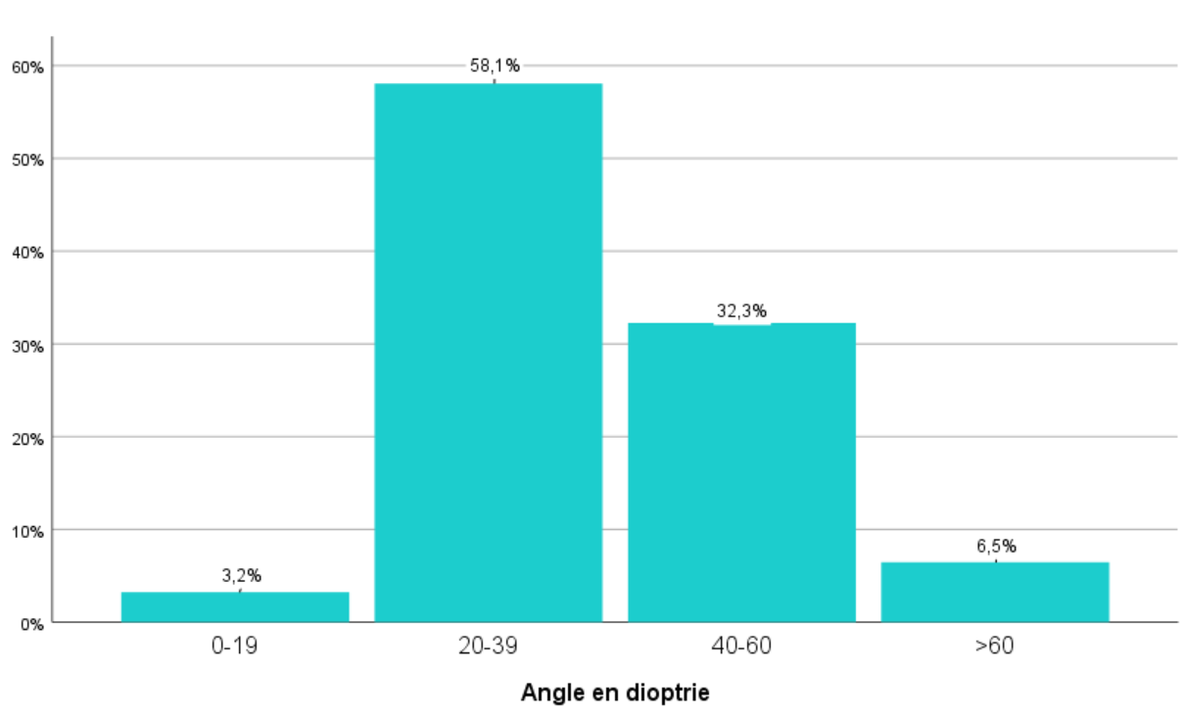
Figure 1: Patient distribution by minimum deviation angle (PD) in the esotropia group
-Maximum Angle:
The mean maximum angle was 41.2 prism diopters (PD), with a range from 20 to 80 PD.
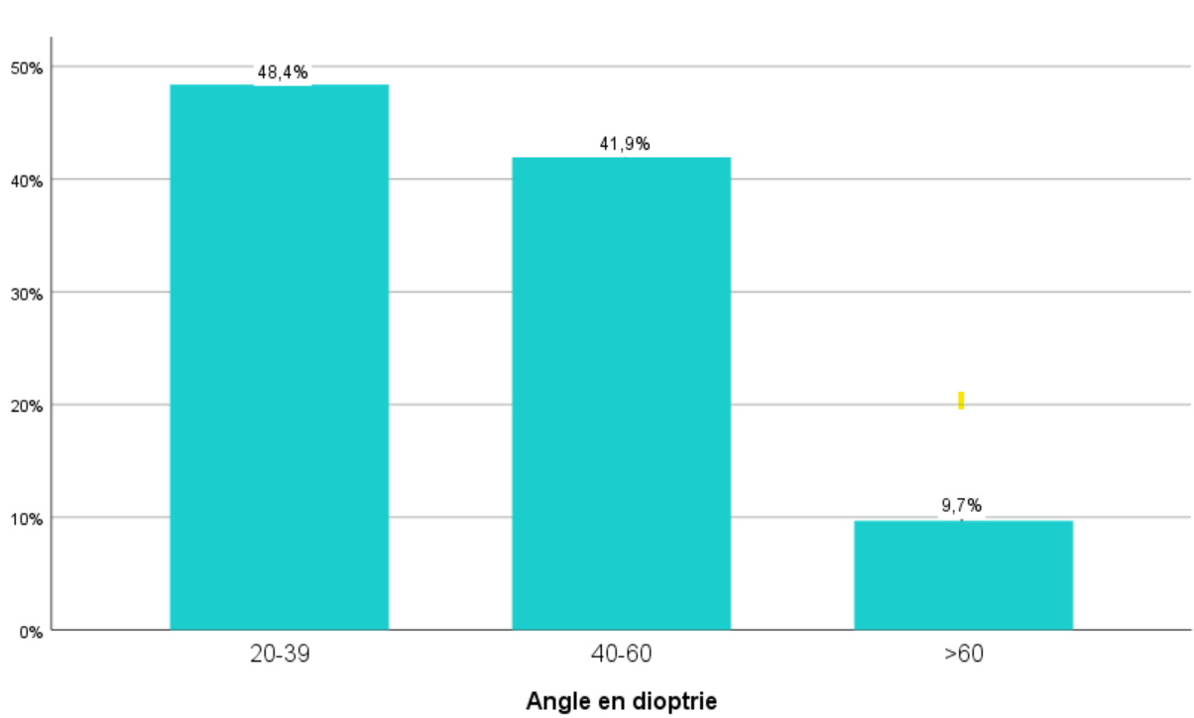
Figure 2: Patient distribution by maximum deviation angle (PD) in the esotropia group.

-Angular Variation:
The mean angular variation was 6.3 prism diopters (PD), with a range from 0 to 15 PD. It was less than 10 PD in 15 patients.
Divergent Strabismus:
-Minimum Angle:
The mean minimum angle was 40.88 PD, with a range from 20 to 60 PD.
Divergent Strabismus
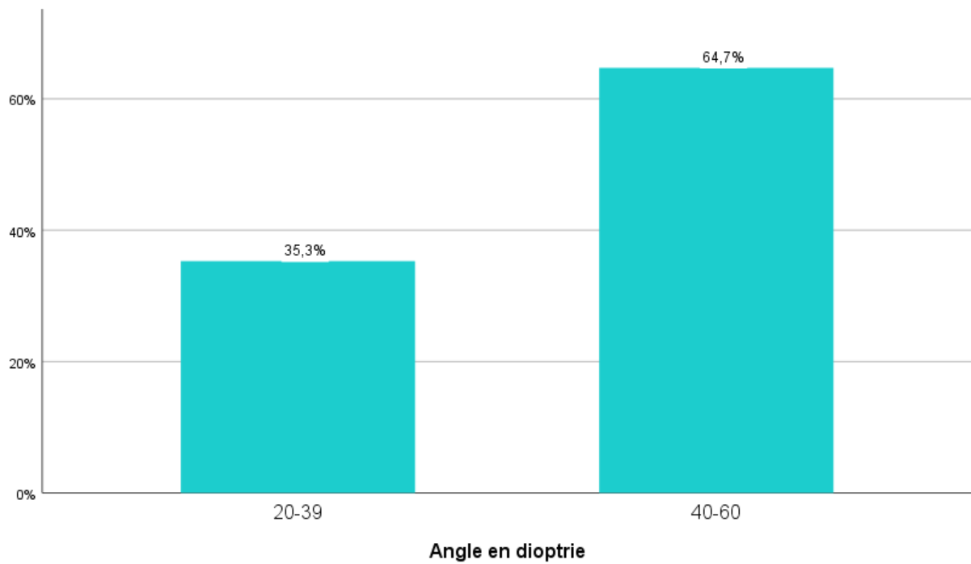
Figure 3: Patient distribution by minimum deviation angle (PD) in the exotropia group.
-Maximum Angle:
The mean maximum angle was 42.05 prism diopters (PD), with a range from 20 to 70 PD.
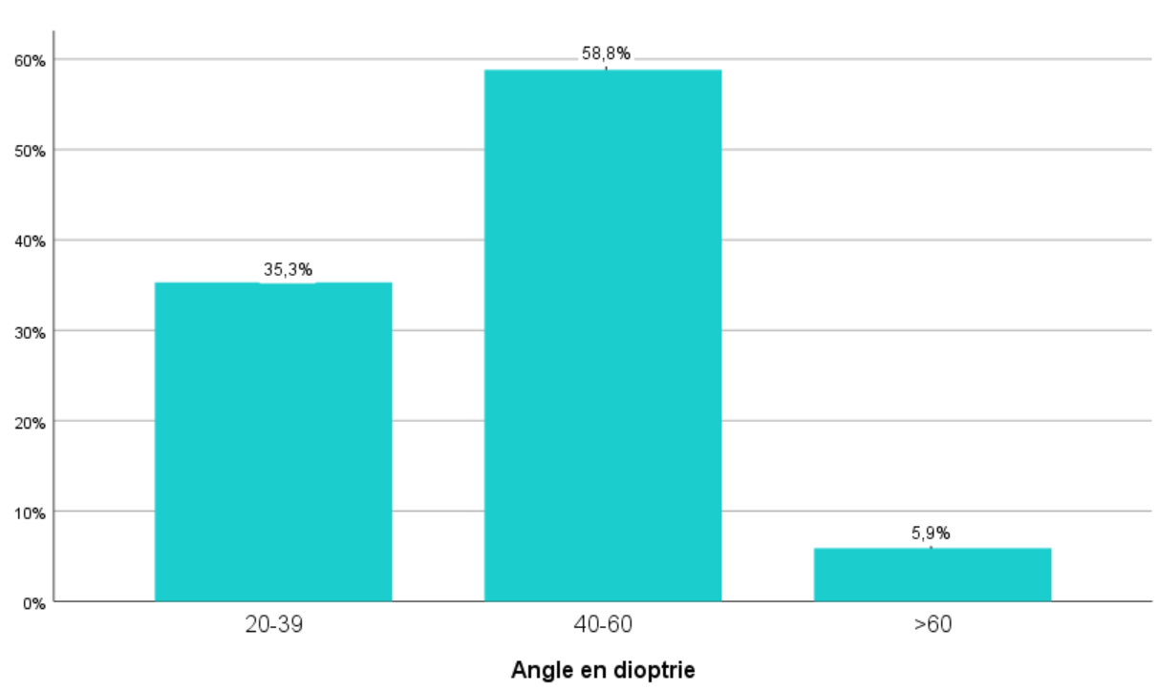
Figure 4: Patient distribution by maximum deviation angle (PD) in the exotropia group.
-Angular Variation:
The mean angular variation was 2.6 prism diopters (PD), with a range from 0 to 10 PD.

Table 6: Minimum and maximum deviation angles and prism diopter range by clinical type of strabismus.
Clinical form | Early ET | Accommodative ET | Non-accommodative ET | Early XT | Intermittent XT | Sensory strabismus
Mean minimum angle (Δ) | 35.0 | 36.0 | 42.0 | 37.5 | 47.1 | 35.0
Mean maximum angle (Δ) | 41.3 | 40.5 | 43.0 | 39.1 | 48.5 | 35.0
Mean angular variation (Δ) | 7.0 | 7.0 | 5.0 | 2.0 | 1.0 | 3.0

3. Ocular Motility
In the esotropia group, spasm of both medial rectus muscles was observed in 18 patients, being unilateral in 60.6% of cases and bilateral in 39.3%. In the same group, limitation of the medial rectus was noted in 18 cases (51.4%).
In the exotropia group, one case of unilateral medial rectus spasm was observed in a patient with intermittent exotropia. Unilateral overaction of the lateral rectus muscle was also identified in two cases of sensory exotropia.

Table 7: Ocular motility according to the clinical type of strabismus.

Clinical form | Early ET | Accommodative ET | Non-accommodative ET | Early XT | Intermittent XT | Sensory strabismus
Medial rectus muscle spasms | 12 | 6 | 0 | 0 | 1 | 0
Limitation of the lateral rectus muscle | 14 | 4 | 0 | 0 | 0 | 0
Overaction of the lateral rectus muscle | 0 | 0 | 0 | 0 | 0 | 2
4. Vertical Syndrome
Vertical syndrome was frequently observed in early strabismus. The most common features were inferior oblique overaction in 38.5%, V-pattern in 32.7%, and A-pattern in 11.5%. Dissociated vertical deviation (DVD) was found in 3.8% of cases.
Table 8: Distribution of vertical syndrome according to the type of strabismus.
Vertical strabismus pattern | Early ET | Accommodative ET | Non-accommodative ET | Early XT | Intermittent XT | Sensory strabismus
Dissociated vertical deviation (DVD) | 3 | 0 | 0 | 0 | 0 | 0
A-pattern strabismus | 4 | 0 | 1 | 1 | 0 | 0
V-pattern strabismus | 7 | 3 | 1 | 3 | 3 | 2
Hypertropia | 0 | 0 | 0 | 1 | 0 | 1
Hypotropia | 1 | 0 | 0 | 0 | 0 | 0
Inferior oblique overaction | 7 | 3 | 1 | 4 | 5 | 2
II. Sensory Assessment
A. Study of Monocular Vision
1. Refractive Errors
In our study, hyperopia was observed in 80.8% of cases, of which 48.1% was associated with astigmatism.

Table 9: Distribution of refractive errors according to the clinical types of strabismus.

Refractive errors | Subgroup | Early ET | Accommodative ET | Non-accommodative ET | Early XT | Intermittent XT | Sensory strabismus
Hyperopia | < 2 D | 2 | 1 | 2 | 0 | 0 | 0
 | 2–4 D | 8 | 3 | 2 | 3 | 5 | 0
 | > 4 D | 8 | 6 | 0 | 1 | 1 | 0
Myopia | < 2 D | 1 | 0 | 0 | 0 | 0 | 2
 | 2–4 D | 0 | 0 | 1 | 1 | 0 | 1
 | > 4 D | 1 | 0 | 0 | 1 | 1 | 1
Emmetropia |  | 0 | 0 | 0 | 0 | 0 | 0
Astigmatism |  | 0 | 0 | 0 | 0 | 0 | 0
Eight cases of high hyperopia and one case of high myopia were observed in early strabismus syndromes.
Four cases (11.4%) of esotropia were anisometropic.
All patients with accommodative esotropia (10 cases) were hyperopic.
Ten cases of astigmatism associated with spherical ametropia and one case of anisometropia were noted among exotropia patients.
2. Study of Visual Acuity and Amblyopia
Visual acuity could not be measured in six cases due to the young age of patients. In these cases, the presence or absence of amblyopia was inferred from whether the strabismus was alternating or non-alternating. A total of 38 patients (82.7%) presented with amblyopia.
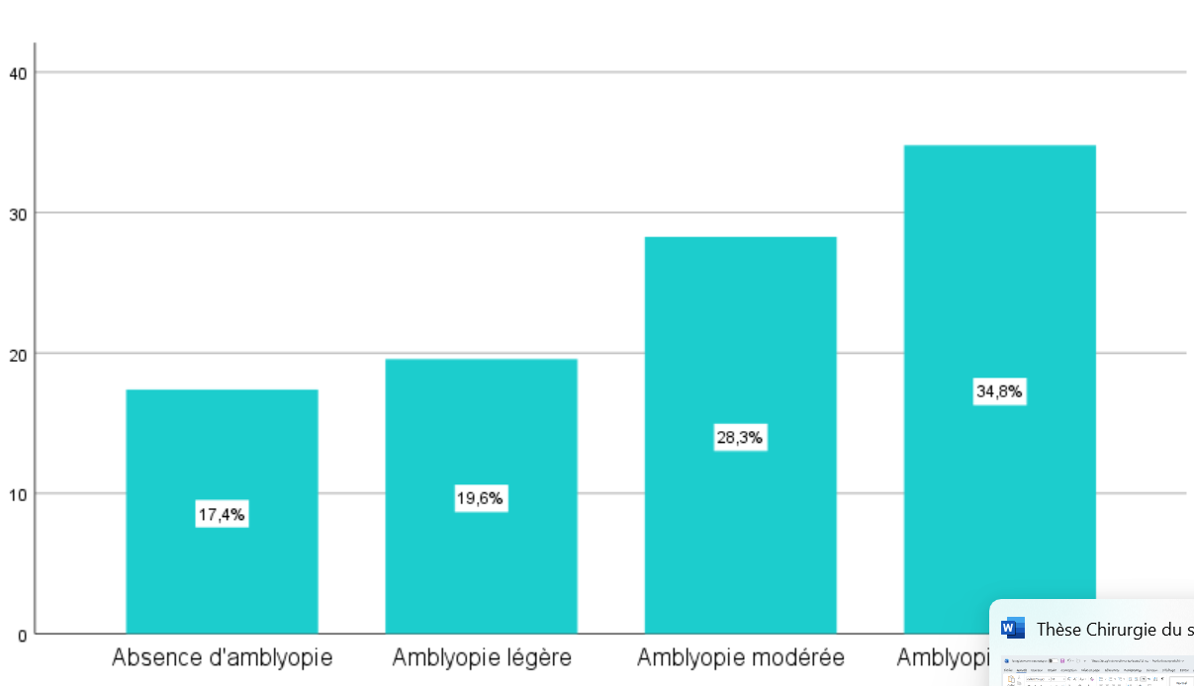
Figure 5: Distribution of patients according to the degree of amblyopia
Table 10: Distribution of amblyopia across clinical types of strabismus
Severity | Early ET | Accommodative ET | Non-accommodative ET | Early XT | Intermittent XT | Sensory strabismus
Absent | 0 | 1 | 2 | 1 | 4 | 0
Mild | 1 | 6 | 2 | 0 | 0 | 0
Moderate | 4 | 2 | 1 | 1 | 1 | 4
Severe | 9 | 1 | 0 | 4 | 2 | 0
The amblyopia rate was 95% in patients with early strabismus syndrome. In the group with partially accommodative esotropia, the amblyopia rate was 90%. Among patients with non-accommodative acquired esotropia, the rate was 60%. For intermittent exotropia, the amblyopia rate was 43.8%.
3.Type of Fixation and Strabismus
Among esotropia cases, 15 patients (51.7%) exhibited alternating strabismus, of whom 66.6% had equal visual acuity. In the exotropia group, 8 patients (47%) had alternating strabismus, with 6 of them (75%) demonstrating equal visual acuity. The majority (81%) of patients with constant strabismus presented with amblyopia, which was either moderate or, more frequently, profound.
Table 11: Rates of amblyopia and equal visual acuity according to the type of fixation.
Amblyopia severity | Esotropia Alternating | Esotropia Constant | Exotropia Alternating | Exotropia Constant
Absent | 3 | 0 | 5 | 0
Mild | 7 | 2 | 0 | 0
Moderate | 4 | 3 | 2 | 4
Severe | 1 | 9 | 1 | 5
Equal visual acuity | 10 | 1 | 6 | 0
B. Study of Binocular Vision
1. Status of Retinal Correspondence
Normal retinal correspondence was found in three cases of non-accommodative acquired esotropia. In the exotropia group, normal retinal correspondence was observed in only one case of intermittent exotropia. Overall, 80.7% of patients had abnormal retinal correspondence.

Table 12: Preoperative retinal correspondence according to the clinical types of strabismus.
Retinal correspondence | Early ET | Accommodative ET | Non-accommodative ET | Early XT | Intermittent XT | Sensory strabismus
Normal | 0 | 0 | 3 | 0 | 1 | 0
Abnormal | 14 | 10 | 2 | 6 | 6 | 4
Not specified | 6 | 0 | 0 | 0 | 0 | 0

2. Examination of Fusion
Good preoperative fusion was observed in only two cases in the group with non-accommodative acquired esotropia
Table 13: Status of fusion according to the type of strabismus
Fusional status | Early ET | Accommodative ET | Non-accommodative ET | Early XT | Intermittent XT | Sensory strabismus
Good fusion | 0 | 0 | 2 | 0 | 0 | 0
Bad fusion | 14 | 10 | 3 | 6 | 7 | 4
3. Examination of Stereoscopic Vision
Good preoperative stereoscopic vision was documented in only two patients in the group with non-accommodative acquired esotropia (Table 13).
Table 14: Status of stereoscopic vision according to the type of strabismus
Stereoscopic vision | Early ET | Accommodative ET | Non-accommodative ET | Early XT | Intermittent XT | Sensory strabismus
Present | 0 | 0 | 2 | 0 | 0 | 0
Absent | 14 | 10 | 3 | 6 | 7 | 4
IV. Associated Signs
Torticollis was observed in 5 patients (9.6%). Nystagmus was present in 6 patients (11.5%). Headache, photophobia, and asthenopia were the most frequently reported associated clinical symptoms.

Table 15: Associated clinical symptoms in patients with strabismus in our series.
Symptom | Esotropia, n (%) | Exotropia, n (%)
Photophobia | 10 (28.5) | 10 (58.8)
Headache | 16 (55.1) | 11 (76.5)
Diplopia | 2 (6.9) | 2 (11.7)
Asthenopia | 5 (17.2) | 8 (47.0)

DISCUSSION
I. Epidemiological Data
A. Age of Onset of Strabismus
1. Esotropia
In a series of 68 cases of early esotropia, (Lajmi et al,2022) reported a mean age at onset of 5 ± 4.5 months, with a median of 6 months. (Buch et al, 2015) reported a mean age at onset of non-accommodative acquired esotropia of 7 years and 4.7 years, respectively. By contrast, (Topcu Yilmaz et al, 2020) observed a much later onset, with a mean age of 17.8 ± 10.3 years.
In our cohort, the mean age at onset varied by subtype: 0.7 years for early esotropia, 3.6 years for partially accommodative esotropia, and 10.4 years for non-accommodative acquired esotropia.
2. Exotropia
Early exotropia usually presents in a manner similar to congenital esotropia. In a study of 135 cases of early-onset exotropia, Na et al. reported a mean age at onset of 6.7 months (Na et al, 2019). Determining the onset of intermittent exotropia is often challenging, since it may initially manifest as exophoria. During this latent phase, patients maintain binocular vision and normal retinal correspondence. Over time, exophoria may evolve into intermittent exotropia, alternating between phoric and tropic phases, most notably at distance fixation, and may ultimately progress to constant exotropia (Govindan M et al,2005).
In 43 cases of sensory exotropia,(Lajmi et al,2020) reported a mean age at onset of 6 years (range: 4–16 years).
In our series, the mean age of onset was 11.7 months for early exotropia, 4.5 years for intermittent exotropia, and 7.8 years for sensory exotropia.
B. Sex Distribution
Most studies have reported a female predominance in divergent strabismus. In a series of 184 cases, (Nusz et al,2005) found that exotropia was significantly more frequent in females (64.1%) than in males (35.9%). Over the 20-year study period, two out of three children diagnosed with intermittent exotropia were girls. This sex distribution suggests a possible X-linked dominant inheritance pattern.
In our cohort, 25 patients were male (48.1%) and 27 were female (51.9%), giving a male-to-female ratio of 0.92:1. We hypothesize that sociocultural factors may contribute to this slight female predominance, as parents often express greater concern about the facial appearance of daughters, leading to earlier consultation.
C. Risk Factors
In a large U.S. study involving 9,970 patients, the risk factors for exotropia included maternal smoking during pregnancy, gestational age <33 weeks, female sex, astigmatism >1.5 D, and a positive family history of strabismus (Cotter et al, 2011). Early exotropia is frequently associated with systemic conditions such as prematurity, central nervous system malformations, epilepsy, and intellectual disability (Govindan M et al, 2005). Brain MRI reveals abnormalities in more than 80% of such patients (Baeteman et al, 2008), supporting the need for systematic pediatric neurological evaluation and neuroimaging when indicated.
In our cohort, all patients with early exotropia underwent pediatric neurological assessment. Among the five cases, one child had psychomotor developmental delay.
Risk factors for esotropia include maternal smoking during pregnancy, prematurity (<33 weeks), anisometropia >1 D, and hyperopia >+2 D (Cotter et al, 2011). In our study, a positive family history was found in 29.4% of exotropia cases (5 involving uncles/aunts) and in 40% of esotropia cases (3 involving parents and 9 siblings).
II. Clinical Data
A. Distribution by Strabismus Type
1. Esotropia
A decline in esotropia prevalence has been reported, possibly due to reduced hyperopia levels (Friedman et al, 2009). In the Baltimore Pediatric Eye Disease Study, Friedman et al. observed a prevalence of 2.61%, suggesting that earlier detection and treatment of refractive errors, particularly hyperopia, may contribute to this trend.
Infantile Esotropia Syndrome (IES) accounts for about 90% of early strabismus cases, with an estimated prevalence of 2% in the general population, and represents 28–93% of all esotropia cases (Lajmi et al, 2022). In a cohort of 221 children, Mohney (2001) reported a 10.4% prevalence of non-accommodative acquired esotropia. In another series of 215 esotropia cases, (Çorak Eroğlu et al, 2020) identified partially accommodative esotropia in 25.5%.
In our series, infantile esotropia accounted for 57.1%, partially accommodative esotropia for 28.6%, and non-accommodative acquired esotropia for 14.3%. These findings are consistent with the literature.
2. Exotropia
The prevalence of exotropia is likely underestimated in our setting due to delayed consultation. It is generally less frequent than esotropia and represents a heterogeneous disorder with several subtypes (Chia et al, 2007). (Archer et al,2015) reported that only 2 in 3,000 newborns developed primary infantile exotropia, whereas other studies estimated a prevalence as low as 1 in 30,000 births.
Intermittent exotropia, however, affects about 1% of the general population and represents 75–90% of exotropia cases (Masson, 2015). (Mohney,2007) found a 6.7% prevalence of sensory strabismus before age 19, with a slight predominance of esotropia (4%) over exotropia (2.7%). (Wong AM, 2020) observed equal proportions of esotropia and exotropia when vision loss occurred congenitally or before age 5, but exotropia predominated when vision loss occurred later.
In our cohort, early exotropia represented 35.3% of exotropia cases, intermittent exotropia 41.2% (80.7% of which were basic type), and sensory exotropia 23.5%.
B. Sensory Assessment
1. Refraction
(Thouvenin et al,2008) reported that high refractive errors and anisometropia are major risk factors for strabismus, either through their accommodative component or through the visual deprivation they induce. In the series by (Birch EE et al, 2002), hyperopia was present in 70.73% of esotropia cases, myopia in 24.4%, and astigmatism in 51.21%. Anisometropia greater than 1 diopter in spherical equivalent was noted in 23.4%. In 120 cases of exotropia, (Abassorra, 2003) found that hyperopia was the most frequent refractive error, affecting 50% of patients.
In our cohort, esotropia was associated with hyperopia in 84.3% of cases, myopia in 3%, and anisometropia in 12.5%. Among exotropia cases, 53.3% had hyperopia, 40% myopia, and 6% anisometropia. In early strabismus, 85.7% of patients were hyperopic.
2. Amblyopia
(Bienvenu et al,2015) reported amblyopia in 75.75% of esotropia cases and 48.75% of exotropia cases in a Cameroonian cohort. The same study found amblyopia in 80.18% of early-onset esotropia and 73.31% of early-onset exotropia. In intermittent exotropia, amblyopia is usually absent or mild and, when present, is most often associated with anisometropia (Govindan M et al, 2005). By contrast, sensory exotropia is invariably associated with severe amblyopia (Wong AM, 2020).
In our series, amblyopia was present in 88.8% of convergent strabismus and 66.6% of divergent strabismus, likely reflecting delayed presentation for ophthalmological evaluation.
3. Binocular Vision
(Chia et al, 2007) reported stereopsis in 17.39% of acute acquired concomitant esotropia cases. In acquired non-accommodative esotropia, normal retinal correspondence may be preserved, and binocular vision may be restored after correction of the deviation (Speeg-Schatz et al., 2015). (Yam et al,2013) observed stereopsis in 41% of patients with early exotropia.
In our series, normal retinal correspondence was found in three cases of acquired non-accommodative esotropia and in one case of intermittent exotropia.
C. Motor Assessment
1. Horizontal Deviation
Large-angle deviations are characteristic of strabismus associated with abnormal binocular vision. In early esotropia, angles usually exceed 35 prism diopters (PD), and alternating fixation is frequent (Gunton et al, 2015). Early exotropia also tends to present with large angles, typically >35 PD (Gunton et al, 2015). In intermittent exotropia, the mean deviation was 34 PD in the study by (Zou et al,2017). In (Wong AM, 2020) series of sensory exotropia, deviation ranged from 10 to 70 PD.
In our cohort, mean deviation ranged from 36.3 to 41 PD in esotropia and from 40.8 to 42.05 PD in exotropia.
2. Ocular Motility
(Simonsz HJ et al, 2011) reported spasm of both medial rectus muscles in 25% of esotropia cases, while (Barjol, 2012) found it in 16%. In exotropia, (Simonsz HJ et al, 2011) observed medial rectus limitation in 10.1% of cases and lateral rectus overaction in 17.7%.
In our study, medial rectus spasm was present in 18 patients with esotropia (50.4%), possibly due to delayed correction of hyperopia. In the exotropia group, unilateral lateral rectus overaction was seen in two cases of sensory exotropia, and unilateral medial rectus spasm was noted in one case of intermittent exotropia.
3. Vertical Deviations
3.1. Dissociated Vertical Deviation (DVD)
DVD is considered almost pathognomonic of early strabismus (Baeteman et al, 2008). (Simonsz HJ et al, 2011) reported it in 3% of cases. In 1,228 patients with intermittent exotropia, Yang et al. (2016) found DVD in 4.8%. (Yam et al, 2013) reported a prevalence of 5% in early exotropia.
In our series, DVD was observed preoperatively in three patients (8.6%), all of whom had early strabismus syndrome.
3.2. Oblique Muscle Overaction
The reported prevalence of oblique muscle overaction ranges from 5% to 71% in esotropia, with inferior oblique involvement in about 70% of cases (Ozsoy et al, 2019; Wilson et al, 1989). Inferior oblique overaction (IOOA) was found in 40.3% and 63% of early esotropia in the series by (Freitas-da-Costa et al,2023) and (Wilson et al, 1989), respectively. In exotropia, IOOA has been reported in about 30% of cases (Ozsoy et al, 2019).
In our series, IOOA was present in 42.3% of esotropia cases (35% of early, 30% of acquired, and 20% of non-accommodative acquired). In exotropia, IOOA was observed in 66.6% of early-onset, 71.4% of intermittent, and 50% of sensory cases.
3.3. Patterned Strabismus
Patterned strabismus is defined as a vertical incomitance in horizontal strabismus, with a difference in deviation between upgaze and downgaze (von et al., 1965). It occurs in 15–25% of esotropia cases (Dickmann et al, 2011). (Simonsz HJ et al,2011) reported patterned strabismus in 63% of esotropia cases, most frequently V-patterns, which were associated with inferior oblique overaction in 55%. (Yam et al, 2013) reported a V-pattern in 24% of early exotropia and 22% of intermittent exotropia.
In our study, we observed an A-pattern in four cases of early-onset strabismus syndrome (EOSS), one case of non-accommodative acquired esotropia, and one case of early exotropia. A V-pattern was present in six cases of EOSS, three of partially accommodative esotropia, one of non-accommodative acquired esotropia, three of early exotropia, three of intermittent exotropia, and one of sensory strabismus.
CONCLUSION
This study demonstrates that early-onset strabismus is the most prevalent form in the studied population, often associated with amblyopia and significant refractive errors. While the sample size of this single-center study provides valuable insights into the epidemiological and clinical characteristics, it is insufficient to draw definitive conclusions about long-term surgical or functional outcomes. The findings highlight the importance of timely, tailored therapeutic interventions, both surgical and non-surgical. Implementing standardized screening protocols in primary care and school settings could significantly improve early diagnosis rates. Future large-scale, multicenter prospective studies with longer follow-up periods are needed to adequately assess long-term functional and psychosocial outcomes. Further research should also explore genetic, neurodevelopmental, and environmental factors to refine prevention and management strategies.

AcknowledgEments

We would like to express our sincere gratitude to all the participants in this study for their cooperation and willingness to contribute to this research. Our thanks also extend to the medical and administrative staff of the Ophthalmology Department at Kasserine for their invaluable support in patient recruitment and data collection

Competing interests
Authors have declared that no competing interests exist

Authors’ Contributions

Lotfi Chaabani designed the study, performed the statistical analysis, wrote the protocol,
and wrote the first draft of the manuscript.
Doulemi Yosra and Ksouri Saifeddine managed the literature searches.

Consent

Written informed consent was obtained from the subjects to participate in this study

Ethical approval
All procedures performed in studies involving human participants were in accordance with the ethical standards of the institutional and/or national research committee and with the 1964 Helsinki declaration and its later amendments or comparable ethical standards.
-Patients’ privacy was fully respected.
-There are no identifying details in our study

DISCLAIMER (ARTIFICIAL INTELLIGENCE)

Author(s) hereby declare that NO generative AI technologies such as Large Language Models (ChatGPT, COPILOT, etc.) and text-to-image generators have been used during the writing or editing of this manuscript.
References

1.Kattan JM, Velez FG, Demer JL, Pineles SL. Relationship between binocular summation and stereoacuity after strabismus surgery. Am J Ophthalmol. 2016;165:29-32. doi:10.1016/j.ajo.2016.02.020.
3.Bienvenu YA, Angel MN, Sebastien MM, et al. Study of strabismus in children aged 0 to 15 years followed in Lubumbashi.Pan Afr Med J. 2015;22:66. doi:10.11604/pamj.2015.22.66.6713.
4. Hatt, S. R., Leske, D. A., Kirgis, P. A., Bradley, E. A., & Holmes, J. M. (2007). The effects of strabismus on quality of life in adults. American journal of ophthalmology, 144(5), 643-647.
5. Lajmi, H., Choura, R., Hmaied, W., & El Fekih, L. (2022). Esotropia management: outcomes and prognostic factors. Acta Ophthalmologica, 100.
6.Buch H, Vinding T. Acute acquired comitant esotropia of childhood. Acta Ophthalmol. 2015;93(6):568-74.
7.Topcu Yilmaz P, Ural Fatihoglu Ö, Sener EC. Acquired comitant esotropia in children and young adults. J Pediatr Ophthalmol Strabismus. 2020;57(4):251-6.
8.Na KH, Kim SH. Different surgical outcomes in infantile exotropia according to onset time. J AAPOS. 2019;23(6):317.e1-317.e6. doi:10.1016/j.jaapos.2019.07.003.
9. Govindan M, Mohney BG, Diehl NN, Burke JP. Incidence and types of childhood exotropia: A population-based study. Ophthalmology. 2005;112(1):104-8. doi:10.1016/j.ophtha.2004.07.033.
10.Lajmi H, Ben Yakhlef A, Bouazzeoui EOA, et al. Outcomes of surgery in patients with sensory exotropia. J Fr Ophtalmol. 2020;43(2):128-32. doi:10.1016/j.jfo.2019.07.007.
11.Nusz KJ, Mohney BG, Diehl NN. Female predominance in intermittent exotropia. Am J Ophthalmol. 2005;140(3):546-7. doi:10.1016/j.ajo.2005.03.071.
12.Cotter SA, Varma R, Tarczy-Hornoch K, et al. Risk factors associated with childhood strabismus. Ophthalmology. 2011;118(11):2251-61. doi:10.1016/j.ophtha.2011.06.032.
13. Baeteman, C., Denis, D., Loudot, C., Toesca, E., Bronsard, J., Benso, C., ... & Girard, N. (2008). Primary exotropia: importance of cerebral MRI. Journal Francais D'ophtalmologie, 31(3), 287-294.
14.Friedman DS, Repka MX, Katz J, et al. Prevalence of amblyopia and strabismus in the Baltimore Pediatric Eye Disease Study. Ophthalmology. 2009;116(11):2128-34. doi:10.1016/j.ophtha.2009.04.034.
15.Mohney BG. Acquired nonaccommodative esotropia in childhood. J AAPOS. 2001;5(2):85-9. doi:10.1067/mpa.2001.113400.
16.Çorak Eroğlu F, Oto S, Şahin Fİ, et al. The role of heredity and the prevalence of strabismus in families. Turk J Ophthalmol. 2020;50(3):143-50. doi:10.4274/tjo.galenos.2019.09433.
17.Chia A, Roy L, Seenyen L. Comitant horizontal strabismus: an Asian perspective. Br J Ophthalmol. 2007;91(10):1337-40. doi:10.1136/bjo.2006.112623.
18.Wong AM. New concepts concerning the neural mechanisms of strabismus. Eye (Lond). 2020;34(2):251-7. doi:10.1038/s41433-019-0739-6.
19. Thouvenin, D. A., Sotiropoulos, M. C., Arné, J. L., & Fournié, P. R. (2008). Esotropias that totally resolve under general anesthesia treated exclusively with bilateral fadenoperation. Strabismus, 16(4), 131-138.
20. Birch, E. E., Fawcett, S. L., & Stager Sr, D. R. (2002). Risk factors for the development of accommodative esotropia following treatment for infantile esotropia. Journal of American Association for Pediatric Ophthalmology and Strabismus, 6(3), 174-181.
22.Gunton KB, Wasserman BN, DeBenedictis C. Strabismus. Prim Care. 2015;42(3):393-407. doi:10.1016/j.pop.2015.05.006.
23.Zou D, Casafina C, Whiteman A, et al. Predictors of surgical success in intermittent exotropia. J AAPOS. 2017;21:15-20. doi:10.1016/j.jaapos.2016.10.008.
24. Yam, J. C., Chong, G. S., Wu, P. K., Wong, U. S., Chan, C. W., & Ko, S. T. (2013). Prognostic factors predicting the surgical outcome of bilateral lateral rectus recession surgery for patients with infantile exotropia. Japanese journal of ophthalmology, 57(5), 481-485.
25.Ozsoy E, Gunduz A, Ozturk E. Inferior oblique muscle overaction. J Ophthalmol. 2019;2019:9713189. doi:10.1155/2019/9713189.
26.Wilson ME, Parks MM. Primary inferior oblique overaction. Ophthalmology. 1989;96(7):950-7. doi:10.1016/S0161-6420(89)32755-9.
27. von Noorden, G. K., & Olson, C. L. (1965). Diagnosis and surgical management of vertically incomitant horizontal strabismus. American Journal of Ophthalmology, 60(3), 434-442.
28. Dickmann, A., Petroni, S., Salerni, A., Parrilla, R., Savino, G., Battendieri, R., ... & Balestrazzi, E. (2011). Effect of vertical transposition of the medial rectus muscle on primary position alignment in infantile esotropia with A-or V-pattern strabismus. Journal of American Association for Pediatric Ophthalmology and Strabismus, 15(1), 14-16.
29. Speeg-Schatz, C., Gottenkiene, S., Sauer, A., & Roth, A. (2015). Surgery for convergent strabismus in childhood: Why and when?. Journal Francais D'ophtalmologie, 38(3), 247-252.

