Case report

Kartagener Syndrome (KS): Presentation of Five Pediatric Clinical Cases and Review of Recent Literature

.
ABSTRACT

Objectives: To describe the clinical presentation, diagnostic journey, and outcomes of five pediatric patients with Kartagener syndrome (KS), in order to highlight the challenges of early diagnosis and multidisciplinary management within a Moroccan context.

Study Design: Descriptive case series.

Place and Duration of Study: Department of Pediatrics, Mohamed V Military Teaching Hospital, Rabat, Morocco; January 2023 to June 2025.

Methodology: Five patients (4 females, 1 male), aged 4.5 to 20 years, diagnosed with KS were included. Data were collected retrospectively from clinical files. All patients presented with chronic respiratory symptoms including productive cough, recurrent sinusitis, and bronchorrhea. Imaging studies (chest X-ray [CXR], thoracoabdominal computed tomography [CT], and echocardiography [Echo]) were used to confirm the presence of situs inversus and bronchiectasis. Treatment protocols included antibiotics, respiratory physiotherapy (RP), and vaccination. One patient developed chronic respiratory failure requiring long-term oxygen therapy (O₂T).

Results: Five patients were included, with a mean age of 9.7 ± 6.7 years and a median of 6 years (range 4.5–20); four were female and one male. The mean delay between the onset of symptoms and diagnosis was 4.2 ± 3.6 years, with a median of 3 years (range 1–10). All patients (100%) presented with chronic respiratory symptoms, complete situs inversus, and bilateral bronchiectasis on imaging. ENT complications were observed in 2 patients (40%): one case of recurrent otitis media and one case of mastoiditis. Documented bacterial infections included Pseudomonas aeruginosa in 2 cases (40%) and Haemophilus influenzae in 1 case (20%). Two patients (40%) required repeated hospitalizations for lower respiratory tract infections, and the only adult patient (20%) developed chronic respiratory failure requiring long-term oxygen therapy. No genetic testing could be performed due to unavailability, but all patients received antibiotics, regular respiratory physiotherapy, and vaccination updates as indicated.

Conclusion: KS remains underdiagnosed in low-resource settings due to lack of awareness and diagnostic tools. Early recognition of the association between chronic respiratory symptoms and situs inversus is essential. A multidisciplinary approach is key to improving patient outcomes and preventing severe respiratory complications

Keywords: Kartagener syndrome, primary ciliary dyskinesia, situs inversus, bronchiectasis, pediatrics.

INTRODUCTION
Kartagener syndrome (KS) is the most recognized clinical phenotype of primary ciliary dyskinesia (PCD), a rare group of genetic disorders characterized by structural and functional abnormalities of motile cilia. This defect in mucociliary clearance leads to recurrent respiratory infections, chronic ENT manifestations, and, in about 50% of cases, situs inversus forming the classic triad of KS [1]. Complications notably include progressive bronchiectasis and impaired quality of life.
Diagnosis is often delayed due to clinical variability and the limited availability of specialized tests, which may worsen prognosis [1,2]. Early detection and multidisciplinary management are therefore essential to limit respiratory complications. Electron microscopy, although considered the reference examination for assessing ciliary ultrastructure, is not always available, and its absence should not delay the clinical diagnosis or the initiation of appropriate management

CASE PRESENTATION

Observation 1:

Yasmine, a 5-year-old girl, was hospitalized for acute mastoiditis on a background of chronic bronchorrhea, recurrent otitis (OM), and sinusitis. Clinical examination revealed growth retardation (-2 SD), a right retroauricular inflammatory mass, fever, bilateral wheezing, and displacement of the apex beat to the right. Abdominal ultrasound and echocardiography revealed complete situs inversus.Thoracoabdominal CT scan showed bilateral bronchial dilatation, as illustrated in images A and B of Figure 1. The diagnosis of Kartagener syndrome was established. Treatment included intravenous antibiotics, pneumococcal and influenza vaccination, sequential antibiotic therapy, and respiratory physiotherapy.

A 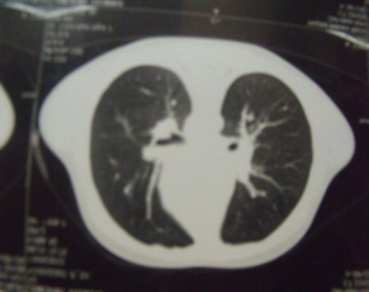B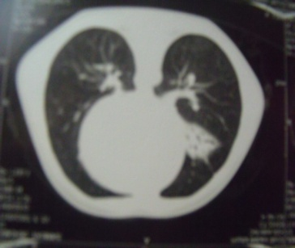

Figure 1: Axial CT images of the chest showing diffuse bilateral bronchiectasis in a child with Kartagener syndrome.

Observation 2

Chaimae, 5 years old, with a history of recurrent pneumonias. Clinical presentation included morning bronchorrhea and recurrent sinusitis. Thoracoabdominal CT showed situs inversus, bilateral bronchiectasis, and a left pulmonary focus. Sinus CT scan revealed bilateral rhinosinusitis. Treatment included empirical antibiotic therapy, vaccination, and respiratory physiotherapy.

Observation 3

Med, a 4.5-year-old boy, presented with chronic productive cough since the age of 6 months, along with rhinorrhea and growth retardation. CXR revealed bronchial thickening and dextrocardia, while the thoracic CT scan showed areas of lobar collapse with preserved aeration and a micronodular interstitial syndrome. Situs inversus was confirmed, and the diagnosis of Kartagener syndrome was established, as shown in images A and B of Figure 2.
A 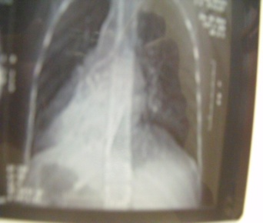B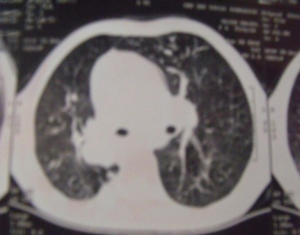

Figure 2: Chest X-ray (A) and thoracic CT scan (B) showing dextrocardia, bronchial thickening, and bilateral aerated collapse with interstitial micronodular infiltrates in a child with Kartagener syndrome.

Observation 4

Lamyae, a 13-year-old girl, third among four siblings, followed since early childhood for recurrent respiratory infections. Incidentally discovered dextrocardia. She experienced repeated hospitalizations since 2023 for pneumonias caused by Haemophilus influenzae and Pseudomonas aeruginosa. Clinical examination revealed a right-sided apex beat without cardiac murmur or signs of heart failure. Echo and thoracic CT confirmed complete situs inversus and bilateral bronchiectasis, as shown in images A and B of Figure 3. The clinical course has been stable under antibiotic prophylaxis and biweekly respiratory physiotherapy.

A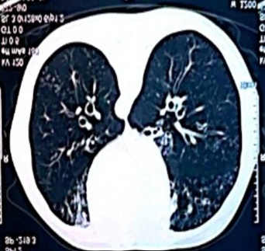B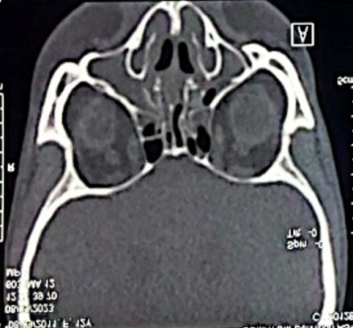
Figure 3: Thoracic and sinus CT images showing diffuse bilateral bronchiectasis (A) and associated chronic sinusitis (B) in a patient with Kartagener syndrome.

Observation 5

Chaimaa, a 20-year-old woman, second among four siblings, diagnosed at 6 years old with Kartagener syndrome. History of chronic bronchorrhea and recurrent lower respiratory infections since childhood. A recent thoracic CT scan, as shown in Figure 4 below, revealed diffuse bronchiectasis with signs of superinfection, and confirmed the presence of situs inversus. Since 2024, she has developed chronic respiratory failure requiring continuous O₂T. Pulmonary function tests (PFTs) revealed severe obstructive syndrome. The clinical course was marked by frequent hospitalizations for infectious exacerbations caused by Pseudomonas aeruginosa, managed with adapted antibiotic therapy and colistin nebulizations.

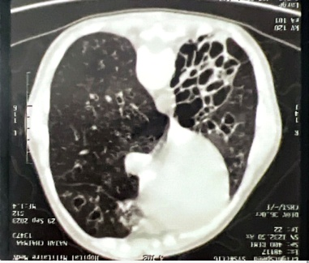
Figure 4: Axial chest CT scan showing extensive bilateral cystic bronchiectasis, predominantly in the right upper lobe

Comparative table
Table 1 provides a summary of our results.

Table 1: Individual characteristics and overall results of the five patients with Kartagener syndrome

Parameters | Patient 1 | Patient 2 | Patient 3 | Patient 4 | Patient 5 | Summary / Results
Age (years) | 4.5 | 5 | 6 | 13 | 20 | Median 6 years (4.5–20), mean 9.7 ± 6.7
Sex | F | F | M | F | F | 4 females (80%), 1 male (20%)
Diagnostic delay (years) | 2 | 3 | 1 | 5 | 10 | Median 3 years (1–10), mean 4.2 ± 3.6
Chronic respiratory symptoms | Yes | Yes | Yes | Yes | Yes | 5/5 (100%)
Complete situs inversus | Yes | Yes | Yes | Yes | Yes | 5/5 (100%)
Bilateral bronchiectasis | Yes | Yes | Yes | Yes | Yes | 5/5 (100%)
ENT complications | No | Recurrent otitis media | No | Mastoiditis | No | 2/5 (40%)
Documented bacterial infections | None | Pseudomonas aeruginosa | Haemophilus influenzae | Pseudomonas aeruginosa | None | 3/5 (60%): 2 Pseudomonas, 1 Haemophilus
Recurrent hospitalizations | No | Yes | No | Yes | No | 2/5 (40%)
Chronic respiratory failure | No | No | No | No | Yes (adult) | 1/5 (20%)
Genetic testing | No | No | No | No | No | 0/5 (0%)
Treatment | ATB + Respiratory physio + Vaccines | ATB + Respiratory physio + Vaccines | ATB + Respiratory physio + Vaccines | ATB + Respiratory physio + Vaccines | ATB + Respiratory physio + Vaccines | All patients: antibiotics, regular respiratory physiotherapy, vaccination updates

Discussion

Kartagener syndrome is related to mutations affecting the structure and function of motile cilia [3]. Several genes have been implicated, notably DNAH5, DNAI1, and CCDC39 [4,5]. It follows an autosomal recessive inheritance pattern [6]. Diagnosis is based on clinical presentation, imaging, and, when possible, genetic confirmation or electron microscopy [7].

Case Analysis

The five cases we report share common features: all patients presented with complete situs inversus confirmed by imaging. Chronic respiratory symptoms appearing in early childhood (morning bronchorrhea, productive cough, recurrent sinusitis) were constant, in line with classical descriptions of PCD [8]. Diagnosis was often made following repeated pneumonias, sometimes complicated by otitis or mastoiditis [9].

Progression to bronchiectasis is frequent and represents a major complication of delayed diagnosis [10]. Two patients had chronic Pseudomonas aeruginosa colonization, which is associated with accelerated respiratory decline [11]. The evolution toward chronic respiratory failure observed in Chaimaa illustrates the harmful impact of chronic bacterial colonization.

Moroccan Specificities

Our series highlights the necessity for early recognition of Kartagener syndrome in Morocco, where diagnosis often remains delayed due to lack of awareness [12]. The lack of awareness, combined with the absence of systematic screening programs, promotes progression to severe forms. Our observations confirm the importance of developing local awareness strategies within pediatric and ENT departments [13].

Diagnostic Challenges and Future Perspectives

The main obstacle remains the lack of systematic access to genetic diagnostic tests, particularly targeted sequencing or videomicroscopy analysis of ciliary beating [14]. The development of specialized laboratories is crucial for early confirmation of PCD cases, optimized management, and ultimately the exploration of innovative therapeutic approaches such as gene therapy [15].

Need for Multidisciplinary Management

Our observations reinforce the importance of a multidisciplinary approach (pediatrics, pulmonology, ENT, physiotherapy, genetics) in the follow-up of children with PCD [13]. Structured follow-up could significantly improve their quality of life, slow respiratory decline, and reduce infectious complications.

Conclusion

Kartagener syndrome is a complex disease that requires a rigorous multidisciplinary approach. Our five cases illustrate the importance of early diagnosis and appropriate management to improve quality of life and limit respiratory complications. It should be clarified that the diagnosis is not exclusively based on electron microscopy, and this limitation should not prevent the identification of such patients who require early management and should not be confused with other differentials [16,17].

Consent

All authors declare that written informed consent was obtained from the patients’ parents or legal guardians for the publication of these pediatric case reports and the accompanying images. A copy of the written consent is available for review by the editorial office, the Editor-in-Chief, and the editorial board members of this journal.

Ethical approval

All authors hereby declare that all experiments were reviewed and approved by the appropriate ethics committee and were therefore conducted in accordance with the ethical standards outlined in the 1964 Declaration of Helsinki.

Abbreviations

KS: Kartagener Syndrome

PCD: Primary Ciliary Dyskinesia

CT: Computed Tomography

CXR: Chest X-ray

Echo: Echocardiography

OM: Otitis Media

ENT: Ear, Nose, and Throat

RP: Respiratory Physiotherapy

O₂T: Oxygen Therapy

PFTs: Pulmonary Function Tests

H. influenzae: Haemophilus influenzae

P. aeruginosa: Pseudomonas aeruginosa

Disclaimer (Artificial intelligence)
Option 1:

Author(s) hereby declare that NO generative AI technologies such as Large Language Models (ChatGPT, COPILOT, etc.) and text-to-image generators have been used during the writing or editing of this manuscript.

References

- Shoemark, A., and K. Harman. “Primary Ciliary Dyskinesia.” Seminars in Respiratory and Critical Care Medicine 42.4 (2021): 537-548.
http://www.ncbi.nlm.nih.gov/pubmed/34261178
- Barbato, A., et al. “Primary ciliary dyskinesia: a consensus statement on diagnostic and treatment approaches in children.” European Respiratory Journal 34.6 (2009): 1264-1276.
http://www.ncbi.nlm.nih.gov/pubmed/19948909
- Shapiro, A. J., et al. “Diagnosis of Primary Ciliary Dyskinesia. An Official American Thoracic Society Clinical Practice Guideline.” American Journal of Respiratory and Critical Care Medicine 197.12 (2018): e24-e39.
http://www.ncbi.nlm.nih.gov/pubmed/29905515
- Afzelius, B. A. “A human syndrome caused by immotile cilia.” Science 193.4250 (1976): 317-319.
http://www.ncbi.nlm.nih.gov/pubmed/1084576
- Pennarun, G., et al. “Loss-of-function mutations in a human gene related to Chlamydomonas reinhardtii dynein IC78 result in primary ciliary dyskinesia.” American Journal of Human Genetics 65.6 (1999): 1508-1519.
http://www.ncbi.nlm.nih.gov/pubmed/10577904
- Omran, H., et al. “Homozygosity mapping of a gene locus for primary ciliary dyskinesia on chromosome 5p and identification of the heavy dynein chain DNAH5 as a candidate gene.” American Journal of Respiratory Cell and Molecular Biology 23.5 (2000): 696-702.
http://www.ncbi.nlm.nih.gov/pubmed/11062149
- Lucas, J. S., et al. “Diagnosis and management of primary ciliary dyskinesia.” Archives of Disease in Childhood 99.9 (2014): 850-856.
http://www.ncbi.nlm.nih.gov/pubmed/24771309
- Eliasson, R., et al. “The immotile-cilia syndrome. A congenital ciliary abnormality as an etiologic factor in chronic airway infections and male sterility.” New England Journal of Medicine 297.1 (1977): 1-6.
http://www.ncbi.nlm.nih.gov/pubmed/301245
- Noone, P. G., et al. “Primary ciliary dyskinesia: diagnostic and phenotypic features.” American Journal of Respiratory and Critical Care Medicine 169.4 (2004): 459-467.
http://www.ncbi.nlm.nih.gov/pubmed/14656747
- Shoemark, A., et al. “Genome sequencing reveals underdiagnosis of primary ciliary dyskinesia in bronchiectasis.” European Respiratory Journal 60.5 (2022): 2200176.
http://www.ncbi.nlm.nih.gov/pubmed/35728977
- Holgersen, M. G., et al. “Long-Term Lung Function and Pseudomonas aeruginosa Infection in Genotyped Primary Ciliary Dyskinesia.” Annals of the American Thoracic Society 22.2 (2025): 216-225.
http://www.ncbi.nlm.nih.gov/pubmed/39447114
- El Marzouki, N., et al. “Kartagener’s Syndrome: A Case Series.” Cureus 16.6 (2024): e61722.
http://www.ncbi.nlm.nih.gov/pubmed/38975481
- Shapiro, A. J., et al. “Diagnosis, monitoring, and treatment of primary ciliary dyskinesia: PCD foundation consensus recommendations based on state of the art review.” Pediatric Pulmonology 51.2 (2016): 115-132.
http://www.ncbi.nlm.nih.gov/pubmed/26418604
- Antony, D., et al. “Mutations in CCDC39 and CCDC40 are the major cause of primary ciliary dyskinesia with axonemal disorganization and absent inner dynein arms.” Human Mutation 34.3 (2013): 462-472.
http://www.ncbi.nlm.nih.gov/pubmed/23255504
- Mirra, V., et al. “Primary Ciliary Dyskinesia: An Update on Clinical Aspects, Genetics, Diagnosis, and Future Treatment Strategies.” Frontiers in Pediatrics 5 (2017): 135.
http://www.ncbi.nlm.nih.gov/pubmed/28649564
- Fernández García S, Roblejo Balbuena H, Balbuena Díaz H de la C. Síndrome de kartagener: bases genéticas y hallazgos clínicos. Reporte de un caso. Rev habanera cienc médicas [Internet]. 2011 [citado el 20 de agosto de 2025];10(1):37–44.
http://scielo.sld.cu/scielo.php?script=sci_arttext&pid=S1729-519X2011000100007
- Martinez Montalvo CM. Actinomyces and Kartagener syndrome: Case report and literature review. Acta médica peru [Internet]. 2022 [citado el 20 de agosto de 2025];39(1):73–8.
http://www.scielo.org.pe/scielo.php?script=sci_arttext&pid=S1728-59172022000100073

