Original Research Article

Forecasting Malaysian Rubber Prices Using Time Series Models

.
ABSTRACT

This study is based on Malaysian rubber price data from January 2016 to December 2024, aiming to forecast the future trend of rubber prices in Malaysia for the period 2025 to 2026 using time series models such as ARIMA and Exponential Smoothing. Forecasting accuracy was systematically compared across models using error evaluation metrics including Mean Absolute Error (MAE), Mean Square Error (MSE), Root Mean Square Error (RMSE) and Mean Absolute Percentage Error (MAPE). The results indicate that the ARIMA (1,1,3) model performs best across all evaluation metrics, allowing it to more precisely capture both the long-term trend and short-term fluctuations of rubber prices. The forecasting results suggest that rubber prices will fluctuate between RM800 and RM900 during 2025 to 2026. This study not only provides a scientific modeling approach and reliable empirical results for price forecasting in the Malaysian rubber industry but also offers valuable data support and decision-making references for policymakers, producers, researchers, and other stakeholders in formulating response strategies, optimizing resource allocation, and mitigating market risks.

Keywords: Malaysia Rubber Price; time series analysis; forecasting model; ARIMA; exponential smoothing method; double moving average.

- INTRODUCTION

Malaysia is the fifth largest rubber producer in the world, accounting for more than 90 per cent of global rubber production together with Thailand, Indonesia, Vietnam and India (Fox & Castella, 2013). The rubber industry is an important part of Malaysia's national economy and contributes significantly to the Gross Domestic Product (GDP), especially playing a key role in export earnings and employment (Bashier et al., 2022). In remote and rural areas, rubber cultivation provides employment opportunities for a large labour force and boosts the local economy. However, while the economic importance of the rubber industry cannot be ignored, the volatility of rubber prices and changes in global demand create great uncertainty for the industry. Rubber prices are affected by a variety of factors, including global economic trends, oil price fluctuations, exchange rate changes, and natural disasters (Hashim et al., 2023). In addition, changes in demand for rubber in the global market have a direct impact on the export performance of producing countries (Zuhdi, 2021). Therefore, accurate prediction of rubber prices in the complex and changing international context is important for the stable development of industry and policy formulation.

The volatility of rubber prices in Malaysia has had a serious impact on policy formulation, production planning and export trade, making it challenging for the industry to control costs and make strategic adjustments, which not only threatens the stability of the chain, but also affects the profitability of farmers and enterprises that depend on the rubber industry for their livelihoods (Ali et al., 2021). During periods of high price volatility, rubber producers and exporters often find it difficult to respond effectively and in a timely manner, resulting in economic losses. Despite the importance of the rubber industry in the Malaysian economy, there are still few studies on rubber price forecasting, especially the lack of systematic exploration of time series models. Although existing studies have achieved some results, they mainly rely on older historical data, which is difficult to reflect recent market changes. At the same time, there is a lack of comparative research on different forecasting models and a lack of in-depth discussion on the applicability of each model in rubber price forecasting.

The main objective of this study is to provide a scientific forecast of future rubber prices in Malaysia through a suitable time series forecasting model. To achieve this objective, the study will deeply analyse the time series characteristics of rubber prices in Malaysia, compare the performance of different forecasting models, and finally identify the most suitable model for making price forecasts, and accordingly forecast the rubber price trend from 2025 to 2026. Through model construction and application, the study aims to provide accurate price early warning and decision-making support to the government, producers, exporters and other related parties, in order to enhance the ability of the entire rubber industry to respond to market changes and stabilise the level of development.

This study provides a new reference for exploring the price fluctuation pattern of Malaysian rubber by applying the time series analysis method to forecast the price. In practice, the government can improve its industrial policies based on the forecast results; producers can adjust their production and trading strategies to avoid overproduction or inventory build-up; and investors and financial institutions can use this method to assess the market trend more scientifically, make investment decisions and enhance returns (Erandi et al., 2022; Zuhdi, 2021). Overall, this study not only provides data support for the Malaysian rubber industry to cope with price volatility but also provides a reference for price forecasting studies of other natural resource commodities.

2. methodology

2.1 Data Collection

The data for this study is the monthly data of rubber prices in Malaysia. This data is secondary data and is obtained from the monthly rubber prices published by the Department of Statistics Malaysia (DOSM). The price is calculated as the average price of the monthly deliveries, and the unit of the rubber price is RM/tonne. The period of the data ranges from January 2016 to December 2024 with a total of 108 observations. This study adopted a fixed-ratio training set and test set division method. 90% of the historical data were used for model training and parameter adjustment. The remaining 10% of the historical data were used to evaluate the error.

2.2 Model Selection and Application

2.2.1 AutoReressive Integrated Moving Average (ARIMA) Model

The AutoReressive Integrated Moving Average (ARIMA) model is a widely used time series forecasting method for both smooth and non-smooth data (Kumar et al., 2023). The model consists of three components, the AutoReressive (AR) component, which indicates that the current values are dependent on past observations; the Integrated (I) component, which makes the time series smooth by differencing it; and the Moving Average (MA) component, which indicates that the current values are affected by the past error terms. $ARIMA(p, d, q)$ is the mathematical expression of the ARIMA model, where $p$ denotes the order of the autoregressive term, which indicates that the current value is related to the value at the previous $p$ time points; $d$ denotes the order of the difference, which is used to transform a non-smooth series into a smooth series; and $q$ denotes the order of the moving average term, which reflects that the current value is affected by the previous $q$ error terms (Fu & Jamaludin, 2022; Sukiyono et al., 2019). When selecting ARIMA model parameters, the first step is to determine the differencing order $d$. The autocorrelation function (ACF) and partial autocorrelation function (PACF) plots are then used to preliminarily determine the possible ranges for the autoregressive order $p$ and the moving average order $q$. The formula for the ARIMA model is as follows:

${ Y}_{t}=μ+\sum_{i=1}^{p}{∅_{i}Y_{t-i}+\sum_{j=1}^{q}{θ_{j}ε_{t-j}+ε_{t}}} (1)$
Where $Y_{t}$ is the actual value at time $t$, $μ$ is the constant term, $∅_{i}$ is the autoregressive coefficient, $θ_{j}$ is the moving average coefficient, and $ε_{t}$ is the error term.
By combining autoregression, differencing and smoothing errors, the ARIMA model is able to effectively model non-stationary but non-significantly seasonal time series, providing support for trend analysis and future forecasting.

2.2.2 Exponential Smoothing Model

The Exponential Smoothing (ES) model is a time series forecasting method based on weighted averaging, which assigns a greater weight to the most recent data and a lesser weight to the earlier data, making the forecasts more sensitive to the most recent changes (Ajiono & Hariguna, 2023). Holt-Winter's exponential smoothing model and Brown's exponential smoothing model are two commonly used extensions of the exponential smoothing methods.The Holt-Winter's method can effectively deal with time series that contain both trend and seasonality by adding trend and seasonal terms on top of the single exponential smoothing. The Brown’s method is a double-exponential smoothing method, which is suitable for time series with only a trend but not significant seasonality, and captures the trend changes through two exponential smoothing of the data.
The formula for the Holt-Winter's exponential smoothing model is as follows:

$${ L}_{t}=α\frac{Y_{t}}{S_{t-s}}+(1-α)(L_{t-1}+T_{t-1}) (2)$$
$${ T}_{t}=β(L_{t}-L_{t-1})+(1-β)T_{t-1} (3)$$
$${ S}_{t}=γ\frac{Y_{t}}{L_{t}}+(1-γ)S_{t-s} (4)$$
$${ Y}_{t+m}=(L_{t}+mT_{t})S_{t-s+m} (5)$$
Where ${ L}_{t}$ is the level, ${ T}_{t}$ is the trend, ${ S}_{t}$ is the seasonal component, $s$ is the season length, $α, β, γ$ are smoothing parameters, $m$ is the forecast horizon, ${ Y}_{t+m}$ is the $m$-step-ahead forecast.
The formula for Brown’s exponential smoothing model is as follows:
$$S_{t}^{(1)}=αY_{t}+(1-α)S_{t-1}^{(1)} (6)$$
$$S_{t}^{(2)}=αS_{t}^{(1)}+(1-α)S_{t-1}^{(2)} (7)$$
$$a_{t}=2S_{t}^{(1)}-S_{t}^{(2)} (8)$$
$$b_{t}=\frac{α}{1-α}(S_{t}^{(1)}-S_{t}^{(2)}) (9)$$
$$Y_{t+m}=a_{t}+b_{t}m (10)$$
Where $S_{t}^{(1)}$ and $S_{t}^{(2)}$ are the first and second smoothed values, $a_{t}$ is the level, $b_{t}$ is the estimated trend, $m$ is the forecast horizon,${ Y}_{t+m}$ is the $m$-step-ahead forecast.

2.2.3 Double Moving Average (DMA) Model

Double Moving Average (DMA) is a classic time series smoothing method that removes short-term fluctuations and noise by moving the data twice in order to forecast the trend more consistently. The DMA is suitable for series with low seasonal fluctuations and a smooth trend and is effective in attenuating the effects of extreme values, providing smooth and reliable forecasts (Mohammed et al., 2022). The formula for the DMA model is as follows:
$${MA}_{t}^{(1)}=\frac{1}{n}\sum_{i=0}^{n-1}{Y_{t-i}} (11)$$
$${MA}_{t}^{(2)}=\frac{1}{n}\sum_{i=0}^{n-1}{{MA}_{t-i}^{(1)}} (12)$$
$$a_{t}=2{MA}_{t}^{(1)}-{MA}_{t}^{(2)} (13)$$

$$b_{t}=\frac{2}{n-1}({MA}_{t}^{(1)}-{MA}_{t}^{(2)}) (14)$$

$Y_{t+m}=a_{t}+b_{t}m (15)$
Where $Y_{t}$ is the actual value at time $t$, $n$ is the the moving average window size, ${MA}_{t}^{(1)}$ and ${MA}_{t}^{(2)}$ are the first and second moving averages, $a_{t}$ is the estimated level, $b_{t}$ is the estimated trend, $m$ is the forecast horizon, ${ Y}_{t+m}$ is the $m$-step-ahead forecast.
Compared with simple moving average and exponential smoothing, DMA further reduces random disturbances and improves model stability through double smoothing (Syed et al., 2020). The method is computationally simple and easy to implement and is suitable for short-term forecasting, such as stock and commodity prices, and performs particularly well when markets are relatively stable.

2.3 Model Evaluation

2.3.1 Mean Squared Error (MSE)

Mean Squared Error (MSE) is one of the most used evaluation metrics in time series forecasting and regression analysis. It measures the average of the squared differences between the predicted values and the actual observed values (Chicco et al., 2021). The formula for MSE is as follows:
$MSE=\frac{1}{n}\sum_{i=1}^{n}{{(Y_{i}-\hat{Y_{i}})}^{2}} (16)$
Where $Y_{i}$ represents the actual value, $\hat{Y_{i}}$ is the predicted value, and n is the number of observations.
Since errors are squared before being averaged, MSE gives higher weight to bigger errors, which makes it particularly susceptible to outliers. MSE is widely used because of its straightforward interpretation and strong mathematical properties. However, MSE is sensitive to extreme values and can sometimes distort model evaluation, especially when outliers are present in the dataset. Therefore, it is often used in combination with other metrics such as RMSE and MAE to provide a more complete evaluation of model behaviour (Chicco et al., 2021).

2.3.2 Root Mean Squared Error (RMSE)

Root Mean Squared Error (RMSE) is a widely used metric for evaluating the accuracy of time series forecasting and regression models. It measures the square root of the average squared differences between actual and predicted values, which helps quantify the magnitude of prediction errors (Martínez et al., 2020). The formula for RMSE is as follows:
$RMSE=\sqrt{\frac{1}{n}\sum_{i=1}^{n}{{(Y_{i}-\hat{Y_{i}})}^{2}}} (17)$
Where $Y_{i}$ represents the actual values, $\hat{Y_{i}}$ represents the predicted values, and n is the total number of observations.
RMSE is more relevant in practical applications as it provides an intuitive illustration as the units are consistent with the raw data. RMSE is particularly useful when larger errors need to be penalized more significantly, as it assigns higher weight to large deviations due to squaring the errors before averaging (Martínez et al., 2020). A lower RMSE value indicates better model accuracy.

2.3.3 Mean Absolute Error (MAE)

Mean Absolute Error (MAE) is a widely used criterion for assessing the accuracy of time series forecasting and regression models. It assesses the mean absolute deviation between actual and forecast values, providing an intuitive interpretation of model performance (Hodson, 2022). The formula for MAE is as follows:

$MAE=\frac{1}{n}\sum_{i=1}^{n}{\left|Y_{i}-\hat{Y_{i}}\right|} (18)$
Where $Y_{i}$ represents the actual values, $\hat{Y_{i}}$ represents the predicted values, and n is the number of observations.
Unlike MSE or RMSE, MAE does not square the errors, making it less sensitive to large deviations and outliers, which can be beneficial when extreme values are present in the data (Nyondo & Varghese, 2024).

2.3.4 Mean Absolute Percentage Error (MAPE)

Mean Absolute Percentage Error (MAPE) focuses on the average percentage difference between actual and predicted values, providing a scale-independent assessment of forecast accuracy (Estrada et al., 2020). The formula for MAPE is as follows:
$MAPE=\frac{1}{n}\sum_{i=1}^{n}{\left|\frac{Y_{i}-\hat{Y_{i}}}{Y_{i}}\right|×100\%} (19)$
Where $Y_{i}$ represents the actual values, $\hat{Y_{i}}$ represents the predicted values, and n is the number of observations.
Since MAPE expresses errors as a percentage, it allows for easy interpretation and comparison across different datasets, regardless of their scale or unit of measurement (Estrada et al., 2020). Lower MAPE values indicate higher prediction accuracy and are therefore widely used.

2.3.5 Comparison of Evaluation Results

To evaluate the forecasting models in various aspects, this study will compare the forecasting performance of the exponential smoothing model, the decomposition model and the ARIMA model. In this study, four main evaluation criteria were used: mean square error (MSE), root mean square error (RMSE), mean absolute error (MAE) and mean absolute percentage error (MAPE).
By comparing the values of MSE, RMSE, MAE and MAPE of each model, the smaller value represents that the model has better accuracy (Shaharuddin et al., 2023). Finally, the evaluation results are combined to select a suitable model to forecast the future rubber prices in Malaysia.

3. results and discussion

3.1 Overview of Data

The rubber price data used in this study were obtained from the Department of Statistics Malaysia (DOSM). The monthly price is the average buyer midday price of the free on board (F.O.B.) price of rubber in Kuala Lumpur for the month, with the unit stated as RM. The monthly price data were collected from the Department of Statistics Malaysia (DOSM). The dataset was checked for completeness and accuracy. No missing values or abnormal records were found. This ensures the reliability of the subsequent analysis. The data covers the period from January 2016 to December 2024, with a total of 108 data, as shown in Table 1.
Table 1. Monthly Malaysian Rubber Prices from 2016 to 2024

 | 2016 | 2017 | 2018 | 2019 | 2020 | 2021 | 2022 | 2023 | 2024
January | 466.89 | 957.23 | 587.69 | 548.48 | 590.38 | 628.58 | 734.05 | 596.18 | 710.45
February | 454.03 | 966.94 | 563.14 | 558.09 | 549.68 | 672.68 | 740.47 | 603.47 | 736
March | 516.98 | 863.07 | 554.57 | 592.62 | 517.45 | 707.89 | 723.59 | 593.41 | 767.47
April | 572.43 | 719.25 | 528.9 | 613.86 | 472.64 | 667.85 | 718.03 | 592.62 | 765.21
May | 542.98 | 650.05 | 561.11 | 625.65 | 476.13 | 686.09 | 701.86 | 605.76 | 789.55
June | 510.62 | 602.71 | 545.2 | 623.92 | 484.33 | 668.86 | 710.29 | 608.375 | 816.03
July | 507.78 | 635.24 | 527.8 | 580.82 | 497.86 | 678.69 | 693.25 | 594.43 | 777.2
August | 515.00 | 644.25 | 542.98 | 542.48 | 538.68 | 717.65 | 657.61 | 590.14 | 781.43
September | 550.98 | 660.5 | 544.29 | 551.39 | 558.5 | 668.98 | 599.19 | 657 | 820.925
October | 609.48 | 601.21 | 542.96 | 536.5 | 621.76 | 714.075 | 602.68 | 678.68 | 873.39
November | 712.16 | 581.2 | 509.35 | 566.12 | 632.74 | 721.88 | 579.525 | 685.14 | 862.17
December | 839.55 | 580.79 | 518.18 | 595.5 | 628.74 | 713 | 585.81 | 670.83 | 892.375

90% of the historical data were used for model training and parameter adjustment. The remaining 10% of the historical data were used to evaluate the error. Among the 108 data points in this study, 97 price data points (from January 2016 to January 2024) were allocated for training. The remaining 11 data points (from February 2024 to December 2024) were reserved for evaluation. This data split ensured that training and prediction performance closely reflected actual data behavior while avoiding overfitting (Montesinos et al., 2022).

3.2 Identify Time Series Components

Time series data with different characteristics require different models. It is necessary to determine whether the data exhibit trends, seasonality, and other features, and to analyze the characteristics of rubber price data (Hu et al., 2024). Fig. 1 presents the trend of rubber prices from January 2016 to December 2024 in Malaysia.

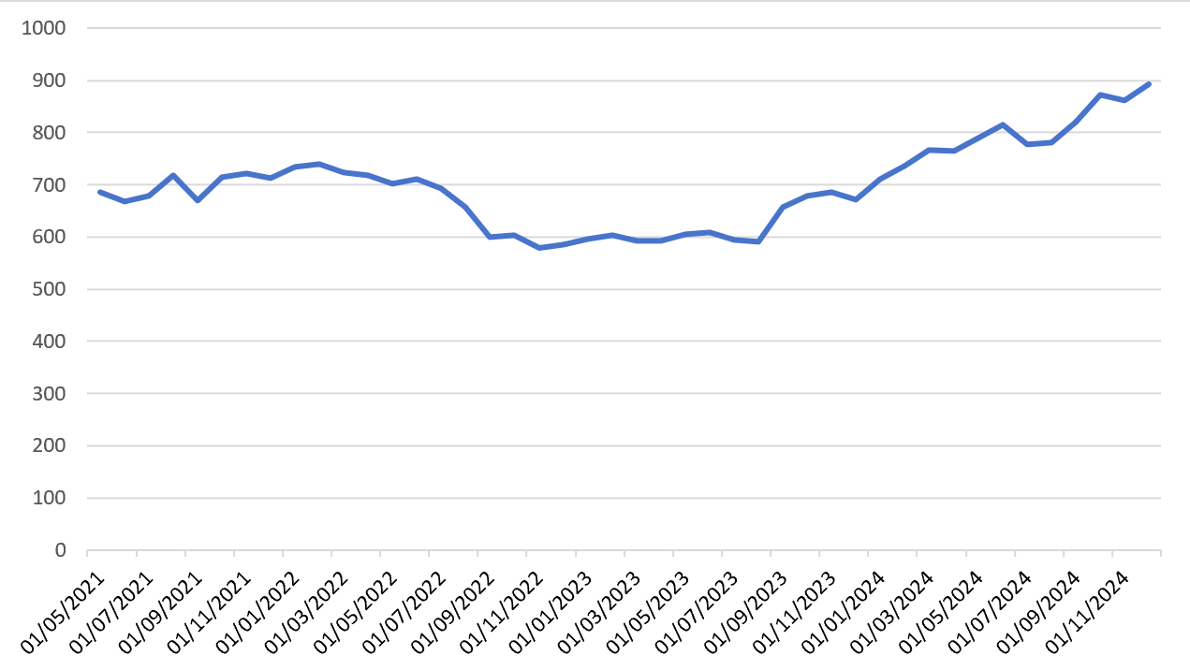
Fig. 1. Rubber Prices in Malaysia from January 2016 to December 2024

A trend reflects the upward or downward directional change in time series data. The analysis of Malaysian rubber prices from January 2016 to December 2024 revealed an overall upward trend. Additionally, it is important to consider whether the data exhibits seasonality. Seasonality refers to fluctuations in a time series that recur periodically with the season or month (Lelwala et al., 2024). This study used the Kruskal-Wallis test for seasonality, and the results showed an H value of 4.81, which is less than the critical value of 19.68, indicating that Malaysian rubber prices do not exhibit significant seasonality. Although individual months may experience short-term fluctuations due to factors such as weather, labor, or export policies, the overall trend exhibits no cyclical pattern.

3.3 Model Selection

By exploring the components of the data, it was found that the data showed a certain trend but no seasonality. Therefore, this study selected three commonly used time series forecasting methods for modelling comparison, which are the ARIMA model, the exponential smoothing model (including the Holt-Winter’s and Brown’s methods), and the double moving average model (DMA).

3.3.1 ARIMA Model

Using 90% of the data for the analysis, a total of 97 data, with a period from January 2016 to January 2024, as shown in Fig. 2. From Fig. 2, it can be obtained that the data is not stationary and needs to have appropriate differencing to eliminate the trend component. The plot after conducting first-order differencing is shown in Fig. 3.

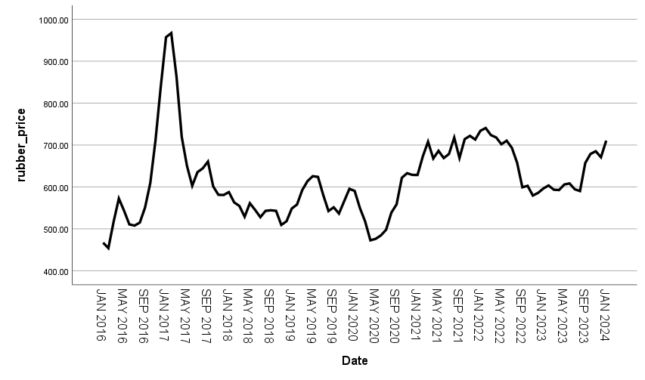
Fig. 2. Time Series Plot of Malaysian Rubber Prices

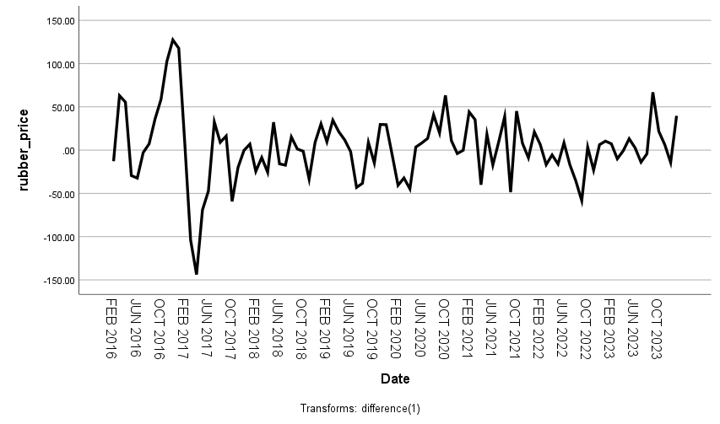
Fig. 3. Time Series Plot of Malaysian Rubber Prices after First-order Difference

From Fig. 3, it can be observed that the differenced data shows stationarity and is suitable for subsequent use of the ARIMA model. The parameters of the ARIMA model are determined by the autoregressive (AR) , difference (I), and moving average (MA). In ARIMA(p,d,q) model, d is the order of the difference, and since the data is stationarity after the first order difference, therefore d is 1.

The ACF and PACF plots were used to determine the values of p and q for the ARIMA (p, d, q) model: p was determined by observing the PACF plot, while q was determined by observing the ACF plot. The ACF and PACF plots after first-order differencing are shown in Fig. 4 and Fig. 5.
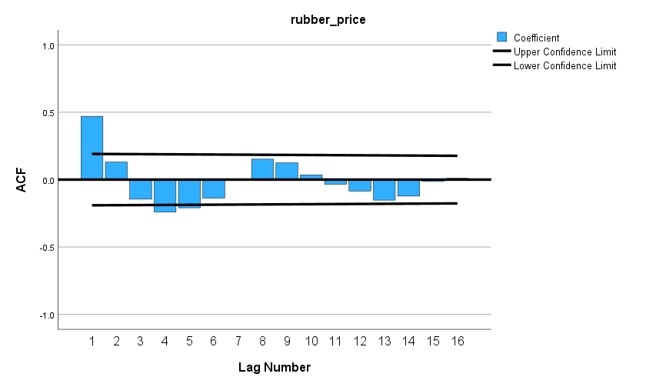
Fig. 4. ACF Plot after First-order Difference

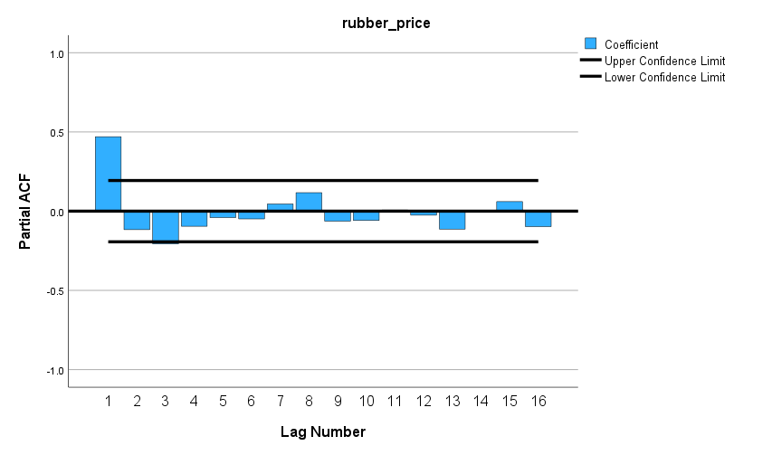
Fig. 5. PACF Plot after First-order Difference

The PACF tails off quickly after the first or second order, indicating that the autoregressive (AR) order p should be set to 1 or 2. The ACF decreases gradually after the first to third orders, indicating that the moving average (MA) order q should be set to 1, 2, 3. The resulting ARIMA models are therefore ARIMA(1,1,1), ARIMA(1,1,2), ARIMA(2,1,1), ARIMA(2,1,2), ARIMA(1,1,3) and ARIMA(2,1,3).

3.3.2 Exponential Smoothing Model

Holt-Winter’s exponential smoothing method is suitable for time series with linear trends and can capture trend changes in time series. This method introduces a trend smoothing factor, allowing it to flexibly adapt to sequences with a single trend. The main advantages of the Holt method are its simplicity and ease of implementation, making it suitable for time series data without seasonal changes but with long-term trends (Febrian et al., 2020; Shukor et al., 2021).

Brown’s double exponential smoothing method, as a variant of the Holt method, does not include a smoothing term for trends and is suitable for relatively stable time series, but it can still capture long-term trends in the data. Its characteristics include fewer model parameters and a simple calculation process, making it suitable for relatively stable sequences with slight trend changes (Wang et al., 2024).

3.3.3 Double Moving Average Model

The double moving average method is a classic technique that eliminates short-term fluctuations by calculating the double moving average of time series data. Its primary feature is the use of two moving windows to smooth the data, effectively reducing the impact of random fluctuations, making it suitable for stable time series data (Febrian et al., 2020). In this study, the DMA (3) model is selected as the forecasting model. DMA (3) effectively smooths out short-term noise and extreme fluctuations, providing a more stable forecast. It’s simple and intuitive computational process makes it ideal for preliminary modeling and comparison. This choice not only serves as a benchmark for comparing different forecasting methods but also suits time series data with less volatility and no clear seasonal or cyclical trends (Chen et al., 2023). Therefore, DMA (3) provides a valuable reference for evaluating the performance of other models, especially in stabilizing market forecasts.

3.4 Model Application

In this study, nine different time series models were used to predict rubber prices in Malaysia. These models include ARIMA models with different structures, exponential smoothing methods (Holt, Brown), and double moving average methods (DMA). The selection of models was based on an analysis of historical rubber price data, aiming to identify the most suitable model for price forecasting. The nine selected models are: ARIMA (1,2,1), ARIMA(1,2,2), ARIMA(2,2,1), ARIMA(2,2,2), ARIMA(2,1,3), ARIMA(1,1,3), Holt-Winter’s exponential smoothing, Brown’s exponential smoothing, and double moving average. The predicted value of rubber from February 2024 to December 2024 resulting from the application of the nine models are shown in Table 2.

Table 2. Predicted Value of Rubber Prices in Malaysia, January-December 2024

Date | Predicted Value
Date | Holt-Winter’s | Brown’s | ARIMA (1,1,1) | ARIMA (1,1,2) | ARIMA (2,1,1) | ARIMA (2,1,2) | ARIMA (2,1,3) | ARIMA (1,1,3) | DMA (3)
1/2/2024 | 740.27 | 740.92 | 734.29 | 734.05 | 726.67 | 726.78 | 729.93 | 739.30 | 706.00
1/3/2024 | 770.10 | 771.80 | 744.90 | 751.33 | 727.66 | 736.33 | 739.15 | 759.41 | 712.09
1/4/2024 | 799.92 | 802.68 | 750.55 | 755.15 | 720.02 | 738.37 | 729.81 | 766.29 | 732.49
1/5/2024 | 829.75 | 833.55 | 754.35 | 757.82 | 708.57 | 735.63 | 717.03 | 766.85 | 735.82
1/6/2024 | 859.57 | 864.43 | 757.45 | 760.38 | 696.55 | 731.90 | 705.77 | 770.38 | 744.95
1/7/2024 | 889.40 | 895.31 | 760.29 | 762.93 | 685.88 | 730.06 | 697.19 | 772.52 | 758.99
1/8/2024 | 919.22 | 926.18 | 763.03 | 765.49 | 677.45 | 731.17 | 691.11 | 775.31 | 765.67
1/9/2024 | 949.05 | 957.06 | 765.73 | 768.04 | 671.48 | 734.67 | 687.05 | 777.79 | 775.69
1/10/2024 | 978.87 | 987.94 | 768.42 | 770.59 | 667.80 | 739.18 | 684.48 | 780.42 | 787.07
1/11/2024 | 1008.69 | 1018.81 | 771.10 | 773.15 | 665.99 | 743.38 | 682.99 | 782.98 | 795.46
1/12/2024 | 1038.52 | 1049.69 | 773.78 | 775.70 | 665.59 | 746.55 | 682.27 | 785.58 | 805.55

Through comparing the actual values with the predicted values from February to December 2024, the predicted values in the various ARIMA models ranged from RM720 to RM790, while the predicted values from the Holt-Winter's and Brown's exponential smoothing method ranged from RM740 to RM1050, and the predicted values from the double moving average (DMA) method ranged from RM700 to RM810. This indicated significant differences in the prediction results among the three methods: ARIMA, exponential smoothing, and double moving average. In this dataset, the exponential smoothing method yielded larger prediction values with a wider range, while the ARIMA models produced moderate prediction values with the narrowest range.

3.4 Model Evaluation

The rubber price values predicted for February to December 2024 using the training data (90%) were compared with the true values and the resulting error assessments for each model were shown in Table 3. From Table 3, it could be obtained that the ARIMA (1,1,3) model performed optimally in all the five error metrics. For ARIMA (1,1,3), the MAE was 37.6065, MSE was 2810.4604, RMSE was 53.0138, and MAPE was 4.4132, which were all lower than the other models. This indicated that the ARIMA (1,1,3) model had higher accuracy and stronger predictive ability in capturing the patterns of Malaysian rubber price.

Table 3. Evaluation of Each Model

Model | MAE | MSE | RMSE | MAPE
ARIMA (1,1,1) | 48.8974 | 3858.6952 | 62.1184 | 5.8048
ARIMA (1,1,2) | 46.1017 | 3620.9300 | 60.1742 | 5.4553
ARIMA (2,1,1) | 115.2803 | 18019.6093 | 134.2371 | 13.8387
ARIMA (2,1,2) | 71.6103 | 7030.3819 | 83.8474 | 8.5859
ARIMA (2,1,3) | 103.1785 | 14902.1670 | 122.0744 | 12.3595
ARIMA (1,1,3) | 37.6065 | 2810.4604 | 53.0138 | 4.4132
Holt-Winter’s | 81.9647 | 9698.6395 | 98.4817 | 9.9101
Brown’s | 87.8754 | 11051.6382 | 105.1268 | 10.6228
DMA | 51.0881 | 3185.6206 | 56.4413 | 6.2095

The ARIMA (1,1,3) model was selected as the final forecasting model due to its superior performance across multiple error metrics. This model provided more reliable forecasting results for practical applications and offered robust data support for decision-making and strategic planning.

3.5 Forecasting

Through the application of differential processing to convert the data into a stationary sequence, the ARIMA (1,1,3) model was used to capture the long-term trends and short-term fluctuations in rubber price data. The model performed exceptionally well during the fitting phase, accurately modeling price fluctuations in historical data and exhibiting minimal prediction errors in the test set. As a result, the ARIMA (1,1,3) model was selected as the final prediction model for this study. The ARIMA (1,1,3) model was used to forecast rubber prices for the period from January 2025 to December 2026, as shown in Table 4.

Table 4. Rubber Prices in Malaysia from 2025 to 2026 Predicted Using ARIMA (1,1,3) Model

Date | Forecast value | Date | Forecast value
Jan 2025 | 893.52 | Jan 2026 | 805.19
Feb 2025 | 891.40 | Feb 2026 | 804.09
Mar 2025 | 873.55 | Mar 2026 | 803.49
Apr 2025 | 858.76 | Apr 2026 | 803.30
May 2025 | 846.55 | May 2026 | 803.47
Jun 2025 | 836.53 | Jun 2026 | 803.93
Jul 2025 | 828.37 | Jul 2026 | 804.65
Aug 2025 | 821.79 | Aug 2026 | 805.58
Sep 2025 | 816.53 | Sep 2026 | 806.69
Oct 2025 | 812.40 | Oct 2026 | 807.96
Nov 2025 | 809.23 | Nov 2026 | 809.35
Dec 2025 | 806.87 | Dec 2026 | 810.86

The ARIMA (1,1,3) model predicts rubber prices from January 2025 to December 2026, as shown in Fig. 6.

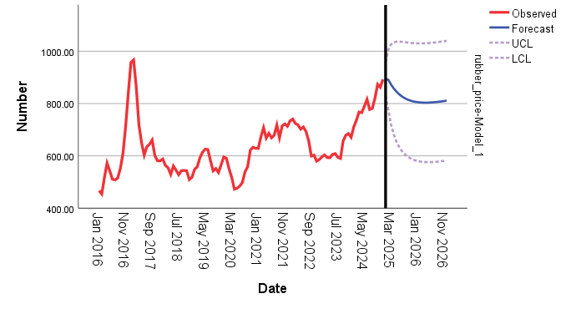
Fig. 6. Predicted Values Using ARIMA (1,1,3) Model

As can be seen from Fig. 6, rubber prices declined slightly in early 2025, then stabilized and maintained a slight upward trend. In particular, in the second half of 2025, price changes were relatively stable, with significantly reduced volatility. Overall, the forecast value of rubber prices remained between RM800 and RM900, demonstrating market stability and a certain degree of risk resistance. Specifically, from January to December 2025, rubber prices experienced a certain degree of decline. The predicted price for January 2025 was RM893.52, which then decreased to RM891.40 and RM873.55 in February and March, respectively. During the period from January 2026 to June 2026, the predicted prices gradually stabilized. From January 2026 to June 2026, rubber prices remained stable between RM803 and RM805, with very limited fluctuations. From June 2026 onwards, rubber prices began to increase slowly, showing a certain upward trend.

This data indicated that rubber prices would follow a relatively stable trend in the future, with relatively low volatility, reflecting market stability. The overall price trend showed a slow recovery, but the magnitude was small, indicating that the momentum for global rubber demand growth was weak, while the supply side might also be gradually returning to normal.

4. Conclusion

This study was based on analyzing the Malaysian natural rubber price data for the period from January 2016 to December 2024, which was identified as having a trend and no seasonality. Based on the characteristics of rubber price data, nine time series forecasting models were constructed using the ARIMA model, the Exponential Smoothing and the Double Moving Average (DMA) method, and the model forecasting performance was evaluated using the Mean Absolute Error (MAE), Mean Square Error (MSE), Root Mean Squared Error (RMSE), and Mean Absolute Percentage Error (MAPE). The results showed that the ARIMA (1,1,3) model performed the best among all the evaluation metrics, had the smallest prediction error, and could capture the price trend and volatility characteristics more accurately. Based on the forecast results of the ARIMA (1,1,3) model, it was predicted that the rubber price would stabilize in the range of RM800 to RM900 from 2025 to 2026, reflecting a balanced supply and demand in the market with relatively moderate volatility.

Based on the forecast results, it was recommended that the government and producers use model trends to guide policy planning and prepare for price fluctuations. Based on the predicted rubber prices, the government could prepare safeguards in advance in its policy planning to cope with the falling price phase; and producers could prudently control their production and inventories during the lower rubber price phase. In addition, relevant organizations should continuously track market and price data, and regularly update model parameters to ensure that forecasts were forward-looking and effective.

This study made forecasts based on historical rubber price series and did not incorporate external factors that might affect price fluctuations, such as macroeconomic variables (inflation rate, exchange rate, international oil price, etc.), supply chain shocks (natural disasters, transportation disruptions, raw material shortages, etc.) and seasonal changes (rainfall, rubber harvesting season, etc.). These factors might affect forecast accuracy, so in practical applications, comprehensive interpretation was necessary in conjunction with relevant background information.
Competing interests

Authors have declared that no competing interests exist.

COMPETING INTERESTS DISCLAIMER:
Authors have declared that they have no known competing financial interests OR non-financial interests OR personal relationships that could have appeared to influence the work reported in this paper.

Disclaimer (Artificial intelligence)
Authors hereby declare that NO generative AI technologies such as Large Language Models (ChatGPT, COPILOT, etc.) and text-to-image generators have been used during the writing or editing of this manuscript.

References

Ajiono, A., & Hariguna, T. (2023). Comparison of three time series forecasting methods on linear regression, exponential smoothing and weighted moving average. International Journal of Informatics and Information Systems, 6(2), 89-102. https://doi.org/10.47738/ijiis.v6i2.165

Bashier, Y. M., Ahmed, E. M., Elfaki, K. E., Thambah, S., & Khin, C. A. A. (2022). Factors Affecting the Malaysian Natural Rubber Production and Consumption. Academy of Strategic Management Journal, 21, 1-12.

Ali, M. F., Akber, M. A., Smith, C., & Aziz, A. A. (2021). The dynamics of rubber production in Malaysia: Potential impacts, challenges and proposed interventions. Forest Policy and Economics, 127, 102449. https://doi.org/10.1016/j.forpol.2021.102449

Chen, Y., Fang, Y., Li, X., & Wei, J. (2023). A factor pricing model based on double moving average strategy. Humanities and Social Sciences Communications, 10(1), 1-13. https://www.nature.com/articles/s41599-023-02362-x

Chicco, D., Warrens, M. J., & Jurman, G. (2021). The coefficient of determination R-squared is more informative than SMAPE, MAE, MAPE, MSE and RMSE in regression analysis evaluation. Peerj computer science, 7, e623. https://doi.org/10.7717/peerj-cs.623

Febrian, D., Al Idrus, S. I., & Nainggolan, D. A. J. (2020). The comparison of double moving average and double exponential smoothing methods in forecasting the number of foreign tourists coming to North Sumatera. In Journal of Physics: Conference Series (Vol. 1462, No. 1, p. 012046). IOP Publishing. https://doi.org/10.1088/1742-6596/1462/1/012046

Erandi, J. D. T., Dilshan, L. H. K., Piyasena, K. N. T., & Chandrasekara, N. V. (2022, December). Time Series and Neural Network Approaches for Accurate Forecasting of Monthly Natural Rubber Prices in Sri Lanka. In 2022 6th SLAAI International Conference on Artificial Intelligence (SLAAI-ICAI) (pp. 1-5). IEEE. https://doi.org/10.32604/csse.2023.037366

Estrada, M. D. R. C., Camarillo, M. E. G., Parraguirre, M. E. S., Edgar, M., Castillo, G., Juárez, E. M., & Gómez, M. J. C. (2020). Evaluation of several error measures applied to the sales forecast system of chemicals supply enterprises. International Journal of Business Administration, 11(4), 39-51. https://doi.org/10.5430/ijba.v11n4p39

Fox, J., & Castella, J. C. (2013). Expansion of rubber (Hevea brasiliensis) in Mainland Southeast Asia: what are the prospects for smallholders?. The Journal of Peasant Studies, 40(1), 155-170. https://doi.org/10.1080/03066150.2012.750605

Fu, M. C., & Jamaludin, S. S. S. (2022). Forecasting Malaysia bulk latex prices using autoregressive integrated moving average (ARIMA) and exponential smoothing. Malaysian Journal of Fundamental and Applied Sciences, 18(1), 70-81. https://doi.org/10.11113/mjfas.v18n1.2404

Hashim, Z., Yusof, Z. M., Rahman, R. A., & Norizan, N. F. H. M. (2023, November). Factors that affecting natural rubber price in Malaysia: A perspective from a rubber tappers in Padang Terap, Kedah. In AIP Conference Proceedings (Vol. 2896, No. 1). AIP Publishing. https://doi.org/10.1063/5.0177282

Hodson, T. O. (2022). Root mean square error (RMSE) or mean absolute error (MAE): When to use them or not. Geoscientific Model Development Discussions, 2022, 1-10. https://doi.org/10.5194/gmd-2022-64

Hu, T., Chen, C., & Wei, H. (2024). A Novel Methodology for Forecasting Petrochemical Product Prices in East China Market by Applying ARIMAX Time Series and Machine Learning Models. In International Petroleum Technology Conference (p. D011S011R004). IPTC. https://doi.org/10.2523/IPTC-23115-MS

Kumar, K. A., Pinto, P., Spulbar, C., Birau, R., Hawaldar, I. T., Vishal, S., & Bărbăcioru, I. C. (2023). ARIMA model to forecast the RSS-1 rubber price in India: A case study for textile industry. Industria Textilă, 74(02), 238-245. https://doi.org/10.35530/IT.074.02.2022132

Lelwala, E. I., Seamasinghe, W. M., & Gunarathna, K. M. L. M. (2024). Nonparametric Approach to Detecting Seasonality in Time Series: Application of the Kruskal-Wallis (KW) Test on Tourist Arrivals to Sri Lanka. South Asian Journal of Business Insights, 4(1). https://doi.org/10.4038/sajbi.v4i1.61

Martínez, S., Eguía, P., Granada, E., Moazami, A., & Hamdy, M. (2020). A performance comparison of multi-objective optimization-based approaches for calibrating white-box building energy models. Energy and Buildings, 216, 109942. https://doi.org/10.1016/j.enbuild.2020.109942

Mohammed, A. R., Hassan, K. S., & Abdel-Aal, M. A. (2022). Moving average smoothing for Gregory-Newton interpolation: a novel approach for short-term demand forecasting. IFAC-PapersOnLine, 55(10), 749-754. https://doi.org/10.1016/j.ifacol.2022.09.499

Montesinos López, O. A., Montesinos López, A., & Crossa, J. (2022). Overfitting, model tuning, and evaluation of prediction performance. In Multivariate statistical machine learning methods for genomic prediction (pp. 109-139). Cham: Springer International Publishing.

Nyondo, P., & Varghese, R. (2024). Forecasting natural rubber prices using commodity market indicators: a machine learning approach. International Journal of Revenue Management, 14(3), 221-252. https://doi.org/10.1504/IJRM.2024.142325

Shaharuddin, H. I. B., Azmi, N. N. B. K., & Shamsudin, F. I. M. B. (2023). Modelling and Forecasting Natural Rubber Price in Malaysia: Comparison Between HES, ARIMA and ANN. In International Conference on Mathematics, Statistics, and Computing Technology (pp. 145-160). Singapore: Springer Nature Singapore. https://doi.org/10.1007/978-981-97-3450-4_10

Shukor, S. A., Sufahani, S. F., Khalid, K., Abd Wahab, M. H., Idrus, S. Z. S., Ahmad, A., & Subramaniam, T. S. (2021, May). Forecasting stock market price of gold, silver, crude oil and platinum by using double exponential smoothing, Holt’s linear trend and random walk. In Journal of Physics: Conference Series (Vol. 1874, No. 1, p. 012087). IOP Publishing. https://doi.org/10.1088/1742-6596/1874/1/012087

Sukiyono, K., Yuliarso, M. Z. S. P., Utama, E., Yuliarti, R., Novanda, R., & Priyono, B. S. (2019). Possible method for monthly natural rubber price forecasting. Journal of Advanced Research in Dynamical and Control Systems–Jardcs, 11, 387-395.

Syed, M. A., Abdalla, A. A., Al-Hamdi, A., & Khalid, M. (2020, November). Double moving average methodology for smoothing solar power fluctuations with battery energy storage. In 2020 International Conference on Smart Grids and Energy Systems (SGES) (pp. 291-296). IEEE. https://doi.org/10.1109/SGES51519.2020.00058

Wang, N., Zhuang, W., Ran, Z., Wan, P., & Fu, J. (2024). Prediction of acute onset of chronic cor pulmonale: comparative analysis of Holt-Winters exponential smoothing and ARIMA model. BMC Medical Research Methodology, 24(1), 204. https://link.springer.com/article/10.1186/s12874-024-02325-z

Zuhdi, F. (2021). The Indonesian natural rubber export competitiveness in global market. International Journal of Agriculture System, 8(2), 130-139. http://dx.doi.org/10.20956/ijas.v8i2.2518

