**Congenital Insensitivity to Pain in a Nigerian Child: A Case Report and Literature Review**

**ABSTRACT**

**Background**

The pain pathway is a complex pathway mediated by several chemical mediators that begins with the activation of nociceptors and the subsequent triggering of various biochemical changes that result in the transmission of the pain impulse to the thalamus and the somatosensory cortex. Congenital insensitivity to pain (CIP) is a very rare genetic disorder that may not be diagnosed early, leading to worsening deformities.

**Aim**: This case report presents the history, diagnosis and management of a 2-year-old female with CIP, highlighting the difficulties in diagnosing this condition, emphasising the need for careful history taking and physical examination, including the need for multidisciplinary care.

**Case Report**

The case summary of a 2-year-old Nigerian female who presented with complaints of developmental delay and repeated self-inflicted injuries was reported. A clinical diagnosis of congenital insensitivity to pain was made. An initial diagnosis of self-mutilation: Lesch-Nyhan syndrome with left hand cellulitis to rule out chronic osteomyelitis of the left hand. Acute osteomyelitis of the left leg with a background of developmental delay was made. The results of investigations revealed normal serum uric acid levels of 179mmol/L. During the admission, she was co-managed with the Orthopaedic surgeons, Oro-maxillofacial surgeons and Burns and Plastic surgeons. She received parenteral antibiotics with multidisciplinary management, and her parents were counselled extensively on her condition. She made a good clinical response and had complete healing of the wounds after 3 weeks.

**Conclusion:** In developing countries, although perinatal asphyxia as a cause of developmental delay is more commonly observed, putting affected children at risk of non-accidental injuries, careful history taking and physical examination may identify uncommon diagnoses like CIP early and prevent worsening disabilities and increased risk for death.

**Key words**

*Congenital insensitivity to pain, Nigeria*, *Child*, *Hereditary and sensory neuropathy*, *Case report.*

**INTRODUCTION**

Pain is defined as “an unpleasant sensory and emotional experience associated with, or resembling that associated with, actual or potential tissue damage” 1. Although uncontrolled pain is often regarded as an unpleasant sensation, pain has a vital protective function, alerting to harmful stimuli and protecting against further tissue damage2. There is a long history of disagreement as to the essence of the experience in a definition of pain. This is not surprising as the term covers a substantial range of experiences arising from diverse conditions of injury and disease (Craig & MacKenzie, 2021; Djordjevic, 2023).

The pain pathway is a complex pathway mediated by several chemical mediators that begins with the activation of nociceptors and the subsequent triggering of various biochemical changes that result in the transmission of the pain impulse to the thalamus and the somatosensory cortex.3,4.. The process of nociception (i.e., the neural process of encoding noxious stimuli may become impaired as occurs in Congenital insensitivity to pain (CIP)5,6. CIP is a broad term for a group of rare hereditary diseases classified as hereditary sensory autonomic neuropathies (HSAN).5

In the HSAN, which are largely autosomal recessive conditions, the absence of pain sensation may be accompanied by defects in other sensory (thermal sensitivity, light touch, proprioception) and autonomic functions (anhidrosis or hyperhidrosis, defective lacrimation, postural hypotension)7 and may result in marked disability due to the inability to feel painful stimuli and protect adequately.

Patients with CIP often experience trauma, bony fractures, and osteomyelitis because of insensitivity to pain. Therefore, such patients may undergo surgery such as osteotomy and amputation. Since it is a rare condition, reports on the anaesthetic conduct in patients with CIPA are not easily found in the literature (Klaitman et al., 2024). This case report presents the history, diagnosis and management of a 2-year-old female with CIP, highlighting the difficulties in diagnosing this condition, emphasising the need for careful history taking and physical examination, including the need for multidisciplinary care.

**CASE PRESENTATION**

A 2 year 3 month old female was referred to the Paediatric Neurology Clinic of our hospital with complaints of delayed motor development and recurrent self-mutilation of the lips and fingers.

She was initially evaluated in another tertiary hospital where a diagnosis of cerebral palsy was made; however, with recurrent deforming hand injuries, she was referred to our facility for Orthopaedic evaluation. Following presentation in the General Children Outpatient Clinic of our facility, she was assessed to have Cerebral palsy with wound sepsis and self-mutilation, with a differential diagnosis of Lesch-Nyhan syndrome and was subsequently referred to the Paediatric Neurology Clinic for further evaluation and care.

Pregnancy was supervised, and delivery was at term via an emergency caesarean section for poor progress in labour. She did not cry well at birth and weighed 2.5kg. She was presently only able to walk with support; other developmental milestones were within normal limits. She is the second child of non-consanguineous parents. The older sibling is a 4-year-old female who did not have similar symptoms. There was no other family history of similar symptoms.

On examination, she had no cranial nerve deficits, had normal tone, power, and deep tendon reflexes. She had deformed fingers on both hands, with missing distal phalanges on the right hand, with hyper pigmented healed contracture deformities. She had a diffuse swelling on the left 4th and 5th digits, extending to the wrist with erythema of the palmar aspect of the left hand with differential warmth and pus discharging from the tip of the fourth left digit. In addition, she had healing ulcers on both knees and a diffuse, tender swelling of the proximal half of the left leg.

She had a healed scar with residual defect on the left lateral aspect of the lower lip and a deformed lower jaw, with missing lower incisors and canines. She had a weight of 10 kg and a length of 85 cm, which were within normal limits for her age. The images of the limb and lower lip deformities are shown in Figures 1 and 2 below, respectively.

An initial diagnosis of self-mutilation: Lesch-Nyhan syndrome with left hand cellulitis to rule out chronic osteomyelitis of the left hand. Acute osteomyelitis of the left leg with a background of developmental delay was made.

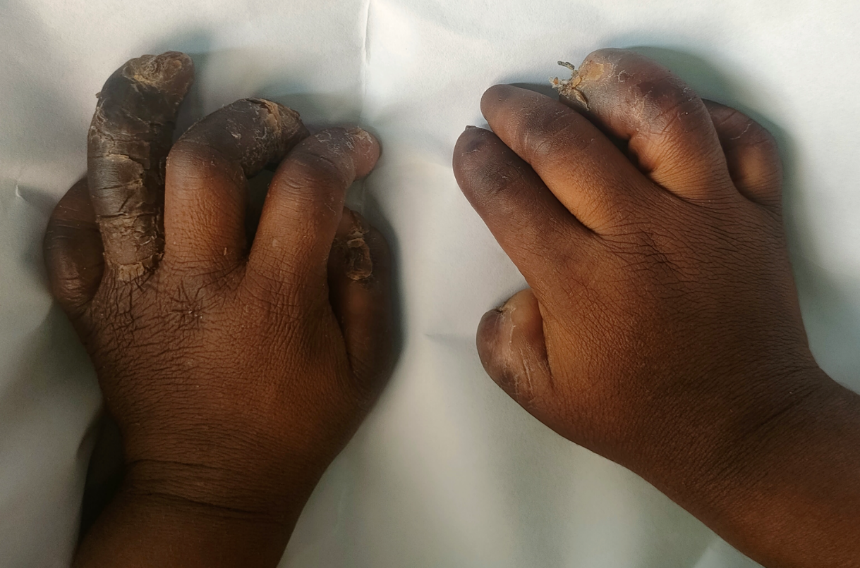

Figure 1: Image of the hand deformity and resolving cellulitis on the left hand

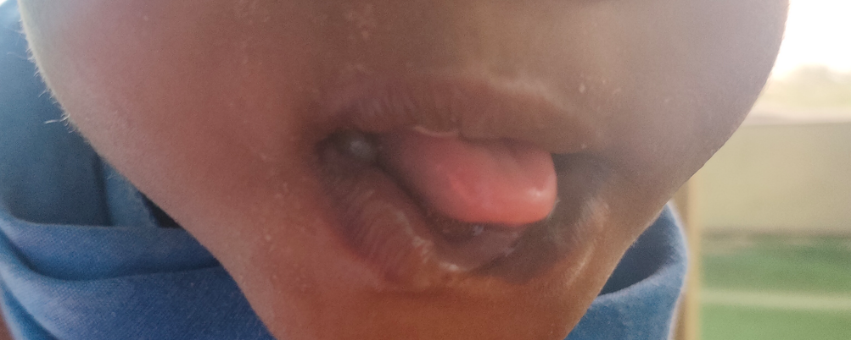

Figure 2: Image of the lower lip defect.

The results of investigations revealed normal serum uric acid levels of 179mmol/L.

Radiographs of the hands revealed absent proximal and distal phalanges of the right thumb, right distal 2nd, 3rd and 4th distal phalanges and absent distal phalanges of the third and fourth digits of the left hand (Figure 3). The radiograph of the left leg was essentially normal.

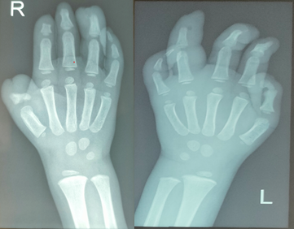

Figure 3: Radiograph of the right and left hands of a child showing destruction of some distal phalanges

The full blood count revealed moderate anaemia with PCV of 25.9%, thrombocytosis of 403 X 109/L, leucocytosis of 35.4 X 109/L and neutrophilia of 73.8%. Serum electrolytes, urea and creatinine revealed hyponatraemia of 128 mmol/L and hypokalaemia of 2.9 mmol/LThe wound swab microscopy, culture and sensitivity revealed a heavy growth of *Staphylococcus aureus*. The blood culture did not yield any growth.

Due to the severity and pattern of deforming injuries, she was also evaluated by the Social Paediatricians on the clinical suspicion of non-accidental injuries. Serendipitously, during the admission, she was noticed not to have any painful reaction during phlebotomies or securing intravenous access. She was also observed not to respond to painful stimuli and exhibited a lack of reflex withdrawal to noxious stimuli. Further neurologic examination revealed a generalised absence of pain and temperature sensation. Further history elicited from parents revealed the absence of cry to painful stimuli noticed from birth, such as during vaccinations and earlobe piercing. Parents also recalled that on various occasions, she did not cry in response to touching hot surfaces or liquids and often bumped into objects or fell down without displaying any sign of distress or pain. She was, however, noted to sweat excessively.

During the admission, she was co-managed with the Orthopaedic surgeons, Oro-maxillofacial surgeons and Burns and Plastic surgeons. She received she was on admission for two weeks, where she received intravenous antibiotics and haematinics as well as alternate daily wound dressing with Betadine and KY Jelly-soaked gauze, covered with crepe bandage up to the distal third of both forearms. Aspiration of the left leg swelling revealed a haematoma, possibly from a recent fall. She made good clinical improvement and was discharged home after two weeks on admission on oral antibiotics and continued wound dressing on an outpatient basis.

Parents were counselled on the child’s condition and need for more vigilant supervision to prevent further injuries, and home safety measures. She was discharged to the Paediatric Neurology outpatient clinic, the Orthopaedic surgeons, Burns and Plastics surgeons and Paedodontist and Ophthalmologist.

On her follow-up visit 2 weeks after discharge, her wounds were completely healed, and there was no occurrence of new injuries.

**LITERATURE REVIEW**

This case report focuses on a 2-year-old female patient with congenital insensitivity to pain (CIP), highlighting the challenges in diagnosis, limitations in treatment options, and the importance of a multidisciplinary approach in managing this condition.

Congenital Insensitivity to Pain, also known as Congenital Analgesia, is a rare neurological disorder in which patients have a specific inability to perceive pain but intact sensation to other stimuli such as vibration sense, proprioception, and light touch. Motor, autonomic, and cognitive modalities also remain unaffected. The first described case was reported in 1932 of a circus performer who acted as a human pincushion 8–11. Congenital insensitivity to pain is inherited in an autosomal recessive pattern. Over the years, there have been various studies exploring the different aspects of CIP. These research studies have been vital in aiding the understanding of the complexities and challenges associated with CIP.

Congenital Insensitivity to Pain, a hereditary sensory and autonomic neuropathy (HSAN), is genetically and clinically heterogeneous, caused by mutations in several different genes. It may result from a genetic mutation within the NTRK1 gene, which governs the production of the tyrosine receptor (TrkA) responsible for nerve growth factor (NGF). It may also result in a mutation in the SCN9A gene, which encodes for Nav 1.7, a sodium channel receptor on nociceptors 6,12 . This loss-of-function mutation results in the lack of transduction of painful stimuli to the brain, and subsequent loss of safeguarding reflexes and protection from noxious stimuli.

Karmani et al.,13 noted that recurrent fractures, neuropathic joints, and osteomyelitis were common orthopaedic complications in patients with CIP. The authors also highlighted the possibility of non-accidental injury in the child reported. Our patient exhibited a milder form of CIP compared to the more severe type described by Pérez-López et al.,11. The severe form, known as Congenital Insensitivity to Pain associated with anhidrosis (CIPA) or hereditary sensory and autonomic neuropathy type IV, is characterised by three primary clinical features: insensitivity to pain, the inability to sweat, and intellectual disability. This description aligns with the findings reported by Kelly Knupp et al.,14 who highlighted that individuals with anhidrosis may experience life-threatening episodes of hyperthermia if not promptly recognised.

Schalka et al.,15 reported a 4-year case study of CIP patients and proposed the use of a mouth guard-like appliance, starting once the first primary molars erupted. In cases of poor device retention, a small amount of composite resin could be bonded to the cervical region of the buccal surface of the first primary molars before making an impression. The study suggested that extracting all primary teeth should be a last resort, considered only if all other options fail or in extreme cases.

Shorer et al.,16 reported a novel, loss-of-function mutation in homozygosity that causes CIP and provides a comprehensive clinical description of the patient. This may contribute to the clinical and neurophysiological characteristics of the sodium channel Nav1.7 channelopathy and expand our genetic knowledge, which might provide more accurate and comprehensive clinical, electrophysiological and genetic information. Ahsan et al., 17 on the other hand, emphasised that a multidisciplinary approach is required to treat these patients, including specialists in paediatrics, orthopaedics, dentistry, ophthalmology, and dermatology. Pérez-Lópezet al., 11 in their work introduced two novel and significant therapeutic concepts for managing these patients,viz, early surgical intervention for long bone fractures to prevent pseudoarthrosis and enable early weight-bearing, thus reducing the risk of further osteopenia, and the use of bisphosphonates to impede the progression of osteopenia and decrease the incidence of consecutive fractures.

Brandes and Stuth18 suggest that using a Bispectral Index (BIS) monitor in paediatric patients can be valuable for precisely adjusting anaesthetics to ensure unconsciousness, especially in cases where nociceptive feedback is compromised, and muscle relaxation is required for surgical purposes. Similarly, Drissi et al.,19, report states that the CIP gene discovery is catalysing the manufacturing of completely new classes of analgesics, and these are needed as alternatives to synthetic, highly potent opioids. This innovative approach holds the potential to address the opioid epidemic and provide safer pain management options for patients.

Early diagnosis based on the clinical features, differentiating it from other sensory neuropathies, and definitive genetic testing is of paramount importance.

Although the clinical presentation strongly indicated congenital insensitivity to pain, a genetic study was crucial to confirm the diagnosis. This, however, could not be done due to limited access to genetic studies in our locality and exorbitant out-of-pocket costs.

In our case, the patient received parenteral antibiotics and wound care and received multidisciplinary care by the Orthopaedic Surgeon, Burns and Plastic Surgeons, Dentist, and Dermatologist, with care ongoing.

A notable limitation in managing CIP was the lack of awareness among healthcare workers, which can delay or hinder proper diagnosis and treatment. Hence, there should be a high index of suspicion for this rare condition in order to avoid misdiagnoses.

**DISCUSSION**

This case report is among a few reported cases of this condition in African children8, especially in Nigeria among the paediatric population9. Although genetic testing was not possible in our setting, we made a clinical diagnosis of congenital insensitivity to pain based on the onset of symptoms in the neonatal period and clinical findings. Most cases of CIP reported have been with anhidrosis10. However, this was not the case in the index child. Due to its rarity, CIP could be misdiagnosed as other medical conditions that are seen more commonly. Nevertheless, clinicians need to be alert to the possibility of CIP in children with a history of recurrent self-mutilation with deforming injuries and developmental delay.

Congenital Insensitivity to Pain presents significant diagnostic and treatment challenges, particularly in resource-limited settings. The lack of availability and affordability of genetic studies in Nigeria further complicates the diagnosis of CIP. Treatment limitations, including the unavailability of specialised interventions, contribute to the management challenges faced by healthcare professionals. Increasing awareness among healthcare workers and the public is crucial for early detection and effective multidisciplinary management of CIP, as well as improving the quality of life of affected patients.

**Conclusion**

In conclusion, although perinatal asphyxia as a cause of developmental delay is more commonly observed in developing countries, putting affected children at risk of non-accidental injuries, careful history taking and physical examination may identify uncommon diagnoses like CIP early and prevent worsening disabilities and increased risk for death. Parent education and preventive measures of self-mutilation and injuries are essential. Further research and efforts to improve access to genetic testing and specialised interventions are needed to enhance the care and quality of life for individuals with CIP.

**CONSENT**

Written informed consent was obtained from the child’s parent.

**Disclaimer (Artificial intelligence)**

Option 1:

Author(s) hereby declare that NO generative AI technologies such as Large Language Models (ChatGPT, manuscript.

Option 2:

Author(s) hereby declare that generative AI technologies such as Large Language Models, etc. have been used during the writing or editing of manuscripts. This explanation will include the name, version, model, and source of the generative AI technology and as well as all input prompts provided to the generative AI technology

Details of the AI usage are given below:

1.

2.

3.

**REFERENCES**

1. IASP. IASP Announces Revised Definition of Pain - International Association for the Study of Pain (IASP) [Internet]. 2020 [cited 2025 Mar 20]. Available from: https://www.iasp-pain.org/publications/iasp-news/iasp-announces-revised-definition-of-pain/

2. Liu S, Kelliher L. Physiology of pain—a narrative review on the pain pathway and its application in the pain management. Dig Med Res [Internet]. 2022 Dec 30 [cited 2025 Mar 20];5(0). Available from: https://dmr.amegroups.org/article/view/8443

3. Wang M, Thyagarajan B. Pain pathways and potential new targets for pain relief. Biotechnol Appl Biochem. 2022;69(1):110–23.

4. Schon KR, Parker APJ, Woods CG. Congenital Insensitivity to Pain Overview. In: Adam MP, Feldman J, Mirzaa GM, Pagon RA, Wallace SE, Amemiya A, editors. GeneReviews® [Internet]. Seattle (WA): University of Washington, Seattle; 1993 [cited 2025 Mar 20]. Available from: http://www.ncbi.nlm.nih.gov/books/NBK481553/

5. Makar G, Kahlon S, Seeley M. Congenital Insensitivity to Pain due to a de novo L369P mutation in the SCN11A gene with Heterotrophic Ossification - A Case Report. J Orthop Case Rep. 2023 Aug;13(8):19–23.

6. Kurban M, Wajid M, Shimomura Y, Christiano AM. A nonsense mutation in the SCN9A gene in congenital insensitivity to pain. Dermatol Basel Switz. 2010;221(2):179–83.

7. Urs GKP, Urs GM, Hebbar VV, Konanur V. Hereditary Sensory and Autonomic Neuropathy V: A Case Report. | EBSCOhost [Internet]. Vol. 17. 2023 [cited 2025 Mar 20]. p. 1. Available from: https://openurl.ebsco.com/contentitem/doi:10.7860%2FJCDR%2F2023%2F62445.18082?sid=ebsco:plink:crawler&id=ebsco:doi:10.7860%2FJCDR%2F2023%2F62445.18082

8. Othman SA, Malik AA. Congenital insensitivity to pain with anhidrosis in Sudanese children. Sudan J Paediatr. 2016;16(2):80.

9. Y C, C L, L L. [Congenital insensitivity to pain with anhidrosis: A case report and literature review]. Zhong Nan Da Xue Xue Bao Yi Xue Ban [Internet]. 2019 Oct 28 [cited 2025 Mar 20];44(10). Available from: https://pubmed.ncbi.nlm.nih.gov/31857517/

10. S L, M AB, S A, M H, M H. Congenital insensitivity to pain with anhydrosis: report of a family case. Pan Afr Med J [Internet]. 2011 [cited 2025 Mar 20];9. Available from: https://pubmed.ncbi.nlm.nih.gov/22355435/

11. Pérez-López LM, Cabrera-González M, Gutiérrez-de la Iglesia D, Ricart S, Knörr-Giménez G. Update Review and Clinical Presentation in Congenital Insensitivity to Pain and Anhidrosis. Case Rep Pediatr. 2015;2015(1):589852.

12. Ur Rehman U, Mahmood T, Ali Z, Panityakul T. A Novel Approach of Complex Dual Hesitant Fuzzy Sets and Their Applications in Pattern Recognition and Medical Diagnosis. J Math. 2021;2021(1):6611782.

13. Karmani S, Shedden R, De Sousa C. Orthopaedic manifestations of congenital insensitivity to pain. J R Soc Med. 2001 Mar 1;94(3):139–40.

14. Knupp K, Brooks-Kayal AR. 49 - Channelopathies. In: Swaiman KF, Ashwal S, Ferriero DM, Schor NF, Finkel RS, Gropman AL, et al., editors. Swaiman’s Pediatric Neurology (Sixth Edition) [Internet]. Elsevier; 2017 [cited 2023 Nov 2]. p. 405–11. Available from: https://www.sciencedirect.com/science/article/pii/B9780323371018000497

15. Schalka MMS, Corrêa MSNP, Ciamponi AL. Congenital insensitivity-to-pain with anhidrosis (CIPA): A case report with 4-year follow-up. Oral Surg Oral Med Oral Pathol Oral Radiol Endodontology. 2006 Jun 1;101(6):769–73.

16. Shorer Z, Wajsbrot E, Liran TH, Levy J, Parvari R. A Novel Mutation in SCN9A in a Child With Congenital Insensitivity to Pain. Pediatr Neurol. 2014 Jan 1;50(1):73–6.

17. Ahsan S, Hydrie MZI, Hyder Naqvi SMZ, Shaikh MA, Shah MZ, Jafry SIA. Antibiotic prescription patterns for treating dental infections in children among general and pediatric dentists in teaching institutions of Karachi, Pakistan. PloS One. 2020;15(7):e0235671.

18. Brandes IF, Stuth E a. E. Use of BIS monitor in a child with congenital insensitivity to pain with anhidrosis. Pediatr Anesth. 2006;16(4):466–70.

19. Drissi I, Woods WA, Woods CG. Understanding the genetic basis of congenital insensitivity to pain. Br Med Bull. 2020 May 15;133(1):65–78.

20. Klaitman, S. S., Ling, G., Kristal, E., David, O., Elamour, S., Hershkovitz, E., & Ling, E. (2024). Living without pain: A 10-year study of congenital insensitivity to pain with anhidrosis. Pediatric Research, 1-6.

21. Craig, K. D., & MacKenzie, N. E. (2021). What is pain: Are cognitive and social features core components?. *Paediatric and Neonatal Pain*, *3*(3), 106-118.

22. Djordjevic, C. M. (2023). Finding a meaning for pain: Definitions, sense‐making, and philosophical health. *Journal of Evaluation in Clinical Practice*, *29*(7), 1196-1202.