INTEGRATED GRAVITY AND MAGNETIC DERIVATIVE MODELLING FOR STRUCTURAL CONTROL OF GOLD MINERALIZATION IN NORTH-CENTRAL NIGERIA
.

Abstract
Structural controls play a critical role in the localization of gold mineralization within Precambrian basement terrains. For this study, integrated gravity and magnetic derivative modelling is utilized to assess structural controls on gold mineralization in North-Central Nigeria. Schist belts, granitoid intrusions, and fault systems are the drivers behind mineral deposition in this region that makes up part of the Nigerian Basement Complex. In order to highlight subtle structural signatures in the aeromagnetic and bouguer gravity data, the datasets were processed using multiple derivative filters including the first vertical derivative (FVD), tilt derivative (TD), and analytic signal (AS). Structural lineaments were identified and analysed to describe possible pathways for the movement of hydrothermal fluids. Integration of gravity and magnetic derivatives identifies at least 48 major lineaments, with dominant NE–SW orientations (45%) and secondary NW–SE trends (33%) that correspond to the main tectonic fabrics of the basement. Strong spatial correlations were observed between identified structural lineaments and documented gold occurrences. A key finding from this study is that 72% of documented gold occurrences are located within 2 km of major lineaments, with the highest density of occurrences along fault intersections and zones of structural complexity.

Keywords: Gravity, Magnetic Derivatives, Structural Control, North-Central Nigeria, Gold Exploration
- Introduction
Gold mineralization in Precambrian basement terrains is commonly controlled by structural features such as faults, fractures, and shear zones (Ajibade et al., 2008). The Nigerian Basement Complex, part of the Pan-African mobile belt, is an excellent region for investigating and mapping these structures due to its complex tectonometamorphic history and extensive artisanal and small-scale gold mining activities. North-Central Nigeria, in particular, is characterized by NE–SW and NW–SE trending structural fabrics that have been reactivated during successive tectonic events, making it highly prospective for structurally hosted orogenic gold deposits (Ajibade et al., 2008; Obaje, 2009; Akintola et al., 2022) as mineral exploration in crystalline basement terrains often relies on identifying geological structures that serve as conduits for mineralizing fluids (Groves et al., 2016).

Geophysical techniques have proved over the decades to be powerful tools for mapping these structures as affirmed by Telford et al., 1990 because variations in density and magnetic susceptibility often reflect structural and lithological contrasts. In Egypt, Gobashy et al., 2023 combined geology and magnetic surveys to map the subsurface, identifying a clear link between specific geological structures and the presence of gold. Researchers in Nigeria have used single dataset (Oden 2019) and multi-datasets (Anakwuba 2014) for mineral exploration. Recent studies (Akinduko et al., 2022; Augie et al., 2024; Salako et al., 2024) has established the effectiveness of integrating geophysical datasets, particularly magnetic and radiometric data, and successfully delineated geological structures such as faults, fractures, and lineaments, which are considered potential hosts for minerals like gold. However, a notable gap exists in the application of the gravity method in many contemporary surveys around North Central Nigeria.

Gravity method is used extensively in many regions of the world for structural mapping. Eldursi et al., (2018) used gravity data and hydrothermal modelling to investigate the formation of mineral deposits in Morocco's Tighza district and found out that a large, underlying intrusive body, spreading from the Tighza fault, is responsible for the phases of mineralization in the region supporting the idea that mineral deposits are inherently linked to younger magmatic plutons. Despite increasing geophysical exploration efforts in Nigeria, relatively few studies have systematically integrated gravity and magnetic derivatives to investigate structural controls on gold mineralization in North-Central Nigeria. Hence, the underutilization of gravity method represents a potential limitation in current mineral exploration practices within the region. This study addresses this gap by applying advanced derivative filters such as Reduction-to-Equator (RTE), tilt derivative, vertical derivatives, analytic signal, and Euler deconvolution to both gravity and magnetic datasets, thereby providing a more holistic view of the structural architecture controlling gold mineralization in the region.
The objective of this research is therefore to delineate major and subsidiary lineaments, faults, and structural intersections using integrated gravity and magnetic derivative modelling, and to correlate these geophysical features with known gold occurrences.
- Location and Geological Setting
The study area, approximately 72,600 square kilometres, constituting about 7.86 % of the country’s landmass covers part of Niger state, Federal Capital Territory (FCT) and few other towns in Kaduna, Plateau and Nasarawa adjoining the FCT. The study area bounded by latitude 8º30’00”– 10º00’00” North of the equator and longitude 5º00’00” – 9º00’00” East of the Greenwich meridian (Figure 2.1) lies within the North-Central part of Nigeria. Some of the towns found within the region are Abuja, Minna, Keffi, Wushishi. Abaji, and Munya.

The region is underlain majorly by the Precambrian Basement Complex (Figure 2.2) comprising migmatite-gneiss complexes, schist belts, gneisses, granites, and metavolcanic sequences or Pan-African granitoids (Rahaman, 1988; Obaje, 2009; Bolarinwa et al., 2021). The lithological composition of the region includes migmatite–gneiss complexes, schist belts, and older granites, which are further intruded by Pan-African granitoids and minor doleritic dykes (Adekeye et al., 2023). Studies in areas such as Abuja, Burumburum, and Akwanga have revealed diverse petrographic units, including fine-to-medium grained biotite granites, granodiorites, syenites, diorites, aplites, pegmatites, and calc-silicate rocks. These units host common minerals such as quartz, feldspar, biotite, muscovite, hornblende, garnet, and tourmaline (Ameh et al., 2024). In the Arum and Nasarawa areas, the lithologies include porphyritic granite, granitic gneiss, and porphyroblastic gneiss, which exhibit structures such as foliation, joints, veins, and fractures with dominant NE–SW and NW–SE orientations (Ola-Buraimo et al., 2021). In the Ube-Wulko area of Akwanga, the basement rocks are composed of migmatitic gneisses and metasedimentary schists intruded by pegmatites and dolerites, indicating high-grade metamorphism and polyphase deformation (Ekwueme et al., 2010).
The Schist Belt of North Central Nigeria is a significant lithotectonic unit within the Nigerian Basement Complex (Precambrain) characterized by significant structural features such as tight to isoclinal folding, steep foliation, shearing, and pervasive jointing, which are indicative of complex polyphase deformation events (Ameh et al., 2023). It is traversed by N-S, NE-SW, and NW-SE trending structures as documented in articles like Ogunmola et al. 2015, Daniel et al., 2019, Mustapha et al., (2020), Ahmed et al., (2020), Ebele et al., (2021), Arogundade et al., (2022), Usman et al., (2023) and Egbelehulu and Abu (2024), which are consistent with the regional Pan-African structural grain. These structures serve as important conduits for fluid migration and are closely associated with mineralization zones, especially for gold and other base metals.

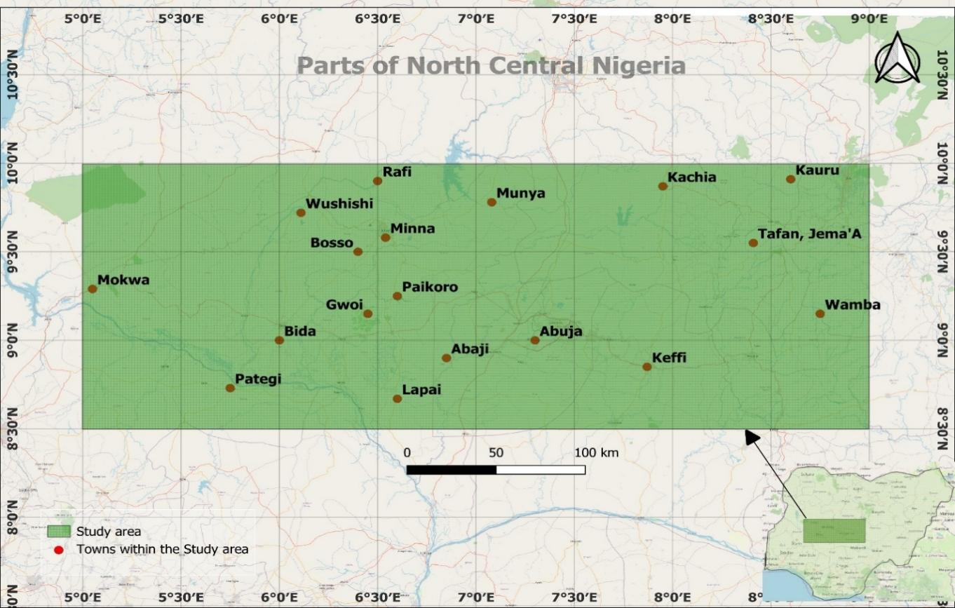
Figure 2.1: Location map of the study area (Created using the free and open source QGIS)
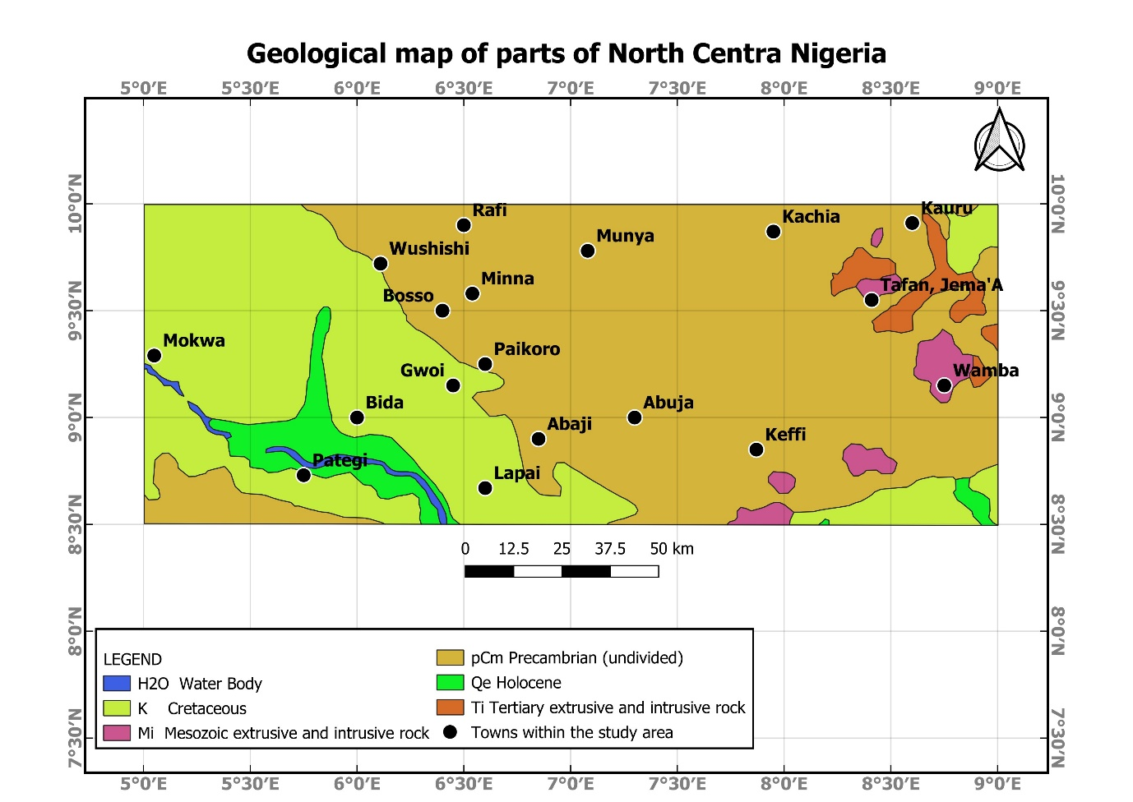Figure 2.2: The geological map of the study area (Extracted from USGS World Geologic Maps website. Accessed May 28th, 2024; modified using the free and open source QGIS )

- Materials and Method
  - Data source and Acquisition
Total Magnetic Intensity (TMI) data covering 24 sheets which are Fashe (161), Akerre(162), Zungeru (163), Minna (164), Bishini (165), Kachia (166), Kafanchan (167), Naragatu 168), Mokwa (182) , Egbako (183), Bida (184), Paiko (185), Abuja (186), Gitata (187), Jema’a (188), Kurra (189), Lafiagi (203), Pategi (204), Baro (205), Gulu (206), Kuje (207), Keffi (208), Akwanga (209), and Wamba (210) were obtained from the Nigerian Geological Survey Agency (NGSA 2024). The data were captured for NGSA by Fugro Airborne surveys between 2007 and 2009 as part of the nationwide airborne geophysical surveys and were acquired along a series of NE-SW profiles with a flight line spacing of 500 and terrain clearance of 80 m.
The Bouguer gravity anomaly was obtained from the Bureau Gravimetric International (BGI) World Gravity Map archives (2012) retrieved on June 30th 2025. The Geological framework maps (needed for correlation) was extracted from the USGS earth explorer World Geologic Maps website (US Geological Survey, 2024 retrieved on May 28th, 2024).
The mineral occurrence points were digitized from the Mineralization Map and Metallogenic domain map of Nigeria (NGSA 2023) on a scale of 1:2,000,000 and 1:3,500,000 respectively. These maps were retrieved on June 22nd,2025 from the NGSA website. The “Downes” mineral deposit classification system was utilized by NGSA. The mineralization map was produced using the National airborne magnetic and radiometric datasets acquired between 2005 and 2010 by NGSA to build and constrain the structural geometry and lithological associations and integrate the developing understanding of the mineral deposits types and systems in Nigeria. The mineral deposit domain map shows the spatial distribution related to the structural and tectonic setting which controlled the fluid/magma system related to the development of the mineral systems for some of the major metallic deposit types including gold Au, and Lithium Li
3.2 Data processing and Derivative Filtering
Using the 2010 International Geomagnetic Reference Field, irregularities caused by regional features were removed from the magnetic data. RTE trailed to mathematically transform the magnetic data to simulate how it would appear if measured at the magnetic equator. Hence, positioning the magnetic anomalies above their source bodies. The RTE map was then subjected to further filtering FVD, AS, TD to improve data interpretation. The FVD was carried out on the RTE map to identify subtle variations in the subsurface, such as lineaments as it enhances near-surface anomalies, The AS was computed from the RTE data to highlights changes in the data’s amplitude, and to detect edges of magnetic sources. Euler deconvolution map of structural index of 1 (SI=1) was obtained to reveal the locations and depths of magnetic sources within the study region
The gravity Bouguer map for the area was preprocessed as in the case of aeromagnetic data interpretation. Regional-residual separation was carried out to isolate the regional component of the gravity field from the local anomalies, derivatives (vertical, and tilt) were also computed. The gravity derivatives were computed from the TD which enhance subtle structures and FVD which sharpens shallow density features. As in the case of the magnetic analysis, the Euler deconvolution map of structural index of 1 (SI=1) was computed for the gravity data to obtain depths to source bodies. All datasets (FVD, TD, AS, and Euler deconvolution) were georeferenced to UTM Zone 32N, WGS84 datum, and resampled to a 30 m spatial resolution using bilinear interpolation. Structural features from each derivative map were extracted and digitized. Structural orientation analysis was finally carried out to compare interpreted structures with known gold occurrences.
3.2.1 Reduction to the Equator (RTE)
The RTE is a geophysical data processing technique primarily used in the interpretation of magnetic data. The Earth's magnetic field is dipolar, that is its intensity and direction vary with latitude. This variation can complicate the analysis of magnetic anomalies because the anomalies' shapes and amplitudes are influenced by the inclination and declination of the Earth's magnetic field at the survey location. RTE is used in low magnetic latitudes to centre the peaks of magnetic anomalies over their sources; transforming the observed magnetic data as if it were measured at the magnetic equator, where the field is horizontal. This can make the data easier to interpret while not losing any geophysical meaning. Application of the RTE simplifies the interpretation of magnetic data by providing a more consistent anomaly shape, and enhances the visibility of geological structures

$$L\left(θ\right)=\frac{{[sin({I)-i*}\cos\left(I\right)*\cos{(D-θ)]}}^{2}*(-\cos^{2}(D-θ))}{{[sin}^{2}\left(I_{a}\right)+\cos^{2}\left(I_{a}\right)* \cos^{2}(D-θ)]*[\sin^{2}\left(I\right)+\cos^{2}\left(I\right)* \cos^{2}(D-θ)]} , if( \left|I_{a}\right|)<(\left|I\right|),I_{a}=1$$
(1)
where; I = Geomagnetic inclination in °; D = Geomagnetic declination in ° azimuth; I_{a} = inclination for amplitude correction (never less than I) Default is ± 20 degrees. If |I_{a}| is specified to be less than |I|, it is set to I.

3.2.2 First Vertical Derivative (FVD)
The FVD technique is particularly effective in identifying subtle variations in the subsurface, such as faults, mineral deposits, and hydrocarbon reservoirs. It highlights the sharpness of an anomaly in geophysical data, making it easier to identify geological boundaries or structures. One recent study by Ishola et al. (2020) utilised magnetic data to map the subsurface structure of Ewekoro region, Southwestern Nigeria. The vertical derivative of the potential field enhances the shallow features while attenuating the deep-sited features, and sharpens the shorter wavelength at the shallow subsurface region (Salako et al. 2024; Aliyu et al., 2021).

$FVD= \frac{∂T}{∂z} = \frac{Z\left(x,y,z+∆z\right)-Z(x,y,z)}{∆z}$ (2)
where:
$T$ is the measured geophysical anomaly (e.g., magnetic or gravity field data), $\frac{∂T}{∂z}$ is the first vertical derivative, and $∆z$ is the vertical distance over which the derivative is computed.
3.2.3 Analytical Signal (AS)
The AS is useful in locating the edges of magnetic source bodies, particularly where remanence and/or low magnetic latitude complicates interpretation. It is a measure of the rate of change of a geophysical field calculated by taking the square root of the sum of the squared derivatives of the field in each direction highlighting changes in the data’s amplitude and locating anomalies
$AS=\sqrt{\left({\left(∂T/∂x\right)}^{2}+{\left(∂T/∂y\right)}^{2}+{\left(∂T/∂z\right)}^{2}\right)}$ (3)
where; $AS$ constitute the amplitude of the total gradient of the signal at the $\left(x,y\right)$ plane, $T$ is the measured magnetic susceptibility, $∂T/∂x+∂T/∂y+∂T/∂z$ are the vertical and orthogonal derivatives along the $z, y and x$planes, respectively.
3.2.4 Tilt derivative (TD)
Tilt derivative (TD) technique is one that can be applied to potential field (magnetic or gravity) data to enhance features and reveal structural trends and edges of anomalous bodies. It is useful for mapping shallow basement structures and mineral exploration targets The TD is a geometrical function that uses the vertical and horizontal derivatives of a field. The technique involves calculating the tilt angle of the field and then taking the derivative of the tilt angle to the horizontal coordinate x and vertical coordinate y. Abdelrady et al. (2023) used the TD to identify several anomalies that are associated with gold deposits and also to map the distribution of subsurface structures in an area. The TD is computed from the FVD of the magnetic or gravity anomaly and is given by the formula:

$TD=\tan^{-1}(\frac{VDR}{THDR})$ (4)
where VDR and THDR are first vertical and total horizontal derivatives, respectively, of the field T for a range of $-\frac{π}{2}≤TDR≤+\frac{π}{2}$.; $VDR=\frac{dT}{dZ}$; $THDR=\sqrt{{(\frac{dT}{dx})}^{2}+ {(\frac{dT}{dy})}^{2 } }$

3.2.5 Euler deconvolution
Euler deconvolution technique, based on Euler's homogeneity equation is used to locate the source of anomalies in magnetic and gravity data. The Euler's homogeneity equation relates the curvature of the magnetic or gravity field to the location of the source of the anomaly. The technique involves fitting a set of magnetic or gravity data to Euler's homogeneity equation and solving for the location of the source of the anomaly (Reid et al., 1990).

$\left(x-x^{0}\right)\frac{∂T}{∂x}+\left(y-y^{0}\right)\frac{∂T}{∂y}+\left(z-z^{0}\right)\frac{∂T}{∂z}=η\left(β-T\right)$ (5)
where β is the regional value of the total field, (x⁰, y⁰, z⁰) is the position of the source which produces the total field T, and η, defines the structural index. Identified structural geometry and depth is controlled by the structural index; η (Reid et al., 1990).

4 Results and Discussion
4.1 Interpretation of Gravity Data
The Bouguer residual anomaly map (Figure 4.1) showcases values ranging from -29.4705 mGal in the low-density zones to 50.7770 mGal over high-density basement outcrops. The highest anomalies correspond to the migmatite–gneiss complex and Pan-African granitoids, particularly around Wushishi-Minna- Paikoro corridor, while the lowest anomalies occur along fault-bounded troughs around Kauru, Tafan Jema’a and Tagagi regions, interpreted as zones of deep weathering and alteration.
The gravity FVD map (Figure 4.2) highlights variations in density contrast within the upper crust revealing subsurface structural features affirming the high density (about 300 mGal/m) observed around the Minna area. The high positive values shown in pink, red, and orange tones correspond to zones of steep density gradients, often associated with faults, fractures, and intrusive bodies which are key features that can control hydrothermal fluid flow and mineralization. Conversely, areas of low values (blue and green) typically represent more homogeneous geological zones or deeper, less variable basement regions.
The gravity TD map (Figure 4.3) effectively enhances density contrasts, revealing continuous NE–SW and NW-SE trending anomalies, with tilt values ranging from -1.3712 radians to 1.1993 radians with many exceeding ±0.3 radians in tilt angle. These trends extend for more than 25 km in some cases, suggesting regionally persistent structural corridors. The Minna–Kampala–Paikoro corridor, with elevated tilt values, suggests significant crustal breaks or lithological contacts. The Wamba–Jema’a–Keffi region, which shows moderate to high tilt responses, likely corresponding to sheared or fractured terrains, possibly associated with hydrothermal activity and mineralizing fluids. The Lapai–Tagagi–Gurdi area, characterized by linear high tilt anomalies trending in NE–SW and NW–SE directions. These structural trends coincide with regional tectonic fabrics and could act as conduits for mineralization.
The gravity Euler deconvolution map (Figure 4.4) showcases colour-coded Euler solutions represent varying depths to geological contacts from blue dots (<250 m) representing shallow sources to magenta dots (>2000 m) representing deep sources. The clustering of Euler solutions across the study area delineates zones of intense structural deformation. Notably, regions such as Minna–Paikoro–Abaji, Malagum–Tafan Jema’a, and Wamba–Keffi exhibit a high density of shallow to intermediate depth solutions, suggesting the presence of near-surface fault zones, fracture corridors, and lithological boundaries. The clustering of Euler solutions across the study area delineates zones of intense structural deformation. Notably, regions such as Minna–Paikoro–Abaji, Malagum–Tafan Jema’a, and Wamba–Keffi exhibit a high density of shallow to intermediate depth solutions, suggesting the presence of near-surface fault zones, fracture corridors, and lithological boundaries. The eastern and southeastern regions around Wamba, Malagum, and Kachia are marked by deeper solutions (>1000 m), indicative of subsurface intrusions or major crustal structures, potentially acting as conduits for deep-seated hydrothermal fluids.
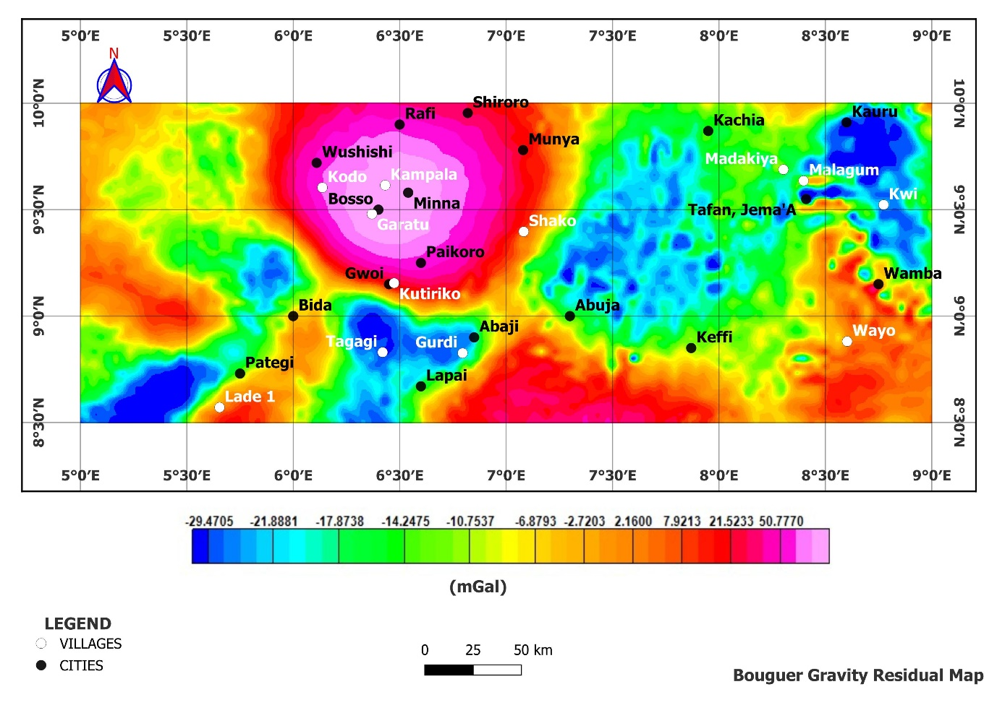Figure 4.1: Bouguer gravity residual map (Source: Bureau Gravimetric International (BGI) World Gravity Map archives (2012) retrieved on June 30th 2025)
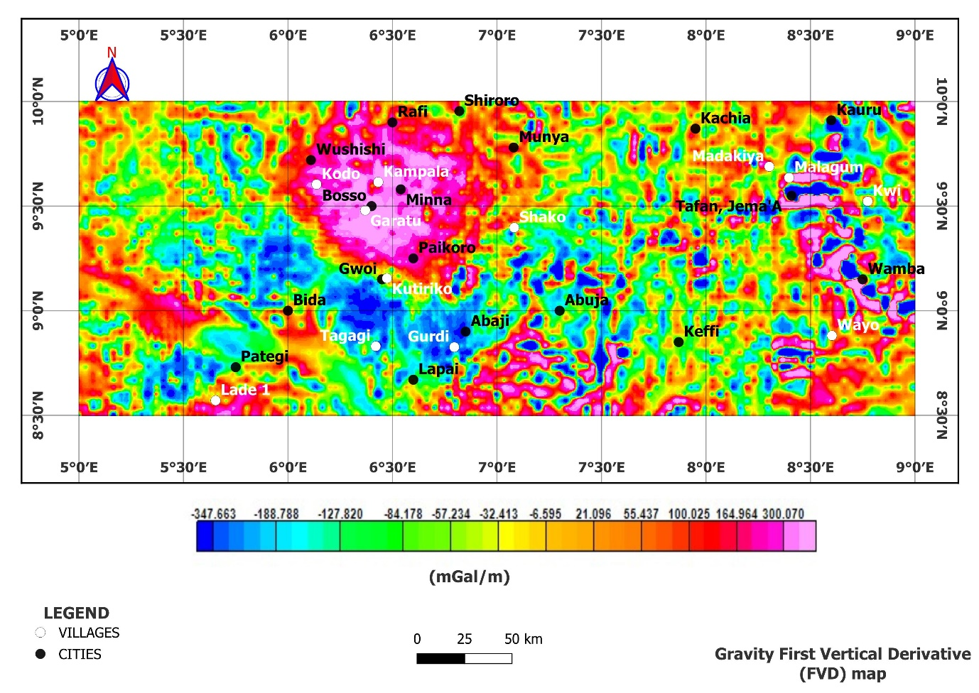
Figure 4.2: Gravity First Vertical Derivative (FVD) map [Produced from the Bouguer map obtained from BGI World Gravity Map 2012 (retrieved on June 30th 2025) using Oasis Montaj and QGIS software]

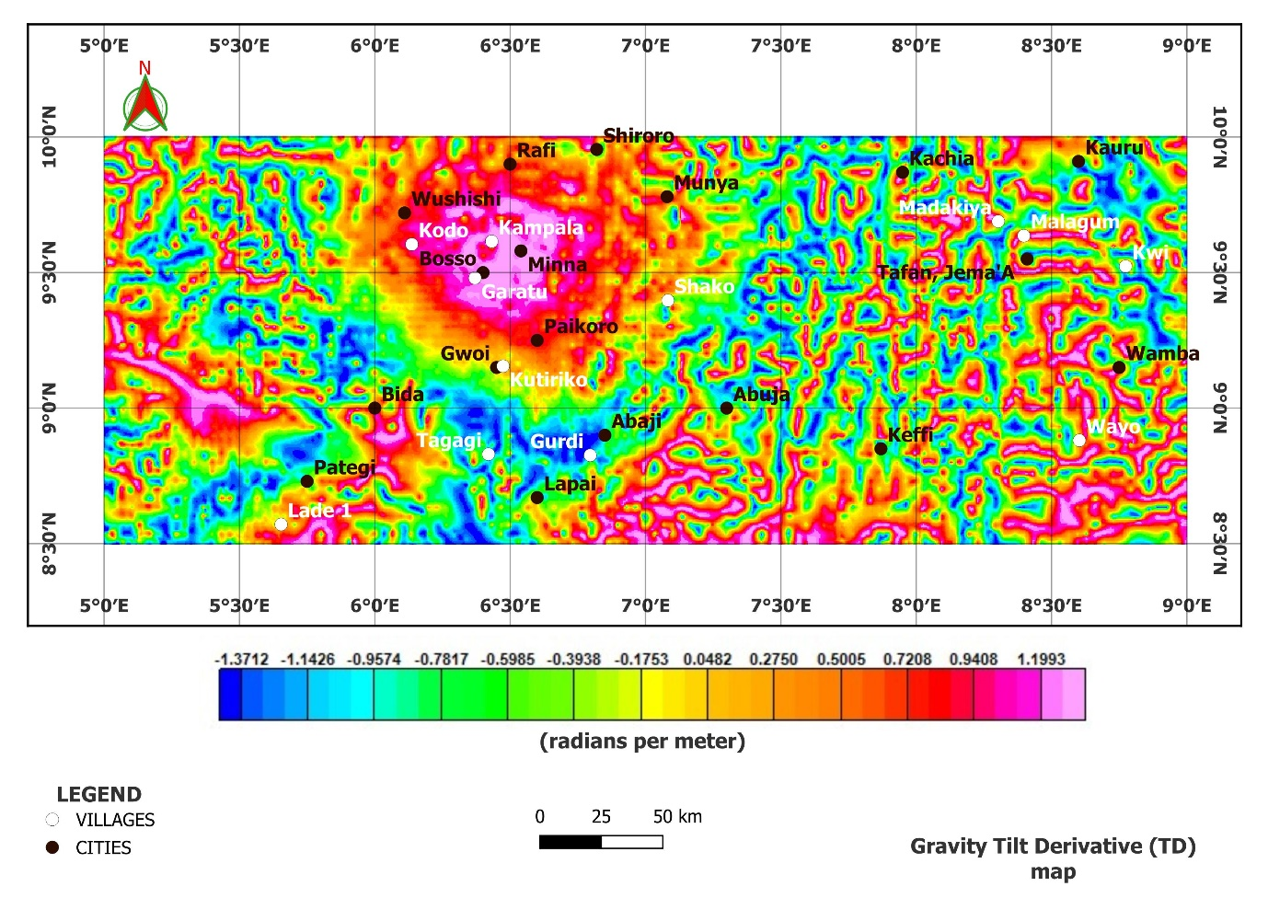
Figure 4.3: Gravity Tilt Derivative (TD) Map [Produced from the Bouguer map obtained from BGI World Gravity Map 2012 (retrieved on June 30th 2025) using Oasis Montaj and QGIS software]
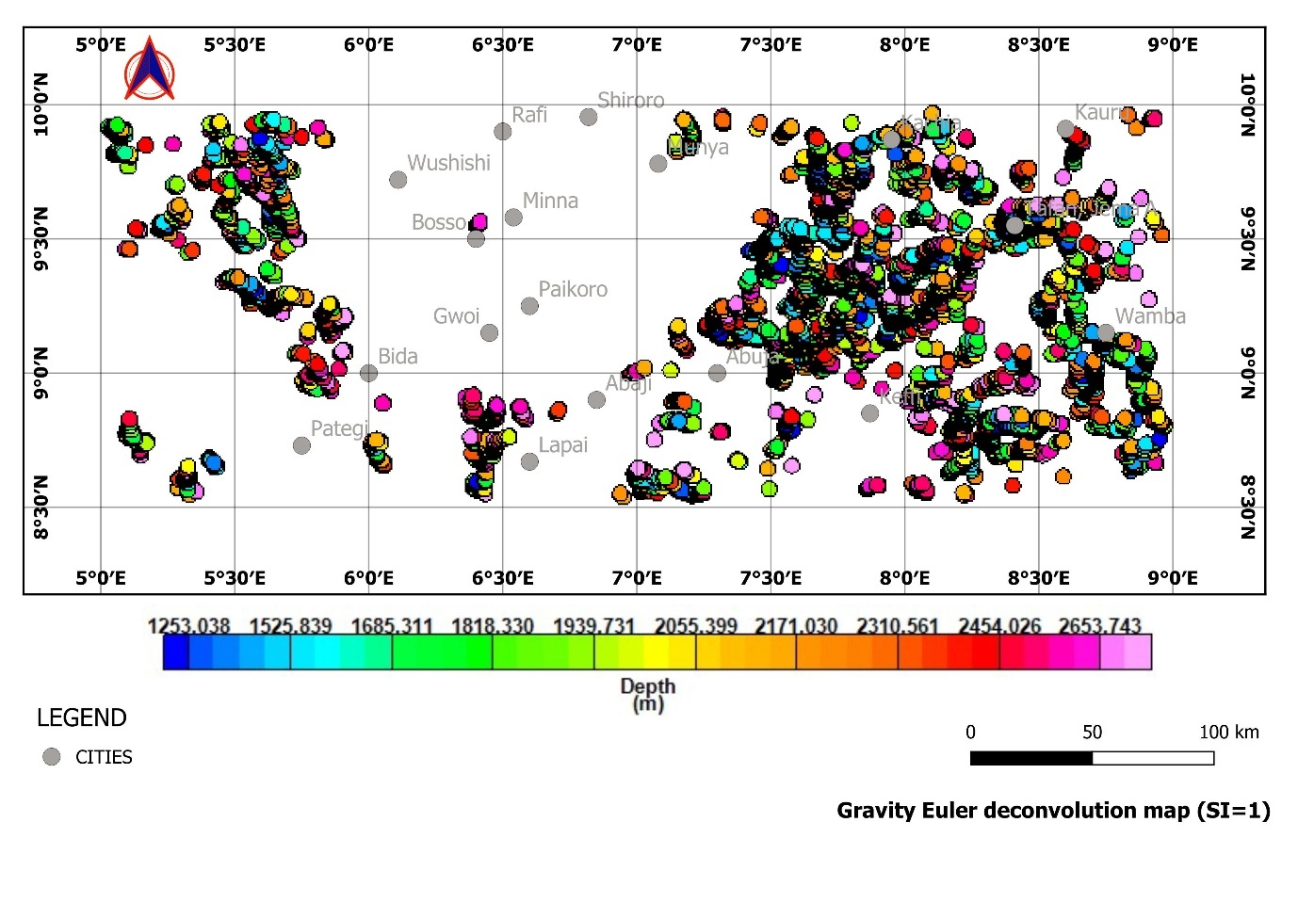Figure 4.4: Gravity Euler Deconvolution map of structural Index of one (SI=1) [Produced from the Bouguer map obtained from BGI World Gravity Map 2012 (retrieved on June 30th 2025) using Oasis Montaj and QGIS software]

4.2 Magnetic Data Interpretation
From magnetic RTE map (Figure 4.5), the magnetic field is seen to range from -43.94 nT to 113.58 nT. Low magnetic field intensities (< 61.26 nT) are predominant covering about 70% of the study area. High magnetic intensity (> 100 nT) is observed majorly at the central region of the study area covering parts of the Precambrian (basement) rocks as evident on the geology map (Figure 2.2)
The magnetic FVD map (Figure 4.6) accentuates shallow magnetic sources, with anomaly magnitudes exceeding 0.04 nT/m in mineralized shear zones. Zones of reduced magnetic intensity observed around places like Bida and Lapai, suggests magnetite destruction during mineralizing events. The magnetic AS map (Figure 4.7) records amplitudes ranging from -0.105 to 0.169 nT/m, with the highest responses over mafic intrusions near Wushishi, Bosso, Minna, Paikoro, and Abaji regions and lower amplitudes over altered regions like Keffi, Abuja, and Lapai. The magnetic TD (Figure 4.8) map highlights variations in the magnetic field associated with geological structures as visible also in Figure 4.6 and 4.7. Structures like faults and contacts are precisely identified with the colour scale representing the tilt derivative values, ranging from 1.63 (dark blue) to 1.55 (pink). Except at the central, northern and small other areas like the south west corner of the study area, over 60% of the study area is pronounced by warm colours, suggesting the presence of deeper and less magnetic materials. In the magnetic Euler deconvolution map (Figure 4.9),
At the central part of the map is a notable cluster with a mix of depths (< 1000 m). These shallower anomalies (blue and green points) correspond to surface-level features observed around regions like Minna, Paikoro, Bosso, Abaji, Munya, Wushishi, Rafi. The deeper anomalies (pink and red points) notable majorly as the linear trends running northwest to south indicates complex geological structures favourable for mineral deposition. These deep dense clusters of points represented by the pink and red points (> 1000 m) indicates deeper geological structures that could be associated with mineralization processes.

4.3 Integrated Structural Analysis
Integrating gravity and magnetic method, gravity low regions in blue and green tones (< –10 mGal), particularly around Abaji (Figure 4.1) correspond to deeply weathered or altered zones where hydrothermal fluids have altered the host rocks and reduced bulk density. Such density reduction, coupled with low magnetic amplitudes (≤ 0.1 nT/m) (Figure 4.6) suggests magnetite destruction due to sulphidation processes, a common feature in orogenic gold systems (Groves et al., 1998).
The tilt derivative and first vertical derivative maps (Figure 4.2, 4.3, 4.6, and 4.8) highlight structurally coherent NE–SW and NW–SE trends. The dominance of NE–SW structures align with regional transcurrent shear zones formed during the Pan-African orogeny (~600 Ma). These shear zones are known to be major gold-bearing corridors across West Africa (Leube et al., 1990; Feybesse et al., 2006). The NW–SE trends represent cross-cutting faults that act as dilation zones or secondary conduits for gold-bearing fluids.
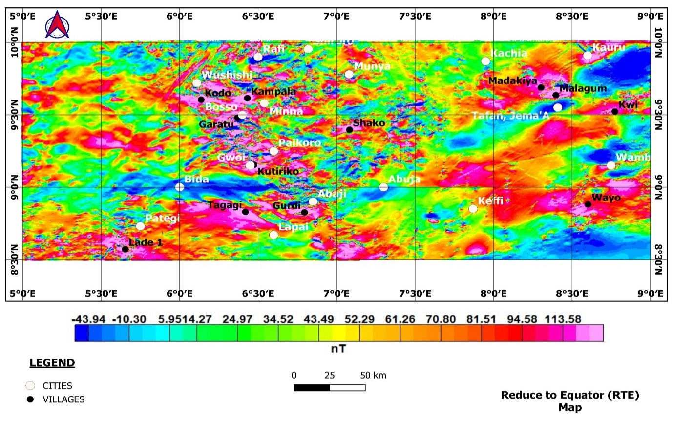Figure 4.5: Reduction to Equator (RTE) map [Produced from the Aeromagnetic data obtained from NGSA (2024) using Oasis Montaj and QGIS software]
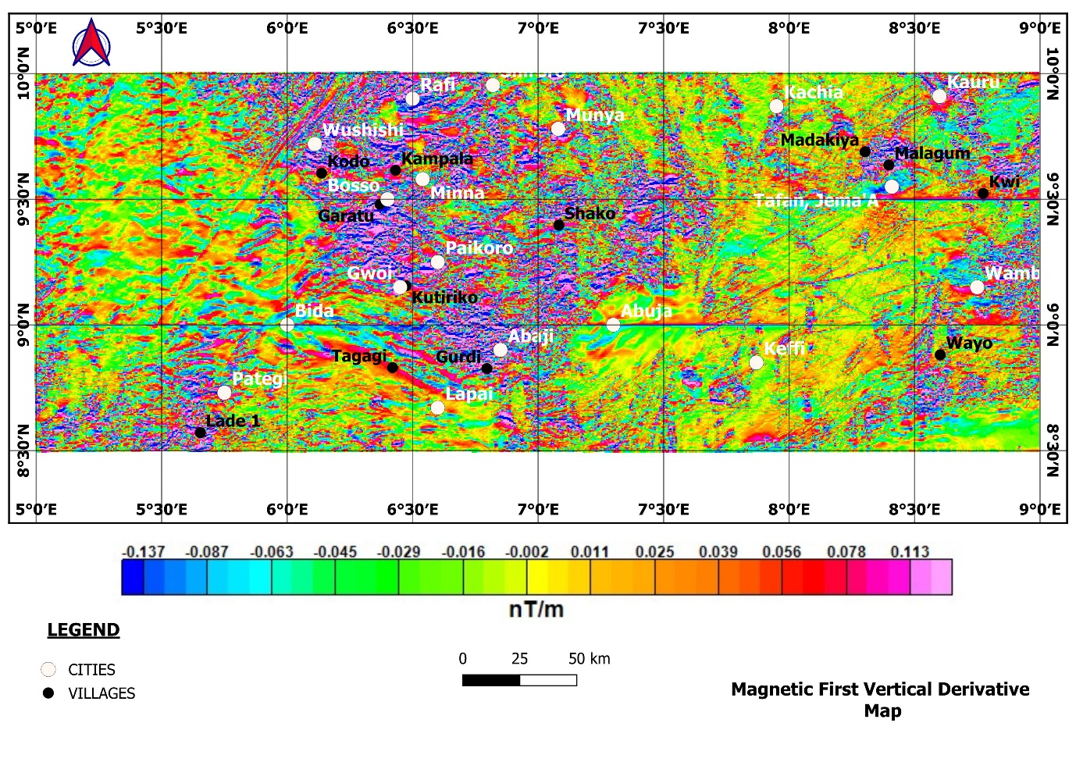
Figure 4.6: Magnetic First Vertical Derivative (FVD) map [Produced from the Aeromagnetic data obtained from NGSA (2024) using Oasis Montaj and QGIS software]
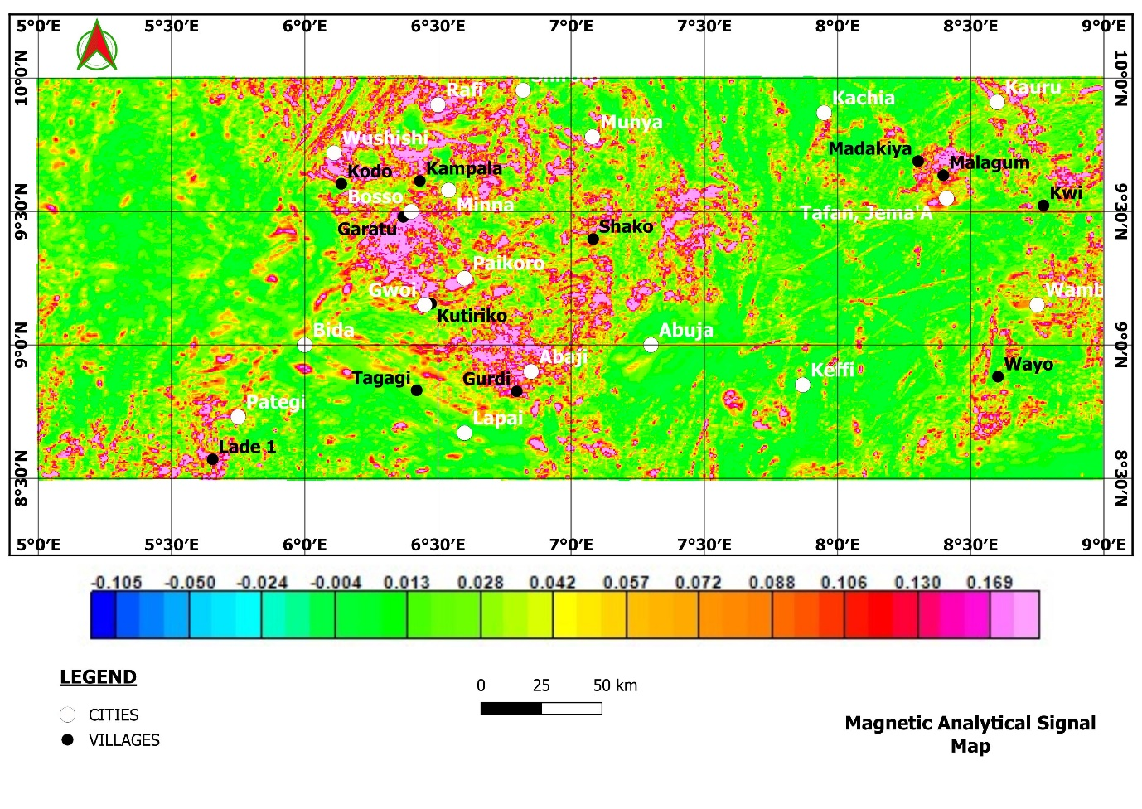Figure 4.7: Magnetic Analytical Signal map [Produced from the Aeromagnetic data obtained from NGSA (2024) using Oasis Montaj and QGIS software]

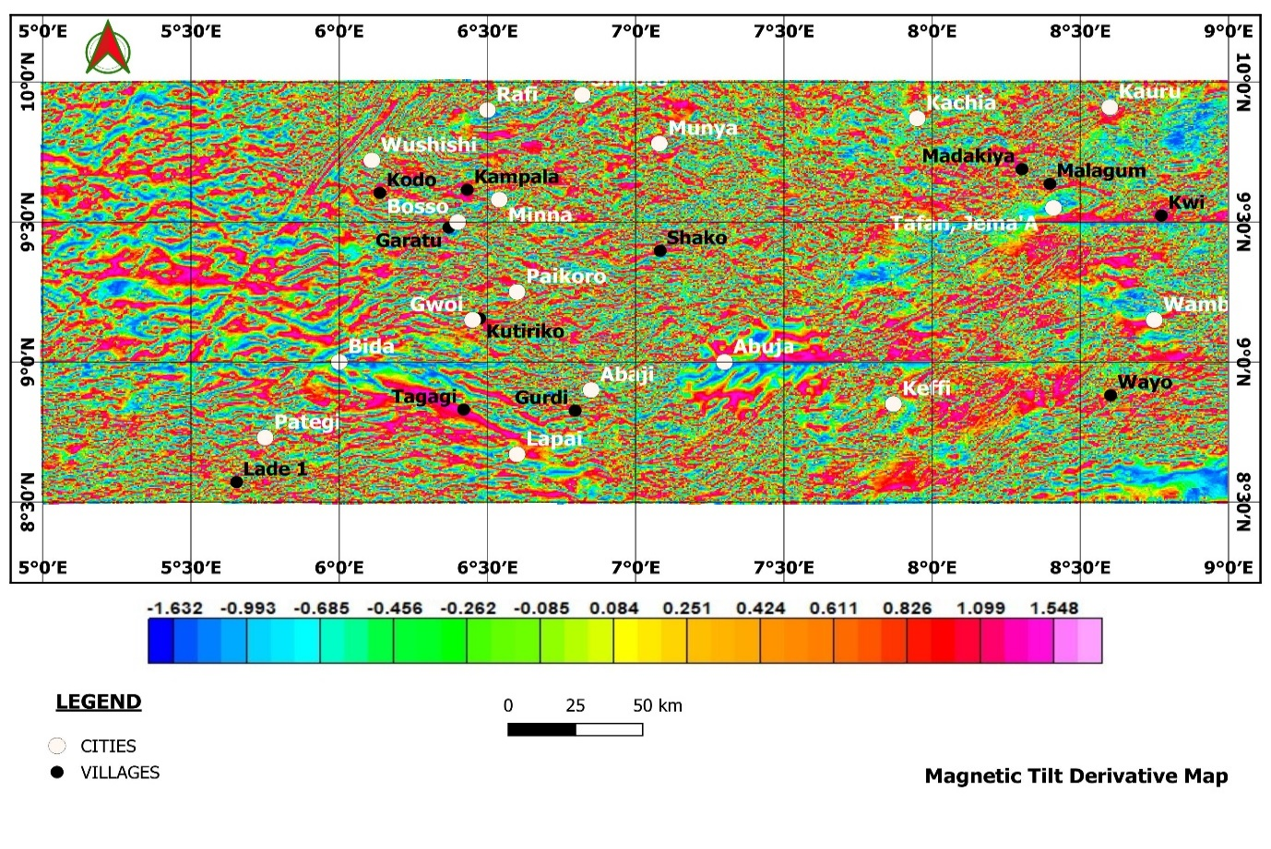Figure 4.8: Magnetic Tilt Derivative (TD) Map [Produced from the Aeromagnetic data obtained from NGSA (2024) using Oasis Montaj and QGIS software]
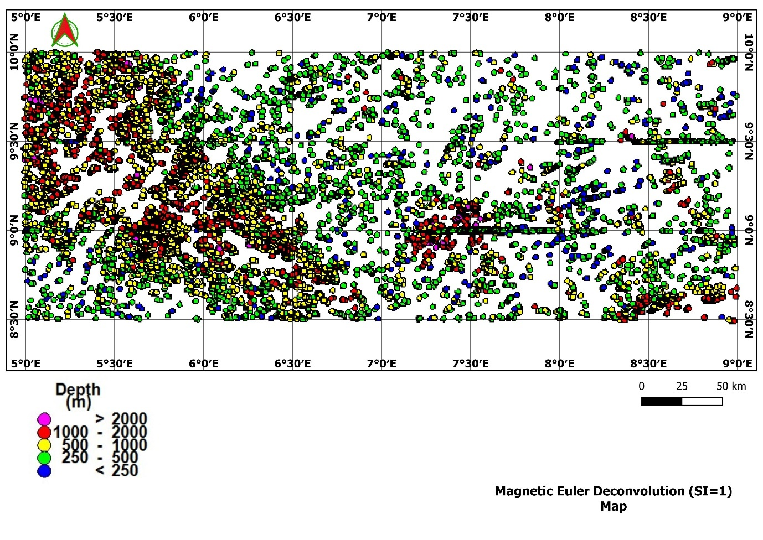
Figure 4.9: Euler Deconvolution map of Structural Index of one (SI = 1) [Produced from the Aeromagnetic data obtained from NGSA (2024) using Oasis Montaj and QGIS software]

Integration of gravity and magnetic derivatives (Figure 4.10) identifies at least 48 major lineaments, with dominant NE–SW orientations (45% of total) and secondary NW–SE trends (33%). The structural intersections cluster particularly in Minna–Paikoro axis can be said to be associated with gold occurrences as the Abaji corridor as documented by Ayuba and Abu 2024 is said to host multiple artisanal gold workings. The northern Lapai zone is characterized by deep-seated faults inferred from gravity lows coupled with magnetic breaks. Overlaying the structural derivative map on the mineral occurrence map (Figure 4.11) and metallogenic map (Figure 4.12), over 72% of known gold occurrences fall within 2 km of these mapped structures, with many located at triple junctions where three or more faults converge. These structural relationships strongly suggest that mineralization is controlled by fault permeability and associated hydrothermal fluid pathways.
The integrated gravity and magnetic interpretations reveal structural and lithological controls that are consistent with the known metallogenic framework of North-Central Nigeria (Figure 4.11 and 4.12). The high Bouguer anomalies (> +50 mGal) observed over migmatite–gneiss complexes and Pan-African granitoids likely reflect dense crystalline basement rocks, which in some cases act as rigid blocks that focus strain along their margins. These margins are often sites of shear zone development, providing pathways for mineralizing fluids, as also documented by Odeyemi et al. (1999) and Anakwuba et al. (2014) in similar Nigerian schist belt settings.
A key finding from this study is that 72% of documented gold occurrences are located within 2 km of major lineaments, with the highest density of occurrences at structural intersections. This is significant because such junctions often localize ore due to enhanced permeability and fluid focusing (Robert et al., 1997). The Paikoro axis is one of the regions documented by Ayuba and Abu (2024) to possess high K/Th ratio. High K/Th ratio and strong gravity gradients, indicates intense alteration adjacent to deep-seated faults and these conditions are favourable for gold deposition.

5. Conclusion
This study demonstrates that the integration of gravity and magnetic derivative modelling provides an effective framework for delineating structural controls on gold mineralization in North-Central Nigeria. The results reveal that NE–SW and NW–SE trending faults, identified from tilt and vertical derivative maps, act as primary conduits for hydrothermal fluids, with structural intersections being the most prospective zones. The spatial association between negative gravity anomalies, low magnetic responses, and documented gold occurrences underscores the importance of alteration-related density and magnetic susceptibility reduction in mineralizing processes. Approximately 72% of known gold occurrences were found within 2 km of major lineaments, highlighting the significance of structural proximity in exploration targeting.

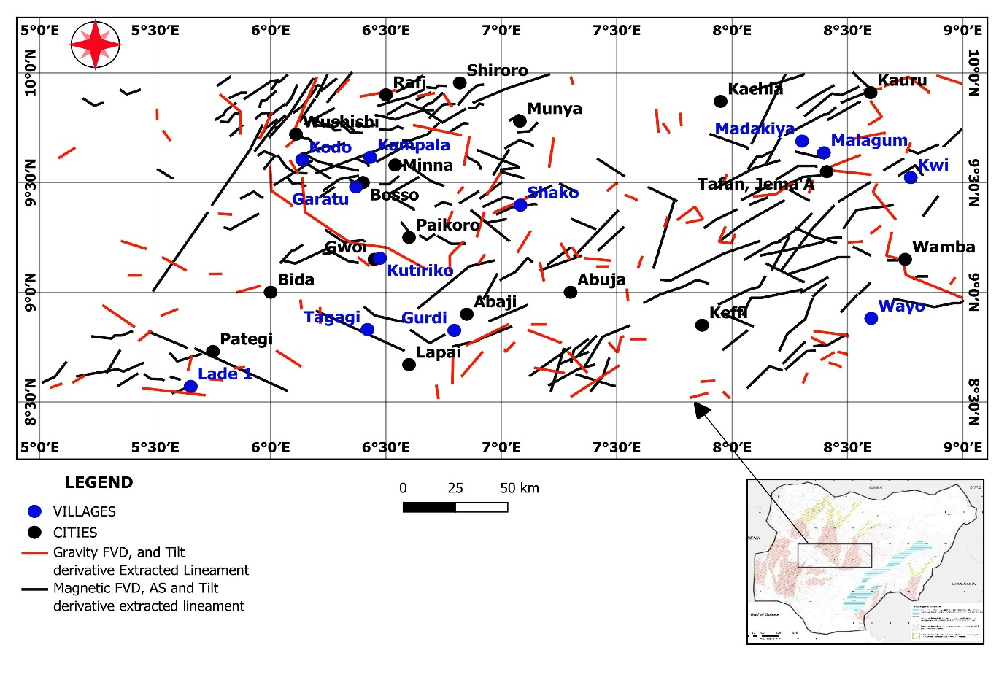
Figure 4.10: Gravity and Magnetic structures extracted from FVD, AS and Tilt Derivatives [Produced from the gravity and aeromagnetic data obtained from BGI (2012) and NGSA (2024) respectively using Oasis Montaj, QGIS, and ArcGIS software]
Figure 4.11: Gravity and Magnetic structural derivative overlayed on Mineral resources map of the study area [Produced from the gravity, aeromagnetic data and mineralization map obtained from BGI (2012), NGSA (2024) and NGSA (2023) respectively using Oasis Montaj, QGIS, and ArcGIS software]

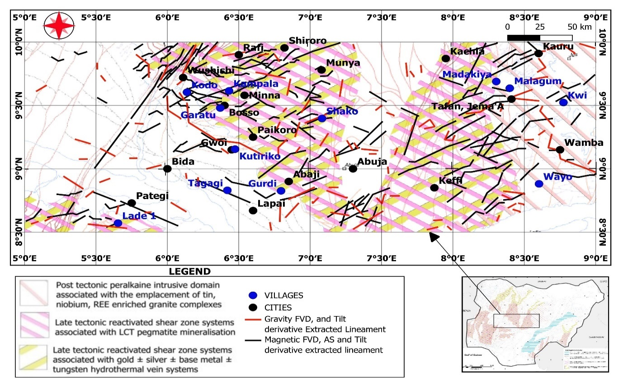
Figure 4.12: Gravity and Magnetic structural derivative overlayed on Metallogenic map of the study area [Produced from the gravity, aeromagnetic data and mineralization map obtained from BGI (2012), NGSA (2024) and NGSA (2023) respectively using Oasis Montaj, QGIS, and ArcGIS software]

Competing Interests Disclaimer
Authors have declared that they have no known competing financial interests OR non-financial interests, or personal relationships that could have appeared to influence the work reported in this paper.

Authors’ Contributions
This work was carried out in collaboration between all authors. Author LJO managed the literature searches, analysed the data and wrote the manuscript. Author AM, NNA and GJN designed the study, checked the protocol of the study, the grammar and language and appraised data quality. All authors read and approved the final manuscript

REFERENCES
Abdelrady, M., Moniem, M. A., Alarfi, S. S., Abdelrady, A., Othman, A., Mohammed M. A. A., & Mohamed, A., (2023). Geophysical investigation for the identification of subsurface features influencing mineralization zones. Journal of King Saud University-Science, 35(7), https://doi.org/10.1016/j.jksus.2023.102809
Adekeye, J. I., Lawal, B. A., & Oladipo, M. O. (2023). Petrology and geochemistry of basement rocks in parts of north-central Nigeria. Nigerian Journal of Geosciences, 59(2), 45–61.
Ahmed, S. A., Nuhu, M. W., Hadiza, L. M., Mohammed, A. M., & Apeh, A. G., (2020). Reconnaissance geochemical and geophysical exploration for gold at Iri gold field, North central Nigeria. Scientia Bruneiana, 18(2), pages 19-31.
Ajibade, A. C., Anyanwu, N. P. C., Okoro, A. U., & Nwajide, C. S. (2008). The geology of the Minna area (Bulletin No. 43). Nigerian Geological Survey Agency.
Akinduko, O. K., Salako, K. A., Alhassan, U. D., Lawrence, J. O., Alkali, A., Aliyu, S. B., Abdullahi, M., Adewumi, T., & Damidami, L., (2022). Aero-magnetic and Aero-radiometric prospecting for Gold Mineralisation over Ilesha and its Environs Southwest, Nigeria. Asian Journal of Geological Research (AJOGER), 5(4), pp. 1-16; Article no. AJOGER 96016
Akintola, O. A., Olatunji, A. S., & Adepoju, K. A. (2022). Geology and mineral resources of North-Central Nigeria: A review. Journal of African Earth Sciences, 191, 104520. https://doi.org/10.1016/j.jafrearsci.2022.104520
Aliyu, S. B., Adetona, A. A., Rafiu, A. A., Ejepu, J., Adewumi, T., (2021). Delineating and interpreting the gold veins within Bida and Zungeru area, Niger State, Nigeria, using aeromagnetic and radiometric data. Pakistan Journal of Geology (PJG), 5(2), pp 41-50. DOI: 10.2478/pjg-2021-0006
Ameh, P. O., Abdullahi, A., & Muhammad, A. M. (2024). Petrographic and structural mapping of Abuja basement terrain. International Journal of Geosciences and Environmental Studies, 12(1), 12–24.

Ameh, P. O., Ibrahim, K. M., & Abdullahi, A. (2023). Structural and metamorphic characteristics of the schist belt in the Ilorin-Afon region, north-central Nigeria. Journal of Geosciences and Geomatics, 11(2), 45–55.

Anakwuba, E. K. (2014). Integration of aeromagnetic and Landsat ETM data for geological structure interpretation over parts of North-Central Nigeria. International Journal of Scientific & Technology Research, 3(1), 152–161.
Anakwuba, E. K., Chinwuko, A. I., Onwuemesi, A. G., & Oha, I. A. (2014). Interpretation of aeromagnetic data over Maiduguri and environs for structural and mineral prospectivity analysis. International Journal of Science and Technology, 3(1), 67–79.
Arogundade A. B., Awoyemi, M.O., Hammed, O.S. Falade, S.C., & Ajama O. D. (2022). Structural Investigation of Zungeru-Kalangai Fault Zone, Nigeria using Aeromagnetic and Remote Sensing Data. Heliyon, 8(3), e09055. https://doi.org/10.1016/j.heliyon.2022.e09055
Augie, A. I., Salako, K. A., Rafiu, A. A. & Jimoh, M. O. (2024). Integrated Geophysical Investigation for Potential Gold Mineralised Zone within Lower Part of Zuru Schist Belts, NW Nigeria. Nigerian Journal of Physics (NJP), 33(2). ISSN online: 3027-0936ISSN print: 1595-0611. DOI: https://doi.org/10.62292/njp.v33i2.2024.212, Special Issue, June 2024
Ayuba Bwamba Jonah, & Abu Mallam (2024). Integrated interpretation of Aeromagnetic and Aero-radiometric data to delineate structures and hydrothermal Alteration zones associated with gold Mineralization in parts of North-Central Nigeria. Asian Journal of Geological Research (AJOGER) 7(2): 136-153. https://journalajoger.com/index.php/AJOGER/article/view/161.
BGI - Bureau Gravimetrique International / International Gravimetric Bureau, World Gravity Map (WGM) (2012). WGM2012 maps visualization/extraction – BGI (retrieved on June 30th, 2025)
Bolarinwa, A. T., Oyebanjo, O. A., & Ojo, A. M. (2021). Structural framework and geochemical characteristics of mineralized zones in Nigeria. Minerals, 11(12), 1396. https://doi.org/10.3390/min11121396
Daniel, E., Jimoh, R., & Lawal, K. (2019). Delineation of Gold Mineral Potential Zone Using High Resolution Aeromagnetic Data Over Part of Kano State, Nigeria. Journal of Geology & Geophysics 8:464. 10.35248/2381-8719.464
Ebele, J. E., Ofoegbu, C. O. & Nur, A. (2021). Interpretation of high-resolution aeromagnetic and radiometric data for delineation of mineral potential zones over Abuja and Environs, North-Central Nigeria. Arabian Journal of Geosciences, 14(1947) https://doi.org/10.1007/s12517-021-07915-5. Corpus ID: 237412613
Egbelehulu, P., & Abu, M. (2024). Integration of ground magnetic method and whole-rock analysis for solid mineral prospecting in a part of Abuja, Nigeria. Pakistan Journal of Geology (PJG), 8(1), 67-73. DOI: http://doi.org/10.26480/pjg.01.2024.67.73
Ekwueme, B. N., Ike, E. C., & Elueze, A. A. (2010). The geology and geochronology of the basement rocks of Akwanga area, north-central Nigeria. Journal of Mining and Geology, 46(2), 95–109.
Eldursi, K., Branquet, Y., Guillou-Frottier, L., Martelet, G., & Calcagno, P. (2018). Intrusion-Related Gold Deposits: new insights from gravity and hydrothermal integrated 3D modeling applied to the Tighza gold mineralization (Central Morocco). Journal of African Earth Sciences, 140, 199-211. https://www.sciencedirect.com/science/article/pii/S1464343X18300190
Feybesse, J. L., Billa, M., Guerrot, C., Duguey, E., Lescuyer, J. L., Milesi, J. P., & Bouchot, V. (2006). The Paleoproterozoic Ghanaian province: Geodynamic model and ore controls, including regional stress modeling. Precambrian Research, 149(3–4), 149–196. https://doi.org/10.1016/j.precamres.2006.06.003
Gobashy, M. M., Eldougdoug, A., Abdelwahed, M., Abdelazeem, M., Abd El-Rahman, Y., Abdelhalim, A., & Said, S. (2023). Role of integrated magnetics and geology in tracking and exploring complex structures controlling gold mineralization. Example from the Fawakheir-Atalla Gold Prospects, Eastern Desert, Egypt. Pure and Applied Geophysics, 180(7), 2775-2805. https://link.springer.com/article/10.1007/s00024-023-03284-0
Groves, D. I., Goldfarb, R. J., Gebre-Mariam, M., Hagemann, S. G., & Robert, F. (1998). Orogenic gold deposits: A proposed classification in the context of their crustal distribution and relationship to other gold deposit types. Ore Geology Reviews, 13(1–5), 7–27. https://doi.org/10.1016/S0169-1368(97)00012-7
Groves, D. I., Goldfarb, R. J., Santosh, M., & Zhang, L. (2016). The conjunction of factors that lead to formation of giant gold provinces and deposits in non-arc settings. Geoscience Frontiers, 7(3), 303–314. https://doi.org/10.1016/j.gsf.2015.07.001
Ishola, K. S., Akerele, P. O., Folarin, O., Adeoti, L., Adegbola, R. B., Adeogun, O. Y. (2020). Application of aeromagnetic data to map subsurface structural features in Ewekoro, Southwestern Nigeria. Modeling Earth Systems and Environment. pp. 1 - 12 https://doi.org/10.1007/s40808-020-00812-y
Leube, A., Hirdes, W., Mauer, R., & Kesse, G. O. (1990). The Early Proterozoic Birimian Supergroup of Ghana and some aspects of its associated gold mineralization. Precambrian Research, 46(1–2), 139–165.
Mustapha S., Suleman S., Iliyasu S. R., Udensi E. E., Sanusi Y. A., Dahuwa D. and Abba L (2020) Interpretation of Aeromagnetic Data and Landsat Imagery over the Nigerian Younger Granites in and around Kafanchan Area, North-Central Nigeria. FUDMA Journal of Sciences, 4(4), pp 323 – 333. DOI: https://doi.org/10.33003/fjs-2020-0404-489
Nigeria Geological Survey Agency (NGSA) (2023). Geological Maps - Mineralization map of Nigeria.
https://ngsa.gov.ng/geological-maps/ retrieved on 2025/06/22
Nigeria Geological Survey Agency (NGSA) (2024). Aeromagnetic data sheets.
Obaje, N. G. (2009). Geology and Mineral Resources of Nigeria. Springer.
Oden, M. I. (2019). Interpretation of high-resolution aeromagnetic data for subsurface structural mapping in parts of North-Central Nigeria. Heliyon, 5(8), e02389. https://doi.org/10.1016/j.heliyon.2019.e02389
Odeyemi, I. B., Anifowose, Y. B., & Asiwaju-Bello, Y. A. (1999). Multi-technique graphical analyses of fractures from remote sensing images of basement regions of Nigeria. Journal of Mining and Geology, 35(1), 88-105.
Ogunmola, J. K., Gajere, E. N., Ayolabi, E. A., Olobaniyi, S. B., Jeb, D. N., & Agene, I. J. (2015). Structural study of Wamba and Environs, North-central Nigeria using Aeromagnetic data and NigeriaSat-X image. Journal of African Earth Sciences, 111(1), pp. 307-321. https://doi.org/10.1016/j.jafrearsci.2015.07.028
Ola-Buraimo, A. O., Udensi, E. E., & Adeniji, O. A. (2021). Structural evolution and tectonic implications in the Arum area of Nasarawa State, Nigeria. Journal of Geology and Earth Sciences, 9(3), 77–89.
Rahaman, M. A. (1988). Recent advances in the study of the Basement Complex of Nigeria. In Precambrian Geology of Nigeria (pp. 11-41). Geological Survey of Nigeria.
Reid, A. B., Allsop, J. M., Granser, H., Millet, A. J. & Somerton, I. W. (1990). Magnetic interpretation in three dimensions using Euler deconvolution. Geophysics, 55(1), pp 80-91.
Robert, F., Poulsen, K. H., Cassidy, K. F., & Hodgson, C. J. (1997). Gold deposits and their geological classification. In R. V. Kirkham, W. D. Sinclair, R. I. Thorpe, & J. M. Duke (Eds.), Mineral deposit modeling (pp. 199–214). Geological Association of Canada.
Salako, K.A., Adetona, A. A., Rafiu, A. A., Augie, A. I., Jimoh, M. O., Alkali, A., Muriana, R. A. Lawrence, J. O., (2024). Integrated geophysical Investigation for gold mineralization potential over southern parts of Kebbi state and its Environs, northwestern Nigeria. Heliyon 10 (2024) e34093 https://doi.org/10.1016/j.heliyon.2024.e34093.
Telford, W. M., Geldart, L. P., & Sheriff, R. E. (1990). Applied geophysics (2nd ed.). Cambridge University Press. https://doi.org/10.1017/CBO9781139167932
U.S. Geological Survey, (USGS) 2024, World Geologic Maps, accessed May 28th, 2024 at https://www.usgs.gov/media/images/world-geologic-maps-data-downloads
Usman, A. A., Okeke, O. C., & Gana, I. A. (2023). Lineament mapping and structural analysis using remote sensing in north-central Nigeria. FUGUS International Journal of Scientific and Geological Studies, 11(1), 66–78.

