Original Research Article

Lithology and Pore-Fluid Discrimination Using Rock Physics Analysis in the “Kola” Field, Niger Delta

ABSTRACT
Background: The ultimate goal of any Rock Physics analysis is to gain insights into the physical properties of a reservoir. These consist of properties such as lithology, porosity, and permeability, or dynamic properties like fluid content or pressure. A geophysical Rock Physics analysis will make use of the measured elastic properties from seismic data to generate attributes that yield relevant information about the reservoir rocks/sand.
Aim: This study aimed to predict reservoir behaviour with respect to rock physics, elastic properties and presence of fluid within the study area “KOLA” Field, Niger Delta.
Methodology: The study is an offshore field located within latitude 05⁰51’55N to 05⁰52’03N and longitude 05⁰41’27E to 05⁰42’05E in the Niger Delta. The Niger Delta basin is one of the seven sedimentary basins in Nigeria where active petroleum exploration activities are carried out. The study took place between August 2023 and August 2024. Seismic attributes, e.g. Vp/Vs ratio, Lambda-Rho, Mu-Rho, and P-Impedance, were estimated. Rock physics cross-plots of the attributes were used to discriminate fluid and lithology in the reservoir sands of the ‘KOLA’ Field Offshore Niger Delta. The seismic attributes were colour-coded with various reservoir properties from well logs such as gamma ray and resistivity, in order to differentiate the lithology and zones charged with hydrocarbon from zones charged with brine.
Results
The results of the analysis showed that hydrocarbon sands have low P-Impedance, VP/VS, Lambda-Rho and Mu-Rho values. P–Impedance and VP/VS are sensitive to both fluid and lithology, whereas Lambda-Rho is only sensitive to fluid, and Mu-Rho (rigidity) is only sensitive to rock matrix. The results showed that both mu-rho and density are lithology discriminators, with density also being a fluid discriminator. Cross-plot of Vp/Vs and Acoustic impedance was used to differentiate the reservoirs into hydrocarbon-charged zones and water-charged zones. Cross-plot of Lambda-rho (incompressibility) and velocity ratio differentiate the reservoir lithology into sands and shale units. Lambda-rho (λρ) and mu-rho (μρ) cross-plots classified the reservoir unit into three zones, namely water saturated sand, oil saturated zone and gas saturated zone, confirmed by density and neutron cross-plot.
Conclusion
Having realized that the porosity in the reservoir unit is moderately good and the water saturation is low. The models explained the general behavior of the rock in terms of poor, moderate and good qualities. This is helpful to note that the reservoir is good and economical.

Keywords: Rock physics, seismic attribute, Property attribute, Fluid, lithology, Niger Delta

- INTRODUCTION
A reservoir is a subsurface rock which is described in terms of its lithology and pore fluid saturation. This influences the reservoir development and its management. The structure of the reserves of developed deposits is changing; new fields with a more complex geological structure are being discovered, and new, more efficient technologies for developing oil fields are being introduced, but interest in reservoir stimulation technologies based on the use of various chemical compositions remains (Li et al., 2021). This is due to the need to search for technical solutions “for tomorrow”, when drilling wells and regulating their operating modes, the introduction of new design approaches and optimisation of the field development system as a whole will not be able to provide the required level of production and depletion of oil reserves (Malozyomov et al., 2023). According to Bello (2015) subsurface reservoir with good effective porosity and permeability containing an accumulation of hydrocarbons within a porous or fractured rock formation is commercially exploitable. Prospectively, reservoir zones in mature fields often require unconventional exploration tools (Bello, 2015). There are many risks associated with the exploitation of hydrocarbons, particularly at the potential drilling location (Ali et al., 2023).
The ultimate goal of any Rock Physics analysis is to gain insights into the physical properties of a reservoir. These consist of properties such as lithology, porosity, and permeability, or dynamic properties like fluid content or pressure. A geophysical Rock Physics analysis will make use of the measured elastic properties from seismic data to generate attributes that yield relevant information about the reservoir rocks/sand. Pelletier and Gunderson (2004). An important useful tool in studying rocks and their features is the acoustic impedance, which can be obtained from seismic data and from wells using sonic and density logs (Eyinla et al., 2021). According to Pelletier and Gunderson (2004), there are several other sources of Rock Physics information that can and should be used by the analysts to understand the study area. These other sources are petrophysical, geophysical, and/or geological in nature. (This includes wireline logs, mudlogs, core, DST/RFT pressure and fluid analyses, VSP, and checkshot surveys. This will help in understanding the reservoir because the more tools we use, the less risk associated with an exploration/exploitation undertaking will be reduced.
1.1 Aim and Objectives
The aim of the model is to predict reservoir behaviour with respect to rock physics, elastic properties and presence of fluid within the study area “KOLA” Field, Niger Delta.
The objectives are to:
- Identify and discriminate fluid type within reservoir unit along wellbore,
- generate and analyse crossplot models for elastic and rock physics properties.
- analyze elastic and rock physical properties to identify the hydrocarbon zone.

Literature Review
Pelletier and Gunderson (2004) presented a case study from the Brazeau River 3D to illustrate how the integration of a petrophysical analysis was used to actually direct the course of a successful geophysical analysis. The Rock Physics Analysis identified two targets, one clastic and one carbonate. The clastic target was the Viking sand interval, with the project goal to identify the fluid content. The carbonate target was the Nisku formation, where lithology differentiation would be the key to success. Good well control was available in the area with wells penetrating both the Viking and Nisku intervals. The petrophysical analysis workflow involved: a) log edits and reconstruction as necessary; b) standard formation evaluation; c) lithology-driven shear estimation for missing shear sonics based on local Vp/Vs trends for sand, shale, and carbonates; d) calculation of AVO and Rock Property attributes; and e) attribute interpretation. The petrophysical “feasibility” study was instrumental in providing a roadmap to focus the geophysical study. The geophysical work proceeded with a) extraction of the pre-stack information through various AVO methodologies; b) inversion of these AVO products to convert the reflectivity attributes into layer properties; c) calculation of Lamé parameters (LMRTM) attributes; d) cross-plotting and interpretation, and e) calibration/comparison with the petrophysical results.
Mithilesh Kumar et.al. (2018) characterised the Eocene reservoir in Chandmari oil field of Assam-Arakan basin, India. Using petrophysical properties and rock physics modelling to evaluate six wells, estimating fluid and mineral types, and rock or pore fabric types, for both invaded and virgin zones, was calibrated with core data where available. The results from rock physics analysis revealed the influence of porosity, mineral composition, and fluid saturation on subsurface elastic properties. It revealed that the Eocene reservoirs consisted primarily of sandstone with incidental clay and some calcareous cementation, effective porosity ranging from 15% to 22% and water saturation varying widely, with the lowest at 5%. This distinguished hydrocarbon-bearing sands, brine sands, and shale based on lithology variability and pore-fluid types.

2. METHODOLOGY

2.1 Location of the Study Area
The study is an offshore field located within and latitude 05⁰51’55N to 05⁰52’03N and longitude 05⁰41’27E to 05⁰42’05E in the Niger Delta. The Niger Delta basin is one of the seven sedimentary basins in Nigeria where active petroleum exploration activities are carried out (Fig.1). It covers an area of 300 sq km. Niger Delta province is the twelfth richest in petroleum resources, with 2.2% of the world’s discovered oil and 1.4% of the world’s discovered gas (Petro consultants, Inc. 1996a).

2.2 Geological setting of the Study Area
Niger Delta Basin to date is the most prolific and economic sedimentary basin in Nigeria by virtue of the impact size petroleum accumulations, discovered and produced, as well as the spatial distribution of the petroleum resources to the Onshore, Continental Shelf through Deepwater terrains. Classic integrated geological studies have shown that several different depobelts are abound in the Niger delta basin. Figure 1. Three (3) categories of structural styles are common in the Niger Delta Onshore, Continental Shelf and Deepwater terrains. They are the Extensional Zone (Growth faults), Translational Zone (Diapirs) and Compressional Zone (Toe thrust). The Niger Delta Basin is situated in the Gulf of Guinea in equatorial West Africa, between latitudes 3^{ᵒ} N and 6^{ᵒ} N and longitudes 5^{ᵒ} E and 8^{ᵒ} E (Reijers et al, 1996). It is framed on the northwest by a subsurface continuation of the West African Shield, the Benin Flank. The eastern edge of the basin coincides with the Calabar Flank to the south of the Oban Masif (Murat, 1972). Well sections through the Niger Delta generally display three vertical lithostratigraphic subdivisions: an upper delta top facies; a middle delta front lithofacies; and a lower pro-delta lithofacies (Reijers et al, 1996).

2.3 Stratigraphy of the Niger Delta
These lithostratigraphic units correspond respectively with the Benin Formation (Oligocene-Recent), Agbada Formation (Eocene-Recent) and Akata Formation (Palaeocene-Recent) of Short and Stauble (1967). In the Niger delta, this sequence is modified by the numerous transgressions which have occurred from time to time, breaking the continuity of the main overall regression, and becoming stratigraphically superimposed (Short and Stauble, 1967). The thick wedge of the Niger delta is considered to consist of three units: Benin, Agbada and Akata formations (Figure 1).
These formations are strongly diachronous and cut across the time stratigraphic units, which are characteristically S-shaped in cross section. The typical sections of these formations are described by Short and Stauble (1967), Avbovbo (1978), Doust and Omatsola, (1990), and Kulke (1995). Akata formation, which is composed of marine shales that form the main source rocks for petroleum, the formation is overlain by the paralic Agbada formation, which consists of the main reservoir units. The Agbada formation is made up of intercalations of Sand and shale sequences.
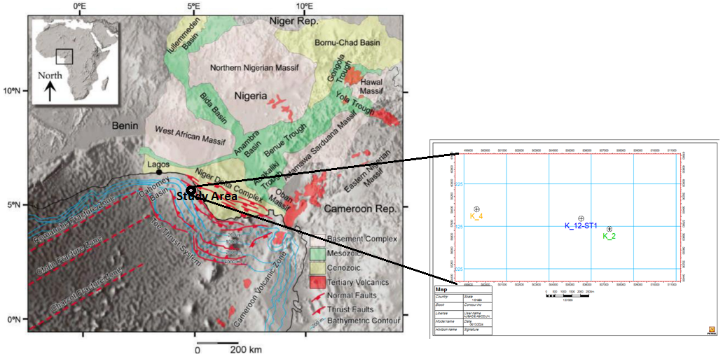
Figure 1: Location map of the Niger Delta region showing the main sedimentary basins and tectonic features (adopted from Onuoha, 1999)

  - Data set and Data presentation
Three (3) well logs and 3D-seismic data from the study area were used for data analysis. The well data consists of composite logs, which are gamma ray, sonic, resistivity, neutron and density logs. The 3D seismic volume is in SEG-Y format, while the well log data are in LAS format. The wells' data used cover a total vertical depth range from 14,931.71 ft (4,551.19 m), 13,133.98 ft (4,003.24 m), and 11,398.05 ft (3,474.13 m) in the study area.

  - Data Analysis
The well logs data served as input logs for the computation of relevant rock physics properties used for the research. Lithofaces units within the study area were delineated using a gamma ray log across the three wells.

3.3 Rock Physics Analysis
Rock physics parameters were estimated based on the relationships between sediment deposition, pore space and the presence of fluid within the study area. The following properties were accurately estimated (LambdaRho, MuRho, acoustic impedance, and compressional and shear velocity ratio) using the relations below. They were computed and analysed to establish their relationship with different types of fluids. Crossplot models were generated to understand the level of incompressibility and rigidity of the sediments in place due to fluid types occupying the pore space.
Lambda/Rho – Mu/Rho
The Lame's parameters were calculated using the following equations:
$Lambda( λ)=ρ\left({V_{p}}^{2}- {{2V}_{s}}^{2}\right)$ (1)
$Mu( μ)=ρ{V_{s}}^{2}$ (2)
where V_{p} is the primary velocity, V_{s} is the shear velocity, and ρ is the density. To calculate lambda-rho and mu-rho, the Lame’s parameter equations are multiplied by the density.
$λρ=ρ^{2}\left({V_{p}}^{2}-2{V_{s}}^{2}\right)$ (3)
$μρ=ρ^{2}{V_{s}}^{2}$ (4)

4. RESULTS AND DISCUSSIONS
4.1 Lithology and Fluid Type Analysis
Two types of lithofacies (shale and sands) were identified in the study area, as shown in Figure 2.
The sand sediment pore space is filled with gas, oil and water as interpreted from resistivity, density and neutron logs signatures shown in Figure 2. This was observed from a positive and high resistivity signature for hydrocarbon (gas and oil), while a low positive signature indicates water within the sand sediments. Gas is designated with red colour, oil with green and water with blue colour. Some relevant estimated rock physics parameters, such as (LambdaRho, MuRho, and velocity 4ratio), explained the relationships between sediment deposition and the type of fluid presence within the reservoir. Their response to the elastic parameter was also observed in Figure 3.

These were modelled by cross plotting density against sonic to illustrate fluid distribution and elastic parameter behaviour within a hydrocarbon reservoir, as in Figures 4a, 4b and 4c. It revealed that gas distribution is within high sonic at relatively low density, while oil and water were distributed at relatively high density against low sonic, with the exception where there is overlapping fluid distributions. It revealed a relationship between the petrophysical and elastic rock properties in the prediction of reservoir properties away from the well locations.
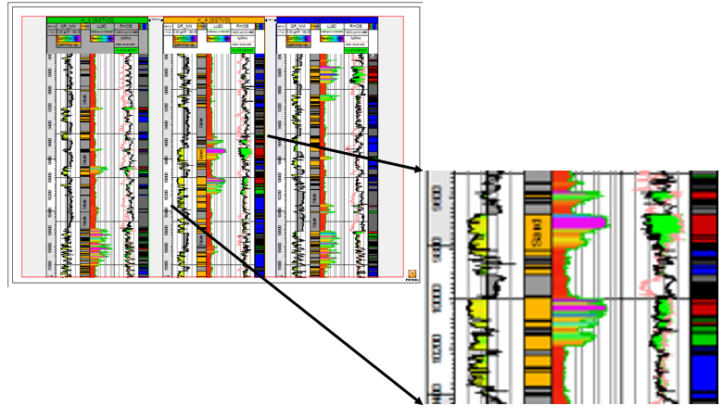
Figure 2: Resistivity, Density and Neutron logs Analysis
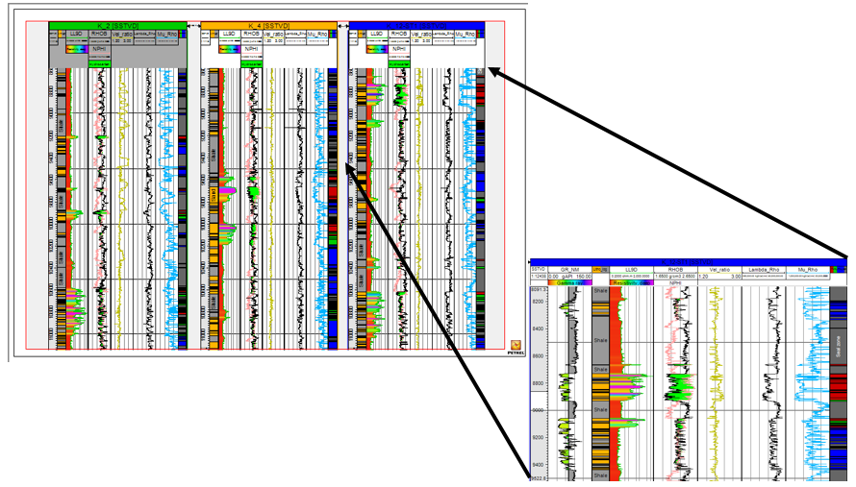
Figure 3: Derived Rock physics Logs (Velocity ratio, LambdaRho and MuRho)

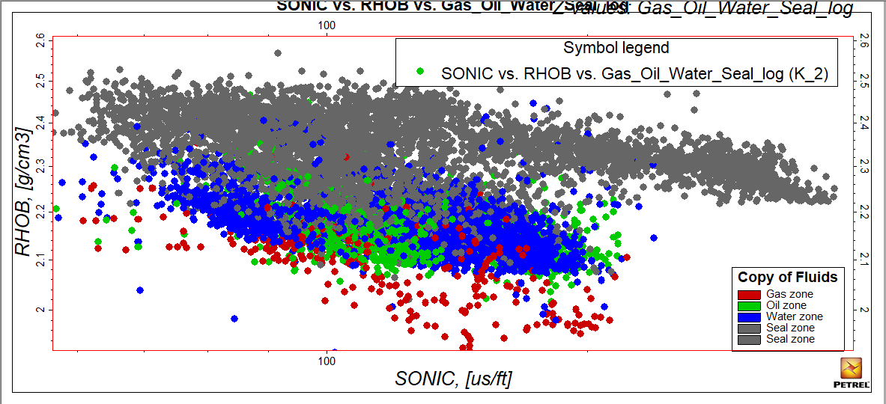
Figure 4a: Density against Sonic Cross Plot Modelled (SONIC vs. RHOB vs. Gas_Oil_Water_Seal_Log (K_2))

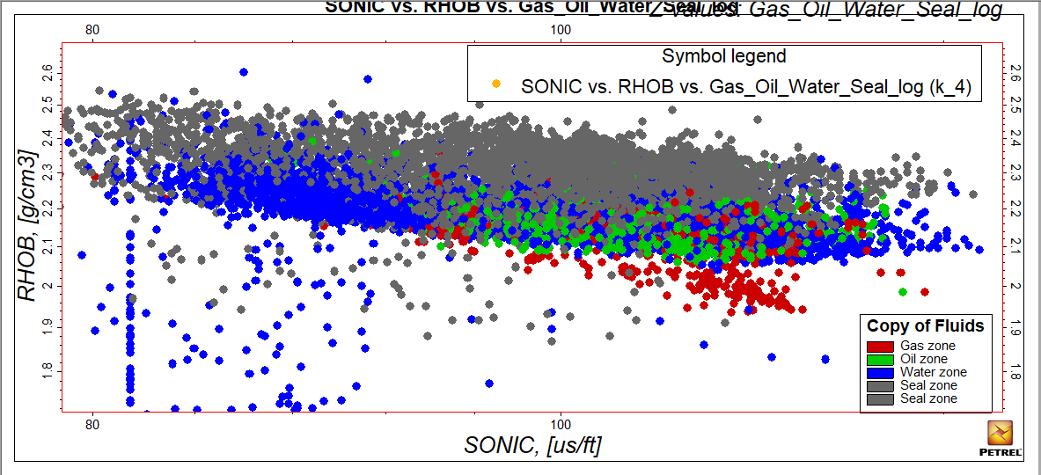
Figure 4b: Density against Sonic Cross Plot Modelled (SONIC vs. RHOB vs. Gas_Oil_Water_Seal_Log (K_4))

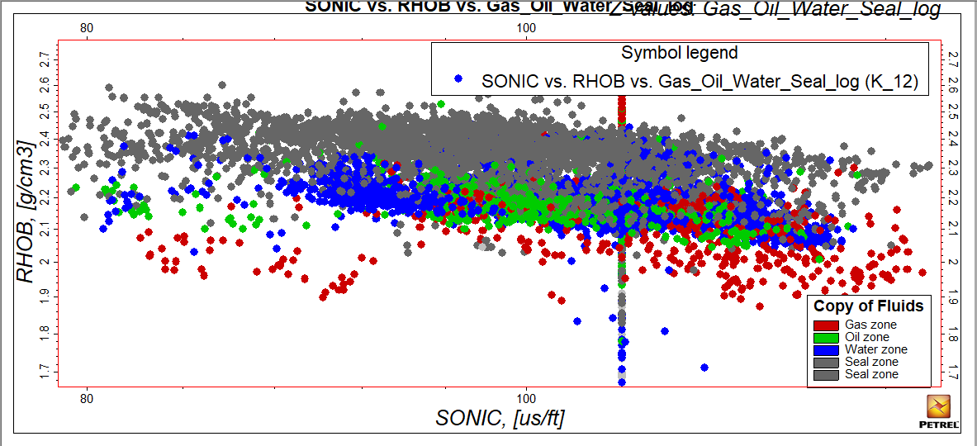
Figure 4c: Density against Sonic Cross Plot Model (SONIC vs. RHOB vs. Gas_Oil_Water_Seal_Log (K_12))

4.2 Velocity_Ratio versus Mu_Rho Crossplots Analysis
It was observed that Vp/Vs increased and Mu_Rho decreased within the hydrocarbon zone, while it overlap is observed within water zones. By comparing Figure 5a and 5b, Figure 6a and 6b and Figure 7a and 7b, it could be explained that the type of fluid in the reservoir sand made the Vp/Vs ratio high and Mu_Rho to drop. This is as a result of the good interconnection of pore space occupying the sediments, which has helped the accumulation of fluid in place. The compaction trend analyses from the density and P-sonic log crossplot also explained the cause of the Vp/Vs ratio increase and decrease in Mu_Rho with depth in the reservoir sand unit.

Distribution of litho-fluids in the area along the wellbore was also observed from both μρ and Vp/Vs crossplots, space discrimination, as high μρ and low Vp/Vs (>1.95) depict gas sand, while lower Vp/Vs (1.95) value indicates oil and water within the sand unit. Some level of overlap in the values of the Vp/Vs ratio and μρ also reveals gas sands and brine sands from the crossplots as shown in Figure 8a and b.
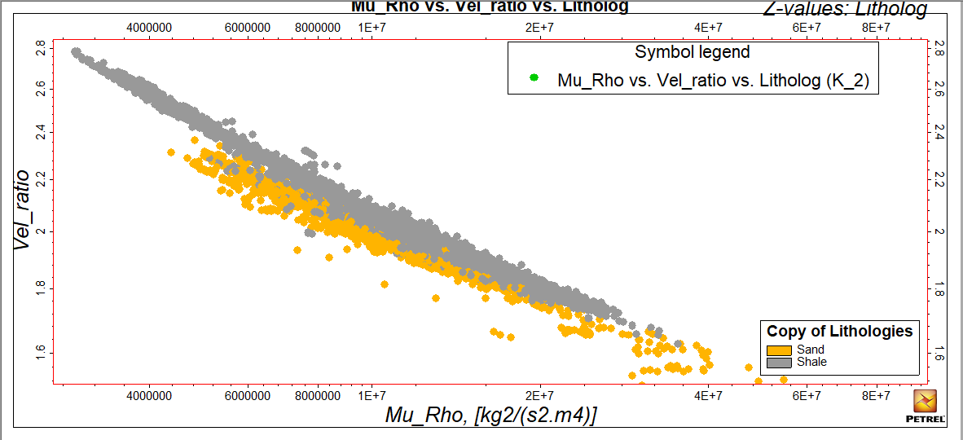
Figure 5a: Velocity_Ratio versus Mu_Rho Crossplots Model (Mu_Rho vs. Vel_ratio vs. Litholog (K_2))

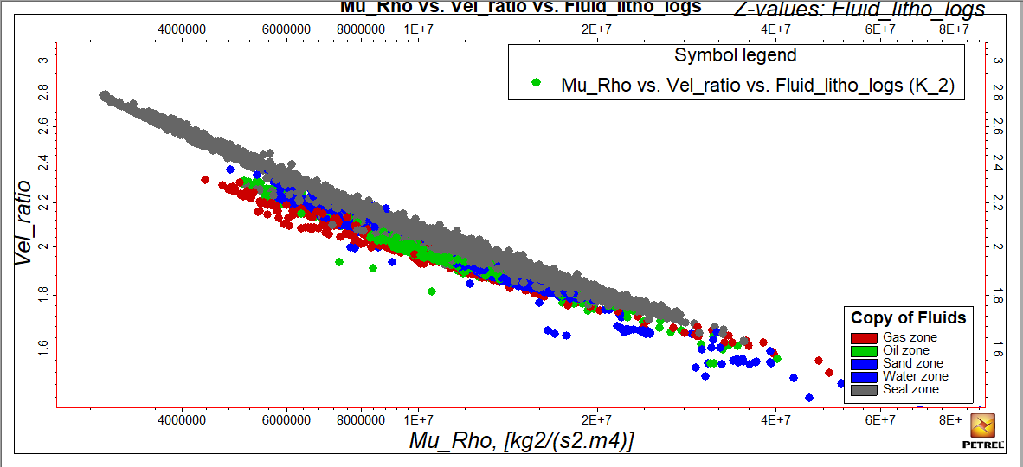
Figure 5b: Velocity_Ratio versus Mu_Rho Crossplots Model (Mhu_Rho vs. Vel_ratio vs. Fluid_litho_logs (K_2))

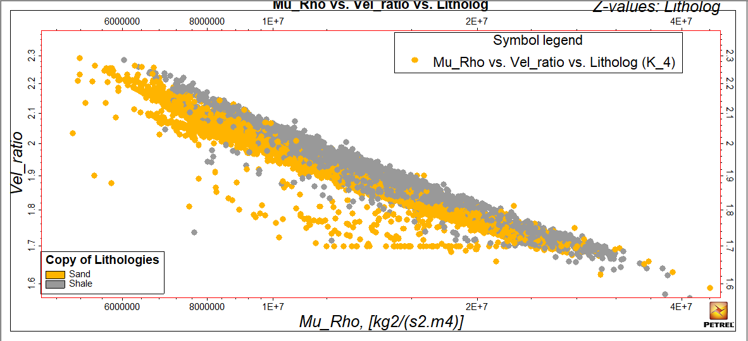
Figure 6a: Velocity_Ratio versus Mu_Rho Crossplots Model (Mhu_Rho vs. Vel_ratio vs. Litholog (K-4))

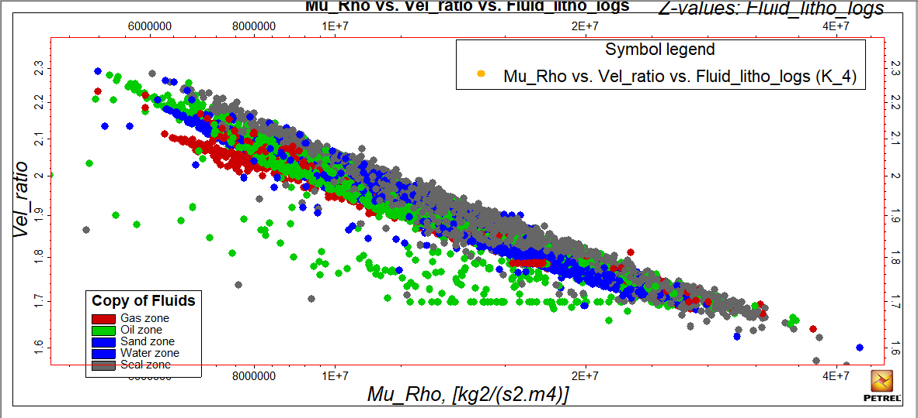
Figure 6b: Velocity_Ratio versus Mu_Rho Crossplots Model (Mhu_Rho vs. Vel_ratio vs. Fluid_litho_logs (K_4)

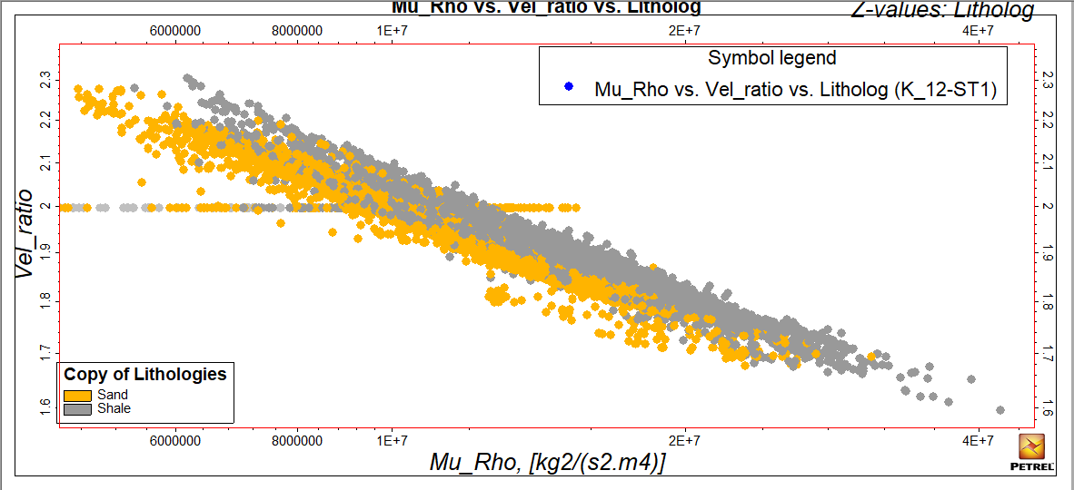
Figure 7a: Velocity_Ratio versus Mu_Rho Crossplots Model (Mhu_Rho vs. Vel_ratio vs. Litholog (K_12-ST1))

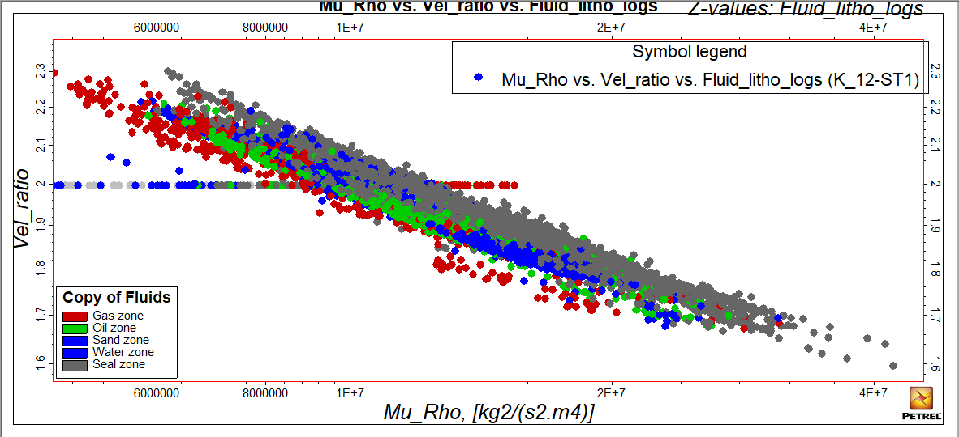
Figure 7b: Velocity_Ratio versus Mu_Rho Crossplots Model (Mhu_Rho vs. Vel_ratio vs. Fluid_litho_logs (K_12-ST1))
4.3 Incompressibility and Rigidity Analysis
In order to characterise the incompressibility and the rigidity of the rocks with respect to fluids in the pore spaces. Lambda-Rho (λρ) versus Mu-Rho (λρ) cross-plot shows a positive relationship that implies the higher the lambda-rho values, the higher the Mu-rho values, indicating that an increase in incompressibility provides lithological and fluid information within the reservoir sand. In the hydrocarbon zones, the Lambda_Rho values increase while MuRho tends to decrease in reservoir zones (Fig. 8). Lambda-Rho (λρ) versus Mu-Rho (λρ) colour coded with resistivity showed that the zone with the lowest Lambda-Rho values has the highest resistivity response, indicating hydrocarbon-charged zones. There are four cluster zones shown that were defined as Shale (gray sphere), Brine (Blue sphere) Oil-charged (Green sphere) and Gas-charged sand (red sphere) lithology (Fig. 8). This implied, that water filled sands unit has high level of incompressibility than oil and gas-filled sand units, also that shale increases in rigidity and incompressibility than reservoir sands. This was as a result of the low density of hydrocarbons compared to that of the water zone and the higher acoustic impedance of sand than shale (Oyetunji, 2013).

In the hydrocarbon zones, as shown in Figure 8a, 8b and 8c, the Lambda_Rho and Mu_Rho values are low compared to water zones as revealed from the logs signatures, most especially in gas. This is due to higher density and velocity, where encounter water zones are higher than those of hydrocarbons. Even though Mu_Rho should reveal higher values in reservoir sands zones as a results of have higher acoustic impedance than shales but the presence of hydrocarbon within the pore space has altered the rock properties across the wells.
Cluster analysis of elastic rock properties further helped to discriminate fluid fills in the reservoirs with gas-oil saturation and wet sand. Oladele, et al., (2019). This revealed a distinct trend in the distribution of fluid types present within the reservoir sand units on cross-plots. The cross-plots reveal that clusters with the least water saturation correspond to high resistivity, which implies highly charged hydrocarbon saturation sand that confirms the presence of gas/oil in the reservoir sand and shows lower Lambda_Rho values, confirming its low incompressibility within the sand unit.
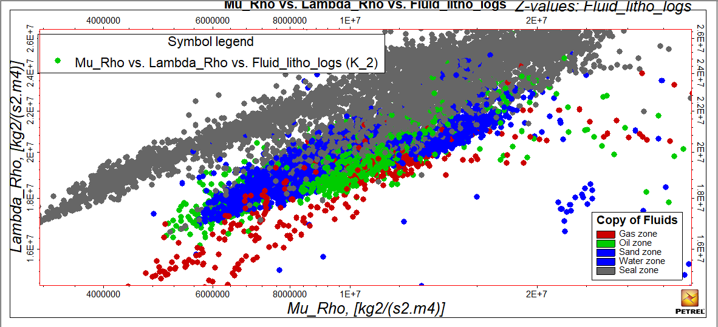
Figure 8a: Lambda_Rho versus Mu_Rho Crossplots Model (Mhu_Rho vs. Lambda_Rho vs. Fluid_litho_logs (K_2))

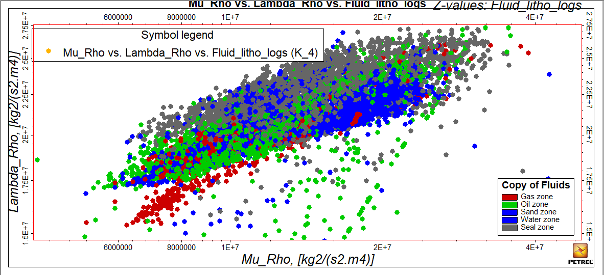
Figure 8b: Lambda_Rho versus Mu_Rho Crossplots Model (Mhu_Rho vs. Lambda_Rho vs. Fluid_litho_logs (K_4))
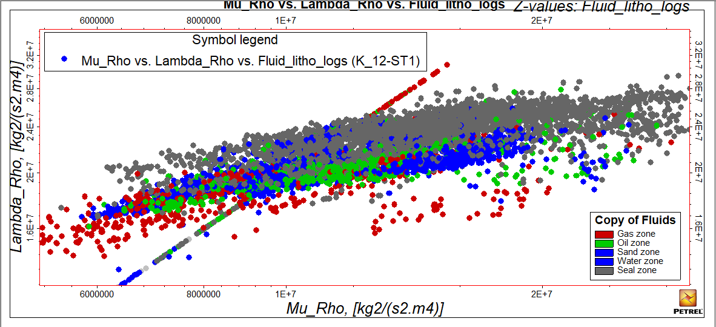
Figure 8c: Lambda_Rho versus Mu_Rho Crossplots Model (Mhu_Rho vs. Lambda_Rho vs. Fluid_litho_logs (K_12_ST1))

CONCLUSION
Reservoir lithology and fluid discrimination were done using rock physics cross-plots of P–Impedance, Lambda-Rho, Mu-Rho, and VP/VS ratio seismic attributes. The analysis of elastic and rock physics parameters from the field of study has revealed pore-fluid types, distinguishing hydrocarbon-bearing sand units and shale as counterparts on lithology within the study area. The effect of porosity, mineral composition, and fluid saturation on the subsurface was observed in the variations of elastic properties of the sediments. P-sonic and density logs, which provide insight about the porosity trend and density information for the different lithologies. Having realised that the porosity in the reservoir unit is moderately good, and the water saturation is low. The models explained the general behaviour of the rock in terms of poor, moderate and good qualities. This is helpful to note that the reservoir is good and economical.

Disclaimer (Artificial intelligence)

Option 1:

Author(s) hereby declare that NO generative AI technologies such as Large Language Models (ChatGPT, COPILOT, etc.) and text-to-image generators have been used during the writing or editing of this manuscript.

Option 2:

Author(s) hereby declare that generative AI technologies such as Large Language Models, etc. have been used during the writing or editing of manuscripts. This explanation will include the name, version, model, and source of the generative AI technology and as well as all input prompts provided to the generative AI technology

Details of the AI usage are given below:
1.
2.
3.

REFERENCES
- Avbovbo, A.A., 1978. Tertiary lithostratigraphy of Niger Delta: American Association of Petroleum Geologists Bulletin, v. 62, pp. 295-300.
- Doust, H., and Omatsola, E., 1990, Niger Delta, in, Edwards, J. D., and Santogrossi, P.A., eds., Divergent/passive Margin Basins, AAPG Memoir 48: Tulsa, American Association of Petroleum Geologists, p. 239-248.
- Heath Pelletier and Jay Gunderson 2004, Application of Rock Physics to an Exploration Play: A Case Study from the Brazeau River 3D, VeritasDGC, Calgary
- Kulke, H., 1995. Nigeria, In. Regional Petroleum Geology of the World (H. Kulke, Ed.) Part II: Africa, America, Australia and Antarctica, Gebruder Borntraeger Berlin, pp. 143-172.
- Mithilesh Kumar, R. Dasgupta, Dip Kumar Singha, and N. P. Singh (2018) Petrophysical evaluation of well log data and rock physics modeling for characterization of Eocene reservoir in Chandmari oil field of Assam-Arakan basin, India. J Petrol Explor Prod Technol (2018) 8:323–340.
- Olowokere M. T. and J.S. Ojo (2010).Fluid Detections and Lithology Discrimination Using Lame Petrophysical Parameters from Simultaneous Inversion: an example from Northern North Sea, Norway: Nigerian Association of Petroleum Explorationist (NAPE) Bulletin Vol. 22 (1) 36-42.
- Olowokere, M. T. and J. S. Ojo (2011b), Improved Reservoir Parameters Prediction from Seismic Attributes using Multivariate Statistics and Neural Networks: A Niger Delta Case Study. Nigerian Association of Petroleum Explorationist (NAPE) Bulletin, pp 28-38.
- Onuoha, K.M., 1999. Structural features of Nigeria's Coastal margin: an assessment based on age data from wells. J. Afr. Earth Sci. 29 (3), 485e499.
- Petroconsultants, 1996a, Petroleum exploration and production database: Houston, Texas, Petroconsultants, Inc., [database available from Petroconsultants, Inc., P.O. Box 740619, Houston, TX 77274-0619].
- Reijers, T.J.A., Petters, S.W., and Nwajide, C.S., 1996, The Niger Delta Basin, in Selley, R.C., ed., African Basins--Sedimentary Basin of the World 3: Amsterdam, Elsevier Science, pp. 151-172
- Short, K. C., and Stäublee, A.J., 1967, Outline of geology of Niger Delta: American Association of Petroleum Geologists Bulletin, v. 51, p. 761-779.
- Sonny Inichinbia , Peter O. Sule, Aminu L. Ahmed , Halidu Hamza and Lucky M. Omudu (2014) Fluid and lithology discrimination of Amangi hydrocarbon field of the Niger Delta using Lambda-Mu-Rho technique IOSR Journal of Applied Geology and Geophysics (IOSR-JAGG).Volume 2, Issue 2 Ver. II. PP 01-07 www.iosrjournals.org.
- Bello, Rasaq; Igwenagu, C. Linda; and Onifade, YS (2015) Cross plotting of Rock Properties for Fluid and Lithology Discrimination using Well Data in a Niger Delta Oil Field. Science and Environmental Management. J. Appl. Sci. Environ. Manage. Sept, 2015 Vol. 19 (3) 539 - 546 Full-text Available Online at www.ajol.info and www.bioline.org.br/ja
- Eyinla, D. S., Oladunjoye, M. A., Olayinka, A. I., & Bate, B. B. (2021). Rock physics and geomechanical application in the interpretation of rock property trends for overpressure detection. Journal of Petroleum Exploration and Production, 11(1), 75-95.
- Malozyomov, B. V., Martyushev, N. V., Kukartsev, V. V., Tynchenko, V. S., Bukhtoyarov, V. V., Wu, X., Tyncheko, Y. A., & Kukartsev, V. A. (2023). Overview of Methods for Enhanced Oil Recovery from Conventional and Unconventional Reservoirs. Energies, 16(13), 4907.
- Li, X., Yang, Z., Li, S., Huang, W., Zhan, J., & Lin, W. (2021). Reservoir characteristics and effective development technology in typical low-permeability to ultralow-permeability reservoirs of China National Petroleum Corporation. Energy Exploration & Exploitation, 39(5), 1713-1726.
- Ali, M., Ashraf, U., Zhu, P., Ma, H., Jiang, R., Lei, G., Ullah, J., Ali, J., Vo Thanh, H., & Anees, A. (2023). Quantitative Characterization of Shallow Marine Sediments in Tight Gas Fields of Middle Indus Basin: A Rational Approach of Multiple Rock Physics Diagnostic Models. Processes, 11(2), 323.

