**Soil Moisture, Reservoir, and Groundwater Interactions: Managing Water Sustainability in South Singbhum**

**Abstract**

|  |
| --- |
| **Background:** The South Singbhum region is dependent on reservoirs and groundwater for agricultural, domestic, and industrial utility. However, considerable changes in water storage and utilization patterns present obstacles to long-term water management.  **Aims:** This research examines the groundwater, surface water and soil moisture data and recommend measures for ensuring equitable and long-term water resource sustainability in the region.  **Study design:** This study uses a quantitative research design to analyze reservoir storage, groundwater utilization and soil moisture data from the South Singbhum region during a two-year timeframe. Statistical and comparative tools are used to figure out patterns, fluctuations, and stress zones in water resources, shedding information on the region's water management concerns and potential solutions.  **Place and Duration of Study:** South Singhbhum Craton region in Odisha is extended between latitude ${20}^{o} {58}^{'}58.238''N$ to ${22}^{o}{34}^{'}{1.051}^{''}N$ and longitude ${84}^{o}{43}^{'}30.304''E$ to ${86}^{o}{42}^{'}{35.307}^{''}E$. The area spread over $19, 609 km^{2}$ on 45 blocks of Eight district in Odisha.  **Methodology:** It entails gathering monthly data on reservoir storage levels, soil moisture and groundwater consumption from several areas in the South Singbhum region, followed by statistical analysis to determine trends and changes. Also, the study assesses the effects of various water management strategies across districts and their consequences for sustainable water usage through comparative analysis.  **Results:** The findings show large changes in water storage across the Baitarani (Salandi), Baitarani-Brahmani, and Brahmani (Rengali) reservoirs, with noticeable seasonal declines, particularly in early 2021. Groundwater consumption varies greatly between districts, with some areas relying heavily on groundwater for irrigation and others having more balanced usage patterns. The soil moisture data from the three basins showed consistent seasonal peaks during the monsoon months, with the highest moisture levels in August and September, and notable decreases in the dry months These findings emphasize the importance of adapted water management techniques to address both storage variations and groundwater sustainability in the region.  **Conclusion:** The South Singbhum region has major issues in water resource management because to variations in reservoir storage and groundwater utilization among districts. To maintain long-term water supply, it is critical to develop effective water management measures such as enhanced irrigation infrastructure and groundwater recharge methods. Future research should focus on improving prediction models and mitigating the effects of climate change on water supplies. |

***Keywords****: South Singhbhum, Groundwater, Soil Moisture, Water Reservoir, Statistical Analysis*

# **Introduction**

Water constitutes an essential resource for the sustenance of life as well as for the facilitation of agricultural, industrial, and domestic requirements; however, regions such as South Singbhum encounter substantial challenges arising from seasonal fluctuations in reservoir levels, inequitable groundwater usage, and the escalating repercussions of climate change. Driven by the imperative to address these pressing concerns, this research examines the patterns of variability in water resources within South Singbhum, where reservoirs including Baitarani (Salandi) and Brahmani (Rengali) demonstrate alarming reductions in storage capacity, and groundwater resources are subject to disparate levels of exploitation across various districts. The objective of this study is to reconcile the disparities within fragmented data and generate actionable insights, thereby offering a thorough analysis of the dynamics governing water resources to inform sustainable management strategies. By confronting these pivotal issues, the research aspires to contribute to the assurance of long-term water security, the alleviation of climate change impacts, and the promotion of socioeconomic advancement within the region (Mohanta & Pathy, 2024).

The primary aims and objectives of this comprehensive study are primarily focused on gaining a deeper understanding of the fluctuations and alterations in water levels within significant reservoirs and the groundwater resources over a temporal scale within the South Singbhum region, as well as meticulously identifying specific geographical areas that are currently confronting challenges related to water shortages or experiencing excessive water use. Furthermore, the research endeavours to propose straightforward yet sustainable methodologies for the effective management of water resources, which may include the implementation of improved irrigation techniques and strategies for the recharging of groundwater supplies, with the overarching goal of ensuring that there remains an adequate and reliable supply of water available for all individuals in the foreseeable future.

The remainder of the manuscript is organized as follows: Section 2 offers a thorough examination of the extant literature concerning reservoir storage dynamics, groundwater exploitation, and water resource stewardship, underscoring research deficiencies and the significance of this investigation. Section 3 elucidates the study locale, emphasizing the geographical, climatic, and hydrological attributes of the South Singbhum region, in conjunction with its water demand and resource allocation. Section 4 delineates the methodology, explicating the data acquisition process, analytical methodologies, and criteria employed to assess water resource patterns and challenges. Section 5 articulates the findings and discourse, scrutinizing the variations in reservoir storage, soil moisture and groundwater consumption while correlating the results to broader research implications. Finally, Section 6 culminates the study by recapitulating the findings, recognizing constraints, and proposing avenues for future inquiry, accentuating the significance of sustainable water management strategies for the region.

# **Literature Review**

Effective strategies for sustainable groundwater resource management in arid regions include integrated water resources management (IWRM), rainwater harvesting combined with managed aquifer recharge (RWH-MAR), and the utilization of non-conventional water resources (NCW). IWRM promotes a holistic approach that incorporates stakeholder participation and spatial analysis tools like GIS to enhance decision-making and address the complexities of water scarcity due to climate change and population growth (Adam & Osman, 2024). The RWH-MAR technique has been shown to significantly improve groundwater availability, providing a sustainable solution to water scarcity while also mitigating the impacts of extreme weather events (Abd-Elaty et al., 2024). *Effective strategies* include aquifer operation, hydraulic barriers, material and physical barrier management. These methods safeguard groundwater quality, crucial for sustainable water resources management in arid regions facing contamination risks (Gemail & Abd-Elaty, 2023). Utilizing GIS-based AHP-weighted overlay techniques with remote sensing data fusion is an effective strategy for sustainable groundwater management in arid regions, aiding in delineating groundwater prospective zones (Abdekareem et al., 2022). *The stakeholder-based framework*, *system dynamics modeling, and resilience analysis* suggest modern irrigation systems and water transfer as effective strategies for sustainable groundwater management in arid regions (Moghaddasi et al., 2022). Combining agroforestry, mulching (RSM), and no-tillage (NOT) strategies proved most effective in enhancing groundwater recharge and sustainability in arid regions, as shown in the study (Mohseni et al., 2022). Effective strategies for sustainable groundwater management in arid regions include savings, reutilization, infrastructure works like dams, and desalination plants, although the latter may pose high costs. Integration and proper management are crucial (Pulido-Bosch et al., 2020). The most effective strategy for sustainable water management in arid regions is constructing wastewater treatment facilities and reusing wastewater in industry and agriculture, prioritized using SWOT coupled AHP technique (Banihabib et al., 2020). A multi-isotopic evaluation of groundwater in hyper-arid regions can inform sustainable water management strategies by assessing water sources in rapidly developing areas, aiding in effective resource utilization and conservation (Gómez-Alday et al., 2022). Optimization modeling for groundwater management in arid regions is crucial. Strategies should aim to reduce water stresses by 45% within 25 years to achieve sustainability and address future shortages effectively (Al-Jawad et al., 2019). Additionally, leveraging NCWs, such as reclaimed water and desalination, is crucial for enhancing water security and food production in these regions (Bouramdane, 2024). Finally, the application of virtual water transfer strategies can optimize water allocation across regions, addressing the unbalanced distribution of water resources (Zheng et al., 2024). Together, these strategies form a comprehensive framework for sustainable groundwater management in arid environments. Artificial recharge techniques play a crucial role in augmenting groundwater resources and enhancing water security, particularly in regions facing water scarcity. These methods, which include water spreading, recharge pits, and the use of treated wastewater, aim to increase groundwater storage by facilitating the natural percolation of surface water into aquifers (Asano, 2016). For instance, studies in India demonstrate that integrating geospatial technologies can identify optimal sites for artificial recharge, significantly improving groundwater levels and addressing local water demands (Janarthanan & Thirukumaran, 2024). In Egypt, artificial recharge is a key component of national water management strategies, helping to mitigate the impending water supply crisis by replenishing aquifers and improving water quality (Dawoud, 2024). Furthermore, research in Afghanistan highlights the potential of rainfall harvesting to enhance groundwater levels, particularly in arid climates (Rasouli & Vaseashta, 2024). Artificial recharge techniques, like Managed Aquifer Recharge (MAR), can augment groundwater resources, reduce overdraft, and enhance water security, especially in arid regions, aiding in climate change resilience (Cruz-Ayala & Megdal, 2022). Artificial recharge techniques can enhance groundwater storage, aiding water security. In Al-Qilt catchment, hydrological modeling identified suitable sites, guiding effective groundwater management for improved water availability (Masri & Ghanem, 2022). These techniques not only support sustainable water management but also provide a strategic response to the challenges posed by population growth and climate variability.

Surface water variability significantly impacts water resource management, as evidenced by multiple studies highlighting the interplay between anthropogenic and climatic factors. In the contiguous United States, nearly 79% of river basins experienced an increase in surface water extent due to rising precipitation, while arid regions faced reductions linked to urbanization and increased potential evapotranspiration (PET) (Palazzoli et al., 2023). Similarly, in the Wuding River Basin, human activities and climate change have led to a continuous decline in runoff, emphasizing the need for adaptive management strategies that consider both groundwater exploitation and evapotranspiration control (Dang et al., 2021). Furthermore, in sub-Saharan Africa, climate variability and recurrent droughts have exacerbated surface water scarcity, necessitating improved monitoring techniques, such as remote sensing, to inform management practices (Bhaga et al., 2020). Collectively, these findings underscore the critical need for integrated water resource management approaches that account for both natural variability and human impacts on surface water systems.

Surface water variability significantly impacts agricultural irrigation through its influence on water quality, availability, and management strategies. In regions like Taiwan, uneven rainfall distribution exacerbated by climate change leads to both flooding and drought conditions, complicating irrigation water management and necessitating supplementary water resources for agriculture (Huang & Fan, 2023). Additionally, the dynamics of irrigated land and water requirements are affected by climate variability, which can alter the extent of irrigated areas and the volume of water needed for optimal crop growth (Zhu & Siebert, 2023). Furthermore, the interaction between surface and subsurface water flows, influenced by spatial variability in soil and topography, can affect irrigation performance at the field scale, highlighting the need for accurate modeling to improve irrigation efficiency (Dong et al., 2018). Surface soil water content spatial organization varies between irrigated and non-irrigated fields, impacting agricultural irrigation by influencing water distribution and availability for crops within different areas of the field (Cosh et al., 2012). Surface water variability, influenced by soil moisture and vegetation growth, affects irrigation efficiency by impacting sensible and latent heat fluxes, evapotranspiration rates, and overall agricultural water management in vineyards (Geli et al., 2019). Surface water variability, influenced by ENSO events, affects agricultural irrigation by determining precipitation, stream flows, and sustainable water withdrawal, enabling ecologically sound irrigation practices in the study area (Mondal et al., 2011). Surface characteristics like soil texture and residue cover influence soil water content variability in agricultural fields, impacting irrigation efficiency and water management practices in agriculture (Manns et al., 2014). Lastly, future hydrologic variability poses risks to water supply sustainability, particularly in regions with high agricultural dependency, leading to increased uncertainty in irrigation practices (Birnbaum et al., 2024). Thus, effective management strategies must adapt to these variabilities to ensure sustainable agricultural practices.

Surface water variability plays a crucial role in urban water supply systems, primarily influenced by climatic factors and human activities. Research indicates that the spatial variability of surface runoff is significantly affected by both natural and anthropogenic factors, such as urban settlements and agricultural practices, which can alter the water balance in catchments (Alonso Vicario et al., 2023). Urban areas often rely on climate-dependent water sources, making them vulnerable to variability and uncertainty, particularly in the context of climate change (Sibly & Tooth, 2015). Moreover, the yield of urban water supply systems is sensitive to climate variability and the input variables used in their management. Studies show that shorter planning periods lead to greater volatility in yield estimates, highlighting the importance of considering climate variability in system design and operation (King, 2009). Thus, effective management of surface water variability is essential for ensuring reliable urban water supply, necessitating adaptive strategies to mitigate the impacts of changing climatic conditions and human influences (King, 2009; Sibly & Tooth, 2015).

To mitigate surface water variability in water resource management, several strategies can be implemented based on recent research findings. First, identifying and enhancing surface runoff source areas is crucial, as these areas significantly influence hydrological regimes and can be optimized through nature-based solutions, such as creating habitats that improve soil water retention and infiltration capacity. This approach can help mitigate extreme hydrological events like droughts and floods (Jakubinsky et al., 2021). Additionally, adopting Climate Smart Water Management (CS-WM) practices is essential, particularly in regions facing climate variability. Strategies include improving data collection for adaptive management, raising community awareness, and leveraging technology to enhance water management effectiveness (Teferi Taye et al., 2023). Furthermore, implementing Best Management Practices (BMPs) such as cover crops and vegetative filter strips can significantly reduce sediment and nutrient loads in surface water, thereby improving water quality and reducing variability (Venishetty et al., 2023). The optimal bid method for small hydropower generators in metropolitan water purification facilities can mitigate surface water variability in water resource management by enhancing renewable resource variability mitigation strategies (Lee et al., 2023). Strategies like Managed Aquifer Recharge (MAR) and Surface Water Recharge (SWR) can mitigate surface water variability in water resource management by thermal exploitation of alluvial aquifers (Epting et al., 2023). Implement strategies like setting rules based on current water levels, forecasting dry season flows, restricting withdrawals, improving irrigation efficiency, and allowing expansion only during high water availability months to manage surface water variability (Collischonn et al., 2014). Implementing a water conservation program and managed aquifer recharge can mitigate surface water variability in water resource management, enhancing system reliability and sustainability in the Eastern Snake Plain Aquifer (Ryu et al., 2012). Reducing watershed evapotranspiration and controlling groundwater exploitation are key strategies to mitigate surface water variability in water resource management, as highlighted in the study on the Wuding River Basin (Dang et al., 2021). Dry sanitation, education projects, and tariff structures are effective strategies to mitigate surface water variability in water resource management, as identified in the study on the Northern Cape, South Africa (Mukheibir, 2007). Development of real-time surface water abstraction management tools integrating rainfall-runoff models, uncertainty analysis, and water resource management can mitigate surface water variability in water resource management effectively (Asfaw, 2018). Strategies like optimizing conjunctive water use by adjusting surface water contributions can mitigate surface water variability, ensuring sustainable water management under uncertainty in hydrological systems (Kifanyi, 2022). Strategies like sustainable management practices can help mitigate surface water variability in water resource management, as discussed in the paper on sustainable surface water management (Charlesworth & Booth, 2016). Collectively, these strategies provide a comprehensive framework for addressing surface water variability in diverse contexts. Recently, Mohanta & Pathy, (2024) provided thorough information about rainfall trends and variability in South Singhbhum from 2008 to 2021 using extensive statistical analysis and revealed significant trends of decreasing rainfall on an annual and monthly basis. It determined the critical periods of year-to-year variability and showed that there was significant spatial variability of rainfall with different blocks and how this affects water resource management.

# **Methodology**

# **Study Area**

South Singhbhum Craton region of Odisha is extended between latitude ${20}^{o} 58' 58.238'' N$ to ${22}^{o} 34' 1.051'' N$ and longitude ${84}^{o} {43}^{'}30.304'' E$ to ${86}^{o}{42}^{'}{35.307}^{''}E$. The area is spread over $19,609 km^{2}$ on 45 blocks of Six District in Odisha. The region is full of natural resources and famous for its mineral resources, such as iron ore, manganese, bauxite, chromite, etc., and the area is formed from hilly, plateau, and residual hills. The following comparative table provides detailed information about the research that has been conducted previously in this area. Figure 1 depicts the research region, which covers 19,609 square kilometers in 45 blocks across eight districts in Odisha.

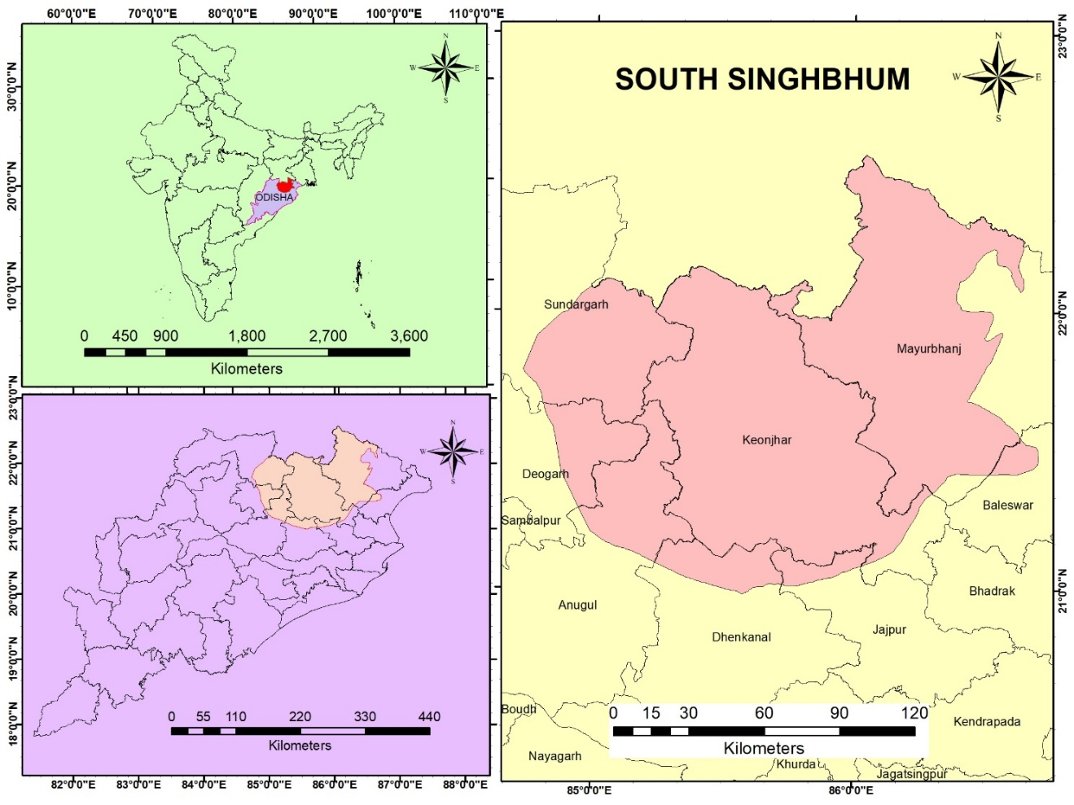

Figure 1: Study Area Boundaries and Key Locations

The methodological framework for this investigation encompasses a structured technique aimed at examining variations in reservoir storage and groundwater usage within the South Singbhum area from January 2020 to December 2021. The research design is crafted to amalgamate data acquisition, statistical scrutiny, and comparative assessment to extract insights regarding trends in water resources and the requisite management strategies. Presented below is a comprehensive exposition of the methodologies utilized:

* 1. **Data Collection**:

Reservoir storage data pertaining to the Baitarani (Salandi), Baitarani-Brahmani, and Brahmani (Rengali) water bodies were meticulously acquired from the relevant local water management authorities, in addition to secondary sources, which collectively provided a detailed account of the monthly averages throughout the designated study period. The groundwater data, which encompassed various critical aspects such as availability rates, extraction figures, and the specific usage statistics for irrigation, domestic consumption, and industrial applications, were diligently sourced from the district water resource departments as well as comprehensive government reports. To enhance the robustness of these datasets and ensure a thorough representation of the region's water resources, additional blockwise information was collected for each district, thereby allowing for a more nuanced understanding of the hydrological dynamics at play.

* 1. **Data Pre-processing and Validation**:

The data that was meticulously collected throughout the research process underwent a thorough examination to ensure that it met the rigorous standards of both consistency and accuracy, thereby establishing a solid foundation for subsequent analyses. In instances where entries were found to be missing or exhibited inconsistencies, these anomalies were systematically addressed through the application of sophisticated imputation techniques, or alternatively, such entries were excluded from further consideration if they were judged to be unreliable based on predetermined criteria. To facilitate meaningful comparisons across disparate datasets, standardized measurement units were employed, specifically utilizing billion cubic meters (BCM) for quantifying reservoir storage capacities and million cubic meters (MCM) for assessing groundwater resources, thus promoting uniformity in the data representation. In addition, comprehensive spatial and temporal trends within the dataset were meticulously identified and analyzed, which served to illuminate both seasonal variations and long-term shifts in the patterns of water resource availability and utilization.

* 1. **Statistical Analysis**:

Descriptive statistics, which encompass a variety of measures including the arithmetic mean, the median value, the standard deviation reflecting the dispersion of data, as well as the range that indicates the difference between the maximum and minimum values, were meticulously calculated in order to provide a comprehensive summary of the variability observed in both reservoir storage capacities and the utilization patterns of groundwater resources. Seasonal trends, along with any anomalies that deviated from established patterns, were systematically identified and analyzed through the application of time-series analysis, a method that enables the examination of data points collected or recorded at successive points in time to uncover underlying trends. In addition, comparative analyses were rigorously conducted to evaluate differences in storage capacities, the availability of groundwater resources, and the patterns of their utilization across various geographical regions, specifically focusing on distinct blocks and districts as unit areas of analysis. Furthermore, a range of graphical representations, such as line graphs that illustrate trends over time, bar charts that compare different categories, and scatter plots that depict relationships between variables, were generated for the purpose of visually interpreting the identified trends and relationships within the data.

* 1. **Geospatial and Comparative Analysis**:

Blockwise and district-level datasets were meticulously analyzed in order to comprehensively identify and elucidate the spatial disparities that exist in both the availability of groundwater resources and the patterns of their usage across different geographical regions. To facilitate this intricate analysis, advanced Geographic Information Systems (GIS) tools were strategically employed to generate detailed and informative maps that illustrate not only the varying levels of reservoir storage but also the diverse patterns of groundwater utilization, as well as the delineation of zones experiencing significant stress due to over-extraction or inadequate replenishment. In addition, thorough comparative assessments were systematically conducted across various districts with the aim of determining the overall sustainability of water usage practices, while simultaneously highlighting specific regions that are in urgent need of immediate management interventions to ensure the long-term viability of this critical resource.

* 1. **Interpretation and Recommendations**:

Insights that were meticulously derived from the comprehensive analyses conducted were synthesized in order to attain a profound understanding of the intricate dynamics associated with the fluctuations and utilization of water resources in various contexts. The expansive scope of the study successfully identified several key challenges that persist within the water management system, including, but not limited to, the seasonal shortages that significantly affect availability, the overextraction of water resources in specific geographic areas, and the notable underutilization of water in other regions, thereby highlighting the disparities in resource management. Based on the extensive findings gathered from this rigorous investigation, a series of tailored recommendations aimed at promoting sustainable water management practices were thoughtfully formulated, with a particular emphasis on the enhancement of irrigation practices, the implementation of effective groundwater recharge techniques, and the necessity for strategic policy interventions that address the identified issues.

The diagram illustrated in Figure 7 delineates a methodological approach that establishes a comprehensive framework for comprehending the intricate dimensions of water resource management in the South Singbhum area, thereby laying the groundwork for subsequent investigations and the formulation of policy initiatives.

# **Results and Discussion**

The examination of the monthly average storage data for the South Singbhum region indicates significant fluctuations in the Baitarani (Salandi), Baitarani-Brahmani, and Brahmani (Rengali) reservoirs between January 2020 and December 2021. The Baitarani (Salandi) reservoir experienced a substantial decrease in water storage, dropping from 0.33 billion cubic meters (BCM) in January 2020 to a minimum of 0.03 BCM in the initial months of 2021 (refer to see Figure 2). This fall indicates notable seasonal fluctuations and possible influences from climate and usage patterns. The average storage for Baitarani (Salandi) is 0.189 BCM, with a middle value of 0.22 BCM and a measure of variation of 0.139, suggesting a somewhat consistent but steadily decreasing pattern throughout the examined timeframe.

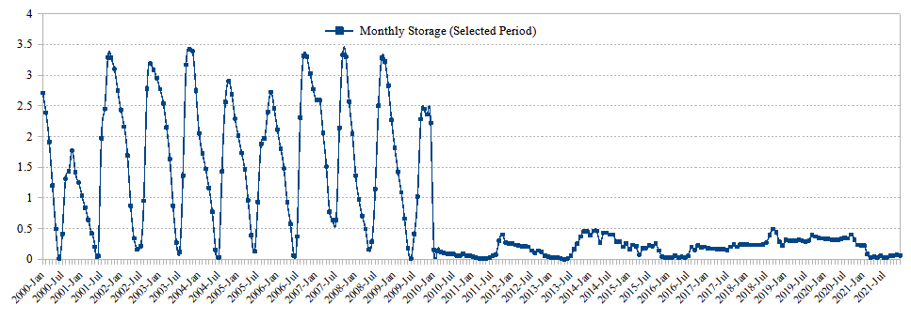

Figure 2: Water storage in Baitarani (Salandi) reservoir

On the other hand, the Baitarani-Brahmani reservoir consistently maintains a greater storage level, with average and middle values of 0.638 BCM and 0.53 BCM, respectively (refer to see Figure 3). The storage capacity reaches its maximum level of 1.54 BCM in February 2020, but subsequently decreases progressively, reaching its lowest point of 0.11 BCM in May 2021. The standard deviation of 0.408 BCM indicates moderate variations, indicating a more dependable water source in comparison to the Baitarani (Salandi). The significant decline witnessed in the subsequent months emphasizes the potential strain on water resources and underscores the necessity for efficient water management measures.

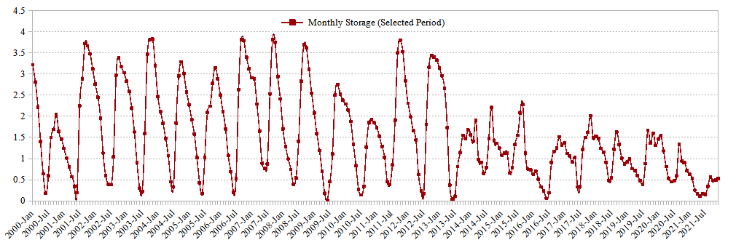

Figure 3: Water storage in Baitarani-Brahmani reservoir

Similarly, the data from the Brahmani (Rengali) reservoir displays variations, with an average storage of 0.449 BCM and a middle value of 0.415 BCM (refer to see Figure 4). The storage levels had a significant decrease from January 2020 (1.12 BCM) to early 2021, reaching their lowest point in May 2021 at 0.08 BCM. The standard deviation of 0.321 BCM suggests a notable level of variability, which may be attributed to seasonal influences and potentially fluctuating patterns of precipitation or water usage needs. In summary, the data highlights the significance of closely observing and controlling water resources in the South Singbhum region to guarantee long-term viability and tackle possible deficits during periods of low storage.

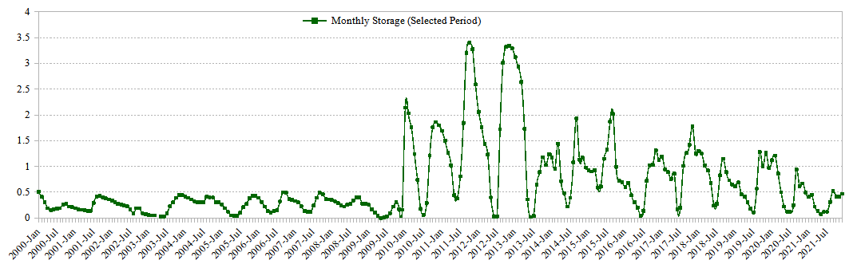

Figure 4: Water storage in Brahmani (Rengali) reservoir

The assessment of groundwater supply and extraction in different districts shows considerable variation among different subdivisions. The districts of Angul and Baleshwar have a comparatively abundant supply of groundwater, especially in blocks like Palalahada (6468 units) and Nilagiri (8306 units). Nevertheless, the irrigation draft and total draft in these areas are significant, suggesting a strong dependence on groundwater for agricultural activity. As an example, the district of Angul has a specific area called Kaniha, which has an irrigation draft of 2422.98 units. This contributes to the overall draft of the district, which amounts to a total of 2760.98 units. Similarly, the town of Oupada in Baleshwar district has a total water consumption of 2866.13 units, with irrigation being the primary user. This pattern indicates the need for implementing sustainable approaches in groundwater management to guarantee its long-term availability.

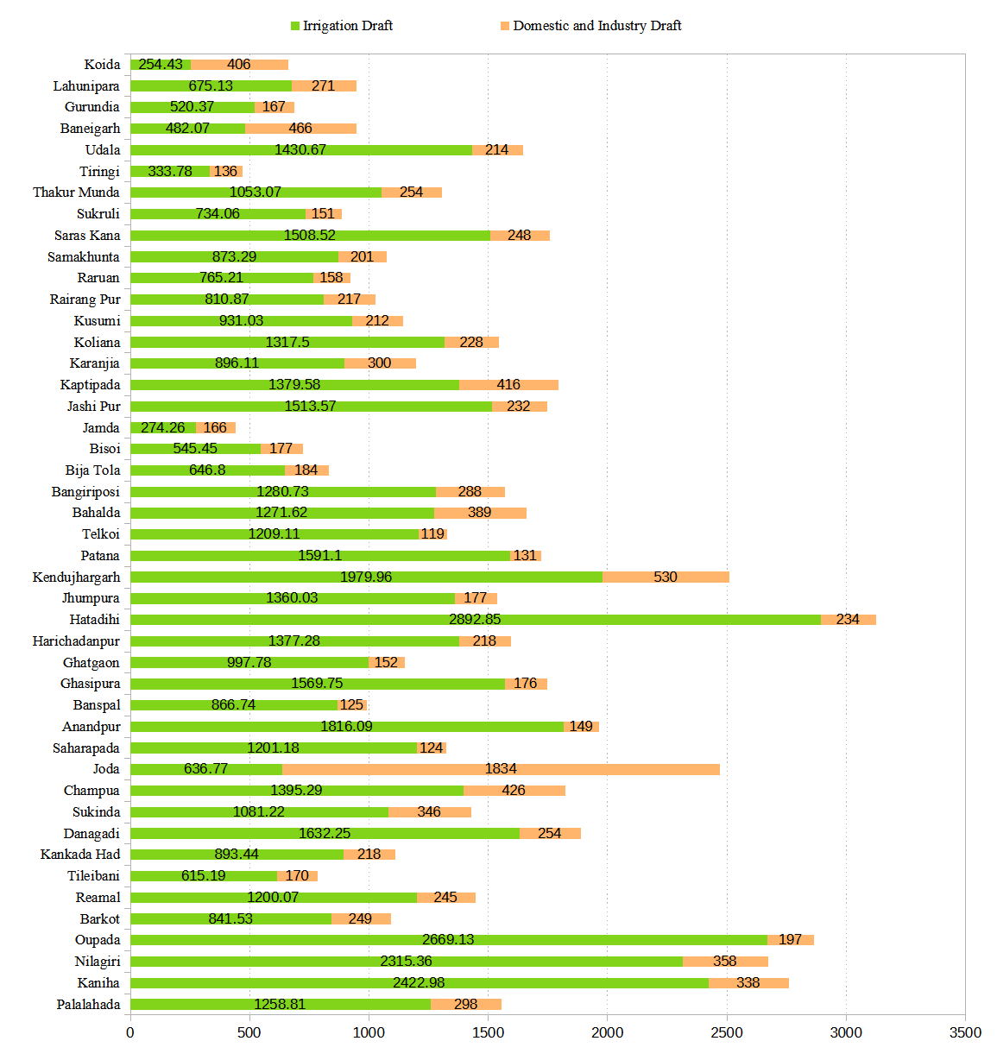

Figure 5: Blockwise groundwater utility in irrigation, and domestic and industry in South Singhbhum region

Conversely, the blocks in Deogarh and Dhenkanal districts display a distinct pattern. Although Barkot (Deogarh) and Kankada Had (Dhenkanal) have a reasonable groundwater availability of 6729 and 6186 units, respectively, their irrigation and total drafts are somewhat lower. As an illustration, Barkot's overall draft amounts to 1090.53 units, while Kankada Had's totals 1111.44 units. This suggests that these blocks may have a relatively equitable distribution of groundwater usage or may be supplemented by additional water sources to meet their demands. Nevertheless, the data necessitates vigilant observation to avert excessive extraction in the future, particularly considering the potential rise in home and industrial requirements.

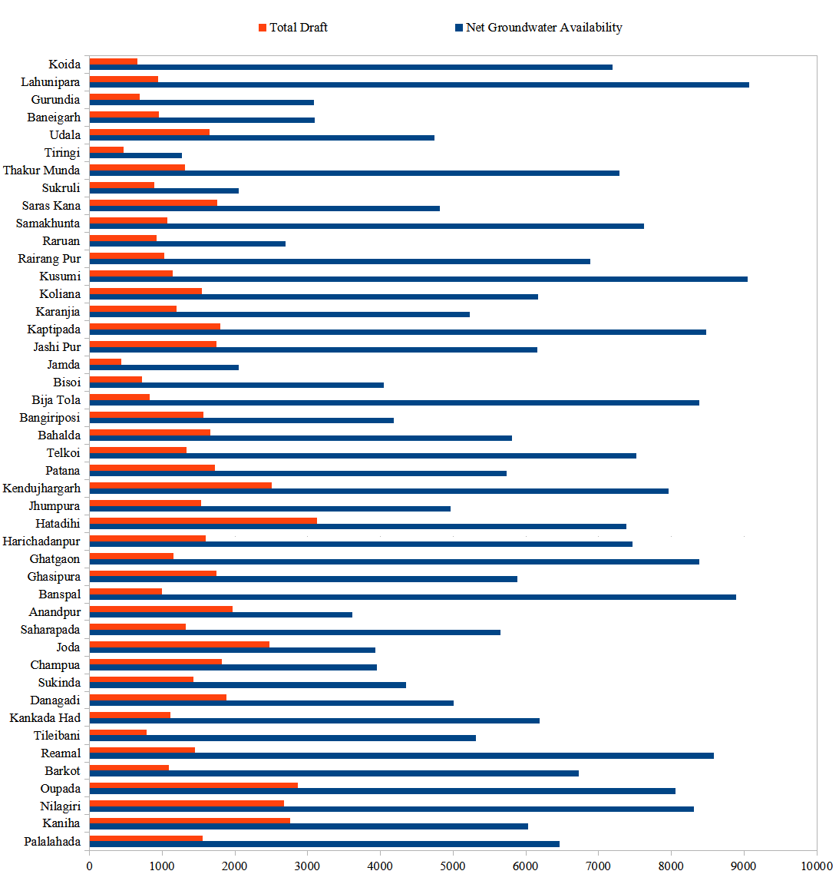

Figure 6: Total Draft vs Net groundwater availability in South Singhbhum region

The districts of Keonjhar and Mayurbhanj exhibit a varied situation, with certain blocks seeing elevated pressure on groundwater supplies. The Hatadihi block in Keonjhar has a substantial total draw of 3126.85 units compared to a net availability of 7385 units, primarily due to a strong demand for irrigation. In contrast, blocks such as Rairangpur in Mayurbhanj demonstrate a more traditional approach, utilizing a total of 1027.87 units out of the 6881 units available. It is worth mentioning that the blocks of Lahunipara and Koida in the Sundargarh district have a lower total water usage compared to the amount of groundwater available. This indicates that these blocks rely less on groundwater for irrigation, maybe due to the presence of other water sources or different agricultural methods. The varied exploitation of groundwater in different areas emphasizes the necessity for customized techniques in managing groundwater to effectively handle local conditions and ensure its sustainable use. Figure 5 provides a comparative analysis of blockwise groundwater usage for irrigation, domestic, and industrial purposes in the South Singhbhum region. Figure 6 provides a comparative analysis of blockwise groundwater availability and water utility in the South Singhbhum region.

In Table 1, the groundwater situation in South Singbhum exhibits a varied depiction of usage and accessibility throughout its regions. For instance, Kendujhar estimates an annual groundwater withdrawal of 34,078.74 million cubic meters (MCM) from a significant replenishable groundwater supply of 89,098.83 MCM. This leaves a net availability of 81,179.11 MCM. Mayurbhanj, which has a strong emphasis on irrigation (48,251.04 MCM), has a total water usage of 56,089.91 MCM and a noteworthy net groundwater supply of 137,053.64 MCM. Deogarh, on the other hand, exhibits lesser statistics, with a total draft of 16,494.11 MCM and a net availability of 30,689.22 MCM. These numbers indicate that Deogarh has a smaller resource base and natural discharge.

The level of groundwater utilization, a crucial measure of sustainability, significantly differs among districts. Jajpur, currently at a development stage of 64.56%, is approaching a crucial point where immediate management measures are necessary to avoid over exploitation. Baleshwar exhibits a significant level of development at 56.56%, which requires diligent monitoring. Meanwhile, Sundarghar and Denkanal demonstrate higher levels of sustainable usage with development phases of 37.77 % and 36.48%, respectively. This suggests that there is potential for improved utilization without the immediate danger of depletion. These disparities emphasize the necessity for groundwater management measures tailored to each district. Figure 7 provides a comparative analysis of the domestic and industrial groundwater utilities among districts within the South Singbhum region.

To ensure successful groundwater management in South Singbhum, it is necessary to develop customized strategies that take into consideration the specific conditions of each area. Districts like as Kendujhar and Mayurbhanj, which have abundant availability, should prioritize improving irrigation infrastructure in order to increase agricultural productivity. On the other hand, Deogarh and Jajpur require strict measures to control extraction and enhance recharging processes. Subsequent studies should improve estimates of recharge and predictive models to incorporate the effects of climate change. Meanwhile, policy initiatives should encourage the adoption of water-efficient technology, rainwater harvesting, and community awareness to ensure the implementation of sustainable practices at all levels. Figure 8 shows a comparative examination of the irrigation practices employed by groundwater utilities across several districts in the South Singbhum region.

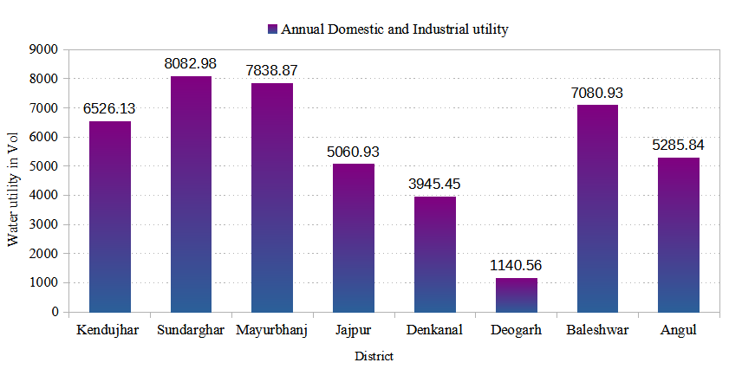

Figure 7: Domestic and industrial ground water utility in South Singbhum region

Table 1: Status of Groundwater in South Singbhum Region

|  |  |  |  |  |  |  |  |  |  |
| --- | --- | --- | --- | --- | --- | --- | --- | --- | --- |
| District | Annual Domestic and Industrial utility | Annual Irrigation utility | Annual Groundwater Draft (Total) | Annual Replenishable Groundwater Resources (Total) | Natural Discharge During Non-Monsoon Season | Net Groundwater Availability | Projected Domestic & Industrial Uses Upto 2025 | Groundwater Availability for Future Irrigation | Stage of Groundwater Development (%) |
| Kendujhar | 6526.13 | 27552.61 | 34078.74 | 89098.83 | 7919.72 | 81179.11 | 6604.91 | 46479.77 | 41.98 |
| Sundarghar | 8082.98 | 21873 | 29955.98 | 85676.61 | 6372 | 79304.61 | 6671.02 | 48635.51 | 37.77 |
| Mayurbhanj | 7838.87 | 48251.04 | 56089.91 | 147671.25 | 10617.61 | 137053.64 | 8297.08 | 80310.1 | 40.93 |
| Jajpur | 5060.93 | 28635.65 | 33696.58 | 56967.07 | 4776.26 | 52190.81 | 5505.05 | 18185.95 | 64.56 |
| Denkanal | 3945.45 | 12370.81 | 16316.26 | 48250.13 | 3525.56 | 44724.57 | 3895.5 | 28166.89 | 36.48 |
| Deogarh | 1140.56 | 15353.55 | 16494.11 | 33640.41 | 2951.19 | 30689.22 | 1009.97 | 14117.77 | 53.75 |
| Baleshwar | 7080.93 | 61512.34 | 68593.27 | 131300.9 | 10016.87 | 121284.03 | 7947.22 | 52127.95 | 56.56 |
| Angul | 5285.84 | 20250.43 | 25536.27 | 59529.76 | 4452.37 | 55077.39 | 4916.11 | 28922.49 | 46.36 |

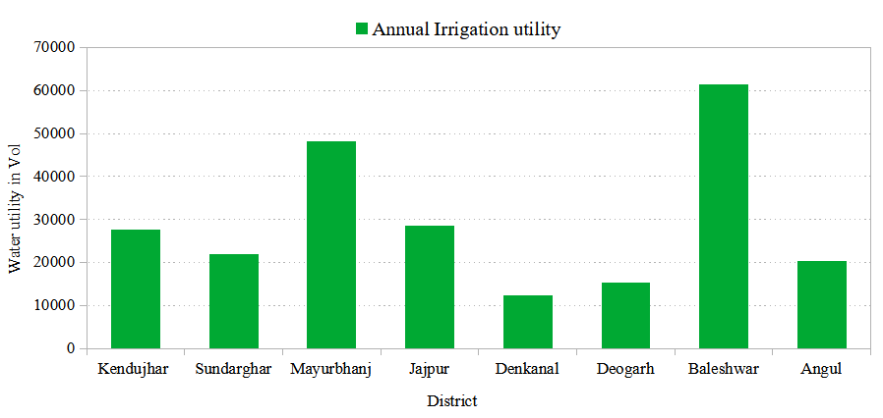

Figure 8: Groundwater utility for irrigation in South Singbhum region

A block-wise comparison of groundwater utility and groundwater availability in the South Singhbhum Region is shown in Figure 9. Also, Figure 10 illustrates a comparative analysis of annual irrigation, domestic and industrial water utilization, as well as groundwater resource utilization in the South Singhbhum Region.

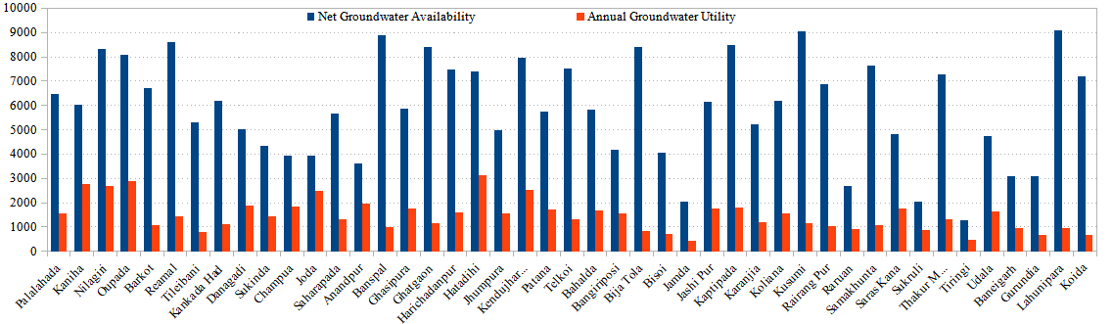

Figure 9: Comparison between net groundwater availability and annual groundwater utility

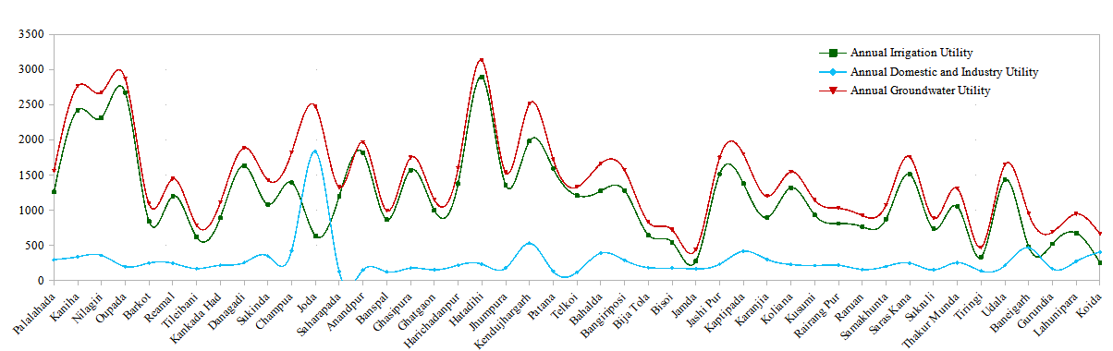

Figure 10: Comparison between annual irrigation, domestic and industrial, and groundwater utility

The monthly volumetric soil moisture data in Figure 11 for the Brahmani sub-basin, Brahmani and Baitarni Basin from August 2018 to December 2021 shows clear and noticeable changes that occur both within each year and between different years. The data shows that soil moisture levels are consistently greater throughout the monsoon months (June to September) every year, reaching their highest point in August and September, often surpassing a value of 30. In August 2018, the recorded value was 36.61. In August 2019, 2020, and 2021, the levels remained consistently high, with measurements of 35.93, 36.71, and 30.21, respectively. In contrast, the soil moisture is considerably reduced during the dry months (November to April), reaching its minimum levels in winter months like January 2021 (15.1) and February 2021 (13.98). The dataset shows that the greatest annual soil moisture occurred in August 2020, with a value of 36.71. This indicates a significant influence of monsoonal patterns on soil moisture levels in this basin. The inter annual patterns indicate fluctuations, but overall show stable seasonal peaks and troughs that correspond to the monsoon and dry seasons, respectively.

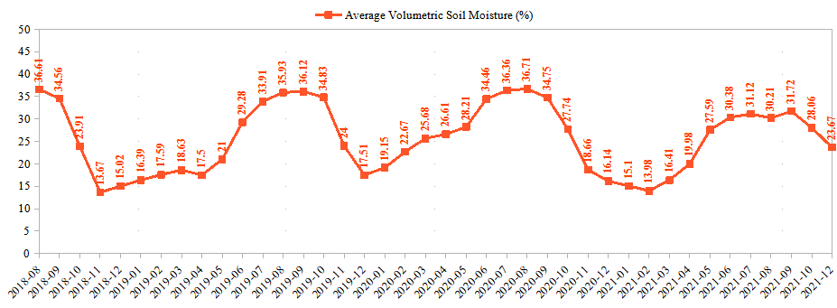

Figure 11: Monthly Volumetric Soil Moisture (%) data of Brahmani, Brahmani and Baitarni Basin from 2018-08 to 2021-12

An examination of the monthly average volumetric soil moisture in Figure 12 of the Subernarekha Basin between August 2018 and December 2021 indicates clear seasonal fluctuations, characterized by elevated soil moisture levels during the monsoon period (June to September) and reduced levels during the dry winter months (November to February). According to the statistics, the highest moisture levels, reaching almost 37%, occur during the monsoon season, particularly in August and September. On the other hand, the lowest moisture levels, as low as 14.87%, are seen in the dry months, such as December 2018. Annual patterns demonstrate a steady increase in soil moisture prior to the monsoon season, followed by a decrease thereafter, with sporadic deviations such as the significant decrease in November 2018 and an early increase in April 2021. These trends highlight the necessity of implementing efficient water resource management and agricultural planning to handle seasonal variations, maximize water utilization, and alleviate the effects of climate change. Continuous monitoring is crucial for enhancing climate models and guaranteeing sustainable water management in the region. An examination of the monthly average volumetric soil moisture in the Subernarekha Basin between August 2018 and December 2021 indicates clear seasonal fluctuations. The soil moisture is higher during the monsoon months (June to September) and lower during the dry winter months (November to February). According to the statistics, the moisture levels reach their highest point, approximately 37%, during the monsoon season, particularly in August and September. On the other hand, the lowest values are observed during the dry months, such as December 2018, with a reported level of 14.87%. Annual patterns demonstrate a steady increase in soil moisture prior to the monsoon season, followed by a decrease thereafter, with sporadic deviations such as the significant decrease in November 2018 and an early increase in April 2021. These trends highlight the necessity of implementing efficient water resource management and agricultural planning to handle seasonal variations, maximize water utilization, and alleviate the effects of climate change. Continuous surveillance is crucial for enhancing climate models and guaranteeing sustainable water management in the area.

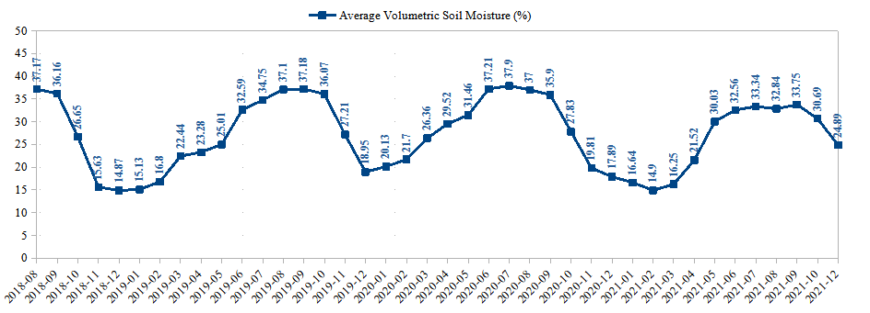

Figure 12: Monthly Volumetric Soil Moisture (%) data of Subernarekha Basin from2018-08 to 2021-12

The monthly volumetric soil moisture data in Figure 13 for the Baitarni sub-basin, Brahmani, and Baitarni Basin between August 2018 and December 2021 demonstrates notable seasonal variations and annual patterns. Commencing at 36.19 in August 2018, the moisture levels exhibited a general decline until the conclusion of the year, ultimately reaching a minimum of 10.85 in January 2019. The moisture content saw a progressive increase, reaching its highest point in August 2019 at 36.01. Subsequently, it experienced a fall during the winter months. In 2020, there was a consistent trend where moisture levels reached their highest points during the monsoon months of June (35.68) and July (35.93), and then gradually declined towards the end of the year. Significantly, the initial months of 2020 exhibited elevated moisture levels in comparison to 2019, suggesting the potential occurrence of increased precipitation or other hydrological influences. The data for 2021 exhibits a consistent increase, commencing at 15.24 in January and peaking at 32.76 in September. However, the peak in 2021 is slightly less prominent than it was in previous years. The soil moisture levels for December 2021 are much lower compared to the same period in prior years, reaching a value of 25.7. This analysis emphasizes the recurring pattern of soil moisture that aligns with the seasonal rainfall cycles, exhibiting high levels during the monsoon months and low levels during the winter months.

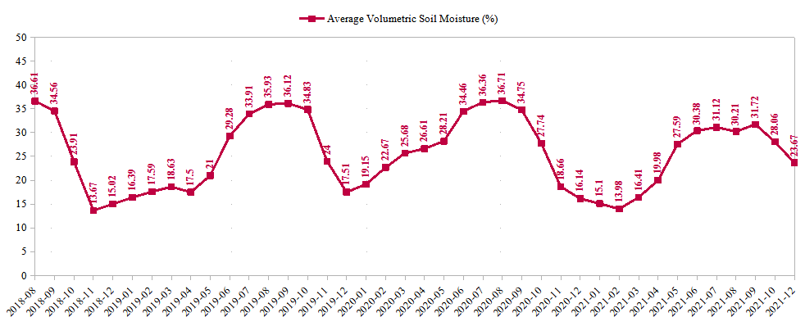

Figure 13: Monthly Wise Volumetric Soil Moisture (%) data of Brahmani, Brahmani and Baitarni Basin from 2018-08 to 2021-12

The volumetric soil moisture data collected between August 2018 and December 2021 in the Brahmani, Subarnarekha, and Baitarni regions exhibit clear seasonal and year-to-year fluctuations, which are impacted by monsoon patterns as shown in Figure 14. In general, all three regions display elevated soil moisture levels throughout the monsoon period (June to September) and reduced levels during the dry months (November to February). Subarnarekha routinely exhibits elevated soil moisture levels in comparison to Brahmani and Baitarni, most likely because to its distinctive geographical and hydrological attributes. In August 2018, the soil moisture levels were 36.61% for Brahmani, 37.17% for Subarnarekha, and 36.19% for Baitarni. However, in the dry month of January 2019, these values decreased to 16.39%, 15.13%, and 10.85% for Brahmani, Subarnarekha, and Baitarni, respectively. During the three-year timeframe, there are observed changes in soil moisture levels for the same month in different years, which can be related to the shifting patterns of rainfall each year. The Subarnarekha River maintains comparatively elevated levels even during periods of little rainfall, demonstrating its ability to withstand seasonal variations. This study examines the fluctuations in soil moisture levels in these basins, emphasizing the significant influence of seasonal rainfall. It offers essential observations for the management of water resources, planning of agricultural activities, and monitoring of the environment.

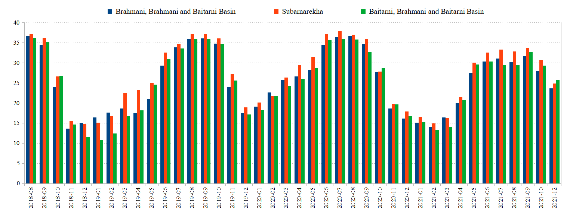

Figure 14: Comparison between Monthly Volumetric Soil Moisture (%) of Brahmani, Subarnarekha, and Baitarni river Basin from 2018-08 to 2021-12

# **Conclusions**

The comprehensive examination of reservoir storage dynamics and groundwater utilization practices within the South Singbhum region presents a compelling illustration of substantial spatial and temporal fluctuations, thereby underscoring the imperative for the implementation of strategic and systematic water resource management protocols that are sensitive to these variations. The reservoirs that are prominently featured in this discourse, including the Baitarani (Salandi), Baitarani-Brahmani, and Brahmani (Rengali), manifest pronounced seasonal variations and a concerning decline in storage capacities, which are significantly influenced by the dual factors of climate variability and the demands imposed by various usage patterns. Furthermore, the groundwater resource data illuminate a considerable dependence on this vital resource for both agricultural irrigation and domestic consumption in districts such as Angul, Baleshwar, and Kendujhar, thereby revealing a notable strain on the existing water supplies that are available for use. In contrast, regions like Deogarh and Sundargarh exhibit a more harmonious approach to groundwater utilization, which could potentially serve as exemplary models for sustainable management practices that could be replicated in other areas. The implications of these findings are profound, as they emphasize the vital necessity for the integration of tailored, innovative, and efficient water management strategies to secure the long-term viability of water resources within the region.

Notwithstanding these valuable insights, the study presents several inherent limitations that must be acknowledged. Firstly, the reliance on monthly average data may prove insufficient in capturing the nuances associated with short-term fluctuations or peak usage trends that can significantly impact water availability. Moreover, the exclusive focus on certain reservoirs and groundwater systems inadvertently omits consideration of alternative water sources, such as surface water and contributions from rainfall, both of which are crucial in the overall hydrological context. Additionally, the study fails to explicitly model the potential long-term ramifications of climate change on water availability, a factor that has become increasingly relevant in light of the evolving global weather patterns that are being observed. Furthermore, it is worth noting that socioeconomic elements, including factors such as population growth, industrial expansion, and agricultural practices, are addressed only in a cursory manner, which ultimately limits the ability to contextualize the findings within the broader and more complex regional dynamics that are at play.

Future investigations ought to emphasize the formulation of dynamic and predictive models that amalgamate climate variability, land utilization, and socio-economic determinants to yield more comprehensive understandings of water resource trajectories. Initiatives should also concentrate on the examination of innovative techniques for groundwater recharge, rainwater harvesting, and conservation strategies that are specifically adapted to the region's unique hydrological and ecological contexts. Broadening the focus to encompass the conjunctive utilization of surface and groundwater resources may enhance resource efficiency. Furthermore, evaluating the ramifications of water management policies and facilitating community involvement will promote more equitable and sustainable practices across various districts.

By addressing these deficiencies and pursuing advanced research trajectories, the South Singbhum region can develop resilient water management frameworks. The integration of climate change projections, the promotion of water-efficient technologies, and the enhancement of community awareness will be crucial to ensuring water availability for future generations. Customized strategies that reconcile resource extraction with replenishment, in conjunction with robust policy initiatives, will guarantee the sustainable utilization of water resources while accommodating the diverse requirements of the region's populace and industries.

Disclaimer (Artificial intelligence)

Option 1:

Author(s) hereby declare that NO generative AI technologies such as Large Language Models (ChatGPT, COPILOT, etc.) and text-to-image generators have been used during the writing or editing of this manuscript.

Option 2:

Author(s) hereby declare that generative AI technologies such as Large Language Models, etc. have been used during the writing or editing of manuscripts. This explanation will include the name, version, model, and source of the generative AI technology and as well as all input prompts provided to the generative AI technology

Details of the AI usage are given below:

1.

2.

3.

# **References**

Abd-Elaty, I., Kuriqi, A., Ahmed, A., & Ramadan, E. M. (2024). Enhanced groundwater availability through rainwater harvesting and managed aquifer recharge in arid regions. *Applied Water Science*, *14*(6), 121.

Abdekareem, M., Al-Arifi, N., Abdalla, F., Mansour, A., & El-Baz, F. (2022). Fusion of remote sensing data using GIS-based AHP-weighted overlay techniques for groundwater sustainability in arid regions. *Sustainability*, *14*(13), 7871.

Adam, A. Y. F., & Osman, M. B. O. (2024). Towards Integrated and Sustainable Water Management in Water-scarce Arid Environments: Case of Sudan. In *Hydrology-Current Research and Future Directions*. IntechOpen.

Al-Jawad, J. Y., Al-Jawad, S. B., & Kalin, R. M. (2019). Decision-making challenges of sustainable groundwater strategy under multi-event pressure in arid environments: The Diyala River Basin in Iraq. *Water*, *11*(10), 2160.

Alonso Vicario, S., Mazzoleni, M., & Garcia, M. (2023). Exploring the human influence on surface water availability in the contiguous United States. *EGU General Assembly Conference Abstracts*, EGU--8061.

Asano, T. (2016). *Artificial recharge of groundwater*. Elsevier.

Asfaw, A. S. (2018). *Development of Real-Time Surface Water Abstraction Management Tools*. University of Sheffield.

Banihabib, M. E., Noori, A., Jur\’\ik, L., Gacko, I., & Mirzaie, N. (2020). Prioritization of sustainable water management strategies in arid and semi-arid regions using swot coupled ahp technique in addressing SDGs. *Acta Sci Pol Form Circum*, *19*(2), 35–52.

Bhaga, T. D., Dube, T., Shekede, M. D., & Shoko, C. (2020). Impacts of climate variability and drought on surface water resources in Sub-Saharan Africa using remote sensing: A review. *Remote Sensing*, *12*(24), 4184.

Birnbaum, A., Shabestanipour, G., Zhao, M., Snyder, A., Wild, T., & Lamontagne, J. (2024). Characterizing the multisectoral impacts of future global hydrologic variability. *Environmental Research Letters*.

Bouramdane, A.-A. (2024). *Sustainable Management Strategies for Non-Conventional Water Resources: Enhancing Food and Water Security in Arid and Semi-Arid Regions*.

Charlesworth, S. M., & Booth, C. A. (2016). *Sustainable surface water management: a handbook for SUDS*. John Wiley \& Sons.

Collischonn, B., Lopes, A. V, & Pante, A. R. (2014). Dealing with variability in water availability: the case of the Verde Grande River basin, Brazil. *Proceedings of the International Association of Hydrological Sciences*, *364*, 176–181.

Cosh, M. H., Evett, S. R., & McKee, L. (2012). Surface soil water content spatial organization within irrigated and non-irrigated agricultural fields. *Advances in Water Resources*, *50*, 55–61.

Cruz-Ayala, M.-B., & Megdal, S. B. (2022). Managed Aquifer recharge as a tool to improve water security and resilience. In *Oxford Research Encyclopedia of Environmental Science*.

Dang, C., Zhang, H., Singh, V. P., Yu, Y., & Shao, S. (2021). Investigating hydrological variability in the Wuding River Basin: implications for water resources management under the water--human-coupled environment. *Water*, *13*(2), 184.

Dawoud, M. A. (2024). The Role of Artificial Recharge of Aquifers in Water Resources Management in Egypt. In *Managed Groundwater Recharge and Rainwater Harvesting: Outlook from Developing Countries* (pp. 15–38). Springer.

Dong, Q., Zhang, S., Bai, M., Xu, D., & Feng, H. (2018). Modeling the Effects of Spatial Variability of Irrigation Parameters on Border Irrigation Performance at a Field Scale. *Water*, *10*(12), 1770.

Epting, J., Affolter, A., Scheidler, S., Schilling, O. S., & others. (2023). Climate change adaptation and mitigation measures for alluvial aquifers-Solution approaches based on the thermal exploitation of managed aquifer (MAR) and surface water recharge (MSWR). *Water Research*, *238*, 119988.

Geli, H. M. E., González-Piqueras, J., Neale, C. M. U., Balbont\’\in, C., Campos, I., & Calera, A. (2019). Effects of surface heterogeneity due to drip irrigation on scintillometer estimates of sensible, latent heat fluxes and evapotranspiration over vineyards. *Water*, *12*(1), 81.

Gemail, K. S., & Abd-Elaty, I. (2023). Unveiling the hidden depths: a review for understanding and managing Groundwater Contamination in arid regions. *Groundwater Quality and Geochemistry in Arid and Semi-Arid Regions*, 3–35.

Gómez-Alday, J. J., Hussein, S., Arman, H., Alshamsi, D., Murad, A., Elhaj, K., & Aldahan, A. (2022). A multi-isotopic evaluation of groundwater in a rapidly developing area and implications for water management in hyper-arid regions. *Science of the Total Environment*, *805*, 150245.

Huang, Y.-Z., & Fan, C. (2023). Irrigation water quality management under the impact of climate change. *EGU General Assembly Conference Abstracts*, EGU--3760.

Jakub\’\insk\`y, J., Pechanec, V., Cudl\’\in, O., Purkyt, J., & Cudl\’\in, P. (2021). Identification of surface runoff source areas as a tool for projections of NBS in water management. In *Nature-Based Solutions for Flood Mitigation: Environmental and Socio-Economic Aspects* (pp. 313–338). Springer.

Janarthanan, G., & Thirukumaran, V. (2024). Locating Potential Sites for Artificial Recharge Using Geospatial Technology in the Pulampatty Watershed, South India. *Journal of Geology, Geography and Geoecology*, *33*(2), 282–289.

Kifanyi, G. E. (2022). A Novel Approach for Optimum Conjunctive Use Management of Groundwater and Surface Water Resources under Uncertainty. *Open Journal of Modern Hydrology*, *13*(1), 52–75.

King, D. M. (2009). *On the importance of input variables and climate variability to the yield of urban water supply systems*. Victoria University.

Lee, J. H., Kim, K. H., Chu, Y. O., Oh, J. Y., Yoon, Y. T., & Kim, S. J. (2023). Metropolitan water purification facilities towards variability mitigation of the renewable resources: Optimal bid method for small hydropower generators. *Heliyon*, *9*(6).

Manns, H. R., Berg, A. A., Bullock, P. R., & McNairn, H. (2014). Impact of soil surface characteristics on soil water content variability in agricultural fields. *Hydrological Processes*, *28*(14), 4340–4351.

Masri, A., & Ghanem, M. (2022). Groundwater Artificial Recharge Potentiality in Al-Qilt Catchment Jericho--West Bank--Palestine. *Advances in Environmental and Engineering Research*, *3*(4), 1–13.

Moghaddasi, P., Kerachian, R., & Sharghi, S. (2022). A stakeholder-based framework for improving the resilience of groundwater resources in arid regions. *Journal of Hydrology*, *609*, 127737.

Mohanta, J., & Pathy, A. C. (2024). Investigating Rainfall Patterns in South Singhbhum: A Non-parametric Approach Utilizing Mann-Kendall Tests and Sen’s Slope Estimator. *Asian Journal of Geographical Research*, *7*(4), 45–66.

Mohseni, B., Shahedi, K., Habibnejhad-Roshan, M., & Darzi-Naftchali, A. (2022). Improving groundwater sustainability through conservation strategies in a critical-prohibited coastal plain. *Physics and Chemistry of the Earth, Parts A/B/C*, *127*, 103176.

Mondal, P., Srivastava, P., Kalin, L., & Panda, S. N. (2011). Ecologically sustainable surface water withdrawal for cropland irrigation through incorporation of climate variability. *Journal of Soil and Water Conservation*, *66*(4), 221–232.

Mukheibir, P. (2007). Qualitative assessment of municipal water resource management strategies under climate impacts: the case of the Northern Cape, South Africa. *Water Sa*, *33*(4), 575–581.

Palazzoli, I., Montanari, A., & Ceola, S. (2023). Contribution of anthropogenic and hydroclimatic factors on the variation of surface water extent across the contiguous United States. *Environmental Research Communications*, *5*(5), 51006.

Pulido-Bosch, A., Vallejos, A., Sola, F., & Molina, L. (2020). Groundwater sustainability strategies in the Sierra de Gador-Campo de Dalias system, Southeast Spain. *Water*, *12*(11), 3262.

Rasouli, H., & Vaseashta, A. (2024). Artificial Recharge to the Groundwater Resources Using Rainfall Water Collection: A Case Study of Kabul, Afghanistan. In *Modeling and Monitoring Extreme Hydrometeorological Events* (pp. 245–263). IGI Global.

Ryu, J. H., Contor, B., Johnson, G., Allen, R., & Tracy, J. (2012). System Dynamics to Sustainable Water Resources Management in the Eastern Snake Plain Aquifer Under Water Supply Uncertainty 1. *JAWRA Journal of the American Water Resources Association*, *48*(6), 1204–1220.

Sibly, H., & Tooth, R. (2015). Managing water variability issues. *Understanding and Managing Urban Water in Transition*, 383–400.

Teferi Taye, M., Tekleab, S., Tilaye Geressu, R., Alemu, M., & Seid, A. (2023). Strategies for Climate Smart Water Management in Awash River basin, Ethiopia. *EGU General Assembly Conference Abstracts*, EGU--11769.

Venishetty, V., Parajuli, P. B., & Nepal, D. (2023). Spatial Variability of Best Management Practices Effectiveness on Water Quality within the Yazoo River Watershed. *Hydrology*, *10*(4), 92.

Zheng, B., Liu, L., Huang, G., Baetz, B., Zhai, M., Zhang, K., & Lu, C. (2024). Sustainable water resources management through disaggregated multi-region virtual water flow and interaction analysis. *Water Resources Management*, 1–20.

Zhu, W., & Siebert, S. (2023). Towards a dynamic representation of irrigation in land surface models. *EGU General Assembly Conference Abstracts*, EGU--8885.