**RAMSAY HUNT SYNDROME-CASE REPORT**

**ABSTRACT:**

Ramsay Hunt syndrome is the later sequel of the virus varicella-zoster(chicken pox) and shows geniculate ganglion involvement.The virus involved in this syndrome is Herpes Zoster and the infection is commonly called SHINGLES. It includes vesicular rash on ear and mouth,ear pain, and facial paralysis.So it is necessary to perform early diagnosis and treatment. Symptoms like tinnitus, hearing loss, nausea, vomiting, vertigo, and nystagmus are seen in a few cases.There are slight differences in facial paralysis in Bell's palsy and Ramsay Hunt syndrome. If left untreated or delayed diagnosis results in permanent damages like hearing loss,muscle weakness.

**Key Words:**  Herpes zoster,later complication of the virus varicella-zoster, ear pain, facial paralysis, antiviral drugs, post herpetic neuralgia

**INTRODUCTION:**

Ramsay Hunt syndrome is regarded as a complication of herpesvirus infection, characterized by lesions of the geniculate ganglion often presenting with viral involvement of the skin of the external ear, vesicular eruptions, and peripheral facial nerve paralysis(1).After exposure to varizella zoster in the early stages i.e., chicken pox, this virus stay dormant for life in the sensory ganglion of the and craninal nerves especially in the geniculate ganglion(2).After exposure to certain conditions resulting in the reactivation of this disease resulting in herpes zoster infection i.e.,SHINGLES. The reactivation and replication of HZV leads to inflammatory lesions and spreads throughout the dermatome supplied by this ganglion(2) The victims of the Ramsay Hunt syndrome are: "elderly people, patients with lymphoma,HIV or those receiving chemotherapy or steroids"(3). Therefore, ideal symptoms of herpes zoster (shingles) is “pain and rash in the involved ganglion” where The primary stages will be presenting as ipsilateral facial paralysis, vesicles at the ear, and otalgia(4).The characteristic triad of Ramsay Hunt Syndrome is: "facial paralysis, otalgia and a vesicular rash" but in some cases the patients presents facial paralysis preceding the rash and in few other cases no rashes at all(5). But the clinical manifestations are facial paralysis, painful rashes around the ear,hearing loss, tinnitus and vertigo when there is involvement of "vestibulocochlear nerve" involvement and hoarseness of voice with involvement of vagus nerve(6).Other manifestations include “change in taste sensation, dry eye, tearing, hyperacusis, nasal obstruction, and dysarthria”(6).

In those cases where the facial paralysis precedes rashes, it is often confused with Bell’s Palsy which is difficult to rule out. In such a scenario, it is differentiated by 2 ways : 1. Onset paralysis is severe in initial stages in Ramsay Hunt Syndrome where gradual onset in Bell’s Palsy 2. Treatment with antiviral drugs reduces the paralysis in the former while in latter the symptoms persists even after medications 3. Blood investigations show Herpes Zoster load in the former while negative in latter (7).Now let us look into the case scenario of a 52 year old female patient who is manifested with the symptoms of RHZ.

**CASE REPORT:**

A 52 year old female patient named Mrs.Shanthi came to the "Department of Oral Medicine and Radiology" with the chief complaint of ulcerations on the right side of the face for the past 3 days. The patient had a history of fever for the past week. She had burning sensation all over the face and in the oral cavity and gradually vesicles developed on the right side of the face as well as on the nose within 3 days. Few of those vesicles turned into ulcerations. Patient has a history of pain which is gradual in onset, sharp, continuous, tingling, itchy and pricking radiating all over the place, aggravated to touch and relieved at rest. Patient had a history of episodes of dizziness during any head movements for the past 3 days and bright light and was relieved at rest with temporary hearing loss. The patient has had episodes of burning sensation in the right side eye for the past 3 days.

The patient had the history of an episode of chicken pox in her childhood.

Physical examination of cranial nerve assessment shows facial asymmetry in relation to the right side of face with absence of frowning of forehead, no rise of smile. Whisper test reveals mild loss of hearing in relation to right ear and romberg test shows positive results revealing grade III moderate dysfunction noted in the ‘’ House Brackmann Facial Nerve Grading System’’

On extra oral examination, multiple small blisters on the right side of the face of size 1x1cm to 2x2cm each spread all over the right side of face not crossing from lower orbit to lower philtrum which has smooth surface and border. On palpation all inspectory findings are confirmed with site, size and extent and those blisters are tender to palpate with fluid like discharge and no bleeding. Periorbital swelling is seen in relation to the right side of the eye of size 2x4cm extending in relation to canthus of eye to temporal region in relation to right eye superiorly and swollen upper lip of size 2x2cm extending in relation to right half of upper eye inferiorly which has smooth surface and border. On palpation all inspector findings are confirmed with site, size and shape and those swelling are tender to palpate with no bleeding and fluid-like discharge.

On intra oral examination, blisters are seen in relation to the labial aspect of gingiva of 11,12,13,14 and 15 of size 1x1mm each with smooth surface and border. On palpation all inspector findings are confirmed with site, size and extent which is tender to palpate and had pus discharge and no bleeding.

Hard tissue examination reveals generalised extrinsic stains and Ellis class I fracture in 11 and 12.On soft tissue examination, generalised grade II recession is seen.

The main etiology of

Based on history physical and clinical findings, the case is provisionally diagnosed with **Acute Orofacial Herpes Zoster with Ramsay Hunt Syndrome** which can be differentially diagnosed as ‘’ bell’s palsy , lyme disease, Melkersson Rosenthal Syndrome’’

So the patient was advised for blood and urine investigation revealing an increase in serum creatinine level of 0.91mg/dL (ideal:0.5 to 0.9 mg/dL) during renal function test suggestive of viral infection and patient is also advised for viral culture test

The patient was under conservative management for 7 days. Patient was prescribed topical and systemic antiviral drugs and NSAIDS.

TABLE 1:

Tab.VALACYCLOVIR 1 g 1-1-0-1

Tab.PARACETAMOL 650mg 1-1-0-1

Tab.RANITIDINE 150mg 1-1-1-1

Topical.HERPEX ointment 5% 5mg 1-1-1-1

FOR 7 DAYS

The patient is reviewed after 10 days and followed for 10 days. The patient healing is satisfactory and hearing and balancing functions are recovered within 3 consecutive visits

**DISCUSSION:**

Varicella-zoster ,DNA virus, comes under "α-herpes virus" causing chicken pox primarily. The virus becomes dormant in the dorsal root of the cranial nerve causing the secondary infection "HERPES ZOSTER" (8) causing trauma to “dermatomes of T3 to L2" however around "**13% of the patients present with infections involving any of the three branches of the trigeminal nerve"**.(9) The syndromes and symptoms associated with HZV is “Guillain-Barré syndrome, encephalitis, myelitis, Ramsay–Hunt Syndrome, and Horner’s syndrome”. In general, “ulcerations, haemorrhage, conjunctivitis, and optic neuritis are due to ocular complications” (10)

The main etiology of this syndrome is a member of herpes family “VARIZELLA ZOSTER” which remains dormant in the ganglion and expresses only when the favourable conditions occur. Factors that reactivate this virus are “the person who has never had the chicken pox vaccine, immunocompromised patients, newborns, pregnant women, and any physical or psychological stress (a). Clinical features include the **TRIAD :** “Zoster oticus, Zoster stomatitis and Facial Palsy” with additional symptoms like hearing loss, vertigo, tinnitus, hoarseness of voice, change in taste and dysarthria.

Only 0.2% of total herpes zoster cases results in Ramsay Hunt Syndrome and with incidence of 5 of 1,00,000 per year (7)(12)

The ideal examination for neurological examination is

Other investigation includes CT examination, audiometry test and serological test

The main aims of the management are "to decrease the incidence of late complications, including spastic facial paralysis and postherpetic neuralgia". Ideal therapy should include “(1) isolation of patient (2) skin lesion local management (3) pain elimination and control, (4) using antiviral drugs for “limiting extent, duration and severity of disease” (5) treatment of post-herpetic neuralgia.”(10)

Prognosis of the Ramsay Hunt Syndrome is more complicated than Bell’s Palsy if early diagnosis and prognosis is delayed(12). The recovery of this syndrome is purely based on the severity of the facial paralysis(14). If left untreated or delay of the treatment results in complications like  "synkinesis,greater axonal damage, presence of oropharyngeal lesions, multiple cranial neuropathies, and diabetes and post herpetic neuralgia"(12)(14)

The pharmacological treatment we adapted to Tab. VALACYCLOVIR 1000 mg four times a day for 7 days has shown better results in the prognosis of the HZV disease as this reduces symptoms and pain. The desirable results are observed in patients who start treatment within 48 hours-of the onset of symptoms. Moreover pain relief is specifically noticeable in patients who suffered from severe pain.It appears that "a seven day course is preferable to a five day course of treatment". (14 )

Topical.HERPES, an antiviral medicine which has acyclovir as the active ingredient. This medicine acts by stopping or killing the growth of viruses, thus preventing the spread of the infection. (17)

The medications followed by NSAIDs Tab.PARACETAMOL that reduces pain and fever followed by Tab.RANITIDINE as an antiulcerative drug.

Physiotherapy is preferred to restore facial muscle paralysis to hinder permanent loss. It includes neuromuscular retraining, soft tissue mobilisation and massage. This helps the brain to restore the transient loss of functions.

The other pharmacological approaches other than antiviral drugs include corticosteroid therapy of Prednisolone 1mg/Kg/day maximum of 60 mg and this dose should be tapered to prevent adrenal insufficiency(17).Combination of antiviral and steroid therapy shows better results. A study reveals “the combination of antiviral therapy and steroids improves facial nerve recovery compared to steroids alone”.(17)

Recent trends in treatment approach is the “ **TRANSCUTANEOUS FACIAL NERVE STIMULATION** “ showing decrease in pain on fifth day and disappeared within 3 months(20)

Ideally, treatment should begin before the lesion is visible clinically.

**CONCLUSION:**

To conclude this case report, patients who are immunocompromised, under immunotherapy or chemotherapy, HIV and elderly people who had prior history of Varizella Zoster should be aware of this HZV and should refer the physician. And when the slightest blisters starts with previous medical history of chicken pox should visit their physician immediately and should start their antiviral regimen therapy for better prognosis.

**PICTURES:**

**PICTURE 1: AT FIRST VISIT:**

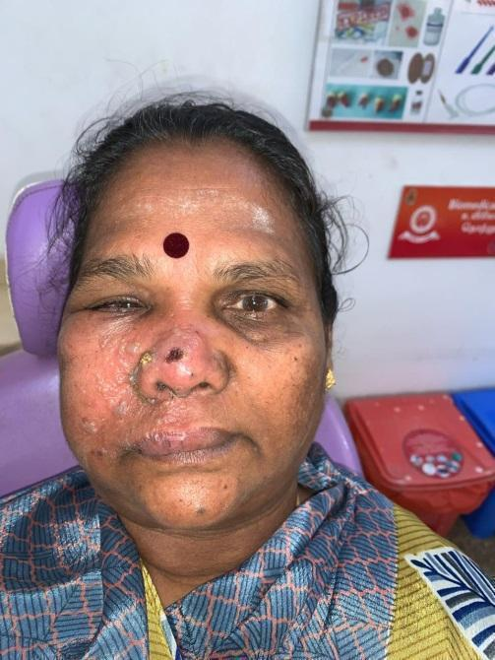 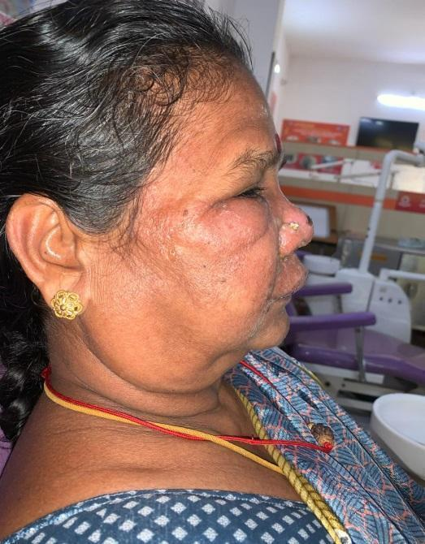



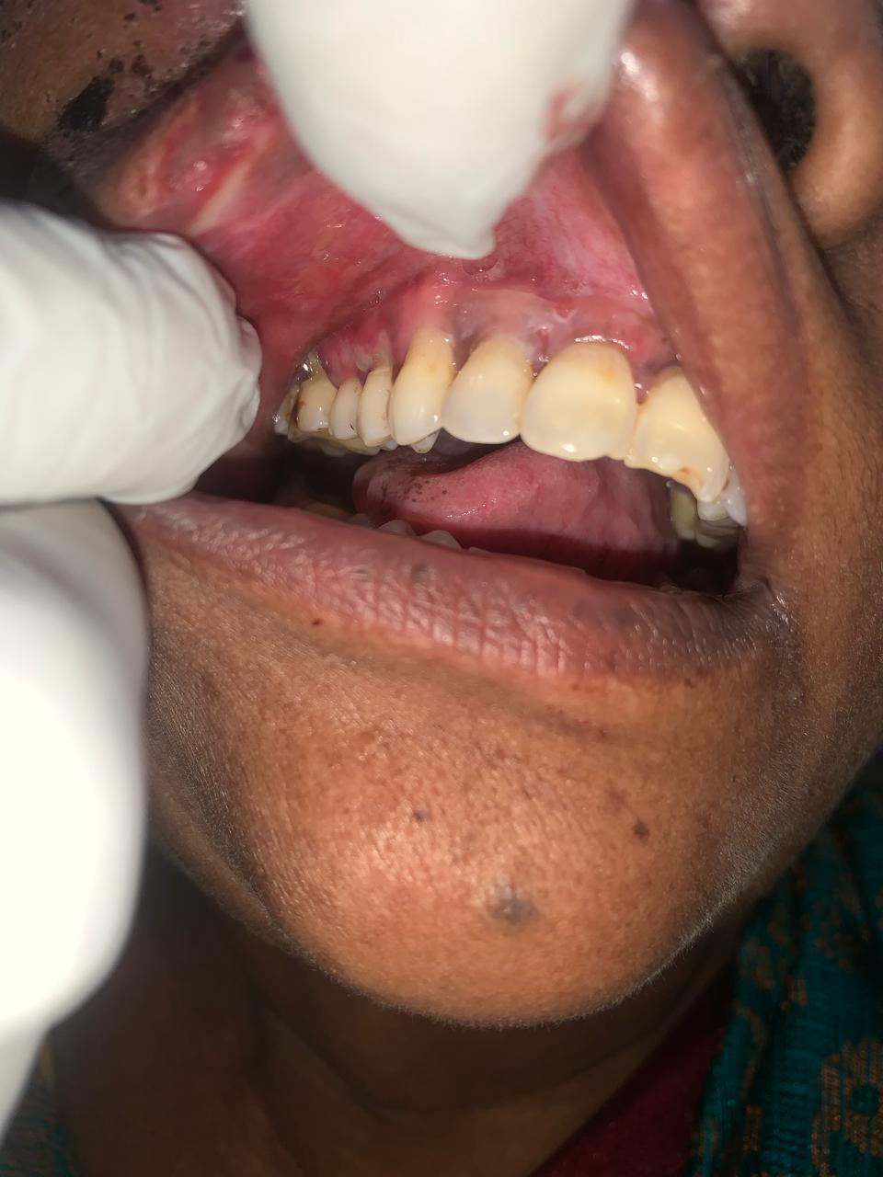 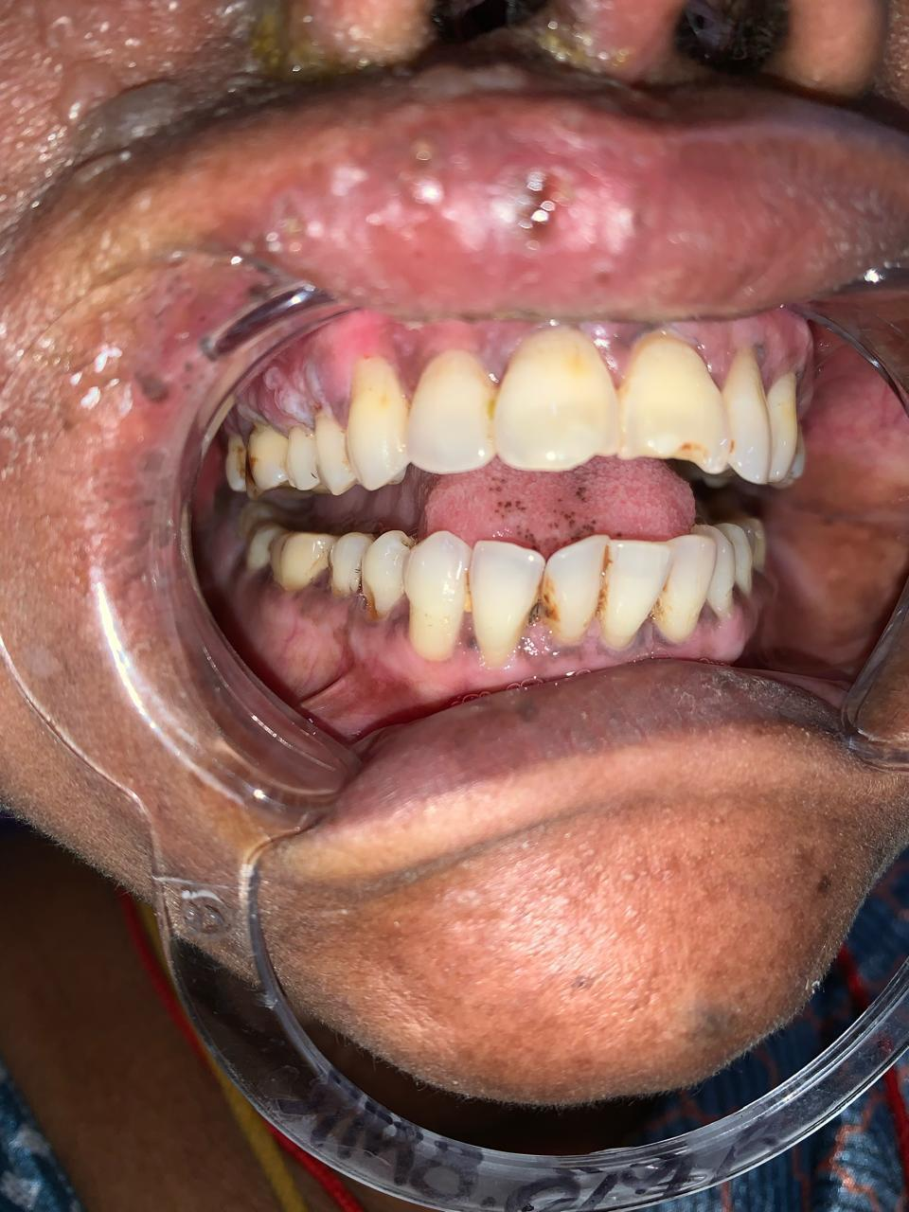

**PICTURE 2: AFTER FIRST REVIEW(AFTER 3 DAYS):**

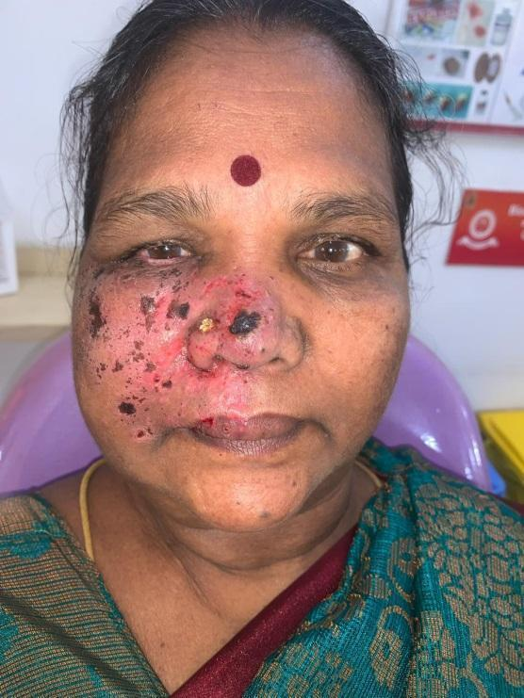 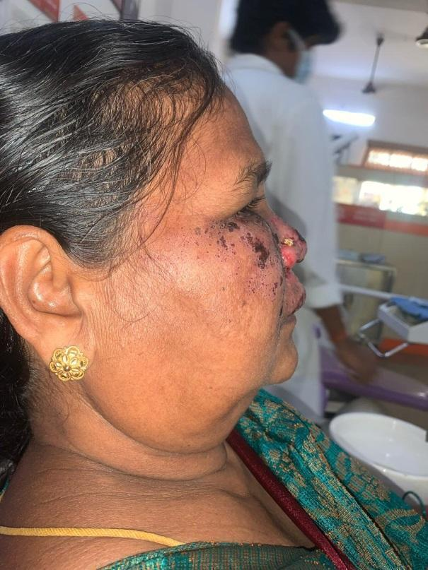

**PICTURE 3: AFTER SECOND REVIEW(AFTER 7 DAYS):**

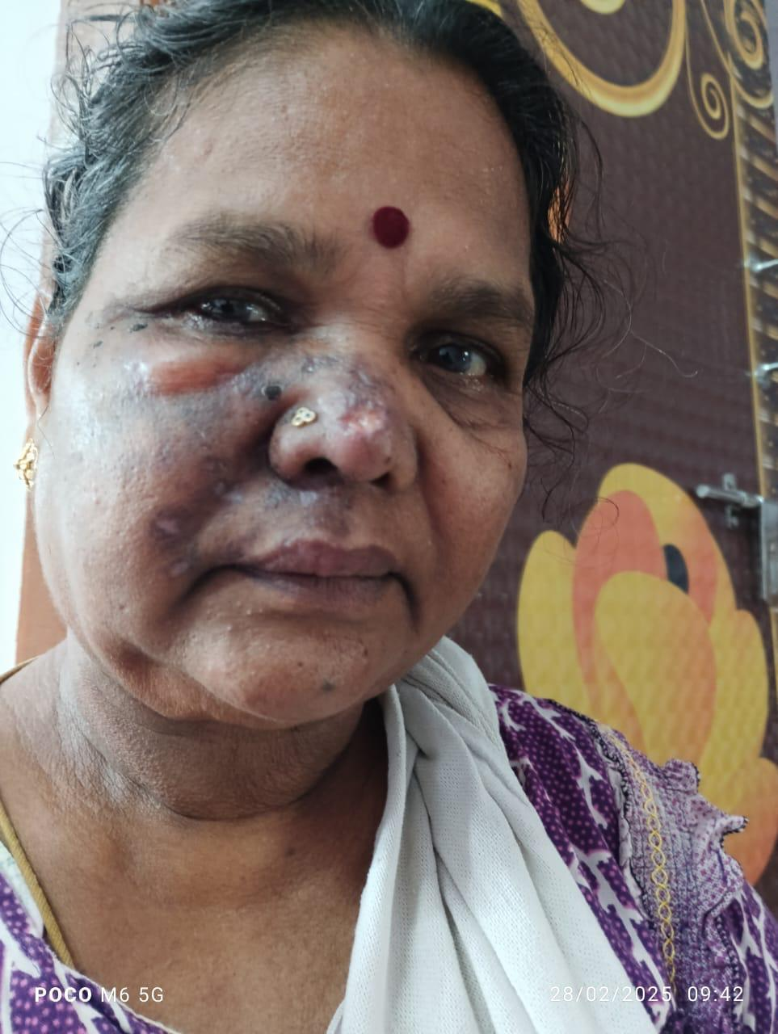

**PICTURE 4: AFTER THIRD REVIEW:**

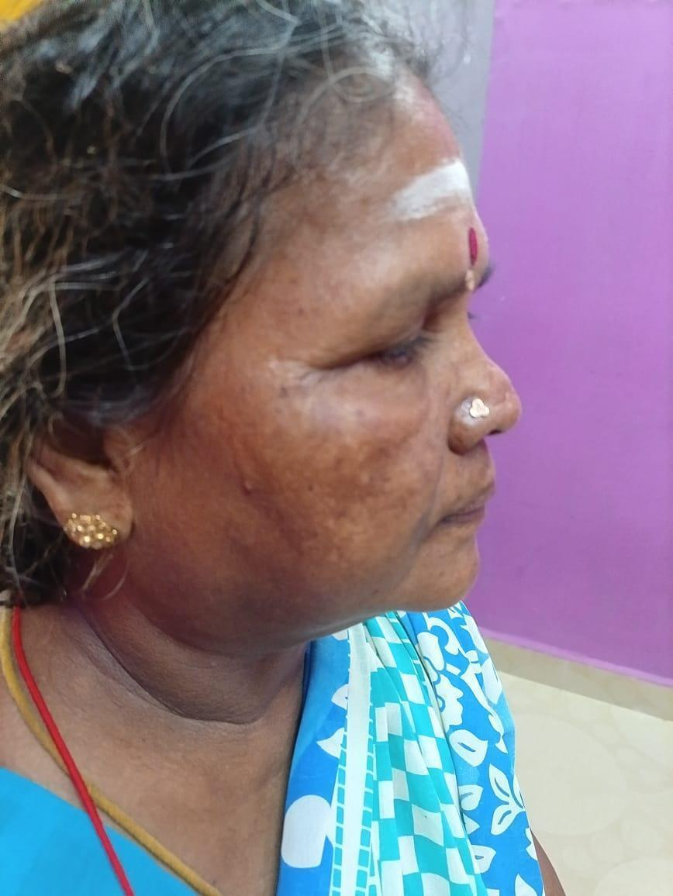 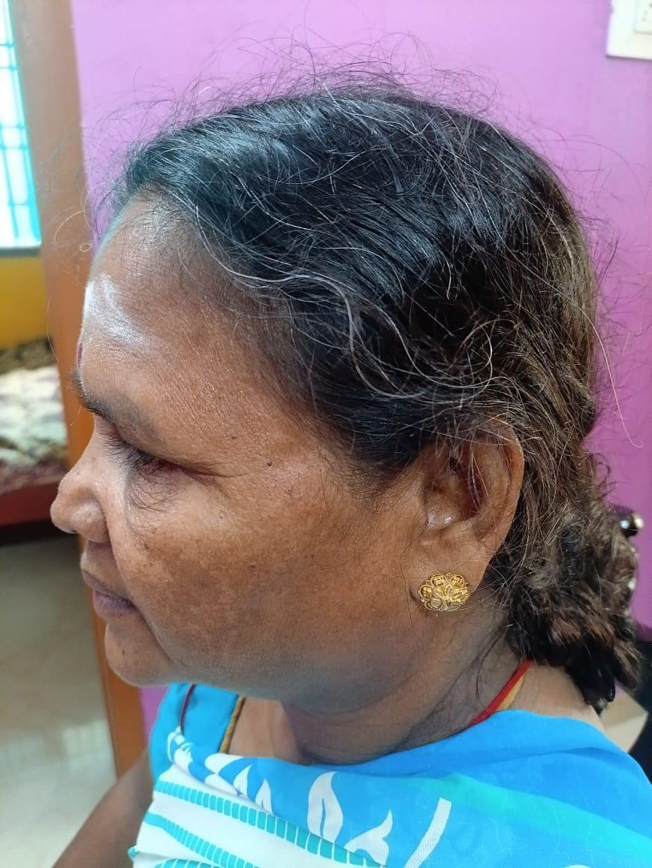 

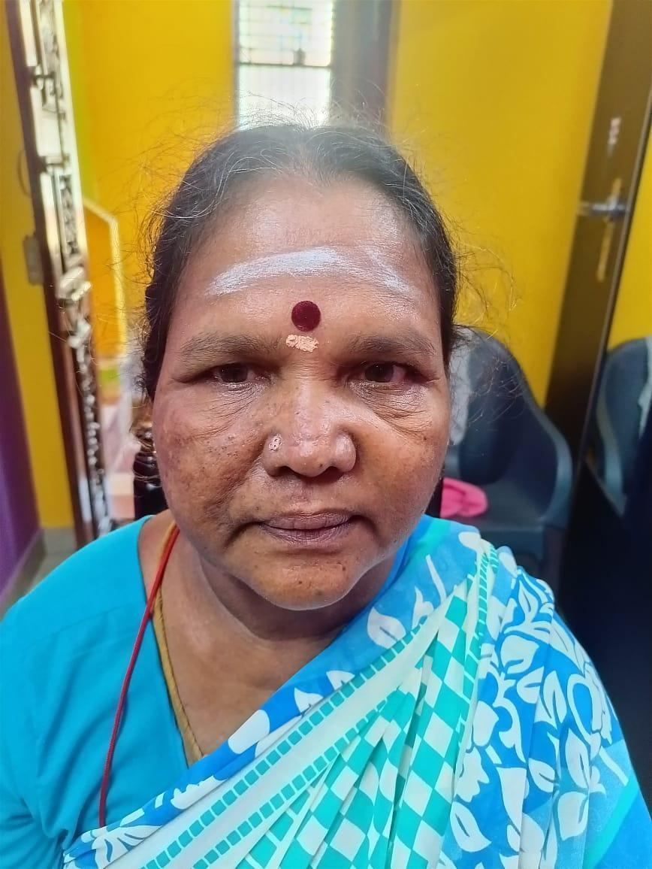

Disclaimer (Artificial intelligence)

Option 1:

Author(s) hereby declare that NO generative AI technologies such as Large Language Models (ChatGPT, manuscript.

Option 2:

Author(s) hereby declare that generative AI technologies such as Large Language Models, etc. have been used during the writing or editing of manuscripts. This explanation will include the name, version, model, and source of the generative AI technology and as well as all input prompts provided to the generative AI technology

Details of the AI usage are given below:

1.

2.

3.

**REFERENCE:**

1. A CLINICAL CASE: RAMSEY HUNT SYNDROME IN A CHILD S. Nikytiuk S. Levenets T. Hariyan A. Mykolenko M. Gikavchuk I. Horbachevsky <https://doi.org/10.24061/2413-4260.XV.2.56.2025.33>
2. Ramsay Hunt Syndrome- Youghoon Jeon, Heryim Lee [10.17245/jdapm.2018.18.6.333](https://doi.org/10.17245/jdapm.2018.18.6.333)
3. Olabode OP, Sebastine O, Akinboro AO. Herpes zoster in diverse situations: A review. Int J ClinMed 2018;9:716‑36 [10.4236/ijcm.2018.99060](http://dx.doi.org/10.4236/ijcm.2018.99060)

# Ramsay Hunt Syndrome: A Case Report Underlining the Importance of Early Diagnosis to Prevent Complications-Abdul Hadi Said,Sarmani Ravichandran <https://doi.org/10.70672/zpy8hn69>

1. Ostwal S, Salins N, Deodhar J, Muckaden MA. Management of ramsay hunt syndrome in an acute palliative care setting. Indian J Palliat Care. 2015 Jan-Apr;21(1):79-81. [10.4103/0973-1075.150195](https://doi.org/10.4103/0973-1075.150195) 2015
2. Ramsay Hunt Syndrome -Andrew E. Crouch; Marc H. Hohman; Minhee P. Moody; Claudio Andaloro.<https://doi.org/10.1101/2023.08.13.23294046>
3. Ramsay Hunt syndrome C J Sweeney, D H Gilden [10.1136/jnnp.71.2.149](https://doi.org/10.1136/jnnp.71.2.149)
4. 17. Mohan RP, Verma S, Agarwal N, Singh U. Treacher Collins syndrome: A case report BMJ CaseRep. 2013;2013:bcr2013009341[10.1136/bcr-2013-009341](https://doi.org/10.1136/bcr-2013-009341)
5. Chidiac C, Bruxelle J, Daures JP. Characteristics of patients with herpes zoster on presentation to practitioners in France. Clin Infect Dis 2001;33:629.[10.1086/320884](https://doi.org/10.1086/320884)
6. Seetharamiah Sunder Raj, Pradhuman Verma, Princy Mahajan, Ankush Puri-Herpes ZosterInfection of the Face: A Case Report with Review doi:10.4103/jiaomr.JIAOMR_91_16
7. Rizaldy Taslim Pinzon1, Priska Gian Gavrila – Ramsay Hunt Syndrome Case Report<https://doi.org/10.69868/ani.v3i01.47>
8. Crouch AE, Hohman MH, Moody MP, Andaloro C. Treasure Island: StatPearls Publishing; 2022. Ramsay Hunt Syndrome https://www.ncbi.nlm.nih.gov/books/NBK557409/
9. . Treatment and prognosis of facial palsy on Ramsay Hunt syndrome: results based on a review of the literature. Monsanto RD, Bittencourt AG, Bobato Neto NJ, Beilke SC, Lorenzetti FT, Salomone R. Int Arch Otorhinolaryngol. 2016;20:394–400. doi: 10.1055/s-0036-1584267. <https://pubmed.ncbi.nlm.nih.gov/27746846/>
10. Ramsay Hunt Syndrome- Andrew E. Coach, Mark H.Hooman,Minhee P. Moody; Claudio Andaloro. <https://www.ncbi.nlm.nih.gov/books/NBK557409/>
11. RAMSAY HUNT SYNDROME: A CASE REPORT Rizaldy Taslim Pinzon, Priska Gian Gavrila.<https://doi.org/10.69868/ani.v3i01.47>
12. Successful treatment of intractable neuralgia in patients with typical and atypical Ramsay Hunt syndrome by transcutaneous facial nerve stimulation: a case series study-Yan-Bo Deng,Ying Zhong,Yu-Xian Lin,Chen Lin,Pin-Pin Ji,[Wei-Yi Gong](https://loop.frontiersin.org/people/1584326) <https://doi.org/10.3389/fnins.2025.1554490>