**Original Research Article**

**APPLICATION OF LINEAR ANTHROPOMETRIC PARAMETERS IN ESTIMATING STATURE: A STUDY OF ADULT IGBO POPULATION IN NIGERIA**

**ABSTRACT**

**Background**: Using various body measures to estimate a person's height and sex was one part of developing a biological profile for forensic investigations.

**Aim:** The study aimed to evaluate a stature estimation model using specific linear anthropometric parameters from the Eastern part of Nigeria.

**Method:** Data analysis was done using the Statistical Package for Social Sciences (version 23). A total of 308 subjects (154 males and 154 females) between the age of 18 to 40 years were recruited for this study. The mega-size calliper and a constructed anthropometric chair were used to measure the sitting height, sitting eye height, elbow height, sitting popliteal height, and sitting hip breadth.

**Results:** The study shows a strong positive correlation (r = 0.787) among the subjects. When compared to sex, males (r = 0.796) show a strongly significant correlation with stature, while females (r = 0.564) show a moderately considerable correlation with stature. Therefore, males have higher anthropometric values than females.

**Conclusion:** The anthropometric parameters were good predictors of stature.

**Keywords:** Linear; Stature; Anthropometric; Igbo; Nigeria

1. **INTRODUCTION**

The application of linear anthropometric parameters in stature estimation has become a valuable tool in various scientific disciplines, including forensic science, ergonomics, physical anthropology, and clinical medicine [1, 2,3]. These measurements, which include dimensions such as arm span, sitting height, knee height, foot length, and tibial length, provide a practical and non-invasive method for predicting an individual's stature, particularly when direct measurement is not possible due to mutilation, car accidents, fire disasters, decomposition, or incomplete skeletal remains [4].

Over time, these efforts led to the development of regression-based models that could reliably estimate stature from one or more body measurements. The accuracy of these models was found to vary among different ethnic groups and populations, highlighting the importance of developing region and sex-specific standards. Moreover, Fawehinmi et al. [1] investigated the Igbo ethnic group's stature and sex estimation using linear anthropometric parameters, finding that sitting shoulder height, shoulder breadth, and sitting knee height were reliable predictors of stature and sex.

Research on the estimation of stature and sex among the Yoruba ethnic group in Nigeria by Fawehinmi et al. [5] notes that the parameters are strongly correlated with stature. Yeasmin et al. [6] found in their study of a Bangladeshi population that there was a good correlation between stature and shoulder height, popliteal height, and knee height. Today, the application of linear anthropometry in stature estimation continues to evolve, supported by advances in statistical modelling and an increasing body of population-specific anthropometric data. This approach not only aids in identifying individuals in forensic cases but also contributes to anthropometric profiling and ergonomic design across various populations.

**2. MATERIALS AND METHODS**

**2.1 Study Design**

A total of 308 subjects (154 males and 154 females) between the ages of 18 and 40 were recruited for this research in the Eastern part of Nigeria. This study adopted a cross-sectional descriptive research approach. The study was conducted in Owerri town, Imo State, over four months (April-July 2024). Moreover, the subjects were selected using a multi-stage random proportionate sampling approach.

**2.2 Selection Criteria**

**Inclusion Criteria**

Only those whose parents and grandparents were of Igbo descent and who had no medical history or accidents that would have affected their hand morphology or stature were included in the study. The study also included participants who gave their consent and were between the ages of 18 and 40.

**Exclusion Criteria**

The study excluded participants who were not of Igbo heritage, did not meet the age requirements, had undergone surgery, or had physical characteristics that might have impacted their standing height or hand shape.

**2.2.1 Anthropometric landmarks**

Anthropometric parameter measures are defined as follows;

**2.2.2. Stature**

The Goodcare ZT-160 stadiometer was used to measure this. Standing upright and barefoot on the level platform of the stadiometer, the participants touched the bar with their heels, buttocks, shoulder blades, and backs of their heads. It was suggested that participants keep their arms at their sides to unwind. To prevent sagging, care was taken.

**2.2.3. Sitting Height**

The subject assumes an upright posture, placing hands on their thighs, arms hanging at the sides, and head in the Frankfort plane. Using a manufactured mega-size calliper, measure the vertical distance between the seat surface and the head's vertex while the hair is forced down.

**2.2.4 Sitting Eye Height**

Measured vertically while the patient is seated in a calm, typical posture from the seat surface to the inner canthus of the eye. Mega-size calliper was used to measure the vertical distance from the top of the inner canthus of the eye at the patient's typical, relaxed sitting position.

**2.2.5. Elbow Height**

The vertical distance, measured with the elbow in 900 degrees of flexion, between the sitting surface and the bottom of the elbow tip (olecranon). The person is sitting straight up, with their thighs fully supported and their lower legs falling loose. They are dressed modestly. The forearms are horizontal, and the upper arms swing freely downward.

**2.2.6. Sitting Popliteal Height**

The popliteal space is the vertical distance, measured at 900 degrees of knee flexion, between the foot surface and the posterior surface of the knee. With their thighs fully supported and the sitting surface extending as far into the hollow of their knee as feasible, the student sits perfectly upright, their lower legs hanging loosely. The measuring mega-size calliper was used to determine the distance to the front edge of the seating surface.

**2.2.7. Sitting Hip Breadth**

This is the greatest horizontal separation between the hips when seated. Mega-size calliper was used to measure it.

**2.3 Method of Data Collection**

Through in-person interviews, the sociodemographic data for Nigeria's Igbo people were acquired and a semi-structured descriptive questionnaire. This ensured that the subjects were healthy enough to take part in the study and that they met the inclusion criteria. A large mega-size calliper was used to measure the following anatomical landmarks: sitting height, sitting eye height, elbow height, sitting popliteal height, and sitting hip breadth. A ZT-160 Goodcare stadiometer was employed to measure the standing height while the subject was upright, from the apex of the head to the sole. The authors recorded and saved the data readings.

* 1. **Method of Data Analysis**

International Business Machine of Statistical Package for Social Science (IBM version 23) was used to analyse the data. The results were displayed as mean ± standard deviation in the table. To assess sexual differences, the t-test was employed as an inferential statistic. The stature model was estimated using linear regression. For statistical significance, a probability of less than 0.05 (p<0.05) was identified.

**3.0 RESULT**

The descriptive statistics of subjects in this study indicated an average stature of 171.32±7.70 cm, sitting height of 85.08±4.17 cm, sitting eye height of 73.97±4.17 cm, elbow height of 211.65±2.27 cm, sitting popliteal height of 43.55±3.17 cm, and sitting hip breadth of 34.43±3.07 cm (Table 1). Table 2 shows that there were sexual differences among the subjects in stature, sitting height, sitting eye height, elbow height, sitting popliteal height and sitting hip breadth. Table 3 presents a summary of the linear regression analysis for stature estimation using anthropometric parameters among the subjects, with a correlation coefficient (R = 0.787, SEE = 4.792) and a standard error of estimate. When comparing males and females, it was revealed that in males (R=0.796, SEM=6.27), the anthropometric parameters show that they are strongly correlated with stature than in females (R=0.27, SEM=5.75).

**Table 1. Descriptive Statistics of Subjects**

|  |  |  |  |  |  |
| --- | --- | --- | --- | --- | --- |
| Parameter | N | Minimum | Maximum | Mean | Std. Deviation |
| Stature | 308 | 150.50 | 194.00 | 171.3208 | 7.70156 |
| Sitting Height | 308 | 71.50 | 96.10 | 85.0815 | 4.16709 |
| Sitting Eye Height | 308 | 60.50 | 85.00 | 73.9682 | 4.09702 |
| Elbow Height | 308 | 18.00 | 29.00 | 21.6484 | 2.26528 |
| Sitting Popliteal Height | 308 | 34.50 | 52.30 | 43.5464 | 3.17237 |
| Sitting Hip Breadth | 308 | 24.00 | 43.20 | 34.4289 | 3.07494 |

**Table 2. Gender Differences among the Subjects**

|  |  |  |  |  |  |  |  |
| --- | --- | --- | --- | --- | --- | --- | --- |
| Parameter | sex | N | Mean±Std. Deviation | Std. Error Mean | T-test | P-value | Inference |
| Stature (cm) | male | 154 | 175.77±6.57 | .52945 | 12.431 | 0.000 | S |
| female | 154 | 166.86±5.99 | .48292 |  |  |  |
| SH (cm) | male | 154 | 87.18±3.58 | .28877 | 10.201 | 0.000 | S |
| female | 154 | 82.98±3.69 | .29231 |  |  |  |
| SEH (cm) | male | 154 | 76.19±3.69 | .29807 | 11.291 | 0.000 | S |
| female | 154 | 71.75±3.18 | .25601 |  |  |  |
| EH (cm) | male | 154 | 21.66±1.96 | .15833 | .113 | .910 | NS |
| female | 154 | 21.63±2.54 | .20442 |  |  |  |
| SPH | male | 154 | 45.27±2.68 | .21586 | 11.324 | 0.000 | S |
| female | 154 | 41.82±2.66 | .21403 |  |  |  |
| SHB | male | 154 | 33.71±2.85 | .22959 | -4.231 | 0.000 | S |
| female | 154 | 35.15±3.13 | .25234 |  |  |  |

*SH=Sitting Height, SEH= Sitting Eye Height, EH= Elbow Height, SPH= Sitting Popliteal Height, SHB= Sitting Hip Breadth, S= Significant, NS= Not Significant*

**Table 3. Linear Regression of the Stature Estimation from Anthropometric Parameters among the Subjects**

|  |  |  |  |  |  |
| --- | --- | --- | --- | --- | --- |
| Subjects | Regression Equation | R | R Square | Std. Error of the Estimate | Sig. F Change |
| All | S=53.03+(SH)0.64+(SEH)0.58+(EH)-0.24+(SPH)0.62+(SHB)-.02 | 0.787 | 0.619 | 4.792 | 0.00* |
| Male | S=55.83+(SH)0.63+(SEH)0.24+(EH)-0.13+(SPH)1.05+(SHB)0.05 | 0.796 | 0.634 | 4.039 | 0.00* |
| female | S=+85.33(SH)0.53+(SEH)0.51+(EH)-0.21+(SPH)0.57+(SHB)0.76 | 0.563 | 0.317 | 5.036 | 0.00* |

*SH=Sitting Height, SEH= Sitting Eye Height, EH= Elbow Height, SPH= Sitting Popliteal Height, SHB= Sitting Hip Breadth, * = Significant*

(A)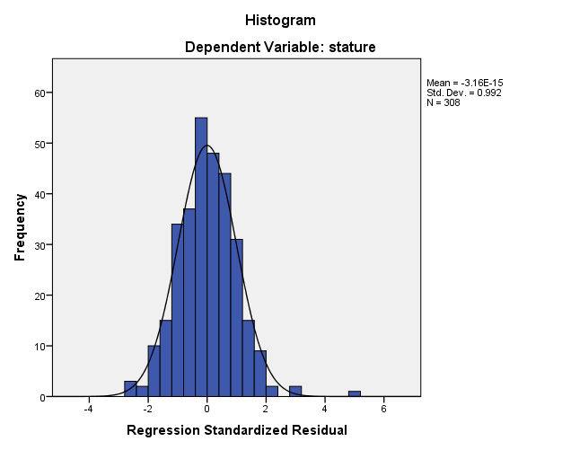

(B)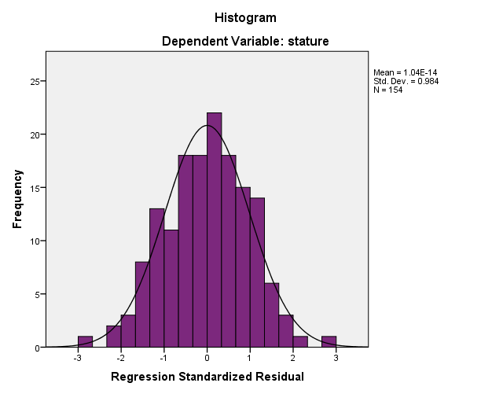

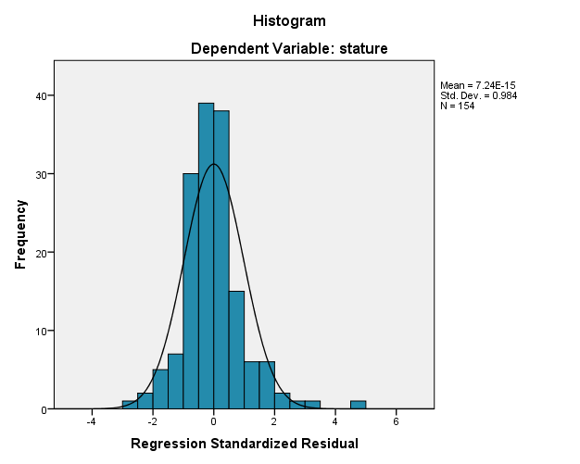

(C)

Fig. 1 (a) Histogram in all subjects, (b) Histogram in male subjects, (c) Histogram in female subjects

1. **DISCUSSION**

The present study utilises anthropometric data on sitting height, sitting eye height, elbow height, sitting popliteal height, and sitting hip breadth to estimate stature in the eastern part of Nigeria. Although this study found that males possess larger anthropometric dimensions in stature, sitting height, sitting eye height, elbow height, sitting popliteal height, and sitting hip breadth than females, previous studies on the Yoruba ethnic group in Nigeria noted that males exhibit higher anthropometric dimensions than females, according to Fawehinmi et al., [5]. Oghenemavwe et al., [7] observed that males have higher anthropometric dimensions than females in the Igbo ethnic group in Nigeria. Fawehinmi et al., [1] reported larger anthropometric dimensions in males than females. Shakya et al., [8] observed that males have higher anthropometric dimensions than females. A similar result was also observed in other populations such as Turkish [9], Bangladeshi [7], Iranian and Pakistani [10], Indonesian [11], and Iranian [12]. However, males have higher anthropometric dimensions than females due to genetic, hormonal, and evolutionary factors. Genetics influence growth potential, while hormonal differences, particularly testosterone, contribute to increased muscle mass and body size [13,14,15]. Evolutionary biology and environmental factors, such as nutrition and physical activity, further amplify these differences in males having higher anthropometric dimensions than females [16,17].

The present study demonstrates a strong positive correlation (r = 0.789) between stature and sitting height, sitting eye height, elbow height, sitting popliteal height, and sitting hip breadth. This indicates that these anthropometric parameters are reliable for predicting human stature. Remarkably, sitting height, sitting eye height, elbow height, sitting popliteal height, and sitting hip breadth of males (r = 0.786) show a highly significant positive correlation with stature compared to females (r = 0.563). Compared with other previous studies in the Yoruba ethnic group in Nigeria, Fawehinmi et al., [5] found a strong positive correlation between both sexes (males, r = 829, females, r = 0.869). In Indonesian, Fatmah [11] discovered the strongest association between stature and knee height (r = 0.837 for males and r = 0.793 for females). Also, Li et al. [18] found a substantial association between height and knee height in an elderly Chinese population (r = 0.633 for males and r = 0.665 for females) in both sexes. In a study conducted in Malaysia, Nor et al. [19] discovered a stronger association between stature and knee height than other parameters (r = 0.720 for males and r = 0.540 for females) in both sexes. However, in the Igbo ethnic group in Nigeria, there was a weak correlation between the sexes (in males, r = 0.44, in females, r = 27) reported by Fawehinmi et al., [1], and this contradicts the present study.

Moreover, the difference in the Standard Error of the Estimate (SEE) between males (+4.039) and females (+5.036) suggests that the regression model used to predict stature from anthropometric measurements is more accurate for males than for females. This can be attributed to several biological and methodological factors. Yeasmin et al., [6], Nor et al., [19] and Kamal and Yadav, [20] aligned with the present study. Thus, the higher SEE in females reflects greater biological variability and potential measurement challenges that reduce the precision of stature estimation in comparison to males.

1. **CONCLUSION**

Forensic science relies on a range of bodily attributes to assess stature to identify individuals whose remains have been disrupted by major disasters. Therefore, the present study developed a stature estimation model using anthropometric parameters, including sitting height, sitting eye height, elbow height, sitting popliteal height, and sitting hip breadth in the Eastern part of Nigeria. Furthermore, this study shows a strong correlation between the stature and sitting height, sitting eye height, elbow height, sitting popliteal height, and sitting hip breadth. Also, males have larger anthropometric dimensions than females, and there were significant differences between the genders. The findings of this study will be beneficial to forensic scientists, archaeologists and anthropologists in order to determine the biological profile (stature) of unknown human remains in mass disasters, fire disasters and car accidents.

**ETHICAL APPROVAL**

The Research Ethics Committee of the University of Port Harcourt in Port Harcourt, Nigeria, provided ethical approval. Written consent was obtained from each individual after they were fully told about the study's protocol.

**CONSENT**

All participants received a written consent form outlining the purpose of the study, and only those who gave their consent were permitted to take part. The authors obtained and saved the consents.

Disclaimer (Artificial intelligence)

Option 1:

Author(s) hereby declare that NO generative AI technologies such as Large Language Models (ChatGPT, COPILOT, etc.) and text-to-image generators have been used during the writing or editing of this manuscript.

**REFERENCES**

Reference

1. Fawehinmi HB, Oghenemavwe LE, Okoh PD, Ebieto CE, Irozulike FC, Asiwe N. Stature and Sex Estimation Using Some Linear Anthropometric Parameters: A Cross-Sectional Study of the Igbo Ethnic Group of Nigeria. Asian Journal of Medical Principles and Clinical Practice. 2024 Nov 25;7(2):482-9.
2. Umar M. An introduction to anthropometry. In Garment sizing and pattern making 2024 Oct 17 (pp. 1-19). Singapore: Springer Nature Singapore.
3. Bravo G, Braganca S, Arezes PM, Molenbroek JF, Castellucci HI. A literature review of anthropometric studies of school students for ergonomics purposes: Are accuracy, precision and reliability being considered?. Work. 2018 Jun 20;60(1):3-17.
4. Chainchel Singh MK, Lai PS, Sidek S, Mohd Noor MH, Abdul Rashid SN, Siew SF. Stature estimation of Malaysians using post-mortem computed tomography images of the spine. Proceedings of Singapore Healthcare. 2022 Aug 18;31:20101058221122305.
5. Fawehinmi HB, Okoh PD, Oghenemavwe LE, Irozulike FC. Stature and Sex Estimation Using Anthropometric Parameters in the Yoruba Ethnic Group of Nigeria. Asian Journal of Medical Principles and Clinical Practice. 2025 Feb 12;8(1):47-57.
6. Yeasmin N, Asadujjaman M, Islam MR, Hasan MR. Stature and sex estimation from shoulder breadth, shoulder height, popliteal height, and knee height measurements in a Bangladeshi population. Forensic Science International: Reports. 2022 Jul 1;5:100258.
7. Oghenemavwe LE, Okoh PD, Irozulike FC, Amadi MA. Multivariate Regression Model for Stature Estimation from Arm Span, Horizontal Fingertip Reach and Foot Length of Igbo Ethnic Group of Nigeria. Journal of Complementary and Alternative Medical Research. 2024;25(8):112-7.
8. Shakya T, Mishra D, Pandey P. Estimation of stature from upper arm length. Int J Health Sci Res. 2021;11(5):23-9.
9. Özer BK, Gültekin T, Sağir M. Estimation of stature in Turkish adults usinig knee height. Anthropologischer Anzeiger. 2007 Jun 1:213-22.
10. Jouzdani AF, Madadi S, Abbas MA, Razavi H, Alizamir T. The comparison of stature estimation from forearm, hand length and foot length between Iranian and Pakistani medical students. AIMS Medical Science. 2022;9(4):496-511.
11. Fatmah F. Predictive equations for estimation of stature from knee height, arm span, and sitting height in Indonesian Javanese elderly people. Int J Med Med Sci. 2009;1(10):456-61.
12. Pajokh M, Mehralizadeh A, Dalfardi M, Seyedi F. Upper limb anthropometric measurements of iranian medical students for estimating sex and stature. Middle East Journal of Rehabilitation and Health Studies. 2022 Jan 1;9(1):1-8.
13. Little MA. Evolutionary strategies for body size. Frontiers in Endocrinology. 2020 Mar 10;11:107.
14. Bribiescas RG. Reproductive ecology and life history of the human male. American Journal of Physical Anthropology: The Official Publication of the American Association of Physical Anthropologists. 2001;116(S33):148-76.
15. Hägg S, Jylhävä J. Sex differences in biological aging with a focus on human studies. elife. 2021 May 13;10:e63425.
16. Leonard WR. Size counts: evolutionary perspectives on physical activity and body size from early hominids to modern humans. Journal of Physical Activity and Health. 2010 Jan 1;7(s3):S284-98.
17. Leonard WR. Size counts: evolutionary perspectives on physical activity and body size from early hominids to modern humans. Journal of Physical Activity and Health. 2010 Jan 1;7(s3):S284-98.
18. Li ET, Tang EK, Wong CY, Lui SS, Chan VY, Dai DL. Predicting stature from knee height in Chinese elderly subjects. Asia pacific Journal of clinical nutrition. 2000 Dec 29;9(4):252-5.
19. Nor FM, Abdullah N, Mustapa AM, Wen LQ, Faisal NA, Nazari DA. Estimation of stature by using lower limb dimensions in the Malaysian population. Journal of forensic and legal medicine. 2013 Nov 1;20(8):947-52.
20. Kamal R, Yadav PK. Estimation of stature from different anthropometric measurements in Kori population of North India. Egyptian journal of Forensic sciences. 2016 Dec 1;6(4):468-77.