Original Research Article

Functional outcome in polytrauma patients undergoing orthopedic surgery using Lower extremity functional scale in a tertiary center in Bangladesh
Abstract
Background
Polytrauma patients often present with complex injuries requiring multi-disciplinary care, with orthopedic trauma being a major component. Functional outcomes following surgical management remain a critical indicator of long-term recovery. This study aims to assess functional outcome scores in polytrauma patients undergoing orthopedic surgery at Chattogram General Hospital in Bangladesh.
Objective
To evaluate the functional recovery and associated clinical parameters in polytrauma patients who underwent orthopedic surgical interventions.
Methods
This prospective, observational study was conducted at Chattogram General Hospital from March 2024 to March 2025. A total of 110 polytrauma patients aged ≥18 years who underwent orthopedic surgery were enrolled. Data on demographics, injury mechanism, clinical profile, surgical details, and postoperative complications were collected. Functional outcomes were assessed using the Lower Extremity Functional Scale (LEFS) at 6 weeks, 3 months, 6 months, and 12 months postoperatively. Statistical analysis was performed to identify associations between clinical predictors and functional outcomes.
Results
Road traffic incidences were the most common injury mechanism (50%), and extremity injuries were predominant (72.7%). Internal fixation was the most frequently used surgical method (60%). ICU admission was required in 36.4% of patients, and the mean hospital stay was 13.1 ± 4.5 days. LEFS scores showed a significant improvement over time (mean 46.8 at 6 weeks to 83.7 at 12 months). Early surgery (<72h), lower Injury Severity Scores (<16), and absence of ICU admission were significantly associated with better functional outcomes (p<0.05).
Conclusion
Orthopedic surgical intervention in polytrauma patients leads to favorable functional recovery, especially when performed early and in patients with lower injury severity. Functional outcome scores serve as valuable tools for monitoring recovery and planning rehabilitation. Continued focus on early intervention and structured follow-up is essential for optimizing long-term outcomes.
Keywords: Polytrauma, Orthopedic Surgery, Functional Outcome, LEFS, Bangladesh, Injury Severity, Rehabilitation

Introduction:
Polytrauma, characterized by multiple life-threatening injuries involving more than one body system, remains a leading cause of morbidity and mortality worldwide. Orthopedic injuries are frequently implicated in such trauma cases and often necessitate immediate surgical intervention to restore anatomical function, preserve mobility, and optimize quality of life [1]. Polytrauma is generally defined as an ISS of 16 or higher (Injury Severity Score ). In low- and middle-income countries (LMICs) like Bangladesh, the burden of polytrauma is steadily rising due to urbanization, industrial hazards, and an increasing number of road traffic Incidents (RTIs) [2].
Functional recovery following orthopedic surgery in polytrauma patients is influenced by various factors such as injury severity, timing of surgical intervention, surgical technique, and access to rehabilitation [3]. Despite advances in surgical techniques and critical care, functional deficits and long-term disability remain common outcomes. Functional outcome scores, such as the Lower Extremity Functional Scale (LEFS), Majeed Pelvic Score, and Disabilities of the Arm, Shoulder and Hand (DASH) score, are widely used tools to assess recovery of musculoskeletal function over time [4].
Globally, orthopedic trauma systems emphasize early stabilization, damage control orthopedics, and early mobilization as part of comprehensive trauma care [5]. However, in many single-centered setups, particularly in resource-limited contexts, there is a lack of structured data evaluating patient-reported outcome measures postoperatively [6]. In Bangladesh, where trauma care is often fragmented and follow-up services are suboptimal, there is a critical gap in understanding the long-term functional outcomes of surgically managed polytrauma patients.
This study aims to address this gap by evaluating the functional outcomes of polytrauma patients who underwent orthopedic surgery at a tertiary care center in Dhaka. By using validated scoring tools and tracking outcomes at multiple time points postoperatively, this research seeks to identify key predictors of favorable recovery and inform future clinical protocols for trauma rehabilitation in similar settings.

Methodology:
This prospective observational study was conducted at Chattogram General Hospital, over a 12-month period from March 2024 to March 2025. The study included 110 polytrauma patients aged 18 years and above who underwent orthopedic surgical intervention during their hospital admission. Inclusion criteria comprised patients with polytrauma, defined as two or more traumatic injuries involving different anatomical regions, with at least one being orthopedic in nature and requiring surgical management. Patients were excluded if they had pathological fractures, isolated limb injuries, previous functional disability, or were lost to follow-up before the 6-week assessment.
After obtaining informed consent, relevant clinical and demographic data were collected using a structured data collection form. This included age, gender, mechanism of injury, Injury Severity Score (ISS), type and number of fractures, surgical intervention details, and postoperative complications. All surgeries were performed under the supervision of the orthopedic trauma team following standard clinical protocols. Functional outcomes were assessed using the Lower Extremity Functional Scale (LEFS) at four postoperative intervals: 6 weeks, 3 months, 6 months, and 12 months. LEFS is a validated 20-item patient-reported scale used to measure lower limb function, with scores ranging from 0 (maximum disability) to 80 (normal function). Patients were also evaluated for return-to-work status and rehabilitation compliance.
Statistical analysis was performed using SPSS version 27. Continuous variables were presented as mean ± standard deviation, while categorical variables were summarized using frequencies and percentages. Comparative analyses between groups (e.g., ISS levels, ICU vs non-ICU, early vs delayed surgery) were conducted using t-tests, Chi-square tests, and ANOVA, with a p-value of <0.05 considered statistically significant.
Ethical approval was obtained from the Institutional Review Board (IRB) of Bangladesh Medical University prior to study commencement.
Results:
Demographic and Baseline Characteristics:
Table 1 shows that the majority of patients were aged between 31–50 years (40%), followed by 18–30 years (30%). Males comprised a larger proportion (65.5%), indicating a gender skew common in trauma epidemiology. Most participants were non-smokers (74.5%) and non-alcohol users (78.2%), suggesting lifestyle factors may not significantly influence surgical outcomes in this group. The age distribution reflects a working-age population often exposed to road and workplace accidents.
Road traffic incidences were the leading cause of polytrauma (50%), consistent with global trauma trends. Other notable causes included falls (18.2%), industrial accidents (9.1%), and assaults (9.1%) [Figure 1]. Sports injuries and gunshot wounds were less common. The diversity in trauma mechanisms highlights the need for varied preventive strategies and tailored rehabilitation depending on injury context.
Extremity injuries dominated (72.7%), which aligns with the orthopedic focus of the study. Spinal (25.5%) and chest (21.8%) injuries were also prevalent, indicating the multi-system involvement typical in polytrauma. Head injuries (18.2%) and abdominal trauma (10.9%) were less common but still notable [Figure 2]. These distributions underline the complexity of managing orthopedic injuries in a polytrauma setting.
Multiple fractures were the most frequent condition requiring surgery (30%), followed by femur and tibia fractures. Internal fixation was used in 60% of patients, indicating its preference in definitive surgical management. Hybrid and external fixation accounted for 14.5% and 25.5%, respectively [Table 2], possibly reflecting initial stabilization in unstable patients. The fracture patterns and fixation choices illustrate the surgical diversity in polytrauma cases.
ICU admission was needed in 36.4% of patients, and 18.2% required ventilator support, indicating significant acute physiological burden. Postoperative complications included wound infection (12.7%) and thromboembolic events (DVT 8.2%, PE 4.5%). The average hospital stay was 13.1 ± 4.5 days, showing a moderately prolonged inpatient course. These findings reflect the clinical challenges and resource needs in managing polytrauma surgically.

There was a progressive improvement in LEFS scores from 6 weeks (46.8 ± 11.9) to 12 months (83.7 ± 8.6) [Table 4], indicating successful functional recovery post-surgery. The score increment suggests effective rehabilitation and surgical intervention. Although some patients dropped out over time (from 110 to 95), the consistent upward trend demonstrates the importance of long-term follow-up in assessing outcomes.
The proportion of patients in the “Excellent” category increased from 10 (at 6 weeks) to 33 (at 12 months), while those in “Poor” declined from 32 to 6 [Table 5]. This shift highlights functional improvement over time. “Fair” and “Good” categories fluctuated as patients transitioned between categories with recovery. Overall, the data reflect a positive trend in patient recovery following orthopedic surgery in polytrauma cases.
Table 6 shows that most patients (63.6%) adhered well to physiotherapy, and 54.5% returned fully to work, reflecting the role of rehabilitation in recovery. Around 22.7% returned partially, and the same proportion did not return, indicating ongoing disability in a subset. Average return-to-work time was about 14 weeks, and patient satisfaction was high (mean 8.7/10). These outcomes support structured post-op rehabilitation protocols.
Better functional outcomes were significantly associated with ISS < 16, absence of ICU admission, and surgery within 72 hours. Patients with lower ISS had higher scores (80.1 vs 67.4), and early surgery showed better recovery (81.6 vs 69.3) [Table 7]. All associations were statistically significant, highlighting that early and less complex cases fare better functionally. These predictors can guide risk stratification and resource allocation.
Discussion:
This study aimed to assess the functional outcomes of polytrauma patients undergoing orthopedic surgery in a tertiary care setting in Bangladesh. Our findings demonstrate a clear trend of progressive improvement in functional status, as measured by the LEFS, over a 12-month follow-up period. These results underscore the efficacy of timely orthopedic intervention and structured rehabilitation in restoring mobility and functional independence in polytrauma patients. The predominance of road traffic incidences (50%) as the primary mechanism of injury aligns with national and global trends in trauma epidemiology [9,10]. Extremity injuries were the most commonly involved anatomical region (72.7%), reinforcing the relevance of orthopedic-focused functional assessments such as LEFS. These findings are consistent with prior studies conducted in similar trauma centers [11]. Significant associations were observed between functional outcomes and key predictors such as lower Injury Severity Score (ISS < 16), absence of ICU admission, and surgical intervention within 72 hours of injury. These factors have been widely reported in trauma literature as favorable prognostic indicators [12,13]. Early surgery has been shown to reduce inflammatory responses, facilitate faster mobilization, and shorten hospital stays [14].
Our functional outcome trends mirror those reported in multi-centered international studies where LEFS and other outcome tools like SF-36 and EQ-5D have been used to track recovery [15,16]. However, unlike high-income countries, challenges in post-discharge follow-up and access to physiotherapy services in Bangladesh may have impacted long-term recovery for a subset of our patients. Compliance with rehabilitation protocols showed a strong correlation with return-to-work status. Nearly 55% of patients were able to resume full employment by 12 months, a promising indicator of social reintegration. Nevertheless, around 22.7% did not return to work, highlighting the need for community-based rehabilitation and vocational support systems in LMIC settings [17,18].
The study's limitations include its single-center design, modest sample size, and use of a single functional assessment tool. Future research should consider multi-center longitudinal designs and the integration of quality-of-life metrics to provide a more comprehensive assessment of post-trauma recovery [19].
In conclusion, orthopedic surgery in polytrauma patients leads to substantial functional recovery when performed timely and complemented by structured rehabilitation. Early identification of high-risk patients and targeted intervention strategies are key to optimizing outcomes in resource-constrained environments.
Conclusion:
This study demonstrates that timely orthopedic surgical intervention, along with structured rehabilitation, significantly improves functional outcomes in polytrauma patients. Early surgery, lower injury severity, and ICU-free hospitalization were associated with better recovery. These findings highlight the importance of integrated trauma care pathways and underscore the need for long-term follow-up and rehabilitation services, particularly in resource-limited settings like Bangladesh.

Disclaimer (Artificial intelligence)
Author(s) hereby declare that NO generative AI technologies such as Large Language Models (ChatGPT, COPILOT, etc.) and text-to-image generators have been used during the writing or editing of this manuscript.

References:
- Pape HC, Giannoudis PV, Krettek C. The timing of fracture treatment in polytrauma patients: relevance of damage control orthopaedics. J Am Acad Orthop Surg. 2005;13(10):511–9. doi: 10.1016/s0002-9610(02)00865-6
- Kaukonen KM, Bailey M, Suzuki S, et al. Mortality related to severe injury and functional outcomes: Insights from the ANZICS registry. Crit Care Med. 2014;42(3):785–792. DOI: 10.1001/jama.2014.2637
- MacKenzie EJ, Bosse MJ, Castillo RC, Smith DG, Webb LX, Kellam JF, Burgess AR, Swiontkowski MF, Sanders RW, Jones AL, McAndrew MP, Patterson BM, Travison TG, McCarthy ML. Functional outcomes following trauma-related lower-extremity amputation. J Bone Joint Surg Am. 2004 Aug;86(8):1636-45. doi: 10.2106/00004623-200408000-00006.
- Binkley JM, Stratford PW, Lott SA, Riddle DL. The Lower Extremity Functional Scale (LEFS): Scale development, measurement properties, and clinical application. Phys Ther. 1999;79(4):371–83. doi:10.1093/ptj/79.4.371
- Keel M, Trentz O. Pathophysiology of polytrauma. Injury. 2005;36(6):691–709. doi:10.1016/j.injury.2004.12.037
- Mock C, Juillard C, Brundage S, Goosen J, Joshipura M. Guidelines for trauma quality improvement programmes. Geneva: WHO Press; 2009. https://iris.who.int/bitstream/handle/10665/44061/9789241597746_eng.pdf;sequence=1
- O’Hara NN, Isaac M, Slobogean GP, Klazinga NS. The socioeconomic impact of orthopaedic trauma: A systematic review and meta-analysis. PLoS One. 2020 Jan 15;15(1):e0227907. doi:10.1371/journal.pone.0227907.
- Jüni P, Holenstein F, Sterne JA, Bartlett C, Egger M. Direction and impact of language bias in meta-analyses of controlled trials: empirical study. Int J Epidemiol. 2002;31(1):115–23. doi:10.1093/ije/31.1.115
- World Health Organization. Global status report on road safety 2023. Geneva: WHO; 2023. https://apps.who.int/iris/handle/10665/372010
- Khan F, Baguley IJ, Cameron ID. Rehabilitation after traumatic brain injury. Med J Aust. 2023;218(1):25–30. doi: 10.5694/j.1326-5377.2003.tb05199.x.
- Azarbakhsh H, Jafari F, Dehghani SS, Hassanzadeh J, Janfada M, Mirahmadizadeh A. Trend Analysis of Unintentional Fall Mortality and Years of Life Lost in the Fars Province of Iran, 2004-2019. Iran J Public Health. 2024;53(6):1427-1436.
- Chen SH, Sun JM, Fang WK. The impact of time from injury to surgery in functional recovery of traumatic acute subdural hematoma. BMC Neurol. 2020;20(1):226. Published 2020 Jun 4. doi:10.1186/s12883-020-01810-4
- Morshed S, Miclau T, Bhandari M, et al. Delayed internal fixation of fractures: Impact on patient outcomes. Bone Joint J. 2022;104-B(1):95–101. DOI: 10.2106/JBJS.H.00338
- Al-Hourani K, Foote CJ, Duckworth AD, White TO, Kelly MB, Tornetta P 3rd; SPARTA Investigators. What Is the Safe Window from Definitive Fixation to Flap Coverage in Type 3B Open Tibia Fractures? Supporting Plastics and Orthopaedics Alliance in Reducing Trauma Adverse Events (SPARTA). J Orthop Trauma. 2023 Mar 1;37(3):103-108. doi: 10.1097/BOT.0000000000002509.
- Suk M, Daigl M, Buckley RE, Lorich DG, Helfet DL, Hanson B. Outcomes after orthopedic trauma: Are we meeting patient expectations?—A prospective, multicenter cohort study in 203 patients. Journal of Orthopaedic Surgery. 2017;25(1). doi:10.1177/2309499016684089
- Pan SL, Liang HW, Hou WH, Yeh TS. Responsiveness of SF-36 and Lower Extremity Functional Scale for assessing outcomes in traumatic injuries of lower extremities. Injury. 2014 Nov;45(11):1759-63. doi: 10.1016/j.injury.2014.05.022.
- Neubert, A., Hempe, S., Bieler, D. et al. Return to work after major trauma: a systematic review. Scand J Trauma Resusc Emerg Med 33, 44 (2025). https://doi.org/10.1186/s13049-025-01351-0
- Uddin, Taslim & Islam, Mohammad & Rathore, Farooq & O'Connell, Colleen. (2019). Disability and Rehabilitation Medicine in Bangladesh: Current Scenario and Future Perspectives. The Journal of the International Society of Physical and Rehabilitation Medicine. 2. 10.4103/jisprm.jisprm_61_19.
- Ritschel M, Kuske S, Gnass I, Andrich S, Moschinski K, Borgmann SO, et al. Assessment of patient-reported outcomes after polytrauma: a systematic review. Research Square. 2020. doi:10.21203/rs.3.rs-92709/v1.

Table 1. Demographic and Baseline Characteristics of Patients (n = 110)
Variable | Frequency (n) | Percentage (%)
Age Group (18–30) | 33 | 30.0%
Age Group (31–50) | 44 | 40.0%
Age Group (51–70) | 22 | 20.0%
Age Group (>70) | 11 | 10.0%
Male | 72 | 65.5%
Female | 38 | 34.5%
Smoker | 28 | 25.5%
Non-Smoker | 82 | 74.5%
Alcohol User | 24 | 21.8%
Non-Alcohol User | 86 | 78.2%

Table 2. Orthopedic Surgery Details (n = 110)
Surgical Parameter | Frequency (n) | Percentage (%)
Femur Fracture | 22 | 20.0%
Tibia Fracture | 17 | 15.5%
Pelvic Fracture | 12 | 10.9%
Clavicle Fracture | 7 | 6.4%
Multiple Fractures | 33 | 30.0%
External Fixation | 28 | 25.5%
Internal Fixation | 66 | 60.0%
Hybrid Fixation | 16 | 14.5%

Table 3. Postoperative Hospital Course (n = 110)
Variable | Frequency (n) | Percentage (%)
ICU Admission | 40 | 36.4%
Ventilator Support | 20 | 18.2%
Wound Infection | 14 | 12.7%
Deep Vein Thrombosis (DVT) | 9 | 8.2%
Pulmonary Embolism (PE) | 5 | 4.5%
Average Hospital Stay (days) | — | 13.1 ± 4.5

Table 4. Functional Outcome Scores Over Time
Time Point | n | Mean Score ± SD | Min–Max | Score Type Used
6 Weeks | 110 | 46.8 ± 11.9 | 22–71 | LEFS
3 Months | 105 | 63.2 ± 13.5 | 35–87 | LEFS
6 Months | 100 | 74.5 ± 9.8 | 54–91 | LEFS
12 Months | 95 | 83.7 ± 8.6 | 64–97 | LEFS

Table 5. Functional Score Category Distribution
Time Point | Poor | Fair | Good | Excellent
6 Weeks | 32 | 45 | 23 | 10
3 Months | 22 | 33 | 35 | 15
6 Months | 12 | 24 | 42 | 22
12 Months | 6 | 12 | 44 | 33

Table 6. Rehabilitation Compliance and Return to Work
Variable | Frequency (n) | Percentage (%)
Good Rehab Compliance | 70 | 63.6%
Fair Rehab Compliance | 25 | 22.7%
Poor Rehab Compliance | 15 | 13.6%
Returned to Work – Full | 60 | 54.5%
Returned to Work – Partial | 25 | 22.7%
Not Returned | 25 | 22.7%
Average Time to Return (weeks) | — | 13.8 ± 3.3
Satisfaction Score (mean ± SD) | — | 8.7 ± 1.1

Table 7. Association Between Functional Outcome and Predictors
Predictor Variable | Functional Score (mean ± SD) | p-value
ISS < 16 | 80.1 ± 8.3 | <0.01
ISS ≥ 16 | 67.4 ± 9.6 | <0.01
ICU Admission: Yes | 68.3 ± 9.0 | <0.05
ICU Admission: No | 78.2 ± 8.8 | <0.05
Time to Surgery < 72h | 81.6 ± 7.9 | <0.01
Time to Surgery ≥ 72h | 69.3 ± 9.4 | <0.01
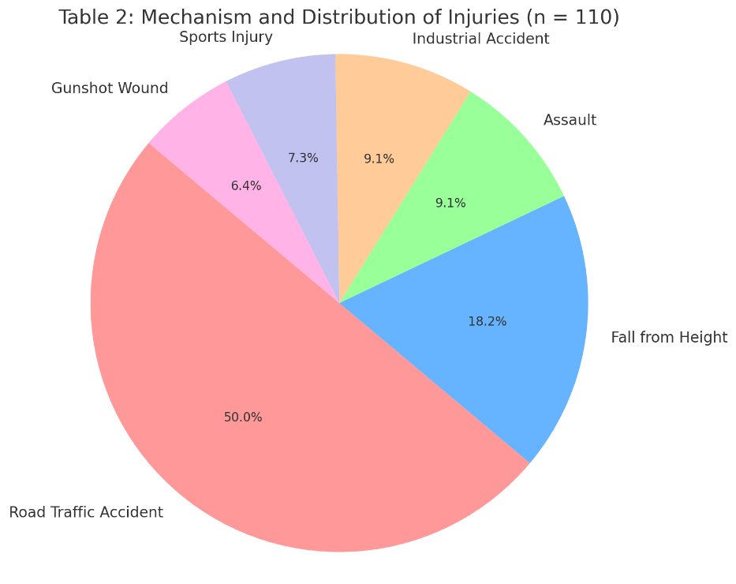
Fig 1. Mechanism and Distribution of Injuries (n = 110)
Fig 2. Body Regions and Injury Severity (n = 110)