# *Original Research Article*

# Endotyping Cellular and Humoral

# Cross-reactivity against Chicken Meat

# and Egg Yolk in Non-IgE-mediated Food Protein-Induced Gastrointestinal Allergies.

## ABSTRACT

|  |
| --- |
| **Background:** Non-IgE-mediated food protein-induced gastrointestinal allergies (FPI-GIAs) are poorly understood, although IgE-mediated hypersensitivities have been extensively described. Patients with poultry meat allergy may present several phenotypes regarding clinical presentations and a wide range of symptom severity, suggesting the existence of several endotypes underlying their diseases.  **Aim:** To evaluate the potential of the Tube Titration of Precipitins (TTP) and the Leukocyte Adherence Inhibition Test (LAIT) to discriminate cellular and humoral immunoreactivity against chicken meat extract and chicken egg yolk extract in patients with non–IgE-mediated gastrointestinal food protein-induced allergic phenotypes.  **Study Design:** We examined retrospectively the medical charts of two cohorts of patients clinically diagnosed with non–IgE-mediated gastrointestinal food protein-induced allergic phenotypes related to consumption of chicken meat and/or chicken egg yolk, who were investigated with the help of TTP or LAIT.  **Methodology:** The TTP and LAIT's registered results against chicken meat and chicken egg yolk extracts were distributed in ranges through a cascade distribution chart to outline the variability of the results within the cohorts. The Pearson correlation test was used to evaluate the correlation between the results obtained simultaneously with both food allergens.  **Results:** The LAIT for the chicken meat extract and egg yolk extract showed a wide distribution range of results. The TTP for the chicken meat and egg yolk extracts showed a distribution concentrated on the higher dilutions. The Pearson correlation test showed a non-significant positive correlation between LAIT for egg yolk and LAIT for chicken meat extract; r(98) = 0.156, p = 0.121. The Pearson correlation test showed a non-significant positive correlation between TTP for the egg yolk extract and TTP for the chicken meat extract; r(98) = 0.181, p = 0.072.  **Conclusion:** Our preliminary results support that the TTP and LAIT performed with chicken meat and egg yolk extracts may discriminate diverse humoral and cellular immunoreactivity degrees in patients suffering from food protein-induced gastrointestinal allergies. Despite no statistically significant quantitative correlation between the results, these findings may improve dietary guidelines for impacted individuals and contribute to creating diagnostic biomarkers. |

*Keywords: Endotype; Hypersensitivity; Chicken meat; Food Protein-Induced Enterocolitis Syndrome; Leukocyte Adherence Inhibition Test; Non–IgE-mediated Immunoreactivity; Poultry meat; Precipitins.*

**Abbreviations:**

FA: Food Allergies

FPI-GIA: Food Protein-Induced Gastrointestinal Allergies

LAI: Leukocyte Adherence Inhibition

LAIT: Leukocyte Adherence Inhibition Test

LMIT: Leukocyte Migration Inhibition Test

TTP: Tube Titration of Precipitins

## 1. INTRODUCTION

Food protein-induced gastrointestinal allergies (FPI-GIA) and Food Allergies (FA) are yet a conundrum for physicians, gastroenterologists, nutritionists, allergists, but mainly for patients who suffer from these conditions (Olivier 2013).

IgE-dependent mechanisms may produce FPI-GIA; however, most cases are produced by hypersensitivities endotypes not mediated by IgE (Heine 2015, Khan 2016, Ahmed et al. 2021). Non-IgE-mediated FPI-GIA are associated with a large spectrum of phenotypic conditions, clinically classified by the predominant anatomic localization of the symptoms (such as food protein-induced proctocolitis, food protein-induced enterocolitis, food protein-induced enteropathy, eosinophilic esophagitis, eosinophilic gastroenteritis, food protein-induced gastro-esophageal reflux disease, celiac disease, multiple food protein intolerance of infancy, food protein-induced gastrointestinal motility disorders), as well as some “functional” conditions, such as infantile colic, which food proteins may also induce (Groetch et al. 2025, Huang and White 2025). These so-called food protein-induced allergic syndromes may manifest through exchangeable, heterogeneous, and recurrent symptoms with mild, moderate, or severe presentations, posing diagnostic and therapeutic dilemmas (Heine 2004).

Self-reported allergy to poultry meat is not a very common complaint in clinical practice (Sloan and Powers 1986). However, when researched, the incidence of diagnosis of hypersensitivity to chicken meat (*Gallus* *domesticus*) may be surprising. Sampson reported an incidence of 16,8% of positive skin prick tests to chicken meat among children with atopic dermatitis due to FA (Sampson and McCaskill 1985).

The first report of chicken meat allergy was described in 1982 as a non–IgE-mediated enteropathy in a child who proved to be allergic to chicken meat and cow’s milk through provocation tests monitored by jejunal biopsies demonstrating severe villous atrophy after ingestion of chicken meat (Vitoria et al. 1982). It took fourteen years for the subsequent description of a non–IgE-mediated Eosinophilic Gastroenteritis to be documented after a chicken meat provocation test monitored by intestinal biopsies (Vandenplas et al. 1994). Food protein-induced enterocolitis syndrome is a non-IgE-mediated FPI-GIA that may present with symptoms such as flatulence, bloating, cramps, postprandial discomfort, vomiting, and diarrhea, due to chronic exposure to an offending food, or general symptoms, such as failure to thrive, while avoiding an offending food. (Agyemang and Nowak-Wegrzyn 2019). Initially described by pediatricians and attributed to liquid foods, such as cow’s milk and liquid infant soy formulas, it was becoming apparent that solid foods (including poultry meat) could also be responsible for food protein-induced enterocolitis syndrome (Nowak-Wegrzyn et al. 2003).

Patients with poultry meat FA may present several phenotypes regarding clinical severity and features, suggesting the existence of several endotypes underlying clinical symptoms (Wanniang et al. 2022). As with any FA, the endotypes behind poultry allergy are primarily classified as IgE-mediated and non–IgE-mediated. Chicken meat allergy has complex sensitization profiles with nine major established allergens and twenty-five proposed candidates (Guiddir et al. 2024). The major chicken meat allergen identified by a proteomics-based approach is a myosin light chain protein designated Gal d 7 (shared by several poultry species), containing the majority of IgE-binding epitopes, characterized by remarkable thermal stability, refolding capacity, and resistance to salivary and gastrointestinal enzymes (Klug et al. 2020). Poultry species develop common allergens, making usual cross-reactivity between chicken meat and turkey meat, as well as with other species (Cahen et al. 1998).

Allergic reactions following the administration of hen’s egg yolk-based vaccines (such as for yellow-fever and typhus) have been described since the forties (Rubin 1946). Allergic symptoms related to ingestion of hen’s egg yolk have been reported since the 1950s, mainly in children, including regurgitation, eczema, and respiratory symptoms (Todd et al. 1957).

Allergy to chicken meat can also develop as a cross-sensitivity against hen egg proteins (bird-egg syndrome) (Hemmer et al. 2016). Bird-egg syndrome is a peculiar IgE-mediated cross-hypersensitivity to egg-yolk alpha-livetin (chicken serum albumin or Gal d 5), also associated with inhaling birds’ feathers and dander (Mandallaz et al. 1988, Szépfalusi et al. 1994). Three chicken meat allergens: parvalbumin (Gal d 8), enolase (Gal d 9), and aldolase (Gal d 10) are also present in fish and are responsible for a cross-reactive hypersensitivity condition called the “fish–chicken syndrome” (Kuehn et al. 2016).

Usually, patients present reactions to multiple foods, an issue reinforced by the few laboratory tests which can suggest the possibility of non-IgE-mediated hypersensitivities (Katz and Goldberg 2014). Some facilities employ the Lymphocyte Stimulation Test for diagnosing hen’s egg yolk–induced enterocolitis syndrome (Kajita et al. 2023).

Humoral immunoreactivity against food allergens and aeroallergens had been classically evaluated by Precipitins (Augustin 1953, Augustin et al. 1960, Cunningham-Rundles et al. 1978, Ferguson and Carswell 1972, Heiner et al. 1962). We also routinely employ the Tube Research of Precipitins (TTP) in our facilities as a triage to evaluate humoral non–IgE-mediated immunoreactivity against suspected allergens before performing more exhaustive *in vivo* provocation tests (Olivier et al. 2023b, Olivier et al. 2021e, Olivier et al. 2021d, Olivier et al. 2024e, Olivier et al. 2024c).

The Leukocyte Adherence Inhibition Test (LAIT) and its similar assay, the Leukocyte Migration Inhibition Test (LMIT), have classically been used to differentiate non–IgE-mediated immunoreactivity against microorganisms and aeroallergens (Fink et al. 1987, Kallen and Nilsson 1979, Kuratsuji 1981, Thomson 1982). The LAIT and the LMIT have also classically been used to differentiate non-IgE-mediated immunoreactivity against food allergens (Allardyce and Shearman 1975, George and Vaughan 1962, Ashkenazi et al. 1980, Butler et al. 1981, Papageorgiou et al. 1983). Non–IgE-mediated cellular immunoreactivity against food allergens had also been reported by our group with the help of the LAIT (Olivier et al. 2022b, Olivier et al. 2022a, Olivier et al. 2022c, Olivier et al. 2023a).

To evaluate the potential of the LAIT and TTP to endotyping non–IgE-mediated cellular and humoral immunoreactivity against egg yolk and chicken meat, we retrospectively compiled the electronic medical charts of patients diagnosed primarily with gastrointestinal food allergies (associated or not with other extra-intestinal allergic phenotypes) related to non–IgE-mediated hypersensitivity, who were investigated for immunoreactivity by one of these two assays.

The present study is a proof-of-concept that hypothesizes that LAIT and the TTP may demonstrate a correlation between cellular and/or humoral immunoreactivity between egg yolk and chicken meat proteins in patients suffering from non–IgE-mediated FPI-GIA.

## 2. MATERIALS AND METHODS

## 2.1 Subjects

After receiving Institutional Review Board approval from the Instituto Alergoimuno de Americana (Brazil; 05/2025), we reviewed the electronic chart of 10.600 outpatients who attended our facility from January 2018 to January 2025.

A cohort of 100 consecutive outside patients (TTP cohort) had been submitted to TTP with chicken meat extract and egg yolk extract for presenting non–IgE-mediated FPI-GIA. This cohort counted 35 males; mean age 43.6 years; SD 22 years; range 5 to 94 years; median 42.5 years; modes = 46 (appeared four times); geometric mean = 36.5 years.

A cohort of 100 consecutive outside patients (LAIT cohort) had been simultaneously submitted to LAIT with chicken meat extract and egg yolk extract for presenting non–IgE-mediated FPI-GIA. This cohort counted 35 males; mean age 34 years; SD 24.7 years; range 1 to 100 years; median 31 years; modes = 5 years (appeared six times); geometric mean = 22.3 years.

This study did not include patients under biological and/or systemic anti-inflammatory therapy. These procedures were offered to patients with clinical suspicion of chicken meat hypersensitivity who demonstrated a non-reactive or inconclusive skin test against chicken meat (Olivier et al. 2013).

**2.2. Extracts**

**2.2.1 Chicken meat extract**

Chicken meat (300g of breast) acquired from the local market (half cooked and half uncooked) was crushed, homogenized, and then left for 48 hours in a Coca-based extractor solution (propylparaben 0.5g, methylparaben 1g, sorbitol 30g, NaCl 5g, NaHCO3 2.5g, 1,000mL H2O) at 4 °C for protein extraction before centrifugation and separation of the water-soluble fraction from solid particles and oily fraction (Coca 1922). The protein quantification of the allergen extracts was done according to Bradford’s protein-dye binding methodology (Bradford 1976). The solution was diluted in antigen dilution solution (NaCl 10g; KH2PO4 0.72g; Na3PO4 2.86g; methylparaben 1g; propylparaben 0.5g; glycerin 400mL; H2O 600mL) to an estimated protein concentration of 1 mg/mL and stored at 4 °C in amber opaque glass vials. The chicken meat extract solution was used to perform allergic skin tests, TTP, and LAIT. All relevant and mandatory laboratory health and safety measures have been complied with during the experiments.

**2.2.2 Egg yolk extract**

Three cooked egg yolks and three uncooked egg yolks were prepared similarly with the chicken meat extract.

**2.3. LAIT: *Ex vivo* Investigation: Leukocyte Adherence Inhibition Test**

**2.3.1 LAIT: Procedure for allergen *ex vivo* challenges**

We performed the LAIT as previously described (Olivier et al. 2012, Olivier et al. 2014, Olivier et al. 2021a, Olivier et al. 2021b, Olivier et al. 2021c).

Shortly, each donor's fresh plasma was divided into two parts and used in parallel *ex vivo* challenging tests with the chicken meat extract (or the egg yolk extract) and the unchallenged plasma (added with antigen dilution solution as a control). We collected plasma with high leukocyte content (buffy coat) from the heparinized tube after one hour of sedimentation at 37 °C. Then, we distributed aliquots of 100 μL into Eppendorf tubes with (or without) the challenging extract and kept them under agitation for 30 minutes (200 rpm at 37 °C).

**2.3.2 LAIT: Procedure for adherence assay**

After incubation, the plasma was allocated into a standard Neubauer hemocytometer counting chamber with a plain, non-metallic glass surface and left to stand for 2 hours at 37 °C in the humidified atmosphere of the covered water bath to allow leukocytes to adhere to the glass. Next, we counted the leukocytes, removed the coverslip, and washed the chamber by immersion in a beaker with phosphate buffer saline (PBS) at 37 °C. Then, we added a drop of PBS to the hemocytometer's chamber and placed a clean coverslip over it. The remaining cells were counted in the same squares as previously examined.

**2.3.3 LAIT: Procedure for calculation**

The percentage of Leukocyte Adherence (LA) of each assay was estimated as: (the number of leukocytes observed on the hemocytometry chamber after washing divided by the number of leukocytes observed on the hemocytometry chamber before washing) and multiplied by 100 (%). The Leukocyte Adherence Ratio (LAR) was estimated based on the ratio between the LA from the antigen-specific challenged plasma and the LA from the unchallenged control plasma: LAR = LA of the challenged sample divided by LA of unchallenged control plasma multiplied by 100 (%). To further calculate the Leukocyte Adherence Inhibition (LAI), we subtracted the LAR from 100 (%). We employed the LAI results for the cascade distribution chart and the statistics calculations; both performed with the help of the Microsoft Excel® statistical package.

**2.4 TTP: *In vitro* Investigation: Tube Titration of Precipitins**

As previously reported, the semi-quantitative TTP against the chicken meat extract (or the egg yolk extract) was performed in a transparent vitreous tube array (Olivier et al. 2024f, Olivier et al. 2024d, Olivier et al. 2024b, Olivier et al. 2024a). Shortly, the patient’s blood was collected in a clot-activator collecting tube. After separation, the serum was centrifuged at 2,000 rpm for 10 minutes. Each allergen extract was allocated in sets of eleven glass tubes at progressively duplicated serum dilutions. The progressive dilutions were combined with separated aliquots of 15 μL of the allergen extract with 250 μL of the patient’s serum, progressively diluted into physiological saline solution (NaCl 0,9%) in the dilution ratios of 1:1; 1:2; 1:4; 1:8; 1:16; 1:32; 1:64; 1:128; 1:256; and 1:512. One tube was a blank control done with water and serum to observe occasional spontaneous precipitation (Sia Test). After 24 hours, the tubes were examined, and the titers (the highest dilution factor that yields a positive reading) were recorded (Williams and Chase 1971).

**3. RESULTS**

As a retrospective survey, there was no research protocol; therefore, we report the incidental immune investigation as registered in the digital medical charts.

The TTP for the chicken meat extract showed a distribution concentrated on the higher dilutions (Fig. 1). There was no negative result. The mean was estimated at 1:307; the median was 1:256; the standard deviation was estimated at 1:175; the mode was 1:512 (appeared 39 times).

The TTP for the egg yolk extract showed a distribution concentrated on the higher dilutions (Fig. 2). There were two negative results. The mean was estimated at 1:335; the median was 1:256; the standard deviation was estimated at 1:179; the mode was 1:512 (appeared 48 times).

The Pearson correlation estimates a non-significant, small positive relationship between TTP for the egg yolk extract and TTP for the chicken meat extract; r(98) = 0.181, p = 0.072. See Fig. 3.

The LAIT for the chicken meat extract showed a wide distribution range of results. The LAI ranged from 0% to 99%. The mean was 48.5%; the median was 50.5%; the standard deviation was 29.8%; the mode was 0% (appeared eleven times). The cascade distribution demonstrates a wide range of LAI results (see Fig. 4). Some patients showed low or moderate immunoreactivity during the ex vivo challenge test. In contrast, others displayed strong immunoreactivity, which could reflect the participation of chicken meat allergens in a Non–IgE-mediated hypersensitivity condition in these patients.

The LAIT for the egg yolk extract showed a wide distribution range of results. Most results were concentrated in the more immunoreactive groups. The LAI ranged from 0% to 99%. The mean was 50.2%; the median was 51%; the standard deviation was 27%; the mode was 0% (appeared eight times). The cascade distribution demonstrates a wide range of LAI results (see Fig. 5). Some patients showed low or moderate immunoreactivity during the ex vivo challenge test. In contrast, others displayed strong immunoreactivity, which could reflect the participation of egg yolk allergens in a Non–IgE-mediated hypersensitivity condition in these patients.

The Pearson correlation estimates a non-significant small positive relationship between LAIT for egg yolk and LAIT for chicken meat extract; r(98) = 0.156, p = 0.121. See Fig. 6.

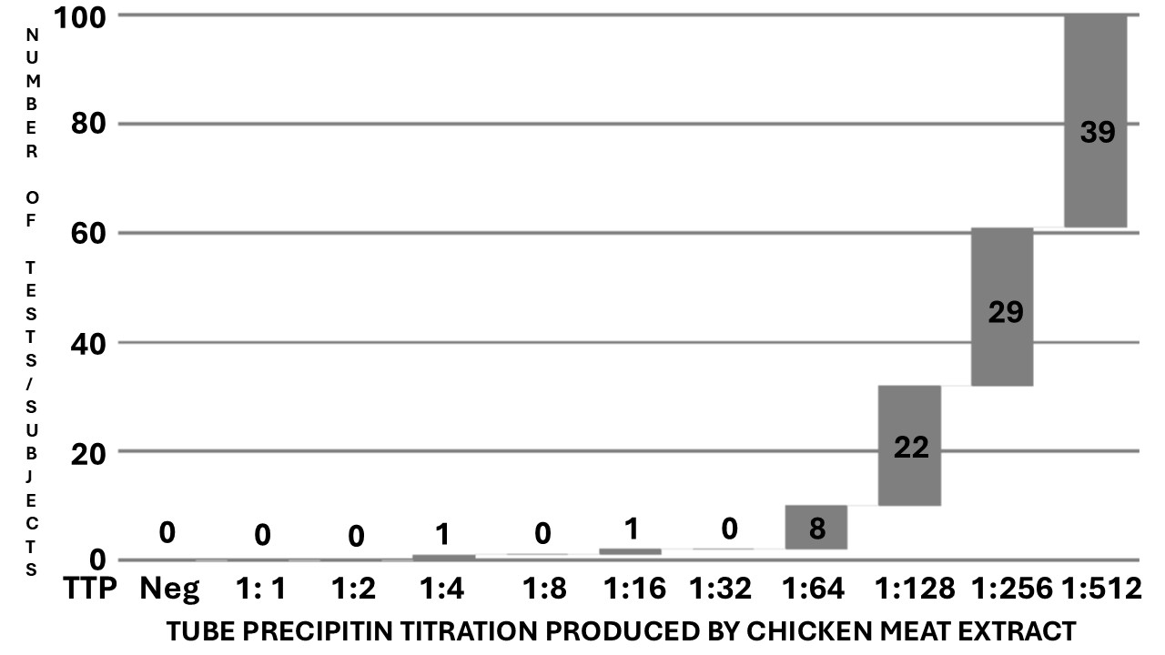

Fig. 1. Cascade distribution chart of the tube titration of precipitins (x-axis %) resulting from the chicken meat extract against the serum of the TTP cohort of 100 tests/subjects (y-axis).

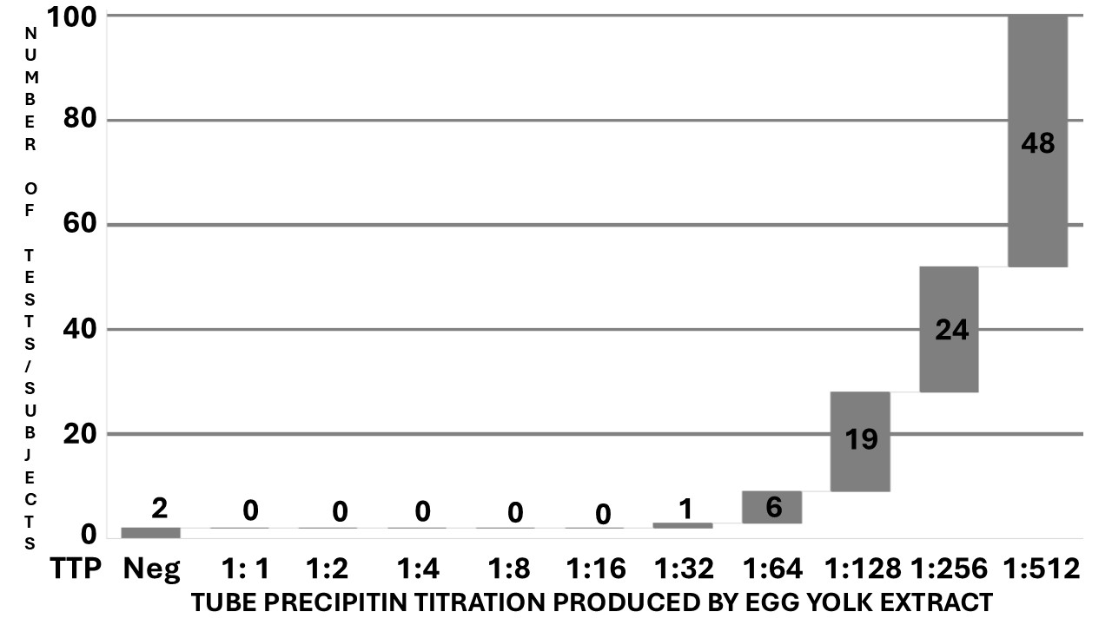

Fig. 2. Cascade distribution chart of the tube titration of precipitins (x-axis %) resulting from the hen’s egg yolk extract against the serum of the TTP cohort of 100 tests/subjects (y-axis).

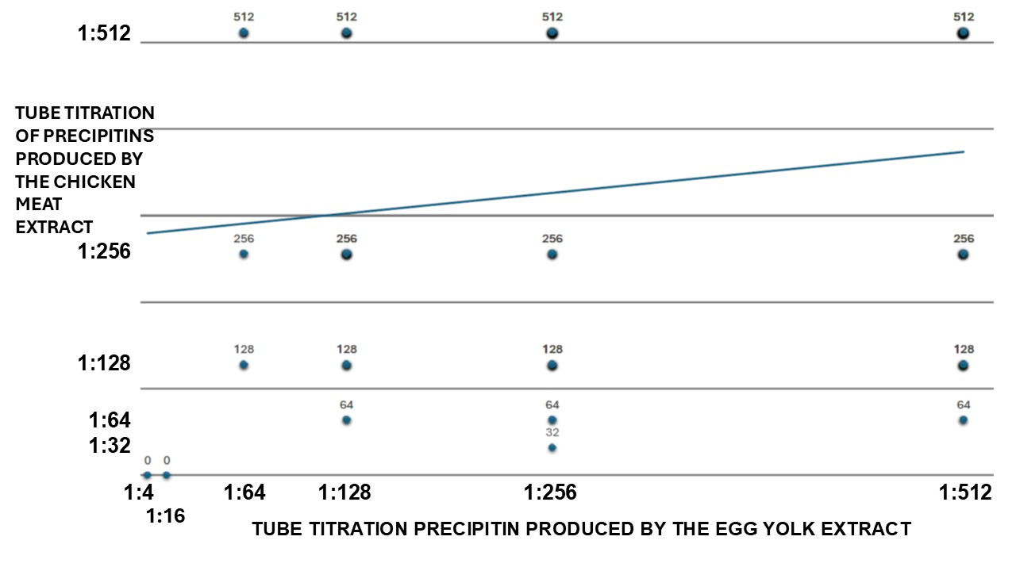

Fig. 3. Dispersion chart of the Tube Titration of Precipitins (TTP) results against hen’s egg yolk extract (x-axis), plotted against the TTP results against chicken meat extract (y-axis). The tendency line shows a non-significant, small positive relationship between the assays; r(98) = 0.181, p = 0.072.

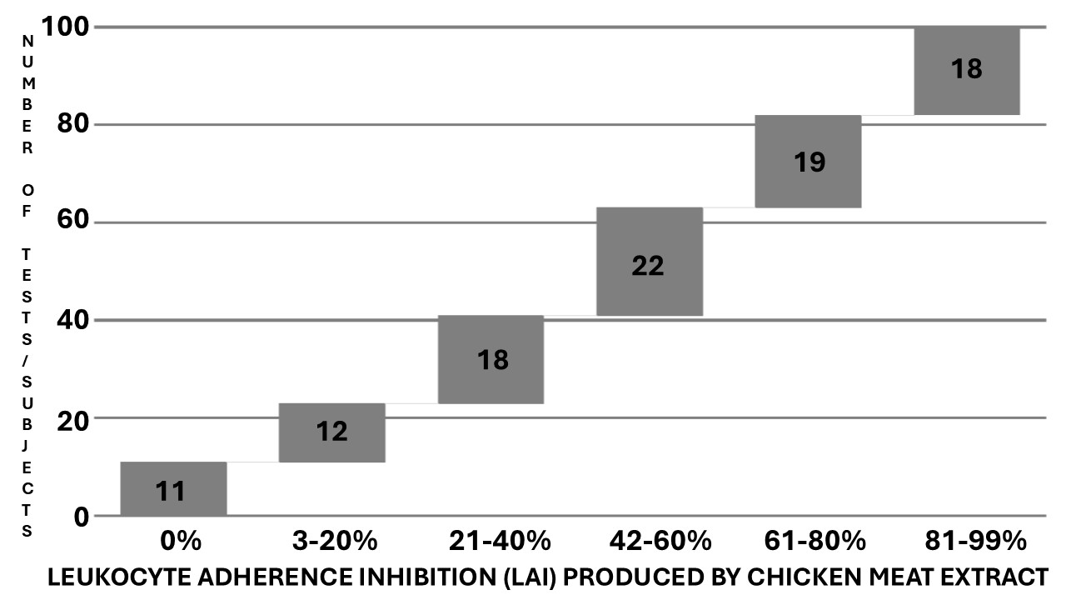

Fig. 4. Cascade distribution chart of the range groups of Leukocyte Adherence Inhibition (LAI) results (x-axis %) of the *ex vivo* challenge test against chicken meat extract monitored by the Leukocyte Adherence Inhibition Test (LAIT), according to the respective number of outcomes over the LAIT cohort with 100 tests/subjects (y-axis).

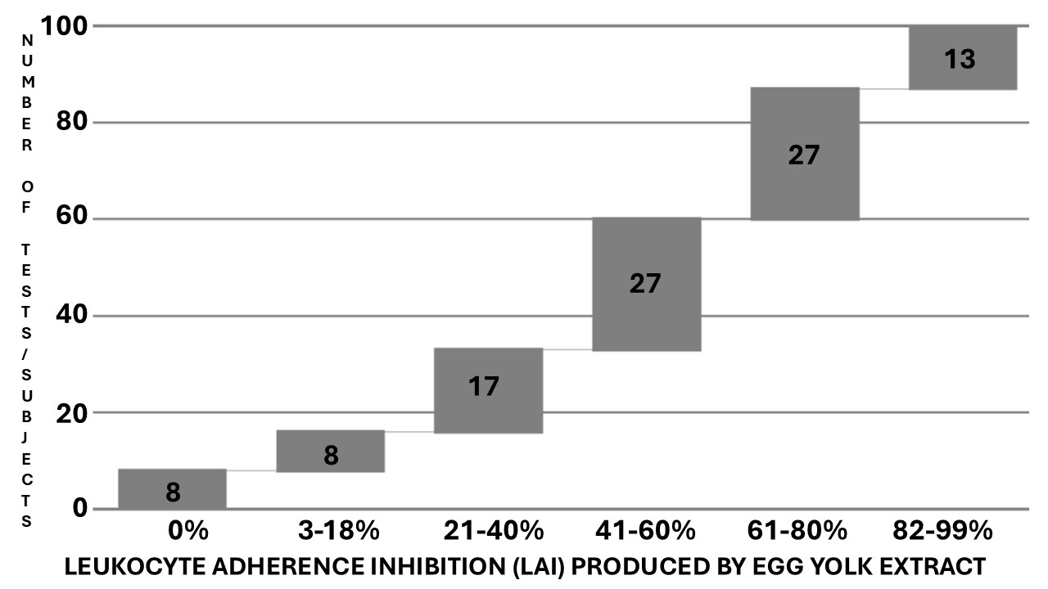

Fig. 5. Cascade distribution chart of the range groups of Leukocyte Adherence Inhibition (LAI) results (x-axis %) of the *ex vivo* challenge test against hen’s egg yolk extract monitored by the Leukocyte Adherence Inhibition Test (LAIT), according to the respective number of outcomes over the LAIT cohort with 100 tests/subjects (y-axis).

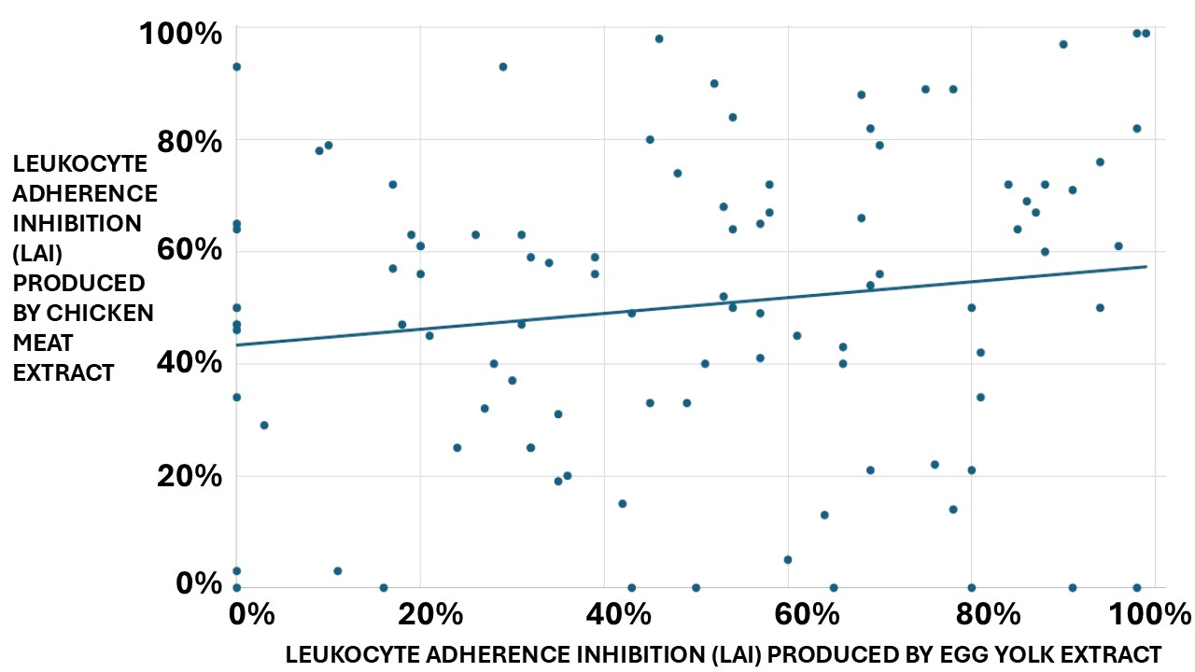

Fig. 6. Dispersion chart of the Leukocyte Adherence Inhibition (LAI) results of the *ex vivo* challenge test against hen’s egg yolk extract (x-axis %), plotted against the LAI results of the *ex vivo* challenge test against chicken meat extract (y-axis %). The tendency line shows a non-significant, small positive relationship between the assays; r(98) = 0.156, p = 0.121.

## 4. DISCUSSION

The semi-quantitative titration of precipitins is a pioneering technique to evaluate humoral immunoreactivity (Wells 1911, Hunter 1905, Olivier et al. 2025b, Olivier et al. 2025a). Precipitating antibodies suggest the presence of a specific humoral immune response against the tested antigens (Gell et al. 1946, Ishizaka et al. 1959). Before the discovery of IgE, the research of precipitins was the leading way to realize *in vitro* diagnosis of immunoreactivity against antigenic and allergenic agents (Augustin and Hayward 1960). The discovery of IgE and its reaginic activity, as well as the concomitant development of the Radio-Allergo Sorbent Test (RAST) to detect specific IgE antibodies, focused the attention of the scientific and medical community on this particular antibody class, mainly after the incorporation of similar non-radioactive assays into routine clinical assays (Wide 1967, Ishizaka and Ishizaka 1967).

Although the serum-free IgE (as detected by routine immunoassays) is not held responsible for clinical symptoms (as are the tissue-bound IgE, responsible for the autocoids released after the encounter with the antigen), the research on serum-specific IgE constructed a paradigm in the physician’s mentality. The research of tissue-bond IgE, as performed by allergic skin tests, is easily performed; however, the demonstration of tissue-bond IgE in mucosal sites is a complex task, substituted by the research of eosinophils and T cells in endoscopic biopsies of patients with FA. This technical hindrance did not prevent the creation of the “IgE-mediated Local Allergic Reaction” concept in food hypersensitive patients (Lin et al. 2002). This concept gave further origin to the similar concept of “IgE-mediated Local Allergic Rhinitis”, which advocates the mucosal production of IgE at insufficient concentrations to be reflected in the blood immunoassays or the skin tests (Rondon et al. 2010).

Usually, the correlation and the distribution of simultaneous positive specific-IgE against food allergens and inhalant allergens are weak; however, when properly investigated, polysensitization is more the rule than the exception in FPI-GIA (Zhang et al. 2025, Čelakovská et al. 2024).

The paradigm of the specific antibody to diagnose the etiology of the allergic symptoms has led to the “IgE culture” and a pressing pursuit to determine the utility of the specific IgG to diagnose the non–IgE-mediated hypersensitivity conditions (Atwah and Koshak 2024). The use of specific IgG against food allergens may be contentious and controversial since the IgG may sometimes act as a hypersensitivity trigger and sometimes as an allergen blocker, depending on its subclass, the antigen-antibody proportion, and the participation of other immune players (Alkhateeb 2020). IgG antibodies can participate in type II (antibody-dependent cell-mediated) and type III (immune complex disease) Gell and Coombs hypersensitivity reactions, which may be theoretically reproduced by the LAIT and the TTP assays, respectively (Olivier et al. 2021a). However, there is a lack of effective and practical tools to diagnose gastrointestinal inflammatory reactions due to FA in patients with no evidence of systemic circulatory IgE (Olivier 2022).

The LAIT is an *ex vivo* challenge test performed with a viable leukocyte buffy coat that can theoretically explore most known immune pathways, as it allows the interaction of all immune-circulating participants with the allergens (Olivier et al. 2021a). Several immune pathways can produce the final leukocyte adherence inhibition (Tong et al. 1979, Halliday 1974).

The present study is a proof-of-concept that hypothesizes that LAIT and the TTP may differentiate diverse degrees of cellular and humoral immunoreactivity against hen’s egg yolk and chicken meat allergens among patients suffering from non–IgE-mediated FPI-GIA. As the tests were performed simultaneously with the same venous sample with the two allergens, it was possible to calculate a correlation test to distinguish some order of cross-reactivity between them.

The retrospective compilation of our data showed a large distribution of results when we ascertained the results of TTP and LAIT to explore humoral and cellular immunoreactivity against two chicken food allergens. These immunoassays did not precisely identify the mechanisms responsible for the clinical condition. Instead, they provide evidence about cellular and humoral immunoreactivity distributed into an extensive spectral range that may suggest immune tolerance or hypersensitivity.

This preliminary retrospective survey demonstrated extensive results from the TTP and the *ex vivo* challenge test monitored by LAIT against hen’s egg yolk and chicken meat allergens in two cohorts of non–IgE-mediated food allergic patients. TTP and LAIT are complementary triage tests used at our facilities to select worthwhile antigens to proceed with more laborious *in vivo* provocation tests when the specific IgE is undetectable. None of our patients presented an exclusive reaction to these allergens. Every patient was simultaneously tested for several chemical and biological allergens, demonstrating positive results for some of them. Our results suggest that patients suffering from FPI-GIA due to hen’s egg yolk allergy may experience additional cross-immunoreactivity against chicken meat allergens and vice-versa.

**5. LIMITATIONS**

This study is a retrospective analysis of data collected over seven years. There was no research protocol, and the subject's data was limited to the essentials available on our electronic sheets. Therefore, we could not establish a cross-comparison between positive and negative controls to validate the results. The number of subjects is appropriate for preliminary analyses; however, future studies must be more comprehensive. The lack of a research protocol implies the possibility of a bias produced by the physician's point of view who indicated the exam (Olivier, CE) based on a clinical suspicion led by anamnesis, physical examination, results of skin tests, and the research of specific IgE. The study lost the follow-up of most patients, hampering the registration of the relationship between the immunoassay results and the patient's clinical outcome. Unfortunately, it was also impossible to compare the two procedures with paired tests because they were taken from distinct groups of patients.

## 6. CONCLUSION

Our preliminary results show that the LAIT and TTP may differentiate diverse degrees of immunoreactivity against chicken meat and egg yolk extracts in patients clinically diagnosed with non–IgE-mediated Gastrointestinal Food Allergies. LAIT and TTP are inexpensive, can be performed with minimum laboratory equipment, and can be incorporated into strategies to address respiratory and food allergy health disparities (Anagnostou et al. 2025). As a preliminary report, the propaedeutic meaning of the presented results and the possibility of interferents must be yet established (Anouar 2024). More studies focused on the quality-by-design approach, with prospective larger double-blind cohorts needed to evaluate the potential contribution of LAIT and TTP for endotyping cellular and humoral immunoreactivity in patients suspected of hypersensitivity against chicken allergens (Chiarentin et al. 2023).

**7. FUTURE DIRECTIONS AND RECOMMENDATIONS FOR CLINICAL PRACTICE**

The primary intended use of *in vitro* or *ex vivo* allergen challenge tests is to spare the patients from being submitted to unnecessary, exhaustive, and dangerous *in vivo* challenge tests. Exploring the humoral and the cellular arms of immune systems, the TTP and LAIT alone or combined may represent, in the near future, a tool for allergists to construct an etiologic diagnosis from their patients, as well as determine the endotypes (mechanisms) of hypersensitivity, in order to choose more convenient and personalized therapies for them. Adding data provided by TTP and LAIT may also contribute to streamlining biomedical research and improving tools such as Large Language Models, usually used by clinicians as a decision support system to enhance diagnostic accuracy (Abers and Mathias 2025).

## CONSENT

As a retrospective survey of results recorded *in cognito*, consent was given collectively by the institution's ethics committee following the principles of the Declaration of Helsinki (WMA 2013).

## ETHICAL APPROVALS

The authors have collected and preserved written ethical approval per international standards.

**Disclaimer (artificial intelligence)**

Authors hereby declare that NO generative AI technologies such as Large Language Models (ChatGPT, COPILOT, etc.) and text-to-image generators have been used during the writing or editing of this manuscript.

**REFERENCES**

Abers, M. S., Mathias, R. A. (2025). Novel applications of large language models in clinical research. *The Journal of Allergy and Clinical Immunology*, 155(3): 813-814.

Agyemang, A., Nowak-Wegrzyn, A. (2019). Food Protein-Induced Enterocolitis Syndrome: a Comprehensive Review. *Clinical Reviews in Allergy and Immunology*, 57(2): 261-271.

Ahmed, E. M., Hussein, T. A., Barkhas, S. A. (2021). The role of IL-4, IL-10 and specific IgE in a sample of Iraqi food allergic patients. *Plant Archives*, 21: 1521-1526.

Alkhateeb, A. F. (2020). Foods Causing Highest IgG Immune Response in Saudi Arabia. *Annual Research and Review in Biology*: 115-127.

Allardyce, R. A., Shearman, D. J. (1975). Leukocyte reactivity to alpha-gliadin in dermatitis herpetiformis and adult coeliac disease. *International Archives of Allergy and Applied Immunology*, 48(3): 395-400.

Anagnostou, A., Wang, J., Chinthrajah, S., Gupta, R., Davis, C. M., Parrish, C., et al. (2025). Addressing health disparities in food allergy: A Position Statement of the AAAAI Prior Authorization Task Force. *The Journal of Allergy and Clinical Immunology*, 155(1): 53-61.

Anouar, S., Hazim, R., Brahim, A. (2024). Interferences in Immunological Assays: Causes, Detection, and Prevention. *Asian Journal of Immunology*, 7(1): 71-78.

Ashkenazi, A., Levin, S., Idar, D., Or, A., Rosenberg, I., Handzel, Z. T. (1980). In Vitro Cell-Mediated Immunologic Assay for Cow's Milk Allergy. *Pediatrics*, 66(3): 399-402.

Atwah, A. F., Koshak, E. A. (2024). Exploring food-specific IgG responses in pediatric allergic disorders: A retrospective cross-sectional study. *Allergologia et immunopathologia (Madrid)*, 52(6): 85-90.

Augustin, R. (1953). Precipitins to grass pollen proteins. *Nature*, 172(4372): 307.

Augustin, R., Hayward, B. J. (1960). Human reagins to grass pollens and moulds: their purification and physico-chemical characterization. *Immunology*, 3(1): 45-73.

Augustin, R., Hayward, B. J., Longbottom, J. L. (1960). Isolation and physico-chemical characterization of reagins, blocking antibodies and precipitins to grass pollens. *Clinical and Experimental Allergy (Copenhagen)*, 7: 31-37.

Bradford, M. M. (1976). A rapid and sensitive method for the quantitation of microgram quantities of protein utilizing the principle of protein-dye binding. *Analytical Biochemical*, 72: 248-254.

Butler, H. L., Byrne, W. J., Marmer, D. J., Euler, A. R., Steele, R. W. (1981). Depressed Neutrophil Chemotaxis in Infants with Cow's Milk and/or Soy Protein Intolerance. *Pediatrics*, 67(2): 264-268.

Cahen, Y. D., Fritsch, R., Wüthrich, B. (1998). Food allergy with monovalent sensitivity to poultry meat. *Clinical and Experimental Allergy*, 28(8): 1026-1030.

Čelakovská, J., Čermákova, E., Andrýs, C., Boudkova, P., Krejsek, J. (2024). Sensitization to latex and food allergens in atopic dermatitis patients according to ALEX2 Allergy Xplorer test. *Molecular Immunology*, 175: 89-102.

Chiarentin, L., Gonçalves, C., Augusto, C., Miranda, M., Cardoso, C., Vitorino, C. (2023). Drilling into "Quality by Design" Approach for Analytical Methods. *Critical Reviews in Analytical Chemistry*: 1-42.

Coca, A. F. (1922). Studies in Specific Hypersensitiveness V. The Preparation of Fluid Extracts and Solutions for Use in the Diagnosis and Treatment of the Allergies with Notes on the Collection of Pollens. *The Journal of Immunology*, 7(2): 163-178.

Cunningham-Rundles, C., Brandeis, W. E., Good, R. A., Day, N. K. (1978). Milk precipitins, circulating immune complexes, and IgA deficiency. *Proceedings of the National Academy of Sciences of the United States of America*, 75(7): 3387-3389.

Ferguson, A., Carswell, F. (1972). Precipitins to dietary proteins in serum and upper intestinal secretions of coeliac children. *British Medical Journal*, 1(5792): 75-77.

Fink, A., Heller, L., Eliraz, A., Weisman, Z., Miskin, A., Schlezinger, M., et al. (1987). Allergen-specific leukocyte adherence inhibition (LAI) assay: sensitivity, specificity and mechanism. *Immunology Letters*, 16(1): 65-70.

Gell, P. G. H., Harington, C. R., Rivers, R. P. (1946). The antigenic function of simple chemical compounds; production of precipitins in rabbits. *British Journal of Experimental Pathology*, 27(5): 267-286.

George, M., Vaughan, J. H. (1962). In vitro cell migration as a model for delayed hypersensitivity. *Proceedings of the Society of Experimental Biology and Medicine*, 111: 514-521.

Groetch, M., Venter, C., Meyer, R. (2025). Clinical Presentation and Nutrition Management of Non-IgE-Mediated Food Allergy in Children. *Clinical and Experimental Allergy*, 55: 213-225.

Guiddir, T., Sénéchal, H., Selva, M. A., Couderc, R., Swoboda, I., Hilger, C., et al. (2024). Chicken meat allergy in children: Complex sensitization profiles with newly described allergen candidates. *Allergy*, 79(8): 2262-2266.

Halliday, W. J., Maluish, A., Miller, S. (1974). Blocking and unblocking of cell-mediated anti-tumor immunity in mice, as detected by the leucocyte adherence inhibition test. *Cellular Immunology*, 10(3): 467-475.

Heine, R. G. (2004). Pathophysiology, diagnosis and treatment of food protein-induced gastrointestinal diseases. *Chemical Immunology and Allergy*, 4(3): 221-229.

Heine, R. G. (2015). Gastrointestinal food allergies. In M. Ebisawa, B. K. Ballmer-Weber, S. Vieths, R. A. Wood (Eds.), *Food Allergy: Molecular Basis and Clinical Practice*, 2015/05/30 ed., Vol. 101: 171-180: Karger.

Heiner, D. C., Sears, J. W., Kniker, W. T. (1962). Multiple Precipitins to Cow's Milk in Chronic Respiratory Disease: A Syndrome Including Poor Growth, Gastrointestinal Symptoms, Evidence of Allergy, Iron Deficiency Anemia, and Pulmonary Hemosiderosis. *American Journal of Diseases of Children*, 103(5): 634-654.

Hemmer, W., Klug, C., Swoboda, I. (2016). Update on the bird-egg syndrome and genuine poultry meat allergy. *Allergo Journal International*, 25: 68-75.

Huang, J., White, A. A. (2025). The heterogeneity of food protein-induced enterocolitis syndrome in adults. *The Journal of Allergy and Clinical Immunology in Practice* 13(4):941-943.

Hunter, A. (1905). On the chemical specificity of precipitins. *The Journal of Physiology*, 32(5-6): 327-342.

Ishizaka, K., Ishizaka, T. (1967). Identification of Gamma-E Antibodies as a Carrier of Reaginic Activity. *The Journal of Immunology*, 99(6): 1187-1198.

Ishizaka, K., Ishizaka, T., Campbell, D. H. (1959). The biological activity of soluble antigen-antibody complexes. *Journal of Experimental Medicine*, 109(2): 127-143.

Kajita, N., Kusakawa, G., Seto, H., Hirao, K., Yokoyama, S., Morikawa, E., et al. (2023). Lymphocyte stimulation test for diagnosing hen's egg yolk-induced enterocolitis syndrome. *The* *Journal of Allergy and Clinical Immunology*, 2(4): 100138.

Kallen, B., Nilsson, O. (1979). Effect of encephalitogenic protein. PPD and tetanus toxoid on leukocyte migration in agarose. A study of "cross-reactivity". *Allergy*, 34(2): 97-102.

Katz, Y., Goldberg, M. R. (2014). Natural history of food protein-induced enterocolitis syndrome. *Current Opinion in Allergy and Clinical Immunology*, 14(3): 229-239.

Khan, M. M. (2016). Allergic Disease. In M. M. Khan (Ed.), *Immunopharmacology*: 197-225. Cham: Springer International Publishing.

Klug, C., Hemmer, W., Román-Carrasco, P., Focke-Tejkl, M., Quirce, S., Boyano-Martínez, T., et al. (2020). Gal d 7-a major allergen in primary chicken meat allergy. *The Journal of Allergy and Clinical Immunology*, 146(1): 169-179.e165.

Kuehn, A., Codreanu-Morel, F., Lehners-Weber, C., Doyen, V., Gomez-André, S. A., Bienvenu, F., et al. (2016). Cross-reactivity to fish and chicken meat - a new clinical syndrome. *Allergy*, 71(12): 1772-1781.

Kuratsuji, T. (1981). Studies on leukocyte adherence inhibition test. Part II. Clinical applications of LAI test to detect delayed type hypersensitivity in infants and children. *Keio Journal of Medicine*, 30(2): 65-69.

Lin, X. P., Magnusson, J., Ahlstedt, S., Dahlman-Höglund, A., Hanson, L. L., Magnusson, O., et al. (2002). Local allergic reaction in food-hypersensitive adults despite a lack of systemic food-specific IgE. *The Journal of Allergy and Clinical Immunology*, 109(5): 879-887.

Mandallaz, M. M., de Weck, A. L., Dahinden, C. A. (1988). Bird-egg syndrome. Cross-reactivity between bird antigens and egg-yolk livetins in IgE-mediated hypersensitivity. *International Archives of Allergy and Applied Immunology*, 87(2): 143-150.

Nowak-Wegrzyn, A., Sampson, H. A., Wood, R. A., Sicherer, S. H. (2003). Food protein-induced enterocolitis syndrome caused by solid food proteins. *Pediatrics*, 111(4 Pt 1): 829-835.

Olivier, C. E. (2013). Food Allergy. *Journal of Allergy Therapy*, S3:004: 1-7 doi:10.4172/2155-6121.S4173-4004.

Olivier, C. E. (2022). Considering intestinal permeability and immune metabolism in the treatment of food allergies. *European Journal of Clinical Medicine*, 3(3): 13-18.

Olivier, C. E., Argentão, D. G. P., Santos, R. A. P. G., Silva, M. D., Lima, R. P. S., Zollner, R. L. (2013). Skin scrape test: an inexpensive and painless skin test for recognition of immediate hypersensitivity in children and adults. *The Open Allergy Journal*, 6: 9-17.

Olivier, C. E., Lima, R. P. d. S., Pinto, D. G., Santos, R. A. P. G. d. (2021ª). The Plasma Preincubation with Papain Before the Assay Suggests that a Gell and Coombs Type II Reaction is Been Demonstrated by the Leukocyte Adherence Inhibition Test. *Biomedical Journal of Scientific Technical Research*, 36(3): 28647 - 28655.

Olivier, C. E., Lima, R. P. S., Pinto, D. G., Santos, R. A. P. G., Silva, G. K. M., Lorena, S. L. S., et al. (2012). In search of a tolerance-induction strategy for cow's milk allergies: significant reduction of beta-lactoglobulin allergenicity via transglutaminase/cysteine polymerization. *Clinics*, 67(10): 1171-1179.

Olivier, C. E., Pinto, D. G., Lima, R. P. S., Silva, M. D. d., Santos, R. A. P. G., Teixeira, A. P. M., et al. Assessment of Immunoreactivity against Therapeutic Options Employing the Leukocyte Adherence Inhibition Test as a Tool for Precision Medicine. *European Journal of Clinical Medicine*, 2(3): 40-45.

Olivier, C. E., Pinto, D. G., Santos, R. A. P. G., Lima, R. P. S. (2021c). Dextran’s interference over the Leukocyte Adherence Inhibition Test. *Academia Letter*, Article (number): 3792.

Olivier, C. E., Pinto, D. G., Teixeira, A. P. M., Miguel, C. S., Santana , J. L. S., Lima, R. P. S., et al. (2025a). Endotyping Cellular and Humoral Cross-reactivity among Canine, Feline, and Swine Allergens in Patients with Allergic Multimorbidity. *Asian Journal of Immunology*, 8(1): 142-162.

Olivier, C. E., Pinto, D. G., Teixeira, A. P. M., Miguel, C. S., Santana , J. L. S., Lima, R. P. S., et al. 2025b. Endotyping Cellular and Humoral Cross-Reactivity between Blomia tropicalis and Farfantepenaeus brasiliensis in Patients with Allergic Multimorbidity. *Asian Journal of Immunology*, 8(1): 163-178.

Olivier, C. E., Pinto, D. G., Teixeira, A. P. M., Miguel, C. S., Santos, R. A. P. G., Santana, J. L. S., et al. (2024). Cellular and Humoral Immunoreactivity against Hen’s Egg White: Relevance in Allergic Patients. *Asian Journal of Immunology*, 7(1): 274-284.

Olivier, C. E., Pinto, D. G., Teixeira, A. P. M., Miguel, C. S., Santos, R. A. P. G., Santana, J. L. S., et al. (2024b). Endotyping Cellular and Humoral Immunoreactivity against Allium spices and Sulfites preservatives in Allergic Patients. A Retrospective Study. *Asian Journal of Immunology*, 7(1): 185-200.

Olivier, C. E., Pinto, D. G., Teixeira, A. P. M., Miguel, C. S., Santos, R. A. P. G., Santana, J. L. S., et al. (2024c). Endotyping Cellular and Humoral Immunoreactivity Against Tartrazine in Allergic Patients: A Retrospective Study. *Asian Journal of Immunology*, 7(1): 217-227.

Olivier, C. E., Pinto, D. G., Teixeira, A. P. M., Santana, J. L. S., Santos, R. A. P. G., Lima, R. P. S. (2021d). Self-imposed food restriction and oral food challenges are correlated with precipitins' accuracy in the diagnosis of non-IgE-mediated food-related adulthood acute episodes of urticaria. *Journal of Allergy Therapy*, 12(8): 1-8.

Olivier, C. E., Pinto, D. G., Teixeira, A. P. M., Santana, J. L. S., Santos, R. A. P. G., Lima, R. P. S. (2023a). Contribution of the Leukocyte Adherence Inhibition Test to the Diagnosis of Innate Non–IgE-mediated Immunoreactivity against *Saccharomyces cerevisiae*. *Asian Journal of Immunology*, 6(1): 234-241.

Olivier, C. E., Pinto, D. G., Teixeira, A. P. M., Santana, J. L. S., Santos, R. A. P. G., Lima, R. P. S. (2024d). Endotyping Cellular and Humoral Immunoreactivity against Aluminum in Allergic Patients: A Retrospective Study. *Asian Journal of Immunology*, 7(1): 149-158.

Olivier, C. E., Pinto, D. G., Teixeira, A. P. M., Santana, J. L. S., Santos, R. A. P. G., Lima, R. P. S. (2024e). Endotyping Non-IgE-mediated Immunoreactivity to Polyethylene Glycol: Implications for Allergic Patients. *Asian Journal of Immunology*, 7(1): 100-111.

Olivier, C. E., Pinto, D. G., Teixeira, A. P. M., Santana, J. L. S., Santos, R. A. P. G., Lima, R. P. S., et al. (2024f). Endotyping Non-IgE-Mediated Immunoreactivity to Dermatophagoides farinae: Implications for Allergic Patients. *Asian Journal of Immunology*, 7(1): 90-99.

Olivier, C. E., Pinto, D. G., Teixeira, A. P. M., Santana, J. L. S., Santos, R. A. P. G. S., Lima, R. P. S. (2021e). Intrinsic Atopic Dermatitis: Titration of Precipitins in Screening Food Allergens for Prescription of Elimination Diets and Desensitization Strategies. *European Journal of Clinical Medicine*, 2(6): 1-9.

Olivier, C. E., Pinto, D. G., Teixeira, A. P. M., Santana, J. L. S., Santos, R. A. P. G. S., Lima, R. P. S. (2022a). Contribution of the Leukocyte Adherence Inhibition Test for the evaluation of immunoreactivity against gluten extracts in non—IgE-mediated / non-autoimmune Gluten-Related Disorders. *European Journal of Clinical Medicine*, 3(2): 1-7.

Olivier, C. E., Pinto, D. G., Teixeira, A. P. M., Santana, J. L. S., Santos, R. A. P. G. S., Lima, R. P. S. (2022b). Contribution of the Leukocyte Adherence Inhibition Test to the Evaluation of Cellular Immunoreactivity against Latex Extracts for Non—IgE-Mediated Latex-Fruit-Pollen Syndrome in Allergic Candidates to Exclusion Diets and Allergic Desensitization. *European Journal of Clinical Medicine*, 3(1): 11-17.

Olivier, C. E., Pinto, D. G., Teixeira, A. P. M., Santana, J. L. S., Santos, R. A. P. G. S., Lima, R. P. S. (2022c). Leukocyte Adherence Inhibition Test to the assessment of Immunoreactivity Against Cow’s Milk Proteins in Non—IgE-Mediated Gastrointestinal Food Allergy. *European Journal of Clinical Medicine*, 3(2): 38-43.

Olivier, C. E., Pinto, D. G., Teixeira, A. P. M., Santana, J. L. S., Santos, R. A. P. G. S., Lima, R. P. S. (2023b). Anti-Saccharomyces cerevisiae antibodies (ASCA) researched by tube precipitins are elevated in dermatologic and gastrointestinal non—IgE-mediated hypersensitivity patients. *European Journal of Clinical Medicine*, 4(2): 25-30.

Olivier, C. E., Santos, R. A. P. G., Lima, R. P. S., Argentão, D. G. P., Silva, G. K. M., Silva, M. D. (2014). A Novel Utility for an Old Method: The Leukocyte Adherence Inhibition Test Is an Easy Way to Detect the Immunoreactive Interference of the Collection Tube Anticoagulant on Cellular Immunoassays. *Journal of Cell Adhesion*, Article ID 860427(http://dx.doi.org/10.1155/2014/860427): 1-6.

Papageorgiou, N., Lee, T. H., Nagakura, T., Cromwell, O., Wraith, D. G., Kay, A. B. (1983). Neutrophil chemotactic activity in milk-induced asthma. *J Allergy Clin Immunol*, 72(1): 75-82.

Rondon, C., Canto, G., Blanca, M. (2010). Local allergic rhinitis: a new entity, characterization and further studies. *Current Opinion in Allergy and Clinical Immunology*, 10(1): 1-7.

Rubin, S. S. (1946). An allergic reaction following typhus-fever vaccine and yellow-fever vaccine due to egg yolk sensitivity. *The Journal of Allergy*, 17: 21-23.

Sampson, H. A., McCaskill, C. C. (1985). Food hypersensitivity and atopic dermatitis: evaluation of 113 patients. *The Journal of Pediatrics*, 107(5): 669-675.

Sloan, A. E., Powers, M. E. (1986). A perspective on popular perceptions of adverse reactions to foods. *The Journal of Allergy and Clinical Immunology*, 78(1 Pt 2): 127-133.

Szépfalusi, Z., Ebner, C., Pandjaitan, R., Orlicek, F., Scheiner, O., Boltz-Nitulescu, G., et al. (1994). Egg yolk alpha-livetin (chicken serum albumin) is a cross-reactive allergen in the bird-egg syndrome. *The Journal of Allergy and Clinical Immunology*, 93(5): 932-942.

Thomson, D. M. P. (1982). *Assessment of immune status by the leukocyte adherence inhibition test*. New York: Academic Press.

Todd, R. H., Howard, W. A., Lafsky, B. P., Webb, C. A., Wolf, S. I. (1957). Studies on the antigenicity of egg yolk. *The Journal of Allergy*, 28(5): 436-448.

Tong, A. W., Burger, D. R., Finke, P., Barney, C., Vandenbark, A. A., Vetto, R. M. (1979). Assessment of the mechanism of the leukocyte adherence inhibition test. *Cancer Research*, 39(2 Pt 2): 597-603.

Vandenplas, Y., Edelman, R., Sacré, L. (1994). Chicken-induced anaphylactoid reaction and colitis. *Journal of Pediatric Gastroenterology and Nutrition*, 19(2): 240-241.

Vitoria, J. C., Camarero, C., Sojo, A., Ruiz, A., Rodriguez-Soriano, J. (1982). Enteropathy related to fish, rice, and chicken. *Archives of Disease in Childhood*, 57(1): 44-48.

Wanniang, N., Codreanu-Morel, F., Kuehn, A., Morisset, M. (2022). Poultry Meat allergy: a Review of Allergens and Clinical Phenotypes. *Current Treatment Options in Allergy*, 9(3): 187-203.

Wells, H. G. (1911). Studies on the chemistry of anaphylaxis (III). Experiments with isolated proteins, especially those of the hen's egg. *Journal of Infectious Diseases*, 9: 147-171.

Wide, L., Bennich, H., Johansson, S. G. O. (1967). Diagnosis of Allergy by an in-vitro Test for Allergen Antibodies. *The Lancet*, 290(7526): 1105-1107.

Williams, C. A., Chase, M. W. (1971). Chapter 13 - Precipitation Reactions, *Reactions of Antibodies with Soluble Antigens*, Vol. 3: 1-102: Academic Press.

WMA. (2013). World Medical Association Declaration of Helsinki: ethical principles for medical research involving human subjects. *Journal of the American Medical Association*, 310(20): 2191-2194.

Zhang, J., Tang, Y., Yang, D., Yu, J. (2025). Investigating allergen-specific IgE distribution and correlations in chronic urticaria: a retrospective study in Shanghai, China. *European Journal of Medical Research*, 30(1): 182.