The Changing Course of Adi Ganga River: Causes of Decay, Present Scenario and Proposed Development Plans in West Bengal, India

.
ABSTRACT
Originating from the Bhagirathi-Hooghly River system, the historically important Adi Ganga served trade and pilgrims as a distribution stream. Following a significant alteration in its course, the river's environment has gradually degraded as a result of external human activities and natural processes. This study examines the historical changes of Adi Ganga, the shifting path, the reasons behind the decay, and its current condition. This study is conducted with the help of secondary data from sources such as the National Atlas and Thematic Mapping Organisation (NATMO), Survey of India, and Google Images, along with a primary survey. Research results demonstrate minimal water velocity (0.68 m/s) through the channel, together with poor discharge (13.398 cubic m/s) levels that result in shallow waters and heavy sediment deposits. Increasing amounts of waste materials, together with the presence of large amounts of improperly disposed garbage, as well as poorly designed drainage systems, contribute to the river's deteriorating condition, resulting in a decrease in mean depth and width downstream. On the other hand, the water quality of Adi Ganga is characterized by poor ecological conditions, with slightly acidic pH levels and very low dissolved oxygen (DO) concentrations. The flow of water through the environment is blocked by recent bridge developments along the rail pillars as structural barriers. A combination of sustainable river management practices, together with community initiatives, is essential to maintain both the ecology and history of the Adi Ganga to save it for future generations.

Keywords: Adi Ganga, Decaying River, Changing course, Cross Section, and Water quality

1. INTRODUCTION

Numerous tributaries and distributaries in the Southern region of West Bengal originated from the Ganga or Bhagirathi–Hooghly River system (Das, 2023). The South Bengal River system consists of multiple connected waterways that provide essential environmental resources for domestic water needs, agricultural production, and fishing-based livelihoods, according to several studies (Ghosh et al., 2022; Mandal, 2018a; Laha, 2015). The Adi Ganga is a river belonging to the Bhagirathi–Hooghly River system, which was formerly the Original River channel when Calcutta became a major port under the British Empire in the last decade of the 17th century (Basu, 2016). The Adi Ganga, also called Gobindapur Creek, was the main flow of the Hooghly River between the 15th and 17th centuries, and it also dried up fast like the Saraswati River (Dey, 2021). A canal was constructed in 1750 to connect the Hooghly River to the Saraswati River at Sankrail. As a result, the main flow of the Adi Ganga shifted westward, and today it is known as the Hooghly River (Basu, 2016). In 1770, William Tolley dug a 15 km canal from Garia to Shamukpota to save the Adi Ganga stream. It helped to connect the original Ganga with the Vidyadhari River, and hence its contiguous branch is known as Tolly's Nala (Basu, 2016).
The Adi Ganga River maintains its sacred status for Hindus because of the Kalighat temple on its banks, together with its historical importance as a major trade pathway (Rudra, 2018). Throughout the British rule period, many international trade ships used the Adi Ganga River as an essential passage for accessing the Calcutta port (Mandal, 2018b). The Adi Ganga River faces multiple connected problems arising from pollution, environmental destruction, and socioeconomic weaknesses. In the first ten years of the twenty-first century, over 300 piers were placed into the riverbed to construct the metro line between Tollygunge and Garia, resulting in the near demise of the Adi Ganga (Rudra, 2018). This river has now become a sewer, encroached upon, transformed into residential ponds, and buried beneath garbage and the Metro train system (Basu, 2016).
The degradation of the Adi Ganga flow is further strengthened by parallel studies of urban river degradation. The analyses of urban rivers all over the world show the same trends of hydrological changes and pollution caused by in-migration of metropolitan areas (Sharma, 2020). Remedial measures applied, such as dredging the riverbeds, building riparian buffer areas, and local community-based surveillance have proven to improve the health of a river in cities significantly (Wantzen et al., 2019). Through the examples of the Yamuna, Mithi, and Musi rivers in India, rivers are dystopian warning stories of ruined sacred rivers that have too many pollutants and broken ecological continuity as a result of which the three rivers have comprehensive restoration strategies combining cultural practices and engineering measures (Sharma et al., 2021).
Therefore, what remains of the Adi Ganga in the present is that it is a stagnant sewage system in the city and no longer a living lifeline to socio-ecological resilience (Sigdel et al., 2023). However, its spiritual and historical permanence makes it significant to complete a restoration of all sorts. This paper questions the path of environmental decline experienced by this river and makes the Adi Ganga part of a paradigm where history has been represented through transitions, ecological degradation and cultural- hydrological interactions (Mukherjee, 2016). Merging primary field data and secondary archival documents, it tries to map the degradation of such river spatially and temporally, and also come up with evidence-based solutions to ecologically redevelop the river in light of the cultural heritage and environmental sustainability (Tian & Huang, 2020).

1.1. History of evolution of Adi Ganga River:

1.1.1. Before the 18th Century:

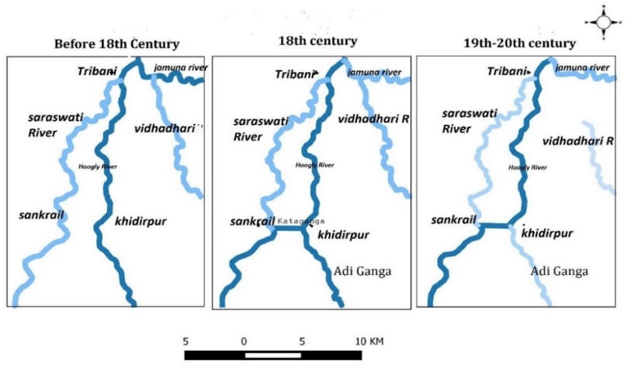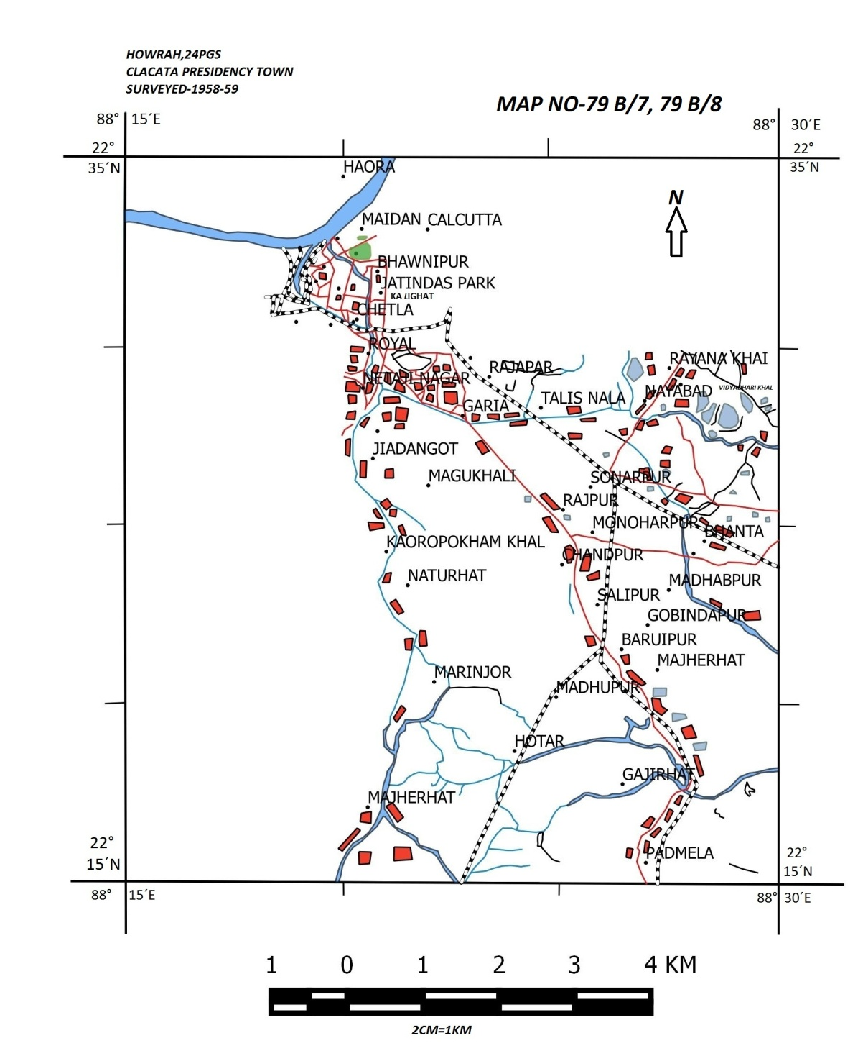The main river network includes the Hooghly River, running along with its Saraswati and Vidyadhari tributaries. During early hydrologic development, the Adi Ganga did not emerge as a separate waterway because the Saraswati River maintained its primary control over the region's water system. Research documents show that during this time, the Saraswati served as an important river route until it started shrinking because of tectonic activity and land build-up (Dey, 2021).

Fig. 1. Course of the Adi Ganga from the 19th to the 20th century. Source: Rudra, 2018 and NATMO

1.1.2. 18th Century:

The formation of the channel called Adi Ganga emerged during this period. At this time, human builders dug canals across the area to boost river travel and trade expeditions. The Saraswati River flow was reduced further because its passage faced growing constriction. The Vidyadhari River maintained its route as the Adi Ganga developed into a principal channel linking Kolkata with Bengal's broader region.

1.1.3. 19th–20th Century:

In this period, the Adi Ganga transformed into a completely separate and defined waterway while the Saraswati River vanished, apart from several disconnected remnants. During this period, the Vidyadhari River lost its previous importance. Urban development alongside natural changes in Kolkata transformed the Hooghly River into the region's principal waterway (Ivermee, 2017).
The patterns of change show river systems operate dynamically through natural processes combined with human impacts. Despite becoming a reduced stream, the Adi Ganga still holds excellent cultural and historical importance in West Bengal (Mukherjee, 2016). The patterns of change show river systems operate dynamically through natural processes combined with human impacts. Despite becoming a reduced stream, the Adi Ganga still holds excellent cultural and historical importance in West Bengal (Dey & Panigrahi, 2022).

1.2. Study Area

Adi Ganga, sometimes referred to as Gobindapur Creek and Tolly's Canal, is a watercourse that was a part of the Hooghly River in the Kolkata region of India. It starts at the Hugli from Dahilghat Bridge and passes across the renowned Hindu temple of Kalighat (Rudra, 2018). It crosses Khidderpore, bifurcates near Kudghat, then runs via Tollygunj until it enters Garia. The flow decreases beyond Garia till it converges with the Bidyadhari at Samukpota. The southern canal extends from Kudghat to the Sundarbans, traversing Sonarpur, Canning, and the Matla River. This canal provides the primary supply of water for the irrigation of the agricultural fields it traverses. Adi Ganga is an approximately 75 km long original waterway that has been obstructed at several locations. The deteriorated path remains identifiable for 36 kilometers from Calcutta to Surjyapur (Bandyopadhyay, 1996). The researchers seek to investigate the impact of anthropogenic factors on the ecosystem and flow dynamics of the Adi Ganga. The present study area is eleven ghats of Adi Ganga in Kolkata such as Dahi Ghat (1), Hasting (2), Taj Bengal (3), Bhawani Bhaban Ghat (4), Om Balaram Basu Ghat (5), Kalighat Mandir (6), Choto Rashbari Ghat (7), Boro Rashbari Ghat (8), Karuna Mohi Bridge (9), Kudghat Bus Stop (10), Garia Metro Station (11).

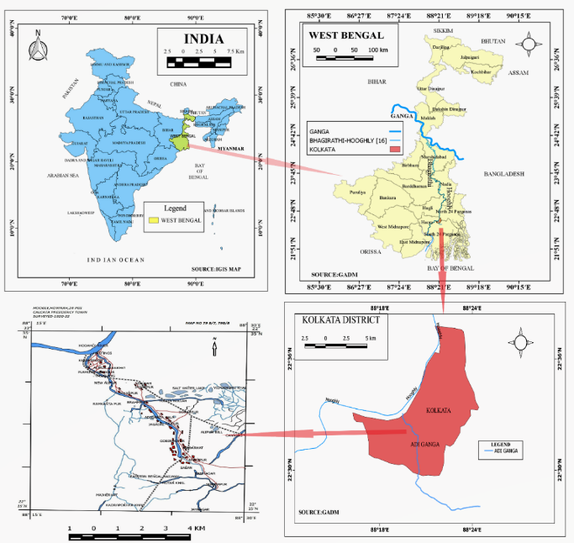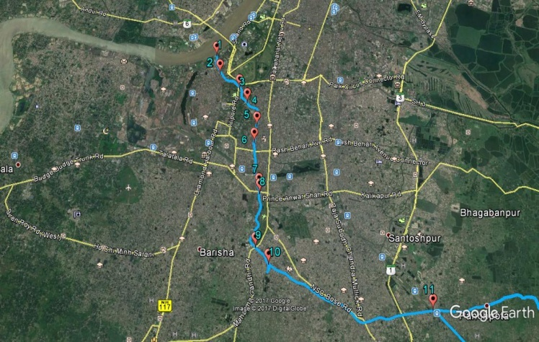

a) (b)
Figure 2. Location map. (a) Study area map; (b) Pointing of eleven ghats of Adi Ganga in Kolkata

2. materials and methods

A field survey was done in various ghats along the Adi Ganga to derive the sources of pollution according to the perceptions of various stakeholders. 50 respondents were interviewed by purposive sampling strategy since they were people using the ghats, live in ghats or work in ghats. The surveyed represented by the respondents were the local residence, boatmen, and shopkeepers among other stakeholders whose lives are deeply applicable in the river on a daily basis. The semi-structured interviews were utilized to gather data where participants had the freedom to report their opinions concerning the causes and contributors to pollution in the Adi Ganga.
The historical evolution of the Adi Ganga map was collected from offices like the National Atlas and Thematic Mapping Organization (NATMO) in 1920-22 (79 B/7 & 79 B/8) and 1958-59 (79 B/7 & 79 B/8). The existing field survey was done in January 2022 by the authors including the channel bed measurement with GPS survey and identifies the cause of pollution of the channel, field measurements of selected sites were taken channel depths, width, and water levels were taken by staff and ranging rod, tape in different parts of Adi Ganga Ghats and Water sample collection in march 2017 from eleven ghats of Adi Ganga and measurement of dissolved oxygen, turbidity by Multiparameter and Conductimeter and BOD measured through dilution method in laboratory. QGIS was used to digitize all the maps and diagrams. The source of pollutants in the Adi Ganga was analyzed through the field survey. Finally, the work was completed through an analytical scientific approach.
The cross-sectional area, mean velocity, and discharge at multiple locations were documented for the assessment of river flow and physical attributes. The velocity was assessed along a 10-meter stretch of the river at designated points, while the discharge was computed using the formula:

Discharge = Cross-sectional Area $×$ Mean Velocity (Charlton, 2007)

pH: The scale of measuring acidity or alkalinity is known as pH. The range goes from 0 - 14, with 7 being neutral. A pH less than 7 indicates acidity, whereas a pH greater than 7 indicates a base (Sorensen, 1909).

Dissolved Oxygen (DO): Oxygen levels ranging from 0 to 2 mg/L are inadequate to sustain the majority of aquatic life. Oxygen levels ranging from 2 to 4 mg/L are somewhat improved, permitting only a restricted variety of fish and aquatic invertebrates to survive. A moderate concentration of 4 to 7 mg/L is appropriate for several aquatic organisms, while it is deemed insufficient for cold-water fish species. Oxygen concentrations ranging from 7 to 11 mg/L are desirable, facilitating the health and survival of the majority of stream fish species that necessitate elevated oxygen levels for good life conditions. This process demonstrates the significance of sustaining sufficient dissolved oxygen levels in aquatic ecosystems for biodiversity and ecological equilibrium (Water Rangers, 2024).

Biological oxygen demand (BOD): Water quality is categorized according to the concentration of a specific component, measured in parts per million (ppm). The classifications are as follows: values of 1 to 2 ppm are classified as "Very Good," signifying a reasonably unpolluted water supply with negligible contamination. A concentration of 3 to 5 ppm is deemed "Good," indicating the existence of some contaminants while remaining within an acceptable threshold for many applications. Water with values between 10 and 20 ppm is designated as "Polluted Water," signifying a significant deterioration in water quality and possible detrimental impacts on ecosystems and human health. Concentrations ranging from 20 to 30 ppm are designated as "Very Polluted Water," indicating severe contamination that presents substantial threats to environmental and public health.

Turbidity: Water turbidity is classified into three distinct levels: low, medium, and high, according to Nephelometric Turbidity Units (NTU). Turbidity values between 0 and 30 NTU are categorized as low, indicating clean water. Within this spectrum, the water exhibits clear transparency, signifying a negligible presence of suspended particles. A moderate turbidity level, defined by values ranging from 30 to 50 NTU, produces water that appears somewhat opaque, with discernible particle matter. Water exhibiting turbidity levels ranging from 50 to 100 NTU is classified as high turbidity, characterized by a considerable cloudiness that signifies a substantial concentration of suspended materials.

3. results and discussion

3.1. Morphometric Components in Different Parts of Adi Ganga River

3.1.1. Velocity

Dahi Ghat (Khidirpur): Surface velocity was assessed along a 10-meter length of the river in this region. This location is adjacent to the Hooghly River. The measured velocity in this section of the channel is 0.68 m/s. The velocity was recorded around 9:00 AM.
Kalighat: In this area, surface velocity was measured over 10 meters of the channel. The observed velocity at this point is 1.16 cubic mt/sec. The velocity was measured at 11.00 am.
3.1.2. Discharge

The study presents discharge measurements taken at different points along the Adi Ganga, focusing on areas like Dahi Ghat, Kalighat, and others.
For instance, at Dahi Ghat (Khidirpur), the cross-sectional area is recorded as 19.704 square meters, and the mean velocity of the water is 0.68 meters per second, resulting in a discharge of 13.398 cubic meters per second. This shows a moderate flow rate in the initial stretch of the river.

Location | Cross-Sectional Area (meter) | Mean velocity In  Cubic (Mt/Sec.) | Discharge In  Cubic (Mt/Sec.)
Dahighat (khidirpur) | 19.704 | 0.68 | 13.398
Table 1. Measurement of Discharge of the Adi Ganga Ghats in Kolkata

3.1.3. Cross sectional area

Dahighat: The map shows (Figure 3 & Table 2) how deep the Adi Ganga is at Dahi Ghat in Kolkata. The latitudinal and longitudinal extension of the cross-section point is 22°33´00.4"N, 88°19´30.9"E. At the off-take point, the deepest part is 1.25 meters, and the shallowest part is 0.4 meters. The canal is 24 meters wide and has an average depth of 0.821 meters at this location. The depth of the waterway means that there is a lot of sand buildup next to the left bank. Tidal influence is present in this area. Dahi Ghat is the starting point of the Adi Ganga River, which comes from the Hooghly River.
Kalighat: The cross-section point's longitudinal and latitudinal extensions are 22°31´11.12"N, 88°19´29.37" E. Compared to the preceding ghat, the depth is modest. This region is subject to tidal effects. The lowest depth at the off-take point is 0.3 meters, while the maximum is 0.9 meters. This canal is 24 meters wide and has a mean depth of 0.628 meters at this location. According to the channel's depth, the right bank has much sedimentation (Figure 4 & Table 2).
Rashbarighat: The graphic (Figure 5 & Table 2) illustrates the depth of the Adi Ganga channel near Choto Rashbari Ghat in Kolkata. The geographical coordinates of the cross-sectional location are 22°30'17.43"N latitude and 88°20'30.68"E longitude. The maximum depth at the off-take point is 1 meter, while the minimum depth is 0.25 meters. The channel's width is 24 meters, and the mean depth at this location is 0.635 meters. The depth is substantial in Kalighat but less in Dahighat. The depth of this canal indicates significant sedimentation on the left bank. This location exhibits a tidal effect.
Garia metro station: the diagram (Figure 6 & Table 2) shows the depth of the Adi Ganga channel at Garia metro station. As we see, the depth is very low from other points. Tidal influence is not present in this area due to waste materials and the metro pillar construction of the channel. In the off-take point, the highest depth is 0.5 meters, the lowest depth is 0.3 meters, and the width of the channel is 18 meters, and the mean depth at this point is 0.32 meters.

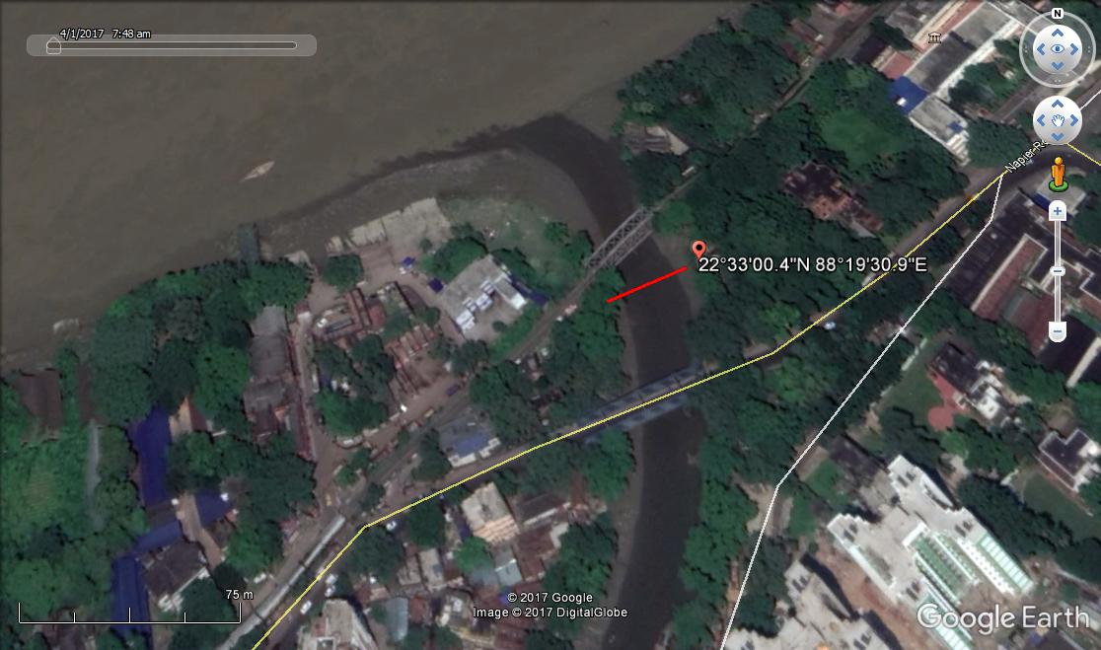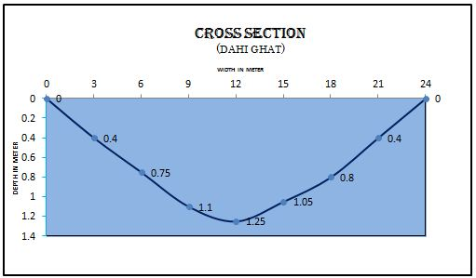Figure 3. Distance and depth in meter of Dahi ghat

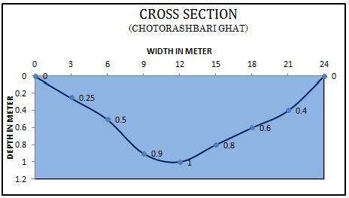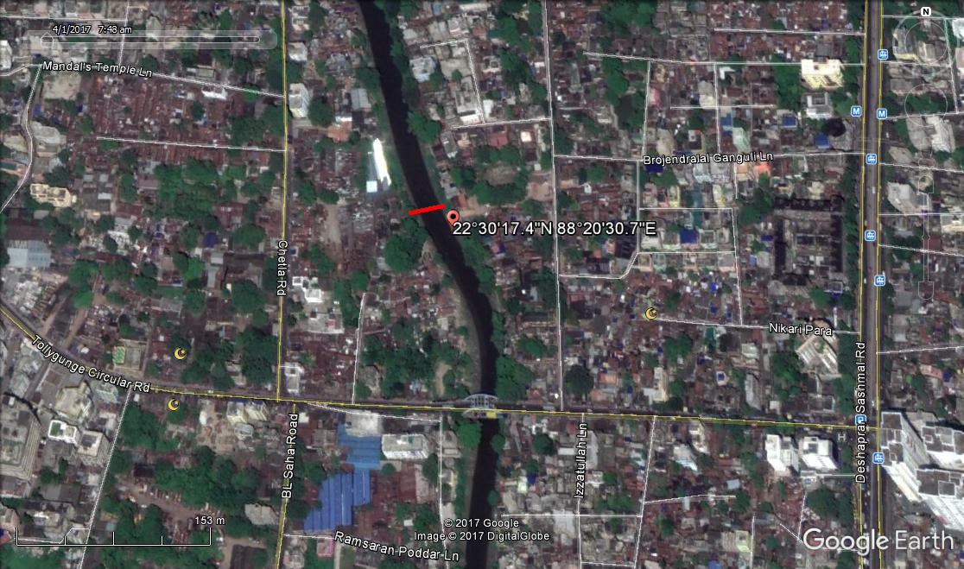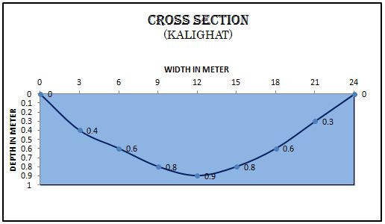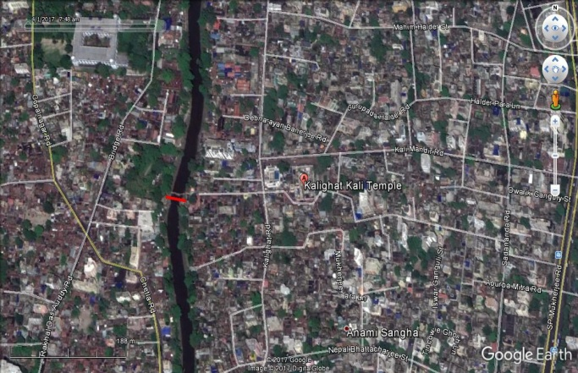Figure 4. Distance and depth in meter of Kalighat

Figure 5. Distance and depth in meter of Chotorashbari Ghat

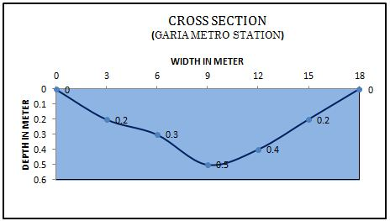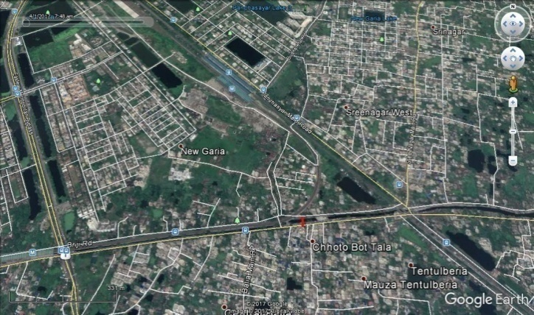Figure 6. Distance and depth in meter of Garia
Table 2. Mean Depth at Different Sites of Adi Ganga in Kolkata.
Location | Mean Depth (In Meter) | Width  (In Meter)
Dahi Ghat (Near Khidirpur) | 0.821 | 24
Hasting (Near Khidirpur) | 0.761 | 24
Taj Bengal (Zoological Garden) | 0.47 | 20
Bhawani Bhaban Ghat | 0.46 | 20
Om Balaram Basu Ghat | 0.43 | 20
Kalighat Mandir | 0.628 | 24
Rashbari Ghat | 0.635 | 24
Panchanantala ghat | 0.718 | 24
Karuna Mohi Bridge | 0.391 | 21
Kudghat Bus Stop | 0.387 | 15
Garia Metro Station | 0.32 | 18

3.2. Water Quality Parameters
The evaluation of the water quality in the Adi Ganga Ghats in Kolkata reveals a considerable environmental deterioration, mainly due to human activities. While most locations show slightly acidic pH levels, some areas show alkaline conditions, suggesting the presence of chemical contaminants. Many ghats exhibit dangerously low levels of dissolved oxygen (DO), with minimum readings of 0.12 mg/L found at the Kudghat and Garia metro stations, reflecting severe pollution and conditions that are not conducive to aquatic organisms. The biological oxygen demand (BOD) reaches its highest level of 50 ppm in Kalighat, indicating significant organic pollution. In contrast, the lowest levels of BOD of 15 ppm in Dahi Ghat imply comparatively improved yet still suboptimal water quality. The turbidity readings differ markedly, with certain ghats showing clear water (less than 30 NTU). In comparison, others demonstrate elevated turbidity levels (50-100 NTU), indicating the presence of suspended particles, chemical deposits, and human-made waste accumulation. Collectively, these parameters highlight the declining health of Adi Ganga, exacerbated by sedimentation, unregulated waste disposal, urban invasions, and infrastructural barriers such as metro pillars and bridges, underscoring the urgent need for sustainable intervention and conservation strategies.

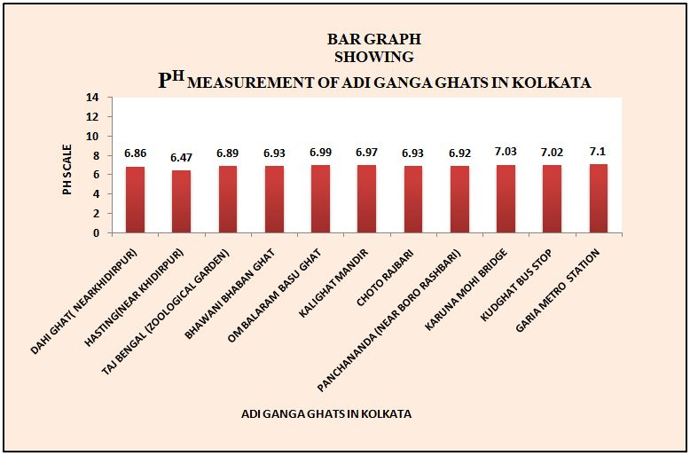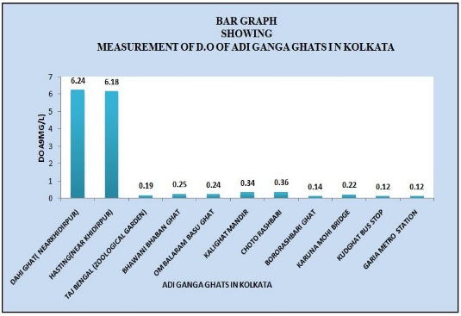 (a) (b)
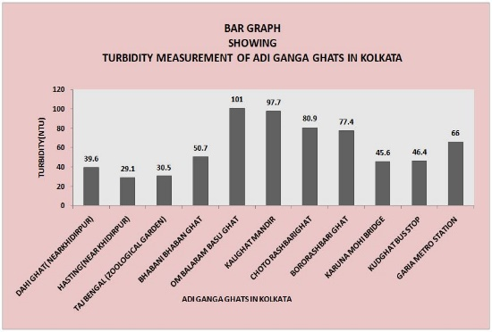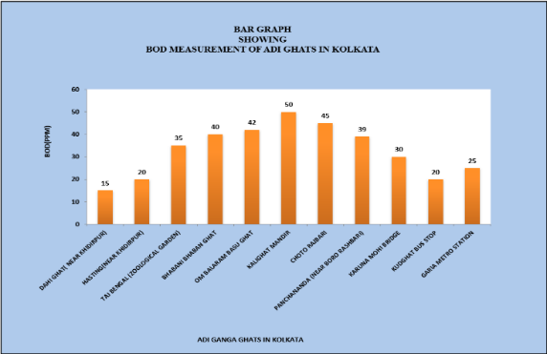 (c) (d)
Figure 7. Water Quality Measurements. (a) PH Measurement; (b) Measurement of D.O. (dissolve oxygen); (c) Turbidity Measurement; (d) BOD (biochemical oxygen demand) measurement.

3.3. Causes of Adi Ganga Channel Decay

Figure 8 shows a pie graph of the perceptions of people about the pollution sources of the Adi Ganga River. The results of the chart reveal that most respondents (40%) find drainage to be the main cause of river pollution. This is then followed by the municipalities which are considered to be the second largest contributor beside the 24 percent pollution. The contributing amount of pollution is believed to be 14 percent by the domestic and 12 percent by factories. Agricultural activities have 0 percent, and interestingly the category has been listed as others which includes other unspecified sources and indicated as 10 percent.
The sources and nature of pollutants vary from site to site. The percentage of pollutants in water hyacinth, grass, garbage, drainage water, and chemical water is consequently high. Plastic and household waste are thrown into the river daily. These caused enormous pollution of the river. The construction of a bridge above the river and even on the riverbed is the distinctive feature of Adi Ganga. Domestic garbage is a widespread natural pollution and a cause of eutrophication. A large population of sewage water with a higher organic load in the Adi Ganga is from this population through domestic water usage. Industrial waste materials and polluted water connect with the Adi Ganga channel.

Figure 8. Source of pollutants of the Adi Ganga River
The original design of Kolkata's drainage system was based on the drainage capacity of the sub-basins. But the unplanned canal drains, the Construction of the metro railway pillar in the bed of Adi Ganga has not only reduced the water flow pathway but also caused the generation of silt and thus reduced the depth of the river. With the rapid urbanization, degeneration, and growth of the Pavement area along the Adi Ganga channel basin area, underground recharge has tended to be very Low. Therefore, all rainfall flows as surface runoff. On the other hand, due to soil erosion, enormous amounts of eroded soil flow into the river and decrease the depth and water carrying capacity of the river. Therefore, the flood may occur in the Monsoon months. Due to urbanization, human settlements are rapidly increasing along the river banks, even if they are using the river floodplain. Some promoters are filling up the floodplains for self-working. When the channel bed level becomes higher than the main river bed, the tidal water cannot go too far. The Adi Ganga channel bed is high at present for deposition of sediment over a long time, but there is no maintenance or cutting of the channel, so the channel bed is high from the source of water.

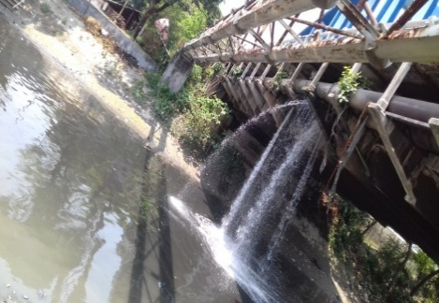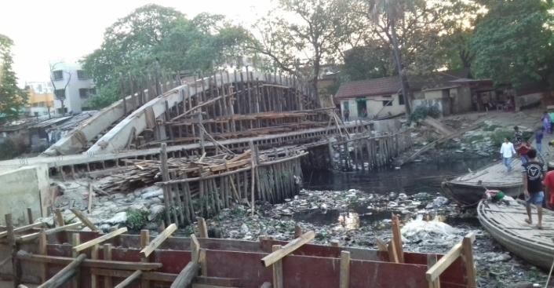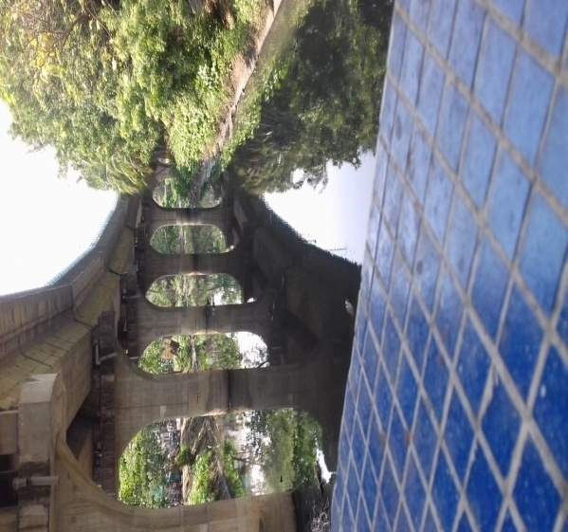 (a) (b) (c)
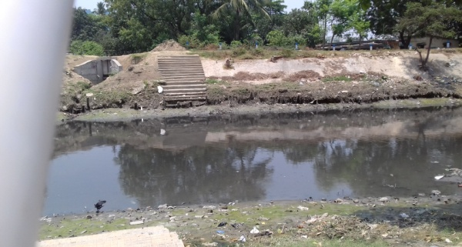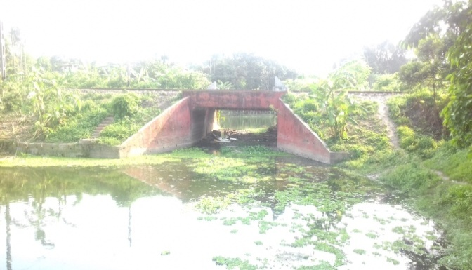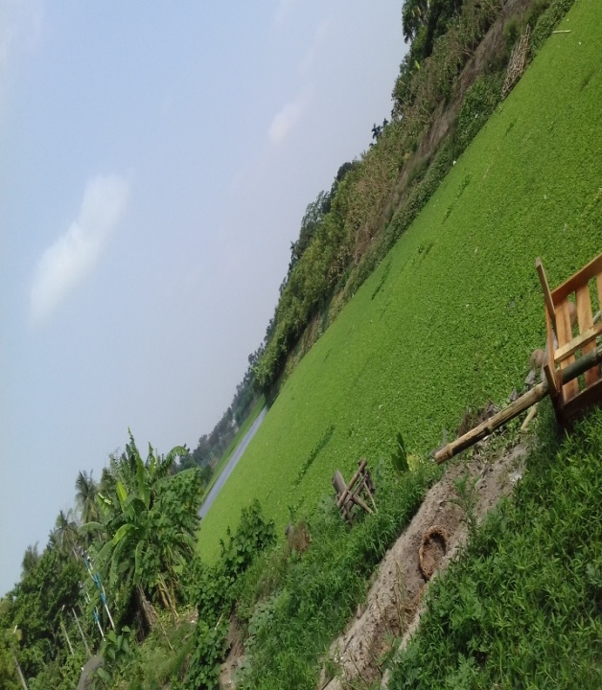
(d) (e) (f)
Figure 9. Some evidence indicates the reasons for the decay of the Adi Ganga. (a) Unplanned drainage system at Bhawani Bhaban Ghat; (b) Waste materials and bridge construction at Kalighat; (c) Metro railway pillar construction on Adi Ganga at near Kudghat; (d) Waste disposal at Om Bolorambasu Ghat; (e) Railway bridge at Baruipur where water depth very low; (f) Baruipur Ghat polluted by Eutrophication

3.4. Ecological Effects of Degradation of Adi Ganga to the Ecosystem of the Basin

The ecological impact of the degradation of the Adi Ganga stretches far beyond the aspect of water quality and sedimentation and basically impacts the biodiversity, hydrological equilibrium of the basin, as well as its socio-economic system. The associated decrease in luggage and rise in the quantity of pollutants has produced hypoxic conditions affecting aquatic biodiversity considerably, entailing a reduction in the population of fish species, on which local fishing communities depend (Ghosh et al., 2022). The death of aquatic life interferes with the occurrence of trophic interactions and ecological dynamics of the riverine system. The natural regime of flow disturbance caused by sediment deposition and infilling of infrastructural intrusions, including the presence of metro pillars, bridge construction, and other structures, decimates the hydrodynamic conditions of wetlands as well as groundwater replenishment capacity (Mandal, 2018a). As the level of connectivity between the river and the surrounding floodplains erodes, the basin flood-buffering also becomes less effective, contributing to flood hazards during monsoonal floods. The vegetation that covers the river banks also suffers due to the effects of the contaminated runoffs and invasions into the habitats, therefore, fragmenting the habitat and degrading the ecosystem services such as erosion control, microclimate regulation, and nutrient cycling (Rudra, 2018). In addition to that, the deterioration enhances the urban heat island effect as the natural sources of water and green areas are substituted by impermeable surfaces and contaminated channels. The sustained effect of these degradations on the environment is a great danger to the overall ecological sustainability of the whole Adi Ganga basin. Unless integrated watershed management and restoration strategies are implemented, the ecosystem remains at risk of undergoing irreparable damage and losing its ecological integrity and human well-being regionally (Basu, 2016; Water Rangers, 2024).

4. Conclusion

After a detailed survey on Adi Ganga was decayed due to indulgence of human activity, dumping of domestic waste, and Untreated industrial effluents from countless tanneries, chemical plants, textile mills, distilleries, slaughterhouses, and hospitals contributed to the pollution of the Adi Ganga and sedimentation is the major factor for the decay of Adi ganga. At present, Tolly Nullah (Adi Ganga) has lost its depth due to siltation, tidal influence, and other solid waste dumping. The natural flushing process of the Adi Ganga was impacted by the disruption of the tidal flow caused by dams and embankments on the channel. The water quality of the Adi Ganga is deteriorated by the direct dumping of untreated sewage from nearby residential areas. Chemicals and heavy metals from industry are frequently dumped into the canal, poisoning it and destroying its natural ecosystem. Throwing religious offerings in the canal is a practice that adds to pollution, especially near temples like Kalighat. Therefore, it is our responsibility to stop pollution and unwanted alteration of rivers. Ganga Action Plan (GAP) has already taken the task of stopping pollution on the Adi Ganga channel. Calcutta High Court, since 2012, has expressed concern over the growing pollution of the sacred river Adi Ganga after the West Bengal Pollution Control Board submitted a report of its survey on the narrow river winding its way in the south-easterly direction past Kalighat and flowing into the Bay of Bengal. The National Green Tribunal and High Court have instructed the Kolkata Municipal Corporation (KMC) to remove latrines, khatals, and piggeries from the banks of the Adi Ganga, and remove all solid waste and other materials obstructing the flow of Adi Ganga. Presently, the Government is seeking funds from the World Bank to renovate the ghats and restore the sacred channel.
Major Findings:
- The high amount of sediment deposition was found in Adi Ganga channel.
- Low water depth of the channel.
- Low water discharge in the channel.
- Very low water velocity in the channel.
- Waste materials, daily garbage and unplanned drainage system.
- The channel gradient decreases with increasing distance toward the downstream.
- Tidal influence decreases downstream.
- The water quality of the Adi Ganga is poor based on DO, Turbidity, pH and BOD.
- Channel flow is hindered by waste materials and railway pillar construction and newly bridge construction of the Adi Ganga channel.
Management Aspect
- After the detailed investigation of the Adi Ganga in Kolkata and Baruipur (24pgs) the whole river basin will get polluted and die. So, maintaining of sustainable development is essential in the river.
- Throwing garbage, waste materials, harmful chemicals fertilizers, oils paints, and detergents in the channel should be stopped.
- The water of the Adi Ganga channel should not be used for washing & bathing purposes.
- Binding of channel bank should be done and afforestation should be raised along two sides of the channel.
- Construction of Illegal settlement colonies on channel banks should be restricted.
- Remove all illegal settlements along the bank of Adi Ganga.
- No factory should not be allowed to drain out into the channel Adi Ganga without proper treatment.
- To drain out the polluted water of Kolkata, underground pipelines should be constructed.
- Where bank erosion is severe, the bank should be protected either by the vegetative method or the engineering method.
- To protect the channel proper dazing operation should be done by the local authority.

Disclaimer (Artificial intelligence)
Author(s) hereby declare that NO generative AI technologies such as Large Language Models (ChatGPT, manuscript.

References

Bandyopadhyay, S. (1996). Location of the Adi Ganga palaeochannel, South 24 Parganas, West Bengal: A review. Zenodo (CERN European Organization for Nuclear Research). https://doi.org/10.5281/zenodo.7264130
Basu, J. (2016, September 19). Adi Ganga disappears in West Bengal. Dialogue Earth. https://dialogue.earth/en/pollution/adi-ganga-disappears/
Charlton, R. (2007). Fundamentals of fluvial geomorphology. In Fundamentals of Fluvial Geomorphology. https://doi.org/10.4324/9780203371084
Das, G. (2023). River Systems of West Bengal -A Review. Indian Science Cruiser, 37, 11–24. https://doi.org/10.24906/isc/2023/v37/i2/223481
Dey, S. (2021). GetBengal. Get Bengal. https://www.getbengal.com/details/story-of-the-vanishing-rivers-saraswati-and-adi-ganga-of-bengal
Dey, S. (2021). Story of the vanishing rivers – Saraswati and Adi Ganga of Bengal. Get Bengal. https://www.getbengal.com/details/story-of-the-vanishing-rivers-saraswati-and-adi-ganga-of-bengal
Dey, S. K., & Panigrahi, A. K. (2022). Ichthyo-Diversity in different rivers of West Bengal, India: Status and conservation strategy. International Journal of Fisheries and Aquatic Studies, 10(1), 119. https://doi.org/10.22271/fish.2022.v10.i1b.2630
Ghosh, P., Paul, A., & Panigrahi, A. K. (2022). An Overview on Fish Assemblages in Riverine Systems of Southern Bengal, West Bengal, India: Diversity, Distribution and Potential Threats. Applied Ecology and Environmental Sciences, 10(7), Article 7. https://doi.org/10.12691/aees-10-7-5
Ivermee, R. (2017). The Hooghly River: A Sacred and Secular Waterway. Association for Asian Studies. https://www.asianstudies.org/publications/eaa/archives/the-hooghly-river-a-sacred-and-secular-waterway/
Laha, C. (2015). Oscillation of meandering Bhagirathi on the alluvial flood plain of Bengal Basin, India; as controlled by the Palaeo-geomorphic architecture. International Journal of Geomatics and Geosciences, 5, 564–572.
Mandal, A. (2018a). Changing Fluvio-dynamic Scenario of the Adi Ganga River, Kolkata, West Bengal, India. Journal of Geography, Environment and Earth Science International, 17(3), 1–14. https://doi.org/10.9734/JGEESI/2018/43731
Mandal, A. (2018b). Myth and Reality of The Adi Ganga: A Paleodistributary Of the Ganges in West Bengal, India. 5, 1347–1353.
Mukherjee, J. (2016). The Adi Ganga. https://www.epw.in/journal/2016/8/reports-states/adi-ganga.html
Mukherjee, J. (2016). The Adi Ganga. https://www.epw.in/journal/2016/8/reports-states/adi-ganga.html
Rudra, K. (2018). The Bhagirathi-Hugli River System. In K. Rudra, Rivers of the Ganga-Brahmaputra-Meghna Delta (pp. 77–93). Springer International Publishing. https://doi.org/10.1007/978-3-319-76544-0_6
Sharma, R., Kumar, A., Singh, N., & Sharma, K. (2021). Impact of seasonal variation on water quality of Hindon River: physicochemical and biological analysis. SN Applied Sciences, 3(1). https://doi.org/10.1007/s42452-020-03986-3
Sharma, S. (2020). Behavioral study of urban watersheds in Bhopal-city of lakes. International Journal of Hydrology, 4(3), 111. https://doi.org/10.15406/ijh.2020.04.00234
Sigdel, R., Carlton, G., & Gautam, B. (2023). Resolving the Ganges pollution paradox: A policy‐centric systematic review. River, 2(1), 126. https://doi.org/10.1002/rvr2.35
Tian, W., & Huang, Y. (2020). Landscape Restoration Design of Guilin Lijiang River Basin Based on” City Betterment and Ecological Restoration”. E3S Web of Conferences, 194, 5033. https://doi.org/10.1051/e3sconf/202019405033
Wantzen, K. M., Alves, C. B. M., Badiane, S. D., Bala, R., Blettler, M. C. M., Callisto, M., Cao, Y., Kolb, M., Kondolf, G. M., Leite, M., Macedo, D. R., Mahdi, O., Neves, M., Peralta, E. M., Rotgé, V., Rueda‐Delgado, G., Scharager, A., Serra‐Llobet, A., Yengué, J.-L., & Zingraff‐Hamed, A. (2019). Urban Stream and Wetland Restoration in the Global South—A DPSIR Analysis. Sustainability, 11(18), 4975. https://doi.org/10.3390/su11184975
Water Rangers. (2024, July 10). Dissolved oxygen - Water Rangers. https://waterrangers.com/testkits/tests/dissolved-oxygen/?srsltid=AfmBOopOOZZgZZwgM4fydXpzg2gs10pgMPExBQUETBSQRiQtf3g7IIMg&v=13b5bfe96f3e

Appendix
Table 3: People's Perception of Pollution Sources in Adi Ganga
Source | Percentage | Samples  (out of 50)
Factories | 12% | 6
Municipalities | 24% | 12
Drainage | 40% | 20
Domestic | 14% | 7
Agriculture | 0% | 0
Others | 10% | 5
Total | 100% | 50

pH is measured on a scale of 0 to 14, where a low pH is acidic and a high pH is more basic. The lower the value, the more acidic the water (below 7), and this can be detrimental to aquatic life.
Dissolved Oxygen (DO) is the name given to the amount of oxygen that is dissolved in water and the aquatic life needs that. The low DO levels, which are below 2 mg/L, are signals of hypoxic conditions.
Biological Oxygen Demand (BOD) refers to the oxygen consumption of microorganisms in order to break down organic material in water, and the higher the value, the more pollution a sample has.

