MAPPING URBANIZATION INTENSITY AND DIRECTIONAL GROWTH IN KOZHIKODE, INDIA: A 30-YEAR SPATIO-TEMPORAL STUDY

.

ABSTRACT

|  |
| --- |
| Rapid urbanization in coastal Indian cities poses significant challenges for sustainable land use and infrastructure planning. Kozhikode, also known as Calicut, located along the southwest coast of India, is among the fastest-growing urban areas in the country. This study aims to analyze the spatial and temporal dynamics of urban expansion in Kozhikode and its suburbs over a 30-year period from 1993 to 2023, highlighting the need for sustainable urban planning in rapidly developing coastal cities. Landsat satellite imagery for the years 1993, 2003, 2013, and 2023 was processed to extract urban built-up areas, comprising high-density residential and newly developed zones. Aeolotropic Buffer Gradient Analysis (BGA) was performed using ArcGIS to identify directional trends in urban growth. Urbanization Proportional Index (UPI) and Urbanization Intensity Index (UII) were used to quantify the magnitude and rate of urban expansion. The results reveal a clear spatial shift in urban growth, with significant expansion towards the North-Northeast (NNE), East-Northeast (ENE), and East-Southeast (ESE) directions. Built-up areas have intensified particularly along the recently widened National Highway corridor. The Kozhikode urban agglomeration now stretches from Elathur in the north to Ramanattukara in the southeast and Kunnamangalam in the northeast. These findings provide essential inputs for policymakers, planners, and urban managers to develop informed strategies for balanced and sustainable urban development in rapidly urbanizing coastal regions. |

*Keywords:* *Urbanization intensity; Buffer gradient; Spatial Aeolotropy; Urbanization Intensity Index; Urbanization Proportional Index*

1. INTRODUCTION

Urbanization has become a defining phenomenon of the 21st century, significantly transforming landscapes, ecosystems, and socio-economic structures across the globe. The expansion of urban areas often occurs at the expense of natural environments, resulting in fragmented landscapes, altered hydrological patterns, loss of biodiversity, and increased vulnerability to environmental hazards such as flooding and heat waves (Ben Messaoud et al., 2024; Ramachandra et al., 2014). Understanding the **spatial and temporal dynamics of urban growth** is therefore essential for effective planning and sustainable development, especially in ecologically sensitive and rapidly urbanizing regions. Despite a growing body of research on urban expansion in India's metropolitan areas, there remains a lack of detailed, spatially explicit studies focusing on **medium-sized coastal cities** that are experiencing unplanned urban sprawl. **Xiao et al. (2021)** demonstrated the relevance of geospatial indices, particularly the Urbanization Intensity Index (UII), in effectively quantifying urban growth and how integrated metrics derived from built-up areas, population density, and nighttime light data can monitor spatial and temporal patterns of urbanization for sustainable urban planning. **Haldar et al. (2024)** employed an integrative approach combining spatial metrics, statistical modeling, and predictive simulations to highlight the peri-urban expansion.

Kozhikode is the third-largest city in Kerala and plays a vital role in the region’s economy, culture, and trade. Reports by the **UN-Habitat and the Lincoln Institute of Land Policy** identify Kozhikode as **India’s fastest-growing urban area,** while the **Economist Intelligence Unit (2020)** ranks it as the fourth fastest-growing city in the world (Navaneeth et al., 2021; Nishara et al., 2021). The city located along the southwest coast and intersected by rivers, canals, and wetlands, is highly vulnerable to ecological degradation due to unregulated development. This study addresses that gap by focusing on **Kozhikode,** a historically significant coastal city in Kerala, India. Kozhikode presents a unique case for urban studies due to its **complex rural-urban continuum,** high population density, rapid land-use change, and **ecological sensitivity**. Unlike many other cities in Kerala where urban growth is gradual, Kozhikode has experienced a **rapid and spatially uneven expansion,** driven by a real estate boom, infrastructure development, and intra-state migration. However, this rapid growth is not accompanied by adequate spatial planning or environmental safeguards, posing serious challenges to sustainable urban management. In this context, **the present study aims to analyze the patterns, intensity, and direction of urban expansion in Kozhikode and its suburbs using geospatial techniques.** Specifically, it employs remote sensing (RS) and geographic information system (GIS) tools, combined with buffer gradient analysis and spatial indices such as the **Urbanization Intensity Index (UII)** and **Urbanization Proportional Index (UPI)**, to quantify and map urban growth over time. This study seeks to fill the gap in spatio-temporal urban analysis by examining the pattern, intensity, and direction of urban expansion in Kozhikode. Specifically, it aims to analyze land use and land cover (LULC) changes over time and to quantify urban growth intensity using geospatial indices. Landsat data for the years 1993,2003,2013 and 2023 were integrated with GIS-based buffer gradient analysis and urbanization indices (UII and UPI) provides a robust framework for evaluating the pace and direction of urban expansion. The years **1993, 2003, 2013, and 2023** were strategically selected to examine urban expansion in Kozhikode, offering a comprehensive decadal analysis over a 30-year period. Each year holds contextual significance; **1993** serves as a baseline shortly after India’s economic liberalization, marking the onset of new urban growth dynamics; **2003** reflects the impact of the 74th Constitutional Amendment, with urban local bodies gaining a stronger role in planning and peri-urban development becoming more pronounced; **2013** captures the momentum of infrastructure-led expansion under missions like JNNURM and the integration of geospatial tools in urban governance; and **2023** offers insights into current urbanization trends shaped by smart city initiatives, post-pandemic transformations, and evolving migration patterns. This sequence thus provides a well-structured framework to analyze spatial and policy-driven shifts in Kozhikode’s urban landscape. By focusing on Kozhikode, a rapidly growing coastal city, the study contributes to the broader discourse on urban growth patterns in environmentally sensitive regions. The findings offer valuable insights for understanding urban dynamics in coastal cities and supports evidence-based planning for sustainable urban development.

2. methodology

#### 2.1 Image Pre-processing and Classification

This study utilized **multi-temporal Landsat satellite images** from the USGS Earth Explorer for four representative years: **1993, 2003, 2013, and 2023**. All images were selected to have minimal cloud cover and consistent seasonal conditions to reduce temporal variability. The images, with a **30-meter spatial resolution** and seven spectral bands, were processed using **ERDAS IMAGINE** software. Image pre-processing included **geometric correction** and radiometric correction. **Supervised classification** using the **Maximum Likelihood Classification (MLC)** algorithm was applied to classify the image.. This method was selected for its statistical robustness in estimating the likelihood of a pixel belonging to a land cover class based on the spectral signature. Five major **Land Use/Land Cover (LULC)** classes were identified: Built-up land, Mixed crops, Barren land, Paddy wetlands, and wetlands other than paddy wetland. The urban built-up category, which includes high-density residential areas and newly developed zones, was extracted for further analysis.

#### 2.2 Accuracy Assessment of LULC Classification

To evaluate the reliability of the classified, an **error matrix** was generated using stratified random sampling and ground truth reference points (from Google Earth imagery and field data). **Accuracy metrics** including **Overall Accuracy**, **Producer’s Accuracy**, **User’s Accuracy**, and the **Kappa Coefficient** were calculated. Omission and commission errors were also analyzed to assess the quality of classification and minimize misclassification among land cover types.

#### 2.3 Urbanization Indices

**Urbanization Proportional Index (UPI)** and the **Urbanization Intensity Index (UII)**, are the two spatial indices employed to quantify and compare urban expansion over time and space. The indices are defined as follows Liu (2000):

UPIi, t~t+n= (ULAi, t+n - ULAi,t) *100/ TLAi

UIIi,t~t+n = [( ULAi,t+n - ULAi,t) /n] *100/ TLAi

*Where*

UPIi, t~t+n= indices of the proportion of urbanization within a spatial unit *i* during a time period *t~t+n*

UIIi,t~t+n = intensity of urbanization within a spatial unit *i* during a time period *t~t+n*

ULAi, t+n = urban land-use for years *t+n*

ULAi,t = urban land-use for years *t*

TLAi = total area of the spatial unit *i*

The **UPI** expresses the **magnitude** and **spatial expansion** of urban area over the study period, whereas the **UII** captures the **annual rate** or **intensity** of change. Both metrics are necessary to assess not only how much land was urbanized, but also how rapidly the transformation occurred.

#### 2.5 Buffer Gradient and Directional (Aeolotropic) Analysis

To understand the **spatial dynamics** and **directionality** of urban expansion, **GIS-based buffer gradient analysis** was employed using **ArcGIS** software. Two complementary buffer systems were developed. **Concentric Buffer Zones** having multiple circular buffers with a radius of **2 km intervals** were generated around the urban core (1993 urban extent) to capture distance-based variations in urban expansion. **Aeolotropic Buffer Analysis** developed to assess **directional urban growth**. Each circular buffer zone was divided into **eight angular sectors** based on compass orientation (Table 1)

**Table 1. Angular Direction based on compass orientation**

|  |  |
| --- | --- |
| Direction | Angular range |
| North-Northeast (NNE) | 0º to 45º |
| East-Northeast (ENE) | 45º to 90º |
| East-Southeast (ESE) | 90º to 135º |
| South-Southeast (SSE) | 135º to 180º |
| South-Southwest (SSW) | 180º to 225º |
| West-Southwest (WSW) | 225º to 270º |
| West-Northwest (WNW | 270º to 315º |
| North-Northwest (NNW) | 315º to 360º |

Source: Compiled by Researcher

This approach offered the identification of **spatial heterogeneity** and **preferred directions of urban expansion**, capturing the influence of natural barriers, transportation networks, and economic drivers on the growth pattern. For each buffer zone and directional segment, **UPI** and **UII** were calculated to map and quantify urban growth both **radially** and **directionally** over the periods 1993–2003, 2003–2013, and 2013–2023.

**3. STUDY AREA**

Kozhikode is a bustling city situated along the Malabar Coastin Kerala, India. The study area comprises Kozhikode Corporation, Feroke and Ramanattukara municipalities, Kadalundi, Olavanna, Perumanna, Peruvayal, Mavoor, Kunnamangalam, Kuruvattur,Kakkodi, Chelannur, Thalakkulathur, Atholi, and Chemanchery panchayaths and lies between the coordinates 11˚7’24” N - 11˚26’26” N latitude and 75˚ 42’35” E-75˚ 58’15”E longitude. The area chosen for the study includes major urban clusters and peripheral areas with low to high degree of urbanization. Kozhikode city has grown on marshy tract, reached to its present magnificence by filling the wetlands. Location of the study area is given in figure 1.

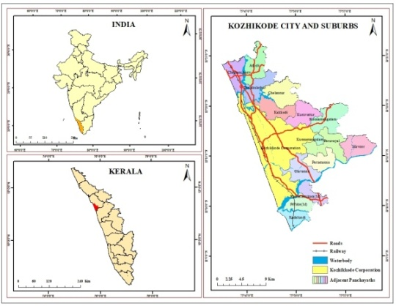

Figure 1. Location of the study area

4. RESULT AND DISCUSSION

4.1 Land USE LAND COVER IN KOZHIKODE CITY AND SUBURBS DURING 1993-2023

Understanding changes in land use and land cover (LULC) patterns is crucial for assessing and mapping the expansion of built-up areas. Land use and Land Cover map of the study for the years 1993,2003, 2013 and 2023 was prepared using Landsat images. The study area was categorized into five LULC classes- built up; mixed crops; barren land; paddy wetlands and wetlands other than paddy wetlands. Residential, commercial, institutional, and industrial buildings as well as transportation related infrastructure are considered as built-up land. Mixed crops include mixture of trees and crops planted in home gardens and commercial plantations in the midlands and lowlands. Land that is underutilized and degraded as a result of poor management is barren land. Lowland ideal for rice cultivation comes under paddy wetlands. Wetlands other than paddy wetlands include rivers or streams, canals, reservoirs, lakes and ponds, waterlogged areas, mangroves and estuaries. The LULC results are mapped and the spatial expansion of each LULC class for the year 1993, 2003, 2013 and 2023 has been represented in figure 1. Accuracy of the classified LULC maps assessed using error metrics.

In the year 1993, built up land covered an area 1203.88 hectares and shared only 3.34 % of the study area. Area under barren land was 292.43 (0.81%), mixed crops were 25695.95 ha (71.21%), paddy wetlands were 6742.56 ha (18.69%) and wetlands other than paddy wetlands were 2148.78 ha (5.96 %). In the year 2003, area under built up, barren land, mixed crops , paddy wetlands and wetlands other than paddy wetlands was 3997.71 ha (11.07 %), 222.01 ha (0.62 %), 23089.89ha (63.99%), 6612.99ha (18.33%) and 2166.00 ha (6.00 %) respectively. In the year 2013, area under built up was 5535.61ha (15.34%) and barren land was 225.26ha (0.62%). Mixed crops covered 62.02 % of study area with an area of 22379.47hectares, whereas paddy wetlands and wetlands other than paddy wetlands covered an area of 5832.18ha (16.16%) and 2111.08ha (5.85%) respectively. In the year 2023 built up area encompassed 35.75 % of study area with an area of 12901.61 hectares. Area under mixed crops was 15317.96 (42.45%). Barren land occupied only 0.21 % of the study area with an area of 76.46 hectares. 15.77 % of the study area was occupied by paddy wetlands with an area of 5691.76 hectares. Wetlands other than paddy wetlands covered an area of 2095.81 hectares, which is about 5.81% of the total area. Table 2 shows area under different LULC class for the year 1993, 2003, 2013 and 2023.

**Table 2. LULC of Kozhikode City and its suburbs 1993-2023**

|  |  |  |  |  |  |  |  |  |
| --- | --- | --- | --- | --- | --- | --- | --- | --- |
| LULC CLASS | 1993 | | 2003 | | 2013 | | 2023 | |
| Area (Ha) | Area (%) | Area (Ha) | Area (%) | Area (Ha) | Area (%) | Area (Ha) | Area (%) |
|
| Built up land | 1203.88 | 3.34 | 3992.71 | 11.07 | 5535.61 | 15.34 | 12901.61 | 35.75 |
| Barren land | 292.43 | 0.81 | 222.01 | 0.62 | 225.26 | 0.62 | 76.46 | 0.21 |
| Mixed crops | 25695.95 | 71.21 | 23089.89 | 63.99 | 22379.47 | 62.02 | 15317.96 | 42.45 |
| Paddy wetland | 6742.56 | 18.69 | 6612.99 | 18.33 | 5832.18 | 16.16 | 5691.76 | 15.77 |
| Wetlands other than paddy wetland | 2148.78 | 5.96 | 2166.00 | 6.00 | 2111.08 | 5.85 | 2095.81 | 5.81 |
| Total | 36083.60 | 100.00 | 36083.60 | 100.00 | 36083.60 | 100.00 | 36083.60 | 100 |

Source: Compiled by Researcher

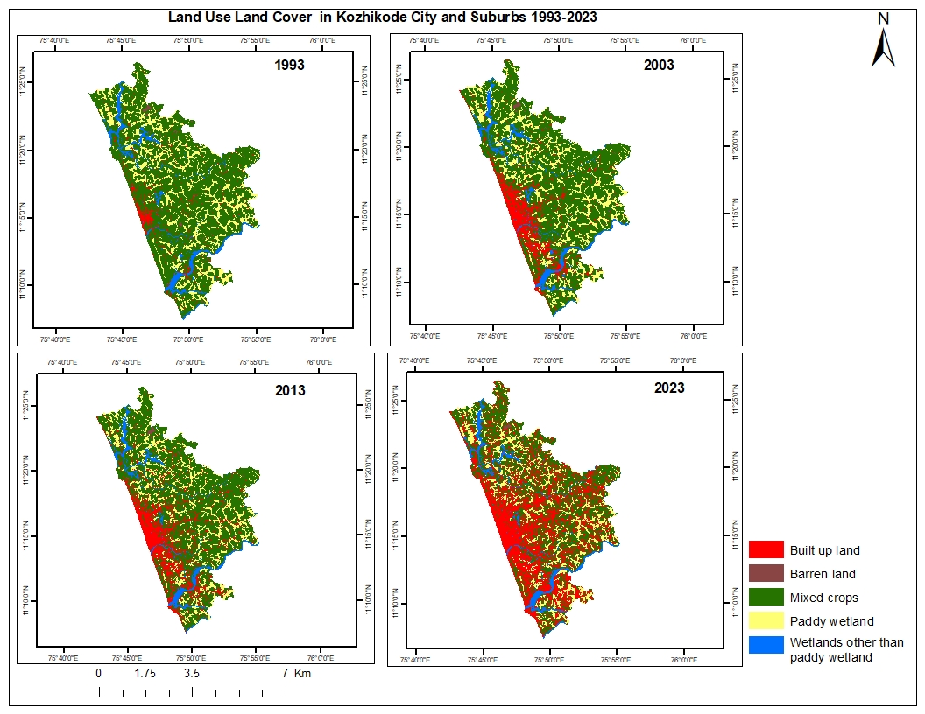

Figure 2. Land use Land cover in Kozhikode City and suburbs

The overall accuracy of LULC classification was found to be 96.67% and the Kappa Co-efficient was 0.94 which indicates that the accuracy of LULC assessment is acceptable. The accuracy assessment was carried out by taking 210 sample points randomly. 52 samples for built up; 44 samples for mixed crops; 41 samples for barren land; 43 samples for paddy wetlands and 30 for wetlands other than paddy wetlands were taken. The researcher has visited all the selected sample area for ground truthing. The ground truth was verified using Google Earth, Survey of India Toposheet and field survey. Satellite images of 1993, 2003 and 2013 were mostly verified using Google Earth and Survey of India Toposheet. Classified image for the year 2023 is validated with field verification. Sample points of latitude and longitude transferred to hand held GPS for field verification. Then, the Error Matrix and Kappa Co-efficient were generated for assessing the accuracy of classified images with ground verification. The error matrix or confusion matrix signifies the classified and actual result in table format. Classified LU/LC is placed in rows and ground verified samples are placed in columns. Cohen’s Kappa Coefficient is also widely accepted method for the classified LU/LC accuracy assessment by many researchers (Sanjoy Roy et al., 2015 and Arumugam et al, 2021). Kappa Co-efficient computes degree of agreement between two variables that measure the same land use. The result is less than or equal to one with the values near to one represents the perfect agreement and near to zero represents the worst agreement. Error matrix of LULC accuracy assessment is given in table 3.

**Table 3: Accuracy Assessment of LULC**

|  |  |  |  |  |  |  |  |
| --- | --- | --- | --- | --- | --- | --- | --- |
| LULC | Built up | Mixed Crops | Barren land | Paddy wetlands | Wetlands other than paddy wetlands | Total  (User) | User accuracy |
| Built up | 50 | 1 | 0 | 1 | 0 | 52 | 96.15 |
| Mixed Crops | 2 | 42 | 0 | 0 | 0 | 44 | 95.45 |
| Barren land | 1 | 0 | 40 | 0 | 0 | 41 | 97.56 |
| Paddy wetlands | 1 | 0 | 0 | 42 | 0 | 43 | 97.67 |
| Wetlands other than paddy wetlands | 0 | 0 | 1 | 0 | 29 | 30 | 96.67 |
| Total (Producer) | 54 | 43 | 41 | 43 | 29 | 210 |  |
| Producer Accuracy | 92.59 | 97.67 | 97.56 | 97.67 | 100 |  |  |
| Overall Accuracy = 96.67 | | | | | | | |
| Kappa Co-efficient =0.94 | | | | | | | |

Source: Computed by researcher

4.2 SPATIO TEMPORAL TRENDS OF URBANIZATION INTENSITY IN KOZHIKODE CITY AND SUBURBS DURING 1993-2023.

Kozhikode City, the administrative capital of Kozhikode district, has exhibited a clear outward urban expansion trend over the past few decades. Historically rooted in spice trade and colonial commerce, the city’s core anchored around Big Bazar, Palayam, SM Street, and Mananchira Square developed early into a dense Central Business District (CBD), marked by wholesale markets, commercial establishments, transport hubs, and administrative offices. This early development is reflected in the high Urbanization Intensity Index (UII) within the 0–2 km buffer during 1993–2003, signaling saturation and limited scope for further growth in the urban core. The buffer-based analysis from 1993 to 2023 indicates a declining UII trend from the core toward the periphery, confirming a centrifugal urbanization pattern. While the inner city continued modest expansion, the 2–4 km zone experienced intensified urban growth, driven by the emergence of submarkets and residential developments along corridors like MM Ali Road. Between 4–12 km, areas such as Kottooli wetlands, Palazhi, and Chevayur saw steady increases in built-up land due to greater land availability. After 2013, a significant shift occurred: UII declined in the saturated core, while peripheral zones (4–22 km) witnessed accelerated urban growth. Infrastructure projects such as NH 66 bypass and NH 766 played a vital role in channeling development towards northeastern, eastern, and southeastern parts of the city, including growth hotspots like Ramanattukara and Kunnamangalam. Institutions such as IIM Kozhikode, Cyberparks, and major hospitals further catalyzed suburban expansion. Even the outermost zones (18–22 km), though still less urbanized, have begun to show increasing UII values, suggesting potential for future growth driven by affordable land and improving connectivity. Overall, the city’s urban landscape is shaped by an outward redistribution of development intensity, transitioning from a saturated historic core to rapidly urbanizing peripheral corridors. Figure 3 and table 4 shows the UII of Kozhikode city during 1993 and 2023. Distribution of Built-up area in each buffer zone is depicted in Figure 4.

Figure 3. Changes in UII of Kozhikode City and suburbs 1993-2023

**Table 4. Changes in UII of Kozhikode City and Suburbs 1993-2023**

|  |  |  |  |  |  |  |  |  |  |
| --- | --- | --- | --- | --- | --- | --- | --- | --- | --- |
| BUFFER ZONE (KM) | 1993 | 2003 | 2013 | 2023 | Area (Ha) | Urbanization Intensity Index | | | |
| 1993-2003 | 2003-2013 | 2013-2023 | 1993-2023 |
| 2 | 355.83 | 736.84 | 773.35 | 795.74 | 848.68 | 4.49 | 0.43 | 0.26 | 1.73 |
| 4 | 103.89 | 1026.86 | 1141.01 | 1547.49 | 2104.25 | 4.39 | 0.54 | 1.93 | 2.29 |
| 6 | 92.57 | 657.98 | 954.44 | 1928.82 | 3352.46 | 1.69 | 0.88 | 2.91 | 1.83 |
| 8 | 67.63 | 427.86 | 632.95 | 1880.98 | 4607.73 | 0.78 | 0.45 | 2.71 | 1.31 |
| 10 | 85.23 | 364.9 | 560.89 | 1892.21 | 5938.02 | 0.47 | 0.33 | 2.24 | 1.01 |
| 12 | 62.05 | 197.79 | 441.07 | 1923.72 | 6704.5 | 0.20 | 0.36 | 2.21 | 0.93 |
| 14 | 35.43 | 98.46 | 284.1 | 1617.57 | 6172.81 | 0.10 | 0.30 | 2.16 | 0.85 |
| 16 | 12.22 | 41.23 | 100.08 | 874.64 | 3970.64 | 0.07 | 0.15 | 1.95 | 0.72 |
| 18 | 9 | 25.1 | 49.4 | 406.19 | 2730.49 | 0.06 | 0.09 | 1.31 | 0.48 |
| 20 | 11.63 | 18.02 | 35.53 | 237.93 | 1407.82 | 0.05 | 0.12 | 1.44 | 0.54 |
| 22 | 3.16 | 1.3 | 5.97 | 62.8 | 311.26 | -0.06 | 0.15 | 1.83 | 0.64 |

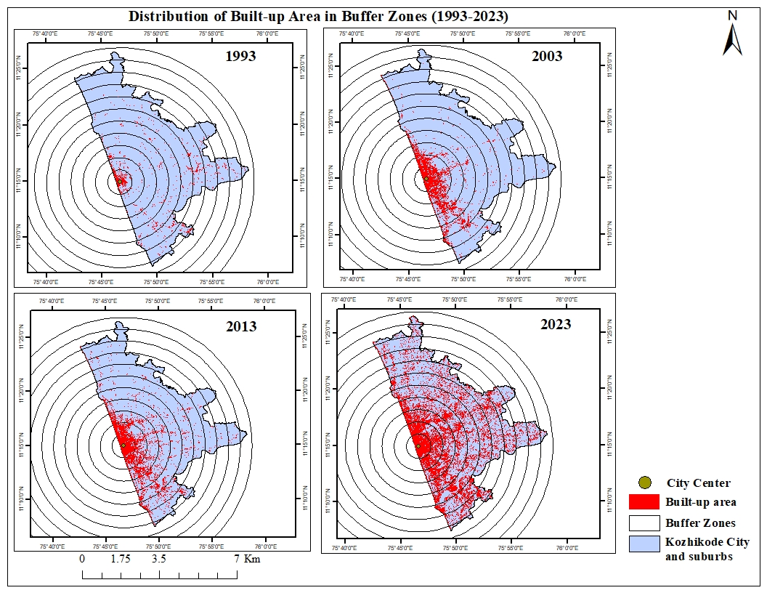

Figure 4. Distribution of built up areas in buffer zones

**4.2 SPATIAL AEOLOTROPY OF KOZHIKODE CITY –UII BASED ON BUFFER ANALYSIS DURING 1993-2023**

The spatial pattern of urban expansion in Kozhikode City between 1993 and 2023, analyzed using the Urbanization Intensity Index (UII) across directional buffer zones, reveals a clear aeolotropic (directionally varied) trend. During the period 1993–2003, urban growth was concentrated in the inner buffer zones (0–4 km), especially in the eastern and southern sectors. This indicates an early saturation of the core, where the Central Business District (CBD) had already developed around major commercial and administrative hubs. Expansion was most prominent in zones directly adjoining the core, particularly in the north-northeastern and southeastern directions, where improved connectivity and available land supported intensified development. In contrast, limited growth occurred in the western directions due to the coastal boundary, which restricts horizontal expansion. From 2003 to 2013, the UII curves continued to show low values at the core with increased intensities in adjacent buffer zones, reflecting gradual outward growth. Urbanization extended notably along major transportation corridors, particularly where national highways intersected, enhancing accessibility and stimulating built-up expansion. However, natural features like rivers and wetlands acted as barriers in certain directions, moderating development in those zones.

During the most recent period, 2013–2023, a noticeable shift occurred. UII values declined further at the center, confirming the saturation of the core, while peripheral zones (4–14 km) witnessed heightened urban intensification. This phase of development was largely infrastructure-driven, shaped by the expansion of arterial corridors such as NH 66, its bypass, and radial roads branching toward the northeast and southeast. These corridors catalyzed commercial, residential, and institutional growth, supporting the emergence of new urban nodes outside the traditional core. Suburban expansion was reinforced by the establishment of educational institutions, IT parks, and healthcare facilities, transforming previously peripheral areas into vibrant urban clusters.

The current spatial structure of Kozhikode reflects a radial-concentric pattern of development, with strong linear growth along major highways and transportation spines. While urban sprawl continues in the north, east, and south, expansion toward the west remains constrained by the Arabian Sea. The resulting urban form is increasingly defined by directional corridors, connecting the city core with outlying regions and fostering a decentralized yet interconnected urban landscape. The linear pattern of development along the road corridors has caused urban sprawl in the areas adjoining to the city and the areas stretches to Elathur in the north, Kunnamangalam in the east and Ramanattukara in the south. City cannot grow in the direction of WSW, WNW and NNW because of coastal limits. Figure 5 illustrates the distribution of built up area in eight directions. Figure 5 shows UII curve in each directions.

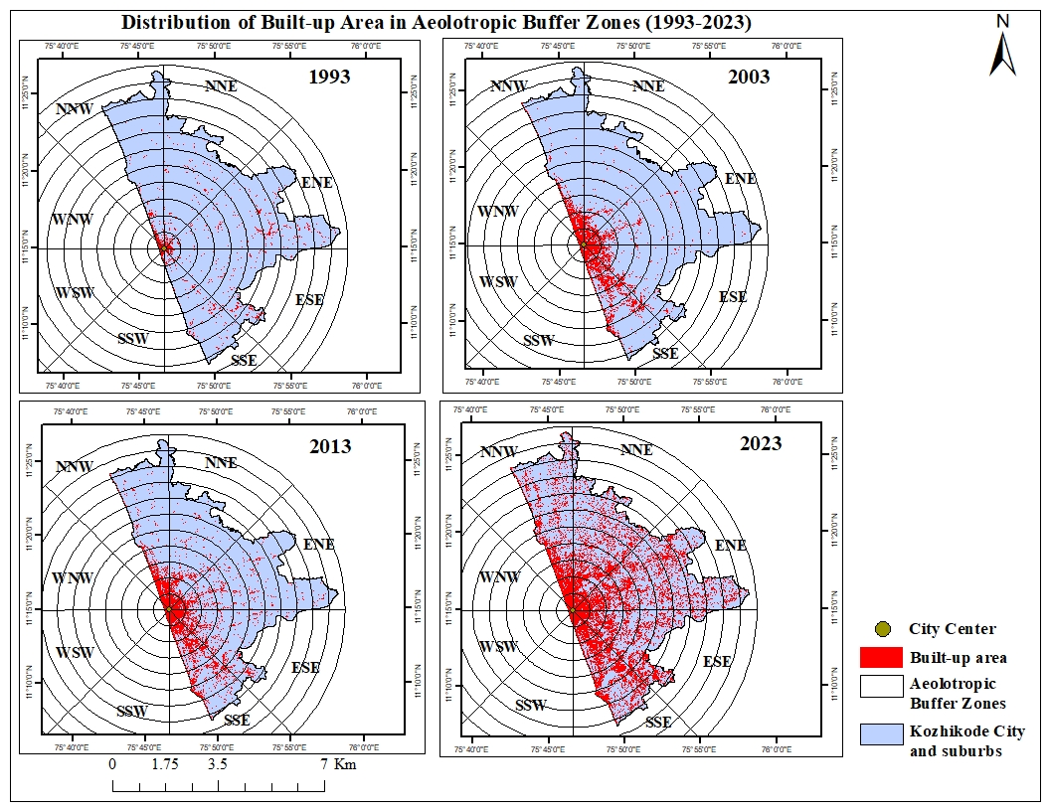

Figure 5. Distribution of built up area in eight directions

|  |  |
| --- | --- |
| (**a**) | (**b**) |
| (**c**) | (**d**)  (**f**) |
| **(e)** |
| **(g)** | **(h)** |

**Figure 6.** (**a**) Urbanization intensity in North Northeast direction; (**b**) Urbanization intensity in East Northeast direction; (**c**) Urbanization intensity in East Southeast direction; (**c**) Urbanization intensity in South Southeast direction; (**e**) Urbanization intensity in South Southwest direction; (**f**) Urbanization intensity in West Southwest direction; (**g**) Urbanization intensity in West Northwest direction; (**h**) Urbanization intensity in North Northwest direction.

**4.3 SPATIAL AEOLOTROPY OF URBANIZATION PROPORTIONATE INDEX (UPI) BASED ON BUFFER ANALYSIS DURING 1993- 2023**

The directional expansion of Kozhikode City from 1993 to 2023, assessed using the Urbanization Proportionate Index (UPI), reveals a distinct aeolotropic pattern of growth. During 1993–2003, urban expansion was most prominent in the SSE direction, largely influenced by port connectivity and railway-road intersections. In contrast, limited growth was observed in the western sectors (SSW, WSW, WNW) due to coastal constraints and in the outer directions due to the dominance of agricultural land and concentrated investment in the urban core. The central part of the city, anchored by commercial, institutional, and transportation hubs, saw high intensification during this period. urban expansion was strongly core-centric with significant growth concentrated in the southern directions, particularly SSE (22.07) and SSW (21.05), driven by the city's historical development and proximity to the coast. Moderate expansion also occurred laterally in directions like WNW (17.88) and WSW (13.40), indicating horizontal outward growth from the city center. In contrast, the northern and northeastern zones such as NNE (3.52) and ENE (3.34) exhibited minimal development, reflecting their early-stage peripheral nature. Between 2003 and 2013, urban development radiated further outward, particularly in the NNE, ENE, ESE, and SSE directions. This expansion aligned with major transportation corridors and areas with emerging commercial and institutional infrastructure. Roads running parallel to canals and bypasses facilitated new developments, while improved access to services and civic amenities further stimulated growth. The city’s extension in this period reflects the beginning of a shift from a core-centric model to a more distributed urban pattern. a notable decline in UPI values was observed in SSW, WSW, and WNW directions, where urban growth dropped to near zero, likely due to spatial saturation and geographic limitations, particularly coastal constraints. Growth activity shifted toward the city’s interior and northeastern sectors, with gradual increases in ESE (6.15), NNW (2.52), and NNE (3.09). Although SSE continued to grow (UPI 4.75), its pace significantly reduced compared to the previous decade, signaling a deceleration in southern urbanization.

In the decade from 2013 to 2023, urbanization intensified significantly in the northeastern and eastern sectors, driven by the development of key transportation infrastructure—especially the NH 66 and NH 766 corridors. These highways catalyzed suburban growth, encouraging the establishment of retail, healthcare, IT, and service-oriented enterprises. As a result, the urban core began to lose its primacy due to congestion and scarcity of vacant land, while peripheral zones became focal points for new investments and residential expansion. The northeastern corridor, in particular, witnessed strong urban momentum, boosted by institutional developments and improved connectivity. This period marked a major spatial reorientation of urban development. The highest UPI values were recorded in ENE (24.03), ESE (22.62), and NNE (22.48), indicating a pronounced outward expansion toward the northeastern and eastern fringes. This growth was strongly supported by major infrastructure projects such as NH 66 and NH 766, along with the establishment of key institutional and commercial hubs. NNW (17.51) also showed a significant increase in urbanization, reinforcing the trend of centrifugal growth away from the saturated core. Conversely, southern and western directions like SSW (0.24), WSW (2.59), and WNW (1.38) remained largely stagnant, confirming their limited potential for future development due to both environmental and spatial constraints. The spatial aeolotropy of UPI clearly demonstrates that urban growth in Kozhikode has followed a centrifugal trend, extending predominantly toward the northeast and east over the study period. Overall, Kozhikode’s urban form is evolving into a corridor-based structure, shaped by infrastructural drivers and real estate investments, especially in suburban zones beyond the traditional core. While analyzing the spatial aelotropy of UPI based on buffer gradient(Table 5 and Figure 7), it is clearly evident that Kozhikode city is expanding towards the outskirts in northeastern and eastern direction and city cannot grew into western direction because of coastal constraints. The three-decade analysis of Urbanization Proportionate Index (UPI) for Kozhikode City reveals a clear spatial and temporal shift in urban growth patterns. This can be summarized as follows:

### ****Core-Centric and Southern Expansion during 1993–2003:****

* The **SSE (22.07)** and **SSW (21.05)** directions recorded the **highest UPI values**, indicating intense urbanization toward the southern coastal areas.
* **WNW (17.88)** and **WSW (13.40)** also experienced moderate growth, suggesting lateral expansion from the city center.
* Urban growth was relatively **low in the northern and northeastern directions**, such as NNE (3.52) and ENE (3.34), indicating early-stage peripheral development.

### ****Shift Away from Coastal Zones during 2003–2013:****

* A **sharp decline** in UPI is seen in **SSW, WSW, and WNW**, with UPI dropping to **zero or near-zero**, indicating that these areas either reached saturation or faced development constraints (e.g., coastal limitations or lack of infrastructure).
* Urban growth shifted toward **ESE (6.15)**, **NNW (2.52)**, and **NNE (3.09)**—reflecting emerging development in interior and northeastern directions.
* The **SSE** direction still maintained moderate growth (4.75), but much lower than in the previous decade.

### ****Peripheral and Northeastern Urban Intensification during 2013–2023:****

* A major shift occurred as the **highest UPI values were recorded in ENE (24.03), ESE (22.62), and NNE (22.48)**. This reflects **accelerated urban expansion toward the northeastern and eastern peripheries**, largely driven by highway infrastructure (NH 66, NH 766) and institutional developments.
* **NNW (17.51)** also saw a significant increase, supporting the trend of outward centrifugal growth.
* **Southern and western sectors**, like **SSW (0.24)**, **WSW (2.59)**, and **WNW (1.38)**, remained largely stagnant, confirming their limited capacity for further urban expansion.

**Table 5. Urbanization Proportionate Index**

|  |  |  |  |
| --- | --- | --- | --- |
| **Direction** | **Urbanization Proportionate Index** | | |
| **1993-2003** | **2003-2013** | **2013-2023** |
| NNE | 3.52 | 3.09 | 22.48 |
| ENE | 3.34 | 2.39 | 24.03 |
| ESE | 8.24 | 6.15 | 22.62 |
| SSE | 22.07 | 4.75 | 19.88 |
| SSW | 21.05 | 0.00 | 0.24 |
| WSW | 13.40 | 0.00 | 2.59 |
| WNW | 17.88 | 0.00 | 1.38 |
| NNW | 6.55 | 2.52 | 17.51 |

Figure 7. Urbanization Proportionate Index of Kozhikode City

The results derived from the Urbanization Intensity Index (UII) and Urbanization Proportionate Index (UPI), based on buffer gradient analysis, clearly depict the evolving trends and pace of urbanization in Kozhikode City and its suburbs over three distinct phases: steady growth, rapid expansion, and diffusive development.

**Phase I: Steady Urban Growth (1993–2003)**  
During this initial phase, urbanization was primarily concentrated in the central business district (CBD) and its immediate surroundings. The intensity of urban growth diminished progressively with increasing distance from the city center. This phase was characterized by a compact and balanced development of infrastructure, anchored around wholesale markets, administrative functions, educational institutions, and healthcare facilities. The urban core functioned as the focal point, with a gradual but steady expansion of the built-up area radiating outward in a relatively contained manner.

**Phase II: Rapid Urban Growth (2003–2013)**

This period marked a significant acceleration in urban expansion, with the built-up area extending well beyond the traditional city core. Urbanization spread vigorously into the surrounding zones, transforming previously semi-urban or rural areas into emerging urban centers. The intensity of development increased notably, particularly in zones adjacent to the earlier urban core, driven by growing demand for housing, commercial spaces, and public infrastructure. This rapid growth phase witnessed a shift in urban activity toward the outer fringes, signaling the beginning of suburban transformation and spatial restructuring.

**Phase III: Diffusive Urban Growth (2013–2023)**

In the most recent phase, urban development has become increasingly dispersed, reaching into rural hinterlands and peri-urban zones. The city center, having reached saturation, now exerts less influence on the location of new development projects. Urban growth is characterized by the emergence of decentralized nodes and extensive suburbanization, with formerly rural areas being absorbed into the urban fabric. The expansion pattern has become more diffused and regionally integrated, leading to blurred boundaries between urban and suburban zones. While the extent of urbanized land continues to increase, the intensity of development has become less concentrated, reflecting a shift from compact growth to a more dispersed and networked urban form.

5. Conclusion

The spatial and temporal analysis of urbanization patterns in Kozhikode City from 1993 to 2023 reveals a marked transformation in the direction and intensity of urban growth. The study, employing the Urbanization Intensity Index (UII) and Urbanization Proportionate Index (UPI) through buffer and directional analysis, highlights a clear shift from core-centric and southern expansion in the early decades to peripheral, northeastern, and eastern intensification in the most recent period. The initial urban growth was concentrated in the southern and southwestern sectors, largely influenced by port activities, transport nodes, and central business functions. However, from 2003 onwards, these areas witnessed saturation or were constrained by coastal and ecological limitations, prompting a spatial redirection of development. The decade from 2013 to 2023 marks a significant phase of centrifugal urban expansion, particularly toward the ENE, ESE, and NNE directions. This transition is strongly associated with the development of major transportation corridors (NH 66 and NH 766), the establishment of institutional infrastructure, and increasing private and NRI investments in the suburban fringes. The findings underscore the growing spatial anisotropy of urban development, wherein infrastructure-led growth corridors dictate the directionality of expansion. These patterns call for targeted urban planning strategies that address the challenges of peripheral growth, infrastructure provisioning, and environmental sustainability, particularly in rapidly urbanizing zones beyond the historical core of Kozhikode City.

Competing interests

Authors have declared that no competing interests exist.

Authors’ Contributions

This work was carried out in collaboration among all authors. All authors read and approved the final manuscript.

ETHICAL STATEMENT

This study relied entirely on available satellite imagery and secondary data sources. Therefore, ethical approval and informed consent were not required. All data used in this research were obtained from open-access platforms and were handled in compliance with relevant institutional and publication ethical standards.

References

Bhagyanathan, A., & Dhayanithy, D. (2023). A canal, urban sprawl and wetland loss: The case of Kozhikode, India, from colonialism to climate change era. *Area*, *55*(3), 435–446. <https://doi.org/10.1111/area.12875>

DEPARTMENT OF TOWN AND COUNTRY PLANNING - GOVERNMENT OF KERALA, Poulose, C. J., State Project Cell for LDP-IDDP-SPP, Easow, J., Ushakumari, P. R., Baiju, K., & Mony, D. D. S. (2011). *DISTRICT URBANISATION REPORT KOZHIKODE*.

Grover, A., & Vadakkuveettil, A. (2023). Multi-temporal dynamics of land use land cover change and urban expansion in the tropical coastal district of Kozhikode. In *Springer eBooks* (pp. 57–68). <https://doi.org/10.1007/978-3-031-21587-2_4>.

Haldar, S., Chatterjee, U., Bhattacharya, S., Paul, S., Bindajam, A. A., Mallick, J., & Abdo, H. G. (2024). Peri-urban dynamics: Assessing expansion patterns and influencing factors. Ecological Processes, 13, Article 58. <https://doi.org/10.1186/s13717-024-00518-3>

Haldar, S., Mukhopadhyay, A., Bhattacharya, S., et al. (2023). Development potentiality of peri-urban region in India: A quantitative analysis on Durgapur Municipal Corporation (DMC). Future Urban Regions and Planning, 1, 15. <https://doi.org/10.1007/s44243-023-00021-y>

Khoirurrizqi, Y., Handayani, W., & Santosa, H. (2024). Effect of urban expansion intensity on urban ecological status utilizing remote sensing and GIS: A study of Semarang, Indonesia. International Journal of Remote Sensing and Geoinformatics, 6(1), 45–60. https://doi.org/10.1016/j.rsg.2024.02.005

Messaoud, K. B., Wang, Y., Jiang, P., Ma, Z., Hou, K., & Dai, F. (2024). Spatial-Temporal Dynamics of Urban Green Spaces in Response to Rapid Urbanization and Urban Expansion in Tunis between 2000 and 2020. *Land*, *13*(1), 98. <https://doi.org/10.3390/land13010098>

Nishara, V. P., Krishnan, V. S., & Firoz, C. M. (2021). Geo-Intelligence-Based Approach for Sustainable Development of Peri-Urban Areas: A case study of Kozhikode City, Kerala (India). Advances in geographical and environmental sciences (pp.35–52). <https://doi.org/10.1007/978-981-16-4768-0_3>

Rajendran, L. P., Leal, R., Chen, M., Andrade, J. C. G., Akhtar, R., Mngumi, L. E., Chander, S., Srinivas, S., Roy, M. R., et al. (2024). The ‘peri-urban turn’: A systems thinking approach for a paradigm shift in reconceptualising urban-rural futures in the global South. Habitat International, 146, 103041. <https://doi.org/10.1016/j.habitatint.2024.103041>

Ramachandra, T., Bharath, A., & Sowmyashree, M. (2014). Monitoring urbanization and its implications in a mega city from space: Spatio temporal patterns and its indicators. *Journal of Environmental Management*, *148*, 67–81. <https://doi.org/10.1016/j.jenvman.2014.02.015>

Salem, M., Ravetz, J., Sareen, S., Dong, T., Haque, M., Bayoumi, W., Tsurusaki, N., Xu, G., et al. (2025). Managing the urban-rural transition: A review of approaches and policies for peri-urban land use. Journal of Urban Management. <https://doi.org/10.1016/j.jum.2025.04.006>

Shenghe, L. (2000). A GIS based model of urban land use growth in Beijing. ACTA GEOGRAPHICA SINICA.

Shi, Z., Liu, M., Tian, G., & Kovács, K. F. (2024). Web of science-based literature review of peri-urban areas: a comparison between Europe and China. *European Journal of Remote Sensing*, *57*(1). <https://doi.org/10.1080/22797254.2024.2414475>