The Impact of Floating Net Cage Cultivation (FNC) On Primary Productivity in The Saguling Reservoir, West Java, Indonesia

.

ABSTRACT

|  |
| --- |
| This study aimed to analyze the impact of fish farming using floating net cage (FNC) system on primary productivity in Saguling Reservoir. Conducted between January and February 2025, the research utilized a comparative descriptive design at Saguling Reservoir, West Bandung Regency and in the Aquatic Resources Laboratory, Universitas Padjadjaran. Water sampling was performed at four stations based on varying levels of FNC activity to represent areas with and without aquaculture. The parameters measured included physical (temperature, transparency), chemical (pH, dissolved oxygen (DO), biochemical oxygen demand (BOD), carbon dioxide (CO2), nitrate, ammonia, phosphate), as well as biological factors. Primary productivity was assessed using the light and dark bottle oxygen method with sampling conducted four times with weekly intervals. The results revealed that the highest primary productivity value is 746,028 mgC/m3/day, was recorded at station 2, which is situated in an area with a high density of FNC (1.203 units), while the lowest value was observed at station 1, 225,216 mgC/m3/day located in the reservoir inlet without FNC. The results indicate that FNC activities contribute significantly to increased nutrient levels (N and P), promoting phytoplankton growth and photosynthesis, thereby increasing primary productivity. The presence and intensity of FNC aquaculture significantly affect the trophic status and primary productivity in Saguling Reservoir. Management strategies should be implemented to monitor and control the density of floating net cages to preserve the reservoir’s ecological balance. |

*Keywords: Floating net cage, primary productivity, water quality, nitrate, phosphate, eutrophication*

1. INTRODUCTION

Saguling Reservoir has an area of 5.600 ha (Astuti & Krismono, 2006), located in West Bandung Regency, Indonesia. Built primarily for hydroelectric power generation, the reservoir has expanded its role to support multiple purposes such as irrigation, flood control, domestic water supply, tourism and aquaculture. Among these, aquaculture using floating net cage (FNC) system has seen rapid growth due to its practicality and capacity to yield high fish production in relatively limited space.

However, the rapid increase in FNC installations has raised significant environmental concerns. The operation of FNC systems involves a continuous input of feed, not all of which is consumed by the fish. This residual feed, along with fecal matter and fish excretions, contributes to the accumulation of organic materials in the water. Over time, the microbial decomposition of this organic matter releases nutrients primarily nitrogen (N) and phosphorus (P) into the water column (Heriyanto *et al.* 2018). While these nutrients are essential for supporting phytoplankton growth, their excessive presence can lead to eutrophication, resulting in algal blooms, oxygen depletion and a decline in overall water quality (Agista *et al*. 2018)

Phytoplankton play a crucial role in aquatic ecosystems as primary producers, converting solar energy into chemical energy through photosynthesis (Aprianto *et al.* 2020). The rate of this photosynthetic process, known as primary productivity, serves as an indicator of the overall health and nutrient dynamic of the aquatic environment. Monitoring primary productivity offers valuable insights into trophic status and can act as an early warning system for anthropogenic stressors, such as overloading effects of aquaculture

In recent years, Saguling Reservoir has shown signs of increasing nutrient loads and shifts in trophic status (Mulyadi & Atmaja, 2011). Phenomena that are suspected to be linked to the high density of FNC in certain areas of the reservoir. Therefore, this study aims to investigate the influence of FNC aquaculture on primary productivity and water quality by comparing regions with varying levels of aquaculture intensity. The findings are anticipated to contribute to the development of sustainable aquaculture practices and inform ecological management strategies for long term preservation of Saguling Reservoir.

2. Research methods

**2.1 Time and Place of Research**

Sampling was conducted in Saguling Reservoir, West Bandung Regency, West Java, Indonesia. The field sampling was carried out over a period of four weeks from January to February 2025, during which weekly sampling was performed. Laboratory analyses were conducted at the Aquatic Resources Laboratory, Faculty of Fisheries and Marine Sciences, Universitas Padjadjaran.

**2.2 Sampling Stations and Depth**

The method used to determine sampling stations is to select locations based on specific considerations tailored to field conditions (Putrisia *et al.* 2022). The study was conducted at four sampling stations strategically selected to represent zones with varying levels of floating net cage (FNC) activity in Saguling Reservoir (Figure 1). The selection of the stations is:

* Station 1 was located at the reservoir’s inlet and characterized by the absence of aquaculture activities.
* Station 2, situated in the lacustrine (central) zone, had the highest density of FNC installations, total 1.203 cage units.
* Station 3 is also in the lacustrine zone but with moderate aquaculture intensity, had 672 cages.
* Station 4 was positioned at the outlet area, where no FNC were found, representing a downstream control site.

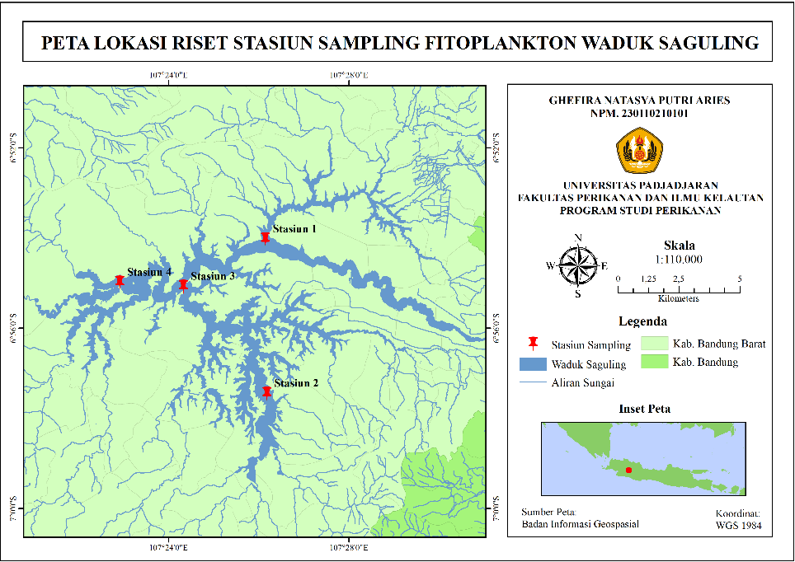

**Figure 1.** Location of Research Station

At each station, water samples were collected at three specific depths to capture vertical variation in water quality. These included the surface (0 – 0,5 meters), half compensation depth and compensation depth. These depth levels were chosen to assess how light availability, influenced by water transparency that affects primary productivity and related parameters in each zone.

**2.3 Parameters Measured and Data Analysis**

A comprehensive set of physical, chemical and biological water quality was measured during the research. Physical parameters included water temperature and water transparency, which was determined using a Secchi disk. These measurements helped evaluate light penetration and stratification patterns relevant to phytoplankton productivity.

Chemical parameters were assessed using both field and laboratory methods. Chemical parameters include pH, Dissolved Oxygen (DO) levels were determined using the Winkler method, Biochemical Oxygen Demand (BOD) was calculated based on the difference between initial DO and DO after a 5day incubation, Carbon Dioxide (CO2), and nutrient concentrations were also analyzed which is nitrate (NO3), Ammonia (NH3) and Phosphate (PO4). These nutrient parameters served as a key indicators of eutrophication potential and aquaculture impact.

Biological analysis focused on primary productivity, which was estimated using the light and dark bottle oxygen method. At each depth, four bottle were filled – two kept in the light and two in the dark measurement. The bottles were incubated directly at Saguling Reservoir for four hours. The tools, methods and observation locations used are presented in Table 1.

**Table 1.** Physical, Chemical and biology Parameters

|  |  |  |  |  |
| --- | --- | --- | --- | --- |
| **Parameter** | **Unit** | **Tool** | **Method** | **Location** |
| **1. Physical** | | | | |
| Temperature | °C | Thermometer | Potentiometric | Direct |
| Transparency | M | Secchi disk | Visual | Direct |
| **2. Chemical** | | | | |
| pH | - | pH meter | Potentiometric | Direct |
| CO2 | Mg/L | Erlenmeyer flask | Titrimetric | Direct |
| BOD | Mg/L | Winkler bottle | Titrimetric | Laboratory |
| DO | Mg/L | DO meter | Potentiometric | Direct |
| Nitrate | Mg/L | Spectrophotometric | Spectrophotometric | Laboratory |
| Ammonia | Mg/L | Spectrophotometric | Spectrophotometric | Laboratory |
| Phosphate | Mg/L | Spectrophotometric | Spectrophotometric | Laboratory |
| **3. Biology** | | | | |
| Primary Productivity | mgC/m3/day | Light and dark bottle | Potentiometric | Direct |

**2.4 Data Analysis**

The data obtained from field and laboratory measurements were analyzed to assess spatial and vertical variations in water quality and primary productivity across the four stations. Primary productivity values were interpreted using the trophic state classification proposed where values below 0-200 mgC/m3/day indicate oligotrophic conditions, values between 200-750 mgC/m3/day suggest mesotrophic conditions and values above 750 mgC/m3/day reflect eutrophic conditions (Sunaryo, 2017). Comparisons among stations were made to determine the influence of FNC aquaculture on the productivity and nutrient dynamics of the reservoir, providing a scientific basis for future management and conservation strategies.

3. results and discussion

**3.1 Primary Productivity**

The measurement of primary productivity across the four stations in Saguling Reservoir revealed a clear spatial variation, strongly influenced by the presence and intensity of aquaculture activities using floating net cages (FNC). The highest value of primary productivity was observed at station 2, located in the central zone of the reservoir where the density of FNC reached 1.203 units. At this site, primary productivity reached 746,028 mgC/m3/day, particularly pronounced at the ½ compensation depth, where light penetration is still adequate and nutrient concentration is elevated. This high productivity indicates that nutrient enrichment due to organic waste from uneaten feed and fish metabolism has stimulated phytoplankton growth and photosynthetic activity.

Station 3, which is also situated in the lacustrine zone but with a moderate number of cages (672 units), showed slightly lower but still elevated productivity values, with an average of 689,724 mgC/m3/day. In contrast, significantly lower productivity was recorded at station 1, 225,216 mgC/m3/day and station 4 with 478,584 mgC/m3/day which are located in the inlet and outlet zones repectively, both without FNC activities. These results support the hypothesis that nutrient input from FNC operations significantly contributes to increased primary productivity (Aprianto *et al.* 2020). The spatial distribution of productivity values follows a gradient consistent with aquaculture density, reinforcing the role of anthropogenic input as a key driver of trophic dynamics in the reservoir. The following is a table of primary productivity values obtained (Table 2).

**Table 2.** The Value of Primary Productivity in Saguling Reservoir

|  |  |  |  |  |
| --- | --- | --- | --- | --- |
| **Depth (m)** | **Station** | | | |
| **1**  **mgC/m3/day** | **2**  **mgC/m3/day** | **3**  **mgC/m3/day** | **4**  **mgC/m3/day** |
| Surface | 267,444 | 534,888 | 492,660 | 478,584 |
| ½ Compensation | 422,280 | 746,028 | 689,724 | 450,432 |
| Compensation | 225,216 | 506,736 | 450,432 | 408,204 |

According to the trophic classification by Sari *et al.* (2017), all of the stations can be categorized as mesotrophic rage. Mesotrophic reservoir still support a diversity of organisms because at this trophic level they are sufficient to support the life of organisms but not excessively (Ismail *et al.* 2018). This pattern a shift in trophic status in areas with intensive aquaculture, which could, over time, lead to ecosystem degradation if not managed appropriately. Table 3 shows the average value of primary productivity and the trophic status of Saguling Reservoir during the research.

**Table 3.** Average Value of Primary Productivity and Trophic Status of Saguling Reservoir

| **Station** | **Primary Productivity**  **(mgC/m3/day)** | **Trophic status** |
| --- | --- | --- |
| 1 | 304,980 | Mesotrophic |
| 2 | 595,884 | Mesotrophic |
| 3 | 544,272 | Mesotrophic |
| 4 | 445,740 | Mesotrophic |

Source: Sari *et al.* (2018)

**3.2 Physical and Chemical Water Quality Factors**

The physical and chemical characteristics of the water also showed distinct differences across stations, further supporting the findings on primary productivity.

**3.2.1 Water Temperature**

Water temperature across the reservoir ranged from 23,9°C ± 1,95°C – 26,7°C ± 0,44°C, with minimal variation between stations and depths. These values are within the optimal range for phytoplankton growth (Kadir *et al.* 2015), suggesting that temperature was not a limiting factor during the research.

**3.2.2 Water Transparency**

Paserang (2020) stated that the optimal water clarity level for plankton photosynthesis is between 30 – 50 cm. But in this case, the transparency in Saguling Reservoir is above 50 cm at all stations, meaning that photosynthesis in the Saguling Reservoir still occurs at a depth of more than 50 cm.

**3.2.3 pH**

The pH value in Saguling Reservoir varies between 6,7 and 7,2 at the surface from station 1 to station 4. At half compensation depth, the pH value ranges from 6,4 to 7,8 while at the compensation depth, the pH value ranges from 6,5 to 7,7. Thus, the pH value in Saguling Reservoir is still within the optimal range to support tilapia cultivation activities (Indriati & Hafiludin 2022).

**3.2.4 Carbon dioxide (CO2)**

The average CO2 value in Saguling Reservoir ranges from 12,92 to 19,21 mg/L. there is a negative correlation between carbon dioxide concentration and pH (Prasetyawan *et al.* 2017). This means that the higher pH value, the lower CO2 concentration and vice versa, the lower pH value, the higher CO2. This can be seen in measurements at station 1 compensation depth, which showed a low pH value 6,5 has 23,05 mg/L of CO2 and pH value at the surface of station 3 which reached 7,0 has 11,52 mg/L of CO2.

**3.2.5 Biochemical Oxygen Demand (BOD)**

BOD value in Saguling Reservoir was high, the highest BOD5 value was recorded at surface station 1, reaching 10,14 mg/L, while the lowest value during the research was 3,65 mg/L at ½ compensation depth at station 3. This high BOD value indicates a high substantial organic loading. High BOD reflects the microbial oxygen consumption needed to break down organic material (Anas *et al.* 2017), further stressing the oxygen balance in the ecosystem. Similar to CO2 concentrations were elevated at depth in FNC zones, indicating increased respiration and organic decay processes.

**3.2.6 Nitrate and Phosphate (N & P)**

Nutrient concentrations showed a consistent pattern with productivity data. Nitrate and phosphate levels were significantly higher at station 2 and station 3, consistent with input from fish excretion and decomposing feed (Heriyanto *et al*. 2018). These nutrients are essential for phytoplankton growth and were directly associated with the higher productivity observed in these stations.

Nitrate value in Saguling Reservoir ranges from 0,051 mg/L to 0,218 mg/L, while phosphate levels ranged from 0,040 mg/L to 0,064 mg/L. These value indicates that nitrate and phosphate concentration still meets quality standards (PP No. 22 tahun 2021 kelas 2).

**3.2.7 Ammonia (NH3)**

Ammonia concentrations were also elevated in FNC zones, suggesting incomplete nitrifications or overloading of system’s assimilation capacity (Melinda *et al.* 2019). The lowest value is 0,0097 mg/L was measured on the surface of station 1, while the highest value was at station 4 that reached 0,0374 mg/L in ½ compensation depth.

Overall, the water quality at each observation station can be classified as good, except at station 1 which showed indications of organic pollution, as evidenced by a high BOD value, thus requiring water quality management in the surrounding area. Based on these measurements, the nutrient content supporting primary productivity in the Saguling Reservoir meets the water quality standards, placing its primary productivity within the mesotrophic trophic status, or moderate trophic level.

4. Conclusion

This study confirms that floating net cage (FNC) aquaculture significantly impacts primary productivity and water quality in Saguling Reservoir. Stations with high FNC density, particularly station 2, exhibited elevated primary productivity due to increased nutrient input, especially nitrogen and phosphorus from organic waste. In contrast stations without FNC showed lower productivity and better water clarity.

Physical and chemical analyses further revealed that aquaculture zones had higher concentrations of BOD, CO2, ammonia, nitrate, and phosphate indicating organic enrichment and a shift toward eutrophic conditions. While moderate nutrient input can support productivity, excessive accumulation risks eutrophication and ecological imbalance.

To ensure sustainability, it is essential to regulate FNC density, improve feed management and conduct regular water quality monitoring. Responsible aquaculture practices are necessary to balance fish production with the preservation of the reservoir’s ecological integrity.

Disclaimer (Artificial intelligence)

Option 1:

Author(s) hereby declare that NO generative AI technologies such as Large Language Models (ChatGPT, manuscript.

Option 2:

Author(s) hereby declare that generative AI technologies such as Large Language Models, etc. have been used during the writing or editing of manuscripts. This explanation will include the name, version, model, and source of the generative AI technology and as well as all input prompts provided to the generative AI technology

Details of the AI usage are given below:

1.

2.

3.

References

Agista, R., Rahman, M., & Yasmi, Z. (2018). Primary Productivity Around Floating Net Cages (FNC) in the Riam Kanan Reservoir, Aranio District, Banjar Regency, South Kalimantan Province. AQUATIC Journal of Aquatic Resources Management, 1(2), 119-131.

Anas, P., Jubaedah, I., & Sudinno, D. (2017). Water Quality and Waste Load of Floating Net Cages in the Jatiluhur Reservoir, West Java. Journal of Fisheries and Marine Extension, 11(1), 35-47.

Aprianto, T. R., Simarmata, A. H., & Dahril, T. (2020). Primary Productivity Based on the Oxygen Method in Lake Tuok Tonga, Buluh Cina Village, Siak Hulu District, Kampar Regency, Riau Province. Journal of Aquatic Resources and Environment, 1(1), 40-51.

Astuti, L. P., & Krismono. 2006. Management of Cascade Reservoirs (Saguling, Cirata, Jatiluhur) for Fish Cultivation in Floating Net Cages (KJM).

Heriyanto, H., Hasan, Z., Yustiati, A., & Nurruhwati, I. (2018). The Impact of Floating Net Cage Cultivation on Primary Productivity in the Darma Reservoir, Kuningan Regency, West Java. Journal of Fisheries and Marine Affairs Vol. IX No. 27, 33.

Indriati, P. A., & Hafiludin, H. (2022). Water Quality Management in Tilapia (Oreochromis niloticus) Hatchery at the East Teja Fish Seed Center, Pamekasan. Juvenil: Scientific Journal of Marine Affairs and Fisheries, 3(2), 27-31.

Ismail, I., Melani, W. R., & Apriadi, T. Water Fertility Level in the Waters of Kampung Madong, Kampung Bugis Subdistrict, Tanjungpinang City. Jurnal Akuatiklestari, 2(1), 9-13.

Kadir, M. A., Damar, A., & Krisanti, M. (2015). Spatial and Temporal Dynamics of Zooplankton Community Structure in Jakarta Bay. Indonesian Journal of Agricultural Sciences, 20(3), 247-256.

Melinda, F. S., Rudiyanti, S., & Haeruddin, H. (2019). Water Pollution Status of Jatibarang Reservoir, Semarang City in Various Activities Allocation. Management of Aquatic Resources Journal (MAQUARES), 8(3), 118-125.

Mulyadi, A., & Atmaja, E. S. (2011). The Impact of Saguling Reservoir Pollution on Floating Net Fish Farming. Gea Geography Journal, 11(2).

Paserang, A. P. (2020). Primary Productivity of Lake Sibili Waters, Tawaeli District, Palu City, Central Sulawesi. Biocelebes, 14(3), 244-252.

Prasetyawan, I. B., Maslukah, L., & Rifai, A. (2017). Measurement of the carbon dioxide (CO2) system as baseline data for determining carbon flux in Jepara waters. Marina Oceanography Bulletin, 6(1), 9-16.

Putrisia, A. V., Ain, C., & Rahman, A. (2022). Primary Productivity Analysis As an Effort to Manage Water Quality in Jatibarang Reservoir, Semarang. TRITON: Journal of Water Resources Management, 18(1), 19.

Sari, D. Y., Haeruddin, H., & Rudiyanti, S. (2018). Habitat Quality Review based on Level of Productivity as Utilization Database Coastal Waters Tasikagung Village, Rembang. Management of Aquatic Resources Journal (MAQUARES), 6(4), 490-497.

Sunaryo, A. 2017. Primary Productivity in Ir. H. Juanda Reservoir, Purwakarta Regency, West Java Province. Journal of Fisheries and Marine Extension, 11(2): 110-120.