Use Of Yakult Probiotic Materials With Different Fermentation Durations In Bioflock Systems On Biological Performance Of Vanname Shrimp (Litopenaeus vannamei)

.
ABSTRACT

Litopenaeus vannamei is one of the most economically important aquaculture species globally. However, intensified farming practices have raised concerns over feed efficiency and environmental sustainability. Biofloc technology, which utilizes microbial fermentation to enhance water quality and provide supplementary nutrition, has shown promising results. This study aimed to investigate the effect of different fermentation durations using Yakult-based probiotics on the biological performance of L. vannamei cultured in a biofloc system. The experiment was conducted for 60 days using a completely randomized design consisting of three treatments (3-day fermentation, 7-day fermentation, and control) with three replicates each. Key performance indicators, including absolute growth, survival rate, feed conversion ratio (FCR), feed efficiency, biofloc volume, and water quality parameters, were evaluated. Results revealed that the 7-day fermentation treatment produced significantly higher growth (1.64 g), a higher survival rate (82.9%), and greater feed efficiency, as well as a larger biofloc volume (35 ml/L), compared to the 3-day treatment and control. The control group without biofloc demonstrated the lowest performance. These findings suggest that a 7-day Yakult-based probiotic fermentation enhances the functionality of the biofloc system, thereby improving shrimp performance and reducing environmental waste. This approach offers a viable strategy for advancing sustainable aquaculture practices.

Keywords: Biofloc technology; Litopenaeus vannamei; Probiotic fermentation; Feed efficiency; Water quality

1. INTRODUCTION
Litopenaeus vannamei, commonly known as Pacific white shrimp, is one of the leading aquaculture commodities with high economic value on a global scale. The consistently increasing market demand for this species has driven the intensification of shrimp farming systems to meet large-scale production targets. The biological advantages of L. vannamei, such as rapid growth rate, favorable feed conversion efficiency, and adaptability to a wide range of environmental conditions—particularly salinity and temperature—make it an ideal candidate for sustainable aquaculture development strategies in tropical and subtropical regions. Furthermore, L. vannamei exhibits notable physiological resilience to environmental stressors, rendering it compatible with advanced production systems such as biofloc and recirculating aquaculture systems (RAS) (Hasim et al., 2021; Tahe et al., 2015).
Although the intensification of L. vannamei culture has led to increased productivity, it often results in adverse ecological consequences when not accompanied by proper environmental management. These include deteriorating water quality, accumulation of organic waste, increased physiological stress on cultured organisms, and reduced feed efficiency (Crab et al., 2012). To address these challenges, ecologically based technologies such as the biofloc system have been widely adopted as integrated solutions. This system relies on the activity of heterotrophic bacteria to convert nitrogenous waste into nutrient-rich microbial biomass. Bioflocs consist of aggregated microorganisms, organic particles, and natural feed materials rich in protein, which can be directly consumed by shrimp as an additional source of energy and protein, thereby enhancing growth performance and survival rates (Adipu, 2019; Emerenciano et al., 2013).
Biofloc fermentation is generally initiated through the addition of probiotics, carbon sources, and other fermenting agents. One widely used probiotic is the commercial product Yakult, which contains lactic acid bacteria (Lactobacillus spp.) capable of increasing floc density and improving water quality (Setiawan et al., 2016; Citria et al., 2018). However, the effectiveness of biofloc fermentation is highly dependent on the duration of fermentation. Previous studies have shown that varying fermentation times result in flocs with different microbial densities, structural integrity, and nutritional compositions, all of which can impact the biological performance of cultured shrimp (Faridah et al., 2019; Suryaningrum, 2012).
While several studies have examined the application of biofloc and probiotics in shrimp culture, a critical knowledge gap remains concerning the optimization of fermentation duration for Yakult-based probiotics in biofloc systems and their direct impact on the growth, survival, feed conversion ratio (FCR), and feed efficiency of L. vannamei. Therefore, this study aims to evaluate the effects of different fermentation durations (3 days and 7 days) of Yakult-based probiotics within a biofloc system on the biological performance of L. vannamei. The findings are expected to contribute both scientifically and practically to the advancement of efficient and environmentally friendly biofloc-based aquaculture technologies.

2. material and methods

The research was conducted for 60 days with the research location at Balai Pengembangan Teknologi Budidaya Ikan Laut dan Payau (BPTBILP) in Lamu Village, Boalemo Regency, Gorontalo Province.
The tools used in this study include an aquarium as a cultivation container, a blower to supply oxygen, a thermometer to measure temperature, a pH meter to measure acidity, a DO meter to measure dissolved oxygen, a refractometer to measure salinity, scales to measure organism body weight, and sample bottles. At the same time, the materials used in this study are vannamei shrimp (Litopenaeus vannamei) as the research object, probiotic ingredients, Yakult, palm sugar, fine bran, pellets, and yeast as fermentation ingredients.
This study employed a completely randomized design with three treatments and three replications. Fermentation duration of 3 days with the use of probiotic Yakult (A), fermentation duration of 7 days with the use of probiotic Yakult (B), and control without any additional treatment (C).
The stages in this study include preparing cultivation containers, conducting the fermentation process, checking water quality, rearing shrimp, feeding, adding carbohydrates, and monitoring and observing shrimp conditions. This study was conducted using an aquarium container measuring 50 x 40 x 30 cm, and 30 liters of seawater equipped with aeration.

Biofloc growth is achieved by first fermenting different types of probiotic ingredients, which are then stocked in each fermentation aquarium. The biofloc will be stocked at 3 and 7 days in the culture container, and added 7 days prior to vannamei shrimp stocking. The dose used in fermentation consists of 15 ml of probiotics, 450 g of palm sugar, 15 g of baker's yeast, and 450 g of fine bran, all dissolved in 6 liters of water.

White shrimp rearing was carried out for 60 days, stocked with a density of 60 shrimp/30 L. PL20 white shrimp seeds with an average size of ± 0.03 g and a weight of ± 1 cm. Feeding is done twice a day, at 7:00 am and 4:00 pm, with the amount of feed given adjusted according to body weight, at 5%.

Water quality measurements are necessary to assess the impact of bioflocs on the water conditions of the rearing media. The measured water quality, namely temperature, DO, pH, and salinity, was carried out every 7 days before and after storage during the study. Other quality measurements, including ammonia, nitrate, and nitrite, will be tested in the laboratory using the results obtained during the study.

Data obtained, such as growth, survival, and feed efficiency, on biological performance, are analyzed using analysis of variance (ANOVA) at a 95% confidence level. If. If the data shows a real effect, it will be further analyzed using the Least Significant Difference (LSD) method.

Absolute biomass growth is the difference between the wet weight at the end of the study and the wet weight at the beginning of the study (Sedu et al., 2020):

$$W=W_{t}- W_{0}$$
Description:
W = Absolute growth (gr)
W_{t} = Biomass weight at the end of the study (gr)
W_{o} = Biomass weight at the beginning of the study (gr)

Shrimp survival rate can be calculated using the formula from research (Rozi et al., 2018):

$$SR= \frac{N_{t}}{N_{0}} x 100\%$$
Description:
SR = Survival rate
N_{o} = Initial shrimp count
N_{t} = Final shrimp count

The feed conversion ratio value can be calculated using the formula (Irsyadi, 2020):

$$FCR= \frac{\left(W_{t}+D\right)- W_{0}}{F}$$
Description:
FCR = Feed Conversion Ratio
W_{t} = Shrimp Biomass Weight at the End of the Study (gr)
W_{o} = Shrimp Biomass Weight at the Beginning of the Study (gr)
D = Weight of Shrimp That Died During the Study (gr)
F = Amount of Shrimp Feed Given During the Study (gr)

Feed efficiency was calculated using the formula by Rozi et al. (2018) as follows

$$EP=\frac{\left(W_{t}+D\right)-W_{0}}{F} x 100\%$$
Description:
EP = Feed Efficiency (%)
Wt = Shrimp Biomass Weight at the End of the Study (gr)
Wo = Shrimp Biomass Weight at the Beginning of the Study (gr)
D = Weight of Shrimp that Die During the Study (gr)
F = Amount of Shrimp Feed Given During the Study (gr)

Floc volume is a representation of the density of floc particles in a water column (Avnimelech et al., 2012). A total of 50 ml of water sample was sedimented for 30 minutes in a 50 ml conical tube.
$$Floc Volume=\frac{V_{e}}{V_{s}} x 1000$$
Description:
FV = Floc Volume (ml/l)
Vs = Total Measured Water Volume (ml)
Ve = Measured Floc Sediment Volume (ml)]

3. results and discussion

[3.1 Absolute Growth Rate

Growth becomes one of the important things in the cultivation of vanname shrimp (Litopenaeus vannamei), this can be obtained from the increase in length and weight of shrimp during maintenance. The observation of absolute growth of vanname shrimp (Litopenaeus vannamei) during the study can be seen in Figure 1.

Figure 1. Absolute Growth Rate
Based on Figure 1, it can be seen that the growth rate of vanname shrimp (Litopenaeus vannamei) experienced an increase in body weight from the beginning of stocking, which was 0.03 g. The absolute growth rate at the end of the study had a weight ranging from 1.24-1.64 g. This study shows that the best growth rate is the treatment of 7 days of fermentation using yakult probiotic material (B) has a shrimp weight of 1. 64 g. In contrast to the treatment of 3 days of fermentation using yakult probiotic material (A) got the weight of shrimp 1.54 g. The lowest value of absolute growth rate was in the control treatment (C) by not using biofloc obtained shrimp weight 1.26 g. The results of this study showed that shrimp given biofloc substitution showed better growth than control.

The results of this study prove that vanname shrimp (Litopenaeus vannamei) given probiotic yakult with 7 days of fermentation (B) showed the best growth results, this is due to the high total bacteria in the biofloc that is 52 x 10⁷ so as to produce an abundant amount of floc as an additional feed besides pellets. Good bacterial density will spur the protein source of vanname shrimp (Litopenaeus vannamei).

The use of bioflocs with abundant bacterial density will provide an additional source of protein in addition to pellet feed, this greatly affects the growth of vanname shrimp (Litopenaeus vannamei) in retaining protein (Martini, 2017). Yakult which contains Lactobacillus sp. bacteria that can accelerate shrimp growth is supported by research (Anggana et al., 2021).

In contrast to the growth results of the use of probiotic yakult ingredients with a fermentation duration of 3 days (A) is lower because the formation of flocs has not been maximized compared to 7 days fermentation (B). Treatment A has a lower growth value than treatment B because the total bacteria obtained is around 26 x 10⁷ so that the resulting floc is less abundant for shrimp. The role of bacteria produced from probiotic ingredients yakult will occur, when the length of fermentation biofloc produced successfully process organic waste. Bacterial density in each treatment except control can indicate the provision of bacteria or probiotics affect the density of bacteria, so that their effectiveness to remodel organic matter as food can accelerate growth.

Based on the results of the 95% analysis variance test, each treatment had a significant effect (P<0.05) on the feed efficiency of vaname shrimp (Litopenaeus vannamei). Subsequently, a LSD test was conducted to determine that treatment B differed significantly (P<0.05) from treatments A and C, and treatment A differed significantly (P<0.05) from treatment C. Treatment B with a fermentation period of 7 days yielded the best results because the total number of bacteria entering the shrimp's digestive tract and surviving aligned with the shrimp's growth.
3.2 Survival Rate
Survival Rate is the percentage of the number of shrimp that live during the rearing period compared to the number of shrimp at the time of the start of stocking. Based on the results obtained in this study, the survival value of Vanname shrimp culture (Litopenaeus vannamei) had the highest average value, followed by treatments B (82.9%), A (77.6%), and K (53.3%). Treatments A and B, supplemented with probiotic ingredients from Yakult, achieved a higher SR of 77.6-82.9%, indicating that the application of the biofloc system provided important nutritional content and increased the antioxidants contained therein.

Figure 2. Survival Rate

The trajectory of treatment using probiotic ingredients to maintain vannamei shrimp (Litopenaeus vannamei) can achieve survival rates ranging from 71.55% to 99.78% (Dahlan et al., 2017). This suggests that the treatment of probiotic Yakult material does not interfere with the physiological processes and behavior of shrimp during maintenance but instead stimulates an increase in the biological performance of shrimp.
The treatment with a fermentation time of 3 days (A) had a lower survival value (77.6%) than the treatment with a fermentation time of 7 days (B), which had a survival value (82.9%). It is known that the bacteria that play a role in bioflocs increase because 7 days of fermentation can produce a high number of bacteria. The lack of mortality was due to the availability of additional food in the form of flocs, which can suppress cannibalism. The length of probiotic fermentation increased to 7 days on day 6, resulting in a bacterial count of 10⁹-10¹¹ CFU/ml (Citria et al., 2018).
The survival results showed that the control treatment had the lowest survival rate at 60.5% due to high mortality, which was influenced by the lack of feed, leading to cannibalism among the shrimps. Low survival due to competition for food can trigger cannibalism in shrimps (Afriyadi et al., 2020). This study showed that the survival rate of shrimp treated with the biofloc system was higher than that of the control, which is thought to be because shrimp treated with biofloc were in healthier conditions and had a more favorable impact on survival than those in the control pond.
Based on the results of the 95% analysis of variance, each treatment had a significant effect (P<0.05) on the survival of the vanname shrimp (Litopenaeus vannamei). An LSD test was then conducted, showing that treatment B differed significantly (P<0.05) from treatments A and C, and treatment A differed significantly (P<0.05) from treatment C. Treatment B, which used Yakult probiotic material and a fermentation period of 7 days, showed high results because it did not interfere with the physiological processes and behavior of vanamei shrimp (Litopenaeus vannamei), resulting in lower mortality rates.

3.3 Feed Conversion Ratio

Feed conversion ratio (FCR) is the ratio of the total amount of feed given to the weight gain of shrimp during maintenance. The observation results obtained during the study started from the smallest feed conversion ratio value of B (1.99 g), followed by treatment A (2.06 g), and C (3.26 g). The value of feed conversion ratio can be seen in Figure 3.

Figure 3. Feed Conversion Ratio

Based on Figure 3 shows that the value of feed conversion ratio in this study is different in each treatment. In treatment B has the lowest FCR value so that to produce 1 g of shrimp meat requires 1.99 g, while treatment A with an increase in shrimp weight of 1 g required 2.06 g and treatment C with the highest FCR value requires 3.26 g of feed to produce 1 g shrimp weight. The value of feed conversion ratio in treatments A and B proves that the rate of growth and survival is high.

Based on the results of the feed conversion ratio value, the fermentation time of 3 days (A) is lower than the fermentation time of 7 days (B), this is a reference that the longer the fermentation, the better it is to use so that at the stage before stocking the same time is added for both treatments, namely 7 days. In accordance with research Adipu, (2019) that fermentation for 7 days with the addition of probiotic ingredients can produce an aroma that is not pungent or in neutral conditions so it is good to use before stocking shrimp, while the length of fermentation for 3 days produces a foul-smelling aroma because the process of microbial decomposition of protein and other nitrogenous components has not been maximized.

Based on the results of the 95% analysis variance test, each treatment had a significant effect (P<0.05) on the feed conversion ratio of vaname shrimp (Litopenaeus vannamei). A LSD test was conducted, showing that treatment B differed significantly (P<0.05) from treatments A and C, and treatment A differed significantly (P<0.05) from treatment C. The lower the FCR, the less feed is required, resulting in more efficient feed utilization and reduced feed costs.

3.4 Feed Efficiency

Feed efficiency is the amount of feed consumed by vanname shrimp (Litopenaeus vannamei) during maintenance. Growth rate is related to feed efficiency because the higher the growth rate, the greater the shrimp body weight so that the better the feed efficiency value. The results obtained that the value of feed efficiency can be seen in Figure 4. The highest feed efficiency value was obtained by treatment with the use of probiotic ingredients yakult with fermentation duration of 7 days (B). While the use of probiotic ingredients yakult with fermentation duration of 3 days (A) get lower feed efficiency value and control treatment without the presence of biofloc has the lowest value.

Figure 4. Feed Efficiency

The level of feed efficiency increases with the formation of flocs produced from different types of probiotic ingredients. Treatments A and B have a high feed efficiency value, it is thought that the utilization of feed and the role of probiotic ingredients yakult more efficient because it has a high floc density of 26-35 mg / l so that the natural feed obtained effect for the improvement of shrimp metabolism.

Shrimp can utilize the abundance of floc as a nutritious natural feed so as to increase feed efficiency and reduce cultivation waste (feces or feed residue). LAB's ability to increase the nutritional value and physical properties of food by mixing several microorganisms can produce a unique taste (Aditiashalihah, 2019).

Treatment K gets the lowest feed efficiency value of 30%, proving that the treatment with the use of biofloc systems can make feed efficiency. The application of the biofloc system can have a slightly higher feed efficiency value due to an increase in biofloc biomass as a source of nutrition or additional food for shrimp (Supono et al., 2021).

Based on the results of the 95% analysis variance test, each treatment had a significant effect (P<0.05) on the feed efficiency of vaname shrimp (Litopenaeus vannamei). Further analysis using the LSD test revealed that treatment B differed significantly (P<0.05) from treatments A and C, and treatment A differed significantly (P<0.05) from treatment C. Higher feed efficiency results in more efficient absorption of the provided feed by the shrimp, thereby enhancing growth and survival rates.

3.5 Floc Volume

The density of biofloc is an important factor in the biological performance of vanname shrimp (Litopenaeus vannamei) because the floc produced from fermentation and the use of probiotic ingredients not only produces additional food, but the natural food in the floc can be nutrients, energy and protein for shrimp for growth, low feed conversion ratio, high feed efficiency and good survival. The volume of floc during the study is listed in Table 1.

Table 1. Floc Volume
Treatment | Floc Volume Range (ml/l) | Average (ml/l)
A | 18 - 26 | 26
B | 20 - 35 | 35

Based on Table 1, the floc volume of each treatment produced from the study starts with the highest value to the lowest, namely treatment B (35 mg/l), A (26 mg/l). This is supported by the appearance of flocs in Figure 5.

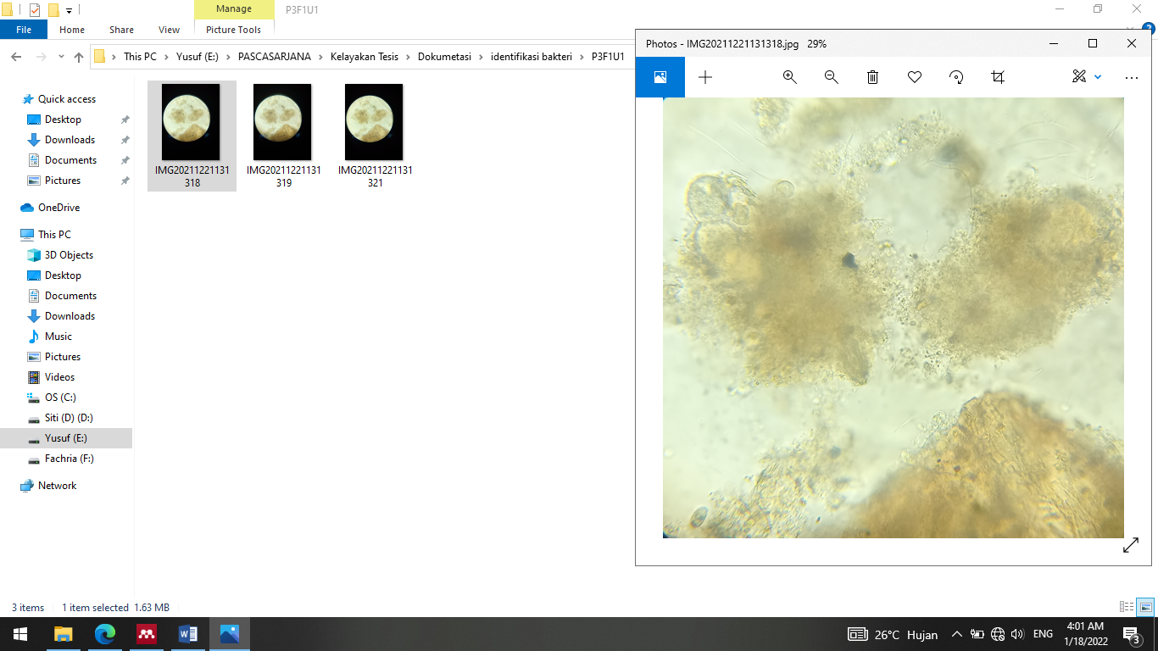
(A)

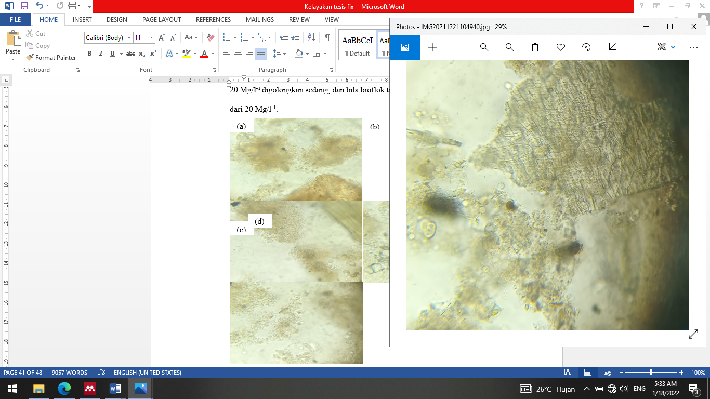
(B)
Figure 5. Floc Appearance of Treatment A and B

Based on Figure 5 shows that flocs are like small clumps formed from bacteria and at the time of the formation of flocs seen from the cultured fermentation began to be characterized by foamy water media conditions. The high value of floc volume means the success of biofloc fermentation from the role of probiotic bacteria can form flocs which can then be utilized by shrimp as feed.

The volume of flocs formed indicates that the bacteria present during maintenance can utilize the provision of different types of probiotic ingredients with different fermentation lengths for growth and survival so as to obtain a low ratio value and high feed efficiency.

3.5 Water Quality Parameters

Water quality is one of the factors supporting the success of shrimp farming activities in the formation of bioflocs, and even the bacteria that will develop must optimize water quality. The results of the water quality measurements during maintenance are presented in Table 2.
Table 2 shows that the biofloc system in vanname shrimp (Litopenaeus vannamei) with the provision of Yakult probiotic material and different fermentation durations helped improve water quality, except in the control treatment. This is in accordance with the opinion of Adipu (2019), who stated that the shrimp's ability to utilize bioflocs, which in turn utilize bacteria for floc formation, plays a role in improving water quality, increasing productivity, and enhancing biosecurity.
The biofloc system applied was optimal in maintaining water quality without requiring water changes, as the values of each water quality parameter observed were not significantly different. Maintenance of the biofloc system can provide more value, such as controlled water quality; therefore, there is no need to make changes compared to maintenance without biofloc technology. (Sitorus et al., 2019).

Table 2. Water Quality Parameters
Parameter | Treatment |  |  | Reference Source
 | A | B | C
pH | 7.00-7.22 | 7.06-7.05 | 6.04-7.49 | 6.9-9 (Dahlan et al., 2017)
Temperature | 27-29 | 27-29 | 27-30 | 26-32 ºC  (Rakhfid et al., 2017)
DO | 6.6-10.9 | 6.7-12.4 | 3.3-7.1 | >3.5 mg/l  (Adharani et al., 2019)
Salinity | 28-30 | 28-30 | 26-31 | 10-30 ppt  (Arsad et al., 2017)
Ammonia | 0.07-0.09 | 0.02-0.08 | 0.13-0.20 | 0.3-1 mg/l  (Putri et al., 2015)
Nitrate | 122.7-154.9 | 154.3-154.9 | 29.8-40.6 | <0.01 mg/l  (Rahmah et al., 2022)
Nitrite | 0.375 | 0.375 | 0.375 | 0.1-1 mg/l  (Adipu, 2019)

Treatments A and B remained at a neutral pH due to the presence of good nitrification activity in shrimp farming. The pH value is more favorable when it is neutral, and it is more productive compared to acidic and alkaline water (Zega, 2018). Temperature in optimal conditions that support the sustainability and growth of vanname shrimp (Litopenaeus vannamei). The growth rate increases in line with the optimal temperature range of 28.19°C-31.24 °C (Yusuf, 2017).

The presence of oxygen is necessary for the formation of bioflocs, and a lack of oxygen can prevent bacteria from developing optimally. This condition can endanger shrimp during rearing because it can cause susceptibility to diseases and mass shrimp mortality. The results of dissolved oxygen measurements in this study were optimal at 3.3-12.4 mg/l, because this was influenced by the tightness of aeration in the biofloc process. The oxygen content during the rearing period of vanname shrimp (Litopenaeus vannamei) ranged from 2.80-15.90 mg/l (Tahe et al., 2015).

Salinity is the average concentration of all salt solutions that can stabilize seawater. This is based on the research of Adipu (2019), which has an impact on the physiological ability of shrimp to osmoregulate, thereby maintaining a balance of salt and water.

The ammonia levels during the observation period in Table 2 were still relatively low because the application of the biofloc system effectively controlled the remaining pkan and feces, which were decomposed with the help of probiotic bacteria, thereby suppressing ammonia in the living medium of vannamei shrimp (Litopenaeus vannamei). However, in contrast to the control treatment, ammonia production was higher, at approximately 0.13-0.20 mg/l. High ammonia levels can occur due to a lack of water changes, which further accumulate in the feed and feces at the bottom of the water (Arsad et al., 2017).

Nitrate measurements in treatments given probiotics and fermentation materials yielded results ranging from 122.3 to 154.9 mg/L. According to Government Regulation No. 82 of 2001 on water quality management and water pollution control, the standard criteria for water quality regarding nitrate levels that are still within safe limits are 100 mg/l (Rusdy et al., 2021). However, as floc formation increases, it affects the increase in nitrate concentration, which is caused by the nitrification process (Deswati et al., 2023).

The nitrite content is the result of nitrifying bacteria that utilize ammonia, and the nitrite results obtained exceed the SNI 06-6989.30-2005 standard, which is 0.350 mg/l, while the nitrite range results obtained are 0.375 mg/l. However, this is still tolerable and does not impact the growth conditions or survival of Vanname shrimp (Litopenaeus vannamei).

4. Conclusion

The interaction between Yakult-based probiotics and varying fermentation durations in each treatment had a significant effect on the biological performance of Litopenaeus vannamei. This was evidenced by increased growth rates, higher survival percentages, lower feed conversion ratios (FCR), improved feed efficiency, greater floc volume density, and consistently stable water quality parameters throughout the culture period. These findings suggest that both probiotic type and fermentation duration play crucial roles in optimizing the functionality of biofloc systems.
Based on these results, lime supplementation should be considered in culture media to suppress excessive nitrite levels. Furthermore, Yakult-based probiotics with optimized fermentation durations should be implemented on a commercial scale to support sustainable and efficient shrimp farming practices.

Disclaimer (Artificial intelligence)

Author(s) hereby declare that NO generative AI technologies such as Large Language Models (ChatGPT, COPILOT, etc.) and text-to-image generators have been used during the writing or editing of this manuscript.

References

Adharani, N., Wardhana, M. G., & Harsanti, S. (2019). Water Quality for Cultivating Whiteleg Shrimp with Bacillus megaterium and Bacillus aquimaris. 65–75.
Adipu, Y. (2019). Water Quality Profile in Whiteleg Shrimp (Litopenaeus vannamei) Cultivation in a Biofloc System with Palm Sugar as a Carbohydrate Source. 8(3), 122–125.
Aditiashalihah, A. (2019). The Effect of Storage Length of Goat Milk Yogurt with Black Soybean Extract (Glycine soja sieb) Substitution at Low Temperature (4oC) on Total Lactic Acid Bacteria, Lactic Acid Content, and Inhibitory Power of E. coli Bacteria.
Afriyadi, M., Putra, I., & Rusliadi. (2020). The Effect of Probiotic Addition with Different Frequencies on the Growth and Survival of Whiteleg Shrimp (Litopenaeus vannamei). 1(1), 80–86.
Anggana, M., Heza, S., Absharina, F. D., & Gevira, Z. (2021). Application of Biofloc and Probiotics in Feed for Pearl Catfish (Clarias gariepinus) Farming.
Arsad, S., Afandy, A., Purwadhi, A. P., Maya V, B., Saputra, D. K., & Buwono, N. R. (2017). Study of Whiteleg Shrimp (Litopenaeus vannamei) Farming Activities with Different Maintenance Systems. Scientific Journal of Fisheries and Marine Sciences, 9(1), 1. https://doi.org/10.20473/jipk.9i1.7624
Crab, R., Defoirdt, T., Bossier, P., & Verstraete, W. (2012). Biofloc technology in aquaculture: Beneficial effects and future challenges. Aquaculture, 356–357, 351–356. https://doi.org/10.1016/j.aquaculture.2012.04.046
Citria, I., Abidin, Z., & Astriana, H. (2018). The Effect of Probiotics Fermented with Different Carbon Sources on the Growth of White Shrimp (Litopenaeus vannamei). Fisheries Journal, 8(1), 14–22.
Dahlan, J., Hamzah, M., & Kurnia, A. (2017). The Growth of White Shrimp (Litopenaeus vannamei) Cultured in a Bioflock System with Probiotic Supplementation in the Diet. 1(2), 1–9.
Deswati, Zein, R., Dwisani, R., Fitri, W. E., & Putra, A. (2023). Biofloc-based catfish cultivation and its effect on the dynamics of water quality. Journal of Environmental Science and Aquatic Technology, 16(6).
Emerenciano, M., Gaxiola, G., & Cuzon, G. (2013). Biofloc Technology (BFT): A Review for Aquaculture Application and Animal Food Industry. Biomass Now – Cultivation and Utilization, InTech. https://doi.org/10.5772/53902
Faridah, F., Diana, S., & Yuniati, Y. (2019). Catfish Cultivation Using the Biofloc Method in Conventional Catfish Farmers. Caradde: Journal of Community Service, 1(2), 224–227. https://doi.org/10.31960/caradde.v1i2.74
Fernando, E. (2016). The Effect of Variations in Dosage and Frequency of Probiotic Feed Administration on the Growth and Mortality of Whiteleg Shrimp (Litopenaeus vannamei). 1–103.
Hasim, H., Baidi, N., Syamsuddin, S., & Tuiyo, R. (2021). Administration of the Probiotic Sanolife Mic-S on the Biological Performance of Whiteleg Shrimp (Litopenaeus vannamei) PL 10. Technium Romanian Journal of Applied Sciences and Technology, 3(8), 42–57. https://doi.org/10.47577/technium.v3i8.4581
Martini, N. N. D. (2017). The Effect of Different Cultivation Systems on the Growth Rate of Whiteleg Shrimp (Litopenaeus vannamei). Jurnal IKA, 15(1), 1–20.
Putri, B., Wardiyanto, W., & Supono, S. (2015). The Effectiveness of Using Several Bacterial Sources in a Biofloc System on the Performance of Tilapia (Oreochromis niloticus). E-Journal of Aquaculture Engineering and Technology, 4(1), 433–438. https://doi.org/10.23960/jrtbp.v4i1.1348p433-438
Rahmah, I. I., Laili, S., & Liminingsih, R. D. (2022). Analysis of Phytoplankton Community Structure in Whiteleg Shrimp (Litopenaeus vannamei) Ponds in Manyar District, Gresik Regency.
Rakhfid, A., Baya, N., Bakri, M., & Fendi, F. (2017). Growth and Survival of Whiteleg Shrimp (Litopenaeus vannamei) at Different Stocking Densities. 1996.
Rozi, R., Mukti, A. T., Samara, S. H., & Santanumurti, M. B. (2018). The effect of chitosan in feed on growth, survival rate, and feed utilization efficiency of Nile tilapia (Oreochromis niloticus). Journal of Fisheries Sciences, 20(2), 103–111. https://doi.org/10.22146/jfs.38868
Runa, N. M., Fitrani, M., & Taqwa, F. H. (2019). Utilization of Different Doses of Tapioca Flour as a Carbon Source in Biofloc Rearing Media of Catfish Fry (Pangasius sp.). Journal of Aquaculture and Fish Health, 8(1).
Rusdy, I., Nurfadillah, & Harahap, D. H. (2021). Water quality in shrimp cultivation vaname (Litopenaeus vannamei) bioflok system with dense high spreading in Alue Naga City Banda Aceh. Jurnal Kelautan dan Perikanan Indonesia, 1(3), 104–114. http://jurnal.unsyiah.ac.id/JKPI
Sedu, A. L., Lumenta, C., Kalesaran, O. J., & Sinjal, J. H. (2020). The use of Taiwanese gravestone (Anodonta woodiana) and pearl mussel (Pinctada margaritifera) carcass flours in feed formulation for the growth of tilapia (Oreochromis niloticus) in pond. Aquaculture Science, 8(2), 14–21..
Setiawan, A., Ariqoh, R., Tivani, P., Pipih, L., & Pudjiastuti, I. (2016). "Bioflocculation System": High-Density Catfish Cultivation Technology with a Capacity of 1 m3/750 Fish Using Flock-Forming Bacteria. Chemical Engineering Innovation, 1(1), 45–49. https://publikasiilmiah.unwahas.ac.id/index.php/inteka/article/view/1644/1721
Sitorus, N. K., Lukistyowati, I., Syawal, H., & Putra, I. (2019). Identification of Lactic Acid Bacteria from Biofloc Technology That Have Been Giving Mollusks to Red Tilapia (Oreochromis sp.) Aquaculture. pp. 83–92.
Supono, Pinem, R. T., & Harpeni, E. (2021a). Performance of White Shrimp Litopenaeus vannamei (Boone, 1931) Reared in a Biofloc System with Different Carbon Sources. pp. 30–42.
Supono, S., Pinem, R. T., & Harpeni, E. (2021b). Performance of Whiteleg Shrimp Litopenaeus vannamei (Boone, 1931) Maintained in Biofloc Systems with Different Carbon Sources. Jurnal Kelautan: Indonesian Journal of Marine Science and Technology, 14(2), 192–202. https://doi.org/10.21107/jk.v14i2.9191
Suryaningrum, F. M. (2012). Application of biofloc technology in tilapia fry cultivation. 123.
Tahe, S., Suwoyo, H. S., & Fahrur, M. (2015). Application of Rica and Commercial Probiotics in Whiteleg Shrimp Cultivation. 2012, 435–445.
Yahra, S. (2020). Analysis of nitrate and phosphate content and their relationship to mangrove density on Labu Beach, Deli Serdang Regency.
Yusuf, S. F. (2017). Ki Performance of White Shrimp (Litopenaeus vannamei) Nursery in Biofloc System with Different Carbohydrates.
Zega, Y. (2018). The Effect of Adding Multi-Cell Booster Probiotics to Water Media with Different Doses on Reducing Ammonia Concentration, Increasing Growth and Survival of Catfish (Mystus nemurus). Energies, 6(1), 1–8.

