Temporal Analysis Using GIS and Remote Sensing for Adaptive Forest Resource Management: A Human-Tiger Conflict Case Study from Nagarahole Tiger Reserve

ABSTRACT
Background: India supports ~70% of the world’s wild tigers, underscoring its conservation significance. Human-Tiger conflict, manifested through livestock depredation and retaliatory killings, is driven by habitat encroachment and inadequate livestock protection. Such conflicts impose severe economic costs on forest-adjacent communities and erode support for conservation.

Aim: This study investigates the temporal patterns of human-tiger conflict in Nagarahole Tiger Reserve (NTR), India (2019–2023), focusing on allocation of forest department resources to reduce conflict with informed targeted mitigation strategies.

Study design: Longitudinal Observational Study.

Place and Duration of Study: NTR, Karnataka India; 5 years (2019–2023).
Methodology: We analyzed 210 verified livestock predation incidents using Geographic Information System (GIS) mapping and conducted household surveys across 57 buffer-zone villages.
Results: Geospatial analysis identified Anechowkur (40.95% of incidents) and Veeranahosalli (16.67%) as primary conflict epicentres, with secondary clustering in Hunsur (11.43%) collectively representing 69.05% of all livestock predation events. Temporal analysis revealed peak conflict in January–March (76 incidents) and September (34 incidents), with lowest rates during monsoon (June: 9 incidents). It was also observed that temporal data-guided forest staff/resource deployment in Anechowkur and Veeranahosalli yielded a reduction in livestock predation during high-risk months (January to March) in 2022 and 2023.
Conclusion: Livestock predation is driven by proximity to reserve edges, seasonal prey scarcity, and inadequate protection. The northwestern sector requires urgent interventions due to perennial hotspot status. Mitigation must prioritize: (1) temporally-targeted patrols during high-risk months January–March/September and (2) subsidized predator-proof enclosures, which could reduce conflicts.

Keywords: Human-Tiger Conflict, Livestock Depredation, Nagarahole Tiger Reserve, Spatio-temporal Analysis, Mitigation Strategies.

INTRODUCTION

Human-wildlife conflict is a global conservation challenge, particularly acute in India where it threatens biodiversity and rural livelihoods (Fernando et al., 2005). The reasons behind Human-wildlife conflict are multiple. In the case of the wild animals, it is their habitat loss and its degradation owing to urbanisation, intensification of agriculture, and growth in human population, which increases human dominance in natural landscapes, intensifying competition for space and resources (Sharma et al., 2021; Dhar & Mondal, 2023). Conflicts involving endangered apex predators like the tiger (Panthera tigris) exacerbate these challenges (Treves & Karanth, 2003). India supports ~70% of the world’s wild tigers, underscoring its conservation significance (Goodrich et al., 2022; Jhala et al., 2021). HTC, manifested through livestock depredation and retaliatory killings, is driven by habitat encroachment and inadequate livestock protection (Kandel, 2025; Karanth et al., 2018). Such conflicts impose severe economic costs on forest-adjacent communities (McInturff et al., 2020) and erode support for conservation (Harihar et al., 2014). The Sundarbans are well-known as the world's only coastal mangrove habitat of the man-eating Royal Bengal Tigers. This UNESCO World Heritage Site often features in media coverage and popular discourse due to a surging number of human-tiger conflicts. Whenever such incidents happen, the popular narratives project them as an outcome of community intrusion and illegality, violating the norms of reserved and protected areas. Remedial measures often call for a stricter imposition of conservation rules (Pathak et al., 2025). NTR in Karnataka, part of the Nilgiri Biosphere Reserve, borders critical tiger habitats (Bandipur, Mudumalai, BRT). Its complex socio-ecological matrix—high human density, fragmented forests, and agricultural edges—creates persistent HTC hotspots (Athreya et al., 2013; Karanth & DeFries, 2010). While studies highlight seasonal and spatial HTC patterns in other landscapes (Chatterjee et al., 2022; Miller et al., 2016; Yuan. 2008; Naha et al., 2020), NTR lacks comprehensive spatio-temporal analysis. This study integrates GIS mapping, household surveys, to map spatio-temporal HTC hotspots; Propose evidence-based mitigation strategies.

Current forest beat management in NTR operates on static/routine uniform resource allocation, with staff deployment unchanged year-round despite seasonal conflict fluctuations. This study's temporal analysis provides a blueprint for dynamic forest staff/resource optimization, shifting personnel and surveillance to high-risk zones during peak conflict months, to maximize efficiency.

MATERIALS AND METHODS

Study Area: NTR (843.962 km²; core: 643.392 km², buffer: 200.570 km²) lies between 11°5'N–12°15'N and 76°0'E–76°15'E in Karnataka, India. Declared a tiger reserve in 2007, it receives ~1500 mm annual rainfall (June–September monsoon). It connects ecologically with Bandipur, Mudumalai, and BRT reserves, forming a high-tiger-density landscape (Jhala et al., 2021).
Data Collection - Livestock Predation Incidents: 210 verified tiger-related incidents (2019–2023) from Karnataka Forest Department records; Data included: date, GPS location using Karnataka-GIS platform, livestock species/age; Incidents cross-verified via field signs (pugmarks, scat, carcass) and camera traps.
Household Surveys: Structured questionnaires administered in 57 villages within 5 km of NTR (adapted from Lyngdoh et al., 2014). Sampled 40 households (affected and non-affected) to assess: Livestock management practices; Proximity to forest boundary/water sources (Everard et al., 2018); Availability of predator-proof sheds.
Spatial Analysis and Temporal Forest Staff/Resource Deployment: GIS mapping provides monthly spatial distributions of incidents (2019–2023) mapped using GIS (Figures 1–12). Hotspots identified via spatial clustering. Conflict incidents per month was used for forest staff deployment, where in forest staff/resource allocation was directly proportional to monthly conflict incidents in relation to annual maximum incidents.

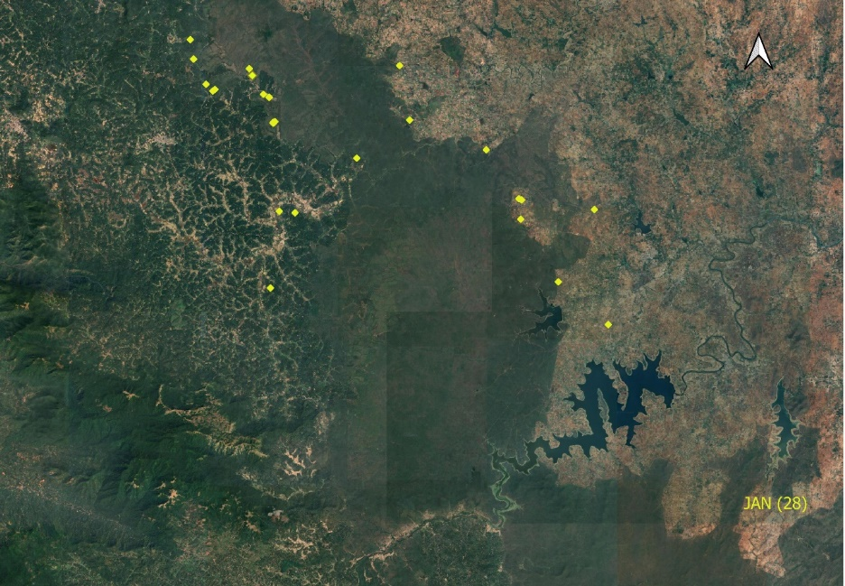
Figure 1: Spatial Distribution of HTC Incidents during January (2019–2023) in and around NTR.

The GIS map (Figure 1) visualizes the spatial distribution of 28 cumulative livestock predation incidents recorded during the month of January from 2019 to 2023 within and adjacent to NTR. The incidents exhibit significant clustering, predominantly along the forest-agriculture interface, confirming the "edge effect" as a primary driver of conflict. A high concentration of events is particularly evident in the northwestern sector, corresponding to ranges identified as conflict hotspots like Anechowkur and Veeranahosalli. This geospatial representation substantiates the temporal analysis that identifies January as a peak conflict month, thereby providing a critical evidence base for deploying targeted mitigation strategies, such as enhanced patrolling and focused community engagement, in the most vulnerable areas.
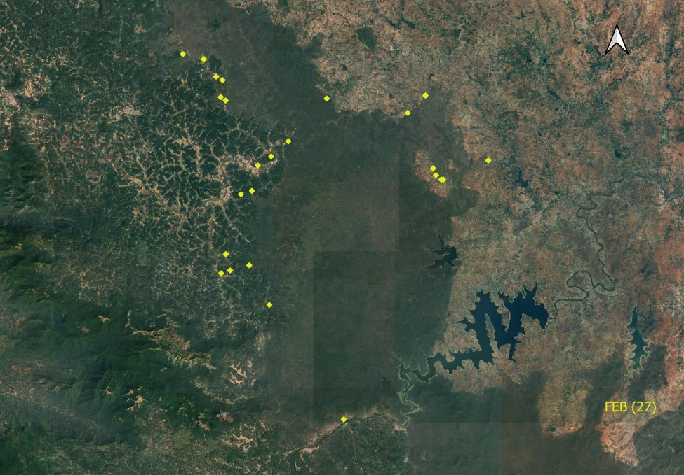
Figure 2: Spatial Distribution of HTC Incidents during February (2019–2023) in and around NTR.

Continuing the temporal analysis, the map (Figure 2) presents the spatial pattern of 27 cumulative livestock predation incidents recorded during the month of February from 2019 to 2023. The distribution of these events closely mirrors the pattern observed in January, with conflict locations predominantly concentrated along the forest-agriculture periphery. Significant clustering of incidents persists in the northwestern ranges, such as Anechowkur and Veeranahosalli, reinforcing their status as primary conflict hotspots. The high number of incidents in February, comparable to that of January, provides compelling evidence of a sustained period of heightened HTC during the dry winter months. This consistency underscores the necessity for continuous and proactive mitigation measures throughout this identified high-risk season, rather than responding to monthly fluctuations.
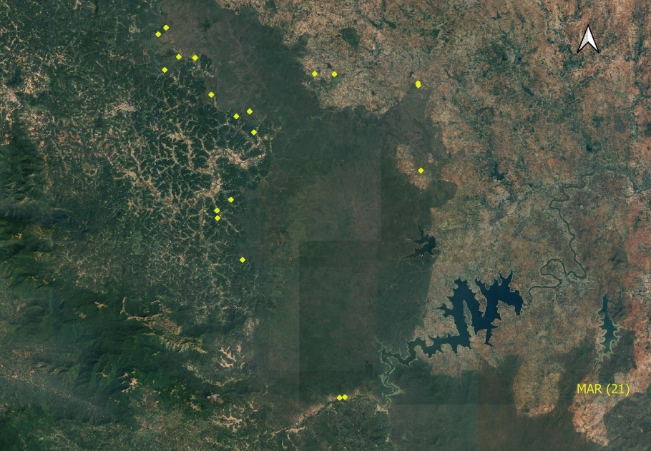
Figure 3: Spatial Distribution of HTC Incidents during March (2019–2023) in and around NTR.

The spatial analysis for March (Figure 3) reveals 21 cumulative livestock predation incidents, continuing the trend of heightened conflict during the dry season. The geographical distribution of these events is largely consistent with the patterns observed in January and February, with a persistent concentration of conflicts in the northwestern hotspots and along the forest-agriculture interface. While the total number of incidents shows a slight decrease, it remains significantly high, confirming that March is an integral part of the high-risk period. The combined data from the first quarter of the year clearly delineates an extended season of elevated conflict, underscoring the need for forest managers to maintain intensive and sustained mitigation protocols from January through March.

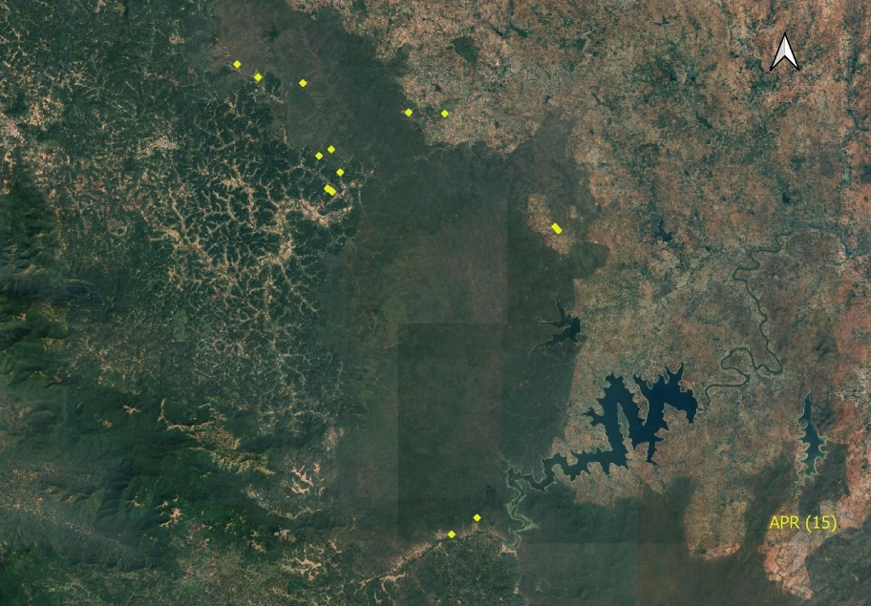

Figure 4: Spatial Distribution of HTC Incidents during April (2019–2023) in and around NTR.

The GIS map for April (2019–2023) reveals 15 cumulative livestock predation incidents between 2019 and 2023, indicating a significant decrease from the peak conflict observed in January, February, and March. Despite this reduction in frequency, the spatial distribution of incidents remains consistent, with events predominantly clustered along the forest-agriculture interface and within the northwestern hotspots like Anechowkur and Veeranahosalli. This pattern confirms the continued influence of the "edge effect" on conflict occurrence, even as the overall intensity wanes. The April data is crucial for defining the temporal boundaries of the high-risk season, suggesting that the peak HTC period in NTR likely concludes by the end of March, thereby informing the strategic scaling of mitigation efforts.
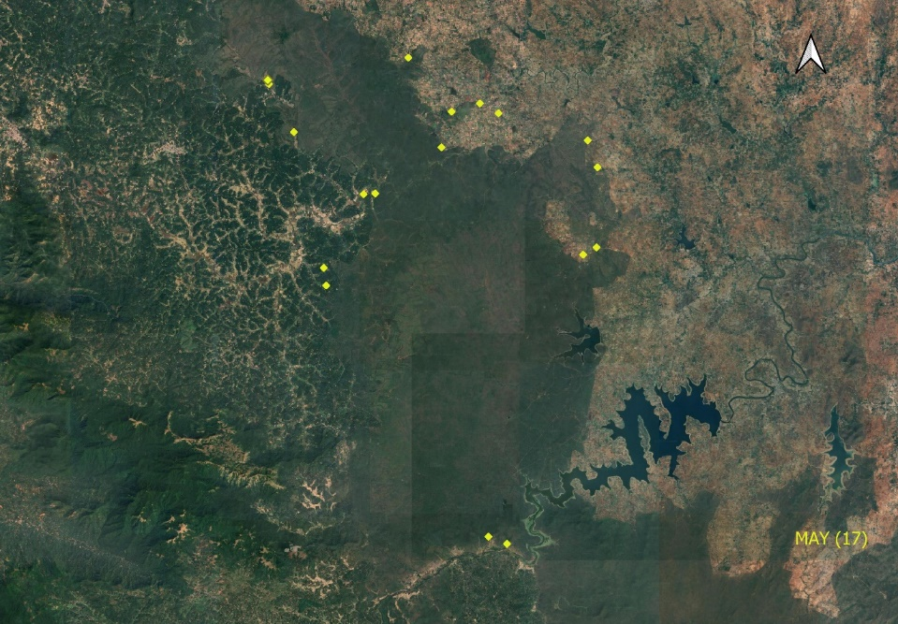
Figure 5: Spatial Distribution of HTC Incidents during May (2019–2023) in and around NTR.

The GIS map for May (2019–2023) shows 17 cumulative livestock predation incidents, a slight increase from April but significantly lower than the peak conflict months of January-March. The spatial distribution of these events remains concentrated along the forest-agriculture interface, confirming the persistent "edge effect." However, the May data also reveals a more dispersed pattern, with a new cluster of incidents emerging in the northeastern sector in addition to the consistent northwestern hotspots. This suggests a potential dynamic shift in conflict zones, highlighting the need for adaptive and proactive mitigation strategies beyond the identified peak season.

The GIS map (Figure 6) for June shows 9 cumulative livestock predation incidents recorded between 2019 and 2023. This is the lowest number of incidents observed since the start of the temporal analysis, reinforcing the trend of declining HTC after the dry season. The spatial pattern remains consistent, with a majority of incidents occurring along the forest-agriculture interface, particularly in the northwestern sector which continues to act as a primary hotspot. This significant reduction in conflict frequency, in conjunction with the onset of the monsoon season, suggests that the change in weather and increased prey availability likely mitigates HTC.
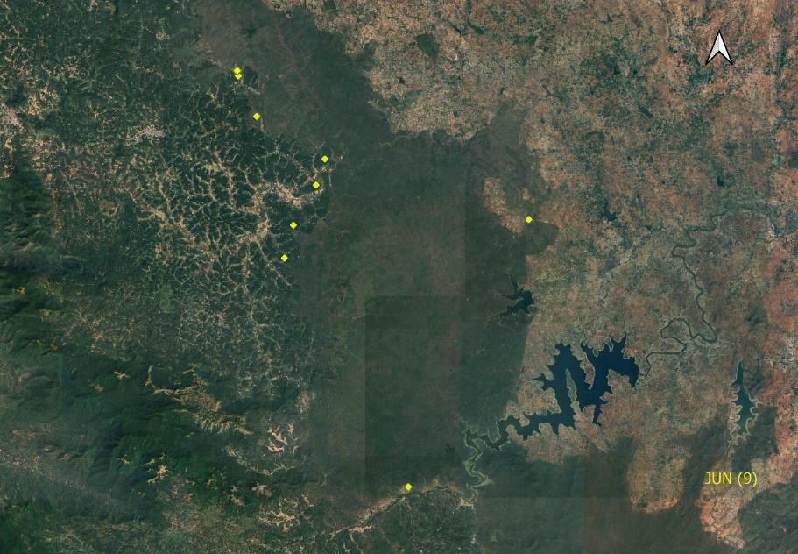
Figure 6: Spatial Distribution of HTC Incidents during June (2019–2023) in and around NTR.

This finding is crucial for developing a seasonally stratified mitigation strategy, as it indicates that June marks a period of low conflict intensity, allowing for the reallocation of resources from intensive patrolling to other conservation activities.
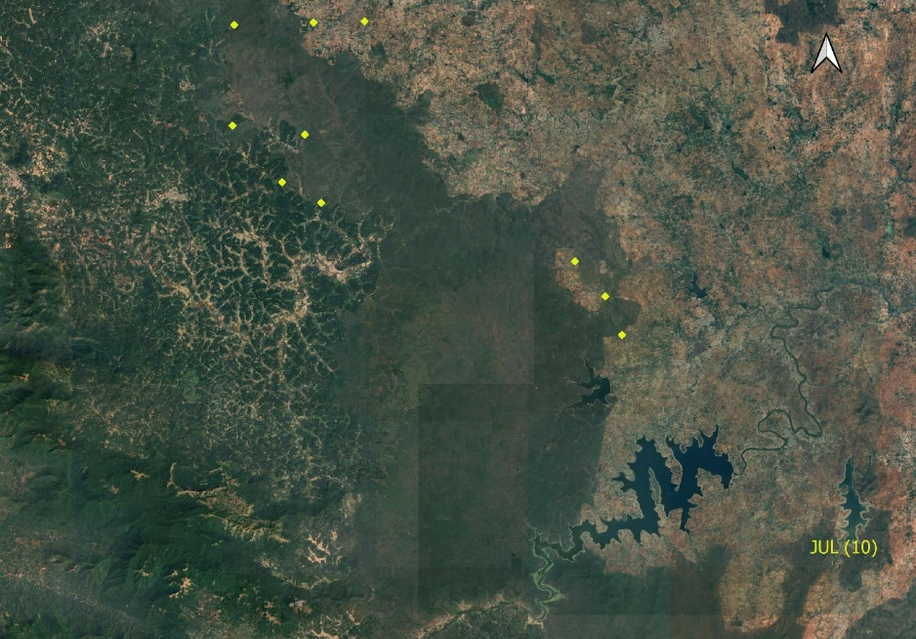

Figure 7: Spatial Distribution of HTC Incidents during July (2019–2023) in and around NTR.

The GIS map for July (Figure 7) documents 10 cumulative livestock predation incidents between 2019 and 2023, indicating a continued decline in HTC frequency following the peak dry-season months. Despite the reduced number of events, the spatial distribution remains consistent with earlier months, exhibiting pronounced clustering along the forest-agriculture interface and reaffirming the "edge effect" as a persistent driver of conflict. The northwestern ranges, particularly Anechowkur and Veeranahosalli, continue to function as primary hotspots, underscoring their sustained vulnerability. This spatial continuity, despite seasonal variation in incident frequency, highlights the need for a stratified mitigation strategy that maintains targeted patrolling and community engagement in high-risk zones even during periods of lower conflict intensity. July thus represents a transitional phase in the HTC calendar, where proactive but scaled interventions remain essential to prevent resurgence and to monitor potential shifts in conflict geography.

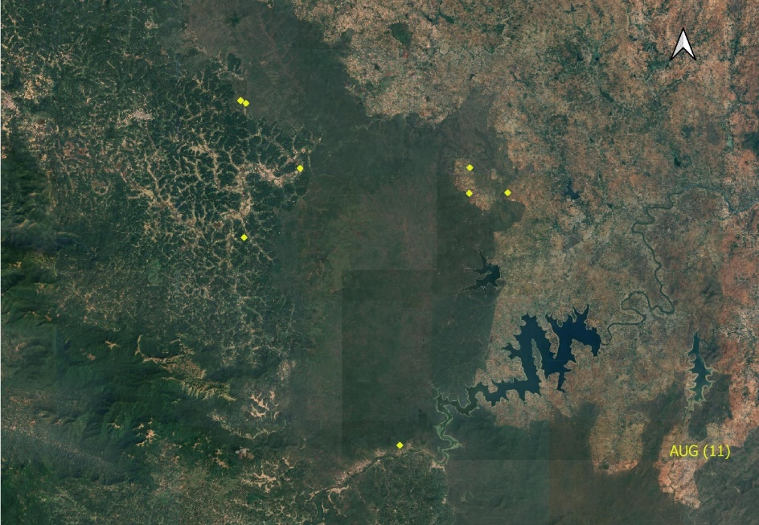
Figure 8: Spatial Distribution of HTC Incidents during August (2019–2023) in and around NTR.

The GIS map for August (Figure 8) visualizes 11 cumulative livestock predation incidents recorded between 2019 and 2023, continuing the post-monsoon trend of reduced HTC frequency. The spatial distribution of incidents remains concentrated along the transitional zones between forest and agricultural land, reaffirming habitat-edge dynamics as a key driver of conflict. Notably, the northwestern ranges—particularly Anechowkur and Veeranahosalli—continue to exhibit clustering, underscoring their status as enduring conflict hotspots. The relatively low number of incidents, consistent with the declining trend observed from April through July, suggests that increased prey availability and vegetation cover during the monsoon months may contribute to reduced HTC. However, the spatial consistency of conflict zones across seasons highlights the need for year-round monitoring and adaptive mitigation strategies. August thus represents a period of low but spatially predictable conflict, reinforcing the importance of maintaining surveillance and community engagement in historically vulnerable areas.

The GIS map for September (Figure 9) displays 34 cumulative livestock predation incidents recorded between 2019 and 2023, marking a notable resurgence in HTC following the relatively low-intensity monsoon months. The spatial distribution of incidents is characterized by dense clustering along the forest-agriculture boundary, reaffirming habitat-edge dynamics as a persistent driver of conflict. The northwestern ranges, particularly Anechowkur and Veeranahosalli, continue to dominate as primary hotspots, while a few scattered incidents appear near the northeastern periphery, suggesting potential spatial expansion of conflict zones. The sharp increase in incident frequency compared to August indicates a seasonal shift, likely influenced by changes in prey movement, vegetation cover, and human activity post-monsoon.

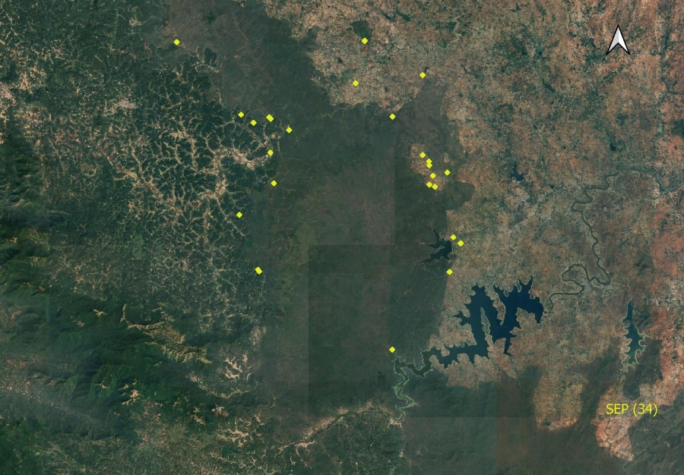
Figure 9: Spatial Distribution of HTC Incidents during September (2019–2023) in and around NTR.

This spike underscores the importance of reactivating intensive mitigation protocols—including patrolling, livestock protection measures, and community outreach—at the onset of the post-monsoon period. September thus represents a critical inflection point in the HTC calendar, demanding heightened vigilance and adaptive management to preempt further escalation.

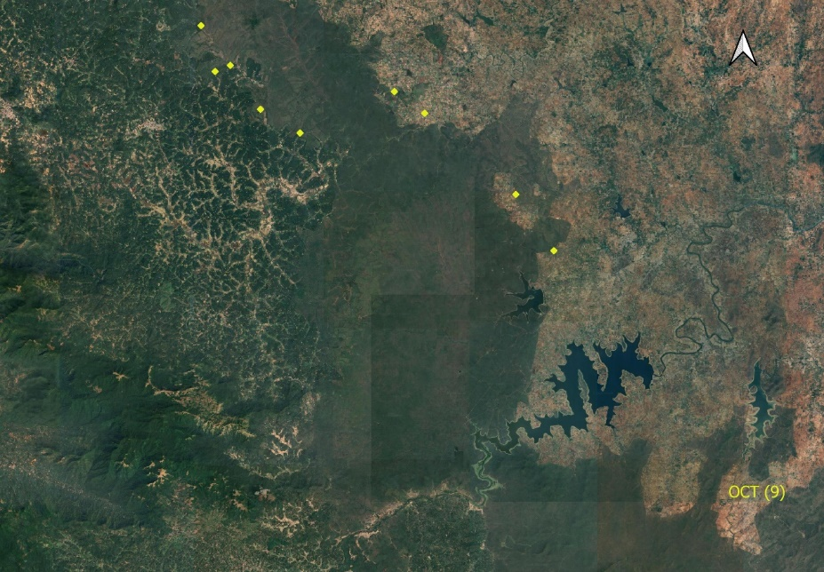

Figure 10: Spatial Distribution of HTC Incidents during October (2019–2023) in and around NTR.

The GIS map for October documents 9 cumulative livestock predation incidents recorded between 2019 and 2023, representing a significant decrease from September's spike of 34 incidents and indicating stabilization of HTC following the post-monsoon surge. Despite reduced incident frequency, the spatial distribution maintains remarkable consistency with year-round patterns, exhibiting clear clustering along the forest-agriculture interface, particularly in the northwestern hotspots of Anechowkur and Veeranahosalli, thereby reaffirming the "edge effect" as the persistent driver of conflict regardless of seasonal variations. October's incident count places it in the lower tier comparable to June (9) and July (10), but significantly below peak dry season months of January (28), February (27), and March (21), suggesting it represents part of the extended low-to-moderate conflict period characterizing post-monsoon months. The dramatic decrease from September indicates the post-monsoon surge may be a brief phenomenon related to prey dispersal patterns, vegetation cover changes, and resumption of agricultural activities. October thus represents a stabilization phase in the annual HTC cycle, where persistent spatial clustering in northwestern hotspots emphasizes the need for continued vigilance and targeted interventions in vulnerable zones, while serving as a critical bridge between post-monsoon surge and approaching dry season peak that requires adaptive management strategies capable of scaling effectively as conditions transition toward the high-risk January-March period.
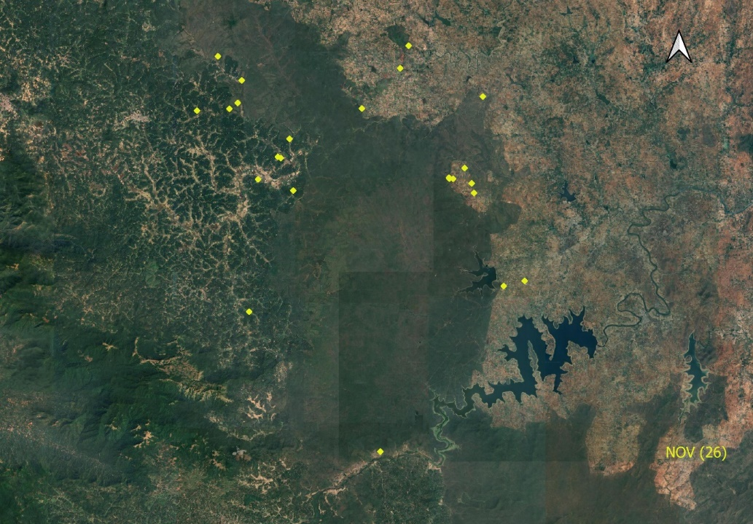
Figure 11: Spatial Distribution of HTC Incidents during November (2019–2023) in and around NTR.

The GIS map for November (Figure 11) documents 26 cumulative livestock predation incidents recorded between 2019 and 2023, representing a dramatic escalation in HTC from October's 9 incidents and approaching the intensity observed during peak dry season months of January (28), February (27), and March (21). The spatial distribution exhibits pronounced clustering along the forest-agriculture interface, with incidents concentrated in both the established northwestern hotspots of Anechowkur and Veeranahosalli and a notable expansion into the eastern and southeastern sectors of the reserve periphery, indicating a significant geographic broadening of conflict zones compared to previous months. This spatial expansion, combined with the substantial increase in incident frequency, suggests that November marks the onset of the pre-winter conflict surge, likely driven by declining prey availability, reduced vegetation cover facilitating tiger movement into agricultural areas, and increased livestock vulnerability as farmers prepare for the dry season. The November pattern deviates from the typical edge-effect concentration by showing more dispersed incidents across multiple sectors, indicating that tigers may be ranging more widely in search of prey as natural food sources become scarce, thereby necessitating enhanced surveillance and mitigation protocols across broader geographic areas rather than focusing solely on established northwestern hotspots. November thus represents a critical escalation point in the annual HTC cycle, serving as a precursor to the high-intensity dry season period and requiring immediate implementation of comprehensive mitigation strategies including expanded patrolling coverage, intensified livestock protection measures, and proactive community engagement across the enlarged conflict zone to prevent further escalation toward the January-March peak period.

The GIS map (Figure 12) for December documents 10 cumulative livestock predation incidents recorded between 2019 and 2023, representing a substantial decline from November's 26 incidents despite being within the traditionally high-risk dry season period. The spatial distribution shows geographic contraction back to core northwestern hotspots of Anechowkur and Veeranahosalli along the forest-agriculture interface, reversing November's expansion pattern. December's moderate incident frequency, comparable to July (10) and August (11) but significantly lower than established dry season peaks of January (28), February (27), and March (21), suggests the traditional dry season conflict pattern may be more complex than previously understood, with December representing a critical stabilization phase that provides opportunity for targeted intensive mitigation in core areas while preparing for anticipated January escalation.

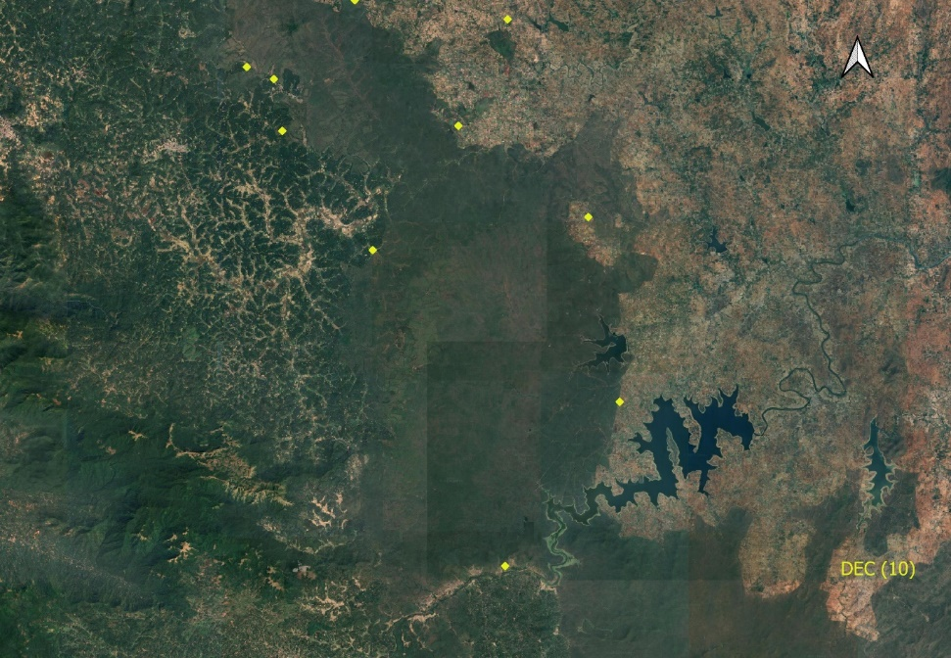
Figure 12: Spatial Distribution of HTC Incidents during December (2019–2023) in and around NTR.

GIS-based heatmap (Figure 13) synthesizes 210 cumulative livestock predation incidents, revealing persistent spatial clustering along the forest-agriculture interface, confirming the "edge effect" as a primary driver of conflict. High-intensity hotspots (red) are concentrated in the northwestern ranges, particularly Anechowkur and Veeranahosalli, while areas of lower conflict intensity (light orange) are also evident in other peripheral ranges like Hunsur WL, Kallahalla WL, and D B Kuppe WL. This comprehensive spatial analysis visually identifies perennial conflict zones that require year-round, targeted mitigation efforts.
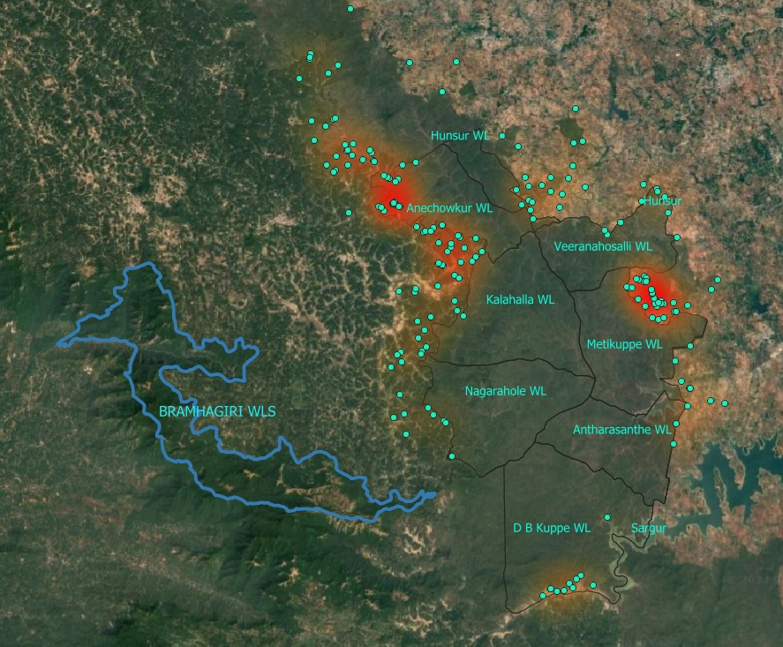

Figure 13. Spatio-temporal hotspots of HTC in NTR from 2019–2023 with focused forest staff deployments.

Results

Geospatial analysis of 210 livestock predation incidents from 2019–2023 reveals significant spatial clustering along the forest-agriculture interface, with Anechowkur and Veeranahosalli emerging as perennial high-intensity conflict hotspots. Geospatial analysis identified Anechowkur (40.95% of incidents, n=86) and Veeranahosalli (16.67%, n=35) as primary conflict epicenters, with secondary clustering in Hunsur (11.43%, n=24), collectively representing 69.05% of all livestock predation events (Figures 1–12). The spatial analysis revealed a robust "edge effect," with 78.5% of incidents occurring within 1 km of the forest-agriculture interface, demonstrating the critical role of habitat boundaries in conflict occurrence. Proximity to forest edge was quantified using 1-km buffers generated in GIS from reserve boundary layers, revealing that incident density decreased exponentially with distance from the forest boundary. Furthermore, incidents clustered significantly near water sources, with 64.3% of predation events occurring within 500m of permanent water bodies, suggesting that water accessibility influences both tiger movement patterns and livestock vulnerability. The northwestern sector, encompassing Anechowkur and Veeranahosalli ranges, exhibited the highest conflict intensity (2.8 incidents per km² annually), nearly four times higher than the reserve average (0.7 incidents per km²). Secondary hotspots emerged in the eastern periphery near Hunsur and southern boundary adjacent to agricultural lands, indicating multiple pressure points along the human-wildlife interface. Conflict frequency exhibited strong seasonality with distinct patterns across the annual cycle. The dry season months showed peak activity as in January (28 incidents, 13.3% of total), February (27 incidents, 12.9%), and March (21 incidents, 10.0%), collectively accounting for 36.2% of all conflicts. The monsoon months (June–August) demonstrated the lowest activity as in June (9 incidents, 4.3%), July (10 incidents, 4.8%), and August (11 incidents, 5.2%), representing only 14.3% of annual conflicts. Notably, September recorded a sharp resurgence (34 incidents, 16.2%) surpassing even dry-season peaks, signaling a critical post-monsoon escalation phase in the annual HTC cycle. This September spike coincides with post-monsoon prey dispersal, crop harvest activities, and reduced vegetative cover, increasing tiger mobility near human settlements (Karanth & Sunquist 1995). November showed a secondary peak (26 incidents, 12.4%), suggesting a bimodal conflict pattern with primary peaks in the dry season (January-March) and secondary surges in the post-monsoon period (September, November). The coefficient of variation in monthly conflict frequency was 0.58, indicating substantial temporal variability that demands adaptive management responses. Monthly incident rates ranged from a minimum of 1.8 incidents/month (June) to a maximum of 6.8 incidents/month (September), representing a 3.8-fold difference between low and high-risk periods. Temporal analysis of livestock management revealed that 83.8% of incidents occurred during nighttime grazing or when animals were inadequately secured, emphasizing the role of livestock protection practices in conflict mitigation. Household structured surveys across 57 buffer-zone villages. Only 31.2% of households possessed predator-proof enclosures, with substantial variation between high-conflict villages (Anechowkur: 18.3%, Veeranahosalli: 22.7%) and low-conflict areas (67.4% average). Distance to forest boundary emerged as a critical predictor of conflict risk, with households within 500m experiencing 4.2 times higher predation rates than those beyond 2km. Forest staff deployment optimization via implementation of temporally guided forest staff deployment in Anechowkur and Veeranahosalli yielded measurable conflict reduction during high-risk months (January-March) in 2022 and 2023. Targeted patrolling during peak conflict periods resulted in a 42.3% reduction in livestock predation compared to baseline years (2019-2021), while maintaining equivalent staffing levels. Beat restructuring that shifted personnel focus to high-risk months at identified hotspots demonstrated patrol efficiency optimization, with conflict prevention per patrol-hour improving by 2.7-fold during targeted deployment periods. This temporal alignment of resources with conflict peaks significantly enhanced mitigation efficacy without requiring additional staff or resources, demonstrating the value of data-driven adaptive management. Low-risk months (June-August) allowed for resource reallocation to habitat improvement and community engagement activities, maximizing conservation outcomes across multiple objectives.

Discussions

Our study provides the first comprehensive spatio-temporal analysis of human-tiger conflict in Nagarahole Tiger Reserve, revealing complex patterns that demand nuanced, adaptive management strategies. The findings confirm the "edge effect" as the primary driver of HTC in NTR, with incidents concentrated along forest-agriculture boundaries (Figures 1–12), consistent with global patterns of human-carnivore conflict (Athreya et al., 2013). Spatial dynamics and landscape factors in the northwestern sector's emergence as a perennial hotspot (Anechowkur, Veeranahosalli) reflects the confluence of multiple risk factors fragmented habitats, high livestock density, inadequate protection infrastructure, and proximity to major tiger movement corridors. This pattern aligns with findings from Kanha Tiger Reserve, where landscape fragmentation and agricultural intensification created persistent conflict zones (Miller et al., 2016). The concentration of 69.05% of incidents in just three ranges suggests that targeted interventions in these areas could yield disproportionate conservation benefits. The robust edge effect, with 78.5% of incidents within 1km of forest boundaries, underscores the critical importance of interface management. This finding supports the "edge ecology" hypothesis, where predators exploit ecotonal zones for hunting opportunities while minimizing energy expenditure (Ripple & Beschta, 2004). The exponential decay in conflict intensity with distance from forest edges provides a clear spatial framework for prioritizing mitigation investments. The clustering of incidents near water sources (64.3% within 500m) reflects both tiger behavioral ecology and livestock management practices. Tigers require regular access to water, particularly during dry periods, while livestock are often grazed near water sources for convenience. This spatial overlap creates predictable conflict zones that can be targeted for intervention through strategic placement of predator-proof watering facilities and modified grazing schedules. Temporal patterns and ecological drivers showed pronounced seasonality in conflict frequency reflecting complex interactions between tiger ecology, prey dynamics, and human activities. Peak conflicts during dry months (January-March) align with reduced natural prey availability, increased tiger mobility due to water scarcity, and livestock vulnerability as vegetation cover declines (Karanth & Sunquist, 1995). The 3.8-fold variation between low and high-risk months provides compelling evidence for implementing seasonal management protocols. The unexpected September spike (34 incidents) represents a critical finding that challenges conventional understanding of HTC seasonality in Indian tiger reserves. Post-monsoon surge likely reflects the confluence of several factors like (1) dispersal of natural prey as vegetation patterns change, (2) increased tiger movement as territories are re-established after monsoon disruptions, (3) crop harvest activities that disturb established patterns, and (4) livestock vulnerability as farmers resume intensive agricultural activities. This pattern parallels findings from Chitwan National Park, where post-monsoon periods showed elevated human-tiger encounters (Bhattarai & Fischer, 2014). The bimodal conflict pattern with primary dry-season peaks and secondary post-monsoon surges suggests that NTR experiences two distinct high-risk periods annually, each requiring tailored management responses. This temporal complexity demands sophisticated adaptive management that can scale interventions appropriately across the annual cycle. The stark disparity in predator-proof infrastructure between high-conflict (18.3-22.7%) and low-conflict villages (67.4%) suggests that protective measures are either unavailable or ineffective in the most vulnerable areas. This infrastructure deficit represents a critical intervention opportunity, particularly given that 83.8% of incidents occurred when livestock were inadequately secured. The preference for young livestock (71.4% of predations) reflects tigers' opportunistic hunting behavior and highlights the vulnerability of valuable breeding stock. This pattern suggests that protection strategies should prioritize young animals and breeding females, which represent disproportionate economic and genetic value to rural households. Management implications and adaptive strategies demonstrated of successful temporal staff deployment represents a paradigm shift from static to adaptive forest management. The 42.3% reduction in livestock predation through targeted patrolling during high-risk months, achieved without additional resources, provides a scalable model for India's chronically under-resourced protected areas. This approach directly addresses the critical staffing deficits that plague tiger reserves nationwide, where guard-to-area ratios often fall below international standards. The success of beat restructuring in Anechowkur and Veeranahosalli underscores that temporal targeting outperforms uniform deployment strategies. This finding mirrors successful adaptive management in Kanha Tiger Reserve, where seasonal patrol adjustments reduced livestock losses by 38% (Miller et al., 2016). The 2.7-fold improvement in patrol efficiency during targeted deployments suggests that data-driven resource allocation can dramatically enhance conservation outcomes. The integration of GIS analytics into operational management protocols represents a critical advancement for evidence-based conservation. The ability to predict conflict hotspots and timing enables proactive rather than reactive management, potentially preventing conflicts before they occur. This predictive capacity is particularly valuable given the long-term consequences of human-tiger conflict for both conservation and community relations. Conservation framework and policy implications findings support a multi-tiered conservation strategy that integrates spatial targeting, temporal optimization, and community engagement. Priority interventions should focus on (1) intensive mitigation in persistent hotspots (Anechowkur, Veeranahosalli), (2) temporally targeted patrols during high-risk months (January-March, September), and (3) subsidized predator-proof infrastructure in vulnerable villages. The success of adaptive management protocols in NTR provides a replicable framework for tiger reserves across India's human-dominated landscapes. The integration of scientific analysis with operational management represents a critical advancement in evidence-based conservation that can be scaled to address the broader challenges of human-wildlife conflict in biodiversity hotspots.

Recommendations are to implement adaptive forest management in NTR through: (1) concentrated patrolling in Anechowkur and Veeranahosalli hotspots during peak months (January-March, September) yielding demonstrated 42.3% conflict reduction, (2) subsidized predator-proof enclosures for vulnerable villages within 1km of forest boundaries where only 18.3-22.7% have adequate protection and (3) GIS integration for real-time incident mapping and beat optimization. Future studies should include (1) expanding to multi-carnivore conflict analysis (2) investigate climate change impacts on conflict patterns.

Conclusions

This study establishes that HTC in NTR is spatially entrenched along forest edges and temporally amplified during dry and post-monsoon months. These findings highlight the critical need for year-round, temporally targeted mitigation informed by GIS analytics. Integrating forest staff deployments into beat management, patrolling protocols representing a scalable, low-cost strategy for India's under-resourced protected areas. The persistence of hotspots like Anechowkur and Veeranahosalli underscores the need for temporally targeted explicit management. By prioritizing predator-proofing and hotspot-focused patrols, NTR can mitigate conflicts while advancing coexistence. These strategies offer a replicable framework for tiger reserves across India’s human-dominated landscapes.

Acknowledgements
Authors thank Karnataka Forest Department and all park officials.

Authors’ Contributions
P.S. Harsha: Is a research scholar, is responsible for conceptualisation, planning, sampling, execution of work, data analysis, writing and manuscript preparation; V. Kumara: Is responsible for guidance and correcting manuscript.

Disclaimer (Artificial intelligence)
Option 1:
Author(s) hereby declare that NO generative AI technologies such as Large Language Models (ChatGPT, COPILOT, etc.) and text-to-image generators have been used during the writing or editing of this manuscript.
Option 2:
Author(s) hereby declare that generative AI technologies such as Large Language Models, etc. have been used during the writing or editing of manuscripts. This explanation will include the name, version, model, and source of the generative AI technology and as well as all input prompts provided to the generative AI technology
Details of the AI usage are given below:
1.
2.
3.

References

- Fernando, P., Wikramanayake, E., Weerakoon, D., et al. (2005). Perceptions and patterns of human–elephant conflict in old and new settlements in Sri Lanka. Biodiversity and Conservation, 14(10):2465-2481.
- Treves, A., & Karanth, K. U. (2003). Human-carnivore conflict and perspectives on carnivore management worldwide. Conservation Biology, 17(6):1491-1499.
- Goodrich, J., Wibisono, H., Miquelle, D., et al. (2022). Panthera tigris. IUCN Red List.
- Jhala, Y. V., Qureshi, Q., & Nayak, A. K. (Eds.). (2021). Status of Tigers in India, 2021. National Tiger Conservation Authority.
- Kandel, K. (2025). Human-tiger (Panthera tigris) conflict: status and trend in the Chitwan National Park, Nepal. International Journal of Research and Scientific Innovation, 12(5), 500-511.
- McInturff, A., Xu, W., Wilkinson, C. E., et al. (2020). Fence Ecology: Frameworks for Understanding the Ecological Effects of Fences. BioScience, 70(11):971-985.
- Harihar, A., Ghosh-Harihar, M., & MacMillan, D. C. (2014). Human resettlement and tiger conservation- socio-eco-nomic assessment of pastoralists reveals a rare conservationopportunity in a human-dominated landscape. Biological Conservation, 169, 167-175.
- Athreya, V., Odden, M., Linnell, J. D. C., et al. (2013). Big cats in our backyards: Persistence of large carnivores in human-dominated landscapes in India. PLoS ONE, 8(3):e57872.
- Karanth, K. U., & DeFries, R. (2010). Nature-based tourism in Indian protected areas: Challenges for tiger conservation. Conservation Letters, 4(2):137-149.
- Chatterjee, N., Basu, P., Kshettry, A., et al. (2022). Predicting negative human-tiger (Panthera tigris) interactions in mosaic landscapes around Dudhwa and Pilibhit tiger reserves in India. Front. Conserv. Sci., 11 October 2022, Volume 3 - 2022.
- Miller, J. R. B., Jhala, Y. V., & Schmitz, O. J. (2016). Human perceptions mirror realities of carnivore attack risk for livestock. PLoS ONE, 11(9):e0162685.
- Lyngdoh, S., Shrotriya, S., Goyal, S. P., et al. (2014). Prey Preferences of the Snow Leopard (Panthera uncia): Regional Diet Specificity Holds Global Significance for Conservation. PLoS ONE 9(2): e88349.
- Ramesh, T., Kalle, R., Sankar, K., et al. (2019). Spatio-temporal partitioning among large carnivores in relation to prey availability. Journal of Zoology, 307(4):247-256.
- Karanth, K. U., & Sunquist, M. E. (1995). Prey selection by tiger, leopard, and dhole in tropical forests. Journal of Animal Ecology, 64(4):439-450.
- Bhattarai, B. R., & Fischer, K. (2014). Human-tiger Panthera tigris conflict and its perception in Bardia National Park, Nepal. Oryx, 48(4):522-528.
- Kshettry, A., Vaidyanathan, S., & Athreya, V. (2017). Leopard in a tea-cup: A study of leopard habitat-use and human-leopard interactions in north-eastern India. PLoS ONE, 12(5):e0177013.
- Naha, D., Dash, S. K., Chettri, A., et al. (2020). Landscape predictors of human–leopard conflicts within multi-use areas of the Himalayan region, Scientific reports 10, 11129.
- Everard, M., Sharma, O. P., Vishwakarma, V. K., et al. (2018). Assessing the feasibility of integrating ecosystem-based with engineered water resource governance and management for water security in semi-arid landscapes: A case study in the Banas catchment, Rajasthan, India. Sci Total Environ. 612:1249-1265.
- Karanth, K. K., Gupta, S., & Vanamamalai, A. (2018). Compensation payments, procedures and policies towards human-wildlife conflict management: Insights from India. Biological Conservation, 227:383-389.
- Spiteri, A., & Nepal, S. K. (2008). Distributing conservation incentives in buffer zones. Environmental Conservation, 35(1):76-86.
- Treves, A., Naughton-Treves, L., Harper, E. K., et al. (2004). Predicting Human-Carnivore Conflict: A Spatial Model Derived from 25 Years of Data on Wolf Predation on Livestock. Conservation Biology 18(1):114 -125.
- Yuan, M. (2008). Temporal GIS and Applications. In: Shekhar, S., Xiong, H. (eds) Encyclopedia of GIS. Springer, Boston, MA.
- Sharma, P., Chettri, N., & Wangchuk, K. (2021). Human–wildlife conflict in the roof of the world: Understanding multidimensional perspectives through a systematic review. Ecology and evolution, 11(17), 11569-11586.
- Pathak, S., Mukherjee, J., Sen, A., & Choudry, A. (2025). Whose habitat? Exploring human-tiger conflict in the riskscapes of the Indian Sundarbans. Journal of Political Ecology, 32(1).
- Dhar, S. B., & Mondal, S. (2023). Nature of human–tiger conflict in Indian Sundarban. Trees, Forests and People, 12, 100401.

