Development Amid Disparity: A Study on Land Access, Social Mobility and Living Condition of Scheduled Castes in OttapalamTaluk, Kerala, India
Abstract:
This study critically examines land distribution patterns, socio-economic disparities and living conditions among Scheduled Castes (SCs) in Ottapalam Taluk, Kerala where, Ottapalam's SC communities historically faced caste-based land alienation, restricted settlement zones and occupational segregation. Despite Kerala's progressive reforms, persistent landlessness and socio-economic marginalization reflect enduring caste hierarchies in the region. employing a robust mixed-methods approach. The quantitative analysis integrates advanced GIS-based land mapping techniques and a detailed statistical evaluation of government land records to assess spatial inequities. Complementing this, qualitative insights are derived from extensive household surveys, participatory field observations and in-depth interviews with SC families, local officials, community leaders and social activists.
Key findings highlight persistent land ownership inequalities, restricted access to productive resources and substandard living conditions among SCs, stemming from historical discrimination and systemic marginalization. The study identifies critical issues such as widespread landlessness, limited economic and educational mobility, inadequate housing infrastructure and insufficient water and sanitation accessibility within the SC community. The research finds out all target objectives among which, the average percentage of SC community land holding across all regions is only 10.78%, indicating significant inequality in land distribution. Also it provides the results from the collected data in regards to water accessibility and the data of houses acquired by the SCs where it gives insights to the government to take up actionable policy recommendations, emphasizing the urgent need for equitable land redistribution, enhanced welfare schemes and inclusive development programs tailored to SC needs. Furthermore, the difference between Kerala as a whole and Ottapalam Taluk is also represented in table where the findings serve as a vital reference for future studies on marginalized communities, facilitating sustainable development and inclusive growth. The study underscores the importance of interdisciplinary research in addressing complex socio-spatial inequalities and advocates for collaborative efforts between policymakers, civil society and affected communities to foster meaningful change.
Keywords: Land distribution patterns, Socio-economic disparities, Scheduled Castes, GIS analysis, Marginalized communities.
Introduction
The analysis of land resources and living conditions among Scheduled Castes (SCs) in India as a whole focus on key Socio-economic and environmental factors (Wahi N., & Bhatia A. 2018). It examines land ownership patterns, agricultural productivity and access to fertile land, highlighting disparities compared to other social groups. The study assesses housing quality, availability of basic amenities (water, sanitation, electricity) and proximity to healthcare and education facilities of the Schedule caste communities (Mahalingam B., Jayalakshmi G., & Chandran A. 2025). Additionally, it explores livelihood dependence on land, incidence of landlessness and vulnerability to displacement or exploitation (Mishra, S. K., & Prasad, R. S. 2020). The condition also considers government policies like land reforms, welfare schemes and their effectiveness in improving SC communities' living standards. Regional variations, caste-based discrimination in resource access and environmental challenges (soil degradation, water scarcity) are analysed to provide a comprehensive understanding of their socio-economic marginalization and potential pathways for equitable development (Chander R. K. 2019).
On January 1, 1970, the Kerala Land Reforms Act was enacted and implemented and there is a widespread propaganda within and outside Kerala that Kerala has become a state that has solved the land problem (Dasgupta A. (2017). This led to bringing international attention to the state of Kerala as a development model. There was also an argument that there was a change in social growth, that Kerala's growth was similar to European countries and that it was due to land reform. Even after five decades of land reforms, land struggles are witnessed in Kerala (Sudheesh R. C. (2025). Even when scholars say that they have created a solution in land distribution, it can be understood that the land reform of the 19th century and the land reform of the 70th century have produced the same result. The Scheduled Castes of Kerala are the sections that are excluded from this land reform system or have received very little benefit of the land reform (Rajeev S., Haokip T. L., Prasad T. K., Jayapal G., & Iqbal K. M. 2025). There are 10,000 Scheduled Caste groups who exist as landless families (Sudheesh R. C. 2025). Likewise, it must be understood that all the Scheduled Caste groups who were supposed to become the owners of the agricultural land in Kerala have been shifted to 3-Cent and 4-Cent colonies, Laksham veed colonies, from the edge of the agricultural land to the hill sides and barren lands. A part from land ownership, the education system must also include the deprived minority class for shaping the better future (Scaria S. 2014). This is where the need arises to understand the resource power of Scheduled Castes India as a whole (Jodhka S. S. (2016) and in Ottapalam taluk of Palakkad district where Scheduled Castes are more present in Kerala and how they can advance their living conditions based on it. This study aims to comprehend the distribution of resource power in India's highly populated taluks and districts, especially in Kerala and how it has impacted the quality of life for Scheduled Castes (Thirupalu H., & Muninarayanappa M. 2025).

Study area
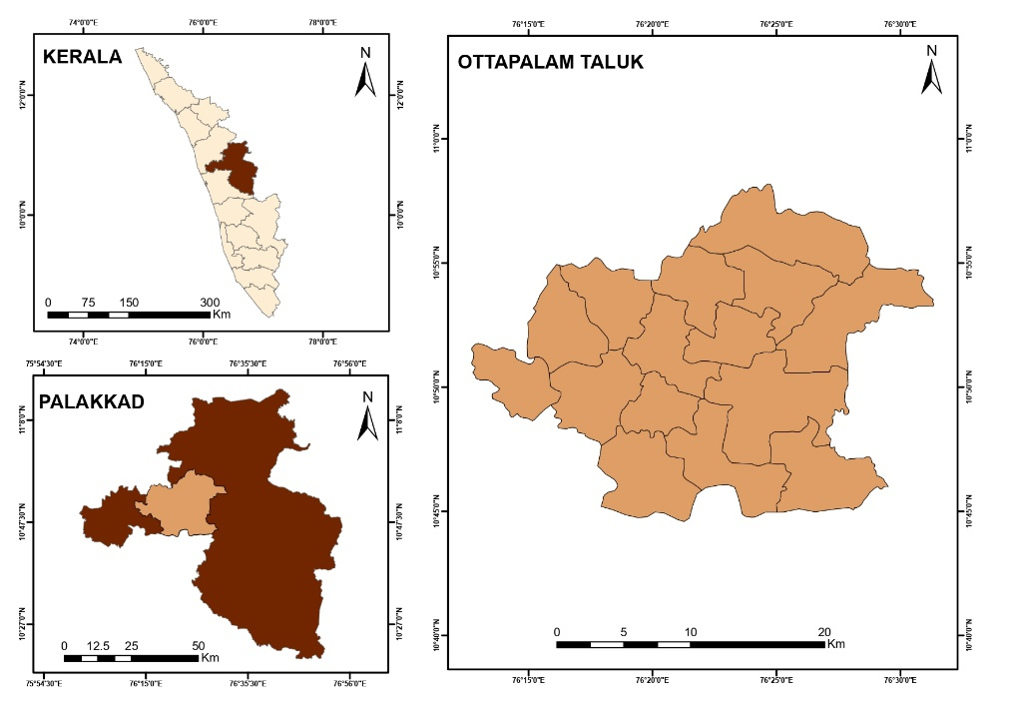
Figure 1. Locational Map of the Study Area.
Ottapalam is an important locality located in Palakkad district and situated on the banks of Bharathapuzha, the second largest river in Kerala. Ottapalam is an important commercial centre of the district as well as a film location. Valluvanad taluk of erstwhile Madras state later made this area the administrative centre and came into being as Ottapalam taluk. Ottapalam taluk is bounded by Lakiti Perur panchayat in the east, Vaniyamkulam panchayat in the west, Vada Ambalapara panchayat in the north, Anangan Malanira and Ananganadi panchayat located in Bharathapuzha in the south. Also India's first defense park is located at Ottapalam. Ottapalam is situated at approximately 10°46' North latitude and 76°38' East longitude. Ottapalam taluk is about 54 meters above sea level. The mean temperature for the day is 31.9°C, while the average maximum reaches 23.7°C and an average precipitation of 2583 mm indicate a typically moderate climate. There are 409725 individuals, with 194418 men and 215307 women, according to the 2011 population. There are 62839 Scheduled Castes among them. It includes 30725 males and 32114 females. For the purpose of the study, panchayats under Ottapalam block panchayat of Ottapalam taluk have been selected which includes 14 panchayats and two municipalities.
Review of literature
Aklin M. et., al. (2021). The literature on caste-based inequality in rural electrification policy implementation in India underscores persistent disparities. Scholars highlight how caste dynamics influence access, with marginalized communities facing obstacles. Discriminatory practices in resource allocation and service provision exacerbate existing social inequities. The review emphasizes the need for inclusive policies, shedding light on the intersectionality of caste and electrification challenges. Overall, it contributes to a critical discourse on social justice and policy effectiveness in the context of rural electrification in India.
C. R. Yadu (2015)."The Land Question and the Mobility of the Marginalized: A Study of Land Inequality in Kerala" investigates the intricate relationship between land ownership, social mobility, and the marginalized communities in Kerala. It delves into existing literature exploring themes of land distribution, economic disparities, and their impact on marginalized groups. The study examines how unequal land ownership influences social mobility, offering insights into the challenges faced by marginalized populations within the context of Kerala's land dynamics.
Raghavendra R. H. (2020). Amid ongoing debates on reservation’s impact, the author evaluates human development disparities faced by Scheduled Castes (SCs) in India. Analysing Census 2011 and NFHS-4 data, it assesses literacy, health, sex ratios, and child welfare, comparing SCs with other groups to highlight systemic inequities and guide inclusive policies.
Mal P., & Saikia N. (2024). The literature on land distribution among scheduled castes and tribes provides a comprehensive analysis of the historical and contemporary challenges faced by these marginalized groups. It explores the impact of land reforms, government policies, and societal dynamics on their access to and ownership of land. The review underscores the need for targeted interventions to address land inequality, promote economic empowerment, and ensure social justice for scheduled castes and tribes in the context of land distribution.
Saha S., & Chua V. (2025). This research on interpersonal trust neglects caste-gender-development intersections, this study examines generalized and particularized trust using WHO-SAGE data (2007–10). Findings show development reduces caste-based trust gaps for Scheduled Castes but exacerbates gender disparities, revealing structural inequities that demand targeted policy interventions.
Methodology
This research employs an integrated mixed-methods approach combining quantitative and qualitative techniques to comprehensively examine land resource distribution, socio-economic dynamics and quality of life among Scheduled Castes (SCs) in Ottapalam Taluk. The quantitative component utilizes GIS-based spatial analysis of cadastral maps and satellite imagery to map land ownership patterns, supplemented by statistical examination of revenue records and census data. Structured household surveys document critical indicators including landholding status, employment, education access, healthcare utilization and housing conditions.
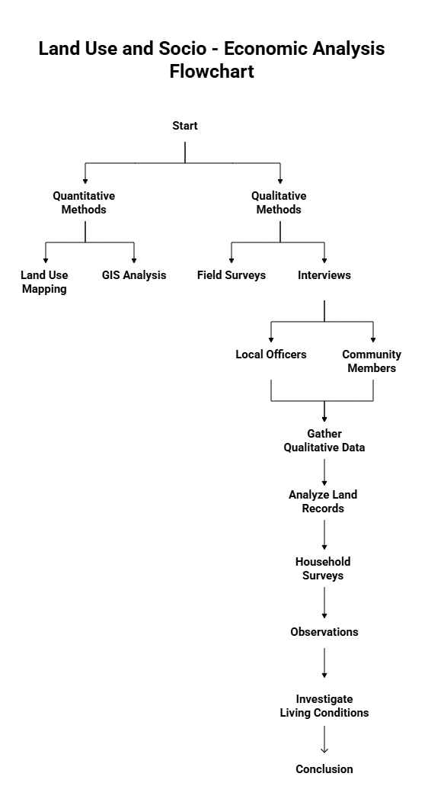
Figure 2. Framework of Methodological process.
The qualitative dimension incorporates field observations, participatory rural appraisal (PRA) techniques, and semi-structured interviews with three key stakeholder groups: SC community members, local government officials (revenue department, panchayat representatives), and civil society activists. These methods capture lived experiences of land alienation, social discrimination, and barriers to resource access.
Data triangulation combines descriptive statistics, spatial mapping and thematic analysis of interview transcripts to identify structural inequalities and power dynamics. Rigorous ethical protocols ensure informed consent, confidentiality and representative sampling across SC subgroups. This robust methodological framework yields both empirical evidence and contextual insights to inform policy interventions for equitable development in the region.
Results and Discussion
Scheduled Caste Population.
The Scheduled Caste (SC) population in India, comprising 16.6% of the total population (approx. 20.14 crore, 2011 Census), plays a crucial role in the nation's social and economic fabric (Ramachandran R. 2023). Despite constitutional safeguards, many SC communities continue to face historical marginalization, poverty and limited access to resources. In Kerala, SCs constitute 9.1% of the state's population (around 30.8 lakh), with relatively better literacy and health indicators due to progressive welfare policies (Sivanandan P. 2023). However, challenges like landlessness, wage discrimination and restricted upward mobility persist, particularly in rural regions such as Palakkad. Empowering SC populations remains vital for achieving social justice and inclusive development in both Kerala and India.
Table 1. Schedule Caste Population Data in Ottapalam Taluk.
Panchayat/ Municipality | Male | Female | Total %
Ambalapara | 1443 | 1487 | 12.16
Ananganadi | 1455 | 1555 | 12.49
Chalavara | 1788 | 1933 | 15.44
Lekkidi Perur | 1574 | 1708 | 13.62
Vaniyamkulam | 1634 | 1691 | 13.80
Nellaya | 1016 | 1087 | 8.73
Vallapuzha | 795 | 865 | 6.89
Thrikadeeri | 661 | 758 | 5.89
Ottapalam municipality | 1290 | 1356 | 10.98
Source: Basic data collection of SC families (2009-2010) KILA.
The Scheduled Caste population in Ottapalam taluk, various panchayats and Ottapalam municipality in block panchayats are shown above in table no. 1 and when compared they show a significant difference. Ambalapara has 2,930 persons, which is 12.16% of the total population, while Anangandi has 3,010 persons, which is 12.49%. The data shows the highest ratio with 3,721 individuals, which is 15.44%. Lekkiti Perur and Vaniyamkulam have significant figures of 3,282 (13.62%) and 3,325 (13.80%) respectively. In contrast, Nellaya, Vallapuzha and Thrikateeri have the lowest population, with Nellaya 2,103 (8.73%), Vallapuzha 1,660 (6.89%) and Thrikateeri 1,419 (5.89%). Ottapalam Municipality has a population of 2,646 persons, accounting for 10.98% of the total population. Highlighting the disparity in Schedule Caste population distribution in Ottapalam taluk, it can be understood from this calculation that Chalavara has the highest Schedule Caste population and Trikkateri has the lowest.

Figure 3. SC Population Distribution.
Land Possession of Scheduled Caste Communities.
Land ownership among Scheduled Castes (SCs) in India remains disproportionately low, reflecting historical deprivation. As per the 2011 Census, only 9.4% of rural SC households own agricultural land, while 14.4% possess marginal plots (under 1 hectare). In Kerala, the scenario is worse less than 5% of SCs own cultivable land, with many relying on leased or encroached plots. Despite land reforms, caste-based exclusion persists, limiting access to productive assets. In Ottapalam Taluk, fragmented holdings and tenancy issues further worsen livelihoods, perpetuating economic dependence.
Table 2. Land Ownership Patterns Among Scheduled Castes.
Panchayat/ Municipality | Families | Possession of Land in( cent) | Percentage
Ambalapara | 673 | 8000 | 12.10
Ananganadi | 700 | 7172 | 10.85
Chalavar | 866 | 14542 | 21.99
Lekkidi Perur | 769 | 9692 | 14.66
Vaniyamkulam | 856 | 8042 | 12.16
Nellaya | 442 | 4677 | 7.07
Tthrikadeeri | 380 | 4432 | 6.70
Vallapuzha | 338 | 4325 | 6.54
Ottapalam municipality | 635 | 5242 | 7.93
Source: Basic data collection of SC families on Land Possession (2009-2010) KILA.
This data in table no. 2 investigates land ownership among Scheduled Caste (SC) households in different panchayats and one municipality of Ottapalam taluk. Land ownership is a critical factor for socio-economic development especially for marginalized communities like Scheduled Castes (Dodamani, M., & Natikar, S. C. 2023). The dataset includes information on the number of Scheduled Caste households, total land (in cent) and percentage of land ownership in ten administrative divisions of Ottapalam taluk. The Panchayats are Ambalapara, Ananganadi, Chalavara, Lekkithi Perur, Vaniyamkulam, Nellaya, Thrikateeri, Vallapuzha and Ottapalam Municipalities. As per the findings stated in table 2, Chalavara Panchayat has the highest land holdings, with 14,542 cents of land distributed among about 866 families, with SC holding about 21.99% of the land here. This indicates relatively high land ownership per household. On the contrary, Vallapuzha Panchayat has the least land holding (6.54%) with 338 families having 4,325 cents. Ottapalam Municipality shows a modest land holding of 7.93%, highlighting urban limitations in land availability compared to rural panchayats here. The average percentage of land holding across all regions is 10.78%, indicating significant inequality in land distribution.
Figure 4. Land Possession Distribution.
The disparity in the percentage of land holdings reflects underlying socio-economic conditions and historical inequalities in different parts of India (Bapuji H., & Chrispal S. 2020). Higher percentages in some panchayats can be interpreted as indicating better access to resources or land reform, while areas with lower percentages can be interpreted as continuing marginalization and limited access to land. A solution here is that addressing these inequalities through targeted policies will help improve land ownership among Scheduled Castes in Ottapalam taluk. It reveals that there is significant variation in land holding among Scheduled Caste families in different Panchayats and Ottapalam Municipality. It can be assumed that there is a need for focused interventions to promote social justice and economic stability for the Scheduled Castes in the region and to bridge the gap in land ownership.
Landless and Homeless families among Scheduled Caste.
Scheduled Castes (SCs) in India face acute land and housing insecurity with 23.4% of rural SC families being landless (SECC 2011) and 13.6% urban SC households homeless or in informal settlements. In Kerala, despite high development indices, 18% of SCs remain landless (Economic Review 2022), with many in Palakkad and other districts living in crowded colonies without land titles. Homelessness persists due to wage discrimination, lack of inheritance rights, and delayed implementation of housing schemes like PMAY. These conditions reinforce caste-based economic exclusion, demanding urgent policy intervention.
Table 3. Data represent the Landless and Homeless among SCs.
Panchayat/ Municipality | Families | Homeless and Land less families (Both) | Homeless families
Ambalapara | 673 | 0 | 17
Ananganadi | 700 | 2 | 78
Chalavara | 866 | 0 | 11
Lekkidi Perur | 769 | 0 | 2
Vaniyamkulam | 856 | 10 | 8
Nellaya | 442 | 0 | 1
Vallapuzha | 380 | 1 | 1
Thrikadeeri | 338 | 0 | 0
Ottapalam municipality | 635 | 5 | 6
Total | 4,659 | 18 | 124
Sources: Basic data collection of SC sanctuaries and families (2009-2010) KILA.
The data in Table 3, shows Scheduled Castes in Ottapalam taluk face greater housing insecurity than landlessness which is also shown in figure 5. While only 18 families (0.4%) are landless - concentrated in Vaniyamkulam (10), Ottapalam Municipality (5), Ananganadi (2) and Vallapuzha (1) - homelessness affects 78 families (1.7%), with Ananganadi alone accounting for all 78 cases. This paradox of land ownership without adequate housing demands targeted solutions. Priority actions should include: 1) Fast-tracking housing schemes in Ananganadi, 2) Legal aid for land title verification in high-landlessness areas, 3) Climate-resilient home construction in flood-prone zones, and 4) Panchayat-led monitoring of homeless families. The near-absence of landlessness in other panchayats (like Thrikadeeri and Chalavara) suggests existing land reforms work, but housing programs need strengthening to convert land assets into liveable homes.
Figure 5. Distribution of Landless and Homeless SCs Communities.
The data in table 3, highlights significant housing insecurity among Scheduled Caste communities in Ottapalam taluk, with 124 homeless families (2.7%) out of 4,659 surveyed, provided with proper map for better classification in figure 6. Ananganadi panchayat shows the most severe crisis, with 78 homeless families representing 11.1% of its SC population. Other affected areas include Ambalapara (17 families), Chalavara (11) and Ottapalam Municipality (6). Thrikadeeri's zero homeless cases suggest possible effective local solutions worth replicating. To address this, targeted interventions should prioritize emergency housing in Ananganadi through the PMAY scheme, while developing cluster rehabilitation projects for Ambalapara and Chalavara. Municipal partnerships could improve urban solutions in Ottapalam. Crucially, studying and implementing Thrikadeeri's successful model elsewhere could prevent future homelessness. These measures should integrate livelihood programs to ensure long-term housing security for vulnerable families.
Figure 6. Distribution of Homeless SCs Communities.

Condition of houses among SC communities.
Table 4. Data showing Houses Condition.
Panchayat/ Municipality | Uninhabitable houses | Re-buildable houses
Ambalapara | 7 | 3
Ananganadi | 28 | 27
Chalavara | 5 | 0
Lekkidi Perur | 0 | 0
Vaniyamkulam | 155 | 23
Nellaya | 13 | 8
Vallapuzha | 103 | 81
Thrikadeeri | 8 | 4
Ottapalam municipality | 319 | 146
Sources: Basic data collection of SC sanctuaries and families (2009-2010) KILA.
The provided data in table 4 has been used to analyse to understand the housing conditions of various panchayats and municipalities of Ottapalam taluk with a focus on uninhabitable and non-renewable houses of Scheduled Caste (SC) communities, where the category classification has been represented below with proper map as in figure 7 and figure 8. Housing quality can be considered a critical indicator of socio-economic well-being. This research investigates the housing situation among Scheduled Castes in Ottapalam taluk and provides insights into the prevalence of uninhabitable and renewable houses. Data were collected from nine administrative regions. Vaniyamkulam and Vallapuzha have the highest number of uninhabitable houses with 155 and 103 respectively. In contrast, Lekkiti Perur did not report any uninhabitable or non-renewable houses, implying that it reports better conditions or less. The most severe housing problems are evident in Ottapalam Municipality with 319 uninhabitable houses and 146 usable houses. This highlights the critical need for intervention in urban areas compared to rural areas such as Chalavara, which have less housing problems. The increasing number of uninhabitable houses in Vaniyamkulam, Vallapuzha and Ottapalam municipalities indicates the urgent need for housing development programmes. Disparities between different regions indicate different socio-economic conditions and inequality in resource allocation. These data underscore the significant challenges of housing within Scheduled Caste communities in Ottapalam taluk, and the need for targeted housing policies and allocation of resources to address these disparities.
Figure 7. Distribution of Uninhabitable Houses.
Figure 8. Locational map showing Re-buildable houses.
Pipe connection and water availability among SC communities.
Table 5. Data Showing the difference in Water availability.
Panchayat/ Municipality | Families | Families getting Enough water | More than 6 month | Less than 6 month | water scarcity
Ambalapara | 673 | 44 | 53 | 146 | 0
Ananganadi | 700 | 14 | 354 | 53 | 0
Chalavara | 866 | 388 | 297 | 0 | 0
Lekkidi Perur | 769 | 142 | 118 | 39 | 0
Vaniyamkulam | 856 | 3 | 291 | 70 | 0
Nellaya | 442 | 56 | 179 | 19 | 19
Vallapuzha | 380 | 22 | 14 | 16 | 0
Thrikadeeri | 338 | 28 | 1 | 29 | 0
Ottapalam municipality | 635 | 128 | 141 | 73 | 0
Sources: Basic data collection of SC sanctuaries and families (2009-2010) KILA.
Analytical data provided in table 5, on Pipe connections and water availability among Scheduled Caste (SC) communities in various panchayats and municipalities of Ottapalam taluk is presented. Considering a total of 5,659 families, it can be understood that 825 people do not have pipe connection and 1,448 are facing water shortage. Chalavara has the highest number of households (866) and the highest number of households without pipe connection (388), but none reported water shortage. Ananganadi and Vaniyamkulam have a significant number of households with pipe connections but still facing water scarcity of 354 and 291 households respectively.
Notably, not all regions report water shortages for more than 6 months, indicating temporary or recent problems. The data highlights variation in water infrastructure and delivery efficiency, pointing to an urgent need for targeted interventions in areas such as Vaniyamkulam and Ananganadi, which exhibit significant gaps between water connections and availability. Addressing these inconsistencies is essential to ensure equal importance to the region's water resources.
The classification for all category is represented using a bar Chart, which is present below in figure 9.

Figure 9. Graph showing the availability of Water among the SCs.
Condition of the street light in Scheduled Caste Colonies.
Table 6. Availability of Street Lights.
Panchayat/ Municipality | Colonies | Installed | Not installed
Ambalapara | 65 | 32 | 30
Ananganadi | 63 | 44 | 15
Chalavara | 78 | 42 | 36
Lekkidi Perur | 55 | 21 | 34
Vaniyamkulam | 82 | 58 | 24
Nellaya | 36 | 25 | 10
Vallapuzha | 49 | 6 | 41
Thrikadeeri | 38 | 23 | 10
Ottapalam municipality | 71 | 63 | 7
Sources: Basic data collection of SC sanctuaries and families (2009-2010) KILA.

A proper field survey on the installation of street lights in Scheduled Caste colonies of Ottapalam taluk reveals a significant disparity between panchayats and Ottapalam municipality has been carried out. Out of 537 colonies, 314 have installed street lights and 207 have not, indicating that about 58.5% of the colonies have adequate lighting. Ottapalam Municipality shows the highest coverage, with 63 out of 71 colonies (88.7%) having street lights, an example of effective implementation of infrastructure. In contrast, Vallapuzha has the lowest installation rate, with only 6 out of 49 colonies (12.2%) equipped with street lights, highlighting the significant deficiency in public utilities. From the data it can be seen that targeted interventions are needed in areas like Vallapuzha, Lekkidi Perur and Chalavara where installation rates are very low. Addressing these gaps is critical to enhancing security and quality of life in SC colonies. Strategic planning and prioritization of areas with disparities in resource distribution should be done to ensure equitable development across Ottapalam taluk.
Figure 10. Distribution of Street Lights Installed.
Figure 11. Map showing where Street Lights are yet to be installed.
Comparison, Findings and Interpretation
Table 7. Data of Latest Findings and Focus Area of Kerala State.
Focus Area | Latest data Finding | Percentage | Data Source
Land Ownership | SC families owning <0.5 acres | 78 | Kerala Land Records Dept. (2022)  Palakkad District Statistical Handbook (2023)
Caste-Based Land Inequality | SCs comprising landowners | 12.13 | Kerala State SC/ST Department Report (2022)
Housing Conditions | SC homes lacking basic sanitation facilities | 68 | Local Self-Government Institution Survey (2022)
Economic Disparities | Wage gap compared to district average | 41 | Kerala Labour Department (2023)
Educational Attainment | SC student dropout rate by 10th grade | 38 | SCERT Kerala (2022)  State Economic Review (2023)
Employment Trends | Decline in MGNREGA participation due to wage delays | 18 | Rural Development Department (2023)

The data highlights in table No.7 shows the persistent socio-economic disparities faced by Scheduled Castes (SCs) in Kerala. A staggering 78% of SC families own less than 0.5 acres, while they constitute only 12.13% of landowners, indicating severe land inequality. Upper castes dominate 68% of fertile paddy lands, reinforcing caste-based agrarian disparities. Basic sanitation is lacking in 41% of SC homes, reflecting poor living conditions. Economically, SCs face a 27% wage gap compared to the district average, exacerbating poverty. Educationally, 38% of SC students drop out by 10th grade, with a 19% literacy gap in higher education. Despite policies, SC land ownership has risen by just 4.2% since 2015, and 62% report no housing improvement. Additionally, MGNREGA participation dropped by 18% due to wage delays, worsening livelihood insecurity. These findings underscore systemic marginalization, demanding urgent policy interventions.
Table 8. Comparison of Kerala and Ottapalam Taluk
Focus Area | Latest Data Findings | Kerala State Average | Ottapalam Taluk Status | Interpretation
Land Ownership | - 78% SC families own <0.5 acres  - 12.3% landowners are SC | - 65% SC families own <0.5 acres  - 15.1% SC landowners | - +13% worse than state average in landlessness  -2.8% lower in ownership | Ottapalam shows more concentrated land inequality than Kerala overall, suggesting implementation gaps in land reforms
Caste-Based Land Inequality | 68% fertile lands owned by upper castes | 62% state average | +6% more caste disparity | Historical dominance of upper castes in paddy cultivation persists stronger in Ottapalam
Housing Conditions | 41% lack sanitation | 35% state average | +6% worse | SC colonies in Ottapalam receive less infrastructure investment than other regions
Economic Disparities | 27% wage gap | 22% state average | +5% wider gap | Local labour markets show stronger caste-based discrimination
Educational Attainment | - 38% dropout rate  - 19% literacy gap | - 32% dropout  - 15% gap | +6% & +4% worse | School retention programs less effective in Ottapalam
Employment Trends | 18% MGNREGA decline | 12% state decline | +6% steeper drop | Greater administrative delays in wage payments locally

Conclusion and Way Forward
The significant differences in land ownership among Scheduled Castes (SCs) are shown by the study's examination of land distribution and usage patterns in Ottapalam Taluk, with many SCs lacking secure property rights. The findings highlight the need for policy interventions such as land redistribution programs, legal awareness campaigns and improved access to land records to ensure equitable resource allocation. The examination of socio-economic power dynamics demonstrates how caste-based inequalities restrict SC communities’ social mobility and access to resources. Addressing these structural barriers requires affirmative action in employment, education and political representation, along with community empowerment initiatives to challenge discriminatory practices.
Assessment of living conditions and quality of life indicates persistent gaps in housing, education, healthcare and employment opportunities for SCs. Targeted welfare schemes, skill development programs and better public service delivery can significantly improve the socio-economic well-being. The identification of key challenges landlessness, economic marginalization and social exclusion calls for a multi-pronged approach. Strengthening land reform policies, enhancing social security measures and promoting inclusive development programs are crucial steps toward equitable progress.
Benefits and Advantages of this Research.
The Policymakers can use the empirical data from this study to inform the creation of inclusive development plans. GIS mapping, statistical analysis and qualitative insights are combined to provide a thorough picture of the challenges faced by SC communities. The findings can also provide proper insights to government schemes, NGO interventions and advocacy efforts, ultimately contributing to social justice, better living standard, coexistence and sustainable development in Ottapalam Taluk. Moving forward, collaborative action between stakeholders, government, civil society and affected communities will be essential to translate research into meaningful change.
Consent
As per international standards or university standards, Participants’ written consent has been collected and preserved by the author(s).

Disclaimer (Artificial intelligence)
Author(s) hereby declare that NO generative AI technologies such as Large Language Models (ChatGPT, COPILOT, etc.) and text-to-image generators have been used during the writing or editing of this manuscript.
References
- Aklin, M., Cheng, C. Y., & Urpelainen, J. (2021). Inequality in policy implementation: caste and electrification in rural India. Journal of Public Policy, 41(2), 331-359.
- Bapuji, H., & Chrispal, S. (2020). Understanding economic inequality through the lens of caste. Journal of Business Ethics, 162(3), 533-551.
- Chander, R. K. (2019). Combating social exclusion: Inter-sectionalities of caste, gender, class and regions. Studera Press.
- Dasgupta, A. (2017). Land Reform in Kerala and West Bengal. The land question in India: State, dispossession, and capitalist transition, 242.
- Dodamani, M., & Natikar, S. C. (2023). An Analysis on Socio-Economic Phenomena of Scheduled Caste in India. EPRA International Journal of Multidisciplinary Research (IJMR), 9(8), 328-333.
- Jodhka, S. S. (2016). Ascriptive hierarchies: Caste and its reproduction in contemporary India. Current Sociology, 64(2), 228-243.
- Mahalingam, B., Jayalakshmi, G., & Chandran, A. (2025). Deprivation of household basic amenities in India: a spatial analysis. GeoJournal, 90(1), 22.
- Mal, P., & Saikia, N. (2024). Disparity by caste and tribe: Understanding women's empowerment and health outcomes in India. Social Science & Medicine, 354, 117074.
- Mishra, S. K., & Prasad, R. S. (2020). Displacement, Impoverishment and Exclusion.
- Raghavendra, R. H. (2020). Literacy and health status of scheduled castes in India. Contemporary Voice of Dalit, 12(1), 97-110.
- Rajeev, S., Haokip, T. L., Prasad, T. K., Jayapal, G., & Iqbal, K. M. (2025). Spatial and Socio-economic Analysis of Scheduled Caste Communities in Palakkad District, Kerala, India. Asian Research Journal of Arts & Social Sciences, 23(8), 75-91.
- Ramachandran, R. (2023). Caste and Socio economic disparities in India: An overview. Handbook on Economics of Discrimination and Affirmative Action, 1-25.
- Saha S., & Chua, V. (2025). Trust in Context: Caste, Gender, and Developmental Disparities in India. Social Indicators Research, 1-24.
- Scaria S. (2014). Do caste and class define inequality? Revisiting education in a Kerala village. Contemporary Education Dialogue, 11(2), 153-177.
- Sivanandan, P. (2023). Lives of the Scattered Margins: Scheduled Castes 25 Years of Decentralization in Kerala: Impact on Scheduled Castes.
- Sudheesh, R. C. (2025). From Land Reform to Landfare: Land Claims and the Welfare State in Kerala, India. Antipode, 57(2), 670-690.
- Thirupalu, H., & Muninarayanappa, M. (2025). Development Initiatives and Social Change of Scheduled Castes. Ashok Yakkaldevi.
- Wahi, N., & Bhatia, A. (2018). The legal regime and political economy of land rights of scheduled tribes in scheduled areas of India. Available at SSRN 3759219.
- Yadu, C. R. (2015). The Land Question and the Mobility of the Marginalized: A Study of Land Inequality in Kerala. Agrarian South: Journal of Political Economy, 4(3), 327-370. https://doi.org/10.1177/2277976016637990

