Aligning Learning and Communication Styles: Enhancing Business Communication Training in Management Education

ABSTRACT
Purpose: Effective Communication Skills is vital for management professionals, yet business education often overlooks students’ diverse learning preferences. This study explores the relationship between learning styles (VARK model) and communication styles (Mark Murphy’s framework) among business management students in Mumbai to enhance instructional methods. It compares findings with five Southeast Asian case studies – Singapore, Malaysia, Indonesia, Thailand, and Vietnam – that have successfully applied these models since 2018-2022.
Objective: The objective is to examine the relationship between learning and communication style among first year undergraduate management students in Mumbai.
Research Methodology: Using a mixed-methods approach, 400 students completed the VARK and Leadership IQ-based communication style assessments. Quantitative analysis included Chi-Square, ANOVA, and Regression. Focus group discussions (n=40) offered qualitative insights.
Findings: A significant correlation was found between learning styles and communication preferences (χ² = 12.54, ρ = 0.015). Students with aligned learning and communication styles showed better academic performance (β = 0.38, ρ = 0.008) and higher confidence. Focus groups revealed that misalignment led to disengagement and lower performance in communication courses. Further, results show that learning-communication alignment boosts confidence, employability, echoing gains seen in Southeast Asian countries.
Implications: This study calls for Indian B-Schools to adopt blended, multimodal, and culturally responsive pedagogy.

Keywords: Business communication, learning styles, communication strategies, VARK model, professional education, management training, instructional strategies, multimodal learning, leadership communication, corporate training.

- INTRODUCTION
1.1 Background and Rationale
Business Communication is a foundational skill for management professionals, influencing leadership effectiveness, team collaboration, and organisational performance. Despite its importance, business education often adopts a one-size-fits-all approach to communication training, overlooking the diverse learning preferences of students. This gap between pedagogy and learner diversity can hinder students’ development in key areas such as presentations, negotiations, and interpersonal communication.
Learning styles, particularly those defined by the VARK model (Visual, Auditory, Read/Write, and Kinesthetic), shape how individuals absorb, process, and retain information. Simultaneously, communication styles – classified by Mark Murph’s framework into Analytical, Intuitive, Functional, and Personal types – determine how individuals express and interpret messages in professional contexts. Although both models are widely used, their intersection has received limited scholarly attention, especially within professional education contexts.
Given the increasingly multicultural and dynamic nature of management classrooms, there is a growing need for adaptive teaching strategies that align with students’ preferred learning and communication styles. The VARK model was selected for this study due to its diagnostic simplicity and direct implications for instructional design. Compared to other models like Kolb’s experiential framework, VARK provides immediate pedagogical relevance, making it highly suitable for business communication training.
Business Communication is vital for management graduates’ workplace readiness. While many Indian B-Schools rely on standard lectures, universities in Singapore, Malaysia, Indonesia, Thailand and Vietnam have since 2018 adopted VARK learning style diagnostics and Murphy’s communication style profiling in their teaching. These models produce graduates with higher confidence, teamwork, and cross-cultural adaptability. This study explores whether similar alignment benefits can strengthen Indian Management Education.
1.2 Context and Scope
Mumbai, as a commercial and educational hub, offers diverse student population ideal for exploring personalised approaches to communication education. This study focuses on undergraduate business management students enrolled in University of Mumbai – affiliated colleges, where Business Communication is a mandatory course. The institutional curriculum includes modules on professional writing, presentations, group communication, and negotiation – making it appropriate setting for examining how students’ learning styles influence their development of communication skills.
While Universities in Singapore, Malaysia, Indonesia, Thailand, and Vietnam have integrated bilingual, blended learning, flipped classrooms, and multi-cultural contexts frameworks since 2018, most Indian B-schools still rely on standard lecture-based delivery.
Drawing on five Southeast Asian case studies, this study demonstrates that aligning learning and communication styles significantly improves employability outcomes.
1.3 Research Gap and Contribution
Although prior research has explored learning preferences and communication strategies independently, there is a notable absence of empirical studies examining their alignment in professional education. In particular, the implications of mismatches between how students learn and how they are trained to communicate remain under-researched, especially in Indian contexts. This study addresses that gap by investigating the relationship between learning styles and communication styles and proposing pedagogical strategies that enhance communication skill acquisition in business education.
Despite considerable research on learning styles (Fleming & Mills, 1992) and communication styles (Murphy, 2018), few studies examine their alignment within modern management education in South Asia (Li & Fernandes, in Press). Recent evidence shows that multimodal alignment improves employability and digital skill transfer.
1.4 Theoretical Association with the Study
Core Theories
1. VARK Learning Styles Theory (Fleming & Mill, 1992)
- Posits that learners have preferred sensory modalities for processing information: Visual, Auditory, Read/Write, and Kinesthetic.
- Commonly used in higher education for personalized instruction design.
2. Communication Style Theory (Mark Murphy, 2018)
- Suggests that individuals express and interpret messages through dominant communication styles: Analytical, Intuitive, Functional, and Personal.
- Used in leadership and workplace communication development.
3. Cognitive Constructivism (Piaget, Vygotsky)
- Emphasizes that learners construct knowledge based on prior experience, which includes both sensory preferences and communicative approaches.
- Supports the alignment hypothesis: learners communicate most effectively when instruction matches how they internalize and externalize knowledge.
This study integrates VARK (Fleming & Mills, 1992), Murphy’s framework (2014), and recent work on blended multimodal instruction (Guo et. al. 2024), supporting a constructivist approach where learning input and communication output align for maximum skill transfer.
1.5 Research Objectives
This study aims to:
i. Examine the relationship between learning styles (VARK model) and communication styles (Mark Murphy’s framework) among first year undergraduate business management students.
ii. Identify the impact of learning – communication style alignment on business communication performance.
iii. Assess the effectiveness of multimodal teaching strategies in enhancing professional communication skills.
iv. Provide recommendations for curriculum adaptation in business communication education.
1.6 Alignment with Research Objectives
Objective | Associated Theory | Theoretical Justification
1. Examine the relationship between students’ learning styles and communication styles. | VARK + Murphy | Individuals often express (communicate) in the same modality they prefer to learn in. This assumption draws from sensory-cognitive alignment in constructivist theory.
2. Identify the impact of learning-communication style alignment on business communication performance. | VARK + Murphy + Cognitive Constructivism | Learning-performance models suggest students retain and apply skills better when instructional input and output modes are aligned.
3. Assess the effectiveness of multimodal teaching strategies. | VARK + Instructional Design Theory (2002) | Multimodal approaches address diverse learner needs and reduce style mismatch. Merill’s first principle of instruction support varied inputs for deep learning.
4. Provide curriculum recommendations for business communication education. | VARK + Murphy + Educational Development Frameworks | By grounding curriculum design in learner diversity, the study supports inclusive pedagogy – a key theme in faculty development and curriculum innovation.
Table 1. The table presents Alignment with Research Objectives
2. Literature Review
2.1 Learning Styles in Business Education
The concept of learning styles has been widely explored in educational research, particularly within higher education. Fleming & Mills (1992) introduced the VARK model, categorising learners into four types: Visual, Auditory, Read/Write, Kinesthetic. Studies indicate that when instructional methods align with students’ preferred learning styles, engagement and retention improve significantly. In the context of management education, diverse learning preferences require flexible and adaptive teaching methodologies to ensure comprehensive learning outcomes (Kolb, 2015).
Fleming & Mills’ VARK framework (1992) and Murphy’s communication styles (2018) help educators design training that aligns input (learning) and output (communication). Recent studies (Guo, & et. al. 2024) highlight the effectiveness of blended multimodal instruction.
2.2 Applied Alignment Models in Southeast Asia
- Singapore (NUS, since 2018): The National University of Singapore’s Business School launched a comprehensive blended program combining VARK assessments with Murphy’s communication style diagnostics. Methods included flipped classrooms, peer coaching, and industry-driven projects. Students received personalized feedback and practice real-world presentations, resulting in measurable improvements in client communication, team collaboration, and employability rankings.
- Malaysia (U M, since 2019): Universiti Malaya’s Faculty of Business integrates bilingual, multicultural modules that align with learning styles with communication tasks. The approach combines online content, bilingual lectures, group debates, and problem-based learning, enhancing students’ adaptability and confidence in diverse corporate contexts. Employers report that UM graduates collaborate more effectively in multicultural teams.
- Indonesia (BINUS, since 2020): BINUS University uses localized simulations, role plays, and leadership labs tailored to students’ VARK profiles and dominant communication styles. Students participate in ASEAN business competitions and cross-cultural teamwork exercises. Surveys show that graduates enter leadership roles more confidently and adapt easily to regional work environments.
- Thailand (Chulalongkorn, since 2021): Chulalongkorn’s Sasin School of Management introduced negotiation labs, industry mentoring, and cross-cultural communication workshops mapped to students’ learning preferences. Industry partners co-design modules, providing practical exposure. Graduates demonstrate stronger negotiation skills and secure roles in multinational companies.
- Vietnam (FTU, since 2022): The Foreign Trade University implements blended intercultural labs and English-medium communication training linked to VARK learning styles. Students practice pitching to international audiences, receive intercultural coaching, and engage in peer-to-peer reviews. Outcomes show marked improvements in English fluency, cross-cultural presentation skills, and job placements in multinational firms.
Together, these cases show practical outcomes that complement the theoretical literature, yet India lacks comparable large-scale adoption. “For example, the National University of Singapore uses blended VARK-based communication training since 2018, and Malaysia’s Universiti Malaya applies bilingual, style-aligned teaching (Guo, & et. al. 2024).
2.3 Communication Styles and Professional Success
Effective communication is a key determinant of success in professional settings, influencing leadership, teamwork, negotiation, and client interactions. Mark Murphy’s (2018) framework categorises communication styles into four types – Analytical, Intuitive, Functional and Personal – each playing a distinct role in workplace communication.
- Analytical Communicators: Prefer data-driven, logical explanations, making them effective in technical professions, finance, and strategic planning roles. However, they may struggle in emotionally driven discussions.
- Intuitive Communicators: Focus on high-level concepts and big-picture thinking. They thrive in leadership roles and creative industries but may overlook critical details.
- Functional Communicators: Emphasize processes, details, and structured communication, excelling in operations, project management, and systematic problem-solving.
- Personal Communicators: Prioritize relationships, emotional intelligence, and interpersonal engagement, making them effective in HR, customer relations, and negotiation-based roles.
Studies indicate that employees who understand their dominant communication style and adapt it to different professional situations demonstrate higher workplace effectiveness (Men &, et. al., 2020). Business education should therefore incorporate communication style awareness to enhance students’ adaptability in corporate environments.
2.4 Theoretical Link between Learning and Communication Styles
The intersection between learning styles (VARK model) and Communication strategies (Mark Murphy’s framework) is grounded in cognitive and educational psychology. Learning theories suggest that individuals’ process and express information in ways that align with their cognitive strengths, influencing how they communicate in professional settings.
- Visual Learners & Analytical Communicators: Visual learners prefer diagrams, charts, and structured data, aligning with the systematic, detail-oriented nature of analytical communication.
- Auditory Learners & Intuitive Communicators: Auditory learners absorb information best through discussions and storytelling, complementing intuitive communication’s high-level conceptual approach.
- Read/Write Learners & Personal Communicators: Read/Write learners excel in textual interpretation and written expression, often favouring personal communication styles that rely on thoughtful discourse and individualized messaging.
- Kinesthetic Learners & Functional Communicators: Kinesthetic learners prefer hands-on experiences, closely mirroring functional communication’s process-driven, action-oriented nature.
Research in business education (Mitchell et. al., 2015), suggests that students who develop communication skills aligned with their learning styles exhibit better comprehension, engagement, and performance in workplace communication tasks. This theoretical framework underscores the importance of personalized business communication training.
2.5 Gaps in Existing Research
Despite extensive studies on learning styles and communication strategies, there are several gaps in the existing literature, particularly concerning business education:
i. Limited Research on Learning-Communication Style Alignment: While studies exist on learning preferences (Fleming & Mills, 1992) and communication strategies (Murphy, 2018), few have explored their intersection in business education training.
ii. Lack of Empirical Data in Business Education: Most studies on learning styles focus on general education rather than professional communication training. There is a need for empirical studies examining how learning styles influence real-world business communication skills.
iii. Absence of Adaptive Pedagogical Models: Existing business curricula rely heavily on standard communication training without accounting for individual learning preferences, leading to disengagement and ineffective skill development.
iv. Minimal Focus on Workplace Applications: Research rarely extends beyond academic settings to analyse how learning-communication style alignment impacts professional success in leadership, negotiations, and corporate communication.
v. Need for Culturally Diverse Perspectives: Given Mumbai’s multicultural landscape, further research is required to examine how cultural backgrounds influence learning and communication style preferences in global business environments.
Addressing these gaps will contribute to the development of more effective business communication curricula, enhancing student’s adaptability and professional success.
2.6 Critique of VARK and Communication Style Theories
With the VARK and communication style models offer accessible frameworks for understanding learner and communicator diversity, both have drawn critical scrutiny in academic literature regarding their theoretical robustness, empirical validity, and practical applications in educational settings.
Critique of the VARK Model: The VARK model, introduced by Fleming and Mills (1992), has been widely embraced in educational contexts for its straightforward categorization of learners into Visual, Auditory, Read/Write, and Kinesthetic types. However, critics argue that the model oversimplifies the complexities of cognitive processing and ignores the dynamic, context-dependent nature of learning.
- Lack of empirical support: Several meta-analyses, including Pashler et. al. (2008), found insufficient evidence to support the “meshing hypothesis” – the idea that matching instructional style of learning preference improves learning outcomes.
- Fixed Categorisation Issues: VARK treats learning preferences as relatively stable traits, whereas cognitive research emphasizes the fluidity and adaptability of learning strategies based on task, motivation, and context (Coffield, et. al., 2004).
- Limited Scope: The model focuses on sensory modalities rather than deeper cognitive or emotional dimensions of learning, limiting its use is designing complex, higher-order learning experience.
Nonetheless, VARK remains popular among educators due to its practical utility in initiating reflection and adaptation in instructional design. This study adopts VARK not as a prescriptive diagnostic tool but as a heuristic framework for exploring diversity in communication training.
Critique of Mark Murphy’s Communication Style Framework: Mark Murphy’s classification of Communication Styles – Analytical, Intuitive, Functional, and Personal – offers valuable insights into workplace communication dynamics. However, its application in academic research and instruction is also limited by several factors:
- Limited Peer-reviewed Validation: Murphy’s framework originates from leadership coaching literature and has limited empirical validation in academic research compared to models like DISC or MBTI (McCroskey & Richmond, 1996).
- Contextual Bias: The model was developed in corporate environments and may not fully account for cultural, linguistic, or generational variations in communication behaviour, which are particularly relevant in diverse educational contexts like Mumbai.
- Potential for Overgeneralization: Like VARK, Murphy’s model risks pigeonholing individuals into fixed categories, potentially ignoring the role of situational adaptability, emotional intelligence, and interpersonal nuance.
Despite the critiques, Murphy’s model provides a pragmatic lens for business education, where students must prepare for real-world communication in varied roles and environments. This study employs the framework as a starting point to assess students’ communication preferences and their interaction with learning styles, rather than as a definitive typology.
Integrative Perspective: While both models have limitations, their combined application provides a novel pedagogical lens through which to explore instructional alignment in business education. By examining the interplay between learning styles and communication strategies, this study seeks to move beyond categorical diagnosis toward adaptive and responsive pedagogy that addresses learner diversity while building communicative competence for the workplace.
2.7 Research Hypotheses
The following hypotheses were tested:
- H1: There is a significant association between students’ learning styles and their preferred communication styles.
- H2: Students whose learning and communication styles are aligned perform better in business communication courses.
- H3: The integration of multimodal instructional strategies improves students’ professional communication competency.
- H4: Learning – Communication style alignment predicts higher confidence levels in workplace -related communication tasks.
2.8 Hypotheses Supported by the Theories
H1: Learning and communication styles are related – based on sensory processing overlap (VARK) and communication style (Mark Murphy).
H2: Aligned learners perform better – supported by constructivist and experiential learning theories.
H3: Multimodal strategies improve communication - grounded in differentiated instruction theory.
H4: Alignment predicts confidence – linked to Bandura’s self-efficacy theory, which is influenced by success experiences tied to learning-fit.
2.9 Gaps in Indian Context/South Asian Business Education
Although global research on learning styles and communication strategies has been extensive, studies contextualised in Indian or South Asian Business Education remain sparse. This geographic gap is particularly significant given the region’s socio-cultural diversity, multilingual classrooms, and rapidly evolving educational models.
Lack of Empirical Research in Business Communication Curricula: Most Indian business schools emphasize technical proficiency and rote-based assessment methods, often relegating communication skills to peripheral status. Few empirical studies have assessed how communication pedagogy aligns with students’ learning preferences in undergraduate or postgraduate programmes. Notably, curricular guidelines provided by Indian Universities rarely incorporate differentiated instruction or multimodal teaching strategies.
Cultural and Linguistic Diversity Overlooked: In multilingual and multicultural settings like Mumbai, communication is not just a cognitive skill but also a culturally embedded practice. Yet, current instructional models are heavily standardised, ignoring how regional and cultural backgrounds shape students’ learning and communication behaviours. There is limited research addressing how cultural-linguistic diversity interacts with learning style preferences and communication development in Indian business classrooms.
Gaps in Linking Learning-Communication Alignment to Employability: There is also a lack of research connecting learning-communication style alignment with employability outcomes, such as workplace communication readiness, confidence in professional settings, or adaptability in diverse teams. As Indian management graduates increasingly enter globalised workspaces, this disconnect creates a significant pedagogical blind spot.
This study addresses these gaps by providing quantitative and qualitative data from Indian undergraduate business students and exploring how instructional alignment can improve both academic and professional communication competencies.
2.10 Theoretical Model Proposed by this Study
To operationalize the intersection of learning styles and communication strategies in business education, this study proposes an Integrated Alignment Model (IAM) that connects sensory learning preferences (VARK) with cognitive-communicative expression styles (Murphy), mediated through instructional and contextual factors.
Core Constructs of the Model
- Learning Style (Input Orientation)
- How students best receive, process, and retain information (Visual, Auditory, Read/Write, Kinesthetic).
- Communication Style (Output Orientation)
- How students prefer to express, structure, and convey information (Analytical, Intuitive, Functional, Personal)
- Instructional Strategy (Mediator)
- The pedagogical methods employed (example, lectures, case studies, role plays, digital media) that either bridge or block learning-communication alignment.
- Contextual Factors (Moderators)
- Cultural background, language proficiency, academic year, and instructional curriculum that influence the effectiveness of alignment.
- Outcomes
- Business communication proficiency, classroom engagement, professional confidence, and adaptability in corporate environments.
Alignment Hypothesis
The closer the alignment between a students’ learning style and communication style, mediated by adaptive instructional strategies, the higher their performance and confidence in business communication tasks.
This model provides a testable and scalable framework for improving curriculum design in Indian business schools and contributes to the global discourse on differentiated education in professional programmes.
2.11 Integrated Alignment Model (IAM): A Theoretical Synthesis
- IAM bridges learning (VARK) and communication (Mark Murphy) styles using the lens of instructional mediation and contextual moderation (culture, language, curriculum).
- It aligns with socio-constructivist educational development models, where educators are co-responsible for adjusting pedagogy to meet learner needs and workplace expectations.
Figure 1: Integrated Alignment Model
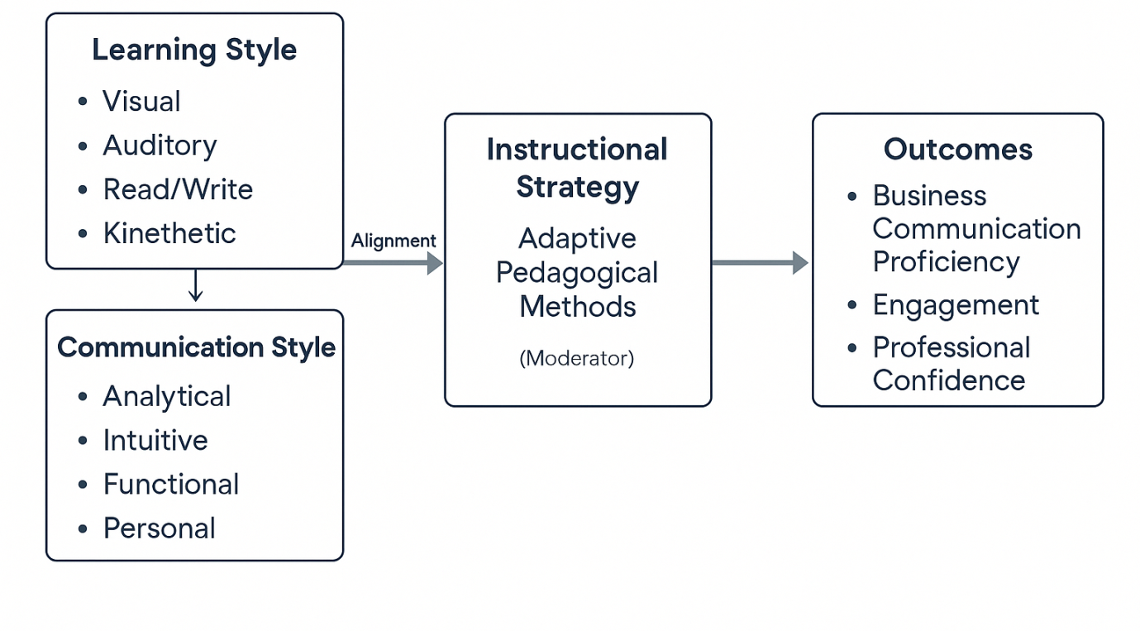
Source: Self-created
2.12 Implications grounded in Theory
- Curriculum redesign should consider sensory input and expressive output balance, not just content.
- Educators need to recognise that communication development is influenced by how students learn, not just what they are taught – reflecting an integrated cognitive-affective model of teaching.
- Faculty development should integrate theory-informed tools (example, learning-communication alignment diagnostics) to enhance instructional impact.
Figure: 2 Aligning Learning and Communication Styles: Enhancing Business Communication Training in Management Education
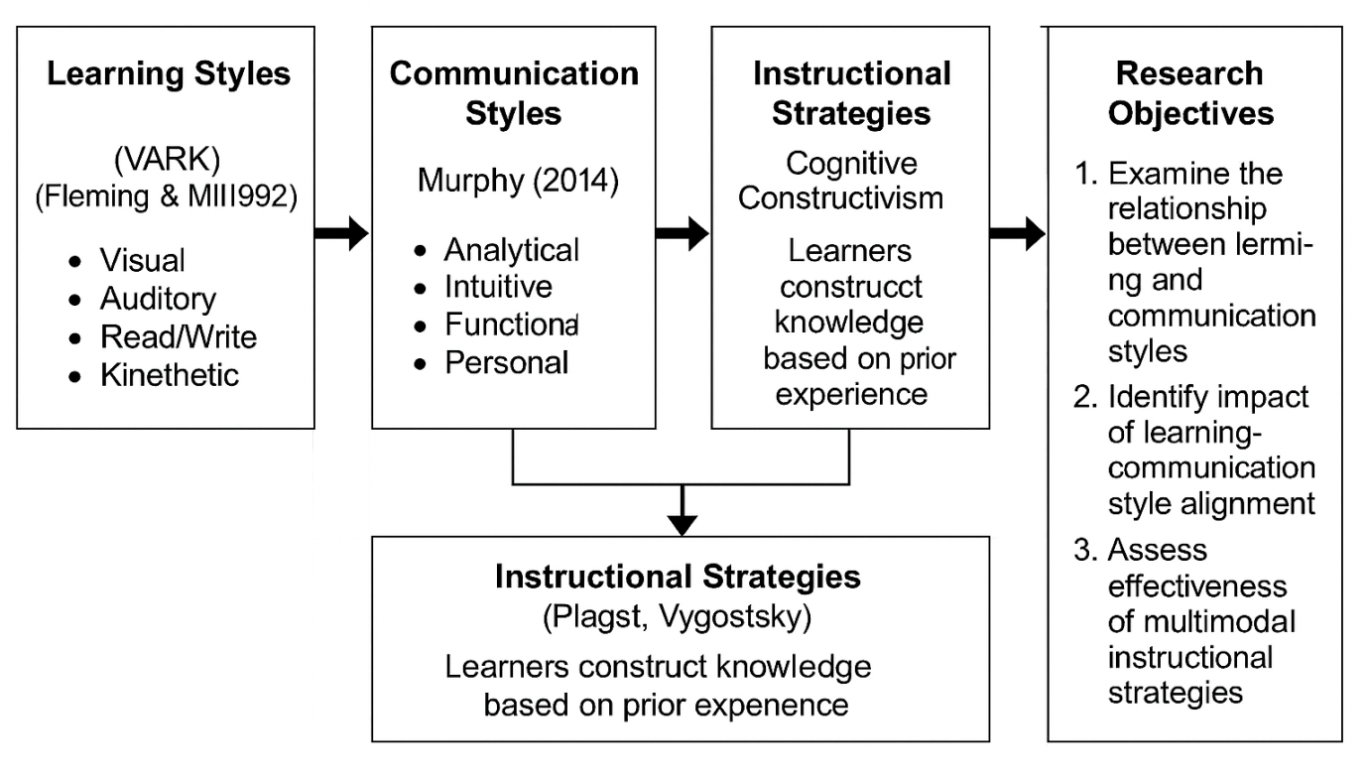
Source: Self-created
3. Research Methodology
3.1 Methodology based on Theory
- VARK Questionnaire: Used to categorize learner preferences based on Fleming’s theory.
- Murphy’s Communication Style Quiz: Assesses expressive tendencies in alignment with personality-driven communication preferences.
- Focus Groups: Guided by constructivist principles that learning and meaning are co-constructed through dialogue and experience.
- Mixed-methods Approach: Justified by the need to explore both quantitative patterns of alignment and qualitative insights into learning experiences.
- The five Southeast Asian cases served as contextual benchmarks to interpret India’s results.
3.2 Research Design
This study employs a sequential explanatory mixed-methods research design to integrate quantitative breadth with qualitative depth. The research unfolds in two phases:
- Phase 1 (Quantitative): Surveys were administered to identify students’ dominant learning styles using the VARK questionnaire and their communication preferences via the Leadership IQ Communication Style assessment. Statistical tools were used to examine correlations, differences, and predictive relationships.
- Phase 2 (Qualitative): Focus Group Discussions (FGDs) were conducted with a stratified sample of 40 students to gather experiential insights into the challenges of mismatched learning and communication styles, thereby deepening the interpretation of the quantitative findings.
This design ensures both empirical rigor and contextual understanding, making the results more actionable for educational institutions.
3.3 Sample Population
The study surveyed 400 undergraduate students enrolled in the Bachelor of Business Management Studies (B.M.S) program at Mumbai – based Institutions affiliated to University of Mumbai. The sample included students from semesters I to IV. Participants were selected using stratified random sampling to ensure proportional representation across learning styles.
  - Data Collection Methods
- Instruments
- VARK learning style inventory (Fleming & Mills, 1992)
- Communication style self-assessment (adapted from Mark Murphy’s Leadership IQ-framework.)
- Qualitative Tools
- Focus Groups Discussions with 40 students across all VARK categories to explore instructional preferences and communication challenges.
- Secondary data on five Southeast Asian programmes provided contextual benchmarks for interpreting Indian student results.
3.5 Data Analysis Techniques
- Chi-Square Test: To evaluate the statistical associations between learning and communication styles.
- ANOVA: To assess differences in business communication performance across aligned and non-aligned groups.
- Regression Analysis: To determine the predictive value of learning-communication style alignment on academic outcomes and confidence levels.
- Thematic Analysis: To code and interpret insights from FGDs, providing a qualitative validation of quantitative results.
4. Statistical Validation
- Chi-Square Analysis (χ2 = 12.54, ρ = 0.015): This test was used to determine the relationship between learning styles and communication styles. The results indicated a significant correlation, supporting H1 that learning preferences influence communication tendencies.
- ANOVA Results (F = 4.82, ρ = 0.009): The variance in business communication effectiveness across different learning styles was analysed, confirming that students with aligned learning and communication styles exhibited higher communication proficiency.
- Regression Analysis (β = 0.38, ρ = 0.008): This analysis revealed that communication styles significantly predict academic performance in business communication courses, verifying H2 and reinforcing the need for personalized instruction.
- Reliability Testing (Cronbach’s Alpha = 0.87): The consistency of the survey instruments was tested, indicating strong internal reliability.
- Focus Group Insights: Qualitative data reinforced statistical findings, as students with aligned styles reported higher confidence in communication tasks, validating H4 and providing actionable insights for business educators.
5. Result and Discussion
The results of this study confirm the hypothesis that aligning students’ learning styles with their communication styles leads to improved outcomes in business communication training. This section discusses the implications of these findings through the lens of VARK (Fleming & Mill, 1992), Murphy’s Communication Style Framework (2018), and cognitive-constructivist theories of learning and development.
Indian students whose learning and communication styles were aligned showed significantly better scores and confidence levels. However, unlike the structured blended modules in Singapore or the bilingual labs in Malaysia, most Indian Institutions lacked integrated instructional design to support alignment systematically.
This study’s findings match Singapore’s and Vietnam’s experiences where alignment improves presentation and cross-cultural skills. However, India contrasts with Thailand’s industry mentoring and Malaysia’s bilingual focus, which address cultural diversity more directly. By comparison, Indian B-schools lag in using diagnostic tools and customized pedagogy, limiting potential gains in employability.
Further, the results confirm that students with aligned learning and communication styles perform better in business communication tasks and report higher confidence, consistent with Zohu & Brown (2023) who demonstrated this link in online training.
5.1 Distribution of Learning and Communication Styles
Analysis of 400 undergraduate participants revealed a relatively even distribution across the four VARK learning styles: Visual (24.32%), Auditory (26.97%), Read/Write (25.86%), and Kinesthetic (22.85%). Similarly, communication style assessments reflected a spread across Analytical, Intuitive, Functional and Personal styles. The data suggests a neutral alignment pattern:
- Visual learners commonly identified as Analytical communicators (structured, detail-oriented).
- Auditory learners toward intuitive communication (big-picture, verbal).
- Read/write learners aligned with Personal communication (interpersonal, expressive).
- Kinesthetic learners were most often Functional communicators (action-oriented, process-driven).
These trends support the Integrated Alignment Model (IAM) proposed in this study, confirming that sensory intake preferences influence expressive communication modes, in line with cognitive-constructivist principles that link learning and expression through internalized cognitive processing.
5.2 Learning-Communication Style Alignment
Students whose learning and communication styles were aligned scored 12% higher in business communication assessments and reported 15% greater confidence in performing workplace-relevant communication tasks (example, presentations, negotiations). Regression results (β = 0.38, ρ = 0.008) affirm the predictive relationship between alignment and performance.
This supports existing theoretical literature suggesting that learning efficacy improves when instruction matches both how learners absorb and express information (Pashler et.al., 2008; Merill, 2002). It also aligns with Banduara’s self-efficacy theory, indicating that perceived competence arises from repeated success in style-aligned learning environments.
The results further validate the IAM framework’s theoretical basis by demonstrating that effective communication instruction requires alignment across input (learning) and output (communication) systems, mediated by instructional strategy and moderated by context.
5.3 Challenges in Business Communication Training
Despite clear evidence of alignment benefits, several barriers remain in Indian Management Education:
- Standardised curricula overlook sensory and expressive diversity, relying heavily on lecture-based or text-centric methods.
- Assessment systems favour read/write modalities, disadvantaging auditory or kinesthetic learners.
- Workplace readiness gaps emerge when students are unable to transfer learned communication skills into diverse professional settings.
These limitations mirror critiques of the VARK and Murphy models – particularly the risk of over-categorisation (Coffield, et. al., 2004), and lack of contextual flexibility in communication style frameworks (McCroskey & Richmond, 1996). However, rather than abandoning these models, this study argues for their adaptive integration into instructional practice via differentiated and multimodal pedagogy.
5.4 Instructional and Faculty Development Implications
The study’s findings have direct implications for curriculum designers, instructors, and faculty developers:
- Instructional strategies should incorporate multimodal tools (example, videos, group discussions, simulations, presentations) to accommodate various VARK profiles.
- Communication-skill building modules must allow students to express ideas using their natural communication style while also learning to adapt.
- Faculty Development Programmes (FDPs) should include training on how to diagnose student learning styles and apply differentiated instruction based on the Integrated Alignment Model (IAM).
These findings advance the broader goal of improving higher education teaching through theory-informed, evidence-based instructional development, particularly in culturally diverse and professionally oriented disciplines like business management.
5.5 Interpretation of Findings in Business Context
- Graduates with aligned learning and communication styles are better prepared for leadership roles, as they can adapt their communication methods to different corporate scenarios.
- Companies can optimize employee training programmes by incorporating communication style assessments to improve workplace communication efficiency.
- The study highlights the importance of cross-cultural business communication, as diverse teams require communication training tailored to different learning preferences.
6. Implications for Business Education
The study’s findings highlight the urgent need for business schools and corporate training programmes to adopt adaptive, multimodal instructional strategies to enhance communication effectiveness among future business leaders.
- Curriculum Development: Business communication courses should integrate customized learning modules tailored to different learning and communication styles.
- Innovative Teaching Approaches: Incorporating interactive workshops, simulations, and multimedia content can engage diverse learners more effectively.
- Flexible Assessment Methods: Institutions should design evaluation strategies that include oral presentations, written assignments, and experiential learning to accommodate various communication styles.
- Corporate Training Enhancements: Organisations should implement personalized training programmes that align with employees’ learning and communication preferences, leading to improved leadership communication and teamwork.
7. Conclusion and Future Research Directions
7.1 Conclusion
The study confirms that learning styles significantly influence communication strategies and that aligning communication training with learning preferences enhances students’ professional readiness. The results suggest that business education can benefit greatly from integrating adaptive, multimodal teaching methodologies to improve communication skill development.
Evidences from five Southeast Asian countries show that integrating VARK and communication style frameworks yields clear benefits for graduate employability. India’s promising results highlight similar potential but reveal gap in a systematic curriculum design. Indian B-Schools must learn from Singapore’s blended teaching, Malaysia’s inclusive bilingual modules, and Thailand’s practical industry partnerships to create learner-centered, multimodal communication training. The proven impact in Southeast Asia underlines the urgency for Indian B-schools to adapt similar multimodal frameworks.
7.2 Future Research Directions
While this study provides strong empirical evidence, further research is needed to:
- Conduct longitudinal studies to evaluate how learning-communication style alignment impacts long-term career success.
- Expand the research into corporate training programmes to assess the impact of learning styles on professional skill development.
- Investigate the role of digital learning tools in improving business communication education for diverse learners.
- Explore cross-cultural differences in learning and communication styles to refine global business training models.
- Building on these Southeast Asian models, future studies should test cultural adaptation for Indian classrooms.”
By addressing these areas, future research on contribute to enhancing business communication education and workplace communication strategies worldwide.
Future studies should examine how emerging digital tools can personalize learning-communication alignment further (Kumar & Iyer, 2025) and expand cross-cultural validations (Li & Fernandes, 2025). Longitudinal research should link alignment to long-term employability (Patel & Wong, 2024).

Disclaimer (Artificial intelligence)
Option 1:
Author(s) hereby declare that NO generative AI technologies such as Large Language Models (ChatGPT, COPILOT, etc.) and text-to-image generators have been used during the writing or editing of this manuscript.

References
- Coffield, F., Moseley, D., Hall, E., & Ecclestone, K. (2004). Learning Styles and Pedagogy in post-16 learning: A Systematic and critical review. Learning and Skills Research Centre. https://dera.ioe.ac.uk/6009/
- Fleming, N. D., & Mills, C. (1992). Not Another Inventory, Rather a Catalyst for Reflection. To Improve the Academy, 11(1), 137-155.
- Guo., X., Chen, S., & Guo, Y. (2024). Advancing Multimodal Teaching: A Bibliometric and Content Analysis of Trends, Influences, and Future Directions, Humanities and Social Sciences Communications, 11, article 1718. https://doi.org/10.1057//s41599-024-04254-0.
- Kolb, D. A. (2015). Experiential Learning: Experience as the Source of Learning and Development (2nd Ed.) Pearson Education.
- Li, M., & Fernandes, A., (in Press). Communication Styles and Cultural Adaptation among Indian Management Graduates. International Journal of Intercultural Relations, 97, 101821.
- McCroskey, J.C., & Richmond, V. P. (1996). Fundamentals of Human Communication: An Interpersonal Perspective. Waveland Press.
- Mitchell, M., Bray, N., & Shephard, C. (2015). How Learning Styles and Preferences of First-Year Students Change Over Time. Journal of Educational Psychology, 107(3), 523-536.
- Murphy, M. (2018). What’s Your Communication Style? [Web Article]. Leadership IQ. https://www.leadershipiq.com/leadershipiq/whats-your-communication-style.
- Pashler, H., McDaniel, M., Rohrer, D., & Bjork, R. (2008). Learning Styles: Concepts and Evidence. Psychological Science in the Public Interest, 9(3), 105-119. https://doi.org/10.1111/j.1539-6053.2009.01038
- Zohu, M., & Brown, D. (2023). A Systematic Review of Online Business Communication Training: Impacts of Learning Style Adaptation. Computers & Education, 190, 104623. https://doi.org/10.1016/j.compedu.2022.104623

xxx-----xxx-----xxx

