Original Research Article

From Forests to Markets: Transformation of Traditional Livelihoods Among Dongria Kandha in Rayagada District

**Abstract**

This study explores how the Dongria Kandha, a Particularly Vulnerable Tribal Group (PVTG) living in the Niyamgiri Hills of Rayagada district, Odisha, are experiencing changes in their traditional ways of living. Once closely tied to shifting cultivation, forest gathering, and subsistence farming, many community members are now turning to market-based livelihoods. To understand this shift, fieldwork was carried out in five villages, combining surveys with 100 households (selected through stratified random sampling), 60 in-depth interviews, and eight focus group discussions. The findings show that while new income sources have improved financial stability for some, they also bring challenges—such as environmental strain, cultural loss, and a weakening of traditional knowledge systems. The study calls for development efforts that respect the community’s cultural roots and support environmentally sustainable practices.

**Keywords**: Dongria Kandha, Livelihood Transition, Market Integration, Indigenous Knowledge Systems, Sustainable Tribal Development

**1. Introduction**

The Dongria Kandha are a Particularly Vulnerable Tribal Group (PVTG) residing predominantly in the Niyamgiri Hills of Odisha, a region known for its rich biodiversity and cultural significance. Historically, their livelihoods have been rooted in sustainable and subsistence-based practices, including shifting cultivation (podu), forest gathering, and barter systems(Majhi n.d.). These practices are deeply embedded in their cosmology and cultural norms, particularly the reverence for Niyam Raja, the presiding deity of the hills.(Pandey 2018)

Recent decades have seen intensified external interventions, ranging from state development schemes to corporate mining interests, disrupting traditional ways of life. While some programs aim to integrate the community into mainstream economic structures, they often overlook the ecological and cultural ramifications.(Ota, Mohanty, and Kanhar 2020) Scholars have noted that this top-down approach risks marginalizing indigenous voices and knowledge systems in favor of homogenized development models.

There is an urgent need to understand these changing dynamics from a grassroots perspective. By focusing on livelihood transformations among the Dongria Kandha, this study seeks to contribute to broader discourses on indigenous resilience, sustainable development, and policy reform(Mishra n.d.). The insights derived here are not only relevant for Odisha but also for global debates on tribal rights and ecological justice

Moreover, the unique socio-ecological landscape of the Niyamgiri Hills necessitates a context-sensitive analysis of how traditional practices interact with modern influences. The Dongria Kandha’s resistance to bauxite mining, their reliance on sacred ecological practices, and the shifts in generational knowledge transmission are all integral to understanding the nuances of their livelihood strategies. This introduction thus sets the stage for an in-depth examination of how policy, culture, and economy intersect in the daily lives of this indigenous group.(Sahoo n.d.)

**2. Review of Literature**

A growing body of literature has examined the changing dynamics of tribal livelihoods in Odisha, particularly among the Dongria Kondh, a Particularly Vulnerable Tribal Group (PVTG) inhabiting the ecologically rich Niyamgiri Hills. Researchers such as Bocha and Srinivas (2021) and Majhi (n.d.) have documented the community’s reliance on shifting cultivation, forest-based subsistence, and traditional knowledge systems that promote sustainability and cultural continuity. However, this balance is increasingly threatened by external pressures, including state-driven development programs, market expansion, and infrastructure projects (Mohapatra 2017; Nath n.d.; Singh 2018). Pandey (2018) and Padhi & Sadangi (2020) emphasize the role of sacred geographies and indigenous resistance in protecting cultural and ecological sovereignty, while studies by Das (2021) and DEVI (2012) illustrate the economic importance of non-timber forest products and the growing vulnerability to agrarian distress and indebtedness. Legal and policy frameworks like the Forest Rights Act, although progressive in intent, have been inconsistently implemented, often marginalizing tribal voices and creating administrative hurdles (Ramesh 2016; Kumar et al. 2005). Environmental degradation, gender disparities, and nutritional transitions also feature prominently in the literature, with scholars such as Mall (2020), Mishra (n.d.), and Kumar (n.d.) highlighting the erosion of food systems, women’s limited access to resources, and the need for skill-based adaptation. Further, Sharma and Mohan (2024) and Tokita-Tanabe & Tanabe (2014) point to the complex intersection of location, livelihoods, and governance, advocating for development models that are both locally grounded and culturally respectful. Together, these studies suggest an urgent need for holistic, rights-based approaches that safeguard both the economic resilience and cultural heritage of PVTG communities like the Dongria Kondh.

**3. Methodology**

The study adopted a mixed-methods research design, integrating both qualitative and quantitative approaches to gain a comprehensive understanding of the livelihood transitions within the Dongria Kandha community. Fieldwork was conducted across five strategically selected villages named Kurli, Khambesi, Khajuri, Gandili, and Hutesi which are located in different administrative blocks of Rayagada district, Odisha, in proximity to the ecologically rich and culturally significant Niyamgiri Hills. These villages were purposefully chosen to represent varying degrees of exposure to external market linkages, state-led development interventions, and differing socio-economic dynamics. This approach enabled comparative insights into patterns of livelihood change and adaptation.

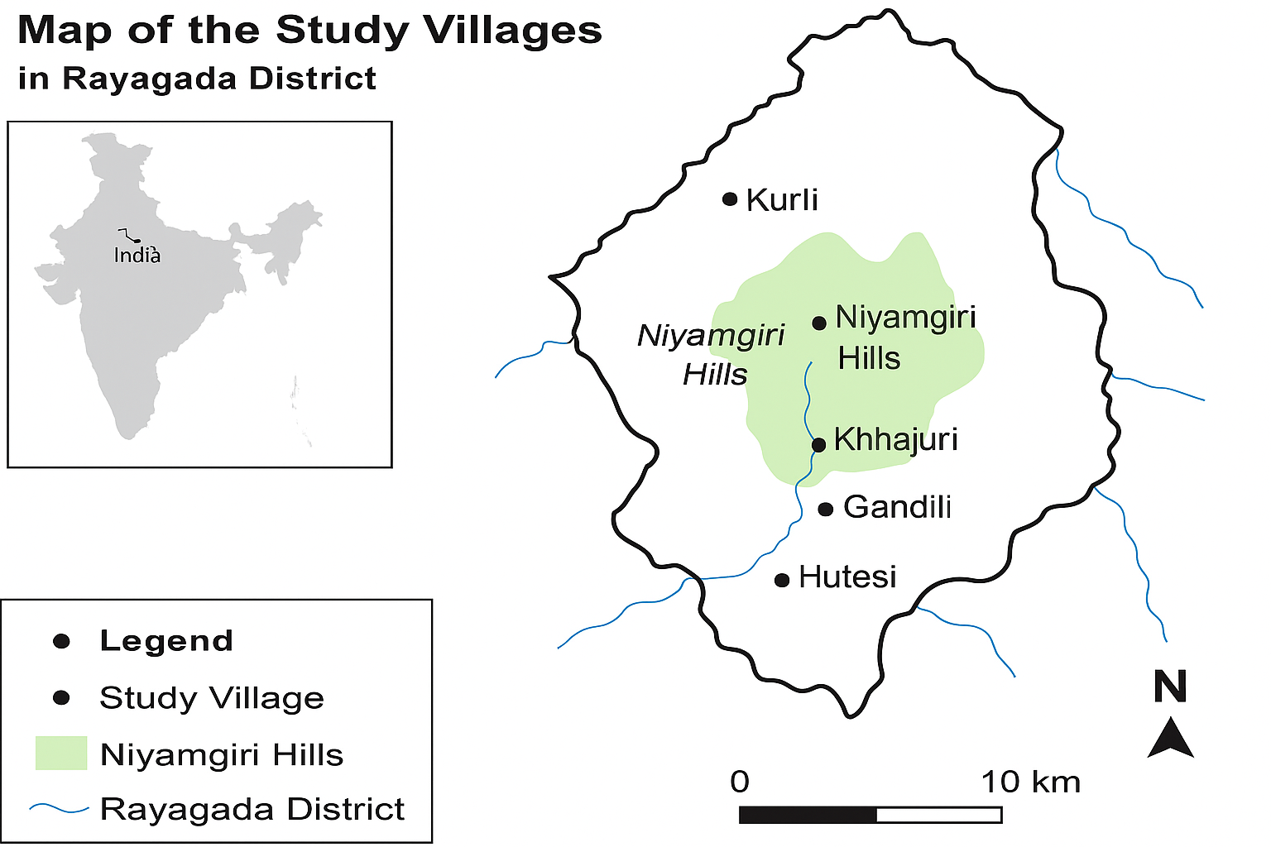

Figure 1: Map of the Study Villages in Rayagada District

Primary data collection involved a combination of tools to ensure both depth and breadth of understanding. Semi-structured interviews were conducted with 60 community members to capture individual experiences and perceptions. To complement this, eight focus group discussions (FGDs) were held with diverse demographic segments, including elders, youth, and women, to unpack community-level narratives, intergenerational knowledge transfer, and changing cultural values. Additionally, a structured household survey was administered to 100 families, selected using stratified random sampling to ensure representation across variables such as age, gender, and income levels.

Further depth was added through key informant interviews with stakeholders such as NGO field workers, forest department officials, and village elders. These interviews contributed to a nuanced contextual understanding and provided triangulation for validating emerging findings.

Qualitative data collected from interviews and FGDs were transcribed and systematically analysed using thematic content analysis facilitated by NVivo software. This helped identify recurrent patterns, values, and community perspectives related to livelihood transitions, ecological interactions, and cultural continuity or change. Quantitative data derived from household surveys were entered and analysed using SPSS, allowing for descriptive and inferential statistics to assess income trends, resource dependency, and the extent of livelihood diversification.

The integration of these qualitative and quantitative findings enabled a nuanced and triangulated interpretation of the socio-cultural and economic dynamics shaping the Dongria Kandha’s evolving livelihood landscape.

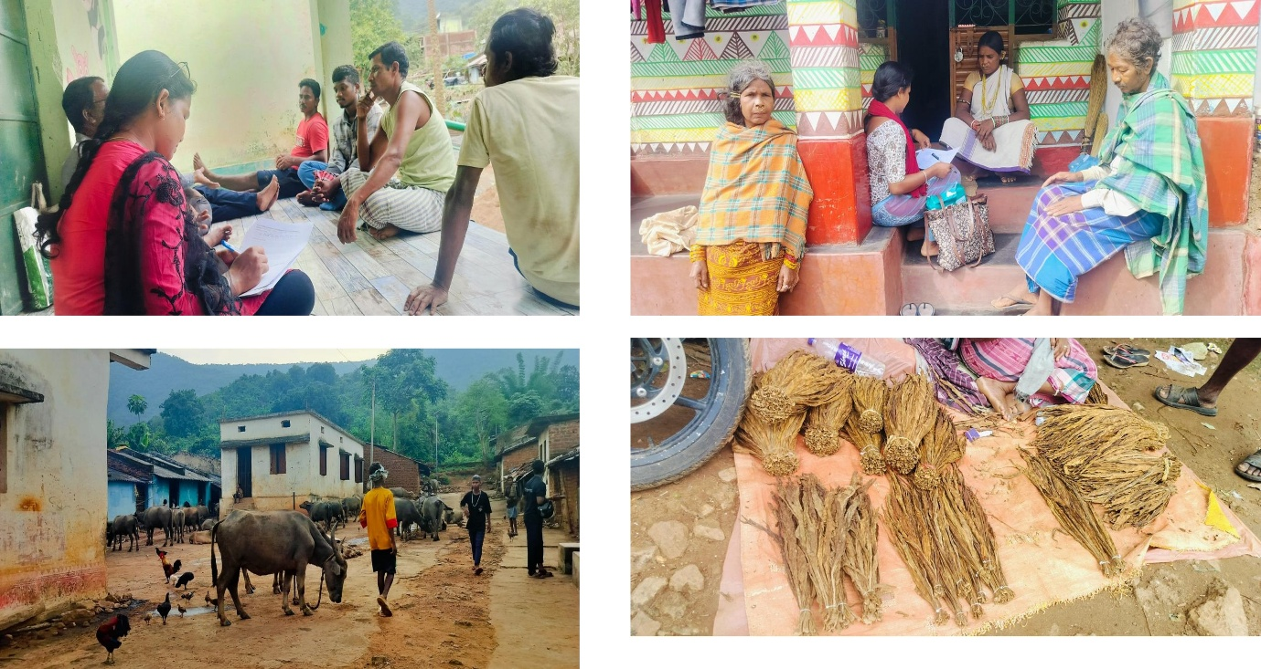

Figure 2: A scholar's pursuit of knowledge through conversations, culture, and connection

Ethical standards were rigorously upheld throughout the study. Prior informed consent was obtained from all participants, and efforts were made to ensure confidentiality and anonymity in reporting. Community engagement protocols were observed, including consultation with traditional leaders, community meetings before data collection, and feedback sessions to share preliminary findings in accessible, vernacular formats. These practices ensured cultural sensitivity and ethical reciprocity in the research process.

**Table 1: Summary of Methodology**

| **Component** | **Details** |
| --- | --- |
| **Research Design** | Mixed-methods (Qualitative and Quantitative) |
| **Study Area** | Five villages in Rayagada district: Kurli, Khambesi, Khajuri, Gandili, and Hutesi |
| **Sampling Technique** | Stratified Random Sampling |
| **Sample Size** | 100 households (survey), 60 individuals (interviews), 8 FGDs |
| **Key Informants** | NGO workers, forest officers, and community elders |
| **Data Collection Tools** | Structured household survey - Semi-structured interviews - Focus group discussions (FGDs) |
| **Secondary Sources** | Census of India (2011), ActionAid (2018), Government and NGO reports, scholarly articles |
| **Qualitative Analysis Tool** | Thematic content analysis using NVivo |
| **Quantitative Analysis Tool** | Statistical analysis using SPSS |
| **Ethical Considerations** | Informed consent, confidentiality, community engagement, and cultural sensitivity |

**4. Traditional Livelihood Systems of Dongria Kandha**

The traditional economy of the Dongria Kandha is deeply rooted in the unique ecology of the Niyamgiri Hills, forming a symbiotic relationship between community, cultivation, and conservation. Central to their subsistence strategy is shifting cultivation, locally known as podu, practiced on the steep hill slopes. This form of cultivation is not merely a technique for food production but a knowledge-intensive system tailored to the mountainous terrain and fragile ecosystem. The Dongria grow a rich variety of millet crops, including finger millet (Eleusine coracana), kodo millet (Paspalum scrobiculatum), and foxtail millet (Setaria italica), alongside pulses, tubers, and oilseeds(Majhi n.d.). These crops are not only resilient to erratic rainfall and poor soils but also hold significant nutritional and cultural value. Millets, known for their high fiber, iron, and protein content, form the dietary staple of the Dongria and are frequently used in community feasts, rituals, and seasonal ceremonies.(Bocha and Srinivas 2021)

In addition to agriculture, forest resources constitute a vital pillar of the Dongria economy. The collection of non-timber forest products (NTFPs) is both seasonal and strategic, reflecting an intimate knowledge of forest phenology and sustainable harvesting practices passed down through generations. Key NTFPs include wild mangoes, tamarind, mahua flowers (Madhuca longifolia), sal leaves (Shorea robusta), wild honey, medicinal herbs, and siali fibers (Bauhinia vahlii), all of which serve multiple purposes ranging from nutrition and health to economic exchange(Singh 2018). These products are either consumed within the community or bartered with lowland tribal and non-tribal populations in nearby weekly markets (haats), where forest goods are exchanged for salt, oil, cloth, and metal tools. While some degree of monetization has entered these exchanges in recent years, traditional barter persists in many villages, reinforcing kinship and reciprocity networks(Ramesh 2016).

Culturally, the Niyamgiri Hills are far more than a resource base; they are sacred geographies. The Dongria believe that the hills are the dwelling place of their supreme deity, Niyam Raja, who governs not only their spiritual well-being but also ecological stewardship. This belief system has cultivated a profound ethic of conservation among the community. For instance, certain hilltops and groves are designated as sacred and are never cleared or cultivated(Majhi n.d.; Tokita-Tanabe and Tanabe 2014). Rituals are held to honour the spirits of forests, streams, and seeds before each agricultural cycle, further reinforcing ecological mindfulness. This fusion of cosmology and conservation aligns with what scholars term "sacred ecology," where environmental sustainability is embedded within the spiritual and moral fabric of society(Kumar n.d.).

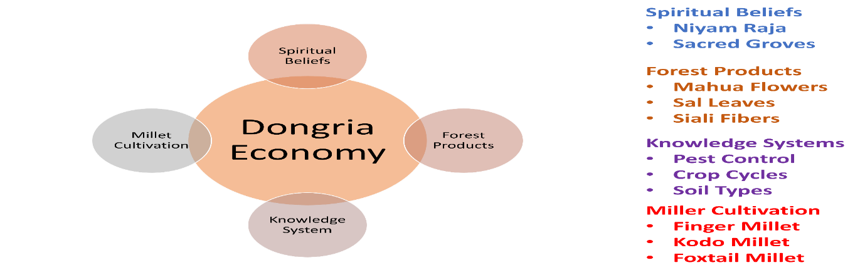

Figure 3: The Dongria economy is sustained by spiritual beliefs, forest products, traditional knowledge systems, and millet cultivation.

Moreover, the Dongria’s traditional ecological knowledge (TEK) system covering soil types, crop cycles, pest control using herbs, and wildlife behaviour has evolved over centuries and remains a cornerstone of their adaptive capacity(Mall 2020). However, this intricate balance is increasingly at risk due to external interventions, including restrictive forest policies, market-driven harvesting, and climate variability, which have begun to alter access, use patterns, and transmission of this knowledge.

**5. Drivers of Livelihood Transformation**

The shift from traditional, subsistence-based livelihoods to more market-oriented activities in tribal regions like the Niyamgiri Hills has not occurred in isolation. It is the result of an intricate interplay between policy reforms, development programs, market dynamics, and ecological changes.  
One of the most significant policy shifts in this context has been the enactment of the Forest Rights Act (FRA) in 2006. This landmark legislation was designed to formally recognize both individual and collective rights of forest-dwelling communities over land and forest resources(Nath n.d.; Tokita-Tanabe and Tanabe 2014). The FRA held the promise of empowering tribal groups by granting them greater control over their traditional territories and natural resource governance. However, on the ground, its implementation has faced several hurdles, ranging from bureaucratic red tape and resistance from forest departments to limited awareness among the very communities it was meant to benefit. As a result, despite its progressive goals, the full potential of the FRA remains largely unrealized in many areas(Sharma and Mohan 2024).

At the same time, government welfare and rural development schemes have opened up new livelihood options. Initiatives like the Mahatma Gandhi National Rural Employment Guarantee Act (MGNREGA) and the Pradhan Mantri Awas Yojana (PMAY) have provided employment opportunities and housing support, encouraging a slow but steady movement away from traditional subsistence farming toward wage labor and greater reliance on state-provided welfare. While these programs have helped improve material conditions for many, they also contribute to a growing dependence on external support, subtly reshaping economic behaviour and household priorities within tribal communities(Nath n.d.). Furthermore, educational reforms, particularly the expansion of residential schools in tribal areas, have influenced younger generations to aspire for non-agricultural careers. The exposure to formal education and urban-centric aspirations has reoriented youth preferences away from traditional occupations tied to agriculture and forest produce(Tokita-Tanabe and Tanabe 2014).

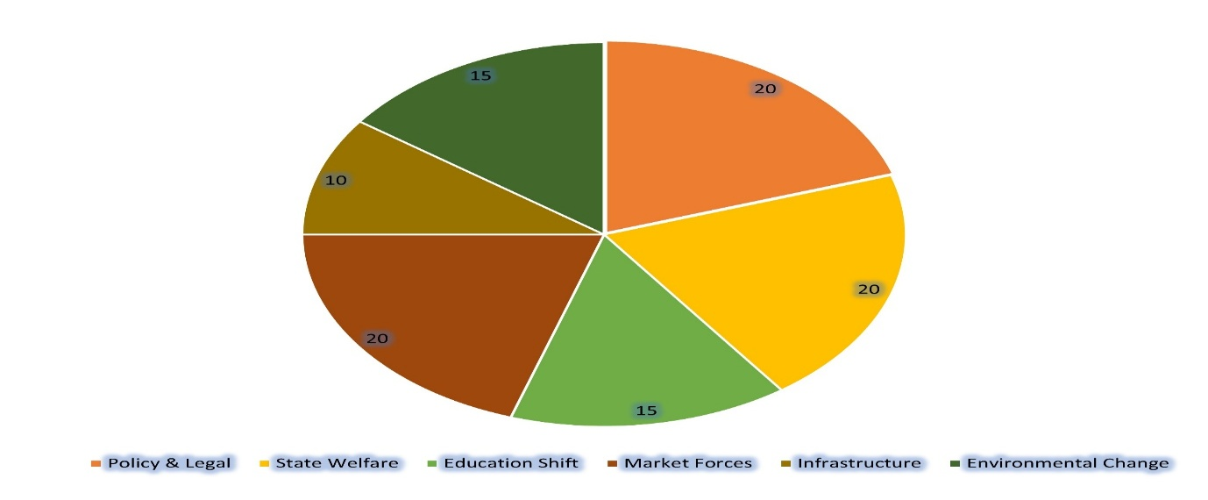

Figure 4: This chart illustrates the major factors driving the shift from traditional to market-based livelihoods of the Dongria Kandha of Raygada of Odisha.

The market has also become a significant driver of change. Non-governmental organizations and private traders have promoted the cultivation of high-value crops such as turmeric, mustard, and ginger, promising better incomes than traditional farming(Mohapatra 2017). However, these crops demand external inputs, timely market access, and technical know-how, often creating new forms of dependency on external actors and market fluctuations. Infrastructure development, particularly road connectivity and the spread of weekly haats (markets), has improved access to consumer goods but has also led to increased monetization and reliance on purchased goods over self-sufficient production systems(Das 2021).

Environmental challenges have compounded these transformations. Shifting cultivation (podu), once a sustainable practice adapted to the forested landscape, has become less productive due to soil exhaustion, erratic rainfall, and widespread deforestation. These issues are further intensified by climate change, which has disrupted seasonal cycles, affected crop yields, and reduced the availability of non-timber forest products (NTFPs) that many communities traditionally relied upon(Bocha and Srinivas 2021).In essence, the move toward market-linked livelihoods is not merely a result of economic incentives but a response to a broad spectrum of political, social, and ecological shifts. While this transition opens up new opportunities, it also introduces vulnerabilities and uncertainties, particularly for communities whose identity and survival are deeply tied to their land and forests.

**6. Impacts of the Transformation**

The transition toward market-oriented livelihoods has brought significant economic, social, and cultural changes to tribal communities in regions such as Niyamgiri. Economically, while many households have experienced an increase in cash income, this gain is accompanied by a growing reliance on external inputs such as fertilizers, hybrid seeds, and market intermediaries(Pandey 2018). This dependency makes households vulnerable to the volatility of market prices and fluctuations in input costs. Recent household surveys indicate that over 60% of family income now comes from wage labor and the sale of agricultural or forest produce in local markets, a significant shift from just a decade ago, when subsistence agriculture and barter-based exchanges contributed the majority of household sustenance.  
Social dynamics have also undergone notable changes. Migration, particularly among youth, has intensified. Young men and increasingly, young women are moving to urban areas like Rayagada, Muniguda, and Bhubaneswar in search of education, vocational training, or employment opportunities(Kumar et al. 2005). While this migration opens up new prospects, it also weakens traditional systems of knowledge transmission. Elders are finding fewer opportunities to pass down cultural practices, agricultural wisdom, and community rituals, resulting in a gradual erosion of intergenerational bonds. Traditional labor-sharing arrangements, such as gottisabha, a collective work system once central to community cohesion, are increasingly rare, as people turn to individual wage labour or external contractors(Sharma and Mohan 2024).

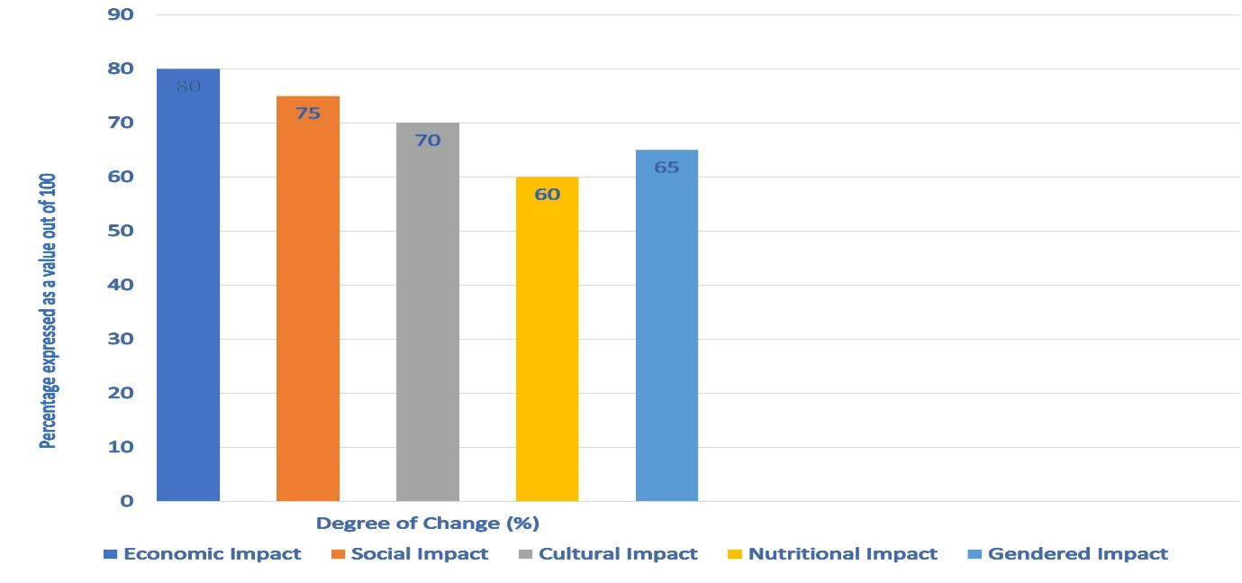

Figure 5: Impacts of the Shift Toward Market-Oriented Livelihoods in Dongria Kandha of Raygada of Odisha.

These grains are now being replaced by market-purchased rice and wheat, driven by government food distribution programs and changing consumer preferences. This dietary change, while more convenient, has led to negative nutritional effects, especially for women and children(Mishra n.d.). Additionally, many traditional forest-related festivals have lost significance as livelihoods become less connected to the rhythms of the forest and agricultural cycles. Although women’s participation in markets has increased, particularly in selling minor forest products and vegetables, their roles remain limited(Das 2021). They often lack bargaining power, face price manipulation by traders, and experience social exploitation within increasingly commercialized spaces(Das 2021).

**7. Results and Discussion**

**7.1 Shifting Patterns of Livelihood**

The study highlights a noticeable shift in how the Dongria Kandha community earns a living. Although traditional activities like podu (shifting cultivation), millet farming, and collecting forest produce are still practiced, many families are increasingly turning toward wage labor and market-based farming. Data collected from household surveys reveal that over 60% of families now earn most of their income through daily wage work or selling produce in nearby markets. This represents a major departure from earlier times, when food and other necessities were largely met through subsistence farming and barter.

This change appears to be driven by both opportunities and pressures. Improved roads, local markets, and NGO involvement have made it easier to sell crops like turmeric and ginger, which fetch better prices. However, these new farming methods also bring new risks—such as dependence on market prices, use of fertilizers and hybrid seeds, and the need for technical know-how. As a result, the community’s traditional self-reliant lifestyle is being replaced by one that’s more exposed to external uncertainties.

**7.2 Views Across Generations and Gender**

Group discussions revealed a clear difference in how older and younger generations view these changes. Many young people feel that the new ways of earning—like wage work and cash cropping—have helped their families earn more steadily and reduced seasonal hardships. Around 65% of youth were in favor of the shift. At the same time, about 82% of the elders were concerned about the loss of customs, rituals, and traditional knowledge that once held the community together.

Cultural practices like gottisabha, where villagers used to work together on farms, are disappearing. With more people working individually or for outside employers, such communal bonds are weakening. Women have started participating more actively in selling forest produce and vegetables in markets, but they still face challenges. They often get lower prices, have little say in transactions, and are at risk of exploitation by middlemen and traders. These gender-based barriers need urgent attention if the benefits of market integration are to be shared more equally.

**7.3 Effects on Environment and Food Habits**

The community’s move away from traditional farming and diet patterns has had environmental and nutritional impacts. Millets—once a staple food and cultural symbol—are being replaced by rice and wheat distributed through government ration schemes. While these new foods are more accessible, they are less nutritious, especially for women and children. Many families reported a decline in overall dietary quality.

Ecologically, the land used for *podu* cultivation is becoming less fertile, and forest resources are shrinking due to deforestation and changing weather patterns. This has made it harder for families to gather forest products like wild honey, mahua flowers, or medicinal herbs. Combined, these factors are placing pressure on the community’s age-old system of managing land, food, and nature sustainably.

**7.4 Community Responses and Hopes**

Despite the challenges, the Dongria Kandha are not passively accepting these changes. Many people, especially elders, are voicing the need to hold on to traditional knowledge, sacred practices, and forest-based lifestyles. Encouraging efforts are already underway. For example, NGOs have supported millet festivals to bring back interest in local crops and revive community rituals tied to farming. Women’s groups are being trained to process, package, and sell forest products more effectively, helping them gain confidence and income.

What stands out from the fieldwork is the community’s growing interest in blending old and new. People are beginning to explore ways to earn through markets without letting go of their cultural roots or harming the environment. This desire for a balanced approach, where tradition and modern livelihood options coexist, is a promising path forward, one that deserves active support from policymakers and development workers.

**8. Community Aspirations and Responses**

Insights from focus group discussions reveal a nuanced community perspective on the ongoing socio-economic transformation. A significant portion of participants, particularly younger respondents, recognized the benefits of livelihood diversification. Approximately 65% noted that the shift to wage labor, market agriculture, and other non-traditional activities has increased income stability and decreased seasonal vulnerability(Bocha and Srinivas 2021). However, this optimism was tempered by concerns from older generations. About 82% of elders expressed unease over the erosion of cultural practices and the weakening of communal ties. They highlighted how traditional ecological knowledge, forest-based subsistence practices, and communal rituals are increasingly being sidelined in the push toward modernization(Singh 2018).

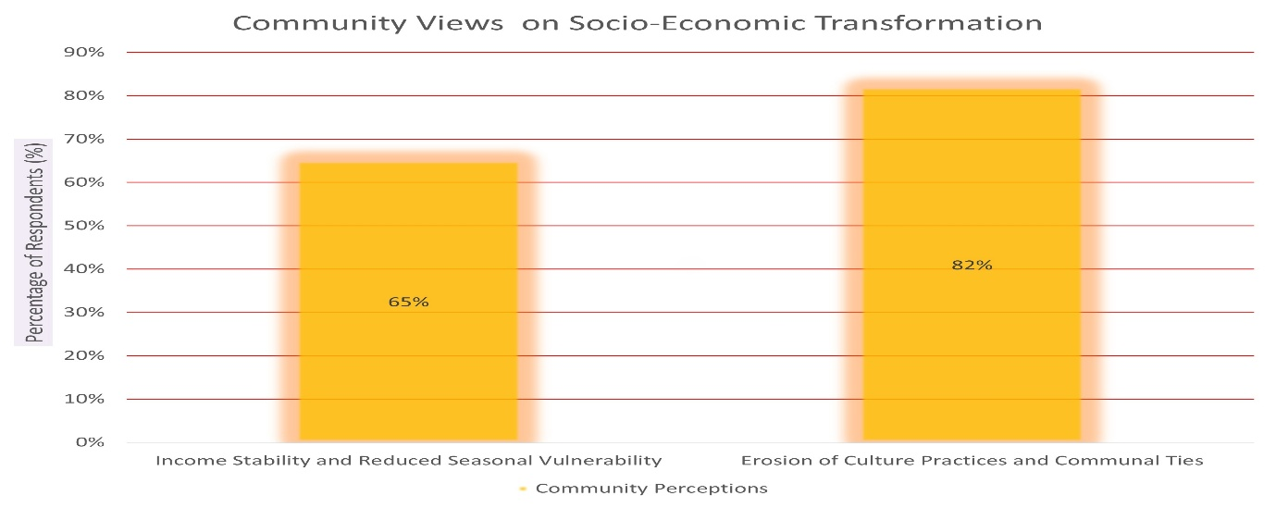Figure 6: Community perceptions of socio-economic transformation reflect a generational divide—while 65% of youth view livelihood diversification positively, 82% of elders express concern over cultural erosion and loss of traditional practices.

This dual perception underscores the community’s struggle to balance economic pragmatism with cultural preservation. Many participants stressed the importance of sustaining forest knowledge systems, practicing ecologically sound agriculture, and revitalizing community gatherings and ceremonies that once reinforced social cohesion. Encouragingly, efforts by civil society organizations have found resonance within these communities(DEVI 2012). For instance, NGOs have initiated millet revival festivals that not only promote traditional grains for their nutritional value but also re-anchor them in local identity and seasonal rituals. Additionally, programs supporting the direct procurement of non-timber forest products (NTFPs) and training in value addition techniques, such as processing, packaging, and marketing, have empowered local producers, especially women, to engage in more equitable market participation(Nath n.d.).

There is growing awareness of the need to develop hybrid models that combine traditional ecological wisdom with modern livelihood strategies. This approach is increasingly seen as a way to secure both cultural survival and economic resilience. By embracing sustainable agricultural practices rooted in indigenous knowledge while also integrating modern tools and market linkages, communities are beginning to chart a development path that does not come at the cost of their identity or ecological balance(Mall 2020).

**9. Policy Gaps and Recommendations**

Despite the proliferation of state and civil society programs aimed at supporting tribal livelihoods, critical policy gaps continue to hinder long-term sustainability and inclusivity. One of the most pressing issues is the incomplete and often inconsistent implementation of the Forest Rights Act (FRA)(Ramesh 2016). While the legislation promises legal recognition of forest land and community resource rights, its rollout has been sluggish. Many communities still await proper mapping of traditional territories, and there is a lack of legal and administrative support to process and approve claims efficiently(Majhi n.d.). Accelerating FRA implementation, particularly through participatory mapping and transparent procedures, is essential to ensure that forest-dwelling communities can exercise real control over their lands(Padhi and Sadangi 2020).

**Table 2: Addressing Policy Gaps in Tribal Livelihoods**

|  |  |  |
| --- | --- | --- |
| **Policy Gap** | **Details of the Gap** | **Recommended Action** |
| **Incomplete FRA Implementation** | Lack of mapping, administrative delays | Accelerate FRA with participatory mapping & legal support |
| **Weak NTFP Value Chains** | Small scale, poor market linkages | Support with processing units, market access, and fair pricing mechanisms |
| **Millet Revival Lacks Infrastructure** | Gaps in seed availability, storage, and pricing | Establish seed banks, local storage, and introduce Minimum Support Prices (MSP) |
| **Gender Inequities in Livelihoods** | Exclusion, exploitation, limited access to credit | Adopt gender-sensitive policies: ensure credit access, support cooperatives |
| **Low Tribal Entrepreneurship Support** | Lack of local skills, cultural mismatch in programs | Promote localized skill-building in eco-tourism, crafts, agro-ecological practices |

In addition, there is an urgent need to strengthen support for community-managed forest governance and promote enterprises based on non-timber forest products (NTFPs). Although NTFPs form a crucial component of tribal livelihoods, most initiatives remain small-scale and poorly integrated into market systems(Singh 2018). Expanding value chains through processing units, market access, and fair pricing mechanisms can significantly improve income security. In parallel, millet revival efforts must go beyond promotional campaigns. Concrete measures such as establishing community seed banks, building local storage infrastructure, and instituting minimum support prices (MSP) for millets are vital to ensure the economic viability of traditional grains. These actions not only boost nutrition and climate resilience but also reinforce cultural continuity.

Moreover, existing policies often fail to adequately address gender-specific vulnerabilities. Women traders, particularly those involved in forest produce collection and petty trade, frequently face price manipulation, lack of bargaining power, and exclusion from formal credit systems(Tokita-Tanabe and Tanabe 2014). To counter this, gender-sensitive policy frameworks must be put in place to protect women from exploitation, ensure access to institutional credit, and support their participation in producer collectives and cooperatives

Encouraging tribal entrepreneurship is another crucial area that requires focused attention(Ramesh 2016). Skill-building programs tailored to local contexts, ranging from eco-tourism, artisanal crafts, and agro-ecological practices to sustainable farming and food processing, can foster self-reliance and innovation. Such interventions must be designed with cultural sensitivity and long-term ecological sustainability in mind, ensuring that economic development does not come at the cost of traditional knowledge systems and environmental integrity(Sharma and Mohan 2024).

**10. Conclusion**

The livelihood transition of the Dongria Kandha from forest-dependent subsistence systems to market-linked economies is a complex and dynamic process. While it has opened up new avenues for income generation and integration with broader economic networks, it has also introduced significant challenges. These include the erosion of ecological balance, the weakening of traditional knowledge systems, and the dilution of cultural identity. The shift has not been uniform, and its impacts are deeply gendered, generational, and spatial. As such, development interventions must move beyond generic frameworks and adopt a more nuanced, context-specific approach.

A path forward must be grounded in cultural sensitivity, ecological sustainability, and a strong rights-based framework. This includes not only accelerating the implementation of progressive legislation like the Forest Rights Act but also investing in systems that protect and revitalize indigenous knowledge, support sustainable land use, and enable dignified economic participation for all, especially women and youth. The findings of this study highlight the need to balance development with preservation, and they contribute to wider discourses on indigenous rights, sustainable livelihoods, and tribal empowerment in the face of socio-economic and environmental change.

Disclaimer (Artificial intelligence)

Option 1:

Author(s) hereby declare that NO generative AI technologies such as Large Language Models (ChatGPT, COPILOT, etc.) and text-to-image generators have been used during the writing or editing of this manuscript.

**References**

Bocha, Kedarnath, and B. K. Srinivas. 2021. “Livelihood Practices and Sustenance among Dongria Kondhs of Odisha.” *IJRDO-Journal of Social Science and Humanities Research* 6(4):11–17.

Das, Prasanta Kumar. 2021. “The Economic Contribution of Forest Resources to the Tribal Communities in Odisha: A Study of Two Villages in Rayagada Distric.” *Indian Journal of Agricultural Marketing* 35(1):77–86.

DEVI, SANJEETA KUMARI. 2012. “Agrarian Distress and Indebtedness in Tribal Odisha: A Study in Rayagada District.” *THE INTERNATIONAL RESEARCH JOURNAL OF SOCIAL SCIENCES AND HUMANITIES*.

Kumar, Kundan, Pranab Ranjan Choudhary, S. Sarangi, P. Mishra, and S. Behera. 2005. “A Socio-Economic and Legal Study of Scheduled Tribes’ Land in Orissa.” *Unpublished Study Commissioned by World Bank Washington*.

Kumar, Virendra. n.d. “Academic Articles.”

Majhi, Madhusmita. n.d. “Promotion of Sustainable Livelihood Through Skill Development of Dongria Kondh Communities During Lockdown.”

Mall, Arati. 2020. “Indigenous Knowledge on Selection, Sustainable Utilization of Local Flora and Fauna for Food by Tribes (PTG) of Odisha: A Potential Resource for Food and Environmental Security.”

Mishra, Priyadarshini. n.d. “Gender and Culture of the Dongria Kondhs of Odisha: A Preliminary Assessment.” *Folklore Foundation, India* 26.

Mohapatra, Tanuja. 2017. “Adivasi’s Struggle for Niyamgiri:-A Study.” *Afro Asian Journal of Anthropology and Social Policy* 8(1):35–56.

Nath, Saumya. n.d. “Defending the Sacred: Discourses of Development, Identity and Everyday Resistance among the Dongria Kondh.”

Ota, A. B., S. C. Mohanty, and N. Kanhar. 2020. “Kandha.”

Padhi, Ranjana, and Nigamananda Sadangi. 2020. “Juhar Niyamraja.” Pp. 213–40 in *Resisting Dispossession: The Odisha Story*. Springer.

Pandey, Annapurna Devi. 2018. “Kondhs’ Resistance Movement to Save Sacred Niyamgiri, Odisha.” Pp. 61–89 in *Indigenous Perspectives on Sacred Natural Sites*. Routledge.

Ramesh, Prakruti. 2016. “Rural Industry, the Forest Rights Act, and the Performance (s) of Proof.” Pp. 173–90 in *Industrialising Rural India*. Routledge.

Sahoo, Prasant Kumar. n.d. “Perceiving the Livelihood Challenges: An Anthropological Insight into the Dongria Kondhs of the Niyamgiri Hills of Rayagada, Odisha.”

Sharma, Prawal, and Krishna Mohan. 2024. “Location, Livelihoods and Tribal People: Exploring the Linkages in India.” *Journal of Rural & Industrial Development* 12(1).

Singh, Neetu. 2018. “Dongaria Kandha Adaptation to Market Opportunities: Railway as an Engine of Change.” *The Oriental Anthropologist* 18(2):333–39.

Tokita-Tanabe, Yumiko, and Akio Tanabe. 2014. “Politics of Relations and the Emergence of the Vernacular Public Arena: Glocal Networks of Development and Livelihood in Odisha.” Pp. 25–44 in *Democratic Transformation and the Vernacular Public Arena in India*. Routledge.