Evolution of Wastewater Treatment Plants in Lake Chapala, Mexico (2011-2024)

.
ABSTRACT
The Lerma-Santiago-Pacific region faces significant challenges related to water availability and pollution. The main problem lies in the fact that water extraction exceeds the annual renewable natural supply. The contamination of the Lerma River is evident from its source, aggravated along its course by urban, industrial and agricultural discharges deficient treatment or without treatment. The Lerma River undergoes intense extraction for agricultural use and receives discharges from various cities, reaching negligible flows in the dry season. Water quality continues to deteriorate until it reaches Lake Chapala, where about 64% of the water arrives untreated, where the Wastewater Treatment Plants (WWTPs) are insufficient or not operating. The objective of this research is to determine the status of the treatment plants of the Lake Chapala basin in the period 2011-2024. Descriptive study of the evolution of the treatment plants of the Lake Chapala basin. Place and duration of study are the treatment plants of the Lake Chapala basin in the period 2011-2024. The methodology consisted of analyzing the information collected in a 2011 study regarding the projections for the capacity of WWTPs for the year 2020, together with the analysis of the historical growth of the population and the estimation of the same for the year 2030, and evaluating how the provision of drinking water and wastewater supply has evolved, likewise, the proposed capacity for the construction, expansion and/or modification of the WWTPs will be evaluated, as well as the technical details on the proposed expansions, the proposed processes for the expansions and the economic and financial evaluation, as well as the systematic expenses in their current state and the projection considerations. The results showed the comparison of WWTPs between 2011 and 2025 shows an increase from 22 to 42 WWTPs, many of them located and operated in private, outside the municipal administration. However, although the number of WWTPs has increased, 13 of them are out of operation. Some of the plants increased their capacity, however most were not expanded and decreased their operating capacity, so they are insufficient for current demand. Most small towns decreased their population growth rate and increased the operating capacity of their WWTPs. However, large populations increased their population growth, which represents a risk that in a short time the expansions of the WWTPs will be insufficient to meet the demand for wastewater that needs to be treated before discharging it into Lake Chapala. The conclusion of this analysis reveals the complexity of wastewater treatment infrastructure planning and management in a dynamic demographic and economic context. The results underscore the importance of adopting more flexible and adaptive approaches to infrastructure planning that can respond to reality.
Keywords: Treatment plants, own basin, Lake Chapala, plant capacity.

1. INTRODUCTION
The Lerma-Santiago-Pacific basin (LSPB) is a relevant region of Mexico in terms of availability and use of water resources. Over the last few decades, the basin has faced serious pollution problems associated with population growth and the industrial activities that take place in its surroundings (IMTA, 2011; Chávez-Alcántar, Martínez-Rodríguez, Ramos-Leal & Villanueva-Estrada, 2011). In 2011, several studies were carried out focused on the evaluation of water quality and the capacity of wastewater treatment plants within the Lake Chapala basin. These studies made it possible to identify the presence of organic pollutants, nutrients, heavy metals and toxic compounds, in addition to pointing out the limitations in the treatment infrastructure (Vallejo-Rodríguez & López-López, 2011; CEA, 2012, Ramírez-Sánchez & Fajardo Montiel 2024, 2025). Based on these diagnoses, projections were generated on future needs for sanitation and water quality by 2020.
This study (2025) seeks to analyze the accuracy of those projections made in 2011, as well as to evaluate the evolution of the environmental and hydraulic conditions of the Lake Chapala basin. This analysis will identify the progress made, the pending challenges and the current needs in terms of water and sanitation management in the region.
The Lerma-Santiago-Pacific basin encompasses a vast area that includes parts of the states of Mexico, Querétaro, Guanajuato, Michoacán, and Jalisco. This region is central to the national economy, being home to important industrial and agricultural centers. However, this economic development has brought with it significant challenges in terms of water pollution, mainly due to inadequately treated industrial, agricultural, and urban discharges (Chávez-Alcántar, Martínez-Rodríguez, Ramos-Leal, & Villanueva-Estrada, 2011; IMTA, 2011).
The 2011 study evaluated the existing capacity of the treatment plants in the Chapala basin itself and projected the needs to 2020, as well as proposing solutions to meet future demand (IMTA, 2011; Vallejo-Rodríguez & López-López, 2011; CEA, 2012). This analysis was crucial for long-term planning of wastewater management in the region, seeking to balance economic growth with environmental preservation. However, it is important to establish a clear plan of action for the coming years. This should include short-term goals (1-2 years) to address immediate needs, medium-term goals (3-5 years) to implement substantial improvements, and a long-term vision (+10 years) to ensure the sustainability of the water treatment system in the Lake Chapala Basin itself.
1.1 BACKGROUND
The Lerma-Santiago-Pacific basin is one of the main hydrological systems in Mexico, originating in the state of Mexico and flowing near San Blas in the state of Nayarit (CONAGUA, 2016; IMTA, 2011). This region maximizes the use of its natural resources, especially water, which has led to a hydrological imbalance and degradation of water quality (Chávez-Alcántar, Martínez-Rodríguez, Ramos-Leal, & Villanueva-Estrada, 2011).
The region comprises the hydrological system of the Lerma River, Lake Chapala and the Santiago River to the Pacific Ocean, including the closed basins of Pátzcuaro-Cuitzeo and Sayula-San Marcos. It borders the regions North Pacific, Nazas-Aguanaval, Golfo Norte, Valle de México, Balsas and the Pacific Ocean, covering an area of 192,374 km², which represents 10% of the country (CONAGUA, 2016; IMTA, 2011).
Includes the states of Colima, Aguascalientes, Jalisco, Guanajuato, Michoacán, Estado de México, Querétaro, Zacatecas and Nayarit. It includes important population centers such as Toluca, Querétaro, Guadalajara, and Tepic, among others (CONAGUA, 2016). The region is subdivided into five subregions based on hydrological characteristics: Alto Lerma, Medio Lerma, Bajo Lerma, Alto Santiago, and Bajo Santiago (CONAGUA, 2020).
The relief of the Lerma–Santiago–Pacific basin is made up of four large physiographic provinces: the Trans-Mexican Neovolcanic Axis, with 42% of the total area of the region; the Sierra Madre Occidental, with 25%; the Sierra Madre del Sur, with 23%; and the Mesa Central, with 9% (CONAGUA, 2020; IMTA, 2011).
1.1.1 Sub-Region Level Description
The subregion presents a remarkable diversity in its relief and geology. The Alto Lerma includes the subprovinces of Lagos and Volcanes de Anáhuac, covering areas of the State of Mexico and the Mil Cumbres subprovince, including areas of Acámbaro. These subprovinces cover 66% of the subregion, while the Michoacán Sierras and Bajíos cover 16%, the Tarascan Neovolcanic 15%, and the Plains and Sierras of Querétaro and Hidalgo 3% (CONAGUA, 2016; IMTA, 2011). The relief in this subregion includes landscapes of mountain ranges and volcanoes such as the Nevado de Toluca (4,560 meters above sea level) in the State of Mexico and the mountain ranges of Angangueo and San Andrés (up to 3,600 meters above sea level) in Michoacán, as well as valleys, hills, and large lakes such as Pátzcuaro and Cuitzeo (INEGI, 2010). Geologically, it comprises Quaternary and Upper Tertiary periods, mainly along the Lerma River, with 70% extrusive igneous rocks, 29% volcano-sedimentary rocks and almost 1% metamorphic rocks (IMTA, 2011).
The Middle Lerma includes the subprovinces Sierras and Bajíos Michoacanos (25%), Bajío Guanajuatense (23%), Sierras and Plains of northern Guanajuato (16%), Altos de Jalisco (19%) and Plains and Sierras of Querétaro and Hidalgo (10%). The Mesa Central covers 29 per cent of the subregion's area. The relief has large valleys such as those of the Bajío Guanajuatense, Llanos San Felipe and San Diego de la Unión, and mountain ranges such as San Pedro (2,730 meters above sea level), El Cubo (2,880 meters above sea level), Comanjá (2,300 meters above sea level) and Guanajuato (2,960 meters above sea level) (INEGI, 2010). Geologically, it presents extrusive igneous rocks from the Quaternary and Upper Tertiary periods, composed of 58% extrusive igneous rocks and 41% sedimentary rocks (IMTA, 2011).
The Bajo Lerma includes the subprovince of Chapala, which covers 68% of the surface and includes Lake Chapala and its own basin, as well as the valleys of Ciénega de Chapala, Zamora and Sahuayo in Michoacán. The Altos de Jalisco subprovince covers 14% of the subregion, while the remaining 18% is covered by the Sierras and Bajíos Michoacanos, the Neovolcanic Tarasca and the Sierra de Jalisco subprovinces. This subregion includes important valleys such as the Ciénega de Chapala and Zamora, and mountain ranges such as Patamban and Arandas, with altitudes of up to 2,500 meters above sea level. It contains lakes such as Chapala, the largest in the country, and others such as San Marcos, Sayula, Atotonilco, and Cajititlán (CONAGUA, 2016; IMTA, 2011). Geologically, it is composed of 68% extrusive igneous rocks and 32% Cenozoic sedimentary rocks (IMTA, 2011).
The Alto Santiago subregion is formed by the Neovolcanic Axis, the Sierra Madre Occidental and the Mesa Central. It includes the subprovinces of Altos de Jalisco, Chapala and Guadalajara, which together cover 40% of the area, and the Sierra Madre Occidental with 38%. The Mesa Central covers the remaining 22%. Large canyon and mountain range formations predominate with altitudes of up to 2,800 meters above sea level in Cerro Grande and 2,600 meters above sea level in Nochistlán. The geological composition includes Cenozoic and Quaternary periods, with 63% of extrusive igneous and volcano-sedimentary rocks. The only natural fault crosses the state of Aguascalientes from north to south (IMTA, 2011; INEGI, 2010).
Lower Santiago, whose subregion belongs to 93% of the Sierra Madre Occidental, includes subprovinces such as Mesetas and Cañadas del Sur and Sierras y Valles Zacatecanos, encompassing the Sierra de Valparaíso and other mountain ranges. The geology of Bajo Santiago is mostly from the Cenozoic, with 91% igneous rocks and 9% sedimentary rocks. The five normal faults are aligned from north to south (IMTA, 2011).
Population growth has led to urbanization and industrialization, altering terrestrial ecosystems. The lack of conservation and proper management generates a loss of soil fertility and desertification. Causes include overexploitation of natural resources, inappropriate use of agricultural technologies, abuse of pesticides and fertilizers, incorrect irrigation methods, erosion, exposure of uncovered soil to wind and rain, drying up of streams and bodies of water, atmospheric phenomena, and human settlements in fertile soils (SEMARNAT, 2018).Erosion is the main driver of desertification, affecting 77% of the national territory. In the region, the most affected areas are Guanajuato, Jalisco, Mexico and Michoacán. Water erosion, caused by water, affects 85% of the national surface. The most advanced areas in water erosion in the region are Aguascalientes, Guanajuato, Michoacán, Jalisco and Mexico. Wind erosion, caused by wind, severely affects Querétaro. At the national level, 85% of the territory is eroded by wind, with an annual loss of almost 460 million tons (SEMARNAT, 2018).
The Lerma-Santiago-Pacific watershed has a complex topography and climatic variations, resulting in a mosaic of plant communities. It includes elements from the Nearctic and Neotropical biogeographic zones, reflecting high biotic diversity and diverse plant formations (INEGI, 2010; SEMARNAT, 2018).
1.2 REGIONAL PROBLEMS
The Lerma-Santiago-Pacific basin faces significant challenges related to water availability and pollution. The main problem lies in the fact that the extraction of water, both surface and groundwater, exceeds the annual renewable natural supply (CONAGUA, 2016). The contamination of the Lerma River is evident from its source, aggravated along its course by urban, industrial and agricultural discharges deficient treatment or without treatment. The Lerma River suffers intense extraction for agricultural use and receives discharges from various cities, reaching inappreciable flows in times of low water. Water quality continues to deteriorate until it reaches Lake Chapala, where approximately 64% of the water arrives untreated, where the Wastewater Treatment Plants (WWTPs) are insufficient or not operating (IMTA, 2011; CONAGUA, 2016a, CONAGUA 2016b, López-Hernández, Ramos-Espinosa, & Carranza-Fraser, 2007).
1.2.1 Water Quality Monitoring
As of 2016, there were 26 measuring stations in the Lerma River and 25 in Lake Chapala (CONAGUA, 2016). The measurements indicate that the quality of the water in the streams of the Lerma subregion is classified between polluted and very polluted, with AQI values below 60 (Ramirez-Sanchez & Fajardo-Montiel, 2024). There is no section of the Lerma River where the quality of the water is suitable as a source of supply for human consumption (CONAGUA, 2016; Ramirez-Sanchez & Fajardo-Montiel, 2024). Contamination problems have been detected by coliforms, ammonia nitrogen, suspended solids, dissolved oxygen and organic matter. In addition, pesticide problems and high toxicity have been found in sediments due to the accumulation of heavy metals in the Lerma and its tributaries (IMTA, 2011; Ramirez-Sanchez & Fajardo-Montiel, 2024, 2025).
1.2.2 Inventory and capacity of Wastewater Treatment Plants (WWTPs)
According to the study carried out in the basin of Lake Chapala itself, 22 treatment plants were counted distributed in 11 municipalities. Treatment capacity varies significantly between plants, from 3 l/s in San Pedro Tesistán to 130 l/s in Ocotlán (Table 1). In total, these plants manage to sanitize a flow of 2.5 m³ per second, which represents 17% of the total wastewater discharged throughout the state (IMTA, 2011; SEMARNAT/INEGI, 2010).
1.2.3 Costs and operation of WWTPs
The costs of operation and maintenance of the WWTPs have mainly been borne by the state government, with a growing participation of some municipalities such as Jocotepec, Poncitlán and Arandas. Annual operation and maintenance costs are reported ranging from $657,959 to $5,675,073 Mexican pesos per plant. The data should be analyzed under the consideration that the study was integrated in 2012. Beginning in 2002, responsibility for the operation and maintenance of the plants was assigned to the State Water and Sanitation Commission (CEAS). It was estimated that by 2006, the process of transferring the plants to the municipalities was completed, with the municipalities being responsible for 100% of the operation.
1.2.4 Types of treatment processes
Most plants use activated sludge processes with extended aeration. Some variants include aerated and polished lagoons. These processes were selected based on an analysis of investment, operation and maintenance costs.
1.2.5 General diagnosis
According to the study carried out in 2011, several general problems were identified in the treatment plants, among them the following:

Table 1. Capacity of Water Treatment Plants in the Lake Chapala Basin (CEAS, 2002)
No. | Municipality | Locality | Plant Name | Average expenditure (l/s)
1 | Chapala | Ajijic | San Antonio Tlayacapan-Ajijic | 25
2 | Chapala | San Nicolás Ibarra | San Nicolás Ibarra | 8
3 | Chapala | Chapala | Chapala | 60
4 | El Salto | El Salto | El Salto | 25
5 | Ixtlahuacán de los Membrillos | Ixtlahuacán de los Membrillos | Ixtlahuacán de los Membrillos | 16
6 | Ixtlahuacán de los Membrillos | Atequiza | Atequiza | 22
7 | Jamay | Jamay | Jamay | 40
8 | Jocotepec | Jocotepec | Jocotepec | 66
9 | Jocotepec | San Juan Cosalá | San Juan Cosalá | 13
10 | Jocotepec | Chantepec (El Chante) | El Chante | 6
11 | Jocotepec | San Pedro Tesistán | San Pedro Tesistán | 3
12 | Jocotepec | San Cristóbal Zapotitlán | San Cristóbal Zapotitlán | 4
13 | Juanacatlán | Juanacatlán | Juanacatlán | 40
14 | La Barca | La Barca | La Barca | 80
15 | Ocotlán | Ocotlán | Ocotlán | 130
16 | Poncitlán | Poncitlán | Poncitlán | 35
17 | Poncitlán | San Juan Tecomatlán | San Juan Tecomatlán | 4
18 | Poncitlán | Mezcala | Mezcala | 8
19 | Poncitlán | San Pedro Itzicán | San Pedro Itzicán | 6
20 | Tizapán el Alto | Tizapán el Alto | Tizapán el Alto | 28
21 | Tuxcueca | Tuxcueca | Tuxcueca | 12
22 | Tuxcueca | San Luis Soyatlán | San Luis Soyatlán | 24

- Lack of preventive maintenance on equipment, leading to premature wear and low operational efficiency.
- Presence of weeds around the facilities, creating conditions conducive to harmful fauna.
- Need for maintenance on structures and anti-corrosion coatings on equipment and pipes.
- Lack of monitoring of operating parameters during the various treatment processes, resulting in underutilization of facilities and equipment.
- Lack of minimum essential resources and updated training for plant operators.
These issues suggested the need to improve maintenance practices, increase investment in resources and training, and establish a more rigorous system of monitoring operating parameters to optimize the efficiency of treatment plants.
Thus, the objective of this research is to determine the status of the treatment plants of the Lake Chapala basin in the period 2011-2024.
2. Material and methods
The methodology will consist of analyzing the information collected in the 2011 study regarding the projections that were made in terms of the capacity of the WWTPs for the year 2020, the analysis of the historical growth of the population and the estimation of the same for the year 2030, and evaluating how the provision of drinking water and wastewater supply has evolved. likewise, the proposed capacity for the construction, expansion or modification of the WWTPs will be evaluated, as well as the technical details on the proposed expansions, the proposed processes for the expansions and the economic and financial evaluation, as well as the systematic expenditures in their current state and the projection considerations.
2.1 WWTP Capacity Projection to 2020
A projection was made on the capacity of the Wastewater Treatment Plants (WWTPs) of the Lake Chapala Basin, with a vision for the year 2020. The analysis was based on the need to adjust the infrastructure for the treatment of both wastewater and sludge, according to the expected population growth in the surrounding localities. These projections were calculated using robust methodologies of historical population growth and were adjusted to the urban planning instruments of local governments.
2.2 Analysis of Historical Population Growth
To project the capacity of the WWTPs, it was necessary to evaluate the historical population growth of the localities under study. Data collection included official sources and field verifications. The key institutions in this process were the State Water and Sanitation Commission (CEAS), the National Population Council (CONAPO), the National Water Commission (CONAGUA), the National Institute of Statistics, Geography and Informatics (INEGI) and other state and federal entities.
Among the documents consulted were population and housing censuses, state and municipal development plans, and a statistical yearbook of Jalisco. This made it possible to construct a schedule of inhabitants from 1960 to the year 2000, which revealed annual growth rates that varied considerably between localities. Some localities with accelerated growth stood out, while others showed decreases in the growth rate. The geometric and arithmetic coefficients of annual growth were calculated to establish a historical pattern that would serve as the basis for future projections.
2.3 Population Estimate to the Year 2030
Subsequently, the population was projected until 2030. To do this, three main methods of demographic projection were used:
- Arithmetic Method: This method assumes a constant growth in the number of inhabitants, regardless of the size of the population. Growth is based on the analysis of historical data.
- Geometric Method: Considers that population growth is proportional to the current size of the population. This approach tends to project faster growth for larger localities.
- Geometric Method with Variable Rate: This method is more sophisticated, since it assumes that population growth decreases progressively as infrastructure and services improve. The approach is better suited to current trends in urbanization and development of localities. The idea behind this method is that, with the improvement of the quality of life and services, such as water treatment, population growth tends to slow down.
For this analysis, the geometric method with variable rate was used to model population growth in the Lake Chapala basin. Projections with this method show a declining growth rate as localities improve in terms of infrastructure and services, which is expected to have a more moderate and manageable population growth by 2030.
2.4 Provision of Drinking Water and Wastewater Supply
One of the key aspects for the design and planning of WWTPs is the amount of drinking water available per person and the proportion of that water that is converted into wastewater. It is considered that an average unit supply of 200 liters per inhabitant per day (l/inhabitant/day) of drinking water. From this endowment, the volume of wastewater that the localities would generate was calculated, estimating that approximately 75% of the drinking water used is converted into wastewater, which gives a value of 150 l/inhabitant/day of wastewater per person.
It was emphasized that wastewater calculations must take into account not only the current population, but also changes in infrastructure, service coverage, and demand variation coefficients. These parameters allow the correct dimensioning of WWTPs to avoid overload problems in the plants, which could cause public health problems or environmental impacts on Lake Chapala.
2.5 Proposed Capacity for Wastewater Treatment Plants
Based on the population growth data and the volume of projected wastewater, a detailed schedule of the capacity required for the WWTPs in each of the localities was developed. Table 1 presents the volume of wastewater to be treated in each locality during the period from 2000 to 2030, reflecting the expected increase in population and, therefore, the greater demand for water treatment.
The study highlights the importance of treatment plants being sized correctly to not only handle the current volume of wastewater, but also to forecast future growth. This preventive approach is crucial in a region such as the Lake Chapala basin, where the environmental balance is very delicate due to the importance of the lake as a water and ecological resource. It is important to highlight the need to keep plants up to date in terms of their technology and operational efficiency, since poorly maintained or underused plants can compromise both the quality of the treated water and the levels of sanitation in the localities.
2.6 Technical details on the proposed extensions
According to the 2011 study, expansion proposals were carried out for the Wastewater Treatment Plants (WWTPs) in the Chapala Basin itself, with the aim of increasing the treatment capacity and improving the operational efficiency of the existing plants. The suggested modifications suggested guaranteeing adequate treatment in the face of the increase in wastewater, derived from population growth and the increase in the pollutant load.
2.7 Proposed Process for Enlargements
The conventional treatment process begins with the entry of wastewater by gravity, which is screened and desander to remove coarse solids. Subsequently, the water is directed to pumping stations, which act as regulating tanks. This system allows to cushion variations in hydraulic and organic loads, ensuring a constant flow that facilitates the design and operation of the secondary treatment.
Proposed Biological Treatment
The biological treatment proposed is through an extended aeration system in oxidation trenches, a variant of the activated sludge process. This system includes the following key aspects:
- High hydraulic retention times, which improves the degradation of organic matter.
- High concentrations of activated sludge in the reactor.
- High solids retention times, allowing microorganisms to act effectively on the waste.
One of the advantages of the system is that it generates less sludge than conventional processes, and this sludge is partially digested, which facilitates its dewatering. The process suggests that the effluent be treated in secondary clarifiers to remove the remaining solids, improving water quality before disinfection. Final disinfection ensures the reduction of fecal coliforms in the treated water.
2.8 Sludge Management
The generated sludge will be sent to drying beds, where a sufficient amount of water will be removed so that the sludge can be handled as solid material, with a moisture content of less than 70%. This approach facilitates the management and final disposal of sludge, complying with sanitation and waste treatment regulations.
2.9 Treatment Plants (5 l/s)
The basic sizing of a treatment plant designed to handle a flow rate of 5 liters per second (l/s). The calculations were generated using specialized software and equations developed by the Environmental Protection Agency (EPA). The formulas used allow estimating plant construction costs based on data from more than 700 previous installations. The budget for the construction of a 5 l/s plant, considering the costs of key components such as screening, pumping, biological treatment and secondary clarifiers must be estimated. Likewise, the operation and maintenance costs are calculated, including: supply of chemical aggregates for disinfection, salaries and wages of the personnel in charge of the operation, general expenses of conservation of the system and consumption of electrical energy, calculated according to the needs of the proposed equipment.
2.10 Treatment Plants (25 l/s)
In addition to the 5 l/s plant, a larger treatment plant is proposed, with a capacity to process 25 l/s. The basic sizing of this facility includes details about the process units, such as biological oxidation trenches, secondary clarifiers, chlorine contact tanks, and drying beds. As in the previous proposal, the budget should detail construction costs and operating costs, using the same EPA equations to get accurate estimates. All operational aspects are included, from energy consumption to personnel and chemical costs.
2.11 Treatment Plants (80 l/s)
Finally, it is necessary to design a plant with a larger capacity to treat 80 l/s. This facility would require larger biological oxidation trenches, circular clarifiers, and powerful pumping systems to handle the flow rate. The capacity of this plant is justified based on population growth and the increased demand for wastewater treatment in the surrounding localities. The budget for this plant must contain accurate estimates of construction costs and operating expenses. Energy costs, disinfection chemicals, staff salaries, and maintenance costs are calculated. As in the previous cases, the budget is based on the formulas established by the EPA.
2.12 Economic and financial evaluation
The economic and financial evaluation was carried out in the proposals for the expansions for the Wastewater Treatment Plants (WWTPs) in the Chapala Basin itself. The evaluation must be carried out taking as a reference the recommendations of international organizations, such as the United Nations, to evaluate development projects. The criteria used allow us to define the financing schemes and the economic viability of the project.
Marginalization Index
One of the determining factors in the financial analysis is the rate of marginalization of the beneficiary localities. This index, provided by the National Population Council (CONAPO), classifies localities according to socioeconomic indicators, such as: Limited access to basic services, family income levels, fertility, morbidity and schooling indexes, and quality of housing and overcrowding.
General Financing Scheme
The financing of the proposed works will be carried out through a mix of resources that includes:
- Federal and state government fiscal resources.
- Credit resources managed by local authorities.
- Contributions from users of the service.
This mixed scheme takes into account that the collection for the drinking water service is insufficient to cover the costs of the expansions. For this reason, the study suggests several ways to obtain additional resources, such as direct contributions from the population, volunteer work or the contracting of loans guaranteed by the community and the municipality.
Financial Analysis Conditions and Criteria
The study established several criteria for carrying out the financial analysis of the project. The most relevant conditions include:
- Necessary infrastructure: It is guaranteed that, during the project period, both the drinking water network and the sewerage system and the treatment plant will have sufficient capacity to serve 100% of the target population.
- Service coverage: During the project, the drinking water infrastructure is expected to reach 95% of the population, and the sewerage system 85%. It is estimated that 80% of the water collected will be used by users, while 20% will correspond to leaks, leaks or clandestine taps.
In addition, some hypotheses are put forward under which financial viability is analyzed, such as the contribution of work or money by the population and the possibility of covering the costs through credits.
Amount of Proposed Works
The study presents a summary of the estimated costs of the expansion works for the different treatment plants, including a margin of 10% for unforeseen events, a scaling of 4% for future prices, and an additional 7% for administration and engineering. This is in line with the recommendations of the National Water Commission (CNA).
Particular Financing Schemes
A particular financing scheme was developed for each locality, adjusted to the needs and the rate of marginalization of each one. The financing is divided between federal and state resources, credit resources and contributions from users, with different proportions depending on the locality. For example:
- Ajijic and San Antonio Tlayacapan: With a total cost of 3,377,351.67 pesos, the financing is distributed in 42% of federal resources, 20% of state, 25% of credit resources and 13% of user contributions.
- Ocotlán: For this locality, with a significantly higher total cost (12,885,297.26 pesos), the financing scheme follows the same proportion.
Systematic Expenses
The National Drinking Water and Sewerage Program establishes that the expenses of operation, maintenance and administration of the infrastructure must be covered by the income obtained from the collection of water and sewerage services. Systematic expenses include: salaries and wages of personnel, supply of chlorine for disinfection, electricity to operate the plants and fixed expenses of administration and maintenance.
2.13 About the current state and projection considerations
The study carried out in 2011 on the operating situation of the Wastewater Treatment Plants (WWTPs) in the Chapala Basin shed light on the critical challenges faced by the region in the management of its water resources. The research revealed a complex problem that went beyond simple wastewater management, encompassing aspects of overexploitation of resources, widespread pollution and deficiencies in existing infrastructure.
At the heart of the problem was the alarming situation of the Lerma River and Lake Chapala. The study showed that water extraction, both surface and groundwater, far exceeded the annual renewable natural supply. This imbalance was aggravated by the severe pollution of the Lerma River, which began at its source and intensified along its course due to urban, industrial and agricultural discharges. As a result, approximately 64% of the water that reached Lake Chapala did so without having received any treatment, putting the health of the ecosystem and the communities dependent on this vital resource at risk.
As for the treatment infrastructure, the outlook was not encouraging. There were 22 treatment plants distributed in 11 municipalities of the Lake Chapala basin. These plants, as a whole, managed to clean a flow of 2.5 m³ per second, which represented only 17% of the total wastewater discharged throughout the state. This clearly insufficient treatment capacity underscored the urgent need to expand and improve existing infrastructure.
The study also highlighted a number of operational challenges that affected the efficiency and effectiveness of existing WWTPs. Among the most pressing problems were the lack of preventive maintenance on electromechanical equipment, which caused premature wear and low operational efficiency. In addition, a widespread presence of weeds was detected around the facilities, creating conditions conducive to harmful fauna. The need for maintenance on structures and anti-corrosion coatings on equipment and pipes was evident, as well as the lack of monitoring of operating parameters during the various treatment processes.
One of the most worrying aspects was the lack of minimum essential resources and the lack of up-to-date training for plant operators. This situation not only compromised the operational efficiency of the WWTPs, but also put at risk the quality of the treatment and, therefore, the environmental health of the region. Looking ahead, the 2011 study projected population growth through 2030. These estimates were based on robust demographic projection methods, using historical data and adjusting to the urban planning instruments of local governments. These projections were crucial to anticipate future wastewater treatment needs and plan the necessary expansions in the WWTP infrastructure.
3. results and discussion
The evaluation carried out in 2011 showed that at that time there were 22 treatment plants operating in the Lake Chapala basin, where it was evident that their state of conservation, operational efficiency and installed capacity was deficient, since it was found that many WWTPs suffered from a lack of preventive maintenance, which resulted in premature wear of equipment and low operational efficiency. In addition, several plants were operating near or above their designed capacity. Likewise, it was found that the general state of conservation of the plants was of great deterioration. In addition, there was no training for the personnel in charge of the operation of the WWTPs. And finally, a large number of environmental challenges, such as the large presence of weeds in the facilities, poor hygiene, which represented a potential risk to public health.
The analysis concluded that for that year 9 of the 22 plants did not require expansion until 2020, while the remaining ones needed to increase their capacity. This triggered a planning of investments and improvements in the wastewater treatment infrastructure in the Lake Chapala basin. Thus, various proposals were prepared that concluded in recommending an expansion of 79 l/s for the Ocotlán plant, 25 l/s for the Salto and 5 l/s for each of the five smaller plants. Specific designs were developed for plants with capacities of 80 l/s, 25 l/s, and 5 l/s, seeking to standardize solutions and optimize implementation costs.
To analyze and compare the 2011 projections with the current reality, it is necessary to examine the population estimates and how this has impacted the actual demand for wastewater treatment in these populations. This will allow us to understand the effectiveness of the projection methods and improve future planning. The comparison of growth rates was carried out in a particular way for each municipality since the projected versus actual growth rates differ if they are taken in a general way and as a consequence impact the assessment of wastewater treatment needs. The current infrastructure and installed capacity of WWTPs (2025) needs to be assessed, which will make it possible to determine whether the expansions proposed in 2011 were sufficient or whether further adjustments are required. It is also necessary to evaluate operational efficiency in order to compare it with the 2011 projections.
Thus, the information found until May 2025 is that it was increased from 22 to 42 WWTPs, many of them located and operated by individuals, outside the municipal administration. However, even though the number of WWTPs has increased, 13 of them are out of operation (Table 2). Some of the plants increased their capacity, however a large part of them were not expanded and decreased their operating capacity, so they are insufficient for the current demand. Figure 1 shows the current geographical distribution of the WWTPs in the Lake Chapala basin. The results shown reflect that the planning carried out in 2011 did not give the expected results, since almost 15 years later the treatment of wastewater has been complicated by the decrease in the operational efficiency of the WWTPs and these are insufficient for the current demand of the population.
3.1 RESULTS BY MUNICIPALITY 2012-2024
More than a decade after the original study, it is imperative to carry out a thorough update that allows us to assess the progress made, identify persistent challenges and adapt our strategies to the current reality.
3.1.1 San Antonio Tlayacapan
Original projection: 15,769 inhabitants, with a proposed plant capacity of 30 l/s. Updated 2024: 19,408 inhabitants, real capacity of 32 l/s. The population grew by 23% more than expected, indicating faster urban development than expected. The plant's capacity was increased slightly above what was proposed (an additional 6.67%), suggesting an adaptive response to this unforeseen growth. This relatively accurate adjustment between population growth and plant capacity indicates proactive management of wastewater treatment infrastructure. The "In Operation" situation suggests that, despite the unanticipated growth, the plant is adequately handling current demand (Graph 1).
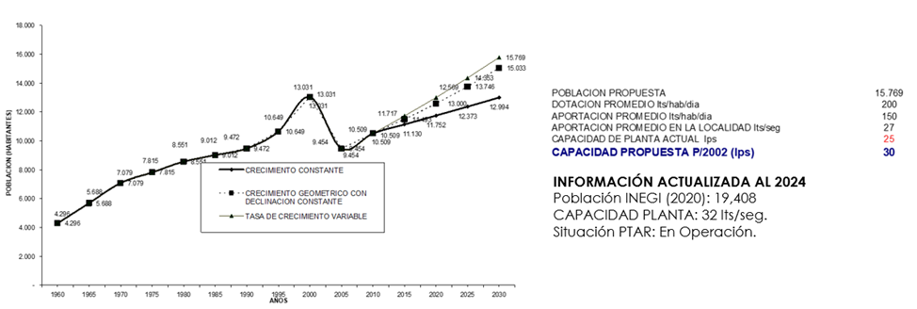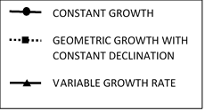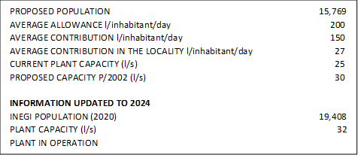
Year
Population

Graph 1 Population growth projections and wastewater plant capacity analysis for 2024 in San Antonio Tlayacapan
3.1.2 Chapala
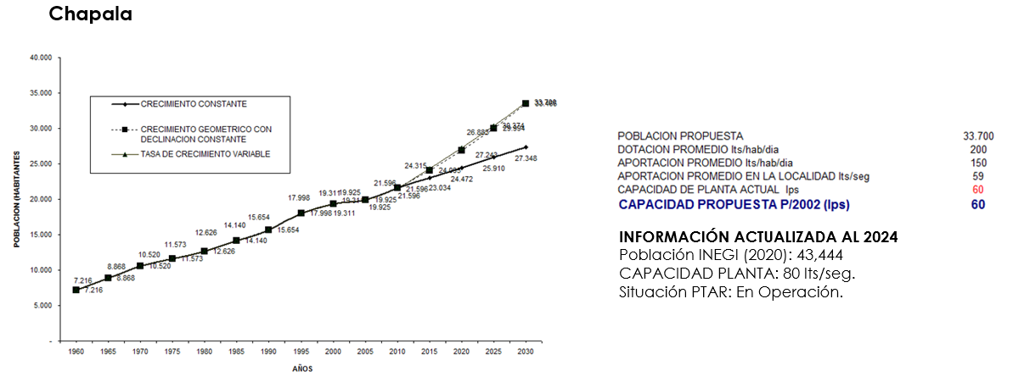
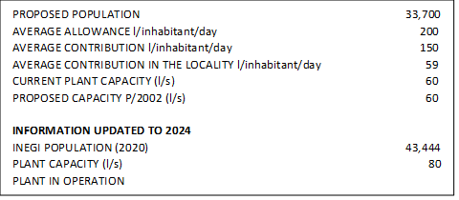
Original projection: 33,700 inhabitants, proposed capacity of 60 l/s. Updated 2024: 43,444 inhabitants, real capacity of 80 l/s. Chapala experienced significant population growth, exceeding expectations by 29%. This substantial increase could be attributed to factors such as tourism development or migration. Notably, the plant's capacity increased by 33%, from 60 to 80 l/s, demonstrating effective adaptive planning. This proportional increase in treatment capacity suggests a well-calibrated response to population growth, ensuring that the infrastructure could handle the increase in wastewater generation (Graph 2).
Year
Population

Graph 2 Population projection and wastewater treatment capacity analysis for 2024 in Chapala
3.1.3 San Nicolas de Ibarra
Original projection: 1,568 inhabitants, proposed capacity of 2 l/s. Updated 2024: 1,321 inhabitants, real capacity of 8 l/s. Contrary to expectations, San Nicolás de Ibarra experienced a population decrease of 15%. However, the plant's capacity quadrupled, from 2 to 8 l/s. This disparity between population and treatment capacity could indicate several scenarios: a forecast of future growth, the need to treat wastewater from surrounding areas, or possibly an overestimation of future needs. It could also suggest a change in land use, such as the development of industries or services that require greater water treatment capacity despite the decrease in the resident population (Graph 3).

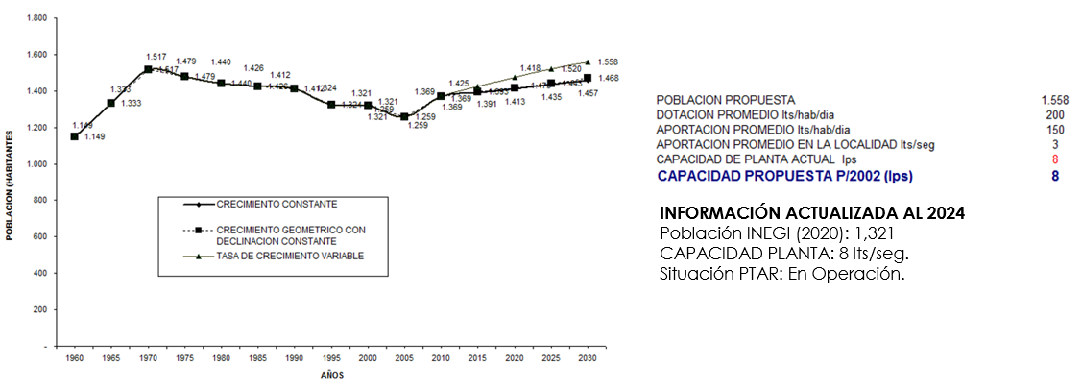
Year
Population

PROPOSED POPULATION 1568
AVERAGE ALLOWANCE l/inhabitant/day 200
AVERAGE CONTRIBUTION l/inhabitant/day 150
AVERAGE CONTRIBUTION IN THE LOCALITY l/inhabitant/day 3
CURRENT PLANT CAPACITY (l/s) 8
PROPOSED CAPACITY P/2002 (l/s) 8

INFORMATION UPDATED TO 2024
INEGI POPULATION (2020) 1,321
PLANT CAPACITY (l/s) 8
PLANT IN OPERATION
Graph 3 Population projection and wastewater treatment capacity analysis for 2024 in San Nicolas de Ibarra

3.1.4 Atotonilquillo-Atequiza
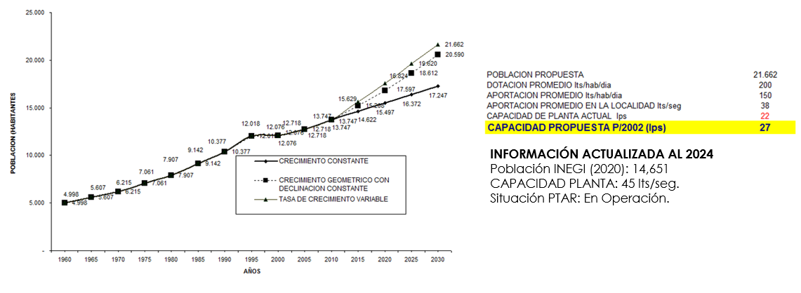
Original projection: 21,662 inhabitants, proposed capacity of 27 l/s. Updated 2024: 14,651 inhabitants, real capacity of 45 l/s. This locality shows a significant decrease in population (32% less than projected), but a considerable increase in treatment capacity (67% more). This divergence is notable and could indicate several factors: an anticipation of future growth despite the current trend, a change in the economic profile of the area requiring greater water treatment, or possibly the inclusion of additional areas in the plant's service. It could also reflect a long-term strategy to improve the quality of water treatment or to manage seasonal fluctuations in demand (Graph 4).
Year
Population

PROPOSED POPULATION 21,662
AVERAGE ALLOWANCE l/inhabitant/day 200
AVERAGE CONTRIBUTION l/inhabitant/day 150
AVERAGE CONTRIBUTION IN THE LOCALITY l/inhabitant/day 38
CURRENT PLANT CAPACITY (l/s) 22
PROPOSED CAPACITY P/2002 (l/s) 27

INFORMATION UPDATED TO 2024
INEGI POPULATION (2020) 14,651
PLANT CAPACITY (l/s) 45
PLANT IN OPERATION
Graph 4 Population projection and wastewater treatment capacity analysis for 2024 in Atotonilquillo-Atequiza
3.1.5 Ixtlahuacán de los Membrillos
Original projection: 8,597 inhabitants, proposed capacity of 16 l/s. Updated 2024: 5,263 inhabitants, real capacity of 16 l/s. Ixtlahuacán de los Membrillos experienced a significant population decrease of 39%, which contrasts sharply with initial projections. Despite this decrease, the plant's capacity remained at 16 l/s, as originally proposed. This scenario raises questions about long-term planning and resource allocation. It could indicate an expectation of a reversal in population trends, the need to maintain capacity for non-residential uses, or simply a decision not to reduce existing infrastructure despite the decline in current demand (Graph 5).
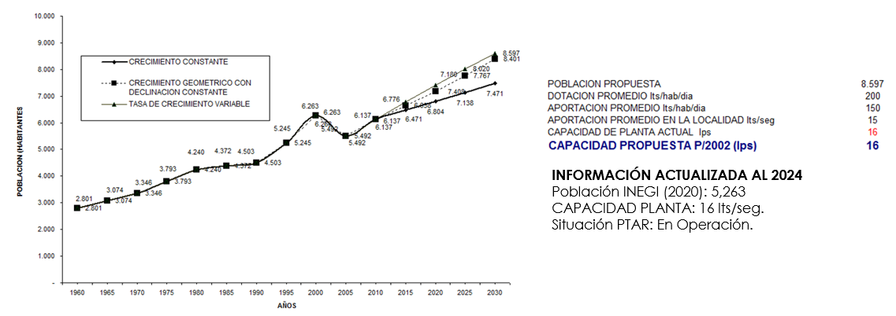
Year
Population

PROPOSED POPULATION 8,597
AVERAGE ALLOWANCE l/inhabitant/day 200
AVERAGE CONTRIBUTION l/inhabitant/day 150
AVERAGE CONTRIBUTION IN THE LOCALITY l/inhabitant/day 15
CURRENT PLANT CAPACITY (l/s) 16
PROPOSED CAPACITY P/2002 (l/s) 16

INFORMATION UPDATED TO 2024
INEGI POPULATION (2020) 5,263
PLANT CAPACITY (l/s) 16
PLANT IN OPERATION
Graph 5 Population projection and wastewater treatment capacity analysis for 2024 in Ixtlahuacán de los Membrillos

3.1.6 Jamay
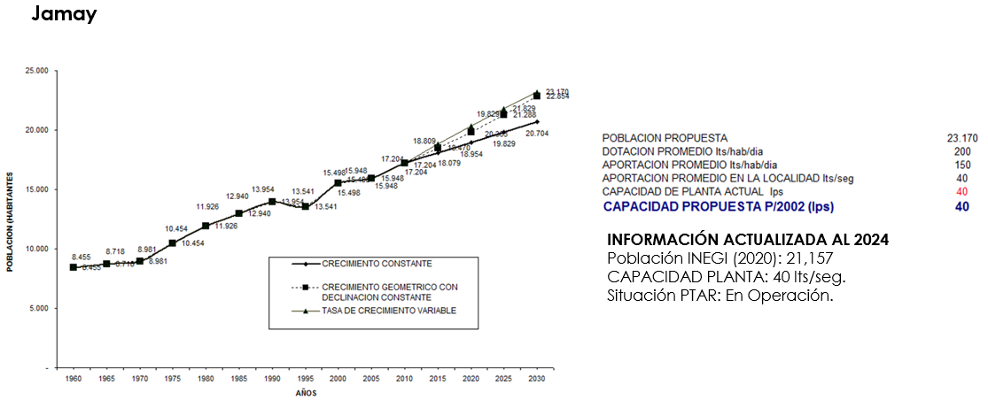
Original projection: 23,170 inhabitants, proposed capacity of 40 l/s. Updated 2024: 21,157 inhabitants, real capacity of 40 l/s. Jamay shows a slight population decline of 9% over projection, while plant capacity remained exactly as planned. This situation suggests conservative planning that has proved adequate despite the small reduction in population. Maintaining the proposed capacity could indicate a forecast of future growth or the need to manage seasonal variations in demand, possibly related to tourism or agricultural activities in the region. Taken together, these results reveal the complexity of wastewater treatment infrastructure planning in a context of dynamic demographic changes. They demonstrate the importance of flexibility in planning and the need to consider multiple factors beyond simple population projections when designing and upgrading these critical facilities (Graph 6).
PROPOSED POPULATION 23,170
AVERAGE ALLOWANCE l/inhabitant/day 200
AVERAGE CONTRIBUTION l/inhabitant/day 150
AVERAGE CONTRIBUTION IN THE LOCALITY l/inhabitant/day 40
CURRENT PLANT CAPACITY (l/s) 40
PROPOSED CAPACITY P/2002 (l/s) 40

INFORMATION UPDATED TO 2024
INEGI POPULATION (2020) 21,157
PLANT CAPACITY (l/s) 40
PLANT IN OPERATION
Year
Population

Graph 6 Population projection and wastewater treatment capacity analysis for 2024 in Jamay
3.1.7 El Chante

Original projection: 2,739 inhabitants, proposed capacity of 6 l/s. Updated 2024: 2,004 inhabitants, real capacity of 9 l/s. El Chante experienced a population decrease of 26.8% compared to what was projected. However, the plant's capacity increased by 50%, from 6 to 9 l/s. This divergence suggests planning that anticipates potential future growth or the need to handle seasonal demands. It could also indicate an improvement in the quality of treatment or coverage of additional areas not initially anticipated (Graph 7).

Table 2. Water Treatment Plants in the Lake Chapala Basin (AJSC, 2025)
No. | Municipality | Locality | Plant Name | Watershed | Hydrological sub-basin | Design Expense (l/s) | Situation | Operating Expense (l/s)
1 | Chapala | Ajijic | San Antonio Tlayacapan - Ajijic | L. Chapala | L. Chapala | 32 | In operation | 30
2 | Chapala | San Nicolás de Ibarra | San Nicolas De Ibarra | L. Chapala | L. Chapala | 8 | In operation | 6
3 | Chapala | Santa Cruz de la Soledad | Santa Cruz De La Soledad | L. Chapala | L. Chapala | 4 | In operation | 3
4 | Chapala | Chapala | Chapala | L. Chapala | L. Chapala | 80 | In operation | 68
5 | El Salto | El Salto | El Salto | R. Santiago - Guadalajara | R. Corona - R. Green | 32 | In operation | 29
6 | El Salto | Fracc. Parques del triunfo | Fracc. Parques del triunfo | R. Santiago - Guadalajara | R. Corona - R. Green | 18 | In operation | 7
7 | Ixtlahuacán de los Membrillos | Ixtlahuacán de los Membrillos | Ixtlahuacán De Los Membrillos | L. Chapala | L. Chapala | 16 | In operation | 16
8 | Ixtlahuacán de los Membrillos | Atequiza | Atequiza | R. Santiago - Guadalajara | R. Corona - R. Green | 45 | In operation | 45
9 | Ixtlahuacán de los Membrillos | Ixtlahuacán de los Membrillos | Rinconada La Loma | R. Santiago - Guadalajara | R. Corona - R. Green | 8 | Out of operation | 0
10 | Ixtlahuacán de los Membrillos | Los Olivos | Los Olivos 2 | R. Santiago - Guadalajara | R. Corona - R. Green | 25 | Out of operation | 0
11 | Ixtlahuacán de los Membrillos | Ixtlahuacán de los Membrillos | Los Girasoles | R. Santiago - Guadalajara | R. Corona - R. Green | 8 | Out of operation | 0
12 | Ixtlahuacán de los Membrillos | Ixtlahuacán de los Membrillos | Real Del Lago | R. Santiago - Guadalajara | R. Corona - R. Green | 20 | In operation | 20
13 | Ixtlahuacán de los Membrillos | Huerta Vieja | Fracc. Huerta Vieja | R. Santiago - Guadalajara | R. Corona - R. Green | 10 | Out of operation | 0
14 | Ixtlahuacán de los Membrillos | Ixtlahuacán de los Membrillos | Fracc. Valle de los Sabinos | R. Santiago - Guadalajara | R. Corona - R. Green | 40 | Out of operation | 0
15 | Ixtlahuacán de los Membrillos | Fracc. Residencial la Loma | Fracc. Residencial La Loma | R. Santiago - Guadalajara | R. Corona - R. Green | 5 | Out of operation | 0
16 | Ixtlahuacán de los Membrillos | Capilla del Refugio | Capilla del Refugio | R. Santiago - Guadalajara | R. Corona - R. Green | 9 | In operation | 9
17 | Jamay | La Maltaraña (La Palmita) | Maltaraña | R. Lerma - Chapala | R. Briseñas - L. Chapala | 2 | Out of operation | 0
18 | Jamay | San Miguel de la Paz | San Miguel De La Paz | R. Santiago - Guadalajara | R. Zula | 10 | In operation | 10
19 | Jamay | Jamay | Jamay | L. Chapala | L. Chapala | 40 | In operation | 40
20 | Jocotepec | Jocotepec | Jocotepec | L. Chapala | L. Chapala | 80 | In operation | 66
21 | Jocotepec | San Juan Cosalá | San Juan Cosalá | L. Chapala | L. Chapala | 20 | In operation | 21
22 | Jocotepec | Chantepec (El Chante) | El Chante | L. Chapala | L. Chapala | 9 | In operation | 9
23 | Jocotepec | San Pedro Tesistán | San Pedro Tesistán | L. Chapala | L. Chapala | 3 | Out of operation | 0
24 | Jocotepec | Las Trojes | Las Trojes | R. Santiago - Guadalajara | R. Corona - R. Green | 2 | Out of operation | 0
25 | Jocotepec | Potrerillos | Potrerillos | R. Santiago - Guadalajara | R. Corona - R. Green | 3 | Out of operation | 0
26 | Jocotepec | San Cristóbal Zapotitlán | San Cristóbal Zapotitlán | L. Chapala | L. Chapala | 4 | In operation | 4
27 | Juanacatlán | Juanacatlán | Juanacatlán | R. Santiago - Guadalajara | R. Corona - R. Green | 40 | In operation | 19
28 | Juanacatlán | Ex-Hacienda de Zapotlanejo | Ex-hacienda de Zapotlanejo | R. Santiago - Guadalajara | R. Corona - R. Green | 2 | Out of operation | 0
29 | Juanacatlán | Juanacatlán | Fracc. Andalucía | R. Santiago - Guadalajara | R. Corona - R. Green | 20 | Out of operation | 0
30 | La Barca | La Barca | La Barca | R. Lerma - Chapala | R. Angulo - R. Briseñas | 80 | In operation | 61
31 | Ocotlán | Ocotlán | Ocotlán | R. Santiago - Guadalajara | R. Zula | 300 | In operation | 234
32 | Poncitlán | Poncitlán | Poncitlán | R. Santiago - Guadalajara | L. Chapala - R. Corona | 65 | In operation | 65
33 | Poncitlán | Cuitzeo (La Estancia) | Cuitzeo | R. Santiago - Guadalajara | L. Chapala - R. Corona | 12 | In operation | 12
34 | Poncitlán | San Jacinto | San Jacinto | R. Santiago - Guadalajara | L. Chapala - R. Corona | 3 | Out of operation | 0
35 | Poncitlán | San Juan Tecomatlán | San Juan Tecomatlán | L. Chapala | L. Chapala | 4 | In operation | 4
36 | Poncitlán | Mezcala | Mezcala | L. Chapala | L. Chapala | 8 | In operation | 7
37 | Poncitlán | San Pedro Itzicán | San Pedro Itzicán | L. Chapala | L. Chapala | 6 | In operation | 4
38 | Tizapán el Alto | Tizapán el Alto | Tizapán El Alto | L. Chapala | L. Chapala | 50 | In operation | 48
39 | Tizapán el Alto | Villa Emiliano Zapata | Villa Emiliano Zapata | L. Chapala | L. Chapala | 6 | In operation | 9
40 | Tuxcueca | El Tepeguaje | El Tepeguaje | L. Chapala | L. Chapala | 2 | In operation | 2
41 | Tuxcueca | Tuxcueca | Tuxcueca | L. Chapala | L. Chapala | 12 | In operation | 8
42 | Tuxcueca | San Luis Soyatlán | San Luis Soyatlán | L. Chapala | L. Chapala | 24 | In operation | 15
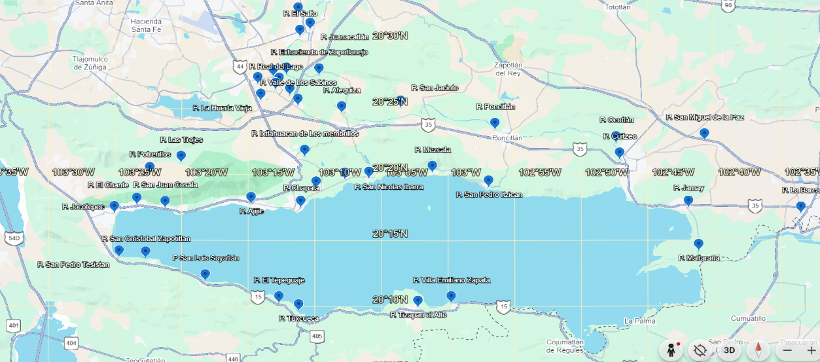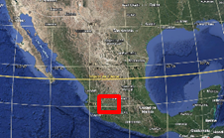
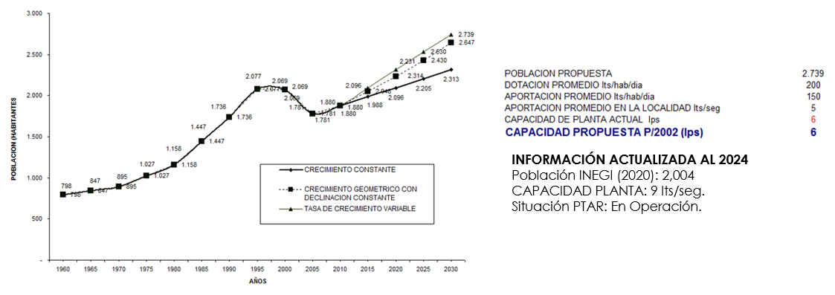
Figure 1. Current geographical distribution of the WWTPs of the Lake Chapala basin
Year
Population

PROPOSED POPULATION 2,739
AVERAGE ALLOWANCE l/inhabitant/day 200
AVERAGE CONTRIBUTION l/inhabitant/day 150
AVERAGE CONTRIBUTION IN THE LOCALITY l/inhabitant/day 5
CURRENT PLANT CAPACITY (l/s) 6
PROPOSED CAPACITY P/2002 (l/s) 6

INFORMATION UPDATED TO 2024
INEGI POPULATION (2020) 2,004
PLANT CAPACITY (l/s) 9
PLANT IN OPERATION
Graph 7 Population projection and wastewater treatment capacity analysis for 2024 in El Chante

3.1.8 Jocotepec
Original projection: 27,468 inhabitants, proposed capacity of 66 l/s. Updated 2024: 15,639 inhabitants, real capacity of 80 l/s. Jocotepec shows a significant population decrease of 43% compared to what was projected. Surprisingly, the plant's capacity increased by 21.2%. This disparity could indicate an anticipation of future demographic recovery, a change in the region's water use profile (possibly due to tourism or industrial development), or a strategy to improve the quality of wastewater treatment (Graph 8).
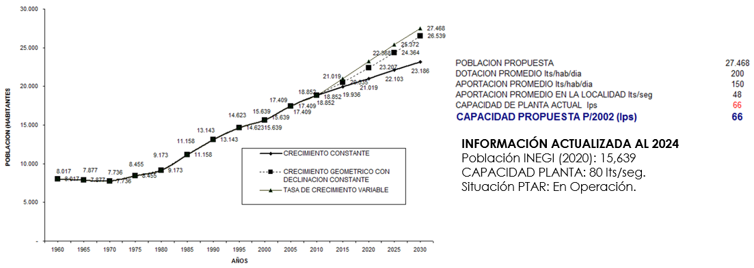
Graph 8 Population forecast and wastewater plant capacity for 2024 in Jocotepec
Year
Population

PROPOSED POPULATION 27,468
AVERAGE ALLOWANCE l/inhabitant/day 200
AVERAGE CONTRIBUTION l/inhabitant/day 150
AVERAGE CONTRIBUTION IN THE LOCALITY l/inhabitant/day 48
CURRENT PLANT CAPACITY (l/s) 66
PROPOSED CAPACITY P/2002 (l/s) 66

INFORMATION UPDATED TO 2024
INEGI POPULATION (2020) 15,639
PLANT CAPACITY (l/s) 80 PLANT IN OPERATION
3.1.9 San Juan Cosalá
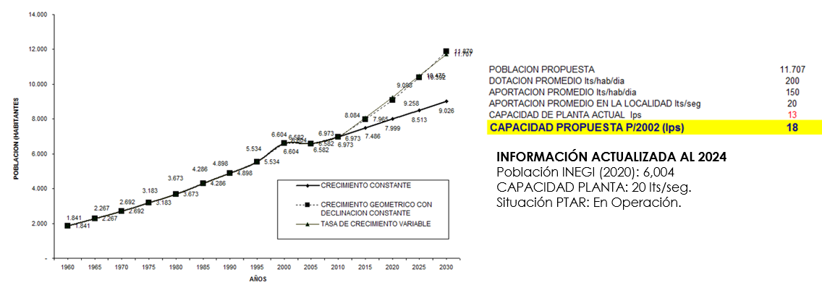
Original projection: 11,707 inhabitants, proposed capacity of 18 l/s. Updated 2024: 6,004 inhabitants, actual capacity of 20 l/s. San Juan Cosalá experienced a population decrease of 48.7%, almost half of what was projected. Despite this, the plant's capacity increased slightly from 18 to 20 l/s. This scenario could reflect conservative planning, anticipating a possible population rebound or the need to manage seasonal variations, related to tourism (Graph 9).
Year
Population

PROPOSED POPULATION 11,707
AVERAGE ALLOWANCE l/inhabitant/day 200
AVERAGE CONTRIBUTION l/inhabitant/day 150
AVERAGE CONTRIBUTION IN THE LOCALITY l/inhabitant/day 20
CURRENT PLANT CAPACITY (l/s) 13
PROPOSED CAPACITY P/2002 (l/s) 18

INFORMATION UPDATED TO 2024
INEGI POPULATION (2020) 6,004
PLANT CAPACITY (l/s) 20 PLANT IN OPERATION
Graph 9 Population forecast and wastewater plant capacity for 2024 in San Juan Cosalá
3.10 Juanacatlán
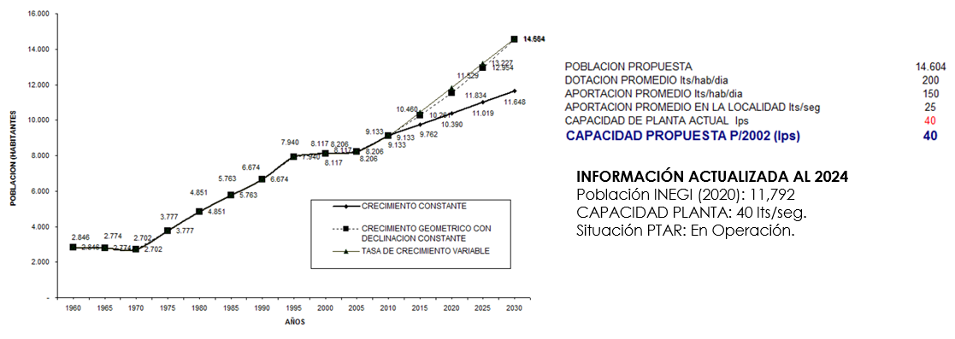
Original projection: 14,604 inhabitants, proposed capacity of 40 l/s. Updated 2024: 11,792 inhabitants, real capacity of 40 l/s. Juanacatlán shows a population decrease of 19.3% compared to what was projected, while the capacity of the plant remained exactly as planned. This suggests planning that has turned out to be adequate despite population reduction, possibly anticipating future needs or changes in water use in the region (Graph 10).
Year
Population

PROPOSED POPULATION 14,604
AVERAGE ALLOWANCE l/inhabitant/day 200
AVERAGE CONTRIBUTION l/inhabitant/day 150
AVERAGE CONTRIBUTION IN THE LOCALITY l/inhabitant/day 25
CURRENT PLANT CAPACITY (l/s) 40
PROPOSED CAPACITY P/2002 (l/s) 40

INFORMATION UPDATED TO 2024
INEGI POPULATION (2020) 11,792
PLANT CAPACITY (l/s) 40 PLANT IN OPERATION
Graph 10 Population forecast and wastewater plant capacity for 2024 in Juanacatlán
3.11 La Barca
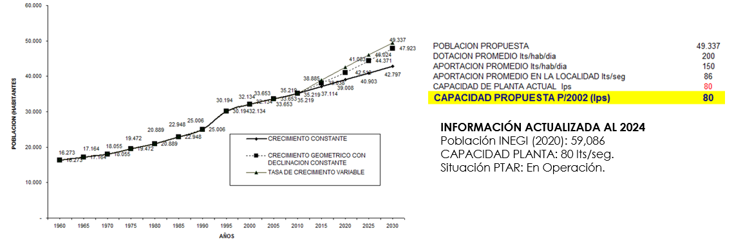
Original projection: 49,337 inhabitants, proposed capacity of 80 l/s. Updated 2024: 59,086 inhabitants, real capacity of 80 l/s. La Barca experienced a population growth of 19.8% above what was projected. Interestingly, the plant's capacity was maintained at 80 l/s as proposed.
Year
Population

PROPOSED POPULATION 49,337
AVERAGE ALLOWANCE l/inhabitant/day 200
AVERAGE CONTRIBUTION l/inhabitant/day 150
AVERAGE CONTRIBUTION IN THE LOCALITY l/inhabitant/day 86
CURRENT PLANT CAPACITY (l/s) 80
PROPOSED CAPACITY P/2002 (l/s) 80

INFORMATION UPDATED TO 2024
INEGI POPULATION (2020) 59,086
PLANT CAPACITY (l/s) 80 PLANT IN OPERATION
Graph 11 Population forecast and wastewater plant capacity for 2024 in La Barca
This suggests that the initial planning was robust enough to absorb this unforeseen growth, although it could imply that the plant is operating close to its maximum capacity (Graph 11).

3.12 Ocotlán
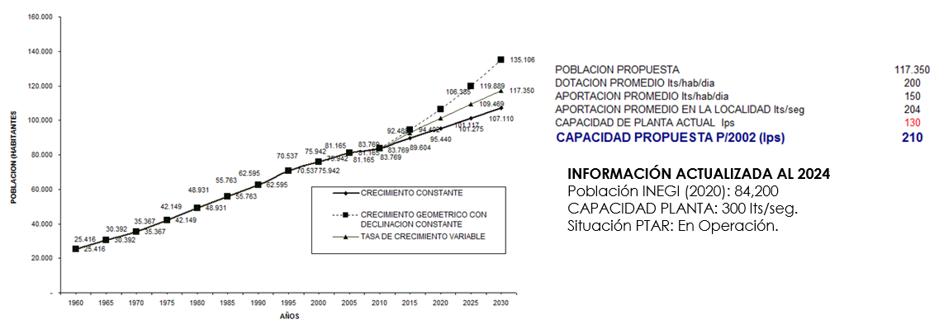
Original projection: 117,350 inhabitants, proposed capacity of 210 l/s. Updated 2024: 84,200 inhabitants, real capacity of 300 l/s. Ocotlán shows a population decrease of 28.2% compared to what was projected. However, the plant's capacity increased significantly, 42.9% more than initially proposed. This considerable increase in capacity in the face of a population decrease could indicate an anticipation of future industrial or urban developments, a substantial improvement in the quality of treatment, or the inclusion of surrounding areas in the plant's service (Graph 12).
Year
Population

PROPOSED POPULATION 117,350
AVERAGE ALLOWANCE l/inhabitant/day 200
AVERAGE CONTRIBUTION l/inhabitant/day 150
AVERAGE CONTRIBUTION IN THE LOCALITY l/inhabitant/day 204
CURRENT PLANT CAPACITY (l/s) 130
PROPOSED CAPACITY P/2002 (l/s) 210

INFORMATION UPDATED TO 2024
INEGI POPULATION (2020) 84,200
PLANT CAPACITY (l/s) 300 PLANT IN OPERATION
Graph 12 : Population forecast and wastewater plant capacity for 2024 in Ocotlán

3.13 Poncitlán
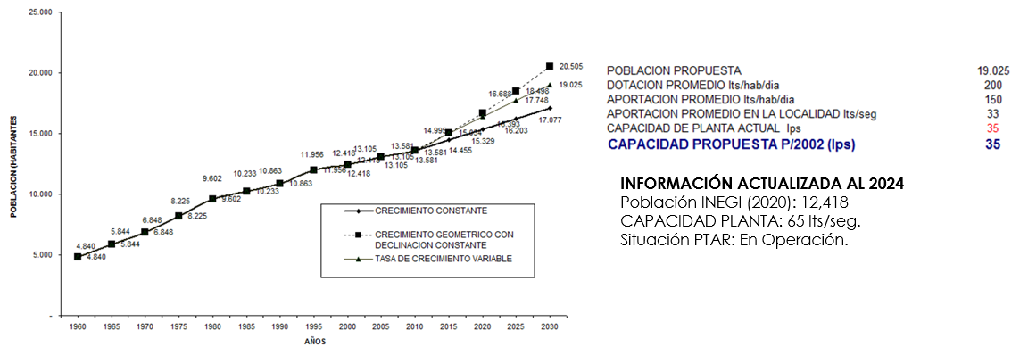
Original projection: 19,025 inhabitants, proposed capacity of 35 l/s. Updated 2024: 12,418 inhabitants, real capacity of 65 l/s. Poncitlán experienced a population decrease of 34.7% compared to what was projected. However, the plant's capacity increased significantly, 85.7% more than initially proposed. This considerable increase in capacity in the face of a population decrease could indicate an anticipation of future industrial or urban developments, a substantial improvement in the quality of treatment, or the inclusion of surrounding areas in the plant's service (Graph 13).
Year
Population

PROPOSED POPULATION 19,025
AVERAGE ALLOWANCE l/inhabitant/day 200
AVERAGE CONTRIBUTION l/inhabitant/day 150
AVERAGE CONTRIBUTION IN THE LOCALITY l/inhabitant/day 33
CURRENT PLANT CAPACITY (l/s) 35
PROPOSED CAPACITY P/2002 (l/s) 35

INFORMATION UPDATED TO 2024
INEGI POPULATION (2020) 12,418
PLANT CAPACITY (l/s) 65 PLANT IN OPERATION
Graph 13 Population forecast and wastewater plant capacity for 2024 in Poncitlán

3.14 Tizapán el Alto
Original projection: 20,841 inhabitants, proposed capacity of 33 l/s. Updated 2024: 19,766 inhabitants, real capacity of 50 l/s. Tizapán el Alto shows a slight population decrease of 5.2% compared to what was projected. The plant's capacity increased significantly, 51.5% more than proposed. This increase in capacity could reflect planning that anticipates future growth or the need to improve the quality of wastewater treatment (Graph 14).
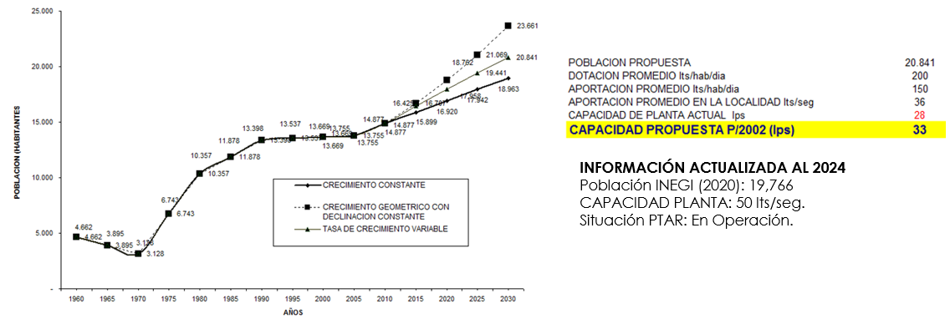
Year
Population

PROPOSED POPULATION 20,841
AVERAGE ALLOWANCE l/inhabitant/day 200
AVERAGE CONTRIBUTION l/inhabitant/day 150
AVERAGE CONTRIBUTION IN THE LOCALITY l/inhabitant/day 36
CURRENT PLANT CAPACITY (l/s) 28
PROPOSED CAPACITY P/2002 (l/s) 33

INFORMATION UPDATED TO 2024
INEGI POPULATION (2020) 19,766
PLANT CAPACITY (l/s) 50 PLANT IN OPERATION
Graph 14 Population forecast and wastewater plant capacity for 2024 in Tizapán el Alto

3.15 San Luis Soyatlán
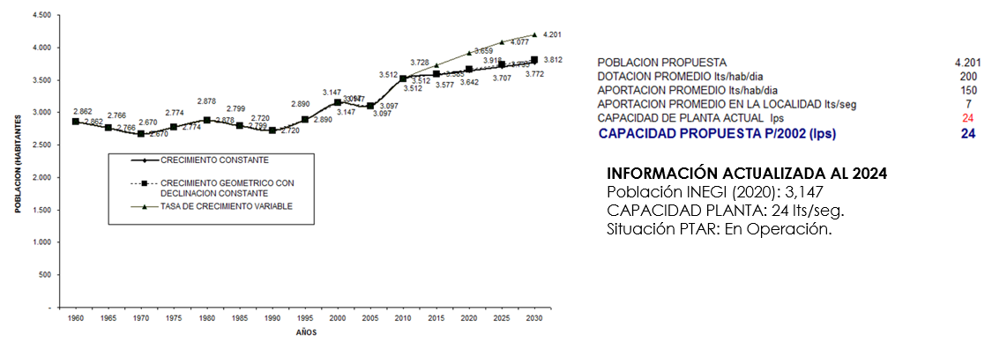
Original projection: 4,201 inhabitants, proposed capacity of 24 l/s. Updated 2024: 3,147 inhabitants, real capacity of 24 l/s. San Luis Soyatlán experienced a population decrease of 25.1% compared to what was projected. Despite this, the plant's capacity remained as planned. This could indicate conservative planning that anticipates a possible population rebound or the need to manage seasonal variations, possibly related to tourism (Graph 15).
Year
Population

PROPOSED POPULATION 4,201
AVERAGE ALLOWANCE l/inhabitant/day 200
AVERAGE CONTRIBUTION l/inhabitant/day 150
AVERAGE CONTRIBUTION IN THE LOCALITY l/inhabitant/day 7
CURRENT PLANT CAPACITY (l/s) 24
PROPOSED CAPACITY P/2002 (l/s) 24

INFORMATION UPDATED TO 2024
INEGI POPULATION (2020) 3,147
PLANT CAPACITY (l/s) 24 PLANT IN OPERATION
Graph 15 : Population forecast and wastewater plant capacity for 2024 in San Luis Soyatlán

3.16 Tuxcueca
Original projection: 1,410 inhabitants, proposed capacity of 12 l/s. Updated 2024: 1,371 inhabitants, real capacity of 12 l/s. Tuxcueca shows a slight population decrease of 2.8% compared to projection, while the capacity of the plant remained exactly as planned. This suggests planning that has turned out to be adequate despite the small population reduction (Graph 16).
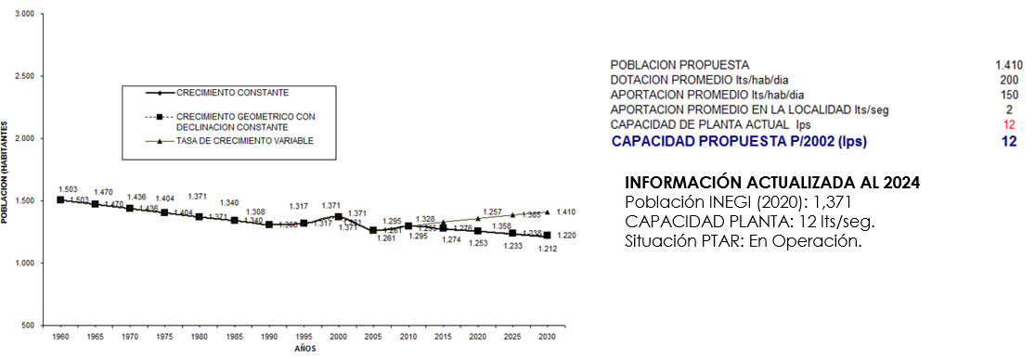
Year
Population

PROPOSED POPULATION 1,410
AVERAGE ALLOWANCE l/inhabitant/day 200
AVERAGE CONTRIBUTION l/inhabitant/day 150
AVERAGE CONTRIBUTION IN THE LOCALITY l/inhabitant/day 2
CURRENT PLANT CAPACITY (l/s) 12
PROPOSED CAPACITY P/2002 (l/s) 12

INFORMATION UPDATED TO 2024
INEGI POPULATION (2020) 1,371
PLANT CAPACITY (l/s) 12 PLANT IN OPERATION
Graph 16 Population forecast and wastewater plant capacity for 2024 in Tuxcueca
  - El Salto
Original projection: 33,445 inhabitants, proposed capacity of 50 l/s. Updated 2024: 27,875 inhabitants, real capacity of 32 l/s. El Salto experienced a population decrease of 16.7% compared to what was projected. The actual capacity of the plant is 36% less than originally proposed. This reduction in both population and treatment capacity could indicate changes in the economic or demographic dynamics of the region (Graph 17).
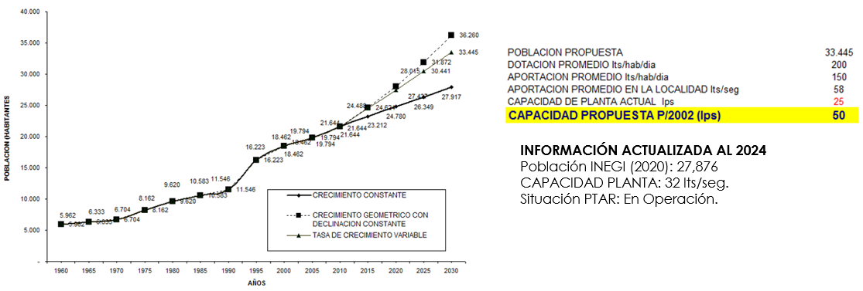Graph 17 Population forecast and wastewater plant capacity for 2024 in El Salto
PROPOSED POPULATION 33,445
AVERAGE ALLOWANCE l/inhabitant/day 200
AVERAGE CONTRIBUTION l/inhabitant/day 150
AVERAGE CONTRIBUTION IN THE LOCALITY l/inhabitant/day 58
CURRENT PLANT CAPACITY (l/s) 25
PROPOSED CAPACITY P/2002 (l/s) 50

INFORMATION UPDATED TO 2024
INEGI POPULATION (2020) 27,876
PLANT CAPACITY (l/s) 32 PLANT IN OPERATION
Year
Population

3.18 San Cristóbal Zapotitlán
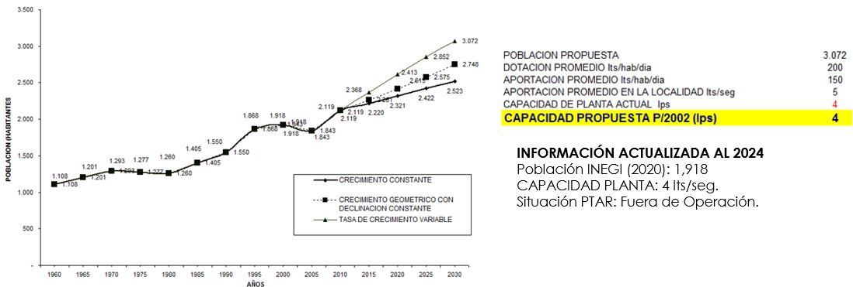
Original projection: 3,072 inhabitants, proposed capacity of 4 l/s. Updated 2024: 1,918 inhabitants, real capacity of 4 l/s. San Cristóbal Zapotitlán shows a significant population decrease of 37.6% compared to what was projected. The plant's capacity was maintained as planned. However, it is important to note that the situation of the WWTP is reported as "Out of Operation", which raises questions about the reasons for this status and the implications for wastewater treatment in the locality (Graph 18).}
PROPOSED POPULATION 3,702
AVERAGE ALLOWANCE l/inhabitant/day 200
AVERAGE CONTRIBUTION l/inhabitant/day 150
AVERAGE CONTRIBUTION IN THE LOCALITY l/inhabitant/day 5
CURRENT PLANT CAPACITY (l/s) 4
PROPOSED CAPACITY P/2002 (l/s) 4

INFORMATION UPDATED TO 2024
INEGI POPULATION (2020) 1,918
PLANT CAPACITY (l/s) 4 OUT OF OPERATION
Year
Population

Graph 18 Population forecast and wastewater plant capacity for 2024 in San Cristóbal Zapotitlán
3.19 San Pedro Tesistán
Original projection: 1,359 inhabitants, proposed capacity of 3 l/s. Updated 2024: 1,295 inhabitants, real capacity of 3 l/s. San Pedro Tesistán experienced a slight population decrease of 4.7% compared to what was projected. The plant's capacity was maintained exactly as planned. This suggests a fairly precise planning that has proved adequate despite the small population reduction. The plant is in operation, indicating that it is effectively managing the current needs of the community (Graph 19).

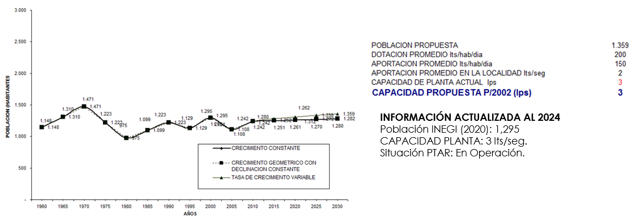
PROPOSED POPULATION 1,359
AVERAGE ALLOWANCE l/inhabitant/day 200
AVERAGE CONTRIBUTION l/inhabitant/day 150
AVERAGE CONTRIBUTION IN THE LOCALITY l/inhabitant/day 2
CURRENT PLANT CAPACITY (l/s) 3
PROPOSED CAPACITY P/2002 (l/s) 3

INFORMATION UPDATED TO 2024
INEGI POPULATION (2020) 1,295
PLANT CAPACITY (l/s) 3 PLANT IN OPERATION
Year
Population

Graph 19 Population forecast and wastewater plant capacity for 2024 in San Pedro Tesistán
3.20 Mezcala
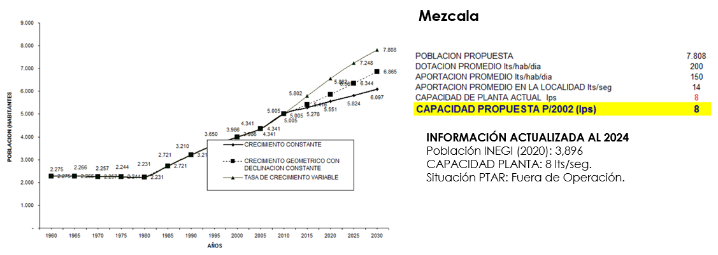
Original projection: 7,808 inhabitants, proposed capacity of 8 l/s. Updated 2024: 3,896 inhabitants, real capacity of 8 l/s. Mezcala shows a significant population decrease of 50.1% compared to what was projected. Despite this large reduction, the plant's capacity remained as planned. However, it is important to note that the situation of the WWTP is reported as "Out of Operation". This raises questions about the reasons for this status, especially considering that the installed capacity appears to be sufficient for the current population (Graph 20).
PROPOSED POPULATION 7,808
AVERAGE ALLOWANCE l/inhabitant/day 200
AVERAGE CONTRIBUTION l/inhabitant/day 150
AVERAGE CONTRIBUTION IN THE LOCALITY l/inhabitant/day 14
CURRENT PLANT CAPACITY (l/s) 8
PROPOSED CAPACITY P/2002 (l/s) 8

INFORMATION UPDATED TO 2024
INEGI POPULATION (2020) 3,896
PLANT CAPACITY (l/s) 8 OUT OF OPERATION
Year
Population

Graph 20 Population forecast and wastewater plant capacity for 2024 in Mezcala
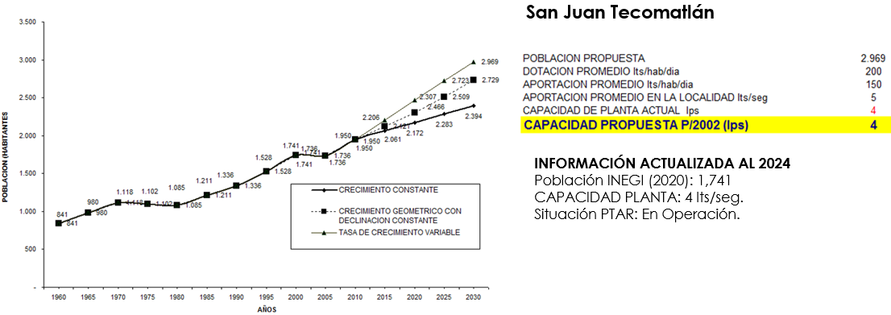
3.21 San Juan Tecomatlán
PROPOSED POPULATION 2,969
AVERAGE ALLOWANCE l/inhabitant/day 200
AVERAGE CONTRIBUTION l/inhabitant/day 150
AVERAGE CONTRIBUTION IN THE LOCALITY l/inhabitant/day 5
CURRENT PLANT CAPACITY (l/s) 4
PROPOSED CAPACITY P/2002 (l/s) 4

INFORMATION UPDATED TO 2024
INEGI POPULATION (2020) 1,741
PLANT CAPACITY (l/s) 4 OUT OF OPERATION
Year
Population

Graph 21 Population forecast and wastewater plant capacity for 2024 in San Juan Tecomatlán
Original projection: 2,969 inhabitants, proposed capacity of 4 l/s. Updated 2024: 1,741 inhabitants, real capacity of 4 l/s. San Juan Tecomatlán experienced a population decrease of 41.4% compared to what was projected. The plant's capacity was maintained as planned. Despite the significant reduction in population, the plant is in operation, suggesting that it may be providing higher quality treatment or serving additional areas not initially planned (Graph 21).

3.22 San Pedro Itzicán
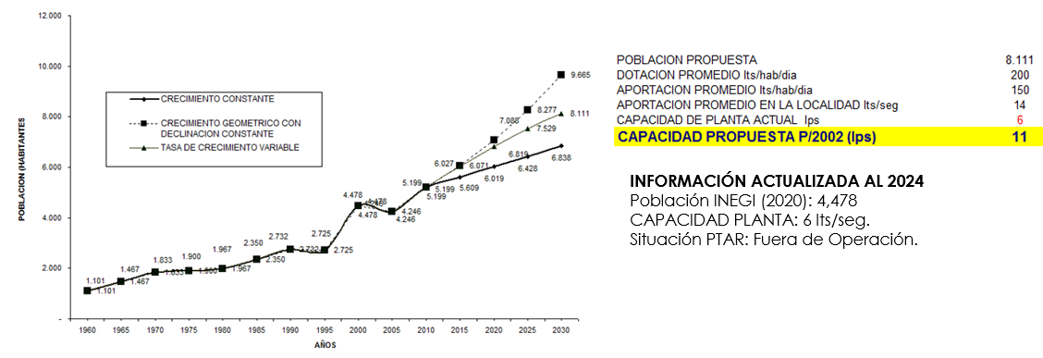
Original projection: 8,111 inhabitants, proposed capacity of 11 l/s. Updated 2024: 4,478 inhabitants, real capacity of 6 l/s. San Pedro Itzicán shows a significant population decrease of 44.8% compared to what was projected. The actual capacity of the plant is 45.5% less than originally proposed, which seems proportional to the population reduction. However, the WWTP is reported as "Out of Operation", which raises serious concerns about wastewater management in this community (Graph 22).
PROPOSED POPULATION 8,111
AVERAGE ALLOWANCE l/inhabitant/day 200
AVERAGE CONTRIBUTION l/inhabitant/day 150
AVERAGE CONTRIBUTION IN THE LOCALITY l/inhabitant/day 14
CURRENT PLANT CAPACITY (l/s) 6
PROPOSED CAPACITY P/2002 (l/s) 11

INFORMATION UPDATED TO 2024
INEGI POPULATION (2020) 4,478
PLANT CAPACITY (l/s) 6 OUT OF OPERATION
Year
Population

Graph 22 Population forecast and wastewater plant capacity for 2024 in San Pedro Itzicán
4. Conclusion
The analysis of the data presented on wastewater treatment plants (WWTPs) in various locations in the region reveals complex and challenging patterns in the planning and management of hydraulic infrastructures. These results offer valuable lessons for future sanitation projects and policies such as:
- Disparity between projections and demographic reality: Most localities experienced significant population declines compared to initial projections. This underscores the difficulty of accurately predicting long-term demographic trends and the need to incorporate greater flexibility into infrastructure planning.
- Adaptability of treatment capacity: Varied responses were observed in terms of treatment capacity. Some localities maintained or even increased their capacity despite the population reduction, while others adjusted it downwards. This diversity suggests the influence of factors beyond simple demographic projections on infrastructure decision-making.
- Operational Challenges: The presence of plants reported as "Out of Operation" in some locations raises serious concerns about the sustainability and long-term maintenance of these critical infrastructures. This highlights the importance of considering not only the initial construction, but also the resources and planning required for ongoing operation and maintenance.
- Long-term planning versus current realities: In several cases, an increase in treatment capacity was observed despite population decline. This could indicate planning that anticipates future developments, improvements in treatment quality, or the inclusion of additional areas in the service. However, it also raises questions about resource efficiency and the need for a more adaptive approach to planning.
- Public Health and Environmental Implications: Discrepancies between installed capacity, current population, and the operational status of some plants suggest potential public health and environmental risks in certain localities. This underscores the need for continuous monitoring and adaptive management of these critical infrastructures.
- Need for a holistic approach: The results show that effective sanitation infrastructure planning requires an approach that goes beyond demographic projections. Factors such as economic development, changes in water use patterns, seasonal variations, and environmental considerations must be integrated into the planning process.
In conclusion, this analysis reveals the complexity inherent in the planning and management of wastewater treatment infrastructures in a context of dynamic demographic and economic change. The results underscore the importance of adopting more flexible and adaptive approaches in critical infrastructure planning, which can respond to changing realities on the ground. For future projects and policies, it is recommended to:
- Incorporate multi-scenario analysis into planning projections.
- Prioritize modular, scalable designs that allow for easier adjustments to treatment capabilities.
- Strengthen long-term maintenance and operation programs.
- Implement continuous monitoring systems to allow timely adjustments in management.
- Encourage greater integration between infrastructure planning and regional urban and economic development strategies.
- Implement new technologies in wastewater treatment. Since the advances of recent years have influenced the efficiency, operating capacity and operating costs of WWTPs
These lessons and recommendations can contribute significantly to improving the effectiveness and sustainability of sanitation infrastructures, ensuring a better correlation between installed capacities and the real needs of communities.
DISCLAIMER (ARTIFICIAL INTELLIGENCE)
Author(s) hereby declare that no generative ai technologies such as large language models (chatgpt, copilot, etc.) And text-to-image generators have been used during the writing or editing of this manuscript.
References
- Chávez-Alcántar, A., Martínez-Rodríguez, A., Ramos-Leal, J. A., & Villanueva-Estrada, R. E. (2011). Hidroquímica de las aguas superficiales de la Ciénega de Chapala e índice de calidad del agua. Terra Latinoamericana, 29(1), 83–94. https://www.scielo.org.mx/scielo.php?pid=S0187-57792011000100083&script=sci_abs tract&tlng=en
- Jalisco State Water Commission (CEA). (2012). Jalisco modernizes its treatment plants in Jocotepec and San Juan Cosala. Government of Jalisco. https://www.ceajalisco.gob.mx/notas/2012/nota_jalisco_moderniza_ptars.html
- Comisión Nacional del Agua (CNA), & Secretaría de Medio Ambiente y Recursos Naturales (SEMARNAT). (2024). Programa Hidráulico Regional: Región Lerma–Santiago–Pacífico. Gobierno de México. https://files.conagua.gob.mx/conagua/generico/ PNH/PHR_2021-2024_RHA_VIII_LSP.pdf
- Comisión Nacional del Agua (CONAGUA). (2016a). Atlas del agua en México 2016. Secretaría de Medio Ambiente y Recursos Naturales. Atlas del Agua en México 2016-CONAGUA – Agua.org.mx
- Comisión Nacional del Agua (CONAGUA). (2016b). Regiones Hidrológicas de México. Gobierno de México. https://www.gob.mx/conagua
- Comisión Nacional del Agua (CONAGUA). (2016c). Estadísticas del agua en México 2016. Secretaría de Medio Ambiente y Recursos Naturales. https://agua.org.mx/biblioteca/estadisticas-del-agua-en-mexico-edicion-2016/
- Comisión Nacional del Agua (CONAGUA). (2020). Atlas del agua en México: cuencas y regiones hidrológicas. Gobierno de México. https://www.gob.mx/conagua
- Comisión Nacional del Agua (CONAGUA). (2016). Calidad del agua en la cuenca Lerma-Chapala. Gobierno de México. https://www.gob.mx/conagua
- INEGI (Instituto Nacional de Estadística y Geografía). (2010). Atlas Nacional de México: Geografía Física y Recursos Naturales. URL: https://www.inegi.org.mx/app/atlas
- López-Hernández, M., Ramos-Espinosa, M. G., & Carranza-Fraser, J. (2007). Análisis multimétrico para evaluar contaminación en el río Lerma y lago de Chapala. Hidrobiológica, 17(1), 17–30.
- Instituto Mexicano de Tecnología del Agua (IMTA). (2011). Actualización del estudio de calidad del agua del río Santiago (desde su nacimiento en el lago de Chapala hasta la represa Santa Rosa). Comisión Estatal del Agua de Jalisco / Comisión Nacional del Agua. https://agua.org.mx/biblioteca/actualizacion-del-estudio-de-calidad-del-agua-del-rio-santiago-desde-su-nacimiento-en-el-lago-de-chapala-hasta-la-presa-santa-rosa/
- Ministry of Environment and Natural Resources / National Institute of Statistics and Geography (SEMARNAT / INEGI). (2010). National Inventory of Wastewater and Water Quality. https://www.gob.mx/semarnat
- Ramírez-Sánchez, H. U., & Fajardo-Montiel, A. L. (2024). Assessment of Water Quality, Ecological and Health Risks of Inland Water Bodies in Mexico: A Case Study of Lake Chapala. Asian Journal of Environment & Ecology, 23(6), 91–108. https://doi.org/10.9734/ajee/2024/v23i6558
- Ramírez-Sánchez, H. U., & Fajardo-Montiel, A. L. (2025). Assessment of Pesticide Contamination in the Water of the Santiago River, Mexico. Asian Journal of Environment & Ecology, 24(5), 396–417. https://doi.org/10.9734/ajee/2025/v24i5719
- SEMARNAT (Ministry of Environment and Natural Resources). (2018). National Inventory of Soils and Desertification. URL: https://www.gob.mx/semarnat https://www.gob.mx/semarnat
- Vallejo-Rodríguez, R., & López-López, A. (2011). Study of pollution in wastewater that flows into Lake Chapala. Center for Research and Assistance in Technology and Design of the State of Jalisco (CIATEJ). [Summary in local press: El Mañana]. https://www.elmanana.com/abastece-chapala-agua-contaminada/3226080

