A Study on the Selection of Nest Trees by Asian Open Bill Storks (Anastomus Oscitans) in Adina Deer Park, West Bengal, India

ABSTRACT

A field study on the nesting pattern of Asian Openbill Stork (Anastomus oscitans) was conducted over two days in September, 2024 in Adina Deer Park (25°08'25"N, 88°10'24"E) of West Bengal, India. The study area was the deer’s enclosure of Adina Deer Park, where colony of Asian Open Bill Stork has been observed. The study area has an elevation of 17 meters and an average annual temperature of 26.4°C. The aim of the present study was to investigate the total number of nests, the population, and the preferred nest tree species of Asian Openbill Storks in Adina Deer Park. All observations were conducted during the day using either the naked eye or 10x40 binoculars. A total of 332 trees of 19 species have been studied that were used by Asian Open Bill Storks for nesting. The current study suggests that Anthocephalus cadamba tree species have a greater preference for nesting, with an average of 31 nests per tree. Albizia lucida, Trewia nudiflora, Pongamia glabra and Cassia siamea also showed a good number of nests. Diameter at breast height (DBH) of every nest tree was also measured. Nest trees having DBH of (60-70) cm showed the highest average number of nests per tree. Statistical analysis revealed a strong positive correlation (r=0.91, P=0.01) between nest tree DBH and average nest per tree. Their selection of specific tree species for nesting emphasises how dependent they are on particular environmental factors.

Keywords: Asia Openbill Stork, Migratory Bird, Nesting Preference, Nesting Tree

1. INTRODUCTION

Asian Openbill Stork (Anastomus oscitans) is a common colonial breeder found throughout Southeast Asia. Globally, there are nineteen species of storks, of which only nine occur in India (Ali & Ripley, 1987). Among them, Asian Openbill Stork is the most common and the smallest stork species. Every year, they typically migrate to northern India in June, and return to the southern parts of the country in November, where they spend around six months (Das et al., 2014). Its distinguishing features include a forked black tail, black wings, pinkish to grey legs, greyish or pale white plumage, and a swollen-looking bill with a small gap between mandibles. It is known as “Openbill” because of this unique gap, which is believed to be an adaptation for handling its primary food source, common Indian apple snail (Pila globosa) (Elliott et al., 2020). Due to this feeding habit, it is commonly referred to as "Samukh-khol" (Samukh: Snail) in West Bengal (Roy & Sah, 2013). Asian Openbill Stork is currently listed as “Least Concern” by IUCN (BirdLife International, 2016) as it has stable populations and wide distribution (Tamang et al., 2024) but is protected under Schedule II of the Wildlife Protection Act, 1972 as a preventive measure against poaching, habitat loss, and human disturbance threats.
Wetland habitats are essential to the Asian Openbill Stork (AOS). Inland wetlands, marshes, lakes, paddy fields, and slowly flowing rivers are common habitats where these storks are frequently observed. Their primary food source, snails, is abundant in these habitats. They also feed on insects, frogs, fishes, and other small aquatic animals (Pramanik et al., 2010). Nest construction and nest-site selection are key behavioral aspects of migratory birds. A safe and sheltered nesting site is essential for successful breeding and for reducing the risk of predation, which is a major cause of nest failure (Ricklefs, 1969; Descamps et al., 2011; Donehower et al., 2007). Due to their ecological adaptability and ability to thrive in diverse environments, the AOS is considered as a valuable bioindicator of environmental health.
Several studies have investigated the nesting habits and habitat preference of the Asian Openbill Stork; however, no published literature exists on the nesting patterns of AOS in Adina Deer Park (ADP), West Bengal, India. The present study aimed to determine the total number of nests, their population and the preferred nest tree species of these storks in ADP.

2. methodology

2.1 Study Area

The study was carried out at Adina Deer Park (25°08'25"N, 88°10'24"E) in the Malda district of West Bengal, India. The area has an elevation of 17 meters. The average annual temperature of the park is 26.4°C and average precipitation is about 1,554 mm (61.2 in) per year. The park is recognised as a mini zoo by the Central Zoo Authority and records an annual footfall of over 100,000 visitors. This park serves as a vital conservation and breeding center for spotted deer (Axis axis) and houses other wildlife species, such as Nilgai (Boselaphus tragocamelus) and a variety of captive and free-ranging birds, including the Asian Openbill Stork (Anastomus oscitans). The park's landscape comprises lush orchard plantations, grasslands, and three small to medium water bodies, creating a serene and biodiverse environment. The study area for the study was the deer’s enclosure of Adina Deer Park as, all the nests of Asian Open Bill Stork were found in the deer’s enclosure. Asian Openbill Stork primarily feed on the common Indian apple snail (Pila globosa) and other snail species, which are abundant in the paddy fields and water bodies surrounding Adina Deer Park. These factors make ADP an ideal location for the AOS to breed and feed. A map of the study area has been shown in Fig. 1. The map has been created on QGIS 3.40.4 software.
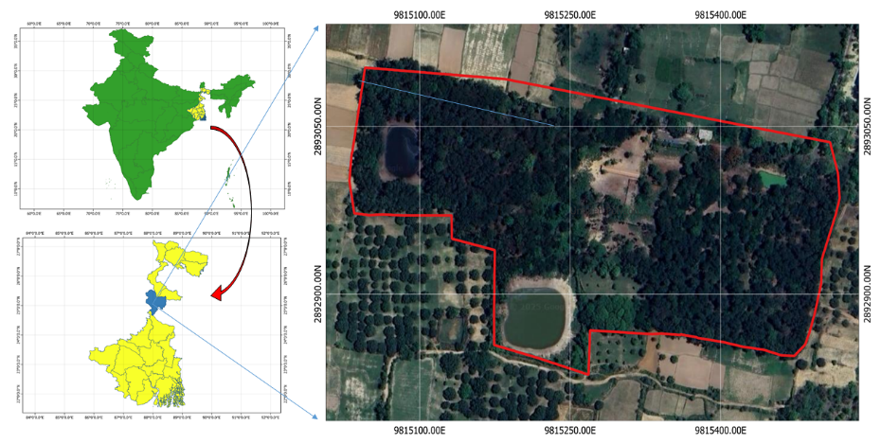

Fig 1: Location of the Study Area (The marked area is the deer’s enclosure of Adina Deer Park which was the survey site of the study)

2.2 Data Collection & Analysis

The field study was carried out on the 24th and 25th of September of 2024. The colony of Asian Open Bill Storks was located in the deer’s enclosure of Adina Deer Park. A total of 72,695 square meters of area has been covered during the survey. All observations were made during the daylight from 11:00 am to 4 pm. Initially, trees with active nests were identified, aided by observing the storks' defensive behavior around their nests. Each nest tree was marked with white paint at its base according to its assigned number (Fig 2). Only trees with active nests were observed and recorded. The nest tree species were identified by the unpublished official reports of Malda Forest Division and a field guide book (Naskar et al., 2023). Nests in the trees were counted with the naked eye and sometimes using 10x40 binoculars. During the observation, on average, three Asian Open Bill storks were observed in every active nest. Total nests and bird population of every nest tree species in study area were counted one by one. Then, diameter at breast height (DBH) of each nest tree was measured using a DBH tape, which is a specialized tape mainly used for this purpose. The DBH was measured at 150 cm above the ground for every nest tree species. Then, the average DBH of every nest tree species was calculated. DBH of nests trees were further categorized into (10-20) cm, (20-30) cm, (30-40) cm, (40-50) cm, (60-70) cm range and compared them with their number of nests and number of trees for every found nest tree species. The relationship between the nest tree DBH and the average number of nests per tree, irrespective of species, was analyzed using linear regression. Durbin-Watson statistics were also performed to detect autocorrelation in the residuals of the regression analysis. All the analyses were carried out using Microsoft Excel 2019. Additional information was gathered from secondary sources, including official documents from the relevant departments.

3. results

3.1 Nest Counting of AOS

A total of 332 trees of 19 species were studied, where nesting of AOS was observed. Among these 19 tree species, 4 tree species were exotic in nature of origin and the remaining 15 tree species were of the native type. It is observed that average 3 storks, including nestlings are present on every observed nest. In ADP, a total of 4396 no. of nests and 13188 no. of Asian Open Bill Storks were observed. During this study, interestingly other species of birds were observed along with them very rarely. Tree species type, total no. of trees, average DBH, total no. of nests, average nests per tree and total no. of birds regarding their tree species has been depicted in Table 1. Though trees of Trewia nudiflora were more common in Adina deer Park, but Anthocephalus cadamba shows highest no. of average nests per tree. Some significant tree species with a good number of average nests per tree are Lagerstroemia flosreginae, Ficus rumphii and Albizia lucida. In Fig 3, a graphical representation of nest tree species and their total no. of trees and total no. of nests has been depicted.

Table 1: Study of nest tree species at the study area of Adina Deer Park, Malda, India.
Species Type | Species  (Common Name) | Scientific Name | Total No. of Trees | Average DBH (cm) | Total No. of Nests | Average Nests Per tree | Total No. of Birds
Exotic | Rudrapalash | Spathodea campanulata | 2 | 46.95 | 38 | 19 | 114
Exotic | Mahogony | Swietenia mahogoni | 14 | 28.84 | 135 | 10 | 405
Exotic | Radhachura | Caesalpinia pulcherrima | 1 | 32.89 | 2 | 2 | 6
Exotic | Krishnachura | Delonix Regia | 1 | 33.42 | 18 | 18 | 54
Native | Gokunja | Albizia lucida | 41 | 29.45 | 929 | 23 | 2787
Native | Kadam | Anthocephalus cadamba | 3 | 35.01 | 94 | 31 | 282
Native | Dumur | Ficus hispida | 3 | 33.42 | 20 | 7 | 60
Native | Pithali | Trewia nudiflora | 94 | 30.24 | 901 | 10 | 2703
Native | Bel | Aegle marmelos | 1 | 32.99 | 14 | 14 | 42
Native | Siris | Albizia lebbeck | 1 | 17.51 | 5 | 5 | 15
Native | Jarul | Lagerstroemia flosreginae | 1 | 29.44 | 21 | 21 | 63
Native | Minjiri | Cassia siamea | 52 | 19.10 | 712 | 14 | 2136
Native | Mahua | Bassia latifora | 1 | 55.70 | 2 | 2 | 6
Native | Taal | Borassus flabellifer | 1 | 28.65 | 2 | 2 | 6
Native | Karamja | Pongamia glabra | 49 | 24.13 | 916 | 19 | 2748
Native | Sisso | Dalbergia sisoo | 1 | 44.56 | 6 | 6 | 18
Native | Pakur | Ficus rumphii | 1 | 52.52 | 23 | 23 | 69
Native | Jam | Syzygium cumini | 38 | 25.89 | 369 | 10 | 1107
Native | Bakul | Mimusops elengi | 27 | 39.55 | 189 | 7 | 567
Native |  |  | 332 |  | 4396 |  | 13188
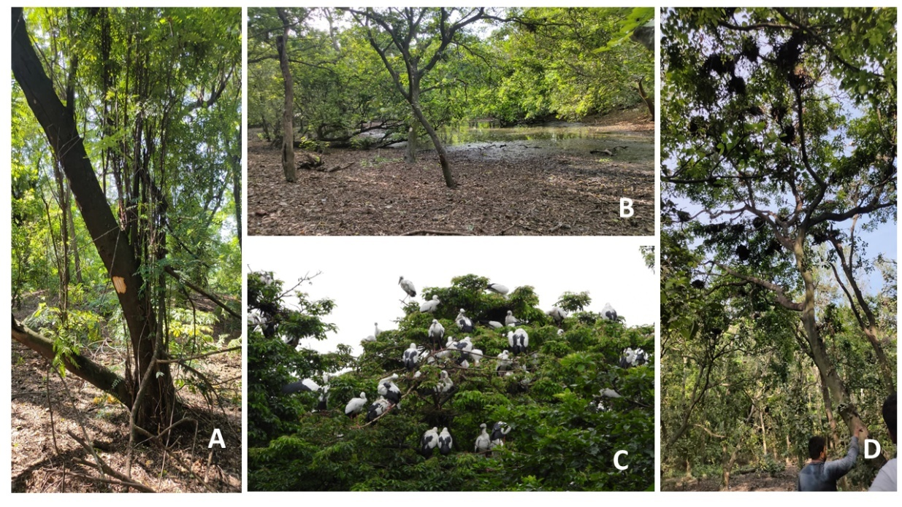

Fig 2: A. Marking of nest trees with white paint according to assigned number; B. Presence of small water body in the study area; C. Picture of Asian Open Bil Storks in the study area; D. Picture of nests on a single tree in study area.

Fig 3: Comparison of total no. of trees and total no. of nests on every nest species found in the study area.

3.2 Relation between DBH of trees and nests of AOS and statistical analyses

The relation between DBH and number of nests was also tried to be observed. DBH is calculated for all 19 species at the height of 150 cm. The nest trees were further categorised into different ranges. In Table 2, total no. of trees and total no. of nests of nest tree species with their different DBH ranges were depicted. In ADP, nest trees with DBH of (20-30) cm and (30-40) cm ranges are more abundant. But among all the trees regardless of their species, trees with the DBH of (60-70) cm showed the highest average number of nests per tree. Moreover, it is observed that trees with a DBH of greater than 30 cm show a good number of average nests per tree.

Linear regression analyses were conducted to assess the relationships between average nests per tree and DBH of nest trees (Fig 4). Correlations are considered strong when the r values lie between ±0.50 and ±1 (Mukaka, 2012). Significant correlation coefficients between average nests per tree and DBH of nest trees were observed (r=0.91, P=0.01). Durbin Watson statistics were also performed and a positive autocorrelation was observed (Durbin Watson statistics =2.67).

Table 2: Table of different DBH ranges of nest tree species and total number of nests and trees of that tree species at the study area, Adina Deer Park, Malda, India

Species |  | DBH of Tree (cm) |  |  |  |  |  | Total
 |  | 10-20 | 20-30 | 30-40 | 40-50 | 50-60 | 60-70 | Total
Spathodea campanulata | No. of Trees | 0 | 0 | 0 | 2 | 0 | 0 | 2
Spathodea campanulata | No. of Nest | 0 | 0 | 0 | 38 | 0 | 0 | 38
Albizzia lucida | No. of Trees | 6 | 16 | 15 | 4 | 0 | 0 | 41
Albizzia lucida | No. of Nest | 53 | 284 | 445 | 147 | 0 | 0 | 929
Anthocephalus cadamba | No. of Trees | 0 | 1 | 1 | 1 | 0 | 0 | 3
Anthocephalus cadamba | No. of Nest | 0 | 53 | 12 | 29 | 0 | 0 | 94
Ficus hispida | No. of Trees | 0 | 0 | 3 | 0 | 0 | 0 | 3
Ficus hispida | No. of Nest | 0 | 0 | 20 | 0 | 0 | 0 | 20
Trewia nudiflora | No. of Trees | 5 | 48 | 35 | 4 | 1 | 1 | 94
Trewia nudiflora | No. of Nest | 19 | 335 | 405 | 82 | 28 | 32 | 901
Aegle marmelos | No. of Trees | 0 | 0 | 1 | 0 | 0 | 0 | 1
Aegle marmelos | No. of Nest | 0 | 0 | 14 | 0 | 0 | 0 | 14
Albizzia lebbak | No. of Trees | 0 | 0 | 1 | 0 | 0 | 0 | 1
Albizzia lebbak | No. of Nest | 0 | 0 | 5 | 0 | 0 | 0 | 5
Lagerstroemia flosreginae | No. of Trees | 0 | 0 | 1 | 0 | 0 | 0 | 1
Lagerstroemia flosreginae | No. of Nest | 0 | 0 | 21 | 0 | 0 | 0 | 21
Cassia siamea | No. of Trees | 4 | 17 | 23 | 8 | 0 | 0 | 52
Cassia siamea | No. of Nest | 24 | 263 | 304 | 121 | 0 | 0 | 712
Bassia latifora | No. of Trees | 1 | 0 | 0 | 0 | 0 | 0 | 1
Bassia latifora | No. of Nest | 2 | 0 | 0 | 0 | 0 | 0 | 2
Swietenia mahogoni | No. of Trees | 1 | 8 | 3 | 2 | 0 | 0 | 14
Swietenia mahogoni | No. of Nest | 2 | 55 | 18 | 60 | 0 | 0 | 135
Borassus flabellifer | No. of Trees | 1 | 0 | 0 | 0 | 0 | 0 | 1
Borassus flabellifer | No. of Nest | 2 | 0 | 0 | 0 | 0 | 0 | 2
Caesalpinia pulcherrima | No. of Trees | 0 | 0 | 0 | 0 | 1 | 0 | 1
Caesalpinia pulcherrima | No. of Nest | 0 | 0 | 0 | 0 | 2 | 0 | 2
Delonix Regia | No. of Trees | 0 | 1 | 0 | 0 | 0 | 0 | 1
Delonix Regia | No. of Nest | 0 | 18 | 0 | 0 | 0 | 0 | 18
Pongamia glabra | No. of Trees | 18 | 20 | 10 | 0 | 1 | 0 | 49
Pongamia glabra | No. of Nest | 201 | 414 | 229 | 0 | 72 | 0 | 916
Dalbergia sisoo | No. of Trees | 0 | 0 | 0 | 1 | 0 | 0 | 1
Dalbergia sisoo | No. of Nest | 0 | 0 | 0 | 6 | 0 | 0 | 6
Ficus rumphii | No. of Trees | 0 | 0 | 0 | 0 | 1 | 0 | 1
Ficus rumphii | No. of Nest | 0 | 0 | 0 | 0 | 23 | 0 | 23
Syzygium cumini | No. of Trees | 6 | 25 | 7 | 0 | 0 | 0 | 38
Syzygium cumini | No. of Nest | 33 | 266 | 70 | 0 | 0 | 0 | 369
Mimusops elengi | No. of Trees | 0 | 5 | 9 | 9 | 4 | 0 | 27
Mimusops elengi | No. of Nest | 0 | 31 | 74 | 67 | 17 | 0 | 189
Total Nos of Trees |  | 42 | 141 | 109 | 31 | 8 | 1 | 332
Total Nos of Nest |  | 336 | 1719 | 1617 | 550 | 142 | 32 | 4396
Average Nest Per Tree |  | 8 | 12.19 | 14.8 | 17.74 | 17.75 | 32

Fig 4: Linear regression analyses between average nests per tree and DBH of nest trees

Discussion

Migratory birds are the key mobile links that contribute to the function of diverse ecosystems. The present study aimed to find out about the selection of nest trees of AOS in ADP. The periodic arrival of Asian Openbill Storks in Adina Deer Park is seasonal. Most of the tree species selected by AOS were mostly native in nature. A total of 19 different nest tree species were recorded in this study. AOS in ADP preferred large trees for nesting. Large trees, such as Anthocephalus cadamba, Albizia lucida and Ficus rumphii which were mostly used as nest trees in the study area by AOS, have thick side branches that can offer adequate support to the AOS nest. Among these plant species, Anthocephalus cadamba showed the highest average number of nests per tree. These trees provide sufficient space or platforms for nesting and it is easy to construct the nest properly among the radiating branches of these trees. In another study, Anthocephalus cadamba is also observed as the most preferred nest tree for other storks (Choudhary & Abdullah, 2023). Other significant tree species were Albizia lucida, Ficus rumphii and Lagerstroemia flosreginae. Though nests were observed in Syzygium cumini and Pongamia glabra tree species in this study, they were not found in another study (Das et al., 2014). In Eucalyptus tereticornis, no nest had been observed in ADP. An affinity to build nests on top canopies was observed but the nesting height varied from 3.5m to 12 meters. The trees with DBH of (60-70) cm had the highest number of average nests per tree. Trees with higher DBH possess more branches, which is better for nesting. Similar result were obtained by other studies for other storks (Sundar et al., 2016; Barman & Sharma 2020; Bhattarai et al., 2021). It was also observed that AOS prefer trees closer to the water bodies. In Adina deer park, most of the nests were in the radius of 30m from the smaller water body. Interestingly, it is also observed that outside 120m radius from the smaller water body, AOS is not showing so much interest in making nests. Though no physiochemical study of the water bodies has been performed, it is recommended.
Typically, birds are expected to actively select new breeding habitats or alter their nesting behavior to avoid potential threats (Hunter et al., 2016; Ma et al., 2019). Natural phenomenon like rainfall or other natural calamities can severely impact the arrival of AOS (Roy & Sah., 2013; Mahanty et al., 2024). A recent study has been reported the rapid decline in the number of breeding colonies and Asian Open Bill Storks population (Mandal, 2024). Asian Openbill storks were seen to spend more time in regions with vegetation (Greeshma & Jayson, 2018). The presence of a nearby water body is crucial in establishing the vegetation pattern, which in turn ensures that there are sufficient nest sites with sustainable food and building materials for birds. ADP is surrounded by many agricultural lands; most of them are paddy fields, where their main food source, snails, can be found profoundly, especially in the season of monsoon. The abundance of food resources and favorable climate at ADP is most likely the key factors for the nesting of AOS every year. In ADP, it was observed that spotted deer and nilgai are coexisting with AOS. This interspecies interaction may also play a major role in the arrival of AOS in ADP.

CONCLUSION

This study provides the first comprehensive documentation of Asian Openbill Stork nesting patterns in Adina Deer Park, establishing critical baseline data for conservation management. The investigation revealed a thriving population of 13,188 Asian Open Bill Storks utilising 4,396 nests across 332 trees of 19 species, demonstrating ADP's significance as a breeding habitat for this bird species. In conclusion, the nesting process of Asian open bill storks, depends on the conservation of specific plant species. The current study demonstrates that the presence of AOS is substantially correlated with certain tree species, and it can be inferred that AOS favours tree species with higher DBH. Consequently, the result and discussion show that there is a strong correlation between nests and DBH of tree species. These storks' selection of specific tree species for colonies' nesting locations emphasises, how dependent they are on particular environmental factors. In order to sustain these nesting activities, conservation efforts must be made to maintain healthy tree populations. Future research should include physicochemical analysis of water bodies of Deer’s enclosure and long-term population monitoring of Asian Open Bill Storks in Adina Deer Park.

Disclaimer (Artificial intelligence)

Authors hereby declare that no generative AI technologies such as large language models (ChatGPT, copilot, etc.) and text-to-image generators have been used during the writing or editing of this manuscript.
References

Ali, S., Ripley, S. D., & Dick, J. H. (1987). Compact handbook of the birds of India and Pakistan: together with those of Bangladesh, Nepal, Bhutan and Sri Lanka.
Barman, P. D., & Sharma, D. K. (2020). Foraging analysis of Endangered Greater Adsjutant Stork Leptotilus dubios Gemlin in certain habitat of Assam, India. bioRxiv (Cold Spring Harbor Laboratory). https://doi.org/10.1101/2020.05.31.125328
Bhattarai, B. P., Adhikari, J. N., & Rijal, M. (2021). Nesting habitat selection and challenges of conservation of the vulnerable Lesser Adjutant Leptoptilos javanicus (Horsfield, 1821) in the Chitwan National Park, Nepal. Ornis Hungarica, 29(1), 33–46. https://doi.org/10.2478/orhu-2021-0003
BirdLife International (2016). Species factsheet: Asian Openbill Anastomus oscitans. Downloaded from https://datazone.birdlife.org/species/factsheet/asian-openbill-anastomus-oscitans. accessed on 22/08/2025
Choudhary, D. N., & Abdullah. (2023). Some Observations on the Nest Site Selection, Nesting and Other Breeding Behaviors of Greater Adjutant Stork (Leptoptilos dubios) in the Flood Plains of Kosi River in District Bhagalpur, Bihar, India. Asian Journal of Environment & Ecology, 20(2), 19–31. https://doi.org/10.9734/ajee/2023/v20i2434
Das, A., Sarkar, S., Banerjee, K., Nandy, A., Talapatra, S. N., & Swarnakar, S. (2014). A study on the occurrence of Asian open bill stork, Anastomus oscitans in particular tree species at Nature Park, Kolkata, India. International Letters of Natural Sciences, 22.
Descamps, S., Bêty, J., Love, O.P. and Gilchrist, H.G. (2011), Individual optimization of reproduction in a long-lived migratory bird: a test of the condition-dependent model of laying date and clutch size. Functional Ecology, 25: 671-681. https://doi.org/10.1111/j.1365-2435.2010.01824.x
Donehower, C. E., Bird, D. M., Hall, C. S., & Kress, S. W. (2007). Effects of gull predation and predator control on tern nesting success at Eastern Egg Rock, Maine. Waterbirds, 30(1), 29-39. https://doi.org/10.1675/1524-4695(2007)030[0029:EOGPAP]2.0.CO;2
Elliot, A., Garcia, E., Boseman, P.F.D., & Kirwan, G.M. (2020). Asian Openbill (Anastomus oscitans), version 1.0. In Birds of the World (J. del Hoyo, A. Elliott, J. Sargatal, D. A. Christie, and E. de Juana, Editors). Cornell Lab of Ornithology, Ithaca, NY, USA. https://doi.org/10.2173/bow.asiope1.01
Greeshma, P., & Jayson, E. A. (2018). Asian Openbill Stork (Anastomus oscitans), Not a “Nutcracker”: A Study from Kole Wetlands of Thrissur, Kerala. In Springer eBooks (pp. 139–149). https://doi.org/10.1007/978-981-10-6605-4_7
Hunter, E. A., Nibbelink, N. P., & Cooper, R. J. (2016). Threat predictability influences seaside sparrow nest site selection when facing trade-offs from predation and flooding. Animal Behaviour, 120, 135–142. https://doi.org/10.1016/j.anbehav.2016.08.001
Ma, L., Zhang, J., Liu, J., Yang, C., Liang, W., & Møller, A. P. (2019). Adaptation or ecological trap? Altered nest-site selection by Reed Parrotbills after an extreme flood. Avian Research, 10(1), 2. https://doi.org/10.1186/s40657-019-0141-1
Mahanty, S., Roy, S., Mandal, S., Mahanti, B., Mahapatra, M., & Majumder, S. (2024). Impact of average rainfall and the COVID-19 lockdown on the abundance and nesting habits of the Asian openbill stork (Anastomus oscitans, Boddaert). Ornithology Research, 33(1), 8. https://doi.org/10.1007/s43388-024-00208-x

Mandal M. (2024). Breeding colony contraction of Asian openbill stork (Anastomus oscitans): an eco-spatial monitoring from Keleghai River Bank, India. Environmental monitoring and assessment, 196(3), 317. https://doi.org/10.1007/s10661-024-12485-6

Mukaka, M. M. (2012). Statistics corner: A guide to appropriate use of correlation coefficient in medical research. Malawi medical journal: the journal of Medical Association of Malawi, 24(3), 69–71.
Naskar, A.K., Bhunia, A.K., Mondal, A.K. (2023). Identification Approach of Bengal Plants: A pictorial. Iterative International Publishers.

Pramanik, A., Santra, K., & Manna, C. (2010). Nest-building Behaviour of the Asian Open Billed Stork Anastomus oscitans, in the Kulik Bird Sanctuary, Raiganj, India. Our Nature, 7(1), 39–47. https://doi.org/10.3126/on.v7i1.2552
Ricklefs, R.E. (1969). An analysis of nesting mortality in birds. Smithsonian Institution Press; for sale by the Supt. of Docs., U.S. Govt. Print. Off. https://doi.org/10.5479/si.00810282.9
Roy, P. B., & Sah, R. (2013). Causes of temporal variation in the arrival of Asian Open Bill stork population: a case study of Kulik Wildlife Sanctuary, West Bengal, India. International Research Journal of Environmental Sciences, 2(4), 39-43.
Sundar, K. G., Koju, R., Maharjan, B., Marcot, B. G., Kittur, S., & Gosai, K. R. (2019). First assessment of factors affecting breeding success of storks in lowland Nepal using Bayesian Network models. Wildfowl. 69: 45-69., 69, 45-69.

Tamang, G., Katuwal, H. B., Subba, A., & Singh, N. B. (2024). Breeding ecology of the Asian openbill in eastern Nepal: Larger trees support higher fledgling success. Ecology and evolution, 14(6), e11504. https://doi.org/10.1002/ece3.11504

