Spatiotemporal dynamics of Land Use and Land Cover change in the Surha Tal Wetland, Uttar Pradesh, India

.

ABSTRACT

Wetland ecosystems are highly responsive to changes in land use and land cover (LU/LC), profoundly affecting hydrological processes, biodiversity, and ecosystem health. The current research examines the spatio-temporal land-use/land-cover (LU/LC) transitions in a 1.5-kilometre buffer zone surrounding Surha Tal, a prominent wetland in Ballia, Uttar Pradesh, over 20 years (2005–2025). Utilizing Landsat 5 and Landsat 8 satellite imagery, and supported by background data from Google Earth, this study employs the Normalized Difference Vegetation Index (NDVI) and Normalized Difference Water Index (NDWI) to examine changes in vegetation cover and the conditions of water bodie. The supervised classification, using the maximum likelihood classification, generated LU/LC maps for the selected years. An accuracy evaluation was performed using a confusion matrix and ground truthing points, resulting in overall classification accuracy exceeding 85%, with Kappa statistics indicating high agreement. Agricultural land saw the largest expansion, increasing from 26.97 km² to 34.50 km², a growth of 27.92%. Similarly, built-up areas more than doubled, growing from 1.89 km² to 3.90 km², a substantial increase of 106.35%. Conversely, natural vegetation experienced a dramatic decline. It decreased from 13.91 km² in 2005 to 3.79 km² in 2025, representing a loss of 72.76%. The water body area showed a complex fluctuation. It initially decreased from 5.30 km² to 4.8 km² between 2005 and 2015, but then recovered to 5.32 km² by 2025. This resulted in a slight net increase of +0.02 km² (0.38%) over the entire period. Aquatic vegetation followed a similar fluctuating pattern, with a net increase of +0.57 km² (4.28%) over the twenty years. These findings correspond with the fact that urbanization and agricultural encroachment are the primary drivers of LU/LC change. The findings highlight an urgent need for action regarding sustainable land-use planning and efficient conservation policies to ensure the ecological integrity of Surha Tal.

***Keywords****: Land Use and Land Cover Dynamics, NDVI, NDWI, Remote Sensing, Surha Tal Wetland.*

1. **INTRODUCTION**

Wetlands are among Earth's most productive and vital ecosystems, providing essential services like water filtration, flood control, carbon storage, and supporting diverse plant and animal life (Ramsar Convention, 1971; Mitsch & Gosselink, 2015; Singh & Rao, 2024). However, human activities, especially Land Use and Land Cover (LU/LC) changes, increasingly threaten these ecosystems (Davidson, 2014; Singh & Rao, 2024). Driven by agriculture, urbanization, and industrial growth, LU/LC changes significantly impact wetland hydrology, biodiversity, and overall ecological health (Zedler & Kercher, 2005). Understanding these processes is crucial for effective conservation and maintaining the long-term health of these ecosystems.

Over the past 20 years, many studies have used remote sensing and GIS-based methods to monitor and analyze LULC changes (Jamal & Ahmad, 2020). For example, Li et al. (2017) used Landsat-derived NDVI and NDWI indices to evaluate wetland reduction in eastern China, while Pontius et al. (2008) showed that CA–Markov models effectively predict future land use patterns. Similarly, Verburg et al. (2002) emphasized the need to include socioeconomic variables in LULC models to better understand the drivers of land conversion. These methods have established a foundation for combining spectral indices with predictive models to improve land-use planning and conservation efforts.

In India, a growing body of work has documented LULC changes in major river basins and wetland systems (Rawat & Kumar, 2015; Roy et al., 2020; Sannigrahi et al., 2020). These studies have mapped deforestation, agricultural intensification, and urban encroachment over decades, contributing to our understanding of landscape change dynamics. However, most assessments focus on large wetlands like Chilika or Loktak, while smaller but equally important wetlands remain understudied.

The Surha Tal wetland in Ballia, Uttar Pradesh, India, is an ecologically valuable resource that supports local biodiversity and provides livelihoods for local communities (Kumar et al., 2020). Despite its ecological and socioeconomic importance, the wetland has undergone significant LU/LC changes over the past two decades (Singh et al., 2018). These changes have caused a decline in its hydrological processes, deforestation, and a reduction of the wetland area, negatively impacting its ecological integrity (Prasad et al., 2022). While LU/LC change has been extensively studied in other global and regional wetland systems (e.g., Turner et al., 2007; Li et al., 2017), a comprehensive long-term evaluation of LU/LC dynamics within the Surha Tal catchment and their environmental effects has been lacking.

This research aims to address that gap through an integrated, two-decade (2005–2025) study of land-use change in the Surha Tal wetland ecosystem. Using remote sensing techniques with Landsat-5 and Landsat-8 satellite imagery and spatial analysis in GIS software, this study measures and analyzes the trends and patterns of LU/LC conversions (Jensen, 2015a). It particularly emphasizes monitoring the expansion of agricultural land and urban areas, the degradation of vegetation, and the shrinking of wetland cover. These changes are examined for their environmental impacts, such as increased surface runoff, decreased groundwater recharge, higher sedimentation rates, and reduced water quality (Wang et al., 2010).

The analysis reveals a disturbing trend: an increase in human-induced pressures on the wetland system, underscoring the urgent need for integrated and sustainable land-use planning. The expansion of agricultural development and urbanization highlights the necessity of effective policy forums that balance development goals with conservation requirements (Millennium Ecosystem Assessment, 2005; Foley et al., 2005). Furthermore, these findings are crucial for informing the efforts of conservationists, planners, and policy advisors, providing the evidence needed to establish remedial actions like zoning practices, buffer zones, wetland restoration programs, and community stewardship initiatives.

Beyond technical analysis, this research emphasizes a critical paradigm shift: wetland conservation is not merely a constraint on development but a fundamental investment in ecological infrastructure essential for long-term human well-being. The study's novel contribution is its high-resolution, spatio-temporal analysis specific to Surha Tal, a relatively understudied wetland in eastern Uttar Pradesh. By combining remote sensing data with landscape-level ecological indicators, it provides localized evidence of wetland degradation and proposes context-sensitive solutions. This scientifically grounded framework enhances the understanding of LU/LC dynamics in the Indo-Gangetic plain and serves as a model for integrating wetland conservation into sustainable regional planning.

**Study Area**

Surha Tal, which is in Ballia district (250 49'-250 52' N Latitude and 840 8'-840 12' E Longitude) of Uttar Pradesh, is an important freshwater wetland ecosystem contributing significantly to local biodiversity and ecology, spread over an area of about 34 square kilometres. Figure 1 presents the map of the study area..A Katahal Nala connects Surha Tal to the Ganga River (Wildlife Institute of India, 2022). In 1991, Surha Tal was first designated as the Jaiprakash Narayan Bird Sanctuary (MoEFCC, 2019). The Tal sustains local communities' livelihood through fishing, agriculture, and small-scale aquaculture. It is, however, subjected to various anthropogenic stressors such as pollution, encroachment, and uncontrolled land use changes. The wetland has both historical and cultural importance, with the area surrounding it being rich in heritage and tradition.While the official Eco-Sensitive Zone (ESZ) notification issued in March 2019 defines a 1 km buffer around the Jai Prakash Narayan (Suraha Tal) Bird Sanctuary (MoEFCC, 2019), this study extends the buffer to 1.5 km. This broader boundary has been selected to include areas where human activities—such as agriculture, settlements, and infrastructure development—are actively influencing the sanctuary but lie just beyond the 1 km limit. Moreover, many ecological processes, including bird movement, water spread during the monsoon, and habitat use by surrounding wildlife, often go beyond the official boundary. Therefore, a 1.5 km buffer provides a more realistic and inclusive zone to assess both ecological changes and human impact on the sanctuary.

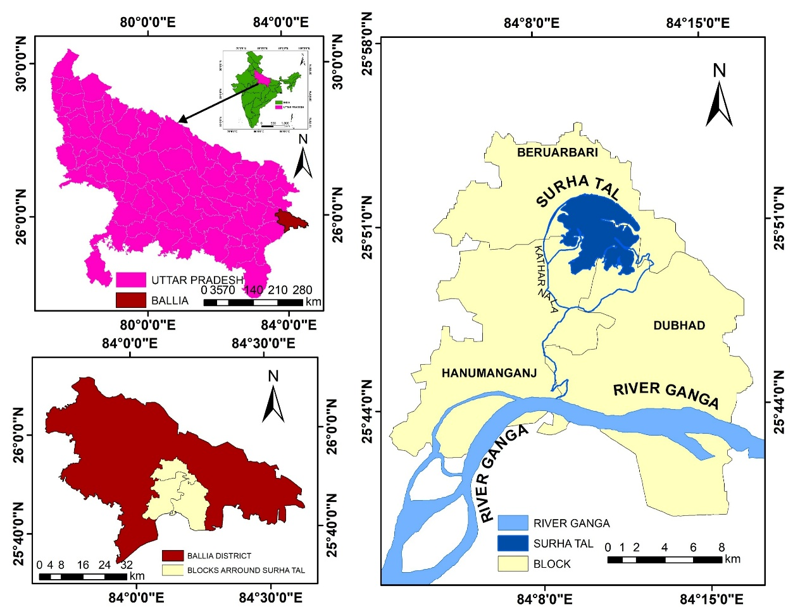

**Figure 1: Location map of the study area representing Surah Tal and its bordering Block**

1. **Materials and Methods**

The methodological framework adopted for the spatiotemporal analysis and prediction of Land Use and Land Cover (LULC) changes in the Surha Tal Wetland is illustrated in Figure 2. The study area, Surha Tal, located in Ballia district, Uttar Pradesh, was chosen for its ecological importance and vulnerability to anthropogenic activities. Multi-temporal satellite imagery from Landsat 5 TM and Landsat 8 OLI sensors was utilized, focusing on the pre-monsoon season. Preprocessing steps included geometric correction and the generation of False Colour Composites (FCCs) to enhance visual interpretation of land cover features (Lillesand et al., 2015).

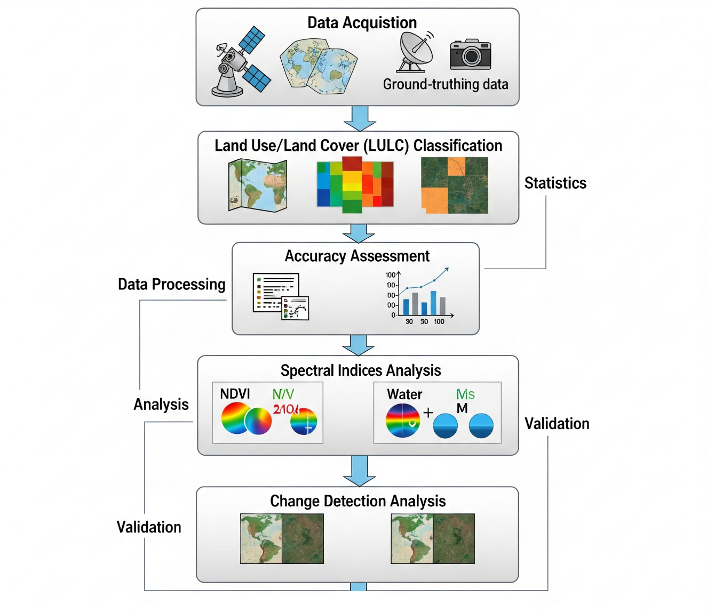

**Figure 2: LULC Change Detection Analysis Framework for Surha Tal**

Supervised classification was performed using the Maximum Likelihood Classifier (MLC), categorizing the landscape into five major land use classes (Jensen, 2015a). To further aid in thematic separation, the Normalized Difference Vegetation Index (NDVI) and Normalized Difference Water Index (NDWI) were computed to distinguish vegetative and water features, respectively (McFeeters, 1996; Tucker, 1979). The accuracy of classification results was assessed using a confusion matrix, from which Overall Accuracy (OA), User’s Accuracy (UA), Producer’s Accuracy (PA), and the Kappa Coefficient were derived to ensure statistical validity (Congalton & Green, 2009).

**2.1 Data Acquisition**

Landsat satellite data was acquired for USGS Earth Explorer (https://earthexplorer.usgs.gov/) for the last 20 years, considering 2005,2015,2025. The study employs Landsat 5 Thematic Mapper (TM) for 2005 and Landsat 8 Operational Land Imager (OLI) and Thermal Infrared Sensor (TIRS) for 2015 and 2025. The sensors have high spatial resolution (30 meters) and wide temporal coverage, ideal for LU/LC mapping and computation of spectral indices such as NDVI and NDWI. Apart from the satellite data, other data in the form of topographic maps, hydrological data, and ground truthing points were used to provide spatial accuracy and validation to the analysis. Such a dataset provides a comprehensive examination of land use patterns and surface water processes in the selected periods.

**2.2 Land Use and Land Cover Classification**

To explore the spatiotemporal dynamics of the Surha Tal wetland catchment area, supervised classification techniques were employed using Landsat satellite data for 2005, 2015, and 2025. Maximum Likelihood Classification (MLC) technique was used to classify the area into various land use and land cover (LU/LC) classes, which were: Water Bodies (Surha Tal and related hydrological features), Vegetation (natural forest, grassland, and other vegetation), Aquatic Vegetation (wetland vegetation), Agricultural Land (cropland and fallows), and Built-up Areas (urban settlement and infrastructure). Accuracy of classification was enhanced using ground truth validation by employing GPS-based field data and Google Earth high-resolution imagery. To measure the accuracy and dependability of the classification result, error matrices and the Kappa coefficient were utilized. Post-classification change detection techniques were also employed to examine the quantification of the LU/LC transitions over the study period (2005–2025). Through these analyses, significant land cover transformation patterns of interest to this research, particularly wetland contraction, agricultural expansion, and urbanization encroachment, were revealed. The overall LU/LC assessment herein assists in revealing insights into wetland ecosystem anthropogenic pressures and enables useful conservation planning and land use planning to sustainable land management goals in the Surha Tal.

**2.3 Accuracy Assessment**

The accuracy and validity of Land Use and Land Cover (LU/LC) classification accuracy and change detection results were assessed with a confusion matrix (e.g., error matrix) as well as several accuracy metrics, such as the Kappa coefficient, producer's accuracy, user's accuracy, and total accuracy. These accuracy metrics assess the overall state of classification performance by comparing classification outputs with ground truth data and other ancillary datasets, enabling the reliable and valid evaluation of classification results (Foody, 2002; Congalton & Green, 2019). Ground truth data from field surveys. Field surveys were conducted between 2023 and 2025 to validate classified LU/LC types. Ground photographs were taken across different zones of Surha Tal wetland to support the interpretation and verification of major land use transitions observed in satellite data, and high-resolution satellite imagery was used for validation. The accuracy of Land Use and Land Cover (LU/LC) classification and change detection was rigorously evaluated using a confusion matrix (error matrix) generated in ArcGIS Pro (10.8). Key accuracy metrics (Kappa coefficient, Producer’s Accuracy, User’s Accuracy, and Overall Accuracy) were calculated using ArcGIS's classification assessment tools, based on standard formulations:

**2.3.1 Overall Accuracy (OA):** The Overall Accuracy represents the proportion of instances correctly classified during the classification process.

***OA = (Σᵢ₌₁ᵏ nᵢᵢ) / N Equation (1)***

Where:  
***nᵢᵢ*** = Number of correctly classified pixels for class *i* (diagonal values of the confusion matrix).  
***κ*** = Number of classes in the classification.  
***N*** = The total number of validation (reference) samples. Represents the proportion of correctly classified instances.

**2.3.2 Producer’s Accuracy (PA):** Producer’s Accuracy measures the omission error, representing the classifier's ability to capture true class members.

***PAᵢ = nᵢᵢ / nᵢ+ Equation (2)***

Where:

***nᵢᵢ*** = Number of correctly classified pixels for class *i* (diagonal values of the confusion matrix).  
***nᵢ+*** = Total number of reference pixels for class *i* (row total in the confusion matrix).

**2.3.3 User’s Accuracy (UA):** User’s Accuracy indicates the reliability of a classified map from the perspective of the end-user. It measures the proportion of correctly classified pixels within a particular map class, thereby reflecting the level of commission error (i.e., the inclusion of pixels that do not belong to that class).

***UAᵢ = nᵢᵢ / n⁺ᵢ Equation (3)***

Where:

***nᵢᵢ*** = Number of correctly classified pixels for class *i* (diagonal values of the confusion matrix).  
***n⁺ᵢ* =** Total number of pixels classified as class *i* (column total in the confusion matrix).

**2.3.4 Kappa Coefficient(κ):** The Kappa Coefficient quantifies the agreement between classification and reference data corrected for chance (Cohen, 1960; Congalton & Green, 2019).

***κ = [ N Σᵢ₌₁ᵏ nᵢᵢ − Σᵢ₌₁ᵏ (nᵢ+ × n⁺ᵢ)] / [ N² − Σᵢ₌₁ᵏ (nᵢ+ × n⁺ᵢ)] Equation (4)***

**Where:**

***N*** = The total number of validation (reference) samples

***κ*** = Number of classes in the classification.

***nᵢᵢ*** = Number of correctly classified pixels for class *i* (diagonal values of the confusion matrix).

***nᵢ+*** = Total number of reference pixels for class *i* (row total in the confusion matrix).

***n⁺ᵢ*** = Total number of pixels classified as class *i* (column total in the confusion matrix).

Overall Accuracy only measures the proportion of correct classifications; it does not consider the possibility that some agreement may occur randomly. In wetland land use/land cover (LULC) classification studies, Kappa provides a more robust and reliable accuracy indicator, especially when class proportions are highly imbalanced (e.g., much more water area than built-up area).

**2.4 Analyzing Spectral Indices**

To assess and monitor changes in the environment, two significant spectral indices were calculated: NDVI and NDWI. These indices are suitable for monitoring vegetation and water bodies.

**2.4.1 NDVI (Normalized Difference Vegetation Index)**

NDVI is widely used to estimate vegetation health, density, and vigor (NASA Earth Observatory, n.d.). Red and near-infrared (NIR) bands from Landsat data are used in its computation.

***NDVI=(NIR+Red)/(NIR-Red)***  ***Equation (5)***

Here, Red stands for red band reflectance values and NIR for near-infrared band reflectance. NDVI values range from -1 to 1, and high values indicate healthy and more dense vegetation. This index is particularly useful for observing changes in vegetation over time, such as deforestation, crop health, or regrowth.

We used Landsat-5 data in 2005 for this study. In Landsat 5 images, the NDVI calculation formula uses a certain band number for the calculation. The Landsat formula is shown below.

***NDVI = (Band 4-Band 3) / (Band 4+Band 3) Equation (6)***

Band 4 is the Near Infra-Red (NIR) (0.76-0.90 µm) wavelength (U.S. Geological Survey, n.d.). This band is sensitive to healthy vegetation since plants reflect the NIR, and Band 3 is the red wavelength (0.63–0.69 µm) (U.S. Geological Survey, n.d.). This band is sensitive to chlorophyll absorption features in vegetation.

The 2015 and 2025 Landsat 8 images were used to calculate the NDVI. Landsat 8, which was launched in 2013, collects high-quality multispectral data with better radiometric and spatial resolution, and therefore, it is well suited for environmental monitoring. Here is the formula used for Landsat 8:

***NDVI = (Band 5-Band 4)/ (Band 5+Band 4) Equation (7)***

**2.4.2 Normalized Difference Water Index (NDWI)**

The Normalized Difference Water Index (NDWI) is a popular remote sensing technique applied to water body mapping and water level tracking (Masuik, 2023). It is based on the spectral reflectance properties of water in green and near-infrared (NIR) wavelengths. In terms of reflectance, water absorbs NIR with a high reflective contrast and reflects strongly in green. Water bodies are highlighted by NDWI, while other land cover classes, such as plant and soil, are less noticeable. (McFeeters, 1996; Xu, 2006).

The NDWI can be computed from the following equation:

***NDWI=(Green-NIR)/(Green+NIR) Equation (8)***

Where:

Green: Reflectance in the green spectral band.

NIR:  Near infrared reflectance.

A typical range of NDWI values is +1 to -1. Positive values indicate water in general, where the higher the value, the clearer the water. Values close to zero, or less than zero, are typically terrestrial features that can include vegetation, soil, or built-up areas. Note that in turbid or high-sediment water, NDWI values might be slightly lower as a result of a greater reflectance in the near-infrared (NIR) band (Xu, 2006).

**3.4.3 Normalized Difference Water Index Calculation for Landsat Sensors**

The bands utilized specifically for NDWI computation differ according to the Landsat sensor. Keeping this in mind is crucial when working with data that spans multiple periods. For the Landsat 5 Thematic Mapper (TM) imagery (utilized for the 2005 data), the Normalized Difference Water Index (NDWI) was computed through the following formula:

The NDWI formula for Landsat 5 TM is

***NDWI=(Band2-Band4)/(Band2+Band4) Equation (9)***

Where:

**Band 2 (Green)** is equivalent to the wavelength of 0.52–0.60 µm, which is water body and vegetation sensitive (U.S. Geological Survey, n.d.).

**Band 4 (Near-Infrared, NIR)** Band 4 (Near-Infrared, or NIR) is a wavelength range of 0.76 to 0.90 µm that is significantly reflected by soil and vegetation and strongly absorbed by water (U.S. Geological Survey, n.d.). For the Landsat 8 Operational Land Imager (OLI) imagery (applied to the 2015 and 2025 data), the Normalized Difference Water Index (NDWI) was computed with the following formula:

***NDWI=(Band3-Band5)/(Band3+Band5) Equation (10)***

Where:

**Band 3 (Green)**corresponds to the wavelength range of 0.53–0.59 µm, which is sensitive to water bodies and vegetation (U.S. Geological Survey, 2019).

**Band 5 (Near-Infrared, NIR)**corresponds to the wavelength range of 0.85–0.88 µm, which is highly absorbed by water and reflects strongly from vegetation and soil.

This study examines the temporal dynamics of Surha Tal wetland over the past 20 years (2005–2025) using the Normalized Difference Water Index (NDWI). NDWI is a well-established remote sensing method that supports the accurate mapping and quantification of surface water extent in wetland catchments, thus providing an essential baseline for judging water resource distribution (McFeeters, 1996). The study monitors changes in water coverage by examining NDWI values over these 20 years, which aids in identifying long-term patterns and evaluating the impact of long-term trends and judgment of the influence of seasonal change, climate variability, and human activities on hydrology in the wetland (Xu, 2006). The index plays a crucial role in measuring surface water variations caused by anthropogenic factors such as land use changes, groundwater abstraction, and pollution. Moreover, NDWI helps in following seasonal and interannual hydrologic fluctuations, which provide useful insights into the wetland's resistance and water supply under different climatic conditions (Jensen, 2015b). The conclusions from this assessment help in a greater understanding of the ecological health of Surha Tal and the range of human-driven changes, hence supporting informed management and conservation actions for this key freshwater ecosystem.

**2.5 Change Detection Analysis**

Change detection analysis involves identifying and quantifying temporal changes in land use and land cover (LU/LC) patterns. In this study, we utilized ArcGIS software for the change detection analysis, which is a critical process for evaluating anthropogenic environmental effects, especially in ecologically sensitive regions like wetlands. A strict post-classification change detection analysis was conducted to determine and analyze differences between various LU/LC classes across different periods. The main aim of the analysis was to track the behavior of surface water and the spatiotemporal dynamics in the Surha Tal area.

3. results and discussion

**3.1 Land Use and Land Cover Analysis**

For this study, satellite images for the month of January were selected for the years 2005, 2015, and 2025. January was chosen as it represents the post-monsoon season in the study area, when cloud cover is low, enabling a clear distinction between different land use/land cover (LULC) classes. The spatial distribution and graphic depictions of Land Use/Land Cover (LU/LC) changes over 20 years (Figure 2) illustrate a diverse urbanization process. The initial stages of urban growth in 2005 were marked by a minimal level of built-up land, which appears to represent a “low-populated, semi-rural” environment. By 2015, urbanization was occurring at a very high rate, with ongoing increases in the construction of buildings, roads, and other infrastructure. While the rapid pace of urbanization reflects a gradual shift in economic activity, likely due to changes in socioeconomic conditions and a rapid increase in population, the trend of continued urban growth extends into 2025. The greater decline in vegetation cover compared to 2005 is accompanied by the expansion of built-up areas and increased levels of agricultural land use. This decline can lead to significant ecological impacts, including the loss of biodiversity and substantial changes to local ecosystems. At the same time, the significant increase in agricultural land use suggests an evolving interplay between urbanization and food production needs. To meet the growing demands of urban development, changes are being observed in the agricultural sector and its processes. These environmental change patterns were likely caused by a combination of factors, including population growth, shifting economic priorities, and the need to address evolving socioeconomic demands related to urban infrastructure and food security.



**Figure 3: Land Use Land Cover; (a) 2005, (b) 2015, (c) 2025**

**3.2 Accuracy Assessment of Land Use/Land Cover (LU/LC) Classification**

The accuracy assessment of Land Use/Land Cover (LU/LC) classification for the years 2005, 2015, and 2025 was conducted using confusion matrices and Kappa statistics, providing a comprehensive evaluation of classification reliability and consistency. In 2005, 83 out of 100 reference samples were correctly classified, resulting in an Overall Accuracy of 83% and a Kappa Coefficient of 0.72 (Table 1). According to the interpretation scale proposed by Landis and Koch (1977), a Kappa value between 0.61 and 0.80 indicates a substantial level of agreement, thereby confirming the statistical validity of the classification for that year.

An improvement was observed in 2015, with 91 out of 100 reference samples correctly classified, yielding an Overall Accuracy of 91% and a Kappa Coefficient of 0.84, which reflects a strong agreement beyond random chance (Table 1). The most recent classification, projected for 2025, further reinforced the robustness of the methodology, achieving an Overall Accuracy of 92% and a Kappa Coefficient of 0.86 (Table 1), signifying a high level of concordance between the classified and reference datasets.

Each accuracy assessment included five LU/LC classes—Built-Up Area (B), Vegetation (V), Water Body (W), Agricultural Land (AL), and Aquatic Vegetation (AV)—and exhibited consistent internal agreement within each confusion matrix, confirming structural stability across the datasets. Overall, the progressive improvement in classification accuracy over the three time periods highlights the effectiveness and reliability of the LU/LC mapping approach employed in this study.

**Table 1: Confusion Matrix of 2005, 2015, and 2025**

|  |  |  |  |  |  |  |  |  |  |
| --- | --- | --- | --- | --- | --- | --- | --- | --- | --- |
|  | 2005 | | | | | | | | |
| S. No. | Class | W | AV | AL | V | B | Total | User  Accuracy | Kappa |
| 0 | W | 4 | 1 | 0 | 0 | 0 | 5 | 0.8 | 0 |
| 1 | AV | 2 | 9 | 3 | 0 | 0 | 14 | 0.64 | 0 |
| 2 | AL | 0 | 0 | 50 | 0 | 0 | 50 | 1 | 0 |
| 3 | V | 0 | 0 | 11 | 17 | 0 | 28 | 0.60 | 0 |
| 4 | B | 0 | 0 | 0 | 0 | 3 | 3 | 1 | 0 |
| 5 | Total | 6 | 10 | 64 | 17 | 3 | 100 | 0 | 0 |
| 6 | Producer  Accuracy | 0.66 | 0.90 | 0.78 | 1 | 1 | 0 | 0.83 | 0 |
| 7 | Kappa | 0 | 0 | 0 | 0 | 0 | 0 | 0 | 0.72 |
| 2015 | | | | | | | | | |
| S.  No. | Class | B | V | W | AL | AV | Total | User  Accuracy | Kappa |
| 0 | B | 4 | 0 | 0 | 4 | 0 | 8 | 0.5 | 0 |
| 1 | V | 0 | 6 | 0 | 3 | 0 | 9 | 0.66 | 0 |
| 2 | W | 0 | 0 | 11 | 0 | 0 | 11 | 1 | 0 |
| 3 | AL | 0 | 0 | 0 | 59 | 0 | 59 | 1 | 0 |
| 4 | AV | 0 | 0 | 0 | 2 | 11 | 13 | 0.84 | 0 |
| 5 | Total | 4 | 6 | 11 | 68 | 11 | 100 | 0 | 0 |
| 6 | Producer  Accuracy | 1 | 1 | 1 | 0.86 | 1 | 0 | 0.91 | 0 |
| 7 | Kappa | 0 | 0 | 0 | 0 | 0 | 0 | 0 | 0.84 |
| 2025 | | | | | | | | | |
| S.  No. | Class | AV | W | AL | V | B | Total | User  Accuracy | Kappa |
| 0 | AV | 15 | 0 | 3 | 3 | 0 | 21 | 0.71 | 0 |
| 1 | W | 0 | 9 | 0 | 0 | 0 | 9 | 1 | 0 |
| 2 | AL | 0 | 0 | 56 | 1 | 0 | 57 | 0.98 | 0 |
| 3 | V | 0 | 0 | 1 | 5 | 0 | 6 | 0.83 | 0 |
| 4 | B | 0 | 0 | 0 | 0 | 7 | 7 | 1 | 0 |
| 5 | Total | 15 | 9 | 60 | 9 | 7 | 100 | 0 | 0 |
| 6 | Producer  Accuracy | 1 | 1 | 0.93 | 0.55 | 1 | 0 | 0.92 | 0 |
| 7 | Kappa | 0 | 0 | 0 | 0 | 0 | 0 | 0 | 0.86 |

**3.3 Change in NDVI dynamics**

Figure 3 presents the Normalized Difference Vegetation Index (NDVI) maps for the years 2005, 2015, and 2025. The NDVI values, which range from +1 to -1, serve as indicators of vegetation health and coverage. Positive values denote vegetated areas, while negative values correspond to non-vegetated surfaces, such as water bodies, bare soil, or urban regions. In 2005 (Figure 3a), NDVI values span from -0.209 to 0.473. The presence of negative values suggests notable non-vegetated regions, whereas the moderate peak (0.473) reflects areas of healthy vegetation. By 2015 (Figure 3b), the NDVI range had narrowed to -0.045 (minimum) and 0.443 (maximum). The reduced negative minimum (-0.045 vs. -0.209 in 2005) implies fewer intensely non-vegetated zones, but the decline in the maximum NDVI (0.443 vs. 0.473) signals deterioration in the vegetation health. This trend intensifies in the 2025 projection (Figure 3c), where NDVI values further contract to -0.023 (minimum) and 0.43 (maximum). The progressive decline in peak NDVI—from 0.473 (2005) to 0.43 (2025)—indicates a consistent loss of dense, healthy vegetation. While non-vegetated areas (negative NDVI) diminish in severity (as minima approach zero), the overall reduction in high NDVI values highlights the widespread vegetation degradation. These trends collectively suggest rapid vegetation loss, likely driven by factors such as urbanization, deforestation, or climatic shifts. The narrowing of the NDVI range over time underscores a landscape transition toward sparser or less robust vegetation cover.



**Figure 4: Normalized Difference Vegetation Index; (a) 2005, (b) 2015, (c) 2025.**

**3.4 Change in NDWI dynamics**

It is a remote sensing technique used to study the dynamics of water bodies. Through this, hydrological changes such as expansion, contraction, or fluctuations in water bodies can be monitored. The value of NDWI is between +1 to -1. High value closer to 1 represents open water, and the low value closer to -1 represents features such as vegetation or dry land. Figure 4a shows the 2005 NDWI. Here, the lower limit of NDWI is -0.462, and the upper limit is 0.272. The higher upper limit shows significant water presence during this period. Figure 4b shows the NDWI of 2015. The upper limit has a sharp decrease with a value of 0.101, and the lower limit is -0.390, indicating a sharp decline in the water body. This indicates a possible increase in sedimentation or anthropogenic water extraction. The NDWI of 2025 is shown in Figure 4c. The upper limit of NDWI further decreases to 0.074 in 2025. This value indicates the decreasing trend. Here, the upper limit is also decreasing continuously, which means a decrease in hydrological variability due to climate change, ongoing environmental stress, or land use change. The progressive decline in NDWI maxima (0.272 → 0.101 → 0.074) over the two-decade period highlights a concerning trend of water body shrinkage or degradation. Concurrently, the shift in the lower limit suggests shifts in non-aquatic features, such as vegetation loss or soil moisture alterations. These patterns may reflect climate-driven aridification, unsustainable water management, or ecosystem transitions. The 2025 projection underscores the urgency for interventions to mitigate further hydrological decline.



**Figure 5:** **Normalized Difference Water Index; (a) 2005, (b) 2015, (c) 2025**

**3.5 Land Use and Land Cover Change Detection**

The assessment of Land Use and Land Cover (LU/LC) changes within the Surha Tal wetland catchment from 2005 to 2025 reveals substantial transformations driven by both natural and anthropogenic activities. Over this two-decade period, the region has undergone significant ecological and hydrological shifts. Table 2 provides a comprehensive summary of these changes. A notable trend is the dramatic decline in natural vegetation, which decreased from 13.91 km² in 2005 to just 3.79 km² by 2025, representing a massive 72.76% loss. This decline highlights the intensifying impact of human activities like agricultural expansion, urban encroachment, and resource exploitation. Conversely, built-up areas showed a clear upward trajectory, more than doubling from 1.89 km² in 2005 to 3.90 km² by 2025, a 106.35% increase that reflects ongoing urbanization and infrastructure development. The most pronounced shift was observed in agricultural land, which expanded from 26.97 km² to 34.50 km², an increase of 7.53 km² (27.92%). This surge, while supporting local livelihoods, poses a significant ecological threat to the wetland system. Runoff from these areas, rich in nutrients and agrochemicals, can lead to eutrophication, disrupting the delicate ecological balance of the wetland.

**Figure 6: Land Use Land Cover change detection from 2005 to 2025**

**Table 2:** **Comparative summary of the LU/LC changes during the study period**

|  |  |  |  |  |
| --- | --- | --- | --- | --- |
| LU/LC Category | 2005 (km²) | 2015 (km²) | 2025 (km²) | Net Change (2005-2025) |
| Water Body | 5.30 km² | 4.8 km² | 5.32 km² | Increase +0.02 km² (0.38%) |
| Aquatic Vegetation | 13.32 km² | 9.42 km² | 13.89 km² | Increase +0.57 km² (4.28%) |
| Agricultural Land | 26.97 km² | 34.29 km² | 34.50 km² | Increase +7.53km² (27.92%) |
| Vegetation | 13.91 km² | 5.30 km² | 3.79 km² | Decrease -10.12km² (72.76%) |
| Built-up Area | 1.89 km² | 3.11 km² | 3.90 km² | Increase +2.01km² (106.35%) |

The Water Body category exhibited a complex fluctuation. An apparent decline from 5.30 km² in 2005 to 4.8 km² in 2015 can be attributed to the deficient monsoon of 2015, which saw a nationwide rainfall deficit of 14% and a Ganga Basin deficit of 25.8% (Mishra et al., 2016). As Surha Tal is hydrologically connected to the Ganga River via the Kathal Nala, this climatic stress likely reduced water inflow and impeded the regeneration of wetland vegetation in transitional zones. By 2025, the water body area had nearly reverted to its 2005 extent, reaching 5.32 km², resulting in a marginal net increase of just 0.02 km² over the two decades. This fluctuation highlights the extreme vulnerability of the wetland's hydrology to both major flood events and drought conditions.

Figure 7, a field photograph capturing the northeastern zone of Surha Tal and U.P. Jal Nigam Lab, Ballia, provides crucial on-the-ground validation for our remote sensing analysis. The image depicts a degraded vegetation fringe, directly corroborating the significant decline in NDVI values and the corresponding changes in our LULC classification maps from 2005 to 2025. While the consistent drop in NDWI values from satellite data indicates a loss of vegetation and water body, this photograph offers a visual representation of the same trend on the ground. The field evidence confirms that the natural vegetation along the wetland's periphery is under severe pressure, driven by anthropogenic activities such as agricultural encroachment and expanding built-up areas. Thus, this photograph lends credibility to our LULC and NDWI trend analysis, strengthening the overall conclusions of the study.

Overall, the LU/LC dynamics observed in the Surha Tal wetland catchment from 2005 to 2025 reflect significant ecological and hydrological transformations. The trends of declining natural vegetation, expanding agriculture and built-up areas, and fluctuating water regimes highlight the growing pressure on this sensitive wetland ecosystem. These developments raise concerns about long-term ecological sustainability and underscore the urgent need for integrated land management and wetland conservation strategies.

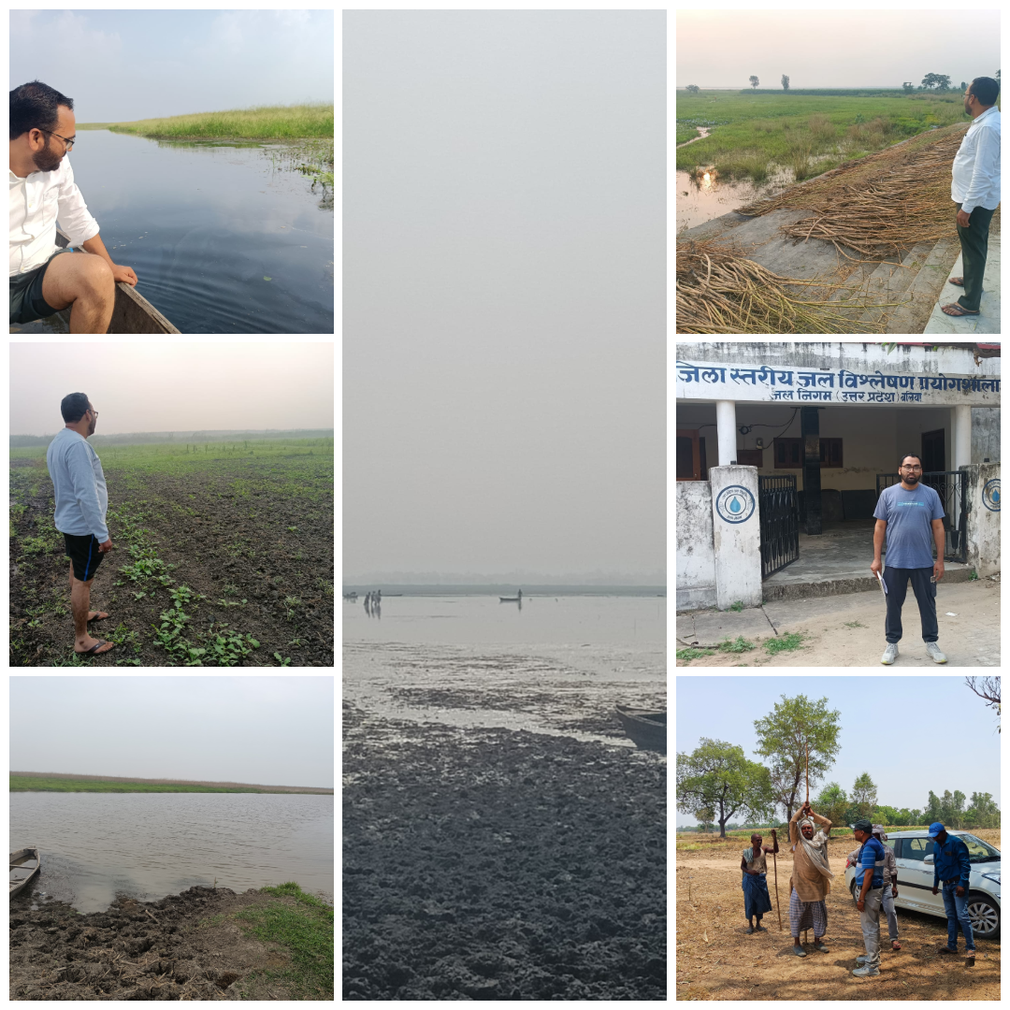

**Figure 7: Field photograph showing degraded vegetation fringe around the northeastern Surha Tal zone (November-June 2025). This supports the significant NDVI decline observed in the classified map.**

The LU/LC classification findings from 2005 to 2025 reveal a substantial transformation in the Surha Tal wetland catchment. Cropland expansion into previously natural vegetation areas indicates increased agricultural pressure, driven by population growth, changing consumption patterns, and the intensification of irrigation practices. The increasing demand for food security encouraged land clearance for farming. Simultaneously, the emergence of urban built-up areas, especially along the wetland's northern and eastern fringes, reflects unregulated urbanization, partially fuelled by infrastructure development, such as road expansion under schemes, and a lack of strict zoning regulations.

The significant depletion of forest cover and water body area over the two-decade period further indicates the absence of integrated wetland policy implementation. Despite legal protection through designations like bird sanctuaries, enforcement remains weak. Meanwhile, population pressure and land fragmentation continue to drive encroachment into ecologically sensitive zones, underlining the socio-political failure to treat wetlands as critical ecological infrastructure. Remote sensing indicators validate these trends. The consistent decline in NDVI values across the study period suggests increasing vegetative stress, likely due to deforestation, soil degradation, and habitat fragmentation. At the same time, NDWI analysis reveals shrinking water presence—particularly in the periphery zones—indicating a reduction in seasonal water retention and groundwater recharge capabilities. These changes are not just visual trends; they translate into tangible ecological consequences.

The environmental costs of these changes are profound and multidimensional. The loss of vegetative cover contributes to elevated surface runoff, increasing sediment and nutrient inflow into the wetland system. This leads to eutrophication, turbidity, and altered dissolved oxygen levels—conditions detrimental to aquatic biodiversity, including native fish species and migratory birds. Additionally, the disruption of wetland microclimates due to forest loss contributes to increased local temperatures and erratic rainfall patterns, further exacerbating wetland shrinkage and ecological imbalance. Species such as *Channa punctata* and *Rana tigrina*, once common in the wetland zone, are now rarely sighted, indicating a gradual collapse of trophic chains.

These findings corroborate earlier studies from the Indo-Gangetic plain. Singh et al. (2016) observed a 12% decline in wetland cover in eastern Uttar Pradesh over 15 years due to agricultural intensification, closely mirroring the trends documented in this study. Similarly, Sharma and Thakur (2018) highlighted urban sprawl as a critical driver of land transformation in the Saryu River Basin. While their study emphasized industrialization, the present research identifies agriculture and peri-urban expansion as more dominant forces in the Surha Tal catchment. Further, Kumar et al. (2020) employed NDVI and NDWI to demonstrate declining ecological health in Bihar wetlands—a pattern echoed here through a more localized, high-resolution lens.

The landscape in 2025 illustrates not just physical change but a paradigm failure. It underscores how viewing wetland conservation as a constraint on development results in measurable long-term ecological and economic losses—ranging from reduced fishery yields and flood buffering to declining tourism and cultural degradation. This reinforces the argument for treating wetland conservation as a strategic investment in ecological infrastructure. By establishing functional buffer zones, enforcing land-use zoning, and investing in restoration programs, policymakers can ensure sustainable development while maintaining ecological equilibrium.

Therefore, this study offers more than a technical assessment—it contributes a policy-relevant framework for wetland restoration and management. It urges urgent action through participatory conservation, integration of wetlands in district-level development planning, and ecological monitoring protocols that align with climate resilience strategies. The data-driven insights here aim to influence a shift in perception, positioning Surha Tal not as an obstacle to progress, but as a keystone ecosystem vital to long-term regional sustainability.

4. Conclusion

This study highlights the substantial and ongoing transformations in land use and land cover within the Surha Tal wetland catchment over the past two decades. Through integrated geospatial analysis—including Landsat imagery interpretation, NDVI and NDWI indices, and rigorous accuracy assessments—it identifies agricultural intensification and unregulated urban expansion as the primary drivers of ecological degradation. These changes have led to the loss of forest cover, reduced groundwater recharge, increased surface runoff, and elevated sedimentation levels, all of which have disrupted the hydrological stability and threatened the biodiversity of the wetland ecosystem.

To mitigate these adverse impacts, this research strongly recommends the immediate adoption of sustainable land management practices tailored to the Surha Tal context. These include the establishment of protective buffer zones, enforcement of wetland-sensitive land use zoning regulations, and promotion of eco-friendly agricultural practices such as organic farming and contour plowing in fringe areas. In order to measure ecosystem health in real time, it is also necessary to institutionalize seasonal ecological monitoring utilizing remote sensing methods. The study also calls for the revival of traditional water harvesting structures and community-led afforestation drives to enhance local stewardship and ecological resilience.

Crucially, the successful implementation of these strategies depends on multi-level collaboration among district planning bodies, environmental agencies, civil society, and local communities. Adaptive and participatory planning frameworks must be embedded into regional development policies to ensure a balance between ecological preservation and socio-economic advancement.

**Disclaimer (Artificial intelligence)**

Author(s) hereby declare that these two tools are used for improving the writing of manuscript. For technical analysis no AI is used.

1. Quill Bot (For Paraphrasing)

2. Chat GPT 3.5 Free Version (For enhanced writing)

References

Cohen, J. (1960). A coefficient of agreement for nominal scales. Educational and Psychological Measurement, 20(1), 37-46.

Congalton, R. G., & Green, K. (2019). Assessing the Accuracy of Remotely Sensed Data: Principles and Practices. CRC Press.

Davidson, N. C. (2014). How much wetland has the world lost? Long-term and recent trends in global wetland area. Marine and Freshwater Research, 65(10), 934–941.

Foley, J. A., DeFries, R., Asner, G. P., Barford, C., Bonan, G., Carpenter, S. R., … & Snyder, P. K. (2005). Global consequences of land use. Science, 309(5734), 570–574. <https://doi.org/10.1126/science.1111772>

Foley, J. A., et al. (2005). Global consequences of land use. Science, 309(5734), 570–574.

Foody, G. M. (2002). Status of land cover classification accuracy assessment. Remote Sensing of Environment, 80(1), 185-201.

Jamal, S., & Ahmad, W. S. (2020). Assessing land use land cover dynamics of wetland ecosystems using Landsat satellite data. SN Applied Sciences, 2(11), 1891.

Jensen, J. R. (2015a). Introductory Digital Image Processing: A Remote Sensing Perspective. Pearson.

Jensen, J. R. (2015b). Remote Sensing of the Environment: An Earth Resource Perspective. Pearson Education.

Landis, J. R., & Koch, G. G. (1977). An application of hierarchical kappa-type statistics in the assessment of majority agreement among multiple observers. Biometrics, 363-374.

Li, H., Wang, C., Zhong, C., Zhang, Z., & Liu, Q. (2017). Mapping Typical Urban LULC from Landsat Imagery without Training Samples or Self-Defined Parameters. Remote. Sens., 9, 700. https://doi.org/10.3390/RS9070700.

Li, X., et al. (2017). Impacts of land use and land cover change on regional climate: A case study in the agro-pastoral transitional zone of China. Environmental Research Letters, 12(12), 124015.

Lillesand, T., Kiefer, R. W., & Chipman, J. (2015). Remote sensing and image interpretation. John Wiley & Sons.

Masiuk, O., Novitskyi, R., Hapich, H., & Chubchenko, Y. (2023). Elements of assessment of the anthropogenic impact of a coal mining mine on the site of the Emerald Network using methods of remote sensing of the Earth. In International Conference of Young Professionals «GeoTerrace-2023» (Vol. 2023, No. 1, pp. 1-5). European Association of Geoscientists & Engineers.

McFeeters, S. K. (1996). The use of the Normalized Difference Water Index (NDWI) in the delineation of open water features. International Journal of Remote Sensing, 17(7), 1425–1432.

Millennium Ecosystem Assessment. (2005). Ecosystems and Human Well-being: Wetlands and Water Synthesis. World Resources Institute.

Mishra, V., Aadhar, S., Asoka, A., Pai, S., & Kumar, R. (2016). On the frequency of the 2015 monsoon season drought in the Indo‐Gangetic Plain. Geophysical Research Letters, 43(23), 12102–12112. https://doi.org/10.1002/2016GL071407

[MoEFCC (2019). Eco-Sensitive Zone (ESZ) notification for Jai Prakash Narayan (***Surha*** Tal) Bird Sanctuary, Ballia, Uttar Pradesh. Gazette of India, Ministry of Environment, Forest and Climate Change, Government of India](https://www.google.com/search?sca_esv=e018978d43334d92&sxsrf=AE3TifPbYO5-KKfAi8xh2lyuVQ9htJBOMQ:1755411176229&q=MoEFCC+(2019).+Eco-Sensitive+Zone+(ESZ)+notification+for+Jai+Prakash+Narayan+(Surha+Tal)+Bird+Sanctuary,+Ballia,+Uttar+Pradesh.+Gazette+of+India,+Ministry+of+Environment,+Forest+and+Climate+Change,+Government+of+India.&spell=1&sa=X&ved=2ahUKEwin7N-cmJGPAxXQUWwGHQ4MF08QBSgAegQICxAB)

NASA Earth Observatory. (2000, Aug 30). Measuring vegetation (NDVI & EVI). NASA. https://earthobservatory.nasa.gov/features/MeasuringVegetation/measuring_vegetation_2.php

Ramsar Convention. (1971). Convention on Wetlands of International Importance. Ramsar, Iran.

Rawat, J. S., & Kumar, M. (2015). Monitoring land use/cover change using remote sensing and GIS techniques: A case study of Hawalbagh block, district Almora, Uttarakhand, India. The Egyptian Journal of Remote Sensing and Space Science, 18(1), 77-84.

Roy, D. P., Wulder, M. A., Loveland, T. R., Woodcock, C. E., Allen, R. G., Anderson, M. C., ... & Zhu, Z. (2014). Landsat-8: Science and product vision for terrestrial global change research. Remote Sensing of Environment, 145, 154–172.

Sannigrahi, S., Pilla, F., Basu, B., Basu, A. S., Sarkar, K., Chakraborti, S., ... & Roy, P. S. (2020). Examining the effects of forest fire on terrestrial carbon emission and ecosystem production in India using remote sensing approaches. Science of the Total Environment, 725, 138331.

Singh, N. K., & Rao, M. (2024). Limnology Essentials: Ecosystems, Ecology, Evolution. Notion Press.

Singh, P. N., & Dwivedi, A. K. (2016). Cultural Importance and Livelihood Contribution of Turanala and Talkandla Wetlands in Gorakhpur, India. Int J Waste Resour, 6(245), 2.

Verburg, P. H., Soepboer, W., Veldkamp, A., Limpiada, R., Espaldon, V., & Mastura, S. S. (2002). Modeling the spatial dynamics of regional land use: The CLUE-S model. *Environmental Management, 30*(3), 391–405

Wildlife Institute of India. (2022). Surha Taal Wildlife Sanctuary. https://wii.gov.in/nmcg/protected-areas-along-ganga/surhataal-wildlife-sanctuary

Xu, H. (2006). Modification of normalised difference water index (NDWI) to enhance open water features in remotely sensed imagery. International Journal of Remote Sensing, 27(14), 3025–3033.

Zedler, J. B., & Kercher, S. (2005). Wetland resources: Status, trends, ecosystem services, and restorability. Annual Review of Environment and Resources, 30, 39–74.