Diversity and Conservation Status of True Mangrove and Mangrove Associates in the Junput Mangrove, East Midnapore, West Bengal, India

ABSTRACT

From the perspective of mangroves ecosystem, these ecosystems are the most productive and ecologically significant on the planet, delivering important goods and services that are essential for environmental well-being. Before implementing any strategies for the protection or restoration of mangrove populations, it is crucial to gather comprehensive data on their scope and diversity. Present study investigates the composition, diversity, and spatial distribution of true mangroves species and their associates along the Junput Mangrove area, East Midnapore, West Bengal. The field study was conducted over a period of one year, specifically from May, 2023 to April, 2024. Based on the findings of the study, it was revealed that a total 35 floral species were recorded during the study period in Junput mangrove coastal area in which 6 flora are true mangrove species, 12 mangrove associates species, 16 beach flora and 1 back mangrove species, classified in 24 family and 33 genera.

In this study, the IUCN status of mangrove floral species was shared by Not Evaluated (19), Least Concern (15) and Endangered (1). Mangrove forest provide vital ecosystem services, such as reducing atmospheric carbon and have become a focal point for conservation efforts due to their crucial role in marine ecology. However, over recent decades, mangrove ecosystems have come under severe pressure due to intense exploitation. The presence of mangroves has significantly enhanced the value of other coastal and marine resources—such as fisheries—by boosting productivity and supporting a wide array of biological species.
Keywords: True Mangrove; Mangrove associates; Mangrove diversity; IUCN; Junput Mangrove

- Introduction:

Mangroves are recognized as highly specialized ecological communities comprising of halophytic plants that serve as a transitional zone between land and ocean. These ecosystems consist of a variety of shrubs and trees with diverse taxonomies ecosystem, found in tropical and subtropical environmental condition (Qasim,1998). “Mangroves holds pneumatophores or breathing roots, stilt roots, knee roots, viviparous germination, xerophyllous leaves and salt excretory glands” (Tomlinson, 1986). Mangroves are among the most productive and biologically significant ecosystems on Earth, offering essential ecosystem goods and services such as coastal protection, carbon sequestration and habitat of diverse of diverse species. To develop effective conservation strategies or introduce new populations, it is essential to consolidate data on the extent and diversity of mangroves (Pillai and Harilal, 2018). “They inhabit specific habitats, including shores, estuaries, tidal creeks, backwaters, lagoons, marshes, mudflats and even upstream areas where water maintains salinity” (Qasim, 1998). Studies on the status and distribution of mangroves in Asia suggests that they are primarily found in the following countries, including Bangladesh, Indonesia, Pakistan, Sri Lanka, Philippines and India (Naskar and Mandal,1999). Mangrove forest represents distinctive functional ecosystems with significant social, economic and biological importance. They rank among the World’s most productive ecosystem, offering crucial supplies and services to human society, as well as coastal and marine ecosystem (Bouillon et al., 2003; FAO, 2007). These habitats engage with a diverse range of aquatic and terrestrial flora and fauna, foresting their growth and establishment. Given their environmental and community value, the conservation of mangroves should be prioritized, with efforts directed towards developing effective conservation methods (Bosold, 2012). More precisely a true mangrove is a tree, shrub, palm or ground fern typically over 0.5 meters tall, growing above mean sea level in the intertidal zones of tropical coastal or estuarine ecosystem (Duke, 1992). He listed 69 true mangrove species Worldwide. The mangrove biodiversity cover is more extensive and widespread on the East coast than on the West Coast due to its unique geomorphological features. These diversification in mangrove distribution can be explained by two factors: i) The East Coast features large estuaries and deltas formed by runoff and sediment deposition, while the West Coast has funnel-shaped estuaries lacking deltas and ii) The East Coast has gentle slopes and broad flats that are conducive to mangrove colonization, whereas the west Coast has steeper slopes (Kathiresan, 2010). “The classification of mangrove species diversity into 3 groups: major mangrove components (true, strict or specialized mangrove species), minor components (non-specialized mangrove species) and mangrove associates (species rarely submerged by high tides) was done by” (Tomlinson, 1986). He identified 34 species as major components and 20 as minor components. Generally, mangroves are categorized into two types: “True mangrove species” (plant found exclusively in tropical intertidal environments) and “Mangrove associates species” (plants that are not confined to these habitats) (Polidoro et al.,2010). However, there are important uncertainties about the types of certain species such as Excoecaria agallocha, Heritiera littoralis, Acrostichum spp. and Acanthus spp. with differ opinions among different researchers (Wang et al., 2011). The more scientific classification based on examining leaf features and salt content was accomplished (Wang et al., 2011). But their efforts did not resolve the existing uncertainties. Consequently, the classification of mangrove into true mangrove species and mangrove associates species remains unclear. “India’s mangrove habitat is generally categorized into 3 types: Deltaic Mangroves (Eastern Coast Mangroves), estuarine and Backwater Mangroves (Western Coast Mangroves) and Insular Mangroves (Andaman and Nicobar Islands)” (Mandal and Naskar, 2008). Total coverage is estimated 4740 km² with approximately 58 % located along the East Coast (Bay of Bengal), 29 % along the West Coast (Arabian Sea) and remaining 13% in the Andaman and Nicobar Islands (FSI, 2015). In India the mangrove forest management has long tradition. The first mangrove in the world put under scientific management was the Sundarban mangrove, situated in the Bay of Bengal. First management plan was implemented in the year 1892 in this mangrove (Chaudhuri and Chaudhury, 1994). Various researcher mentioned different mangrove plants and mangrove associates while working on mangroves. India holds its 4th position in terms of mangrove area in the World and 60 species of mangroves to 41 genera and 29 families (Blasco, 1975). In Indian coast 85 species of mangrove / mangrove associates species were commonly found (Naskar, 2004).For instance, Blasco (1977) concluded that 58 mangrove vegetation in the Indian territories, while Rao (1986) reported that 60 species from 41 genera and 29 families. In West Bengal mangrove biodiversity are found in the Sundarbans, a large deltaic of the Ganges River shared by Bangladesh (62%) and India (38%). The Indian Sundarban ecosystem host 33 true mangrove species belonging to 21 genera and 14 families. On the Odisha coastal area, mangrove diversity are spread across 3 zones: the Mahanadi delta, the Brahmani and Baitarani delta (including the Bhitarkanika mangrove zone), and the Balasore coast. Among these, Bhitarkanika is the most significant due to its extensive area and unique biodiversity. A total of 35 true mangrove species from 20 genera and 14 families have been identified in Odisha. Extensive studies have been conducted on the mangrove forests of the Bhitarkanika Wildlife sanctuary, the Mahanadi delta and chilka lake but other estuaries like Devi, Budhabalanga, Rushikulya and Subarnarekha have not received similar attention (Panda et al., 2013). Wide variety of mangroves vegetations were found the coastal part of East Midnapore, West Bengal. East Midnapore has 68 kms of coastline, started from mohona of Rasalpur river, Hijli sarif of Khejuri to the Udoypur beach Digha border. The intertidal zone is mouth of Bay of Bengal showed great varieties of mangrove vegetation and the present study invented that 23 angiospermic species of which total 9 species were mangrove and remaining 14 species are mangrove associates (Das.et al., 2015). In the East Midnapore coastal belt of West Bengal 06 mangrove species and 36 species of mangrove associates have been documented (Jana and Mandal, 2020). Junput, located in the East Midnapore District of West Bengal, India is a coastal settlement situated at the northern end of Bay of Bengal. The area is well known for its extensive beaches, floral diversity and serves as one of the prominent seaside destinations of the state.

2. Materials and Methods:
2.1 Study area: Present study was conducted in Junput mangrove area in about 8-10 km experimental area. The study area located between Latitude 21°38'N to 27°10'N and Longitude 85°38'E to 89°50'E. Junput mangrove area (Latitude- 21°94'04.5"N; Longitude- 87°26'59.5"E) is situated in the district of East Midnapore (Figure 1) The East Midnapore district is rich in natural resources especially brackish water resource which supports the life of different flora and fauna. The investigation was carried out over the one year, specifically from May, 2023 to April, 2024.

2.2 Data collection and identification of samples: Specimens of mangroves and their associates were collected manually by hand during low tide and their photographs were taken by Realme Mobile Phone (Model No. RMX3092). Collected samples were gathered in plastic bags for their identification. The collected samples of mangroves and their associates were identified using the mangrove identification manual and standard flora references (Banerjee et al.,1989; Kumudranjan and Rathindranath, 1999; Kathiresan, 2000; Giesen et al., 2006; Chintala, 2008; Pandey and Pandey, 2010; Barik and Chowdhury, 2014) as well as online resources such as the India Biodiversity Portal, India Flora Online and eFlora of India. Microsoft Excel 2007 was used to generate graphs of different datasets.
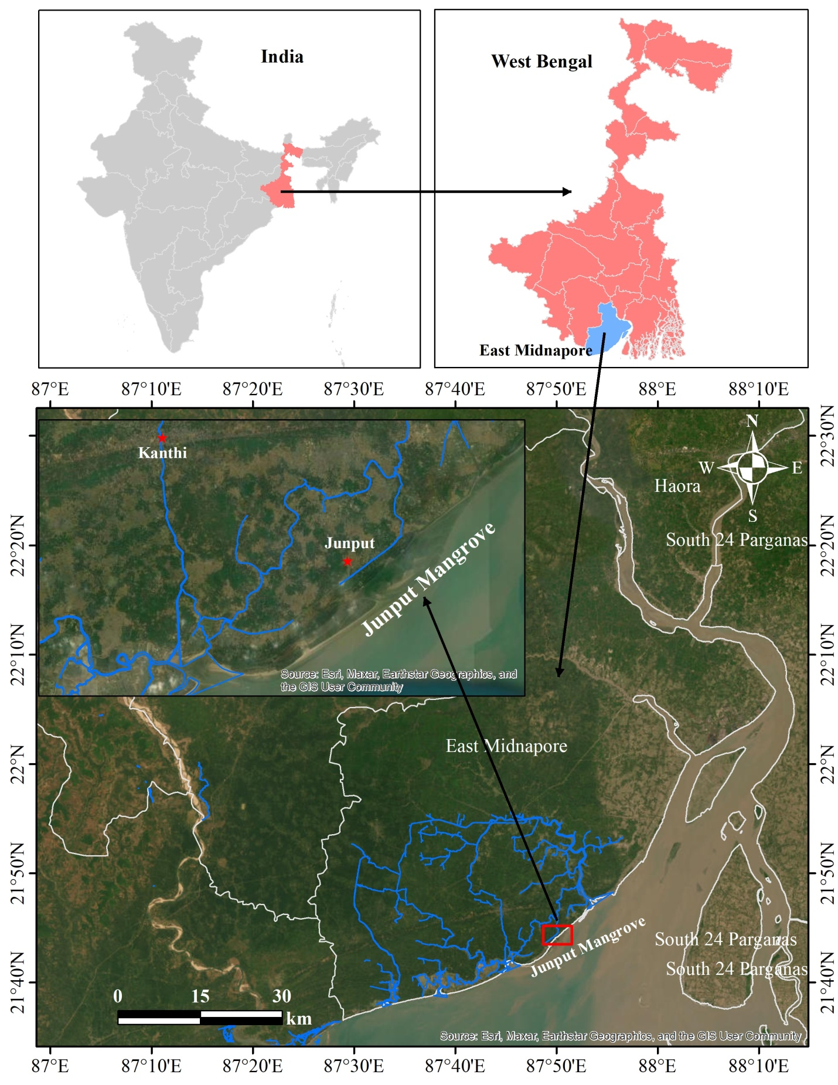
Figure 1: Location of Study site

3. Results:
Investigation on the floral diversity of the Junput mangrove area focuses mainly on commercially significant species and a selected few others. Based on the findings of the study, it was revealed that 35 mangrove and mangrove associates species were identified (Table 1), classified in 24 families , in which 6 flora were true mangrove species, 12 mangrove associates species, 16 beach flora and 1 back mangrove species (Plate 1, Plate 2). In this study, the IUCN status of mangrove floral species was shared by 19 numbers of Not Evaluated, 15 numbers of Least Concern and 1 number of species was Endangered.

Table 1: Mangrove species/ Mangrove associate / Beach flora/Back mangrove/ Coastal flora enlisted at Junput Mangrove, East Midnapore, West Bengal, India
Sl.  No. | Scientific Name | Family | Local Name | Common Name/ Vernacular Name | Habit | Habitat | Mangrove species/ Mangrove associate / Beach flora/Back mangrove/ Coastal flora | IUCN
1. | Avicennia marina (Forssk)Vierh.,1907 | Acanthaceae | Peara Baine | Grey mangrove | Tree | Grows in tidal mud. | Mangrove species | Least Concern
2. | Bruguiera gymnorrhiza  (L.) Savigny,1798 | Rhizophoraceae | Kankra | Burma Mangrove /Larged leafed orange mangrove | Tree | Intertidal mudflat and estuary and high tidal area. | Mangrove species | Not Evaluated
3. | Excoecaria agallocha  L.,1759 | Euphorbiaceae | Gewa | Blinding mangrove/  Milky mangrove | Tree | Common in coastal side and canal side of East Midnapore, where salinity is low | Mangrove species | Least Concern
4. | Heritiera fomes  Banks.,1800 | Malvaceae | Sundari | Sunder Sundri/  Jekanazo/ Pinlekan | Tree | Grows in less saline environment | Mangrove species | Endangered
5. | Acanthus ilicifolius  L.,1753 | Acanthaceae | Harkach/ Holithi/  Harkanchi | Sea holly/Holli-leaved mangrove/Holly leaved acanthus | Shrub | Aquatic, mainly found both sides of every canal. | Mangrove associates | Least Concern
6. | Opuntia dillenii  (Ker Gawl.)Haw.,1819 | Coctaceae | Fonimansa | Erect Pricklypear | Shrub | Sandy and rocky soils | Back mangrove | Not Evaluated
7. | Acacia nilotica  (L.) Willd. ex Delile.,1813 | Mimosaceae | Babur/ Bambur/ Babullo | Gum Arabic tree/ Babul acacia | Tree | Mainly terrestrial. Sometimes it grows in tidal areas. | Beach flora | Not Evaluated
8. | Desmodium triflorum  (L.) Dc.,1825 | Fabaceae | Kudaliya | Three-flower beggarweed | Small perennial trailing herb | Occurs in moist, well-drained soils in the humid and subhumid tropics and subtropics area | Beach flora | Least Concern
9. | Parthenium hysterophorus L.,1753 | Asteraceae | Carrot grass | Factsheet/ Santa maria feverfew/ Whitetop weed | Ephemeral herb | Found in semi-arid, subtropical, tropical and warmer temperate regions | Beach flora | Not Evaluated
10. | Guilandina bonduc  L., 1753 | Caesalpiniaceae | Natakaranja | Gray nicker/ Nicker bean/ Fever nut/ Knicker nut | Climber | Grows in low tide area | Beach flora | Least Concern
11. | Sesuvium portulacastrum  (L.) L., 1759 | Aizoaceae | Jadu Palang | Shoreline purslane/ Sea purslane | Herb | Grows in muddy sea beach | Mangrove associates | Not Evaluated
12. | Pongamia pinnata  (L.) Pierre.,1899 | Fabaceae | Karanj | Indian beech/ Pongam olitree | Tree | Occurs in river and stream banks, moist places along irrigation channel | Mangrove associates | Least Concern
13. | Ipomoea pes-caprae (L.)R. Br.,1818 | Convolvulaceae | Kanchona luota/ Kansari nata | Beach morning glory/ Bayhops | Climber | Coastal beaches, Salt marshes, Dune and coastal scrublands | Mangrove associates | Not Evaluated
14. | Portulaca oleracea  L.,1753 | Portulacaceae | Baro Lonia | Common purslane | Herb | Grows in dry sandy soil and in rocky area | Beach flora | Least Concern
15. | Coccina grandis  (L.) Voigt.,1845 | Cucurbitaceae | Tindora/ Tindli | Ivy gourd/ Scarlet-Fruited Gourd | Herb | Abandoned fields and roadsides,  sometime found in coastal beach area | Beach flora | Not Evaluated
16. | Terminalia catappa  L.,1767 | Combretaceae | Badam | India almond | Tree | Subtropical and tropical maritime climates | Beach flora | Least Concern
17. | Pandanus odoratissimus Linn.f.,1781 | Pandanaceae | Kewda or Keya | Screw-pine | Tree | It grow in low tide areas , River banks and coastal area | Mangrove associates | Least Concern
18. | Prosopis juliflora (Sw.) DC.,1825 | Fabaceae | Vilayati Babul" | Mesquite/ Screwbean mesquite | Thorny tree or Shrub | It can grow in low and high tide areas | Beach flora | Least Concern
19. | Thespesia populnea  (L.) Sol. ex Corrêa, 1807 | Malvaceae | Poroso pippoli/ Goya | Indian tulip tree/ Portia Tree/ Seaside Mahoe | Tree | Grows in Beach front, Mangrove swamps, Coral atolls | Mangrove associates | Least Concern
20. | Phoenix sylvestris (L). Roxb.,1814 | Arecaceae | Khajuri | Indian date palm/Wild date palm. | Tree | It grows in low tide area | Beach flora | Not Evaluated
21. | Sporobolus indicus  (L.) R.Br.,1810 | Poaceae | Grass | Smut grass/ West Indian dropseed/ Rat tail grass/ Parramatta gras | Grass | Grows in grassland, desert, wet land | Mangrove associates | Least Concern
22. | Anacardium occidentale  L.,1753 | Anacardiaceae | Kaju | Cashew | Tree | Grows primarily in the seasonally dry tropical biome and sometime in beach side | Beach flora | Not Evaluated
23. | Calotropis gigantea  (L.) W.T.Aiton, 1811 | Apocynaceae | Aakanda | Giant Milkweed | Shrub | Canal side | Beach flora | Not Evaluated
24. | Casuarina equisetifolia  L.,1759 | Casuarinaceae | Belati-jhau Jamu, Jhabuko, Sobako | She-oak | Tree | Grows near the sea, behind beaches and near estuaries, sometimes on rocky headlands | Beach flora | Not Evaluated
25. | Clerodendrum inerme  R.Br., 1810 | Lamiaceae | Nuthunga, Phul-joli, Chinyan shi | Garden quinine/ Coastal lolly bush, Indian privet | Climber | It grows at canal side and road side | Mangrove associates | Not Evaluated
26. | Paspalum scrobiculatum  L.,1767 | Poaceae | Dhan ghas | Kodomillet | Grass | Subtropical and tropical regions | Beach flora | Not Evaluated
27. | Porteresia coarctata (Roxb.)Tateoka.,1965 | Poaceae | Dhani ghas | Saline Rice/Saline Tolerant Rice | Herb | Grows in muddy saline soil | Mangrove associates | Not Evaluated
28. | Suaeda maritima  (L.) Dumort.,1827 | Amaranthaceae | Giria/ Harmich | Common Indian Salt wort / Annual Sea-blite | Herb | Occurs in salt marshes and sea shores | Mangrove associates | Not Evaluated
29. | Suaeda nudiflora (Willd) Moq.,1831 | Amaranthaceae | Giria | Seepweeds and sea-blites / Naked seed plant | Herb | Grows in muddy beach | Mangrove associates | Not Evaluated
30. | Chromolaena odorata  (L.) R.M.King & H.Rob., 1970 | Asteraceae | Gandhuri/  Pokasunga | Bitter bush/ Jack in the bush/ Siam weed/ Triffid weed | Flowering shrub | Commonly found in tropical and subtropical regions around the world. | Beach flora | Not Evaluated
31. | Ceriops decandra (Griff.) W.Theob.,1860 | Rhizophoraceae | Goran | Yellow mangrove/  Flat-leaved spurred mangrove | Tree | Grows in high tidal area. | Mangrove species | Least Concern
32. | Suaeda fruticosa  Forssk.ex.J.F. Gmel.,1776 | Amaranthaceae | Khagra /  Suaeda | Shrubby seablight | Herb | Occurs in arid and semi-arid saltflats, salt marshes and similar habitats | Mangrove associates | Least Concern
33. | Sauropus bacciformis  (L.) Airy Shaw.,1980 | Phyllanthaceae | Billi nariya | Nilam-thenga | Herb | Occurs in grassy pastures near sea and mangrove forests | Beach flora | Not Evaluated
34. | Rhizophora mucronate  Lam.,1804 | Rhizophoraceae | Garjan | Red mangrove/Loop root mangrove | Tree | Estuaries, tidal creeks and flat coastal areas subject to daily tidal flooding. | Mangrove species | Least Concern
35. | Eleocharis geniculata  (L) Roem. & Schult., 1817 | Cyperaceae | Judi ghas | Knoblike spikesedge/ Bent spikerush | Herb | Mudflats and swampy areas and in wet meadows and grassy marshes. | Beach flora | Not Evaluated

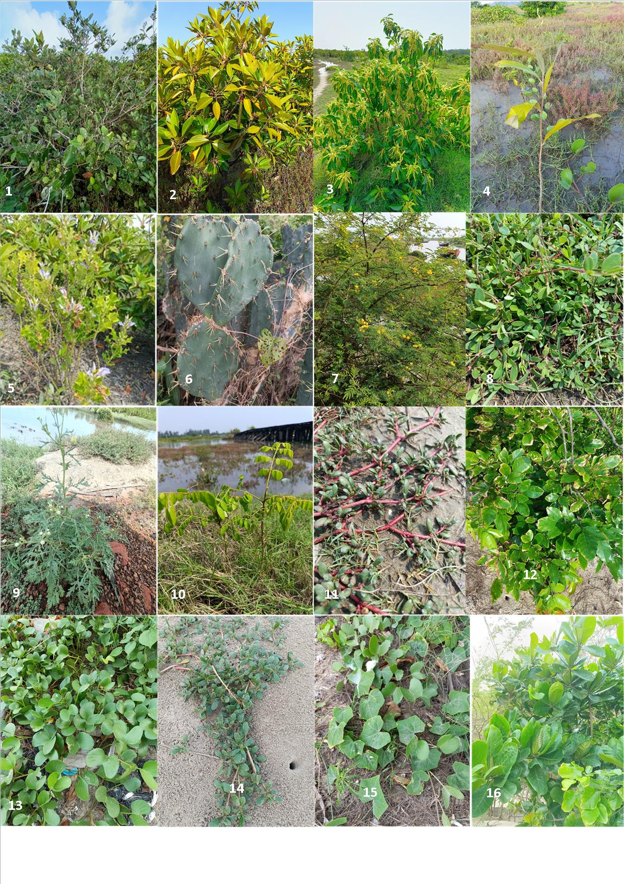
Plate 1: 1. Avicennia marina (Forssk) Vierh.,1907; 2. Bruguiera gymnorrhiza (L.) Savigny,1798; 3. Excoecaria agallocha L.,1759; 4. Heritiera fomes Banks.,1800; 5. Acanthus ilicifolius L.,1753; 6.Opuntia dillenii (Ker Gawl.)Haw.,1819; 7. Acacia nilotica (L.) Willd. ex Delile.,1813; 8. Desmodium triflorum (L.) Dc.,1825; 9. Parthenium hysterophorus L.,1753; 10. Guilandina bonduc L.,1753; 11. Sesuvium portulacastrum (L.) L., 1759; 12. Pongamia pinnata (L.) Pierre.,1899; 13. Ipomoea pes-caprae (L.)R. Br.,1818; 14. Portulaca oleracea L.,1753; 15. Coccina grandis (L) Voigt.,1845;16. Terminalia catappa L.,1767.

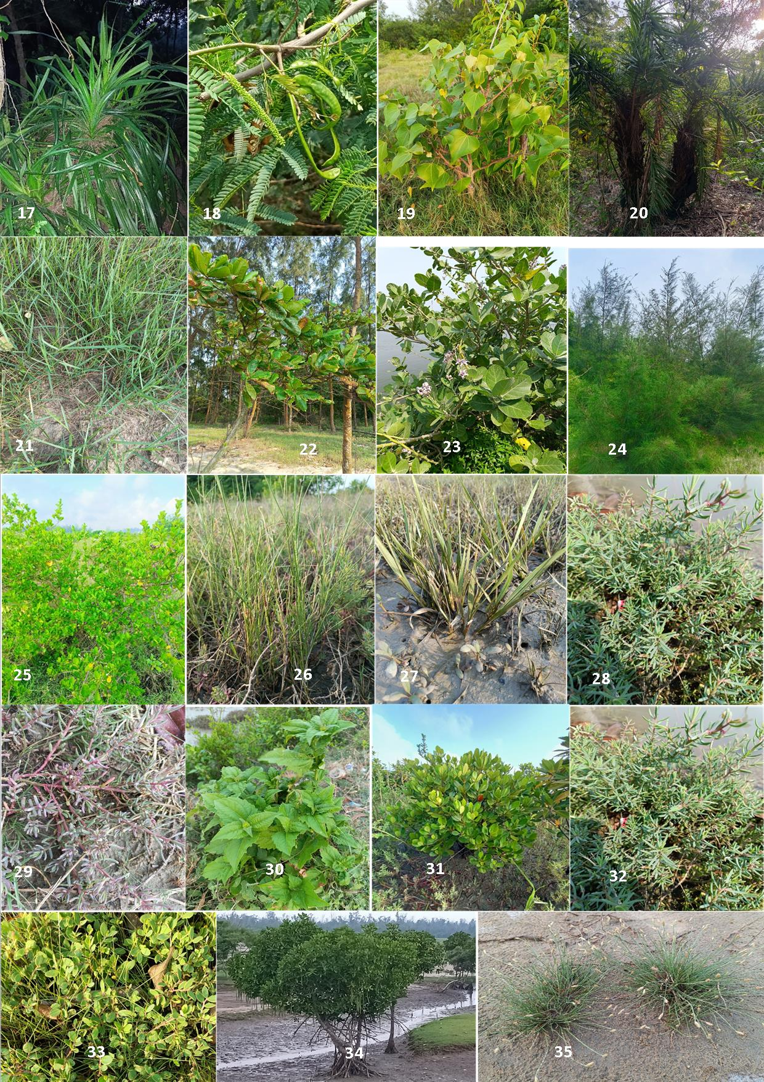
Plate 2: 17. Pandanus odoratissimus Linn.f., 1781; 18. Prosopis juliflora (Sw.) DC.,1825; 19. Thespesia populnea (L.) Sol. ex Corrêa, 1807; 20. Phoenix sylvestris (L). Roxb.,1814; 21. Sporobolus indicus (L.) R.Br.,1810; 22. Anacardium occidentale L.,1753; 23. Calotropis gigantean (L.) W.T.Aiton, 1811; 24. Casuarina equisetifolia L.,1759; 25. Clerodendrum inerme R.Br., 1810;m 26. Paspalum scrobiculatum L.,1767; 27. Porteresia coarctata (Roxb.)Tateoka.,1965; 28. Suaeda maritima (L.) Dumort.,1827; 29. Suaeda nudiflora (Willd) Moq.,1831; 30.Chromolaena odorata (L.) R.M.King & H.Rob., 1970; 31. Ceriops decandra (Griff.) W.Theob.,1860; 32. Suaeda fruticosa Forssk.ex.J.F. Gmel.,1776; 33. Sauropus bacciformis (L.) Airy Shaw.,1980; 34. Rhizophora mucronate Lam.,1804; 35. Eleocharis geniculata (L.) Roem. & Schult.,1817.

- Discussions:

However, the forest hosts a rich genetic pool of plants, comprising timber species, wild variants of cultivated plants and several endemic species. Mangrove vegetation are the identical ecosystems found along with tropical and subtropical coastlines area, harbor a kinky alignment of plant diversity specially adapted to saline and brackish water environment. The floral species of mangrove forest environment is incredibly varied, comprising plant species with remarkable adaptations to heighten in the challenging intertidal conditions where land and sea meet. In this investigation, 35 mangrove and mangrove associates species were identified, classified in 24 families (Figure 2), in which 6 flora were true mangrove species, 12 mangrove associates species, 16 beach flora and 1 back mangrove species . In this study, the IUCN status (Figure 3) of floral species was shared by Not Evaluated, Least Concern and Endangered with 19, 15 and 1 species respectively.

Figure 2: Family wise mangrove plant species recorded in Junput Mangrove

Figure 3: IUCN status mangrove plant species recorded in Junput Mangrove

Various researchers reported diversified number of species while working on coastal mangrove in India, 59 species, encompassing true mangrove and mangrove associates species belonging to 41 genera and 29 families (Banerjee et al.,1989). Through investigations have confirmed that there are 32 true mangrove species are available (Sing et al.,2012; Sing and Garge, 1993). The floral diversity of India’s mangrove consists of a core of 38 mangrove species (Kathiresan, 2003). Indian mangrove ecosystem diversifications have been broadly studied in terms of their biogeography, ecology and forestry, yet significant difference in species composition remain and comprehensive locality data is lacking. For example, Blasco (1977) identified 58 mangrove species in India, while Rao (1986) listed 60 species across 41 genera and 29 families. Naskar and Guha Bakshi (1987) reported 35 true mangrove species, 28 mangrove associates and 7 back mangals. Other sources, such as Untawale (1986), Banerjee et al. (1989), Deshmukh (1991) and the ENVIS centre (2002) documented 59 species from 41 genera and 29 families. Jagtap et al. (1993) reported 50 mangrove species. Species like Acrostichum sp., Acanthus spp., Pemphis acidula, Phonix paludosa, Cynometra spp. and Dolichandrone spathacea are recognized globally as true mangrove species (Duke.1992; Polidoro et al., 2010), but their classification varies within India. Mandal and Naskar, 2008 identified a total 82 mangrove species across 52 genera and 36 families from various studies and endeavor to classify them into major mangroves species and mangrove associates species based on modified morphological and anatomical features of leaves, stems, roots and reproductive organs. They listed 30 major true mangrove species in India. However, their classification had limitations; species such as Cynometra iripa, Excoecaria indica, Pemphis acidula and Acrostichum speciosum were exclude from their list while Acanthus volubilis, Brownlowia tersa, Acrostichum aureum and Dolichandrone spathacea were classified as mangrove associates species. Sanjappa et al., 2011 identified 68 true mangrove species, but their list also comprised coastal plants and salt marsh species species such as Caesalpinia crista, Cerbera manghas, Clerodendrum inerme, Dalbergia spinosa and Thespesia populneoides which were classified as true mangrove species. Jayatissa et al., 2002 extensively studied that the negative effects of including mangrove associates species or beach vegetation and species that are unlikely to ensure in the total count of mangrove species for a given field. The distribution position showed that mangrove species are found in 105 nations globally; from which 10 nations possess nearly 52 % (Hamilton and Casey, 2016). The mangrove biodiversity, encompassing 47 % of the world’s mangrove region and hosting 85 % of the world’s mangrove species across various habitats, play an important role in the coastal biodiversity of 30 countries bordering the Indian Ocean (Kathiresan and Rajendran.2005). One of the identifying features of mangrove flora species is their proficiency to withstand high level of salinity. These unique characteristics are important for survival in the intertidal zones where freshwater and seawater mix, creating an environment inhospitable to many different plant species. Mangroves acquire this abidance through a variety of mechanisms including specialized root formation and presence of salt-excreting glands. Mangrove ecosystems are fascinating root system. Mangrove species are complex roots or pneumatophores that protrude above the water surface, providing proper stability condition in the soft, muddy substrate and facilitating oxygen uptake in waterlogged soils. Mangrove plant species also play an important role in coastal environment by providing habitat and food for a diverse range of organisms. All the other mangrove species in India, with the exception of Avicennia marina and Exocecaria agallocha are at different levels of endangerment (Kathiresan, 2008; Bhatt and kathiresan, 2011).

5. Conclusion:

The current work shows that the diversity of mangroves, mangrove associates, back mangrove, beach flora species. During the study period in Junput mangrove coastal area reported 35 mangrove plant species belonging to 24 family and 33 genera. In this study, the IUCN status of floral species was shared by Not Evaluated, Least Concern and Endangered as 19, 15 and 1 respectively. The Junput mangrove ecosystem, represents a unique and sensitive habitat along the Bay of Bengal coast. This study revealed that the mangrove vegetation is dominated by Avicennia marina, Excoecaria agallocha, and Sonneratia apetala species that are highly tolerant to salinity and tidal fluctuations. Mangrove forest vegetation gives also ecological advantages and maintaining environmental equilibrium is widely spreaded. Large-scale transformation of mangroves for aquaculture and other different sources uses have led to an important environmental impacts, these mangrove forests can still be restored if properly maintain effective management strategies. It is now widely acknowledged that mangroves ecosystem are important to human well-being and must be conserved for our own benefits.

DISCLAIMER (ARTIFICIAL INTELLIGENCE)

Author(s) hereby declare that NO generative AI technologies such as Large Language Models (ChatGPT, COPILOT, etc) and text-to-image generators have been used during writing or editing of this manuscript.

6.References:

- Tomlinson, P. B.(1986). The botany of mangroves. Cambridge (Cambridge University Press). 419.
- Qasim, S. Z. (1998). Mangroves, In: Glimpses of the Indian Ocean, University Press, Hyderabad, 123‐129.
- Pillai, N. G., & Harilal, C.C. (2018). MANGROVES – A REVIEW. International Journal of Recent Advances in Multidisciplinary Research, 5(8), 4035-4038.
- Naskar, K. R. & Mandal, R. N. (1999). Ecology and Biodiversity of Indian Mangroves, Milton Book company, Dehra Dun, India, 3, 348.
- Bouillon, S., Dahdouh, G. F., Rao, A. V. V. S., Koedam, N. & Dehairs, F. (2003). Sources of organic carbon in mangrove sediments: variability and possible ecological implications, Hydrobiologia,495,33-39. DOI:10.1023/A:1025411506526
- FAO, (2007). The World's Mangroves 1980-2005. FAO Forestry Paper No. 153. Rome, Forest Resources Division, FAO.77.
- Bosold, A. L. (2012). Challenging the “Man” In Mangroves: The Missing Role of Women In Mangrove Conservation.
- Duke, N.C. (1992). Mangrove foristics and biogeography. In: Robertson AI, Alongi DM (eds) Tropical mangrove ecosystems. American Geophysical Union, Washington, 63–100.
- Polidoro, B. A., Carpenter, K. E., Collins, L., Duke, N. C., Ellison, A. M., Ellison, J. C., & Yong, J. W. H. et al. (2010). The Loss of Species: Mangrove Extinction Risk and Geographic Areas of Global Concern. PloS one, 5(4), e10095.
DOI.org/10.1371/journal.pone.0010095
- Wang, L., M. Mu, X. Li, P. Lin &. Wang, W.(2011).Differentiation between true mangroves and mangrove associates based on leaf traits and salt contents. Journal of .Plant Ecol, 4(4), 292-301. DOI.org/10.1093/jpe/rtq008
- Mandal, R.N., & Naskar, K.R. (2008). Diversity and classification of Indian mangroves: a review. Trop. Ecol. 49,131–146.
- FSI. (2015). India State of forest report. Forest Survey of India (FSI), Dehra Dun. 62–67.
- Chaudhuri, A.B. & Choudhury, A. (1994). Mangroves of the Sundarbans. Vol. I. India, The IUCN Wetlands Programme. Bangkok: IUCN. 247.
- Naskar, K.R. (2004). Manual of India Mangroves. Delhi: Daya Publishing House.
- Rao, R.S. (1986). Flora of Goa, Diu, Daman, Dadra and Nagarhaveli. Vol. 2. Rubiaceae-Selaginellaceae. Botanical Survey of India, Howrah.
- Rao, A.N. (1986). Mangrove ecosystem of Asia and the Pacific – In: Umali, R.M (Eid) Mangroves of Asia and specific status and management, Pilot program on mangroves in Asia and Pacific, Technical report of UNDP Research and training.
- Blasco, F. (1977). Outline of ecology, botany and forestry of the mangals of the Indian subcontinent.. In: (Chapman, V.J. ed.) Ecosystems of the World 1: Wet Coastal Ecosystems. Elsevier, Amsterdam, 241-260.
- Panda, S.P., Subudhi, H., and Patra, H.K.( 2013). Mangrove forest of river estuaries of Odisha, India. Int J. Biodivers. Conserv. 5(8), 446–454. DOI: 10.5897/IJBC12.004
- Das, D. C., Pati, M., Mahato, G., & Das, M. (2015) .Study Of The Tidal Vegetation Of Purba Medinipur District Of West Bengal, India, International Journal of Bioassays, 4 (5), 3915- 3921
- Jana, B., & Mondal, A. K. (2020). Studies on tidal vegetation in East Midnapore Coastal Belt, West Bengal, India. World Journal of Environmental Biosciences, 9(2), 35-39.
- Banerjee, L.K., Sashtry, A.R.K., Nayar M.P. (1989). Mangrove in India, Identification Manual. Botanical Survey of India, Govt of India.
- Deshmukh, S.V. (1991). Mangroves of India: Status Report. Global Network of Mangrove Genetic Resource Center.
- Blasco, F. (1975). The Mangroves in India. Institute Francais de Pondicherry, Inde, Sri Aurobinda Ashram, India.
- Jagtap, T.G., Chavan, V.S., & Untawale A.G. (1993). Mangrove Ecosystems of India: A need for protection (synopsis). AMBIO, 22, 252-254.
- Kathiresan, K. (2003). How do mangrove forests induce sedimentation? Rev. Biol. Trop, 51,355-360.
- Kathiresan, K., & Rajendran N. (2005). Coastal mangrove forests mitigated tsunami. Estuarine Coastal and Shelf Science. 65(3), 601-606. DOI.org/10.1016/j.ecss.2005.06.022
- Naskar, K.R., & Guha Bakshi, D.N. (1987). Mangrove Swamps of the Sundarbans– An Ecological Perspective. Naya Prakash, Calcutta, India, 64.
- Naskar, K.R., & Mandal, R.N. (1999). Ecology and Biodiversity of Indian Mangroves. Daya Publishing House, New Delhi, India.
- Bhatt, J. R., & Kathiresan, K. (2011). Biodiversity of Mangrove Ecosystems in India. In (Bhatt J.R., Macintosh, D.J., Nayar, T.S., Pandey, C.N., Nilaratna, B. P., eds.) Towards Conservation and Management of Mangrove Ecosystems in India. IUCN India.1–34.
- ENVIS Centre (Environmental Information System Centre). (2002). Mangroves of India. ENVIS publication series 2. Tamil Nadu, India: Annamalai University, 139.
- Kathiresan, K. (2010). Importance of mangrove forest of India. J. Cost. Environ. 1(1),70-89.
- Jagtap, T.G., Chavan, V.S. & Untawale, A.G. (1993). Mangrove Ecosystems of India: A need for protection (synopsis). Ambio 22, 252–254.
- Singh, V.P., & Garge, A. (1993). Ecology of Mangrove Swamps of the Andaman Islands. International Book Distributors (Dehradun, India). 181.
- Untawale, A.G. (1986). India mangrove ecosystem. In: Technical Report of the UNDP/UNESCO Research and Training Pilot Programme on Mangrove Ecosystem in Asia and the Pacific. Mangroves of Asia and the Pacific: Status and Management. Manila: Natural Resources Management Centre, 467–470.
- Sanjappa, M., Venu, P., Arisdasan, W., & Dinesh-Albertson, W. (2011). A review of mangrove species in India. Towards Conservation and Management of Mangrove Ecosystems in India. IUCN India, New Delhi, 35-50.
- Kathiresan, K. (2008). Biodiversity of Mangrove Ecosystems. Proceedings of Mangrove Workshop. GEER Foundation, Gujarat, India.
- Hamilton, S.E. & Casey, D. (2016). Creation of a high spatio-temporal resolution global database of continuous mangrove forest cover for the 21st century (CGMFC-21). Global Ecol. Biogeogr. 25(6), 729 - 738. DOI: 10.1111/geb.12449
- Singh, A. K., Ansari, A., Kumar, D. & Sarkar, U. K. (2012). Status, biodiversity and distribution of mangroves in India: an overview. Uttar Pradhesh Sate Biodiversity Board. Marine Biodiversity: One Ocean, Many Worlds of Life, 59- 67.
- Jayatissa, L. P., Dahdouh-Guebas, F., & Koedam, N. (2002). A review of the floral composition and distribution of mangroves in Sri Lanka. Botanical journal of the Linnean Society, 138(1), 29-43. DOI.org/10.1046/j.1095-8339.2002.00002.x
- Kumudranjan, N., & Rathindranath, M. (1999). Ecology and biodiversity of Indian Mangroves. New Delhi, India: Daya Publishing House, 783.
- Kathiresan, K. (2000). Flora and Fauna in mangrove ecosystem: A manual for identification. All India coordinated project on coastal and marine diversity, training and capacity building and Coastal diversity (East–West). Parangipettai: Ministry of Environment and Forest, CAS in Marine Biology.
- Chintala, S.R. (2008).Field Identification Guide for Indian Mangroves. New Connaught Place, Dehra Dun, India: Bishen Singh Mahendra Pal Singh, 100.
- Pandey, C.N., & Pandey, R. A. (2010). Window to the World of Mangroves. Gandhinagar, Gujarat: Gujarat Ecological Education and Research Foundation.
- Barik, J., & Chowdhury, S. (2014). True Mangrove Species of Sundarbans Delta, West Bengal, Eastern India. Check List, 10(2), 329-334. DOI: 10.15560/10.2.329
- Giesen, W., Wulffraat, S., Zieren, M., & Scholten, L. (2006). Mangrove Guide Book for Southeast Asia. FAO and Wetlands International. RAP Publication 2006/07. 198.
- India Biodiversity Portal. https://indiabiodiversity.org. Accessed in December 2024.
- India Flora Online. https://indiaflora-ces.iisc.ac.in. Accessed in December 2024.
- eFlora of India. https://efloraofindia.com. Accessed in January 2025.

