**Morphometric Analysis of the West Rapti River Basin: Geospatial Assessment and Hydrological Implications**

**ABSTRACT**

**Background and aim of the study:** The West Rapti River Basin in Nepal is a crucial geographical region with significant ecological and socio-economic importance. Planning for sustainable development, evaluating the danger of flooding, and managing land and water resources effectively all depend on an understanding of this basin's morphometric features. This work performs a thorough morphometric examination of the West Rapti River Basin using GIS methodologies.

**Data and methodology:** The analysis incorporates various morphometric parameters, including linear, areal, and relief aspects, to assess the basin's geometric and topographic properties. The study utilizes remote sensing data, Advanced Spaceborne Thermal Emission and Reflection Radiometer (ASTER) digital elevation models (DEMs), and geographic information system (GIS) tools to extract relevant morphometric attributes.

**Results:** It was discovered that the river basin had a dendritic structure, with an uneven tendency in SLR flowing from the youth to the mature stage. Its shape was less elongated, and its southern portion had more runoff. Quantitative methods based on compound ranking of each attribute and land use land cover (LULC) based on possible erosion risk have been tried to prioritize 25 sub-watersheds (SW). A mean composite score inculcating parameters and LULC was computed ranging from 6 to 16.5. The findings revealed that SW3, SW5, SW8, SW9, and SW12 were very highly prioritized sub-watersheds whereas SW13, SW15, SW21, SW23, and SW24 were found to be in very low category. The analysis of five year data of the river basin demonstrated that the river course has changed over the time affecting 17.6 sq. km. area to erosion and 15. 2 sq. km. area to accretion mostly at the river’s syntaxial bends and southern parts of the watersheds.

**Conclusion:** This research contributes to the scientific understanding of river basin morphology and provides valuable information for sustainable land and water resource management. Different watershed management treatment to prevent soil erosion can be performed on priority basis which prevent further degradation of critically eroded area.

**Keywords:** morphometric analysis, geospatial techniques, LULC, vulnerable, erosion & accretion, river basin management

**1. INTRODUCTION**

Water, the fundamental building block of life on Earth, is the world's most pressing issue as we approach the first quarter of the twenty-first century. Concerns are growing that the increasing demand may cause the world's water consumption to double or even triple by the year 2050, with freshwater scarcity becoming an increasingly pressing issue on the international scene (Jones, 2014). Hydrology is a crucial scientific field that provides valuable insights into the complex dynamics of water in its different forms on and below the Earth's surface, making it an invaluable tool in the effort to understand and tackle this pressing challenge (Dingman, 2015).

The broad implications of hydrology go beyond scholarly research; it is essential to the development of plans for the management of water resources, environmental preservation, and engineering projects. Hydrologists play a vital role in protecting this vital resource by evaluating water availability, building reservoirs, and creating sustainable water use guidelines for a variety of industries (Subramanian et al., 2023).

Morphometric analysis is a crucial component of hydrological research and the foundation for understanding river basins. Morphometric analysis offers a quantitative lens through which the complex drainage system of a river basin can be systematically understood, as claimed by Raj and Azeez (2012) and Strahler (1964). Morphometry, defined by Clarke (1966) as the study of landform size, shape, and the structure of the Earth's surface, is essential to understanding the complexity of watersheds. In addition to being crucial for long-term water conservation and erosion control, these crucial regions of land - where precipitation converges to a common point - are also necessary for sustained growth (Desta et al., 2005).

The combination of hydrological research and geospatial technologies, like Geographic Information Systems (GIS) and remote sensing, has transformed our capacity to accurately and efficiently analyze river basins in the modern era. These tools have become indispensable in deciphering the complexities of hydraulic processes, from the strategic use of data from the Shuttle Radar Topography Mission (SRTM) and Advanced Spaceborne Thermal Emission and Reflection Radiometer (ASTER) to the creation of stream networks via Digital Elevation Models (DEMs) (Waikar & Nilawar, 2014; Sreedevi et al., 2005).

This study stands at the nexus of watershed management and technological innovation, drawing inspiration from the initiation of watershed management planning in Nepal in the late 1960s. The establishment of the Department of Soil Conservation and Watershed Management (DSCWM) in 1975 marked a watershed moment in governmental commitment. Over the years, evaluations based on erosion status and studies on Himalayan watersheds have spotlighted the need for meticulous planning and assessment methodologies (MPFSP, 1989; Bogati et al., 1997; DSCWM, 2016, Ghimire, 2023). Subedi et al. (2022) have carried out a work on different river basin to address the long term mean monthly flow estimation for assessing the risk of flood in the region. Shrestha et al. (2023) while discussing the change in climate change, assessed the change in hydrological variable utilizing the Coupled Model Intercomparison Project phase 6 (CMIP 6) data found the harsh climate in near future in eastern Nepal leading to floods and drought both.

Citing a case of West Rapti river, the downstream area has gone drastic changes in built up area and most of the population is residing along the river. Moreover, the area is experiencing flood every year, urging us to prioritize the sub watershed based on river morphology and land use (Bhattarai & Ghimire, 2023). The study aims to locate the most common sub-watersheds that fall within the same priority by utilizing both morphometric and LULC analyses which contributes to the scientific understanding of river basin morphology and provides valuable information for sustainable land and water resource management. This study also contributes to redefine watershed management in response to the constantly changing land scape of technological capabilities and the ongoing challenges of variable availability. This research aims to present an integrated approach leading to new frontiers in effective watershed management treatment to prevent soil erosion on priority basis which prevent further degradation of critically eroded area of the West Rapti river basin.

**2. STUDY AREA**

Geographically, WRRB extends from 27°43′28″N to 28°34′13″N and 81°39′29″E to 83°09′14″E (Fig. 1). The overall area of the watershed is 6655.81 km2. Eventually, it merges with the Ghaghara River, a major left bank tributary of the River Ganges, which is known as the Karnali in Nepal. The basin experiences diverse climatic conditions, with the upper West Rapti River basin characterized by a temperate climate, while the lower basin, including the Banke district, exhibits a tropical to subtropical climate (Talchabhadel & Sharma, 2014). The Jhimruk, Madi, Arun, Lungri, Dunduwa, Sotiya, and Gandheli rivulets are some of the main sources of water for the West Rapti River, which is the largest tributary of the River Ghaghara. The river is named West Rapti River towards downstream from the confluence of the Jhimruk and Madi Rivers at the Airawati. The ASTER digital elevation model shows that the Rapti River basin is situated between 65 and 3627 meters above sea level. It has several tributaries. Major tributaries are Jhimruk River, Madi River, Arun River, Lungri River, Sit River, Dunduwa River, Sotiya and Gandheli rivulets. Downstream of the confluence of the Jhimruk and Madi Rivers, the river is named the West Rapti River. The average slope of 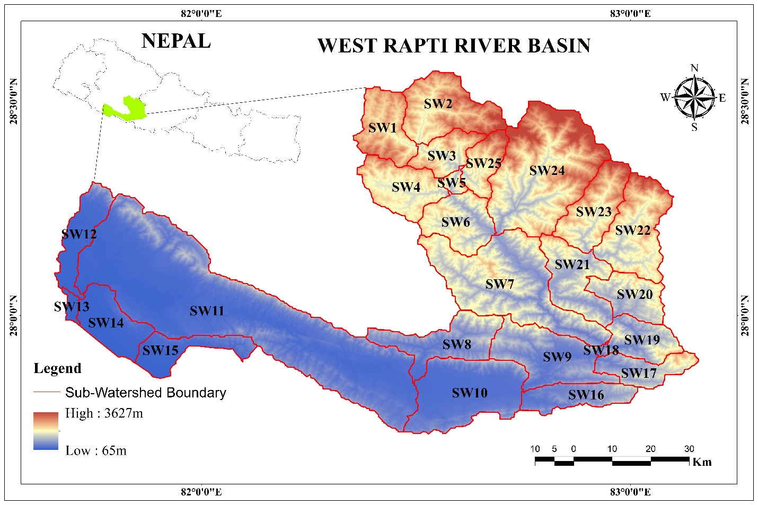the basin is 16.8%. The source of runoff is due to the monsoon rainfall and groundwater.

Fig. 1 Location map of the study area showing elevation and sub-watersheds

**3. METHODOLOGY**

* 1. ***Data Base***

This study utilized the secondary sources of data. The major sources were Advanced Space Borne Thermal Emission & Reflection (ASTER) Digital Elevation Model (DEM) and Sentinal-2. The ASTER DEM was downloaded from Earth Data Search. Altogether 6 DEMs i.e. 27-81, 27-82, 27-83, 28-81, 28-82 and 28-83 have been downloaded having a resolution of 30 m. The land use land cover was extracted from the Sentinal-2 data.

* 1. ***Delineation of Sub-Watersheds***

The delineation of sub-watershed was carried out in ARC GIS Software version 10.5. In the present study, twenty-five Sub-watersheds were delineated utilizing stream gage (pour point) method using ASTER DEM which was further used for the preparation of drainage map of the study area. The stream order map was generated using the Strahler’s stream ordering method of (Strahler, 1952) by utilizing the fill, flow direction and accumulation etc. (Fig. 3).

Table 1 Morphometric Parameters and its formulae used for calculation

|  |  |  |
| --- | --- | --- |
| Parameters |  | Formulae |
| Linear Parameters | Stream Order | hierarchical order |
|  | Stream Length (SL) | length of stream |
|  | Stream Frequency (SF) | SF = SN/BA, where, SN=stream number and BA= basin area |
|  | Stream Length Ratio (SLR) | SLR= Ʃ(SLn/TSL)/N, where SLn= Stream length of a particular order, TSL= Total Stream Length of sub watershed, N= Number of order |
|  | Drainage Density (DD) | DD= SL/BA, where, SL= stream length, BA= basin area |
|  | Drainage Texture (DT) | total number of stream order/ perimeter |
|  | Bifurcation Ratio (BR) | BR= SN/ (SN+1), where, SN= number of particular stream order |
|  | Drainage intensity (DI) | DI=SF/DD, |
|  | Length of overland flow (LOF) | LOF=1/2*DD |
|  | Constant of Channel Maintenance (CCM) | CCM=1/DD |
| Relief Parameters | Relative Relief (RR) | RR=(Mmax/P)*100, where Mmax= maximum height (in Km) |
|  | Absolute Relief (AR) | AR= Mmax-Mmin, Mmin=minimum height (in Km) |
|  | Relief Ratio (R Ra) | RRa= AR/BL |
|  | Ruggedness Number (RN) | RN=AR*DD |
| Areal/shape Parameters | Basin Length (BL) | BL=1.312*((BA)^0.568) |
|  | Circulatory Ratio (CR) | CR= 4µBA/BP² where, CR is circulatory ratio, and µ=22/7 or 3.14 which is also constant is basin area and BP is the basin perimeter and 4 is the constant |
|  | Elongation Ratio (ER) | ER = 2 /π *√A/ BL where , A= Area of the basin (Km2 ) BL =(Maximum) Basin length (in Km) |
|  | Form Factor (FF) | FF= BA/BL² where, BA= basin area, BL= basin length |
|  | Shape Index (SI) | SI= 1/FF |

* 1. ***Computation of Morphometric parameters***

Morphometric analysis has been carried out by taking linear parameters like stream order, stream frequency, drainage density, texture, bifurcation ratio, drainage intensity, length of overland flow, constant of channel maintenance, relief parameters such as relative relief, absolute relief, relief ratio, ruggedness number and areal/shape parameters like basin length, circulatory ratio, elongation ratio, shape index and form factor (Nag & Chakraborty, 2003; Hajam et al., 2013). The methods of which are mentioned in Table 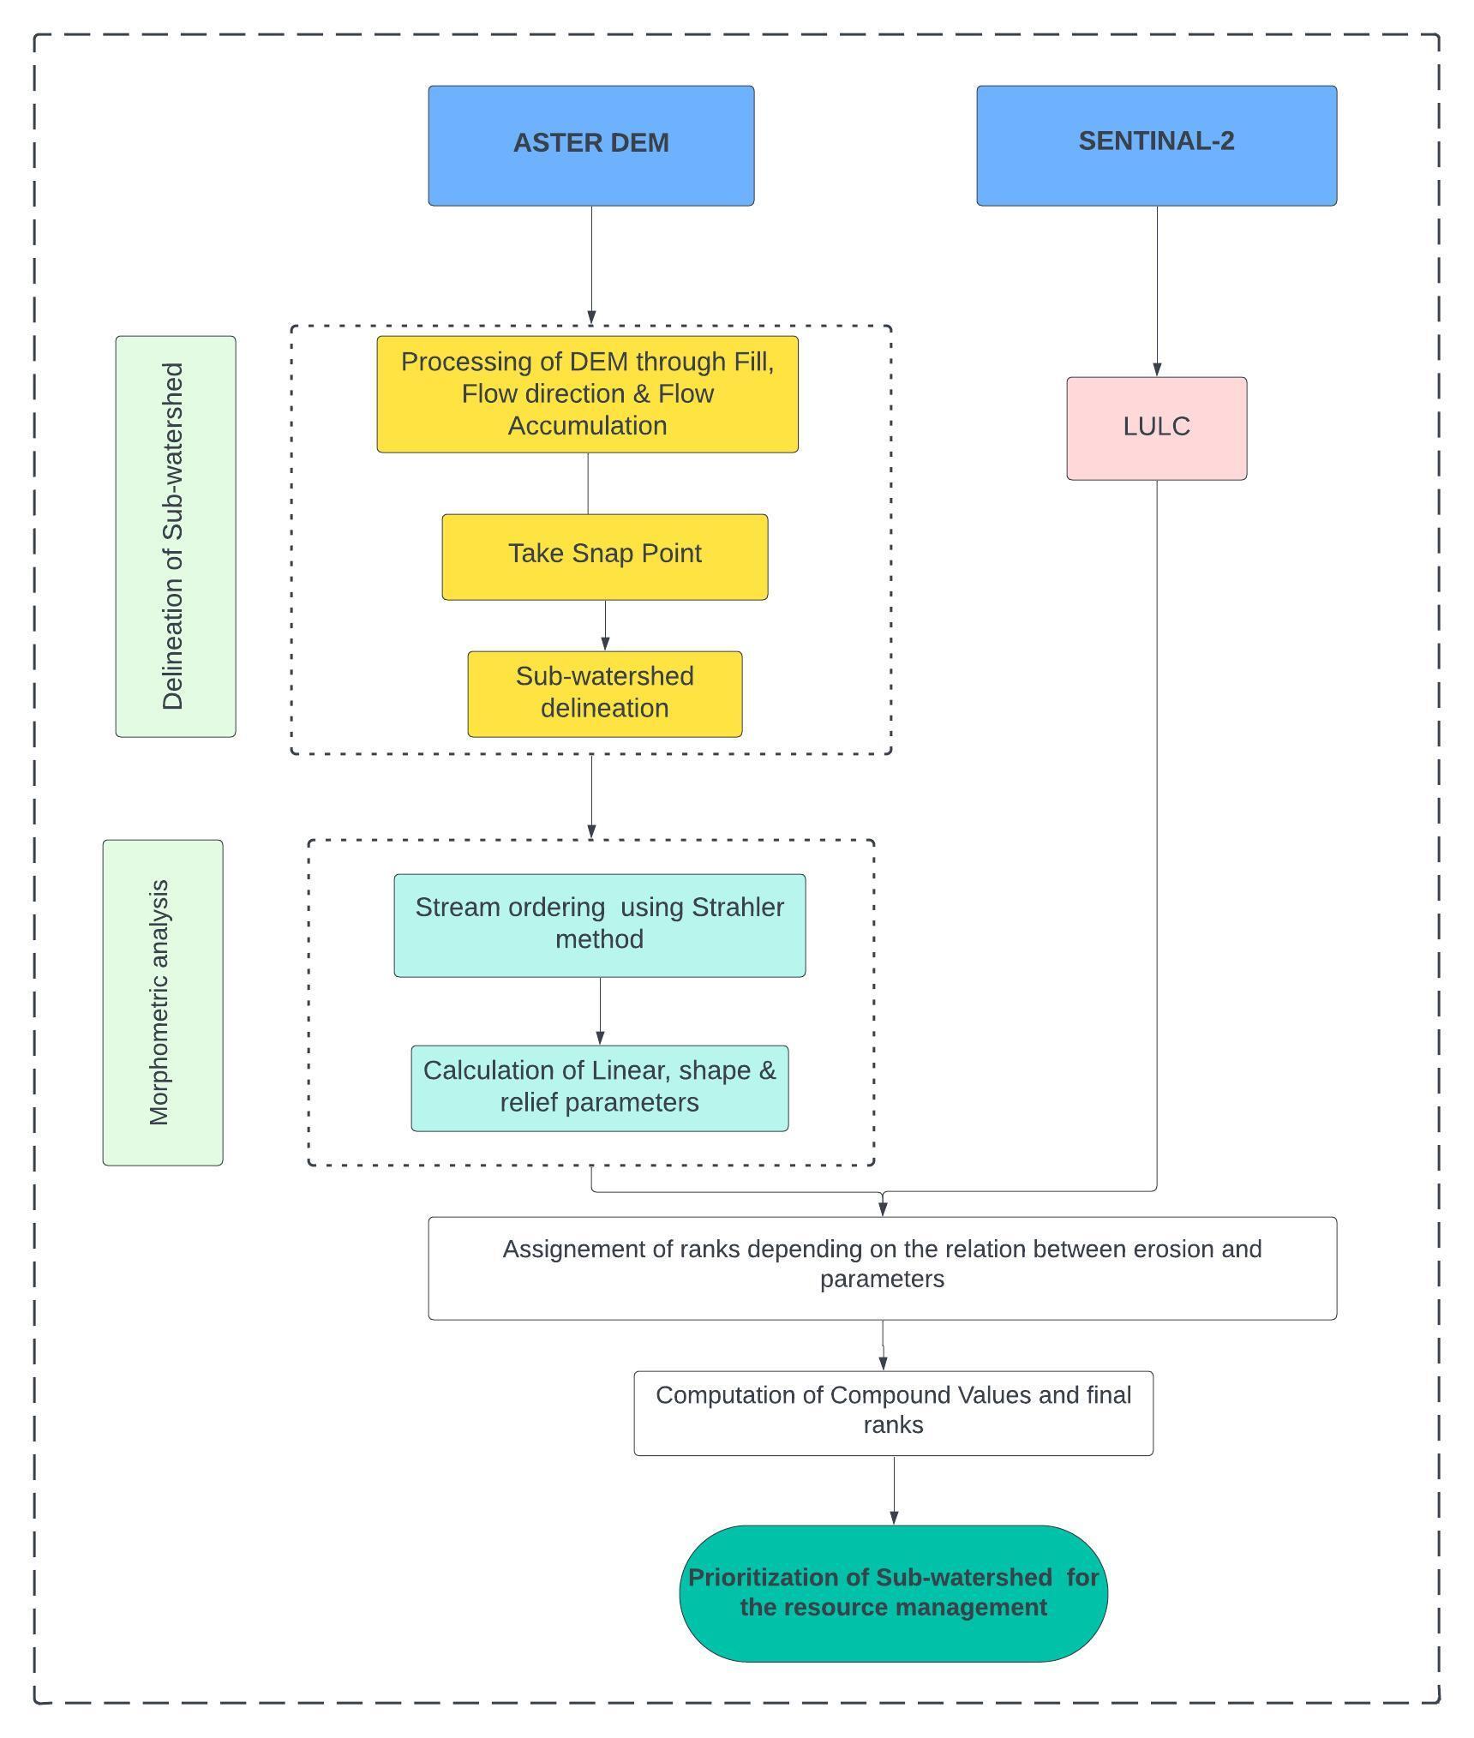1.

Fig. 2 Methodological framework for the present study

* 1. ***Preparation of Land use land cover (LULC) Classification***

For the evaluation of resources in the study area, a map was prepared (Lam, 2008) to identify the different types of Land Use Land Cover (LULC) using the maximum likelihood classifier (MLC) in the Arc GIS 10.5 version. Six LULC classes were identified based on Environmental System Research Institute (ESRI’s) LULC classification system. The major land use land cover classes identified were water body, tree cover, agricultural land, built-up area, bare ground and grassland area.

* 1. ***Determination of Compound Value and assigning ranks for prioritization***

Soil erosion is directly relevant to the linear and relief characteristics such as mean bifurcation ratio, drainage density, stream frequency, drainage texture, relief, ruggedness number, and so on. The most erodible soil in a catchment is indicated by the maximum value of its linear and relief characteristics. As a result, the sub-watershed that exhibits the highest relief and linear characteristics value is ranked first, followed by the sub-watershed with the second highest value, the third highest value, and so forth.

The areal characteristics such as basin length, circularity ratio, shape index, elongation ratio, and form factor have an indirect relationship with soil erosion. The most erodible soil in a catchment is the soil with the minimum areal characteristic value (Handique et al., 2025). Hence, sub-watershed having the lowest areal characteristics values was ranked first, the second lowest areal characteristic values was ranked as second, the third lowest areal characteristic values was ranked as third, and so on. The highest value for linear and relief parameters is ranked as 1, followed by the next highest value at rank 2, and so forth. When it comes to areal parameters, the lowest value received a ranking of 1, the next lowest value received a ranking of 2, and so forth.

After getting all ranks for individual parameters in each sub-watershed, the next step is to find the compound value for each sub-watershed. To arrive at the compound value, all the ranks in SW1 are added together and divided by the number of parameters and repeat the procedures for other sub-watersheds. The very high priority has been given to the sub-watersheds with the very low compound value, denoted by the rank 1 (very high priority) followed by rank 2 to the next value and so on. Accordingly, the low priority has been given to the sub-watersheds having higher compound value, i.e. rank 25. Following the calculation of rank, the sub-watersheds were categorized into five categories very high (1-5), high (5-10), medium (10-15), low (15-20) and very low (20-25) (Fig. 7).

**4. RESULTS AND DISCUSSION**

The quantitative morphometric measurements give information on the catchment’s hydrological features. There are twenty-five sub-watersheds in the West Rapti catchment. By examining multiple criteria like the basin’s linear aspect, areal aspect, and relief aspect, the morphometric analysis was utilized to prioritize sub-watersheds of West Rapti river basin. The details of various parameters are discussed below.

**4.1 Basic parameters of river basin**

**Basin Area of the watershed (BA)**

The total amount of water can be directly represented by the watershed's area. Given that the entire area of a watershed is projected onto the horizontal plane, it is one of the crucial parameters. It is denoted by “BA.” The overall area of the watershed is 6655.81 km2. In the present study, the largest and smallest sub-watershed areas are 1523.91 km2 (SW11) and 8.87 km2 (SW18), respectively (Table 2).

**The perimeter of a watershed (BP)**

Watershed’s outer boundary that encloses its area is defined as the watershed perimeter and is designated by BP. The total perimeter of the watershed is 592.2 km. Out of the twenty-five sub-basins of West Rapti river, the largest and smallest sub-watersheds’ perimeter are 247.87 km (SW11) and 14.93 km (SW18), respectively (Table 2).

**4.1 Linear Aspects**

***4.1.1 Stream Order (SO)***

The river system functions as an intricate network made up of linked nodes and links. This network analysis includes geometric considerations such as length, area, shape, relief, and orientation parameters, in addition to topological and system connectivity assessments. The fundamental components of the network, known as stream segments or links, define the distances between "fingertip" tributaries and channel junctions. One important characteristic that indicates the hierarchical arrangement of these segments is the stream order, which is essential to comprehending relative discharge. For stream ordering, Strahler and Shreve are two popular systems that are used.

Under the Strahler system, unbranched tributaries comprise the first order, and combinations of lower orders yield higher orders. In contrast, Shreve's system gives important information about relative stream discharge by defining magnitude based on the number of fingertip tributaries feeding a channel segment. These methods advance a thorough comprehension of the composition, dynamics, and drainage patterns of the river system.

The West Rapti River basin's stream orders are classified using Strahler's system, with a total of 8,251 orders distributed across different levels. These include 3,632 in the first order, 2,613 in the second order, 939 in the third order, 370 in the fourth order, 244 in the fifth order, and 453 in the sixth order, as illustrated in Figure 3. This classification provides valuable information for comprehending the hierarchical structure and drainage patterns within the West Rapti River basin.

***4.1.2 Stream Length (SL)***

The West Rapti River basin's stream length is determined using the Horton (1945) methodology. Table 3 presents the results of this method for calculating the stream length from the West Rapti sub-basins' mouth to the drainage divide. Stream length is defined by Horton's law as the average length of streams in each unique order within a catchment. By enabling a thorough evaluation of the spatial distribution and features of stream lengths, this approach offers important insights into the drainage patterns and hierarchical structure of the West Rapti River basin. By using Horton's framework, one can gain a quantitative understanding of the stream network and make it easier to interpret how it functions within the larger hydrological context and its dynamics.

Because of this, a first-order stream has a longer stream and its length grows as stream order does as well. It is designated by SL in this research. In the present study, the lengths of the largest and smallest of the streams are SW11 (6751.14 km) and SW13 (14.4 km), respectively (Fig. 3).

***4.1.3 Stream Length Ratio (SLR)***

The ratio of the mean lengths of one order to the next lower order of the stream segment is known as the stream length ratio (Horton, 1945). In Table 2, the SLR for the West Rapti sub-basin is computed. Because of the slope and topography, it is noted that the variation in SLR varies from 0.31 in SW13 to 1.63 in SW3 (Fig. 4).

|  |  |  |  |  |  |  |  |  |  |  |  |  |  |  |  |  |  |  |  |  |  |
| --- | --- | --- | --- | --- | --- | --- | --- | --- | --- | --- | --- | --- | --- | --- | --- | --- | --- | --- | --- | --- | --- |
| SW_No. | BA | BP | SN | SL | SLR | BR | SF | DD | DT | DI | LOF | CCM | RR | AR | R Ra | RN | BL | CR | ER | FF | SI |
| SW1 | 190.19 | 64.58 | 226.00 | 122.79 | 0.63 | 2.76 | 1.19 | 0.65 | 3.50 | 1.84 | 0.77 | 1.55 | 4.34 | 1.61 | 0.06 | 1.04 | 25.85 | 0.57 | 0.60 | 0.28 | 3.51 |
| SW2 | 280.79 | 79.29 | 329.00 | 832.69 | 0.89 | 1.86 | 1.17 | 2.97 | 4.15 | 0.40 | 0.17 | 0.34 | 4.35 | 2.26 | 0.07 | 6.70 | 32.26 | 0.56 | 0.59 | 0.27 | 3.71 |
| SW3 | 121.58 | 56.00 | 127.00 | 314.39 | 1.63 | 1.53 | 1.04 | 2.59 | 2.27 | 0.40 | 0.19 | 0.39 | 5.57 | 2.18 | 0.11 | 5.63 | 20.05 | 0.49 | 0.62 | 0.30 | 3.31 |
| SW4 | 208.38 | 66.61 | 215.00 | 557.52 | 0.85 | 1.68 | 1.03 | 2.68 | 3.23 | 0.39 | 0.19 | 0.37 | 4.22 | 1.94 | 0.07 | 5.18 | 27.23 | 0.59 | 0.60 | 0.28 | 3.56 |
| SW5 | 24.20 | 24.36 | 14.00 | 33.95 | 0.64 | 3.30 | 0.58 | 1.40 | 0.57 | 0.41 | 0.36 | 0.71 | 8.97 | 1.34 | 0.17 | 1.88 | 8.02 | 0.51 | 0.69 | 0.38 | 2.66 |
| SW6 | 194.82 | 63.48 | 203.00 | 522.67 | 0.85 | 1.35 | 1.04 | 2.68 | 3.20 | 0.39 | 0.19 | 0.37 | 3.43 | 1.53 | 0.06 | 4.11 | 26.21 | 0.61 | 0.60 | 0.28 | 3.53 |
| SW7 | 579.48 | 142.53 | 764.00 | 2162.44 | 1.13 | 1.06 | 1.32 | 3.73 | 5.36 | 0.35 | 0.13 | 0.27 | 1.49 | 1.76 | 0.04 | 6.56 | 48.68 | 0.36 | 0.56 | 0.24 | 4.09 |
| SW8 | 238.77 | 98.06 | 231.00 | 608.83 | 0.80 | 1.93 | 0.97 | 2.55 | 2.36 | 0.38 | 0.20 | 0.39 | 1.75 | 1.50 | 0.05 | 3.82 | 29.42 | 0.31 | 0.59 | 0.28 | 3.62 |
| SW9 | 300.21 | 96.27 | 397.00 | 998.38 | 0.92 | 3.19 | 1.32 | 3.33 | 4.12 | 0.40 | 0.15 | 0.30 | 1.87 | 1.52 | 0.05 | 5.07 | 33.51 | 0.41 | 0.58 | 0.27 | 3.74 |
| SW10 | 397.47 | 94.79 | 385.00 | 1121.28 | 0.76 | 2.01 | 0.97 | 2.82 | 4.06 | 0.34 | 0.18 | 0.35 | 1.24 | 0.95 | 0.02 | 2.68 | 39.30 | 0.56 | 0.57 | 0.26 | 3.88 |
| SW11 | 1523.91 | 247.87 | 2847.00 | 6751.14 | 0.72 | 5.58 | 1.87 | 4.43 | 11.49 | 0.42 | 0.11 | 0.23 | 0.49 | 1.16 | 0.01 | 5.13 | 84.31 | 0.31 | 0.52 | 0.21 | 4.66 |
| SW12 | 158.38 | 81.86 | 147.00 | 364.58 | 0.65 | 3.03 | 0.93 | 2.30 | 1.80 | 0.40 | 0.22 | 0.43 | 1.27 | 0.95 | 0.04 | 2.18 | 23.30 | 0.30 | 0.61 | 0.29 | 3.43 |
| SW13 | 20.85 | 26.48 | 5.00 | 14.40 | 0.31 | 4.00 | 0.24 | 0.69 | 0.19 | 0.35 | 0.72 | 1.45 | 0.60 | 0.07 | 0.01 | 0.05 | 7.37 | 0.37 | 0.70 | 0.38 | 2.60 |
| SW14 | 186.88 | 62.93 | 162.00 | 441.34 | 0.76 | 1.95 | 0.87 | 2.36 | 2.57 | 0.37 | 0.21 | 0.42 | 0.68 | 0.34 | 0.01 | 0.79 | 25.60 | 0.59 | 0.60 | 0.29 | 3.51 |
| SW15 | 147.16 | 76.88 | 99.00 | 245.45 | 0.47 | 4.02 | 0.67 | 1.67 | 1.29 | 0.40 | 0.30 | 0.60 | 0.90 | 0.59 | 0.03 | 0.98 | 22.35 | 0.31 | 0.61 | 0.29 | 3.39 |
| SW16 | 150.58 | 67.85 | 211.00 | 468.32 | 0.68 | 2.53 | 1.40 | 3.11 | 3.11 | 0.45 | 0.16 | 0.32 | 1.99 | 1.08 | 0.05 | 3.35 | 22.64 | 0.41 | 0.61 | 0.29 | 3.40 |
| SW17 | 133.66 | 64.95 | 93.00 | 275.49 | 1.06 | 1.92 | 0.70 | 2.06 | 1.43 | 0.34 | 0.24 | 0.49 | 3.41 | 1.88 | 0.09 | 3.86 | 21.16 | 0.40 | 0.62 | 0.30 | 3.35 |
| SW18 | 8.87 | 14.93 | 8.00 | 14.41 | 0.64 | 3.00 | 0.90 | 1.63 | 0.54 | 0.56 | 0.31 | 0.62 | 7.05 | 0.72 | 0.16 | 1.16 | 4.53 | 0.50 | 0.74 | 0.43 | 2.32 |
| SW19 | 147.65 | 54.81 | 262.00 | 414.80 | 0.97 | 1.70 | 1.77 | 2.81 | 4.78 | 0.63 | 0.18 | 0.36 | 4.07 | 1.87 | 0.08 | 5.25 | 22.39 | 0.62 | 0.61 | 0.29 | 3.40 |
| SW20 | 156.11 | 62.22 | 175.00 | 422.58 | 0.82 | 9.18 | 1.12 | 2.71 | 2.81 | 0.41 | 0.18 | 0.37 | 3.29 | 1.47 | 0.06 | 3.97 | 23.11 | 0.51 | 0.61 | 0.29 | 3.42 |
| SW21 | 229.69 | 86.00 | 199.00 | 555.02 | 1.27 | 1.78 | 0.87 | 2.42 | 2.31 | 0.36 | 0.21 | 0.41 | 2.82 | 1.86 | 0.06 | 4.50 | 28.78 | 0.39 | 0.59 | 0.28 | 3.61 |
| SW22 | 296.17 | 86.67 | 313.00 | 826.18 | 1.06 | 1.53 | 1.06 | 2.79 | 3.61 | 0.38 | 0.18 | 0.36 | 3.81 | 2.45 | 0.07 | 6.84 | 33.25 | 0.50 | 0.58 | 0.27 | 3.73 |
| SW23 | 216.91 | 70.77 | 170.00 | 452.40 | 1.31 | 2.03 | 0.78 | 2.09 | 2.40 | 0.38 | 0.24 | 0.48 | 5.11 | 2.77 | 0.10 | 5.78 | 27.86 | 0.54 | 0.60 | 0.28 | 3.58 |
| SW24 | 629.70 | 115.86 | 574.00 | 1478.42 | 0.77 | 1.89 | 0.91 | 2.35 | 4.95 | 0.39 | 0.21 | 0.43 | 3.13 | 3.00 | 0.06 | 7.03 | 51.03 | 0.59 | 0.55 | 0.24 | 4.14 |
| SW25 | 113.40 | 50.92 | 95.00 | 260.67 | 0.96 | 1.54 | 0.84 | 2.30 | 1.87 | 0.36 | 0.22 | 0.44 | 7.02 | 2.61 | 0.14 | 6.01 | 19.27 | 0.55 | 0.62 | 0.31 | 3.28 |

Table 2. Sub-watershed wise Morphometric Parameters of the West Rapti river basin

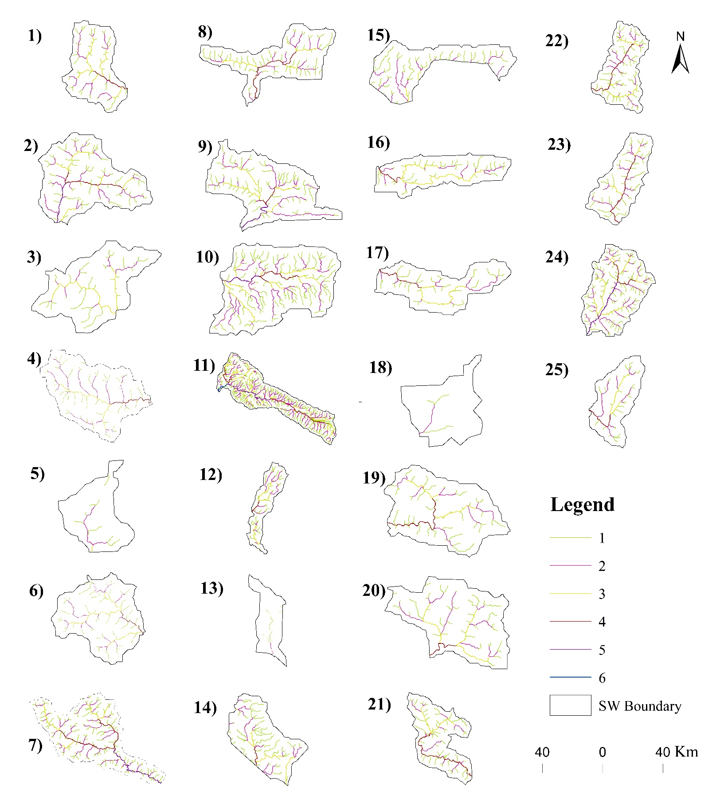Fig. 3 Stream order of sub-watersheds in the study area

***4.1.4 Bifurcation Ratio***

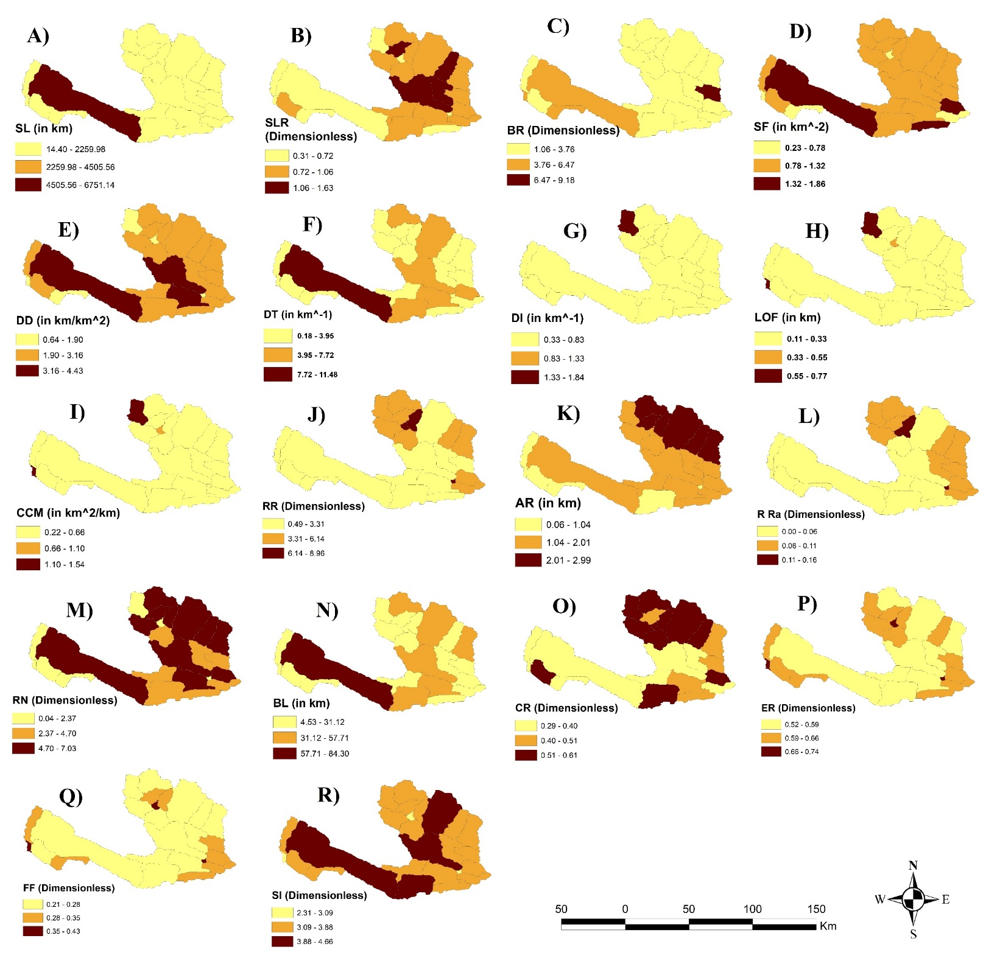A key indicator of the drainage features of the West Rapti sub-basin is the bifurcation ratio (BR), which is the proportion of one order's stream segments to the subsequent order's segments (Schumm, 1956). BR was particularly noted by Horton (1945) as a sign of relief and dissections within a watershed. The determined bifurcation ratios for the West Rapti sub-basins are shown in Table 3.

Fig. 4 Morphometric parameters- Linear (A-I), Relief (J-M), and Areal (N-R)

Table 3 Stream Order wise morphometric details of the study area

| Sub-Watershed | Stream Order | Stream Number | Stream Length | SLR | BR |
| --- | --- | --- | --- | --- | --- |
| SW1 | 1 | 112 | 50.063 | N/A | N/A |
|  | 2 | 33 | 33.037 | 0.659908515 | 3.393939394 |
|  | 3 | 66 | 29.718 | 0.899536883 | 0.5 |
|  | 4 | 15 | 9.976 | 0.335688808 | 4.4 |
|  |  | Total = 226 | 122.79 | Average = 0.63 | 2.76 |
|  |  |  |  |  |  |
| SW2 | 1 | 159 | 244.707 | N/A | N/A |
|  | 2 | 97 | 250.238 | 1.022602541 | 1.639175258 |
|  | 3 | 27 | 106.007 | 0.423624709 | 3.592592593 |
|  | 4 | 24 | 112.572 | 1.061929873 | 1.125 |
|  | 5 | 22 | 119.17 | 1.058611378 | 1.090909091 |
|  |  | Total = 329 | 832.69 | Average = 0.89 | 1.86 |
|  |  |  |  |  |  |
| SW3 | 1 | 59 | 99.061 | N/A | N/A |
|  | 2 | 23 | 58.583 | 0.591383087 | 2.565217391 |
|  | 3 | 45 | 156.85 | 2.67739788 | 0.511111111 |
|  |  | Total = 127 | 314.49 | 1.63 | 1.53 |
|  |  |  |  |  |  |
| SW4 | 1 | 93 | 157.924 | N/A | N/A |
|  | 2 | 63 | 174.025 | 1.101954105 | 1.476190476 |
|  | 3 | 39 | 135.07 | 0.776152852 | 1.615384615 |
|  | 4 | 20 | 90.5 | 0.670022951 | 1.95 |
|  |  | 215 | 557.52 | 0.85 | 1.68 |
|  |  |  |  |  |  |
| SW5 | 1 | 8 | 14.859 |  | N/A |
|  | 2 | 5 | 15.536 | 1.045561612 | 1.6 |
|  | 3 | 1 | 3.552 | 0.228630278 | 5 |
|  |  | 14 | 33.95 | 0.64 | 3.3 |
|  |  |  |  |  |  |
| SW6 | 1 | 99 | 168.201 | N/A | N/A |
|  | 2 | 43 | 116.536 | 0.692837736 | 1.443339397 |
|  | 3 | 42 | 154.259 | 1.323702547 | 0.755456732 |
|  | 4 | 19 | 83.674 | 0.542425401 | 1.84357148 |
|  |  | 203 | 522.67 | 0.85 | 1.35 |
|  |  |  |  |  |  |
| SW7 | 1 | 325 | 520.805 | N/A | N/A |
|  | 2 | 179 | 460.16 | 0.883555265 | 1.131791116 |
|  | 3 | 72 | 251.904 | 0.547426982 | 1.826727642 |
|  | 4 | 76 | 343.392 | 1.363185976 | 0.733575622 |
|  | 5 | 112 | 586.383 | 1.707619863 | 0.585610429 |
|  |  | 764 | 2162.44 | 1.13 | 1.06 |
|  |  |  |  |  |  |
| SW8 | 1 | 115 | 208.658 | N/A | N/A |
|  | 2 | 51 | 143.386 | 0.687181896 | 2.254901961 |
|  | 3 | 46 | 158.497 | 1.105386858 | 1.108695652 |
|  | 4 | 19 | 98.291 | 0.62014423 | 2.421052632 |
|  |  | 231 | 608.83 | 0.8 | 1.93 |
|  |  |  |  |  |  |
| SW9 | 1 | 183 | 293.123 | N/A | N/A |
|  | 2 | 86 | 235.008 | 0.801738519 | 2.127906977 |
|  | 3 | 105 | 348.906 | 1.484655842 | 0.819047619 |
|  | 4 | 12 | 54.697 | 0.156767152 | 8.75 |
|  | 5 | 11 | 66.65 | 1.218531181 | 1.090909091 |
|  |  | 397 | 998.38 | 0.92 | 3.19 |
|  |  |  |  |  |  |
| SW10 | 1 | 189 | 382.906 | N/A | N/A |
|  | 2 | 80 | 258.024 | 0.673857291 | 2.3625 |
|  | 3 | 76 | 279.247 | 1.082252039 | 1.052631579 |
|  | 4 | 23 | 105.739 | 0.378657604 | 3.304347826 |
|  | 5 | 17 | 95.37 | 0.90193779 | 1.352941176 |
|  |  | 385 | 1121.28 | 0.76 | 2.01 |
|  |  |  |  |  |  |
| SW11 | 1 | 1355 | 2049.129 | N/A | N/A |
|  | 2 | 967 | 2368.529 | 1.155871104 | 1.401240951 |
|  | 3 | 173 | 676.904 | 0.285790885 | 5.589595376 |
|  | 4 | 238 | 1025.937 | 1.515631463 | 0.726890756 |
|  | 5 | 108 | 584.507 | 0.569729915 | 2.203703704 |
|  | 6 | 6 | 46.136 | 0.078931476 | 18 |
|  |  | 2847 | 6751.14 | 0.72 | 5.58 |
|  |  |  |  |  |  |
| SW12 | 1 | 87 | 143.145 | N/A | N/A |
|  | 2 | 30 | 96.703 | 0.675559747 | 2.9 |
|  | 3 | 25 | 99.858 | 1.032625668 | 1.2 |
|  | 4 | 5 | 24.874 | 0.249093713 | 5 |
|  |  | 147 | 364.58 | 0.65 | 3.03 |
|  |  |  |  |  |  |
| SW13 | 1 | 4 | 10.965 | N/A | N/A |
|  | 2 | 1 | 3.436 | 0.313360693 | 4 |
|  |  | 5 | 14.4 | 0.31 | 4 |
|  |  |  |  |  |  |
| SW14 | 1 | 85 | 174.379 | N/A | N/A |
|  | 2 | 46 | 128.665 | 0.737846874 | 1.847826087 |
|  | 3 | 15 | 68.922 | 0.535670151 | 3.066666667 |
|  | 4 | 16 | 69.376 | 1.006587156 | 0.9375 |
|  |  | 162 | 441.34 | 0.76 | 1.95 |
|  |  |  |  |  |  |
| SW15 | 1 | 65 | 130.596 | N/A | N/A |
|  | 2 | 29 | 94.234 | 0.721568808 | 2.24137931 |
|  | 3 | 5 | 20.425 | 0.216747671 | 5.8 |
|  |  | 99 | 245.45 | 0.47 | 4.02 |
|  |  |  |  |  |  |
| SW16 | 1 | 114 | 163.423 | N/A | N/A |
|  | 2 | 60 | 143.345 | 0.877140917 | 1.9 |
|  | 3 | 29 | 122.514 | 0.85467927 | 2.068965517 |
|  | 4 | 8 | 39.037 | 0.318632973 | 3.625 |
|  |  | 211 | 468.32 | 0.68 | 2.53 |
|  |  |  |  |  |  |
| SW17 | 1 | 49 | 92.949 | N/A | N/A |
|  | 2 | 12 | 42.129 | 0.453248556 | 4.083333333 |
|  | 3 | 15 | 62.421 | 1.481663462 | 0.8 |
|  | 4 | 17 | 77.997 | 1.249531408 | 0.882352941 |
|  |  | 93 | 275.49 | 1.06 | 1.92 |
|  |  |  |  |  |  |
| SW18 | 1 | 6 | 8.792 | N/A | N/A |
|  | 2 | 2 | 5.621 | 0.63933121 | 3 |
|  |  | 8 | 14.41 | 0.64 | 3 |
|  |  |  |  |  |  |
| SW19 | 1 | 85 | 138.532 | N/A | N/A |
|  | 2 | 30 | 83.384 | 0.601911472 | 2.833333333 |
|  | 3 | 23 | 82.982 | 0.995178931 | 1.304347826 |
|  | 4 | 24 | 109.91 | 1.324504109 | 0.958333333 |
|  |  | 162 | 414.8 | 0.97 | 1.7 |
|  |  |  |  |  |  |
| SW20 | 1 | 86 | 133.694 | N/A | N/A |
|  | 2 | 38 | 105.448 | 0.788726495 | 2.263157895 |
|  | 3 | 49 | 169.118 | 1.603804719 | 0.775510204 |
|  | 4 | 2 | 14.324 | 0.084698258 | 24.5 |
|  |  | 175 | 422.58 | 0.82 | 9.18 |
|  |  |  |  |  |  |
| SW21 | 1 | 102 | 190.372 | N/A | N/A |
|  | 2 | 42 | 115.132 | 0.604773811 | 2.428571429 |
|  | 3 | 17 | 69.141 | 0.600536775 | 2.470588235 |
|  | 4 | 38 | 180.377 | 2.608828336 | 0.447368421 |
|  |  | 199 | 555.02 | 1.27 | 1.78 |
|  |  |  |  |  |  |
| SW22 | 1 | 145 | 248.174 | N/A | N/A |
|  | 2 | 76 | 197.281 | 0.79493017 | 1.907894737 |
|  | 3 | 39 | 143.162 | 0.725675559 | 1.948717949 |
|  | 4 | 53 | 237.564 | 1.659406826 | 0.735849057 |
|  |  | 313 | 826.18 | 1.06 | 1.53 |
|  |  |  |  |  |  |
| SW23 | 1 | 90 | 163.103 | N/A | N/A |
|  | 2 | 42 | 117.648 | 0.721311073 | 2.142857143 |
|  | 3 | 12 | 44.929 | 0.381893445 | 3.5 |
|  | 4 | 26 | 126.727 | 2.820605845 | 0.461538462 |
|  |  | 170 | 452.4 | 1.31 | 2.03 |
|  |  |  |  |  |  |
| SW24 | 1 | 293 | 493.696 | N/A | N/A |
|  | 2 | 159 | 430.749 | 0.872498461 | 1.842767296 |
|  | 3 | 65 | 254.393 | 0.590582915 | 2.446153846 |
|  | 4 | 31 | 143.836 | 0.565408639 | 2.096774194 |
|  | 5 | 26 | 155.749 | 1.082823493 | 1.192307692 |
|  |  | 574 | 1478.42 | 0.77 | 1.89 |
|  |  |  |  |  |  |
| SW25 | 1 | 45 | 73.049 | N/A | N/A |
|  | 2 | 22 | 67.949 | 0.930183849 | 2.045454545 |
|  | 3 | 14 | 55.445 | 0.815979632 | 1.571428571 |
|  | 4 | 14 | 64.231 | 1.158463342 | 1 |
|  |  | 95 | 260.67 | 0.96 | 1.54 |

For these sub-basins, the mean bifurcation ratio values vary from 1.06 (SW7) to 9.18 (SW20). Notably, watersheds with lower BR values are those where structural influences have less of an impact on drainage patterns. The differences in bifurcation ratios provide important information for comprehending the hydrological dynamics and landscape evolution in the West Rapti sub-basin, including the degree of relief and channel network complexity (Fig. 4).

***4.1.5 Stream Frequency (SF)***

Stream frequency is an important measure of the hydrological features of the West Rapti basin. It is defined as the total number of stream segments of all orders per unit area (Horton, 1932). Low stream frequency values are indicative of low relief and permeable subsurface material, according to Reddy et al. (2004). Although it is inherently challenging to count the number of channel segments per unit area (Singh, 1980), an attempt has been made to determine the West Rapti basin's stream frequency, as shown in Table 2. Low to medium stream frequencies and, consequently, low to moderate runoff in the sub-basins are indicated by the values obtained, which range from 0.24 in SW13 to 1.87 in SW11 (Fig. 4). Interestingly, there is a positive correlation between the stream frequency and drainage density values, indicating that the stream population is growing as the drainage density is rising. The interplay between these two factors provides important information about the hydrological dynamics and potential runoff in the various sub-basins that make up the West Rapti River basin.

***4.1.6 Drainage Density (DD)***

According to Strahler (1964), drainage density is a crucial metric that indicates the overall length of a stream in a basin in relation to its total area. Numerous factors, including vegetation, surface roughness, runoff, permeability, rock type, relief, and climate, all affect the density coefficient. Surface runoff is directly shaped by the type and amount of precipitation; heavy rainfall, especially in regions that are prone to thunderstorms, increases the ratio of rainfall to runoff and thus creates more surface drainage channels. Nag (1998) states that while high drainage densities are suggestive of weak or impervious subsoil materials, sparse vegetation, and undulating mountainous terrain, low drainage densities are frequently associated with highly resistant or permeable subsoil materials, dense vegetation, and shallow relief (Suresh & Krishnan, 2022). The drainage density values in the current study (Table 2 & Fig. 4) range from 0.65 in SW1 to 4.43 in the sub-water basin SW11, reflecting the study area's varied topography, which includes both flat and mountainous terrain. The present analysis enhances our comprehension of the intricate hydrological features and topographical disparities present in the West Rapti River basin.

***4.1.7 Drainage Texture (DT)***

The relative spacing of drainage lines within a given area is referred to as drainage texture, which is an important concept in geomorphology. When compared to permeable areas, impermeable areas usually have a greater density of drainage lines. According to Horton's definition (1945), drainage texture is represented by the symbol DT in this study and is the total number of stream segments of all orders per unit perimeter of the area. Put more simply, it depicts the concentration of streams around the catchment's edge. The drainage texture in the West Rapti basin varies between sub-basins, with a maximum value of 11.49 at SW11 and a minimum value of 0.19 at SW13 (Table 2 & Fig. 4). This variation in drainage texture adds to our understanding of the geomorphic features of the West Rapti River basin by illuminating the spatial distribution of stream segments and their interactions with the surrounding terrain.

***4.1.8 Drainage Intensity (DI)***

The relationship between stream frequency and drainage density is known as drainage intensity. In this study, it is indicated by DI. Table 2 and Figure 4 illustrate the study's drainage intensity, which is higher in SW1 (1.84) and lower at SW10 (0.34).

***4.1.9 Length of Overland Flow (LOF)***

Horton (1945) defined the length of overland flow (LOF) as the distance that water moves across the ground before coming together to form separate stream channels. Signified by LOF, this parameter is important for evaluating surface runoff dynamics. While lower values indicate shorter surface runoff, higher values of LOF suggest greater surface runoff. LOF is similar to the length of sheet flow and is inversely correlated with the average slope of the channel. The LOF values for the West Rapti sub-basin are 0.11 in SW11 to 0.77 in SW1, as shown in Table 2 and Fig. 4. Interestingly, the overland flow length is longer in SW1 and shorter in SW11, revealing differences in surface runoff and topographical features within the sub-basins of the West Rapti River basin.

***4.1.10 Constant of Channel Maintenance (CCM)***

The quantity of catchment surface units required to sustain one unit of route length is specified by this property. Put another way, it's the quantity of catchment surface area in square kilometers needed to sustain a single linear kilometer of stream segment. It was described as the drainage density in reverse, or the channel maintenance constant. The ongoing upkeep of a channel has a particular genetic significance and reveals the proportional dimensions of the landform units within a drainage basin (Strahler, 1957). According to the results of the present investigation, SW1 has a higher channel maintenance constant (1.55), while SW11 has a lower constant (0.24). The average channel maintenance constant for the study area is 0.50 (Table 2 & Fig. 4).

**4.2 Relief Aspects**

***4.2.1 Relative Relief (RR)***

The definition of relative relief, also known as "local relief" or "amplitude of available relief," is the height difference between the highest and lowest points (height) within a unit area. The relief ratio in this study (Table 2 & Fig. 4) has a lower value of 0.49 at SW11 and a higher value of 8.97 at SW5. According to the computed RR values, the study area's relief varies from low to higher.

***4.2.2 Absolute Relief (AR)***

This is yet another crucial morphometric analysis parameter. Its definition is the height difference in a unit area between the highest and lowest points. According to Table 2 and Figure 4, the absolute height of the West Rapti basin ranges from 0.07 (in km) at SW13 to 3.0 at SW23. The computed values demonstrate that the study area's absolute relief ranges from plain to mountainous terrain.

***4.2.3 Relief Ratio (R Ra)***

The term "total relief" refers to the difference in elevation between a river basin's highest point and lowest point on the valley floor. It is a dimensionless height-length ratio that is equal to the tangent of the angle formed at the basin's mouth by two planes that intersect-one of which represents the horizontal and the other goes through the basin's highest point. When a drainage basin's size and drainage area decrease, the R Ra typically rises as well. The relief ratio, represented by R Ra (Table 2 & Fig. 4), is defined as the ratio of the maximum catchment relief to the minimum catchment length that is parallel to the primary catchment line. In this study, the higher value of the relief ratio is at SW5 (0.17) and the lower value of the relief ratio is at SW11, SW13 and SW14 (0.01).

***4.2.4 Ruggedness Number (RN)***

The ruggedness ratio (RN) is a metric used to measure surface roughness or unevenness within a given geographic area. This measure, which combines maximum catchment relief and drainage density, sheds light on the region's complex topography. In order to integrate slope steepness with its length, Strahler (1964) defines ruggedness number as the product of basin relief and drainage density. Rigidity values that are abnormally high suggest a combination of high drainage density and steep slopes. On the other hand, a watershed with a low ruggedness value is thought to be less prone to soil erosion and to have inherent structural complexity in relation to drainage density and relief. With the lowest value recorded at SW13 (0.05) and the highest at SW24 (7.03), the current study provides a nuanced understanding of the varying topographic ruggedness within the sub-basins of the West Rapti River basin (Table 2 & Fig. 4).

**4.3 Areal/Shape Aspects**

***4.3.1 Basin Length (BL)***

The major dimension among the essential parameters of the major drainage channel is the watershed length i.e. Basin Length (Table 2 & Fig. 4). It is denoted by BL. In the current research, the longest length of the sub-watersheds is at SW11 (84.31 km), while the shortest is at SW18 (4.53 km).

***4.3.2 Circulatory Ratio (CR)***

The ratio of the basin's area to the area of a circle whose perimeter is equal to the basin is known as the circularity ratio, which is an important metric in watershed analysis (Miller, 1953). This ratio is an important measure of the dendritic stage of a watershed, and it is largely determined by the relief structure and varied slope of the watershed. The circularity ratio is influenced by a number of variables, such as stream length and frequency, geological structure, land use and cover, climate, undulations, and basin slope. According to Wilson et al. (2012), the young, mature, and old stages of a tributary watershed's life cycle are represented by low, medium, and high CR values. Circularity ratios in the West Rapti sub-watersheds under investigation range from 0.30 at SW12 to 0.62 at SW19 (Table 2 & Fig. 4), showing that every sub-basin has a structurally controlled drainage system and a circular shape with varying degrees of high to moderate relief. A basin that closely resembles a circle has a circularity ratio closer to 1. The West Rapti River basin sub-watersheds' morphological traits and evolutionary stages are better understood thanks to this analysis.

***4.3.3 Elongation Ratio (ER)***

A river basin's shape can be determined by measuring its elongation ratio (ER), which is the ratio of the drainage basin's maximum length to the diameter of a circle with the same area. When it comes to runoff discharge, a circular basin performs better than an elongated one. ER values normally fall between 0.6 and 1.0, with values near 1.0 being connected to areas with extremely low relief and values between 0.6 and 0.8 being connected to areas with high relief and steep ground slopes. These values fall into three categories: less elongated (0.8-0.7), oval (0.9-0.8), and circular (>0.9). The estimated and displayed ER values in Table 2 and Fig. 4 for the West Rapti sub-basin range from 0.52 to 0.74. According to Reddy et al. (2004), this suggests that the sub-basins have a moderate susceptibility to erosion and sediment load. Notably, in this investigation, SW11 (0.52) shows a lower elongation ratio and SW18 (0.74) a higher one.

***4.3.4 Form Factor (FF)***

The form factor (FF), as defined by Horton (1932), represents the ratio of the basin area to the square of the basin length. For a perfectly circular basin, the form factor value is 0.7854 (Strahler, 1964). Form factor values, as shown in Table 2 and Fig. 4, fall between 0.21 and 0.43 in the study area. Interestingly, these values are not always greater than 0.7854, suggesting that the basins are not round. Higher form factor values are associated with basins that have high peak flows for shorter periods of time, while lower form factor values indicate flatter peak flows for longer periods of time. In the current investigation, SW18 shows a higher form factor, suggesting a more elongated basin shape, while SW11 shows a lower form factor, suggesting a more circular basin shape. A more sophisticated knowledge of the hydrological traits and flow dynamics in the sub-watersheds of the West Rapti River basin is made possible by these form factor values.

***4.3.5 Shape Index (SI)***

The shape index is the reciprocal of the form factor. It was first proposed by Horton. It is denoted by the symbol SI (Table 2 & Fig. 4). In this research, SW11 (4.66) has a higher shape index and SW18 (2.32) has a lower shape index

**4.4 Morphometric sub-watershed prioritization and ranking**

After assigning a ranking based on each parameter, the ranking values for all twenty-five sub-water sheds were averaged to arrive at a Mean Composite Score (MCS). Table 4 shows the results of ranking for all twenty-five sub-watersheds. Sub-watershed 1 has a compound value of 9.88 if all the ranks in SW1 are added together and divided by 17 characteristics. The procedure has been repeated for other sub-watersheds (from SW2 to SW25) and presented in Table 4.

Table 4 Sub-watershed wise rank of parameters and Mean Composite Score

|  |  |  |  |  |  |  |  |  |  |  |  |  |  |  |  |  |  |  |  |
| --- | --- | --- | --- | --- | --- | --- | --- | --- | --- | --- | --- | --- | --- | --- | --- | --- | --- | --- | --- |
| SW | SLR | BR | SF | DD | DT | DI | LOF | CCM | RR | AR | R Ra | RN | BL | CR | ER | FF | SI | MCS | Rank |
| 1 | 23 | 9 | 6 | 25 | 9 | 1 | 1 | 1 | 7 | 12 | 13 | 1 | 13 | 20 | 13 | 13 | 1 | 9.88 | 3 |
| 2 | 10 | 17 | 7 | 5 | 5 | 12 | 21 | 2 | 6 | 5 | 10 | 2 | 19 | 19 | 7 | 7 | 2 | 9.18 | 1 |
| 3 | 1 | 22 | 10 | 12 | 18 | 8 | 14 | 3 | 4 | 6 | 4 | 3 | 5 | 11 | 21 | 21 | 3 | 9.76 | 2 |
| 4 | 11 | 20 | 12 | 11 | 10 | 15 | 15 | 4 | 8 | 7 | 9 | 4 | 15 | 22 | 11 | 11 | 4 | 11.12 | 6 |
| 5 | 21 | 5 | 24 | 23 | 23 | 7 | 3 | 5 | 1 | 17 | 1 | 5 | 3 | 15 | 23 | 23 | 5 | 12.00 | 8 |
| 6 | 12 | 24 | 11 | 10 | 11 | 13 | 16 | 6 | 11 | 13 | 15 | 6 | 14 | 24 | 12 | 12 | 6 | 12.71 | 11 |
| 7 | 4 | 25 | 5 | 2 | 2 | 22 | 24 | 7 | 19 | 11 | 20 | 7 | 23 | 5 | 3 | 3 | 7 | 11.12 | 7 |
| 8 | 14 | 14 | 14 | 13 | 16 | 16 | 13 | 8 | 18 | 15 | 16 | 8 | 18 | 3 | 8 | 8 | 8 | 12.35 | 9 |
| 9 | 9 | 6 | 4 | 3 | 6 | 11 | 23 | 9 | 17 | 14 | 18 | 9 | 21 | 9 | 5 | 5 | 9 | 10.47 | 4 |
| 10 | 16 | 12 | 13 | 6 | 7 | 24 | 20 | 10 | 21 | 20 | 22 | 10 | 22 | 18 | 4 | 4 | 10 | 14.06 | 17 |
| 11 | 18 | 2 | 1 | 1 | 1 | 5 | 25 | 11 | 25 | 18 | 23 | 11 | 25 | 2 | 1 | 1 | 11 | 10.65 | 5 |
| 12 | 20 | 7 | 15 | 17 | 20 | 10 | 9 | 12 | 20 | 21 | 19 | 12 | 11 | 1 | 15 | 15 | 12 | 13.88 | 16 |
| 13 | 25 | 4 | 25 | 24 | 25 | 23 | 2 | 13 | 24 | 25 | 25 | 13 | 2 | 6 | 24 | 24 | 13 | 17.47 | 25 |
| 14 | 17 | 13 | 18 | 15 | 14 | 19 | 11 | 14 | 23 | 24 | 24 | 14 | 12 | 23 | 14 | 14 | 14 | 16.65 | 24 |
| 15 | 24 | 3 | 23 | 21 | 22 | 9 | 5 | 15 | 22 | 23 | 21 | 15 | 7 | 4 | 19 | 19 | 15 | 15.71 | 23 |
| 16 | 19 | 10 | 3 | 4 | 12 | 4 | 22 | 16 | 16 | 19 | 17 | 16 | 9 | 10 | 17 | 17 | 16 | 13.35 | 15 |
| 17 | 5 | 15 | 22 | 20 | 21 | 25 | 6 | 17 | 12 | 8 | 6 | 17 | 6 | 8 | 20 | 20 | 17 | 14.41 | 20 |
| 18 | 22 | 8 | 17 | 22 | 24 | 3 | 4 | 18 | 2 | 22 | 2 | 18 | 1 | 13 | 25 | 25 | 18 | 14.35 | 19 |
| 19 | 7 | 19 | 2 | 7 | 4 | 2 | 19 | 19 | 9 | 9 | 7 | 19 | 8 | 25 | 18 | 18 | 19 | 12.41 | 10 |
| 20 | 13 | 1 | 8 | 9 | 13 | 6 | 17 | 20 | 13 | 16 | 12 | 20 | 10 | 14 | 16 | 16 | 20 | 13.18 | 13 |
| 21 | 3 | 18 | 19 | 14 | 17 | 21 | 12 | 21 | 15 | 10 | 11 | 21 | 17 | 7 | 9 | 9 | 21 | 14.41 | 21 |
| 22 | 6 | 23 | 9 | 8 | 8 | 17 | 18 | 22 | 10 | 4 | 8 | 22 | 20 | 12 | 6 | 6 | 22 | 13.00 | 12 |
| 23 | 2 | 11 | 21 | 19 | 15 | 18 | 7 | 23 | 5 | 2 | 5 | 23 | 16 | 16 | 10 | 10 | 23 | 13.29 | 14 |
| 24 | 15 | 16 | 16 | 16 | 3 | 14 | 10 | 24 | 14 | 1 | 14 | 24 | 24 | 21 | 2 | 2 | 24 | 14.12 | 18 |
| 25 | 8 | 21 | 20 | 18 | 19 | 20 | 8 | 25 | 3 | 3 | 3 | 25 | 4 | 17 | 22 | 22 | 25 | 15.47 | 22 |

Based on the values of mean composite score (MCS), among 25 sub-watersheds of the West Rapti basin, SW1, SW2, SW3, SW9, and SW11 are falling within very high priority; SW4, SW5, SW7, SW8, and SW19 fall within high priority; SW6, SW16, SW20, SW22 and SW23 fall within medium priority; SW10, SW12, SW17, SW18, and SW24 fall under low priority; and SW13, SW14, SW15, SW21, and SW25 fall under very low priority. This means that the sub-watersheds with the highest priority have the greatest danger of runoff, peak flow, and soil erosion risk (Javed et al., 2009). The final priority map of sub-watersheds in the West Rapti catchment is shown in Table & Fig. 7. SW1, SW2, SW3, SW9, and SW11 are the most vulnerable sub-watersheds to land degradation, and they are more vulnerable to soil erosion and runoff. As a result, the findings will help in better planning and the management of the West Rapti catchment (Bhat et al., 2023).

**4.5 Land Use/Land Cover (LULC) analysis**

Prioritization of LULC of sub-watersheds was based on LULC data of the year 2022 from Sentinel-2 imagery. LULC has a resolution of 10 m. LULC categories include eight primary classes such as grass, flooded vegetation, water, trees, crops, scrub/shrub, built-up area, and bare ground. Figure 5 depicts the LULC map of the research area. Table 5 shows the details of the various LULC categories. The results of the LULC analysis-based prioritizing showed that the SW5, SW12, SW14, SW16 and SW18 sub-watersheds are of very high priority

The following classes are the LULC criteria that were considered for prioritizing sub-watersheds.

***4.5.1 Trees***

SW18 has the highest percentage of land with trees (94.75%), while SW13 has the lowest percentage of trees (19.25%). Sub-watersheds with a smaller percentage of trees have been given a high rank, while those with a higher percentage of trees have been given a low rank (Table 6).

Table 5 Sub-watersheds wise LULC categories in the study area

|  |  |  |  |  |  |  |  |  |  |  |  |  |  |  |  |  |  |  |  |  |  |  |  |  |  |
| --- | --- | --- | --- | --- | --- | --- | --- | --- | --- | --- | --- | --- | --- | --- | --- | --- | --- | --- | --- | --- | --- | --- | --- | --- | --- |
| LULC Category | SW1 | SW2 | SW3 | SW4 | SW5 | SW6 | SW7 | SW8 | SW9 | SW  10 | SW  11 | SW  12 | SW  13 | SW  14 | SW  15 | SW  16 | SW  17 | SW  18 | SW  19 | SW  20 | SW  21 | SW  22 | SW  23 | SW  24 | SW  25 |
| Water | 0.01 | 0.00 | 0.05 | 0.04 | 0.21 | 0.89 | 4.12 | 0.56 | 2.86 | 4.62 | 22.14 | 0.31 | 0.00 | 4.76 | 0.00 | 0.71 | 0.19 | 0.26 | 0.86 | 0.06 | 2.00 | 0.42 | 0.14 | 0.39 | 0.01 |
| Tree | 110.49 | 162.08 | 84.97 | 143.45 | 16.16 | 150.63 | 434.70 | 206.54 | 249.05 | 226.70 | 1277.69 | 107.57 | 4.01 | 88.45 | 102.71 | 136.57 | 105.76 | 8.39 | 114.56 | 93.24 | 155.55 | 149.92 | 138.54 | 396.91 | 80.36 |
| Marshland | 0.00 | 0.00 | 0.00 | 0.00 | 0.00 | 0.00 | 0.00 | 0.00 | 0.00 | 0.00 | 0.01 | 0.00 | 0.00 | 0.00 | 0.00 | 0.00 | 0.00 | 0.00 | 0.00 | 0.00 | 0.00 | 0.00 | 0.00 | 0.00 | 0.00 |
| Agriculture Crops | 0.04 | 0.02 | 0.30 | 4.76 | 0.03 | 2.61 | 13.17 | 3.34 | 7.92 | 99.94 | 111.38 | 35.18 | 14.31 | 68.19 | 27.93 | 0.75 | 0.20 | 0.00 | 0.24 | 0.15 | 6.91 | 0.12 | 0.10 | 2.86 | 0.28 |
| Built-up Area | 0.97 | 0.68 | 2.08 | 4.46 | 0.18 | 2.22 | 6.92 | 4.20 | 4.91 | 26.97 | 20.18 | 13.73 | 2.42 | 7.89 | 2.03 | 1.28 | 1.09 | 0.00 | 2.04 | 0.97 | 9.07 | 1.94 | 0.89 | 5.10 | 2.46 |
| Bare Ground | 0.00 | 0.00 | 0.00 | 0.00 | 0.01 | 0.01 | 1.03 | 0.96 | 2.70 | 8.55 | 14.97 | 0.08 | 0.00 | 2.98 | 0.01 | 1.53 | 0.06 | 0.05 | 0.00 | 0.05 | 1.24 | 0.43 | 0.04 | 0.27 | 0.00 |
| Grassland | 78.68 | 117.88 | 34.12 | 55.67 | 7.61 | 38.47 | 119.54 | 23.14 | 32.75 | 30.38 | 77.45 | 1.47 | 0.09 | 14.56 | 14.37 | 9.42 | 26.29 | 0.16 | 29.91 | 61.64 | 54.92 | 143.32 | 77.16 | 224.10 | 30.28 |
| Total Area | 190.19 | 280.67 | 121.53 | 208.38 | 24.20 | 194.82 | 579.48 | 238.74 | 300.19 | 397.16 | 1523.82 | 158.34 | 20.83 | 186.82 | 147.05 | 150.25 | 133.59 | 8.85 | 147.60 | 156.11 | 229.69 | 296.15 | 216.88 | 629.63 | 113.40 |
| Water | 0.01 | 0.00 | 0.04 | 0.02 | 0.86 | 0.45 | 0.71 | 0.23 | 0.95 | 1.16 | 1.45 | 0.20 | 0.01 | 2.55 | 0.00 | 0.47 | 0.14 | 2.90 | 0.58 | 0.04 | 0.87 | 0.14 | 0.06 | 0.06 | 0.01 |
| Tree | 58.10 | 57.75 | 69.92 | 68.84 | 66.80 | 77.29 | 75.02 | 86.51 | 82.96 | 57.08 | 83.85 | 67.94 | 19.25 | 47.34 | 69.85 | 90.89 | 79.17 | 94.75 | 77.61 | 59.73 | 67.72 | 50.62 | 63.88 | 63.04 | 70.86 |
| Marshland | 0.00 | 0.00 | 0.00 | 0.00 | 0.00 | 0.00 | 0.00 | 0.00 | 0.00 | 0.00 | 0.00 | 0.00 | 0.00 | 0.00 | 0.00 | 0.00 | 0.00 | 0.00 | 0.00 | 0.00 | 0.00 | 0.00 | 0.00 | 0.00 | 0.00 |
| Agriculture Crops | 0.02 | 0.01 | 0.25 | 2.28 | 0.11 | 1.34 | 2.27 | 1.40 | 2.64 | 25.16 | 7.31 | 22.22 | 68.69 | 36.50 | 18.99 | 0.50 | 0.15 | 0.00 | 0.16 | 0.09 | 3.01 | 0.04 | 0.05 | 0.45 | 0.25 |
| Built-up Area | 0.51 | 0.24 | 1.71 | 2.14 | 0.74 | 1.14 | 1.19 | 1.76 | 1.63 | 6.79 | 1.32 | 8.67 | 11.64 | 4.23 | 1.38 | 0.85 | 0.82 | 0.00 | 1.38 | 0.62 | 3.95 | 0.65 | 0.41 | 0.81 | 2.17 |
| Bare Ground | 0.00 | 0.00 | 0.00 | 0.00 | 0.05 | 0.00 | 0.18 | 0.40 | 0.90 | 2.15 | 0.98 | 0.05 | 0.00 | 1.60 | 0.01 | 1.02 | 0.05 | 0.60 | 0.00 | 0.03 | 0.54 | 0.15 | 0.02 | 0.04 | 0.00 |
| Grassland | 41.37 | 42.00 | 28.08 | 26.72 | 31.45 | 19.74 | 20.63 | 9.69 | 10.91 | 7.65 | 5.08 | 0.93 | 0.42 | 7.79 | 9.77 | 6.27 | 19.68 | 1.78 | 20.26 | 39.49 | 23.91 | 48.39 | 35.58 | 35.59 | 26.71 |
| Total Area (%) | 100.00 | 100.00 | 100.00 | 100.00 | 100.00 | 100.00 | 100.00 | 100.00 | 100.00 | 100.00 | 100.00 | 100.00 | 100.00 | 100.00 | 100.00 | 100.00 | 100.00 | 100.00 | 100.00 | 100.00 | 100.00 | 100.00 | 100.00 | 100.00 | 100.00 |

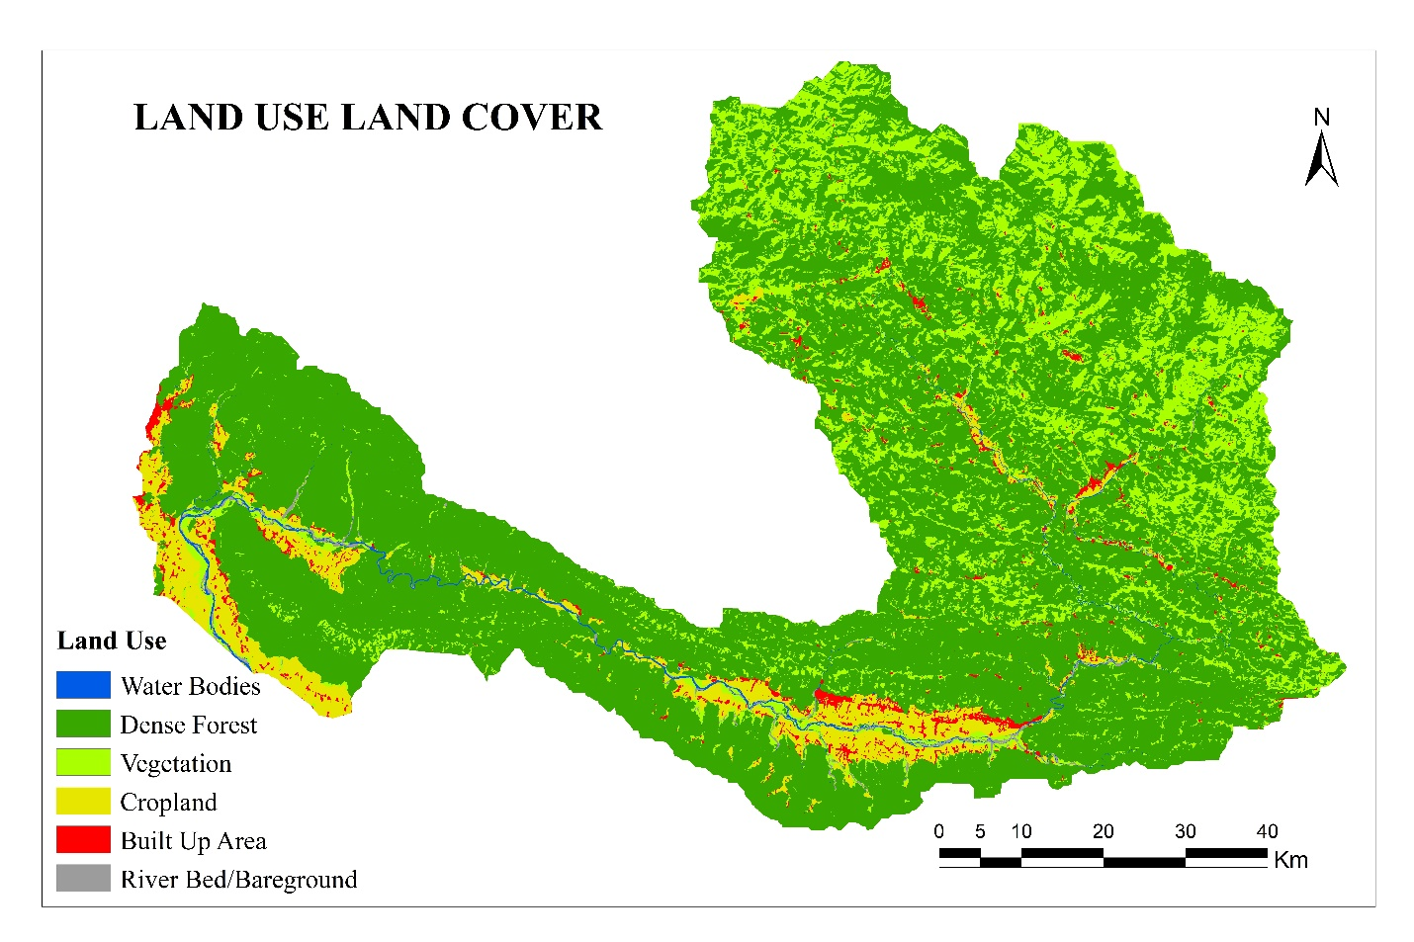

Fig. 5 different land use found in the study area

Table 6 Sub-watershed wise Rank and Composite Score in case of LULC

|  |  |  |  |  |  |  |  |
| --- | --- | --- | --- | --- | --- | --- | --- |
| SW | Trees | Agriculture Land | Built-up Area | Bare Ground | Rangeland | Composite | Rank |
| 1 | 11 | 4 | 20 | 20 | 21 | 15.2 | 20 |
| 2 | 19 | 2 | 23 | 23 | 22 | 17.8 | 25 |
| 3 | 5 | 11 | 14 | 19 | 14 | 12.6 | 12 |
| 4 | 15 | 16 | 9 | 24 | 17 | 16.2 | 24 |
| 5 | 3 | 3 | 24 | 16 | 4 | 10 | 4 |
| 6 | 17 | 13 | 13 | 18 | 15 | 15.2 | 21 |
| 7 | 24 | 19 | 6 | 7 | 23 | 15.8 | 22 |
| 8 | 20 | 15 | 10 | 8 | 8 | 12.2 | 10 |
| 9 | 22 | 18 | 8 | 4 | 13 | 13 | 13 |
| 10 | 21 | 24 | 1 | 2 | 12 | 12 | 9 |
| 11 | 25 | 25 | 2 | 1 | 20 | 14.6 | 18 |
| 12 | 10 | 22 | 3 | 11 | 3 | 9.8 | 3 |
| 13 | 1 | 20 | 12 | 25 | 1 | 11.8 | 8 |
| 14 | 6 | 23 | 5 | 3 | 7 | 8.8 | 2 |
| 15 | 8 | 21 | 16 | 17 | 6 | 13.6 | 15 |
| 16 | 13 | 12 | 18 | 5 | 5 | 10.6 | 5 |
| 17 | 9 | 8 | 19 | 12 | 9 | 11.4 | 6 |
| 18 | 2 | 1 | 25 | 13 | 2 | 8.6 | 1 |
| 19 | 12 | 9 | 15 | 22 | 10 | 13.6 | 16 |
| 20 | 7 | 7 | 21 | 14 | 18 | 13.4 | 14 |
| 21 | 18 | 17 | 4 | 6 | 16 | 12.2 | 11 |
| 22 | 16 | 6 | 17 | 9 | 24 | 14.4 | 17 |
| 23 | 14 | 5 | 22 | 15 | 19 | 15 | 19 |
| 24 | 23 | 14 | 7 | 10 | 25 | 15.8 | 23 |
| 25 | 4 | 10 | 11 | 21 | 11 | 11.4 | 7 |

***4.5.2 Agricultural Crops***

SW13 has the highest percentage of land with agricultural crops (68.69%), while SW2 has the lowest percentage of crops (0.01%). Sub-watersheds with a small percentage of crops were given a high rank, while those with a high percentage of crops were given a low rank (Table 6).

***4.5.3 Built‑up area***

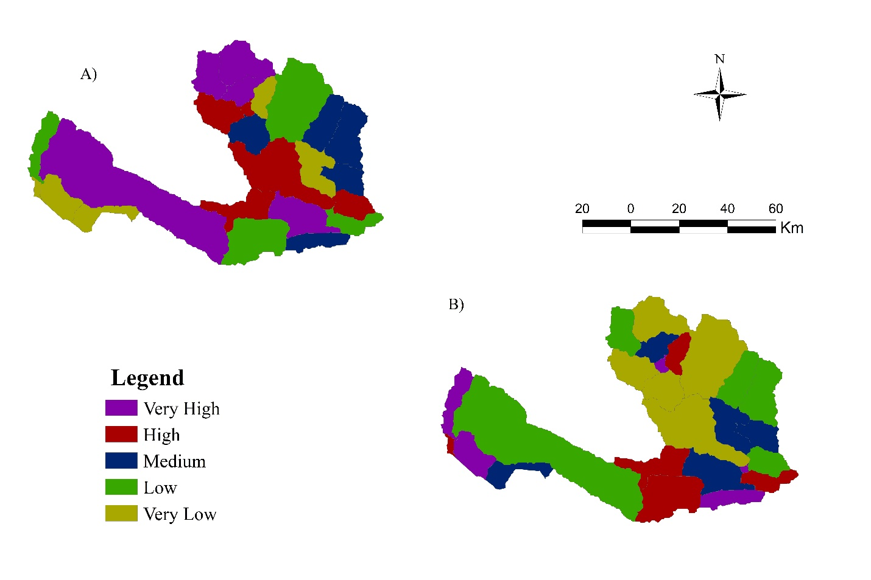SW13 has the highest percentage of land with the built-up area (11.64%), while SW18 has the lowest percentage of built-up area (0.00%). Sub-watersheds with a larger percentage of theconstructed area have a low rank, while sub-watersheds with a smaller percentage of the built-up area have a high rank (Table 6).

Fig. 6 Prioritization and ranking of sub-watersheds in A) Morphometric parameters and B) Land use

Fig. 6 A) is depicting the priority categories of sub-watersheds in the West Rapti river basin based upon composite rank (CR) of morphometry and Fig. 6 B) is demonstrating the ranking categories of sub-watersheds based on CR of land use. All the sub-watersheds have been prioritized and ranked into five categories in the study area.

***4.5.4 Grassland***

SW22 has the highest percentage of grassland (48.39%), while SW13 has the lowest percentage of scrub (0.42%). Sub-watersheds with a lower percentage of grassland have a high rank, whereas those with a larger percentage of grassland have a low rank (Table 6).

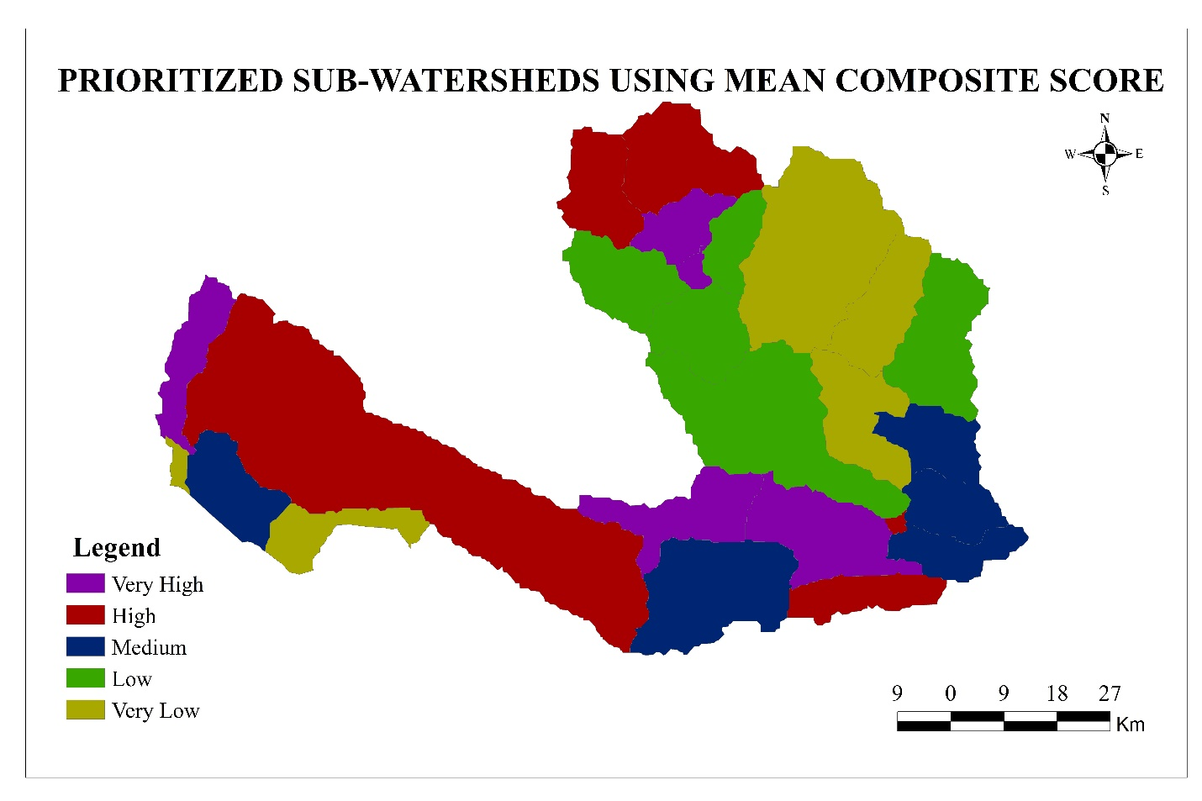

Fig. 7 final prioritization of sub-watersheds for their management

Table 7 Final Ranking ofSub-watersheds in the study area

|  |  |  |  |  |
| --- | --- | --- | --- | --- |
| SW | CR(Land) | CR(M) | Composite Value | Rank |
| 1 | 20 | 3 | 11.5 | 8 |
| 2 | 25 | 1 | 13 | 10 |
| 3 | 12 | 2 | 7 | 2 |
| 4 | 24 | 6 | 15 | 19 |
| 5 | 4 | 8 | 6 | 1 |
| 6 | 21 | 11 | 16 | 20 |
| 7 | 22 | 7 | 14.5 | 16 |
| 8 | 10 | 9 | 9.5 | 4 |
| 9 | 13 | 4 | 8.5 | 3 |
| 10 | 9 | 17 | 13 | 11 |
| 11 | 18 | 5 | 11.5 | 9 |
| 12 | 3 | 16 | 9.5 | 5 |
| 13 | 8 | 25 | 16.5 | 22 |
| 14 | 2 | 24 | 13 | 12 |
| 15 | 15 | 23 | 19 | 24 |
| 16 | 5 | 15 | 10 | 6 |
| 17 | 6 | 20 | 13 | 13 |
| 18 | 1 | 19 | 10 | 7 |
| 19 | 16 | 10 | 13 | 14 |
| 20 | 14 | 13 | 13.5 | 15 |
| 21 | 11 | 21 | 16 | 21 |
| 22 | 17 | 12 | 14.5 | 17 |
| 23 | 19 | 14 | 16.5 | 23 |
| 24 | 23 | 18 | 20.5 | 25 |
| 25 | 7 | 22 | 14.5 | 18 |

Fig. **7** demonstrates the final ranking of all sub-watersheds of the West Rapti basin which has been computed based on composite value determined from the composite rank of morphometry and land. A mean composite score inculcating morphometric parameters and LULC was computed ranging from 6 to 16.5. The results showed that the sub-watersheds designated as SW3, SW5, SW8, SW9, and SW12 were highly prioritized. These sub-watersheds are the most susceptible to runoff and soil erosion as well as land degradation whereas SW13, SW15, SW21, SW23, and SW24 were found to be in very low category.

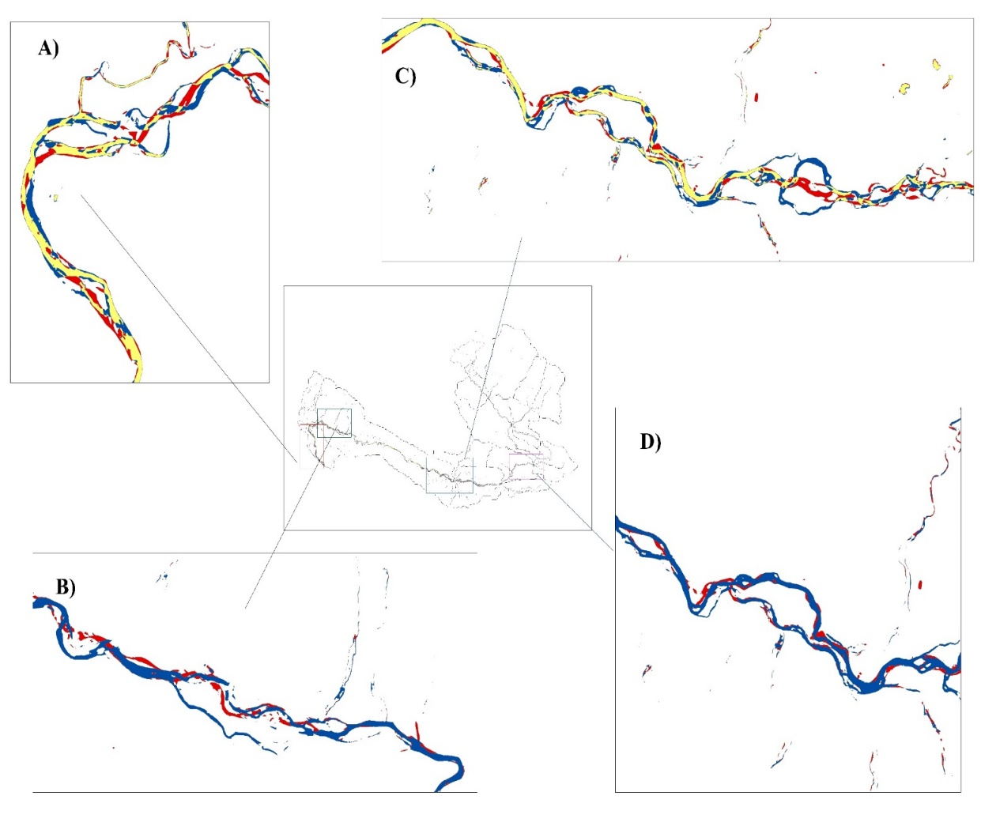

Fig.8 Erosion and accretion of river course

The analysis of five year data (2017-2022) of the West Rapti river basin demonstrated that the river course has changed over the time. In the year 2017, the total area of the river course was found 47.8 sq. km. which was seen to be decreased to 45.5 sq. km. in the year 2022 and the unchanged area was 30.3 sq. km. While analyzing the erosion and accretion of the river course, the West Rapti River is affecting 17.6 sq. km. area to erosion and 15. 2 sq. km. area to accretion mostly at the river’s syntaxial bends and southern parts of the watersheds as shown in Fig. 8.

**CONCLUSION**

GIS and remote sensing approaches have been used for morphometric and LULC research over the West Rapti catchment area of Nepal. Seventeen parameters of morphometric and six parameters of LULC have been calculated and scientifically analyzed in this study. The results of morphometric analysis-based prioritization showed that the SW1, SW2, SW3, SW9, and SW11 sub-watersheds are of very high priority. The results of the LULC analysis-based prioritizing showed that SW5, SW12, SW14, SW16 and SW18 sub-watersheds are of very high priority. Comparing morphometric and LULC analysis, the common sub-watersheds falling within very high priority are SW3, SW5, SW8, SW9, and SW12 which are found to be the most vulnerable sub-watersheds to land degradation, and they are more vulnerable to soil erosion and runoff. Whereas SW13, SW15, SW21, SW23, and SW24 were found to be in very low category. The analysis of West Rapti river basin demonstrated that the total area of the river has got declined and mostly erosion and accretion process are found to be active at the river’s syntaxial bends and southern parts of the watersheds. The deployment of soil and water conservation measures may be conducted in the very high and high-priority sub-watersheds. As a result, effective land and water management strategies should be planned for each sub-watershed based on their sensitivity rankings. Hence, this analysis will improve living standard of people in the watershed or river basin by making appropriate plan for watershed management. Therefore, the findings are directing towards the need for future planning to minimize soil erosion and to conserve the land and water resources within the West Rapti catchment.

**Disclaimer (Artificial intelligence)**

Option 1:

Author(s) hereby declare that NO generative AI technologies such as Large Language Models (ChatGPT, COPILOT, etc.) and text-to-image generators have been used during the writing or editing of this manuscript.

Option 2:

Author(s) hereby declare that generative AI technologies such as Large Language Models, etc. have been used during the writing or editing of manuscripts. This explanation will include the name, version, model, and source of the generative AI technology and as well as all input prompts provided to the generative AI technology

Details of the AI usage are given below:

1.

2.

3.

**REFERENCES**

Bhat , A. G., Paradkar , V., Aishwarya M. S., Balley, P., & Rema K. P. (2023). Geospatial Analysis of Kurumanpuzha Sub Watershed in the Chaliyar River Basin: A Remote Sensing and GIS Approach for Geomorphological Assessment. Journal of Experimental Agriculture International, 45(11), 9–21. https://doi.org/10.9734/jeai/2023/v45i112230

Bhattarai, T. N., & Ghimire, S. (2023). Flood susceptibility analysis in west rapti river basin using frequency ratio model. Jalawaayu, 3(1), 1-24.

Bogati, R., Kharel, B. P., Shrestha, B., & Das. (1997). Guidelines and methodology for sub-watershed prioritization in watershed management planning. Nepal: Kathmandu.

Clarke, J. I. (1996). Morphometry from maps. Essays in geomorphology. New York: Elsevier Publ. Co., 235–274.

Desta, L., Carucci, V., Wendem-Agenehu, A., & Abebe, Y. (2005). Community-based participatory watershed development. a guideline. annex.

Dingman, S. L. (2015). *Physical hydrology*. Waveland press.

DSCWM. (2016). Sub-watershed planning guideline. Department of Soil Conservation and Watershed.

Ghimire, M., Timalsina, N., & Zhao, W. (2023). A Geographical approach of watershed prioritization in the Himalayas: a case study in the middle mountain district of Nepal. *Environment, Development and Sustainability*, 1-34.

Hajam, R. A., Hamid, A., & Bhat, S. (2013). Application of morphometric analysis for geo-hydrological studies using geo-spatial technology–a case study of Vishav Drainage Basin. *Hydrology Current Research*, *4*(3), 1-12.

Horton, R. E. (1932). Drainage-basin characteristics. *Transactions, American geophysical union*, *13*(1), 350-361.

Horton, R. E. (1945). Erosional development of streams and their drainage basins; hydro physical approach to quantitative morphology. Bull Geol Soc Am 56:275–370

Javed, A., Khanday, M. Y., & Ahmed, R. (2009). Prioritization of sub-watersheds based on morphometric and land use analysis using remote sensing and GIS techniques. *Journal of the Indian society of Remote Sensing*, *37*, 261-274.

Jones, J. A. A. (2014). Global hydrology: processes, resources and environmental management. Routledge.

Lam, N. S. N. (2008). Methodologies for mapping land cover/land use and its change. In *Advances in land remote sensing: System, modeling, inversion and application* (pp. 341-367). Dordrecht: Springer Netherlands.

Miller, V. C. (1953). *A quantitative geomorphic study of drainage basin characteristics in the Clinch Mountain area, Virginia and Tennessee* (Vol. 3). New York: Columbia University.

MPFSP (1989). Master plan for the forestry sector Nepal. 142.

Nag, S. K., & Chakraborty, S. (2003). Influence of rock types and structures in the development of drainage network in hard rock area. *Journal of the Indian Society of Remote Sensing*, *31*, 25-35.

Raj, P. N., & Azeez, P. A. (2012). Morphometric analysis of a tropical medium river system: a case from Bharathapuzha River Southern India.

Reddy, G. P. O., Maji, A. K., & Gajbhiye, K. S. (2004). Drainage morphometry and its influence on landform characteristics in a basaltic terrain, Central India–a remote sensing and GIS approach. *International Journal of Applied Earth Observation and Geoinformation*, *6*(1), 1-16.

Schumm, S. A. (1956). Evolution of drainage systems and slopes in badlands at Perth Amboy, New Jersey. *Geological society of America bulletin*, *67*(5), 597-646.

Singh, K. N. (1980). *Quantitative Analysis of Landform and Settlement Distribution in Southern Uplands of Eastern Uttar Pradesh, India*. Vimal Prakashan.

Sreedevi, P. D., Subrahmanyam, K., & Ahmed, S. (2005). The significance of morphometric analysis for obtaining groundwater potential zones in a structurally controlled terrain. *Environmental Geology*, *47*, 412-420.

Strahler, A. N. (1952). Hypsometric (area-altitude) analysis of erosional topography. *Geological society of America bulletin*, *63*(11), 1117-1142.

Strahler, A. N. (1957). Quantitative Analysis of Watershed Geomorphology. Trans. AGU 38, 913–920. doi:10.1029/tr038i006p00913

Strahler, A. N. (1964). “Quantitative Geomorphology of Drainage Basins and Channel Networks,” in Handbook of Applied Hydrology. Editor V. T. Chow (New York: McGraw Hill Book Company). section 4.

Subedi, B., Jha, P. C., Gautam, N., Lamichhane, B., & Jaiswal, G. (2022). Comparative Study of Flood and Long-term Mean Monthly Flow Estimation Approaches: Case Studies of Six Basins in Nepal. The Geographic Base, 15-38.

Subedi, B., Devkota, B., & Shrestha, B. (2023). Flood hazard mapping using a multi-criteria decision analysis approach over the Indrawati River Basin. Jalawaayu, 3(1), 25-42.

Subramanian, A., Nagarajan, A. M., Vinod, S., Chakraborty, S., Sivagami, K., Theodore, T., ... & Mangesh, V. L. (2023). Long-term impacts of climate change on coastal and transitional eco-systems in India: an overview of its current status, future projections, solutions, and policies. *RSC advances*, *13*(18), 12204-12228.

Suresh, S., & Krishnan, P. (2022). Morphometric Analysis on Vanniyar Basin in Dharmapuri, Southern India, Using Geo-Spatial Techniques. *Frontiers in Remote Sensing*, *3*, 845705.

Talchabhadel, R., & Sharma, R. (2014). Real time data analysis of west Rapti River Basin of Nepal. *Journal of Geoscience and Environment Protection*, *2*(05), 1-7.

Waikar, M. L., & Nilawar, A. P. (2014). Morphometric analysis of a drainage basin using geographical information system: a case study. *Int J Multidiscip Curr Res*, *2*(2014), 179-184.

Wilson, J. J., Chandrasekar, N., & Magesh, N. S. (2012). Morphometric analysis of major sub-watersheds in Aiyar & Karai Pottanar Basin, Central Tamil Nadu, India using remote sensing & GIS techniques. *Bonfring International Journal of Industrial Engineering and Management Science*, *2*(1), 8-15.

Handique, A., Dey, P., & Bhujel, S. (2025). Geospatial Assessment of Soil Loss Using Revised Universal Soil Loss Equation (RUSLE) in the Dibrugarh District, Assam, India. Asian Journal of Geographical Research, 8(3), 136–152. <https://doi.org/10.9734/ajgr/2025/v8i3282>