Impact of Varied proportions of vermicompost on Biochemical Parameters of mulberry saplings of V-1, S-36 and S-13 Varieties

Abstract: Vermicompost is rich in nutrients and is a microbiologically active amendment that is obtained from the interaction between microorganisms and earthworms in the breakdown of organic matter. It is an organic fertilizer produced through the decomposition of organic waste by earthworms. It has significant environmental, agricultural, and economic benefits. The experiment was conducted to study the performance of mulberry saplings as influenced by the different proportions of vermicompost. Different proportions of vermicompost (10 %, 20 %, 30 % and 40 % + red soil and sand) were used as treatments with control (1/3 compost + 1/3 sand + 1/3 red soil) in three varieties of mulberry cuttings (V-1, S-36 and S-13). The results revealed that in all three varieties of mulberry cuttings, treatments with 20 per cent, 30 per cent and 40 per cent vermicompost were statistically on par with each other compared to control with respect to Leaf moisture content, Moisture retention capacity, Carbohydrate content of leaf, Crude Fibre, Ash, Protein content and Total Chlorophyll Content followed by 10 per cent vermicompost and the least observations are recorded in the control (1/3 compost + 1/3 sand + 1/3 red soil). The higher proportion of vermicompost in planting media improved significantly the biochemical parameters of mulberry saplings.
Keywords: Vermicompost, Mulberry, Variety, Cuttings, Biochemical parameters

INTRODUCTION
Mulberry being a vegetatively propagated perennial crop; initial establishment is of prime importance. Vegetative propagation of mulberry by stem cuttings raised in the nurseries or by direct planting in the field is commonly practiced.
Nursery is the place where saplings/seedlings are raised under intensive management for transplanting to the main field. This practice ensures economy of planting material and permits intensive management that reduces infestation of pathogens and insect pest attack on seedlings.
Mulberry a hardy and perennial plant has short proliferation period, fast growth rate and plant adapts itself to varied environmental conditions like tropical, subtropical and temperate regions. Mulberry (Morus alba L.) a commercial crop that is food for silkworm (Bombyx mori L.). Soil and climatic condition in which mulberry is grown influences the quality of mulberry, which in return decides the quantitative and qualitative feature of cocoon yield.
Varied growing media commonly used for growing plants are peat moss, sphagnum moss, sawdust, coir pith, cocopeat, poultry manure, farm yard manure (FYM), vermicompost, etc​. Hartman and Kester (1997) quoted that “there is no ideal rooting medium for cuttings because the requirements depend on the plant species, type of cuttings, season and propagation system”
Abbasi and Ramasamy (1999) quoted that “amongst organic manures vermicompost is becoming popular because it is eco-friendly and favourite soil conditioner. Vermicompost has additional attributes of providing enzymes and hormones which stimulate plant growth”
Vermicompost is rich in nutrient, microbiologically active amendment which is obtained from the interaction between microorganisms and earthworms in the breakdown of organic matter (Domínguez and Edwards, 2004).

MATERIAL AND METHODS
A pot experiment was conducted with reference to the topic “Study on biochemical parameters of mulberry saplings as influenced by different proportions of vermicompost” during 2021-2022, at the Department of Sericulture, University of Agricultural Sciences, Gandhi Krishi Vignana Kendra, Bengaluru.
The details of the material used and methodologies adopted during the study are discussed below.
A. Experiment details
The present study was undertaken to demonstrate the effect of different proportions of vermicompost on growth parameters of mulberry cuttings of V-1, S-36 and S-13 mulberry varieties.
B. Material
Filling of polythene bags
Fifteen polythene bags were taken for each replication in the treatments. Two small holes were made at the base of each bag, for proper drainage after which the bags were filled with as per treatments with varied proportions of vermicompost mixed with sand and soil and kept replication-wise for further planting of mulberry cuttings.
Source and preparation of cuttings
The cuttings of selected mulberry varieties viz., V-1, S-36, and S-13 were prepared from 8-month-old branches of the existing mulberry garden at the department of sericulture. Cuttings were prepared an hour before planting by giving a straight cut on the distal ends. All the cuttings were showered thoroughly with water to prevent drying of cuttings just before planting in to the bags containing different proportions of vermicompost (10 %, 20 %, 30 % and 40 %).
List 1 : Treatment details
Treatments | Treatment details
T₁ | 10 % vermicompost + 90 % soil* for V-1
T₂ | 20 % vermicompost + 80 % soil* for V-1
T₃ | 30 % vermicompost + 70 % soil* for V-1
T₄ | 40 % vermicompost + 60 % soil* for V-1
T₅ | Control (1/3 compost + 1/3 sand + 1/3 red soil) V-1
T₆ | 10 % vermicompost + 90 % soil* for S-36
T₇ | 20 % vermicompost + 80 % soil* for S-36
T₈ | 30 % vermicompost + 70 % soil* for S-36
T₉ | 40 % vermicompost + 60 % soil* for S-36
T₁₀ | Control (1/3 compost + 1/3 sand + 1/3 red soil) S-36
T₁₁ | 10 % vermicompost + 90 % soil* for S-13
T₁₂ | 20 % vermicompost + 80 % soil* for S-13
T₁₃ | 30 % vermicompost + 70 % soil* for S-13
T₁₄ | 40 % vermicompost + 60 % soil* for S-13
T₁₅ | Control (1/3 compost + 1/3 sand + 1/3 red soil) S-13
*- Sand + Red soil
Preparation of potting media
The potting media was prepared by mixing combinations of different proportions of vermicompost with the required quantity of soil and filled into polythene bags measuring 14.5 × 5.0 cm.
Vermicompost: Vermicompost was procured from the Gandhi Krishi Vignana Kendra, Zonal Agricultural Research Station (ZARS) vermicompost sale unit.

List 2: Commencement of the experiment on the mulberry crop
Methods
Commencement of experiment | May 2022 – August 2022
No. of treatments | 15
No. of replications | 3
No. of cuttings per replications | 15
Design | CRD (Completely Randomized Design)
Crop | Mulberry
Variety | V-1, S-36 and S-13
Poly bag size | 14.5 ×5.0 cm
Location | Department of Sericulture, GKVK, Bengaluru

Planting and after care
Each treatment consists of 15 polythene bags with V-1, S-36 and S-13 mulberry cuttings replicated three times and the mixture of the different proportions of vermicompost and soil was filled in polythene bags of half kilogram leaving one-inch gap at the top. Cuttings were planted in the bags measuring 14.5 ×5.0 cm. One cutting was planted in each polythene bag. After planting of cuttings, a fine spray of water was given with the help of rose water can in such a way that water soaked to the bottom of polythene bags. Later irrigation was given at regular intervals of three to four days.

Weeding
Weeds were completely removed as soon as they appeared in polythene bags. Weeding was done manually and polythene bags were kept clean by uprooting the weeds at regular intervals.
C. Observations recorded:
Biochemical parameters of Mulberry Saplings
Estimation of biochemical constituents of leaves
The leaf samples at three different heights of the plant viz., top, middle and bottom were collected in paper bags, 60 days after planting and composite leaf samples were made. Leaves were shade dried for three days and then dried in a hot air oven at 70°C until a constant weight was obtained. The dried leaf samples were ground into a fine powder and preserved in butter paper bags for chemical analysis. Each sample had three replications.
Leaf moisture content (%)
The moisture content of mulberry leaves in each replication of every treatment was determined by the hot air oven method, where the fresh weight of the samples was recorded and then the samples were placed in the hot air oven for 24 hours at 105±1°C, again the dry sample weight was recorded. The per cent moisture content was determined by using the following formula:
(Fresh weight of sample) − (Dry weight of sample)
Leaf moisture content (%) = × 100
Fresh weight of the sample
Leaf Moisture after six hours of harvest (%)
To determine leaf moisture after six hours of harvest, a composite sample of thirty leaves was collected and fresh weight was taken. The leaves were kept open under laboratory condition and the weight was recorded at 6 hours after harvest. The leaves were dried thoroughly at 80°C in the oven. Dry weight was taken; the moisture retention capacity at different durations was calculated by using the formula

(A – B)
Moisture loss (%) = × 100
A
Moisture Retention Capacity (%) = 100 - Moisture loss (%)
*Fresh weight is considered as 100 %
Where,
A= fresh weight of leaf
B= Weight of leaves after six hours of harvest
Carbohydrate content of the leaf
Carbohydrate content in mulberry leaf was determined by following Anthrone reagent method (Ranganna, 1986). Mulberry leaf sample of 0.2 g was crushed in pestle and mortar with 50 ml of 2.5 N HCL. Sample was hydrolysed by keeping it in boiling water bath for three hours, cooled to room temperature and neutralized with solid sodium carbonate until effervescence ceased. Volume was made up to 50 ml by adding distilled water and centrifuged at 5000 rpm for 10 minutes. Supernatant was collected and 4 ml of Anthrone reagent was added to get green colour and heated for 8 minutes in a boiling water bath. The absorbance value of the green colour was noted to evaluate the carbohydrate content using U-V spectrophotometer at wavelength of 630 nm. Standard graph was drawn by plotting concentration of the standard (Dextrose L) on X- axis and absorbance on the Y- axis. From the graph value carbohydrate content present in the sample was calculated.
Chlorophyll estimation
Chlorophyll content of mulberry leaf was determined by the following procedure described by Hiscox and Isrealstam (1979) at the wavelength of 645 and 663 nm using spectrophotometer.
The chlorophyll ‘a’ and chlorophyll ‘b’ contents of leaf were computed using the formula suggested by Arnon (1949).

12.7 (O.D.663) – 2.69 (O.D.645) × volume
Chlorophyll ̔ a ̓ (mg/g) = × 100
1000 × weight of leaves (g)

22.9 (O.D.645) – 4.68 (O.D.663) × volume
Chlorophyll ̔ b ̓ (mg/g) = × 100
1000 × weight of leaves (g)

20.2 (O.D.645) + 8.02 (O.D.663) × volume
Total Chlorophyll ̔ a ̓ (mg/g) = × 100
1000 × weight of leaves (g)

Protein content (%)
Protein content in leaves of mulberry was estimated by determining nitrogen content in 0.5 gm sample by Micro-kjeldhal method. The protein content was calculated by multiplying the per cent nitrogen sample with a factor 6.25 (Jackson, 1973).
Protein content (%) = N (%) x 6.25
Crude fibre (%)
Crude fibre content in mulberry leaves were estimated by using AOAC (1955) method and expressed in percentage.
The crude fibre of the sample was estimated by using moisture and fat-free sample by Fibra plus apparatus. 2-3 g of moisture and fat-free sample was transferred to fibre estimating thimbers and placed in the digestion chamber. 150 ml of boiling sulphuric acid was added to the chamber and the temperature was set at 500 °C for 10 min, the temperature then was reduced to 400 °C and left for 30 min., after that the acid was drained by using a suction pump and washed with boiled distilled water. After an acid wash, the digestion chamber was filled with 150 ml of boiling sodium hydroxide solution for about 30 min at 400°C. Then the alkali solution was drained out by using the suction pump and again the tubes were washed with boiled distilled water. After that, the crucibles were placed in an oven at 100 °C for about one hour and the weight of the crucible was taken after which the crucible was placed in a muffle furnace at 550 °C for 3 hours or until the white ash was formed and the final weight was taken.
The fibre content of the sample was calculated by:

[100 − (Moisture + Fat content of the sample)] × W_{e} − W_{a}
Crude fibre (%) = × 100
Weight of the sample taken

where,
W_{e} - Pre-weighed ash (g)
W_{a} - Weight of dish after washing (g)
Ash (%)
The ash content in selected leaves of mulberry were estimated by adopting by using AOAC (1955) method and expressed in percentage.
(Z – X)
Ash content (%) = x 100
(Y – X)
where,
X – Weight of empty crucible (g)
Y – (Weight of crucible + sample) (g)
Z – (Weight of crucible + ash) (g)
D. Statistical analysis
The data recorded on various parameters were subjected to fisher’s method of Analysis of variance (ANOVA) and interpreted according to Gomez and Gomez (1984). The level of significance used in F and t- tests was P=0.05 for CRD. The critical difference (CD) values were computed where F- test was found significant.

RESULTS AND DISCUSSION
- Effect of different proportions of vermicompost on biochemical parameters of
mulberry saplings
Leaf moisture content (%)
The moisture content was statistically on par in treatments with 20 per cent vermicompost (74.62, 73.75 and 72.68 %), 30 per cent vermicompost (74.68, 74.03 and 73.03 %) and 40 per cent vermicompost (75.75, 74.98 and 73.41 %) in all three varieties of mulberry viz., V-1, S-36 and S-13 followed by treatments with 10 per cent vermicompost (74.12, 73.41 and 71.98 %). On the other hand, control (1/3 compost + 1/3 sand + 1/3 red soil) in all three varieties viz., V-1, S-36 and S-13 recorded least moisture content of 73.31, 73.25 and 71.29 per cent respectively.
Similar results have also been reported by Mahesh et al. (2021) who observed increase in leaf moisture content, the reason may be due to water retention capacity of vermicompost which steadily supplies the moisture and increases the nitrogen uptake leading to increase in the moisture content in leaf.
Moisture retention capacity (%)
Among the different proportions of vermicompost applied, there was no significant difference observed between treatments with 20 per cent vermicompost (95.42, 95.33 and 95.22 %), 30 per cent vermicompost (95.92, 95.89 and 95.74 %) and 40 per cent vermicompost (96.84, 96.78 and 96.28 %) regarding moisture retention capacity in all three varieties viz., V-1, S-36 and S-13, followed by treatments with 10 per cent vermicompost (94.80, 94.40 and 94.29 %). On the other hand, control (1/3 compost + 1/3 sand + 1/3 red soil) in all three varieties viz., V-1, S-36 and S-13 recorded least moisture retention capacity of 94.63, 94.33 and 94.16 per cent respectively.
Kasi Reddy et al. (2003) reported that the leaf moisture content and moisture retention capacity was comparatively more in vermicompost treated mulberry when compared that with FYM treated plants. Increasing crop yields and quality has often been recorded in plants grown in the presence of vermicompost.
Carbohydrate content of leaf
Regarding Carbohydrate content of leaf, the mulberry cuttings nourished with 40 per cent vermicompost (19.08, 18.92 and 18.75 %) was found statistically on par with 20 per cent vermicompost (18.21, 18.06 and 17.76 %) and 30 per cent vermicompost (18.76, 18.54 and 18.32 %) in all three varieties viz., V-1, S-36 and S-13 followed by treatments with 10 per cent vermicompost (17.92, 17.38 and 17.05 %). However, it was least (16.98, 16.54 and 16.21 %) in control (1/3 compost + 1/3 sand + 1/3 red soil) in all three varieties viz., V-1, S-36 and S-13.
The current results are in conformity with Naika (2007) who recorded highest carbohydrate content (18.92) with application of vermicompost with recommended P and k.

Table 1: Effect of different proportions of vermicompost on moisture content, moisture retention capacity and carbohydrate content of
mulberry
Treatments | Moisture content  (%) | Moisture retention capacity  (%) | Carbohydrate  (%)
T₁ = 10 % vermicompost + 90 % soil* for V-1 | 74.12 | 94.80 | 17.92
T₂ = 20 % vermicompost + 80 % soil* for V-1 | 74.62 | 95.42 | 18.21
T₃ = 30 % vermicompost + 70 % soil* for V-1 | 74.68 | 95.92 | 18.76
T₄ = 40 % vermicompost + 60 % soil* for V-1 | 75.75 | 96.84 | 19.08
T₅ = Control (1/3 compost + 1/3 sand + 1/3 red soil) V-1 | 73.31 | 94.63 | 16.98
T₆ = 10 % vermicompost + 90 % soil* for S-36 | 73.41 | 94.40 | 17.38
T₇ = 20 % vermicompost + 80 % soil* for S-36 | 73.75 | 95.33 | 18.06
T₈ = 30 % vermicompost + 70 % soil* for S-36 | 74.03 | 95.89 | 18.54
T₉ = 40 % vermicompost + 60 % soil* for S-36 | 74.98 | 96.78 | 18.92
T₁₀ = Control (1/3 compost + 1/3 sand + 1/3 red soil) S-36 | 73.25 | 94.33 | 16.54
T₁₁ = 10 % vermicompost + 90 % soil* for S-13 | 71.98 | 94.29 | 17.05
T₁₂ = 20 % vermicompost + 80 % soil* for S-13 | 72.68 | 95.22 | 17.76
T₁₃ = 30 % vermicompost + 70 % soil* for S-13 | 73.03 | 95.74 | 18.32
T₁₄ = 40 % vermicompost + 60 % soil* for S-13 | 73.41 | 96.28 | 18.75
T₁₅ = Control (1/3 compost + 1/3 sand + 1/3 red soil) S-13 | 71.29 | 94.16 | 16.21
F-test | ** | ** | **
SEm± | 1.533 | 1.985 | 0.373
CD @ 5% | 4.427 | 5.732 | 1.077
** Significant at 5%, DAP- days after planting, * Sand + Red soil (Equal proportion)

Crude fibre (%)
In terms of crude fibre content, there was no significant difference between treatments with 20 per cent vermicompost (9.72, 9.60 and 9.46 %), 30 per cent vermicompost (9.75, 9.67 and 9.58 %) and 40 per cent vermicompost (9.86, 9.78 and 9.66 %) in all three varieties viz., V-1, S-36 and S-13 followed by treatments with 10 per cent vermicompost (9.58, 9.51 and 9.34 %). Whereas, crude fibre content was found lower (9.33, 9.31 and 8.98 %) in control (1/3 compost + 1/3 sand + 1/3 red soil) in all three varieties viz., V-1, S-36 and S-13.
Ash (%)
Regarding ash content in mulberry leaves, the treatments with 20 per cent vermicompost (9.79, 9.75 and 9.69 %) and 30 per cent vermicompost (9.85, 9.81 and 9.74 %) were on par with 40 per cent vermicompost (9.92, 9.88 and 9.83 %) in all three varieties of mulberry viz., V-1, S-36 and S-13, followed by treatments with 10 per cent vermicompost (9.74, 9.70 and 9.67 %). Ash content was recorded least (9.65, 9.62 and 9.58 %) in control (1/3 compost + 1/3 sand + 1/3 red soil) in all three varieties viz., V-1, S-36 and S-13.
Protein content (%)
There was no significant variation between treatments with 20 per cent vermicompost (19.88, 19.50 and 18.25 %), 30 per cent vermicompost (20.31, 20.31 and 19.38 %) and 40 per cent vermicompost (20.50, 20.50 and 19.69 %) in all three varieties of mulberry viz., V-1, S-36 and S-13 in terms of protein content, followed by treatments with 10 per cent vermicompost (19.31, 18.63 and 16.56 %). Protein content was significantly least (18.50, 18.31 and 16.38 %) in control (1/3 compost + 1/3 sand + 1/3 red soil) in all three varieties viz., V-1, S-36 and S-13.
The present results are on par with the findings of Rashmi et al. (2009), where 18.22 per cent protein content was noticed in treatment with 100 per cent recommended N through vermicompost and remaining P and K through fertilizer.
The increase in protein content in mulberry leaves may be due to the availability of sufficient quantity of nitrogen to the plants. The present results are in agreement with the research findings of Ray et al. (1973) wherein the protein content increased with increased level of organic manures.

Table 2: Effect of different proportions of vermicompost on crude fibre, ash, and protein
content of mulberry
Treatments | Crude fibre (%) | Ash  (%) | Protein  (%)
T₁ = 10 % vermicompost + 90 % soil* for V-1 | 9.58 | 9.74 | 19.31
T₂ = 20 % vermicompost + 80 % soil* for V-1 | 9.72 | 9.79 | 19.88
T₃ = 30 % vermicompost + 70 % soil* for V-1 | 9.75 | 9.85 | 20.31
T₄ = 40 % vermicompost + 60 % soil* for V-1 | 9.86 | 9.92 | 20.50
T₅ = Control (1/3 compost + 1/3 sand + 1/3 red soil) V-1 | 9.33 | 9.65 | 18.50
T₆ = 10 % vermicompost + 90 % soil* for S-36 | 9.51 | 9.70 | 18.63
T₇ = 20 % vermicompost + 80 % soil* for S-36 | 9.60 | 9.75 | 19.50
T₈ = 30 % vermicompost + 70 % soil* for S-36 | 9.67 | 9.81 | 20.31
T₉ = 40 % vermicompost + 60 % soil* for S-36 | 9.78 | 9.88 | 20.50
T₁₀ = Control (1/3 compost + 1/3 sand + 1/3 red soil) S-36 | 9.31 | 9.62 | 18.31
T₁₁ = 10 % vermicompost + 90 % soil* for S-13 | 9.34 | 9.67 | 16.56
T₁₂ = 20 % vermicompost + 80 % soil* for S-13 | 9.46 | 9.69 | 18.25
T₁₃ = 30 % vermicompost + 70 % soil* for S-13 | 9.58 | 9.74 | 19.38
T₁₄ = 40 % vermicompost + 60 % soil* for S-13 | 9.66 | 9.83 | 19.69
T₁₅ = Control (1/3 compost + 1/3 sand + 1/3 red soil) S-13 | 8.98 | 9.58 | 16.38
F-test | ** | ** | **
SEm± | 0.199 | 0.203 | 0.398
CD @ 5% | 0.574 | 0.586 | 1.149
** Significant at 5%, DAP- days after planting, * Sand + Red soil (Equal proportion)

Fig. 1: Effect of different proportions of vermicompost on crude fibre, ash and protein content of mulberry
Total chlorophyll (mg/g)
Data regarding the effect of different proportions of vermicompost on chlorophyll content in V-1, S-36 and S-13 mulberry saplings was recorded periodically as shown in Table 1.
Among the varied proportions of vermicompost, chlorophyll ̔ a ̓ content was statistically on par in treatments with 20 per cent vermicompost (1.58, 1.52 and 1.47 mg/g), 30 per cent vermicompost (1.58, 1.53 and 1.49 mg/g) and 40 per cent vermicompost (1.59, 1.54 and 1.50 mg/g) in all three varieties of mulberry viz., V-1, S-36 and S-13 followed by control (1/3 compost + 1/3 sand + 1/3 red soil) (1.56, 1.50 and 1.47 mg/g). While least chlorophyll ̔ a ̓ content (1.52, 1.48 and 1.45 mg/g) was seen in treatments with 10 per cent vermicompost in all three varieties of mulberry viz., V-1, S-36 and S-13.
Among the different proportions of vermicompost, chlorophyll ̔ b ̓ content was significantly on par in the treatments with 20 per cent vermicompost (0.74, 0.73 and 0.65 mg/g), 30 per cent vermicompost (0.75, 0.73 and 0.69 mg/g) and 40 per cent vermicompost (0.75, 0.74 and 0.71 mg/g) in all three varieties of mulberry viz., V-1, S-36 and S-13 followed by control (1/3 compost + 1/3 sand + 1/3 red soil) (0.74, 0.72 and 0.64 mg/g). Whereas, least chlorophyll ̔ b ̓ content (0.73, 0.72 and 0.63 mg/g) was seen in treatments with 10 per cent vermicompost in all three varieties of mulberry viz., V-1, S-36 and S-13.
From the different levels of vermicompost, the total chlorophyll content was significantly on par in the treatments with 20 per cent vermicompost (2.32, 2.25 and 2.12 mg/g), 30 per cent vermicompost (2.33, 2.26 and 2.18 mg/g) and 40 per cent vermicompost (2.34, 2.28 and 2.21 mg/g) in all three varieties of mulberry viz., V-1, S-36 and S-13 followed by control (1/3 compost + 1/3 sand + 1/3 red soil) (2.30, 2.22 and 2.11 mg/g). Whereas, least total chlorophyll content (2.25, 2.20 and 2.08 mg/g) was recorded in treatments with 10 per cent vermicompost in all three varieties of mulberry viz., V-1, S-36 and S-13.
These observations are in agreement with the findings of Singhal et al. (2000) where, nitrogen helped in harvesting of solar energy through chlorophyll synthesis, as it is an essential constituent of chlorophyll.

Table 3: Effect of different proportions of vermicompost on chlorophyll content of mulberry
Treatments | Chlorophyll ̔ a ̓  (mg/g) | Chlorophyll ̔ b ̓  (mg/g) | Total Chlorophyll (mg/g)
T₁ = 10 % vermicompost + 90 % soil* for V-1 | 1.52 | 0.73 | 2.25
T₂ = 20 % vermicompost + 80 % soil* for V-1 | 1.58 | 0.74 | 2.32
T₃ = 30 % vermicompost + 70 % soil* for V-1 | 1.58 | 0.75 | 2.33
T₄ = 40 % vermicompost + 60 % soil* for V-1 | 1.59 | 0.75 | 2.34
T₅ = Control (1/3 compost + 1/3 sand + 1/3 red soil) V-1 | 1.56 | 0.74 | 2.30
T₆ = 10 % vermicompost + 90 % soil* for S-36 | 1.48 | 0.72 | 2.20
T₇ = 20 % vermicompost + 80 % soil* for S-36 | 1.52 | 0.73 | 2.25
T₈ = 30 % vermicompost + 70 % soil* for S-36 | 1.53 | 0.73 | 2.26
T₉ = 40 % vermicompost + 60 % soil* for S-36 | 1.54 | 0.74 | 2.28
T₁₀ = Control (1/3 compost + 1/3 sand + 1/3 red soil) S-36 | 1.50 | 0.72 | 2.22
T₁₁ = 10 % vermicompost + 90 % soil* for S-13 | 1.45 | 0.63 | 2.08
T₁₂ = 20 % vermicompost + 80 % soil* for S-13 | 1.47 | 0.65 | 2.12
T₁₃ = 30 % vermicompost + 70 % soil* for S-13 | 1.49 | 0.69 | 2.18
T₁₄ = 40 % vermicompost + 60 % soil* for S-13 | 1.50 | 0.71 | 2.21
T₁₅ = Control (1/3 compost + 1/3 sand + 1/3 red soil) S-13 | 1.47 | 0.64 | 2.11
F-test | ** | ** | **
SEm± | 0.032 | 0.015 | 0.047
CD @ 5% | 0.091 | 0.043 | 0.134
** Significant at 5%, DAP- days after planting, * Sand + Red soil (Equal proportion)
The increment in leaf protein and chlorophyll contents in vermicompost applied plots may be due macro and micro nutrients available in vermicompost which enhances the synthesis of protein content in mulberry leaves (Nethra et al., 1999).
The increased amount of chlorophyll content in leaves indicates the photosynthetic efficiency, thus it can be used as one of the criteria for quantifying photosynthetic rate in mulberry (Sujathamma and Dandin, 2000).
The interaction effect of vermicompost and organic formulations on the chlorophyll “a”, “b” and total chlorophyll in soybean leaves was non-significant. The increase in chlorophyll content might be due to presence of increased population of photosynthetic bacteria in the liquid organic formulations (P. B. Lokhande et al., 2023)

Fig. 2: Effect of different proportions of vermicompost on chlorophyll ‘a’, chlorophyll ‘b’ and total chlorophyll content of mulberry

CONCLUSION
vermicompost is the superior choice for sericulture due to its quicker nutrient availability, better leaf quality, and promotion of healthier silkworms, resulting in higher silk yield. The faster decomposition process and enhanced microbial activity of vermicompost make it an ideal fertilizer in the intensive and high-value production system of sericulture. The present study has revealed that 20 per cent vermicompost, 30 per cent vermicompost and 40 per cent vermicompost have performed better with respect to biochemical parameters compared to control (1/3 compost + 1/3 sand + 1/3 red soil).
FUTURE SCOPE
Since the current study has revealed that 20 percent vermicompost as a component of rooting media is good enough in terms of overall performance of mulberry saplings and economics it can be extended to the field in future for economical and vigorous mulberry sapling production.
DISCLAIMER (ARTIFICIAL INTELLIGENCE)
Author(s) hereby declare that NO generative AI technologies such as Large Language Models (ChatGPT, COPILOT, etc.) and text-to-image generators have been used during the writing or editing of this manuscript.
ACKNOWLEDGEMENTS
Authors are thankful to Department of Sericulture, university of Agricultural Sciences, Bangalore and Department of Post harvest technology, university of Agricultural Sciences, Bangalore, India for providing all facilities required during course of study.

REFERENCES
ABBASI, S.A. AND RAMASAMY, E.V., 1999, Biotechnological Methods of Pollution Control. Orient Longman (Universities Press India Ltd.), Hyderabad, India, 168p
ARNON, O. I., 1949, Copper enzymes in isolated chloroplasts polyphenoxidase in Beta vulgaris. Pl. Physiol., 24: 1-15
ASSOCIATION OF OFFICIAL AGRICULTURAL CHMISTS (AOAC), 1995, Official methods of analysis, 8th edition, Washington, 99: 118-119.
DOMINGUEZ, J. AND EDWARDS C. A., 2004, State of the art and new perspectives on vermicomposting. Earthworm ecology, Boca. Raton. pp. 401-424.
HARTMAN, H. AND KESTER, D. E., 1997, Plant propagation principles and paritcles Prention hall inc., New Jersey. pp.662.
HISCOX, J. D. AND ISRAELSTAM, G. F., 1979, A method for the estimation of chlorophyll from leaf tissue without maceration. Can. J. Bot., 57: 1332-1334.
JOCKSON, M. L., 197, Soil chemical analysis: Prentice Hall (India) Pvt. Ltd., New Delhi, pp. 260.
KASI REDDY, B., RAMA RAO, D.M., REDDY, D.C. AND SURYANARAYANA, N., 2003, Studies on the effect of farmyard manure and vermicompost on quantitative and qualitative characters of mulberry under semi-arid conditions of Andhra Pradesh. Adv. Plant Sci., 16(1): 177 182.
MAHESH, D. S., DORESWAMY, C., RAMAKRISHNA NAIKA, C., CHIKKALINGAIAH, SUBBARAYAPPA, C. T. AND VENKATESH, M., 2021, Impact of the Various Organic Manures Supplemented with Standard Package on Soil Properties for Mulberry Production in Chamarajanagar District under Southern Dry Zone of Karnataka. Biol. Forum – An Int. J., 13(2): 31-38
NAIKA, R., 2007, Response of Victory-1 mulberry to different sources of organic manures and their impact on growth and development of silkworm. Ph.D. Thesis, University of Agricultural Sciences, Bangalore, India. P. 251.
NETHRA, N.N., JAYAPRASAD, K.V. AND KALE, R.D., 1999, China aster (Callistephus chinensis (L.) Ness) cultivation using vermicompost as organic amendment. Crop Res., 17: 209-215.
P. B. LOKHANDE, A. L. DHAMAK, N. M. PATIL, A. J. INGOLEA AND P. P. SATWADHAR., 2023, Effect of Vermicompost and Organic Formulations on Growth and Yield of Soybean Grown on Vertisol. Int.J.Environ.Clim.change., 13(4): 23-30
RANGANNA, S., 1986, Handbook of Analysis and Quality Control for Fruit and Vegetable Products, Tata McGraw-Hill Publishing Company Limited, New Delhi, pp: 1-1112.
RASHMI, K., SHANKAR, M.A., SHASHIDHAR, K.R. AND NARAYANASWAMY, T.K., 2009, Growth and Foliar Constituents of Mulberry (M-5) Cultivated under Organic Based Nutrient Management. Int. J. Ind. Entomol., 19(1): 165-169.
RAY, D., MANDAL, L. N., PAIN, A. K. AND MANDAL, S. K., 1973, Effect of NPK and farm yard manure on the yield and nutritive values of mulberry leaf. Indian J. Seric., 12: 7-12.
SINGHAL, B. K., CHAKRABORTI, S., MALA, V. R., SARKAR, A. AND DATTA, R. K., 2000, Photosynthesis for crop improvement in mulberry (Morus sp.) – A review. Sericologia, 40: 27-55.
SUJATHAMMA, P. AND DANDIN, S. B., 2000, Leaf quality evaluation of mulberry (Morus spp.) through chemical analysis. Indian J. Seric., 39: 117-121.

APPENDIX
$Chlorophyll ' a ' (mg/g fresh weight) = \frac{12.7 (O.D.663)- 2.69 ( O.D.645) x volume}{1000 x weight of leaves (g)}$
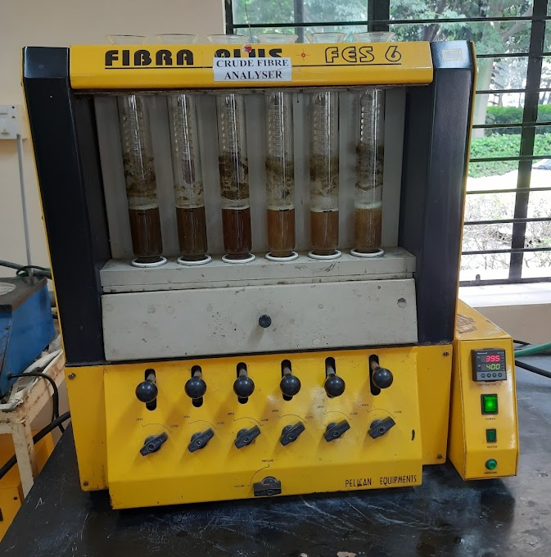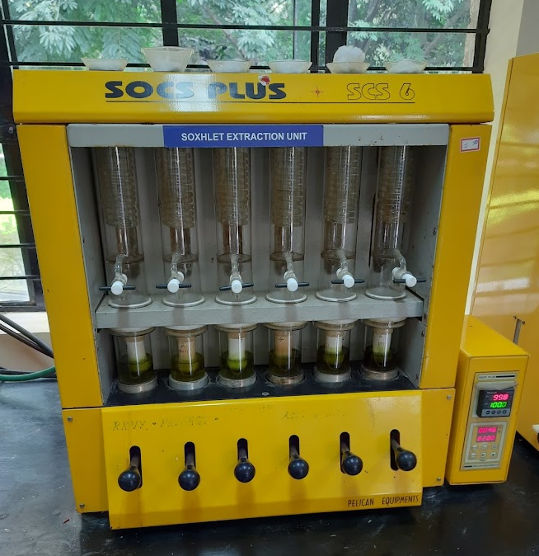
Plate 2: Fat analysis using socs plus apparatus
Plate 1: Crude fibre analysis using fibra plus soxhlet

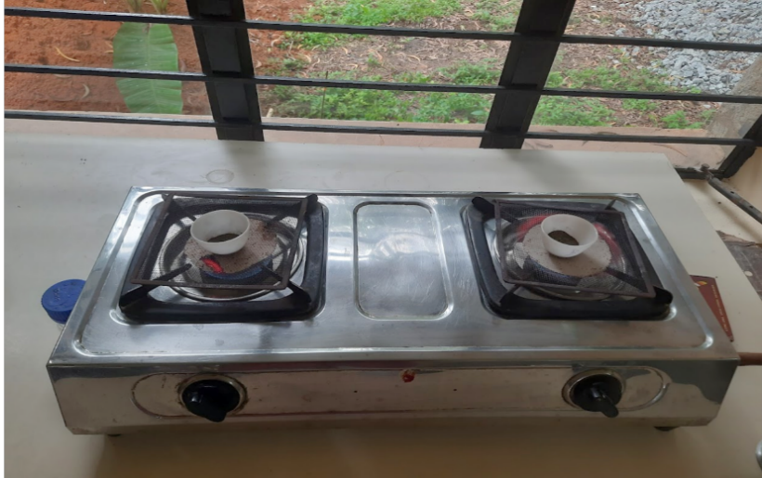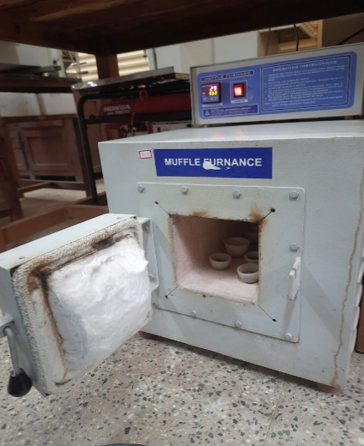
Plate 4: Muffle furnace used for white ash formation
Plate 3: Ashing of mulberry leaves using crucibles

Plate 3: Sprouted cuttings of mulberry

Plate 2: Planting of cuttings in
polythene bags

