**Economic and Environmental Benefits of Green Cultivation**

**Abstract**

Green cultivation emphasizes sustainable farming practices that offer both economic and environmental benefits. This study explores key aspects of green cultivation, including organic farming, community-supported agriculture (CSA), and sustainable land use. The economic advantages include increased profitability through reduced input costs, improved market opportunities, and integration with agritourism. Additionally, green cultivation promotes local economies and enhances food security. Environmentally, it supports biodiversity, improves soil health, and reduces greenhouse gas emissions. Case studies from regions like Spain and Egypt highlight the effectiveness of sustainable farming methods in balancing productivity with ecological preservation. As green cultivation becomes more widespread, supportive policies and educational initiatives will be crucial in expanding its adoption. This transition not only benefits farmers but also plays a pivotal role in combating climate change and promoting long-term agricultural sustainability.

***Keywords:*** *Green cultivation, sustainable farming, organic agriculture, economic benefits, environmental impact*

**1. Introduction**

Green cultivation represents a transformative approach to agriculture that emphasizes sustainability and environmental stewardship while also providing economic benefits. This article aims to explore the economic and environmental advantages of green cultivation practices, which include organic farming, community-supported agriculture (CSA), and innovative agricultural techniques that prioritize ecological balance. The economic benefits of green cultivation are multifaceted. For instance, community-supported agriculture (CSA) enhances food security for local households and supports local economies by connecting consumers directly with producers (Ludden *et al.,* 2018). This model fosters a sense of community and encourages consumers to invest in local agriculture, which can lead to increased sales for farmers and reduced transportation costs, thereby lowering the carbon footprint associated with food distribution. Furthermore, the adoption of organic farming practices has been shown to improve farm income, albeit modestly, as it often requires a shift in management practices and consumer education (Sadłowski *et al.,* 2021). The integration of organic methods, such as crop rotation and the use of green manures, can enhance soil health, which is crucial for long-term agricultural productivity (Li *et al.,* 2012; Khoiri *et al.,* 2021). From an environmental perspective, green cultivation practices contribute significantly to the restoration and maintenance of ecosystem health. Organic farming, for example, avoids the use of synthetic fertilizers and pesticides, thereby reducing chemical runoff into waterways and promoting biodiversity (Vita *et al.,* 2018). Techniques such as crop diversification and the use of cover crops can enhance soil structure and fertility, leading to improved resilience against pests and diseases (Sharma *et al.,* 2021; Kumar *et al.,* 2020). Moreover, the emphasis on sustainable practices aligns with global initiatives, such as the EU Green Deal, which aims to reduce reliance on chemical inputs and promote sustainable agricultural practices (Tataridas *et al.,* 2022). The shift towards green agriculture not only mitigates environmental degradation but also enhances the overall sustainability of food systems, ensuring that agricultural practices can meet the needs of future generations (Li *et al.,* 2021). Lastly, green cultivation offers substantial economic and environmental benefits that are essential for sustainable agricultural development. By fostering local economies, enhancing food security, and promoting ecological balance, green cultivation practices present a viable path forward in addressing the challenges posed by conventional agricultural methods. The integration of these practices into mainstream agriculture is not only beneficial for farmers and consumers but is also crucial for the health of our planet.

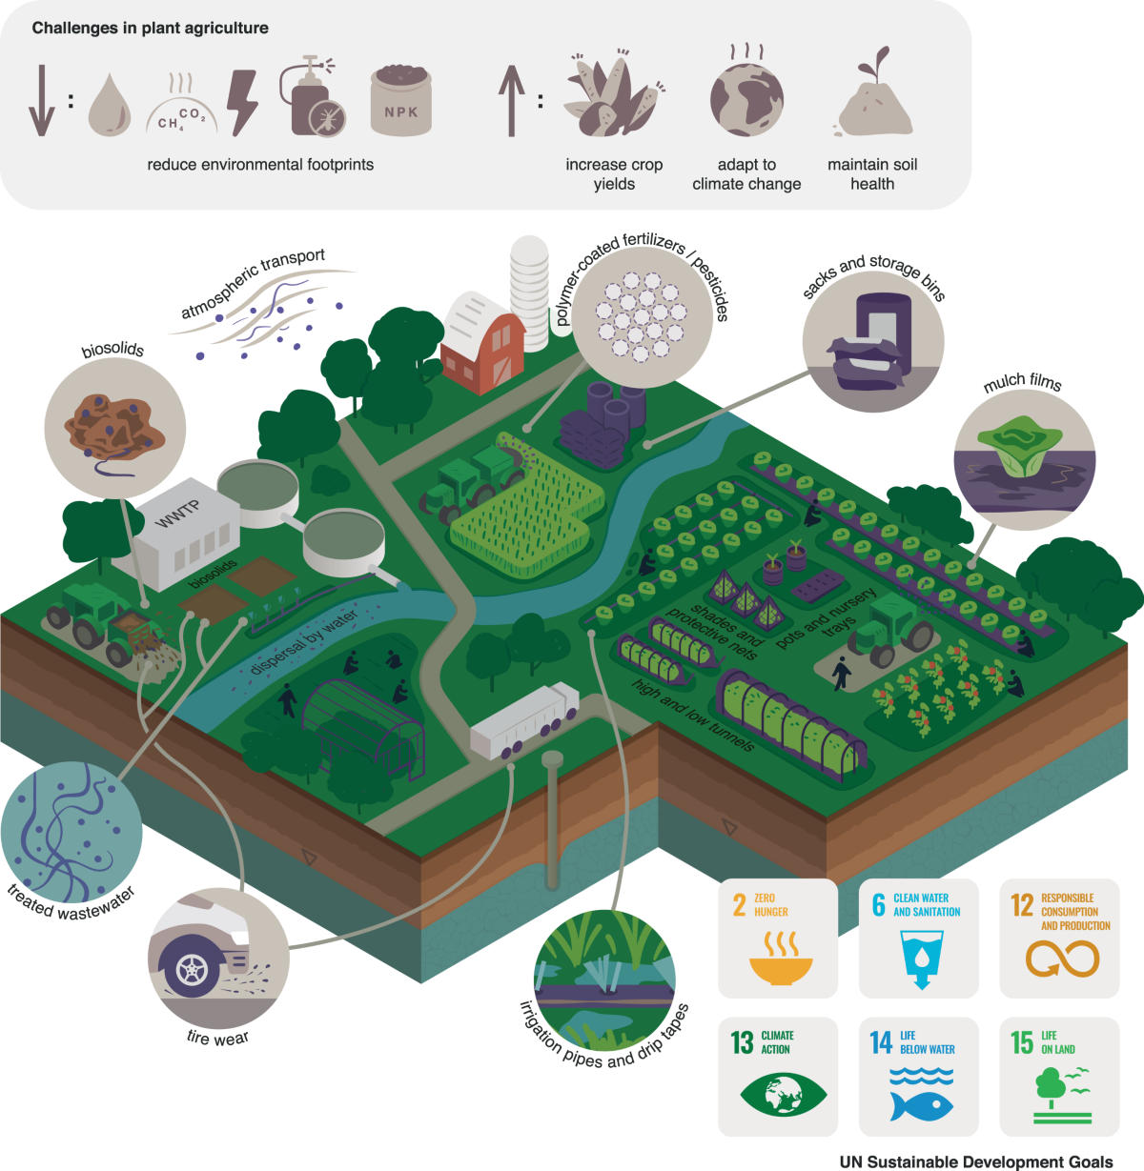  
**Fig.1.** Illustration of green cultivation strategies promoting sustainable agriculture through biosolids, treated wastewater, precision farming, and biodegradable inputs—aimed at reducing environmental impact, enhancing soil health, and supporting UN Sustainable Development Goals like zero hunger, clean water, and climate action.

**2. Economic Benefits of Green Cultivation**

The economic benefits of green cultivation are multifaceted, encompassing increased profitability, reduced costs, and enhanced market opportunities for farmers. Green cultivation, particularly organic farming, has been shown to yield significant economic advantages compared to conventional agricultural practices. For instance, research indicates that organic cotton cultivation in India resulted in lower cultivation costs and higher gross and net returns over a six-year period, demonstrating the financial viability of organic methods (Rana and Bhatt, 2018). This aligns with findings that suggest the combination of reduced input costs and favorable price premiums for organic products can offset lower yields, making organic farms competitive with conventional counterparts (Rana and Bhatt, 2018). Moreover, the integration of agritourism with green farming practices has been linked to improved economic outcomes. Farms that engage in agritourism not only diversify their income streams but also tend to adopt environmentally sustainable techniques that enhance biodiversity and resource management (Khanal *et al.,* 2019). This diversification is crucial as it allows farmers to tap into new markets and consumer segments, thereby increasing their overall economic resilience (Khanal *et al.,* 2019). The economic benefits of green cultivation extend beyond individual farmers to the broader community. Urban green infrastructure, for example, has been shown to provide substantial economic benefits, including increased property values and enhanced community health (Gashu and Gebre-Egziabher, 2019). By investing in green infrastructure, cities can improve their economic landscape, attracting tourism and enhancing the quality of life for residents, which in turn stimulates local economies (Gashu and Gebre-Egziabher, 2019). Additionally, the economic evaluation of green land use in regions such as Beijing-Tianjin-Hebei has highlighted the importance of green governance and economic benefits, indicating that effective management of green spaces can lead to improved economic outcomes (Wen-ying *et al.,* 2022). Furthermore, the cultivation of green manures and the adoption of innovative agricultural practices contribute to soil health and productivity, which are essential for sustainable agricultural systems. Studies have shown that green manure crops can enhance nutrient cycling and improve yields in subsequent crops, thereby increasing the economic viability of farming operations (Nascimento *et al.,* 2016). This practice not only supports the environment but also provides farmers with a cost-effective means of maintaining soil fertility without relying heavily on chemical fertilizers.

**3. Environmental Advantages of Sustainable Farming**

Sustainable farming practices offer numerous environmental advantages that contribute to the overall health of ecosystems and the mitigation of climate change. These practices are increasingly recognized for their potential to enhance biodiversity, improve soil health, and reduce greenhouse gas emissions, thereby fostering a more resilient agricultural system. One of the primary environmental benefits of sustainable farming is its positive impact on biodiversity. Sustainable agricultural practices, such as crop rotation, intercropping, and the use of organic fertilizers, promote a diverse range of plant and animal species within agricultural landscapes. Clark and Tilman (2017) emphasize that organic farming systems, which are a significant component of sustainable agriculture, tend to support higher biodiversity compared to conventional systems. This is particularly important as biodiversity plays a crucial role in ecosystem resilience, pest control, and pollination, which are essential for food production. Soil health is another critical aspect enhanced by sustainable farming methods. Practices such as the use of cover crops and green manures improve soil structure, increase organic matter, and enhance nutrient cycling. For instance, Deus et al. (2022) highlight that green manures can provide essential ecosystem services, including nutrient cycling and the establishment of new agroecosystems. Additionally, catch crops have been shown to reduce nitrogen leaching, thereby minimizing water pollution and improving soil microbial activity (Janušauskaitė *et al.,* 2013). These practices not only contribute to more productive agricultural systems but also help in maintaining the ecological balance. However, sustainable farming practices are instrumental in mitigating climate change. By adopting techniques that reduce reliance on synthetic fertilizers and pesticides, farmers can significantly lower greenhouse gas emissions associated with agricultural production. For example, climate-smart agriculture (CSA) integrates practices that enhance productivity while reducing emissions (Sadiku *et al.,* 2017). This approach aligns with the findings of (Hou and Li, 2010), who discuss the importance of adapting agricultural practices to changing climatic conditions to ensure sustainability. Furthermore, the implementation of sustainable practices can enhance carbon sequestration in soils, which is vital for combating climate change. The economic implications of these environmental benefits are also noteworthy. Sustainable farming can lead to cost savings through reduced input requirements and improved efficiency. Grassini et al. (2013) indicate that advancements in sustainable agricultural practices can lead to yield improvements without the excessive use of chemical inputs, thereby enhancing profitability for farmers. Additionally, the adoption of sustainable practices can open up new markets for organic and sustainably produced goods, further contributing to economic viability.

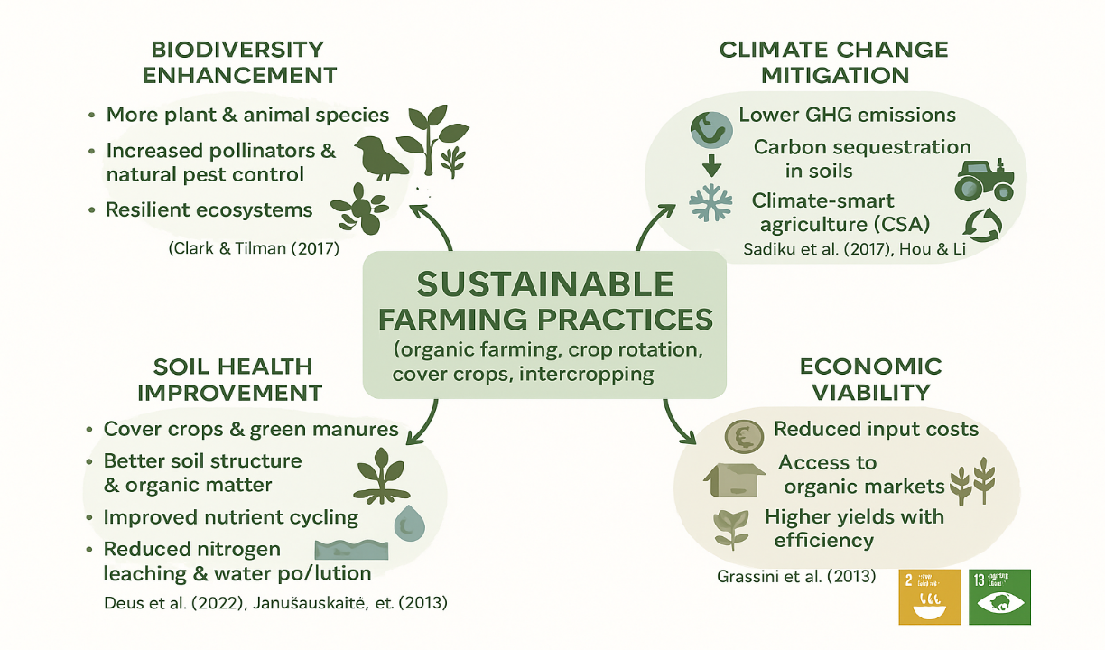

**Fig.2**. The figure highlights how sustainable farming practices enhance biodiversity, improve soil health, reduce emissions, and boost economic viability, supporting climate-smart and resilient agriculture.

**4. Case Studies and Real-World Applications**

The economic and environmental benefits of green cultivation are increasingly recognized in contemporary agricultural practices. Green cultivation, which emphasizes sustainable farming methods, enhances productivity while mitigating adverse environmental impacts. Case studies from various regions illustrate these benefits, showcasing how sustainable practices can lead to improved economic outcomes while preserving ecological integrity.

* One notable case study is presented by, who explored the trade-offs between economic, environmental, and social sustainability on Spanish crop farms. Their findings indicate that environmentally sustainable farms produce slightly less output than socially sustainable farms but utilize significantly fewer polluting inputs, such as pesticides and nitrogen fertilizers. This reduction in chemical use benefits the environment and aligns with consumer preferences for sustainably produced goods, potentially leading to higher market prices and increased profitability for farmers who adopt such practices (Sidhoum *et al.,* 2022).
* In Egypt, conducted a case study on a sustainable farm that demonstrated the practical application of sustainable agriculture principles. Their research highlighted the multifaceted benefits of sustainable practices, including enhanced soil health, reduced input costs, and improved crop yields. Such outcomes underscore the potential for sustainable farming to contribute positively to both the economy and the environment, as farmers can achieve better financial returns while minimizing ecological footprints (Abdelrazek and Khafif, 2022). Furthermore, the work of emphasizes the necessity of sustainable intensification in agriculture, which aims to increase food production without exacerbating environmental degradation. Their analysis suggests that adopting sustainable practices can lead to more resilient farming systems capable of withstanding extreme weather events, thereby securing food supply and enhancing economic stability for farmers (Gadanakis *et al.,* 2015). This is particularly relevant in the context of climate change, where traditional farming methods may no longer be viable.
* The educational initiatives in Brazil, as discussed by, illustrate the importance of knowledge transfer in promoting sustainable practices. By integrating sustainability into farming education, students are better equipped to implement these practices on their own farms, leading to broader adoption of green cultivation methods. This approach fosters a new generation of environmentally conscious farmers and contributes to the economic viability of rural communities through enhanced agricultural productivity (Miller, 2022).

The case studies and real-world applications of green cultivation demonstrate significant economic and environmental benefits. Sustainable farming practices improve crop yields and reduce input costs while contributing to ecological preservation and resilience against climate change. As these examples illustrate, the transition to green cultivation is not merely an environmental imperative but also a viable economic strategy for farmers seeking long-term sustainability.

**5. Future Prospects of Green Cultivation**

Green cultivation, also referred to as sustainable or eco-friendly farming, is no longer a niche practice; it is rapidly gaining global relevance as a viable solution to the interlinked challenges of food security, environmental degradation, and climate change. As awareness increases among consumers, policymakers, and producers, the future prospects of green cultivation appear promising and transformative.

**5.1. Economic Prospects**

Green cultivation is expected to drive the global green economy, creating trillions in value by 2040. It fosters rural development by generating jobs in sustainable agriculture, logistics, and agri-tech. Farmers benefit from increased productivity and profitability through data-driven and diversified farming methods. Reduced dependence on costly chemical inputs lowers expenses, while growing consumer demand for organic and eco-friendly products opens up premium market opportunities.

**5.2. Environmental Prospects**

Environmentally, green cultivation restores ecosystems through regenerative practices that improve soil health and biodiversity. It significantly reduces pollution by minimizing chemical runoff and promotes efficient use of water and energy resources. These practices also contribute to climate change mitigation, helping agriculture align with global carbon neutrality and sustainability goals.

**5.3. Technological Advancements**

The future of green cultivation is closely linked to technological innovation. AI and precision agriculture enhance decision-making and input efficiency. Vertical farming and controlled environment agriculture support local, low-impact food production in urban areas. Biotechnological advancements, including drought-resistant crops and alternative protein sources, further reduce agriculture’s environmental impact and open new economic possibilities.

**5.4. Challenges and Considerations**

Despite its potential, the transition to green farming faces key challenges. Policy reforms and supportive regulations are needed to scale sustainable practices. Smallholder farmers often struggle with financial constraints and lack of access to training or technology. Maintaining consumer demand and awareness for sustainable products is essential to ensure ongoing economic and environmental benefits.

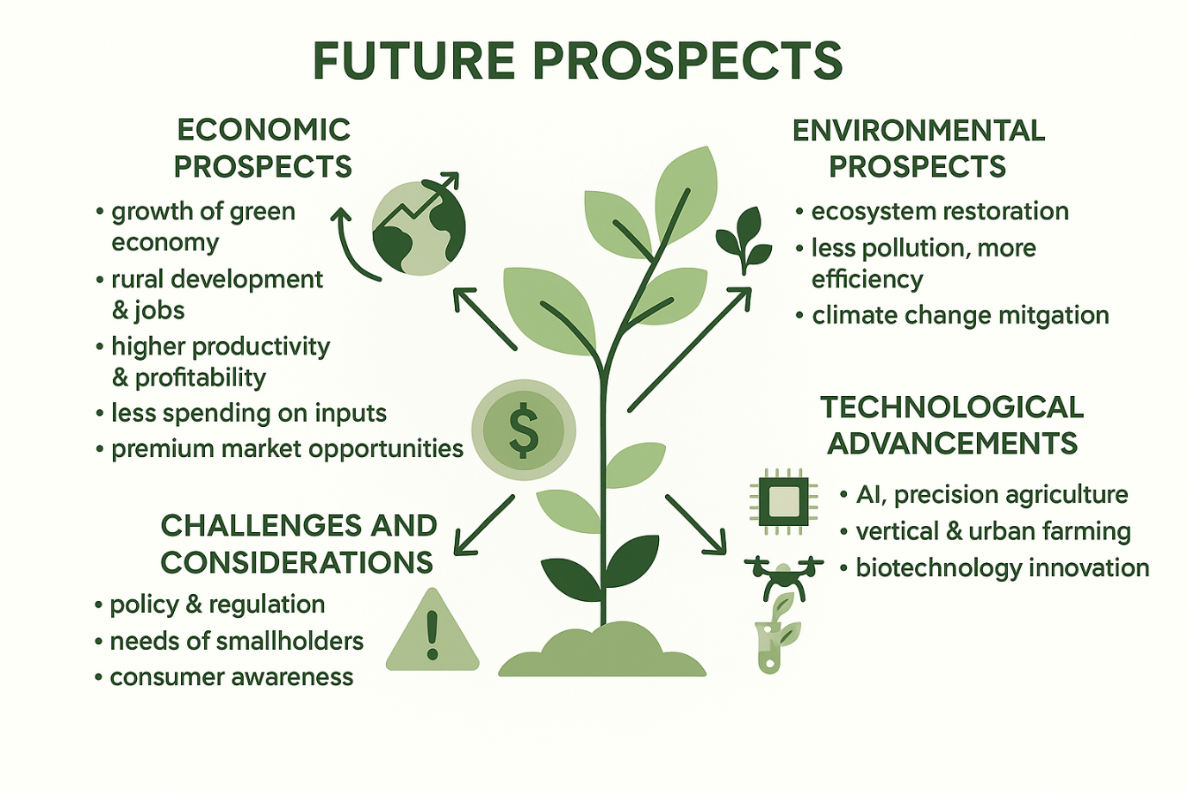

Fig.3. The diagram illustrates the future prospects of sustainable farming, highlighting economic growth, environmental benefits, technological innovations, and key challenges.

All these areas are indeed being significantly impacted by green cultivation. In the present time, its importance is increasing day by day in human life. Moreover, it is expected to influence many other areas, such:

* **Rising Global Demand for Organic and Sustainable Food**
* Consumer Preference Shift: Increasing health consciousness, concerns about pesticide residues, and preference for clean, natural food are driving demand for organically and sustainably produced food globally.
* Export Opportunities: Countries adopting green cultivation practices, such as India, have vast potential for exporting organic products to international markets like the EU, USA, and Japan, where demand is rising.
* **Climate Change Adaptation and Resilience**
* Climate-Smart Agriculture: Green cultivation helps build resilience to climate shocks through soil conservation, water efficiency, and biodiversity enhancement. These practices make farming systems more adaptive in the face of erratic rainfall, droughts, and floods.
* Carbon Sequestration: Techniques like agroforestry, cover cropping, and reduced tillage enhance carbon capture in soil and vegetation, offering a role in global climate mitigation strategies.
* **Government and Institutional Support**
* Policy Shifts: Many countries, including India, are framing policies to promote natural and organic farming. Schemes like Paramparagat Krishi Vikas Yojana (PKVY) and Zero Budget Natural Farming (ZBNF) reflect this commitment.
* Incentives and Certification Support: Future policies may increasingly offer subsidies for organic inputs, easier certification processes, and direct procurement systems to ensure stable markets for green cultivators.
* **Youth and Entrepreneurial Interest**
* Agri-Entrepreneurship: Young entrepreneurs are entering agriculture with a sustainable mindset, launching organic brands, eco-farms, agritech startups, and farm-to-fork delivery systems.
* Employment Opportunities: As green cultivation grows, so will related sectors like organic input manufacturing, certification services, sustainable packaging, and ecological consulting.
* **Reviving Indigenous Knowledge and Practices**
* Traditional Wisdom: Green cultivation aligns with many indigenous farming systems that emphasize harmony with nature. There is a growing trend to revive and scientifically validate traditional methods like Panchgavya, vermicomposting, and mixed cropping.
* Cultural Relevance: Such practices not only ensure sustainability but also strengthen local communities and cultural identity.
* **Sustainable Rural Development**
* Empowering Small Farmers: With appropriate training and support, green cultivation offers small and marginal farmers a way to escape the input-debt trap and earn better through premium produce.
* Community-Based Farming Models: Cooperative and community-supported agriculture (CSA) models are expected to grow, encouraging collective marketing, shared resources, and farmer solidarity.

**6. Impact of green cultivation on Sustainable Development Goals (SDGs):**

The **Sustainable Development Goals (SDGs)** are a universal set of **17 interconnected goals** adopted by all **United Nations Member States in 2015** as part of the **2030 Agenda for Sustainable Development**. These goals provide a shared blueprint for peace, prosperity, and environmental protection for both people and the planet.

The SDGs aim to address the world’s most urgent challenges—ranging from poverty, hunger, and inequality to climate change, environmental degradation, peace, and justice—through a comprehensive and inclusive development framework.

**Key Features of the SDGs:**

* **Universal:** Applicable to all countries—developed and developing—recognizing that sustainable development is a global concern.
* **Integrated:** Each goal is interconnected with others. Progress in one area often supports progress in another.
* **Measurable:** Each SDG includes specific **targets (169 in total)** and **indicators (over 230)** to track progress over time.

**Purpose and Importance of SDGs:**

* The SDGs are designed to address global challenges such as poverty, hunger, health, education, climate change, gender equality, and environmental sustainability. They provide a holistic blueprint to achieve a better and more sustainable future for all (UNDP, 2023).

**Green cultivation contributes directly to multiple some SDGs:**

1. **Zero Hunger (SDG 2):** Green cultivation directly supports the goal of **Zero Hunger** by promoting sustainable and inclusive agricultural practices that enhance food availability, accessibility, and affordability. Unlike conventional farming, which can degrade soil and water resources over time, green cultivation emphasizes long-term soil fertility, water conservation, and ecological balance—ensuring that agricultural productivity can be maintained or even improved over time. By adopting methods such as crop rotation, composting, organic fertilization, and integrated pest management, green farming increases yield stability, especially in the face of climate change. These practices are particularly beneficial for **smallholder and marginal farmers**, who often face food insecurity themselves. Green cultivation helps reduce their input costs, enhance soil health, and create diversified sources of income, thereby improving household food security. Furthermore, green cultivation promotes **local food systems** and **nutrient-rich crops**, which play a crucial role in combating malnutrition and hunger. By supporting the growth of indigenous and climate-resilient crops, it contributes to dietary diversity, a key factor in achieving nutritional security. In a broader context, sustainable farming also strengthens rural economies, reduces dependency on food imports, and ensures the long-term resilience of the global food system. Thus, green cultivation is not just an environmentally conscious practice—it is a strategic approach to ending hunger and building a food-secure future for all.
2. **Good Health and Well-being (SDG 3)** Green cultivation plays a crucial role in promoting public health by reducing the dependency on synthetic fertilizers, pesticides, and other harmful agrochemicals. These chemicals, widely used in conventional farming, are known to leave toxic residues on food, contaminate soil and water, and cause long-term health problems such as cancer, hormonal imbalances, and respiratory disorders. By focusing on organic inputs and natural pest management techniques, green cultivation ensures the production of food that is free from hazardous substances, thus safeguarding consumer health. Additionally, eco-friendly farming methods reduce air and water pollution, which directly benefits the health of surrounding communities and ecosystems. For farmers and agricultural workers, green cultivation practices also offer a safer working environment by minimizing exposure to toxic substances. Moreover, increased nutritional value in organically grown food—often richer in antioxidants and essential nutrients—further contributes to improved well-being. In this way, green cultivation aligns strongly with the objectives of SDG 3 by supporting healthier diets, cleaner environments, and safer farming conditions, ultimately enhancing the overall quality of life.
3. **Clean Water and Sanitation (SDG 6):** Its aims to ensure availability and sustainable management of water and sanitation for all. Access to clean and safe water is fundamental for human health, agricultural productivity, and environmental sustainability. Green cultivation plays a vital role in achieving this goal by promoting water-efficient and non-polluting agricultural practices.

**Role of Green Cultivation in Supporting SDG 6 as the following:**

* 1. Reduction in Water Pollution
  2. Efficient Water Use
  3. Soil-Water Retention
  4. Wastewater Reuse
  5. Protection of Groundwater

Green cultivation directly helps in water use efficiency, and availability, that change the quality of produces.

1. **Climate Action (SDG 13)** Climate change threatens food production, rural livelihoods, and global biodiversity. Green cultivation directly contributes to climate action by addressing the root causes of agricultural emissions while offering farmers sustainable alternatives that ensure long-term productivity and profitability. Green cultivation directly contributes to climate action by minimizing agriculture’s environmental footprint and enhancing the sector’s resilience to climate change. Traditional farming methods are a major source of greenhouse gas (GHG) emissions, due to excessive use of chemical fertilizers, methane emissions from flooded fields, and land-use changes like deforestation. In contrast, green cultivation emphasizes sustainable practices that mitigate climate change while promoting adaptation. One of the key ways green cultivation supports climate action is through **reduced greenhouse gas emissions**. The adoption of organic fertilizers, composting, and biopesticides limits the release of nitrous oxide and carbon dioxide, two potent GHGs. Additionally, practices such as conservation tillage and minimal soil disturbance help prevent carbon loss from soil and support its natural carbon sequestration abilities. Green cultivation also improves **climate resilience**. Techniques like crop diversification, integrated pest management, and water-efficient irrigation systems strengthen the ability of farming systems to withstand droughts, floods, and erratic weather patterns. These strategies reduce vulnerability and support stable agricultural productivity under changing climatic conditions. Furthermore, green cultivation promotes **agroforestry** and **cover cropping**, which contribute to **carbon sequestration** by absorbing CO₂ from the atmosphere and storing it in biomass and soils. These nature-based solutions help offset emissions from other sectors and play a critical role in meeting global climate goals.
2. **Life on Land (SDG 15)** aims to protect, restore, and promote sustainable use of terrestrial ecosystems, manage forests sustainably, combat desertification, halt and reverse land degradation, and halt biodiversity loss. Agriculture has a profound impact on terrestrial ecosystems, and sustainable practices such as green cultivation play a pivotal role in achieving this goal. Green cultivation also plays a vital role in supporting terrestrial ecosystems by enhancing **soil health and restoring degraded land** through organic inputs and conservation practices. It promotes **forest and biodiversity conservation** by reducing deforestation and encouraging agroforestry and habitat-friendly farming. Sustainable land use is achieved through methods like crop rotation and intercropping, which maintain productivity without exhausting natural resources. By minimizing the use of harmful chemicals, green cultivation also protects soil organisms and surrounding ecosystems. Additionally, it helps **combat invasive species** while supporting the growth of **indigenous flora**, thereby preserving ecological balance and strengthening the resilience of land-based environments.
3. **This alignment ensures global support and funding in the years to come:** Aligning agricultural practices like green cultivation with internationally recognized frameworks such as the Sustainable Development Goals (SDGs) attracts broader attention and cooperation at both policy and funding levels. When nations, institutions, and farming systems adopt practices that contribute to global goals—such as climate action, zero hunger, and environmental sustainability—they position themselves to benefit from international funding mechanisms, technical assistance, and partnerships. Multilateral organizations, donor agencies, and climate finance bodies are increasingly directing their resources toward projects that demonstrate strong alignment with SDGs. This includes access to green funds, research grants, capacity-building programs, and technology transfer. Moreover, governments and private investors are more inclined to support initiatives that show a long-term vision aligned with global priorities. This strategic alignment not only ensures sustained financial backing but also strengthens credibility, scalability, and the long-term success of green cultivation practices.

**7. Conclusion**

The future of green cultivation is abundant with opportunities. As ecological concerns take center stage in policy-making, commerce, and public awareness, green farming emerges as a resilient, ethical, and economically viable model of agriculture. With the right integration of modern technology, traditional knowledge, institutional support, and robust market linkages, green cultivation has the potential to drive a sustainable agricultural revolution—ensuring food security, farmer prosperity, and environmental sustainability for generations to come. Driven by innovations such as precision agriculture, bio-inputs, and eco-friendly farming technologies, the future of green cultivation looks increasingly promising. These advancements not only aim to improve productivity but also significantly reduce environmental footprints. However, scaling up such practices to meet global food demands, along with overcoming adoption resistance and infrastructure gaps, remains a considerable challenge.

Addressing these issues opens avenues for further growth and innovation. Supportive government policies, financial incentives, and awareness campaigns will be essential in accelerating the adoption of green cultivation. As the movement expands, it is poised to make a transformative impact on global agriculture—enhancing soil health, reducing greenhouse gas emissions, preserving water resources, and fostering biodiversity.

Ultimately, the future of green cultivation rests on a collective commitment to sustainability. With continued efforts, it will not only meet current agricultural needs but also ensure a healthier, more resilient planet for future generations.

**Disclaimer (Artificial intelligence)**

Author(s) hereby declare that generative AI technologies such as Large Language Models, etc. have been used during the writing or editing of manuscripts. This explanation will include the name, version, model, and source of the generative AI technology and as well as all input prompts provided to the generative AI technology

Details of the AI usage are given below:

1. ChatGPT for pictures/fig. generations

2.

3.

**References:**

1. Abdelrazek, N. and Khafif, M. (2022). Toward sustainable agriculture: the case of a sustainable farm in egypt. Management and Sustainability an Arab Review, 1(2), 113-126.
2. Clark, M. and Tilman, D. (2017). Comparative analysis of environmental impacts of agricultural production systems, agricultural input efficiency, and food choice. Environmental Research Letters, 12(6), 064016. https://doi.org/10.1088/1748-9326/aa6cd5
3. Deus, T., Giongo, V., Salviano, A., Santana, M., Silva, V., and Santos, T. (2022). Selection of green manures to provide ecosystem services in a semi-arid environment. Revista Brasileira De Ciências Ambientais (Online), 57(3), 409-421.
4. Gadanakis, Y., Bennett, R., Park, J., and Areal, F. (2015). Evaluating the sustainable intensification of arable farms. Journal of Environmental Management, 150, 288-298.
5. Gashu, K. and Gebre-Egziabher, T. (2019). Public assessment of green infrastructure benefits and associated influencing factors in two ethiopian cities: bahir dar and hawassa. BMC Ecology, 19(1). https://doi.org/10.1186/s12898-019-0232-1
6. Grassini, P., Eskridge, K., and Cassman, K. (2013). Distinguishing between yield advances and yield plateaus in historical crop production trends. Nature Communications, 4(1). https://doi.org/10.1038/ncomms3918
7. Hou, L. and Li, H. (2010). The quantitative evaluation on the response of climate change upon the sustainability of the agricultural production. Advanced Materials Research, 129-131, 1161-1165.
8. Janušauskaitė, D., Arlauskienė, A., and Maikštėnienė, S. (2013). Soil mineral nitrogen and microbial parameters as influenced by catch crops and straw management. Zemdirbyste-Agriculture, 100(1), 9-18.
9. Khanal, A., Mishra, A., and Omobitan, O. (2019). Examining organic, agritourism, and agri-environmental diversification decisions of american farms: are these decisions interlinked?. Review of Agricultural Food and Environmental Studies, 100(1-4), 27-45.
10. Khoiri, A., Cheevadhanarak, S., Jirakkakul, J., Dulsawat, S., Prommeenate, P., Tachaleat, A., and Sutheeworapong, S. (2021). Comparative metagenomics reveals microbial signatures of sugarcane phyllosphere in organic management. Frontiers in Microbiology, 12. https://doi.org/10.3389/fmicb.2021.623799
11. Kumar, V., Obour, A., Jha, P., Li, R., Manuchehri, M., Dille, J., and Stahlman, P. (2020). Integrating cover crops for weed management in the semiarid u.s. great plains: opportunities and challenges. Weed Science, 68(4), 311-323.
12. Li, R., Khafipour, E., Krause, D., Entz, M., Kievit, T., and Fernando, W. (2012). Pyrosequencing reveals the influence of organic and conventional farming systems on bacterial communities. Plos One, 7(12), e51897.
13. Li, Y., Jiang, G., and Quan, Z. (2021). Addressing the differences in farmers’ willingness and behavior regarding developing green agriculture—a case study in xichuan county, china. Land, 10(3), 316.
14. Ludden, M., Welsh, R., Weissman, E., Hilchey, D., Gillespie, G., and Guptill, A. (2018). The progressive agriculture index: assessing the advancement of agri-food systems. Journal of Agriculture Food Systems and Community Development, 1-27. https://doi.org/10.5304/jafscd.2018.083.003
15. Miller, M. (2022). An outlook on the future of brazilian agriculture: how farming students of tocantins perceive sustainability in the cerrado. Revista Brasileira De Ciências Ambientais (Online), 57(2), 215-229.
16. Nascimento, V., Arf, O., Tarsitano, M., Garcia, N., Penteado, M., and Sabundjian, M. (2016). Economic analysis of rice and common bean production in succession to green manure crops and mecahnical soil decompression in brazilian savannah. Revista Ceres, 63(3), 315-322.
17. Rana, D. and Bhatt, A. (2018). Evaluation of socio-economic status of the skilled and unskilled workers of an organic farm of himachal pradesh, india- a case study. Journal of Applied and Natural Science, 10(2), 643-647.
18. Sadiku, M., Tembely, M., and Musa, S. (2017). Climate-smart agriculture. International Journal of Advanced Research in Computer Science and Software Engineering, 7(2), 148-149.
19. Sadłowski, A., Wrzaszcz, W., Smędzik-Ambroży, K., Matras-Bolibok, A., Budzyńska, A., Angowski, M., and Mann, S. (2021). Direct payments and sustainable agricultural development—the example of poland. Sustainability, 13(23), 13090.
20. Scherr, S., Shames, S., and Friedman, R. (2012). From climate-smart agriculture to climate-smart landscapes. Agriculture and Food Security, 1(1). https://doi.org/10.1186/2048-7010-1-12
21. Sharma, G., Shrestha, S., Kunwar, S., and Tseng, T. (2021). Crop diversification for improved weed management: a review. Agriculture, 11(5), 461.
22. Sidhoum, A., Dakpo, K., and Latruffe, L. (2022). Trade-offs between economic, environmental and social sustainability on farms using a latent class frontier efficiency model: evidence for spanish crop farms. Plos One, 17(1), e0261190. https://doi.org/10.1371/journal.pone.0261190
23. Tataridas, A., Kanatas, P., Chatzigeorgiou, A., Zannopoulos, S., and Travlos, I. (2022). Sustainable crop and weed management in the era of the eu green deal: a survival guide. Agronomy, 12(3), 589.
24. United Nations (UN). (2015). *Transforming our world: the 2030 Agenda for Sustainable Development*. A/RES/70/1. Retrieved from: <https://sdgs.un.org/2030agenda>
25. United Nations Development Programme (UNDP). (2023). *What are the Sustainable Development Goals?* Retrieved from: <https://www.undp.org/sustainable-development-goals>
26. United Nations Statistics Division. (2020). *Global indicator framework for the Sustainable Development Goals and targets of the 2030 Agenda for Sustainable Development*. Department of Economic and Social Affairs. Retrieved from <https://unstats.un.org/sdgs/indicators/indicators-list/>.
27. Vita, F., Giuntoli, B., Arena, S., Quaranta, F., Bertolini, E., Lucarotti, V., and Alpi, A. (2018). Effects of different nitrogen fertilizers on two wheat cultivars: an integrated approach. Plant Direct, 2(10). https://doi.org/10.1002/pld3.89
28. Wen-ying, P., Sun, Y., Li, Y., and Yuchi, X. (2022). An evaluation and promotion strategy of green land use benefits in china: a case study of the beijing–tianjin–hebei region. Land, 11(8), 1158. https://doi.org/10.3390/land11081158