Original Research Article

FINANCIAL PERFORMANCE AND MARKET RESPONSE: PROFITABILITY EFFECTS ON SHARE PRICES IN THE INDONESIAN CIGARETTE SECTOR

.
ABSTRACT

The purpose of this research is to examine how the share price of cigarette subsector companies listed on the Indonesia Share Exchange (IDX) was affected by profitability as determined by Return on Equity (ROE), Net Profit Margin (NPM), Earnings Per Share (EPS), and Price Earning Ratio (PER) between 2015 and 2024. The approach used is quantitative by conducting multiple linear regression analysis as the analysis technique using an analytical tool, namely SPSS version 25. The findings in the research process demonstrate that the four independent variables have a significant impact on share prices at the same time as evidenced by the f test findings, which indicate a 0.000 significance value. However, with significance values of 0.213 and 0.280, respectively, ROE and NPM do not significantly affect the outcome. With a significance score of 0.000 on the other hand, indicates that EPS has a positive and significance impact and PER also has a positive and significance impact on share price with a significance value of 0.004. These results suggest that EPS and PER play a significant role in assessing the value of the subsector's shares, therefore investors can use this a tool to forecast investment value and making informed trading decisions based on the financial performance information.

Keywords: Return on Equity, Net Profit Margin, Earning Per Share, Price Earning Ratio, Share Price.

1. INTRODUCTION

Indonesia's economy depends heavily on the cigarette industry, which is one of the largest producers and consumers of cigarette products globally. Data from Central Statistics Agency (Badan Pusat Statisik, 2024) and the World Health Organization (Yonatan, 2024) highlight a large and growing number of smokers in the nation, making the industry a focal point for investors. Despite its economic importance, the sub-sector faces considerable challenges, including increasingly stringent government regulations such as annual excise tax hikes and advertising restrictions. These factors can directly impact corporate performance, affecting sales, profitability, and consequently share prices in the capital market.

For investors, share prices are a primary concern as their fluctuation determines investment returns. Before making investment decisions, investors typically looking at financial information to see its performance and health. Financial statements are crucial tools in this process, providing insights that inform sound financial decisions. A common method for evaluating intrinsic value is fundamental analysis, which focuses on economic and financial factors. However, data from 2015- 2024 for major Indonesian cigarette companies show a perplexing trend where share prices have declined even as net profits increased, challenging the conventional wisdom that higher profits lead to higher share values.

This anomaly underscores the complexity between financial performance and market valuation. This research explores this connection by looking at how profitability affects share prices. Profitability is proxied with four widely used financial ratios: Return on Equity (ROE), which measures profit generated from shareholder equity, Net Profit Margin (NPM), indicating profit per unit of sales, Earning Per Share (EPS), which reflects profitability available to each outstanding share, and Price Earning Ratio (PER), used to gauge market expectations of future growth.

Previous research on this topic which are (Jayanti et al., 2023) and (Mardiyansyah et al., 2023) have yielded contradictory results, (Jayanti et al., 2023) found ROA and EPS have significant effect on share prices, while (Mardiyansyah et al., 2023) found that all ROA, ROE, NPM, and EPS have no significant effect on share price. Given these inconsistencies and the unique market dynamics of the Indonesian cigarette sector, this study aims to provide clarity by analyzing the partial and simultaneous impact of ROE, NPM, EPS, and PER on the share prices of listed cigarette companies over the period of 2015–2024.

2. literature review

2.1 Financial PERFORMANCE ANALYSIS

Financial performance analysis is the process of breaking down financial reports into simpler components and examining the relationships between relevant quantitative and non-quantitative data. Financial performance evaluation is also critical to assessing how companies manage their financial resources and operations. It encompasses scrutinizing various financial metrics to measure profitability, solvency, liquidity, efficiency, and overall health (Karki et al., 2024). The purpose of this analysis is to gain a deeper understanding of the company’s overall condition, particularly its financial position, which in turn supports informed and appropriate decision-making.

2.2 RETURN ON EQUITY
According to (Qabajeh et al., 2024), Return on Equity is a ration used to determine how effectively a company or organization generates profit based on the capital invested in it. Which is calculated using the following formula:

$$Return on Equity= \frac{Earning After Interest and Tax}{Total Equity}$$

2.3 NET PROFIT MARGIN

According to (Prihadi, 2020:165), net profit margin is a ratio that illustrates how effectively a business can deliver profits to its shareholders. Which is calculated using the following formula:

$$Net Profit Margin = \frac{Earning After Interest and Tax}{Net Sales}$$

2.4 EARNING PER SHARE

According to (Onyeka-Iheme & Victory, 2023), This ratio serves as an indicator of profitability per share, reflecting the amount of income that investors can potentially earn from their share ownership. Which is calculated using the following formula:

$$Earning Per Share = \frac{Earning After Interest and Tax}{Common Shares Outstanding}$$

2.5 PRICE EARNING RATIO

According to (Raharjo, 2022:292), the price earnings ratio reflects the quality of the relationship between a company and its investors. A high multiple (the cost per unit of earnings) is generally favored, as it indicates that investors have a positive perception of the company. Which is calculated using the following formula:

$$Price Earning Ratio = \frac{Price Per Share}{Earning Per Share}$$

2.6 PROFITABILITY ON SHARE PRICE

According to (Sari et al., 2023:14-15), stock price is significantly influenced by a company’s profitability. This fundamental concept stems from the understanding that investors’ perceptions of a company can be shaped by its success in the financial market, which in turn affects its stock price movements. High profitability is typically viewed as a sign of the company’s financial health and the management’s ability to generate earnings (Prasetya Margono & Gantino, 2021).
Financial performance such as profitability being used in this study because the research done by (Usman et al., 2022), show that even though the non-financial performance have an impact, the financial performance remains the core of the investors decision making tools.

When investors seek a safe place to allocate capital, they are more likely to feel secure with companies that have a positive track record of earnings, making such firms highly attractive to potential investors (He & Yang, 2025). In relation to stock price movements, stable and consistent profitability can instill confidence in both existing shareholders and prospective investors. Companies that consistently deliver strong financial results tend to receive greater support from the stock market, as reflected in rising share prices.

2.7 SIGNALING THEORY

The relationship between stock value and profitability can be understood through Signaling Theory. According to (Suganda, 2018), signaling theory explains how companies communicate information to investors regarding management’s perspective on the firm. Through this theory, it can be understood that companies have the ability to send positive signals to investors by demonstrating high profitability. This leads investors to view the company favorably in terms of its financial health and future prospects (Fridatien et al., 2025).

When profits increase, companies may raise dividends or engage in share buybacks actions that are typically received positively by the market. Investors interpret these signals as indicators that the company is capable of generating stable cash flows. As a result, companies with consistently strong profits tend to experience rising stock prices due to increased demand (Andriani et al., 2022).

3. MATERIAL AND METHODS

This study uses a quantitative research design. Quantitative research is defined as data collection and statistical analysis with the goal of generalizing sample results to the target population.(Sujarweni, 2019). The population of this research are all cigarette subsector companies listed on the Indonesia Share Exchange (IDX) since 2015 until2024. The data collected provided a broad overview of the current landscape and allowed for statistical analysis to identify trends and correlations.(Kipilimba, 2024)
This study employed one statistical tools to analyze the impact of profitability on share price, which is SPSS, version 25. The study will conduct classical assumption test, multiple linear regression analysis, and hypothesis test. F value, T value, and coefficient of determination (R²).

3.1 Hypotesis

Based on signaling theory, profit number in the financial reports can give positive signal to investors, so when making investing decisions, the profit number serves as a metric to evaluate a summary of a company's data, profitability reflects on company's ability to generate earnings relative to its revenue, assets, equity, or other financial metrics over time. Profitability is commonly measured through financial ratios such as Return on Equity (ROE), Net Profit Margin (NPM), Earnings Per Share (EPS), and Price Earning Ratio. Investors see a high and consistent profitability as a positive signal that the company is capable of delivering value and maintaining financial stability. Therefore the first hypotheses can be formulated which are:

H1: Return On Equity (ROE), Net Profit Margin (NPM), Earning Per Share (EPS), and Price Earning Ratio (PER) simultaneously have significantly positive effect on the share price.

When making investing decisions, the ROE ratio serves as a metric to evaluate a summary of a company's data, ROE reflects how effectively a company utilizes shareholders’ equity to generate net income. Investors interpret a high ROE as a sign that the company is efficiently turning investments into profits, indicating strong managerial performance. As a result, investors will choose a consistently high roe. Therefore the second hypotheses can be formulated which is:

H2: Return on Equity has significantly positive impact on share prices.

When making investing decisions the NPM ratio serves as a metric to evaluate a summary of a company's data, NPM is a key indicator of a company's overall profitability and operational efficiency. A higher NPM indicates that the company is able to convert a greater portion of its revenues into actual profit, which is often viewed as a sign of strong cost management and effective financial control.

As a result, investors will choose a consistently high or improving NPM because it suggests financial strength and sustainability, making the company more attractive for investment. Therefore the third hypotheses can be formulated which:

H3: Net Profit Margin has significantly positive impact on share prices.

When making investing decisions, the EPS ratio serves as a metric that represents the portion of a company's net income allocated to each outstanding share of common share. As a result, investors will choose a consistently rising EPS and it tends to attract investor interest, which can drive up demand and ultimately lead to a higher share price. Therefore the fourth hypotheses can be formulated which is:

H4: Earning Per Share has significantly positive impact on share prices.

When making investing decisions, the PER ratio serves as a metric to evaluate a summary of a company's data, PER reflects how much investors are willing to pay for each unit of earnings, and is often used to assess whether a share is overvalued or undervalued relative to its earnings potential. As a result, investors will likely choose a low but positive PER because it signal undervaluation, making the share potentially attractive to get. Therefore the fifth hypotheses can be formulated which is:

H5: Price Earning Ratio has significantly positive impact on share prices

4. RESULTS AND DISCUSSION

4.1 CLASSICAL ASSUMPTION TESTS

All classical assumption tests were successfully passed, indicating the regression model is robust which can be prove by these tests.

Normality Test: This test is applied to determine whether the residuals of the prediction follow a normal distribution and the normality test is the histogram, probability plot, and the Kolmogorov – Sminorv Test which result show in fig 1, fig 2, and table 1.

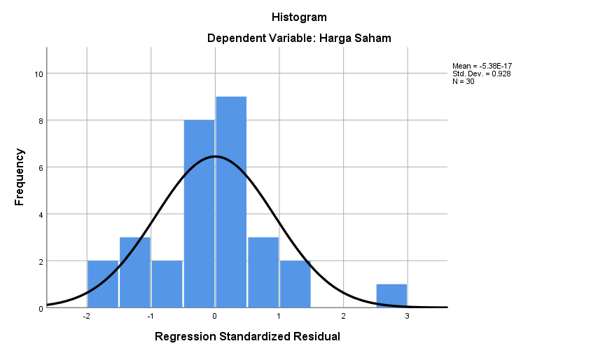
Fig. 1 Histogram

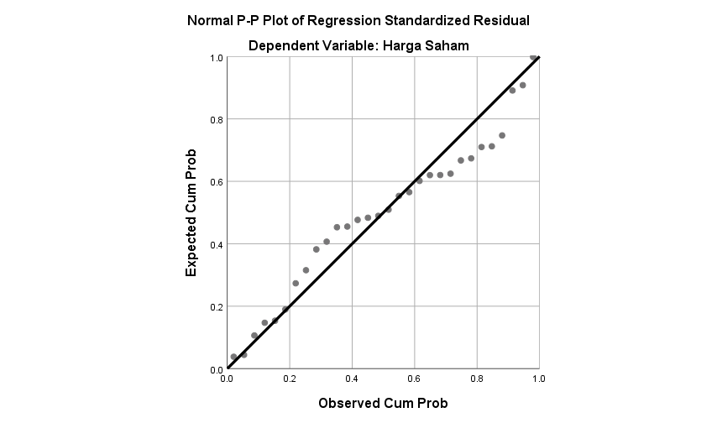
Fig 2. Probability Plot

Table 1. Normality Test

One-Sample Kolmogorov-Smirnov Test
 |  | Unstandardized Residual
N |  | 30
Normal Parameters^{a,b} | Mean | .0000000
Normal Parameters^{a,b} | Std. Deviation | 12202.07105985
Most Extreme Differences | Absolute | .140
Most Extreme Differences | Positive | .140
Most Extreme Differences | Negative | -.116
Test Statistic |  | .140
Asymp. Sig. (2-tailed) |  | .138^{c}
a. Test distribution is Normal.
b. Calculated from data.
c. Lilliefors Significance Correction.

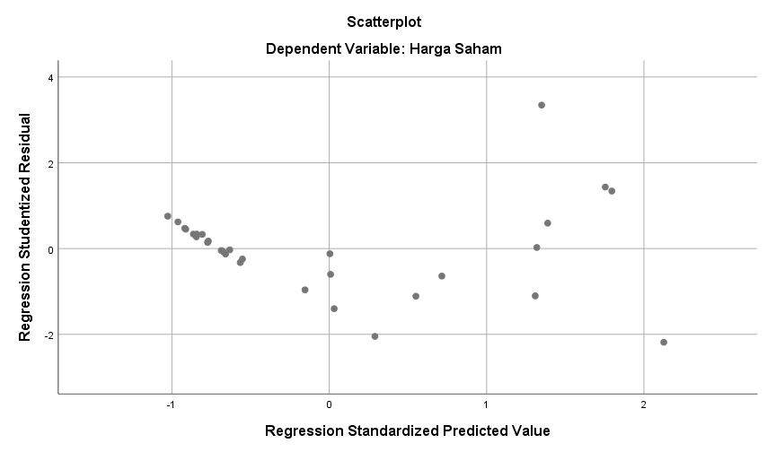
This Histogram test is normal if the histogram graph is within the criteria which is the beam is in an arch curve, Fig. 1 shows that the criteria are stated, and then the data is processed in the study is normal, The probability plot in Fig 2 shows that the data is spread around the diagonal lines and follows the direction of the diagonal, indicating that the regression model fulfils the assumptions of normality. The Kolmogorov Smirnov test indicate that the significance value of the residuals for the data from cigarette sub-sector companies is 0.138. Since this value exceeds the threshold of 0.05, it can be concluded that the residuals are normally distributed, indicating that the data from the cigarette sub-sector companies is normal.

Autocorrelation Test: This test is used to determine whether there is a relationship between the residuals (disturbance terms) at a given time period and those from previous time periods and the autocorrelation test is the Durbin Watson Test

Table 2. Autocorrelation Test

Model Summary^{b}
Model | R | R Square | Adjusted R Square | Std. Error of the Estimate | Durbin-Watson
1 | .910ª | .828 | .800 | 13142.033 | 1.764
a. Predictors: (Constant), Price Earning Ratio, Earning Per Share, Net Profit Margin, Return On Equity
b. Dependent Variable: Share Price

Based on the results presented in the table, the Durbin-Watson value is 1.764, which falls within the acceptable range between -2 and +2. This indicates that the data do not exhibit signs of autocorrelation.

Heteroskedasticity Test: This test is designed to determine if the variance of disturbance errors is constant across all independent factors and the heteroskedasticity test is the Scatter plot and Glejser Test which result show in Fig 1 and table 3.

Table 3. Heteroskedasticity Test

Coefficientsª
Model |  | t | Sig.
1 | (Constant) | 4.588 | .000
1 | Return On Equity | -.207 | .838
1 | Net Profit Margin | -1.160 | .257
1 | Earning Per Share | .816 | .422
1 | Price Earning Ratio | .795 | .434
a. Dependent Variable: ABS_RES
The Glejser Test showed that the significance values for all independent variables (ROE: 0.838, NPM: 0.257, EPS: 0.422, PER: 0.434) were greater than 0.05, confirming no heteroskedasticity.

Fig 3. Scatterplot

Fig. 3 shows the criteria that the regression model used in this study is free from heteroscedasticity problems.

Multicollinearity Test: This test is a diagnostic technique used in regression analysis to determine whether two or more independent variables are substantially associated with one another and this test look at the Variance Inflantion Factor (VIF) and tolerance number, which the result show in table 4.

Table 4. Multicollinearity Test

Coefficientsª
Model |  | Collinearity Statistics
 |  | Tolerance | VIF
1 | (Constant)
1 | Return On Equity | .130 | 7.681
1 | Net Profit Margin | .143 | 6.983
1 | Earning Per Share | .689 | 1.450
1 | Price Earning Ratio | .645 | 1.551
a. Dependent Variable: Share Price

As presented in the calculation results, there is no indication of multicollinearity. This conclusion is supported by the following values: ROE has a tolerance of 0.130 (greater than 0.1) and a VIF of 7.681 (below the threshold of 10), NPM has a tolerance of 0.143 (above 0.1) and a VIF of 6.983 (below 10), EPS shows a tolerance of 0.689 (exceeding 0.1) and a VIF of 1.450 (less than 10), and PER has a tolerance of 0.645 (above 0.1) and a VIF of 1.551 (also below 10). These results confirm the absence of multicollinearity.

4.2 Multiple Linear Regression Analysis

Table 5. Multiple Linear Regression Analysis

Model |  | Unstandardized Coefficients
 |  | B | Std. Error
1 | (Constant) | -12619.444 | 6216.856
1 | Return On Equity | -790.958 | 618.652
1 | Net Profit Margin | 2098.180 | 1899.233
1 | Earning Per Share | 13.500 | 1.722
1 | Price Earning Ratio | 940.679 | 294.171

The multiple linear regression analysis produced the following equation: Share Price = -12619.444 - 790.958 ROE + 2098.180 NPM + 13.500 EPS + 940.679 PER.
Constant (a): -12,619.444 is the constant value. This shows that the expected share price would drop by -12,619.444 if all independent variables (ROE, NPM, EPS, and PER) were held at zero.
Return on Equity (ROE): The regression coefficient for Return on Equity (ROE) is -790.958, meaning that a 1% increase in ROE would lead to a decrease in the share price by 790.958 for companies in the cigarette sub-sector listed on the Indonesia Share Exchange from 2015 to 2024.
Net Profit Margin (NPM): The regression coefficient for Net Profit Margin (NPM) is 2,098.180, indicating that a 1% increase in NPM would result in an increase in share price by 2,098.180.
Earning Per Share (EPS): The regression coefficient for Earnings Per Share (EPS) is 13.500, suggesting that a 1% increase in EPS would increase the share price by 13.500.
Price Earning Ratio (PER): The regression coefficient for Price to Earnings Ratio (PER) is 940.679, implying that a 1% rise in PER would lead to an increase in the share price by 940.679.

F Test: The F test is used to determine the significance of the regression equation, specifically the amount to which the independent variables (X₁, X₂, X₃, and X₄) jointly influence the dependent variable (Y), which is the stock price. The F test result can be see on table 6.

Table 6. F Test

ANOVAª
Model |  | F | Sig.
1 | Regression | 30.085 | .000^{b}
a. Dependent Variable: Share Price
b. Predictors: (Constant), Price Earning Ratio, Earning Per Share, Net Profit Margin, Return On Equity

The F test resulted in an F statistic of 30.085 with a significance value of 0.000. Since the significance is 0.05 and the F-statistic (30.085) is greater than the F-table value (2.690), it is concluded that ROE, NPM, EPS, and PER simultaneously have a significant impact on share prices.

T Test: This test is used to see if an independent variable (X) has a partial effect on the dependent variable (Y). This test calculates the partial regression coefficient for each independent variable

Table 7. T Test

Model |  | t | Sig.
1 | (Constant) | -2.030 | .053
1 | Return On Equity | -1.279 | .213
1 | Net Profit Margin | 1.105 | .280
1 | Earning Per Share | 7.838 | .000
1 | Price Earning Ratio | 3.198 | .004

The T Test result were as follows:

ROE: The significance level was 0.213 (> 0.05), and the t statistic was -1.279. As a result, share prices are not much impacted by ROE.
NPM: The significance level was 0.280 (> 0.05), and the t-statistic was 1.105. As a result, share prices are not much impacted by NPM.
EPS: The significance level was 0.000 (< 0.05), and the t-statistic was 7.838which is higher than the t table. This suggests that EPS has a significantly positive impact on share price.
PER: The significance level was 0.004 (< 0.05), and the t-statistic was 3.198. This suggests that PER has a significantly positive impact on share price.

Coefficient of Determination (R²): The coefficient of determination (R²) measures how well the independent variables (X) explain the variation in the dependent variable (Y). The coefficient of determination test result can be seen on table 8.

Table 8. Coefficient of Determination (R²)

Model Summary^{b}
Model | R | R Square | Adjusted R Square | Std. Error of the Estimate
1 | .910ª | .828 | .800 | 13142.033
a. Predictors: (Constant), Price Earning Ratio, Earning Per Share, Net Profit Margin, Return On Equity
b. Dependent Variable: Share Price

The four independent variables (ROE, NPM, EPS, and PER) account for 80% of the variation in share prices, according to the adjusted R-squared value of 0.800. Other factors not included in this model account for the remaining 20%.

5. DISCUSSION OF RESEARCH FINDINGS

Simultaneous Effect of ROE, NPM, EPS, and PER on Share Price

The F test produced an F statistic of 30.085 with a significance of 0.000. Since the F-statistic is greater than the F table value (2.690) and the significance value is less than 0.05, the independent variables (ROE, NPM, EPS, and PER) have a significant simultaneous impact on Share Price. This finding supports Signaling Theory, suggesting that these four variables collectively provide a comprehensive signal to investors about the company's current profitability (via EPS and NPM) and future prospects (via ROE and PER), thereby attracting investor interest. This result is also supported by research from (Afifah & Monalisa, 2024), (Prasetya Margono & Gantino, 2021), (Fribontius Bon et al., 2022).

The Effect of Return on Equity (ROE) on Share Price

The t test results indicate a regression coefficient for Return on Equity (ROE) of -790.958, with a t-statistic of -1.279 and a significance value of 0.213. As the significance value (p > 0.05) is above the threshold and the t statistic is below the t table value (1.697), ROE is found to have no significant impact on share price. This suggests that the return on equity for firms in the cigarette sub-sector does not significantly influence share price fluctuations. This finding is supported by research from (Barus & Sudjiman, 2021), (Prasetya Margono & Gantino, 2021), (Andriani et al., 2022).

The Effect of Net Profit Margin (NPM) on Share Price

The t test shows a regression coefficient for Net Profit Margin (NPM) of 2,098.180, a t-statistic of 1.105, and a significance value of 0.280. With a significance value greater than 0.05 and a t statistic below the t table value (1.697), NPM does not have a significant impact on share price. This indicates that the net income from sales in the cigarette sub-sector does not materially affect share price movements. The finding is supported by research from (Aming et al., 2023) and (Mardiyansyah et al., 2023).

The Effect of Earning Per Share (EPS) on Share Price

The t test yielded a regression coefficient for Earning Per Share (EPS) of 13.500, a t statistic of 7.838, and a significance value of 0.000. Because the coefficient is positive, the significance value is less than 0.05, and the t-statistic exceeds the t table value (1.697), EPS has a significant positive impact on share price. This result aligns with Signaling Theory, where a higher EPS signals positive corporate performance, attracting investors and driving up the share price. This finding is also consistent with research by (Jayanti et al., 2023), (Afifah & Monalisa, 2024).

The Effect of Price Earning Ratio (PER) on Share Price

The t test for Price Earning Ratio (PER) shows a regression coefficient of 940.679, a t statistic of 3.198, and a significance value of 0.004. As the coefficient is positive, the significance value is below 0.05, and the t statistic is greater than the t table value (1.697), PER has a significant positive impact on share price. This supports Signaling Theory, which posits that PER acts as a signal of corporate performance and positive market expectations. The result is consistent with the findings of (Bandawaty & Nurfitria, 2022).

6. Conclusion
According to the study's findings, the share prices of cigarette company listed on the IDX from 2015 to 2024 are significantly impacted on share prices when simultaneously examined by profitability as measured by ROE, NPM, EPS, and PER. However, only Price Earning Ratio (PER) and Earnings Per Share (EPS) have a significant positive partial impact on share prices when examined separately. Net profit margin (NPM) and return on equity (ROE) were shown to have no significant partial effects.

The findings have practical implications for investors and corporate managers. Investors seeking to make informed decisions in the Indonesian cigarette market are advised to focus more on EPS and PER as key performance indicators, as these metrics appear to be more reliable predictors of share price movements. In the other hand, ROE and NPM, while important for internal analysis, showed less relevance as direct drivers of share prices in this context. For companies, these results emphasize the importance of managing earnings and communicating growth prospects effectively to positively influence market perception and shareholder value.

DISCLAIMER (ARTIFICIAL INTELLIGENCE)

Author(s) hereby declare that NO generative AI technologies such as Large Language Models (ChatGPT, COPILOT, etc) and text-to-image generators have been used during writing or editing of this manuscript.

Competing interests

“Authors have declared that no competing interests exist.”.

Reference

Afifah, E. F., & Monalisa. (2024). Pengaruh ROA, ROE dan EPS Terhadap Harga Saham Pada Perusahaan Sub Sektor Rokok Yang Terdaftar Bursa Efek Indonesia Tahun 2021 - 2023. Jurnal Ilmu Dan Riset Akuntansi, 01(04), 1074–1079. https://jurnal.ittc.web.id/index.php/jebd/article/view/1139.
Aming, B. M., Rivai, A., & Novirsari, E. (2023). Analisis Pengaruh Rasio Profitabilitas, Leverage Dan Kebijakan Dividen Terhadap Harga Saham Perusahaan Rokok Yang Terdaftar Di Bursa Efek Indonesia (Bei) Periode 2015-2020. Jurnal Review Pendidikan Dan Pengajaran, 6(1), 163–174.https://journal.universitaspahlawan.ac.id/index.php/jrpp/article/view/33855.
Andriani, S. D., Kusumastuti, R., & Hernando, R. (2022). Pengaruh Return On Equity (ROE), Earning Per Share (EPS) dan Debt To Equity Ratio (DER) Terhadap Harga Saham (Studi Empiris Pada Perusahaan Industri Makanan Olahan yang Terdaftar di Bursa Efek Indonesia Tahun 2018 – 2020). Owner : Riset Dan Jurnal Akuntansi, 7(1), 333-345. https://doi.org/10.33395/owner.v7i1.1268
Badan Pusat Statisik. (2024). Persentase Penduduk Berumur 15 Tahun ke Atas yang Merokok Tembakau selama Sebulan Terakhir Menurut Kelompok Umur (Persen), 2024. Badan Pusat Statistik. https://www.bps.go.id/id/statistics-table/2/MTQzOCMy/persentase-merokok-pada-penduduk-umur---15-tahun-menurut-kelompok-umur.html.
Bandawaty, E., & Nurfitria, I. P. (2022). Pengaruh profitabilitas terhadap harga saham (Studi empiris: perusahaan sub-sektor perdagangan ritel barang primer yang terdaftar di bursa efek Indonesia tahun 2016-2021). KINERJA Jurnal Ekonomi Dan Bisnis, 5(1), 174–188. https://doi.org/10.34005/kinerja.v5i02.2416.
Barus, S. M. O., & Sudjiman, L. S. (2021). Pengaruh Profitabilitas terhadap Harga Saham. Jurnal Ekonomi Bisnis, Manajemen Dan Akuntansi (JEBMA), 1(3), 231–239. https://doi.org/10.47709/jebma.v1i3.1179.
Fribontius Bon, S., Hartoko, S., & Bon, S. F. (2022). The Effect of Dividend Policy, Investment Decision, Leverage, Profitability, and Firm Size on Firm Value. European Journal of Business and Management Research, 7(3), 7–13. https://doi.org/10.24018/EJBMR.2022.7.3.1405

Fridatien, E., Sulistiyo, H., Ramadhon, R., & Budhiutama, N. T. (2025). Finance Factor Influential Towards Company Value in Perspective Theory Signal (Study Empirical Food and Beverage Companies on the Indonesia Stock Exchange). Asian Journal of Economics, Business and Accounting, 25(8), 203–212. https://doi.org/10.9734/ajeba/2025/v25i81927
He, X., Yang, H. (2025). The Relationship between Financial Performance and Stock Price of Energy Conservation and Environmental Protection Listed Companies-A Study Based on fsQCA. Polish Journal of Environmental Studies, 34(2), 1137-1150. https://doi.org/10.15244/pjoes/187112

Jayanti, H., Kurniawan, A. P., & Ayu Wulandari Nuwa, C. (2023). Pengaruh Profitabilitas Terhadap Harga Saham Pada Perusahaan Rokok Yang Terdaftar Di Bursa Efek Indonesia (BEI) Periode 2015-2021. Jurnal Ekonomi, Manajemen Pariwisata Dan Perhotelan, 2(3), 189–201. https://doi.org/10.55606/jempper.v2i3.2124.

Kipilimba, T. F. (2024). Financial Reporting Revolution: How it Integration Drives Efficiency and Accuracy. Archives of Current Research International, 24(6), 534–557. https://doi.org/10.9734/acri/2024/v24i6811 .
Mardiyansyah, I., Mursalin, & Hendri, E. (2023). Pengaruh Return On Asset (ROA), Return On Equity (ROE), Net Profit Margin (NPM) Dan Earning Per Share (EPS) Terhadap Harga Saham Sektor Rokok Yang Terdaftar DI Bursa Efek Indonesia (BEI). INNOVATIVE : Journal Of Social Science Research, 3(4), 7554–7569. https://j-innovative.org/index.php/Innovative/article/view/4504.
Onyeka-Iheme, Chimeruo Victory. (2023). Financial Performance and Earnings Per Share of Consumer Goods Manufacturing Companies Quoted in Nigeria. International Journal of Business and Economics Research, 12(2), 61-67. https://doi.org/10.11648/j.ijber.20231202.13
Prihadi, T. (2020). Analisis Laporan Keuangan. In PT Gramedia Pustaka Utama. PT Gramedia Pustaka Utama.
Prasetya Margono, F., & Gantino, R. (2021). The Influence Of Firm Size, Leverage, Profitability, And Dividend Policy On Firm Value Of Companies In Indonesia Stock Exchange. Copernican Journal of Finance & Accounting, 10(2), 45–61. https://doi.org/10.12775/CJFA.2021.007
Raharjo, B. (2022). Analysis of Financial Statements. Publisher of Yayasan Prima Agus Teknik, 8(1), 1-318. https://penerbit.stekom.ac.id/index.php/yayasanpat/article/view/344
Sari, L., Assagaf, A., & lusiana. (2023). Strategi Profitabilitas dan Harga Saham (p. 120). PT Penamuda Media.
Suganda, T. R. (2018). Teori dan Pembahasan Reaksi Pasar Modal Indonesia (S. R. Wicaksono (ed.); 1st ed.). CV. Seribu Bintang.
Sujarweni, V. W. (2019). Metodologi Penelitian Bisnis & Ekonomi. PUSTAKABARUPRESS.
Usman, B., Afandy, C., Kamaludin. (2022). The Value Relevance of Non-Financial Information to Firm Profitability: an Empirical Study on the Hypercompetitive Industry. Jurnal Dinamika Manajemen, 13(2), 185-201. https://journal.unnes.ac.id/nju/jdm/article/view/34473/13230.
Yonatan, A. Z. (2024). WHO: Perokok Indonesia Mencapai 38,7% di 2025. Goodstats. https://data.goodstats.id/statistic/who-perokok-indonesia-mencapai-387-di-2025-wtg5r.

