Finance Factor Influential Towards Company Value in Perspective Theory Signal (Study Empirical Food and Beverage Companies on the Indonesia Stock Exchange)

ABSTRACT

|  |
| --- |
| **Aims:** This study aims to test the influence of size, leverage, and profitability on company value.  **Study design:** The design of this research study is correlational.  **Place and Duration of Study:** Indonesian Stock Exchange (IDX) issuers in 2024.  **Methodology:** A population of 98 companies in the food and beverage sector was listed on the Indonesia Stock Exchange (IDX) in 2024, while a sample of 69 selected companies was purposively selected. Data obtained from the Financial Data Ratio on the IDX website. Technique analysis using a multiple linear regression model with SPSS 24 tools.  **Results:** Research results indicate that the size of the company has a significantly negative influence on company value, while the debt-to-assets ratio (DAR) and return on assets (ROA) have a positive and significant impact on company value.  **Conclusion:** Based on the results of the contribution study, this supports signalling theory by giving proof of empirical enhancement of company size, leverage, and profitability in increasing company value. |

*Keywords: size, leverage, profitability, company value.*

1. INTRODUCTION.

Company values are an important indicator that reflects market perception of the company's performance and long-term prospects (Brigham & Houston, 2021). High company value shows investor confidence in the company's ability to produce sustainable profits. In this context, improving company value becomes a strategic objective of importance for management because it can directly impact investor interest, share price, and the company's image in the eyes of the public (Gitman & Zutter, 2015).

However, the company's food and beverages listed on the Indonesia Stock Exchange show a decline in proxy company value, as indicated by the price-to-book value (P/BV) for the five years from 2019 to 2023. PBV of 4.43 in 2019, becoming 2.95 in 2020, 1.90 in 2021, 1.73 in 2022, and 1.58 in 2023 (IDX 2023, 2022, 2021). This phenomenon raises questions about the fundamental factors that influence company value in the sector, it is said. This indicates existing problems that need to be addressed and traced in the structure of the finance and management company.

Numerous studies have previously shown that company value is influenced by the Size of the company, leverage, and profitability. Some studies showed that the Size of a company has a positive influence on company value. Because a larger company generally has easier and more stable access to funding (Berger & Patti, 2006). The results are in harmony with the Research of Prieto et al. (2024), Mahirah et al. (2022), and Radja & Artini (2020).

Similar findings were also reported in studies on leverage, such as those by Santioso (2025), Sulistiyo et al. (2024), and Sulistiyo et al. (2023), as well as Bon & Hartoko (2022), which disclose that leverage has a positive and significant effect on company value. Leverage refers to a company's ability to finance its debt by using borrowed funds. The higher the leverage, the more it indicates trust in the company's creditors, and is reflected positively by the market, allowing the price share to increase, ultimately enhancing the company's value.

Subiyanto et al. (2024), Faoziyanti & Renny (2024), Siregar et al. (2023), Damayanti & Sucipto (2022), and Setyabudi (2021) disclose that profitability is significantly positively influential to company value. Increased profits demonstrate that the company has successfully achieved efficiency and effectiveness in management, capturing the market's positive attention and thereby increasing the company's value.

This study aims to investigate the impact of return on the Size of the company, leverage, and profitability on company value in the food and beverage sector listed on the IDX.

2. Literature Review and Hypothesis Development.

**2.1. Signal Theory.**

Theory signals that information asymmetry between managers (as internal parties) and investors (as external parties) can be reduced through disclosure of relevant and credible information (Spence, 1973). The theory signal is often used to explain the importance of management informing the public about its finances, so that the market reacts positively to the company. Like Dang et al. (2018) stated, the Size of a company is often used as a signal of financial strength and the existence of a long-term strategy that can attract investors. Leverage is a decision strategy that conveys information (signals) to the market regarding the management of optimism to facilitate debt repayment (Frank & Goyal, 2009). Profitability is used by companies as a signal to internal forces in the financial markets (Pindado & de la Torre, 2011).

**2.2. Influence Size Company Against Company Value.**

The Size of a company describes its scale, big or small, which reflects its capacity, assets, sales volume, and resources (Dang et al., 2018). Dang et al. (2018) also revealed that the Size of a company is often measured using the natural logarithm of total assets (Ln Assets) to provide a more stable description of the scale of an operational company.

In perspective signalling theory, the Size of a company can be considered a signal sent by management to investors regarding the prospects and stability of the company in the future. Dang et al. (2018) revealed that the Size of a company is often used as a signal of financial strength and the existence of a long-term track record that can attract investors. Companies of a large size usually have wider access to power, greater financial stability, and stronger bargaining power in the market. Thus, the company is considered more capable of enduring a pressured economy, and opportunities produce more consistent benefits. This signal can increase investor confidence in a performing company, which in turn can push the market price of the company and the value of the company (Brigham & Daves, 2019). Predicting the strengthened results research that shows the Size of a company's influence is positive to company value (Prieto et al., 2024; Mahirah et al., 2022; Radja & Artini, 2020).

Based on the information, Hypothesis 1 (H1) states that the Size of the company is positively influential on company value.

**2.3. The Effect of Leverage on Company Value.**

Leverage shows the proportion of debt in the structure of a funding company (Frank & Goyal, 2009). Leverage can be measured through the Debt-to-Equity Ratio (DER) and the Debt-to-Asset Ratio (DAR). The higher leverage indicates that a big company finances its activities through debt (Brigham & Houston, 2021).

In perspective signal theory, leverage is viewed as a strategic decision that conveys information (signals) to the market regarding the management of optimism to facilitate debt repayment (Frank & Goyal, 2009). The use of debt is seen as a signal that management can produce future cash flows to fulfill its debt obligations. This means that only a real company owns finance prospects with good, brave, and significant take-out loan amounts. Furthermore, the proper use of leverage can enhance managerial efficiency, as debt creates pressure for discipline through the obligation to pay interest and principal on the debt (Jensen, 1986). This matters because it reduces the likelihood of waste of funds by managers, thereby increasing investor confidence in the company's performance and prospects, which ultimately enhances the company's value. Predicting the strengthened results of Research that shows leverage has a significant positive effect on company value (Santioso, 2025; Sulistiyo et al., 2024; Sulistiyo et al., 2023; and Bon & Hartoko, 2022).

Based on the information, Hypothesis 2 (H2) states that leverage has a positive effect on company value.

**2.4. The Effect of Profitability on Company Value.**

Profitability reflects a company's ability to generate profits from its own resources (Brigham & Houston, 2021). The common ratios used to measure profitability include Return on Assets (ROA), Return on Equity (ROE), and Net Profit Margin (NPM) (Brigham & Houston, 2021).

Profitability plays a role as a signal to expect future returns and market valuation of the company (Komara et al (2019). High profitability indicates that the company is managed efficiently and has bright prospects. A company that consistently generates profits is generally perceived to have effective management, a strong market position, and a low risk of financial distress, including bankruptcy. Therefore, high profitability will increase investor confidence, which ultimately reflects in improved stock prices and increased company value. Predicting the strengthened results of previous studies, which show profitability, is significantly influential and positive (Subiyanto et al., 2024; Faoziyanti & Renny, 2024; Siregar et al., 2023; Damayanti & Sucipto, 2022; Setyabudi, 2021).

Based on the information, Hypothesis 3 (H3) states that profitability has a positive influence on company value.

Based on a review of the literature and hypotheses compiled, the study's framework is designed as follows.

Company Size (Size)

H1+

Company Value (PBV)

Leverage (DAR)

H2+

H3+

Profitability (ROA)

Notes:

DAR: Debt to Assets Ratio, PBV: Price Book Value

ROA: Return on Assets,

Figure 1

Research Framework

3. RESEARCH METHODS.

The study design is a quantitative explanatory study. The population is all over the company. There are 98 food and beverage companies listed on the IDX for the year 2024. From the population, a sample of 69 companies was selected using purposive sampling, with the criterion of profit production, and the data are not outliers. Data obtained from the “Financial Data Ratio” published on IDX. Analysis techniques using a multiple linear regression model with equality as follows:

PBV= a + b1Size + b2DAR + b3ROA + e

Notes:

PBV: Enterprise Value, measured with PBV = price share shared book value (Brigham & Houston, 2021).

Size: Company size, measured with the natural logarithm of total assets (Dang et al., 2018).

DAR: Leverage, measured by the Debt-to-Assets Ratio (DAR), is the proportion of debt to total assets (Gitman & Zutter, 2015).

ROA: Profitability, measured with Return on Assets (ROA), is the ability of a company to produce profit from assets owned (Brigham & Houston, 2021).

a: constant

b: coefficient regression

e: errors

Multiple linear regression model analysis techniques include classical assumption testing, model feasibility testing, and hypothesis testing. As for tools used​ for processing, the software is SPSS version 24.

4. results and discussion.

**4.1. Results of The Classical Assumption Test of Multiple Linear Regression.**

**a. Normality Test Results.**

The normality test aims to determine whether the data being processed with the regression technique is normally distributed. This test can use a histogram graph with the criteria that if the beam is in an arch curve, then the processed data is normal (Ghozali, 2021). Figure 2 shows that the criteria are stated, and then the data is processed in the Research. This is normal. The results were also confirmed with a PP-plot graph in Figure 3, which shows that the data is spread around the diagonal lines and follows the direction of the diagonal, indicating that the regression model fulfils the assumptions of normality, as described by Ghozali (2021).

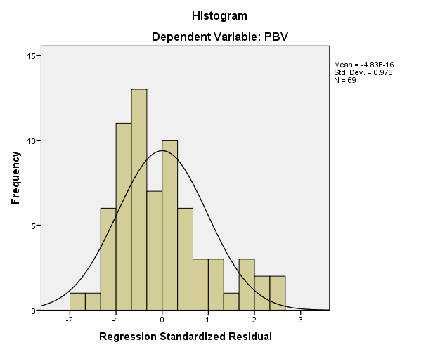

Figure 2. Histogram Graph

Source: Secondary Data Processed (2025)

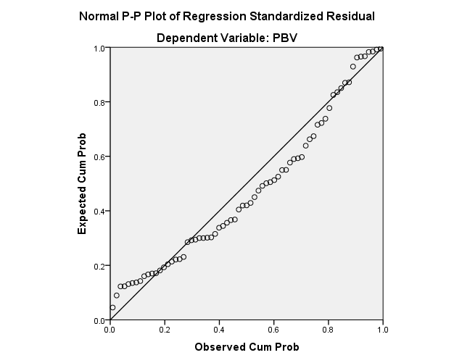

Figure 3. Normal PP-Plot Graph

Source: secondary data processed (2025)

**b. Autocorrelation Test Results.**

The autocorrelation test aims to determine whether the regression model is free from the autocorrelation problem. This test is known as the Durbin-Watson (DW) value, with the du<d<4-du criterion, where "du" is the Durbin-Watson table and "d" is the empirical Durbin-Watson statistic (Ghozali, 2021). In Table 1, the Durbin Watson number is 1.764, while the Mark DW (du) table on the sample size 69, free degrees 5% and the number of independent variables free 3 is 1.703, so 4-du 4-1.703=2.297. Above base information, the mean mark DW or "du" table is smaller than the empirical DW value or "d" and "d" is smaller than "4-du", so that the regression model fulfils criteria free from autocorrelation problems.

|  |  |  |  |  |  |
| --- | --- | --- | --- | --- | --- |
| **Table 1. Model Summaryb** | | | | | |
| Model | R | R Square | Adjusted R Square | Standard Error of the Estimate | Durbin-Watson |
| 1 | .623a | .388 | .360 | 1.33924 | 1,764 |
| a. Predictors: (Constant), ROA, DAR, Size | | | | | |
| b. Dependent Variable: PBV | | | | | |

Source: Secondary Data Processed (2025)

**c. Multicollinearity Test Results.**

The multicollinearity test aims to determine whether the regression model is free from the multicollinearity problem, indicating the absence of existing correlation between variables. This test can be known with a criterion tolerance value above 0.1 and a VIF value of less than 10 (Ghozali, 2021). Table 2 shows the criteria for the regression model study. This fulfils the assumptions free from multicollinearity problems.

**Table 2. Collinearity Statistics**

|  |  |  |  |
| --- | --- | --- | --- |
| Model | | Collinearity Statistics | |
| Tolerance | VIF |
| 1 | (Constant) |  |  |
| Size | .760 | 1,315 |
| DAR | .804 | 1,243 |
| ROA | .785 | 1,274 |
| a. Dependent Variable: PBV | | | |

Source: Secondary Data Processed (2025)

**d. Heteroscedasticity Test Results.**

The heteroscedasticity test aims to determine whether the data being processed with the regression technique is free from the heteroscedasticity problem. This test can utilise a chart scatterplot with criteria if no clear patterns and dots are spread above and below the number 0 on the Y-axis (Ghozali, 2021). Figure 4 shows the criteria that the regression model used in this Research is free from heteroscedasticity problems.

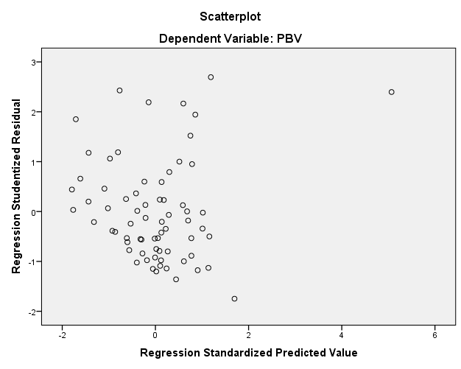

Figure 4. Scatterplot Graph Results

Source: Secondary Data Processed (2025)

**4.2. Model Feasibility Test Results.**

The model feasibility test is used to determine the exact linear regression model that will be used to analyse the sample research. The linear regression model is suitable for use if the empirical F-value at the level of significance is less than 0.05 (Ghozali, 2021). Table 3 shows a significance (sig) value of 0.000, which is smaller than 0.05, indicating that the regression model sample is worthy of use. While size variables are independent, they can explain their influence on dependent variables, as indicated by the adjusted R-squared value of 0.360 (Table 1). This contains the meanings of Size, DAR, and ROA, which can explain their influence on company value by 36%, while the remaining 64% (100%- 36%) is explained by other variables.

|  |  |  |  |  |  |  |
| --- | --- | --- | --- | --- | --- | --- |
| **Table 3. ANOVAa** | | | | | | |
| Model | | Sum of Squares | df | Mean Square | F | Sig. |
| 1 | Regression | 73,883 | 3 | 24,628 | 13,731 | .000 b |
| Residual | 116,582 | 65 | 1,794 |  |  |
| Total | 190,465 | 68 |  |  |  |
| a. Dependent Variable: PBV | | | | | | |
| b. Predictors: (Constant), ROA, DAR, Size | | | | | | |

Source: Secondary Data Processed (2025)

**4.3. Hypothesis Test Results.**

**Table 4. Coefficientsa**

|  |  |  |  |  |  |  |
| --- | --- | --- | --- | --- | --- | --- |
| Model | | Unstandardised Coefficients | | Standardised Coefficients | t | Sig. |
| B | Std. Error | Beta |
| 1 | (Constant) | .547 | .710 |  | .771 | .443 |
| Size | -.124 | .103 | -.134 | -1,200 | .235 |
| DAR | 3,309 | .861 | .416 | 3,844 | .000 |
| ROA | 17,314 | 2,984 | .635 | 5,802 | .000 |
| a. Dependent Variable: PBV | | | | | | |

Source: Secondary Data Processed (2025)

Hypothesis testing refers to the opinion of Ghozali (2021), which states that the hypothesis is accepted if the p-value is less than 0.05. In Table 4, it can be seen as follows:

1. The significance (sig) value of the size variable is 0.235 and greater than 0.05, meaning that Size has no significant effect on company value (PBV). The coefficient of the regression is negative; thus, Hypothesis 1 is rejected.
2. The significance (sig) value of the DAR variable is 0.000 and less than 0.05, indicating that DAR has a significant effect on company value (PBV). The coefficient of the regression is positive, as hypothesised, and thus Hypothesis 2 is accepted.
3. The significance (sig) value of the ROA variable is 0.004 and less than 0.05, indicating that ROA has a significant effect on company value (PBV). The coefficient of the regression is positive, as hypothesised, and thus Hypothesis 3 is accepted.

**4.4. Discussion.**

Test results for Hypothesis 1 show that Size matters negatively, with no significant effect on company value. This means that if the Size of the company increases, then the company value will decrease very slightly. The relationship logic that can be delivered is that while improving the Size of a proxy company with assets that are not productive, no increase in income will occur; in fact, it will add a burden. The increase in assets, for example, in the type of capital expenditure or physical asset investments that are still in development. Asset improvement, such as that, can respond to negative market sentiment, because a decline in price share can impact companies' value that are also declining. Size that is not influential to company value by the opinion of Fadillah & Noormansyah (2023) and Azaro et al. (2020), however, contradictory with the results of Research by Prieto et al. (2024), Mahirah et al. (2022) and Radja & Artini (2020), which revealed a significant positive result.

Test results for hypothesis 2 show that leverage with an influential DAR proxy is positively significant to company value, meaning that an increase in DAR will also increase company value. This confirms that trust in creditors and markets in the food and beverage company at IDX is high. This research result aligns with the findings of Santioso (2025), Sulistiyo et al. (2024), Sulistiyo et al. (2023), and Bon & Hartoko (2022), who have revealed that leverage has a significantly positive effect on company value.

Test results for hypothesis 3 indicate that profitability, as measured by an influential ROA proxy, is positively and significantly related to company value, suggesting that an increase in ROA will also lead to an increase in the company's value. This confirms that investors and the market respond positively to the improvement in business profitability of IDX food and beverages. This Research results in harmony with the findings of Subiyanto et al. (2024), Faoziyanti & Renny (2024), Siregar et al. (2023), Damayanti & Sucipto (2022), and Setyabudi (2021), who revealed that profitability has a positive and significant influence on company value.

**5. CONCLUSIONS AND IMPLICATIONS.**

This conclusion study reveals that Size is influential, negative, and not significant to company value, while leverage and profitability are influential, positive, and significant to company value. This Research Is expected to provide insight for management issuers to increase company value by paying attention to size, leverage, and profitability. In addition, they can strengthen the theoretical signal by providing empirical proof about the influence of leverage and profitability on company value.

This study notes the limitations of the objects studied, which are limited to one type: business food and beverage, resulting in a lack of variety, which is very Possible. It cannot be generalised to other industries. Therefore, for the upcoming study, the samples should be expanded to other industries.

COMPETING INTERESTS

Authors have declared that they have no known competing financial interests OR non-financial interests OR personal relationships that could have appeared to influence the work reported in this paper.

Disclaimer (Artificial intelligence)

Author(s) hereby declare that NO generative AI technologies such as Large Language Models (ChatGPT, COPILOT, etc.) and text-to-image generators have been used during the writing or editing of this manuscript.

References

Azaro, K., Djajanto, L., & Sari, PA (2019). The Influence of Financial Ratios and Firm Size on Firm Value, *Advances in Economics, Business and Management Research*, 136, 142-147.

Bon, S. F., & Hartoko, S. (2022). The Effect of Dividend Policy, Investment Decision, Leverage, Profitability, and Firm Size on Firm Value. *European Journal of Business and Management Research*, 7(3), 7-13. <https://ejbmr.org/index.php/ejbmr/article/view/1405/766>

Berger, A.N., & Bonaccorsi di Patti, E. (2006). Capital Structure and Firm Performance: A New Approach to Testing Agency Theory and An Application to The Banking Industry. *Journal of Banking & Finance*, 30(4), 1065–1102.

Brigham, E. F., & Daves, P. R. (2019). *Intermediate Financial Management (13th ed.)*. Cengage Learning.

Brigham, E. F., & Houston, J.F. (2021). *Fundamentals of Financial Management* (15th ed.). Cengage Learning.

Dang, C., Li, Z., & Yang, C. (2018). Measuring Firm Size in Empirical Corporate Finance. *Journal of Banking & Finance*, 86, 159–176.

Damayanti, R. & Sucipto, A. (2022). The Effect of Profitability, Liquidity, and Leverage on Firm Value with Dividend Policy as Intervening Variable (Case Study on Finance Sector in Indonesian Stock Exchange 2016-2020 Period). *International Journal of Economics, Business and Accounting Research*, 6(2), 863-876.

Faoziyanti, A., & Renny (2024). The Influence of Good Corporate Governance and Profitability on Firm Value of Banking Sub Sector Companies. *Journal of Applied Business,Taxation and Economics Research*, 3(6), 625-641. <https://equatorscience.com/index.php/jabter/article/view/295/253>

Fadillah & Noormansyah (2023). The Influence of Sustainability Report, Intellectual Capital, Liquidity, and Firm Size on Firm Value. *Research of Finance and Banking*, 1(1), 22-33. <https://sanscientific.com/journal/index.php/rfb/article/view/33>

Frank, M. Z., & Goyal, V. K. (2009). Capital Structure Decisions: Which Factors Are Reliably Important? *Financial Management*, 38(1), 1–37.

Gitman, L. J., & Zutter, C. J. (2015). *Principles of Managerial Finance* (14th ed.). Pearson Education.

Ghozali, I. (2021). *Application Multivariate Analysis with IBM SPSS 26 Program, 10th Edition.* Publishing Agency University Diponegoro.

IDX. (2023). *IDX Monthly Statistics* *December 2023*. Indonesia Stock Exchange-Data Services Division. <https://www.idx.co.id/Media/5zfjqgdg/idx-monthly-dec-2023.pdf>

IDX. (2022). *IDX Yearly Statistics* *2022*. Indonesia Stock Exchange-Data Services Division. <https://www.idx.co.id/Media/5pfnt4gg/idx_yearly_statistics_2022.pdf>

IDX. (2021). *IDX Statistics* *2021*. Indonesia Stock Exchange-Data Services Division. <https://idx.co.id/media/10776/idx_annually-statistic_2021.pdf>

Jensen, M. C., & Meckling, W. H. (1976). Theory of the Firm: Managerial Behavior, Agency Costs and Ownership Structure. *Journal of Financial Economics*, 3(4), 305–360.

Jensen, M. C. (1986). Agency Costs of Free Cash Flow, Corporate Finance, and Takeovers. *American Economic Review*, 76(2), 323–329.

Komara A, Ghozali I, Januarti I. (2019) Examining the firm value based on signaling theory. *Proceedings of the 1st International Conference on Accounting, Management and Entrepreneurship (ICAMER 2019)*. <https://www.atlantis-press.com/proceedings/icamer-19/125936207>

Mahirah, A., Uzliawati, L., & Soleha, N. (2023). Effects of Firm Size and Capital Structure on Firm Value (Empirical Study of Telecommunication Companies Listed on the Indonesia Stock Exchange for 2018-2021). Review of Accounting and Taxation, 2(2), 126-136. <https://pdfs.semanticscholar.org/49bf/ce2b1fc90d53834d778ac60f0386bfe1c5a7.pdf>

Pindado, J., & de la Torre, C. (2011). The Role of Investment, Financing and Dividend Decisions in Explaining Corporate Ownership Structure: Empirical Evidence from Spain. *European Financial Management*, 17(4), 704–730.

Prieto, A. B. T., Lee Y., & Falcones, W. A. (2024). The Moderating Role of Corporate Governance in the Relationship between Leverage and Firm Value: Evidence from the Korean Market. *Risks-MDPI*, 12(11), 1-19.

Radja, F. L, & Artini, L. G. S. (2020). The Effect of Firm Size, Profitability and Leverage on Firm Value (Study on Manufacturing Companies Sector Consumer Goods Industry Listed in Indonesian Stock Exchange Period 2017-2019). *International Journal of Economics and Management Studies*, 7(11), 18-24.

Santioso, L. (2025). The Effect of Profitability, Company Size, Sales Growth and Leverage on Firm Value. International Journal of Application on Economics and Business, 3(1), 299-309. <https://journal.untar.ac.id/index.php/ijaeb/article/view/34082>

Setyabudi, TG (2021). The Effect of Institutional Ownership, Leverage, and Profitability on Firm Value: Dividend Policy as an Intervening Variable. *Journal of Business and Management Review*, (7), 457-469.

Siregar, S. D., Toni, N. & Ariesa, Y. (2023). Impact of Dividend Policy, Capital Structure, and Profitability on Consumer Goods Firm Value: Role of Firm Size (2013-2022). *Journal of Economics and Business Letters*, 3(4), 38-48.

Spence, M. (1973). Job Market Signalling. *The Quarterly Journal of Economics*, 87(3), 355–374.

Subiyanto, B., Maulidya, R., & Melati . (2024). Profitability and Firm Value: How Does Good Corporate Governance Affect Them? *International Journal of Economics, Management, Business, and Social Science*, 4(1), 64-74.

Sulistiyo, H., Sitawati, R., Sutono & Sudarman (2024). Examining Firm Value Drivers: An Empirical Analysis of Property and Real Estate Companies on the Indonesian Stock Exchange. *Asian Journal of Economics, Business and Accounting*, 24(6), 273-279.

Sulistiyo, H., Sutono & Manaf, S. (2023). Increasing Company Value in Times of Environmental Uncertainty. *Asian Journal of Economics, Business and Accounting*, 23(23), 169-178.

Virdiani, R. M., & Setiyono, W. (2021). The Influence of Company Size, Capital Structure and Enterprise Risk Management on the Value of Companies Listed on the Indonesia Stock Exchange (IDX) in 2014-2018. *Academia Open*, 5, 1-12.

Wijaya, L. H., & Susilowati, C. (2024). The Influence of Company Size, Company Growth, Leverage and Profitability on Corporate Value. *Journal Education*, 12(1), 105-112.