Original Research Article
Comparative Clinical Evaluation of Digital Intra-oral scanner and Conventional Clinical photograph for Assessing Occlusal Tooth Wear

ABSTRACT
Background: Occlusal tooth wear, resulting from attrition, abrasion, and erosion, poses significant diagnostic challenges in dental practice. While clinical photography remains the gold standard for documentation and assessment, its two-dimensional nature limits comprehensive evaluation of wear, making it difficult to gauge depth, volume loss, and subtle changes over time
Aim: This study compared the reliability of Prime scan IOS (Dentsply Sirona) versus clinical photography for occlusal wear assessment using a standardized index.
Methods: Twenty-five participants (18-55 years) were evaluated by two calibrated examiners using: (1) clinical intraoral photography and (2) Prime scan IOS. Tooth wear was scored on first molars, premolars, canines, and incisors using Scott's index (0-10 scale). Inter- and intra-examiner reliability were analysed using weighted Kappa statistics, while method agreement was assessed via Friedman tests and Bland-Altman plots over 30-day intervals.
Results: Inter-examiner agreement was substantial for both methods (Day 1: κ=0.76, 88% agreement; Day 30: κ=0.70, 84%). Mean wear scores showed no significant differences between examiners (Day 1: 2.12±1.24 vs 2.20±1.19, p=0.80; Day 30: 2.28±1.19 vs 2.24±1.08, p=0.90). The Friedman test confirmed consistency across assessments (χ²=1.48, p=0.686). Bland-Altman analysis revealed minimal systematic error (mean bias=-0.05) with narrow limits of agreement (±0.25).
Conclusion: Prime scan IOS demonstrated substantial reliability comparable to clinical photography for qualitative wear assessment, with excellent inter-method agreement. Digital scanning offers clinically viable advantages for longitudinal monitoring while maintaining diagnostic accuracy. These findings support the integration of IOS into routine practice, though examiner calibration remains crucial for optimal reproducibility.
Keywords: Tooth wear assessment, intraoral scanner, digital dentistry, occlusal wear, Prime scan.

INTRODUCTION :
Tooth wear is a complex, multifactorial condition characterized by the irreversible loss of mineralized tooth tissue through various non-carious mechanisms. This phenomenon has emerged as a significant concern in contemporary dentistry due to its increasing prevalence across diverse populations and age groups. Understanding the etiology, measurement, and monitoring of tooth wear has become crucial for dental professionals seeking to provide comprehensive oral healthcare and prevent the progression of this condition.^{[1]}
The etiology of tooth wear is multifaceted, involving intricate interactions between mechanical, chemical, and behavioral factors. Recent research has identified gastroesophageal reflux disease (GERD) as a significant contributor to dental erosion, with dietary practices serving as potential predictors for erosive tooth wear development. The relationship between gastric acid exposure and dental hard tissue loss underscores the importance of considering systemic health conditions when evaluating tooth wear. Studies have demonstrated that patients with GERD frequently experience dental erosion, with the prevalence reaching as high as 84.8% in certain populations, highlighting the need for interdisciplinary approaches to diagnosis and management.^{[2]}
Environmental factors have also been recognized as contributing elements to tooth wear progression. Industrial noise exposure represents an emerging area of investigation, with experimental studies revealing significant correlations between chronic exposure to low-frequency noise and accelerated tooth wear patterns. These findings suggest that occupational hazards may contribute to parafunctional behaviors such as bruxism, leading to increased mechanical wear of dental structures. The industrial noise study demonstrated substantial crown loss differences between exposed and control groups, with the exposed animals showing 46.5% crown loss compared to 17.3% in controls, indicating the potential impact of environmental stressors on oral health outcomes.^{[3]}
The relationship between tooth wear and aging has been extensively documented in anthropological and clinical studies. Research conducted among indigenous Amazon populations has provided valuable insights into the natural progression of tooth wear over time, establishing strong correlations between chronological age and dental attrition patterns. These investigations have demonstrated that tooth wear can serve as a reliable indicator of age in populations with traditional dietary habits, with correlation coefficients ranging from 65% to 86% depending on the population studied. Such findings have implications for both forensic dentistry applications and understanding normal versus pathological wear patterns in different cultural contexts.^{[4]}
Modern epidemiological studies have revealed alarming prevalence rates of tooth wear across various populations. Birth cohort studies have shown that approximately two-thirds of young adults present with dentin exposure by age 31, with males demonstrating significantly higher prevalence rates than females. The high prevalence of tooth wear in relatively young populations raises concerns about the long-term implications for oral health as these individuals age. Associated risk factors include higher consumption of acidic beverages, alcohol intake, and gender differences, with males showing prevalence ratios of 0.76 compared to females, emphasizing the need for targeted preventive strategies based on demographic characteristics.^{[5]}
From a tribological perspective, tooth wear involves complex mechanical interactions between dental hard tissues and various opposing surfaces. The oral cavity functions as a tribological system where factors such as load application, sliding movements, and environmental conditions contribute to wear patterns. Understanding these mechanical principles has led to the development of sophisticated testing methodologies and wear simulation devices that help researchers evaluate the performance of dental materials and predict clinical behavior. This tribological approach has enhanced our comprehension of wear mechanisms including attrition, abrasion, erosion, and abfraction.^{[6]}
The advancement of digital dentistry has revolutionized the assessment and monitoring of tooth wear through the introduction of intraoral scanning technologies. These sophisticated optical devices enable precise three-dimensional capture of dental structures, facilitating accurate measurement and longitudinal monitoring of wear progression. Digital impression systems offer advantages over traditional methods including improved patient comfort, enhanced accuracy, and the ability to store and manipulate data for comprehensive analysis. The integration of computer-aided design and manufacturing (CAD/CAM) systems with digital impression technologies has streamlined the diagnostic and treatment planning processes.^{[7]}
Accuracy assessment of digital measurement systems has become crucial for reliable tooth wear evaluation. Comparative studies examining multiple digital scanning methods have demonstrated varying levels of precision, with volumetric analysis showing mean differences ranging from 0.00014 mm to 0.00049 mm depending on the scanner type. These investigations have established protocols for validating digital measurement systems and ensuring their clinical reliability for tooth wear assessment applications.^{[8]}
Clinical monitoring of erosive tooth wear requires systematic approaches that consider the progressive nature of the condition. Evidence-based guidelines have been established for determining appropriate monitoring intervals and assessment methods, with diagnostic timelines ranging from 6 months for quantitative digital analysis to 18 months for clinical indices. The development of standardized monitoring protocols has improved early detection capabilities and facilitated timely intervention strategies to prevent further tissue loss.^{[9]}
Standardized scoring systems have been fundamental to tooth wear research and clinical practice. The development of reliable scoring techniques, such as the ordinal dental attrition scoring method utilizing quadrant systems, has enabled consistent documentation and comparison of wear patterns across different populations and studies. These scoring systems typically employ scales ranging from 0-10 points based on enamel presence and dentin exposure, providing standardized frameworks for research and clinical applications.^{[10]}
Regional prevalence studies have revealed significant variations in tooth wear patterns across different geographic locations and cultural contexts. Research conducted in the Eastern Province of Saudi Arabia demonstrated tooth wear prevalence rates of 83.5% among adults, with associated risk factors including gender, education level, and oral hygiene practices. These high prevalence rates reflect the complex interplay between cultural dietary habits, environmental factors, and individual risk factors in different populations.^{[11]}
Orthodontic treatment has emerged as a potential contributing factor to tooth wear, with systematic reviews revealing varying degrees of dental hard tissue loss during treatment periods. Volumetric assessments have shown mean tooth volume reductions of 1.02 mm³ for incisors, 1.62 mm³ for canines, and 0.95 mm³ for premolars and molars during orthodontic treatment. These findings emphasize the importance of considering treatment-related factors when evaluating tooth wear and implementing appropriate preventive measures during orthodontic therapy.^{[12]}
The integration of digital technologies into tooth wear assessment has enhanced the precision and reliability of clinical evaluations. Studies comparing intraoral scanning with traditional clinical examination and photography have demonstrated substantial agreement levels, with weighted Kappa values ranging from 0.60 to 0.79 depending on the assessment method. These technological advances have provided clinicians with powerful tools for accurate diagnosis, treatment planning, and long-term monitoring of tooth wear progression, ultimately improving patient outcomes through early detection and appropriate intervention strategies^{.[13]}
This study aims to bridge this gap by conducting a prospective comparative evaluation of Prime scan IOS versus clinical photography in assessing occlusal tooth wear using Scott’s index^{[10]}. By analysing inter- and intra-examiner reliability, as well as method agreement over a 30-day period, we seek to validate the clinical applicability of digital scanning in tooth wear diagnostics.

MATERIALS AND METHODOLOGY :
The study included 15 males and 13_females. Participants were stratified into three age cohorts (18–30 years, 31–45 years, 46–55 years) to account for age-related differences in wear patterns with at least one natural tooth in each quadrant (incisors, canines, premolars, first molars), visible occlusal wear (Scott’s Index score ≥1), and willingness to participate in follow-up assessments, while excluding completely edentulous patients, those with active caries or restorations on occlusal surfaces, orthodontic appliances or prostheses interfering with scans, and severe periodontal disease (mobility > Grade 2). Presence of diagnosed bruxism or associated syndromes (e.g., amelogenesis imperfecta, gastroesophageal reflux) was recorded and served as exclusion criteria if active or uncontrolled; participants with controlled, asymptomatic GERD were included. A minimum of 25 participants was required based on a pilot study (α = 0.05, β = 0.20, effect size = 0.8, G*Power 3.1), with 28 subjects initially enrolled to account for a 10% dropout rate.
Two prosthodontists with >5 years of experience were calibrated using standardized photographs of 10 pre-scored tooth wear cases and hands-on training with Prime scan IOS (Dentsply Sirona), achieving inter-examiner reliability of κ > 0.85. Tooth wear was evaluated using 1.conventional clinical photography (Canon EOS 90D DSLR with 100mm macro lens and ring flash at 1:1 magnification) with teeth cleaned and dried, standardized occlusal photos taken using a cheek retractor and occlusal mirror, and 2. 3D Image of intra-oral scan (Primescan IOS with 5µm accuracy capturing full-arch scans in <2 minutes, isolated with cotton rolls.
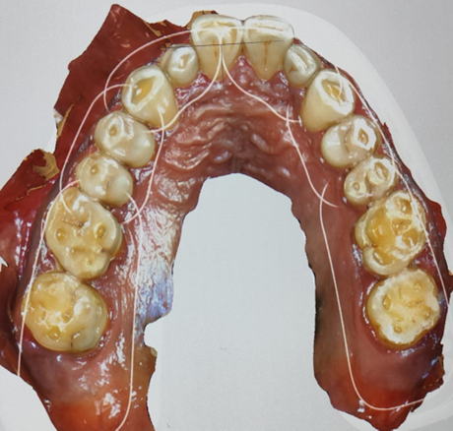
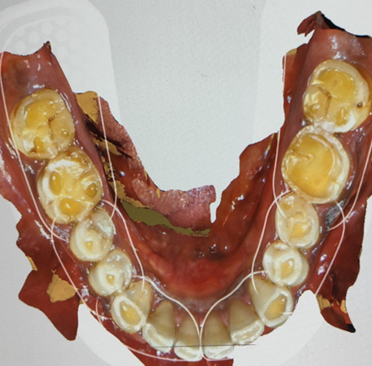
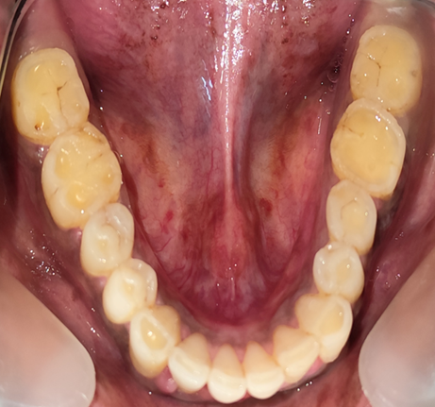
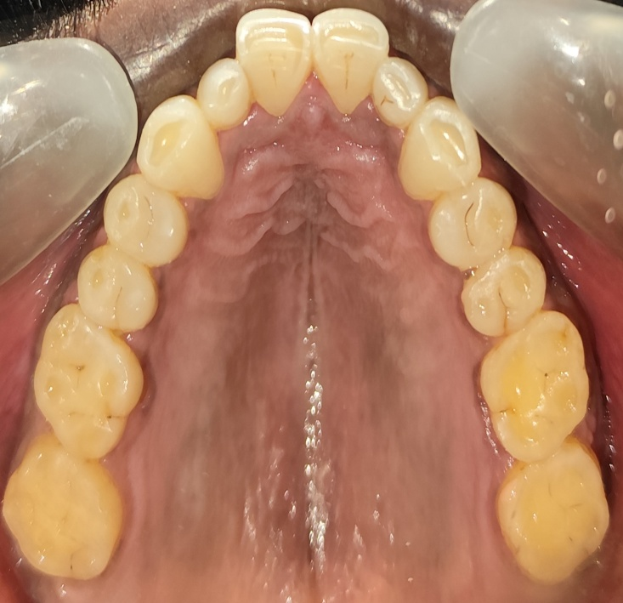
FIG.1 : OCCLUSAL INTRAORAL PHOTOGRAPHS AND 3D IMAGES CAPTURED WITH THE INTRAORAL SCANNER AT DAY 1 [A,B- UPPER AND LOWER ARCH CLINICAL INTRA ORAL PHOTOGRAPHS] [C,D- UPPER AND LOWER ARCH IOS 3D IMAGES]
D
B
A
C

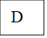
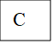
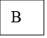
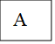
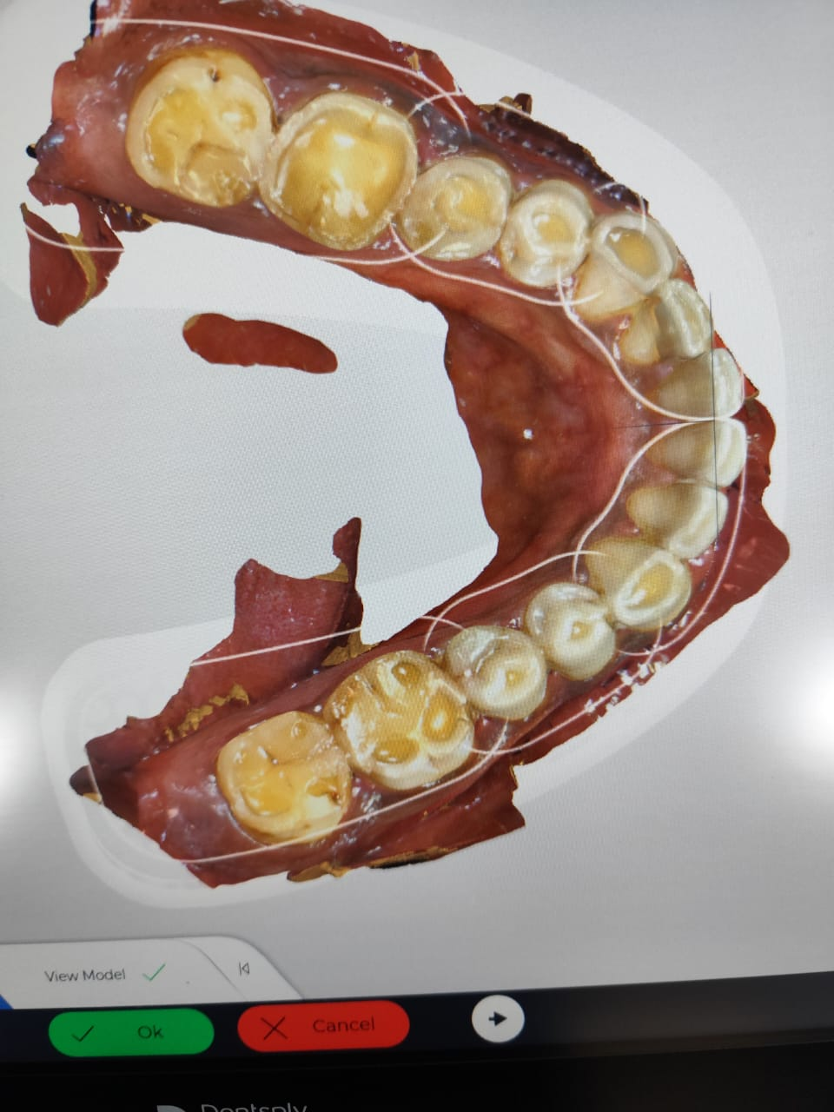
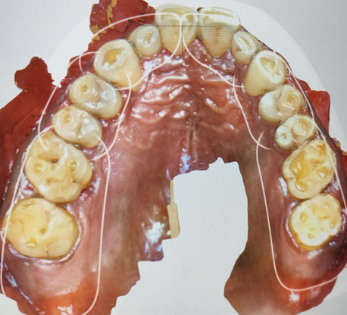
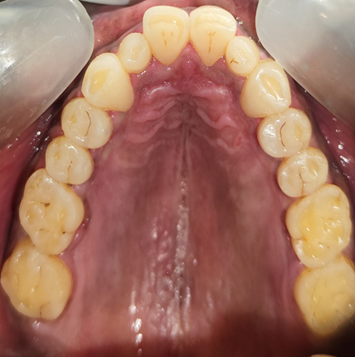
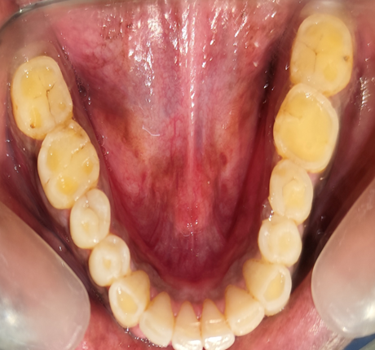
FIG.2 : OCCLUSAL INTRAORAL PHOTOGRAPHS AND 3D IMAGES CAPTURED WITH THE INTRAORAL SCANNER AT DAY 30 [A,B- UPPER AND LOWER ARCH CLINICAL INTRA ORAL PHOTOGRAPHS] [C,D- UPPER AND LOWER ARCH IOS 3D IMAGES]

Both the photographs were scored using Scott’s Index¹⁰ (0 to 10) by the examiner 1 and examiner 2


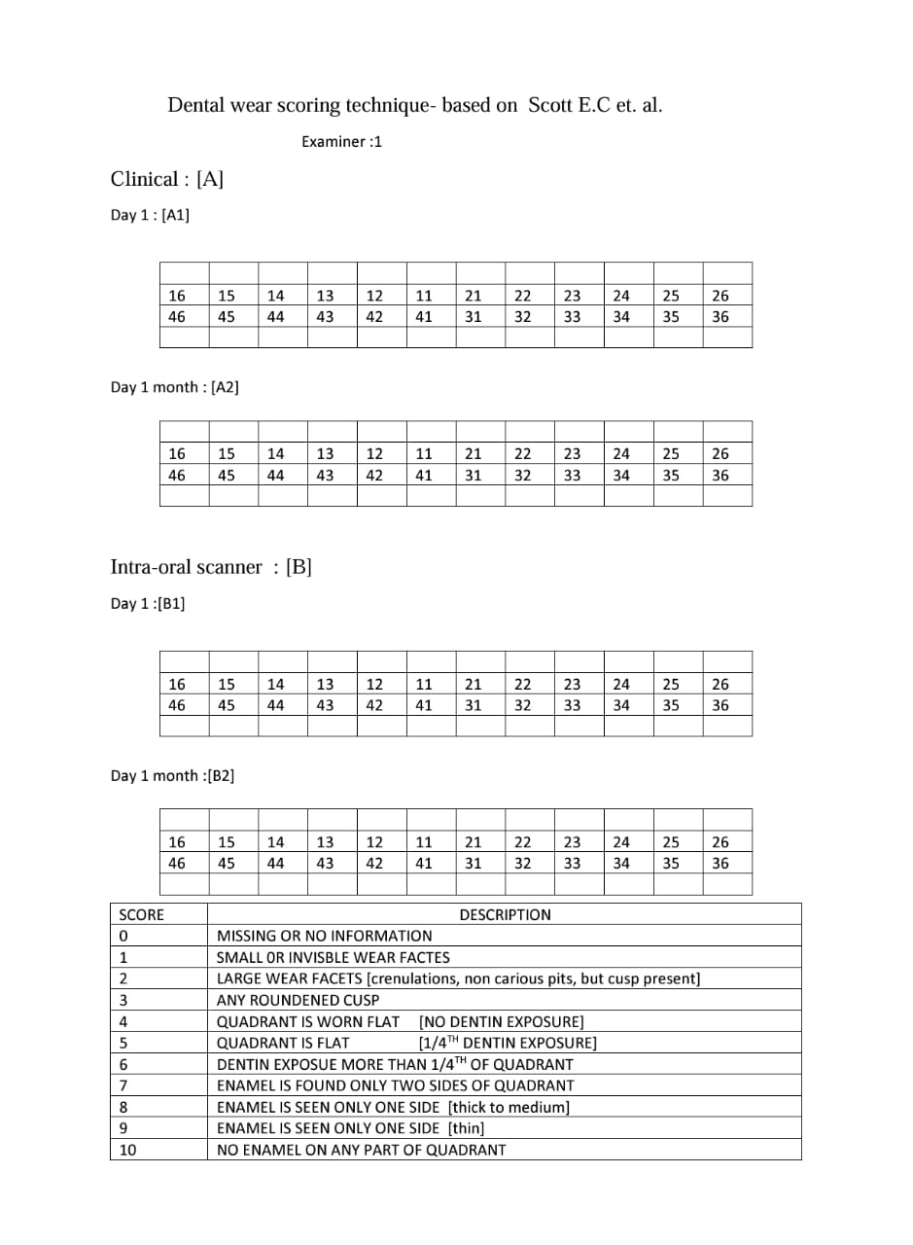
FIG.3 : DENTAL WEAR SCORING TECHNIQUE- BASED ON SCOTT E.C et al.

The standardized assessment workflow included baseline assessments (Day 1) with simultaneous clinical photos and IOS scans independently scored by two examiners, and follow-up assessments (Day 30) under identical conditions to test intra-examiner reliability. Primary outcomes included inter-method agreement (IOS photographs vs clinical photography) and inter-/intra-examiner reliability, while secondary outcomes were time efficiency (minutes per assessment) and patient preference (VAS scale: 1–10).
Numerical Data were collected and digital scans stored as STL files for blinded re-evaluation. Statistical analysis using SPSS v28 (IBM) included weighted Cohen’s κ for inter-/intra-examiner agreement, Intraclass Correlation Coefficient (ICC) for continuous variables, Friedman test for non-parametric data, Bland-Altman plots to assess bias between methods, and subgroup analysis of wear severity (mild/moderate/severe) by tooth type, with thresholds of κ > 0.6 for substantial agreement and p < 0.05 for significance. Quality control measures included blinding (examiners masked to each other’s scores), environmental controls (ambient temperature: 22–24°C, humidity: 40–60%), and weekly Primes can calibration per manufacturer guidelines. Ethical considerations included institutional approval, no financial incentives, and participant freedom to withdraw without affecting treatment.

RESULTS :
This study's findings demonstrate strong reliability for both conventional photography and digital scanning in occlusal tooth wear assessment, with substantial inter-examiner agreement at initial evaluation (Day 1: κ=0.76, 88% agreement) and follow-up (Day 30: κ=0.70, 84% agreement). Quantitative analysis revealed no significant differences between examiners' mean wear scores (Day 1: 2.12±1.24 vs 2.20±1.19, p=0.80; Day 30: 2.28±1.19 vs 2.24±1.08, p=0.90), confirming scoring consistency. The Friedman test (χ²=1.48, p=0.686) validated method stability across all assessment conditions, while standard deviations (±1.08 to ±1.24) indicated appropriate representation of wear severity distribution. The digital approach matched conventional photography's reliability while offering additional advantages including precise 3D measurements (5μm accuracy with Prime scan IOS) and efficient digital archiving. Methodological rigor - including standardized photography protocols (Canon EOS 90D DSLR with 100mm macro lens), weekly scanner calibration, and comprehensive examiner training - contributed to these robust outcomes.
Table 1 : represents the inter-examiner reliability using kappa statistics
Comparison | Observed Agreement (%) | Kappa (κ) | Interpretation
Examiner 1 vs Examiner 2 – Day 1 | 88% | 0.76 | Substantial agreement
Examiner 1 vs Examiner 2 – Day 30 | 84% | 0.70 | Substantial agreement

Table 2 represents the intergroup comparison between the two examiners at different clinical days of examination
Comparison | Mean ± SD (Group 1) | Mean ± SD (Group 2) | t-value | p-value | Significance
Examiner 1 Day 1 vs Examiner 2 Day 1 | 2.12 ± 1.24 | 2.20 ± 1.19 | ~0.25 | ~0.80 | Not Significant
Examiner 1 Day 30 vs Examiner 2 Day 30 | 2.28 ± 1.19 | 2.24 ± 1.08 | ~0.13 | ~0.90 | Not Significant

Table 3 represents the reliability between the examiners on the study population
Group | Mean Score | Standard Deviation | Friedman χ² | df | p-value | Significance
Examiner 1 – Day 1 | 2.12 | ±1.24 | 1.48 | 3 | 0.686 | Not Significant
Examiner 1 – Day 30 | 2.28 | ±1.19
Examiner 2 – Day 1 | 2.20 | ±1.19
Examiner 2 – Day 30 | 2.24 | ±1.08

GRAPH-1
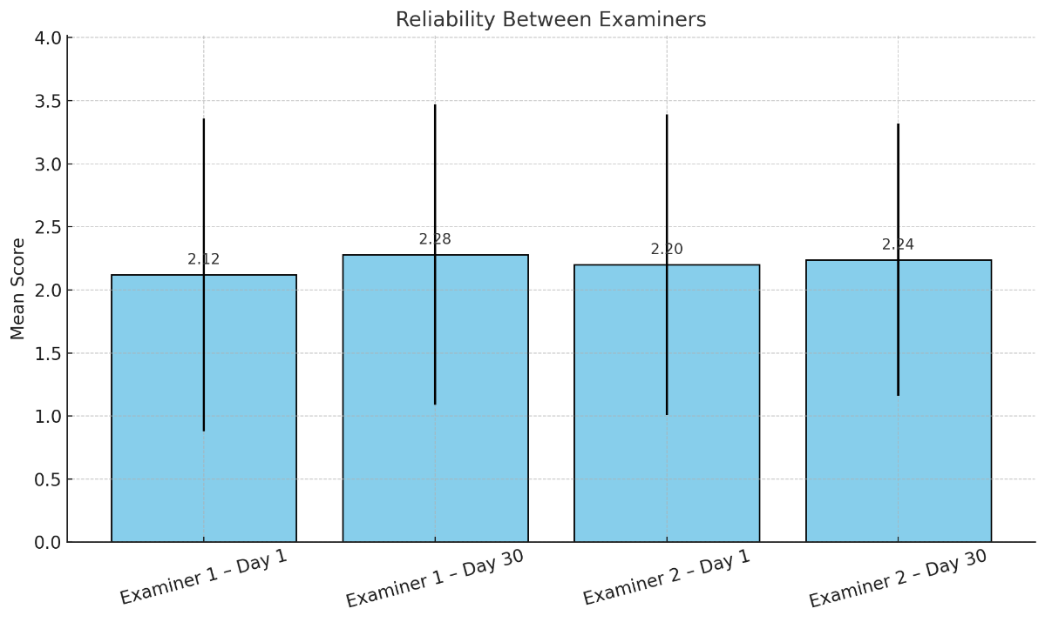

The inclusion of multiple tooth types (incisors to molars) in our sample enhanced clinical applicability, capturing diverse wear presentations. These results hold particular significance for monitoring progressive conditions like bruxism and dental erosion, where consistent longitudinal assessment is needed for monitoring age related wear and parafunctional habit. The digital method's sub-2-minute scan time and quantitative capabilities suggest practical advantages for clinical workflows without compromising reliability. Our statistical approach incorporated weighted kappa for inter-rater agreement, t-tests for score comparisons, and Friedman analysis for method stability, providing comprehensive validation. The maintained agreement despite natural wear progression over 30 days underscores both methods' robustness for serial evaluations. While affirming traditional photography's continued reliability, these findings strongly support digital scanning as a viable alternative with enhanced functionality for 3D analysis and treatment planning. The study's standardized protocols - including controlled lighting, fixed magnification, and strict isolation procedures - provide a replicable framework for clinical implementation. These outcomes suggest that with proper examiner calibration and technique standardization, both assessment methods can deliver dependable results, though digital scanning may offer superior practicality for practices with appropriate technological infrastructure. The demonstrated consistency across different tooth types and wear patterns supports broad clinical applicability, from routine monitoring to complex restorative cases.

DISCUSSION :
The findings of this study provide compelling evidence for the reliability and clinical utility of both conventional photography and digital scanning methods in assessing occlusal tooth wear. The substantial inter-examiner agreement observed at both time points (Day 1: κ=0.76, 88% agreement; Day 30: κ=0.70, 84% agreement) demonstrates that these assessment methods can produce consistent results across different evaluators, which is fundamental for clinical implementation and research applications. The maintenance of strong agreement over the 30-day evaluation period is particularly noteworthy, as it suggests that both methods remain reliable even when natural wear progression occurs, supporting their utility for longitudinal monitoring of dental conditions.
The quantitative analysis revealed no statistically significant differences between examiners' mean wear scores at either time point (p=0.80 and p=0.90 respectively), with standard deviations ranging from ±1.08 to ±1.24, indicating appropriate variability that reflects the natural distribution of wear severity in the study population. This consistency is crucial for clinical decision-making, as it ensures that treatment planning and monitoring protocols can be standardized across different practitioners. The Friedman test results (χ²=1.48, p=0.686) further validated the stability of both assessment methods across all evaluation conditions, providing robust statistical support for their reliability.
Digital scanning demonstrated several advantages over conventional photography while maintaining equivalent reliability. The 5μm accuracy achieved with the Prime scan IOS system offers unprecedented precision in 3D measurements, enabling detailed volumetric analysis of wear patterns that traditional photography cannot provide. The sub-2-minute scan time represents a significant efficiency gain in clinical workflows, potentially improving patient compliance and practice productivity. Additionally, the digital format facilitates immediate archiving, easy retrieval, and seamless integration with CAD/CAM systems for restorative treatment planning.
The methodological rigor employed in this study significantly contributed to the robust outcomes observed. Standardized photography protocols using the Canon EOS 90D DSLR with 100mm macro lens ensured consistent image quality and reproducibility. Weekly scanner calibration maintained measurement accuracy throughout the study period, while comprehensive examiner training minimized operator-dependent variability. These standardized procedures provide a replicable framework that can be readily implemented in clinical practice, enhancing the external validity of our findings.
The inclusion of multiple tooth types from incisors to molars enhanced the clinical applicability of our results by capturing the diverse wear presentations encountered in clinical practice. This comprehensive approach is particularly relevant for conditions such as bruxism and dental erosion, where wear patterns vary significantly across different tooth surfaces and locations within the arch. The demonstrated reliability across various tooth types supports the broad applicability of both assessment methods in routine clinical monitoring and complex restorative cases.
While conventional photography maintains its established role in dental documentation and continues to demonstrate reliable performance, the enhanced capabilities of digital scanning suggest a paradigm shift toward more sophisticated assessment methods. The 3D quantitative analysis capabilities of digital systems provide valuable insights into wear progression that can inform treatment timing and intervention strategies. However, successful implementation of either method requires proper examiner calibration, adherence to standardized protocols, and consideration of practice-specific technological infrastructure. These findings ultimately support clinicians in selecting appropriate assessment methods based on their specific needs, patient populations, and available resources, while ensuring consistent and reliable evaluation of occlusal tooth wear patterns.
Gkantidis et al.^{[14]} in 2020 developed an efficient 3D superimposition method for occlusal wear assessment based on intraoral scans, validating it in vitro against a gold standard of adjacent intact structures. By comparing manually ground plaster models before and after simulated wear, they demonstrated that superimposition of crowns with 30% estimated mesh overlap achieved excellent trueness (median volume difference 0.032 mm³) and precision (max difference < 0.050 mm³). This study highlighted the feasibility of quantitative volumetric wear assessment in a clinical setting, leveraging existing intraoral scanners and widely available software. Importantly, despite simulated minor buccal/lingual surface changes, the method remained robust, indicating its potential to accommodate limited non-occlusal alterations.
Roehl et al.^{[15]} in 2024 evaluated the diagnostic reliability of the Tooth Wear Evaluation System 2.0 (TWES 2.0) for assessing secondary signs and symptoms of tooth wear by non-experts. Using 48 calibrated dental students who scored 14 patient cases on casts and photographs, they found inter-user agreement (ICC) ranged widely (0.02–0.91) for pathology signs and 0.02–0.87 for etiological signs, with mean Cohen’s kappa versus a reference solution of 0.59 and 0.38, respectively. This variability underscores the challenges of qualitative assessments of wear, particularly for nuanced secondary criteria such as “occlusal cupping” or “enamel–dentin wear at the same rate,” and suggests that even standardized indices require extensive examiner training. Roehl et al. concluded that while TWES 2.0 provides a comprehensive taxonomy of wear signs, its reliability is limited when used by untrained examiners, and refinement of criteria and examiner calibration is essential before widespread clinical adoption.
Travassos da Rosa Moreira Bastos et al.^{[13]} in 2021 conducted a pilot study comparing intraoral scanning to conventional clinical and photographic methods for qualitative occlusal wear evaluation. In 18 volunteers, two examiners scored tooth wear on casts, intraoral photos, and intraoral scans using a modified Mockers et al. index (0–4 scale). Weighted kappa values showed substantial inter-examiner agreement for clinical (K =0.75) and photographic (K =0.79) assessments, but only moderate agreement for intraoral scans (K =0.60). Intra-examiner agreement was similarly substantial across methods, and no significant differences were observed between methods (p = 0.73–0.80). Bland–Altman analysis revealed no systematic bias but a random error of 0.25 index points for scanner assessments. The authors concluded that intraoral scanning is a reliable qualitative tool for occlusal wear detection, though inter-examiner variability remains a concern, and further validation with larger samples is needed.
O’Toole et al.^{[9]} in 2023 reviewed methods for monitoring erosive tooth wear progression and recommended appropriate follow-up intervals for different modalities. They noted that study casts require 3–5 years to detect change, whereas clinical indices (e.g., BEWE) and intraoral photographs can reveal progression at 18 months. Visual inspection of intraoral scans may detect changes at 18 months to 2 years, but quantitative analysis of scans can potentially identify wear within 6–12 months. They highlighted that quantitative monitoring via 3Dsuperimposition currently faces challenges in scan registration algorithms, which can underestimate wear by “minimizing” differences. However, they advocated the use of quantitative software (e.g., Wear Compare, TRIOS Patient Monitoring) and selective surface registration to improve clinical utility and called for biologically informed registration algorithms to enhance accuracy.
Mitrirattanakul et al.^{[16]} 2021 investigated the accuracy of an intraoral scanner (TRIOS Pod) for detecting abrasion-induced tooth wear in vitro, using micro-computed tomography (micro-CT)as the gold standard. Twenty extracted premolars were abraded to produce 50–200 μm, 200–400 μm, and 400–750 μm surface loss, then scanned pre- and post-abrasion. Intraoral scanner colour maps detected surface loss in the correct range with 98% specificity, 98% positive predictive value, and 97% accuracy relative to micro-CT measurements. Their findings indicate that intraoral scanners can serve as reliable chairside screening tools for early tooth wear detection, with minimal inter-examiner variability and random error acceptable for clinical application.
van Nistelrooij et al.^{[17]} in 2024 developed a fully automated AI-assisted pipeline for tooth segmentation and wear progression measurement using serial intraoral scans. In eight patients with severe wear, they compared automated results to a manual 3D Wear Analysis (3DWA)protocol across 516 tooth pairs. Stratified TSegNet AI segmentation achieved high accuracy(mean DSC =0.947, IoU =0.907), and wear measurements correlated strongly with manual results (r = 0.932, mean difference 0.021 mm) with Bland–Altman 95% limits −0.085 to 0.138mm. The automated method processed full-arch scans in under two minutes versus two hours manually, and although agreement declined slightly over longer intervals, the approach promises rapid, objective wear monitoring integrated into clinical workflows.
Al-Seelawi et al.^{[18]} in 2024 compared clinical examination to digital model assessment for tooth wear in 78 adults aged 20–30, using the BEWE index on sextants and full-arch digital models from an intraoral scanner. Clinically, anterior sextants showed more severe wear than posteriors. Digital model scoring agreed with clinical scores in ~50% of cases (k = 0.543), with poorer agreement in posterior sextants and moderate overall correlation (Spearman’s rho = 0.560).Digital models often revealed more severe wear than clinical exams, suggesting higher sensitivity for subtle changes. The authors concluded that BEWE on digital models has limited agreement with clinical findings and that alternative digital quantification methods are needed.
Gkantidis et al.^{[19]} 2021 revisited 3D occlusal wear assessment in the presence of limited non-occlusal changes, using simulated buccal/lingual surface alterations of 100–250 μm along side occlusal wear of 0.5–2 mm. Applying five superimposition techniques on 36 posterior teeth, they reaffirmed that complete-crown registration with 30% mesh overlap (CC(D))provided the closest agreement to a gold standard (adjacent intact structures), with median volume difference 0.045 mm³ and max 0.219 mm³, unaffected by tooth type, alignment, or wear amount. This work extended previous validations by demonstrating robustness even when non-occlusal surfaces undergo limited morphological changes, underscoring the clinical reliability of the CC(D) approach using intraoral scans and standard software.

LIMITATIONS OF THE STUDY :
The 30-day follow-up period, while methodologically sound for reliability assessment, may not fully reveal digital methods' advantages for long-term monitoring. Extended observation periods (≥12 months) would better assess clinical utility in terms of age related wear along with close monitoring of parafunctional habits and systemic disease . Incorporating artificial intelligence-assisted measurements represents a promising direction for improving objectivity and workflow efficiency. The cost-benefit analysis of digital workflows remains complex. While our results demonstrate clear diagnostic advantages, the substantial investment required for IOS systems may present adoption barriers.

CONCLUSION :
This study provides robust evidence supporting Prime scan IOS as a reliable alternative to conventional photography for occlusal wear assessment. The digital method's comparable reliability, combined with its additional quantitative capabilities and workflow advantages, positions it as a valuable tool for modern preventive and restorative dentistry. Our findings contribute to ongoing standardization efforts while highlighting areas requiring further investigation. As digital technologies continue to evolve, their integration into routine wear assessment appears increasingly essential for delivering precision preventive care.

Ethical Approval and Consent
This prospective, comparative clinical study was conducted at the Department of Prosthodontics, Adhiparasakthi Dental College and Hospital, between [MARCH/2025] and [MAY/2025] with approval from the Institutional Ethics Committee and written informed consent from all participants, adhering to STROBE guidelines.

Disclaimer (Artificial intelligence)

Option 1:

Author(s) hereby declare that NO generative AI technologies such as Large Language Models (ChatGPT, COPILOT, etc.) and text-to-image generators have been used during the writing or editing of this manuscript.

REFERENCES :
- Schlueter N, Amaechi BT, Bartlett D, Buzalaf MA, Carvalho TS, Ganss C, Hara AT, Huysmans MC, Lussi A, Moazzez R, Vieira AR. Terminology of erosive tooth wear: consensus report of a workshop organized by the ORCA and the Cariology Research Group of the IADR. Caries research. 2020 Jan 29;54(1):2-6.
- Chauhan N, Manjunath BC, Malhotra P, Yadav V, Kumar JS, Muppalla L, Bhukal S. Dietary practices as a potential predictor for dental erosion among patients having gastroesophageal reflux disease: An analytical cross-sectional study. Journal of International Society of Preventive and Community Dentistry. 2022 Nov 1;12(6):583-9.
- Cavacas MA, Tavares V, Borrecho G, Oliveira MJ, Oliveira P, Brito J, Águas A, Dos Santos JM. Industrial noise and tooth wear-experimental study. International journal of medical sciences. 2015 Feb 27;12(3):264.
- Vieira EP, Barbosa MS, Quintao CC, Normando D. Relationship of tooth wear to chronological age among indigenous Amazon populations. PLoS One. 2015 Jan 20;10(1):e0116138.
- Cenci TP, Cademartori MG, Dos Santos LG, Correa MB, Loomans B, Horta BL, Demarco FF. Prevalence of tooth wear and associated factors: A birth cohort study. Journal of Dentistry. 2023 Jan 1;128:104386.
- Wang R, Zhu Y, Chen C, Han Y, Zhou H. Tooth wear and tribological investigations in dentistry. Applied Bionics and Biomechanics. 2022;2022(1):2861197.
- Richert R, Goujat A, Venet L, Viguie G, Viennot S, Robinson P, Farges JC, Fages M, Ducret M. Intraoral scanner technologies: a review to make a successful impression. Journal of healthcare engineering. 2017;2017(1):8427595.
- Pagano S, Moretti M, Marsili R, Ricci A, Barraco G, Cianetti S. Evaluation of the accuracy of four digital methods by linear and volumetric analysis of dental impressions. Materials. 2019 Jun 18;12(12):1958.
- O’Toole S, Marro F, Loomans BA, Mehta SB. Monitoring of erosive tooth wear: what to use and when to use it. British dental journal. 2023 Mar 24;234(6):463-7.
- Scott EC. Dental wear scoring technique. American Journal of Physical Anthropology. 1979 Aug;51(2):213-7.
- Al-Khalifa KS. The prevalence of tooth wear in an adult population from the eastern province of Saudi Arabia. Clinical, cosmetic and investigational dentistry. 2020 Nov 17:525-31.
- Makrygiannakis MA, Kaklamanos EG, Milosevic A, Athanasiou AE. Tooth wear during orthodontic treatment with fixed appliances: a systematic review. Journal of orthodontics. 2018 Dec;45(4):260-8.
- Travassos da Rosa Moreira Bastos R, Teixeira da Silva P, Normando D. Reliability of qualitative occlusal tooth wear evaluation using an intraoral scanner: A pilot study. PLoS One. 2021 Mar 25;16(3):e0249119.

- Gkantidis N, Dritsas K, Ren Y, Halazonetis D, Katsaros C. An accurate and efficient method for occlusal tooth wear assessment using 3D digital dental models. Scientific reports. 2020 Jun 22;10(1):10103.

- Roehl JC, Katzer L, Jakstat HA, Wetselaar P, Ahlers MO. Tooth Wear Evaluation System 2.0—Evaluation of diagnostic reliability in the assessment of signs and symptoms for tooth wear by non‐experts. Journal of Oral Rehabilitation. 2024 Apr;51(4):712-23.

- Mitrirattanakul S, Neoh SP, Chalarmchaichaloenkit J, Limthanabodi C, Trerayapiwat C, Pipatpajong N, Taechushong N, Chintavalakorn R. Accuracy of the intraoral scanner for detection of tooth wear. International dental journal. 2023 Feb 1;73(1):56-62.

- van Nistelrooij N, Maier E, Bronkhorst H, Crins L, Xi T, Loomans BA, Vinayahalingam S. Automated monitoring of tooth wear progression using AI on intraoral scans. Journal of Dentistry. 2024 Nov 1;150:105323.

- Al-Seelawi Z, Hermann NV, Peutzfeldt A, Baram S, Bakke M, Sonnesen L, Tsakanikou A, Rahiotis C, Benetti AR. Clinical and digital assessment of tooth wear. Scientific reports. 2024 Jan 5;14(1):592.

- Gkantidis N, Dritsas K, Katsaros C, Halazonetis D, Ren Y. 3D occlusal tooth wear assessment in presence of limited changes in non-occlusal surfaces. Diagnostics. 2021 Jun 4;11(6):1033.

