Case report

Atrioventricular Block in Young Adults and Cardiac Sarcoidosis

Abstract
Sarcoidosis is a multisystem granulomatous disease of unknown aetiology, and while cardiac involvement is uncommon, it can be life-threatening. Cardiac sarcoidosis may be asymptomatic or manifest through conduction disturbances, arrhythmias, or heart failure. The case of a 34-year-old man admitted for recurrent syncopal episodes and near-fainting spells was reported. Electrocardiogram revealed a second-degree atrioventricular block (2:1) with bradycardia. Chest radiography showed bilateral hilar lymphadenopathy, and further investigations, including thoracic computed tomography and cardiac magnetic resonance imaging, confirmed the diagnosis of sarcoidosis with cardiac and mediastinal-pulmonary involvement. The patient underwent dual-chamber pacemaker implantation and was started on corticosteroid therapy, resulting in a favourable clinical evolution. This case highlights the importance of considering cardiac sarcoidosis in young patients with unexplained atrioventricular block and the role of advanced cardiac imaging in establishing the diagnosis and guiding timely management.
Keywords: Cardiac sarcoidosis, Atrioventricular block, Cardiac MRI, Corticosteroids, Pacemaker

Introduction
Sarcoidosis is a systemic granulomatous disease of unknown aetiology [1]. Cardiac involvement occurs in approximately 5% of patients with sarcoidosis and is often underdiagnosed due to the absence of specific symptoms [2,3]. Cardiac sarcoidosis may be asymptomatic or manifest through conduction disturbances, arrhythmias, or heart failure [3,4]. Cardiac involvement corresponds to heterogeneous infiltration of the myocardium by granulomas, leading to myocardial fibrosis. It can be asymptomatic or lead to severe heart failure (HF), including rhythm and conduction disorders or sudden death (Rahmi et al., 2024). Early diagnosis remains a challenge but is crucial, as prognosis is highly dependent on prompt and appropriate treatment [5]. The recent development of advanced cardiac imaging techniques has significantly improved the detection of cardiac involvement [6]. However, therapeutic strategies are still limited by the lack of large controlled studies [2,7]. A specific therapy for Cardiac sarcoidosis is not available, as the pathogenesis remains poorly understood. Immunosuppression with glucocorticoids is employed to reduce the burden of inflammation, but data regarding its efficacy to prevent progression are limited, and side effects may be severe (Korthals et al., 2024; Sohn & Park, 2023).

Case Report
A 34-year-old male presented with multiple episodes of presyncope over one month. His condition progressed to a complete transient loss of consciousness with aura and full recovery, prompting hospital admission.
He had no notable risk factors, medical history, or drug use. Clinical examination revealed bradycardia at 33 bpm and blood pressure of 120/55 mmHg. Cardiac and pulmonary auscultation were unremarkable.
A 12-lead ECG showed a 2:1 AV block with a heart rate of 27 bpm and narrow QRS complexes (Figure 1).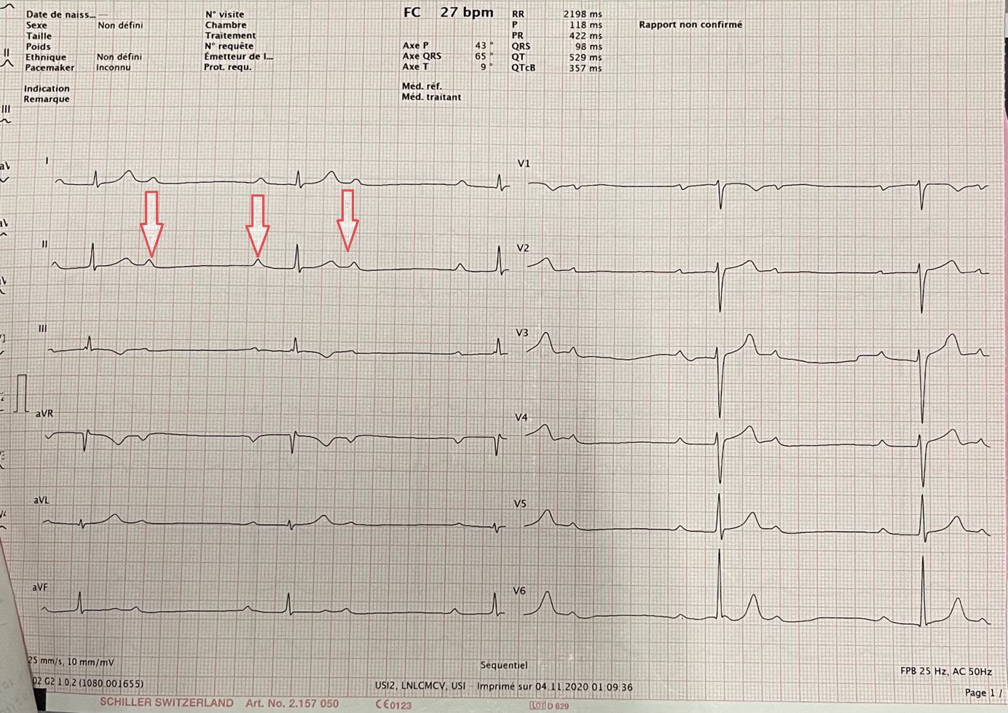

Figure 1: 12-lead ECG
12-lead ECG showing 2:1 atrioventricular block with narrow QRS complexes.

Chest X-ray revealed prominent hilar lymphadenopathy (Figure 2). Hemogram, cardiac enzymes, and inflammatory markers were within normal ranges.

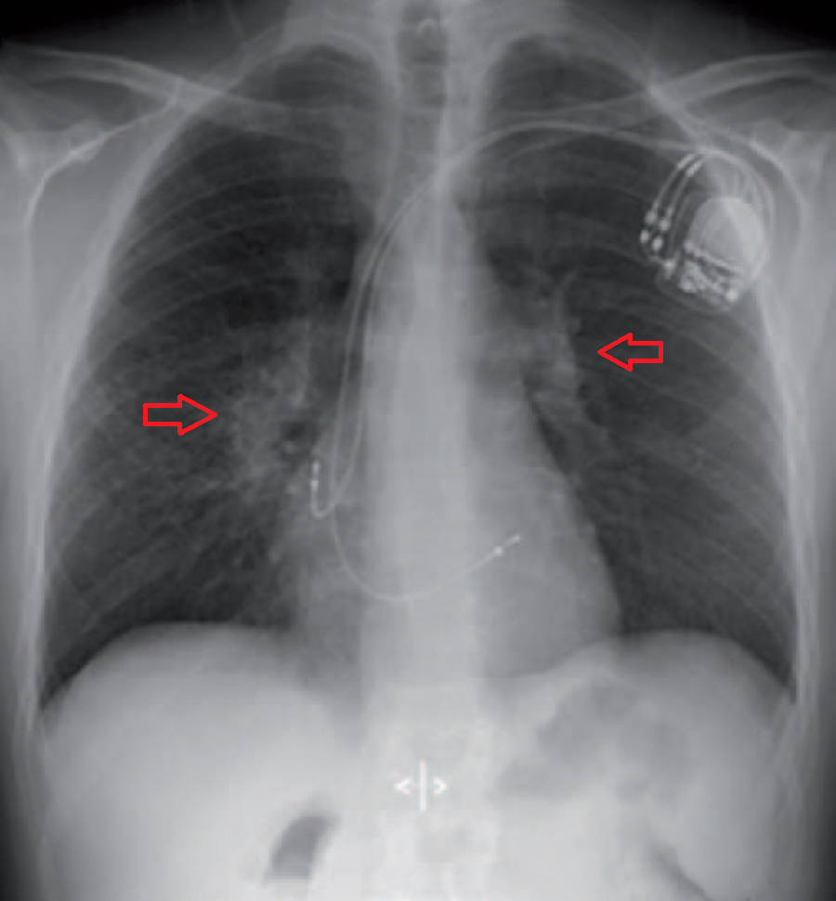
Figure 2: Chest X-ray
Chest X-ray showing bilateral hilar lymphadenopathy.
Transthoracic echocardiography showed biventricular dilation with preserved left and right ventricular function. Etiological workup (renal, hepatic, thyroid function, and calcium levels) was unremarkable.
Thoracic CT scan demonstrated mediastinal lymphadenopathy with centrilobular and subpleural micronodular lesions suggestive of sarcoidosis (Figure 3). 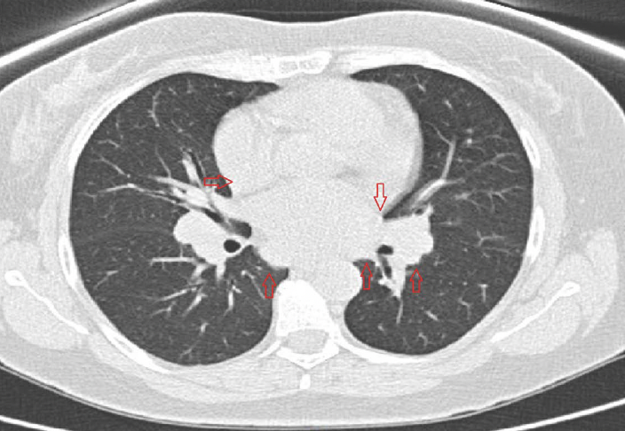

Figure 3: Chest CT scan
Axial chest CT showing mediastinal and hilar lymphadenopathy with centrilobular micronodular lesions.

Cardiac MRI revealed subepicardial late gadolinium enhancement in the basal anterior and mid-septal walls, consistent with cardiac sarcoidosis (Figure 4).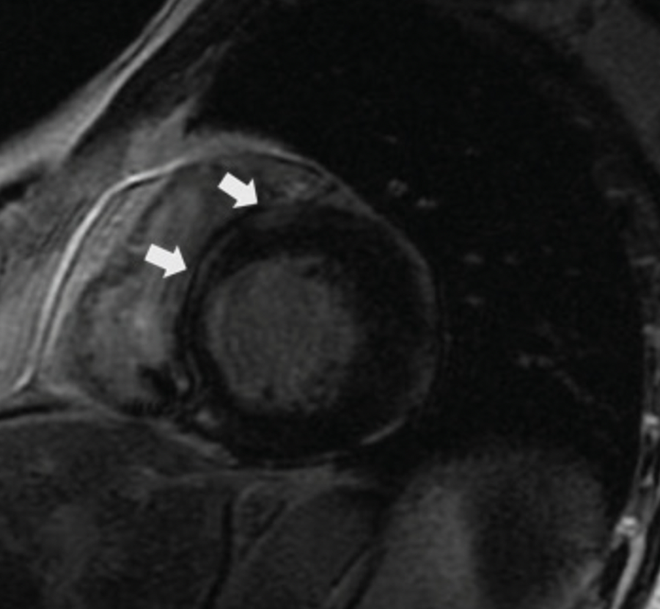

Figure 4: Cardiac MRI
Cardiac MRI showing subepicardial late gadolinium enhancement of the basal anterior and mid-septal wall.
The patient underwent dual-chamber pacemaker implantation via cephalic vein access and was started on corticosteroid therapy with a favourable clinical outcome.

Discussion
Unlike in elderly patients, where atrioventricular block (AVB) is most often due to degenerative causes, the discovery of a complete AVB in a young adult mandates a thorough etiological investigation [8].
In our case, there was no clinical, biological, or serological evidence of infectious disease. The absence of chest pain, typical ECG signs, and normal troponin levels helped rule out ischemic heart disease or myocarditis. There were also no signs or history suggesting systemic inflammatory disease such as systemic lupus erythematosus or scleroderma, and no biological inflammatory syndrome was detected.
Other causes such as hemochromatosis, Hodgkin’s disease, or leukaemia were also excluded.
In the absence of an obvious aetiology for this patient’s AV block, cardiac magnetic resonance imaging (MRI) was performed to look for features suggestive of sarcoidosis. Cardiac MRI can demonstrate nonspecific inflammatory processes as localised intramyocardial hypersignals on T1-weighted images, which are enhanced on T2-weighted images [9]. These findings may reflect active granulomatous inflammation and have significant value in detecting asymptomatic cardiac involvement.
Endomyocardial biopsy has a low diagnostic yield due to the patchy distribution of granulomas in cardiac sarcoidosis, confirming the diagnosis in only 20-30% of cases [10]. The gold standard remains histologic evidence of non-caseating epithelioid granulomas on bronchial, lymph node, cutaneous, or salivary gland biopsies.
Cardiac involvement in sarcoidosis is relatively rare and usually occurs in advanced systemic disease; it is an exceptionally revealing manifestation, as in our case. Conduction disorders are the most frequent presentation, reported in 47-91% of cases, mostly in younger patients [10,11]. Ventricular arrhythmias are also common (up to 50% of cases), though they were absent in our patient.
Conduction disorders and ventricular arrhythmias are responsible for approximately 50% of deaths in cardiac sarcoidosis [10,11]
Treatment is based on corticosteroid therapy, which should be initiated promptly at a dose of 1 mg/kg/day once the diagnosis is confirmed [10,11]. Tapering should be gradual, depending on clinical and ECG response, starting from the fourth to eighth week. A maintenance dose of 10 mg/day is usually continued for at least one year. Some patients may require prolonged treatment due to steroid dependence, and in refractory cases, immunosuppressive therapy may be considered [10,11].
When conduction disorders persist despite medical therapy or in cases of poor hemodynamic tolerance, permanent pacemaker implantation is indicated, as was the case for our patient. If ventricular arrhythmias coexist, an implantable cardioverter-defibrillator (ICD) should be considered [10,11].
This case illustrates the importance of investigating any high-grade AV block in a young adult, and of systematically considering sarcoidosis in the differential diagnosis when no other cause is found. It also underscores the diagnostic value of cardiac MRI in detecting myocardial involvement and guiding therapeutic decisions.

Conclusion
Cardiac sarcoidosis is a potentially severe form of sarcoidosis that must be promptly recognised. Screening for cardiac involvement in patients with extracardiac sarcoidosis should include clinical evaluation, physical examination, 12-lead electrocardiogram, and transthoracic echocardiography.
Advanced imaging techniques, especially cardiac MRI and 18F-FDG PET/CT, have significantly improved detection rates compared to clinical, electrical, or echocardiographic signs alone. These imaging modalities also provide prognostic insights and help guide appropriate therapy.
Consent for publication:
Written informed consent was obtained from the patient for publication of this case report and accompanying images. A copy of the written consent is available for review by the Editor-in-Chief of this journal on request.

Disclaimer (Artificial intelligence)
Option 1:
Author(s) hereby declare that NO generative AI technologies such as Large Language Models (ChatGPT, COPILOT, etc.) and text-to-image generators have been used during the writing or editing of this manuscript.
Option 2:
Author(s) hereby declare that generative AI technologies such as Large Language Models, etc. have been used during the writing or editing of manuscripts. This explanation will include the name, version, model, and source of the generative AI technology and as well as all input prompts provided to the generative AI technology
Details of the AI usage are given below:
1.
2.
3.

References
- Iannuzzi MC, Rybicki BA, Teirstein AS: Sarcoidosis. N Engl J Med. 2007, 357:2153-2165. 10.1056/NEJMra071714
- Birnie DH, Nery PB, Ha AC, Beanlands RS: Cardiac sarcoidosis. J Am Coll Cardiol. 2016, 68:411-421. 10.1016/j.jacc.2016.03.605
- Kandolin R, Lehtonen J, Airaksinen J, et al.: Cardiac sarcoidosis: epidemiology, characteristics, and outcome over 25 years in a nationwide study. Circulation. 2015, 131:624-632. 10.1161/CIRCULATIONAHA.114.011522
- Birnie DH, Sauer WH, Bogun F, et al.: HRS expert consensus statement on the diagnosis and management of arrhythmias associated with cardiac sarcoidosis. Heart Rhythm. 2014, 11:1305-1323. 10.1016/j.hrthm.2014.03.043
- Doughan AR, Williams BR: Cardiac sarcoidosis. Heart. 2006, 92:282-288. 10.1136/hrt.2005.080481
- Patel MR, Cawley PJ, Heitner JF, et al.: Detection of myocardial damage in patients with sarcoidosis. Circulation. 2009, 120:1969-1977. 10.1161/CIRCULATIONAHA.109.851352
- Sadek MM, Yung D, Birnie DH, Beanlands RS, Nery PB: Corticosteroid therapy for cardiac sarcoidosis: a systematic review. Can J Cardiol. 2013, 29:1034-1041. 10.1016/j.cjca.2013.01.012
- Djiane P, Deharo JC: Atrioventricular blocks. Encycl Méd Chir (Elsevier. 11:32.
- Dhôte R, Vignaux O, Blanche P, et al.: Contribution of MRI in the evaluation of cardiac involvement during sarcoidosis. Rev Med Interne. 2003, 24:151-157.
- Berthouet M, Casset-Senon D, Machet MC, et al.: Conduction disorders revealing sarcoidosis or appearing during its course: regression under corticosteroid therapy. Arch Mal Coeur. 2003, 96:677-682.
- Chaperon-Abric C: Cardiac sarcoidosis. Ann Med Interne. 2001, 152:125-133.
- Rahmi, M., Merzouk, F., Ouarradi, A. E., & Habbal, R. (2024). Sarcoidosis with Cardiac Localization: About 03 Cases. Cardiology and Angiology: An International Journal, 13(4), 1–8.
- Korthals, D., Bietenbeck, M., Könemann, H., Doldi, F., Ventura, D., Schäfers, M., Mohr, M., Wolfes, J., Wegner, F., Yilmaz, A., & Eckardt, L. (2024). Cardiac Sarcoidosis—Diagnostic and Therapeutic Challenges. Journal of Clinical Medicine, 13(6), 1694.
- Sohn, D. W., & Park, J. B. (2023). Cardiac sarcoidosis. Heart, 109(15), 1132-1138.

